University of Wales Trinity Saint David
School of Engineering



Evaluating the Effectiveness of Chosen Maintenance Strategies for Dedicated Equipment
Plant and Asset Engineering
(ACMA6007)

Tia Ball
2220258
May 2026
Contents
Table of Figures 3
1. Introduction 4
1.1 Background to the business and asset 4
1.2 Aim, scope and limitations 4
2 Critical Review of Current Maintenance Practices 5
2.1 Description of the wind noise rig and its function 5
2.2 Legislation, regulation and standards 6
2.3 Current maintenance approach 7
2.4 Strengths and weaknesses of the current approach 7
2.5 Why this approach appears to have been chosen 8
3 Evaluation of Improvement Opportunities 9
3.1 Identification of issues and gaps 9
3.2 Potential improvement strategies 9
3.3 Future maintenance planning and implementation 10
4 Costs, Resources and Change Management 12
4.1 Cost analysis 12
4.2 Resource requirements 12
4.3 Change management implications 12
5 Conclusions and Recommendations 14
5.1 Summary of findings 14
5.2 Recommendations 14
6 References 15

Table of Figures
Figure 1 - External view of the wind-noise rig 5
Figure 2 - Internal view of the wind-noise rig showing dual robot arrangement. 6

Introduction

Background to the business and asset
Aston Martin is a British luxury vehicle manufacturer founded in 1913. The company states that its sports cars are produced in Gaydon, while the DBX range is manufactured at St Athan in Wales, making the site an important part of its current production operations (Aston Martin, 2025).
The selected equipment for this report is the wind noise rig. As shown in the figures used in this report, the rig is an enclosed production test cell with dual industrial robot arms, vehicle-location features, access arrangements, and associated safety and control equipment. This makes it more than a standard automated cell because it is also a quality-critical asset used to identify wind-noise issues before vehicles leave the manufacturing process.

Aim, scope and limitations
This report evaluates the maintenance strategy for the wind noise rig and identifies ways to improve it. The discussion focuses on the effect of maintenance on safety, equipment availability, repeatability, and confidence in the test process. It also considers the likely cost, resource, and change management implications of the proposed improvements.
The report is limited to the wind noise rig rather than the wider production system. It also focuses on maintenance strategy rather than detailed acoustic engineering or vehicle design issues. Where detailed internal maintenance records were unavailable, the evaluation has been based on the observed equipment layout, the rig's function, and established maintenance principles relevant to robotic and test equipment.

Critical Review of Current Maintenance Practices

Description of the wind noise rig and its function
The wind noise rig is a dedicated test cell used to identify wind noise or air leak concerns on completed vehicles before release from production. The asset includes an enclosed booth (shown in Figure 1), two industrial robot arms, vehicle-locating hardware, access or shutter systems, and external safety and control equipment. The rig, therefore, supports both production and quality assurance.
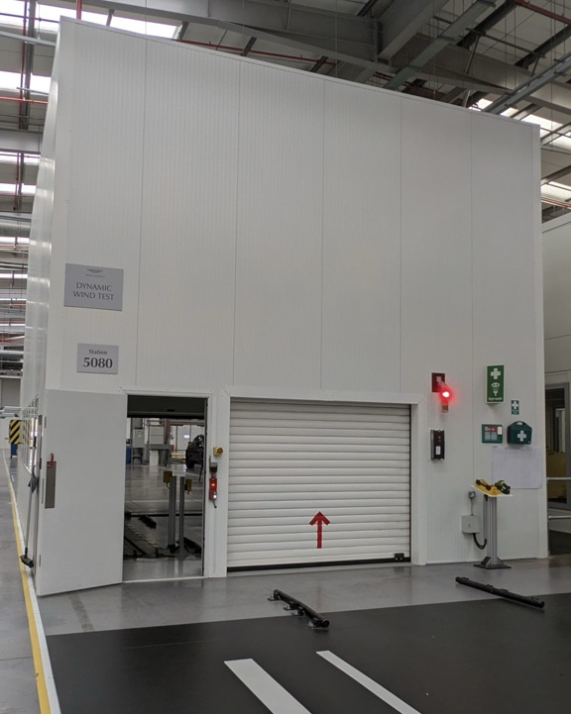
Figure 1 - External view of the wind-noise rig

For this type of equipment, maintenance is not just about whether the rig is running or broken. It also matters whether it can test vehicles consistently and support reliable fault detection. If the cell remains operational but loses repeatability or control, its value as a test asset is reduced. This means maintenance effectiveness should be judged by safety, availability, and testing performance. Figure 2 shows the internal layout of the rig, including the dual robot arrangement used during testing.
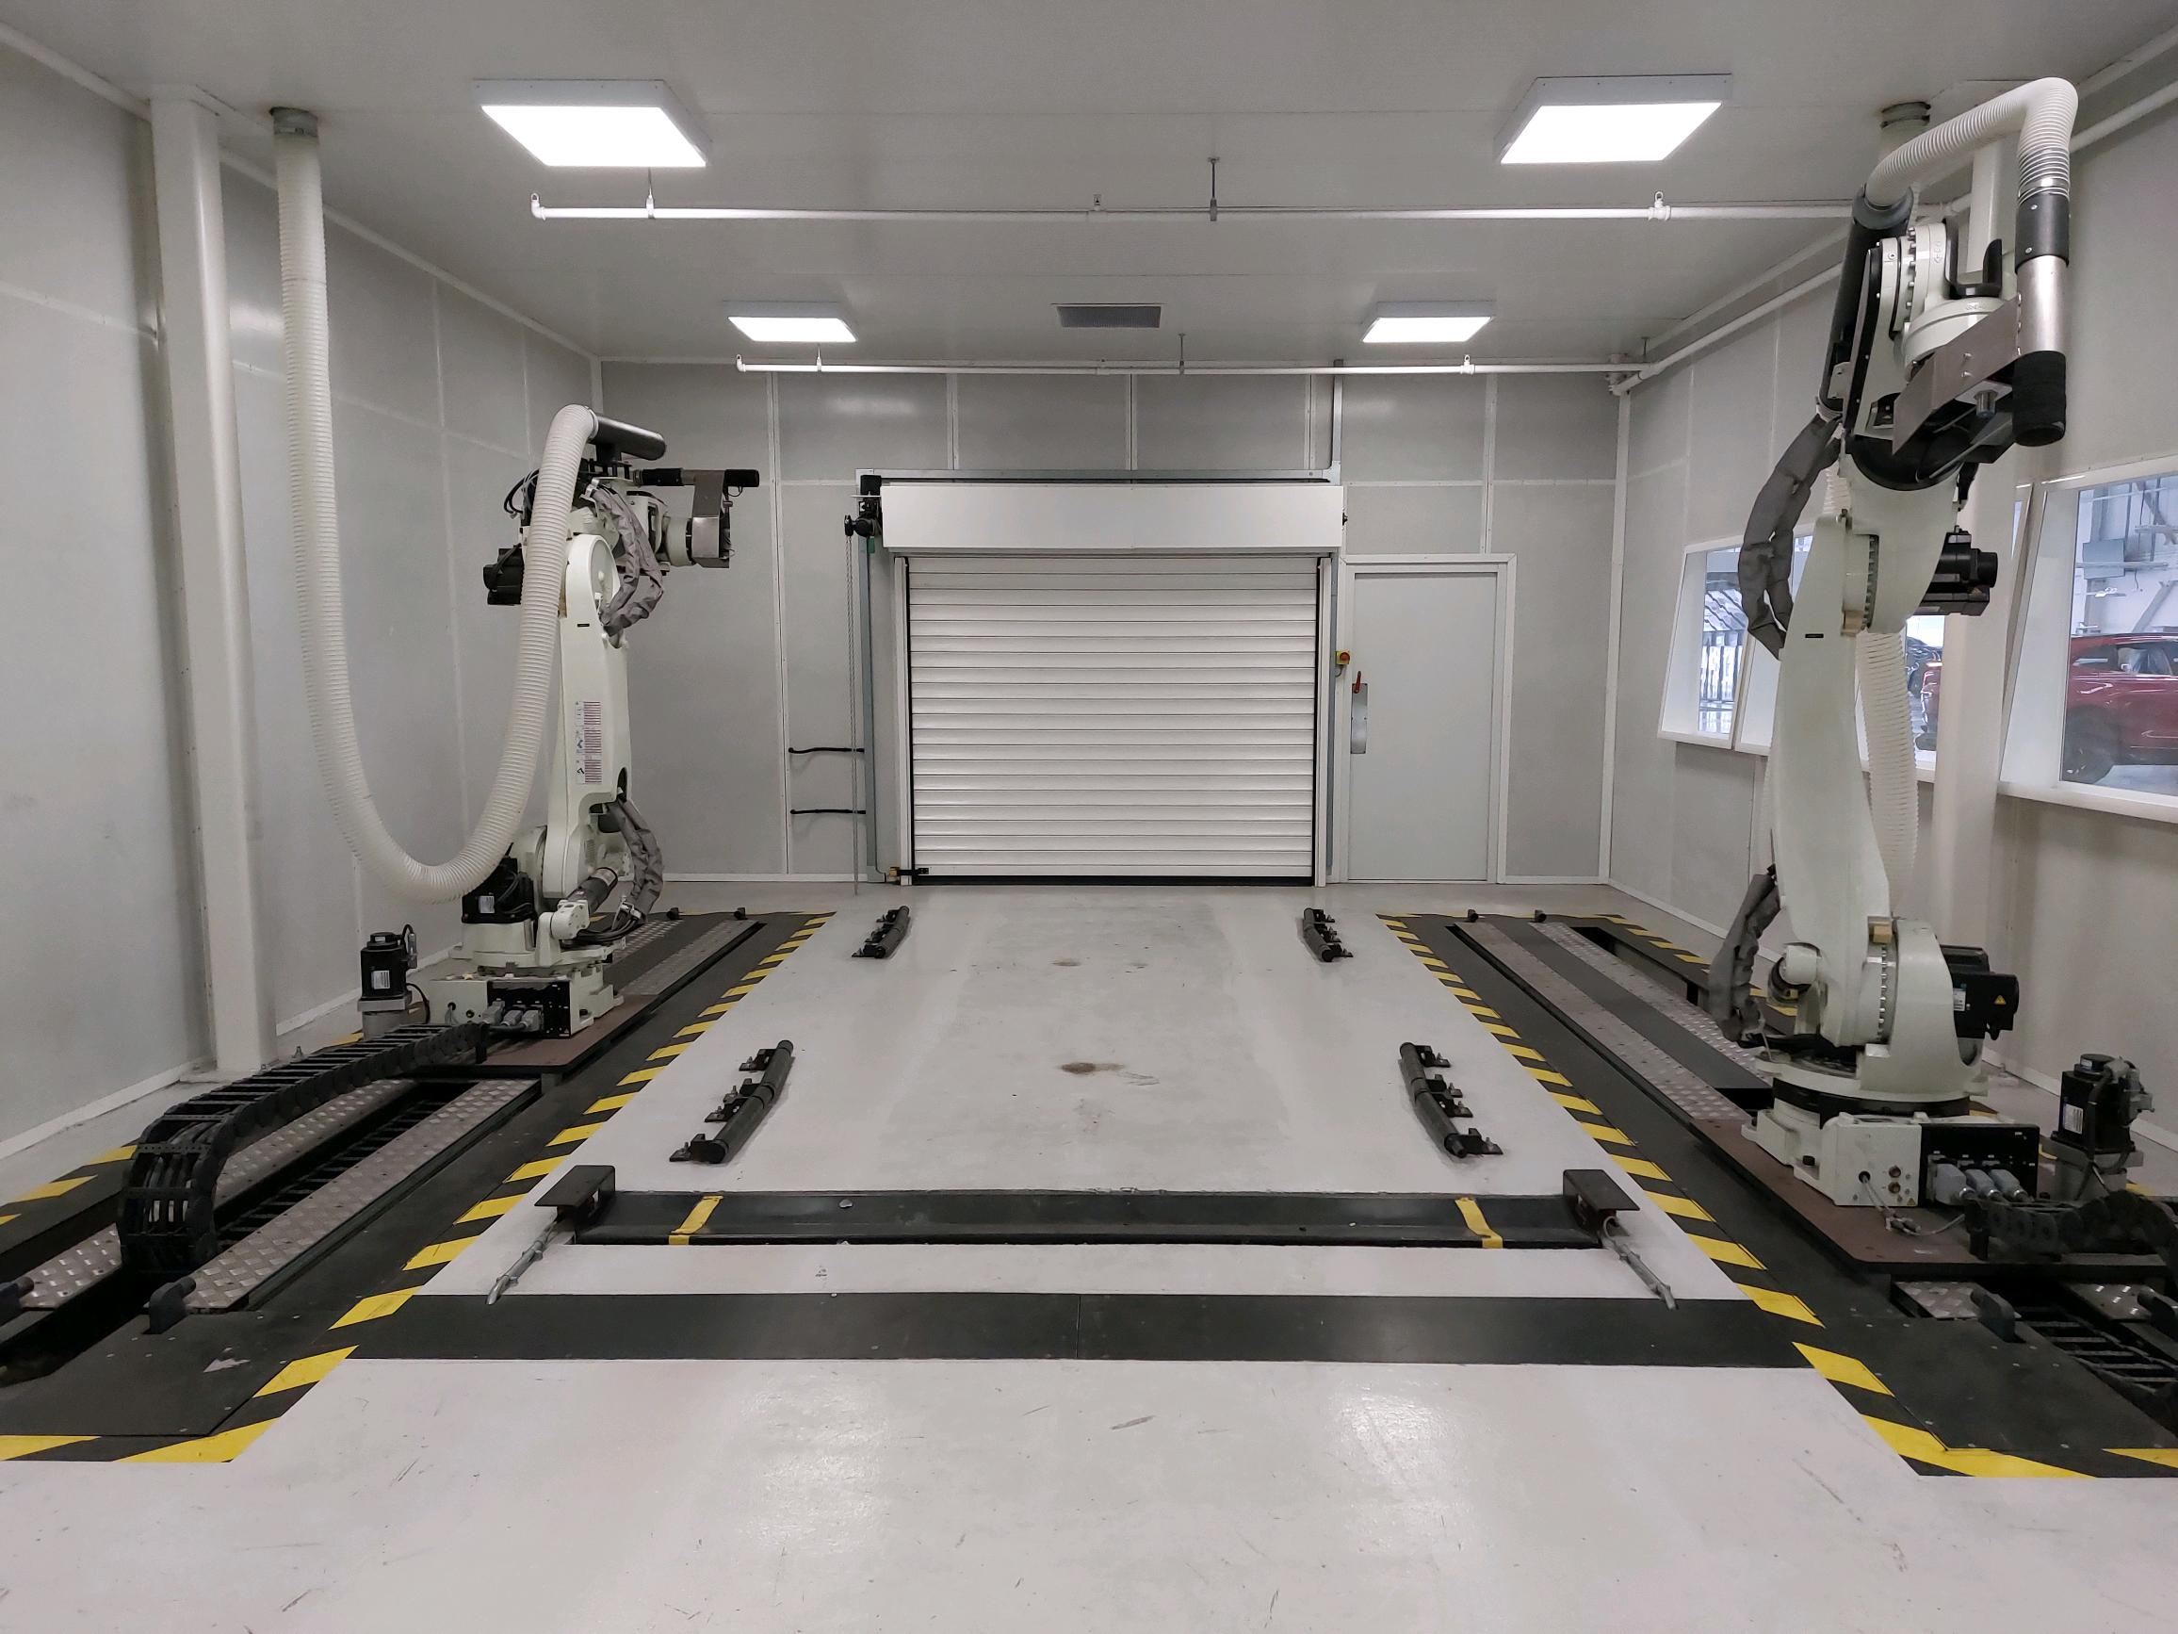
Figure 2 - Internal view of the wind-noise rig showing dual robot arrangement

Legislation, regulation and standards
The maintenance of the wind noise rig is influenced by legal duties and machinery safety standards. The Health and Safety at Work Act 1974 (HSWA) places a general duty on employers to protect the health, safety and welfare of employees and others affected by work activities. In practice, this means work equipment must be maintained so that it remains safe to use (Health and Safety Executive, 2024a).
More specifically, the Provision and Use of Work Equipment Regulations 1998 (PUWER) require work equipment to be kept in an efficient state, in efficient working order and in good repair. For a robotic test cell, this is important because faults in guarding, interlocks, emergency stops, cables or controls could affect both safety and production (Health and Safety Executive, 2024b) (Health and Safety Executive, 2024c) In addition, standards such as ISO 12100 and ISO 13849-1 are relevant because maintenance must preserve the safety functions originally designed into the cell (ISO, 2010) (ISO 13849, 2023).

Current maintenance approach
Without access to full internal maintenance records, the current approach appears most likely to be a conventional planned preventive maintenance system supported by reactive fault rectification when failures occur. This would be typical for a robotic production cell where safety and availability are the main priorities. In practical terms, this is likely to include routine visual inspections, cleaning, safety checks, attention to wear on cables and moving parts, and repair work when faults prevent the rig from operating.
This approach is understandable in production because it is simple to organise, but it prioritises administrative simplicity over test assurance. It also aligns with legal expectations and manufacturer guidance. However, for a wind noise rig, this only addresses part of the maintenance requirement. The rig needs to operate safely and support a repeatable, reliable test process.

Strengths and weaknesses of the current approach
A clear strength of planned preventive maintenance is that it provides structure. Tasks can be scheduled, recorded and completed during planned windows, reducing the risk of obvious neglect. This is especially important for robotic equipment, where faults in safety circuits, control systems or moving components can cause downtime or create hazards. It is also a familiar approach for site teams and does not require major investment in specialist monitoring systems.
However, the current approach has important weaknesses. The first is that time-based maintenance does not always reflect the equipment’s true condition. Components may be checked too early, resulting in wasted effort, or too late, allowing deterioration to continue until it affects operation (Mobley, 2004). For the wind noise rig, this applies to cables, dress packs, locating hardware, shutters and control components.
The second weakness is that the strategy is more focused on uptime than on test capability. A test asset can still run while becoming less reliable at performing its intended function. For example, loss of repeatability, gradual wear or minor faults may reduce confidence in the test without causing a full breakdown. In that sense, maintenance should protect the rig’s function as well as its physical operation. This reflects the principles of reliability-centred maintenance, where the focus is on preserving the functions an asset must perform rather than simply preventing stoppages (Moubray, 1997). This matters because the rig can remain operational while gradually losing repeatability, meaning maintenance failure may appear as reduced test confidence rather than a complete equipment breakdown.
Another weakness is that the current approach does not fully recognise the rig as a quality-critical test asset rather than a normal production machine. For the wind noise rig, performance is more closely linked to consistency and confidence in the test itself. Small changes in robot positioning, fixture condition, booth cleanliness or access hardware may not stop the rig from operating, but they can still affect how repeatable the test is. For this type of equipment, the bigger risk is not always sudden failure but a gradual loss of control over the test environment.
A further weakness is the lack of strong operator involvement. Total Productive Maintenance (TPM) literature suggests that operators can support early fault detection through routine checks, basic inspection and the reporting of abnormalities (Ahuja & Khamba, 2008). On a rig like this, users may notice damage, contamination or unusual behaviour before maintenance technicians do. If that opportunity is missed, smaller problems can develop into larger ones

Why this approach appears to have been chosen
The existing approach was most likely chosen for practical reasons. Planned preventive maintenance is widely used in manufacturing because it is simple, familiar and easy to schedule. It supports compliance, can be linked to manufacturer guidance, and does not require advanced monitoring or specialist analysis. In a busy production environment, this makes it attractive.
It is also likely that the rig has historically been treated mainly as an operational piece of plant rather than a specialist test asset. If that is the case, it is understandable that maintenance has developed around safety and uptime first. However, for this type of equipment, that is no longer enough on its own.

Evaluation of Improvement Opportunities

Identification of issues and gaps
The review in section 2 suggests that the current maintenance strategy provides a foundation for safety and operation, but it does not fully reflect the demands placed on the wind noise rig. The key issue is that this asset is not only a robotic cell, but also a test system that must remain repeatable. Because of this, maintenance should protect both the equipment's condition and its testing capability.
One gap is the likely reliance on fixed maintenance intervals rather than actual condition. This is a known weakness of traditional preventive maintenance because components may be serviced at the wrong time, either too early or too late (Mobley, 2004). On the wind noise rig, this could allow hidden deterioration in moving or electrical parts to continue until performance is affected.
A second gap is the probable lack of condition-based maintenance. For more complex equipment, condition-based approaches can help identify early signs of wear by using information such as alarm history, temperature, vibration, cycle count or repeated fault behaviour (Jardine, Lin, & Banjevic, 2006). This is particularly relevant for components exposed to repeated movement or electrical stress.
A third issue is that the current strategy focuses mainly on keeping the rig running rather than proving that it is still performing the test consistently. For a quality-critical asset, this is a major limitation. If the rig remains operational but loses repeatability, then its value to production quality is reduced.

Potential improvement strategies
The most suitable improvement is a hybrid maintenance strategy rather than a complete replacement of the existing system. Planned preventive maintenance should remain in place, but it should become more targeted and be supported by selected condition-based and operator-led activities.
The first improvement is to review the rig by subsystem criticality. Safety systems, robot motion, access systems, locating features and control hardware should not all be treated in the same way. Reliability-centred maintenance (RCM) is useful here because it links maintenance tasks to failure modes and their consequences (Moubray, 1997). For the wind-noise rig, this would help distinguish between failures that stop the rig and those that reduce test quality.
The second improvement is to introduce condition-based maintenance on selected high-risk items. It is not necessary to monitor every component, but targeted monitoring of alarm history, cycle counts, repeated access faults and recurring electrical issues would allow earlier intervention. Condition-based maintenance is valuable because it helps ensure maintenance decisions are based on evidence rather than solely on time intervals (Jardine, Lin, & Banjevic, 2006).
The third improvement is to introduce a clearer test capability assurance element. This is important because the rig is part of a test process, not just a machine. Periodic checks of robot positioning, fixture condition and overall setup would help ensure the rig continues to support consistent testing. If future upgrades make the rig more measurement-based, calibration and validation should also form part of the maintenance strategy. For that reason, a hybrid strategy is more suitable, as it allows preventive maintenance to remain in place while targeting higher-risk subsystems with more condition-based and function-focused control.
This also shows why a hybrid strategy is more suitable than relying on one method alone. If the business only uses planned preventive maintenance, tasks may continue routinely without checking whether they protect the rig’s most important functions. On the other hand, moving fully to condition-based maintenance would likely be too costly and unnecessary for every part of the cell. A more balanced approach is to keep preventive maintenance as the foundation while applying condition-based thinking to the parts of the rig most likely to suffer wear, repeated movement or intermittent faults. This would allow maintenance effort to be used more effectively and make the strategy more relevant to the asset’s actual risks.
A further improvement is to introduce basic TPM principles. This could include simple operator-led daily checks, such as visual inspection, housekeeping, checking for obvious damage and reporting abnormalities. TPM has been shown to improve communication, reliability and early fault detection when applied properly (Ahuja & Khamba, 2008).
Finally, the strategy would benefit from better maintenance data. A rig like this should have clear records of failure type, affected subsystem, downtime, action taken and recurrence. Better fault history would improve planning and support more effective spare-parts decisions (Baglee & Knowles, 2010).

Future maintenance planning and implementation
In future maintenance planning, the most realistic approach would be phased implementation. The first step should be a review of the rig’s subsystems and their criticality. This would identify which parts affect safety, uptime, and repeatability. The maintenance plan could then be updated so that tasks are linked more clearly to the asset function.
The second step should be to strengthen the current preventive regime by improving task descriptions, reviewing task frequency and introducing simple operator checks. This would improve abnormality detection without creating major disruption.
The third step should be to introduce selected condition-based elements and a stronger critical spares strategy. Holding essential safety, control and connection components would reduce repair time and improve resilience. This is important because maintenance has a direct effect on productivity and profitability, especially where equipment is both production-critical and quality-critical (Alsyouf, 2007).

Costs, Resources and Change Management

Cost analysis
Improving the maintenance strategy for the wind noise rig would involve both direct and indirect costs. Lower-cost actions would include reviewing maintenance tasks, improving inspection routines, updating documentation, and introducing operator check sheets. These would mainly require engineering time rather than major capital expenditure.
Medium-level costs would include technician training, holding critical spare parts, and robot or controls support where required. There may also be costs linked to periodic verification of robot positioning or fixture condition. Higher costs would only arise if the business decided to introduce more advanced condition-based monitoring or software-supported diagnostics.
For this reason, a phased approach is the most practical option. Lower-cost improvements should be introduced first, with higher-cost measures adopted only where recurring faults or critical functions justify them.

Resource requirements
The proposed changes would require more than budget. They would also need engineering time, training, and planning support. Maintenance staff may need additional knowledge in fault trending, robot-related inspection, and function-based maintenance. If operator-led checks are introduced, test or production staff would also need basic training to understand what to look for and how to report abnormalities.
A review of critical spare parts would also be required. Holding items such as safety relays, connectors, or wear parts would increase inventory cost, but it would reduce mean time to repair and the risk of longer production losses (Alsyouf, 2007).

Change management implications
Any change in maintenance strategy will affect the way people work, so change management must be considered. Staff may view new operator checks or positioning verification as extra work, especially if the current system is already seen as acceptable. Resistance may also develop if operators feel maintenance tasks are being pushed onto them.
This is why a phased approach is important. Short-term changes, such as better fault logging and simple checks, are easier to introduce, while larger changes, such as selected condition-based monitoring, can be introduced later. Change is more likely to succeed if staff understand the purpose of the changes and can see the link to reduced downtime and more consistent testing (Kotter, 1996).

Conclusions and Recommendations

Summary of findings
This report evaluated the maintenance strategy for the wind-noise rig in an automotive assembly environment. The review found that the current approach is likely to provide a reasonable level of safety compliance and basic equipment availability through planned preventive maintenance and reactive repair when required.
However, the report also showed that this approach is limited when the rig is treated as a quality-critical test asset rather than standard production equipment. Maintenance should not only keep the rig running, but also support repeatability, consistency and confidence in the test process. A mainly time-based strategy may prevent obvious failures, but it is less effective at identifying gradual deterioration, repeated minor faults, or issues that reduce test quality.
The evaluation showed that a hybrid strategy would be more suitable. Planned preventive maintenance should remain in place, but it should be supported by more targeted task planning, greater operator involvement, improved fault history, selected condition-based monitoring and a stronger focus on test capability assurance.

Recommendations
A phased approach is recommended to improve the maintenance strategy for the wind noise rig.
In the short term, existing preventive maintenance tasks should be reviewed and updated so they better reflect the rig’s most critical subsystems. Fault recording should also be improved, and simple operator-led checks should be introduced.
In the medium term, the maintenance plan should become more function-based, with greater attention to the rig components that affect test repeatability and uptime. Critical spare parts should also be identified and held where justified.
In the long term, the business should consider selected condition-based maintenance techniques for the parts of the rig most affected by wear, repeated motion or intermittent faults. If future upgrades make the rig more data-driven, calibration and validation should also become part of the formal maintenance strategy.
The main recommendation is that the wind noise rig should be maintained as a specialised test asset whose value depends on safety, uptime and repeatable performance.

Reference List
Ahuja, I.P.S. and Khamba, J.S. (2008) ‘Total productive maintenance: literature review and directions’, International Journal of Quality & Reliability Management, 25(7), pp. 709–756.
Alsyouf, I. (2007) ‘The role of maintenance in improving companies’ productivity and profitability’, International Journal of Production Economics, 105(1), pp. 70–78.
Aston Martin (2025) About us. Available at: https://www.astonmartin.com/en/corporate/about-us (Accessed: 18 April 2026).
Baglee, D. and Knowles, M. (2010) ‘Maintenance strategy development within SMEs: the development of an integrated approach’, Control and Cybernetics, 39(1), pp. 275–303.
Health and Safety Executive (2024a) Health and Safety at Work etc. Act 1974. Available at: https://www.hse.gov.uk/legislation/hswa.htm (Accessed: 18 April 2026).
Health and Safety Executive (2024b) Maintenance of work equipment. Available at: https://www.hse.gov.uk/work-equipment-machinery/maintenance (Accessed: 18 April 2026).
Health and Safety Executive (2024c) Provision and Use of Work Equipment Regulations 1998 (PUWER): Overview. Available at: https://www.hse.gov.uk/work-equipment-machinery/puwer-overview (Accessed: 18 April 2026).
International Organization for Standardization (2010) ISO 12100:2010 Safety of machinery — General principles for design — Risk assessment and risk reduction. Geneva: ISO.
International Organization for Standardization (2023) ISO 13849-1:2023 Safety of machinery — Safety-related parts of control systems — Part 1: General principles for design. Geneva: ISO.
Jardine, A.K.S., Lin, D. and Banjevic, D. (2006) ‘A review on machinery diagnostics and prognostics implementing condition-based maintenance’, Mechanical Systems and Signal Processing, 20(7), pp. 1483–1510.
Kotter, J.P. (1996) Leading Change. Boston, MA: Harvard Business School Press.
Mobley, R.K. (2004) Maintenance Fundamentals. 2nd edn. Oxford: Butterworth-Heinemann.
Moubray, J. (1997) Reliability-centered Maintenance. 2nd edn. New York: Industrial Press.

