MY PORTFOLIO



By Samantha Jones
2010718

Contents Page

Blog 1 – Communication
Blog 2 - Versatility
Blog 3 – Teamwork
Blog 4 - Organisational skills
Blog 5 – Presentation skills
Blog 6 - Empathy
Log of programme engagement hours
Academic interview
Poster
References

Blog 1 – Communication

Communication skills are important in the workplace as well as in everyday life. Having good communication skills builds trust, prevents and resolves problems, increases engagement, and it improves productivity in the workplace as through communicating people have a clear understanding of what is needed. (Portland community college, 2019).
There are many ways to ensure communication is done successfully whilst speaking with people, by the tone that’s used, actively listening to someone and understanding a person’s body language (Skills for care, 2018).
I have gained various communication skills by working with colleagues and customers. In customer facing roles I have had to learn to actively listen to ensure I understand what is needed. Working with colleagues’ communication is important so all staff know what they are doing to prevent problems arising. Communicating effectively with everyone in a workplace ensures all involved are clear of what is needed of them and it ensures errors being prevented.

Blog 2 – Versatility

Being versatile provides more opportunities. Employers tend to advertise a vacancy with a list of what skills and experiences they are looking for, being versatile means you can adapt to the needs and demands of a task (Life hack, 2021).
Versatility means you can do more than one thing, you can learn to do new things that might be out of your comfort zone and that you are able to adapt to this. (Workology, 2013).
I have had various jobs in different sectors which has enabled me to be versatile, I have worked in roles such as customer service, warehouse worker, taxi driver among others. In each of these roles I have gained many skills, problem solving, organisation, team working and communication among more. I like the challenge of progressing my learning even when it is something out of my comfort zone. In the workplace this skill is very beneficial as you may have times where you are required to do a different role to normal, being versatile means you can adapt to this change.

Blog 3 – Teamwork

Working as a team has many benefits, each team member will have different skills that can be useful for bringing new ideas, solving problems, enhancing communication, providing support to team members and it can also help people learn from each other. (Zurich, 2017).
Teamwork provides improved efficiency and productivity as the work is shared; it allows goals to be more achievable and increases the work pace. Teamwork in the workplace means you are working together towards the same goal, and this promotes friendship and loyalty as you are supporting and helping each other rather than working against each other. (S.Wehbe, 2017).
I have gained skills in teamwork through employment and by doing this course. This module I worked as part of a team to create a poster, each of us had different skills so we decided between us who was the better fit for each part, we done this by communicating on our strengths and weaknesses. When the task was finished, we all agreed the outcome of the poster was a lot more creative by us working as a team. Teamwork in the workplace is a more effective way of working as it allows more work to be done in less time, it has a positive effect overall as everyone contributing achieves better results.

Blog 4 – Organisational skills

Strong organisational skills are one of the key skills you can develop, this can be shown by the way you plan your time and the way you organise your workload. You can develop these skills by writing reminders down, making a log of what needs to be done and planning for all eventualities. (Youth employment UK, 2016).
Time management is one of the most important skills to maintain organisation in the workplace, managing time ensures tasks are completed in a timeline that might be set. Keeping your workspace tidy will help you stay organised and potentially prevent things getting lost or mixed up. Huntington (2017).
I have gained organisation skills through this course as each module has to be in by a set time, with personal life I have had to organise my time by setting time each week to work on the assignment to ensure it will be completed by the date set. In my experience in work life this skill is very important, without organisation in the workplace problems occur.

Blog 5 – Presentation skills

Presentation skills are vital in higher education for students to gain experience whilst helping to develop professionalism. It helps students gain confidence and to be more successful. (Sunway, 2019).
Presentation skills in the workplace improves the chance of progression, it shows you can communicate clearly and effectively. (New Horizon, 2017).
The first presentation most people will deliver is an interview, where they are in fact presenting themselves by showing what skills they have and what they have to offer. People with good presentation skills are more likely to stand out to superiors leading to more opportunities, as they are confident, good communicators and it also demonstrates strong time management skills. (Presentation Training Institute, 2018).
Through studying in higher education, I am developing these skills. I am not confident is doing this; however, I feel I am progressing in this, and it is something I need to keep working on. Going forward I need to ensure I am prepared and to just practice so I can gain more confidence.

Blog 6 – Empathy

Empathy is being aware of other people’s feelings and emotions. Empathy is a skill that comes naturally to most people, it can also be developed. Empathy is understanding other peoples’ perspectives and showing sensitivity. Understanding peoples’ emotions and perspectives can enable you to resolve conflicts and to improve relationships with co-workers, clients and customers. (Mind Tools, 2021).
During this course there has been many times where classmates have been finding it difficult and getting upset, but from being able to show sensitivity and understanding it has brought the group closer together.

Log of Programme Engagement Hours

Date | Hours Engaged | Module
11.10.21 | 6 | BMHP4016
13.10.21 | 3 | BMHP3002
18.10.21 | 6 | BMHP4016
20.10.21 | 3 | BMHP3002
25.10.21 | 6 | BMHP4016
27.10.21 | 3 | BMHP3002
01.11.21 | 6 | BMHP4016
08.11.21 | 3 | BMHP4016
10.11.21 | 3 | BMHP3002
15.11.21 | 6 | BMHP4016
17.11.21 | 3 | BMHP3002
22.11.21 | 3 | BMHP4016
24.11.21 | 3 | BMHP3002
29.11.21 | 4 | BMHP4016
01.12.21 | 2 | BMHP3001
08.12.21 | 2 | BMHP3001
03.01.22 | 4 | BMHP4015
05.01.22 | 2 | BMHP3001
10.01.22 | 4 | BMHP4015
12.01.22 | 2 | BMHP3001
24.01.22 | 2 | BMHP4015
26.01.22 | 2 | BMHP3001
31.01.22 | 4 | BMHP4015
02.02.22 | 2 | BMHP3001
02.02.22 | 30 EST | WHATSAPP COMMUNICATION WITH CLASSMATES
02.02.22 | 15 EST | COFFEE SHOP MEETING WITH CLASSMATES
07.02.22 | 4 | BMHP4015
09.02.22 | 2 | BMHP3001
Total hours = 135

Academic Interview
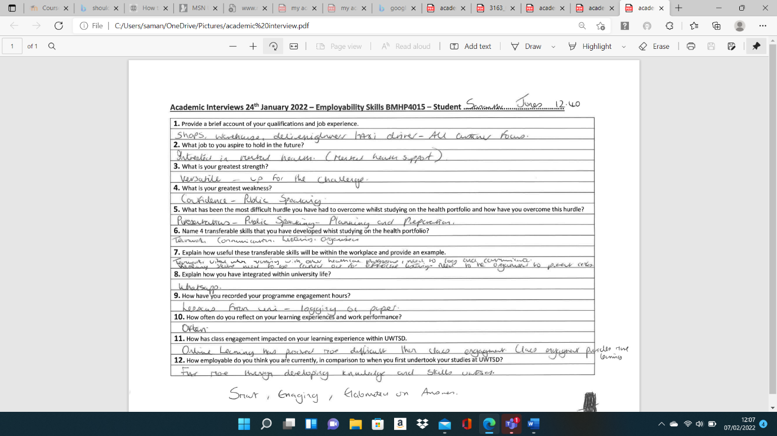

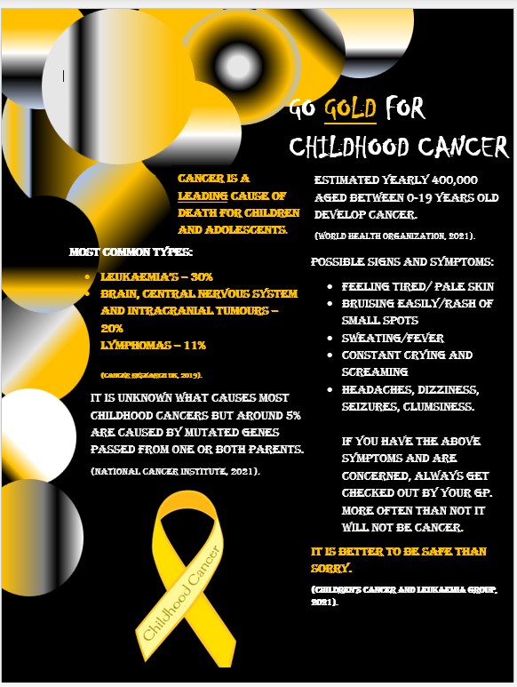
Poster

References

CLIMB Professional Develop and Training (2019) ‘The 7 Benefits of Effective Communication in Personal and Professional Settings’, [blog]. 9 July. Available at: https://climb.pcc.edu/blog/the-7-benefits-of-effective-communication-in-personal-and-professional-settings (Accessed: 25 January 2022).

Huntington, M. (2017) Importance of Organizational Skills in the Workplace. Available at: https://bizfluent.com/13373267/office-management-techniques (Accessed: 26 January 2022)

KNOWHOW (2017) The importance of teams. Available at:
https://knowhow.ncvo.org.uk/your-team/people-management-skills/teams/about-teams-and-types-of-team/importance (Accessed: 25 January 2022).

Lifehack (2021) 17 Versatile Work Skills That Will Gain You More Career Opportunities. Available at: https://www.lifehack.org/794651/work-skills (Accessed:26 January 2022).

Presentation Training Institute (2018) Why Presentation Skills Are the Most Important Skill Set to Have. Available at: https://www.presentationtraininginstitute.com/presentation-skills-important-skill-set/ (Accessed: 27 January 2022)

Skills for Care (2018) Communication skills in social care. Available at:
https://www.skillsforcare.org.uk/resources/documents/Developing-your-workforce/Care-topics/Core-Skills/Communication-skills-in-social-care.pdf (Accessed: 25 January 2022).

Sunway University Press (2019) The Importance of presentation skills in institutions of higher learning. Available at: https://press.sunway.edu.my/blog/im\portance-presentation-skills-institutions-higher-learning (Accessed: 30 January 2022)

Wehbe, S. (2017) 5 Important Reasons Why Teamwork Matters. Available at: https://www.potential.com/articles/5-important-reasons-why-teamwork-matters/ (Accessed: 25 January 2022).

Youth Employment UK (2016) Organisation skills – An overview. Available at: https://www.youthemployment.org.uk/organisation-skills-overview/ (Accessed: 26 January 2022)

