Archaeology, Context and Poetry

Deliberating the Social Structure of the Anglo-Saxon Community of Sutton Hoo

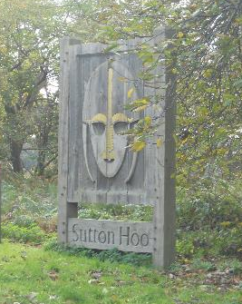

By
Rhys Llewellyn Price (1500103)

Dissertation submitted in partial fulfilment of a B.A. (Hons) in Archaeology and Medieval Studies

University of Wales Trinity Saint David
May 2018

Contents

ii Acknowledgments

1 Introduction

3 Chapter 1 The Archaeology
Assessing the burials of Sutton Hoo from a chronological standpoint.
15 Chapter 2 The Context
Exploring Sutton Hoo in a wider setting, examining its supposed Scandinavian roots and establishing a general social structure of the field based on a likely identity of the buried king.

25 Chapter 3 The Poetry
Analysing the rite of burial tradition of the Sutton Hoo community through Beowulf, comparing the socio-cultural attitudes of East Anglia and the poem.

33 Conclusion

References

APPENDIX Archaeological record of finds from the Sutton Hoo burials

Acknowledgments

First of all, I would like to thank Lindsey Roberts and Claudine Young for their continuous support and for aiding me in developing this work.

Secondly, I would like to thank Nigel Nayling, Ros Coard and William Marx for guiding me in the right direction, and for recommending sources that were a great contribution towards my research.

Thirdly, I would like to thank Martin Carver for taking the time to help me and lead me in the direction of sources that were also of great help for my work.

Special thanks to my family who believed in me, and to Rhiannon Cleaver who provided great moral support.

Introduction

Sutton Hoo has been the subject of intensive academic debate ever since its discovery in the late 1930s (Carver, 2017: 2-28). There have been numerous publications, from assessments of the rich variety of material culture that was found beneath the earth to enquiries on the identities of the people who were buried there. The most famous and most focused of the field, however, are the ship-burials. With an abundance of richly furnished grave goods, these earthly tombs stood out the most; some of the objects found within – namely the helm and the sceptre of the First Mound – are official symbols of the site.
This may suggest an unoriginal concept regarding this thesis. If Sutton Hoo has already been given extensive focus, then why make it the subject of research once more? The purpose of this work is to establish a basic and overall social structure of the site; not by purely looking at the famous burials, but at every one of them. The intent is to combine every grave, from the ordinary folk to the elite, into a single community. Not only that, but it would be ideal to assess that community from different perspectives to get a developed idea of the local context, from archaeology to historical background to depictions in narrative poetry.
The first chapter outlines the archaeology of the area. Martin Carver (2017) established a chronological model which proposes a possible order of the burials’ constructions, assessing which came first and which ones followed in a successive order. By using this model, there will be a more constructive idea as to how Sutton Hoo was set up. The ship-burials will be given some focus, yet there will also be an attempt to see the creation of these burials from the point-of-view of the people who buried the other burials, who appeared to be of the non-elite.
The second chapter will place Sutton Hoo in a wider context by observing its place in relation to not only other Anglo-Saxon sites nearby that are associated with its background, but also places of similar status that are found abroad, lands from which the East Anglian community of Sutton Hoo’s time may have originated. There will also be an examination of the possible identity of the individuals from the ship-burials, to get an idea of what it was that earned them such rich interments by their people.
The third and final chapter takes the approach of study from different perspectives even further by assessing the socio-cultural practices of the East Anglians through the portrayal of their kin in narrative poetry, more specifically the Anglo-Saxon poem Beowulf. Beneath the tale of a hero’s battles against ferocious monsters is a setting not too different from that of Sutton Hoo and other related sites, and there are certain elements that suggest a connection between the two.
On the 5th December 2017, a visit to Sutton Hoo was made. This trip was by no means the inspiration for the research behind this dissertation, seeing as the latter had already begun by that point by means of literary study, yet it was still essential and contributory in terms of fleshing out the project. The trip was part of studying the area from various perspectives as it helped to observe the site up close, and to learn from the landscape. The field’s elevated location combined with the mounds certainly disclosed why this place was chosen. There may not have been any possibility of experiencing the excavations first-hand, but an experience of the land was sufficient in its gift of a new viewpoint into the site.
To put it briefly, the methodology used for this thesis was based on a triangular field of research coined by Michael Shanks (2005: 14): to practice out of a desire to make as well as reflect on the subject; to contextualise out of interest in the ramifications of social, cultural and historical context; and to analyse due to a wish to develop appropriate means to legitimise the practice.

Chapter 1
The Archaeology

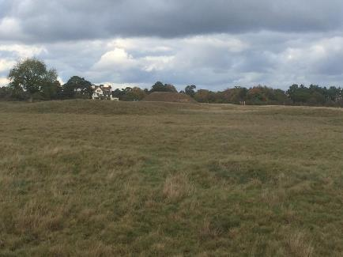
Figure 1: Westward view of Sutton Hoo cemetery, with Second Mound in the distance (Photograph taken 5th December 2017).

At first glance, all that can be assessed from the site is, in the words of Rudgley (2002: 165), a “cluster of grassy mounds”. The excursion at the field certainly gave a seemingly unremarkable landscape besides the towering mound located on the west side, with mere elevations in the field’s surface. Yet, a triumvirate of archaeological campaigns – the first being in the 1930s, the second by the British Museum in the 1960s and the third being a set of excavations that took place in the 1980s - has unearthed a myriad of material culture that provides an illumination on the society that existed there, resulting in the acknowledgment of aspects of Anglo-Saxon life previously unknown.
Bruce-Mitford, in the first component of his series of detailed publications on the site and its content (1975: 1), describes Sutton Hoo initially as lying just above the 100ft contour on a low plateau, comprising a group of burial mounds, numbering perhaps at least 15 in number and underlain by prehistoric occupation. Carver notes 20 (1999: 367-369; 2017: 217-218) mounds in total, 10 of them being more obvious with some of them possibly being prehistoric in nature (2017: 120-154). There are debates as to whether those mounds were the ones which came first due to, according to Rudgley (2002: 164), their close proximity to the river Deben that flows past the ridge upon which the mounds were constructed (the case being with Mounds 12, 17 and 18), being on the highest point (Mound 2) or being the biggest and near the river edge (Mound 1), the latter according to Carver (2017: 120-121), a debate which will be addressed momentarily.
By analysing and comparing the principal burials of this site, it can be possible to gain an idea as to what kind of cemetery this ultimately became, if not what kind it was intended to be. The reason for this is due to a need to develop an overall idea of the site’s structure and layout for the purposes of this dissertation. There is a great familiarity with the ship-burials and their supposed royal nature, but to acknowledge the other burials, from the inhumations of warriors and individuals of unknown status to the execution burials, is to obtain a greater understanding of the site context.

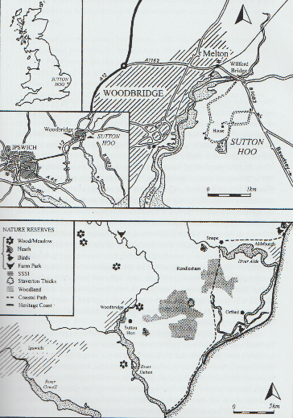
Figure 2: Maps showing location of Sutton Hoo (Carver, 2017: vii).

It could be considered a common misconception that the first and second mounds, the ship-burials, were the first to be constructed. This has been argued to not be the case by Carver (2017: 121), which goes back to the debate as to which of the mounds were constructed first. He brings up some clues based on the stratification of the area. The quarry ditch of Mound 2 cut another on Mound 5. The quarry pits and ditches that were each cut by another are a major indicator, with a varying building method according to the mound, thus indicating a learning process. Carver constructed a model thereafter, suggesting from his notes on the stratified layout that Mound 5 came first and Mounds 6 and 7, all three of them being cremations, followed not long after. There was an apparent halt in immediate planning of mound construction in that area, save for another cremation, Mound 18, and a horse-burial, Mound 17, which were both constructed at the front of the escarpment. The two ship-burials, Mound 2 in the north (ship over chamber) and Mound 1 in the south (chamber in ship), followed. The supposedly later burials; the child graves (12, 15 and 16) and the rich female grave (Mound 14), were established to the east (Carver, 2017: 121).
Based on this proposed model, we can begin to establish a pattern and structure to this community of burials, with a great variety of graves of many shapes and sizes, with a possibility towards a familial cemetery or at least a form of assembly area. There certainly seems to be a focus on ritual given the nature of the burials, with inhumations and cremations preserved together with objects of personal or cultural value. This is interesting seeing as death was more strongly considered a ritualized transition in England during the fifth and sixth centuries, rather than a biological event (Williams, 2011: 238). Mortuary practices in that period facilitated the transformation of the identities of the body, the soul or spirit of the deceased, and the survivors. It was a process of selective remembrance, through means of either the inhumations mentioned above or cremations, with the intention of commemorating the identities of the dead. It is possible that the field was first used as a community burial ground before expanding to a myriad of other graves, including the ship-burials and, at a later point, the execution burials. Perhaps, by assessing the burials and the context of each, one could have an idea of the overall nature of the area, how it began and what its purpose could have been. The order shall be chronological, in order to help with this assessment. By doing it this way, a timeline and a social context could perhaps be established.

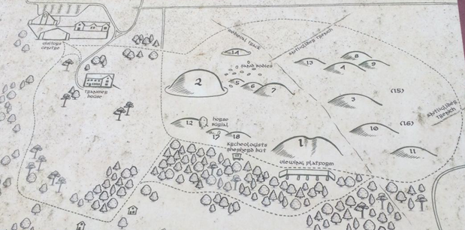
Figure 3: Map depicting Sutton Hoo grave-field, with the First and Second Mounds standing tall (Photograph taken 5th December 2017).

As mentioned above, it has been proposed that Mound 5 was the first, at least stratigraphically, to be introduced to the area, one of many cremation burials that have been found. The first and most notable characteristic of the individual, a youth of unknown gender (Evans et al, 2005: 269-271), is based on the state of the skull, which seemed to have been cut at least nine times by a sword or a form of blade, with no signs of healing present (Carver, 2017: 123), which suggests a very violent death. The body was cremated with some animals, categorised as large ungulates such as horses and cattle, the ashes were gathered, wrapped in cloth and put into a bronze bowl which was placed into a pit along with a number of grave goods and ornaments, most of which seem to have gone missing due to robbing (Evans, 2005: 202) but are indicative of high status. These include silver-vessel mounts from small wooden cups or containers, an ivory box lid, a crushed silver collar and gaming pieces made of bone (the latter showed signs of being in a fire). Other finds include a knife, two bone combs and some shears (Carver, 2005: 75). The surviving collection, according to Carver, suggests that the individual may have been male, stating that the individual’s possessions appear to have an overall male orientation (Evans, 2005: 202), although the individual could have been female.
Mounds 6 and 7 were supposedly constructed around the same time as Mound 5, being similar in nature as cremations in bronze bowls. Mound 6 contained an adult who was cremated with several animals, including joints of pig, a large ungulate and an entire sheep. Mound 7 contained another adult, who was burned with horse, cattle, red deer, pig and sheep or goat; the finds included a multicoloured bead with a hole punctured through – possibly from a sword suspension system – along with cauldron fragments, bone gaming pieces, iron-bound bucket fragments and the remains of a silver-mounted drinking horn (Carver, 2017: 123-124).
Mound 4 contained the cremated remains of more than one individual, perhaps the first in this line of cremations to do so. These were the bones of a man and a woman, put on the pyre with a horse and a dog, their remains found with gaming pieces (Carver, 2017: 124). The cremated remains in Mound 3 consisted of an adult man and a horse. Here they stand out relative to the previous graves due to their being placed on a wooden structure resembling a dug-out boat, trough or pedestal, which was then lowered into a pit, along with the head of a Frankish iron axe, burnt fragments from the facing of a casket that contained a Christian inscription from Italy or France (Carver, 2017: 124; 228), a limestone plaque with an angelic or Victory figure from Alexandria or Byzantium (Carver, 2017: 124-5; 229) and a bronze bowl from Nubia (Carver, 2017: 124). This appears to be the first example of a burial containing material from regions outside the Old Germanic territories, let alone Britain.
The last of the cremation burials is Mound 18, which contained a young adult whose remains had been wrapped in cloth and placed in a bronze bowl like the others except for Mound 3. The only surviving material was a fragment of a comb and the gender of the cremated remains could not be established. Carver (2017: 125) notes a group of individuals who were young males who possibly rode, fought, feasted and engaged in forms of play such as board games, with access to animals, both domestic and wild. As mentioned above, they also possessed objects of certain value from abroad. This certainly gives us a picture of what kind of lifestyle these people had. It suggests a simple life, but with access to riches, possibly earned, the ‘new aristocracy of the seventh century’ (Carver, 2017: 125).

Mound 17 is that of a horse and its rider. The place of its settlement was the northwest corner of the old earthwork which carried the Fifth, Sixth and Eighteenth Mounds, near the edge of the escarpment that overlooked the river. Two pits were dug beside each other, the larger of the two furnished. Two spears lay at the base of the pit, beneath a shield which lay flat with its iron boss highest. Along the north edge of the pit were an iron-bound bucket and a bronze cauldron. Barding for the horse was deposited at the west end, the segments interconnected with bronze pieces and the strap connectors enlivened with pendants. The body of the horse, a stallion of five or six years of age, lay in an adjacent pit to the north, presumably killed to accompany his master beyond the grave (Carver, 2017: 125-127; Carver, 2005: 115-137) or died in battle along with him. Carver remarks upon the grandeur and status which may well have been achieved in the seventh century by dressing one’s horse, as shown when the barding was reconstructed as a whole from the fragments found in the pit (Carver, 2017: 127). The coffin followed the horse’s burial, containing the body of a young man, approximately 25 years old, his sword at his side and a purse by his shoulder. The purse is of special note as it contained mementoes, including some garnets, a piece of millefiori glassware and a pebble. After the coffin was lowered, a comb was placed on the lid, presumably an object of personal value (Carver, 2017: 127-129).

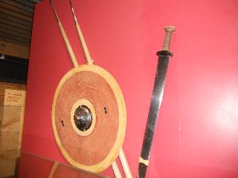
Figure 4: Replicas of Seventeenth Mound weapons (Photograph taken 5th December 2017).

The burial that followed sometime later was arguably one of the most famous, the ship-burial that is known to the modern individual as Mound 2. It is at this point in time where burials in the field became more extravagant in its investment, for the Second Mound is considered one of the richest burials known from this grave field (Carver, 2017: 135); from the materials and the very nature of this interment, one can know for certain that this was intended for an individual of high ranking in their society. This mound can be identified by the presence of iron ship-rivets (Bruce-Mitford, 1975: 111; 121), leading to the interpretation of the grave containing a small boat (Bruce-Mitford, 1975: 110-111). The grave goods were of relatively special value, including fragments of a blue glass squat jar, two gilt-bronze discs with zoomorphic interlace, a gold-coated stud from a buckle, a bronze brooch and a silver buckle, as well as two fragments of dragon-like mounts, the tip of a sword blade showing intricate pattern-welding and silver-gilt drinking horn-mounts (Bruce-Mitford, 1975: 115-123).

The other most famous of the interments, Mound 1 is also known for being the largest and richest, even more so than Mound 2, and being one of the most intact. Given the apparent context of the site mentioned thus far, this burial stands out; an uneven amount of materials survived and several important aspects of the burial rite remain uncertain due to the circumstances of their discovery, namely the structure of the chamber, the question of there actually being a coffin and the route that was taken by the ship (Carver, 2017: 135). Because there is no possibility of returning to the initial excavation undertaken in 1939, any interpretation based on the nature of this mound is limited, with details beyond the reach of current study or conceivable only through reading publications of the data that was obtained then. However, it is still possible to draw information from what has been provided. The presence of a body, in spite of a suggestion that the grave was a cenotaph (Meaney, 1964: 235) is evidenced by traces of chemicals in the chamber floor, specifically phosphate (Bruce-Mitford, 1975: 488-573).
The site that was chosen for the burial was on flat ground, on an outcrop which faced the river Deben. The ship was supposedly brought from the river and onto the heath, an otherwise formidable task that would have in fact been feasible to those who were accustomed to transporting vessels like these over terrestrial areas, as they would have had to follow portage routes from one body of water to another. It is possible that the ships were brought up on rollers. When the ship was excavated, a mass of corky wood covering a long low hump, presumably belonging to a roof or supporting structure, was discovered, with the grave goods found underneath (Carver, 2017: 138). Some sort of chamber must have existed, perhaps to protect the body as well as to display it in a grandiose manner, lying in eternal sleep while surrounded by objects of great personal value. The presence of two rows of iron clamps suggest the existence of a coffin, made from the wood of a tree trunk. The extent of the woody heap and the distribution of objects would suggest a coffin at least 1m wide and more than 3m long, large enough to contain “a body at one end and a pile of personal effects at the other”. A coffin of such grandeur would be more befitting of an individual of high social rank, at least in terms of memorials at the time (Ibid: 139-141).

The grave goods that accompanied the allegedly high-status individual were just as high, in both quality and in quantity. A cauldron with two smaller cauldrons and a tub were found around the east wall of the chamber. The west wall was laden with the symbols of office, including an iron standard, a shield bearing dragon and falcon or hawk motifs stood upright against the wall (Figure 5). A lyre in a beaver-skin bag hung on the south side, and a hanging bowl just below it. A bunch of five spears and three angons were threaded through the handle of a Coptic bowl, an exotic item from North Africa which carried images of a camel, a lion and a donkey. Carver suggests a rather nomadic lifestyle (Ibid: 142), though the goods could have been gifted or traded.

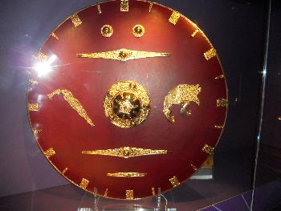
Figure 5: Reconstruction of First Mound Shield, in Sutton Hoo exhibition (Photograph taken 5th December 2017).

The objects that were laid around the dead man were mainly personal. At the base lay an axe-hammer. Two more heaps began here, the furthest from the area where the person’s feet once were consisting of a leather garment, a horn cup and two little hanging bowls, a wooden bowl and a goose-down pillow on top, with two pairs of indoor shoes on either side. The heap nearer to the feet began with a piece of folded twill on which lay a coat of mail, with coils of tape which may have been used for fastening garments. A third heap covered the first two, consisting mainly of toiletries. On top lay a leather object which may have been a travelling bag, covered by a fine yellow cloak (Ibid: 143-146).
The most notable of the grave goods found in this earthly tomb were of far greater expense. They ranged from weapons to treasures of various kinds, found on the coffin lid. These included a great silver dish which was imported from Constantinople and bore the stamp of the emperor Anastasius, drinking-horns, a purse with a golden frame, a sword with a pattern-welded blade, a nest of silver-bowls, a set of gaming pieces, a whetstone sceptre headed by the figure of a stag (Figure 10) and, most famous of all, the helmet (Figure 7).
The iconic nature of this form of apparel was already remarkable when reading about Sutton Hoo as a whole – it is on the front cover of Carver’s Sutton Hoo: Burial Ground of Kings? (1998) - and was observed as equally so when visiting the area itself, to the point that it is practically a mascot for the site; it is displayed prominently above the name on the welcome sign when entering, as well as above the doorway to the exhibition.

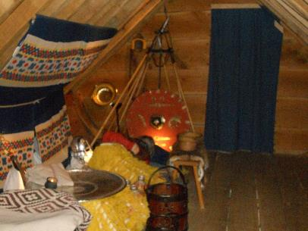
Figure 6: Reconstruction of First Mound burial chamber, in Sutton Hoo exhibition (Photograph taken 5th December 2017).

The helm was discovered in a fragmented state, a fair amount at that which consisted of a gilded bronze nose and mouth piece, parts of a silver crest, two gilded bronze dragon heads and three or four hundred fragments of sand-encrusted rusty iron (Maryon, 1947: 137). When it was reconstructed, the result provided further evidence to the argument proposing the individual’s elite status. It also led to the establishment of a possible connection between it and a set of helms found in another grave field of a similar nature: the burial grounds of Gamla Uppsala.

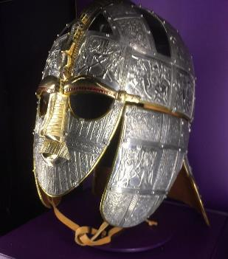
Figure 7: Reconstruction of Sutton Hoo helm, displayed in exhibition. Dragon motif noticeable on nasal area and images of warriors, either dancing (panels over eyes) or mounted ready for battle (panels on side of head) (Photograph taken 5th December 2017).

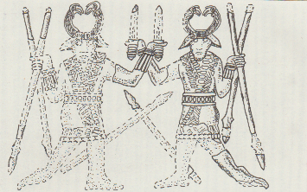
Figure 8 (left): Reconstruction of Design 1 plate image of dancing warriors, based on Sutton Hoo exhibition replica of helm (Drawn October 2015).

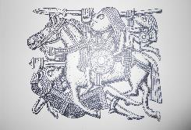
Figure 9 (right): Reconstruction of Design 2 plate image of mounted warrior (Photograph taken 5th December 2017).

The remaining burials in Sutton Hoo which seem to have followed the ships were not necessarily as richly lavished as those of the First and Second Mounds. They did however provide further variety to the entire grave field, as well as suggest that the area was used for more than royal entombment, as they continued to bury their beloved dead even after the passing of their rulers. There were inhumations of children, which gave evidence that Anglo-Saxon society here as well as elsewhere had reached the stage in which status could be inherited, as opposed to achieved, as the youngsters wore belts and were accompanied by weapons (Carver, 2017: 149-151).
There was also the tomb of a high-ranking woman, the only one found so far, with silver ornaments, a châtelaine and pieces of textile. Based on this, Carver suggested that she was a dowager, possibly the last of a princely clan (Ibid: 151-153).

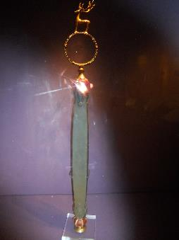
Figure 10: Reconstruction of First Mound whetstone sceptre, displayed in Sutton Hoo exhibition (Photograph taken 5th December 2017).

The variety reaches its peak with a set of 39 graves, with the bodies laid on their side, on their front or folded in half. The burials appeared hasty, the buried persons contorted. The identities of these individuals remain a mystery. The lack of grave goods, as well as the position of the bodies – from removed heads to arms stretched above the head – and the proximity of some to mounds – 16 of them were focused on Mound 5 - suggest a rather likely scenario: that they were either sacrificial victims for the princely entombments or execution burials. They are believed to have dated from the Anglo-Saxon period, seeing as the burials cover the complete period in which execution burials were practised by them (Ibid: 155-173).

From what can be gathered in these interments, there is a large community present here. There are not only numerous inhumations of both adults and children, but also two great ship-burials and execution graves. The ship-burials themselves have been given much focus since their discovery, yet it can be seen in the timeline that has just been used that the grave field was not intended specifically for them. This began as a cemetery for the ordinary folk of East Anglia who wished to lay their beloved to rest, and the ship-graves that once supposedly contained individuals of elite rank followed long after. Very little is known of the people who were buried before and after the elite ones, with archaeology providing the sole information. Perhaps by looking at the background of the area and of the elites, there could be a way of knowing for certain what the social structure of the Sutton Hoo community actually was.

Chapter 2
The Context

In spite of the earlier belief that the ship-burial of Sutton Hoo was a cenotaph, it was eventually widely accepted that there was indeed a person found within. Not only that, but this person must surely have been of a high status in their society who died in the seventh century AD; 1,300 years ago, when England was going through its period of genesis. The burial might have been public, performed in the presence, and with the assistance, of a large group (Carver, 2017: 25). If it were truly buried after the inhumations and other burials that came before it, then there must have been a strong sense of community here, even more so when it comes to the interment of their royal chief. And the presence of such opulent grave goods, from foreign coins to weaponry, would be demonstrative enough that this individual was important. The helm itself may not initially appear to be sufficiently evident for the person being a king; perhaps they were a warrior, due to the presence of arms and armour, and they were revered for their endeavours in battle.

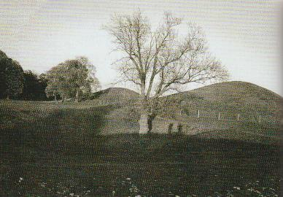
Figure 11: Burial mounds of Gamla Uppsala in Sweden (Carver, 2017: 58).

The Anglo-Saxons were known for holding strength and courage in very high esteem within their culture, as well as power, as exemplified in the likes of Beowulf, which can be seen as a depiction of Anglo-Saxon and Old Scandinavian life in a different manner, using forms of symbolic mythology to portray certain aspects of its society and culture. Warfare therefore was an important part of their society; warriors constituted a defined grade in the social hierarchy, holding pride in their status and the resources invested to them by that society (Pollington, 1996: 23). If one were to also consider the warrior and his horse in the Seventeenth Mound, a burial seemingly constructed in such a way to have the memory of that warrior stand out above the earth like a beacon, then it would seem that the individual was in fact a warrior. That would appear to be the case, if not for a statement made by Michael Wood (2014), that “nothing like a crown was worn by those early kings. The first example of what we would call a crown with prongs comes from the tenth century”. It would seem that, based on this, warriors and kings were both held in high regard, and that the person who was in the ship-burial may have been a warrior-king.
But can that claim be certain? What is there to suggest that it was a king who was buried there? This is admittedly a question that has been raised enough times by academics such as Bruce-Mitford and Carver, with plenty of suggestions as to who it could possibly have been based on approximate dates. It is a question which seems unoriginal and a change of subject from the assessment of the Sutton Hoo graves by focusing on just one of them; that one being the ship-burial which possibly contained a king or chief. In point of fact, this entire debate is centred around setting an idea as to what sort of burial ground this was by examining its social structure. Therefore, finding a possible identity of the ‘King in the Ship’, as well as his place of origin, could be a contribution to that examination. The cremations of the seemingly ordinary people may have come first, using Carver’s most recent timeline (2017). Yet they have a collective element to them in that they all have something in common with each other, such as characteristics of grave goods and varieties of age and gender, from women to children. There was a sense of community in this funerary tradition which could be why the ship-mounds stand beside their loyal ceorls and ealdormen (Arnold, 1997: 174). Despite them being lower on the social ladder, they must have seen their king in very high regard indeed, for his exploits – based on the treasures he got from far and wide – and perhaps his strength as a leader – based on the equal reverence towards warriors and kings in their society. If one were certain as to the context surrounding this mysterious barrow-king, then one could get a better idea of the social status of the burial ground.
Through more profound study of the subject, it seems Sutton Hoo has some connection with sites not only of Anglo-Saxon origin throughout Britain, but also burials of almost similar origin throughout the Scandinavian countries across the North Sea. These burials are known to be ship-burials of certain varieties and to contain material culture similar to that of Sutton Hoo. They are not Anglo-Saxon but originate from the Vendel or the Viking periods, and yet they share so many similarities with their Anglo-Saxon counterpart. Carver even stated that they were of similar date, and he mentioned Bruce-Mitford, who participated in an excavation of the Valsgärde ship-burial along with Sune Lindqvist, as being persuaded of a strong seventh-century connection (1998: 36). This conviction was based on the similarity of the Sutton Hoo helmet and shield with materials found in Swedish sites, as well as the rite of ship-burial. This seems to suggest a shared history, common cultural characteristics that spread out over time.
The Angles and the Saxons, who were both close neighbours to each other, were known to have originated from the region around the coastlands of what is now modern Denmark. According to Rudgley (2002: 119), they came from a land in what is now Schleswig-Holstein, known as Angeln. They collectively made up at least part of the immigrant people who would eventually be known as the Anglo-Saxons, a group of loosely related Germanic peoples who migrated to England. This sounds notably similar to the migrations of Norsemen from their native Scandinavia to Britain among other lands. And because their destination was an island, both counterparts required the use of ships to travel beyond the edges of the continent, so it is possible that one of the reasons why ship-burials were important was related to their importance as making it possible for them to migrate to Britain to begin with. Sea travel was a great part of Scandinavian tradition, so it could be argued, based on similarities between Scandinavian and Germanic cultures, that it was just as important to the Anglo-Saxons as well.
Rupert Bruce-Mitford embarked upon conducting extensive research to be able to place Sutton Hoo in a wider context, that of its district, its kingdom and the neighbours of its realm. First off, there were two areas of fame as equal as that of Sutton Hoo based on the similarities and the associations they had with the burial ground: Rendlesham and Snape. Rendlesham is the neighbouring village to the site which lay within the province of the East Angles, and was a chief place of the Anglo-Saxon region. It too appears to be the site of an early Saxon cemetery, as well as an unlocated palace (Carver, 2017: 38, 42, 63). Its proximity to Sutton Hoo could be a contribution to it being a place where royalty resided, for if kings were buried in Sutton Hoo, they would be of the East Anglian dynasty. Indeed, Rendlesham is closely connected to the Wuffingas dynasty (Bruce-Mitford, 1974: 73). Perhaps the ship was sent from the riverbank near Rendlesham, and then taken from its landing near Sutton Hoo, before it was buried with the ‘king’ it was designed to protect. In fact, Carver has pointed out the mystery of how the ship made its way to the grave; it has been described as a working vessel and not one built specifically for burial (2017: 138).
It would make more sense for royal burials to be established at a further distance from the royal site for the purpose of standing out. Sutton Hoo is indeed situated on a visible point along the river (Bruce-Mitford, 1974: 73-79), or at least it was meant to be. The visit to the site allowed a personal observation of the landscape. As a result, an area of woodland was visible between the burial ground and the river which was further downhill. This can be seen as a natural obstacle to the intentions behind the layout of the barrow grave, but there could be a possibility that this woodland was not present during that time and gradually obstructed the view of any distant bystanders over time, long after the burials. In retrospect, it could be possible that one or two of the higher mounds could still be visible today, from a certain point of the river at least. It has been centuries since the mound was constructed, and the landscape would have changed much during that time.
Snape is a representation of Sutton Hoo being merely one of many sites of a similar kind across Britain. This one was once a cluster of nine or ten mounds before they were dug into in 1827 and 1862, with little record besides gold. The ship, like the First and Second Mounds of Sutton Hoo, was marked by rows of rivets, and the grave goods which survived robbery consisted of two spearheads, a glass claw-beaker and a golden ring. The excavation campaigns also uncovered cremation burials in pots (Carver, 2017: 42; Bruce-Mitford, 1952: 1-26; Bruce-Mitford, 1974: 114-141; Filmer-Sankey, 1992: 39-51). The burial is quite close to Sutton Hoo and Rendlesham, and in close proximity to the coast like its counterparts in Sweden (Figures 12 & 15). This is certainly a substantial contribution to an understanding of Sutton Hoo’s placement in a larger background. It may not seem relevant but it can still be seen as the opening to a far wider picture: the broader context concerning the neighbours of the realm in which Sutton Hoo lies.
Bruce-Mitford then went on to the Swedish district of Mälaren, the birthplace of the Svear. Their kingdom gave Sweden, or Sverige, its name. It is here that the aforementioned cemeteries of Vendel and Valsgärde are found, containing ship-burials of similar date to Sutton Hoo. Bruce-Mitford’s excavation, with Swedish archaeologist Sune Lindquist, of one of the ship-burials helped him develop an even greater discovery of the Swedish links with Sutton Hoo, convincing him of a strong seventh-century connection. The contributing factors to his uncovering were the Swedish references in Beowulf, the similarities between the helmets and shields found in both sites and, most importantly, the rite of ship-burial (Carver, 2017: 42).

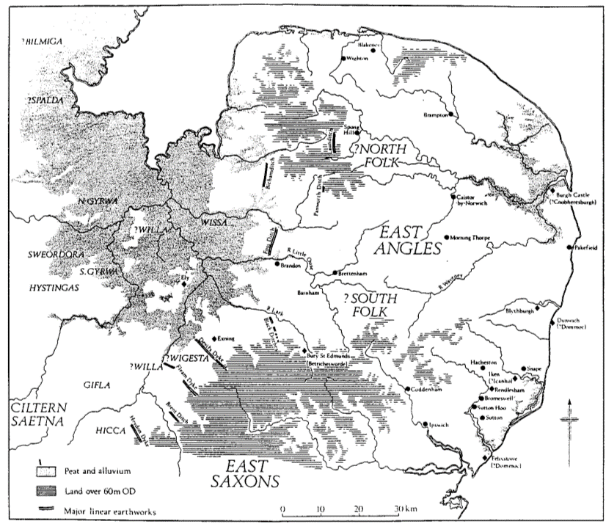
Figure 12: East Anglia and surrounding lands. Sutton Hoo and Rendlesham are marked, near south-eastern coast of East Anglia (Scull, 1992: 4)

As has been stated above, there have been comparisons made between the ship-burial at Sutton Hoo, since its discovery in 1939, and those found in the grave fields at Vendel and Valsgärde in the Swedish province of Uppland. It is namely the presence of a ship in a mound, the weaponry and the iconic helmet which are the major contributing factors to this connection, as they all have their parallels in the Swedish burials. These parallels have led to a range of suggestions as to how these sites can be linked to each other (Woolf, 2014: 5) and there have been attempts to clarify the general position of Sutton Hoo’s burial in the history and the archaeology of England.
One such suggestion, which has been put brought to current attention by Bruce-Mitford (1949: 1), is that the treasure of the ship of Mound 1, was imported, brought to East Anglia by means of maritime travel from Uppland; the majority of the work was essentially produced in Sweden before being eventually taken to England (Maryon, 1946: 28). Maryon’s suggestion is based on his assessment of the shield found in the First Mound, which can be a seen as a good start to this comparative debate. The figure below shows two ornaments from shields found in Mound 1 and in one of the graves in Vendel.
There are some notable differences, to be sure, but the general design is essentially the same, and this similarity extends to the helmet and the jewellery, with the exception of the Byzantine dish, the Coptic bowl, the hanging bowl with escutcheons, the silver spoons and the coins. Maryon considers this a crucial piece of evidence which supports the argument that the treasure of Sutton Hoo was produced in and imported from Sweden, the work of a single school or workshop which was felt throughout. It is, in his words, ‘neither East Anglian, Anglo-Saxon, nor Jutish’.
Another theory (Nerman, 1948, in Bruce-Mitford, 1949: 1) suggests that the Sutton Hoo ship-burial is that of a chief or king of Swedish origin. This adds further to the mystery of the identity of the individual within the mound. It has already been established and practically ascertained that there was once a body there. The identity is now the enduring mystery, and a question that may never be answered if there is insufficient evidence for who this body belonged to. There certainly isn’t enough to know for certain the individual’s country of birth. Such a debate is especially important if one is to find out whether the community found in this East Anglian grave-field is even of Old English origin, or if they or their ancestors travelled to this land from the Scandinavian realms. Was this barrow-king a pagan or a Christian, of the Anglo-Saxon Wuffingas or of a different Swedish dynasty? The answer to this question here begins with the Wuffingas themselves, and of the king or prince who may have been buried in the ship-mound. The lineage of the Wuffingas dynasty is traced back to East Scandinavia, to the point that the first English king of East Anglia, Wehha, came to England from Sweden itself at a certain point, the date itself being unknown at this time (Bruce-Mitford, 1979: 82).
Concerning the passage above relating to the country of origin of the Angles and the Saxons, this may come across as a disconnected revelation, if the Anglo-Saxon Wuffingas now seem to have originated from Sweden as opposed to the Danish-German border lands. A possible answer to this could be based on a suggestion by Lindqvist (Chase, 1997: 6-7), whose assessment of the poem Beowulf lead to a conclusion by him that it may have been composed in honour of the Wuffingas, “a branch of the Royal House of Uppsala”. It would seem, therefore, that the Wuffingas, an Anglo-Saxon society, were related, albeit distantly, to the Swedish Uppsala dynasty. This does make sense, given the interconnectivity between Old Germanic and Old Scandinavian cultures. One such example of this is the claim made by the Anglian collection of royal lineages that Ælfwald, king of East Anglia around 713-749 AD, was descended from Wōden, the Germanic god who became known as Odin in Scandinavian folklore (Herbert, 1994: 7).

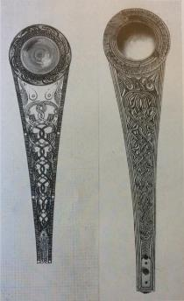
Figure 13: Ornaments from shields found in Sutton Hoo (left) and Vendel (right) (Maryon, 1946: Plate VII)

Also, when looking at the location of Angeln in relation to the Scandinavian lands (Figure 15), the Angles and the Saxons were quite close to the Swedish realms. With the practice of sea travel ranging across Old Scandinavia, it wouldn’t be unreasonable to presume that connections were established between the Danes and the Swedes at the time. Indeed, the route to Britain from the east Swedish coast, where the Uppsala graves are located, does go past Denmark in its procession.
With this established, the major question remains to be answered: who was the king in the ship-burial? What was it that made him so revered by his people; for him to stand guard, beyond the grave, and watch over his loyal subjects, while his burial mound continues to tower above the others as a symbol of remembrance of the people’s king? Taking the approximate date of the burial into account, which is somewhere between 550 and 650 AD (Carver, 2017: 38), the most accepted candidate is Rædwald of the Wuffingas, grandson of Wuffa and great-grandson of Wehha (Figure 14). It is generally agreed that Rædwald was the ruler of East Anglia (Newton at the time of the burial.

Figure 14: Family tree of Wuffingas, royal house of East Anglia, England. Those who are in italics came to the throne (Bruce-Mitford, 1949: 2)

There are other contenders for the identity, of course; the second most popular choice being his son Earpwald who died also during the suggested timescale, either in 627 or 632 AD (Figure 14). Although there is no material evidence to ascertain who was buried there, whether it was Rædwald or his son, there may be a regal list or any other source of information that may be able to identify the buried king (Carver, 1998: 172). Regardless of the near lack of evidence (Chadwick, 1940: 87), there is a possibility that even if Earpwald was not buried in the First Mound, he may well have been buried in the Second: having died around the same time as his father, who died around 624 or 625 AD, it would make sense for him to be placed near his father (Carver, 1998: 172).
If Rædwald was indeed the king who was buried in the First Mound, then he certainly merited his placement in such a grave. He already stands out as a remarkable figure, as he was one of the first kings of England to be baptised, by King Æthelbert (Newton, 2003: 5). He is known and infamous for his respect towards both the old pagan and new Christian religions, placing a Christian altar alongside one to the old gods he also worshipped, synthesising both faiths in a supposed attempt to resolve differing cultural requirements – indeed, Bede condemned him for doing so (Colgrave et al, 1969: 15). His baptism at the hands of English overlord Æthelbert, when he travelled to Kent for initiation into the Christian faith, may have been a test of allegiance to him by the king by acknowledging this new religion (Newton, 2003: 9-10). After Æthelbert’s passing, he became overlord of the south and was at war with Æthelrith, king of the north.

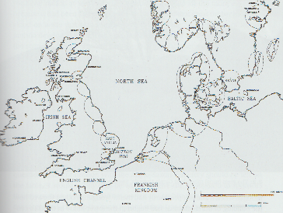

Figure 15: Northern Europe, with Sutton Hoo and Swedish grave-fields marked, and linked by Swedish-East Anglian travel route (Carver, 2017: 57)

This war ended in victory for Rædwald at the Battle of the River Idle, giving him over-lordship of England. Newton suggests that because this was the first successful battle-test for a baptised king of England, this may have been a demonstration of the power of the new god to deliver the blessings of victory (2003: 6). This can be seen as strong supporting evidence for Rædwald being buried in Mound 1. His endeavours, his embracement of both faiths and his reign over an expansive realm would surely have made him a revolutionary figure in the eyes of his people. The cremation burials of the free folk may have preceded him, but then it would be seen as setting him alongside his people as an equal, while still placing him in memory as a successful king. His son Earpwald was also baptised and convinced into following the new faith, which could suggest that he may have been buried in the Second Mound, near the First Mound that may have been his father’s.
The individuals in the First and Second Mounds were of great importance, that much is for certain. Because the Wuffingas seemed to have been related, albeit distantly, to the Swedish kings of Uppsala, whose barrows shared numerous similarities with those of Sutton Hoo, there is a connection here which suggests a tradition ranging across the northern countries. The Anglo-Saxon and Scandinavian people clearly held a high regard for their kings, especially in terms of their achievements. They may have wished to uphold the fondness for them by placing them not only as monuments to be seen from afar but in the vicinity of their relatively modest graves. This reverence towards an individual of elite status seems to have also been demonstrated in oral tradition, and could provide some insight into the social structure of these barrow graves from a different perspective.

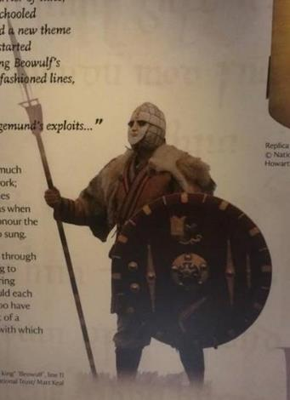
Figure 16: Artist’s interpretation of warrior-king of the First Mound, possibly Rædwald? (Photograph taken 5th December 2017).

Chapter 3
The Poetry

Thus far, the debate on the social context of Sutton Hoo has been both purely archaeological and historical in its nature: there has been much focus on the material culture and the background of the site and its peers across the North Sea, and they provide information based on scientific interpretation and on documentation. The matter of including narrative poetry in an examination of the social status of an archaeological site may seem superfluous, especially when the specific text appears to be a tale of one man’s feud against supernatural threats. The text that is being referred to here is the most famous Anglo-Saxon poem, Beowulf.
The main plot and overall summary of the poem focuses on the glorious achievements of the titular hero, both told and shown, who is famed for his many defeats of men and monsters, from his fight against the dreaded Grendel to the latter’s grieving mother to his mutually fatal triumph over the nameless dragon who attacked his homeland for the disturbance of its treasure hoard. The overall narration seems somewhat simple in its telling, but it is upon further scrutiny and by reading between the lines of certain elements of the story that one begins to see that there is more to the tale than most of us assume. In fact, as put forth and summarised by Hills (1996: 291), archaeology has been deployed since the nineteenth century to illustrate the artefacts and burial rites that have been described in the poem. She goes on to exemplify the parallels for the helmet, the sword and the hall, as well as for cremation and the practice of ship-burial, that have been used in both Britain and Scandinavia during the first millennium A.D., which happens to further emphasise upon the connection between the mortuary practices of Anglo-Saxon England and Old Scandinavia.
It is worth noting that, from personal observation, Beowulf has been given much focus in the exhibition of Sutton Hoo itself, to the point that not only have certain terms and sections of the poem been interpreted and compared with the context of Sutton Hoo but a replica of the first page was on display (Figure 17) and a voiceover recited the same passage in Old English. In that regard, there most certainly appears to be a lot in common between Sutton Hoo, its Scandinavian counterparts and the poem.
A more profound study of Beowulf yields more valuable information concerning this connection. To sum up the essentials, the poem shows awareness of Nordic and Germanic genealogy – the story mentions the Danish ancestry of which King Hrothgar is a part – and there are archaeological indications that East Anglia had stronger Nordic affinities than any other kingdom of early England. The latter is a helpful argument seeing as Beowulf is based entirely in Scandinavia, namely the territories that are now Denmark and Sweden, not to mention the fact brought up in the previous chapter that concerns the Wuffingas being related to the Uppsala rulers.

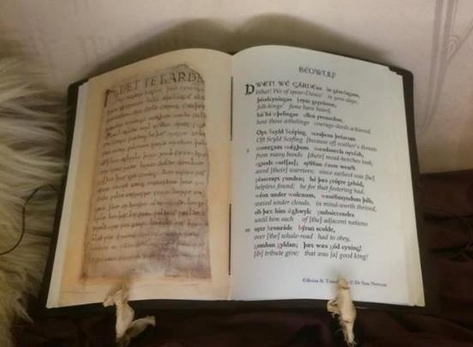
Figure 17: Replica of first page of Beowulf, with Old English transcription and translation into Modern English on right page (Photograph taken in Sutton Hoo, 5th December 2017).

Newton (1993) even argued that Beowulf and Sutton Hoo are in fact reflections of the same society, which is an interesting suggestion seeing as there is much emphasis on royal ancestry in the story much like there is a need to pinpoint a possible dynasty for the identity of the individual in the ship-burial, as well as the ship-burials of Sweden and Denmark (the Wuffingas for Sutton Hoo and the Ynglings for Scandinavia being major candidates). The other contributing factor for this argument is a parallel between the dragon’s lair in the third and final act and the reflection of engagement, at least from the perspective of the poet, with Neolithic megalithic structures (Williams, 2015), an intriguing similarity to Sutton Hoo which has shown evidence of human occupation during that period (Carver, 1998: 94-98). In the summary of reasons made by Carver (1998: 36) of why Bruce-Mitford was persuaded of a strong connection between Sutton Hoo and the Scandinavian sites, one of the other elements that convinced him of this connection concerned the Swedish allusions in Beowulf; this certainly establishes a threefold link between the three topics related to archaeology, historical background and poetry that are being discussed in this thesis: thanks to the subtext in Beowulf, more similarities between Sutton Hoo and the likes of Valsgärde and Nydam have been made possible. The excavations of these Anglo-Saxon burials appear to have unearthed a society upon which the poetry of their time was based, with Beowulf being the most famous of them all.
When it comes to drawing parallels between the fictional setting of Beowulf and the realistic setting of Sutton Hoo, the scene which first comes to mind could very well be the funeral of Scyld Scefing, the first king of the Danes, who was also buried in a ship loaded with treasure:

“There at the haven stood with ringéd prow, ice-hung, eager to be gone, the prince’s bark; they laid then their beloved king, giver of rings, in the bosom of the ship, in glory by the mast. There were many precious things and treasures brought from regions far away; nor have I heard tell that men ever in more seemly wise arrayed a boat with weapons of war and harness of battle; on his lap lay treasures heaped that now must go with him far into the dominion of the sea. With lesser gifts no whit did they adorn him, with treasures of that people, than did those that in the beginning sent him forth alone over the waves, a little child. Moreover, high above his head they set a golden standard and gave him to Ocean, let the sea bear him.” (Tolkien, 2014: 14)

This burial does differ from its Anglo-Saxon and Uppland counterparts in that it was sent out to sea. The mentioning of treasures, however, as well as them being from distant lands, along with weapons and war apparel and a standard representing high status, appear to be sufficient evidence of a link between fiction and fact. One other part of the text that is worthy of note is the descriptive title for King Scyld Scefing, naming him “giver of rings”. This provides more depth to the likes of the Snape ship-burial mentioned in the previous chapter, a grave of similar nature to that of Sutton Hoo that contained a golden ring. Rings were clearly of great significance to elite individuals, not only as objects of personal value but as gifts between royal houses which symbolised alliances.
The next moment which could be of significance regarding this comparison is the poem’s ending, which describes the eponymous hero’s burial following his fatal feud against a dragon who guarded an ancient treasure inside a barrow:

“For him then the Geatish lords a pyre prepared upon the earth, […] with helms o’erhung and shields of war and corslets shining, as his prayer had been. Now laid they amidmost their glorious king, mighty men lamenting their lord beloved. Then upon the hill warriors began the mightiest of funeral pyres to waken […] Then the lords of the windloving people upon a seaward slope a tomb wrought that was high and broad, to voyagers on the waves clear seen afar; and in ten days they builded the memorial of the brave in war […] In that mound they laid armlets and jewels and all such ornament as erewhile daring-hearted men had taken from the hoard, abandoning the treasure of mighty men to earth to keep, gold to the ground where yet it dwells as profitless to men as it proved of old.” (Tolkien, 2014: 104-105)

This burial scene appears to fit the realistic portrayal of the ship-burials more closely, due to the fact that the ship itself was not only buried, but the tomb is also described here as a towering monument above the flatness of the surrounding fields, to be clearly visible to faraway travellers as a memorial beacon of a revered ruler. The “seaward slope” is more literal in the case of the poem; Beowulf’s realm and homeland of Gӧtland is closer to the sea, whereas Sutton Hoo lies further upriver. However, the mound of the latter area could still have existed as a beacon to passers-by, albeit in a terrestrial manner. Either way, the mound containing the East Anglian barrow-king may still have served its purpose as much as the tomb of Beowulf the Geat. Granted, there was no description in the burial of Beowulf of the burial of a ship in a trench; nevertheless, the similarities between both of these worlds exist, at least in terms of ritualistic practice, both echoing into each other.
It is rarely mentioned in discussion of the poem, but there are also two other funerary depictions that are told in the story. They are basically told in the form of background information, as the individuals who were part of their respective burials died long ago. The first was a Scylding prince named Hnæf, hero of the Half-Danes, the latter name sounding rather similar to ‘Healfdene’, father of Danish king Hrothgar, whose royal hall was terrorised by Grendel before the monster’s defeat at the hands of Beowulf.
Going back to the connections made between these two settings (Woolf, 2014: 5), it is inevitable that these conjectures bring Beowulf into the deliberation. The question of the poem’s origin can essentially be linked with the historical context of Sutton Hoo, and its Swedish counterparts at the very least. Throughout the previous century, the poem is believed to have dated from before the ninth century, before the Viking invasions, and at least a century after the funeral of Mound 1 at Sutton Hoo. Newton puts forth a hypothesis based on independent lexical, orthographic and phonological indications that the poem may have possibly been composed during the eighth century. He elaborates upon this, and states that the language of Beowulf is largely West Saxon – as is to be expected of a manuscript written around 1000. However, he does point out some features of non-West Saxon dialects, notably Anglian. Based on consideration of the poem’s vocabulary, this suggests the implication that Beowulf is unlikely to have been composed before the second half of the seventh century (1993: 18). This certainly begins to already put the poem at around the same date of the Mound 1 ship-burial, albeit on an approximate level (1993: 10). He also makes note of the archaic form of the names, such as that of Hrōðgār, the king of the Danes in the poem. He notes how the consonant ð seems to have been lost in the Norse language as early as the ninth century, thus already putting forth a suggestion that Beowulf was composed before that period (Ibid: 14). He reckons that the linguistics indicate that it was possibly composed between the late seventh and early ninth centuries, “perhaps in an Anglian kingdom” (Ibid: 17).
One of the themes that Beowulf seems to be going for, at least according to Newton (1993: 18) and Tolkien (1936: 265), is a confrontation of the recurrent question of the purpose of mortal life; it has been referred to by Tolkien when he wrote of the tale’s primary concern with humanity’s place on earth, and the mortality of their kind. The narrative structure has been described as a ‘balance, an opposition of ends and beginnings’. It elaborates the constant contrast between youth and age, the novelty of one’s first achievement and the finality of one’s death (Tolkien, 1936: 271). This theme appears to reverberate through the tale, especially the funeral scenes: both or either of these contrasting elements are emphasised. There is always mention of mourning and solemnity during the funerals, such as the aforementioned “burial” of Scyld Scefing, who was remembered as a great founder of his people, and the remainder of the burial scene of Beowulf himself:

“Thus bemourned the Geatish folk their master’s fall, comrades of his hearth, crying that he was ever of the kings of earth of men most generous and to men most gracious, to his people most tender and for praise most eager.” (Tolkien, 2014: 105)

This is where both sides of the contrast are present. As is the case with the other funerary depictions in the story, death influenced the traditions of these societies. To them, it marked the end of a precious being, so they took it upon themselves to make sure that this individual would be remembered as vividly as they had lived. Their achievements would be made immortal. Scyld would be remembered for his conquests and his foundation of the society who revered him, and Beowulf would be remembered for his feuds against monstrous adversaries, through the use of his physical strength to tear off Grendel’s arm (Tolkien, 2014: 34-36) and his sense of honour in battle, when he resolved to fight Grendel as an equal with no weapons or armour (Ibid, 2014: 32) as well as his ability to wield a sword forged by giants (Ibid, 2014: 58).

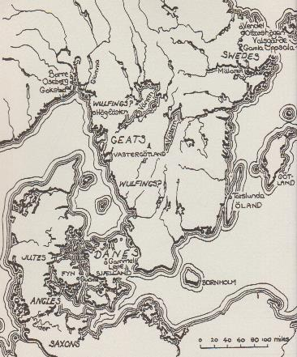
Figure 18: Southern Scandinavia, as setting for Beowulf. Graves of Old Uppsala are located top-right of map. Of noteworthy comment is the possible location of the Wulfings society, a name practically identical to that of house Wuffingas (Newton, 1993: page n.d.)

These qualities of both warriors and kings would be held by Germanic and Scandinavian societies in high regard indeed. They would not only entomb their beloved rulers in tall memorials, they would also continue their legacy in narrative prose and even maintain that legacy through the illustration of their qualities and successes in poetry that involves fictional elements, exemplified in Beowulf, which features a dragon and demonic beings descended from Cain, a Biblical figure (Ibid, 2014: 16).
In this regard, the proposed theme of what mortal life strives for seems quite philosophical through its, and therefore Anglo-Saxon society’s, awareness of the concept of death. They may have buried their kings and loved ones not only out of a desire for their remembrance, but also as a way of coping with that finality. Perhaps there is a form of existence beyond the grave and they wish to give their overlords the glorious accommodation upon their arrival in that mysterious realm of the afterlife they truly deserved; they achieved so much in life through so much arduous effort, the least the people could do was to make sure they were rewarded and safeguarded in death as well as in life. If there was a form of life after death, they must be accompanied by what they held dear in material form, if their loved ones could not yet join them. If that proved not to be the case, that there is oblivion after they have crossed the threshold at the end of their lives, then it was their achievements that remained, and they had to be kept alive in living memory. It is true there were numerous belief systems at the time of both Rædwald’s reign and Beowulf’s approximate composition, both pagan and Christian in nature, all with a concept of the afterlife such as Valhӧll and the Christian Heaven.
Indeed, this underlying theme has been stated as being compatible with both paganism and Christianity, articulated through “a tale of erstwhile nobility, heroism and tragedy which is set in the pre-Christian Northlands” (Newton, 1993: 19). With an embrace of both of these kinds of religions at the time, however, thanks to Rædwald’s baptism and initiation into the new faith of Christianity, there may have been a diversity of beliefs within the community in Sutton Hoo at the time, a following of different beliefs depending on the people involved. Whatever they believed in, pagan or Christian or both or neither, they chose to send their king into a blissful existence, with material symbols of his previous life. If they have sent him to Valhӧll, then it was for his strength and his military prowess. If it was to Heaven, it was for his embracement of the Christian faith.

The poem does appear to possess some elements that propose a connection between the social and cultural aspects of the tale and those of the Sutton Hoo cemetery. Not only do they appear to date from around the same time, but the tradition of burial rites does have that sense of awareness of mortality and the peoples’ response to it through memorial entombment. Taking the linguistics of the text, the socio-cultural attitudes towards strength and honour in battle and the parallels between settings into account, Beowulf is a prime example of how poetry, besides its epic settings, can also be a depiction of Anglo-Saxon society and culture from a different perspective. It shows how much the people of that period choose to remember their rulers; the people would remember Rædwald and his kin just as fondly as the Danes and the Geats would commemorate Scyld Scefing and Beowulf respectively.
The examination of narrative poetry may seem disjointed when it comes to debating the social structure of the Sutton Hoo community. However, when taking the relationship between the people and their ruler into account, how the ordinary folk viewed their king or queen, there is a connection. The people of Sutton Hoo must have appreciated their overlord very much indeed to accept them in their local burial ground.

Conclusion

The use of a chronological model has certainly provided a new look into how Sutton Hoo was constructed. In spite of them being focused upon the most over the years, the First and Second Mounds, the royal burials, came rather late into the succession of burials that took place. This indicates that the field was, for all intents and purposes, a burial ground for the local common-folk of the kingdom of East Anglia, who cremated their dead before entombing the remains with their personal items.
The study of the royal deceased was necessary, for their inclusion in the burials suggested a social bond. They may have been of the elite, in a society that was structured through ranking, with the king placed highest and the theow slave class ranked lowest on the Anglo-Saxon social ladder (Arnold, 1997: 174). Even so, there must have been some form of close relationship between the people and their king, for him and his successors to be placed among them. If they were of the thanes, a class just beneath the king, and all the graves belonged to relatives, then that would be in keeping with the social system at the time.
On the other hand, if the ship-burials did in fact entomb the bodies of Rædwald and his son, then the facts surrounding their endeavours in light of expectations in Anglo-Saxon society proposes a humble opinion of them by the people. It could be that they were highly respected for accepting both pagan and Christian faiths, thus accepting those who would prefer to follow either if not both. This would be seen as a characteristic quality in a time when great changes took place.
The honour and powerful memory of such a person would have continued into the tales and songs that were a common event in Anglo-Saxon culture. Beowulf is a perfect example of that. Besides depicting battles of man against monster – which can be seen as a metaphor of strength in battle against overbearing odds - it also reminisces of powerful figures who performed great deeds; narrative poetry can be a reflection on Germanic and Scandinavian society and culture. There is no certainty as to whether Sutton Hoo started off as such a place, but it would be an interesting insight into its society if it were.
The purpose was to construct a community within Sutton Hoo to establish its social structure. The result seems to be a local grave field intended for the cremation, inhumation and interment of the residents’ beloved dead, followed by the burials of their respected rulers.

References

Arnold, C.J. 1997. An Archaeology of the Early Anglo-Saxon Kingdoms. Routledge: London and New York.

Bjork, R.E. & Obermeier, A. 1996, ‘Date, Provenance, Author, Audiences’, in Bjork, R.E. & Niles, J.D. (eds.). A Beowulf Handbook. University of Exeter Press: Exeter, pp. 13-34

Bruce-Mitford, R.L.S. 1949. ‘The Sutton Hoo Ship-burial: Recent theories and some comments on general interpretation’, Proceedings of the Suffolk Institute of Archaeology and Natural History, XXV (1), pp. 1-78.

Bruce-Mitford, R.L.S. 1952. ‘The Snape Boat-Grave’, Proceedings of the Suffolk Institute of Archaeology and Natural History, XXVI (1), pp. 1-26.

Bruce-Mitford, R.L.S. 1974. Aspects of Anglo-Saxon Archaeology. Victor Gollancz Limited: London.

Bruce-Mitford, R. 1975. The Sutton Hoo Ship-Burial v1: Excavations, Background, the Ship, Dating and Inventory. Trustees of the British Museum: London.

Bruce-Mitford, Rupert Leo Scott. 1979. The Sutton Hoo Ship Burial: A Handbook. British Museum Publications: London.

Carver, M.O.H. 1998. Sutton Hoo: Burial Ground of Kings? British Museum Press: London.

Carver, M. 1999. The Age of Sutton Hoo: The Seventh Century in North-Western Europe. The Boydell Press: Woodbridge.

Carver, M. 2005. Sutton Hoo: A seventh-century burial ground and its context, British Museum Press: London

Carver, M. 2017. The Sutton Hoo Story: Encounters with Early England. The Boydell Press: Woodbridge.

Chadwick, H.M. 1940. ‘The Sutton Hoo Ship-Burial: Who was He?’, Antiquity, XIV, pp. 76-87.

Chase, C. (ed.) 1997. The Dating of Beowulf. University of Toronto Press: Toronto, Buffalo & London.

Colgrave, B. & Mynors, R.A.B (ed. & tr.). 1969. Bede’s Ecclesiastical History of the English People. Oxford Clarendon Press: Oxford.

Evans, A. ‘Seventh-century assemblages: Artefacts from cremations’, in Carver, M. 2005. Sutton Hoo: A seventh-century burial ground and its context, British Museum Press: London, pp. 202.

Evans, A. & Lee, F. ‘Seventh-century assemblages: The cremated human bone from Mounds 2, 5, 6, 7 and 18’, in Carver, M. 2005. Sutton Hoo: A seventh-century burial ground and its context, British Museum Press: London, pp. 269-271.

Filmer-Sankey, W. 1992. ‘Snape Anglo-Saxon Cemetery: The Current State of Knowledge’, in Carver, M.O.H. (ed.), The Age of Sutton Hoo: The Seventh-Century in North-Western Europe, The Boydell Press: Woodbridge, pp. 39-51.

Herbert, K. 1994. Looking for the Lost Gods of England. Anglo-Saxon Books.

Hills, C.M. ‘Beowulf and Archaeology’, pp. 291-310, in Bjork, R.E. & Niles, J.D. (eds.). 1996. A Beowulf Handbook. University of Exeter Press: Exeter.

Maryon, H. 1946. ‘The Sutton Hoo Shield’, Antiquity, XX, pp. 21-30.

Maryon, H. 1947. ‘The Sutton Hoo Helmet’, Antiquity, XXI, pp. 137-44.

Meaney, A. 1964. A Gazetteer of Early Anglo-Saxon Burial Rites. George Allen & Unwin Ltd: London.

Newton, S. 1993. The Origins of Beowulf and the Pre-Viking Kingdom of East Anglia. D.S. Brewer: Cambridge.

Newton, S. 2003. The Reckoning of King Rædwald: The Story of the King linked to the Sutton Hoo Ship-Burial, Red Bird Press: Essex.

Pearson, M. & Shanks, M. 2001. Theatre/Archaeology. Routledge: London & New York.

Pollington, S. 1996. The English Warrior from the Earliest Times Till 1066. Anglo-Saxon Books: Norfolk.

Rudgley, R. 2002. Barbarians: Secrets of the Dark Ages. Channel 4 Books: London, Basingstoke, Oxford.

Scull, C. 1992. ‘Before Sutton Hoo: Structures of Power and Society in East Anglia’, in Carver, M.O.H. (ed.), The Age of Sutton Hoo: the seventh-century in north-western Europe, Boydell Press: Woodbridge, pp. 3-23.

Tolkien, J.R.R. 1936. ‘Beowulf: The Monsters and the Critics’, Proceedings of the British Academy, 22, pp. 245-295.

Tolkien, C. (ed.) & Tolkien, J.R.R. 2014. Beowulf: A Translation and Commentary. Harper Collins Publishers: London.

Williams, H. 2011. Mortuary practices in early Anglo-Saxon England, in H. Hamerow, D. Hinton and S. Crawford (eds) The Oxford Handbook of Anglo-Saxon Archaeology, Oxford: Oxford University Press, pp. 238-59.

Williams, H.M.R. 2015. Beowulf and Archaeology. [Online]. Available at: https://howardwilliamsblog.wordpress.com/2015/08/30/beowulf-and-archaeology/ (Accessed: 17th December 2017).

Wood, M. in Art Documentaries. 2014. 1/2 The Sutton Hoo Helmet – Masterpieces of the British Museum. [Online] Available at: https://youtu.be/-dAPgfW9Qi4 (Accessed: 8th October 2017).

Woolf, A. 2014. ‘Sutton Hoo and Sweden Revisited’, in Gnasso, A., Intagliata, E.E., MacMaster, T.J. & Morris, B.N. (eds.), The Long Seventh Century: Continuity and Discontinuity in an Age of Transition, Peter Lang Publishing: Oxford, pp. 5-17.

Appendix
Archaeological Record of Finds from the Sutton Hoo Burials, based on lists by Martin Carver (2017: 219-223)

Ship-Burials Notes
Mound 1
WEST WALL
Iron standard
Support for standard
Shield 7th century; Swedish?
Sceptre
Bucket
Hanging bowl 7th c.; North British
Nail supporting hanging bowl
Lyre in beaver-skin bag
Coptic bowl East Mediterranean
3 angons
5 spears and 3 ferrules

ON COFFIN LID
Helmet Swedish?
Gaming pieces
Bell
2 silver spoons Byzantine
10 silver bowls Byzantine
Spear 6 (south of keel)
Spear 7 (north of keel)
Gold buckle Late 6th/early 7th c.; East Anglian
Purse, with gold frame and gold and garnet plaques
Two shoulder clasps, of gold and garnet Late 6th/early 7th c.; East Anglian
Baldric, with gold and garnet buckles Late 6th/early 7th c.; East Anglian
37 gold coins, 3 flans & 2 small ingots (purse) Early 7th c.; French.
Sword, with gold & garnet pommel & scabbard studs
3 fine yellow cloaks Syrian?
6 maple-wood bottles 7th century
Two drinking horns 7th c.; Swedish?
Animal bone
Silver dish (Anastasius) 491-518 AD; Byzantine

INSIDE COFFIN, HEAP C
Leather bag with studs
Fluted silver bowl 6th century
Otter-fur cap
Silver ladle and cup 6th/7th c.; Byzantine
7 burrwood bottles Local
4 knives with horn handles
3 combs
Leather garment with buckles

HEAP B
Goose down-filled pillow
Two pairs of shoes (size 7/40)
Wooden bowl
Hanging bowls 2 and 3 North British
Horn cup
Leather garment
Iron axe-hammer

HEAP A
Coils of tape
Mailcoat
Folded twill

BY EAST WALL
48 wooden pegs
Cauldron 1
Cauldron 2
Cauldron 3
Nail supporting Cauldron 1
Chain for cauldron 1
Nail supporting Cauldron 3
Iron-bound tub (yew)
Bucket 1
Nail

ON THE FLOOR
Iron lamp Early 7th c.; wax gave
Pottery bottle North French
Bucket 2
Bitumen Stockholm
Floor covers
20 cleats for coffin
c.1560 ship rivets

Mound 2
Gilt-bronze roundel Segmented bead of blue faience
Blue glass squat jar Silver fittings and wood from box(?)
Gilt-bronze hemispherical stud Joining fragments from silver bowl
Fragments of silver gilt drinking horn mount Silver and gilt bronze fittings (cup?)
Fragment of cast gilt-bronze strip Gilded copper-alloy roundel (shield?)
Small silver buckle Silver gilt terminal (drinking horn)
Bronze ring Gilded copper-alloy foil
Tip of sword blade with mineral replaced textile Gilding from foil
2 iron knives Gilt bronze fitting
Iron blade Copper-alloy sheet or foil
Double sheath containing two iron knives Silver-gilt foil
Objects of wood and iron Fragments of copper-alloy cauldron (x2)
Iron nail Fragments of copper-alloy bowl
Ship rivets Copper-alloy pin
Iron ring and attached rod Copper-alloy stud
Lengths of iron bands Lump of amber
Iron nails and wood from box(?) Fragments of decayed textile(?)
Three iron rivet heads 496 rivets, rib-bolts and gunnel spikes
Leather strip

Cremation Burials Notes
Mound 3
Fragment of limestone plaque East Mediterranean; now lost
Bronze lid of ewer Nubia?
Iron axe-head with wooden haft From a francisca
Pottery sherd with incised decoration Early medieval?
Pottery sherd, undecorated
Textile fragment
6 fragments of thin bone sheeting From a casket
Fragment of decorated facing of bone comb
Unidentified iron concretion carrying textile
Fragments of cremated bone From an adult male human and a horse

Mound 4
Sheet bronze from bowl
Textiles
Bone or ivory gaming counter
Scrap of iron slag
Cremated bone From an adult male, an adult female, a horse and a dog(?)

Mound 5
Fragment of fused glass
Fragments of copper-alloy bowl
Fragments of silver-rim binding For wooden vessel
Iron shears
Textiles Associated by shears
Iron knife in leather sheath
Fragments of textiles Associated with artefacts
Fragments of bone gaming pieces Burnt
Fragments of composite bone comb
Copper-alloy rivet From casket?
Ivory Part of lid of box for stylus?
Silver collar
Cremated human bone Skull cleft by 9 blade cuts
Cremated animal bone Horse and sheep?

Mound 6
Copper-alloy pin
Fragments of copper-alloy bowl Thin-walled, flat out-turned rim
Pyramidal strap-mount of copper alloy Found on side of the mound
Fragments of organic material Textile?
Bone facings from combs and box
Fragments of bone gaming pieces
Bone or ivory rod
Cremated human bone
Cremated animal bone Horse, cattle, sheep and pig?

Mound 7
Fragments of copper-alloy bowl
Fragments of fused silver and gold
Fragment of copper-alloy cauldron
Iron strip
Fragments of textile
Biconical reticella glass bead
Bone gaming counters
Fragments of bone box(?)
Copper-alloy pin
Iron knife
Cremated human bone
Cremated animal bone Horse, red deer, cattle, sheep/goat and pig
Mound 18
Fragments of copper-alloy bowl
Fragment of bone comb
Fragments of mineralised textiles
Cremated human bone

Inhumation burials Notes
Mound 14
Fragment of silver bowl
Fragments of silver fittings From a drinking cup?
Fragments of silver fittings From a leather purse?
Silver hinges From a box?
Tiny fragments of silver wire Probably from a fox-tail chain
Fragments of silver buckle loops
Silver dress fastener
2 copper-alloy pins
Parts of copper-alloy and iron chatelaine Includes links, rods, rings, a knife and preserved textiles
Iron nails From coffin or couch
Iron nails possibly from a wooden box

Mound 17
Coffin with 4 iron clamps With oak coffin wood
Within the coffin
Frame of leather pouch With small copper-alloy buckle containing a beak-shaped garnet, 7 other rough-cut garners, a millefiori fragment and a fragment of glass inlay
Sword With horn pommel, in wooden scabbard, with associated leather, textile, iron buckle, scabbard slide with garnet settings, two pyramidal strap-mounts and silver buckle
Copper-alloy belt buckle With garnet, blue glass, ivory and gold foil inlay
Iron knife With horn handle in leather sheath
Fragment of mineralised leather With copper-alloy rivet
Outside the coffin
Soil mark from tub
2 iron spear heads
Shield With central iron boss, 2 rivets and buckle and fragment of leather strap
Iron-bound wooden tub/bucket
Copper-alloy cauldron
Chaff-tempered pot
Soil mark from bag
Animal bone Ribs of young sheep or goat
Copper-alloy bowl
Copper-alloy rim repair Wooden bowl?
Bone comb Double-sided; composite
West end harness
Snaffle bit With ornamental cheekpieces and 2 strap connectors attached to each side
4 strap fittings from the reins 21 mm-wide straps
3 buckles From the harness; 20-22 mm-wide strap
3 gilded copper-alloy rivets
Set of 5 gilded copper-alloy roundels With axe-shaped pendants from bridle
Set of 5 gilded copper-alloy strap ends
Three-way strap distributor Gilded and copper alloy
4 iron and copper-alloy buckles
2 identical strap links Both silver, copper-alloy and iron
Pair of matching axe-shaped mounts Both silver and copper-alloy
Iron buckle
Large iron buckle Probably for the girth
Iron fragments Probably from saddle; associated with wood
Copper-alloy nails Probably from saddle
Copper-alloy pins or tacks With leather from saddle
Fragments of decayed leather strap
Fragments of replaced textile
Human bone From young male
Animal bone From male horse, about 5-6 years old

Other furnished burials Notes
Mound 13
Fragments of iron cauldron

Near Mound 13
Stray find of gold and garnet cylinder From purse?

A weapon resembling a pike
See Chapter 2.
A decorative belt hook
Lowest class of freeman, directly below the thane (landowner whose status is granted by the king or a military nobleman)
Governor of the shire
Also, the helm and the shield bear motifs of dragons on them, which could be a mark of victory over such a beast, and a symbol of overcoming difficult odds which would come hand in hand with the Anglo-Saxon view towards strength and bravery.
The Neolithic period of Sutton Hoo and the hoard of the Last Survivor guarded by the dragon.
Throwing axe

