MBA Dissertation: Employee Engagement Within Ghana’s Banking Sector
Student Name: Bill Zebre Bakomora
Student Number: 1650832
Module: Dissertation (SBMA7123D)

Abstract
a

Declaration
a

Acknowledgement
a

Content
Chapter 1
Introduction

Chapter 2 – Literature Review
Interest in Employee Engagement (Competitive Advantage)
Engagement – Definition
Motivation
Maslow’s Theory of Hierarchy Needs
Researching Engagement
Employee Engagement in Context
Employee Involvement
Other Constructs vs Engagement
Antecedents of Engagement
Social Exchange Contract
Consequences of Engagement
Disengagement
Engagement Models
Hofstede’s Cultural Dimensions
Employee engagement in Ghana
Engagement and Retention
Conclusion

Chapter 3- Methodology
Research Aims & Objectives

Chapter 4- Findings and Analysis
A

Chapter 5- Discussion, Conclusion, Recommendation

Summary
Conclusion
Recommendations
Further Research
Bibliography

Appendices

Chapter One
Introduction (Target: 2,250 to 2,500; Actual: 2170)
There is a famous story about three brick layers with many variations, but all have the same poignant message. A man walked up to each of the three brick layers one at a time and asked what each was doing. The first replied, “I’m laying bricks”. The second responded, “I’m a builder, I’m building a wall”. The third when asked the same question answered with a smile and a gleam in his eyes, “I am building the greatest cathedral to the Almighty God”. This is perhaps a simple yet powerful illustration of employee engagement. Or to put in another way in lay-man’s terms, putting your heart, mind and soul into your job. But employee engagement is not as simple as this. It is a broad term with no single definition. The contrary is true as it has over 80 variants (Macleod and Clark, 2009) adding to the confusion. To begin with, employee engagement has been defined by Kahn (1990:694) as “the harnessing of organisation member’s selves to their work roles; in engagement, people employ and express themselves physically, cognitively, and emotionally during performances”. So, for employees to be engaged they need to be both physically and psychologically present. Kahn’s (1990) three dimensions of engagement which are emotional, cognitive and physical will be central to this research. Truss et al (2006) offer a simpler definition of employee engagement as ‘passion for work’ which encompasses the three dimensions in Kahn’s (1990) definition. The dimensions have been described by Truss et al (2006) as follows: emotional engagement, being very involved with one’s work; cognitive engagement, focussing very hard while at work and physical engagement, being willing to ‘go the extra mile’. Put simply, it is feeling positive about one’s job (Truss et al, 2006).
The banking sector in Ghana has experienced a cataclysmic change as a result of sweeping reforms introduced by the Bank of Ghana (BoG) in 2017 and I believe employee engagement has a role to play in the success or failure of this industry. The reforms had the overarching aim of modernising and strengthening the banking sector. In pursuant of this, all universal banks had to increase their stated capital to GHS 400 million by 2018 (PWC, 2019), but the scope was much broader than this. Following the deadline, the number of universal banks reduced from 34 to 23 representing a decline of 23% (PWC, 2019). Three mergers between six banks were approved by the BoG, and as a result of this, 16 banks have either been closed or no longer exist as independent entities. As a result of the mergers and closures, a lot of jobs were lost.
A 2019 Bloomberg report stated that Ghana’s banking sector was at risk of loosing a further 4000 jobs as a result of the BoG efforts to clean up the financial industry (Dzawu, 2019). There have been inevitable job loses in Ghana’s banking sector through bank closures and mergers. It is easy to see why employees in this sector will be anxious and not feel they have a secure job, giving that a lot of their colleagues are out of a job. A Gallup study confirmed the connection between job security and employee engagement. A key finding of the research was that job insecurity significantly reduced the odds of employee engagement (Gallup, 2004). Employee engagement decreased by 37% among employees who were insecure about their jobs (Gallup, 2004). The recent job losses and possible future job losses is likely to result in a feeling of job insecurity which leads to the generation of the hypothesis that employees working within Ghana’s banking sector will be less engaged.
Ghana achieved its aim of becoming a middle-income earning country in 2011 (World Bank, 2011) for the first time since the country’s independence in 1957. There’s little doubt that the banking sector played a pivotal role in this achievement. According to Steiner et al (1963), banks are important to the economy because they influence economic activity by mainly expansion and contraction of investments and loans, and this influences what is produced in the country and the quantities of production. Banks also invest directly in the economy for example by buying equity in other firms, and also granting of loans for the purposes of investment and purchase of securities (Ubom, 2009). One way it does this is through the mobilization of savings and the making it available to economic deficit units (Azege, 2009). Economic growth is associated with benefits such as quality healthcare, poverty reduction, quality education and generally a good standard of living. The banking sector in Ghana has contracted significantly and it’s safe to say its ability to support economic growth may be reduced at the very least.
Banks, like other organisations, have a host of boxes to tick if they are to remain competitive. Broadly, organisations need reliable, resilient and adaptable functions in Human Resource, accounting and finance, marketing, production, purchasing, research and development, logistics and legal. Although banks can use any of the above to remain competitive, the focus of this will be limited to employee engagement and how it can be used to achieve a competitive advantage. This is where an organisation makes more profit than its competitors by either lowering cost or selling more than their competitors, or in some cases doing both (Johnson et al, 2011). Employee engagement can achieve this through customer loyalty and improving retention rates (Levinson, 2007). BlessingWhite (2008) reports that 85% of engaged workers plan on staying as compared to 27% of disengaged employees. Engagement affects performance (Kahn, 1990) and engaged staff are more likely to work hard and increase productivity (Lockwood, 2007). Engaged staff are also more likely to promote the positives of the organisation, such as its products and services as well as being a good employer (Scottish Executive Social Research, 2007). Also, a study conducted by Mauno et al. (2007) and Rothbard (2001) revealed that engagement may result in positive feelings towards work as well as positive health effects. These are a few examples that make a strong case for employee engagement and the benefits it provides could be pivotal in the success of Ghana’s banking sector.
Kahn (1990) carried out one of the most influential studies of engagement. He began conceptually with the work of Goffman (1961) who proposed that that “people’s attachment and detachment to their role varies”. But Khan was of the view that Goffman’s work was not adequate to explain engagement as it focussed on fleeting face to face encounters. A different concept was required. Kahn (1990) examined several disciplines to gain further understanding of the levels of attachment individuals expressed. Khan’s work laid the foundation for other works on engagement. One such work is by Truss et al. (2006) which was commissioned by the Chartered Institute of Personnel and Development (CIPD) and carried out by the Kingston Business School and IPSOS MORI. As part of the research, a survey was carried out in 2006 using a stratified sample of 2,000 employees from across the UK. It focussed on Kahn’s (1990) three dimensions of engagement and revealed a higher level of engagement within the UK than previous studies. A relatively recent study is by Kular et al. (2008) which was a literature review of employee engagement. A conclusion of the study was regardless of the country or context of the research, a lot of employees were in the ‘not engaged’ category. This is disappointing considering the potential of employee engagement not just to organisations but to employees. Although numerous people have contributed to the study of engagement, the studies by the above authors was central to this research. According to Kular et al. (2008), much of the research on employee engagement has been carried out in the US, although the CIPD has done considerable studies in the UK. Saks (2006) is of the view that there is little academic research conducted on engagement especially in Sub-Saharan Africa. This research should be a refreshing addition to the study of engagement by focussing on a sub-Saharan country, Ghana.
The purpose of this research is to evaluate employee engagements within Ghana’s banking sector. The overall aim is to determine the effects of the job losses and general sense of job insecurity on engagement within the sector. The research questions are as follows:
- What is the level of engagement within Ghana’s banking sector?
- Have job losses within the sector adversely impacted on engagement?
- What categories of staff are more engaged?
There are three main objectives of this research which are to measure the level of engagement within Ghana’s banking sector, determine how recent job losses within the sector is impacting on engagement and to determine ways to engage employees within the sector.
These research questions have been chosen and pursued because they will provide an independent picture of the experience of work within the banking sector in Ghana. The effects of the job losses and the banking reform as a whole on engagement should also be revealed by the research. Finally, it is important to know which category is more engaged. The goal of any organisation is to engage employees, but if managers are less engaged than non-managers this usually have adverse effects on overall engagement (Truss et al., 2006) as managers have a vital role to play in not only motivating their employees but to ultimately find ways to engage them. As this is the first research of employee engagement in Ghana’s banking sector, it is hoped that it will contribute to the stock of knowledge by revealing previously unknown information about engagement within the context of the research. This information can be used by the sector to make the necessary changes, if any, to engage their employees.
Both primary and secondary data was used in this research. The use of secondary data featured mostly in the literature review. A quantitative method was chosen as the primary research method over a qualitative method. This is because it emphasises objective measurement and the analysis of data (Babbie, 2010; Mujis, 2010). Because researching quantitatively focussing on gathering on gathering numerical data and then making generalizations across groups or explaining a phenomenon (Babbie, 2010; Mujis 2010), it is ideal for this research as its focus was on scope rather than depth. A qualitative method on the other hand yields a detailed description of data and hence appropriate for depth of understanding because it focuses on the “intimate relationship between the researcher and what is being studied” (Denzin and Yvonna, 2010 in Denzin and Yvonna, 2005: p.10). Due to time and resource constraints, the research focussed on scope rather than depth. Since a research of this nature has never been conducted on the Ghanaian banking sector, interest was to explore a wide range of areas in a very limited time. A quantitative method made this possible by allowing for a broader study, greater objectivity and accuracy of results and avoiding personal bias. A limitation of this is that although quantitative data is more efficient and better at testing hypotheses (Babbie, 2010), contextual detail may be lost.
A survey was chosen to gather the primary data due to the scope of the sample size. The survey was based on the CIPD attitude and engagement survey by Truss et al. (2006), a collaboration between the Kingston Business School and Ipsos MORI. It has been tested for validity and covered the scope of the questioning required (Knight, 2011). A modified version was used to measure engagement levels of employees working within Ghana’s banking sector. It focussed on Khan’s (1990) three dimensions of engagement already discussed briefly in this introduction. The questionnaire was designed using Qualtrics Survey Software. This was then sent out electronically together with a consent form and employees were invited to complete the survey making use of a liker type scale to rate statements. For example, strongly disagree, disagree, neither agree nor disagree, agree and strongly agree. The survey was completed was stored within the Qualtrics data base for analysis. This was then exported to Statistical Package for Social Sciences (SPSS) software where it was analysed.
Three types of data analysis were carried out: cross-tabulations, correlation and regression analysis. Cross-tabulations were used to segment data sets in order to examine differences between sub-groups. These were either real differences, differences that have occurred by chance or small or no differences. Only significant differences were reported, which were determined by the T-test as being significant. Correlation analysis were used to examine direction and strength of association between two variables. The analysis was not to infer causality but associations. This is due to the sample size and the research not being repeated due to resources and time constraints. Regression analysis was another form of analysis used. This enabled the exploration of relationships between two sets of variables: input or predictor variables, and outcome or dependent variables. This was used to predict which variables best predict outcomes such as performance or engagement.
*Findings, Analysis & Discussion, Management Implications
A

Chapter 2 – Literature Review (Target: 4000 – 5000, Actual: 4886)
Interest in Employee Engagement
There is a story of John F. Kennedy, former US president, getting lost with his security detail during a visit to the NASA and then met a janitor. He asked the Janitor what he was doing, and he replied, “Mr. President, I’m helping put a man on the moon”. Whilst it is unlikely that the president got lost on an official visit, and the nature of the exact events debated, the story does drive home a poignant message, and captures the essence of employee engagement. It is perhaps safe to say that the goal of most organisations, if not all, is to have employees who share in the unity of purpose, from the janitor to the CEO, in achieving their primary goal. In an increasingly competitive world, organisations are constantly exploring various avenues not just to exist but to have a competitive advantage. This is where a business makes more profit than its competitors either by lowering cost or by selling more than their competitors, or in some cases, doing both (Johnson et al, 2011). The way in which businesses achieve competitive advantage has changed drastically mainly due to technological advances and the low entry barrier brought about by the proliferation of the internet. But the downside of this is that this and other competitive advantage strategies are widely available. Take the technology sector for example, not a lot of technical differences exist in most mobile phones, televisions and laptop computers. At least, not as perceived by the customer. This convergence means businesses have to find new, or other ways to stay ahead of their competitors. Though areas such as advertising and branding, research and development, supply chain management and others are still relevant for a company in gaining competitive advantage, all these aspects depend on the employee, a human being. Employee engagement provides an answer not just in making businesses competitive, but it provides numerous benefits to the employee as well as the organisation, a win-win situation. Little wonder employee engagement is such a hot topic in both academia and business. This is simply because it offers huge potentials. But what does engagement really mean?

Defining Engagement
There is a lack of a universal definition of employee engagement. The opposite is true as there are over 80 variants of the definition of engagement according to Macleod and Clarke, 2009. The danger is already apparent, as two different people may be talking about two completely different things when they use the term employee engagement. The key to avoiding, or at least reducing the confusion, is to find common themes in the 80 varying definitions. To begin with, employee engagement is defined by Kahn (1990:964) as “the harnessing of organisation members’ selves to their roles; in engagement, people employ and express themselves physically, cognitively, and emotionally during role performances”. In Kahn’s (1990) definition are three dimensions of engagement which are physical, cognitive and emotional. This is a theme that runs through, or is expressed in some form, on some definitions of engagement. For example, Truss et al. (2006) defines engagement simply as ‘passion for work’, which Kular et al (2008:3) explain as “a psychological state which encompasses Kahn’s (1990) three dimensions”. Kahn (1990) carried out some of the earliest work on employee engagement and can be regarded as the father of employee engagement, hence, it is important to provide some depth into his definition. Truss et al (2006), describe the emotional component of Kahn’s definition as ‘being very involved with one’s work’. The cognitive part means focussing very hard while at work and the physical component means ‘being willing to ‘go the extra mile’ (Truss et al, 2006). But this is overly simplistic and does not provide enough context or depth. For example, ‘being very involved with one’s work’ sounds a little vague and the difficulty is that, this cannot be measured independently. ‘Being willing to go the extra mile’ also has the same pitfall as just described. To be fair to Truss et al (2006), their descriptions were used in a CIPD research report directed at practitioners and meant for policy change, so the simplicity was right in that context. Kular et al. (2008) offers a much-detailed explanation of Kahn’s three dimensions. The cognitive component of engagement refers to beliefs of employees about the organisation, its leaders and working conditions (Kular et al, 2008). Compare this to Truss et al (2006) description of ‘being very involved with ones work and they seem to mean completely differently things. The emotional aspect according to Kular et al (2008) refers to how employees “feel about each those three factors and whether they have a positive or negative attitude toward the organisation and its leaders” whilst the physical aspect refers to the physical energies exerted by employees in their jobs.
Engagement has also been defined as an intellectual and emotional commitment to an organisation (Baumruk, 2004; Richman, 2006; and Shaw 2005). Frank et al (2004) defines engagement as the level of discretionary effort exhibited by individuals in their role. Even these selected definitions vary. Truss et al (2006) definition of engagement as ‘passion for work’ captures the essence and themes running through these definitions. The varying definitions adds to the confusion of what employee engagement is, as it may mean different things to different people. The different definitions mean that each study on engagement is examined under a different lens. The lack of a universal definition makes it difficult to measure and manage, and it is difficult to tell if efforts to improve it are working (Ferguson, 2007). This is because if study A is centred on a definition of engagement that prioritizes for example the amount of discretionary effort exhibited by individuals and study B is centred on a definition that prioritizes intellectual and emotional commitment to an organisation, then the two studies if carried out on the same organisation will produce different results. The different definitions make comparing different studies difficult as engagement may be examines under different protocols.
Now that employee engagement has been defined in context, it is important to also understand what disengagement is. The absence of engagement does not mean the presence of disengagement. Broadly speaking, workers can be categorised as either engaged, not engaged or disengaged (Truss, 2006). Kahn (1990) defined engagement as the decoupling of the self within the role, involving the individual withdrawing and defending themselves during role performance (May et al, 2004). In other words, being detached from a job psychologically. They can be described as present only in body and ‘clock watching’ in anticipation for the close of another workday. Kahn (1990) found in a study involving summer camp councillors and staff at an architectural firm that disengaged employees display incomplete performance and were effortless, automatic or robotic. An employee who is not the ‘not engaged’ category does not exhibit these traits but also does not exhibit the traits of those engaged.

Employee Involvement
It can be argued that employee involvement is a step beyond engagement. In engagement, the individual has a positive attitude and is engaged emotionally, cognitively and physically in doing their jobs but does not necessarily have a ‘voice’ in decisions that influence the organisation as a whole. Purcell et al (2003) argues that engagement is only meaningful if there is shared responsibility between management and employees over key issues affecting the organisation. In other words, management should genuinely consult employees and take into account their concerns in making key decisions, by so doing giving the employees voice within the organisation, thus the term employee voice. Lucas et al (2006) define employee voice as “the ability of employees to have an input into decisions that are made in the organisation” (Cited in Kular et al, 2006; p15). Truss et al (2006) argues that giving employees an opportunity to feed their views upwards is one of the key drivers of employee engagement. The 2006 CIPD survey by the same researchers concluded that many organisations are not successful at giving employee a ‘voice’ and the lack of opportunity to feed their views up and an inability to have an input in decisions adversely affects engagement. A study by Towers Perrin (2003) on the hand revealed a contrasting result. Their conclusion was that employers are doing well by creating opportunities for employees to make decisions with 62% of respondents saying they have the appropriate authority to make decisions. Kular et al (2006) suggests that these are opposing results, but I would argue the studies were measuring different things so cannot be described as opposing. The study by Truss et al. (2006) was measuring an ability to feed views upward and influence key management decisions which is entirely different from freedom to make decisions relating to your job, not management decisions, which the Towers Perrin (2003) study focussed on.
There is little doubt that employee involvement is of mutual benefit to both the employee and the employer. A study by Konrad (2006) suggests that involvement can develop positive attitudes and beliefs which can lead to enhanced performance through discretionary behaviours. According to Robinson (2006), there is considerable evidence that employees are underutilised through the lack of involvement in decision making. Kular et al (2006) points out that employee involvement is based on the unitarist views of organisations. This assumes that both employer and employee share the same interests. This assumption has an inherent problem as employment disputes point to the contrary in most cases. Power and control are heavily weighted in favour of management and some have argued that employees have very little influence (ibid) which can seriously undermine employee involvement if not managed properly and in good faith. Hyman and Mason (1995) argue there is no significant sharing of power and authority in employee involvement schemes. This is not a fair criticism as the whole focus of employment involvement id not the sharing of power, but rather the involvement of employees in decision making through engagement, from the point of view of the employee.

Consequences of Engagement
Generally, the consequences of employee engagement are positive (Saks, 2006), for both employer and employee. There is evidence linking engagement and business results confirmed by a meta-analysis by Harter et al (2002). Critical links between engagement, customer loyalty, business growth and profitability were found by the Gallup Organisation (2004). It is worth pointing out that this does not infer causality but an association. Levinson (2007) found also found links between customer loyalty, employee retention and engagement. BlessingWhite (2008) reports that 85% of engaged workers plan on staying as compared to 27% of disengaged employees. Kahn (1990) proposed that engagement affects staff performance and engaged staff are more likely to go the extra mile for the organisation (Lockwood, 2007). Engaged staff are also more likely to be advocates for the organisation and actively promote its services and products (Scottish Executive Research, 2007). Studies conducted by Mauno et al (2007) and Rothbard (2001) revealed that engagement may result in positive feelings towards work as well as provide positive health effects for employees whom employers rely on. It can be argued that the primary reason why business exist is to make profit and most organisations are concerned with ‘the bottom line’, which is how much money they have made. Higher workplace engagement was found to predict higher earnings per share among publicly traded companies by Ott (2007) which cited Gallup research.

Other Constructs vs Engagement
Although employee engagement has been defined in different ways, Robinson et al (2004) argues that the definitions often sound similar to other well-known constructs such as ‘organisational Citizenship Behaviour’ (OCB) and ‘Organisational Commitment’ (OC). This begs the question if employee engagement is simply a rehash of old established concepts. In an attempt to draw a distinction between OC and engagement, Robinson et al (2004) defines engagement as ‘one step up from commitment’. But one step up from commitment can be described as being vague. Is there really a difference or a signicant difference between organisation commitment and engagement? An argument can also be made that commitment is a step up from engagement as it depends on which definition of engagement is being used. Saks (2006) is of the view that there is sufficient grounds to argue that engagement is related to, but distinct from other constructs in organisational behaviour. There is the question of whether if this distinction is significant or not. Robinson et al (2004) think it is. They agree that engagement contains many of the elements of both commitment and OCB, but they are not perfect matches. They further explain that the two aspects of engagement and the extent to which engaged employees are expected to have an element of business awareness can not be sufficiently explained by neither OCB nor commitment. This can be difficult to judge given the lack of universal definition for engagement.

Saks (2006) is of the view that organisational commitment and engagement are not the same and differ. He argues that organisational commitment refers to an individual’s attachment and attitude to work whilst employee engagement is the degree to which an employee is absorbed in their work and how attentive they are in the performance of their role and not merely an attitude. Saks (2006) also points out that engagement focusses on an individual’s formal performance of their role whilst OCB focusses on voluntary and informal behaviours that help employees and the organisation. In attempting to differentiate commitment and OCB from engagement, Saks (2006) makes use of ‘performance’ in both examples shown above. Whilst engagement is not merely an attitude, it is largely an attitude and it is not tied to performance. Research by Truss et al (2006) showed that individuals can be engaged without showing a corresponding increase in performance. The second distinction also mentions ‘formal performance’. The same logic applies. Though there are over 80 variants of the definition of employee engagement, this research did not reveal any definitions that used performance as a key variable in any of the definitions. So, it is difficult to conclude if the differences between engagement and the two constructs discussed (commitment and OCB) are significant or not.

Two other constructs closely associated with engagement are job involvement and ‘flow’ (May et al, 2004; Csikszentmihalyi, 1990). Kanungo (1982:342) define job involvement as ‘a cognitive or belief state of psychological identification’. From Kanungo’s (1982) definition, the focus of job involvement is on cognitions whilst engagement according to most definitions encompasses emotional, physical as well as other behaviours. Another difference is that job involvement is concerned more with how individuals employ themselves in the process of doing their jobs.
‘Flow’, the other related construct is defined by Csikszentmihalyi (1975:36) as the “holistic sensation that people feel when they act with involvement”. A case is made that individuals who experience flow do not need external goals or rewards to motivate them as the job process or activity itself is deemed rewarding and presents a constant challenge (ibid in Kular et al, 2008). There are two major differences between ‘flow’ and engagement. First, flow involves cognitive involvement whereas engagement is multifaceted. Second, ‘flow’ is short term and occurs on a momentary basis whereas most definitions of engagements imply its longer term (Kahn, 1990; Holbeche and Springett, 2003). Though related, there are significant difference between flow and engagement, and they are not the same. Employee engagement and related constructs have their roots in motivational theories.

Engagement and Motivational Theories
It would be difficult to understand how to fully engage employees without first understanding what motivates them. In most cases, the same things that motivates them also drive engagement. Mullins and Christy (2010) describe motivation as the direction and determination of carrying out an action. Krech et al (1962) describe it as being concerned with why individuals choose certain course of actions in preference to others, and why they continue with a chosen action over a long period and even during severe and challenging times. At its simplest, motivation can be defined as enthusiasm for doing something. The goal of employee motivation is therefore giving employees a reason to take certain actions that benefit the organisation (Krech et al, 1962). It is becoming evident how strongly motivation is associated with engagement by these definitions. Several theories attempt to explain the nature motivation. It is worthy of note that these theories help to explain the behaviour of certain people at certain times (Mullins and Christy, 2010). There may be difficulties for organisations to motivate employees because it is complex and there are no ready-made solutions or single answer as to what motivate employees. The different theories of motivation direct attention collection to the problem on how best to achieve this (Mullins and Christy, 2010). Three will be discussed in relation to employee engagement because these have a direct association. They are Maslow’ hierarchy of needs theory, Hertzberg’s two-factor theory and Alderfer’s modified need hierarchy theory.
Abraham Maslow developed the theory of hierarchy needs or Maslow’s theory to explain why people are motivated. The theory is based on the proposition that that individuals have needs and will always want more. The needs are arranged in levels and once one level is achieved, the tendency is to want to achieve the next level. There are five levels, usually depicted as a pyramid with the basic needs at the bottom. The levels from the highest to the lowest are self-actualisation, esteem, love and belonging, safety and physiological needs as the most basic needs (Maslow, 1954). Fig x depicts this.

Fig x
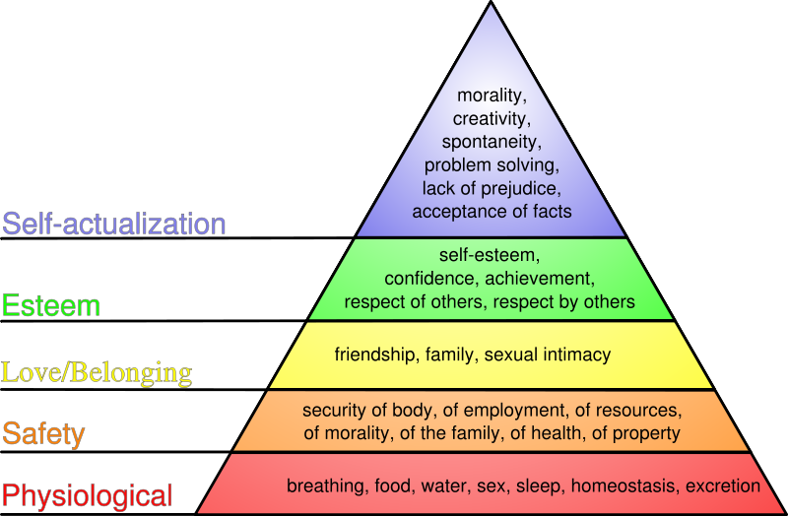
Source:https://positivementalhealthfoundation.com/life-questions/abraham-maslow-hierarchy-of-needs/

According to Hoffman et al (2009), talent and ambition are fully realised at the highest level. So, managers should assist their employees to get to this level as this is where they function at their optimum (Kelleher, 2014). Maslow’s Theory have been described by Kelleher (2014) in relation to the workplace. The first level can be fulfilled by a salary to provide food and shelter as an example. These are basic needs and Kelleher (2014) points out that engagement is absent at this level. The second level is associated with employment safety and is characterised by a long-term career. It is argued that a sense of security can be increased through the setting of long-term goals, incentives and good working conditions (Albrecht, 2010). A 2004 Gallup survey revealed that job insecurity significantly reduces the odds of employee engagement and found that engagement decreased by 37% among employees who were insecure about their jobs (Gallup, 2004). Level three which is belonging is associated with the need to develop social relations such as friendship. Kelleher (2014) points out that organisations should create enabling environments that achieve ‘related’, which according to Deci and Ryan (2008) is one of three essentials components required to achieve engagement. Gallup’s survey found out that employees who answered yes to the question ‘Do you have a best friend at work?’ were more engaged than employees who answered no (Kelleher, 2014). The fourth level which is esteem, is associated with the need for employees to want respect, self-assurance and the appreciation of others (Hoffman et al, 2009). Kelleher (2014) is of the view that when ‘esteem’ needs are met by employees, their engagement and performance increase. Self-actualisation, the fifth level, is associated with employees performing at their optimum and this is where they ultimately completely engage with the organisation (Hoffman et al, 2009). Even though employees perform at their optimum at this level, they are still susceptible if engagement decreases across the organisation (Albrecht, 2010). This could be in response to for example redundancies which can cause a feeling of job insecurity. It is important for organisations and managers to realise that once a need is satisfied, it is no longer a motivator as the needs of the next higher level becomes the new motivating factor (Mullins and Christy, 2010). Table x is an example of how organisations can use Maslow’s theory practically to achieve motivation by creating the conditions that aid in satisfying employees needs.
Table x Applying Maslow’s theory
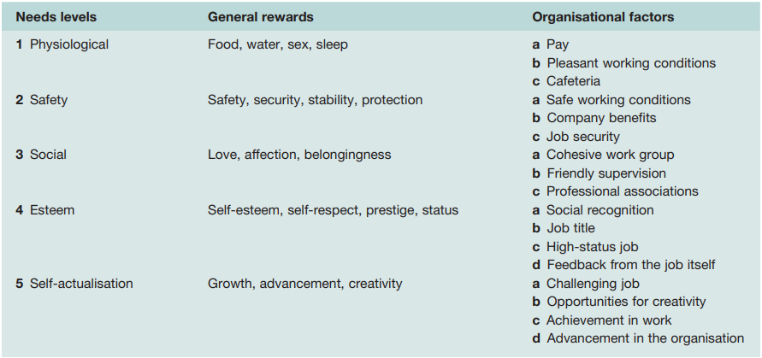
Source: Steers and Porter, 1991

Although Maslow’s theory does a good job of explaining motivation, it is not without its criticisms. The theory assumes peoples needs start from level one and work their way up mechanically through each step, but this is not always the case. The theory is not necessarily in a fixed order and in some cases, it is a complete reversal, something Maslow acknowledges. (Mullins and Christy, 2010). Take for example a priest or a full-time volunteer worker. They may not be bothered much with the first four levels and might just be interested in the highest level which is self-actualisation. Motivation, and by extension engagement, are individual phenomena and what may work for one person might not work for another (Mullins and Christy, 2010).

Alderfer (1972) modified Maslow’s need hierarchy model, condensing the five levels into three levels. These are existence needs, relatedness needs and growth needs (ERG). Hence, this model is often referred to as the ERG theory. Needs of existence are concerned with survival and cover physiological and safety needs (Mullins and Christy, 2010). Relatedness needs are concerned with relationships and cover affiliation, love or belonging and interpersonal relationships (Mullins and Christy, 2010). Growth needs are concerned with the development of potential and cover self-esteem and self-actualisation (Mullins and Christy, 2010). Alderfer’s ERG has some similarities as well as differences to Maslow’s theory. To begin with, Alderfer, like Maslow, suggests that people progress through the levels (hierarchy) from existence, relatedness and then to growth needs after satisfying the lower level. But unlike Maslow, Alderfer suggests that the levels are more of a continuum than hierarchical levels (Mullins and Christy, 2010). Individuals may also progress down a level. Also, unlike Maslow, Alderfer’s ERG theory suggest that a higher level need may emerge without first achieving a lower level need.
There is yet another relationship between Maslow’s theory and Hertzberg two factor principle (Mondy et al, 1940). Frederick Hertzberg’s research identified two different sets of factors influencing work and motivation which are motivating and hygiene factors (Mullins and Christy, 2010). Motivating factors are to motivate individuals to superior performance and hygiene factors are to prevent dissatisfaction. The motivating factors include achievement, recognition, work itself, responsibility, promotion and growth. The hygiene factors include pay and benefits, company policy and administration, relationships with co-workers, physical environment, supervision, status, job security, salary, working conditions and personal life. The relationship between Maslow’s theory and Hertzberg’s two factor principle is shown on fig x.
Fig X
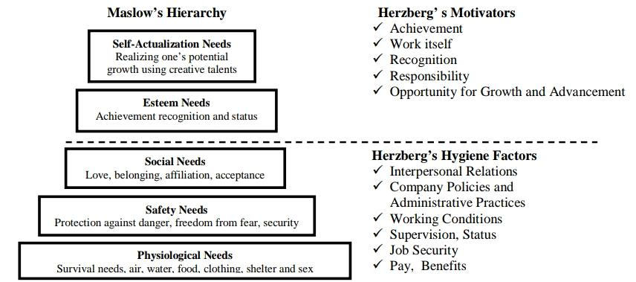
(Ozguner and Ozguner, 2014)

Hygiene factors can be interpreted to mean those factors that exist to prevent disengagement whereas the motivators factors drive engagement by creating the necessary conditions to ultimately achieving self-actualisation for the employee and peak performance for the organisation, a win-win situation.
The relationship linking Maslow’s, Alderfer’s and Herzberg’s theories of motivation is shown on table xx
Table xx
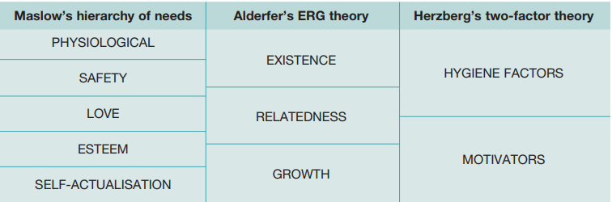
Source: Mullins and Christy, 2010
Employee Engagement in Context
Evidence indicates that employee engagement around the world is low. Much of this evidence comes from the Gallup organisation, which has conducted engagement surveys in many countries. Kular et al (2008) argue that due to cultural and differences in definitions, cross-national comparison of engagement levels should be treated with some caution. Gallup conducted a survey in Thailand in 2005 which revealed that only 12 percent of the population were engaged, 82 percent were actively disengaged, and 6 percent disengaged (Cited in Kular et al, 2008). In the USA, evidence indicates that roughly half of all Americans employees are not fully engaged or are disengaged (Johnson, 2004). A survey by the consulting firm Towers Perrin conducted in 2005 revealed only 14 percent of all employees worldwide were engaged. These are disappointing results giving the immense benefits and potential of employee engagement (Serjits and Crim, 2006). Worst of all, similar studies by Gallup found engagement levels in Australia, China, Japan, New Zealand and Singapore to be 18 percent, 12 percent, 17 percent and 9 percent respectively (Gallup, 2004). *Employee engagement in Ghana*
The international research consultancy, International Survey Research (ISR) conducted a major survey in 2004 into the nature and causes of engagement and how this can be used to enhance performance. It was conducted across 10 of the largest economies which included Brazil, Australia, Germany, France, The Netherlands, Hong Kong, the UK, Singapore and the USA. It highlighted large variations among the countries in terms of employee’s commitment and involvement with employers. As an example, 75 percent of employees in the US and Brazil were found to be engaged with their companies compared to 59 percent of employees in France. This demonstrated that one size does not fit all when it comes to motivating employees to engage with their companies. In Singapore, Australia and Hong Kong for example, respect for management emerged as an influential determinant for employee engagement whereas in the US and UK, long-term career opportunities and long-term employment were major factors for engagement. Employers should use global research as a starting point, but they should gauge their employees’ level of engagement using their own countries norms (ISR, 2004 cited in Kular et al, 2008). Hofstede’s Cultural Dimensions provides a framework to address this.

Hofstede’s Cultural Dimensions
Kluckhohn and Kroeber (1952, p181) define culture as “... comprising in patterned ways of thinking, reacting and feeling which are acquired and convened mainly by symbols, constituting the distinction accomplishments of human groups and their attached values”. Hofstede (1991) labels this model as ‘mental programming’ or software of the mind. In simpler terms, culture is the sum total of how a group of people with a common bond live their lives which include ideas, customs and social behaviour. Because different countries have different cultures and therefore different ‘mental programming’ employee engagement should be set in a cultural context in order to be successful. What works in the UK for example may lead to a spectacular failure in a different country. Hofstede developed the framework as a way of comparing cultures between different countries. The cultural dimensions identified are Power Distance (acceptance that all individuals are not equal), Individualism (interdependence in a society), Masculinity (driven by success, competition and achievement), Uncertainty Avoidance (threatened by ambiguous or unknown situations), Long Term Orientation (links with past while dealing with challenges of present and future) and Indulgence (control of desires and impulses). Below is an example of cultural comparison between Ghana and the UK.

Fig x
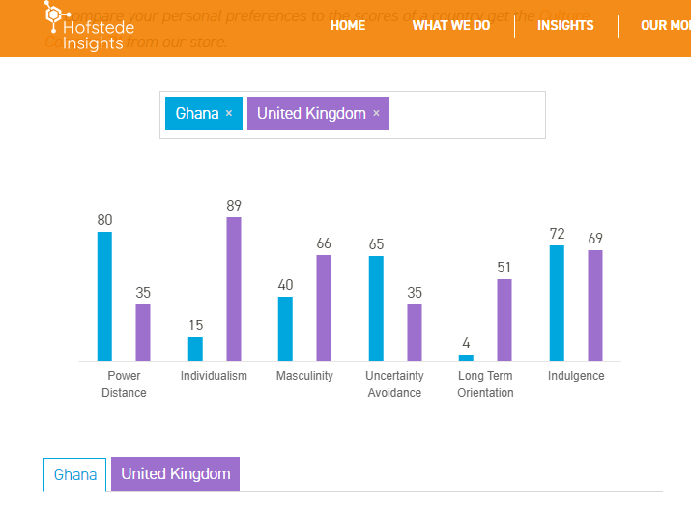
Source: https://www.hofstede-insights.com/country-comparison/ghana,the-uk/
The score of 80 on power distance means employees in Ghana accept a hierarchical order and accept everyone has their place. Scoring 15 on individualism implies Ghana is a collective society. Ghana scores 40 on Masculinity, which implies the focus is on “working to live” and managers strive for consensus and an effective manager is a supporting one. A score of 65 on uncertainty avoidance expresses a preference for avoiding uncertainty. Ghana has a low score of 4 on Long Term Orientation which indicates a strong preference to a normative way of thinking and show a strong attachment to traditions. It scores a high of 72 in Indulgence which implies a willingness to realise their impulses and desires, and place a higher degree on leisure time. It is evident that there is a lot of divergence in five of the dimensions between Ghana and the UK used here as an example and only one divergence. This has implications for international and multinational corporations in terms of implementing measures to achieve employee engagement in a host country. Thus, employee engagement measurers cannot be exported ‘wholesale’ to a different country without putting it in a cultural context. A research by Hofstede (1997) showed that in order for organisations to attract, motivate and retain staff, they must adapt to different norms and cultural values.

Conclusion
Employee engagement is a multifaceted and multidimensional construct which has been made complicated by over 80 definitions, adding to the confusion. Most definitions examined for this research converged around Kahn’s (1990) definition centred around emotional, cognitive and physical engagement. Truss et al (2006) definition seem to capture the very essence of engagement in almost all of the definitions. One issue is that the definitions of employee engagement is not linked to productivity or results which makes it very difficult to accurately measure it. Measurement is relied on people being genuine and honest, which is not always the case. Whilst interest in engagement has grown, there is not sufficient literature on the topic especially in sub-Saharan Africa and other developing and underdeveloped nations. Most of the literature is on the western world and developed nations in general and as such more research is required to develop the full global picture of employee engagement.
Whilst the benefits of engagement are well known, employers are in some ways limited in what they can do to engage employees. This is because engagement also depends on conditions outside the work environment as well as a host of other factors, some of which cannot be controlled by the organisation. Thus, employers cannot have absolute control over employee engagement. As pointed out earlier, engagement should be put in a cultural context to make it relevant. Finally, the quest for engagement is eternal. Engagement can peak, end and then begin all over again. As the consulting firm Towers Perrin pointed out in 2003, building engagement is a process that never ends.

Chapter 3- Methodology (Target: 3000 to 3500. Actual: 3649)
This chapter presents a summary of research aims and objectives as well as the overall research methodology adopted and why. It also describes the research methods used to obtain and analyse the results as well stating and putting the research limitations into context. In summary, it describes how the research was conducted.

Research Aims and Objectives
The purpose of this research is to evaluate employee engagements within Ghana’s banking sector. The overall aim is to determine the effects of the job losses and general sense of job insecurity on engagement within the sector. The research questions are as follows:
- What is the level of engagement within Ghana’s banking sector?
- Have job losses within the sector adversely impacted on engagement?
- What categories of staff are more engaged?
There are three main objectives of this research which are:
- Measure the level of employee engagement within Ghana’s banking sector
- Determine how recent job losses within the sector is impacting on engagement and
- Determine ways to engage employees within the sector.
These research questions have been chosen and pursued because they will provide an independent picture of the experience of work within the banking sector in Ghana. The effects of the job losses and the banking reform as a whole on engagement should also be revealed by the research. Finally, it is important to know which category is more engaged. The goal of any organisation is to engage employees, but if managers are less engaged than non-managers this usually have adverse effects on overall engagement (Truss et al., 2006) as managers have a vital role to play in not only motivating their employees but to ultimately find ways to engage them. As this is the first research of employee engagement in Ghana’s banking sector, it is hoped that it will contribute to the stock of knowledge by revealing previously unknown information about engagement within the context of the research. This information can be used by the sector to make the necessary changes, if any, to engage their employees.
Hypothesis
A 2019 Bloomberg report stated that Ghana’s banking sector was at risk of losing a further 4000 jobs as a result of the BoG efforts to clean up the finance industry (Dzawu, 2019). There have been inevitable job losses in Ghana’s banking sector through bank closures and mergers. It is easy to see why employees in this sector will be anxious and not feel they have a secured job, giving that a lot of their colleagues are out of a job. A Gallup study confirmed the connection between job security and employee engagement. A key finding of the research was that job insecurity significantly reduced the odds of employee engagement (Gallup, 2019). Employee engagement decreased by about 37% among employees who are insecure about their jobs (Gallup, 2019). The recent job losses and possible future job losses is likely to result in job insecurity, thus the generation of hypothesis 1 below:
Hypothesis 1 Employees working within Ghana’s banking sector will be less engaged.

Research Method
The study began by reviewing and analysing relevant literature in relation to engagement. This created the opportunity to determine the main themes that warranted exploration. The literature review also helped to define the scope of the study as well as its aims and objectives. Both primary and secondary data was used in this research. The use of secondary data featured mostly in the literature review. A quantitative method was chosen as the primary research method over a qualitative method. This is because it emphasises objective measurement and the analysis of data (Babbie, 2010; Mujis, 2010). Because researching quantitatively focusses on gathering numerical data and then making generalizations across groups or explaining a phenomenon (Babbie, 2010; Mujis 2010), it was ideal for this research as its focus was on scope rather than depth. A qualitative method on the other hand yields a detailed description of data and hence appropriate for depth of understanding because it focuses on the “intimate relationship between the researcher and what is being studied” (Denzin and Yvonna, 2010 in Denzin and Yvonna, 2005: p.10). A mixed research approach makes use of both qualitative and quantitative methods. This is an ideal method to cover scope as well as depth of understanding. It would have been an ideal method to use for this research but requires more resources and time. Due to time and resource constraints, the research focussed on scope rather than depth. Since a research of this nature has never been conducted on the Ghanaian banking sector, interest was to explore a wide range of areas in a very limited time. Due to the above reasons, a decision was made to research quantitatively. Quantitative research designs are either experimental or descriptive. It is experimental if it establishes causality and descriptive if it establishes associations between variables. Since the focus of the study was to establish associations between variables, a descriptive approach was used.
A quantitative method made possible a broader study, greater objectivity and accuracy of results and avoiding personal bias. A limitation of this is that although quantitative data is more efficient and better at testing hypotheses (Babbie, 2010), contextual detail may be lost.
A survey was chosen to gather the primary data due to the scope of the sample size. The survey was based on the CIPD attitude and engagement survey by Truss et al. (2006), a collaboration between the Kingston Business School and Ipsos MORI. It has been tested for validity and covered the scope of the questioning required (Knight, 2011). A modified version was used to measure engagement levels of employees working within Ghana’s banking sector. It focussed on Khan’s (1990) three dimensions of engagement already discussed briefly in this introduction. An email was sent to the CIPD research department kindly requesting the questions used in the 2006 employee attitude and engagement survey as well as the ‘top-line’ responses in order to adapt and benchmark the results from this study. CIPD responded by granting this request and permission for the information to be used in this study.
The adapted CIPD questionnaire used for this survey was then designed using Qualtrics Survey Software. The survey was first tested on small group of people (Precise number) to unsure that the survey was working as intended on Google Forms and to allow for any corrections to be made prior to the actual collection of data. This was then sent out electronically together with a consent form and employees were invited to complete the survey making use of a Likert type scale to rate statements. For example, strongly disagree, disagree, neither agree nor disagree, agree and strongly agree. The survey was completed was stored within the Google Forms data base for analysis. This was then exported to Statistical Package for Social Sciences (SPSS) software where it was analysed.

Survey Design
The survey was designed to measure the level of employee engagement within Ghana’s banking sector. Aspects which have strong links to employee engagement such as flexibility, job satisfaction, and job content were included in the survey. Engagement needs to be as a whole and not just with focus on the employee. Things such as managerial action, individual preferences and job specific features need to be taken into account. The survey used two types of items. The first was information about the individual participants such as gender and age and. The other item asked participants how they feel or think about an issue. A Likert scale was used to give participants the opportunity to choose one outcome. For example:
To what extent do you agree or disagree that you are committed to helping your organisation achieve its aims and objectives?
Strongly disagree
Disagree
Neither agree nor disagree
Agree
Strongly Disagree

The responses are scored as follows:
Response Score
Strongly disagree 1
Disagree 2
Neither agree nor disagree 3
Agree 4
Strongly Disagree 5

The scores are then entered into a data base for analysis.

In order to analyse as many aspects of engagement, the survey was sectioned into 6 areas. The segments are as follows:
Table x -Breakdown of Survey
Section | Area | Question Numbers
Section 1 | Working Life | Q1-Q3
Section 2 | Employer | Q4-8
Section 3 | Job | Q9-Q13
Section 4 | Job Satisfaction | Q14-Q17
Section 5 | Leadership and Management | Q18
Section 6 | Communication | Q19-Q22
Section 7 | The Future | Q23-Q26

Details on sections of Questionnaire
The questionnaire starts with a title, an introduction and consent and then screen questions followed by the actual questions. The introduction briefly explains what the survey is about and what the research aims to achieve. It explains to potential respondents that the research is not commissioned by any organisations and is completely anonymous and confidential. It also states the approximate time to complete the survey as ten minutes and points out that all data collected would be destroyed after analysis. There is a statement of consent which states that ‘By continuing with this survey you agree to participate in this research’. Next is the screen questions. These were designed to ensure only respondents who met the required criteria could participate. If they did they could then begin answering the actual questions for the survey.
Section one
Section one contains information about the participants working lives. In general, it was designed to seek out information from respondents on how they feel about their job. They were asked questions such as if they looked forward to going to work, job satisfaction, value of work to both themselves and their employers, meaningful work and whether they were worried or enthusiastic by the work they do. Evidence from the literature review points to the fact that if employees are not happy about their working life, engagement will be low, and this is highly likely to affect performance and retention. Information on the working life of employees within Ghana’s banking sector can be invaluable to managers as they can use this information as a general guideline to improve this area of employee lives. This contributes to overall employee engagement and will like increase productivity and the retention of talent within their organisations.
Section two
Section two is about the participants employer. It asked questions about of the respondents about the organisations they work for. One of the benefits of employee engagement for the employer pointed out earlier in this study is advocacy. It is essential for organisation and indeed the whole of the banking sector, to know how their employees communicate about their organisation to the wider public. In particular, it is important for employers to know if their employees are proud to work for their them and if they would speak highly or negatively about them. It is also important to know how much loyalty employees will show, if they are at all interested in for the organisation they work for and finally if they will recommend their company. In essence, this section is about the branding of organisation from the employee’s perspective and if they will be willing to ‘sell’ the brand on their own volition. In other words, how much discretionary effort are employees willing to show for their employers. The information from this section can be used by managers to improve employee advocacy.
Section three asked questions about the respondent’s job. It contained questions designed to reveal engagement at an emotional level and also other important information. The questions included how absorbed they were in the performance of their job, distraction, excitement, job completion and if they put their heart in their job. Other questions about their job include those on stress, pressure, autonomy and support they receive in terms of work-life balance.
Section four
Section four entailed questions about job satisfaction directed at the respondents. Participants were asked about their overall job satisfaction as well other job aspects including performance ability, standard of work, knowledge and skills, physical working conditions, freedom to choose own way of working, immediate boss, how they rate their pay, relations with fellow workers, recognition, opportunities to use abilities, chances for promotion, job security among others. Importantly, they were also asked about their relations with their managers and management of their local branch. Research cited in the literature review section shows that job insecurity is associated with disengagement. Many of the items mentioned in section four can lead to disengagement if not managed properly. Section four should reveal a snapshot of job perception of employees.
Section five
Section five was designed to reveal key information about the leadership and management of the respondent’s organisation. It looked at aspects of leadership and management such as consultation of employees, training and development needs, recognition from management, feedback on performance, supportiveness, fairness. Participants were also asked if management makes them feel if their work count, makes clear of what is expected of them and listens if they have a suggestion to make.
Section six
Section six was about communication within the participants respective organisations. Key finding from Truss et al (2006) survey was that employees having opportunities to fee their views upwards and feeling well-informed about what was happening in the organisation were two of the three main drivers of employee engagement from the study. These were aspects of communication that section six was meant to reveal about Ghana’s banking sector. To achieve this, participants were asked how well informed about what was happening, the extent to which they believe information they receive, satisfaction with opportunities to feed their views upwards and confidence that their problems would be dealt with fairly.
Section Seven
This section was designed to reveal the future intentions of respondent. Intention to quit is associated with disengagement whereas a benefit of engagement is increased retention. Participants were asked about their intentions about their current job, their plan to remain with their organisation in the foreseeable future, if they had thought or done something about leaving their current job and whether they intended to leave their organisation within the next year.

E-Survey
An electronic version of the questionnaire was designed using Google Forms. The introduction and consent screen made use of a forced response. This is where a participant is forced to respond to a question, or they can’t continue. If they choose ‘I do not consent’ they are sent to the end of the survey. If they consent, then they can continue. The screen questions also made use of forced response questions. For example, if a respond answered no to the following question ‘Are you currently employed in Ghana’s banking sector?’, they are sent to the end of the survey because they do not meet the requirement to participate. Some of the questions were put in a matrix to compress the original paper questionnaire. The questionnaire was also divided into sections and only one section could be viewed on the screen at any point. This was to avoid displaying all the questions at once which may put certain respondents off. There was also a progress bar to show participants how long they had till they were finished to serve as a motivator. At the end of the survey participants could submit the results and they got a confirmation of a successful completion.

Administration of Survey
I travelled to Ghana from 17 Jan 2020 to 03 Feb 2020 to identify potential participants. This was done by visiting several banks and asking employees if they would be interested in participating in a survey I was due to conduct as part of my dissertation. Most obliged and handed out contact details which I compiled. An electronic version of the questionnaire which I designed using Google Forms was then sent out to the contacts I had compiled. Since the electronic version was shareable via email and apps such as WhatsApp, participants were encouraged to share the link to the survey with their colleagues within the banking sector.

Limitations of Research Method
Researching quantitatively was suited to this study, as its focus was on scope and not depth. Although quantitative data is more efficient and better at testing hypotheses, a limitation of this is that contextual detail may be lost. One way of minimising this is linking the data with Hofstede’s cultural dimensions to provide some context with regard to engagement and the Ghanaian culture. Standard questions can lead to bias where the data represents the views of the researcher. In this case, I opted to adapt the CIPD 2006 questionnaire developed by Truss et al (2006) which has been tested for validity.
Due to the lack of centralised data base for employees working within Ghana’s banking sector, an alternative arrangement had to be made to collect the data. This involved the research travelling to Ghana and directly speaking to people believed to be employees of banks. They were then asked to make recommendations about colleagues within the sector. This approach was time consuming and a better approach would have been to get participants through a data base, if one existed. This would ensure only individuals working in the sector could participate. To reduce the risk of non-bank sector workers participating in the survey two key things were done. First, the researcher went to the banks personally and only talked to staff in uniform or with name tags identifying them as working for the banks. Second, a ‘screen’ was designed into the electronic questionnaire. This comprised of questions such as employment status and if they worked in the banking sector. Answering no to any of the screen questions would automatically end the survey and thank them for participating. Participants could only progress if they fit the criteria required.
Simple random sampling was used to select participants. Whilst this is not a problem in itself, it was difficult to mirror the demographics and population of Ghana’s banking sector as a whole. Quotas were not set for the participants to reflect the entire banking sector. For example, a percentage of the respondents being women or ages of respondents. Ideally, it’ll have been better to mirror the banking population in terms of age, sex, marital status, disability and so on. This data was not readily available and if it was, time and resource constraints would have prevented such an undertaking. Using simple random sampling was the best option under these circumstances. All limitations were taking into consideration before drawing conclusions.

Analysis
The results from the survey were exported from Google Forms to SPSS (Statistical Package for Social Sciences), and then analysed with SPSS. Preliminary data was then analysed for descriptive statistics such as means and standard deviation (Bryman, 2015). The three dimensions of engagement were analysed to arrive at the overall engagement level. Three types of data analysis were carried out: cross-tabulations, correlation and regression analysis. Cross-tabulations were used to segment data sets in order to examine differences between sub-groups. Comparisons were then made to determine whether there are important differences, such as, if managers were more engaged than non-managers. The data for each column in the cross tabulation were then examined to determine if the differences between the subgroups were statistically significant. The difference between any two subgroups can be either real differences (that is differences that are unlikely to have occurred by chance), differences that have occurred by chance and small or no differences. The researcher used statistical testing to examine for real or significant (statistically) differences between groups. The differences need to differ by a certain number of percentage points in order to be considered significant statistically. The significant level used to perform the test was 5 percent. This means that 95 percent of the time when significant differences were found there is an actual difference in the banking sector. Only significant differences were reported.
Correlation analysis were used to examine direction and strength of association between two variables. The analysis was not to infer causality but associations. This is due to the sample size and the research not being repeated due to resources and time constraints. For example, if communication and engagement are positively associated, then engagement increases with good communication. The opposite is true if they are negatively associated.
Regression analysis was another form of analysis used. This enabled the exploration of relationships between two sets of variables: input or predictor variables, and outcome or dependent variables. This was used to predict which variables best predict outcomes such as performance or engagement. According to Truss et al (2006:p54), “regression analysis examines the likelihood of association between variables, that is, the degree to which the relationship is likely to have occurred by chance”.
Assessing engagement
The entire dissertation is centred around Kahn’s (1990) definition of engagement which has three components namely Cognitive Engagement, Emotional Engagement and Physical engagement. While these have been adequately covered in the literature review, what was not covered is the descriptors used for the three components for this research. Cognitive engagement is described as utter focus on the work, not thinking about other things while performing a task. Emotional engagement is having an emotional connection with your work. Physical engagement is willing and able to display discretionary behaviour, to go the extra mile and work beyond your contract terms.

Problems Encountered
It was the intention of the researcher to use Qualtrics software to design an electronic version of the questionnaire and conduct the survey. It was later realised midway through the dissertation that a Qualtrics subscription for the purposes of this research would cost in excess of £1000. Given that I had to fund it personally a decision was made to use an alternate. After considering a number of softwares, a decision was made to use Google Forms mainly because it could perform the functions needed and as a bonus it was also free. Another that was encountered was that during the pilot survey, there was a relatively large number of answered questions. To rectify this, the number of questions were reduced to include only those deemed essential to the aims and objectives of the research. All of the questions were then made ‘forced responses’ in the electronic survey.

Chapter 4- Findings and Analysis
Findings
General Overview of Respondents
In total the survey received 62 responses (one person did not consent). Of the respondents 37.1% identified as females, 59.7% as males and 3.2% preferred not to state their gender. On the age of participants 1.6% represented ages 18-24, 12.9% represented ages 25-29, 45.2% represented ages 30-34 which was the majority. Ages 34-34 were 38.7%, 45-54 made only up 1.6%. There was no one from ages 55-65 hat took part in the survey. Chart 1 below shows the age distribution.
Chart 1-Age of respondents
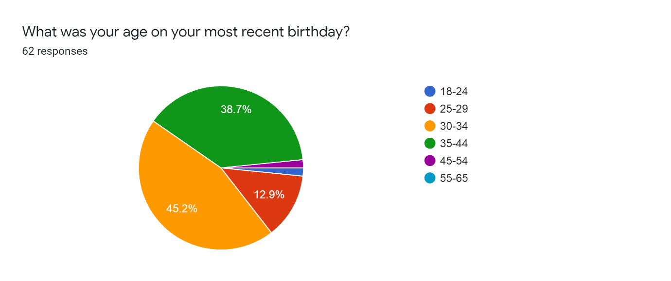
66.1% identified as non-managers and 33.9% identified as managers.

Looking forward to Work
29.8% said they looked forward to work all of the time, 48.9% said they looked forward to work most of the time, 17% said they looked forward to work sometimes and 17% said they rarely looked forward to going to work. None of the respondents said they never looked forward to work.
Chart 2- Looking forward to work
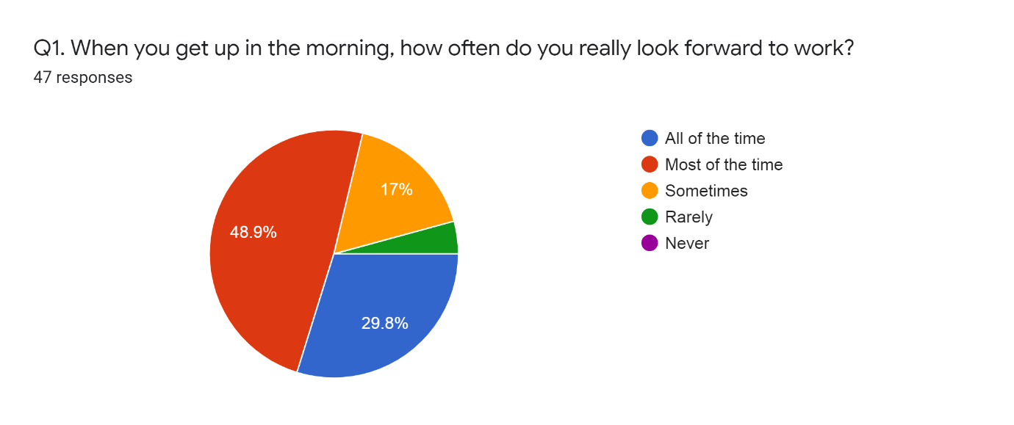

Emotional experiences over past few weeks
When asked how much of the time participants were miserable 38.8% said never, 31.91% said occasionally, 27.6% said they were miserable some of the time and 2.3% said they were miserable most of the time. No one said they were miserable all of the time. When asked how much of the time their job made them feel optimistic 4.2% said Never, 25.53 said Occasionally, 19.15 said Some the time, 38.3% said Most of the time and 12.77% said their job made them feel optimistic all of the time.

Chart 3-Emotional Experience
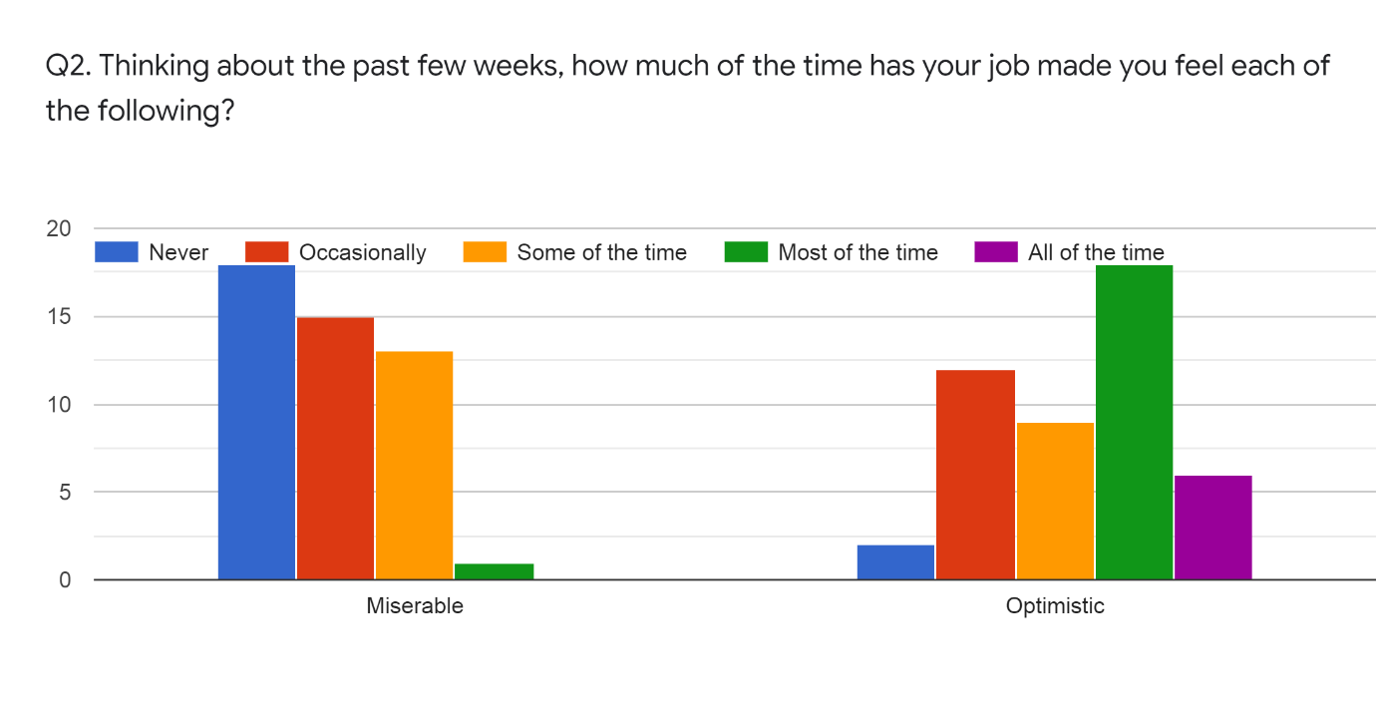

Meaningfulness
When asked if the job they do on their job had was meaningful to them 16.8% strongly disagreed, 2.1% disagreed, 2.1% neither agreed nor disagree, 59.6% agreed and 23.4% Strongly agreed.
Chart 4- Meaningfulness
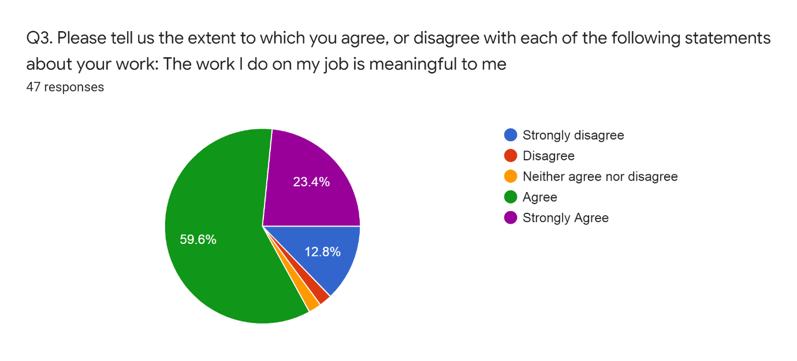

Employer
The survey sought to find out participants opinion on their employer, pride in working for their organisation, interest in their organisation, as well as loyalty and advocacy.
Opinion on Employer
When asked how they would speak of their organisation as an employer to people outside their organisation 40.4% said they would speak highly of their employer without being asked, 40.44% said they would speak highly of their organisation if asked, 17% said they would be neutral towards their organisation and 2.1% said they would be critical of their organisation if asked. None of the participants said they would be critical of their organisation without being asked.
Chart 5- Opinion on employer
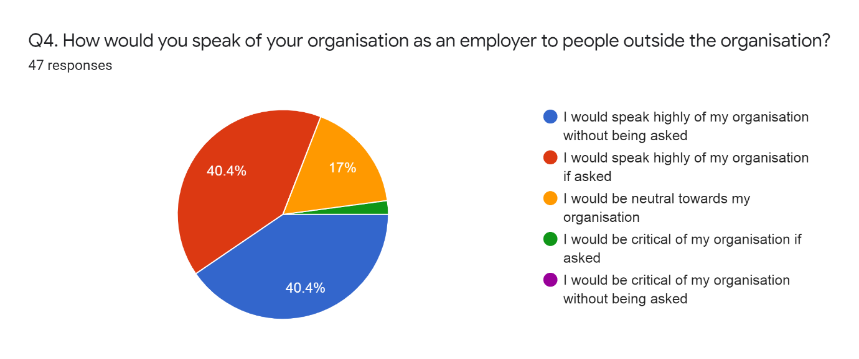

Pride
When asked if they are proud to tell people who they work for 48.9% of the participants said they were very proud indeed, a similar percentage of 48.9% said they were quite proud and 2.1% said they were not very proud. No one said they were not at all proud.
Chart 6 – Pride in employer

Interest in organisation
When asked their views on working for their organisation 6.4% said they were not interested in their organisation but it was just a job, 21.3% said they like to know what is going on but don’t want to get involved, 42.6% said they like to know what is going on and would like to get more involved, 29.8% said they like to know what is going on and are already involved.
Chart 7- Interest in organisation
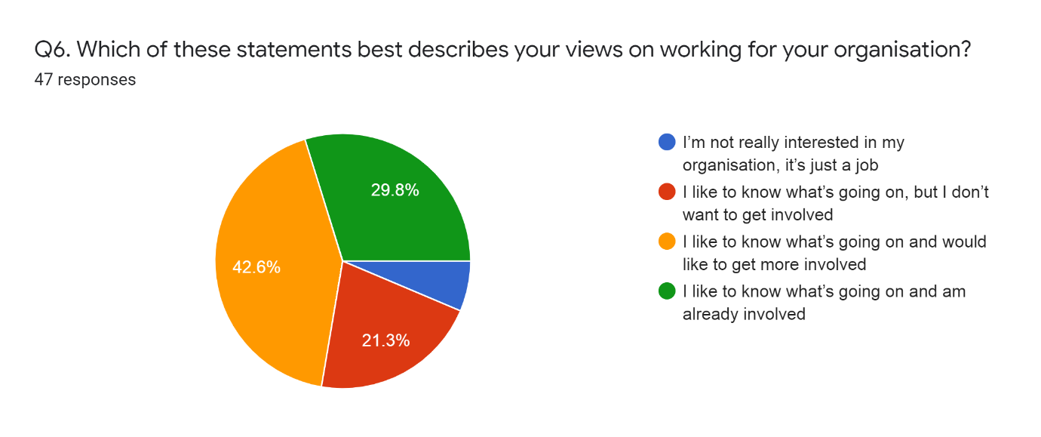

Loyalty
When asked how much loyalty participants felt towards their organisation 2.13% said they feel a little loyalty, 40.43% said they feel some loyalty and 57.45 said they feel a lot of loyalty towards their organisation. When asked how much loyalty participants feel towards their immediate supervisor 2.13% said they feel no loyalty, 6.38% said they feel only a little loyalty, 36.17% said they feel some loyalty, 53.19% said they feel a lot of loyalty towards their immediate supervisor and 2.13% said they didn’t know how they feel.
Chart 8- Loyalty towards organisation and immediate supervisor
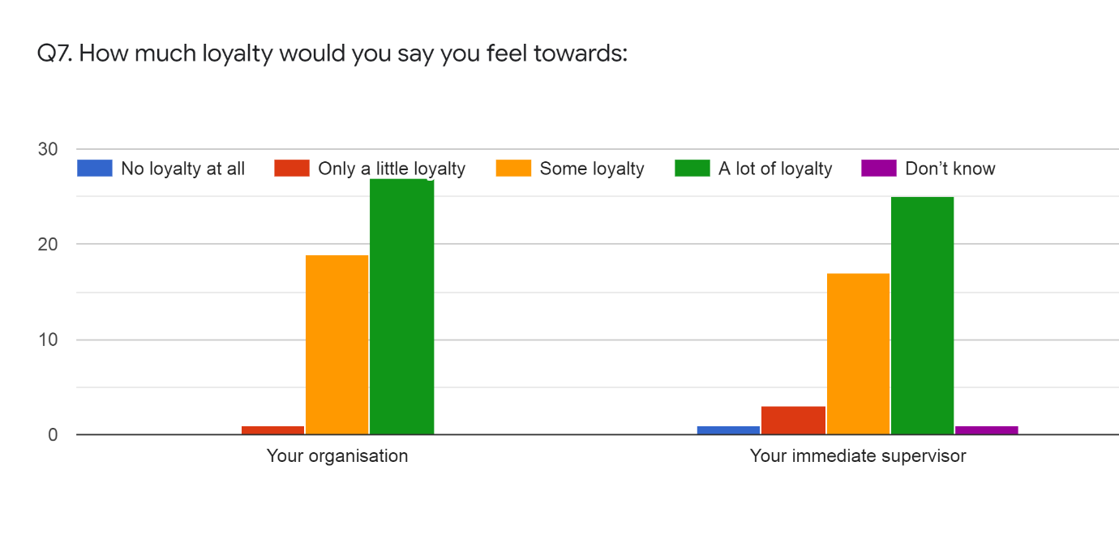

Advocacy
When asked if they would recommend their organisation to someone seeking a job opportunity 4.3% of participants said they strongly disagree, 6.4% said they disagree, 8.5% said they neither agree nor disagree, 42.6% said they agree and 38.3% said they strongly agree to recommending their organisation to someone seeking a job opportunity.
Chart 9- Advocacy
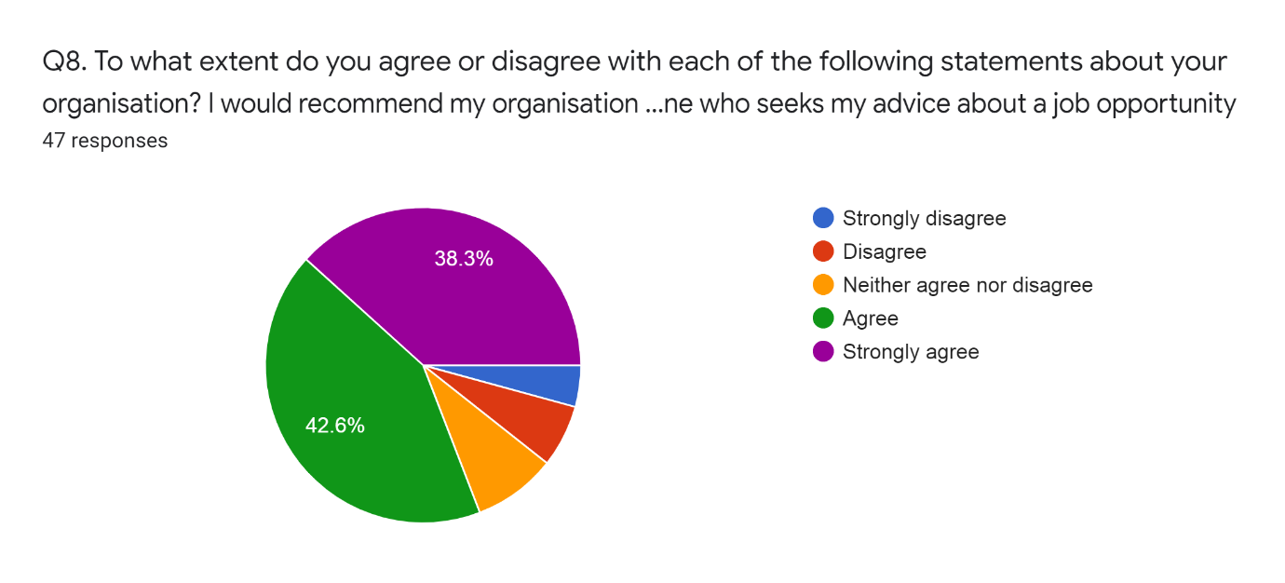

Job
Participants were asked questions in order to access engagement with work, stress, pressure, control and work/Life balance.
Engagement with work
The results for participants engagement with work is shown on chart 10. The overall engagement from the research as well as its three components were reached using the results below. Details of this is on the analysis section.
Chart 10- Engagement with work.
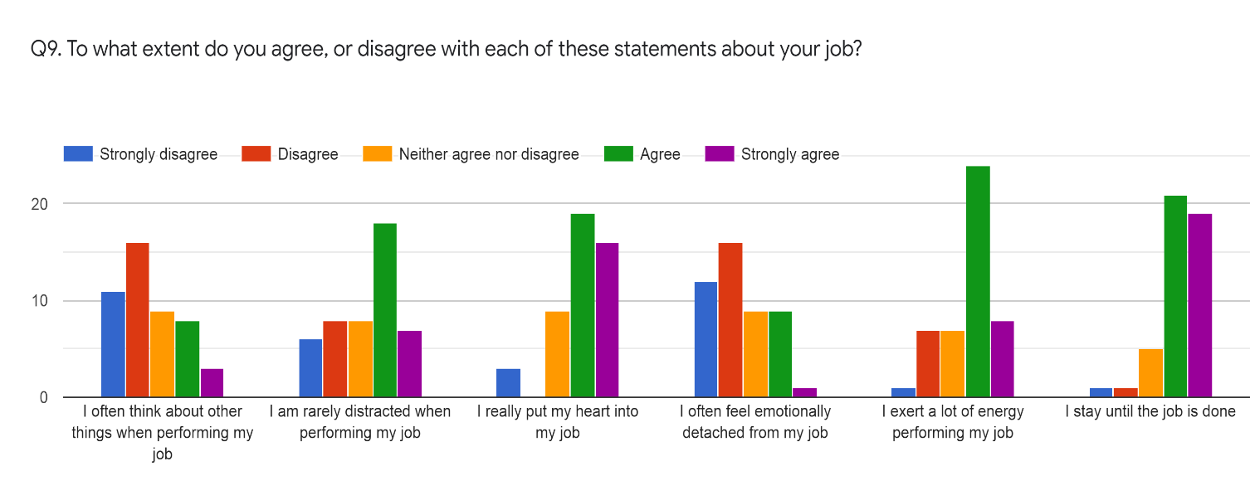

Stress
When asked how stressful their job was 6.4% said it was not at all stressful, 12.8% said it was mildly stressful, 34% said it was moderately stressful, 38.3% said it was very stressful and 8.5% said it was extremely stressful.
Chart 11- Stress
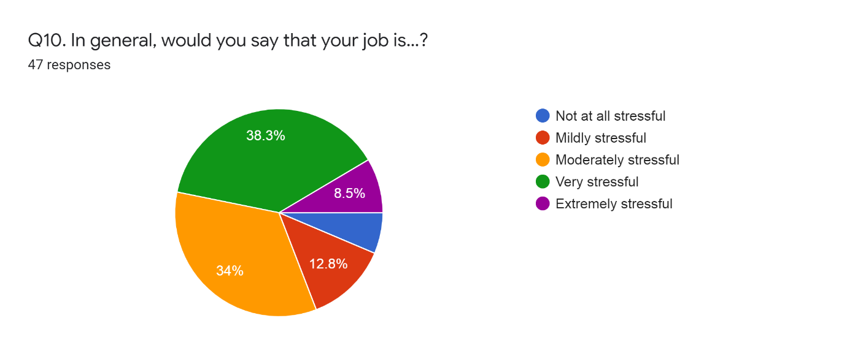

Pressure
When asked how much of the time they feel under excessive pressure in their job 4.3% said never, 12.8% said once or twice a month, 46.8% said once or twice a week and 36.2% od participants said they feel under pressure every day.
Chart 12- Pressure in your job
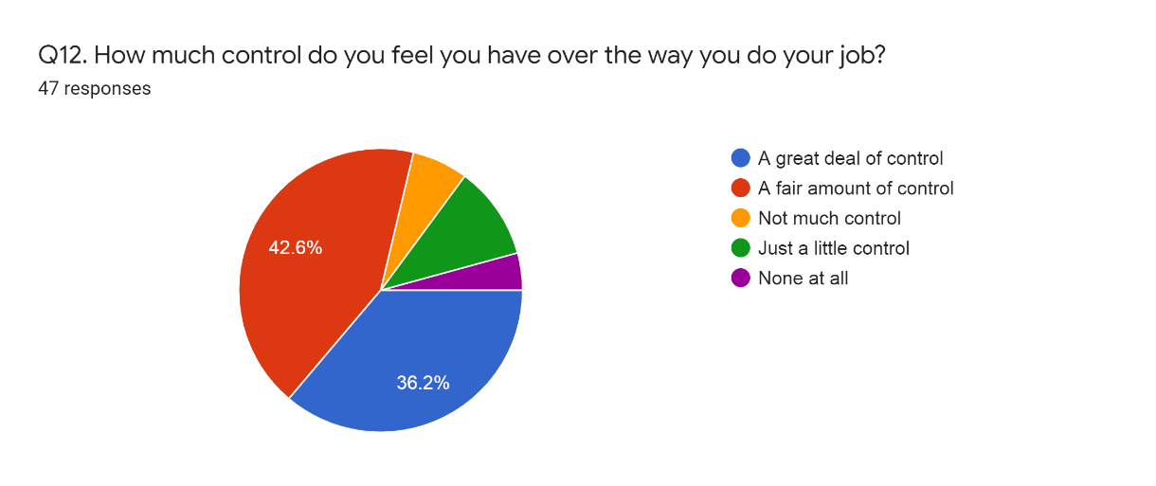

Control
When asked how much control they feel they have over the way they do their job 36.2% of participants said they had a great deal of control, 42.6% said a fair amount of control, 6.4 said they didn’t have much control, 10.6 said just a little control and 4.3% said they feel they didn’t have any control at all.
Chart 13- Control
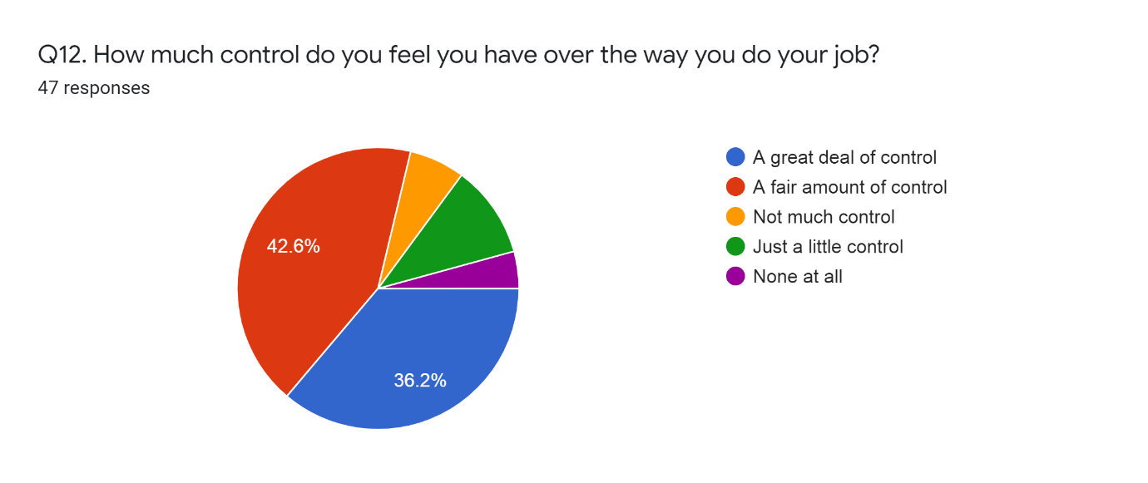

Work/Life balance
When asked if they achieve the correct balance between their home and work lives 6.4% of participants said they strongly disagree, 29.8% said they disagree, 17% said they neither agree nor disagree, 34% said they agree and 12.8% said they strongly agree.

Job Satisfaction
To assess job satisfaction participants were asked questions on their overall satisfaction, performance, recognition, rate of pay and job security.
Overall Satisfaction
When asked how satisfies they are with their current job 8.5% said they were dissatisfied, 21.3% said they were neither satisfied nor dissatisfied, 51.1% said they were satisfied and 19.1% said they were very satisfied.
Performance
When asked if overall they perform to their best ability 46.8% said they strongly agree, 46.8% said they agree and 6.4% said they neither agree nor disagree. No participant disagreed or strongly disagreed with the statement.
Recognition
When asked the extent to which they agree or disagree with the recognition they get for good work 6.4% said they strongly disagree, 17% said disagree, 19% said they neither agree nor disagree, 51.06% said they agree and 6.4% said they strongly agree.
Rate of pay
When asked the extent to which they agree or disagree with their rate of pay 10.6% said they strongly disagree, 21.3% said they disagree, 14.9% said they neither agree nor disagree, 46.8% said they agree and 6.4% said they strongly agree.
Job Security
When asked the extent to which they agree or disagree with their job security 12.8% said they disagree, 8.5% said they disagree, 25.5% said they neither agree nor disagree, 42.55% said they agree and 10.6% said they strongly agree.
Chart 14- Recognition, pay, job security
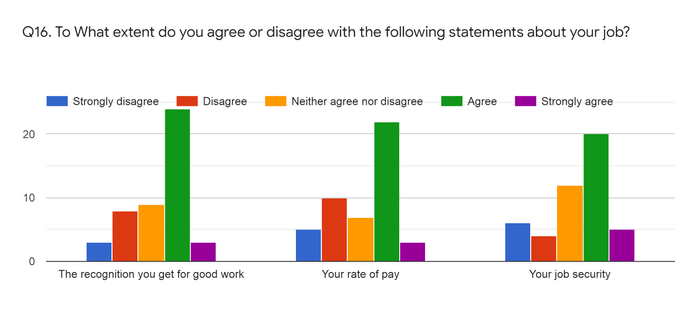
Performance: When asked how they think their performance at work compare to others doing a similar job 21.3% said their performance is about the same as other people in a similar role, 40.4% said their performance is higher and 36.22% said their performance is much higher. 2.1% said they did not know.
Leadership and Management
To assess participants views on the leadership and management of their organisation they were asked questions on respect, consultation, recognition and being kept informed.
Respect
When asked to what extent they agree or disagree that the directors/senior management team of their organisation treat employee with respect 27.7% of participants said always, 34 % said usually, 31.9% said sometimes, 4.3% said rarely and 2.1% said never.
Consultation
When asked to what extent they agree or disagree that the directors/senior management team of their organisation consults them on matters of importance to them 31.1% of participants said always, 14.9% said usually, 36.2% said sometimes, 12.8% said rarely and 4.2% said never.
Recognition
When asked to what extent they agree or disagree that the directors/senior management team of their organisation recognises when they have done a good job 23.4% of participants said always, 25.5% said usually, 38.3% said sometimes, 10.6% said rarely and 2.1% said never.
Being Kept informed (by manager/supervisor)
When asked to what extent they agree or disagree that the directors/senior management team of their organisation keeps in touch with them on what’s going on 27.3% of participants said always, another 27.7% said usually, 31.9% said sometimes, 10.6% said rarely and 2.1% said never.
Chart – Leadership and management
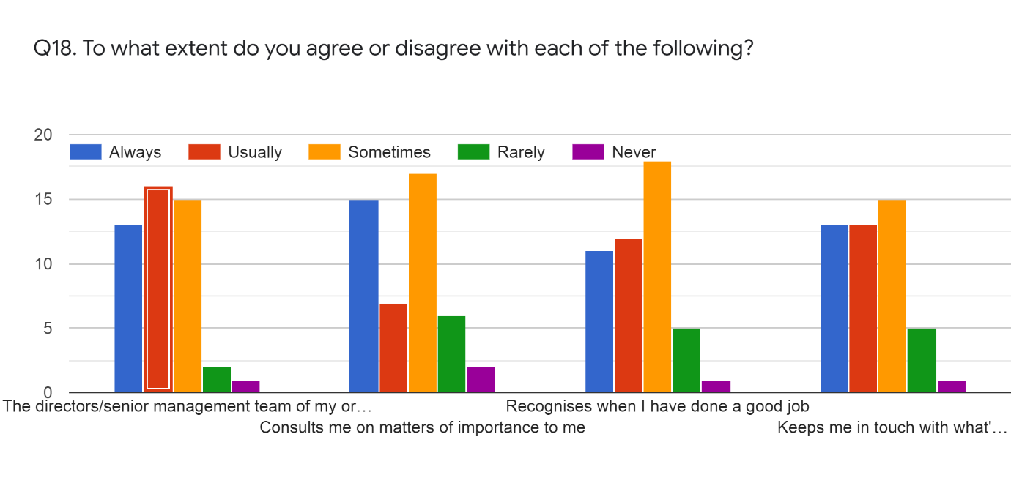

Communication
To assess communication within their organisations the participants were asked about being kept informed by their organisation, believe of information they receive, feedback opportunities and conflict resolution.
Kept informed (organisation)
When asked how well informed they feel about what is happening within their organisation 34% of participants said their organisation keeps them fully informed, 29.8% said their organisation keeps them fairly well informed, 6.4% said their organisation give them only a limited amount of information and 2.1% said they had no opinion.
Believe of information
When asked to what extent they can believe the information they receive about what is happening within their organisation 38.3% of participants said they can always believe it, 36.2% said they can usually believe it, 12.8% said they can believe it about half of the time, 8.5% said they seldom believe it and 4.3% didn’t give an opinion.
Feedback opportunities (employee voice)
When asked how satisfied they are with the opportunities that exist to feed their views upwards 19.1% of participants said they were very satisfied, 36.2% said they were satisfied, 31.9% said they were neither satisfied nor dissatisfied, 10.6% said they were dissatisfied and 2.1% didn’t give an opinion.
Chart – Employee voice
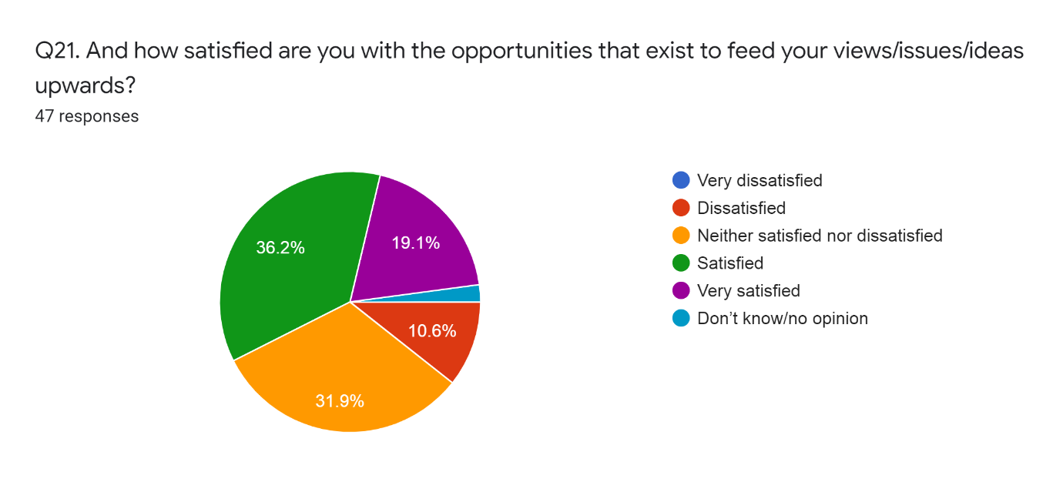

Conflict resolution
When asked if they would be confident that their problems, if they had any at work, would be dealt with fairly 14.9% of participants said they strongly agree, 55.3% said they agree, 12.8% said they neither agree nor disagree, 14 .9% said they disagree and 2.1% said they strongly disagreed.

The Future
To assess participants future intentions with their organisation they were asked about their intention to stay in current job, intention to remain with current employer, intentions to leave and reasons to quit current job, if any.
Intention to stay in current job
When asked about their intentions for their current job within the next year 8.5% said they wanted to stay where they are in their current job, 68.1% said they wanted to gain upward promotion to a higher level, 6.4% said they wanted to move to a position of similar responsibility in another area of their organisation, 10.6% said other reasons and 6.4% said they don’t know.
Intention to remain with current employer
When asked if they plan to remain with their current employer for the foreseeable future 57.4% said yes, 14.9% said no and 27.7% said they didn’t know.
Chart – Intentions to remain with current employer
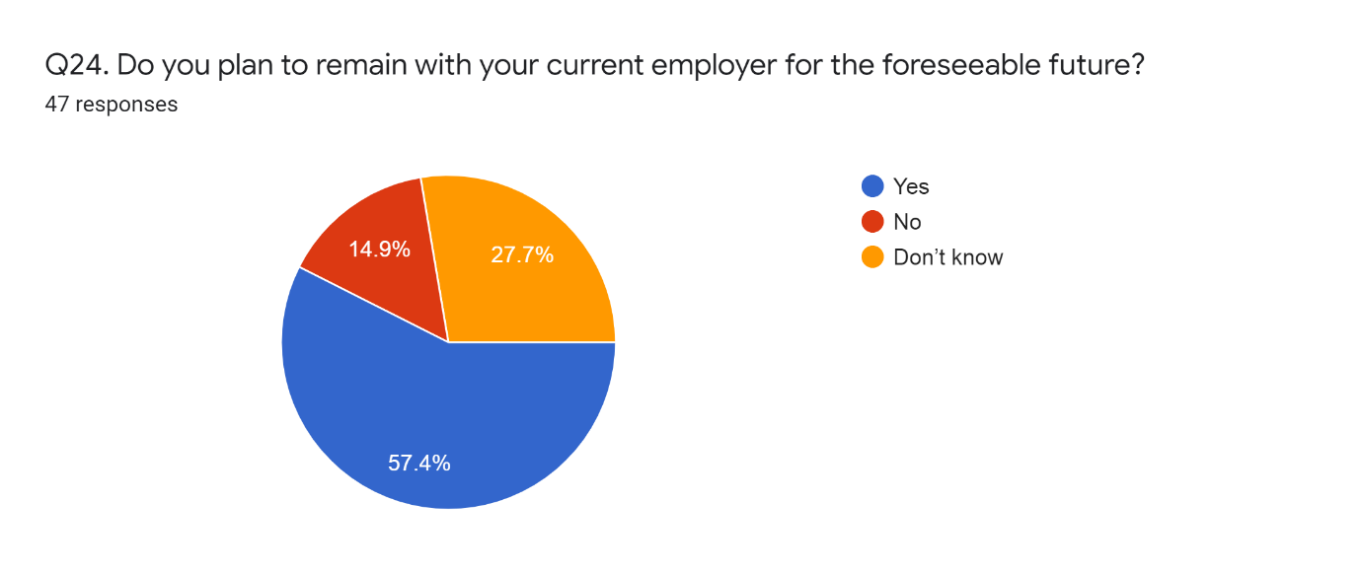
Intentions to leave
When asked if they had ever thought about or done anything to leave their current job 27.7% said they had never thought about leaving, 46.8% said they had sometimes thought about leaving but never done anything about it, 19.1% said they have looked around for other jobs and 6.4% said they were currently in the process of trying to leave.
Reasons to quit current job
When asked what is the likely reason that would make them want to leave their current job 40% of participants said would be for better pay/benefits, 25.7% said to be self-employed, 11.4% said for job satisfaction, 8.6% said to do a different type of work, 5.7% said it would be to find another similar job with a different organisation, 2.9% said it would be to find a different job within their own organisation. To put the figures into context, this was the only optional question and had 35 responses, so the percentages are not reflective on the entire participants.

Analysis
Assessment of cognitive, physically and emotional engagements
This report contains the results of several analyses that were conducted to examine the levels of organizational engagement across different employees. The sample consisted of 63 individuals, of which 16 were excluded due to leaving the questionnaire blank or not giving consent (n = 47).
The results presented in this report were generated using several statistical techniques: T-test, Analysis of Variance (ANOVA), correlation analysis and linear regression.
While the T-test is the appropriate test to compare the scores on a continuous variable between two different groups (Hair et al., 2014), analysis of variance (ANOVA) is used when differences between more than two groups are of interest (Pallant, 2010). Thus. to compare engagement scores between genders, T-test will be used, while ANOVA will be used to compare scores across age groups.
Correlation coefficients are indicators of associations between variables (Pallant, 2010). Values between 0.10 and 0.29 indicate a small degree of association, while values between 0.30 and 0.49 are considered medium and values higher than 0.50 represent a high degree of association (Cohen, 1988). This test will be used to measure the association between different types of engagement and several other variables.
Regression analysis is a technique used to explore the relationship between a continuous dependent variable and one or more independent (or predictor) variables (Pallant, 2010). This method will be used to explore the degree of influence of a variety of variables on overall organizational engagement.

Sample characteristics
55.3% of the sample reported to be male and 40.4% declared to have a managerial position in the organization (graphs below).

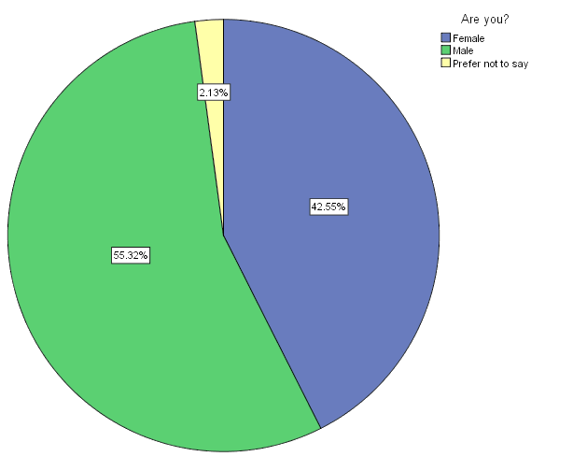
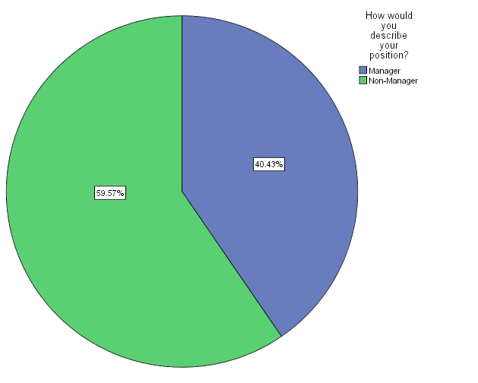

The majority of the sample was between 30 and 44 years old (40 out of 47). The graph below shows the distribution of ages across the sample.

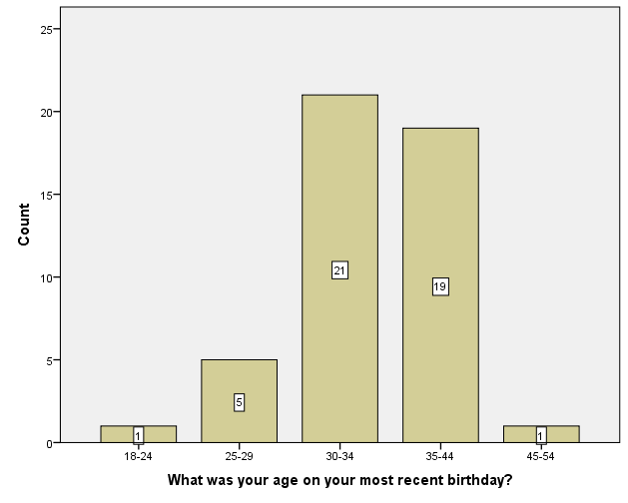

Descriptive statistics
Firstly, graphs were generated to show the distribution of responses (divided by gender) related to each engagement category.
Cognitive engagement
The first bar graph below displays the response frequencies for the first question regarding cognitive engagement. Male responses leaned towards disagreement and neutral (neither agree nor disagree). The amount of female who agreed to the statement was higher when compared to male.
The graphs shown below, however, are just for visualization purposes. The significance of the differences in engagement between male and female are still subject to statistical verification, which will be shown later in the document.

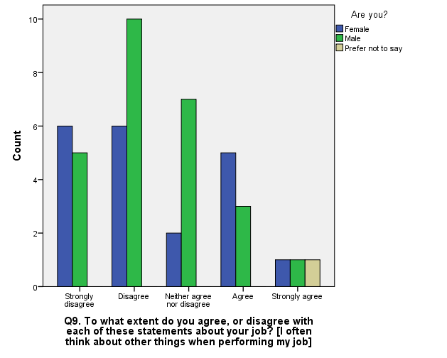

The second graph (below) demonstrates the frequencies of responses of the second question regarding cognitive engagement, for both genders. Both male and female appear to agree with this statement.

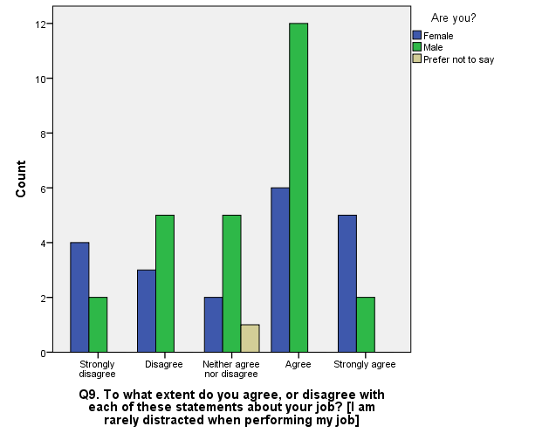
Emotional engagement
In terms of emotional engagement, the overall sample performs well. Most of the people (male and female) seem to be attached to their jobs. The second graph (below) represents the results of a question that is reverse scored (disagreeing with the statement represent more emotional attachment).

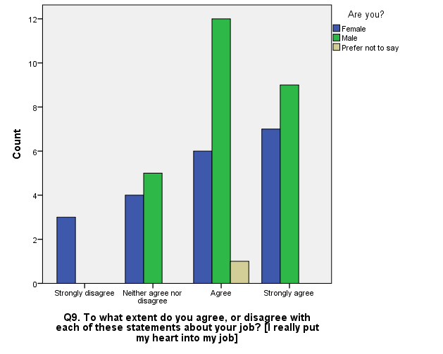
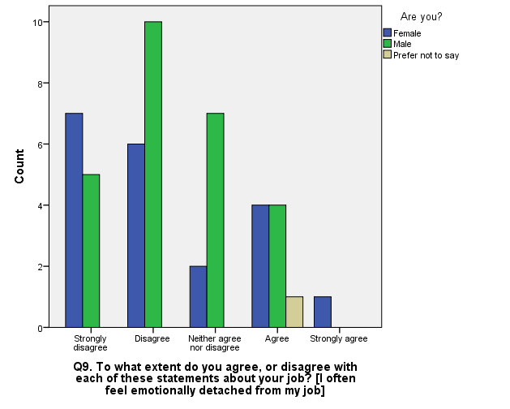

Physical engagement

Physical engagement is also very high across the sample (graphs below), with most people agreeing with both statements.
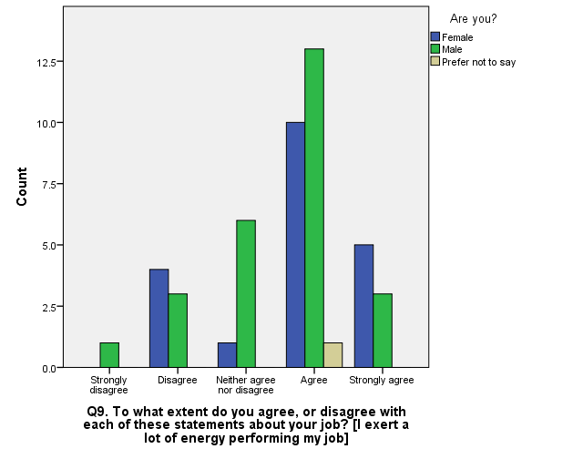
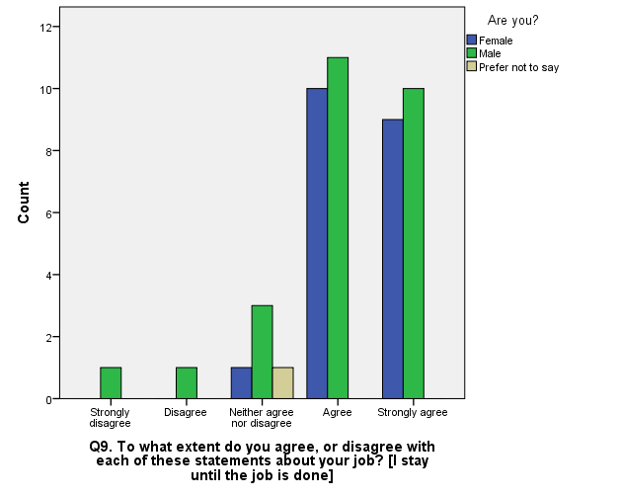

Mean comparisons
Gender comparison

The first hypothesis to be tested using Independent samples T-tests was that different genders have significantly different engagement scores. To calculate engagement scores, the corresponding questions were recoded into numerical scales ranging from 1 to 5 (strongly disagree to strongly agree). Then, scores were summed to represent the engagement category (e.g. cognitive engagement). All three categories were then summed to form a total ‘overall engagement’ score. The figure below shows the descriptive statistics of these variables (along with performance and respect).

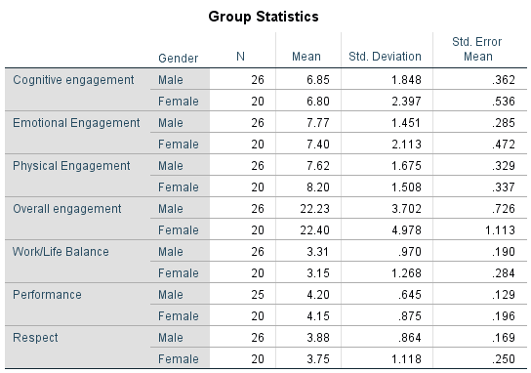

Although the mean scores appear to be relatively different across genders for all variables, the statistical significance of these scores need to be evaluated. This is shown in the next figure.
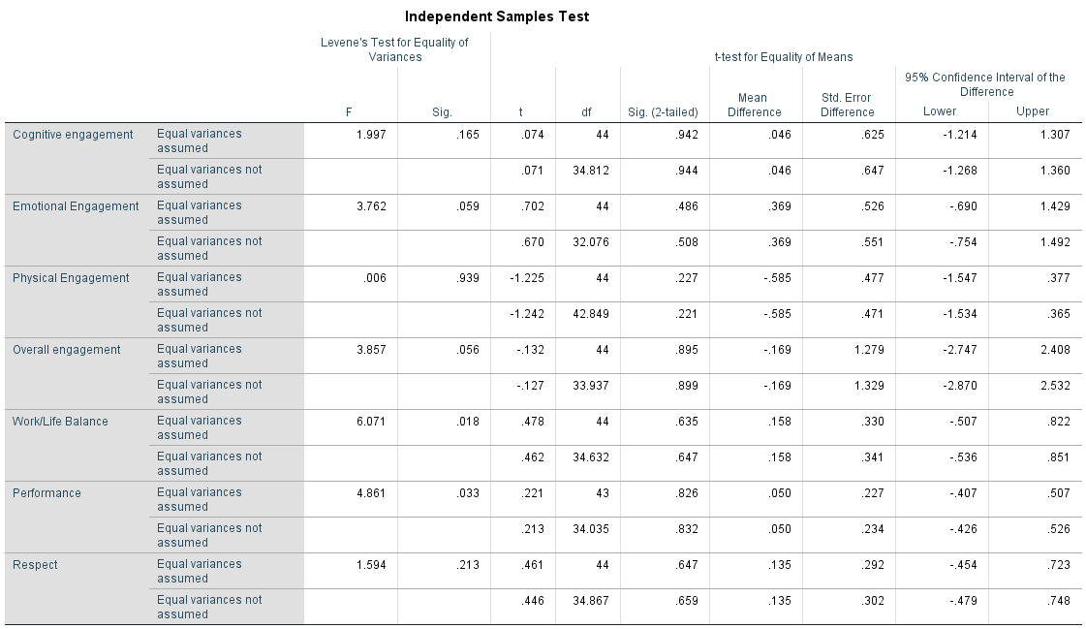

The column ‘Sig.’ in the figure above displays the p-value corresponding to the difference on mean scores across each variable (for the case where variances are equal or not). As can be seen, all p-values are above the significance level of 5% (p > 0.05), which means that genders do not differ in terms of any of the assessed variables, considering the study’s sample.
Age intervals comparison

To compare age groups, ANOVA was used and its results are shown below.
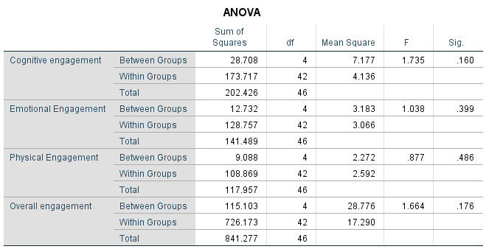
As in the case of the t-test for genders, the column ‘Sig.’ represents the statistical significance of the differences between age groups. The values are also all above 0.05 (p > 0.05) meaning that scores in all the assessed variables (first column) are the statistically the same across all age groups.
Position comparison
Lastly, a comparison test was performed for managerial and non-managerial positions.
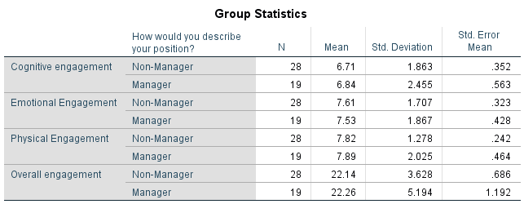

The absolute differences demonstrated on the figure above were small and the non-significance of these discrepancies was confirmed through the t-test (figure below). ‘Sig.’ was higher than 0.05 for all variables tested. Thus, there is no difference in scores between managerial and non-managerial positions.
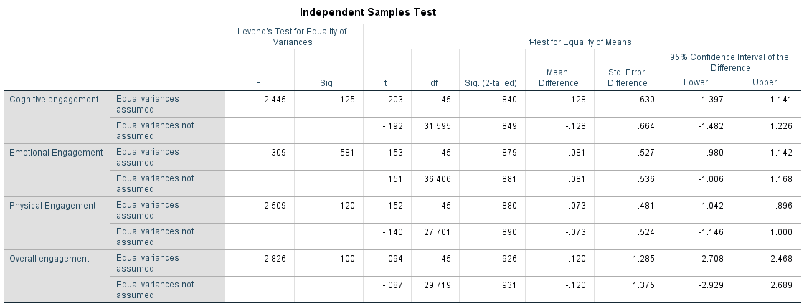
Correlation analysis
The results of the correlation analysis are shown in the figure below. The figure displays a matrix of correlations coefficients between 10 different variables. The values should be interpreted following the guidelines of Cohen (1988): values between 0.1 and 0.29 are considered weak correlations; between 0.30 and 0.49 moderate correlations and above 0.50 are strong correlations.
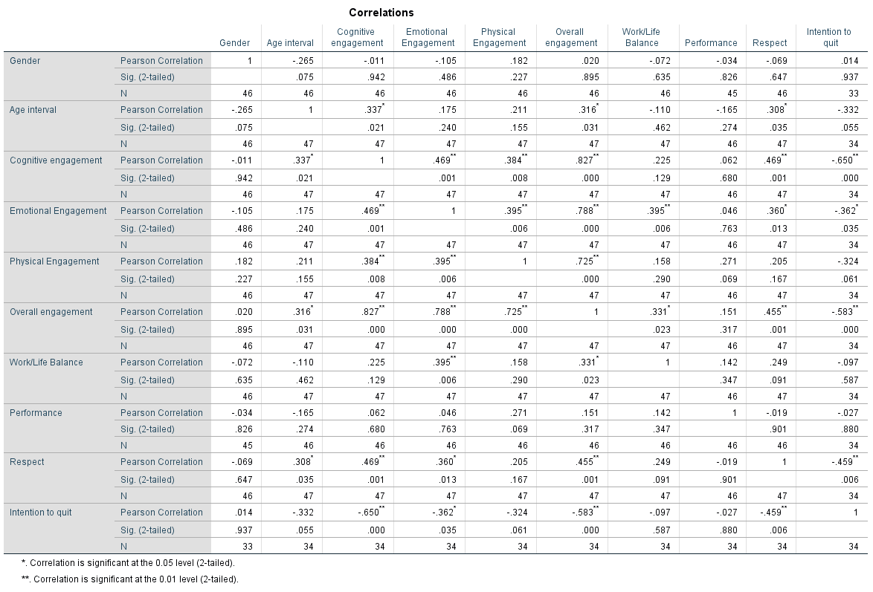

Specifically looking at engagement scores, age is positively correlated with cognitive and overall engagement (r = 0.337 and r = 0.316). That is, when age increases, both these engagements increase as well. Work/Life balance is positively correlated with emotional engagement and overall engagement, but not with cognitive and physical. That is, the stronger the perception of a good work/life balance, the more an employee feel emotionally attached to the organization. Surprisingly, performance is not significantly correlated with any engagement categories. The perception of respect within the organization is correlated with cognitive, emotional and overall engagement. The intention to quit the organization is negatively correlated with all forms of engagement, indicating that the higher the willingness to stay in the organization, the lower the emotional, physical and cognitive engagements.

Regression analysis
Overall engagement
The first regression model was performed to examine the degree of influence that some variables (gender, age, position, work/life balance, respect and intention to quit) have on overall engagement.
The most important assumption of regression analysis is that the dependent variable follows a normal distribution. This can be tested using Kolmogorov-Smirnov’s and Shapiro-Wilk’s tests. In both tests, significance (p < 0.05) mean that normality is not present. Here, both values exceeded 0.05 (figure below) thus normality can be assumed and this assumption was not violated.
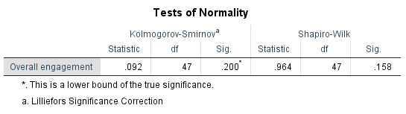

The ANOVA test for the model was significant (p < 0.05) (figure below), meaning that the model is valid and the regression coefficients can be interpreted.
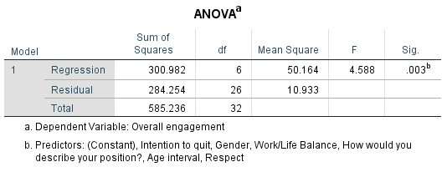
Next figure shows the adjusted R-square for the model (Adj R² = 0.402). This value means the total variance in the variable ‘Overall engagement’ that is explained by all the variables that were inserted in the model. In other words, all variables “explain” 40.2% of the variance in Overall engagement.
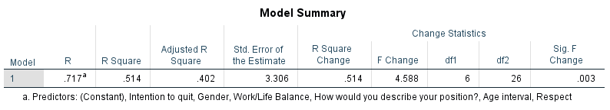

Next, we look at beta coefficients and their significance (columns ‘Beta’ and ‘Sig.’, below). The only variables that significantly influence overall engagement are work/life balance (β = 0.37, p < 0.05) and intention to quit (β = -0.359, p < 0.05). The coefficient for intention to quit is negative, which means that a higher intention to quit negatively affects overall engagement.

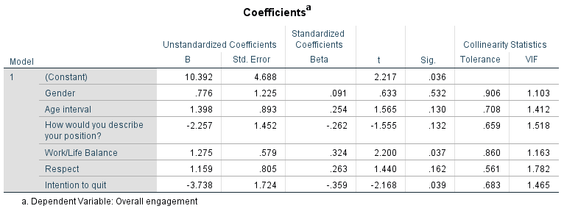

Performance

This analysis was not feasible since performance variable had only three values. Thus, the assumption of normality is largely violated.
Summary
The following conclusions can be drawn, based in the results presented in this report:
- There is no difference across genders, age groups, or position in terms of any form of organizational engagement;
- Cognitive engagement is positively associated with age and respect, while being negatively associated with intention to quit;
- Emotional engagement is positively associated with work/life balance and respect, while being negatively associated with intention to quit;
- Physical engagement is not significantly correlated with any other variable besides the other forms of engagement;
- Overall engagement is positively associated with age, work/life balance and respect, while being negatively associated with intention to quit;
- Work/life balance has a positive effect on overall engagement, while intention to quit has a negative effect on the same variable.

Chapter 5- Discussion, Conclusion, Recommendation
The research revealed surprising higher levels of employee engagement and therefore the hypothesis stated in this report that engagement levels within Ghana’s banking sector cannot be proved. Rather, there is evident from this research that the opposite is highly likely to be true. The overall engagement from this research is at 74% (average overall score was 22.9, which is 74% of 30), far higher than thought and dwarfs that of the CIPD 2006 research of 35%. Cognitive, Emotional and Physical engagements were 67.7%, 77.5% and 78.5% respectively. Whilst the survey answers the ‘what’ it does not answer the ‘why’ in most cases. This is because a decision was made to cover scope rather than depth due to time constraints by making use a survey. But why is employee engagement so high given the relatively recent bank closures? For one, time. The bank closures and forced mergers by the BoG happened between 2017 and 2018. The survey took place in March 2020. For most, that be a time period of two years. Perhaps this time period lessoned the fears of job insecurity, but this is just speculation. Another reason could be that only the most engaged workers were retained during this period with less engaged workers laid off. Employee engagement is correlated with performance but is not enough to cause it (Truss et al, 2006). The high levels of engagement found in this research is in line with recent banking performance in Ghana. A September 2019 report by the BoG (2019) stated that significant gains had been made since the onset of the banking sector reforms. The report also stated that the sector is now resilient and is expected to deliver much stronger performance (BoG, 2019).
Overall, the research revealed a content workforce. Respondents, a majority looks forward to going to work, were generally optimistic and agreed their job was meaningful to them. Most were proud to be working for their employer and would speak highly of their organisation as well as recommend their employer to someone seeking a job opportunity. This points to a strong advocacy and also higher levels of loyalty to their organisation and supervisors were found, which are both benefits of employee engagement. The vast majority were satisfied with their jobs. This is satisfaction is in line with their contentment with the recognition they get for a good work done, rate of pay and job security. Generally, they were content that management and leadership treat them with respect and keeps hem informed with what is going on, but there were mixed responses on being consulted on matters of importance to them. Importantly, the majority of employees plan to stay with their employer for the foreseeable future. This will increase retention rates and drive down the cost of recruitment which can be expensive as well as retaining knowledge and experience.
There were some areas of concern revealed by the research.
Stress and Pressure: There were high levels of stress found. 8.5% of respondents said their job is extremely stressful, 38.3% said their job was very stressful and 34% said their job was moderately stressful. Only 6.4% said their job was not stressful at all. Also, 36.2% of employees say they feel under pressure every day and 46.8% are under pressure once or twice a week. This can affect their health and adversely impact employee engagement and performance.
Work/Life Balance: There are concerns around work/life balance with 29.8 of employees disagreeing that they don’t have the correct balance between their home and work life. 6.4% strongly disagree and 17% were neutral.
Communication: 27.7% of employees said their organisation gives them only little amount of information and another 6.4% said their organisation doesn’t tell them much of what goes. Importantly, 42.5% of employees are not satisfied with opportunities to feed their views upward. This implies a large number of employees without a ‘voice’.
Thoughts of leaving current job: Even though a vast majority of employees plan on remining with their current employer for the foreseeable future, 46.8% of them say they have sometimes thought about leaving but have not done anything about it and 19.1% say they have looks around for other jobs.
Likely reason to leave current job: Of the likely reason’s employees stated to leave their current job, better pay/benefits and to be self employed were the main reasons. Maslow’s theory of hierarchy needs points out that once a lower level need has been achieved, it no longer serves as a motivator and they will want to satisfy the needs of the next level. This explains why employees will always be thinking of the question, so what next?

Implications
One of the objectives of this research was to find ways engage for managers to engage employees. Although engagement levels are generally high, there are some areas where managers need to pay attention in order to improve overall engagement or at least to prevent disengagement. These have been highlighted in the previous paragraphs and their management implications in an employee engagement context will now be discussed.
Stress and Pressure: Working in the banking sector does come with an acceptable level of pressure due to the demanding nature of the jobs and the risks associated with dealing with often large amounts of money. But being stressful and under pressure everyday can have a detrimental effect on the employee’s health which intends affects the organisational health. Truss et al (2006) suggest that managers can use appraisals as an opportunity to find out from employees about how they feel about stress levels in their job. Measures can then be put in place (example, job design, extra breaks and so on) to eliminate where possible, or reduce pressure and stress associated with their job.
Work/life balance: Analysis from the survey revealed that emotional engagement is positively associated with work/life balance and also, work/life balance has a positive effect on overall engagement. It’s been pointed out earlier that a significant number of employees are unhappy with their work/life balance. Other studies have found a link between individual health and work lives (Crabtree, 2005). An attempt will not be made to prescribe specific ways of improving work/life balance for employers in this dissertation as this fall outside its scope. The focus here is to point out to employers that a good number of employees are dissatisfied with their work/life balance. It is up to each organisation to prioritise this as a problem and to find effective ways to deal with this as failure to do this has severe ramification such as poor health and disengaged employees.
Communication: About 30% of employees are not satisfied with the amount of information given about what goes on in the organisation. Also, 42.5% of employees are not satisfied with opportunities to feed their views upward. One possible reason why communication is an issue might be a cultural context. Ghana scores of 80 on power distance (Hofstede’s cultural dimensions) which means employees in Ghana accept a hierarchical order and accept everyone has their place. This may explain a one-way communication system from managers to employees. Opportunities for upward feedback or employee voice, can result in employee involvement, which is important because from the literature review employee involvement is a step above employee engagement. Research by Robinson et al (2004) found two-way communication to be a driver of engagement. Kular et al (2008) suggests that training managers to be effective communicators might improve employee involvement and a sense of belonging.
Thoughts of leaving current job: While most employees (57.4%) plan on staying with their current employer for the foreseeable future, 14.9% plan on leaving. Analysis from the survey revealed that intention to quit has a negative effect on overall engagement. Furthermore, 46.8% of employees have sometimes thought about leaving but have not done anything about it. The major reasons employees are likely to leave their current jobs are to for better pay/benefits else where and to be self-employed. Employers must ensure they pay a fair and competitive wage to attract and retain talent. The idea is not to throw more money at employees just to make them happy. A Towers Perrin (2003) research found that as important as pay and benefits are, they play a less important role in engaging employees.

Summary and Conclusion
Employee engagement is a multifaced and multidimensional construct, with over 80 variants of definition. Without clarity on which definition(s) being used, it is easy to side-track and lose focus on the study of engagement. In evaluating employee engagement levels within Ghana’s banking sector, this research was focussed on Kahn’s (1990) definition of engagement which encompasses three dimensions of engagement namely cognitive, emotional and physical engagement. The evaluation of employee engagement in this study was assessed on these bases.
The overall aim of the research was to evaluate the level of employee engagement within Ghana’s Banking sector. The research had three objectives which are to measure the level of engagement within Ghana’s banking sector, determine how recent job losses within the sector is impacting on engagement and to determine ways to engage employees within the sector. All the objectives were met. Eengagement levels within Ghana’s banking sector are surprisingly high. The overall employee engagement is at 74%. Cognitive, Emotional and Physical engagements were 67.7%, 77.5% and 78.5% respectively. The hypothesis that employee engagement within this sector will be low as result of bank closures and job losses fell flat in the face of the data. A possible reason why issues facing the sector has not affected engagement could be due to the period between the peak of the problems and the time of research which was almost two years later. Another possible reason could be that only the most engaged workers were retained during this period with the less engaged workers laid off. A now resilient sector delivering stronger performance could also be a reason. But these are mere speculation which require further research establish the facts.
Overall, the research revealed a content workforce who are generally optimistic and highly engaged. But there were some areas of concern such as high levels of stress and pressure, dissatisfaction with work/life balance and upward communication issues which is resulting in some employees not having a ‘voice’. The management implications of these as well as ways to motivate employees have also been discussed.
The banking sector plays a vital role in the health of any country and that of Ghana is no exception. Employees engagement has the potential to create a motivated and engaged workforce that can deliver all these benefits especially to a developing nation such as Ghana. Furthermore, engagement can provide numerous benefits to both the employer and employee as well as being a source of competitive advantage for the organisation.
Finally, engagement is a process that never ends. An engaged employee today could be disengaged tomorrow if not managed properly. Employee engagement should be prioritised and weaved into the DNA of organisations in order to take a long-term view and maximise its effects.

Recommendations for further research
Though this survey has revealed some interesting finding, it is not enough. A lot of questions remain answered in part due to the method of research. By researching solely quantitatively due to time and resource constraint, the focus was on scope rather than depth. This means hat certain contextual detail may have been lost, despite all attempts to minimise these. For example, the research revealed engagement was not affected by the job losses within the sector, but did not reveal why? This remains puzzling. Could it be time? Could it be that only the most engaged were retained and less engaged laid off? Does the current resilience and strong performance of the sector have anything to do with the high engagement levels? These are all questions that remain answered. Further research into this is recommended. A mixed research method approach should reveal some knowledge gaps. It is only when all the relevant questions have been answered that managers and organisations can better engage their employees.

References
Albrecht, S. (2010). Handbook of employee engagement. Cheltenham, England: Edward Elgar.

Alderfer, C. P. (1972). Existence, Relatedness and Growth, Collier Macmillan.

Azege, M. (2009). The Impact of Financial Intermediation on Economic Growth: The Nigerian Perspective. Research Seminar Presented at the Lagos State University

Babbie, E. R (2010) The Practice of Social Research. 12th ed. Belmont, CA: Wadsworth Cengage

Blessing White. (2006). Employee Engagement Report 2006 BlessingWhite, Inc. Princeton, New Jersey.

BlessingWhite (2008), The State of Employee Engagement. [online]. Available at: http://blessingwhite.com/wp-content/uploads/2014/02/chapter1.pdf [Accessed: 13 Feb. 2020]

BoG, 2019. Banking Sector Report. [online] Available at: <https://www.bog.gov.gh/wp-content/uploads/2019/10/Banking-Sector-Report-September-2019.pdf> [Accessed 23 March 2020].

Bryman, A. 2015. Social Research Methods. OUP Oxford Publishing. London.

Baumruk, R. (2004) ‘The missing link: the role of employee engagement in business success’, Workspan, Vol 47, pp48-52.

Cohen, J., 1988. Statistical power analysis for the behavioral sciences, 2nd ed. Erlbaum, Hillsdale, NJ.

Csikszentmihalyi, M. (1975) Beyond boredom and anxiety. San Francisco, Jossey-Bass.

Csikszentmihalyi, M. (1990) Flow: The Psychology of Optimal Experience. New York,
Harper.

Deci, E. L., & Ryan, R. M. (2008). Facilitating optimal motivation and psychological well-being across life’s domains. Canadian Psychology, 49, 14–23.

Denzin, K. and Yvonna S. L. “Introduction: The Discipline and Practice of Qualitative Research.” In The Sage Handbook of Qualitative Research. Norman. K. Denzin and Yvonna S. Lincoln, eds. 3rd edition. (Thousand Oaks, CA: Sage, 2005), p. 10.

Dzawu, M. (2019). Ghana’s Shutdown of Second-Tier Lenders Seen Risking 4,000 Jobs. [online] Bloomberg.com. Available at: https://www.bloomberg.com/news/articles/2019-08-20/shutdown-of-ghana-lender-gn-savings-puts-2-700-jobs-at-risk [Accessed 7 Dec. 2019].

Frank, F.D., Finnegan, R.P. and Taylor, C.R. (2004) ‘The race for talent: retaining and
engaging workers in the 21st century’, Human Resource Planning, Vol 27, No 3, pp12-25.

The Gallup Organisation (2004) [online] Available at: www.gallup.com. Accessed 01 Jan
2020.

Goffman, E. (1961) Encounters: Two Studies in the Sociology of Interaction. Indianapolis,
Bobbs-Merrill Co.

Hair, J.F., Black, W., Babin, B., Anderson, R., 2014. Multivariate data analysis, Seventh. ed. Pearson Education, Inc., Edinburgh.

Harter, J.K., Schmidt, F.L. and Hayes, T.L. (2002) ‘Business-unit level relationship between
employee satisfaction, employee engagement, and business outcomes: a meta- analysis’,
Journal of Applied Psychology, Vol 87, pp268-79.

Hyman, J. and Mason, B. (1995) Managing Employee Involvement and Participation.
London, Sage.

Hoffman, E., & Soglian, F. (2009). Enhancing employee engagement: A validation study in Italy. IHRIM Journal. Vol 13, No 3.

Hofstede, G., (1997) Culture and Organisation: Software of the Mind, Intercultural
Cooperation and its Importance for Survival. London: Harpercollins Business.

Hofstede, G. (1991) Culture and Organizations Software of the Mind. (London et al.: McGraw-Hill. German translation by G. Hofstede, Lokales Denken, globales Handeln. Kulturen, Zusammenarbeit und Management, 5th ed. (Mu¨ nchen: Beck, 2009).

Holbeche, L. and Springett, N. (2003) In Search of Meaning in the Workplace. Horsham,
Roffey Park.

Johnson, G., Whittington, R., Scholes, K. (2011) Exploring Corporate Strategy: Text and Cases, 9th ed. Harlow: FT Prentice Hall

Johnson, G. (2004) ‘Otherwise engaged’, Training, Vol 41, No 10, p4.

Kahn, W.A., (1990) ʹPsychological conditions of personal engagement and disengagement at workʹ, Academy of Management Journal, 33(4), 692–724

Kanungo, R.N. (1982) ‘Measurement of job and work involvement’, Jourmal of Applied
Psychology, Vol 67, pp341-349.

Kelleher, B. (2014) Employee Engagement For Dummies. New Jersey. John Wiley & Sons, Inc.

Knight, R. (2011). Employee engagement: A study of employee engagement at Topaz’s South Dublin Region Service Station. Unpublished master’s dissertation, National College of Ireland, Dublin.

Konrad, A.M. (2006) ‘Engaging employees through high-involvement work practices’, Ivey
Business Journal, March/April, pp1-6.

Krech, D., Crutchfield, R. S. and Ballachey, E. L. (1962). Individual in Society. McGraw-Hill

Kroeber, A.J and Kluckhohn, C. (1952) Culture. A Critical Review of Concepts and Definitions. New York, NY: Random House, 1952, p. 181

Kular, S., Gatenby, M., Rees, C., Soane, E. and Truss, K (2008) “Employee Engagement: A Literature. Review”, Kingston Business School, Kingston University

Levinson, E., (2007), Developing High Employee Engagement Makes Good Business Sense. [online] Available at: www.interactionassociates.com/ideas/2007/05/developing_high_ employee_engagement_makes_good_business_sense.php [Accessed 02 Dec, 2019].

Lockwood, N.R., (2007) Leveraging employee engagement for competitive advantage: HR’s strategic role. Society for Human Resource Management Quarterly

Lucas, R., Lupton, B. and Mathieson, H. (2006) Human Resource Management in an
International Context. London, CIPD.

Macleod, D. and Clarke, N. (2009) Engaging for Success (London: Office of Public Sector Information).

Mauno., S., Kinnunen, U. and Ruokolainen, M., (2007) Job demands and resources as antecedents of work engagement: a longitudinal study. Journal of Vocational Behavior, 70, 149–171

May, D.R. Gilson, R.L. and Harter, L.M. (2004) ‘The psychological conditions of
meaningfulness, safety and availability and the engagement of the human spirit at work’,
Journal of Occupational and Organisational Psychology, Vol 77, pp11-37.

Maslow, A. (1954) Motivation and Personality. New York, Harper and Row.

Mondy, R.W., Holmes, R. E. and Flippo, E.B., (1940): Management: Concepts and Practices. Allyn and Bacon, Inc., 269-276

Muijs, D. (2010) Doing Quantitative Research in Education with SPSS. 2nd edition. London: SAGE Publications.

Mullins, L.J. and Christy G. (2010) Management and Organisational Behaviour, Pearson Education

Ott, B. (2007) ‘Investors take note: Engagement boosts earnings’, The Gallup Management
Journal, 14th June.

Ozguner, Z. and Ozgunr, M. (2014) A Managerial point of view on the Relationship between Maslow’s Hierarchy of Needs and Hertzberg’s Dual Factor Theory. International Journal of Business and Social Science, 207–215.

Pallant, J., 2010. SPSS Survival Manual, 4th ed. McGraw-Hill, Berkshire, England.

Purcell, J., Kinnie, N., Hutchinson, S., Rayton, B. and Swart, J. (2003) Understanding the
People and Performance Link: Unlocking the Black Box. London, CIPD.

PWC (2019). Banking reforms so far: topmost issues on the minds of bank CEOs. [online] Pwc.com. Available at: https://www.pwc.com/gh/en/assets/pdf/ghana-banking-survey-2019.pdf [Accessed 7 Dec. 2019].

Robinson, I. (2006) Human Resource Management in Organisations. London, CIPD.

Robinson, D., Perryman, S. and Hayday, S. (2004) The Drivers of Employee Engagement.
Brighton, Institute for Employment Studies.

Richman, A. (2006) ‘Everyone wants an engaged workforce how can you create it?’ Workspan, Vol 49, pp36-39.

Rothbard, N.P., (2001) Enriching or depleting? The dynamics of engagement in work and family roles. Administrative Science Quarterly, 46, 655–684

Saks, A.M. (2006) ‘Antecedents and consequences of employee engagement’, Journal of Managerial Psychology, Vol 21, No 6, pp600-619.

Scottish Executive Social Research (2007), Employee engagement in the Public Sector: a review of literature. [online] Available at: www.scotland.gov.uk/Publications/2007/05/09111348/3 [Accessed: 02 Dec. 2019]

Seijts, G.H and Crim, D. (2006) ‘What engages employees the most or, the ten C’s of
employee engagement’, Ivey Business Journal, March/April, pp1-5.

Shaw, K. (2005) ‘An engagement strategy process for communicators’, Strategic Communication Management, Vol 9, No 3, pp26-29

Steers, R. M. and Porter, L. W. Motivation and Work Behaviour, fifth edition, McGraw-Hill (1991), p. 35.

Steiner, W. H., et al (1963). Money and Banking: An Introduction to the Financial System. New Delhi: Prentice Hall.

Truss, C., Soane, E., Edwards, C., Wisdom, K., Croll, A. and Burnett, J. (2006) Working Life: Employee Attitudes and Engagement 2006. London, CIPD.

Ubom, U. B. (2009). Economic Absorption and the contributions of banks to Economic development in Nigeria. Journal of Business and Finance, 2(1), 229 – 241.

World Bank (2011). Ghana Looks to Retool Its Economy as it Reaches Middle-Income Status. [online] World Bank. Available at: https://www.worldbank.org/en/news/feature/2011/07/18/ghana-looks-to-retool-its-economy-as-it-reaches-middle-income-status [Accessed 1 Jan. 2020].

Appendices
Appendix 1 – Introduction and Consent
Dear Reader,
I am currently studying for a Master of Business Administration with the University
of Wales, TSD. As part of the course, I have to complete a dissertation. The topic
for my dissertation is Evaluating Employee Engagement Within Ghana’s Banking
Sector. My aim is to determine how engaged employees working within Ghana's
banking sector are given recent bank closures and reforms by the Bank of Ghana.
This is an independent research and is not commissioned by any organisation. The
survey takes about ten minutes and the information collected is not identifiable
and therefore, cannot be traced to you. This is strictly anonymous and confidential.
All data collected will be destroyed after analysis. Thank you.
Kind regards,
Bill Bakomora

Consent
By continuing with this survey, you agree to participate in this research

The amount of capital required by a financial regulator that a bank or financial institution needs to have.
https://www.qualtrics.com/uk/lp/uk-ppc-demo-request/?utm_source=google&utm_medium=ppc&utm_campaign=brand+bmm+uk+spart&campaignid=649321870&utm_content=&adgroupid=45256922394&utm_keyword=qualtrics&utm_term=qualtrics&matchtype=b&device=c&placement=&network=g&creative=338371026696&gclid=Cj0KCQiA_rfvBRCPARIsANlV66O_Ozy6AcBiRyg0f-SXyfz1xVdYl1kDfHxl06fhy6h1miq6OBLsIl0aAmKCEALw_wcB
research@cipd.co.uk

