

BA Business management
Code: LCBB4004
Module: Marketing Fundamentals
Lecture name: Mohammad Rahman
Student ID: 2131735
Student name: Stefan Genchev
Lecture name: Mohammad Rahman

Introduction of the marketing and company brief Tesco PLC
Tesco is a multinational British-based grocery chain that was established in 1919 by Jack Cohen. This British-origin international brand is headquartered in Welwyn Garden City, England. In terms of gross revenue, it is the world's third-largest retailing chain and as par revenue, it stands in the ninth position among the topmost retailing chains around the globe (Palmer, 2020). Currently, it occupies around 28.4% of the retail market. In 2021 the revenue of Tesco was £57.887 billion and the net income was £6.147 billion (Humby, Hunt and Phillips, 2021). Currently, the company has created employment opportunities for around 3,50,000.

Marketing mix
Product
Tesco sells a variety of products including foods, clothing, financial services, electronics etc. The product line of Tesco tries to meet every need and demand of the consumers and thereby it has expanded its business in the online sectors as well. It has more than 40,000 product lines that are deliberately offered for meeting consumer needs and wants (Palmer, 2019). It has introduced many products in its own private label such as Tesco loves baby, Tesco Lotus, Tesco Bank etc. Tesco bank provides credit and loans to customers who are unable to pay for their purchases.
Price
Tesco always tries to keep the price of its product as low as possible while keeping the high quality of the products. To get a cost advantage, it uses economies of scale which indicates that the company supplies a lot of products which ultimately reduces the product price hence, Tesco can easily supply products at a relatively lower cost than the competitors (Turner and Wilson, 2016). The low-cost strategy has helped Tesco in becoming the market leader in the UK. Many assumed that due to increasing energy prices, the company might increase its price but the company has operated beyond expectations and the prices are still low which indicates the success of the company's values (Woods, 2017). For each purchase, the consumers also get points which can also be used for further purchases and ultimately it helps in increasing sales of Tesco.
Place
The company has more than 7000 operational stores around the globe. The stores are classified on different terms such as Tesco metro, Tesco Extra, Tesco Express, Tesco superstore etc. depending upon the size of the stores. Tesco superstores are those stores which are supermarkets and these usually sell non-food items and groceries (Munusamy and Wong, 2018). 1000 square metres stores operating in towns and cities are regarded as Tesco metro. Tesco Express are those stores where the company sells essential products and high-margin products. The product of Tesco Express is usually higher because it sells exclusives and premium products. Tesco Extra is a hyper store that sells a variety of products under one roof it usually sells groceries and other generic merchandisers and it enables the customers to meet all their daily supplies from one store (Turner and Wilson, 2016). Tesco also sells its products through its website where it takes orders and then distributes the products through its efficient distribution channels.
Promotion
As Tesco is known for its low cost, its promotional strategies are associated with the idea of communicating with the consumers regarding the low price of Tesco. It uses both ATL and BTL advertising for interacting with consumers. It uses TV ads, billboards, and charitable events to communicate with consumers regarding the brand values of Tesco. It also gives discounts and other promotional offers on different events which ultimately lures consumers into purchasing more products it also gives a loyalty card which is regarded as a Tesco club card which enables the company in segmenting and targetting the consumers and by utilising the club card that consumers get points and then they can redeem those points to get discounts for further purchases (Rowley, 2015). The company also uses digital marketing processes such as online marketing or social media marketing to communicate with consumers.

Segmentation targeting and positioning
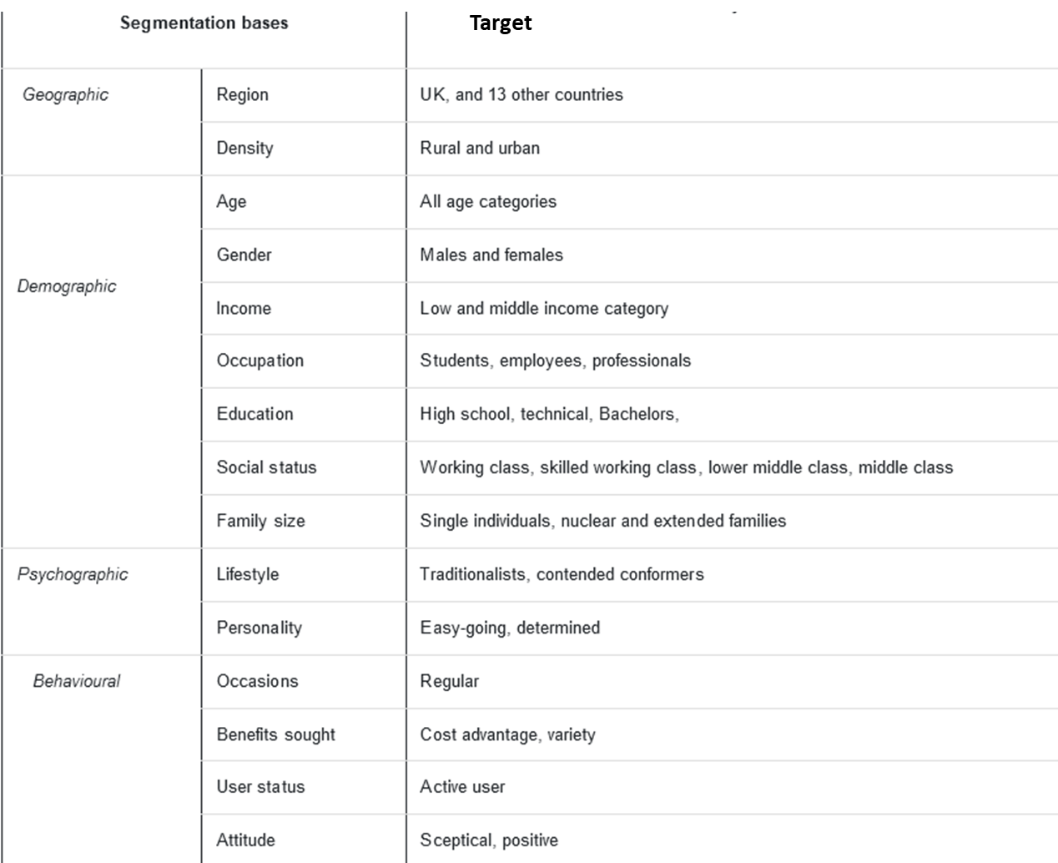
Geographically Tesco segments the market based on region and density. Regionally it targets consumers in the UK and 13 other countries and it also targets consumers in rural and urban areas (Lindgreen and Hingley, 2022). That demographic segmentation segments the market based on age income gender occupation education social status family size etc. It targets all aged consumers both male and female as well as eight tries to sell its product to low and middle-income consumers. on psychographic al segmentation, it segments the consumers based on lifestyles and personality and it targets the traditional easygoing concentrated and determined consumers (Woods, 2017). The positioning strategy of Tesco is that it wants to position itself as a low-price retailer as it uses its advertising catchphrase “cheapest price every day”.
The marketing blogs are provided in the following section,

Marketing blog 1: Cheapest price every day
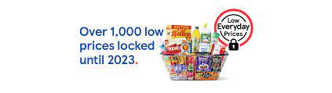
Figure 1: Cheapest price every day (Aiello et al., 2020)
We at Tesco PLC always try to give our consumers the best price possible. Because of the economies of scale, we as a brand can supply the products in an efficient manner and ultimately we have the liberty to provide the customers with the best price. Our stores are big and in our big stores we sell more than 4000variety of products and due to this huge scale of supply of products, we can reduce our operational cost and ultimately we give the consumers the cheapest price that the computers cannot compete with (Aiello et al., 2020). We become efficient due to the huge experience that we have gained during the last 100 years of operations and ultimately we can give you the best price then no other groceries chain can provide.

Marketing blog 2: Distribution of your needs at your doorstep
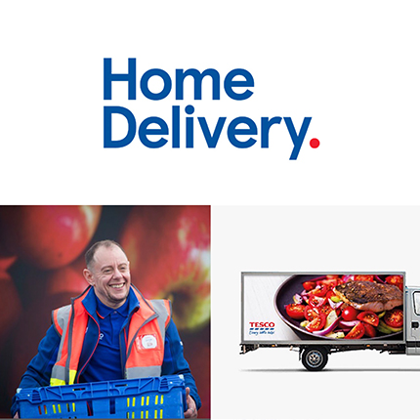
Figure 2: Distribution of the needs at the doorstep (Enders and Jelassi, 2019)
Since the pandemic, consumers have started to face difficulty in going to shops for purchasing their daily needs. We as a brand have understood that the consumers are facing trouble going outside and thereby we have come up with the solutions because we as a brand hope to satisfy all the needs and demands of the consumers (Aiello et al., 2020). Through our analysis, we have found that the consumers have become reluctant to go to the shops and thereby we have started our website through which the consumers can place an order for their needs and through our efficient distribution channel we are trying our best to supply that product at the doorstep of the products within two days. Our distribution channel works in an efficient manner because we do not supply the products from our regional storehouse, rather we supply those products through our local stores and then through utilising our tracking vehicles and establishing a delivery network we are reaching the consumers (Enders and Jelassi, 2019). Due to globalisation, many consumers have started to operate their operations from home and thereby they do not go to offices because they are staying at home for a longer period and do not go outside which has also helped us to understand that the consumers are wanting products or services at their home at their doorstep and we uh trying to utilise that needs of the consumers and we are trying to fulfil that needs and demands of the consumers and thereby we are reaching to those consumers and we are trying to giving the consumers that product that the consumers are wanting and which has helped us to increase our sales revenue and ultimately made Tesco profitable.

Marketing blog 3: Tesco understands the value of customer loyalty
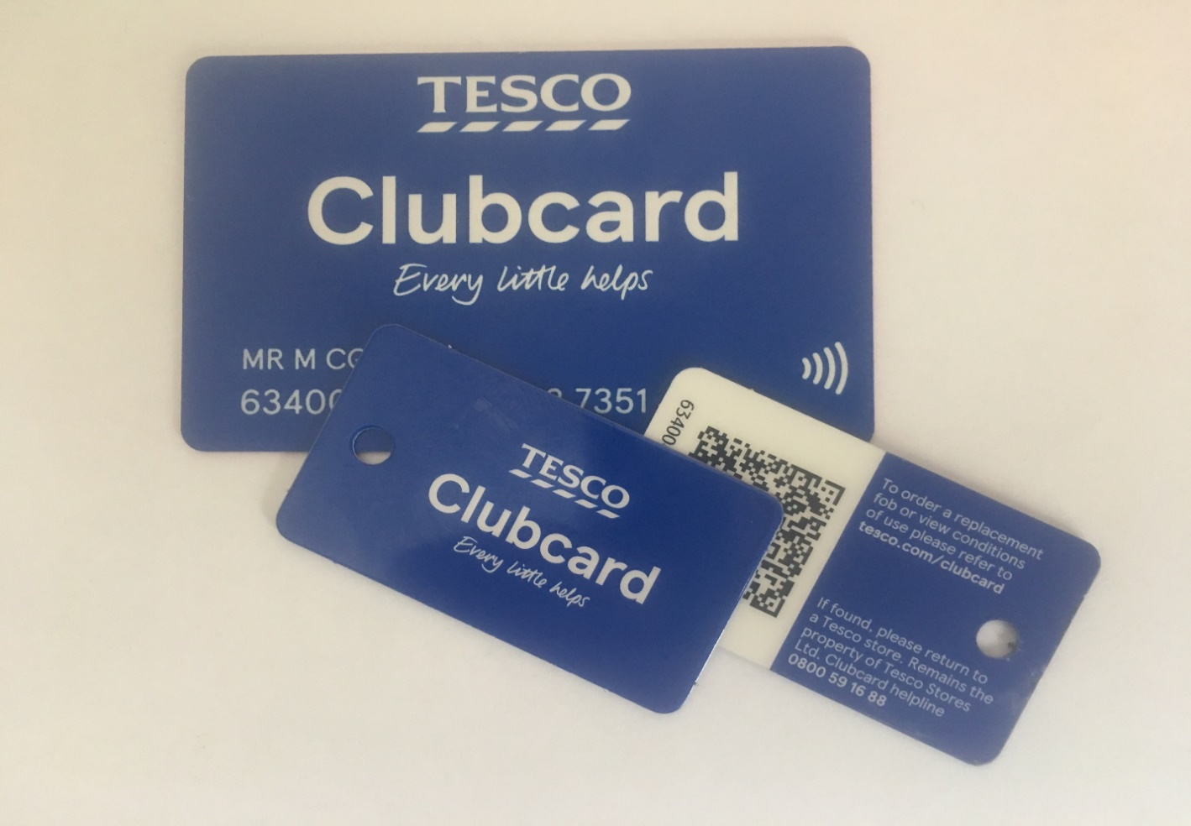
Figure 3: Tesco Clubcard (Evans and Mason, 2018)
The customer base of Tesco is working middle-class people are students who are either from lower middle-class families or higher middle-class families and usually they do not want to spend a lot of money. Tesco understands that to retain these customers or to make these customers loyal to the brand the company needs to offer products at a low cost. The company also understand that if the consumers become loyal to the brand then they can be beneficial from the proportional growth of the company thereby providing benefits to its loyal customers the company has started its loyalty card which is known as the Tesco Clubcard and if consumers who are regular to the brand purchases more and more products from the stores of Tesco then they would get many points and by redeeming those points these consumers can get additional benefits when they purchase new products (Evans and Mason, 2018). Tesco also offers free products or free benefits to the consumers who have enough points in that Tesco Clubcard and thereby the consumers who become loyal to the brand become satisfied and they start to purchase more products from Tesco.

Marketing blog 4: Tesco: One stop thousand options
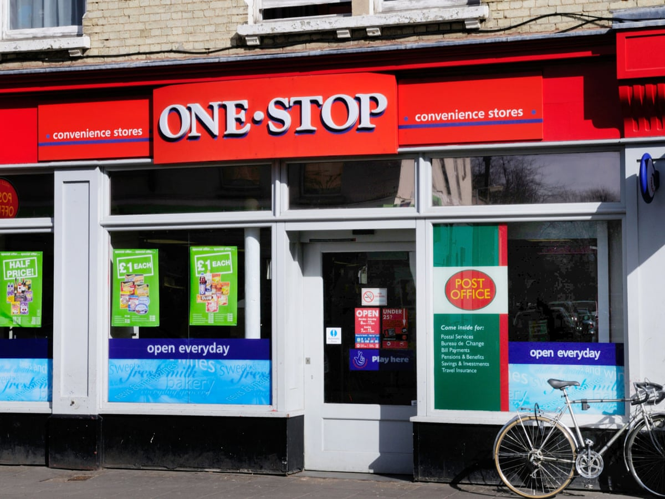
Figure 4: One-stop thousand options (Gopalia, 2022)
Tesco has become successful in its low-cost theory due to its economies of scale. It got its economies of scale due to its huge activity in supplying products of more than 40,000 product lines. Here consumers can find products such as clothes from different brands including Tesco’s own private brands. The consumers can find foods and groceries they can also find health and beauty products here. Consumers can also find entertainment products as well as educational products like books. Consumers can also find pieces of jewellery. If any consumer wants to find products for their newly born baby then they can find baby products which are branded under Tesco’s own private level named Tesco loves baby (Gopalia, 2022). Tesco also provides banking services to consumers who are finding difficulty in purchasing products as well as Tesco provides saving accounts to its consumers. So you can come to take service from Tesco and here at one stop you will get thousands of services that can make your life easy and ultimately we can assure you that through our service and efforts we will try our best to make you satisfied.

Marketing blog 5: Your needs and our efforts
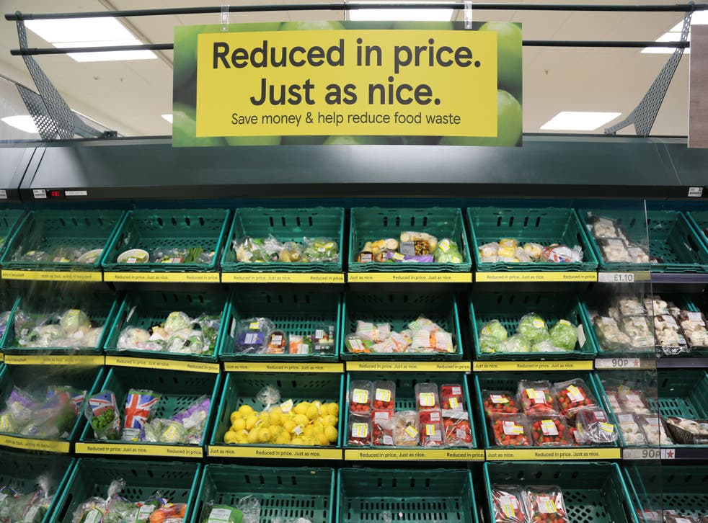
Figure 5: Your needs and our efforts (Munusamy and Wong, 2018)
Tesco has always tried to meet the needs of consumers at the best possible price. This goal has always understood the needs and demands of the consumers by analysing consumer trends. Let's go has more than 4000 shops around the globe and by analysing the customer data it understands where the consumers are focusing more based on that Tesco has always tried to set up efficient distribution channels that are capable to provide those products at a lower cost (Munusamy and Wong, 2018). This girl has also tried to understand the requirements of the consumers and based on that it has always included newer products in its product line which has ultimately made the product lines of Tesco more than 40,000. In recent years the company has understood that consumers have become health conscious and so the company has included healthy products and sugar-free products in its product line which has gained much popularity in recent years. The growth rate of these healthy products has increased by 10% in the last financial year (Lindgreen and Hingley, 2022).

Marketing blog 6: Discount on Christmas
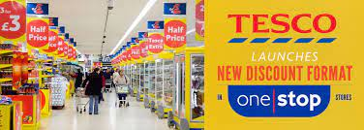
Figure 6: Discounts in Tesco (Humby, Hunt and Phillips, 2021)
Christmas is coming and we know that at Christmas you always want to purchase new products by understanding this we have created our new campaign where we will offer a 20% Discount on exclusive gift items that the consumers will be purchasing for their dear ones. In this campaign, we will also decorate our different types of stores and in the stores, we will include different interactive games and buy engaging the consumers in those games we will provide more Discount coupons to the consumers and ultimately we want to see you happy this Christmas.

Conclusion
This report has provided a discussion on the background of Tesco and thereafter this report has analyzed the marketing mix of the company. Then this report analyzed the segmentation targeting and positioning strategy of the company and finally, this report provided some blogs that are pertinent to the promotional activity of the company.

References
Aiello, L.M., Quercia, D., Schifanella, R. and Del Prete, L. (2020). Tesco Grocery 1.0, a large-scale dataset of grocery purchases in London. Scientific data, 7(1), pp.1-11.
Enders, A. and Jelassi, T. (2019). Leveraging Multichannel Retailing: The Experience of Tesco. com. MIS Quarterly Executive, 8(2).
Evans, B. and Mason, R. (2018). The lean supply chain: managing the challenge at Tesco. Kogan Page Publishers.
Gopalia, A. (2022). Effectiveness of online recruitment and selection process: a case of Tesco. World Applied Sciences Journal, 20(8), pp.1152-1158.
Humby, C., Hunt, T. and Phillips, T. (2021). Scoring points: How Tesco is winning customer loyalty. Kogan Page Publishers.
Lindgreen, A. and Hingley, M. (2022). The impact of food safety and animal welfare policies on supply chain management: the case of the Tesco meat supply chain. British Food Journal.
Munusamy, J. and Wong, C.H. (2018). Relationship between marketing mix strategy and consumer motive: an empirical study in major Tesco stores. Unitar e-journal, 4(2), pp.41-56.
Palmer, M. (2019). International retail restructuring and divestment: the experience of Tesco. Journal of Marketing Management, 20(9-10), pp.1075-1105.
Palmer, M. (2020). Retail multinational learning: a case study of Tesco. International journal of retail & distribution management.
Rowley, J. (2015). Building brand webs: Customer relationship management through the Tesco Clubcard loyalty scheme. International Journal of Retail & Distribution Management.
Turner, J.J. and Wilson, K. (2016). Grocery loyalty: Tesco Clubcard and its impact on loyalty. British Food Journal.
Woods, M. (2017). Linking risk management to strategic controls: a case study of Tesco plc. International Journal of Risk Assessment and Management, 7(8), pp.1074-1088.

