Health, Well-being and Lifestyles
Introduction
Within this poster, we will outline and define the concepts of health, wellbeing and lifestyle, and discuss why they are essential for supporting young children's overall development. It will also explore a range of relevant theories and models and examine how they can be applied effectively within early years settings to promote positive outcomes for children.
Health, wellbeing and lifestyle are multidimensional concepts that are closely connected, with each influencing the others. The behaviours, habits and experiences established during early childhood play a significant role in children's physical, emotional, social and cognitive development and can have lasting effects on their health and future life opportunities. Developing positive habits from an early age helps children build strong foundations for lifelong learning, healthy relationships and overall wellbeing.
Healthy lifestyle behaviours, including balanced nutrition, regular physical activity, adequate sleep and secure, positive relationships, are essential for supporting children's cognitive, emotional and educational development (Marmot et al., 2020). Research also shows that children's early experiences have a significant influence on later outcomes, affecting their health, social development, educational achievement and future employment opportunities (Department for Education, 2011). This highlights the importance of ensuring that children receive appropriate care, guidance and support during the early years.
Ecological, sociocultural and developmental theories provide valuable insight into how children's health, wellbeing and lifestyle choices are shaped by their relationships, experiences and wider environments. Understanding these theories enables early years practitioners to recognise the many factors that influence children's development and to provide appropriate support. This poster therefore explores these theoretical perspectives and demonstrates how they can be applied in early years practice to promote children's holistic development, health and wellbeing.

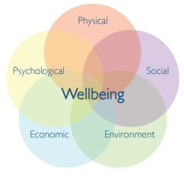

(Pinterest, n.d.)

Health
Health is a holistic concept that includes physical, mental, emotional and social wellbeing. These aspects of health are closely connected and together influence a child's overall development and quality of life. Wellbeing involves feeling safe, secure, valued and able to develop positive relationships with others. Musgrave (2017) states that children's wellbeing is shaped by their daily experiences, the quality of the relationships they form and the support they receive from the adults around them. Research consistently shows that health and wellbeing during the early years have a lasting influence on later life. Children who experience poverty or adverse childhood experiences, such as abuse, neglect or family dysfunction, are more likely to experience poorer physical and mental health, engage in harmful behaviours and have fewer educational, social and employment opportunities in adulthood (Cheung, 2018).
The World Health Organization (2022) defines health as a state of complete physical, mental and social wellbeing rather than simply the absence of disease or illness. It also recognises health as a fundamental human right, stating that everyone should have the opportunity to achieve the highest possible standard of health regardless of their background or circumstances. Similarly, Marmot et al. (2020) emphasise that giving every child the best start in life is essential for reducing health inequalities and improving long-term health, educational attainment and future employment opportunities. Positive early experiences provide children with strong foundations that support healthy growth and lifelong wellbeing.
Mental health is an essential part of overall wellbeing and plays an important role in how children understand and manage their emotions, respond to challenges and build relationships with others. Musgrave (2017) explains that positive mental health helps children develop resilience, confidence, self-esteem and the ability to form healthy relationships. Children who receive consistent emotional support, encouragement and responsive care are more likely to experience positive developmental outcomes, emotional security and enhanced wellbeing throughout childhood.
Supportive environments are equally important for promoting children's health and development. Secure, positive relationships help children develop a sense of safety, belonging and emotional wellbeing, which supports both learning and healthy development (Center on the Developing Child, 2021). Likewise, the World Health Organization (2024) highlights that nurturing care, responsive caregiving, protection, good health, adequate nutrition and opportunities for early learning are all essential in helping children reach their full developmental potential.
The importance of positive relationships is further explained through Bowlby's Attachment Theory. Bowlby suggests that children develop strong emotional bonds with caregivers who consistently provide comfort, protection and security (Holmes, 2014). These secure attachments help children feel safe, valued and confident, supporting their emotional wellbeing and enabling them to cope more effectively with stress, change and everyday challenges. As a result, secure relationships provide a strong foundation for children's overall health, wellbeing and healthy development throughout childhood.

Wellbeing
Wellbeing relates to an individual's quality of life and ability to cope with everyday challenges. Dodge et al. (2012) define wellbeing as a balance between life's demands and the resources available to manage them. Similarly, the World Health Organization (2024) describes wellbeing as a positive state that enables people to realise their abilities, cope with stress and contribute to their communities. Supporting children's physical, emotional, social and psychological needs is therefore essential. Dodge et al. (2012) explain that wellbeing depends on having the resources to manage life’s challenges.
“Good mental health and emotional wellbeing of babies, children, and young people is crucial for their development, happiness, and success in life.” (Public Health Wales, 2025, p. 1)
Wellbeing is often viewed as subjective because people experience happiness differently. Ryff, Boylan and Kirsch (2021) identify two perspectives of wellbeing: hedonic wellbeing, which focuses on happiness and positive emotions, and eudaimonic wellbeing, which relates to personal growth, meaning and achieving one's potential. Children may experience hedonic wellbeing through play and enjoyment, while eudaimonic wellbeing develops through learning, helping others and achieving goals.
Emotional wellbeing refers to a child's ability to experience positive emotions, build confidence and manage challenges. Musgrave (2017) suggests that children with positive emotional wellbeing are more likely to form healthy relationships and show resilience. Ryff (2014) states that psychological wellbeing includes self-acceptance, autonomy, emotional regulation and positive relationships. Howard et al. (2020) found that children exposed to four or more adverse childhood experiences are at a greater risk of poor mental wellbeing. Social wellbeing is also influenced by the quality of relationships children have with family, peers and other significant adults, helping them feel safe, secure and valued (National Scientific Council on the Developing Child, 2004).
Supporting emotional wellbeing is as important as promoting physical health. The Center on the Developing Child (2021) highlights that positive early experiences and supportive relationships help children build resilience, manage stress and develop healthy social connections. Likewise, the World Health Organization (2024) emphasises that good mental health enables children to cope with challenges and participate positively in their communities. Marmot et al. (2020) further argue that positive experiences in the early years improve children's health, wellbeing, educational outcomes and future opportunities.
Meeting children's needs from an early age is fundamental to wellbeing. Maslow (1943) suggests that children feel more secure and emotionally supported when their basic needs are met and their environment is predictable. Similarly, Dowling (2014) argues that consistently meeting children's physical and emotional needs helps develop confidence, positive self-esteem and a secure sense of identity. These foundations are essential for healthy development and overall wellbeing throughout childhood.
.

Lifestyle
Lifestyle refers to the behaviours, habits and choices that shape how people live. Naidoo and Wills (2016) suggest that lifestyle includes factors such as diet, physical activity, relationships and personal habits that influence health and wellbeing. Similarly, Public Health Wales (2023) highlights that health and wellbeing are influenced by a range of social, economic and environmental factors, including family circumstances, housing, education, employment and access to resources.
A child's lifestyle is influenced by their home environment, relationships, culture and community opportunities. Bronfenbrenner (1979) suggests that children's development is shaped by interactions within their family, educational settings and wider social environment. These experiences influence children's attitudes, behaviours and future health choices.
Maintaining a healthy lifestyle supports children's physical, emotional and social wellbeing. Musgrave (2017) explains that healthy habits, including a balanced diet, regular physical activity and positive social relationships, promote healthy development. In addition, regular physical activity strengthens bones, muscles and cardiovascular health while also supporting children's emotional wellbeing (World Health Organization, 2022).
Sleep is another important aspect of a healthy lifestyle. The National Scientific Council on the Developing Child (2020) highlights that adequate sleep supports brain development, learning, memory and emotional regulation. Consistent sleep routines can improve concentration, behaviour and overall wellbeing. Good hygiene practices are also essential, helping to reduce illness and infection and promote overall health (Naidoo and Wills, 2016).
The environment in which children grow plays a key role in shaping lifestyle choices and wellbeing. Marmot et al. (2020) suggest that children who experience safe, supportive and nurturing environments are more likely to achieve positive health outcomes. Similarly, Bradshaw (2016) argues that when children feel secure, valued and supported, they are better able to learn, develop confidence and build resilience. Therefore, promoting healthy habits and positive environments is essential for supporting children's holistic development and long-term wellbeing.

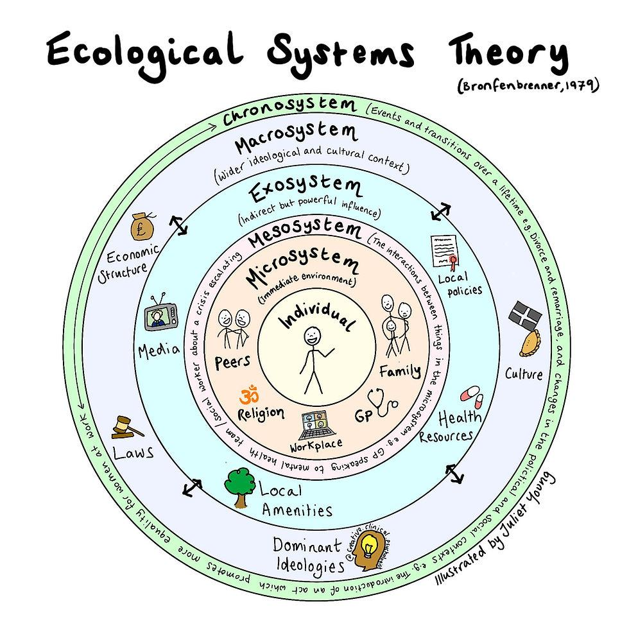

Young children's lifestyle choices are largely influenced by the adults who care for them. Public Health Wales (2023) highlights that children's health and wellbeing are shaped by wider factors, including family circumstances, income, education and access to healthy environments. Early years practitioners therefore have an important role in promoting healthy lifestyles by encouraging balanced nutrition, physical activity and positive daily routines. The Welsh Government (2022) also emphasises that practitioners should provide environments that support children's health, wellbeing and holistic development.
Practitioners should work in partnership with parents, carers and other professionals to ensure children receive appropriate support. The NSPCC (2024) highlights the importance of recognising concerns early, communicating sensitively with families and working collaboratively with other agencies to safeguard children's wellbeing.
Providing opportunities for outdoor play, exploration and creative experiences also promotes children's wellbeing. Musgrave (2017) explains that play supports children's physical, emotional and social development, while the United Nations Convention on the Rights of the Child recognises every child's right to rest, leisure and play (UNICEF, 2021). The Welsh Government (2022) further highlights that enabling environments encourage children to explore, develop confidence and learn through play.
The Curriculum for Wales places health and wellbeing at the centre of children's learning and development, aiming to develop healthy, confident individuals who are ready to learn (Welsh Government, 2022). Practitioners should also recognise when children may be affected by adverse childhood experiences and provide appropriate support. As Boullier and Blair (2018) highlight, helping families access services early can strengthen resilience through increased support and reduce the likelihood of further adverse experiences, reinforcing the importance of timely, needs-led intervention within educational settings. Wilson (2025) suggests Building positive, trusting relationships between practitioners and parents creates opportunities for families to access guidance and information, which can lead to more targeted support when it becomes necessary.

Conclusion
Overall, the evidence presented throughout this poster demonstrates that health, wellbeing and lifestyle are closely interconnected, with each influencing the others. It highlights the importance of providing young children with healthy lifestyles, positive experiences and secure, nurturing relationships to support their physical, emotional, social and cognitive development. The discussion also shows that early years practitioners play a vital role in promoting children's health and wellbeing by creating safe, inclusive and supportive environments, working in partnership with families, recognising individual needs and encouraging healthy habits from an early age. The theories and models explored reinforce the importance of adopting a holistic approach that recognises every aspect of a child's development and acknowledges the influence of family, community and the wider environment. In addition, Welsh Government guidance provides a valuable framework for promoting health and wellbeing within early years practice and supporting children to achieve their full potential. Finally, it is important to recognise that understandings of health and wellbeing continue to evolve and may differ across cultures, communities and stages of life, requiring practitioners to remain responsive, reflective and committed to meeting the diverse needs of every child.

Reference List
Boullier, M. and Blair, M. (2018) ‘Adverse childhood experiences’, Paediatrics and Child Health, 28(3), pp. 132–137. Available at: https://doi.org/10.1016/j.paed.2017.12.008.
Bradshaw, J. (2016) The wellbeing of children in the UK. 4th edn. Bristol: Policy Press.
Bronfenbrenner, U. (1996) The ecology of human development: Experiments by nature and design. Cambridge, MA: Harvard University Press.
Center on the Developing Child (2021) Three principles to improve outcomes for children and families. Cambridge, MA: Harvard University. Available at: https://developingchild.harvard.edu/resources/three-principles-to-improve-outcomes-for-children-and-families/ (Accessed: 19 June 2026).
Cheminais, R. (2013) Effective multi-agency partnerships: Putting Every Child Matters into practice. 2nd edn. London: Sage.
Cheung, R. (2018) International comparisons of health and wellbeing in early childhood. London: Nuffield Trust and Royal College of Paediatrics and Child Health.
Department for Education (2011) The early years: Foundations for life, health and learning. An independent report on the Early Years Foundation Stage to Her Majesty's Government. London: Department for Education. Available at: https://www.gov.uk/government/publications/the-early-years-foundations-for-life-health-and-learning (Accessed: 19 June 2026).
Dodge, R., Daly, A., Huyton, J. and Sanders, L. (2012) ‘The challenge of defining wellbeing’, International Journal of Wellbeing, 2(3), pp. 222–235. Available at: https://www.internationaljournalofwellbeing.org/index.php/ijow/article/view/89 (Accessed: 19 June 2026).
Dowling, M. (2014) Young children's personal, social and emotional development. 4th edn. London: Sage.
Holmes, J. (2014) John Bowlby and attachment theory. 2nd edn. London: Routledge.
Howard, C., Burton, M. and Levermore, D. (2020) Children's mental health and emotional well-being in primary schools: A whole school approach. 2nd edn. London: Learning Matters. Available at: https://librarysearch.uwtsd.ac.uk/permalink/44WHELF_UWTSD/1vbe9ev/alma99100249360302421
Kalmakis, K.A. and Chandler, G.E. (2015) ‘Health consequences of adverse childhood experiences: A systematic review’, Journal of the American Association of Nurse Practitioners, 27(8), pp. 457–465.
Marmot, M., Allen, J., Boyce, T., Goldblatt, P. and Morrison, J. (2020) Health Equity in England: The Marmot Review 10 Years On. London: Institute of Health Equity. Available at: https://www.instituteofhealthequity.org/resources-reports/marmot-review-10-years-on/the-marmot-review-10-years-on-full-report.pdf (Accessed: 19 June 2026).
Maslow, A.H. (1943) ‘A theory of human motivation’, Psychological Review, 50(4), pp. 370–396. Available at: https://psychclassics.yorku.ca/Maslow/motivation.htm (Accessed: 19 June 2026).
McLeod, S. (2024) Bronfenbrenner's ecological systems theory. Simply Psychology. Available at: https://www.simplypsychology.org/bronfenbrenner.html (Accessed: 19 June 2026).
Musgrave, J. (2017) Supporting children's mental health and wellbeing. London: Sage.
Naidoo, J. and Wills, J. (2016) Foundations for health promotion. 4th edn. London: Elsevier.
National Scientific Council on the Developing Child (2020) Connecting the brain to the rest of the body: Early childhood development and lifelong health are deeply intertwined. Working Paper No. 15. Cambridge, MA: Center on the Developing Child, Harvard University. Available at: https://developingchild.harvard.edu/resources/connecting-the-brain-to-the-rest-of-the-body-early-childhood-development-and-lifelong-health-are-deeply-intertwined/ (Accessed: 26 June 2026).
NSPCC (2024) Safeguarding and child protection. Available at: https://learning.nspcc.org.uk/safeguarding-child-protection (Accessed: 19 June 2026).
Pinterest (2018) Digital photograph. Available at: https://www.pinterest.co.uk/pin/309833649338886346/ (Accessed: 19 June 2026).
Public Health Wales (2023) Understanding the wider determinants of health. Cardiff: Public Health Wales. Available at: https://phw.nhs.wales/services-and-teams/wider-determinants-of-health-unit/ (Accessed: 19 June 2026).
Public Health Wales (2025) E-bulletin March 2025. Available at: https://publichealthnetwork.cymru/wp-content/uploads/2025/04/E-bulletin-Mar-25-Eng.pdf (Accessed: 26 June 2026).
Ryff, C.D. (2014) ‘Psychological well-being revisited: Advances in the science and practice of eudaimonia’, Psychotherapy and Psychosomatics, 83(1), pp. 10–28. Available at: https://pmc.ncbi.nlm.nih.gov/articles/PMC4241300/ (Accessed: 19 June 2026).
Ryff, C.D., Boylan, J.M. and Kirsch, J.A. (2021) ‘Eudaimonic and hedonic well-being: An integrative perspective with linkages to sociodemographic factors and health’, in Lee, M.T., Kubzansky, L.D. and VanderWeele, T.J. (eds.) Measuring Well-Being: Interdisciplinary Perspectives from the Social Sciences and Humanities. Oxford: Oxford University Press, pp. 92–135.
UNICEF (2021) Convention on the Rights of the Child. Available at: https://www.unicef.org/child-rights-convention (Accessed: 19 June 2026).
Welsh Government (2022) Curriculum for Wales: Health and Well-being Area of Learning and Experience. Cardiff: Welsh Government. Available at: https://hwb.gov.wales/curriculum-for-wales/health-and-well-being/ (Accessed: 19 June 2026).
Wilson, T. (2025) Working with parents, carers and families in the early years: The essential guide. 2nd edn. London: Routledge. Available at: https://doi.org/10.4324/9781003429562.
World Health Organization (2022) World mental health report: Transforming mental health for all. Geneva: World Health Organization. Available at: https://www.who.int/publications/i/item/9789240049338 (Accessed: 19 June 2026).

