Module: Academic and employability skills
Module code: BMSW4001
Assignment Title: Task 2
Lecturer: Doreen Nyaa
Student name/Id number: Nicoleta Mocanu/2118432

Table of Contents

Introduction 3
Reflective Study on Task 1 By Using Gibb’s Reflection Cycle 3
Gibb’s Reflective Cycle on Teamwork 6
Personal Development Plan 9
Conclusion 11
References 12

Introduction
To learn the capturing, reflection, and evidencing your skills and experiences will be supporting you for the ongoing development and preparing you to apply these skills in the future as an employee or further education to build up your career the entire life. These guides are the tools that provide your information about yourself. To know about your capabilities and reactions you must be evaluating your experiences by self-reflection. It will be helping you in learning from experiences for the coming future, improving your approaches and skillset. This will be boosting up your confidence and will cause you to feel proud of your achievements. The skill development, work experiences, and opportunities for applied learning will be discussed in this report for self-reflection and making the personal development plan.

Reflective Study on Task 1 By Using Gibb’s Reflection Cycle
The report will be presenting my self-reflection using the model of Gibb’s Cycle for analysing how I understood the motivation of employees after completion of task 1 from this assignment.
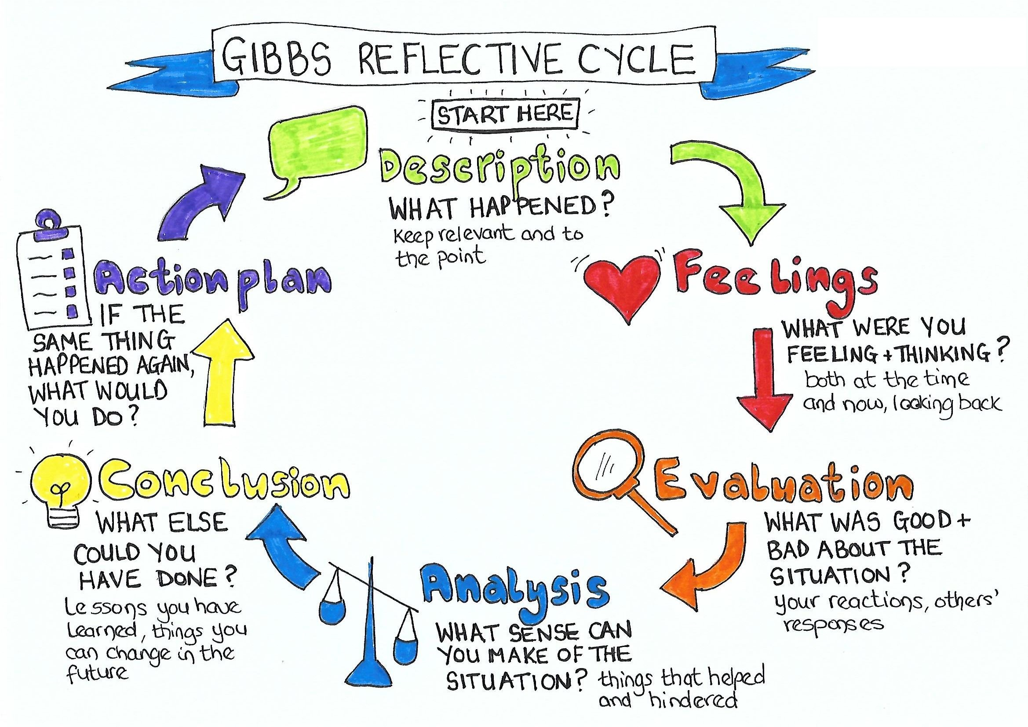

“Description  (What happened?)” | Employee motivation is an essential part of organisational success. It has been observed that the workers tend to perform the best when they are highly motivated by the organisation. I realised motivation’s power when I was reading the different lectures and class notes that were given in the slides. I noticed that executives might use different approaches such as rewards, pay, holidays for motivating the workers. The top organisations have been sharing and giving bonds for motivating them based on their performances (Aeni and Kuswanto, 2021).
“Feelings  (What were you thinking and feeling at the time?)” | It has been understood by me that when it comes to rewarding the workers, the company must be taking the understanding of what to give to an employee as per their managerial positions. In a big organisation, the system of rewards will be tying workers to the firm. Simultaneously, the junior workers will mostly be needing promotions or rewards at work. I feel that employee retention will highly be affected if organisations start providing incentive rewards to their junior employees. It is a highly pleasant experience as it will be resulting in a win-win situation for both parties as the organisation will receive higher performances from the employees.
“Evaluation  (What was good and bad about the experience?)” | I noted that these types of rewards are playing an essential part in the motivation of employees in an organisation. The slides provided to us during classroom lectures stated it clear that workers will be performing during their usual work hours but will get demotivated by not getting anything in return. I noted that the issues of motivating employees must not be taken lightly by an organisation. I think it will be demonstrating what must be done in this criteria of motivating such as changes in the reward system before employees get highly demotivated. The management must be considering the rewarding issues in the organisation and must be adjusted as per the employee’s expectation by the company (Rigolizzo and Zhu, 2020).  The slides have helped me to understand that the best way for the improvement of workers is by giving them the rewards as per their worth in the company. These can be by the increase of their wager. The workers might feel they are not receiving the rewards they must be getting from the organisation which will affect their handling of different assignments. The overall output of the workers depends on their production of overtime which can be less compared with their productivity rate.
“Analysis  (What sense can you make out of the situation?)” | After analysing the slides from the presentation I have appreciated the fact of rewards is a crucial part of motivating employees. These rewards are not always supposed to be rewards that might be given to employees. These can sometimes be the different effective approaches which are concerned by the authorities to their workforce. They must be providing at least the minimum allowable amount of rewards for the commensuration of their output. Their productivity must not be ignored by the employer.  In the notes which were provided to us during class, I noted the management unit of an organisation requires to provide junior employees rewards. The difference of rewarding nature relies on their work performances within the firm (Rigolizzo and Zhu, 2020). The analysis has made me realise that the company cannot ignore the employee reward relevance as the method for motivation of employees. The slides provided us with different theories which might be helping in defining rewards appropriately.
“Conclusion  (What else could you have done? Or what could you have improved?)”  “Action Plan  (If you did another presentation, what would you do differently? What skills do you need to develop?)” | The fact about employee management and the system of rewards must be highly appreciated by the employer of an organisation. To achieve success, I suggest to the human resources to be conducting the system of regular appraisal for workers for the determination of a reward system justified on their actions. I believe it will be eliminating the problems of complaints in work.

Gibb’s Reflective Cycle on Teamwork
The skills for effectively working in a team is an essential skill that is required for developing leadership traits, teaching delegations, and for an effective system of communication. Naturally, there might be challenges that might occur during working as a team. It has been found that the students who are not learning from their mistakes from the past will be failing in the future. The self-reflection will be allowing the individuals for learning from such mistakes and will be providing them with methods to understand and improve. The model of “Gibb’s Reflective Cycle” is a tool that has been used for our group situation during the completion of our “Week 8” group activity. There were some problems that we faced during the completion of our assignment but in the end, we were able to complete it before time. I will be presenting my personal experience of teamwork using Gibbs Reflective Cycle.

“Description  (What happened?”) | In the "Week 8" activity, our teachers allowed us in picking our groups where I made a group with my two friends. There was another member added to our group randomly as it was a requirement to have four members. We were usually holding our group meetings using “Microsoft Teams” so that we were able to read each other thoughts and progress on conference chat. When the topic for the assignment was decided, we all agreed on dividing the report of the presentation into two parts and assigning two persons to write one part (Nuñez et al., 2018). When we had our first meeting, we decided to complete our first draft after one week that was enough time for reviewing and editing till the next meeting to complete the report till the conclusion. While I was starting to write my part of the report, I found it very obvious that the work breakdown structure was not correct because we did not decide what part is being done by whom.
“Feelings  (What were you thinking and feeling at the time?”) | It’s not wrong to say I was having the feeling of “Group-Hate” for the assignment because it required a virtually complete and in past working as a virtual group had bad experiences from me. The term “Group-Hate” could describe my feelings which occurs when working with the wrong group to complete an assignment. This causes a negative mind-set to occur on students for the assignment before it starts (McLachlan et al., 2021). Previously, it was a bit challenging for me to build stronger communication with my group. However, due to group evolving and the continuous meeting made the group-hate fade and made me more productive.
“Evaluation  (What was good and bad about the experience?)” | An aspect that I noted to be working well during our project was that there was a wider skill range that could’ve been used for various situations. For example, a member of our group was best with using technologies who has set up all of our group meetings using “Microsoft Teams”. At the start, I was a little nervous about the random group member as I was not aware of his skills, but slowly I started to understand him and he was bringing various advantages to our team. These random additions were a great approach for focusing on the given task and adding opportunities for finding a new method of thinking (McLachlan et al., 2021). There were fewer off-topic conversations in our group meetings so the random member do not feel left out, these were the reasons why we had fewer distractions and were able to complete our task early.
“Analysis  (What sense can you make out of the situation?)” | In our team, a team member was mostly quiet but we were aware of her nature as she was a “free rider” however she felt shy while sharing her thoughts during our group meetings. Our main strategy was not to waste our time in knowing about each other but were more concerned with the completion of tasks rather than building a personal connection. A good social relationship with the team member was the key to our effective communication during the project.
“Conclusion  (What else could you have done? Or what could you have improved?)” | The assigned tasks had made me realise how important it is to know the members of our team and you must make sure that nobody is feeling left out or is uncomfortable during a project. If there is a stronger connection between the team members, they will be encouraged and will share their opinions openly. I learned from the experience that I must not be evaluating anyone on first look. The lesson learned from the project was completing a task quicker requires a team with synchronisation.
“Action Plan  (If you did another presentation, what would you do differently? What skills do you need to develop?)” | For the completion of projects in the future, I will be making sure that we have agreed on starting the project by building a good connection of communication with my team. It will be ensuring all members that they can rely on each other, engage with the language of their body, and have a strong focus on the goals of the project (Lin and Kim, 2020). Next time, I will be organising my group activities and breaking them down as per the skills of each individual in my team. It will be allowing my team members to feel more confident and will ensure that each individual has a clear role for the completion of the project and can identify their strengths in the group.

Personal Development Plan
From the feedback received after the completion of the "Week 8" activity in a group. I think to become a contributing factor un a team, I must be thriving for personal development which can assist in setting my mind on the enhancement of my managerial skills. Some of the aspects I will develop are discussed below:
“Personal Target” | “How will I achieve this?” | “How will this improve my academic or employability prospects?” | “How will I know that I have achieved this?” | “When will I achieve this by?”
Empathy | I will be improving my attributes as the leader by setting up “one-on-one” discussions with my team members and will be discussing the different issues occurring during the work. | The best way for developing my skills of managing is by introducing my side of empathy to my team members. This will help me manage the people and will be focusing genuinely on the assigned task. | I will know I have achieved them by helping them to get comfortable in sharing and open up to me making them more relaxed during an assigned project. | During class activities or interactions with friends
Reducing Micro-Management | I will try to be resorting to micromanagement. It might cause me to undergo various stresses and will be upon my team. It will allow me to gain the trust of my team members and grow with their support (Awino and Kipsang, 2020). | I think I must be aware of what are the conditions and situations happening in my team. I must be refraining from imposing excess power upon my team members. | When the management of my organization become fluent without any clashes, I will understand I have achieved what I wanted to. | After I get appointed in an organization as an HR manager
Appropriate Expressions | Once I am selected as a team leader, I will be interacting with my senior managers and other executives. | When I’ll be dealing with seniors, it will be helping me to express myself even more. It will be ensuring my body language, tone and posture are correct and respectful. It will help me to grow professionally while interacting with my team. | When my people become comfortable around me. | I will practice this on daily basis.

Conclusion
The reflection paper on the employee management assignment has analysed my skills for learning and practically implying them in different scenarios that can occur in an organisation or during the role of leadership. The management of employees needs different soft and hard skills, balance achievement of requisite standards for the assurance of effectiveness in performance of employees in the organisation according to (Aeni and Kuswanto, 2021). The report concludes that reflection is essential for a person to highlight their different skills and short comes which must be upgraded. The report has used “Gibb’s Reflective Cycle” for the self-reflection during my time in the course of “Academic and Employability Skills”.

References
Aeni, N. and Kuswanto, H.G., 2021. The Influence of Leadership Style, Motivation and Work Discipline on Employee Performance. International Journal of Management Science and Information Technology, 1(2), pp.20-24.
Awino, M. and Kipsang, S., 2020. Career planning and employee commitment: Does rewards system matter; a reflection from manufacturing firms in Kenya. Economic Research, 4(2), pp.231-244.
Lin, D. and Kim, S., 2020. To improve employee career success through organisational development intervention: an action research of AIA Co., Ltd. Changzhou Branch. ABAC ODI Journal Vision. Action. Outcome, 7(1), p.96.
McLachlan, C.J., MacKenzie, R. and Greenwood, I., 2021. Victims, survivors and the emergence of ‘endurers’ as a reflection of shifting goals in the management of redeployment. Human Resource Management Journal, 31(2), pp.438-453.
Nuñez, L.N., Nuñez, W.N., Acosta, A.R., Parejo, I.B. and Palma, H.G.H., 2018. Management Skills and Leadership Styles: A Reflection with a Global Focus. Contemporary Engineering Sciences, 11(54), pp.2661-2668.
Rigolizzo, M. and Zhu, Z., 2020, March. Motivating reflection habits and raising employee awareness of learning. In Evidence-based HRM: a Global Forum for Empirical Scholarship. Emerald Publishing Limited.

