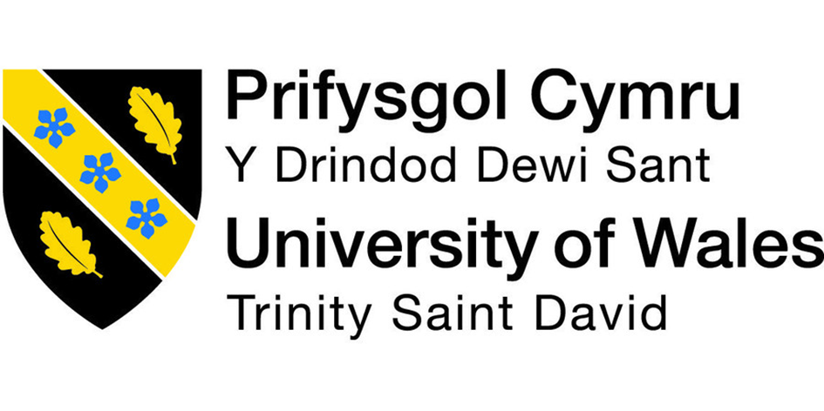

Lecture Name: Yajesh Kumar
Module Title: Managing Enterprise in the 21st Century ~ Business Plan

Student Name: Paulo Ricardo Ferreira Gomes Sampaio (Team Leader)
Student Number: 1906403
Student Name: Edson B. Rondon Neto
Student Number: 1908212
Student name: Kiri Smyllie
Student Number: 1908930
Student name: Katalin Fodor
Student Number: 1908947
Student Name: Kitti Takacs
Student Number: 1906398
Module: Managing Enterprise in the “1st Century
Lecturer: Yajesh Kumar
Student name: Edson B. Rondon Neto
Student ID number: 1908212

Table of Contents

- Introduction
- What is an Executive Summary?
- Executive Summary
- Potential Market
- Business Model
- Financial Projections
- Company
- Team and First Shop
- Conclusion
- References

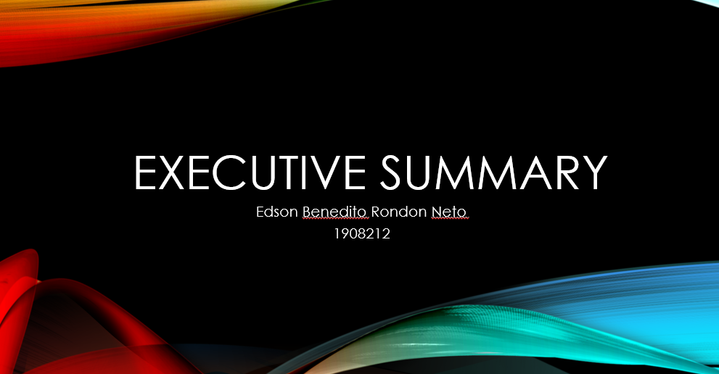
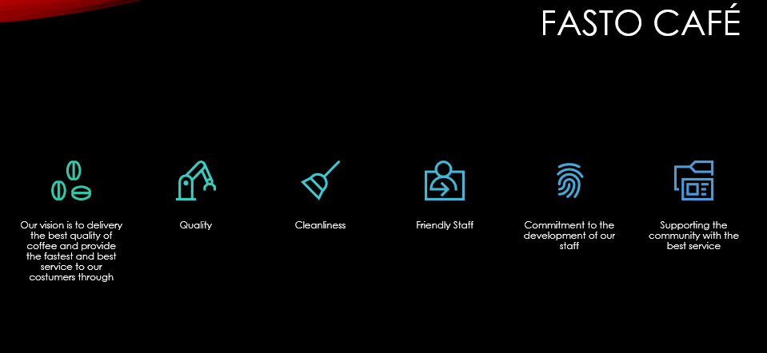
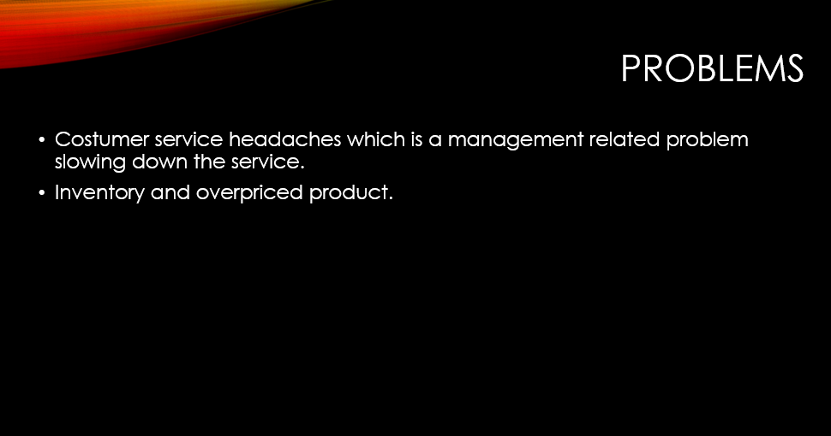
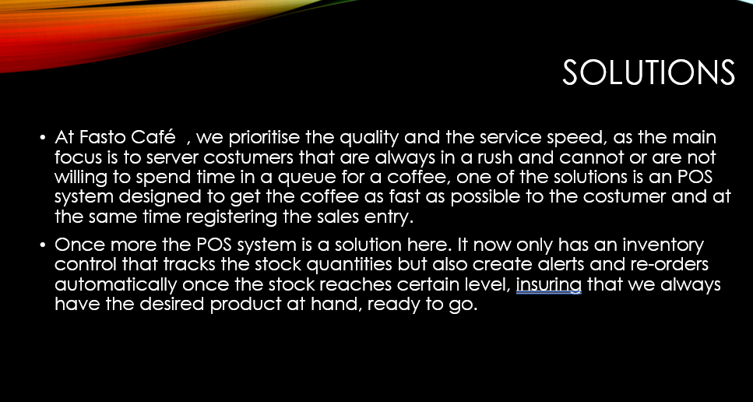
1 Introduction

The aim of this report is to give a good insight on what are an executive summary and Company, explaining their purposes on a business plan and what are their importance on a presentation to get potential investors to your business. As well, show my understanding of the subject in a real and proper business plan as part of the Managing Enterprise in the 21st century TASK 2.

2. What is an Executive Summary?
Executive summary is a report or section of a file produced for enterprise purposes. It resumes a document, thought or a group of related ideas in a way that readers can hastily end up acquainted with a large body of information without the need of reading it all. It is basically a quick general look on the business plan that will be presented to the busy people, potentially investors or even a consolidated company.
In order to make a good Executive Summary keep it short, and only with the necessary information, for example: problems, solutions, grabs, potential market, business model, management team, financial projections to support your claim ( in case you are looking for an investor) , and revenue.

3.Executive Summary
Fasto Café is a dream of five friends who have coffee as a common passion. Its simple concept of grab and go mobile coffee shop to make sure that you never spend time in queues and that you have the best quality of coffee to help you power through the day. Say goodbye to the long queues for a warm coffee.
You might be wondering ‘’ how is that different from any other coffee shop?’’. Fasto Café is planned to be based in various easy access locations around town with the focus on busy tube stations and points where people are always in a rush and can not have the luxury of spend time in the queue for a coffee and remote places to bring the joy of a warm coffee to the people.
As a company we want to have a positive impact on people’s lives as well have the social responsibility to make the difference in the world. Thinking of it we choose to partner up with non-profit organizations to be our main suppliers. These organisations have small farmers as their main coffee’s producers, with a High standard of coffee selection, making sure they bring the best coffee beans from the plantation to our shops, where they are going to be fresh roasted and grinded.

Problems | Solutions
Costumer service headaches which is a management related problem slowing down the service. | At Fasto Café , we prioritise the quality and the service speed, as the main focus is to server costumers that are always in a rush and cannot or are not willing to spend time in a queue for a coffee, one of the solutions is an POS system designed to get the coffee as fast as possible to the costumer and at the same time registering the sales entry. The other solution is the training of our staff who will be able to pour the best coffee in incredible fast serving service, making sure of maintaining the product quality as its higher standards.
Inventory and overpriced product. | Once more the POS system is a solution here. It now only has a inventory control that tracks the stock quantities but also create alerts and re-orders automatically once the stock reaches certain level, insuring that we always have the desired product at hand, ready to go. The system also allows to compare product prices, which would be used to buy good quality products (apart from the beans, as we have partnership with coffee cooperatives/non- profit organizations) for a better price.

4.Pontential Market
Our target market are Adults, residing, working and making connections in the tube lines, who have very little time to themselves and are always in need of that boost up to get them powering through the day ahead. Usually they are subjected to various activities and need that extra push or sustenance to perform their task, these activities take up quite a lot of their time, more like working hours, where a quick coffee is always welcome.
Based on researches, we were able to find out the Peak of the busiest times of the day for the potential costumers, allowing the company to define the opening times and how many staff will be necessary to supply the costumer’s demand, this will save money to company as we will not have many staff working in a shift if it is not necessary and also ensure our costumer can grab that quick warm coffee at any time, whether they are going to work, or going home after a long day at work.

5.Business Model

Product and services
One of the missions of Fasto Café is to ensure the High quality of our products and service and to make sure we always keep it at High standards our coffee bean will always be freshly roasted and grinded, bringing the best flavour to each coffee, full of joy to our costumer. We will offer regular, medium and large coffees, and all the varieties of it, macchiato, cappuccino, lattes, flavoured coffees, with the option of choosing the milk of the costumer preference.
As well as ensuring the best quality of products we also will have the best trained baristas and make sure the costumer service is always at its best. And to make it easier and reduce even more the queue at our shops we will make an app available for pre order your coffee, where the costumer will be able to choose the drink desired and make the payment, once the costumer’s base is created the regular costumer will have the option of per order weekly, and to support even more the use of the app we will offer great rewards and discount on orders.

Market Analysis
Researches show that the coffee industry is saturated, having a coffee shop in every single corner and new entrances faces huge obstacles. For us at Fasto these obstacles are huge- stablished coffee shops and vending machine. Yet we have no fear of challenge it. We one hundred percent believe in our coffee and service. Further we believe the delicious coffee will never run out of patrons.
Financial Projections

As seen in the graph based on a market research our business is very profitable in the first five months projection, the sales will slow down in April due to a decreased flow of people using the tube and rail way as main transport to work, but the sales will pick up again in the following month.

Company

Fasto’s products include a variety of coffees and many other pre-made things, such as sandwiches, bagels, etc.
The coffee shop is looking for a start up financing adding up to a hundred pounds to buy the equipment, installations, locations, and some gears that will help out in the costumer service section, making it possible to delivery all that we promise.
It is a new organisation and partnership with Paulo, Kitti, Edson, Kiri, and Katalyn. We will each be claiming twenty percent of the business to create an equal opportunity of ownership, as well we will be investing the same amount of money to start the business up. We will spend significant time in offering freshly ground coffee, and the food will be handmade crafted.

Team and First shop

As mentioned before the management team will be formed by Paulo, Kitti, Edson, Kiri, and Katalin, each one with equal ownership, however we will be carrying out task individually in the sector of our preference and that we are in used to.
Kitti is our finance adviser, she will plan the pertains to the function of finance and includes the determination of the business financial objectives, policies and procedures, it will save a lot of money from paying third companies to do this type of job.
Kiri will be in charge of the legal procedures wherever it involves the company and the decision can be made without consultancy of the other owners, however any decision involving the company’s money has to go through the finance adviser ensuring the company will always have a good cashflow.
Paulo will be in contact with distributors, suppliers, and ensuring that all the shops will have a good stock of products, and getting the best marketing price for our products as well he will be responsible for the creativity part of the business, always trying to bring innovation and the last word in technology out there.
Katalin is in charge of the recruitment team, making sure we keep our staff to the best standard for the business, as well as getting them to receive the appropriate training to work in our shops.
And Edson will be in charge of the shops management, making sure all the shops are in order and the business is running as smooth as possible, making sure all the equipment has the maintenance up to date, the foods are up to date, and also will be in charge of distribution of left sandwiches that were not sold throughout the day to charities, no food wasting is one of the missions the company has.
The initial idea is to buy a caravan with all the necessary equipment fitted in. The caravan will have a cost of around fifty thousand pounds, it is a great investment as we will be saving money if we were to rent a place. On the other hand, we will need to be licensed as we will drive the caravan around and the costs of the license can be monthly or yearly. At first the idea of getting the license monthly sounds better because as we work in different areas we will be able to define what are the best points in town to run the business and I the near future expand the business and cover all of these points.

The picture bellow is a representative model and its purpose is only for reference.
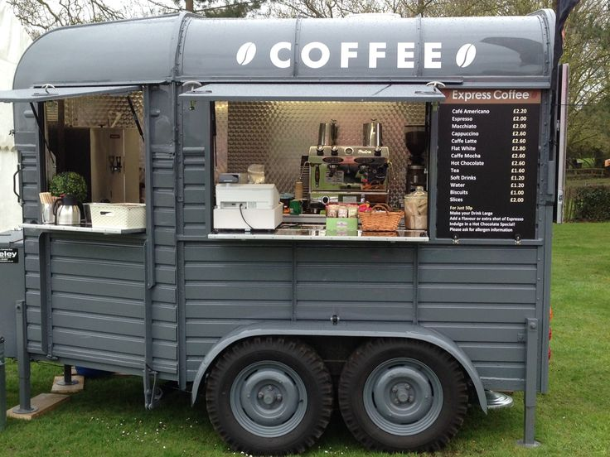
https://i.pinimg.com/736x/2d/cd/25/2dcd25bc5299ae3b3ba41b24cb1bc35d--horsebox-bar-horse-trailers.jpg

Conclusion

The executive summary and Company are one of the most important topics in a business model as it is by itself overall presentation of the business. Therefore, the role it plays is crucial as it has the power to spark the interest of potential investors to read the rest of the business plan, and eventually leading to a contract with investors.
Working as a group in a business plan has helped me to develop great skills, has also showed me points that need to be improved when work as a team.

References

Barclays 2019, Writing a Business Plan, Available from:
https://www.barclays.co.uk/business-banking/business-insight/writing-a-business-plan/
[06 April 2020]

Budget Business Plan 2016, How to plan a coffee shop, Available from:
https://www.profitableventure.com/coffee-shop-business-plan/
[06 April 2020]

Dreamlatte 2016, Coffee Shop Business Plan Management, Available from:
http://www.dreamalatte.com/coffee-shop-business-plan-management/
[06 April 2020]

Profitable venture 2009, Executive summary coffee shop, Available from:
https://www.profitableventure.com/coffee-shop-business-plan/
[06 April 2020]

Module: Managing Enterprise in the 21st Century
Lecturer: Yajesh Kumar
Student Name: Paulo Ricardo Ferreira Gomes Sampaio
Student Id: 1906403
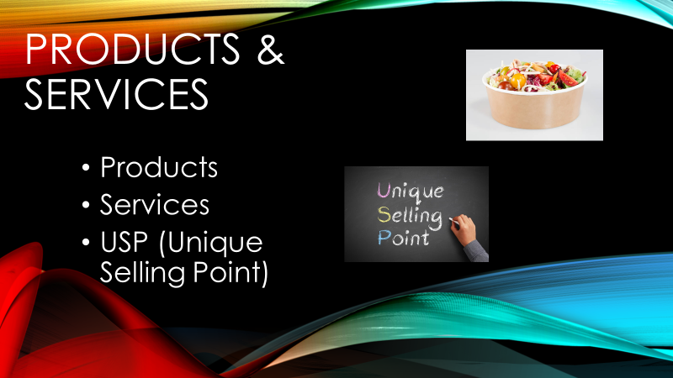
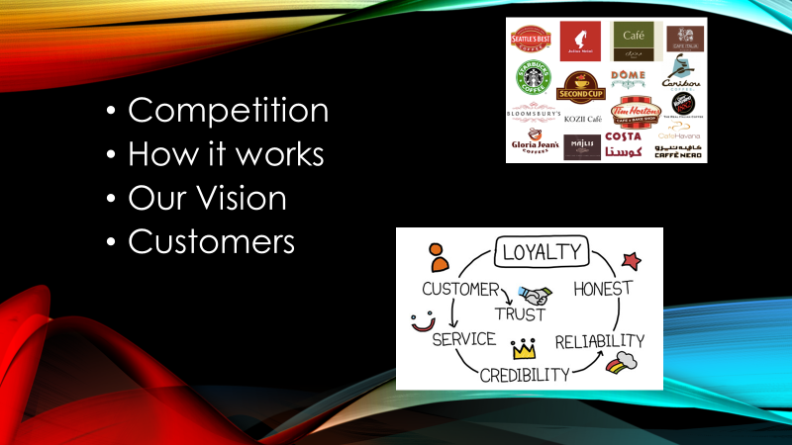
Business Plan
(Products & Services)

Fasto Caffe, will be a mobile coffee place, and having that in mind we opted for alternative products, while improving the service to face the competition.
Fasto will be serving hot beverages such as :
- Fresh brewed coffee
- Tea
- Cappuccino
- Latte
- Americano
- Hot Chocolate

Fasto will be serving also cold beverages such as:
- Water
- Fresh fruit pressed juices
- Fizzy drinks
- Vegan protein shakes

Fasto will also have take-out prepared sandwiches and bakery, as we understand the importance and the need for on-the-go coffee and either be a healthy snack or an amazing pressed panini to accompany that amazing coffee, Fasto will be serving:
- Ham/Cheese/Tuna/Egg/Bacon Sandwiches
- Paninis
- Bakeries (croissants etc)
- Fruits

Any of the products listed here, can be prepared in around three to four minutes, to insure rapid service and high customer satisfaction.

Service description

Fasto will adopt a quick serve and go approach. Meaning we will have our client chose what they want to consume from our simple menu, designed to allow customers to decide quickly what they want, and multiple payments options so that the client can simply touch their card or phone and be on the go.
We will be mobile, which means that we will be able to meet certain demands when opportunities arise, such as local events, sport events etc. Our group at this point in time consists of five owners, two will run the kitchen, two will be assembling orders and one dealing with the money to avoid contamination in the food process area.
It is in the service offerings where we will need to gain the upper hand and differentiate ourselves from the competition.

Competitive comparison
The competition facing Fasto is vast, and this includes every coffee place in and around central London area. Major competitors include Starbucks, Pret a Manger, Nero, Costa, The Attendant, Prufrock Coffee, Notes, Look Mum No Hands, Kaffeine, Flat White, Taylor St, Brooklyn Coffee, Climpson & Sons, Caravan , Lantana Café, The Spoke, Ginger & White, Artigiano, Bean berry Coffee, The Wren, I could go on and on and this are the major ones, I am excluding the minor ones, but they all have one thing in common, they all charge top end prices and are fixed to a physical place, which means that they depend on the flux of people that would walk by every day and is willing to spend £2,80 - £4.00 on a small coffee.
Furthermore, there are a large number of off-licences, that offer coffee in a prepaid machine and pre packed meals to upscale sit down coffee places or cheaper alternatives that make drawing any sort of general conclusions from such vast array of competitors is difficult, but you can say that every conceivable idea of this product and services are contained within this group.

Payment Services
As a mobile coffee shop, we need to make sure our customers will be able to pay quickly and securely by card, most of us nowadays use contactless, either be it through our phones/watches or simply touching the card on the reader. This will allow us to turnover costumers more efficiently and quickly, by reducing transaction times and queues. Having a portable card machine will allow costumers also pay with apple pay and android pay, off course taking the usual methods of payment as well.

USP
Our Unique Selling Point is premium coffee at affordable prices.
Grinded at the same time when ordering a coffee, retaining that amazing smell of coffee that every coffee lover identifies.
With coffee from Colombia, from certified distributers, but the grains itself, grinding when only making the coffee.
As the economy grows harder, people are less willingly to spend premium prices for premium coffee, and since we don’t have a physical rent, we could make affordable prices thus allowing us to compete with top tier brands.

How it would work!
A costumer would approach a member of staff of Fasto, place his order.
A designated member of staff would press the grinder and start making his coffee. At the same time if other product was asked such as a sandwich and so forth, a member of staff would prepare so that the coffee and the product would be given at the same time.
Meanwhile the costumer would be directed to the till to make the payment with the method of his choosing and thus allowing to move the queue and faster serving time.
Every coffee would be served on a standard hot drink cardboard cup, with the Fasto logo, and a lid to protect spills and harming the customer, the food would as equally be served in a hot resistant package to protect the customer and with the company logo stamped.

Bakery will be served the same way, fruit will be washed and served in a paper package. Milkshakes and fruit juices, will have a cup made of biodegradable transparent plastic with the company logo, served with a lid to protect from any spills and straw.

All packaging used and any materials, we will use biodegradable and or organic. We want to make and stand as a different type of business and that will be carried with our image, the times are evolving and thus supporting the environment should be a must.
That in return will attract all kinds of customers to our shop, we want the costumer to be served and feel good that he can take a premium coffee and feel good about the environment, and he feels part of that too.

Why our services are needed
The average worker consumes between 4-5 coffees a day, and tend to exceed when a level of stress rises or they are taking a break. It has become a society norm that if you have a big day ahead nothing better than a good tasting fresh coffee in the morning. The average adult tends to wake up at the very last minute, sometimes exceeding the time that they should have been in bed, resulting in rushing, getting dressed and not even thinking on having a breakfast, and when you finally get to a station or near the workplace you are charged 4 times what you think a coffee is worth, and more often than not through personal experience the coffee is burnt and it can ruin your mood for the morning, and you are left with a sour coffee and faced with a decision, you wither take it or leave it! And here is where we make a difference, with our fast service and simple menu, our coffee that its brewed milliseconds before it falls to the recipient, it is completely fresh, and because we are grinding the coffee ourselves we can save cost which in return allows us to charge less to the customers. Our social media allows us to connect with the customers. Our mobility allows us to be in different places within London, we created a voting system on our social media, where clients can tweet or message where they would like to have “that” special coffee, which allows us to analyse and extract the needed data, to prospect areas, would that be the financial area like Canary Wharf that hasn’t got accessibility to coffee that easy, or Mayfair where charges go through the roof etc. It would allow us as a company to bring that gap between customers and product that step closer, thus creating a knit community and loyal client base. That’s what we will make different, what makes the client keep going back for more? It’s the feeling, that is exactly what Apple did with their products, they created their own Ecosystem, that’s why they charge what they want when clearly for the same amount of money you could easily get a windows laptop that could surpass the MacBook 5 times over. And that’s what we want to achieve, that the customers feel that they are part of it, that we listen to them, that they feel welcome in the Fasto community. Funding projects would be our next step. We would create a wall on the digital media, where clients could post their pictures taking the coffee or near Fasto or even through comments. Next to the wall would be a section named “My wish List” where customers could post what they wanted, if they wanted a better experience or if they had a wish, in that part we would not only monetise certain things but also involve all the community, bring them together for a greater good, before they knew it they had formed a relationship and each customer if they so wished could help one another. We have a lot of examples of coffeeshops having their customer base, but they frequently go because they either enjoy the coffee or the company or because there is nothing else where they could go to, but they never really form a bond with the customer base.
That is what will make us unique.

Vision for the future
Our ultimately goal is to branch out. Create a trustworthy franchise, where people can associate our name Fasto to a brand, just like McDonald’s etc. To have investors willing and wanting to open another branch, because they believe and like our products, while maintaining the same style of service, which will be monitored and tracked, to allow the customer to know that if he goes to Fasto than it’s the same across the branch. The local manager will have full autonomy to take the business where he sees fit, but will have to adhere to certain standards and rules. He will introduce his character and personality to that store. We would also invest in social media technology, deliveries of certain products. Create an app for points and discounts like some of the major competition, ideally, we would have a fixed place, could be in a shopping centre or somewhere with high volume of pedestrian traffic, and possibly also branching out to more prestige areas such as London Centre, Richmond and Wimbledon.
We in time would also start to develop our mixture of coffee, creating a unique brand Fasto, with a unique taste. Any person would have access to it, would it be in a coffee machine from the comfort of their home, or just pouring hot water into the mixture and have a nice coup of tea. The experience would be completely down to the consumer, and hopefully extend our products to big store names and markets, where they would be also sold.
Our vision is to spread our coffee into every household, where the individual would feel great in about having our coffee but also into supporting what we believe and stand for.

References:
https://www.thebalancesmb.com/business-plan-format-1794224 (Accessed 09 May 2020)
https://www.thebalancesmb.com/stand-out-from-your-competition-1794592 (Accessed 09 May 2020)
https://onlinelibrary.wiley.com/doi/abs/10.1002/mde.1059 (Accessed 09 May 2020)

Kiri Smyllie, 1908930,
Managing an enterprise in the 21st century.
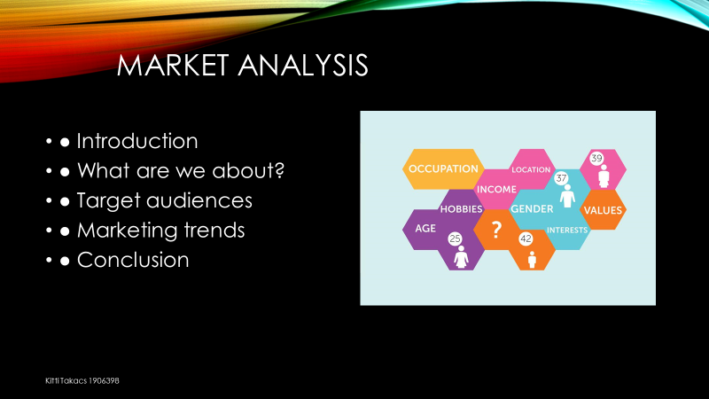
Market Analysis

For my part of the business plan I will be assessing the market analysis for our chosen company to the best of my understanding. I will be focusing on where we are based, what we do, what we have to offer, target audiences and marketing trends.

The kiosk is based in Kings Cross, it goes by the name of Fasto Coffee, in the current location we are based in there is a lot of human traffic passing through that facility which could increase the sales. The kiosk aims to sell beverages such as hot drinks, a variety of cold drinks, including freshly squeezed fruit juices and carbonated soda for anyone in need of a fizz, and snacks such as sandwiches, cakes and cookies. The team involved in this kiosk come from a range of different backgrounds and European countries therefore making it multilingual.

This encourages a wider scale of customers from overseas to be drawn to our business. One of the main attractions that will demonstrate to customers that we are multilingual, will be the fact that we will put up flags of the countries' languages that can be spoken, in hope to attract more than the odd foreign visitor. If enough people have a good experience with the kiosk, it will then be promoted through word of mouth. People from overseas will recommend it to their friends as they know it would be an easier option as we can communicate in many different ways. ‘ In 2017–18, there were 458,490 international students studying at UK higher education institutions, accounting for 19.6% of the total student population in the UK.’ (OECD)

As many young people are always connected to their phones, by making connections with them through food and drinks that they like or are appealing we are using them as a platform to promote our business even further. By running a social media page and taking on any tips or advice given to us by a close partner we can help take in that information and recreate it into our own vision.

We have a target audience of people who are aged 17-70, people from as young as 17 are involved in work opportunities such as apprenticeships or they might have a job in retail, this makes them a valuable target audience. They might now spend as much as another customer but each spend counts. ‘47.8% of people over 65 are living alone’ (Open data).

This means that many people are experiencing loneliness, many people of an older age have what is called a disposable income this means that their money is mainly being spent on self-pleasure as such little drinks and snacks. This specific age group mainly take walks during the days as they are familiar with the area, and some people would stop to have a daily interaction and get a drink, for them it is like a daily coffee meeting, a little bit of stability. Any other potential buyers would be people who are on their way from work, on their lunch break or just running errands. ‘King’s Cross has become London’s largest outdoor, totally free public Wi-Fi zone after signing a deal with The Cloud.”(Kx, 2012). Many train stations offer a free Wi-Fi facility, kings cross is one of them, by being allocated close enough to establish a connection, this entices customers that visit and need a place to use technological devices for personal uses such as contacting families, making appointments, browsing, and even booking tickets for current or future travel. ‘Making Wi-Fi freely available means people can be more productive, or simply entertain themselves, whenever and wherever they are. Forward-thinking places like King’s Cross have invested in this infrastructure to offer people a robust and free network which I am sure will prove to be well used and appreciated.”’(Kx, 2012)

Many students are located in and around the area since there are a few colleges such as Westminster Kingsway College, Central Saint Martins and a well known university called King’s College university located near the station. By having a large number of students in the area this also helps increase the activity of the stall. As many students travel to study and enjoy their youth a lot, finding trustworthy places to be around when you need a break is a major thing.

Kings cross is also known as a connection point for many people to travel to and from. ‘St Pancras International is set at the heart of Central London with more underground connections than any other London station.’ (St Pancras). Meaning this business has a higher rate of attracting customers, it gives ample opportunity and connections to make connections with the locals who want somewhere they can trust. It makes it easier to find spontaneous customers such as tourists or people who have just taken a day out. ‘There are four main services from the station – Eurostar, East Midlands Railway, South-eastern and Thameslink.’ (St. Pancras). These trains bring customers in from places such as Hertford, Leeds, Peterborough and even Paris. By being closely located to St. Pancras as well we are accidently visitors from multiple travels. The thought of standing in Costa, or Starbucks for a coffee that can be made 10 times quicker by us is almost a thought in the past. With the current market constantly growing at a faster rate with smaller businesses’ and staying the same with bigger businesses’ such as Costa, it is continuously opening up gaps in the markets for other businesses to expand and take over.

‘176 Million people pass through King’s Cross and St Pancras stations annually.’ (Argent retail). ‘12 Million people come to the stations to specifically shop.’ (Argent retail). This means that 1 million people attend St Pancras monthly just to shop. If 500,000 people brought a hot chocolate for three pounds, which is the average price of a coffee then this would mean the business would make 1,500,000 in one month and that does not include any other food or drink purchases being made.

There are 3 main times in the day which could influence the sales being made. The first one being morning so from 6-9am where many people are rushing to work (also known as rush hour), leaving them with little to no time to make breakfast meaning they have to pick something up on the way. ‘HALF of Britons – over 25 million – are now regularly missing breakfast, a figure which has soared dramatically compared with just one in five four years ago.’ (Express) .
Many people don’t have the time to stand in a long que in a supermarket either so a quick stop off shop to grab a hot drink or something to help be their fuel for the day tends to be a go to. ‘The number of consumers buying lunch to eat out of the home for an everyday occasion has risen to 76% in 2017, up from 64% in 2016.’(Mintel, 2017)

The second time of the day is lunchtime, again with people not being able to prepare breakfast, they are also missing out on lunch. This is where we come into place, we provide fresh produce to make a delicious yet tempting meal. Bright colours, clean food, anything a person could want. Food for the eyes and heart. By lunchtime people are feeling restless as they know only half of their day is left, having a clean, cheap meal that can be easily accessed is critical, as most people have a set limit for their lunch breaks and also may be conflicted with out of work situations there is no time for food prep. This time of the day also calls upon college students who are having their lunch breaks with friends and would like to find an area where they can get a quick bite to eat, talk to their friends, be socially active and still be local to their place of education.

By the time it gets to the third section of the day, many people are feeling run down and are ready to go home, they are in need of some energy for the journey, or they might just want a little snack or drink to accompany them on the way home. This is the second rush hour in the day, this hour can become busier than the first as many people miss trains and have to wait around, a long day at work might result in a hot coffee, a cookie and a cigarette break. For others it might be a double espresso and a phone call home. No matter your demand we can provide. This also counts for the parents who have just finished work and are planning to take their child home, by advertising bright colours and pretty cakes we aim to attract the attention to our stand in hope of their parents buying something for them, and maybe even themself too.

This then brings it to competition, if there are other places to go to what makes ours so different?

The sources on which we go to, to retrieve fresh products, we make sure that each stock is fresh and renewed weekly. We aimed to make it a simple yet interesting business, something to catch the eye. One of our main competitors Kiosk which is also located outside of Kings cross station, provides similar content but our station aims to deliver a wider variety of meals based around certain produce. Which is a harmless way of proving a point. Covent garden vegetable market is another reliable market we have access to receive the purest quality.

‘In other words, in five years' time Costa won't be opening new shops at the breakneck speed of recent years. It may not be opening any at all - because we'll have enough.’ (BBC). This leaves a break in the market for any upcoming business’ such as ours to pull through and make a name for ourselves.

When it comes to marketing trends, many people are taking it upon themself to do personalised drinks to each specific person. Meaning you can add and take away from your drink to make it your own. ‘Operators can offer a wide and customisable menus, these add-ons also offer opportunities for micro up-selling, boosting profit per serve.’ By doing this you will not only be creating a relationship with your normal customers it helps build bonds with customers you start to see on a regular basis. (coffee trends, 2020)

Overall, this analysis has led me to believe that we will be able to control a business in kings cross, and I also believe it will be a very beneficial and eye opening experience, as it has enough people to feed into the business and run in a stable way as there are a lot of potential customers. By being open to diversity, it opens many opportunities for people to feel welcomed and create spaces for bigger opportunities.

https://opendata.camden.gov.uk/widgets/9egs-2yf7 (Open Data)

https://www.kingscross.co.uk/media/Argent-Retail-Facts-Figures_-Digital.pdf (Argent Retails)

https://www.express.co.uk/life-style/food/754711/Breakfast-skipping-Britain-meal-health (express)

https://stpancras.com/trains (St.Pancras)

https://kingscrosskiosk.com/

https://www.bbc.co.uk/news/business-41251451 (BBC)

https://www.oecd-ilibrary.org/docserver/eag_highlights-2013-12-en.pdf?expires=1589145411&id=id&accname=guest checksum=576402CD5EA7C084BA3BDE9B34CFBC4E (OECD)

https://www.jacobsdouweegbertsprofessional.co.uk/brands/white-ox/coffee-corner/uk-coffee-trends-2020/(coffee)

https://www.mintel.com/press-centre/food-and-drink/brits-out-to-lunch-76-of-brits-now-buy-lunch-out-for-an-everyday-occasion-up-from-64-in-2016 (Mintel)

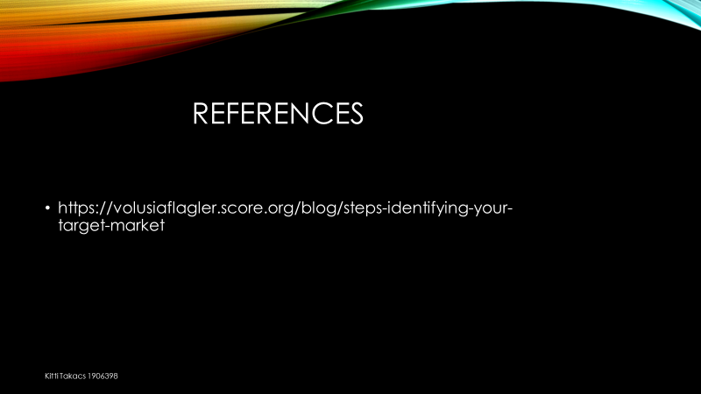

Managing Enterprise for the 21st Century
BUSINESS PLAN

STUDENT NAME: Katalin Fodor
Student ID: 1908947
Lecturer: Yajesh Kumar

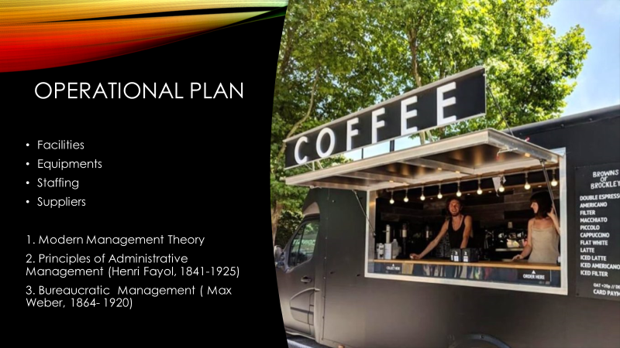
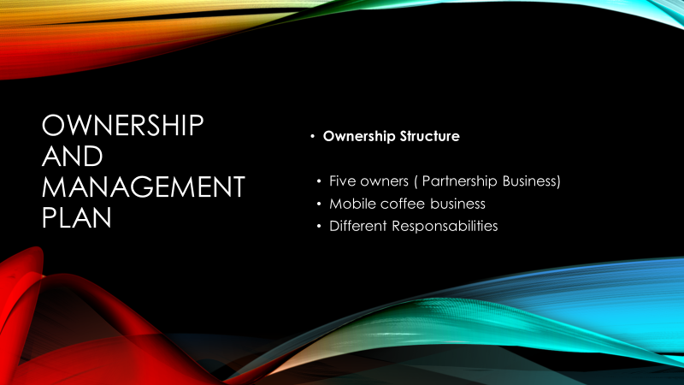

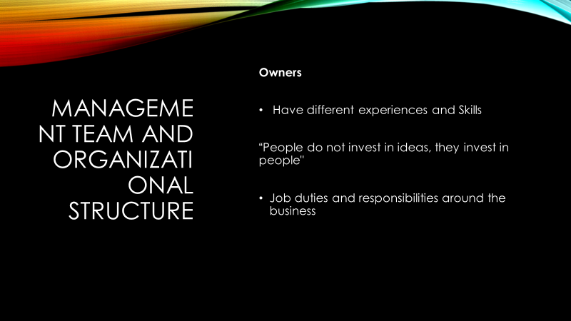

Table of Contents

- Executive Summary..............................................Edson Rondon
- Business/Industry Overview.................................Paulo Sampaio
- Market Analysis and Competition........................Kiri Smyllie
- Sales and Marketing Plan....................................Kiri Smyllie
- Ownership and Management Plan.......................Fodor Katalin
- Operating Plan.....................................................Fodor Katalin
- Financial Plan.......................................................Kitti Takacs
- Appendices and Exhibits......................................Kitti Takacs

5. Ownership and Management Plan

Ownership Structure

The Fasto Coffee (Mobile) it is a private corporation registered in the United Kingdom of London. The name of the coffee shows our business connect with our modern world such as people want to buy food or drink on the go without compromising on quality. This means" quick service" business like ours. Also, people taking advantages of places like ours. The business, first will start at King Cross, here are lots of international buses, trains also tubes, undergrounds. The business mobile coffee you can variety locations, including festivals, outdoor events, functions even weddings and more but this we will do it in the future. First, we will start our business at King cross where we will rent the place where we put our mobile coffee business.
The legal entity will be an ordinary, general partnership business as we share the responsibilities such as management and profit. The good thing is about partnership business is you can keep private the financial and other information. Also, we do not have to pay corporation or capital gains tax. Each of us can remain self- employed, the only legal requirement is be registered with HMRC and each of us registers for self- assessment. The advantage of having partnership business is more than having disadvantages. Such as:
- Flexibility and support – what we can get from each other, even if one or two of us are sick the business will not suffer.
- Broaden skills set – each of us having different skills and experiences
- Less paperwork – all of us remaining self- employed, there is no need to deal with administrative requirements.
As owners we all know if someone cannot pay, because she or he does not have money is our or me be liable for their share of the business debts what of course put me or other owners in risk.
The business is 100% owned by 5 people, 3 Misses and 2 Gentleman. Each people put £20.000 into the business. Every one of us is equal owners as all of us will be actively involved.
- Miss Kitti Takacs- £ 20.000
- Miss Kiri Smyllie - £ 20.000
- Miss Katalin Fodor - £ 20.000
- Mr. Edson Rondon - £ 20.000
- Mr. Paulo Sampaio - £ 20.000

Management Team:
All the 5 owners will manage the business, and doing everything at least for the first 6 months. One or two of us will do the ordering part also the marketing part as well, two of us will be at the front, serving clients, dealing with money or making sandwiches. One of us dealing with managing things around like ordering products from local suppliers. All five owners have experience in different territories, like food services management experience , trained or professional baristas. One of us have accounting diploma. We, owners are really good close friends. There is a really good thoughts what I have read these days and want to put it here because this is really suit all of us:” People do not invest in ideas, they invest in people" ( dreamalatte.com) As we have the right people around us.

Organisational Structure:
We are 5 owners but we have different responsibilities as we agreed, but as I mentioned we share profit and management. Two of us Miss Katalin Fodor and Mr. Paulo Sampaio are dealing with legal insurances, to make sure our business is on the right foot.
Taking the right Insurance for our mobile Coffee business is crucial. If something is happens, insurance could help to protect our greatest assets. We all know Mobile coffee business insurance could cover lots of things such as cover accidents on the road or staff injuries, interruptions, food poisoning and other things.
Here are some what we consider we have and we will mention those insurance when we will hire more staff:
- Public liability insurance could cover against accidental food poisoning.
- Contents and equipment insurance which can protect our mobile coffee business if will be fire, flood or even theft and malicious damage.
- Business interruption can help you to cover any loss of profit or fixed expenses which can damage our mobile coffee business.
- Employer's liability insurance is a legal requirement if we plan to hire more staff.
- Level 2 Food Hygiene Qualification as we provide some food with the coffee/tea to make it more effectively. We will have the NCASS nationwide caterer’s association.
- Street Trading licence as we trade on public streets or roadsides sometime soon.
- Food Safety Risk Assessment
- Gas Safety Certificate which is used for catering purposes and that will mean our equipment is safe and legal to use.
- Electrical Certificate must provide as well safe business premises and equipment
Miss Kiri Smyllie and Mr. Edson provide accounting services to the business. Miss Kitti Takàcs catering will supply the baked goods. Also is a legal requirement to register our coffee business with Environmental Health Development at least 28 days before we begin deal. Also we need to get a Risk Assessment, Method Statement and other Safety documentation if we want to function our mobile coffee business at events, festivals, weddings. But I have mentioned that above will be in the future if our mobile coffee business will speed up.

- Operational Plan
We all heard and read lots of failures even in small businesses that “ have determined that 98% of failures stem from managerial weaknesses”. ( Writing Successful Business Plan, 488 p.) Mentioning five section which should be in the management section: ( Bangs, 1995)
- Personal history of principals
- Related work experience
- Duties and responsibilities
- Salaries
- Resources available to the business
As all business people know every business needs technology, that is why we choose the right one which suits our business. “ Key problem when choosing technology include ( Abrams, 2010):
- Function
- Easy to use
- Cost
- Security
- Ability to be upgraded and expanded
- Integration with existing data and technology systems
We also used some management theories as important as focus on making our business a success because success depends on large part on the way you guide your employees. (In our case the employees we are. )The Theories give us concrete ways inspire eminence in our team. (https:// getsling.com/blog/management-theories/)
On Modern Management theory we all agreed which is for Modern-day business and faced with navigating rapid change and complexities. Also says the people are complex but the theory is not perfect by itself we used other theories to create a structure that be good for our business. “Bureaucratic Management “ according to Weber can be very useful for new business that are in needs of standards procedures( with clear rules and roles) and structures. ( Max Weber, 1864-1920) I will mention the “ Principles of Administrative Management” theory as well as examining a business. This theory are the foundation for many today ‘s most successful businesses.( Henri Fayol, 1841- 1925)
We Outlined the physical requirements on our business, such as retail space, facilities, equipment’s, staffing, suppliers etc. I will detail these under.
Facilities
When we thought about location we knew that is as important when purchase commercial space as it is when leasing. We wanted customer base, that is why we choose part of town. We want a rented premise as we have less capital than buying, we invest in the business instead. It also flexibility to relocate easily. Of course, they are many types of retail space and different regulations what we need to follow. Strategically located within easy walking distance from the tube stations, train station and any other business offices.
The premises we have chosen are King cross near to tube Station. The space features:
The coffee van is size 4x4. The space what we rent will be a bit bigger. Will be two containers space. The space what we only rent the only responsibility what we need to do is paying the utilities such as water, electricity gas, internet will be estimated £600 per month.
The owner of the place is responsible for trash collection, recycling pest control and security.

Staffing
The staff for the first 6 months will be us, the owners. All of us have Health and Safety Certificate and most of us have been trained recently. Two of us who needs more training will be provided during weekdays. First, we will work full - time as we will do everything at the Fasto Coffee. Our duties the customers satisfying, by greeting them as they enter to the coffee zone, make eye contact as we are serving them, trying to get some talk and chit chat while we are serving them, being honest, if for example the coffee going to take few minutes more, another duties is by anticipating their needs like giving napkins for a spilled drink. Also our duties is to be up do date with our stock.
Training provided the following day:
Monday
- Testing how to use coffee machines and plus learn it.
- Begin to familiarising ourselves with the menu
Wednesday
- Learn about how to focus solely on churning through customers as quickly as possible.
Thursday
- Try to learn our drink menu
- Learn about up- selling opportunities
Equipment
When we buy equipment, we want to make sure has got CE label which means the product complies with the essential requirements etc.
The following equipment will be purchased:
- The big Mobile Coffee Bar
Includes:
  - Fully functional plain white bar with a polished steel front
  - Has tall light
  - Built in power connections,
  - Water tank ( with filtration)
  - Sink
  - Hot water
  - Urn a waste
  - External power requirement- a 32amp or 16amp connection
  - Access to a separate 13amp double plug
- Glassdoor mini fridge - what suitable in the coffee van
- Dishwasher
- Microwave
- Misc. shelving, storage bins etc.
We are negotiating this equipment what I have mentioned above with one of the local vendor.
Maintenance contract will be negotiated for the with the local vendor.

- Mobile card machine (can be connected through Bluetooth or Wi-Fi)
  - Accepts contactless payments such as Apple Pay, Android Pay, Samsung Pay.

Supplies
- We have negotiated agreement with local suppliers Caravan Coffee wholesalers to supply premium Columbian coffee/ expresso two day shipping Milk, juices, soft drinks fruit etc. will be sourced from local Starbucks or Costco.
- Sandwiches,( cheese, veggies, salami etc.) snacks some bakery ( croissant, pane chocolate scones etc.) will be supplied on a daily basis from Creekson LTD.
- We also get the napkins, take away cups with different sizes and lids (medium, large)

References

www.startuploans.co.uk
www.entrepreneur.com
www.rocketlawyer.com
www.gestling.com
Morgan,P(2017). The business Student’s Guide to Employability. London: Sage
Maund. A.,Schriek. M.,and Tinkler.P.(2017)
Certificate in Higher Education: Skills for Workplace Student Yearbook.London: Sage
https://www.thebalancesmb.com
https://www.bplans.com
https://www.premierline.co.uk/knowledge-centre/mobile-coffee-business-plan.html
www.gov.uk
www.dreamelatte.com

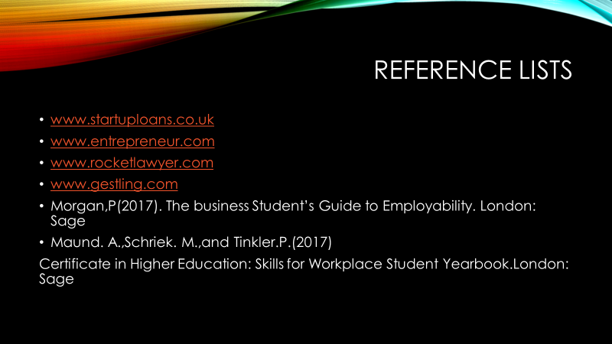

Student Name: Kitti Takacs
Student Number: 1906398
Module Title: Business Plan

“There is only one boss. The customer. And he can fire everybody in the company from the chairman on down, simply by spending his money somewhere else.” (Sam Walton)

Introduction

The company called Fasto Coffee. Fasto coffee owned by 5 members. The company owners are owning the company equally, each member invested £20.000, that means every member has 20% ownership in the company. Fasto coffee total invested budget is £100,000. Below in the document will present the start-up cost and the product detailed sheets also. Festo coffee idea to help the small businesses in London so all products will be ordered from small traders. The company has no actual target age as all ages are able to find products.

Fast Coffee Location

Fasto Coffee located at Kings Cross St Pancras station. The location helps the business to take off as many people passing through day by day. The estimate is 176 Million people pass through King’s Cross and St Pancras stations annually. (https://www.kingscross.co.uk/media/Argent-Retail-Facts-Figures_-Digital.pdf)
Fasto coffee is targeting tourist and workers literately everyone who walks through in this area. The Location brings many tourists to explore this beautiful part of London. The history of this location goes back to 18th century.

Projected Start-Up Costs:

The table below shows the ongoing and one-time cost items that Fasto Coffee need to open the business. Fasto coffee did not take any credit as we individually invested £20,000, we might require some credit in the future if the business does not take off. We are aware of the possibility that the beginning we will not have cash coming immediately. We estimated when the cash will begin to flow into the company. We are covered by six months as you see our table below. As the company owned car will help us reduce the cost month by month and the company in the future can invest in another car if the brand will become popular so we can place another car in a different location. Also, Fasto Coffee has option B as what if the location does not bring as many costumers as we estimate. Fasto Coffee is a movable company. So, we are able to change location and also in the weekends or summer time we can attend in festivals, markets or events. The company does not want to hire in the beginning any staff member as we try to work as an owner’s day by day equally manage the time between 5 of us. It can reduce also the outgoing as we will be on low salary to help take off the business in the first six months. Fasto coffee has plan to invest in another car so we are able to grow and also in the future we can hire new staff members so the company will provide jobs in England.
START-UP COSTS
Fasto Coffee
COST ITEMS | MONTHS | COST/ MONTH | ONE-TIME COST | TOTAL COST
Advertising/Marketing | 6 | £ 1000 | £ 2500 | £ 8,500
Employee Salaries | 6 | £ 7000 |  | £ 42,000
Employee Payroll Taxes and Benefits | 6 | £ 2000 |  | £ 12,000
Rent/Lease Payments/Utilities | 6 | £ 1500 |  | £ 9,000
Computer Equipment | 6 | £ 100 |  | £ 600
Computer Software | 6 | £ 100 |  | £ 600
Insurance | 6 | £ 15 |  | £ 90
Supplies | 6 | £ 1200 |  | £ 7,200
Travel & Entertainment | 6 |  | £ 150 | £ 150
Equipment | 6
Furniture & Fixtures | 6 |  | £ 25000 | £ 25,000
Security Deposit(s) | 6 |  | £ 3000 | £ 3,000
Business Licenses/Permits/Fees | 6 |  | £ 1500 | £ 1,500
Professional Services - Legal, Accounting | 6 | £ 80 |  | £ 480
ESTIMATED START-UP BUDGET |  | £ 12,915 | £ 32,150 | £ 110,120

Fasto Coffee Products
The company provides all details regarding from units cost, margin, cost price and the profit. The sheet shows the items individual costs and profit. The soft drinks will be ordered by a small company.

ITEM | UNIT | UNIT COST PRICE | Margin | Cost Price | Profit
SOFT DRINKS
APPLE EAGER | 330ml | £ 1,25 | 50% | £ 2,50 | £ 1,25
CRANBERRY JUICE EAGER | 330ml | £ 1,46 | 42% | £ 2,50 | £ 1,04
ORANGE JUICE EAGER | 330ml | £ 1,37 | 45% | £ 2,50 | £ 1,13
PINEAPPLE EAGER | 330ml | £ 1,40 | 44% | £ 2,50 | £ 1,10
TOMATO JUICE EAGER | 330ml | £ 1,28 | 49% | £ 2,50 | £ 1,22
GRAPEFRUIT JUICE Eager | 330ml | £ 1,50 | 40% | £ 2,50 | £ 1,00
BITTER LEMON FEVERTREE X 24 | 200ML | £ 0,52 | 74% | £ 2,00 | £ 1,48
GINGER ALE FEVERTREE x 24 | 200ML | £ 0,46 | 77% | £ 2,00 | £ 1,54
GINGER BEER FEVERTREE X 24 | 200ML | £ 0,46 | 77% | £ 2,00 | £ 1,54
LEMONADE FEVERTREE X 24 | 200ML | £ 0,46 | 77% | £ 2,00 | £ 1,54
TONIC W FEVERTREE x 24 | 200ML | £ 0,46 | 77% | £ 2,00 | £ 1,54
TONIC W DIET FEVERTREE x 24 | 200ML | £ 0,46 | 77% | £ 2,00 | £ 1,54
SODA BABIES FEVERTREE X 24 | 200ML | £ 0,46 | 77% | £ 2,00 | £ 1,54
COKE COLA BOTS X24 | 200ML | £ 0,45 | 78% | £ 2,00 | £ 1,55
DIET COKE COLA BOTS X24 | 200ML | £ 0,45 | 78% | £ 2,00 | £ 1,55
KINGSLAND SPRK WATER | BTL | £ 0,60 | 70% | £ 2,00 | £ 1,40
KINGSLAND STILL WATER | BTL | £ 0,60 | 70% | £ 2,00 | £ 1,40

Calculation
Milk and Coffee
Milk and coffee are high cost for the hot drinks. Milk works out more expansive than the coffee. The coffee for the company is whole beans and it comes in 4 kg bags. One espresso is approximately 8 grams of ground coffee. This means that the company can brew 500 espressos with one bag of coffee. The company pays £15 for the bag of coffee. This makes the cost of one espresso £15 / 500 = 3 pence. The milk bought from a local trader. The company provide us bigger bottles.
For example, one cappuccino in Fasto Coffee in a 240ml cup. 6oz is 240ml. The full cup will be 40ml of espresso and 120ml of milk as we create some foam. This means that 120ml cost us 6 pence.
One Cappuccino
Cost: 3p (coffee) + 6p (milk) = 9p
Selling price for £2,50 and we took the VAT (20%) the NET sale of £2,08
Gross Profit = £2,08 – 0,09 = 1,99 =96% Profit Margin
COFFEE | UNIT | UNIT COST PRICE
BEANS | 4 KG | £ 15,00
DECAF | 1 KG | £ 13,00
Milk | 3,6 L | £ 1,80

Fasto Coffee has some grab and go product for customers would like to eat something. Fasto Coffee menu has different type of food. The first sheet shows the basic Toast with Jam calculation. The selling price will be £2,00. So, the profit on this product will £0,93.
Toast with Jam | 1 | portion | £/kg/ unit | total
Sourdough | 120 | g | £ 2,80 | £0,34
butter portion | 25 | g | £ 4,00 | £0,10
Jams | 70 | g | £ 9,00 | £0,63
 |  |  | Total price | £1,07

The Fasto Summer salad will sell in paper box as the company eco-friendly. All cups and boxes made by recycle paper. The Fasto salad costing see below the sheet. The selling price for this product will be £3,50, so the profit on this product is £2,71.

Fasto Summer Salad
 | 1 | kg | £/kg | total
Tomato | 265 | g | £1,63 | £0,4320
baby cucumber | 265 | g | £3,20 | £0,8480
breakfast radish | 105 | g | £7,00 | £0,7350
spring onion | 75 | g | £6,00 | £0,4500
rocket leaves | 50 | g | £8,66 | £0,4330
yellow pepper | 55 | g | £2,62 | £0,1441
baby gem | 2 | each | £0,45 | £0,9000
mint leaves | 17 | g | £7,21 | £0,1226
parsley leaves | 8 | g | £9,60 | £0,0768
 |  |  | total £/kg | £4,14
 |  |  | Portion size (g) | 190
 |  |  | Portion cost | £0,79

Fasto Ham and Cheese Sandwich
Fasto Coffee sells handmade sandwiches. The reasons are the fresh made sandwich is because the cost is lower than the premade sandwiches and also looks better and fresher the handmade products. All the ingredients are from small local suppliers. Fasto coffee also thought about customers who has allergies or vegetarian. The company has 3 different types of sandwiches and 2 different types of bread to help people with allergies or intolerances.
Below this sheet shows the costing of the fresh Fasto ham and cheese sandwich.

Ham and Cheese sandwich
 | 1 | kg | units | total
Bread | 120 | g | £1,22/800g | £0,18
Butter | 10 | g | £7,20/1kg | £0,07
Ham | 150 | g | £1,10/100g | £1,65
Tomato | 40 | g | £3,60/1kg | £0,14
Lettice | 50 | g | £0.67/100g | £0,34
Mayo | 30 | g | £4,38/1kg | £0,13
Cheese | 40 | g | £11,33/1kg | £0,45
 |  |  | Portion cost | £2,96
 |  |  | Portion size (g) | 440g
 |  |  | Selling Price | £7,50

Profits and Plans for the next year
The estimate is 176 Million people pass through King’s Cross and St Pancras stations annually. (https://www.kingscross.co.uk/media/Argent-Retail-Facts-Figures_-Digital.pdf).
The daily average is 482,192 people but only 25% will buy coffee and the rest 75% will have the coffee at home. Fasto Coffee targets less than 1% of the daily average. The company market research shows that we have 4 big coffee companies near. Most of the customers will choose the big branded coffee places so that why Fasto Coffee target less than 1% in the first year. The estimate daily customers will around 800 people.
Our estimate per customer is £5.
Estimate daily £5 x 800 = £4000
Fasto Coffee will operate Monday to Friday.
 | May | June | July | Aug | Sept | Oct | First 6 months | First year
Sales | £84,000 | £84,000 | £84,000 | £84,000 | £84,000 | £84,000 | £504,000 | £1,008,000
Cost of Sales | £33,600 | £33,600 | £33,600 | £33,600 | £33,600 | £33,600 | £201,600 | £403,200
Gross Profit | £50,400 | £50,400 | £50,400 | £50,400 | £50,400 | £50,400 | £302,400 | £604,800
Operating expenses
Salaries, Wages | £10,000 | £10,000 | £10,000 | £10,000 | £10,000 | £10,000 | £60,000 | £120,000
Marketing | £1000 | £1000 | £1000 | £1000 | £1000 | £1000 | £6000 | £12,000
Legal & Accounting | £80 | £80 | £80 | £80 | £80 | £80 | £480 | £960
Supplies | £10,000 | £10,000 | £10,000 | £10,000 | £10,000 | £10,000 | £60,000 | £120,000
Rent | £1500 | £1500 | £1500 | £1500 | £1500 | £1500 | £9000 | £18,000
Utilities | £600 | £600 | £600 | £600 | £600 | £600 | £3600 | £7,200
Insurance | £16 | £16 | £16 | £16 | £16 | £16 | £96 | £192
Taxes | £16,800 | £16,800 | £16,800 | £16,800 | £16,800 | £16,800 | £100,800 | £201,600
Total Oper. expectation | £44,196 | £44,196 | £44,196 | £44,196 | £44,196 | £44,196 | £265,176 | £530,352
Operating Profits | £6,204 | £6,204 | £6,204 | £6,204 | £6,204 | £6,204 | £37,224 | £74,448

Summery

The Company will be expecting Profits. Fasto Coffee will invest the profits into the business. The owners will not take profit out of the business in the first year. Fasto Coffee will invest another Coffee Car. So, the company will able to attend parties, festivals or events. It will help to grow the business and grow the brand name. Expecting a Franchise company in the future.
“We see our customers as invited guests to a party, and we are the hosts. It's our job every day to make every important aspect of the customer experience a little bit better”. (Jeff Bezos)

References

- https://www.kingscross.co.uk/media/Argent-Retail-Facts-Figures_-Digital.pdf
- B. R. Ford, J. M Boorstein, and P. T. Pruitt, The Ernst & Young Business Plan Guide, Hoboken, NJ: John Wiley, 2007
- International Business Environments and Operations, Edition: 11th, Authors: John D Daniels, University of Miami, Lee H Radebaugh, Brigham Young university and Daniel P Sullivan, University of Selaware (Year 2012)
- https://www.amazon.co.uk/alm/storefront?almBrandId=QW1hem9uIEZyZXNo&ref_=nav_em_0_2_9_2__afs_aaf
- https://www.azquotes.com/quotes/topics/business-relationship.html




