University of Whales Trinity Saint David


Marketing Management
Assignment 1
75%

Submitted by
Pavlin Petkov Hristov
(2023214)

MBA 2021/2022
Lecturer: Tushara Balendran

Report on
P R I M A R K

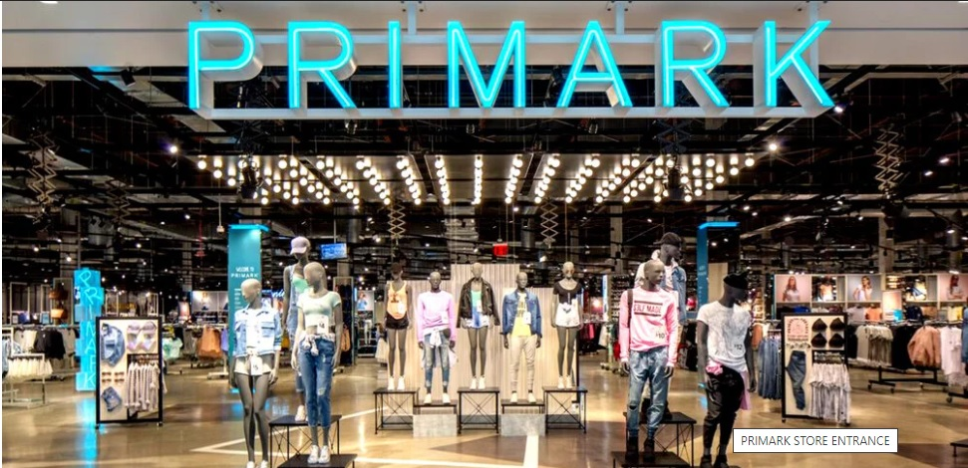

PRESENTED TO THE UNIVERSITY OF WALES TRINITY SAINT DAVID, LONDON CAMPUS IN PARTIAL FULFILLMENT OF THE REQUIREMENTS FOR THE DEGREE OF MASTER OF BUSINESS ADMINISTRATION (MBA) FOR THE MODULE:
MARKETING MANAGEMENT
75% ASSIGNMENT

Table of content
- Introduction
- Communication
- The macro model of Shannon and Weaver in the communication process
- Integrated Marketing Communications
- Promotional concepts of PRIMARK
- Branding Strategies and Brand Equity of PRIMARK
- Keller’s Brand Equity Model
- Advantages and Disadvantages of Keller’s Brand Equity Model
- Brand Equity and Corporate Social Responsibility (CSR)
- PRIMARK’s Customer Touchpoints and Customer Journey
- Advantages and Disadvantages of PRIMARK’s Customer Journey
- Conclusion
- References

- Introduction

Primark is an Irish retail company operating in different countries around the world. The company has shops in Spain, Portugal, France, Germany, Netherlands, Belgium, Austria, UK, Ireland and USA. It was founded and headquartered in Dublin, Ireland.
Primark has more than 27,000 employees doing all their best to ensure that the company is running smooth and generating a lot of profits.
PRIMARK is an absolute sensation in today’s world. The company is a synonym of a trendy cat walk fashion at an affordable price to its customers.
The company believes in its merchandise and the cheap and affordable prices which brings more and more customers to the shops who once been there they know where all the cheap, affordable clothes and accessories are for the future. That strategy really works and convinces the customer to stay a loyal customer of Primark.
Primark has over 370 stores across 12 countries.

- Communication
The definition of communication is: “a process by which messages or information are sent between people and places through various methods such as speaking, writing, body language, or other signals to share information or messages” (Cambridge Dictionary, 2020)
The function of marketing communications is to engage with customers in order to convince them to purchase a particular product or service of a company. (cf. Kottler, 2019)
Primark uses different ways to reach the different groups of customers they have. An example of such is how the company communicates with its customers through its ethical trading website.
When it comes to communications with communities or employees in the countries where they manufacture all the goods, Primark is using initiatives like the community engagement program it has in India.
Primark knows that different groups of customers have different needs and expectations. Knowing that they have to channels of communication to engage with each group of customers.
- The macro model of Shannon and Weaver in the communication process
In 1948, Shannon was an American mathematician, Electronic engineer and Weaver was an American scientist both of them join together to write an article in “Bell System Technical Journal” called “A Mathematical Theory of Communication” and also called as “Shannon-Weaver model of communication”.
This model is invented to help understand and develop the communication between sender and receiver which in the end to be effective. They also describe factors which affecting the communication process called “Noise”. In the beginning the model was invented to improve the Technical communication. On a later stage it is largely applied in every field of communication.
The model deals with various concepts like Information source, transmitter, Noise, channel, message, receiver, channel, information destination, encode and decode.
- Integrated Marketing Communications

Integrated Market Communication also known as (IMC) is a concept based on the illustration of various interlinked promotion strategies communicating with the target market over time (cf. Schultz, 1993) which are harmonized in one promotion campaign aiming at the transmission of a synergetic message to maximize communication effectiveness and efficiency (Jobber and Ellis-Chadwick, 2016).
For marketers an effective and efficient communication is essential and fundamental to identify their target group, create the marketing mix, calculating the budget, decide what the main objectives of the communication will be and in the end to evaluate the results. Those are also known as the five stages of the IMC.

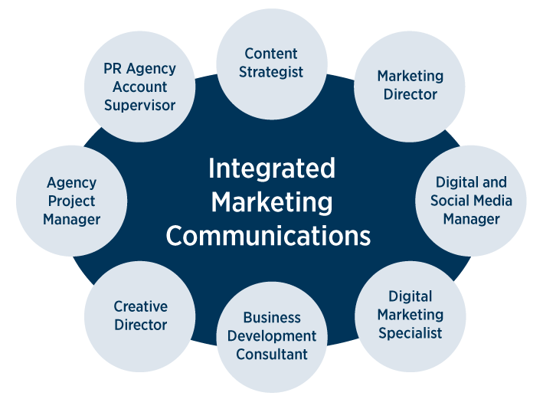

- Promotional concepts of PRIMARK

The biggest and maybe the most effective promotional strategy of Primark is mouth to mouth marketing. When a customer is satisfied he spreads the name of the shop around, posting in social media, talks about it in the local saloon which brings more customers in the shop. Despite not using ecommerce, Primark is using social media such as Facebook, Twitter, Instagram, and Pinterest extensively and gets millions of responses and shares throughout the social media in short periods of time.
Primark is contributing to a vast amount of social causes which works very positively when it comes to image building. Along with UNICEF in 2018, PRIMARK spent over $4 million to support an education program in Cambodia to help children who are vulnerable and help them stay in school and educate themselves. Its contributions to social causes also work very positively in image building.

- Branding Strategies and Brand Equity of PRIMARK

When we speak about a marketing mix that is successful that means the job with the marketing is well done. A marketing job is well done when a branding strategy is in place. The American Marketing Association defines a brand as a “name, term, sign, symbol or design, or a combination of them intended to identify goods and services of one seller or group of sellers and to differentiate them from those of other sellers”. A very well picked and strong brand strategy can increase the awareness of the company and what that company offers that a very strong bond between the customer and the brand to be established.
The very first step when developing a brand strategy is to define the brand. By defining the brand you can easily create the foundation for everything else to build on. The definition of a brand is used as a measuring stick when marketing strategies has to be evaluated. Primark has a very extensive brand portfolio.
When we speak about a brand portfolio we usually refer to company’s set of products or brands. Why having a portfolio? Having a portfolio of brands is better when it comes to one single item. Like that you can minimize the risk and have a diversification of the product.
Next thing that has to be done is to determine the brand objectives. Primark’s brand objectives are quite clear and simple:
- Delivering the message to the customer clearly
- Confirms customers credibility
- Connects emotionally customers target prospects
- Motivates the customer to buy even more
- Creating brand loyalty
- Setting target to gain a specific number of clients for upcoming periods
- Position the company as an industry leader for the following year.
To be successful in with the brand the company must know and fully understands the needs of its customers. Brand objectives should be comprised of company personality, image, core competencies and characteristics. The impressions that the company makes as well as the mouth to mouth strategy are the basic framework of Primark’s brand. When your brand is strong enough that gives the customers the thinking that this company is credible enough, it has influence on the retail market and gives customer the confidence and security to buy from its shops. If everything is correctly done that company will not be looked at as a follower anymore but a leader on the market.
When comes to marketing targets and identifying them a company could find different opportunities. That gives information that is needed to focus on what buyers are interested from and what else the company could possibly offer to them. This can save money and most importantly time in an ever-changing business environment. The strength of ones company brand lies on the ability to focus target audiences. Because of that defining target market can help Primark’s brand effectiveness to get stronger. The target market for Primark is people up to 35 years of age.
The next step in developing Primark’s brand strategy is to analyse the obstacles that may occur. Those obstacles are known as the market conditions that can stop the product or service to achieve the planned success. The potential obstacles in deploying Primark’s brand strategy are competition, timing, financing, location, lack of demand, suppliers not meeting demands and targets. To face these obstacles it is very important to spend time analyzing the product or service and cooperate with the development of the brand and positioning on the market
Last step in brand strategy is the company’s identity in marketplace where the image of that company is about how it appears on the packaging. It’s very important to realize that packaging always can have a positive or negative influence on the customer. When the packaging leaves a negative impression that can lead to losing a potential customer just as the positive impression can lead to more purchases. A special attention to detail has to be given when releasing a new brand. If the brand is strong already that people can recognize then not much of attention is given to the packaging.
A company cannot develop its brand equity instantly. The brand needs to be well looked after so the customers the real value and trust in this brand. When a company manages its brands it has a number of strategies it can use to further increase its brand value. For Primark most suitable brand strategies are extending the line of clothes and introducing new brands. Primark must focus on its brand management as it’s a dynamic and a continuous process that needs consistent investment of time and it must be allocated a specific budget as it is much more than mere marketing communications.Because of the intangible nature of branding the results may not be visible straight away because that process needs time to build customer loyalty. To beat your competitors in branding is a continuous battle for the hearts and minds of the customers. Proposition that Primark’s brand strategy makes is very compelling, attractive and unique among competitive offerings. It must also be consistently reinforced throughout all phases of an organization, from senior executives to customer service, business development and even business partners.
The success of Primark’s gaining and retaining loyal customers lies in the quality of the products and the cheap and affordable prices. If we review the business environment and the other factors about Primark then we realize that the customer behavior is constantly changing and the business environment in the retail industry is evolving every day. Suppliers are really concerned about the prices when it comes to supply. If those prices keep growing that will influence and damage the profits which are currently satisfying. If we look at the forces and factors that Primark is facing we can see that the company is facing lots of challenges and struggling to survive if we look in long term.
Elaine Giles, Research Manager, TNS says, “Shoppers are starting to favour higher priced retailers and premium end of market is performing well. Growth of value sector last year came on back of new store openings and expansions that brought an influx of new buyers, but now sector seems to have reached saturation point. The only way, budget retailers can continue their success is to increase spend of existing buyers, something they may struggle to do given current retail climate.”

- Keller’s Brand Equity Model

Kotler (2008) describes brand equity in its most basic form as the added value or liability that is given to a product or service stemming from an association with the brand. Aaker (2009) identifies five categories of brand equity, these are brand Loyalty, name awareness, perceived quality, brand association and other proprietary brand assets. Of the five categories listed by Aaker, brand loyalty can be said to be the most beneficial to firms. Kotler & Keller (2011) suggest that brand loyalty benefits firms by not only providing a predictability and security in demand but by also making it more difficult for other firms to enter the market. Aaker (2009) furthermore indicates the importance of brand loyalty to brand equity, claiming that a small yet intense loyal customer basis can have a significantly positive effect on brand equity.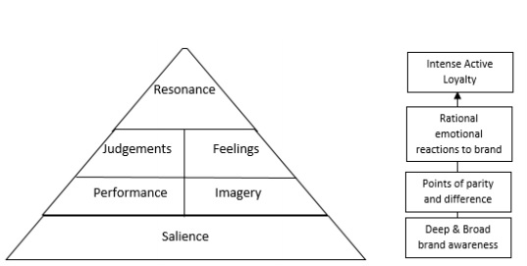

- Advantages and Disadvantages of Keller’s Brand Equity Model

When brand equity is positive that usually allows you to charge the customers more for the product or service that you are offering because buyers will be willing to pay more for your name just like they pay for premium luxury products like jewelry or electronics. A pure example of that is Apple or Pandora. Now we have to ask ourselves is the quality of those products better than the ones from their competitors? It might be, or it might not but the perception of the product remains. When customers are willing to pay extra for a name they trust and/or value, your profit margins will boost.
Expansion opportunities. Positive brand equity can facilitate a company’s long-term growth. By leveraging the value of your brand, you can more easily add new products to your line and people will be more willing to try your new product. You can expand into new markets and geographies. People there will recognize your brand, make an instant positive connection, and follow you.
Negotiating power. Positive brand equity can give you a considerable advantage in negotiating with vendors, manufacturers and distributors. When suppliers recognize that consumers are enthusiastically seeking and buying products that bear your name, they’ll want to work with you. That, will put you in an enviable bargaining position that can lower your cost of goods sold.
Competitive advantage. Do you know who won’t be happy about your company’s strong brand equity? Your competitors. When customers are willing to pay a premium price for your products or services…when customers will try your new product sight unseen, just because it has your logo on it…when customers in a new market flock to you simply because of the reputation you’ve built elsewhere…when you can get better pricing from the same vendors your competition is using (and thus undersell your competition)… that can mean very good things for your business and not-so-good things for your competition.

- Brand Equity and Corporate Social Responsibility (CSR)
Brand equity refers to a value premium that a company generates from a product with a recognizable name when compared to a generic equivalent. Companies can create brand equity for their products by making them memorable, easily recognizable, and superior in quality and reliability. Mass marketing campaigns also help to create brand equity.
When a company has positive brand equity, customers willingly pay a high price for its products, even though they could get the same thing from a competitor for less. Customers, in effect, pay a price premium to do business with a firm they know and admire. Because the company with brand equity does not incur a higher expense than its competitors to produce the product and bring it to market, the difference in price goes to their margin. The firm's brand equity enables it to make a bigger profit on each sale.
Corporate social responsibility (CSR) is a self-regulating business model that helps a company be socially accountable—to itself, its stakeholders, and the public. By practicing corporate social responsibility, also called corporate citizenship, companies can be conscious of the kind of impact they are having on all aspects of society, including economic, social, and environmental.
To engage in CSR means that, in the ordinary course of business, a company is operating in ways that enhance society and the environment, instead of contributing negatively to them.

- PRIMARK’s Customer Touchpoints and Customer Journey

Primark uses different ways to engage with different groups of customers. Such example is through its ethical trading website. To establish communication with workers and communities in the different countries where they make the goods, Primark is using different initiatives like community engagement program like the one they have in India. Primark understands that different customer groups have different needs and expectations. Knowing that they must use an appropriate channel of communication to get in touch with every single customer group
Primark is also cooperating with different civil society groups around the world. Those organizations share a common goal which is to protect the rights of workers. To engage with these groups, Primark is using different methods. Their engagement involves listening the different perspectives of the people involved in the process, learning about the problems and issues that occurs and these group have to face in their day-to-day job. Two key organisations that enable Primark to do this are the Ethical Trading Initiative (ETI) and the International Labour Organisation’s Better Work programme.

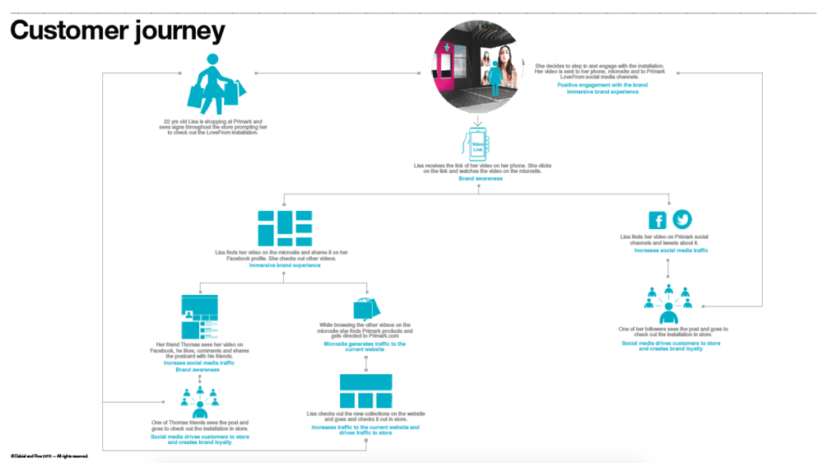

- Advantages and Disadvantages of PRIMARK’s Customer Journey
What Primark is doing well is that they know their customers DNA and they stick to it in every aspect. In this way the company creates a value for their customers. It’s not a secret to anyone and as I mentioned before Primark offers the lowest prices compared to its competitors. But it is not just the price. When you combined the price with the fashion items that’s when the magic is happening. In the end of the day they sell the kid-in-the-candy-store feeling, the Oh-My-God-I-can-buy-all-of-this-and-still-have-money-left experience.
That is the value they offer and that is why they are successful. They are able to make the customer experience so good because everything they do they are doing in exactly this value proposition. That exactly it’s the factor that differentiates Primark from its competitors. Because of all their operations - purchasing, stock management, store design, etc. - are aligned to just create this kid-in-the-candy-store experience.
When we look at Primark from that point of view it really makes sense that they stay away from the ecommerce. If it was only for selling low priced fashion then, yes, there might be a chance for Primark to be on the top but even then the distribution and returns would be really challenging to make that business profitable enough to survive. On top of that the experience they create in the store is much more difficult to be transferred online. You cannot simply grab something, try it and then buy it or change your mind and leave it. And that doesn’t bring the same joy when everything happens online, does it
Primark can give every retailer a lesson that we can learn from. Know your customers and stick to what you know. Lots of other companies in this business are struggling doing that. They don’t know the value they create for the customers and as a result of that they lack focus and alignment. So what’s the lesson? Follow what Primark does and align everything you do around the type of value that you create for your customers.

- Conclusion

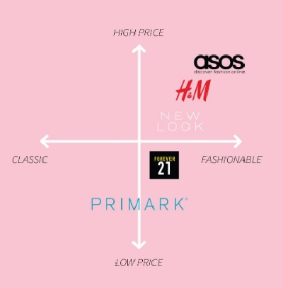

Primark and primary competitor’s position based on fast fashion customer perceptions.
Primark is positioned at the low middle of the map based on its price value and product design. That makes Primark affordable and fashionable at the same time which makes the customer choose it before the other competitors.

On the other hand in the past two years Primark stated that has a loss of billions of pounds during the pandemic. That is simply because of the company’s decision not to go online and sell their product only in the physical stores.

This report analyzed the customer journey of PRIMARK considering the customer touchpoints, IMC and promotion strategies.

- References

- Aaker, D. (1989): Managing Assets and Skills: The Key to Sustainable Competitive Advantage. California Management Review, 21 (3), 91–106. Crossref
- Aaker, D. and Stayman. D. (1990): Measuring Audience Perceptions of Commercials and relating them to Ad Impact. Journal of Advertising Research. 30 (4), 7–17.
- Aaker, D. A. (1991): Managing Brand Equity: Capitalizing on the Value of a Brand Name. Free Press, New York.
- Aaker, D. A. (1992),”The Value of Brand Equity”, Journal of Business Strategy, Vol. 13 Issue 4 pp. 27 – 32 Crossref
- Ailawadi, Kusum L., Donald R. Lehmann, and Scott A. Neslin (2003), “Revenue Premium as an Outcome Measure of Brand Equity, “Journal of Marketing, 67(4), 1-17. Crossref
- Ashforth, B. E., and Mael, F. (1989). Social identity theory and the organization. Academy of Management Review, 14, 20−39
- Atilgan, E., Aksoy, S., and Akinci, S. (2005). Determinants of the brand equity: A verification approach in the beverage industry in Turkey. Marketing Intelligence and Planning, 23), 237 – 248. Crossref
- Baalbaki, Sally Samih, (2012) Consumer Perception of Brand Equity Measurement: A New Scale, page 16, Dissertation of doctor of philosophy, University of North Texas
- Baldauf, A., Cravens, K.S. and Binder, G. (2003), “Performance consequences of brand equity management evidence from organizations in the value chain”, Journal of Product and Brand Management, Vol. 12 No. 4, pp. 220-236 Crossref
- Berry, L.L. (2000), “Cultivating service brand equity”, Journal of the Academy ofMarketing Science, Vol. 28 No. 1, pp. 128-38 Crossref
- Broyles, A., Leingpibul, T., Ross R. and Foster, B. (2010), “Brand equity’s antecedent/consequence relationships in cross-cultural settings”, Journal of Product and Brand Management, Vol. 19 No. 3, pp. 159-169. Crossref
- Buil, I., de Chernatony, L. and Martinez E. (2008), “A cross-national validation of the consumer-based brand equity scale “, Journal of Product and Brand Management , Vol. 17 No. 6,pp. 384-392 Crossref
- Chen, L.-H. (2008), “Internationalization or international marketing? Two frameworks for understanding international students’ choice of Canadian universities”, Journal of Marketing for Higher Education, Vol. 18 No. 1, pp. 1-33. Crossref
- Christodoulides G, John W. Cadogan Cleopatra Veloutsou, (2015), “Consumer-based brand equity measurement: lessons learned from an international study”, International Marketing Review, Vol. 32 Issue 3/4 pp. 307 – 328 Crossref
- Clow, Kenneth E. and Donald Baack (2005), “Brand and Brand Equity”, Concise Encyclopedia of Advertising, Haworth Press, Inc.
- Cobb-Walgren, C. J., Ruble, C. A., and Donthu, N. (1995). Brand equity, brand preference, and purchase intent. Journal of Advertising, 24(3), 25-40. Crossref
- De Chernatony, L., Cottam, S. 2006. Internal brand factors driving successful financial services brands. European Journal of Marketing 40 (5/6), 611 – 633. Crossref
- Falkenberg, A.W. (1996) “Marketing and the Wealth of Firms” Journal of Macromarketing, 16, 4, pp.4-24. Crossref
- Farquhar, P.H. (1989), “Managing brand equity”, Marketing Research, Vol. 1, September, pp. 24-33
- Isabel Buil Eva Martínez Leslie de Chernatony, (2013),”The influence of brand equity on consumer responses”, Journal of Consumer Marketing, Vol. 30 Issue 1 pp. 62 – 74
- Gil, R.B., E.F. Andres and E.M. Salinas, 2007. Family as a source of consumerbased brand equity. J. Prod. Brand Manage. 16(3): 188-99. Crossref
- Hsieh, M.H. (2004), “ Measuring global brand equity using cross-national survey data “, Journal of International Marketing, Vol. 12 No. 2, pp. 28-57 Crossref
- Haizhong Wang Yujie Wei Chunling Yu, (2008),”Global brand equity model: combining customer-based with product-market outcome approaches”, Journal of Product and Brand Management, Vol. 17 Issue 5 pp. 305 – 316
- Isabel Buil Eva Martínez Leslie de Chernatony, (2013),”The influence of brand equity on consumer responses”, Journal of Consumer Marketing, Vol. 30 Issue 1 pp. 62 – 74
- Jung, J. and Sung, E.Y. (2008), “Consumer based brand equity: comparisons among and South Koreans in the USA and South Koreans in Korea”, Journal of Fashion Marketing and Management, Vol. 12 No. 1, pp. 24-35. Crossref
- Keller, K. L. (1993): Conceptualizing, Measuring, and Managing Customer-Based Brand Equity. Journal of Marketing, 57 (1), 1-22. Crossref
- Keller, K.L. (2003). Strategic Brand Management: Building, Measuring and Managing Brand Equity, 2nd ed., Prentice-Hall, Englewood Cliffs, NJ.
- Keller, Kevin L. and Donald R. Lehmann (2003), “How Do Brand Create Value,” Marketing Management, 2003 (May), (26-31).
- Kerri-Ann L. Kuhn Frank Alpert Nigel K. Ll. Pope, (2008),”An application of Keller’s brand equity model in aB2B context”, Qualitative Market Research: An International Journal, Vol. 11 Issue 1 pp. 40 – 58
- Kim, Hong-Bumm, Woo Gon Kim, and Jeong A. an (2003), “The Effect of Consumer-Based Brand Equity on Firms’ Financial Performance”, Journal of Consumer Marketing, 20 (4), 335-351. Crossref
- King, C. and Grace, D. (2009). Employee based brand equity: A third perspective. Services Marketing Quarterly, 30(2), 122-147. Crossref

