“Businesses social responsibility should not be coerced; it is a voluntary decision that the entrepreneurial leadership of every company must make on its own” - John Mackey, Whole Foods Market CEO.

Historically, businesses have been built with profit being the main objective. Social aspects of business were not a priority and employee welfare and support was a foreign idea to many. Businesses operated in a mechanical way with inputs and outputs and money as the goal.
In more modern business thinking, people are considered key assets and employee relationships and wellbeing are more centered in business operations. Unions have formed, activism has pressured societies views on business ethics and practices, and public knowledge of businesses acting unethically has become more forefront. This has caused a shift in pressure for businesses to make public efforts and changes to their operations to be more ethical, sustainable, and reduce their negative climate impact. Businesses are now forced to consider their social responsibility and wider impact on society.

Defining business social responsibility

Business social responsibility (aka corporate social responsibility - CSR) can be categorized into 4 main parts
- Environmental responsibility - Leaving nature in the same or better condition than when you started e.g if you require deforestation, commit to planting trees of an equal equivalent. Recycling materials, not overusing finite resources such as oil and coal, choosing sustainable delivery methods to distribute such as carbon neutral. (Fernando, 2024)
- Ethical responsibility - Fair treatment of customers and employees, supported working conditions and diversity (Fernando, 2024)
- Philanthropic responsibility - How a company spends resources to make the world a better place, e.g committing to donate x amount of profits to a charitable cause. Choosing only the suppliers that align with their company social values. (Fernando, 2024)
- Financial responsibility - Financial investment in environmental, ethical and philanthropic plans to back their claims, e.g paying fair wages, investing in social improvement such as education programmes, sourcing sustainably. (Fernando, 2024)

To summarize, The key points of CSR is that businesses should operate in a way that positively impacts the people and environment around them, or minimize their negative impacts. Stating that businesses should be allowed to determine their own ethics, John Mackey infers that businesses will either instinctively work in an ethical way due to social pressure, or that it's nobody else's concern how companies operate, only it very much is.

Wider impact - Arguments for enforcing CSR

The impact of businesses acting unethically extends far beyond the boardrooms. For example, on 23 July 1973, the US Environmental Protection Agency (EPA) accused Volkswagen of cheating emissions tests, Volkswagen admitted to covering up their actual emission levels of nitrogen oxide and reporting a much lower figure.(Plungis, 2015) They did this by “fitting various vehicles with a “defect” device, with software that could detect when it was undergoing an emissions test and altering the performance to reduce the emissions level.”(Robinson, 2022) This was while Volkswagin was publicly promoting the “low-emissions and eco-friendly features of its vehicles in marketing campaigns”. (Robinson, 2022) Volkswagen engines were actually found to be emitting up to 40 times the allowed limit for nitrogen oxide.

The impact of releasing high emissions of nitrogen oxide (NOx) is changes in soil chemistry which affects crops and biodiversity. Additionally NOx “can react with other air pollutants (e.g. NMVOCs) to form ground-level ozone, Ozone is a gas which is damaging to human health and can trigger inflammation of the respiratory tract, eyes, nose and throat, as well as asthma attacks.” (Emissions of Air Pollutants in the UK – Nitrogen Oxides (NOx), 2024)

In the Example above, Volkswagen was Greenwashing. This is a term used when companies overemphasize the environmental gains, benefits and ethics of a plan, with no real foundation to the claims. The false claims can distract the public from more credible solutions by offering a more palatable quick fix. (United Nations, n.d.) Another example of greenwashing is McDonalds proudly announcing the switch to paper straws in 2018 yet continue to this day* (5th March 2024*) to use plastic lids on all their cups. Paper straws prove far less efficient, falling apart very quickly and so more are often used as a result. A 2019 BBC news article claimed that the new paper straws, unlike the previous plastic straws, are non-recyclable. (BBC news, 2019)

Another example of corporate greenwashing is supermarkets charging 10p for plastic bags in a campaign to curb plastic waste while continuing to package a large portion of their fresh produce in non-recyclable plastic. Co-op has made the switch to biodegradable ‘plastic’ bags in stores since 2007, adding them to more stores in 2018, and committed to use in all stores as of May 2021 (Co-op Blog. n.d. )

Enforcing CSR and having measured targets that must be attained and proven by businesses could hold businesses more accountable and curb environmental damages from large corporations. As large corporations make up most of the market share globally, this will have far more significant outcomes than small independent businesses switching to paper bags instead of plastic bags. These changes may involve annually proving their low emission status, backing their carbon neutral claims and/or following through on zero waste targets.

Counter Argument Against Enforcing CSR

The CEO John Mackey who made the statement that forms this report, is an advocate for ‘conscious capitalism’. At a Liberty con event (Oct 14, 2022) Mackey claimed ‘“Capitalism is the greatest thing that mankind has ever done,”. LibertyCon defines their events as “the largest international pro-liberty gathering in the world.” The event aims to “educate, empower, and energize international leaders around a shared vision of a freer future.” (LibertyCon - International - LibertyCon, 2024), Additionally, In a 2016 panel on the Milken Institute John Mackey made a bold statement that “business is inherently socially responsible” (Barro, 2016) he justified this claim by arguing that businesses create jobs, provide value for customers, provide opportunities to learn and grow and trade with suppliers, which brings in money to “ripple through the economy”. (Milken Institute, 2016) Mackey also claims that by creating money for investors, investors pay higher taxes and are therefore “philanthropic”. (Barro, 2016 and, Milken Institute, 2016)

What John Mackey claimed is not untrue, but also brushes over the many social and environmental costs of large scale businesses growing. Where profits are the main target, regardless of philanthropic investments, corners are often cut to maximize this goal. This often involves overseas sourcing of manufacturing for cheaper labor costs. While you can argue this ‘creates jobs’ it also feeds into exploitation, and becomes too competitive for more local suppliers who are forced to shut down, or lower their prices more than they can afford to. (Hayes, 2024) Consumers are now so used to low prices, they are put off by far more reasonably and sustainably priced items. Newly emerging and rapidly growing online retailers with huge marketing budgets such as TEMU offer such extreme discounts, sometimes even offering 90-100% off for new shoppers (Temu, 2024), that it becomes impossible for independent retailers to compete while paying themselves and their workers a fair wage, and covering their costs. Temu steals designs from small businesses and sells knockoff versions at fractional prices to their competitors, driving out the competition (Jones, 2023)

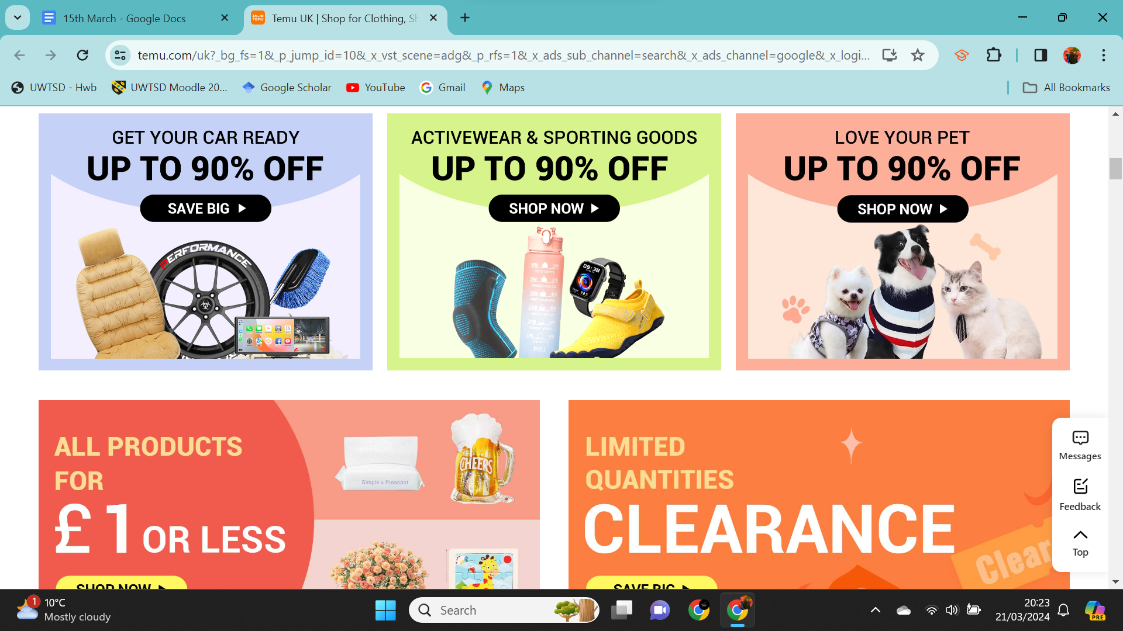
Screenshot of my laptop screen on Temu’s opening page on the website, immediately pushes huge discounts on top of already low prices (Mar 21, 2024)

Current CSR Laws in place

While many debates around CSR follow Mackey's beliefs and suggest they are voluntary additional measures businesses can take to contribute more to society, there is an increase in legislation around CSR. These include “mandatory CSR due diligence, mandatory corporate philanthropy, mandatory governance structure, and a mandatory CSR duty under corporate law.” (Lin, 2020)

France adopted the duty of vigilance law in 2017. The law requires large French companies to “develop, disclose and implement a vigilance plan in order to identify risks and prevent severe human rights violations and environmental damage” (Lin, 2020) The law ensures that companies take responsibility for any actions “resulting directly or indirectly from the operations of the company, its subsidiaries or its subcontractors with whom it has an established relationship”. This encourages companies to be far more selective about who they work with and the environmental impact of their corporate decisions.

Mandatory corporate philanthropy was first adopted in Mauritius in 2009, India and Nepal followed suit. (Lin, 2020) While the law varies slightly across countries, the basis is it “requires companies to commit a certain percentage of their profits to designated CSR programs such as programs to build schools and to provide shelters for the poor” (Lin, 2020) This ensures money is invested in the communities as business expands improving the overall success of the country, not just corporations. The Uk works in a similar way with Tax, where a percentage of profit goes towards public services such as police, education, hospitals and welfare. Tax is different in that it applies to all people earning over an allowance and is split into tax brackets depending on earnings. Corporate tax in the UK can be claimed back if businesses can justify expenses and claim they invested enough in the business to be below the tax bracket for profits. In parts of America this system gets abused with Large corporations claiming a new private jet or new sports car as ‘necessary expense’ for a tax reduction. However, news from a Bloomberg 2024 article claims the IRS is attending to the “ultra-wealthy abuse of tax breaks on the use of corporate jets” (Slowey, E 2024) and will introduce three to four dozen new audits this spring “to identify where inappropriate deductions were made and where personal travel by jet wasn’t logged as income.” (Slowey, E 2024)

Further counter arguments against enforcing CSR

While there are compelling arguments for enforcing CSR, there are counter arguments to consider. Small scale enterprises often don't have the budget, capacity or manpower to be as selective over who they work with. A small corner shop selling chocolate bars isn't responsible for the deforestation for palm oil in the chocolate industry, and they likely do not have the budget or market for using local artisan chocolatiers. A small scale clothing brand building a name for themselves, working on a tight budget, doesn't have the same scalability as larger brands to choose more expensive, more sustainable fabrics to work with. A beginner in business also won't have the same connections to suppliers or bargaining power to negotiate deals for more sustainable practices.

A published paper by Dennis Masaka (2008) debated the ethics of enforcing CSR and concluded that this would become abused by corporations and would “lack intrinsic worth since they are primarily meant to enhance corporate image not out of a genuine concern for the welfare and well being of society” . Since this 2008 article we can see examples of corporations doing just that. Pepsi unveiled a tragically out of touch ad campaign in 2017 during a time of black lives matter (BLM) peace protests against police brutality. In the advert Kendal Jenner, a member of the notoriously out of touch famous American family, the Kardashians, is distracted by the passing protest while doing a modeling shoot. She leaves her shoot to swan through the crowd, beaming at everyone. She boldly walks over to a police officer with a can of Pepsi, the officer takes that can and drinks, everybody cheers and the protest seems to be over, thanks to the miracle of Pepsi. Unsurprisingly this fell completely flat with its audience and even led to a parody in “the boys”. A ‘what if’ series on classic superheros if they were actually bad people. Pepsi responded to criticism with the following statement “Pepsi was trying to project a global message of unity, peace and understanding. Clearly, we missed the mark and apologize,” (Victor, 2017) further adding “We did not intend to make light of any serious issue. We are pulling the content and halting any further rollout.” (Victor, 2017) Although the ad was pulled, it is still available to watch on youtube, linked here: https://youtu.be/uwvAgDCOdU4?si=lb0D-p9068d8IYqH along with “the boys'' parody in season 3, episode 4 linked here: https://youtu.be/F0sYelcwrh0?si=YUdasJ8USTAmurfo

A final criticism for enforcing CSR is there is currently no fixed global standard interpretation for what this means. Many understand it as acting responsibly with consideration for society and the environment, but what do each society value? What are the priorities of different societies when it comes to ‘acting responsibly’?. For example, In some places CSR may be providing better pay, but what is the level of pay that should be attained, and how does that translate globally across currencies and exchange rates? Another may be to take better care of the environment, but what measures specifically? Investing in green energy? Where will each country get the resources and funding for this? What will happen if they can’t/won't? Closing down factories who can't meet these standards would cause job losses and leave society in a worse condition.

Conclusion

There are long debated arguments for and against enforcing CSR, there is potential for corporations to abuse CSR as a marketing strategy to promote their brands as more ethical than they perhaps are. There are also concerns that small businesses may be overly scrutinized for a standard they can't afford to meet. However, if businesses mass adopt sustainable practices, such as investing in green energy for their own uses, using biodegradable ‘plastic’ in packaging, being more conscious about product design to be more recyclable/ reparable /reusable. All of these are very positive, even if done for a publicity move, they are still necessary and valuable changes. In addition, as a byproduct of this, these innovations will have more funding, more development and can become more affordable for the smaller producers. A small company called Notpla is innovating ways to make ‘plastic’ with seaweed that is completely sustainable and biodegradable, some are even edible!. They currently lack the funding to make this commonplace replacement for single use plastic, but could if it was given proper attention and investment. The technology already exists and inventions are already being made, they are just too small to compete with cheap plastic suppliers who sell to big businesses who are not incentivized to make any changes. Enforcing CSR and having publicly published findings, may pressure this to change. Businesses want to make money, if their current formula works, they won’t want to risk big change. We need to make it so the formula has to change, and they will follow suit.

Apozyan, K. (2022, February 25). How Kendall Jenner caused millions in losses for Pepsi with a single advertisement. AMA at USF. https://www.amausf.org/single-post/how-kendall-jenner-caused-millions-in-losses-for-pepsi-with-a-single-advertisement

Barro, J. (2016, May 4). Whole Foods’ co-CEO says business is “inherently socially responsible” — here’s why that’s wrong. Business Insider. https://www.businessinsider.com/john-mackey-whole-foods-business-inherently-socially-responsible-2016-5?r=US&IR=T

BBC News. (2019, August 5). McDonald’s paper straws cannot be recycled. BBC News. https://www.bbc.co.uk/news/business-49234054

Chang, P. (2020, September 19). Pepsi’s Attempt at Corporate social Responsibility Falls Flat. Medium. https://medium.com/marketing-in-the-age-of-digital/pepsis-attempt-at-corporate-social-responsibility-falls-flat-2d1a04641a0d

Co-op rolls out 100% compostable bags across all stores | Co-op Blog. (n.d.). https://www.coop.co.uk/blog/co-op-rolls-out-100-compostable-bags-across-all-stores

Emissions of air pollutants in the UK – Nitrogen oxides (NOx). (2024, February 19). GOV.UK. https://www.gov.uk/government/statistics/emissions-of-air-pollutants/emissions-of-air-pollutants-in-the-uk-nitrogen-oxides-nox

Fernando, J. (2024, February 14). Corporate social responsibility (CSR) explained with examples. Investopedia. https://www.investopedia.com/terms/c/corp-social-responsibility.asp

Hayes, A. (2024, February 13). Fast Fashion: How it impacts retail manufacturing. Investopedia. https://www.investopedia.com/terms/f/fast-fashion.asp

Jones, J. (2023, September 14). Here’s why everything on Temu is so cheap. ZDNET. https://www.zdnet.com/article/heres-why-everything-on-temu-is-so-cheap/

LibertyCon - International - LibertyCon. (2024, February 4). LibertyCon. https://www.libertycon.com/

Lin, L. (2020, November 18). Mandatory Corporate Social Responsibility Legislation around the World: Emergent Varieties and National Experiences.). Oxford Law Blogs. https://blogs.law.ox.ac.uk/business-law-blog/blog/2020/11/mandatory-corporate-social-responsibility-legislation-around-world

Masaka, D. (2008).Why enforcing corporate social responsibility csr is morally questionable.(Vol 13, No1).EJBO Electronic Journal of Business Ethics and Organization Studies. https://citeseerx.ist.psu.edu/document?repid=rep1&type=pdf&doi=ff491d68ecdbff7a85c9e0e1118a3464720cad6f

Milken Institute. (2016, May 3). Leaders of Companies that are Changing the World [Video]. YouTube. https://www.youtube.com/watch?v=ZphjRARjXig

Plungis, J. (2015, September 25). Volkswagen emissions scandal: Forty years of greenwashing - the well-travelled road taken by VW | The Independent. The Independent. https://www.independent.co.uk/news/business/analysis-and-features/volkswagen-emissions-scandal-forty-years-of-greenwashing-the-welltravelled-road-taken-by-vw-10516209.html

Robinson, D. (2022, July 17). 10 companies called out for greenwashing | Earth.Org. Earth.Org. https://earth.org/greenwashing-companies-corporations/

Slowey, E. (2024, February 21). Corporate jet use by Ultra-Wealthy is latest IRS crackdown push. Bloomberg.com. https://www.bloomberg.com/news/articles/2024-02-21/corporate-jet-use-by-ultra-wealthy-is-latest-irs-crackdown-push?leadSource=uverify%20wall

Temu. (n.d.). Temu UK | shop for clothing, shoes, jewelry, beauty & more. https://rb.gy/r96fmc

United Nations. (n.d.). Greenwashing – the deceptive tactics behind environmental claims | United Nations. https://www.un.org/en/climatechange/science/climate-issues/greenwashing

Victor, D. (2017, April 5). Pepsi pulls ad accused of trivializing Black Lives Matter. The New York Times. https://www.nytimes.com/2017/04/05/business/kendall-jenner-pepsi-ad.html

Volvo Dealership 507. (2022, June 12). The boys S03E04 Kendell Jenner Pepsi ad parody [Video]. YouTube. https://www.youtube.com/watch?v=F0sYelcwrh0

Yash Yadav. (2017, April 6). Full Pepsi Commercial starring Kendal Jenner [Video]. YouTube. https://www.youtube.com/watch?v=uwvAgDCOdU4

