UNIVERSITY OF WALES TRINITY SAINT DAVID

USE OF TEHCNOLOGY AND SOCIAL MEDIA


Student Name: Munevver Karabeyaz
Student Number: 1707893
Module Name: DIGITAL SKILLS AND RESEARCH METHODS
ASSIGNMENT 1
Tutor Name: Anly ChandraMahan

Contents
INTRODUCTION 3
TWO TOOLS USED IN WORKPLACES AND IN SCHOOL 4
SOCIAL MEDIA FROM DIFFERENT ANGLES 5
FACEBOOK 6
LINKEDIN 8
TWITTER 10
CONCLUSION 12
REFERENCES 12

Table of Figures
Figure 1 Facebook Profile 6
Figure 2 Facebook customer message 7
Figure 3 LinkedIn Profile 8
Figure 4 Twitter Profile 11

INTRODUCTION

Technology has become a big part of our lives. It's also a big help in our social, work and education lives. Technology has made our lives easier and we use these in our daily lives. For example, email is one of the biggest communication tools that is worldwide used and known. Email has helped communicate in a quicker way especially for businesses. Another technology tool that has made business and job interviews easier is video conferencing. Now days employers and business men can easily have conferences all over the world just by video conferencing. It has also become helpful for us because we can video call our friends and family that live far and see them when we can't travel. Also, there is another technology tool that is good in the workplace and education atmosphere is social media tools. These social media tools help you keep in contact with friends and family even long-lost people you haven't seen in years. Social media is not just good for socializing, but it is also helpful to promote your business or even help you sell things online.
I will be talking about some tools we use in school and in the workplace and I will evaluate social media in different angles and how it is helpful to promote your business. Also, I will discuss some of the social media accounts that I have for socializing and business and how their security settings work.

TWO TOOLS USED IN WORKPLACES AND IN SCHOOL

There are many tools that you can use on your phone, laptop, computer, iPad etc. In school and in the workplace. The two main tools I see used in school and workplaces are Email and WhatsApp.
WhatsApp is a tool that is used to text messages, pictures, videos. You can even make calls and video calls by using internet connection. WhatsApp can be used to make group chats. When you message, instead of messaging everyone the same thing individually, you can make a group and send it to everyone at the same time. For example, if you are doing group work in school, everyone can type and send information at the same time and all the information can be gathered together in an easy way.
Email stands for electronic mail. It is used to exchange messages between people using electronical devices. You can also attach files like documents and pictures. For example, you can be sending a report from home to your manager at the workplace before the deadline.

SOCIAL MEDIA FROM DIFFERENT ANGLES

Social media is now used by almost every person around the world. It is helpful now days to promote your business because you don't have a limited customer range you can also reach out to people worldwide and even grow your business in different countries. Yes, social media is helpful to communicate, easier contact people, promote your business and has also a lot more advantages but it also has the disadvantages. For example, the biggest problem in social media is fake identities. These people that create fake identities can trick people into believing them especially children. Children in this generation have started opening social media profiles at younger ages than they should. This has made parents attentions less observant as they have given their children the chance to do as they ask for. According to a research on a website called "OneDesk" the age group of 18-29 years, US social media users has gone up from %16 in 2005 to %86 in 2010. As you can see from this one example, it is shown how in 5 years there has been a big growth in social media in younger age groups. As for the age groups of 30-49 years, the us social media users were %12 in 2005 and went up to %61 in 2010. If you would like to find out more about the social media percentages and age groups you can go on to "OneDesk" site and there are a lot of helpful charts on there.

FACEBOOK

Facebook is a very famous social media created by Mark Zuckerberg. Here is a brief history that 'THE TELEGRAPH' reporters have written online about Facebook.
They explain that Facebook was first discovered in 2003 as a game called Facemash created by Mark Zuckerberg and a co-founder Eduardo Saverin. They were roommates at Harvard University at the time. Facemash was letting users rate classmates against each other by putting two photos up and deciding if they were "hot or not". A year later, the 19-year-old Zuckerberg launched Facebook.
This social media tool has been used to find and connect with friends, family and even long-lost family and friends. It has improved and become so big and daily used that now you can even do business on it. For example, you can promote your own business or even sell your personal belongings on there. I have a Facebook account which I use for both my personal and business communications.

Here is my Facebook account for my mobile hairdressing business but also my personal account....
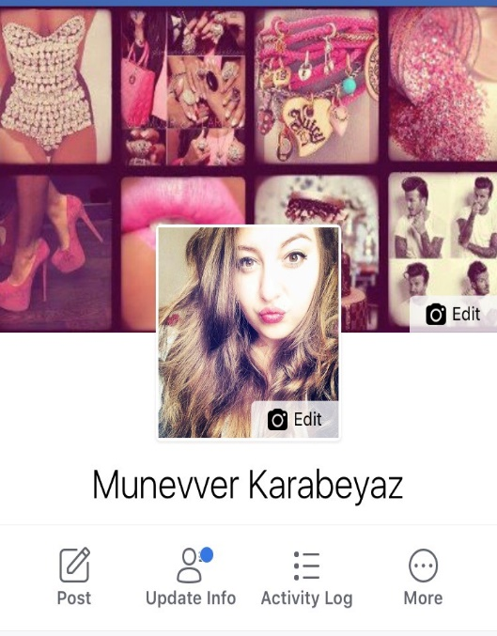
Figure 1 Facebook Profile

And here is a customer who has messaged me to ask about a price to do with my business....
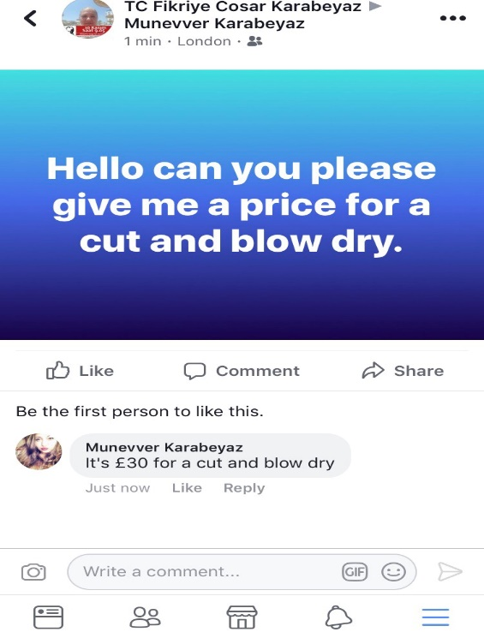
Figure 2 Facebook customer message
If you want to keep all of your personal things private so that no one that isn't your friend on Facebook, you can make these private from the security settings. Stalkers and criminals could track you down by your location. You might think that only your friends have access to this information but if you log in on another device make sure you log off so that third parties can’t see your information. If you ever feel threatened by anyone on Facebook, by someone sending unwanted posts on your public wall or sending messages that are harassing you, you can report it by clicking the "report abuse" link on the post. You also, have the right to ‘untag’ yourself in pictures you don’t want to be tagged in.

LINKEDIN
LinkedIn is a social media that you have probably heard of before. This may be from work colleagues or classmates in school. LinkedIn is actually the most popular social accounts used mostly for hunting work, today. Basically, LinkedIn is a social network for professionals. Whether you're a, a business owner , manager or student looking for part time jobs, LinkedIn is for everybody and anybody who is interested in taking their professional lives forward to find new opportunities to grow their careers and to connect with other professionals.
Here is my LinkedIn account which I have created to find a good career opportunity for my business that I would like to open in the future and to grow my business more successful. Although I have a certificate in hairdressing I want to improve my skills in hairdressing and gain more experience, even learn more things and find a good part time job which will help me for when I open my own business ...
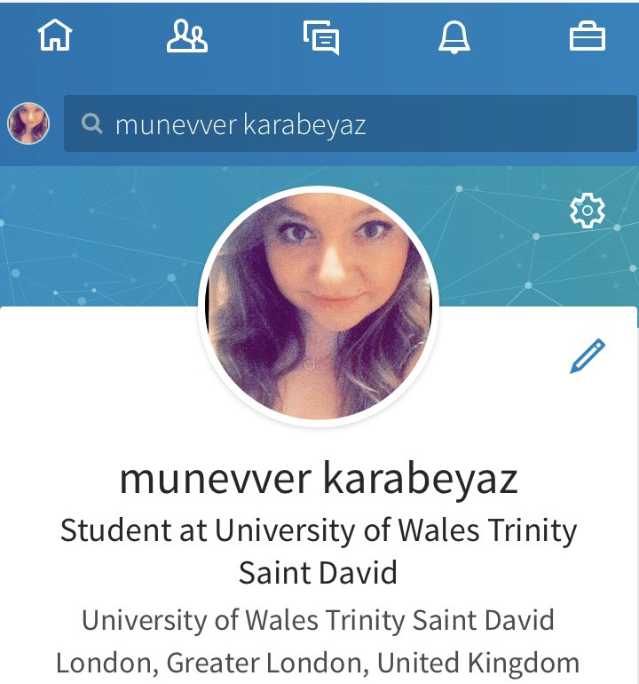
Figure 3 LinkedIn Profile

Security settings in LinkedIn is not the same as Facebook. With your LinkedIn profile you can show your talents, share information such as previous workplaces, where you studied, and maybe projects you've worked on in the past. The problem is that some of the information in your LinkedIn profile might be dangerous in the wrong hands. So, the best thing to do is change your password every so often for example every month to make sure no one hacks into your account. Another helpful way to keep your account and information secure is trying to limit contact information you share on your profile.

TWITTER
Twitter and 'tweeting' is about broadcasting daily short burst messages to the world. In other words, "microblogging". Conversely, Twitter is also about discovering interesting people online and following them to read their messages. Twitter is a big social media used all around the world. Famous people are also using this social media to update their social lives and personal lives. You can also read latest news on anything going on all around the world. It also has a restricted tweet entry of 280 characters or less which makes it scan friendly. The size cap of the limitation of characters focuses on clever use of language. When you are sending tweets, you can also tag people including famous people which may read, reply or retweet your message. Retweet means when someone simply presses retweet on your tweet and it copies your tweet exactly the way it is onto their twitter profile and says who they have retweeted from. Last of all you can promote your business too where you can have customers tweeting to contact you or giving their feedback to let everyone know their thoughts about your business. Twitter has a little blue bird emblem. Birds tweet this is why they have put a bird emblem for twitter.

I have created a twitter account which I promote my mobile hairdressing business. I also like using this account as I can put pictures up and tweet at the same time. For example, if I have done someone that is famous hair I can put a picture up tweet and tag them in my tweet. They can also retweet my tweet or even tweet about their thoughts, tag my page and I could retweet to show how my customers are happy. Seeing all the feedbacks from my customers will make me happier and more motivated in my work and this is why I have a twitter account. The last and most important thing that I can save time on and gain more customers is that instead of contacting them individually I can just give them updates at the same time on twitter and inform them about special offers and prices.

Figure 4 Twitter Profile

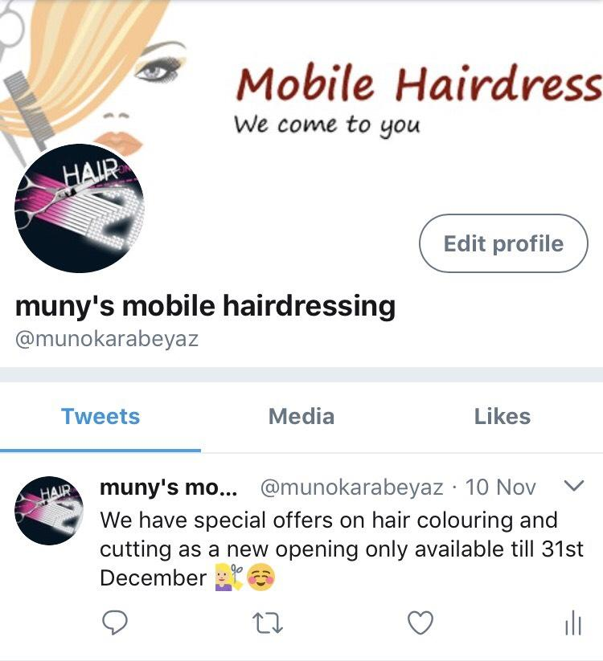
Twitter in a security way is very different in most ways. Twitter allows you to add your location to your tweets. Even though for some people it could seem like a good thing it could actually be a security risk. Adding your location to your tweets allows people to see where you are. For example, you might tweet about how much you’re enjoying your new years party out and any criminal who is 'following' you on Twitter might decide that this could be a good time to break into your house or even come to the place you are and stalk you. Additionally, if you want to remove your location from any tweet you have already posted you can click the 'Delete All Location Information' button.

Twitter also offers a couple of other security options that you should read through and maybe consider. As, Twitter is a bit more public than Facebook it would good to keep in mind not to put a lot of your details on your profile and to keep it limited. It would probably the best to leave out your phone numbers, e-mail addresses, and other bits of personal data.

CONCLUSION

Technology has become a big role in people's lives and made their lives easier, quicker and more practical. It has become part of our daily lives in work, education, medical and even inside the house usages. Technological use is now used everywhere you look around and has a big change from the past from when people were struggling with things. Especially social media helps us get all the updates and news about everything going on in the world. Social media is also used for marketing and business opportunities.

REFERENCES

Kim Chan (September 30, 2011) [online]
The Growth of Social Media (Search Engine Journal)
www.onedesk.com
Andy O'Donnell (November 29, 2016) [online]
5 Tips for Staying Safe on Twitter, Twitter Privacy, Security, and Safety Tips
www.lifewire.com
Penny Loretto (February 02, 2017) [online]
The Balance,
How to use LinkedIn as an Intern
www.thebalance.com

