

Module: Strategic Management for Business
Module code: LCLM 6001

Student Name: Abdul Monnan
Student ID: 2308947
Lecturer: Yohan Mendis

Executive Summary
This is the report with the strategic analysis and recommendations to Zaalsha Fine Indian Cuisine, a local restaurant located in Smethwick, UK. This report aims to consider the current state of the restaurant, stating its main strengths and weaknesses, as well as suggesting its further development and sustainability strategies.
The main insights consist of the idea that Zaalsha enjoys a well-loyal customer base, quality food products and qualified employees. Nevertheless, its small geographical coverage, use of part-time workers and lack of well-developed digital presence are problems. The growth opportunities are the need to go digital with the business in terms of online ordering and delivery services, and also, to diversify the revenue streams by including catering and the creation of branded products. Furthermore, the good reputation that the restaurant enjoys locally can be used to venture into market expansion by establishing a new store.
Among the most crucial strategic suggestions, one must single out the idea of concentrating on the market development by expanding geographically and digitally, streamlining the workflow with the help of better staff training and scheduling, and diversifying the products. These plans will aim at boosting market share, enhancing customer interaction, and long-term sustainability by exploiting new sources of revenue and new geographical markets.

Table of Contents
Executive Summary 2
Introduction 4
Appraise the Current Strategic Direction 5
Environmental Scan and Competitive Positioning 6
Internal Environment Analysis (SWOT Analysis) 6
External Environment Analysis (PESTEL Analysis) 8
Porter’s Five Forces 9
Strategic Growth Choices and New Strategy Proposal 10
Growth Strategy Options 10
New Strategy Proposal 11
Stakeholder Analysis 12
Stakeholder Identification 13
Mendelow’s Matrix 14
RACI Matrix 16
Strategic Recommendations 17
Conclusion 17
References 19

Introduction

Figure 1: Zaalsha Fine Indian
Source: (Zaalsha Fine Indian Cuisine, 2023)
Company Overview
Zaalsha Fine Indian Cuisine is a small-scale, family-run Indian Business operating on 22-24 Abbey Road, Bearwood, and Smethwick. It is renowned for offering quality Indian meals in a relaxed fine-dining environment. Business has a tight, small team of staff which is comprised of four full-time waiters, four full-time kitchen staff, one part-time waiter and one part-time kitchen porter. It has a weekly turnover of £8,000 in the restaurant and serves on a dining-in basis, with minimal emphasis being made on take-out or deliveries.
Products and Services
Zaalsha is a large-scale eatery restaurant serving a variety of traditional Indian cuisines and catering to contemporary tastes as well. Their menu comprised traditional curries, tandoori dishes, and regional specialities in addition to vegetarian and vegan menus. Fine dining is the main business model of the restaurant, as it will mainly specialise in quality food and exemplary customer service (Walker, 2021). The USP of the restaurant is also the use of fresh local ingredients and the traditional way of cooking, which will allow serving the authentic taste of India.
Business Model
The restaurant is in a classic dine-in business format, as it makes money based on patronage. Nevertheless, it has not maximised the modern sources of revenues, including delivery services, catering or online ordering. The company also operates under comparatively low staffing expenses, with a large number of the workforce being part-time workers (Kucher et al., 2024). The pricing approach of the restaurant lies within the mid-to-high category, such that it provides the customers with a high-ticket dining experience at a manageable price for the local customers.
Uniqueness
The fact that Zaalsha focuses on providing a high-quality food experience within a relatively small and community-oriented type of restaurant is what makes it a unique place among the rest of the restaurants in the neighbourhood (Walker, 2021). It is also a signature in the local cuisine scene, as the level of detail in the food preparation and service to customers is exceptional. Its rather small size, opening hour’s restrictions and a reliance on having a small number of staff base are however, areas that may restrict its growth.

Appraise the Current Strategic Direction
Vision, Mission, and Objectives
Vision: Zaalsha Fine Indian Cuisine is the vision of being the best fine dining Indian restaurant in Smethwick and its environs by delivering a genuine and quality experience with emphasis on customer satisfaction and culinary masterpieces (Kipasika, 2024).
Mission: The mission of the restaurants is to serve the customers authentic Indian food in a fine dining atmosphere. The restaurant values quality, sustainability, and high-quality services by putting them in first place so as to establish a memorable dining experience that will make people come back to the restaurant (Clemente and Clemente, 2022).
Objectives:
Short-term: Grow the local customer base by 10% over the next year by initiating a marketing campaign and customer loyalty program.
Medium-term: Enhance services to catering and delivery opportunities in order to access more people.
Long-term: Open a second site or diversify the source of revenue by coming up with a new set of goods (e.g. sauces or packaged foods).
Strategic Evaluation:
The current trend of strategic direction of Zaalsha seems to be sustaining itself as a local fine-dining staple with the greater influence of the quality of food and customer experience. But there is no definite long-term growth plan other than the already set up local market (Kipasika, 2024). The nature of a small, part-time workforce and the limited working hours of the business limit the scalability as well as the operations of the business. In addition, it requires enhanced integration of technology and digital tools that would result in more contact with customers and convenience, as well as more efficient operations.

Environmental Scan and Competitive Positioning

Internal Environment Analysis (SWOT Analysis)
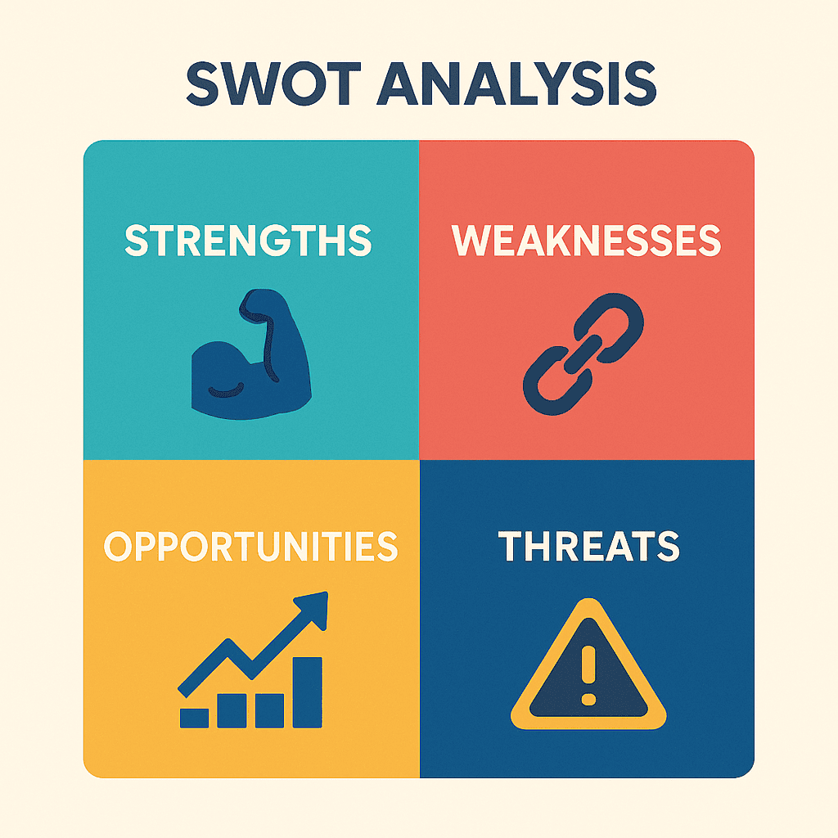
Figure 2: SWOT Analysis
Source: (My Startup Studio, 2025)
Strengths:
Reputation: Famous for authentic Indian food of high quality, it has established a customer base.
Location: Located on a high-traffic local street and appealing to regulars and new patrons.
Skilled Staff: Quality and good customer service are ensured by experienced kitchen staff and waiters (Boitrelle et al., 2021).
Weaknesses:
Staffing Issues: The extensive use of part-time workers will result in quality service disruption and operational inefficiency (Benzaghta et al., 2021).
Limited Business Hours: The restaurant's reliance on internal eating reduces its ability to earn money.
Scalability Constraints: The current environment does not easily scale the business model and its size.
Opportunities:
Expansion: Possibility to expand and provide delivery services, organise special events, or serve the neighbouring areas.
Diversification: Additional sources of revenue would include new menu items or creating complementary products (e.g., ready-made spices or sauces) (Puyt et al., 2025).
Technological Integration: Ensuring internet order placement and online advertising would increase customer interaction.
Threats:
Competitive Pressure: The market share might be threatened by other local restaurants that provide similar cuisines, with possible better access or price.
Economic Conditions: Profitability may be affected by economic recessions or an increase in food and operational expenses.

External Environment Analysis (PESTEL Analysis)
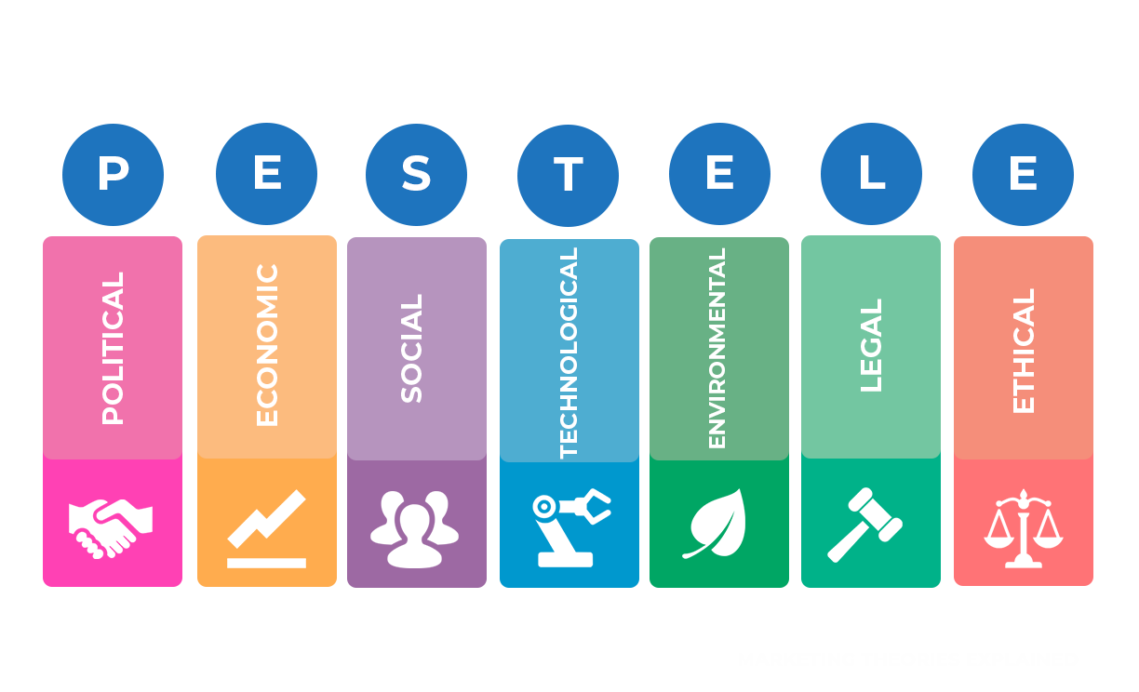
Figure 3: PESTEL Analysis
Source: (Professional Academy, 2022)
Political:
Food Regulation: The restaurant is supposed to adhere to food safety laws and requirements, and this is an important political factor to consider (Buye, 2021). The law of minimum wage or health and safety may make a difference.
Economic:
The restaurant is operating within a competitive local market that is susceptible to changes in the economy. The expenditure pattern of consumers is influenced by the economic environment, and it has a direct impact on the revenues of the restaurants (Kansongue et al., 2023). In addition, the commodity prices were increasing and could lead to a decline in price or margins.
Social:
Changes in the Dining Habits: Interest is showing towards different and exotic foods, such as Indian food. The social trends also suggest that the demand is growing towards healthier and vegetarian food options, and it aligns with the suggestion put forward by Zaalsha.
Technological:
The restaurant can enhance its online presence by establishing an online order system to order and take food, or by involving social media (Cox, 2021). They would also be able to use technology to schedule both digital staff and make ordering easier.
Environmental:
Sustainability: Sustainability is increasingly a significant issue for customers, such as local source usage and the minimisation of food waste (Buye, 2021). The image of the brand would be enhanced by the inclusion of activities that were friendly to the environment.
Legal:
The restaurants are currently operating because of adherence to the health and safety guidelines, and the employment laws related to part-time and full-time employees.

Porter’s Five Forces
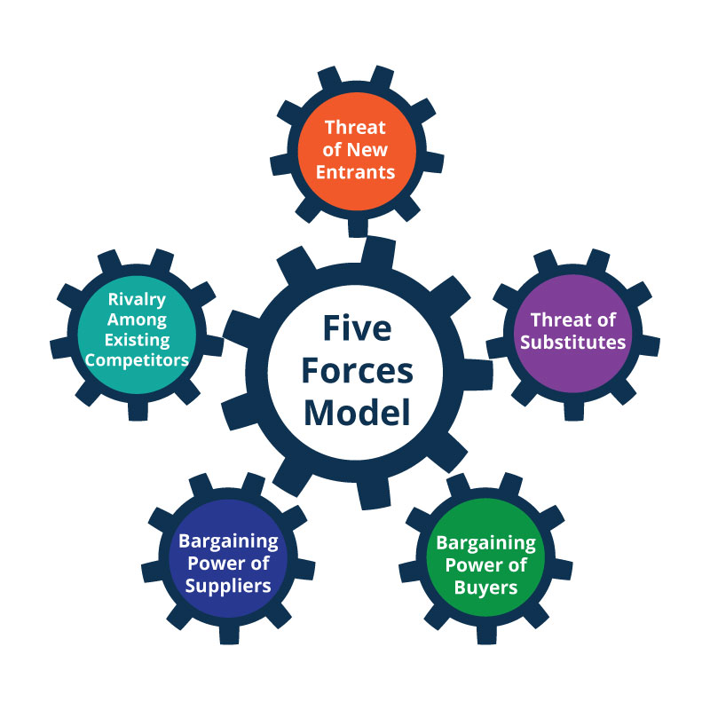
Figure 4: Porter’s Five Forces
Source: (Planium Pro, 2021)
Competitive Rivalry: The local restaurant market is one of high competition, and has several substitutes to fine dining. This puts the pressure on providing quality service and special food.
Supplier Power: The restaurant is also partly reliant on suppliers regarding the quality of ingredients, leaving them with low bargaining power (Pangarkar and Prabhudesai, 2024). This force can be addressed by ensuring that long-term relationships with suppliers are established.
Buyer Power: There are numerous alternative sources of food, and this means that the level of power held by customers is greatly increased. Thus, the demand is highly dependent on customer loyalty and satisfaction.
Threat of Substitutes: Other informal restaurants like fast foods are really good substitutes for the fine-dining concept of Zaalshas, especially during economic hardships.
Threat of New Entrants: The restaurant industry has a moderate entry barrier, but the development of an effective restaurant presupposes massive investments in the sphere of marketing, quality control, and client retention (Rice, 2022).

Strategic Growth Choices and New Strategy Proposal

Growth Strategy Options
Market Penetration:
Market penetration is aimed at expanding the share of the restaurant in the existing market through the attraction of more local consumers. This may be achieved by carrying out the targeted promotions, customer loyalty programs and exploiting online reviews. Special discounts or conducting promo activities (such as theme nights or the early-bird deals) would help Zaalsha attract a revisiting population. Frequent customers would also be rewarded under a loyalty programme that would aid in attracting a steady base of customers (Farida and Setiawan, 2022). Moreover, cultivating a robust online presence where customers provide good reviews of the company online in various sites such as Google and TripAdvisor would contribute to greater visibility and expose more feet on the ground.
Market Development:
Market development is the entry into new geographical locations or new customer segments. Zaalsha might think of establishing the second site in another town or city with the same demographics. This would enable the restaurant to reach a market that is not saturated and expand its market share (Menz et al., 2021). Also, serving local occasions, business and community events would further maximise the clientele beyond normal dine-in services.
Product Development:
Product development is aimed at a new product or service aimed at the current market. New menu options that may be added by Zaalsha to match the evolving customer preferences include seasonal food, fusion or dietary food like vegan food, gluten-free food (Ghosh et al., 2023). Limiting or seasonal menu items might also be a source of excitement and urge customers to visit more often (Zahra, 2021). This would not only draw new customers but also hang on to old ones who want variety.
Diversification:
Diversification is the development of new products or services that are not within the main operations of the restaurants. Zaalsha has the option of diversifying by creating branded products like pre-cooked food, spice packs, or sauces (Menz et al., 2021). These products would be sold online and at the local shops. Using its renowned brand, the restaurant has an opportunity to exploit the increasing needs for convenient and quality Indian food outside the conventional foodservice. This would also be a source of extra revenue, especially when there are off-peak seasons or hours.

New Strategy Proposal
Since it is competitive with the opportunity to grow, Zaalsha Fine Indian Cuisine would benefit by adopting a Market Development strategy, considering both digital and geographical growth. The restaurant is able to penetrate new segments of the environment and reach more customers to enhance its presence in the market.
Online, Zaalsha needs to carry out an intensive marketing effort on social networks, focus on online word-of-mouth, and conduct more specific online promotions to draw in more clients (Farida and Setiawan, 2022). The restaurant could consider the improvement of its online ordering environment and collaboration with delivery services such as Uber Eats or Deliveroo to provide its services to more customers outside the segment where the restaurant is located, making it more convenient and more likely to increase sales (Ghosh et al., 2023).
Geographically, a second branch in a local town would be able to offer an opportunity to a new demographic, help build a stronger brand image, and increase the general presence in the market (Zahra, 2021). The integration of online marketing with in-person diversification guarantees a solid increase in profitability within a short period of time and a foundation of future sustainability and competitiveness in the local restaurant market.

Stakeholder Analysis
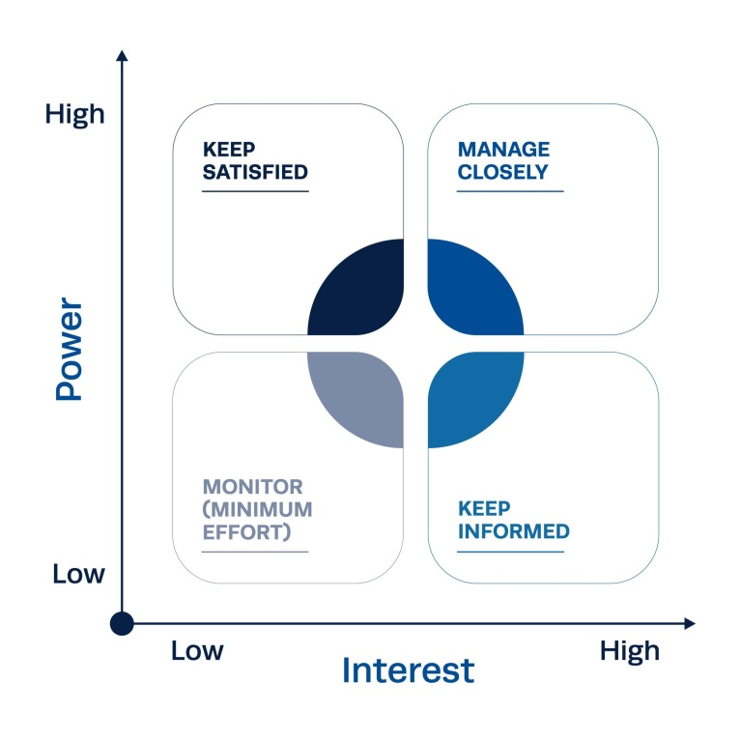
Figure 5: Stakeholder Analysis
Source: (Institute of Project Management, 2022)

Stakeholder Identification
Employees:
Staff members are very crucial to the success of Zaalsha Fine Indian Cuisine since they can directly affect the experience of the customers. The kitchen team should see to the quality of food and its preparation on time, whereas waiters and front-of-house employees create the impression of serving (Dimitrovski et al., 2021). The focus on employee retention and satisfaction is essential to maintain the stability of the operation since morale and high turnover may interfere with the service provision and customer attitude. Continued training and developing opportunities enable the staff to improve and optimise their skills to ensure the high standards and provide high-quality service to the customer constantly (Ghosh et al., 2023).
Customers:
One of the most essential stakeholder groups of any restaurant is the loyal customers. Their responses are also an insightful input that leads to improvement in the items available in the menu and the service delivery (Ghosh et al., 2023). The frequent clients do not simply come and leave, but they leave their reviews online and through word of mouth, and they build the image of the restaurant. The quality of the offered food, service, and atmosphere should be considered by the customers in order to create a good brand image (Ghosh et al., 2023). The relationships with customers can be strengthened by involving customer loyalty programs, personal offers, and feedback services, motivating them to visit the restaurant again and be more satisfied, which will help to make the restaurant attractive and competitive.
Suppliers:
Suppliers play a major role in ensuring that Zaalshas is in a position to provide quality ingredients regularly. Good and well-founded relations with suppliers will guarantee a good supply of fresh produce to the restaurant, allowing the restaurant to sustain its culinary standards (Kujala et al., 2022). Stable suppliers will also make cost control easier and reduce the operational disruption so that the restaurant can work efficiently even during times of high demand.
Local Community:
Zaalsha's relationship with the community around the location is the key to success in the long term. The restaurant is dependent on the local customers who will bring up traffic every day, and brand recognition and loyalty can be boosted by the active community engagement of the restaurant environment (Dimitrovski et al., 2021). Being involved in local activities, sponsoring communities or charity shows an interest in the values of the community and helps to gain a good reputation for the restaurant. By identifying with the community, Zaalsha will be able to become an accepted, respected local brand that will be appealing to its regular customers, as well as to new ones.

Mendelow’s Matrix
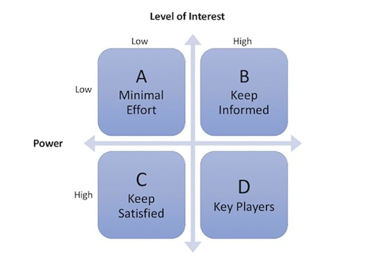
Figure 6: Mendelow’s Matrix
Source: (Adam et al., 2018)
The stakeholders in the Mendelows Matrix are shown according to their interest and power regarding the strategy of restaurants:
High Power, High Interest:
Loyal Customers: The ongoing patronage and their feedback are what will ensure the success of the restaurant. The customers who remain loyal possess a lot of influence on the reputation of the restaurants and are able to influence the improvement of services based on their experiences (Ghosh et al., 2023). Staff members are not excluded either, since their satisfaction is the sole determinant of the quality of service and brand image of the restaurant.
High Power, Low Interest:
Suppliers: Even though the suppliers are critical to ensure a steady quality, they suppliers do not usually care about the day-to-day running of the restaurant (Kujala et al., 2022). They are concentrated more on order handling and continuing the relationship, but not on customer satisfaction or the execution of the strategy directly.
Low Power, High Interest:
Local Residents: One of the segments of potential customers is the local community and inhabitants. They are very interested in the restaurant, as long as the restaurant participates in local activities or advertising.
Low Power, Low Interest:
External Competitors: Although competitors influence the market conditions, they do not greatly influence the market when they do not directly impact customer decisions at Zaalsha (Dimitrovski et al., 2021). They are also uninterested unless there is a major competitor who establishes itself in the area, and this factor may influence the market share of Zaalshas.

RACI Matrix
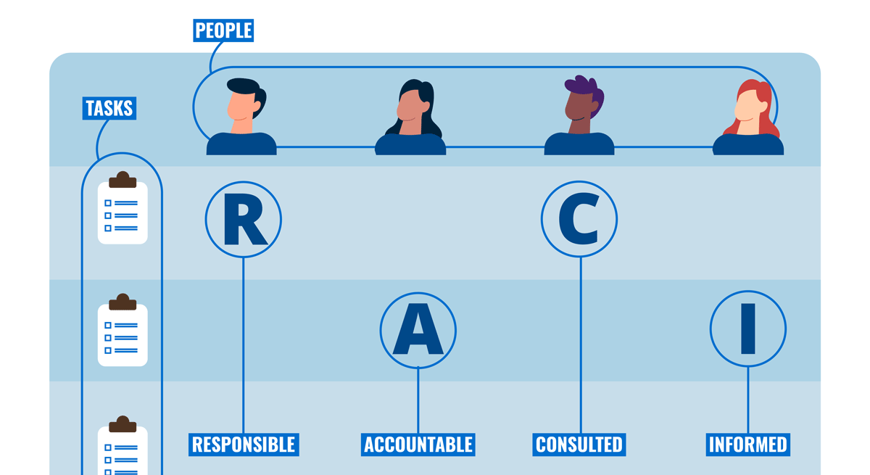
Figure 7: RACI Matrix
Source: (SlideModel, 2024)
Responsible: The waiters, kitchen staff, and managers have direct roles in implementing the new strategy in order to facilitate a seamless implementation of operational change.
Accountable: The boss or manager of the restaurant is the one who has ultimate responsibility for monitoring the strategy implementation, including making ultimate decisions and resource planning.
Consulted: Strategy refinement or incorporation into digital systems, including an online ordering approach, may be sought with the help of external consultants, e.g. marketing professionals or technology consultants (Kujala et al., 2022).
Informed: Strategic changes need to be communicated to all employees and key stakeholders (e.g., suppliers, local partners of the community, etc.), in order to align the whole business and ensure that everyone communicates effectively (Menz et al., 2021).

Strategic Recommendations
Short-term Recommendations:
Improve Operational Efficiency: Standardise choices in menus and enhance employee training to serve at an increased pace and decrease queues (Menz et al., 2021).
Leverage Social Media and Reviews: Increase the presence in the online world by motivating clients to post reviews and offering special offers at the restaurant (Zahra, 2021).
Medium-term Recommendations:
Introduce Delivery Services: Collaborate with such platforms as Deliveroo or Uber Eats to have access to a wider market.
Catering Services: Introduction of launch catering services to local parties and company events that would generate a new source of revenue (Rice, 2022).
Long-term Recommendations:
Expand to New Locations: Open a second restaurant in a nearby town which has the same demographic (Menz et al., 2021).
Diversification into Packaged Goods: Create a selling line of the sauce or pre-cooked food online and in the local shops.
Challenges in Implementing Strategy:
Zaalsha will need to overcome the lack of financial resources, the availability of resources and possible resistance to new business models by staff and customers (Menz et al., 2021). It will take thorough planning and a gradual implementation to overcome such challenges, and perhaps the acquisition of external sources of finance or even a partnership.

Conclusion
In this report, a strategic analysis of Zaalsha Fine Indian Cuisine has been provided, with the identification of major opportunities and threats. The strategies suggested deal with short-term operational improvements, medium-term diversification of the services, and long-term growth of the market. As a result of a well-crafted implementation, Zaalsha will be able to secure its competitive advantage since it will be able to grow sustainably. The focus on customer loyalty, efficiency in operations, and innovations would help the restaurant to stand out in a competitive market. Through these measures, Zaalsha can be well-placed to have a wider coverage, better performance and success in the long run.

References
Adam, P., Ovseiko, P. V., Grant, J., et al. (2018). Mendelow matrix for analysis of stakeholders [Figure]. In ISRIA statement: Ten-point guidelines for an effective process of research impact assessment. ResearchGate. Retrieved October 29, 2025, from https://www.researchgate.net/figure/Mendelow-Matrix-for-Analysis-of-Stakeholders-Adam-et-al-2018_fig2_339842987
Benzaghta, M. A., Elwalda, A., Mousa, M. M., Erkan, I., and Rahman, M. (2021). SWOT analysis applications: An integrative literature review. Journal of Global Business Insights, 6(1), 54-72.
Boitrelle, F., Shah, R., Saleh, R., Henkel, R., Kandil, H., Chung, E., ... and Agarwal, A. (2021). The sixth edition of the WHO manual for human semen analysis: a critical review and SWOT analysis. Life, 11(12), 1368.
Buye, R. (2021). Critical examination of the PESTEL Analysis Model. Project: Action Research for Development, 1-12.
Clemente, B. G., and Clemente, R. C. (2022). Awareness and Acceptability of the CSU Philosophy, Vision, Mission, Goals, and Objectives, and the Graduate School Philosophy, Vision, Mission, Goals, and Objectives. Journal of Positive School Psychology, 6(5).
Cox, J. (2021). The higher education environment driving academic library strategy: A political, economic, social and technological (PEST) analysis. The Journal of Academic Librarianship, 47(1), 102219.
Dimitrovski, D., Lemmetyinen, A., Nieminen, L., and Pohjola, T. (2021). Understanding coastal and marine tourism sustainability-A multi-stakeholder analysis. Journal of Destination Marketing and Management, 19, 100554.
Farida, I., and Setiawan, D. (2022). Business strategies and competitive advantage: the role of performance and innovation. Journal of open innovation: Technology, market, and complexity, 8(3), 163.
Ghosh, N., Karthikeyan, V., Das, S., Boro, P., and Chakraborty, S. N. (2023). Stakeholder Analysis for Hypertension Management in the Context of the Indian Public Health System. Indian Journal of Public Health, 67(Suppl 1), S27-S34.
Institute of Project Management. (2022). Stakeholder Analysis Process: What is it? Retrieved October 29, 2025, from https://instituteprojectmanagement.com/blog/stakeholder-analysis-process/
Kansongue, N., Njuguna, J., and Vertigans, S. (2023). A PESTEL and SWOT impact analysis on renewable energy development in Togo. Frontiers in Sustainability, 3, 990173.
Kipasika, H. J. (2024). Expression of leadership mission, vision, values, and strategic objectives in academic institution development practices. Journal of Research Innovation and Implications in Education, 8(1), 393-402.
Kucher, M. M., Stebliuk, N. F., Haponenko, S. O., Razinkova, М. Y., and Papsuy, K. O. (2024). Features of management of operational activities of restaurant enterprises. Systems and Technologies, 68(2), 155-160.
Kujala, J., Sachs, S., Leinonen, H., Heikkinen, A., and Laude, D. (2022). Stakeholder engagement: Past, present, and future. Business and Society, 61(5), 1136-1196.
Menz, M., Kunisch, S., Birkinshaw, J., Collis, D. J., Foss, N. J., Hoskisson, R. E., and Prescott, J. E. (2021). Corporate strategy and the theory of the firm in the digital age. Journal of Management Studies, 58(7), 1695-1720.
My Startup Studio. (2025). SWOT Analysis: A tool on MyStartup Studio. Retrieved October 29, 2025, from https://mystartup.studio/tool/swot_analysis
Pangarkar, N., and Prabhudesai, R. (2024). Using Porter's Five Forces analysis to drive strategy. Global Business and Organizational Excellence, 43(5), 24-34.
Planium Pro. (2021). Porter’s Five Forces Analysis: Assessing the competitive environment. Retrieved October 29, 2025, from https://www.planiumpro.com/blog/porters-five-forces-analysis-assessing-the-competitive-environment/
(Planium Pro, 2021)
Professional Academy. (2022). Marketing theories – PESTEL analysis. Retrieved October 29, 2025, from https://www.professionalacademy.com/blogs/marketing-theories-pestel-analysis/
Puyt, R. W., Lie, F. B., and Madsen, D. Ø. (2025). From SOFT approach to SWOT analysis, a historical reconstruction. Journal of Management History, 31(2), 333-373.
Rice, J. F. (2022). Adaptation of Porter's five forces model to risk management. Defense AR Journal, 29(2), 126-139.
SlideModel. (2024). What is a RACI matrix? Here’s everything you need to know. Retrieved October 29, 2025, from https://slidemodel.com/what-is-a-raci-matrix/
(SlideModel, 2024)
Walker, J. R. (2021). The restaurant: from concept to operation. John Wiley and Sons.
Zaalsha Fine Indian Cuisine. (2023). Zaalsha Fine Indian Cuisine. Retrieved October 29, 2025, from https://zaalsha.com/
(Zaalsha Fine Indian Cuisine, 2023)
Zahra, S. A. (2021). The resource-based view, resourcefulness, and resource management in startup firms: A proposed research agenda. Journal of management, 47(7), 1841-1860.

