

Programme: Master of Business Administration
Module code: LCMB7026

Module: International Marketing: Principles and Practices Assignment
Title: Assessment component 1: Individual report
Lecturer: Tushara Balendran Dian Mayasari
Student Name- Chetnaben Anilbhai Fadke
Student ID: 2430959
Word Count: 5519

Table of Contents
Section 1: Report on the International Marketing Mix of IKEA in Sweden and Germany 4
1. Introduction and Company Background 4
1.1 Company Background 4
1.2 Purpose of the Report 4
2. PESTLE Analysis 4
2.1 PESTLE Analysis on Sweden and Germany 5
3. Cultural Analysis using Hofstede Model 6
4. STP Strategy 9
4.1 Segmentation 9
4.2 Targeting 10
4.3 Positioning 13
5. Marketing Mix 7Ps 14
6. Ansoff matrix 19
7. Ethical Issues in Sweden and Germany 20
8. Recommendations 21
9. Conclusion 22
Section 2: Reflective Account 23
1. Gibbs’ Cycle 23
1.1. Description 23
1.2 Feelings 24
1.3 Evaluation 24
1.4 Analysis 24
1.5 Conclusion 25
1.6 Action Plan 25
References 27
Appendices 35
Appendix 1: Consumer Spending Graph of Sweden 35
Appendix 2: Inflation Rate Graph of Sweden 36
Appendix 3: GDP graph of Sweden 36
Appendix 4: Inflation rate in Germany 37

Section 1: Report on the International Marketing Mix of IKEA in Sweden and Germany

1. Introduction and Company Background

1.1 Company Background
IKEA is known as the largest furniture retailer in the world, and it has an immense focus on low-cost production and reduced shipping costs. The company started in 1940, by Ingvar Kamprad, with the vision of “creating a better everyday life for the many people” (IKEA, 2024a). Zhou (2024) has stated that IKEA has a significant global presence and has gained a total sale of €39.6 billion in 2020. IKEA focused on the growth of the business through implementing sustainability, efficient value chains, and improvement of customer experiences as its business philosophy.

1.2 Purpose of the Report
It will compare operations in the host country, Sweden and the host country, Germany, by covering PESTLE analysis, Hofstede's cultural dimensions, STP Analysis, marketing mix 7Ps, growth strategies, and ethical issues found in both countries. A reflective account will be provided using Gibbs Reflective Cycle. It will also focus on the revenue streams of each country and assess the sales data of each in 2025.
This report focuses on the market analysis of IKEA in both its home country, Sweden and the host country, Germany. Therefore, it is evident that Germany is significant for the company, due to its high level of sales.

2. PESTLE Analysis
PESTLE Analysis refers to an organised framework that analyses the macro-environmental market of a particular country through some factors. According to Olayiwola et al. (2025), this analysis provides elaborate information about the external barriers of a market condition that will help to improve the organisation in the near-term future. PESTLE Analysis evaluates the political, economic, social, technological, legal, and environmental factors in a particular country for a specific Industry (Refer to Figure 1).

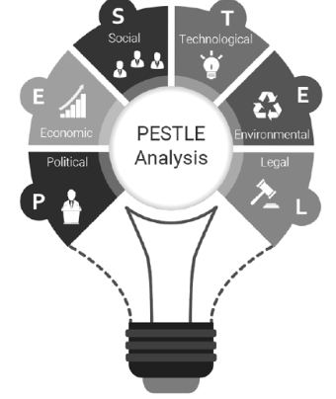
Figure 1: PESTLE Analysis
(Source: Akman, 2020)

2.1 PESTLE Analysis on Sweden and Germany
Political:
Sweden: According to an article by Sweden Sverige (2026), Sweden has a democratic political environment where all people can avail the equal rights and freedom to utilise their powers to examine the government and politicians. Sweden has a stable government with fewer political troubles (Demker and Odmalm, 2022). The Swedish Constitution incorporates the basic rights, freedom of speech, decision-making of the government and utilisation of the power of the Swedish people. The Swedish government provide the freedom to think, act and talk for the important organisations such as the press within the country. [Favourable]
Germany: According to the European Union (2026), Germany’s political system is a federal system in its government operations. Germany has a federal structure, which is led by the chancellor (European Union, 2026). Germany has a stable government which is ruled by the Chancellor, the head of the government, and the head of state. [Favourable]
Economic:
Sweden: According to The Global Economy (2026), Sweden has forecasted its economic growth at about 1.69% upto 2030, and the economic growth has increased to 0.97%. Sweden’s inflation rate is 2.8% in 2024 (The Global Economy, 2026) [Refer to Appendix 2]. Sweden’s per capita GDP is 57723.23 USD, and the inflation rate is 2.8% in 2024 (The Global Economy, 2026) [Refer to Appendix 3]. Economic growth in Sweden is very stable and beneficial for business, making the environment favourable. [Favourable]
Germany: The inflation rate of Germany has decreased to 2.3 in 2024, and the GDP has increased to 55800.22 USD (The Global Economy, 2026). The inflation rate in Germany is expected to 2.3% in the year 2024 (The Global Economy, 2026) [Refer to Appendix 4]. Germany’s economic growth is very stable, and the investment growth is also very persistent. [Favourable]
Cultural:
Sweden: In Sweden, high indulgence and individualism support the growth of independent workers, that supports to improve industrial productivity (The Culture Factor, 2020). [Favourable]
Germany: In Germany, the workers are highly motivated towards achieving success and within their culture, the threat to avoid uncertainty was quite high (The Culture Factor, 2020). Thus, it can be defined that the cultural richness supports the existence of hardworking people in Germany. [Favourable]

3. Cultural Analysis using Hofstede Model
Hofstede’s Cultural Dimension is a model that is used for understanding the cultural influences of a country and how it impacts the values and behaviours of the people of that country. Nickerson (2025) has mentioned that this model is used for differentiating the cultural differences and influences of a country and its impact on social interaction. Based on Hofstede's model, Sweden scores lower on power distance and higher on femininity, which determines the quality of life. Germany scores high on uncertainty avoidance. IKEA's flat-pack concepts suit the DIY culture in Sweden, while the structured society in Germany supports retail systems.
Social:
Sweden: According to OECD (2020), the poverty level in Sweden is 9.2% labour force is higher in number. Sweden has a higher employment rate with 5.32 million people, and the labour cost index is 121.60 (The Global Economy, 2026). Consumer spending in Sweden has increased to 744967 SEK million (Trading Economics, 2026) [Refer to Appendix 1]. CSO firms in Sweden are giving employment to 188100 people in 2020, where women's employment persists to 60.9% (OECD, 2020). Sweden also has equal rights and freedom for all its citizens, and the government supports gender equality. [Favourable]
Germany: According to Sustainable Governance Indicators (2026), Germany has a social sustainability in child education, poverty reduction, health system, gender equality and human needs. Germany’s life expectancy index is high, at about 95.1 (World Economics, 2026). The German government is investing more in health systems to improve the social facilities. [Favourable]
Technological:
Sweden: According to the International Trade Administration (2024), Sweden’s digital industry is rapidly involved with new innovations and adoption that help to build a strong technical infrastructure. Uses advanced digital factors (International Trade Administration, 2024). Households in Sweden have about 99% internet access with high-connectivity and 5G network access. [Favourable]
Germany: According to the International Trade Administration (2025), the German ICT market has experienced growth to 240.9 billion USD. Germany has one of the largest ICT (Internet and Communication Technology) markets in Europe. 40% of German IT companies are using cloud technologies, and 53% are investing more in AI technologies. [Favourable]
Legal:
Sweden: In a report of L&E Global (2025), Sweden has strict labour laws to protect the employees' rights, and also a few laws for employees' training purposes. The country also includes corporate law regarding subscription, payment, memorandum registration and others. [Favourable]
Germany: According to L&E Global (2025), Germany has employee regulations in using IT tools, data protection laws, anti-discrimination and anti-harassment laws and corporate laws for incorporation and registration in the organisations. Strong consumer protection measures (Lambach and Oppermann, 2023). [Favourable]
Environmental:
Sweden: Sweden has lower GHG emissions, which helps to maintain high air quality and follow environmental sustainability. The country also transforms its energy production with renewable resources that save natural resources. [Favourable]
Germany: According to OECD (2026), Germany has a higher population density than the other countries in Europe. Germany has high air quality, lower GHG emissions and rich sources of natural water (OECD, 2026). GHG emissions in Germany are decreasing, and the air quality has been improving in recent years. [Favourable]
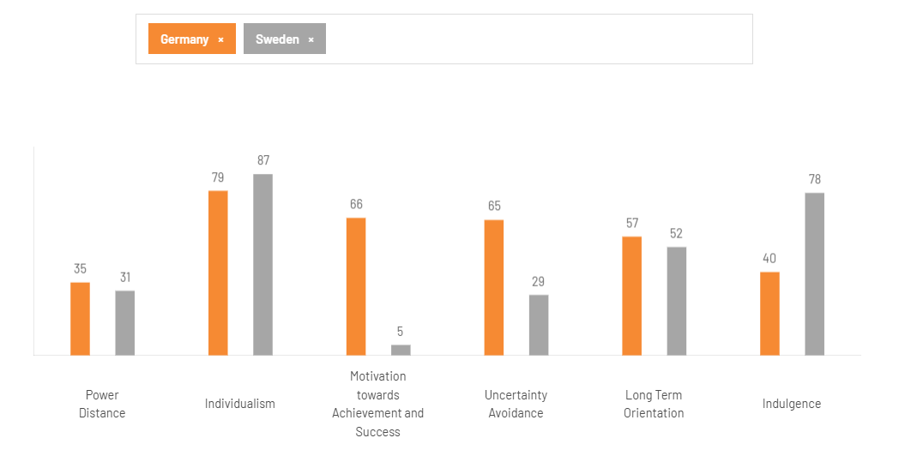
Figure 2: Hofstede’s Cultural Dimensions for Comparing the Cultural Factors of Sweden and Germany
(Source: The Culture Factor, 2020)
Power Distance: Figure 2 depicts the cultural changes between Germany and Sweden, and the power distance between the countries can be defined as quite similar. Viberg et al. (2024) have stated that in Germany, power distance is distributed unequally, similar to Sweden, due to both countries having independent individuals. Therefore, this causes significantly “less powerful members in an organisation”. Sweden has a flatter structure of society, whereas Germany’s society follows a competence, efficient and merit-based hierarchy, which is a little stricter than Sweden.
Individualism: Sweden has a more individualistic society than Germany, following the concept that Germany reflects more on their personal achievements and needs. Thus, the chart depicts that both countries have a high level of individualism among their people. The people of both countries have a significant focus on their self-image, with a robust focus on their family and social life (Clearly Cultural, 2025). The Swedish people focus on their private lives more, and the German people are strict with the boundaries of personal and professional life.
Motivation Towards Achievement and Success: Figure 2 depicts that the motivation among the people of Sweden is significantly low, while the motivation of the people of Germany is exponentially high. This drastic change in motivation for achievement and success (The Culture Factor, 2020). German and Sweden both countries, have ethics in their work orientations and believe in achieving quality for success. This is the primary difference between IKEA in Germany and Sweden, as different motivations create differences in sales.
Uncertainty Avoidance: Yi (2021) has mentioned that countries similar to Sweden have low uncertainty avoidance due to the people of the country accepting uncertainty as a part of life. Thus, it has a relaxed attitude toward tolerating something easily. However, Germany has high uncertainty avoidance due to its focus on larger responsibilities. This is another factor that differs in German society, which avoids risks through relying on laws, and the Swedish people make a unanimous decision for risk avoidance.
Long-Term Orientation: This factor is also quite similar between both countries, as both Germany and Sweden have a focus on maintaining time-honoured traditions for having similar societal views and changes (The Culture Factor, 2020). This link between past and future is significant for IKEA due to the changing preferences of the customers.
Indulgence: It can be seen that Sweden has a high level of indulgence among its people, while the German People do not indulge that much (The Culture Factor, 2020). The country is also known to have a focus on cynicism and pessimism, and thus, while Swedish people are quite impulsive and desirable. Swedish work culture is less hierarchical and more relaxed for its employees; therefore, the German work culture is structured and stressful. However, the model of dimensions by
Hofstede can provide disadvantages due to oversimplification, stereotyping, and neglect regarding agency. However, it also has advantages, including a structured framework, cross-cultural awareness, and practical patterns. Therefore, one of the disadvantages are it only works with the static structure of the culture; dynamic culture is not evaluated, and it provides the idea of miscommunication to the organisation as an advantage.
Sweden and Germany both have a stable political environment, but the governance structure of both countries is different. The economic growth of Sweden and Germany is stable, but the inflation rate discussion is different. Therefore, Germany is more socially developed than Sweden, having a growing health system, child education, and a reduced poverty level. However, Sweden and Germany both are tending to technological developments and adaptations.

4. STP Strategy

4.1 Segmentation
Segmentation | Sweden | Germany
Demographic | The people of the country significantly use IKEA, and the demographic of the country has a focus on ages 18 and older, and both females and males (Dudovskiy, 2022). | The people of Germany also use IKEA, and the demographics of the country focus on young adults and young families between 25 and 45.
Geographic | In Sweden, IKEA’s markets are distributed among the urban and suburban regions, along with strategic locations for achieving hyper-local targeting (Alzghool, 2020). | In Germany, IKEA’s markets are part of the major metropolitan areas, with high coverage, along with urban and suburban areas for logistics and digital access.
Psychograohic | Mehra (2025) has mentioned that the company appeals to the customers with high value, high affordability, and sustainability. | Meanwhile, the psychographic segment of Germany focuses on urban functionalists, sustainable home-makers, and family-oriented settlers.
Behavioural | The Behavioural Segmentation of Sweden focuses on Convenience-Driven Digital Users, Sustainable Shoppers, and Urban Functionalists. | The Behavioural Segmentation of Germany focuses on people focusing on DIY and functions, cost-conscious and eco-conscious people, and more.
Table 2: Segmentation of Sweden and Germany
(Source: Self-Created)
Both in Germany and Sweden, the company shares the same name and similar products with similar designs. Vanathi and Raj (2023) have stated in this regard that in both countries, it utilises social media platforms for reaching its target audience and creating a strong digital presence for building a strong image with its customers. However, its differences stem from its brand value and cultural experiences for prioritising the market in the respective country.

4.2 Targeting
Sweden
Name: Maja Johansson   | Story and Profile: Maja Johansson is a Swedish office worker, and it is known to have a significant focus on sustainable and long-lasting products; thus, IKEA is the only source for her.
Demographics  Age: 27  Income: 37,000 SEK a month  Gender: Female  Occupation: Office Worker | Needs: Her needs include sustainable and long-term products, along with low cost.
Motivation: She gets motivated if the products she gets are long-lasting and can be recycled after usage. | Pain Points: She, so far, has been unable to find proper sustainable products; thus, her only hope has become IKEA.
Table 3: Customer Persona in Sweden
(Source: Self-Created)
VALS segmentation in Sweden
Values: The values of Swedish customers include down-to-earth simplicity, sustainability focus, and pragmatism for its products (Vanathi and Raj, 2023).
Attitude: The attitude of the customers includes cost-consciousness and sustainability.
Lifestyle: The lifestyle of the customers in the country includes urban renters, young professionals, and experiential consumers.
Germany
Name: Paula Schneider   | Story and Profile: Paula Schneider works as a Social Media Marketing Executive, and therefore, needs better furnishing for creating an emphasis on her customers.
Demographics  Age: 30  Income: €53,000 a month  Gender: Female  Occupation: Social Media Marketing Executive | Needs: Her needs are long-lasting furniture that also looks beautiful in a home environment.
Motivation: IKEA sells beautiful, innovative furniture at a low price, which motivates her to buy it. | Pain Points: The furniture she has brought before did not last long; thus, she needs better furniture.
Table 4: Customer Persona in Germany
(Source: Self-Created)
VALS segmentation in Germany
Values: The values include focusing on cost-consciousness and sustainability for the products.
Attitude: The attitude of the customers of IKEA in Germany includes eco-friendliness, pragmatism, and the implementation of a DIY culture.
Lifestyle: The Lifestyle of the Customers in Germany includes urban living, First-time renters and small families (Vanathi and Raj, 2023).
In Sweden and Germany, the attitudes and values of their customers are significantly similar due to them focusing on cost consciousness, sustainability and having the simplicity for the market. However, in Sweden, it has a major focus on having affordable products for families and helping them make a utilitarian home (Global Data UK, 2023). Meanwhile, Germany focuses mostly on precision for high functionality, while creating a modern design.

4.3 Positioning
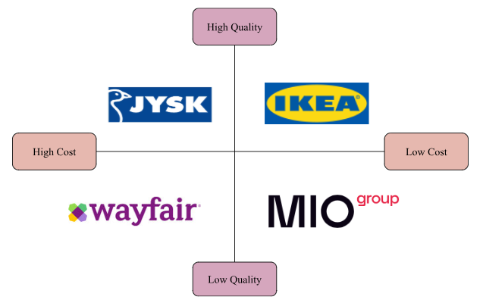
Figure 3: Positioning Map of Sweden
(Source: Self-Created)
In Sweden, Ikea focuses on creating a hybrid positioning model for high-volume cost leadership. IKEA is known to have a significant positioning in Sweden, its home country, and it is evident from its positioning map in Figure 3. The positioning map depicts that IKEA focuses on low-cost and high-quality products to meet the demand of its customers. Thus, it is known for producing durable products that present a proper furnishing idea to its customers (IKEA, 2026a). Thus, the rivals fail in these factors, as JYSK has high quality and high cost, Wayfair has high cost and low quality, and MIO Group has low quality and low cost.
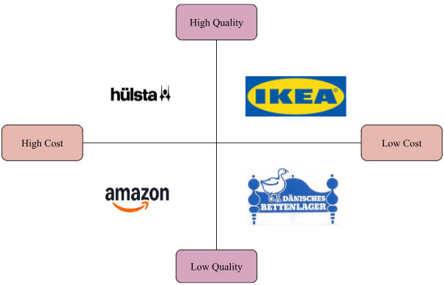
Figure 4: Positioning Map of Germany
(Source: Self-Created).
Germany utilises the democratic design for its positioning and cost structure for providing affordable and stylish options to its customers. In Germany, IKEA also has a significant position, as it also focuses on high quality and low cost (Refer to Figure 4). IKEA in Germany has a robust focus on Strong furniture, lighting and bathroom furniture (IKEA, 2024b). Its rivals, Hulsta focuses on high quality and high cost, Amazon focuses on high cost and low quality, and Dänisches Bettenlager focuses on low quality and low cost.

5. Marketing Mix 7Ps
Marketing Mix 7Ps | Sweden | Germany
Product | Durable, sustainable, modern and functional products. | Wide range of home accessories, including sustainable furniture and FSC-certified wood.
Price | Competitive, low pricing for high-volume products. | Competitive pricing with cost advantage and “knock-down” model.
Place | Strategic locations with showrooms and distribution centres. | Out-of-town suburban stores that are accessible by vehicle.
Promotion | Through the IKEA catalogue, TV commercials, and social media. | Through traditional advertising, social media, and the printed IKEA catalogue.
People | Staff who facilitate the self-service model for assistance. | Trained staff for delivering customer care and encouraging self-service.
Process | Unique shopping experiences with flat-packed items in warehouses. | A guided store layout, in-store restaurants, self-pickup and more.
Physical Evidence | The blue-and -yellow warehouses and stores, with fully furnished items for sale. | Also focusing on blue-and -yellow warehouses and stores and “room-set” showrooms.
Table 5: Marketing Mix 7Ps
(Source: Self-Created)
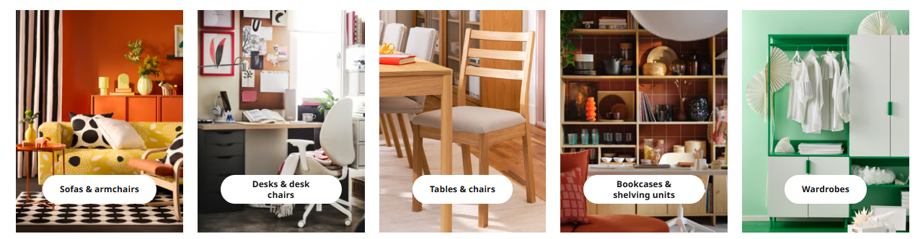
Figure 5: Products of IKEA in Germany
(Source: IKEA, 2025)
Product: In Table 4, the products of IKEA in Sweden are described as durable, sustainable, modern and functional products, including long-lasting furniture (Refer to Figure 5) (It’s Nice That, 2024). Thus, the products and furniture of IKEA in Sweden and Germany focus on kitchenware, storage organisation, bathroom products and more (IKEA, 2026b). Germany utilises large-format retail stores in both countries; however, in Germany, it uses e-commerce and digital channels, while Sweden uses Omnichannel Fulfilment Centres.
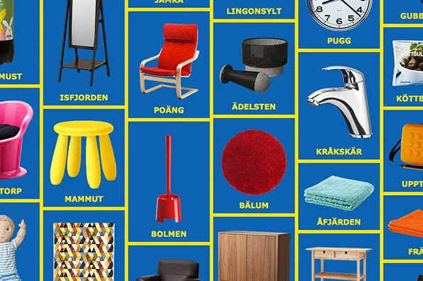
Figure 6: Products of IKEA in Sweden
(Source: It’s Nice That, 2024)
Therefore, the products of IKEA can be described to have democratic and modular design as seen in the products of Figure 6.
Price: The pricing strategy of IKEA in both countries focuses on competitive pricing, and can focus on low-price leadership for maintaining high-volume. Dudovskiy (2022) explains that low prices can help customers gain significant affordability for the products, along with home improvement.
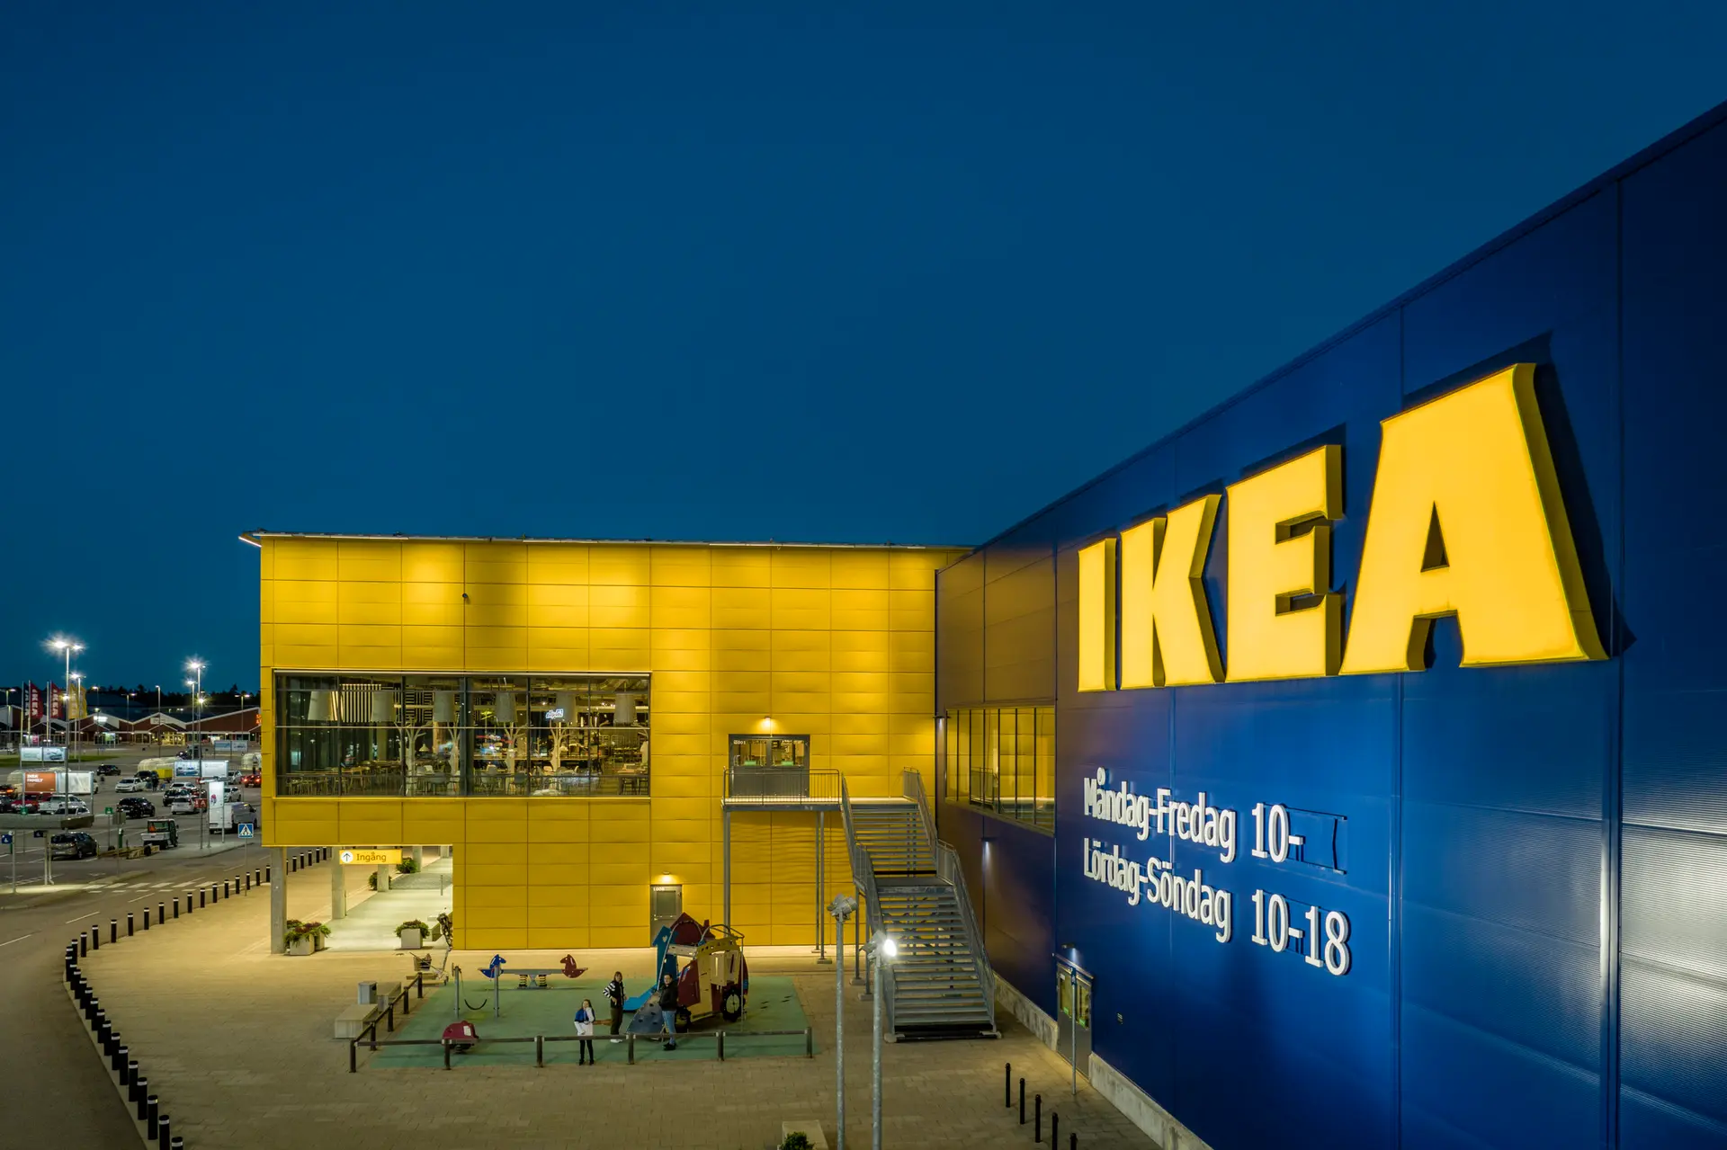
Figure 7: Store of IKEA in Sweden
(Source: Sweden.se, 2023)
Place: Sweden focuses on the changing consumer preferences for addressing the challenges regarding urban expansion in the country (Shastri, 2021). On the other hand, Germany uses out-of-station but easy-to-access locations for its sales of furniture (Refer to Figure 8) (PV, 2019).
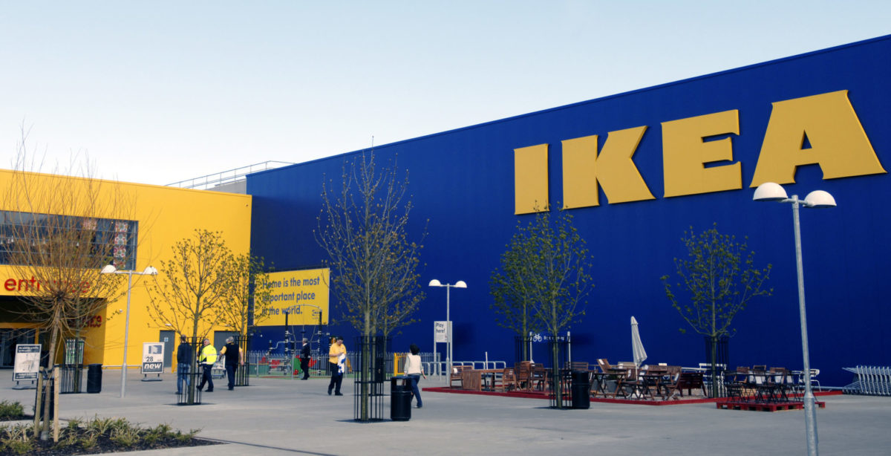
Figure 8: Store of IKEA in Germany
(Source: PV, 2019)
Promotion: it focuses on the IKEA catalogue, social media, and traditional advertising for utilising digital channels and storytelling. In both countries, it uses various methods for successful creating an emphasis on its customers through emotional campaigns and local advertising.
People: In both Germany and Sweden, IKEA focuses on Customer-centric staff, and allows them to help the customers navigate through an IKEA store. The staff also encourage and help customers to utilise the self-service process used in the store for providing them with shopping freedom and individuality (Ashmawy, 2020). In Germany the total number of staff are over 30,000, while in Sweden the total number of staff are over 14,000.
Process: This factor differs between the two countries, and thus, in Sweden, the process focuses on unique shopping experiences, and flat-packed items in the warehouse. In Germany, however, it uses a guided store layout, with self-pickup utilised by the customers. The company also has a focus on store navigation and in-store services for a standardised and one-way path and integrated systems for facilities such as its in-store restaurants.
Physical Evidence: In both Sweden and Germany, the most significant physical evidence for the company is its blue-and-yellow stores, that are easily recognisable from a distance. Therefore, these stores are designed to utilise self-service and a labyrinthine journey in the store, for a creative atmosphere.
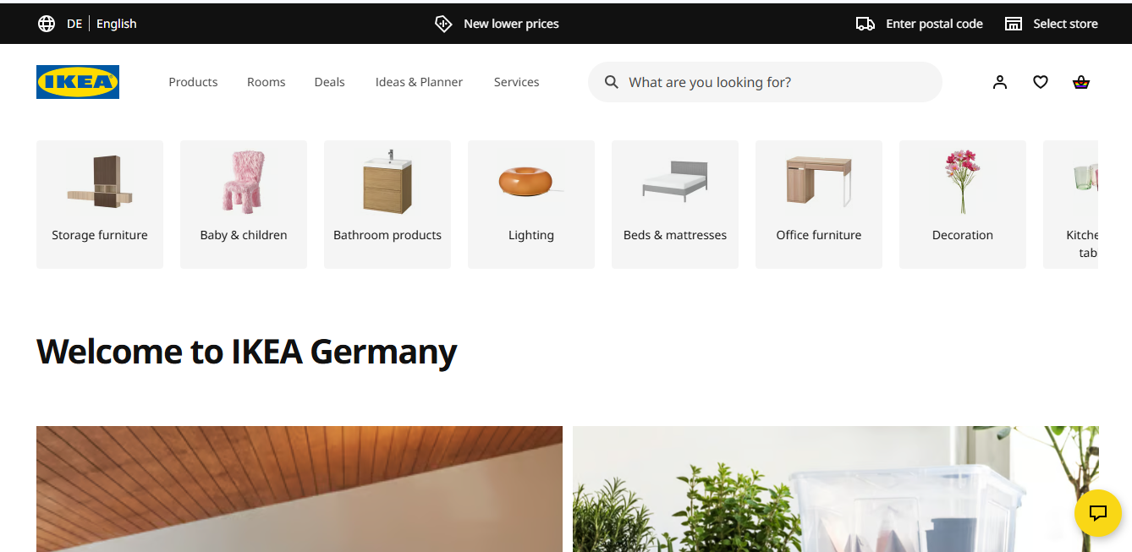
Figure 9: German Home page of IKEA
(Source: IKEA, 2024)
The company is also known for keeping consistency and a significant digital presence through AR for app allowance and making the customers have a “day out” experience.
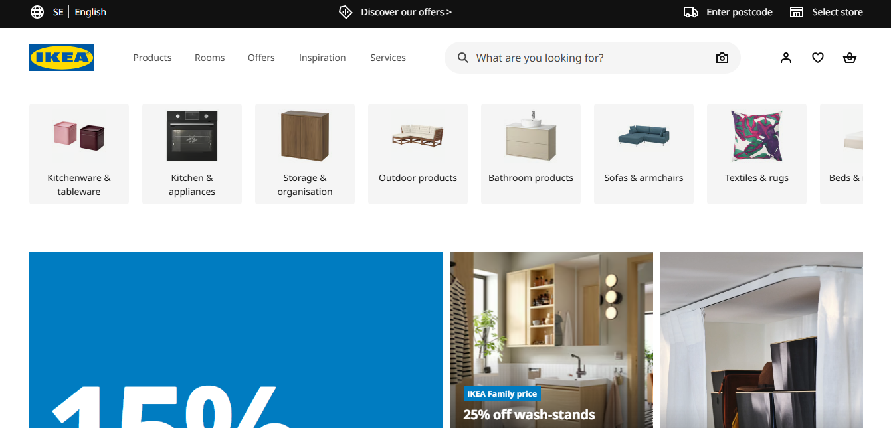
Figure 10: Swedish Home Page of IKEA
(Source: IKEA, 2025)
According to Pervis (2021), the similarity of both countries regarding IKEA comes from its product, pricing and place. since both markets appreciate high-quality, sustainable, and innovative products, and utilise robust, efficient logistics and distribution networks. However, the differences stem from product adaptation, promotion, and customer behaviour.

6. Ansoff matrix
According to Ferreira and de Sá (2024), the Ansoff matrix is used as a marketing tool that helps to plan the marketing strategies of a company, aligning with the basic strategic decisions (Refer to Figure 11). It helps to understand the effective marketing strategies and also evaluates the growth of the company by utilising the strategic plan.
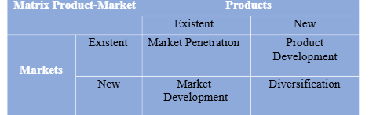
Figure 11: Ansoff Matrix
(Source: Ferreira and de Sá, 2024)
IKEA is a furniture and household brand that is almost successful in its original country, Sweden. IKEA’s market penetration strategy is very successful, and with effective marketing, the sales of the company have increased. IKEA is the world’s largest furniture and household brand, operating in 30 countries with 374 stores that support the market development factors (World Economic Forum, 2026). Diversification for IKEA supports the new product sales in the new country’s market by attracting the customer’s attention. Product Development refers to developing a new product for the existing market to increase the company's sales, that support the revenue growth.
IKEA has launched a new conceptual product, the “Tiny Modular Home”, that helps to fight climate change (Pope, 2020). IKEA can develop this product with more innovations that also impact environmental sustainability. The company can use eco-friendly materials with effective technologies for better outcomes of the product. Housing appliances are responsible for carbon and GHG emissions that can be reduced with modular homes because it uses smart technologies and integrated chips for automating the house environment. Although IKEA is a premium-priced brand, it has to develop the furniture qualities and include more innovations within the product's core development. This step also required consistent research that helps to understand the market needs and allows for capturing the market segment. IKEA should develop other products of its brands with an affordable price range that will attract every segment of customers.

7. Ethical Issues in Sweden and Germany
There have been past challenges over the tax structure in Europe (Dornean and Stoica, 2023). According to The Global Economy (2026), Sweden had an unemployment rate 8.53% in the year 2024, which shows the unskilled labour within the country. Citizens’ lower purchasing capability due to unemployment can hamper the company’s business in Sweden by decreasing product sales. Studies have proven that IKEA has used tax evasion, which can be counted as an ethical constraint of the company. According to Lehner et al. (2020), the Swedish government has declared that 90% of climate changes due to garment waste, that needs the shift to the circular economy. Waste management and eco-friendly material usage support the enhancement and transformation of environmental factors by maintaining sustainability. IKEA also do not use technological solution of the problems that will support effective customer satisfaction. IKEA sales have fallen by 1% in 2025, costing 44.6 billion euros (Fondahn and Reid, 2025). IKEA provides more products on display for less volume, and also store visiting increased.
According to Greenpeace International (2024), IKEA has been investigated for sourcing the raw materials from an old-growth forest in Romania that remains the last forest in Europe. Besides, it also contributes to the waste of the unwell furniture, creating landfills, and affecting the environment. These issues reflect that the organisation is having a lack of system monitoring and scrutiny. Hence, this also impacts the organisation's reputation, besides increasing sustainable pressures. Therefore, the company also looks for its operational goals, low-cost, and financial balances in addition.

8. Recommendations
- IKEA should focus on smaller store formats in the urban areas of China, and also implement localisation for both India and China. According to (GLOBIS Europe, 2025), Nitori Holdings has adapted the localisation strategy in Japan and achieved significant growth in terms of competing with IKEA. Therefore, in the USA, IKEA should focus on partnering and implementing sustainability factors within its business operations. According to PR Newswire (2025), Millerknoll has updated its sustainability strategies to contribute more to the sustainable journey. All the recommendations and provides strengths, commitments and collaborations advantages to the organisations.
- Sustainable impacts through transforming products and materials: IKEA’s Products are mostly often generating waste that affects the sustainable commitments and hampers the sustainable activities. The waste generation can be reduced through utilising eco-friendly materials and reusable resources for a better brand image and a positive environmental impact of the company. For example, Svegea of Sweden has adopted the Zero Waste pattern for removing the waste creation and dumping into the environment (Svegea of Sweden, 2026). Svegea implements a few innovative advanced solutions to maximise the materials utilisation, thus the waste cannot be generated. The company also introduces advanced technologies to transform the production operations and automates the processes that provide the best designs and production outcomes. These technologies help to integrate and boost the zero-waste techniques very seamlessly within the procedures.
- Price Adjustments and Supply Chain Transformation for Revenue Generation in IKEA Germany: According to Yahoo Finance (2024), IKEA sales have fallen by 4.3% in the year 2024 in Germany. In recovering the previous revenue growth, the company should introduce supply chain transformation and also need to make the furniture prices affordable, which will help to attract customers, and the company's profits will also increase. The customers are aware of the inflation, often rethink buying a premium product and high-priced goods, whereas cutting the prices of the furniture will be able to retain those customers. IKEA can also use their online sites to foster the transformations and catch the customers' attention. According to Manufacturing Today (2025), many of the commercial furniture makers are transforming their supply chain amid the issue of tariff increments. However, these changes can help generate revenue and also raise the funding for machinery and high-quality productions. Good quality products with adjusted price rates always seem to be the customer's first choice and show innovative craftsmanship. The price adjustments in the operational costs also help to manage the loss and fall in profit revenue.
Besides these major issues, IKEA should also improve its supply chain and internal operations to improve its services. IKEA should also ensure product safety for its customer that will bring trust in them towards the brand. All the fundamental solutions to the issues will bring an effective brand presentation to the customers.

9. Conclusion
This study explains the business environment and the effective solutions for IKEA to improve its market in Sweden and Germany. At the beginning of the report, a detailed discussion about the company was conducted with the purpose of the report. The PESTLE analysis evaluates the macro-environmental analysis of both countries, Sweden and Germany. This helps to identify the external barriers for the brand IKEA. Then it measures the cultural differences between Sweden and Germany by considering a few factors. Then, the segmentation and the targeting of customers are evaluated through an STP map. It also explores the company's position in both countries by exploring the product quality and product prices. In the next part, the 7p marketing strategy has been described depending on the factors. In the next step, the Ansoff matrix for product development of IKEA is suggested, considering a few development factors. Then, some ethical issues have been discussed for IKEA in operating in Sweden, and some credible recommendations have been suggested for solving the problems are also discussed.

Section 2: Reflective Account

1. Gibbs’ Cycle
Gibbs’ Reflective Cycle was developed by Graham Gibbs in 1988 and is a six-stage reflective model. This model can help to structure the learning from events and experience. Additionally, this model also helps to develop professional skills by identifying new skills during the event and improving existing skills (Galli and New, 2022). Figure 12 highlights all six stages of this model, which helps to improve and develop the skills which were present within the individual and acquired during the event.
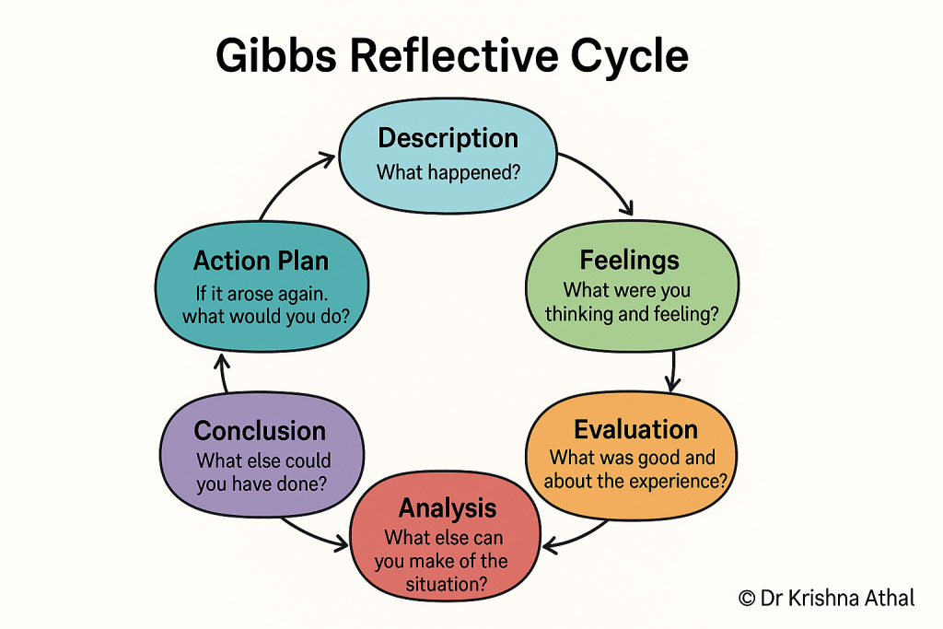
Figure 12: Gibbs’ Reflective Cycle
(Source: Athal, 2025)

1.1. Description
This stage of the Gibbs’ Reflective Cycle helps to introduce an image of the present report structure and the acquired skills of mine, which are impacted by completing the project successfully. At first, I chose IKEA to analyse its marketing strategy within the international aspect. I have also identified that the home country of this company is in Sweden, so I have selected the hosting country for this report in Germany. I have also collected multiple pieces of information by searching several articles, journals, and data from different sources, including company reports and other journals from different databases. The PESTLE Analysis of both countries, Sweden and Germany, helps me to identify the macro-environmental market factors by comparing each country. Hofstede’s cultural dimension theory also helps me to identify how IKEA is operating within both Sweden and Germany. I also have the STP Strategy and Marketing Mix 7Ps to discuss the market positioning of IKEA in both Sweden and Germany. Lastly, in this report, I have identified the ethical issues of Sweden in operating the business of IKEA by recommending some strategies to mitigate the challenges of IKEA in Sweden.

1.2 Feelings
I felt some difficulties in collecting the authentic and recent data from different database sources. This process creates a huge barrier in analysing the macro-environmental factors of the chosen company’s home and hosting countries. The STP analysis is also difficult for me to work on. This part of the report needs to discuss the market positioning of IKEA within Sweden and Germany. I have also identified that the operations of IKEA in both Sweden and Germany are different to each other due to the cultural differences. I also have a feeling of a lack of information regarding Sweden and Germany’s macro-environmental factors. Although I have also provided the most recent news and authentic data as possible.

1.3 Evaluation
This report was prepared to compare the international marketing strategy of IKEA in Germany and Sweden, which helps to acknowledge some of my skills which are present within me. I have analysed, synthesised, synthesised and evaluated the information which I gained by accessing the different sources. Critical thinking can help to foster active engagement and self-reflection (Boogaard, 2024). This skill of mine helps me to access several articles, company reports, and journals to verify authentic information positively. This skill of mine also helps me to identify the ethical data by removing all unnecessary and inauthentic data. This also helps me to use my logical and evidence-based interpretations about the company and the countries.
Time Management is another strength of mine, which is identified by completing this report. This skill of mine helps to plan work positively according to the plan. Time management also helps me to monitor my every planned stage, which helps me to set goals and prioritise the tasks accordingly. This skill of mine can also help to increase productivity and efficiency at work significantly (Martins, 2022). Effective time management can also reduce stress and maintain a balance between professional and personal life by enhancing the quality of the work.

1.4 Analysis
Completion of this report also enlightens my knowledge regarding my strengths and weaknesses effectively. I face a huge dilemma to take any decision regarding the report. Effective critical thinking skills help me to identify and verify the data effectively, yet due to a lack of decision making skill of mine, I faced a huge time loss working on this report. An effective decision-making process can help to choose the best option to work on (Nitta, 2025). However, I faced challenges in choosing a better option to complete the report.
Problem solving skill is also important to complete a whole report positively. I also faced a huge gap in my problem-solving skills, even though I have a strength in my critical thinking process. Due to a lack of decision-making process, I also faced an issue in problem-solving areas. This skill can help to identify the challenges and provide effective communication (Brooks, 2022). Due to the strong critical thinking, I can only recognise the challenges and analyse the reasons and causes of the issues. But the lack of decision-making makes me unable to choose a proper solution to mitigate the challenges effectively.

1.5 Conclusion
The Gibbs’ Reflective Cycle helps me to develop my professional skills, including time management and the critical thinking process. I have identified two main strengths and weaknesses of mine to complete the tasks. I have strong critical thinking and time management skills, yet in terms of the decision-making process and problem-solving skills, I have weaknesses. The action plan can help me to improve my weaknesses, which can help to develop my professional skills significantly.

1.6 Action Plan
Areas to Improve | Suggested Actions and Resources | Time Plan
Decision-Making Process | - Analysing the situation and event to identify the advantages and disadvantages of the situation.  - Using logical insights can also help in the decision-making process positively (Cote, 2024).  - Seeking help to gain more knowledge and perspectives can help to enhance the decision-making process. | 3 months
Problem-Solving Skill | - Improving the decision-making process can also help to improve problem-solving skills.  - Practising daily can also help to enhance problem-solving skills positively (Boyles, 2022).  - Maintaining calmness during pressure can help to improve problem-solving skills positively. | 5 months
Table 6: Action Plan

References
Akman, M.K., 2020. Defence management and PESTLE analysis. Ante Portas-Security Studies, 1(14), pp.93-102.http://anteportas.pl/wp-content/uploads/2020/10/AP.XIV_.pdf#page=93
Alzghool, M. (2020). An Evaluation of IKEA’s Global Position and Marketing Standing. [online] ResearchGate. Available at: https://www.researchgate.net/publication/346059671_An_evaluation_of_IKEA [Accessed 9 Mar. 2026].
Ashmawy, K. (2020). (PDF) Comparative international management: comparing cultures in IKEA. ‘IKEA’ Sweden vs. IKEA China". [online] ResearchGate. Available at: https://www.researchgate.net/publication/341992691_Comparative_international_management_comparing_cultures_in_IKEA_IKEA_Sweden_vs_IKEA_China [Accessed 9 Mar. 2026].
Athal, D.K. (2025). Gibbs Reflective Cycle Explained: A Framework for Structured Self-Reflection - Dr Krishna Athal. [online] Dr Krishna Athal - Life & Executive Coach. Available at: https://drkrishnaathal.com/blog/gibbs-reflective-cycle-explained-a-framework-for-structured-self-reflection/ [Accessed 9 Mar. 2026].
Boogaard, K. (2024). Critical thinking skills: what they are and how to build them. [online] Work Life by Atlassian. Available at: https://www.atlassian.com/blog/productivity/critical-thinking-skills [Accessed 9 Mar. 2026].
Boyles, M. (2022). How to Be a More Creative Problem-Solver at Work: 8 Tips. [online] Business Insights Blog. Available at: https://online.hbs.edu/blog/post/how-to-be-a-more-creative-problem-solver [Accessed 9 Mar. 2026].
Brooks, J. (2022). The art of problem solving and its translation into practice. BDJ In Practice, [online] 35(9), pp.21–23. doi:https://doi.org/10.1038/s41404-022-1714-y.
Clearly Cultural (2025). Individualism – Clearly Cultural. [online] Clearlycultural.com. Available at: https://clearlycultural.com/geert-hofstede-cultural-dimensions/individualism/ [Accessed 9 Mar. 2026].
Cote, C. (2024). How to Enhance Your Decision-Making Skills as a Leader. [online] Business Insights Blog. Available at: https://online.hbs.edu/blog/post/leadership-decision-making [Accessed 9 Mar. 2026].
Demker, M. and Odmalm, P., 2022. From governmental success to governmental breakdown: how a new dimension of conflict tore apart the politics of migration of the Swedish centre-right. Journal of Ethnic and Migration Studies, 48(2), pp.425-440. https://www.research.ed.ac.uk/files/178434201/DemkerMOdmalmPJEMS2020FromGovernmentalSuccess.pdf
Dornean, A. and Stoica, O., 2023. FEATURES AND RECENT CHALLENGES OF EU MEMBER STATES’TAX POLICIES. European Financial and Monetary Policies. Past Experiences and Current Challenges, (85), pp.85-108. https://www.researchgate.net/profile/Irina-Bilan/publication/375445963_EUROPEAN_FINANCIAL_AND_MONETARY_POLICIES_PAST_EXPERIENCES_AND_CURRENT_CHALLENGES/links/654a3ca73fa26f66f4e2622f/EUROPEAN-FINANCIAL-AND-MONETARY-POLICIES-PAST-EXPERIENCES-AND-CURRENT-CHALLENGES.pdf#page=86
Dudovskiy, J. (2022). IKEA 7Ps of Marketing - Research-Methodology. [online] Research-Methodology. Available at: https://research-methodology.net/ikea-7ps-marketing/ [Accessed 9 Mar. 2026].
European Union, 2026. Germany. Available at: https://european-union.europa.eu/principles-countries-history/eu-countries/germany_en [Accessed on 9th March 2026]
Ferreira, A.P.P.F.S. and de Sá, M.M.B.P., 2024. The importance of the Ansoff matrix for the study of the information services market. The Canadian Journal of Information and Library Science, 47(2), pp.78-84.https://www.researchgate.net/publication/382141729_The_Importance_of_the_Ansoff_Matrix_for_the_Study_of_the_Information_Services_Market
Fondahn, G. R. and Reid, H., 2025. IKEA sales fall for second year as retailer makes aggressive price-cutting push. Available at: https://www.reuters.com/business/retail-consumer/ikea-sales-fall-second-year-aggressive-price-cutting-push-2025-10-16/ [Accessed on 9th March 2026]
Galli, F. and New, K. (2022). Gibbs’ cycle review. Emotions as a part of the cycle. [online] ResearchGate. Available at: https://www.researchgate.net/publication/366459771_Gibbs [Accessed 9 Mar. 2026].
GlobalData UK (2023). IKEA, Sweden (Home) Shoppers Profile, Market Share and Competitive Positioning. [online] Market Research Reports & Consulting | GlobalData UK Ltd. Available at: https://www.globaldata.com/store/report/ikea-sweden-home-retail-shopper-profile-analysis/ [Accessed 20 Apr. 2026].
GLOBIS Europe (2025). More than you paid for: How Nitori built Japan’s answer to IKEA - GLOBIS Europe. [online] Globis EU. Available at: https://globis.eu/how-nitori-built-japans-answer-to-ikea/ [Accessed 20 Apr. 2026].
Greenpeace International (2024). IKEA furniture destroys some of Europe’s last remaining ancient forests. [online] Greenpeace International. Available at: https://www.greenpeace.org/international/press-release/66349/ikea-furniture-destroys-some-of-europes-last-remaining-ancient-forests/ [Accessed 20 Apr. 2026].
IKEA (2024). Fresh interior design ideas & affordable furniture. [online] Available at: https://www.ikea.com/de/en/ [Accessed 7 Apr. 2026].
IKEA (2024a). About Us. [online] www.ikea.com. Available at: https://www.ikea.com/us/en/this-is-ikea/about-us/ [Accessed 9 Mar. 2026].
IKEA (2024b). Fresh interior design ideas & affordable furniture. [online] Ikea.com. Available at: https://www.ikea.com/de/en/ [Accessed 9 Mar. 2026].
IKEA (2025). IKEA.com - International homepage. [online] IKEA. Available at: https://www.ikea.com/.
IKEA (2026a). IKEA for Business Retail equipment. [online] Ikea.com. Available at: https://www.ikea.com/in/en/ikea-business/retail-furnishings/ [Accessed 9 Mar. 2026].
IKEA (2026b). IKEA - Home furnishing ideas & affordable furniture2026. [online] www.ikea.com. Available at: https://www.ikea.com/se/en/ [Accessed 9 Mar. 2026].
IKEA. (2025). Furniture - discover home furniture for every room. [online] Available at: https://www.ikea.com/de/en/cat/furniture-fu001/ [Accessed 7 Apr. 2026].
International Trade Administration, 2024. Sweden - Digital Economy. Available at: https://www.trade.gov/country-commercial-guides/sweden-digital-economy [Accessed on 9th March 2026]
International Trade Administration, 2025. Germany - Information and Communications Technology (ICT). Available at: https://www.trade.gov/country-commercial-guides/germany-information-and-communications-technology-ict [Accessed on 9th March 2026]
Its Nice That (2024). Ikea in Swedish shows how to pronounce the names of your favourite furnishings. [online] Itsnicethat.com. Available at: https://www.itsnicethat.com/articles/ikea-in-swedish [Accessed 7 Apr. 2026].
L&E Global, (2025). Germany: Starting a business in Germany. Available at: https://leglobal.law/countries/germany/opening-in-germany/ [Accessed on 9th March 2026]
L&E Global, (2025). Starting a business in Sweden. Available at: https://leglobal.law/countries/sweden/opening-in-sweden/ [Accessed on 9th March 2026]
Lambach, D. and Oppermann, K., (2023). Narratives of digital sovereignty in German political discourse. Governance, 36(3), pp.693-709. https://onlinelibrary.wiley.com/doi/pdfdirect/10.1111/gove.12690
Lehner, M., Mont, O., Mariani, G. and Mundaca, L., (2020). Circular economy in home textiles: Motivations of IKEA consumers in Sweden. Sustainability, 12(12), p.5030.https://www.mdpi.com/2071-1050/12/12/5030
Manufacturing Today (2025). The Commercial Furniture Manufacturer That Outsmarted Supply Chain and Tariff Uncertainties. [online] Manufacturing Today. Available at: https://manufacturing-today.com/news/the-commercial-furniture-manufacturer-that-outsmarted-supply-chain-and-tariff-uncertainties/ [Accessed 7 Apr. 2026].
Martins, J. (2022). 18 Time Management Tips to Boost Productivity • Asana. [online] Asana. Available at: https://asana.com/resources/time-management-tips [Accessed 9 Mar. 2026].
Mehra, K. (2025). IKEA Case Study: What Makes IKEA’s Marketing Strategy So Successful? [online] Amritsardigitalacademy.in. Available at: https://www.amritsardigitalacademy.in/case-studies/ikea-case-study/ [Accessed 9 Mar. 2026].
Nickerson, C. (2025). Hofstede’s Cultural Dimensions Theory & Examples. [online] Simply Psychology. Available at: https://www.simplypsychology.org/hofstedes-cultural-dimensions-theory.html [Accessed 9 Mar. 2026].
Nitta, K. (2025). Decision making. [online] Encyclopedia Britannica. Available at: https://www.britannica.com/topic/decision-making [Accessed 9 Mar. 2026].
OECD, (2020). SWEDEN. Available at: https://www.oecd.org/content/dam/oecd/en/topics/policy-sub-issues/social-economy-and-social-innovation/country-fact-sheets/country-fact-sheet-sweden.pdf [Accessed on 9th March 2026]
OECD, (2026). Environment at a Glance: Germany. Available at: https://www.oecd.org/en/publications/environment-at-a-glance-country-notes_59ce6fe6-en/germany_b6b22e70-en.html [Accessed on 9th March 2026]
Olayiwola, K., Perera, S., Kagioglou, M., Jin, X. and Sharafi, P., 2025. A PESTEL Analysis of Problems Associated with the Adoption of Offsite Construction: A Systematic Literature Review. Buildings, 15(13), p.2146.https://www.mdpi.com/2075-5309/15/13/2146
Pervis, T. (2021). International market selection process between Sweden and Germany. [online] Available at: https://www.theseus.fi/bitstream/handle/10024/677993/Pervis_Titta%2C%20L%C3%B6nnqvist_Pauliina%20.pdf?sequence=2 [Accessed 24 Apr. 2026].
Pope, C., 2020. Ikea tiny homes can help fight climate change by giving small footprints a big toehold. Available at: https://www.nbcnews.com/think/opinion/ikea-tiny-homes-can-help-fight-climate-change-giving-small-ncna1252431 [Accessed on 9th March 2026]
PR Newswire (2025). MillerKnoll Unveils New Sustainability Strategy and Issues 2024 Better World Report. [online] Prnewswire.com. Available at: https://www.prnewswire.com/news-releases/millerknoll-unveils-new-sustainability-strategy-and-issues-2024-better-world-report-302367269.html [Accessed 20 Apr. 2026].
PV (2019). Ikea begins online sale of PV residential module systems in Germany. [online] pv magazine International. Available at: https://www.pv-magazine.com/2019/01/07/ikea-begins-online-sale-of-pv-residential-module-systems-in-germany/ [Accessed 7 Apr. 2026].
Shastri, A. (2021). Complete Marketing Mix of IKEA (7P’s) |IIDE. [online] IIDE. Available at: https://iide.co/case-studies/marketing-mix-of-ikea/ [Accessed 9 Mar. 2026].
Sustainable Governance Indicators, 2026. Social Sustainability in Germany. Available at: https://www.sgi-network.org/2024/Germany/Social_Sustainability [Accessed on 9th March 2026]
Svegea of Sweden, 2026. Zero Waste Pattern Cutting: A Revolution in Sustainable Fashion. Available at: https://svegea.se/zero-waste-pattern-cutting/#:~:text=Svegea%20of%20Sweden:%20Revolutionizing%20Zero,a%20more%20sustainable%20future%20today. [Accessed on 9th March 2026]
Sweden Sverige, 2026. Power from the people! This is how Sweden is governed. Available at: https://sweden.se/life/democracy/swedish-government [Accessed on 9th March 2026]
Sweden.se (2023). IKEA and the flatpack revolution. [online] sweden.se. Available at: https://sweden.se/work-business/business-in-sweden/ikea-and-the-flatpack-revolution [Accessed 20 Apr. 2026].
The Culture Factor (2020). Country comparison tool. [online] Theculturefactor.com. Available at: https://www.theculturefactor.com/country-comparison-tool?countries=germany%2Csweden [Accessed 9 Mar. 2026].
The Global Economy, (2026). Germany: GDP per capita, current dollars. Available at: https://www.theglobaleconomy.com/Germany/GDP_per_capita_current_dollars/ [Accessed on 9th March 2026]
The Global Economy, (2026). Germany: Inflation. Available at: https://www.theglobaleconomy.com/Germany/Inflation/ [Accessed on 9th March 2026]
The Global Economy, (2026). Sweden Economic Indicators. Available at: https://www.theglobaleconomy.com/Sweden/ [Accessed on 9th March 2026]
The Global Economy, (2026). Sweden: GDP per capita, current dollars. Available at: https://www.theglobaleconomy.com/Sweden/GDP_per_capita_current_dollars/ [Accessed on 9th March 2026]
The Global Economy, (2026). Sweden: Inflation. Available at: https://www.theglobaleconomy.com/Sweden/Inflation/ [Accessed on 9th March 2026]
Trading Economics, (2026). Sweden Consumer Spending. Available at: https://tradingeconomics.com/sweden/consumer-spending [Accessed on 9th March 2026]
Vanathi, A. and Raj, A. (2023). INTERNATIONAL JOURNAL OF LAW MANAGEMENT & HUMANITIES An Analysis of IKEA’s Global Positioning. International Journal of Law Management & Humanities, [online] 6(2). Available at: https://www.ijlmh.com/wp-content/uploads/An-Analysis-of-IKEAs-Global-Positioning.pdf [Accessed 20 Apr. 2026].
Viberg, O., Kizilcec, R.F., Jivet, I., Monés, A.M., Oh, A., Mutimukwe, C., Hrastinski, S. and Scheffel, M. (2024). Cultural Differences in Students’ Privacy Concerns in Learning Analytics across Germany, South Korea, Spain, Sweden, and the United States. Computers in human behavior reports, [online] 14, pp.100416–100416. Available at: https://www.sciencedirect.com/science/article/pii/S2451958824000496 [Accessed 9 Mar. 2026].
World Economic Forum, (2026). Ikea Supply. Available at: https://www.weforum.org/organizations/ikea-supply/ [Accessed on 9th March 2026]
World Economics, (2026). Germany's Social Factors: SOCIAL IMPACT FACTORS. Available at: https://www.worldeconomics.com/ESG/Social/Germany.aspx [Accessed on 9th March 2026]
Yahoo Finance (2024). IKEA furniture sales decrease in Germany amid high inflation. [online] Yahoo Finance. Available at: https://finance.yahoo.com/news/ikea-furniture-sales-decrease-germany-092810603.html [Accessed 7 Apr. 2026].
Yi, J.-S. (2021). Revisiting Hofstede’s Uncertainty-Avoidance Dimension: A Cross-Cultural Comparison of Organizational Employees in Four Countries. Journal of Intercultural Communication, [online] 21(1), pp.46–61. Available at: https://www.researchgate.net/publication/362774289_Revisiting_Hofstede's_Uncertainty-Avoidance_Dimension_A_Cross-Cultural_Comparison_of_Organizational_Employees_in_Four_Countries [Accessed 9 Mar. 2026].
Zhou, S. (2024). Analyzing IKEA Brand’s Media Marketing Strategies and Improving Customer Experience through Inductive Reasoning Approach. Journal of Education, Humanities and Social Sciences, [online] 27(4), pp.392–399. Available at: https://drpress.org/ojs/index.php/EHSS/article/view/18243 [Accessed 9 Mar. 2026].

Appendices

Appendix 1: Consumer Spending Graph of Sweden
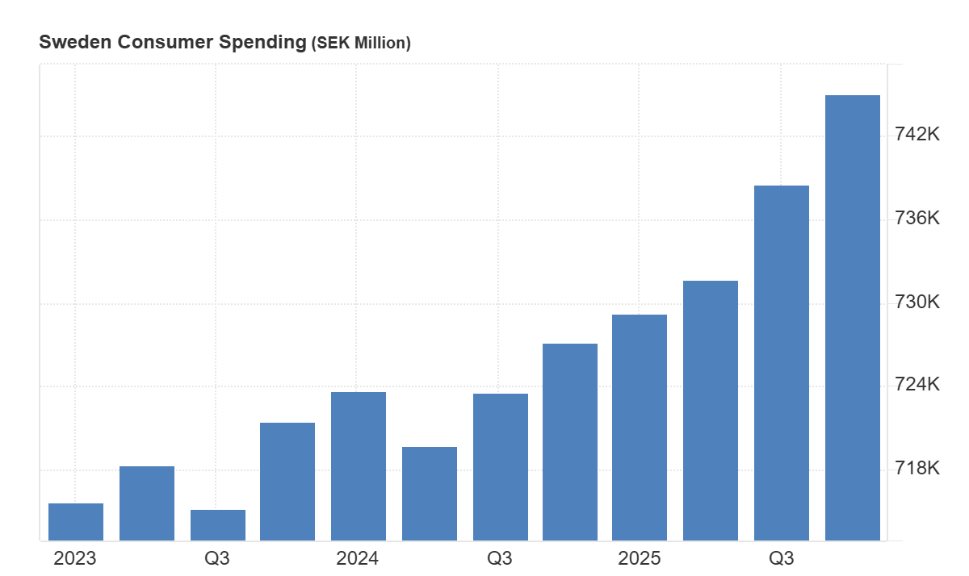
Figure 13: Consumer Spending in Sweden
(Source: Trading Economics, 2026)

Appendix 2: Inflation Rate Graph of Sweden
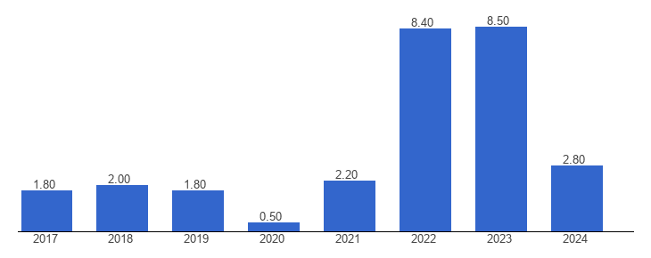
Figure 14: Inflation Rate in Sweden
(Source: The Global Economy, 2026)

Appendix 3: GDP graph of Sweden
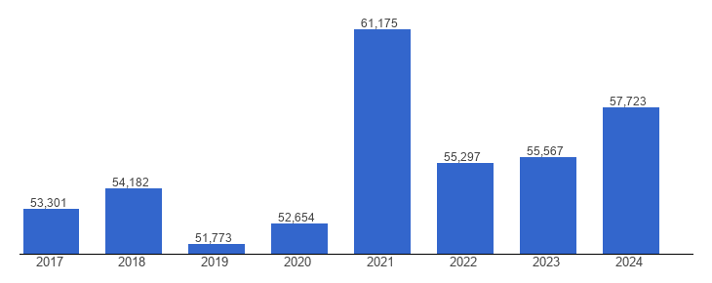
Figure 15: GDP growth of Sweden
(Source: The Global Economy, 2026)

Appendix 4: Inflation rate in Germany
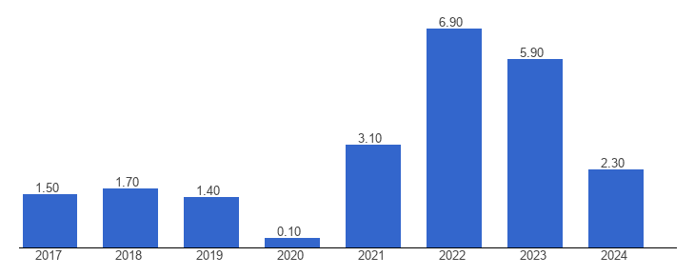
Figure 16: Inflation Rate in Germany
(Source: The Global Economy, 2026)

