Title: Investigation of Possible Correlations among Chinese EFL Teachers’ Reflection, Educational Background and Students’ Achievement and Chinese EFL Teachers’ Attention to Reflect-in-Action

The aims of the investigation:
The purpose of this study is to investigate the three main perspectives: The first is to discuss the possible influence of educational background on Chinese EFL teachers’ reflection. Whether educational backgrounds affect Chinese EFL teachers’ reflection levels? Will teachers with higher educational backgrounds achieve a higher level of reflection and perform better in reflection?
The second is to investigate the possible correlation between Chinese EFL teachers’ reflection levels and their students’ achievements. Whether Chinese EFL teachers’ reflection levels differentiate their students’ achievements? Will teachers with higher levels of reflection have a positive correlation with their students’ achievement?
The last one is to explore Chinese EFL teachers’ attention to reflect-in-action in their reflection activities. Whether reflect-in-action receives enough attention from Chinese EFL teachers? Will Chinese EFL teachers have a preference for a specific reflection type?
Therefore, the study attempts to find out answers to the three research questions:
- Does the educational background make a significant difference in Chinese EFL teachers’ reflection?
- Is there any relationship between the Chinese EFL teachers’ reflection level and their students’ achievement?
- Does reflect-in-action receive enough attention from Chinese EFL teachers?

The rationale and main conceptual themes for the investigation:
Why have I chosen this topic to investigate?
Currently, China attaches more and more importance to English teaching and learning to adapt to globalization, therefore it is required that Chinese EFL teachers should realize the importance of reflection to attain better EFL teaching: English has received unprecedented popularity in China, thus Chinese EFL teachers must apply reflective teaching in their practices as an effective way of improving EFL teaching (Li and Ye, 2016). However, there are only limited Chinese domestic studies related to reflective teaching: According to Li and Ye (2016), there are rather few Chinese domestic works on reflective teaching, including only one book and several research articles mainly focusing on the features of reflective teaching but still lacking discussion on teachers’ reflection level and potential influence brought by teachers’ educational backgrounds to their inflection levels. Hence, there is a research vacancy in the discussion of Chinese EFL teachers’ reflection levels and the possible relationship between Chinese EFL teachers’ educational backgrounds and their reflection levels that ought to be investigated. Moreover, reflection and reflective teaching have great significance to teachers’ vocational development: Aleandri and Russo (2015, quoted in Han and Wang, 2021) indicate that “reflection is one of the most pivotal elements of teachers’ professional development, effectiveness, and well-being”. It can be inferred that reflection can contribute to teachers’ professional achievements and students’ achievement is one of the assessment ways for teachers’ professional achievements in the Chinese context, thus it’s significant to explore the possible correlation between Chinese EFL teachers’ reflection level and their students’ achievements. Furthermore, among the three reflection types: reflect-in-action, reflect-on-action, and reflect-for-action, it is indicated that reflect-in-action receives the least application from EFL teachers that should be improved in practical teaching: according to the results of data analysis on a research about reflective teaching in EFL online classrooms, it is revealed that the majority of participators apply reflection-on-action and reflect-for-action but present lower awareness on the use of reflect-in-action in their classes (Salih and Omar, 2022); Meanwhile, Li and Ye (2016) also refer to the necessity of reflect-in-action to Chinese EFL teachers and emphasize its application: “Reflect immediately the unreasonable contents during the process of teaching”. Therefore, it is essential to find Chinese EFL teachers’ choice and preference for a specific reflection type, to acknowledge their application situation for reflection-in-action, and to discuss whether the reflection-in-action also receives inadequate attention from Chinese EFL teachers.
Why is it important and significant topic to investigate?
On the one hand, reflection and reflective teaching have been regarded as the pivotal capability of EFL teachers to better adapt to current situations: In the post-method era, reflection is considered to be one of the most crucial features needed by EFL teachers for their professional promotion and development (Tabassi, Ghanizadeh and Beigi, 2020); The concept of reflective teaching has promoted scholars and ELT researchers in Asia to share their scientific findings and evidence-based insights on its importance in 21st-century English as a Foreign Language Teaching (EFLT) development (Lubis, 2018). On the other hand, reflection and reflective teaching have great significance to both teachers’ professional development and students’ achievement. As for teachers, reflective teaching possesses both long-term and short-term benefits, which may promote greater teacher and student satisfaction and more classroom success (Mermelstein, 2018); Moreover, reflection functions as an essential factor in teachers’ professional development: Reflective teaching can be one of the core components of teacher professional development and shows substantive importance to teacher education (Hung and Thuy, 2021); Reflective teaching can make profound implications on teachers’ assessment strategies to improve teachers’ professional capability and adaption to changing situations (Yen et al., 2023); Reflective practices has emerged as a key aspect in determining successful teaching practices of teachers, and is a vital component of teachers’ professional growth (Nurkamto and Sarosa, 2020). As to students, teachers’ reflection can have a positive influence on students’ achievement: according to a research relevant to Iranian EFL teacher's reflectivity and their students’ language achievement, it is demonstrated that there is a significant positive correlation between teachers’ reflection and students’ achievement (Kheirzadeh and Sistani, 2018). Therefore, it is essential to further explore EFL teachers’ reflection situation and the probable relation between their reflection level and their students’ achievement in the Chinese context to promote Chinese EFL teachers’ professional development and EFL learners’ success.
What are the relevant ideas and issues in the module material?
The main rationale relevant to teachers’ reflection and reflective teaching of this study is supported by Dewey’s (1933) proposal of reflection, Schön’s (1983) definition of two reflection types: reflect-in-action and reflect-on-action, Van Manen’s (1991) supplement for another reflection type: reflect-for-action, and Farrell’s (2016) interpretation on the apparent feature of teachers’ reflection. John Dewey (1933) initiated the concept of reflection in his book and interpreted reflection as an active, constant, and thorough consideration of any belief or presumed forms of knowledge based on the supporting evidence (Namaziandost, Heydarnejad and Rezai, 2023). Schön (1991) divided two reflection types by expanding Dewey’s (1933) theory of reflection: reflection-in-action, also called active or interactive reflection, refers to intentional thought and modification during practice; Reflection-on-action, as the name implies, entails thinking about how to improve practice after completing prior sessions (Hung and Thuy, 2021); Van Manen (1991) proposed the concept of reflect-for-action as a crucial contribution to reflective practice, which implies that teachers should also stress and predict the possible problems or situations that may occur in their future teaching (Hung and Thuy, 2021). According to Farrell (2016), reflective thinking allows teachers to improve education programs by avoiding impulsive and regular actions (Namaziandost, Heydarnejad and Rezai, 2023).
The relevant researches about teachers’ reflection in the EFL context also discuss its relationship with pre-service and in-serve teachers’ performances, teachers’ professional development, and teachers’ psychology: Reflective practice can help EFL prospective teachers’ teaching skill improvement (Rozimela, 2018); Pre-service EFL teachers need more training about reflection to better prepare for entering their professional career (Azizah, Nurkamto and Drajati, 2018); Reflective teaching promotes pre-service EFL teachers’ teaching performances (Alsuhaibani, 2019); There is a significant positive correlation between EFL teachers’ reflection and job performance (Afshar and Moradifar, 2021); A weak positive and significant relationship is found between EFL teachers’ level of teaching reflectiveness and experience (Motallebzadeh, Ahmadi and Hosseinnia, 2018); Both academic background and teaching experiences distinguish EFL teachers’ reflective teaching perception (Soodmand Afshar and Farahani, 2018); A relationship between EFL teachers’ assessment literacy and their reflective teaching (Ashraf and Zolfaghari, 2018); EFL teachers’ professional success can be relatively predicted by reflective teaching (Malmir and Mohammadi, 2018); Teacher resilience as one of the key factors in positive psychology can also be observed through teachers’ reflection (Xue, 2021).

A description of the evidence you intend to collect:
Responses to questionnaires: a collection of responses to the questionnaire of The English Language Teacher Reflective Inventory (2010) intending to investigate and measure the Chinese EFL teachers’ reflection situation, overall reflectivity level, and average reflectivity level;
Documents-Students’ EFL transcripts of selected teachers: a collection of students’ EFL transcripts in the units of a class of selected teachers respectively and the teachers are divided into two groups with higher overall reflection level and lower overall reflection level, and the students’ EFL transcripts will be used to calculate the average score of each class;
Responses to interviews: a collection of responses to the semi-structured interview about Chinese EFL teachers’ choice for reflection types and their attention to reflect-in-action.

The methods you plan to use to collect your evidence:
This study intends to apply a mixed method, involving both quantitative research and qualitative research. Good research can contribute to more effective EFL education through offering new perspectives into teaching process (Ma, 2015), and the mixed method primarily focuses on developing and applying strategies for collection, analysis, and interpretation of various quantitative and qualitative data (Creswell and Tashakkori, 2007). To answer the research qustion1, the study intends to apply the questionnaire of The English Language Teacher Reflective Inventory-ELTRI (2010), which was designed by Akbari, Behzadpoor, and Dadvand. It contains 29 items and assesses participants’ reflective practices in five subscales: practical (6 items), cognitive (6 items), affective (3 items), metacognitive (7 items), and critical (7 items), which should be responded based on a five-point Likert scale varying from (1) “Never” to (5) “Always”; The scale has high reliability and validity indices, and the reliability coefficient was .911 for total reflective teaching, which shows the scale enjoys high reliability (Motallebzadeh, Ahmadi and Hosseinnia, 2018). The educational backgrounds of participants will be taken into consideration after getting the results of the ELTRI. To answer the research question2, the study intends to compare and analyze data of students’ EFL transcripts of selected teachers, and the selected teachers are divided into two groups with higher reflectivity and lower reflectivity based on the data analysis of The English Language Teacher Reflective Inventory (2010). The quantitative research method is exerted in investigating research question1 and qusetion2. To answer the research question3, the study intends to apply the qualitative research method and conduct a semi-structured interview with all participants. The interview will be conducted and recorded through private phone calls, and each interview is expected to last for at least 45 minutes but no more than one hour: at least 15 minutes for each of the three major questions for the participant’s full statement. Three major questions are designed for the interview: 1. Which reflection type do you prefer (in/on/for)? 2. What reflective teaching activities will you use for the reflection type you choose? 3. What are some benefits you gain from the reflection type you choose in your practice?

A description of the settings in which you plan to collect your evidence:
The study plans to choose 120 Chinese EFL teachers of different genders, ages, and teaching experiences teaching Grade10 students in Baotou city from 6 different high schools as participants. Half of them possess bachelor’s degrees and half of them have master’s degrees. All participants use the same textbooks and their student's EFL levels and proficiency are similar. The ELTRI questionnaire will be sent to all participators online and two weeks for completion, and data collection will be conducted after receiving responses from all participators. The collection of the students’ transcripts will be conducted and analyzed twice, one is after their mid-term exam and the other is after their final exam respectively. The semi-structured interview will be conducted when participants are available by private phone calls and recorded during the whole conversation.

The ethical issues you need to consider:
Based on the adherence to an ethic of respect, it implies that participants’ voluntary informed consent should be involved in the study will be obtained at the start of the research, participants can withdraw at any point without needing to explain, researchers should make sure all participants understand what the study involves, and researchers should prevent participants from harms and avoid excessive demands on participants (BERA,2018); according to UWTSD Research Ethics & Integrity Code of Practice (2022), the researcher should keep the rules of Non-malfeasance: ‘do no harm’, Rights: Protect participants’ interests, and Ensure informed consent. Hence, the researcher should make sure all participants know the purpose of the study and are voluntary to attend the research by signing consents before any data collection; participants’ rights to withdraw at any time should be respected; all the data collection must get full permission from the participants and the authority; the data can only be used for a research purpose; the semi-structured interview will be conducted in a quiet and comfortable environment to make all participants feel unstressed; interview time for each participant will be limited into one hour to avoid excessive demand; and participants’ private information should be well protected.

The methods you expect to use to analyze the evidence you collect:
This study intends to use SPSS for the analysis of data about ELTRI to explore the correlation between Chinese EFL teachers’ reflectivity and educational backgrounds; SPSS is also expected to analyze data on students’ EFL scripts to investigate the relationship between Chinese EFL teachers’ reflectivity and their students’ achievement; NVIVO is supposed to cope with data related to recordings of the semi-structured interviews for inductive generalization on Chinese EFL teachers’ preference for reflection types and their attention to reflect-in-action.

The timetable for the proposed project:
The study intends to start on 01/07/2024 and end on 01/09/2025. From 01/07/2024 to 31/08/2024, the writing of the literature review, research background, the research aims and research significance will be conducted; From 01/09/2024 to 31/12/2024, the data collection will be conducted: two weeks for participants to complete online ELTRI questionnaire for data collecting, two weeks for data collection of students’ EFL transcripts for both their mid-term exam and final exam, and two months for conducting the semi-structured interview and recording arrangement; From 01/01/2025 to 30/04/2025, data analysis and result findings will be dealt with in essay writing process; From 01/05/2025 to 31/08/2025, discussions about the research findings and conclusion part will be done.

Bibliography
Afshar, H.S. and Moradifar, M. (2021) ‘The Structural Interplay between Critical Cultural Awareness, Institutional Identity, Self-Efficacy, Reflective Teaching and Job Performance of EFL Teachers’, International Journal of Society, Culture & Language, 9(1), pp.14-29.
Alsuhaibani, Z. (2019) ‘Perceptions and Practices of EFL Pre-service Teachers about Reflective Teaching’, Arab World English Journal, 10(4), pp. 62–73. Available at: https://doi.org/10.24093/awej/vol10no4.5.
Ashraf, H., and Zolfaghari, S. (2018). 'EFL Teachers' Assessment Literacy and Their Reflective Teaching'. International Journal of Instruction, 11(1), pp.425-436.

Azizah, U.A., Nurkamto, J. and Drajati, N.A. (2018) ‘Reflective practice: The experiences of pre-service EFL teachers in teaching English’. Journal of Language and Linguistic Studies, 14(3), pp.133-144.
British Educational Research Association. (2018). Ethical guidelines for educational research. Bera.

Creswell, J.W. (2013) ‘Steps in Conducting a Scholarly Mixed Methods Study’.

Creswell, J.W. and Tashakkori, A. (2007) ‘Editorial: Differing Perspectives on Mixed Methods Research’, Journal of Mixed Methods Research, 1(4), pp. 303–308. Available at: https://doi.org/10.1177/1558689807306132.
Fetters, M.D., Curry, L.A. and Creswell, J.W. (2013) ‘Achieving Integration in Mixed Methods Designs—Principles and Practices’, Health Services Research, 48(6pt2), pp. 2134–2156. Available at: https://doi.org/10.1111/1475-6773.12117.
Gunasekare, D. U. (2016). 'Mixed research method as the third research paradigm: a literature review', SSRN.

Han, Y. and Wang, Y. (2021). 'Investigating the correlation among Chinese EFL teachers' self-efficacy, work engagement, and reflection'. Frontiers in Psychology, 12, 763234.

Hung, D. M., and Thuy, P. T. (2021). 'Reflective Teaching Perceived and Practiced by EFL Teachers--A Case in the South of Vietnam'. International Journal of Instruction, 14(2), pp.323-344.

Kheirzadeh, S., and Sistani, N. (2018). 'The effect of reflective teaching on Iranian EFL students' achievement: The case of teaching experience and level of education'. Australian Journal of Teacher Education (Online), 43(2), pp.143-156.

Li, Z and Ye, Z. (2016). 'On Reflective Teaching of EFL Teachers in Local Universities of China--A Case Study of Leshan Normal University, Sichuan'. English Language Teaching, 9(6), pp.154-161.

Lubis, A.H. (2018) ‘REFLECTIVE TEACHING TOWARD EFL TEACHERS’ PROFESSIONAL AUTONOMY: REVISITING ITS DEVELOPMENT IN INDONESIA’, International Journal of Education, 11(1), pp. 35-49. Available at: https://doi.org/10.17509/ije.v11i1.9400.
Ma, F. (2015) ‘A Review of Research Methods in EFL Education’, Theory and Practice in Language Studies, 5(3), p. 566. Available at: https://doi.org/10.17507/tpls.0503.16.
Malmir, A. and Mohammadi, P. (2018) ‘Teachers’ Reflective Teaching and Self-Efficacy as Predicators of their Professional Success: A Case of Iranian EFL Teachers’. Research in English language pedagogy, 6(1), pp.117-138.
Mermelstein, A.D. (2018) ‘Reflective Teaching as a Form of Professional Development’, Mextesol Journal, 42(4), pp.1-14.
Motallebzadeh, K., Ahmadi, F. and Hosseinnia, M. (2018) ‘The relationship between EFL teachers’ reflective practices and their teaching effectiveness: A structural equation modeling approach’, Cogent Psychology. Edited by M. Qian, 5(1), p. 1424682. Available at: https://doi.org/10.1080/23311908.2018.1424682.
Nurkamto, J. and Sarosa, T. (2020) ‘Engaging EFL Teachers in Reflective Practice as A Way to Pursue Sustained Professional Development’, International Journal of Pedagogy and Teacher Education, 4(1), pp. 45-58. Available at: https://doi.org/10.20961/ijpte.v4i1.26082.
Namaziandost, E., Heydarnejad, T., and Rezai, A. (2023). 'Iranian EFL teachers’ reflective teaching, emotion regulation, and immunity: examining possible relationships'. Current Psychology, 42(3), pp.2294-2309.

Rozimela, Y. (2018) ‘The Impact of Reflective Practice on EFL Prospective Teachers’ Teaching Skill Improvement’, The Journal of Language Learning and Teaching, 8(1), pp.18-38.
Salih, A.A. and Omar, L.I. (2022) ‘Reflective Teaching in EFL Online Classrooms: Teachers’ Perspective’, Journal of Language Teaching and Research, 13(2), pp. 261–270. Available at: https://doi.org/10.17507/jltr.1302.05.
Şahin, M.D. and Ozturk, G. (2022) ‘Mixed Method Research: Theoretical Foundations, Designs and Its Use in Educational Research’, International Journal of Contemporary Educational Research, 6(2), pp. 301–310. Available at: https://doi.org/10.33200/ijcer.574002.
Soodmand Afshar, H. and Farahani, M. (2018) ‘Inhibitors to EFL teachers’ reflective teaching and EFL learners’ reflective thinking and the role of teaching experience and academic degree in reflection perception’, Reflective Practice, 19(1), pp. 46–67. Available at: https://doi.org/10.1080/14623943.2017.1351353.
Tashakkori, A. and Creswell, J.W. (2007) ‘Editorial: Exploring the Nature of Research Questions in Mixed Methods Research’, Journal of Mixed Methods Research, 1(3), pp. 207–211. Available at: https://doi.org/10.1177/1558689807302814.
Tabassi, F., Ghanizadeh, A., and Beigi, P. G. (2020). 'EFL Teachers’ reflective teaching: A study of its determinants, consequences, and obstacles'. Polish Psychological Bulletin, 51(3), pp.201-218.

Xue, L. (2021) ‘Challenges and Resilience-Building: A Narrative Inquiry Study on a Mid-Career Chinese EFL Teacher’, Frontiers in Psychology, 12, p. 758925. Available at: https://doi.org/10.3389/fpsyg.2021.758925.
Yen, P.H. et al. (2023) ‘Reframing Assessment Strategies: The Impact of Reflective Teaching on University EFL Lecturers’ Perspectives and Practices’, Journal of Language Teaching and Research, 15(1), pp. 35–45. Available at: https://doi.org/10.17507/jltr.1501.05.
Zandvanian, A. and Daryapoor, E. (2013). ‘Mixed methods research: A new paradigm in educational research’. Journal of Educational and Management Studies, 3(4), pp.525-531.

University of Wales Trinity Saint David, Research Ethics & Integrity Code of Practice (2022):
https://www.uwtsd.ac.uk/research/research-ethics/

Appendix
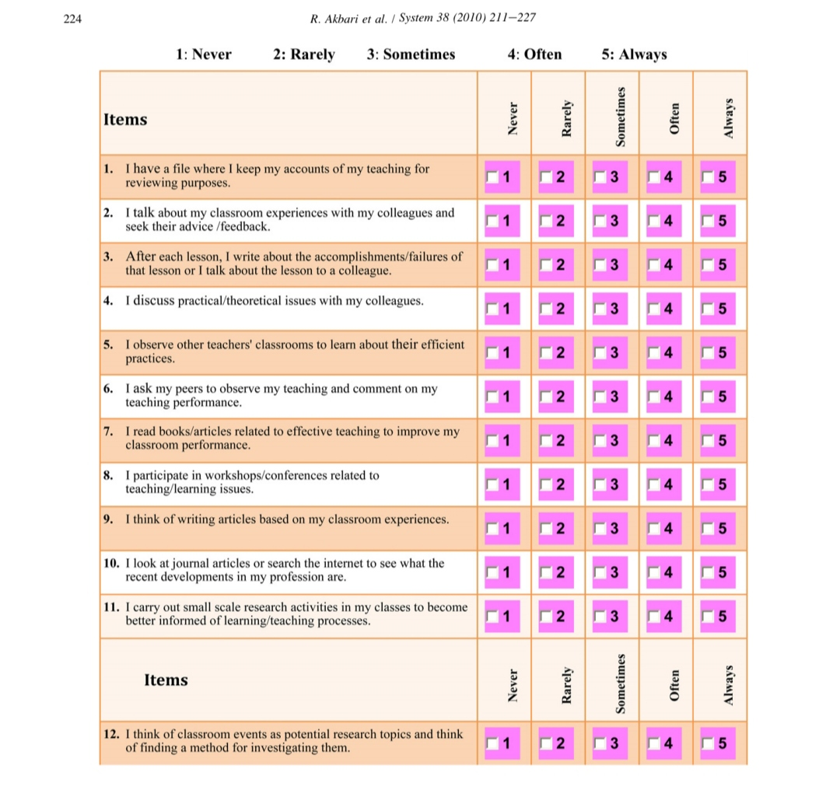
The English Language Teacher Reflective Inventory-ELTRI (2010)

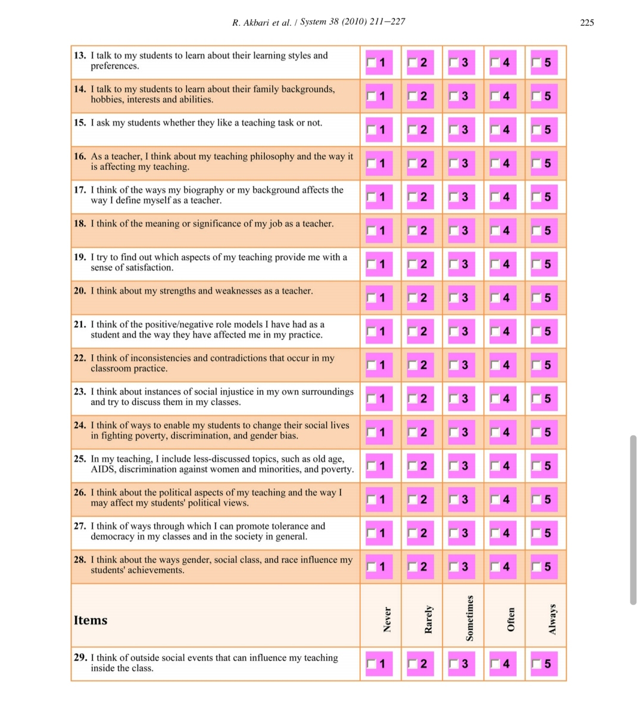
The English Language Teacher Reflective Inventory-ELTRI (2010)

