Problems solved
I solved the problems in exercise 1 and exercise 3
The easiest problem that I solved was the line with the answer all being together with no spaces, so it was hard to read. To fix this I put “endl;” at the end of the code so the next part goes on the next line.
The next problem I solved was creating a array. In my first attempt of the array I tried to make the system when each number would have its own section of code but then code and others were colliding and not working correctly. To fix this issue I made the code more simple by making the array only allow 5 answers to be inputted by the user and then be added up.
The hardest problem to solve was the issue of converting pounds to euro. In my first attempt I tried to make a conversion rate using a “double” but ran into problems when the conversion to euros came out in decimals. My next attempt I replaced the double with a “float” so decimal points can be used and presented.
I also ran into an problem when I was doing the math for the conversion. My first attempt was to create a calculator and use it to work it out but I couldn’t get it to work so instead I used the more simple version of making the “pound” a string and making the answer that was in the string multiply by 1.14 (the British pound to euro rate at the time) to obtain my answer to present.

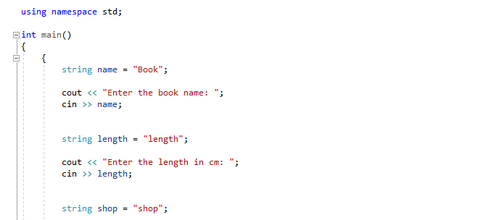
Working out problems for the code
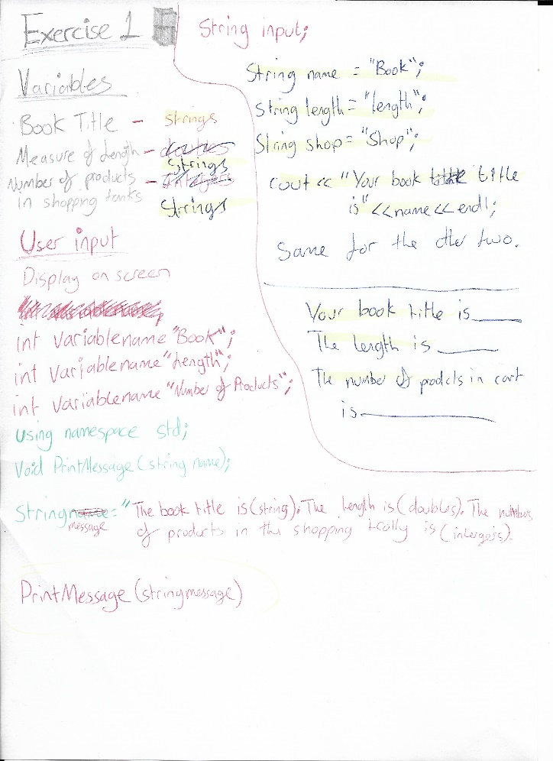
Exercise 1

This part of the code is for defining the strings so they can be used to save the data that the user inputs and use it to display the data at the end of the program.
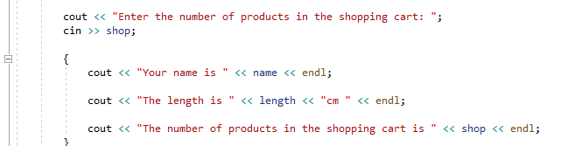

The next part was displaying the data that was inputted by the user. The strings “name” and “length” and “shop” was used to save the data so it can now appear in this sentence.
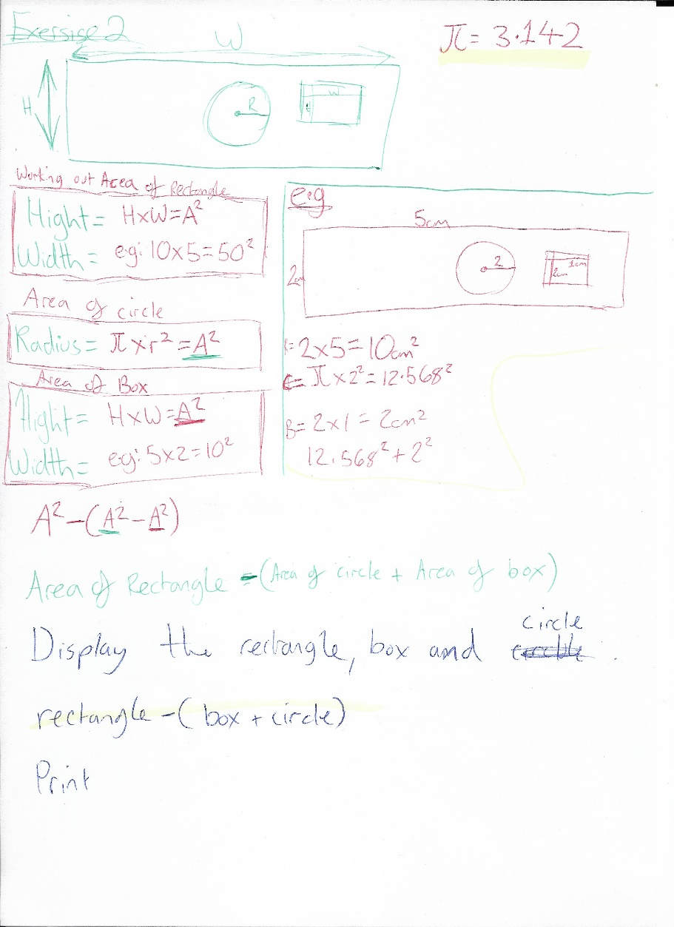
Exercise 2

Exercise 3
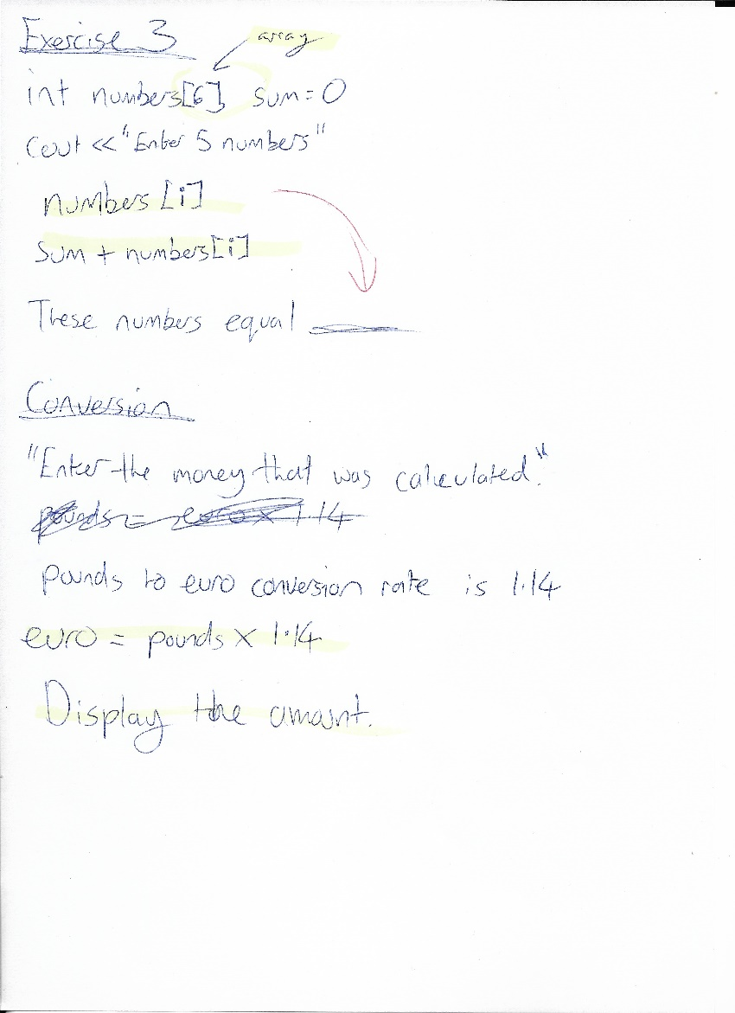
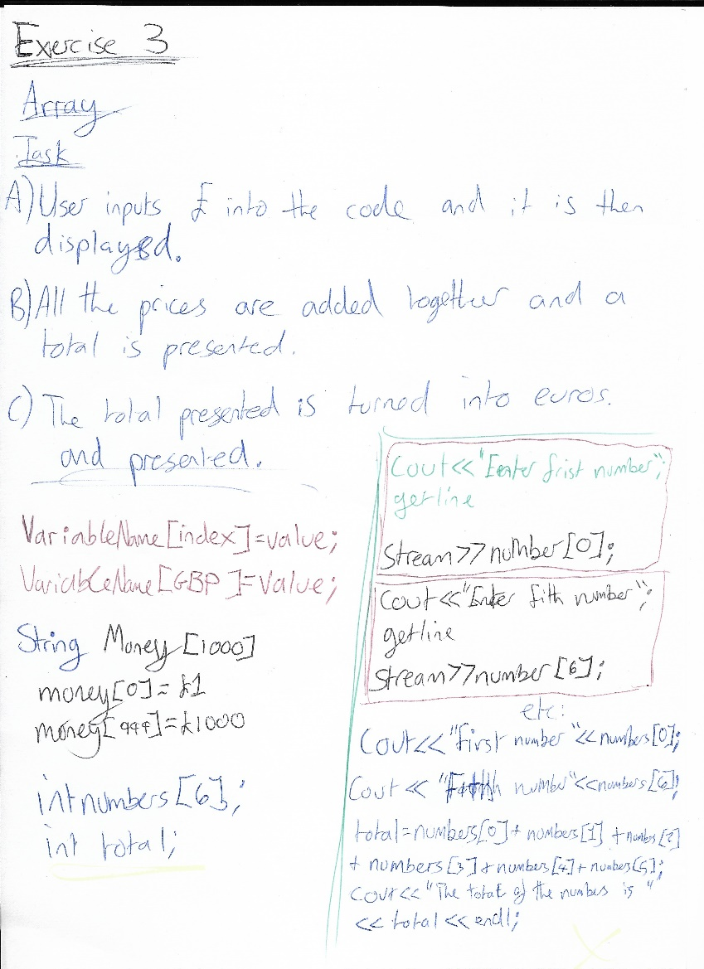

This allows the operations in the code to work when it is defined. This is done for all the exercises.

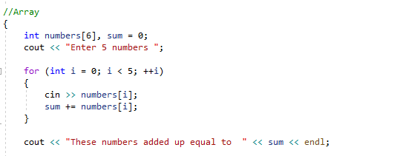

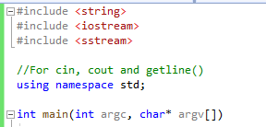
When working this out I created the code in different parts. I started with the user in put allowing five numbers in and having them added up.

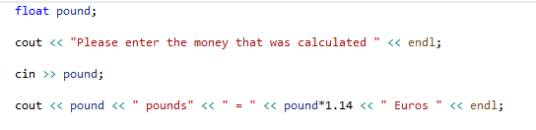

The next part was allowing the user to input the number they got from the calculation and converting it from British pounds to euros.

Tests
Exercise 1
The Test
The first test is to see if the data inputted by the user was saved and presented at the end. The user will input the name of the book, the length of the book and the number of projects in the shopping cart.

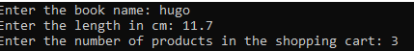

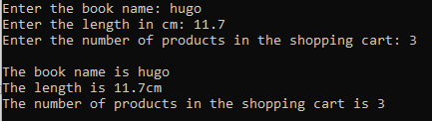
The test was successful.

Exercise 3

Can the user input the five numbers into the array?

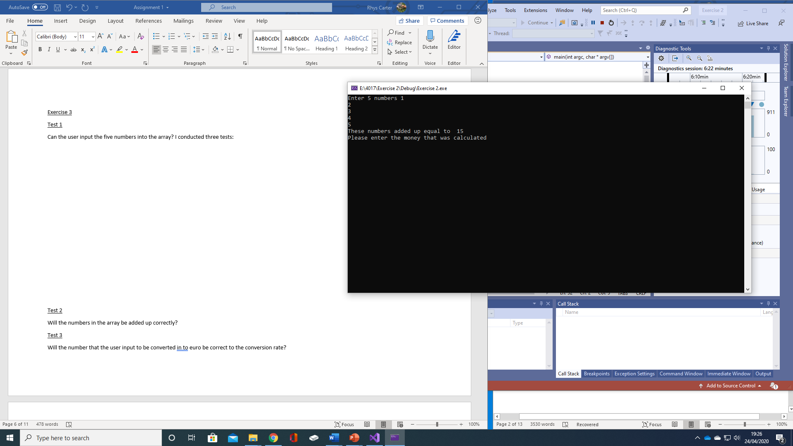

The user can put the numbers they want to into the array so they can be calculated.

Test 2
Will the numbers in the array be added up correctly?
I conducted three tests to make sure that the code added up the array numbers correctly.

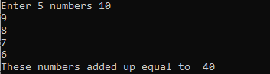
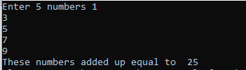
The test was successful.

Test 3
Will the number that the user input to be converted into euro be correct to the conversion rate? The test was done 3 times to make sure it works correctly.
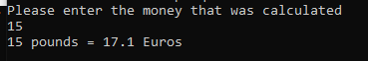

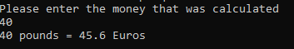

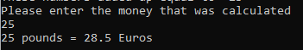
The tests were successful.
Appendix
Exercise 1 code
#include <string>
#include <iostream>
#include <sstream>

//For cin, cout and getline()

using namespace std;

int main()
{
{
string name = "Book";

cout << "Enter the book name: ";
cin >> name;

string length = "length";

cout << "Enter the length in cm: ";
cin >> length;

string shop = "shop";

cout << "Enter the number of products in the shopping cart: ";
cin >> shop;
cout << endl;
{
cout << "The book name is " << name << endl;

cout << "The length is " << length << "cm " << endl;

cout << "The number of products in the shopping cart is " << shop << endl;
}
}

return 0;

}

Exercise 2 code
#include <string>
#include <iostream>
#include <sstream>

//For cin, cout and getline()
using namespace std;

int main(int argc, char* argv[])

//Array
{
int numbers[6], sum = 0;
cout << "Enter 5 numbers ";

for (int i = 0; i < 5; ++i)
{
cin >> numbers[i];
sum += numbers[i];
}

cout << "These numbers added up equal to " << sum << endl;

float pound;

cout << "Please enter the money that was calculated " << endl;

cin >> pound;

cout << pound << " pounds" << " = " << pound*1.14 << " Euros " << endl;

//Pause
cin.get();
return 0;
}

