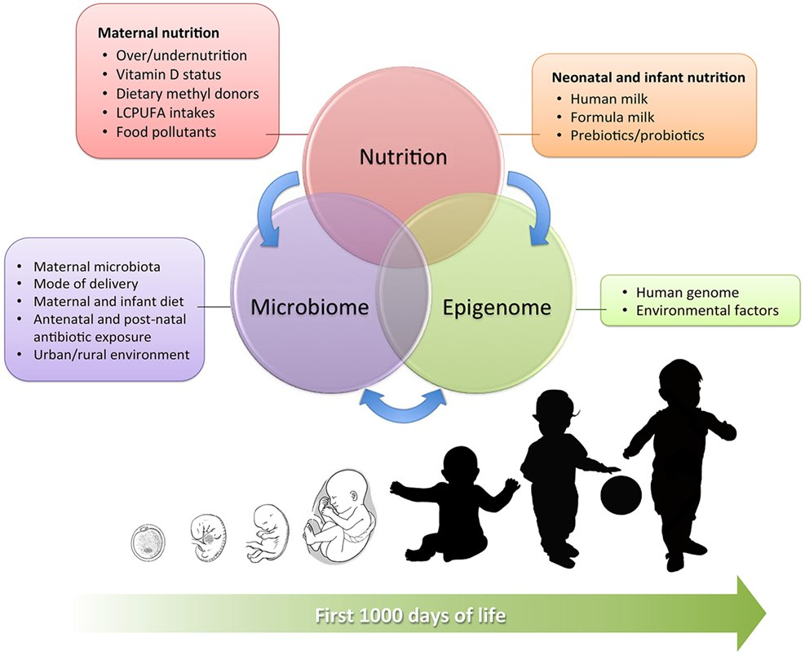
The First 1,000 Days.

Introduction
The aim of this handbook is to go into detail about the first 1,000 days of a child's life. I am going to be specifically talking about three sections of the first 1,000 days which are:
- From birth to six months old.
- The importance of a safe environment.
- The effects covid has had on toddlers (six months old - two years old).
This handbook is also going to be looking into detail about theorist about theirs theories on children's first 1000 days and the three key aspects this handbook is going to be talking about.

Why the first 1,000 days of a child's life is so important.
The first 1,000 days of a child's life is from conception to when the child is two years old. During this period of a child's life it is crucial that the child gets what they need. The first 1,000 days are important because they impact the child's future and sets the child up for a healthy future. According to the Australian Government, (2019), the time from when a baby is conceived until the baby is 2 years old this is the time when the babies brain, body and immune system grows and develops the most significantly. A babies brain develops the most during their first 1,000 days than any other period of their life. A babies brain is also at its most fragile during this period of time, if the child is exposed to abuse, stress or even hunger this can impact the child for the rest of their life.
Whilst the mother is carrying the baby it is again crucial that the mother is keeping healthy for herself and for the baby to be healthy when given birth. According to the Australian Government, (2019) from doing research it tells us that whilst the mother is pregnant her health, nutrition and stress level could have an impact on the baby whilst the baby is in the womb and after given birth. Therefore the mother must try to keep as fit and healthy for herself and for the future baby.
As a baby you rely on your parents or carers to do everything for you and to look after you correctly. For you to give your baby what they need you must:
- Provide the correct healthy food for the child.
- Give the child love and have a loving relationship.
- The child needs to know they are safe and secure, it is essential for a child to feel at ease and comfortable.
- Play games with your child, children learn through play.
- A healthy environment, this includes before birth and after birth.

Reference List.
Australian Government. (2019) Pregnancy birth and baby first 1000 days. Available at: https://www.pregnancybirthbaby.org.au/the-first-1000-days Accessed: 5th January.

Australian Government. (2019) Pregnancy birth and baby first 1000 days. Available at: https://www.pregnancybirthbaby.org.au/the-first-1000-days Accessed: 5th January.

Interaction Design Foundation, (2002) The Esteem Stage of Malow's Hierarchy. Available at: https://www.interaction-design.org/literature/article/esteem-maslow-s-hierarchy-of-needs Accessed at: 6th January.
Interaction Design Foundation, (2020). Safety stage of Maslow's Hierarchy. Available at: https://www.interaction-design.org/literature/article/safety-maslow-s-hierarchy-of-needs#:~:text=The%20need%20for%20safety%20was,of%20family%2C%20and%20of%20health. Accessed: 5th January.
McLeod, S. (2020). Maslow's hierarchy of needs. Available at: https://www.simplypsychology.org/maslow.html Accessed: 4th January.

McLeod, S. (2007) Interaction Design Foundation. Available at: https://www.interaction-design.org/literature/article/esteem-maslow-s-hierarchy-of-needs Accessed: 4th January.

Maslow's theory.
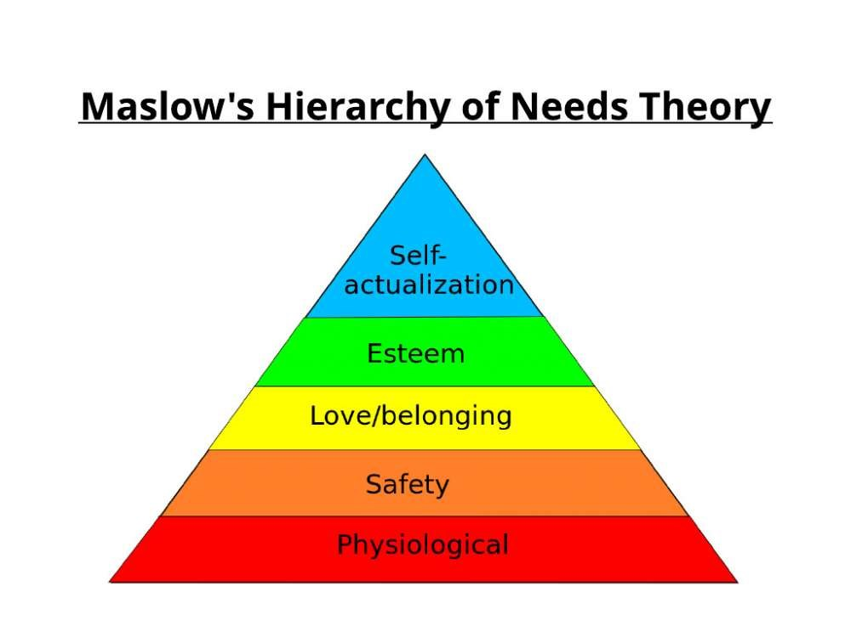
1 - Self actualization-
Self-actualization is at the top of Maslow's hierarchy. According to McLeod, (2020) during 1943 and 1954 Maslow stated that human motivation is based on people seeking their fulfilment and for them as a person to change through personal growth. People which are self-actualized are those which are fulfilled in what they are doing and pushing themselves to their fulfilment. This could include peoples hobbies, learning different languages and peoples creative pursuits. Maslow stated in the 1970's that he estimated only around two percent of people would reach the state of self-actualization.
Esteem-
According to Interaction Design Foundation, (2002) Maslow stated that there are a number of different components which you need to achieve the sense of self-esteem. To enable this for yourself you must:
- Respect others.
- Have an internal acceptance of who we are.
- Confidence in yourself.
- Achievement.
Having esteem as child is essential as it includes, encouragement if you are encouraged to do something it usually helps boost your confidence. You should be protected from any bullying and potential harm. As a child they should receive positive discipline and day to day learning life skills.
Social needs-
According to McLeod, (2007) Maslow stated the third level of the human needs are social needs. This is where the child needs to feel loved and have a feeling of belongingness. The word belonginess refers to another human emotional need for interpersonal relationships, affiliating and being apart of a group.
As a child you need to feel unconditionally loved and have loving interactions with family members or carers which are in their life. As a child you also need room to explore different places and play with peers which are around you.
Safety and security-
According to Interaction Design Foundation, (2020) "The need for safety was acknowledged as a basic human need by Abraham Maslow in his 'Hierarchy of Needs'. Safety needs represent the second tier in Maslow's hierarchy and these needs include the security of body, of employment, of resources, of morality of family, and of health."
Adult caregivers should be protecting the child from any potential danger. This could be with making sure the child has a car seat when travelling. Making sure theirs procedures in place in-case something happens to the parents, being above the poverty line and making sure you are receiving the correct health visits and health care.
According to Public Health NHS, (2022) poverty has negative impacts on many different key aspects during a child's life. Poverty has a negative impact on the child's health, social skills, emotional development, cognitive development and educational outcomes. It shows that children which are born into poverty are more likely to experience health problems, poor nutrition and chronic diseases.
Physiological-
Phycological needs are the most essential needs we have to have as humans to live. This includes water, healthy food, sleep, shelter and human touch.
Maslow stated in 1943-1954 that people are motivated to achieve certain needs although some needs are more important than others. These needs are essential to anyone on a day to day basis and if these needs are not met the human body can not function properly. Maslow considered physiological needs the most important one on his hierarchy pyramid as all the needs become secondary until the physiological needs are met.


