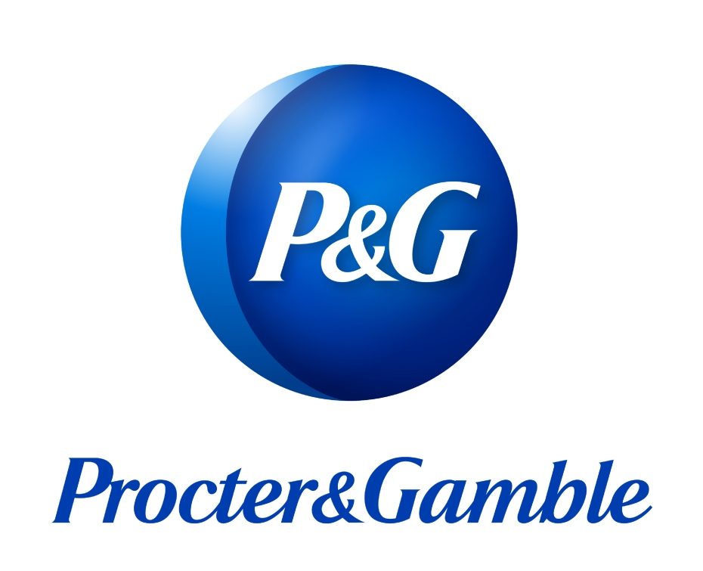
Does Procter & Gamble Have the Right Strategy for Today’s Challenging Environment?
BA (Hons) Leadership and Management – Skills for the Workplace
Elena Alexandra Moise (1908804) | 6/25/22 | Strategic Management

Executive Summary

The report focuses on P&G's strategic management, as it is one of the world's largest consumer goods companies. Retail and department stores carry over 165 of the company's brands. P&G uses a variety of venues to advertise its products. It uses the Noticeable Superiority Strategy to get a competitive advantage in the industry. By 2030, sustainable approaches will be used in 80% of company activities. The UK's external environment is unstable because of Brexit and Covid- 19, and industrial competition is high-moderate. P&G's products are dispersed relatively evenly throughout all market categories, with a strong focus on high and middle-income earners. Items are arranged in accordance to adverts that are likely to appeal to customers. Customer relations are kept under control by the company's "customer impulse" and an online periodical surveys for ladies aged 50 and up. Internally, P&G's strength is its ability to be recognised across a broad variety of product categories, but its internal weakness is its inefficient client engagement approach. The customer has influenced countless lives via their social responsibility efforts and intends to better the world by 2030. It is critical for the company to have outstanding P&G strategic management to sustain its partnerships.
Strategy is the willpower of the important long-term aspirations and aims of a company, the variation of practical methods used, and the provision of means required for attaining these aspirations (Campbell, et.al 2011). Porter (1996) claims that competitive strategy is using unique methods to deliver an exclusive outcome. Stating that strategy is about competitive position, about differentiating yourself in the eyes of the customer, about adding value through a mix of activities different from those used by competitors (Porter, 1996).
P&G’s integrated strategy is the foundation for strong balanced growth and value creation for the near and long term. The company is focused on establishing and extending the superiority of their brands across product, packaging, communication, retail execution and value, making productivity as integral to their culture as innovation, leading constructive disruption across the value chain and improving the company’s focus, agility and accountability . P&G has grown its annual revenue significantly in recent years because of their strategic choices. By narrowing its focus on ten product categories, this resulted in significant cost savings on non-fast-moving goods (P&G, 2020). In this business report, the background information of Proctor and Gamble company will be critically reviewed according to its development over the last 5 years. Next, the mission and vision of the organization will be discussed, and the cause of occurrence will be explained. Further, the theories and strategic models will be critically discussed in the organization and then the current strategy within the organization will be evaluated. Using the analysis, the advantages and disadvantages to the organization and their shareholder of fulfilling their strategy or vision, or mission will be critically described. At last, suggestions will be given for further development of the organisation.

Contents
Executive Summary 1
1.0 Introduction 3
2.0 Main Findings 4
2.0.1 Historical development of P&G over the last 5 years 4
2.0.2 Sustainable development strategy 4
2.0.3 P&G’S Vision and Mission 5
2.1 External Business Environment 6
2.1.0 SWOT analysis 6
2.1.1 PESTEL Analysis 7
2.2 Porter’s Five Forces Analysis 8
2.3 Generic Strategy 10
2.4 Stakeholder Analysis 11
2.4.1 Segmentation, Targeting, and Positioning Analysis 11
2.5 BCG Matrix 12
2.6 Focus on the strategy 13
2.6.1 Strategic objective 13
2.7 Analysis of Internal and External Environment 14
2.7.1 Economic Factor 14
2.7.2 Political and Social 14
2.7.3 Performance outcomes 14
3.0 Conclusion 15
4.0 Recommendations 16
5.0 References 17

Introduction

The terms "leadership" and "management" are commonly used interchangeably. While this is correct, the two phrases have quite different connotations and should not be used interchangeably. Even though these terms relate to different sets of functions, features, and talents, there is an overlap between them. In a group setting, leadership is defined as a social bond formed by two or more individuals who rely on one another to achieve specific common objectives (Sobratee and Bodhanya, 2018). A measure of management effectiveness is the ability to complete tasks on time to achieve measurable results (CIPD, 2020).
Procter & Gamble is a global consumer goods firm headquartered in Cincinnati, while Ohio is home to P&G's corporate headquarters. The firm was established in 1837 by William Procter and James Gamble. It was divided into categories, such as beauty, grooming, universal healthcare, fabric & home care, and infant, feminine, and family care, and specialised in a variety of healthy goods, and personal care and sanitation supplies (P&G, 2022).

2.0 Main Findings

2.0.1 Historical development of P&G over the last 5 years

Procter & Gamble, based in the USA, is a multinational firm that produces a wide range of consumer goods. The corporation commenced operations in October of 1837. From its foundation, the company has been renowned for employing a variety of development strategies, with a special emphasis on corporate restructuring, innovativeness, creativity, thorough market research and investigation. The absence of global uniformity was one of the most noticeable aspects of P&G's product development procedures (P&G, 2022).
P&G considers that establishing product lines according to the consumer preferences and tastes for distinct types of home goods, cosmetics, and food products differ between countries or within countries. The company pursued multiple techniques again for supply and construction of its diversified distribution networks spread across multiple areas in relation to the size of options, wrapping, earnings, and adverts, in addition to numerous techniques for the supply and construction of its diverse distribution networks shared all over multiple areas. Despite the decreased sales base, P&G continues to make nearly the same amount of money today. To put it another way, it has significantly increased its profitability. The operating earnings for last year were $10 billion, down from $10.3 billion the previous year. After adjusting for revenue losses, the core operating margin has increased by two percentage points to little over 22% of sales (Statista, 2022). Due to an efficiency drive that has shaved millions and millions of dollars from the company's spending structure, P&G beats most competitors on this critical metric. Even better, in 2021, management team plans to save an additional $10 billion by reducing personnel and production processes, as well as simplifying output for the whole target audience (Kalogeropoulos, 2017).

2.0.2 Sustainable development strategy
Products
P&G created and promoted "sustainable innovative things" that helped the environment by reducing pollution. In 2007, P&G cut the length of the detergent box in half and increased the solution amount to double that of the original. The strategy decreased waste by reducing the number of packaging materials used. P&G's mission is to make the world a better place (Brown and Anthony, 2011).
Operations
In P&G's headquarters, the "sustainable development team" was formed. The company recycled about 4800 kg of waste paper and restored it with 69,000 fresh pieces thanks to the "green recycling box." In addition, the company's power use was lowered by 10%, saving 17 million kWh, or the monthly electricity consumption of 560 homes. P&G implemented renewable energy and rainwater collection and treatment systems at several facilities and distribution hubs to further cut energy use (P&G, 2022)
Social Responsibility
In 2009, P&G became the first company to ratify the United Nations Framework Convention on Climate Change, and by 2012, it had developed a global carbon footprint set of measures, with the results of the reducing emissions stage being made public. So far, P&G's efforts have resulted in a solution where everyone benefits for both the company and the environment. A corporation that establishes an ecological value chain will gain from energy and waste management efficiency (Simpson, et al., 2020).

2.0.3 P&G’S Vision and Mission
The P&G Company is a leading firm in the consumer goods market, directly competing against Unilever, which is also a major player in the global industry. P&G, the corporate vision statement emphasizes leadership in the global market. The corporate vision statement highlights characteristics relevant to P&G and its business condition be the best consumer products and services company, be recognized as the best consumer products and services company, global market operations (Smithson, 2017).
Alternatively, a company’s mission statement specifies the strategic approach to fulfil the vision. P&G’s corporate mission statement highlights quality and value as the foundation for ensuring business success. The company’s growth path and strategies in the consumer goods industry are based on this strategic approach to reach the corporate vision. P&G’s mission statement is influencing the organisation’s strategic direction. Superiority in quality and value are emphasized, just as these factors are also highlighted in the company’s vision statement. P&G’s corporate mission statement has the following characteristics: branded products and services of superior quality and value, improve the lives of the world’s consumers, now and for generations to come, leadership sales, profit and value creation, prosperity of people, shareholders and communities (Smithson, 2017).
As of 2013, P&G has rebranded itself as PGE (Procter & Gamble Entertainment) with a new logo and an emphasis on multi-platform entertainment production (Statista Research Department, 2022).
P&G is not owned by hedge funds. The company's largest shareholder is The Vanguard Group, Inc., with ownership of 8.9%. With 6.6% and 4.4% of the shares outstanding respectively, BlackRock, Inc. and State Street Global Advisors, Inc. are the second and third largest shareholders. Baby, Feminine and Family Care, Cosmetics, Medical Services, Hygiene, and Textile and Personal Care are P&G's five industry-based Sector Business Units or SBUs. Within these SBUs, the company oversees eleven different product categories. (Yahoo Finance, 2021).
According to the last financial report, the profit of the company in 2022 is $0.51B, compared with year 2021, when the profit was $0.49B (P&G Annual Report, 2022).
As of June 2022, P&G has a market cap of $317.57 Billion. This makes P&G the world's 19th most valuable company by market cap. The market capitalization, commonly called market cap, is the total market value of a publicly traded company's outstanding shares and is commonly used to measure how much a company is worth (Companies Market Cap, 2022).
With around 12 million ordinary shares, David Taylor is the company's largest shareholder. Jon Moeller succeeded David Taylor, who became executive chairperson of the company on November 1, 2021 (Mangan, 2021).

2.1 External Business Environment

2.1.0 SWOT analysis
Strengths
P&G's main assets are its market-leading position, which depends on a strong brand portfolio, excellent cash productivity, and significant marketing and R&D spending. P&G, the world's largest consumer products company, has over fifty top brands in a wide range of industries, which it organises into three international business units: cosmetics and styling, healthcare and well-being and home care products. Despite having a complicated brand portfolio, the firm has demonstrated strong management abilities and successfully used its powerful brand portfolio to maintain its competitive edge in the worldwide market (Hussain, et al., 2020). According to 2010 Data monitor research, the company leads the market in several areas, including new-born care (33%), fabric softeners (33%), feminine cleanliness and safety (37%), and blades and razors (37%). 70% of the time P&G has 23 brands with yearly sales of over one billion dollars and another 20 goods with annual sales of $500 million or more in its portfolio. P&G uses differentiation as its generic strategy for competitive advantage. Differentiation involves developing the uniqueness of the business and its products to attract target customers. In this case, P&G highlights quality and value in its consumer goods, gaining a considerable competitive edge over its market rivals due to several top brands, contributing to its remarkable cash productivity and financial success (Smithson, 2017).
Weaknesses
Despite having a complicated brand portfolio, the firm has demonstrated strong management abilities and successfully used its powerful brand portfolio to maintain its competitive edge in the worldwide market. Prior to 2014, P&G had over 300 brands, but that number has now been cut to 65, which account for 95 percent of the company's entire income. P&G suffered a loss because of this decision because a significant amount of money was put in expanding the other 235 brands. On the other side, P&G's rapid ascent was triggered by a critical choice. After the saturation curve is achieved, the rate of client base growth decreases and innovation is constrained. As a result, P&G's organic growth has slowed. P&G will have to come up with some creative marketing and product gimmicks to compensate. The beauty and personal care goods industry's market trend is for things to be changed every month. There should be a fresh smell or version available on the market. This frequent modification is a market need that affects the company's profitability (Abrams, 2014).
Opportunities
One of P&G's key opportunities is the growing demand for male health and beauty products, and with the acquisition of Gillette, the business is fast expanding in this area. P&G also has a high chance of reacting to the internet's tremendous technical progress by using a variety of marketing strategies and online social networks. P&G has also decoupled from several products, like Gillette's oral-care toothpaste, the Zest brand, which was acquired by Brynwood Partners, to focus on their long-term goals and devote their entire attention to the brands that important to them. P&G has been progressively growing into new countries, and it already has a presence in more than 80. As a result of the fiscal crisis, it is now easier to buy smaller firms that are having financial difficulties (Zulfahmi et al., 2021)
Threats
P&G has plenty of competitors, including Kimberly Clark, Unilever, Johnson & Johnson, and others, all of which pose a significant threat to market share in various nations. Furthermore, P&G's competitors are buying smaller businesses to expand their product lines. As a result of the recession, consumers' budgets have reduced, and their purchasing power has decreased. Furthermore, raw material prices are rising, increasing production costs, and P&G is susceptible to currency swings (Setili, 2022).

2.1.1 PESTEL Analysis
Political
The political atmosphere in a certain area has a significant impact on the future of products in that industry. Working in the region becomes simpler as the administration becomes more stable. P&G has a few opportunities to transform its strategy into a competitive advantage rather than merely a set of guidelines to follow. P&G can collaborate with governments for the greater welfare of society, with governments around the world advocating efficient resource use and P&G promoting a sustainable environment. The firm has formed a political action group (PAC). registered in USA and is responsible for issues that directly affect the company's operations (Thompson, 2017).

Economic
The more revenue a corporation has, the greater, because it will sell more of its commodities. North America accounts for most of their revenue. Any effects on income policies will result in a significant shift in the consumption of required items. Depending on the current policy, it might be higher or lower. Europe comes in a close second, followed by Asia, which is a mix of developed and growing economies, demonstrating how more discretionary income might help improve sales. There is opportunity for growth in a variety of industries, like mouthwash and infant care, which are all projected to increase soon. These are the prospects that will help P&G to grow and spread its brand (Thompson, 2017).
Social
The Live – Learn – Thrive Program, developed by P&G, allows children in need to drink clean water, guaranteeing a good start in life. It also gives kids access to places, resources, and programs that will help them study more successfully. Due to the diversity of cultural backgrounds in different markets, the company must observe social customs when conducting business internationally. The social need for personal objects evolves with time. For instance, demand for men's care has risen in recent years (Thompson, 2017).
Technical
P&G, as a huge firm with a varied variety of goods, is focused on more advanced technology and has successfully eliminated any needless flaws. P&G has a track record of producing new products and upgrading existing ones. Because the personal goods market is so huge, industry players invest heavily in technical advancements to preserve and grow their market share. As a result, this field's technology is fast changing. P&G may be able to focus on products that sell well enough and contribute most the company's revenue if it can forecast shifting patterns. The organisation values "operational simplicity reduction." The firm has created its first smart lab committed only to research and development to provide better quality products in less time (Thompson, 2017).
Legal
P&G is bound by a slew of national rules that regulate personal items, manufacturing processes, and corporate practises. All its facilities are subject to emission limitations established by other countries, and any infractions might result in a slew of lawsuits that could tarnish the company's image. Avoiding lawsuits is a major concern for a business of this scale (Thompson, 2017).
Ethical
Because personal items are so vital in people's daily lives, businesses place a premium on product quality. Any product-related controversy might be damaging to a company's reputation (Thompson, 2017).

2.2 Porter’s Five Forces Analysis
P&G will use Porter's five forces framework to examine the personal goods business before evaluating its present projects. Personal products will be the focus of the five-force analysis in the UK market.
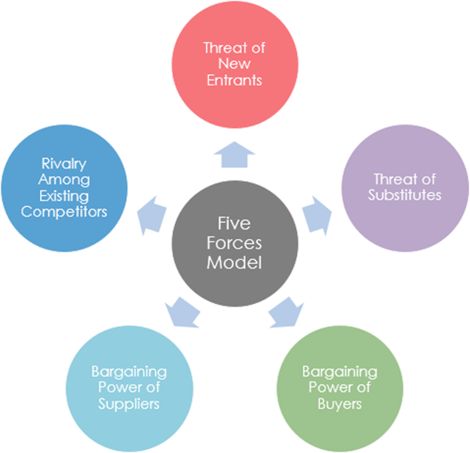
Buyer Power
In recent years, the buying sector in the UK has grown, with a positive prognosis for the future. The market for cosmetics and perfumes has grown to £2.18 billion by 2009. Individuals, as well as large merchants and distributors such as Walmart and Carrefour, are all affected, our customers in the personal goods market. Because of their dispersion, individual customers have minimal spending power and could only have a limited effect on price and goods, but they almost have never had to switch. Major retailers, on the other hand, have a lot of negotiating power because of their substantially bigger purchasing volumes (Chen, 2022).
Supplier Power
Each product line seems to have its own set of preferences and criteria. There are several ingredients, raw materials, and components that must be used, as well as processes that must be followed throughout the manufacturing process. As a result, P&G is dealing with suppliers who are highly differentiated and have little negotiation power. However, the corporation continues to pay switching charges since it strives to maintain a certain level of quality to sustain its brand reputation (Chen, 2022).
Threat of New Entrants
Because of their scale, several brands, and diversified product lines, leading personal products companies like P&G already advantage from economies of scale and scope. Furthermore, major organisations in this field have extensive experience with product development, distribution, and supply chain management. P&G, for example, has been around for around 170 years and has 80 years of global market experience. Consequently, the industry's top incumbents have a head start on the learning curve, which creates barriers for newcomers when paired with scale advantages. Furthermore, this business needs invest much in production, distribution, research and development, and marketing. As a result, the risk of new entrants in this industry is minimal. Large organisations in this industry, on the other hand, are unable to cover every corner and cranny, providing small businesses with the possibility to suit clients' individual needs. This might be due to tiny enterprises noticing and understanding growing market demand, or because they have specialized innovations to make certain things (Balan et al., 2021).
Threat of Substitutes
Even if major corporations such as P&G and Unilever have spent a lot of money to build and develop their brand awareness and loyalty, substitute price power may undermine this advantage. Stores like Tesco and Wilkinson, for example, in the United Kingdom, sell their private label products at cheaper prices than strong brand commodities, creating a substantial threat to large corporations. Even though this industry has many clients, there is little uncertainty and switching costs after six replacements. The personal goods business is plagued with replacement difficulties (Thompson, 2017).
Degree of Rivalry
Worldwide sales of personal items were $361.1 billion in 2008, and the global market value is expected to reach $424.1 billion by the end of 2013. There is a lot of competition in the industry due to the high market value. In terms of corporate trademarks, size, research competence, and revenue, P&G has a lot of comparable competitors. Unilever, Estee Lauder, Avon, and L’Oréal, for instance, all seem to have well-known brands and goods, and also considerable research and development and market knowledge. Because clients have minimal switching costs, the completeness of this business tends to stay high over time. In the UK's FMCG marketplaces, there is moderate to strong rivalry, according to Porter's five forces model. As a result, P&G has established additional procedures to protect its customer base's long-term stability (Tsourvakas, G. and Yfantidou, 2018).

2.3 Generic Strategy
In response to criticisms about local adaption and cost savings, P&G appears to have adopted a global approach as their global strategy. P&G has used a strategy of differentiation since the commencement of its worldwide operations, according to Porter's generic methods. The firm strives to supply consumers with wonderful personal items to establish a loyal client base, and this philosophy has been carried down to the present generation. Significant expenditures in customer awareness and innovation highlight the company's distinct approach. Because of intensive market research, the company has the appropriate global market knowledge, and client understanding is a crucial cornerstone of the business and the company's marketing approaches. The economy grew rapidly because of a frenzy of new investment in innovation. Create a new company or expand an existing one. Items that are delivered daily to meet the needs of local customers. The business was able to maintain its financial performance, customer loyalty, and brand awareness in this fashion. P&G maintains transnational components across its worldwide operations in a variety of disciplines, in addition to product uniqueness. Everything marketed in China, for instance, is created entirely in China, and the company's Chinese division manages operations with both Chinese and international personnel (Galli-Debicella, 2021).

2.4 Stakeholder Analysis

The P&G Enterprise is one of the world's largest companies, a Fortune 500 firm, and a household name, has a number of complex aspects. However, their principal non-market stakeholders are likely the most important linkages they supply. In a non-market situation, stakeholders are classified as either society, administration, or both. Social representation organisations, neighbourhoods, and the news media all play a role in the non-market society environment. Politicians, legal explanation, decision-making, and ideological law enforcement are all part of a non-market governance setting. Owners, shareholders, workers, and managers all operate in a non-market environment that is both society and governance. Non-market stakeholders for P&G include for-profit and non-profit social representation organisations, neighbourhoods, regional, national, and global governments, news media, and labour. Five characteristics are evaluated when determining the extent of a stakeholder's effect on a company's overall performance: legality, strength, immediacy, the likelihood of action, and preferences. David Taylor is the world's biggest stakeholder, with about 12 million common shares. Top ten stakeholder of P&G are The Vanguard Group Inc, BlackRock Fund Advisors, SSgA Funds Management, Inc, Geode Capital Management LLC, Northern Trust Investment Inc, Norges Bank Investment Management, Fidelity Management & Research Co and JPMorgan Investment Management. P&G wields power over claims to help non-profit social representation organisations, as well as community stakeholders since their actions impact the corporation's image rating, which affects performance. Moreover, because a diverse range of stakeholder groups is represented, their voices will be heard. P&G aims to impress social representation communities with their operations and corporate responsibility activities to get consumers to purchase their products. Government and news media interests also affect P&G. A government department that controls advertising, for instance, is the National Advertising Division (Miglietta et al., 2018).

2.4.1 Segmentation, Targeting, and Positioning Analysis
Segmentation
Segmentation refers to the categorising of clients based on racial, behavioural, geographical, and psychological tendencies for P&G strategic management. P&G has segmented its market depending on a variety of factors. Psychographics and behavioural demographics are the most common in the UK. Age, gender, income, family, and a variety of other aspects are all included in demographics. Pampers diapers and Crest toothpaste are two examples of P&G's baby and children's products. The company sells a range of sanitary napkins to women and creates macho fragrances for men (Hussain et al., 2020).

Targeting
In general, the targeting approach focuses on higher-earning markets. Businesses prioritise market segments having a better rate of return on investment. Everyday products, such as those used by most people in the UK, generate large volumes of sales. In this approach, P&G's strategic management has targeted middle- and upper-class clientele. Therefore, product categories including personal, home, textiles, and dental care may be able to meet the needs of customers from both the upper and lower-middle classes (Simons, 2014).

Positioning
Positioning relates to how things are presented to customers in P&G's strategic management. To put it another way, marketing and packaging are equally important after segmentation and targeting. Because the FMCG industry is so competitive, companies must concentrate on their unique selling factors to acquire new clients. This method is used to promote P&G products by employing emotive stories that provide clients with answers to their concerns (Learning, 2021).

2.5 BCG Matrix
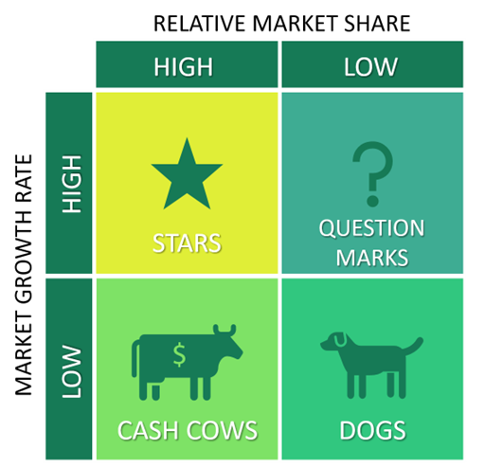( Source: Kader and Hossain, 2020)
The Boston Consulting Group was motivated to build a product portfolio matrix by P&G's strategy formulation. This matrix was created to aid in the discovery of growth prospects by examining a company's product portfolio. The matrix is organized into four sections.

Dogs- These are products or services that have a small market share or are growing slowly. DOGS should be phased out since they deplete company resources while simultaneously increasing consumption. P&G sold Crisco vegetable oil, Camay, Zest, pet food, and Pringles since their market share was smaller than the industry's other brands, as per this viewpoint (Kader and Hossain, 2020).
Question mark- These are items that have a tiny market share but are rapidly increasing in popularity. Based on the company's strategy for boosting these goods' brand value, these products can be a star or a dog. According to this viewpoint, many of P&G's premium items have a slow growth rate, which influences sales in other segments. P&G's strategic management was believed to be centred on increasing the growth of premium products. As a result, the company shifted its focus away from household cleaning and personal care, which resulted in lower sales volume. To increase profitability in the premium line, P&G should provide premium items with a larger market share.
Stars- These are the products with a lot of promise and a large market share. The star goods have a high Return on Investment in comparison to other market segments. Tide and Gillette are two of P&G’s strategic management's hallmark goods. In the United Kingdom, Italy, and Spain, these products are offered at extravagant rates, resulting in significant profits for the firm (Young and Reeves, 2020).
Cash Cow- These are items with a modest pace of growth yet a large market share. These are well-known goods that provide the organisation with consistent revenue. Several P&G goods, such as Pampers, Lynx Deodorants, and paper towels, are mature in this regard. These items are in great demand and sell well, allowing the company to gain a competitive edge.

2.6 Focus on the strategy
The company's business plan is to focus on building unique brands and categories, allowing it to focus on becoming the strongest at marketing, technology, and scalability. P&G has also moved away from a highly centralised organization in which senior management makes most decisions to a more decentralised model in which 10 core consumer goods product categories are managed by teams (P&G, 2022).

2.6.1 Strategic objective
To distinguish itself apart from the competition, P&G's strategic management relies on innovation. In the UK market, many of the items, such as home and personal care, have equivalent substitutes. To boost brand favour, it should expand its unique product production methods. To attract more customers in the UK and other rising regions, they should widen their loyalty programmes. The company's market may be expanded by adding additional items to its ten categories. The firm possesses creative capabilities that may be put to effective use in lowering operational costs. As a result, the firm will be able to offer some of the categories at a low cost, tempting potential clients. Their oral products can be distributed as samples in rural and undeveloped areas, assisting in the promotion of cleanliness among these people. The corporation may make little packets of detergent and other cleaning products as part of its corporate social responsibility activities to help improve living conditions in the UK's poor neighbourhoods (Naiman, 2019).

2.7 Analysis of Internal and External Environment
The external environment encompasses political, economic, and social considerations. They are crucial to the long-term sustainability and profitability of a business. Brexit is one of the political and economic factors affecting many companies and shops in the UK.

2.7.1 Economic Factor
The value of the British pound has plummeted because of the Brexit decision, drastically reducing purchasing power. Therefore, total demand had a considerable impact on P&G's retail products. Because the customer base is mostly made up of precious customers, regular product categories experienced more damage than premium product categories (Keller, 2000).

2.7.2 Political and Social
The UK's GDP is dropping because of the Brexit vote. Because EU and the UK could not agree, exports and imports levies and taxes will be levied across European borders, putting P&G's supply chain at risk. Many small enterprises and retail outlets will close because of import duties. This will have an impact on the distribution channel used by P&G strategy management. Many large and small businesses have been affected by the Covid -19 epidemic. Due to the stoppage of commercial activity, only necessary services are available. As a result, the pandemic has had a major influence on P&G's strategic processes of business, procurement, and distribution. Throughout the outbreak, the country's GDP is expected to decline, and the economic disaster will last until the end of 2020. In response to rising shareholder pressure, P&G's parent company, based in Cincinnati, has announced yet another business plan change.(PWC UK, 2020).

2.7.3 Performance outcomes
P&G forecasted a six to nine per cent increase in GAAP diluted net profit per share in fiscal year 2022, compared to $5.50 GAAP EPS in 2021. In 2022, the company anticipates a three to six per cent increase in core earnings per share, compared to $5.66 in 2021. According to the firm, the organisation's current fiscal 2022 estimate includes headwinds of $2.3 billion after-tax from higher commodity costs, $300 million after-tax from increasing freight rates, and $200 million after-tax from adverse foreign currency impacts. Whenever fiscal 2021 profits are matched to fiscal 2022 earnings, these variables result in a $2.8 billion after-tax disadvantage or nearly $1.10 per share. P&G anticipates a core average tax rate of 18% to 19% in fiscal 2022. Capital investment is estimated to account for four to five per cent of net sales in fiscal 2022 (Statista, 2022).

3.0 Conclusion

In this business report, several theoretical marketing principles were applied to evaluate P&G's strategic management. Large multinational corporations use several market expansion methods in both local and worldwide markets. To gain a strategic edge in the retail sector, P&G uses an approach called Noticeable Superiority. One of the company's most valuable assets is innovation, which has resulted in energy-saving products. In terms of design, development, and management, client interactions are heavily dependent on technology. P&G also intends to develop several eco-friendly corporates practises that will help both large and small enterprises. The external factors in P&G’s remote or macro-environment point to issues that require medium-term and long-term planning for strategic changes in the business. The significance of each of these external factors in P&G’s operations fluctuates over time. Thus, regular monitoring is needed to ensure the relevance and effectiveness of Procter & Gamble’s strategies.

4.0 Recommendations

During its 31-year history, the company has exited several unsuccessful industries while earning handsomely from the placement of high-priced products in rising markets. P&G's strategic management should design one-of-a-kind strategies for building swift consumer interactions that help in client retention, according to the research. It is also proposed that the corporation expands into culinary categories to increase brand awareness in the UK and other emerging regions. The company's long-term strategy has resulted in P&G’s ability to grab the global market. External elements in P&G's remote or macro-environment point to issues that the firm must address in its medium- and long-term objectives. Each of these external businesses has a distinct purpose in P&G's operations. As a result, Procter & Gamble's strategies must be scrutinised on a regular basis to guarantee that they stay effective (Ferreira and Teixeira, 2019). The PESTEL analysis of Procter & Gamble leads to the following recommendations to ensure the long-term success of the consumer goods business:
- Expand e-commerce operations through P&G Shop;
- Further improve product quality;
- Expand Procter & Gamble’s business sustainability and environmental conservation measures.

5.0 References

Abrams, R. (2014) Procter & Gamble to Streamline Offerings, Dropping Up to 100 Brands. The New York Times. Available: https://www.nytimes.com/2014/08/02/business/procter-gamble-to-drop-up-to-100-brands.html. (Accessed 21 June 2022).
Balan, V., Pryimak, V. and Tymchenko, I. (2021). A Hybrid Fuzzy Approach for Industry Competition Analysis. Scientific Papers of the University of Pardubice. Series D. Faculty of Economics and Administration, 29(2). DOI: 10.46585/sp29021280
Brown, B. and Anthony, D., S. (2011) How P&G Tripled Its Innovation Success Rate. Harvard Business Review. Available at: https://hbr.org/2011/06/how-pg-tripled-its-innovation-success-rate. (Accessed: 8 May 2022).
Butler, D. (2020) History of Procter & Gamble: Timeline and Facts. Available at: https://www.thestreet.com/personal-finance/history-of-procter-and-gamble. (Accessed: 8 May 2022).
Campbell, D. et. al (2011) Business Strategy. An Introduction. Palgrave Macmillan
Chen, J. (2022) Employees Motivation Mechanism in Fast Moving Consumer Goods Industry—Case of Procter & Gamble. Proceedings of the 2022, 7th International Conference on Financial Innovation and Economic Development (ICFIED 2022). pp. 15-18. Atlantis Press. doi.org/10.2991/aebmr.k.220307.003.
CIPD, (2020) Performance Management: An Introduction. Available at: https://www.cipd.co.uk/knowledge/fundamentals/people/performance/factsheet#gref. (Accessed: 8 May 2022).
Companies Market Cap (2022) Procter & Gamble. Available at: https://companiesmarketcap.com/procter-and-gamble/marketcap/. (Accessed 21 June 2022).
Ferreira, J.J. and Teixeira, A.A. (2019). Open Innovation and Knowledge for Fostering Business Ecosystems. Journal of Innovation & Knowledge. 4(4), pp.253-255.
Galli-Debicella, A. (2021). How SMEs Compete Against Global Giants Through Sustainable Competitive Advantages. Journal of Small Business Strategy. 31(5), pp.13-21.
Gasde, J., Woidasky, J., Moesslein, J. and Lang-Koetz, C. (2020). Plastics recycling with tracer-based-sorting: challenges of a potential radical technology. Sustainability. 13(1), p.258. doi.org/10.3390/su13010258.
Hussain, S.W., Qureshi, J.A., Mubeen, M. and Asrar, Z. (2020). Local players giving a run for the share to a global giant: A case study of Pampers brand of Proctor and Gamble Pakistan. International Journal of Experiential Learning & Case Studies. 5(1), pp.122-134. DOI: 10.22555/ijelcs.v5i1.3023.
Kader, M.A. and Hossain, H. (2020). An Analysis on BCG Growth Sharing Matrix. International Journal of Economics, Business and Accounting Research. 4(01). Pp: 245-252.
Kalogeropoulos, D. (2017) 3 Ways Procter & Gamble Co. Is Beating the Competition. Available at: https://www.foxbusiness.com/markets/3-ways-procter-gamble-co-is-beating-the-competition. (Accessed 21 June 2022).
Keller, K.,L. (2000) The Brand Report Card. Harvard Business Review. Available at: https://hbr.org/2000/01/the-brand-report-card. (Accessed 21 June 2022)
Learning, L. (2021). Introduction to Marketing I 2e (MKTG 1010). NSCC &Lumen Learning.
Lloyd, R. and Aho, W. (2020). The Four Functions of Management. An Essential Guide to Management Principles. FHSU Digital Press.
Mangan, D. (2021) Procter & Gamble names Jon Moeller as new CEO, will replace current chief David Taylor in November. CNBC. Available at: https://www.cnbc.com/2021/07/29/procter-gamble-names-jon-moeller-as-its-new-ceo-replacing-david-taylor-effective-november.html. (Accessed 21 June 2022).
Miglietta, N., Battisti, E. and Garcia-Perez, A.( 2018). Shareholder value and open innovation: evidence from Dividend Champions. Management Decision. 56(1). DOI: 10.1108/MD-04-2017-0408.
Naiman, L.(2019). Design thinking as a strategy for innovation. The European Business Review, 53. Pp:72-76.
P&G (2020) Environment sustainability. Available at: https://www.pg.co.uk/environmental-sustainability/. (Accessed 14 June 2022).
P&G (2020) Our Integrated Strategy to Win. Available at: https://us.pg.com/annualreport2020/our-integrated-strategy-to-win/. (Accessed: 8 May 2022).
P&G (2022) Annual Reports. Available at : https://www.annualreports.com/HostedData/AnnualReports/PDF/NYSE_PG_2021.pdf. (Accessed 14 June 2022).
P&G (2022) P&G Announces Fiscal Year 2022 Second Quarter Results. Available at: https://news.pg.com/news-releases/news-details/2022/PG-Announces-Fiscal-Year-2022-Second-Quarter-Results/default.aspx. (Accessed: 8 May 2022).
P&G (2022) P&G History. Available at: https://www.pg.co.uk/pg-history/. (Accessed: 28 April 2022).
Porter, M. E. (1996) What Is Strategy? Harvard Business Review. Available at: https://hbr.org/1996/11/what-is-strategy. (Accessed: 8 May 2022).
Procter and Gamble, (2022). Brands. Available at: https://www.pg.co.uk/brands/. (Accessed 14 June 2022).
PWC UK, (2020). The Consumer Reconsidered. Available at: https://www.pwc.co.uk/industries/retail-consumer/consumer-reconsidered.html. (Accessed 14 June 2022]).
Setili, A. (2022) What Lessons Can We Learn from P&G’s Recent Market Share Woes? Available at: https://www.commpro.biz/what-lessons-can-we-learn-from-pgs-recent-market-share-woes/. (Accessed: 20 June 2022).
Simons, R. (2014) Choosing the Right Customer. Harvard Business Review. Available at: https://hbr.org/2014/03/choosing-the-right-customer. (Accessed: 20 June 2022).
Simpson, J., Kumar, P., Kemp, A., Awate, K. and Manning, K. (2020). Strategic Management. Virginia Tech Publishing.
Smithson, N. (2017) Procter & Gamble Co.’s Mission Statement & Vision Statement: An Analysis. Available at: http://panmore.com/procter-gamble-mission-statement-vision-statement-analysis. (Accessed: 8 May 2022).
Smithson, N. (2017) Procter & Gamble’s Generic Strategy & Intensive Growth Strategies. Panmore Institute. Available at: http://panmore.com/procter-gamble-generic-strategy-intensive-growth-strategies. (Accessed: 8 May 2022).
Sobratee, N. and Bodhanya, S. (2018). Leading in a global context: The balancing act between leadership and management. Journal of Business and Retail Management Research. 12(4). Pp:54- 68.
Statista Research Department (2022) Procter & Gamble - Statistics & Facts. Available at: https://www.statista.com/topics/1625/procter-and-gamble/#topicHeader__wrapper. (Accessed: 8 May 2022).
Statista Research Department (2022). Procter & Gamble's global net sales 2012 to 2021. Available at: https://www.statista.com/statistics/238751/net-sales-of-procter-und-gamble-p-und-g-since-2005/. (Accessed 14 June 2022]).
Thompson, A. (2017) Procter & Gamble Five Forces Analysis (Porter’s) & Recommendations. Panmore Institute. Available at: http://panmore.com/procter-gamble-five-forces-analysis-porters-recommendations. (Accessed: 20 June 2022).
Thompson, A. (2017) Procter & Gamble PESTEL/PESTLE Analysis & Recommendations. Panmore Institute. Available at: http://panmore.com/procter-gamble-pestel-pestle-analysis-recommendations. (Accessed: 20 June 2022).
Tsourvakas, G. and Yfantidou, I. (2018). Corporate social responsibility influences employee engagement. Social Responsibility Journal. 14(1). Pp:123-137.
Yahoo Finance (2021) What Type Of Shareholders Make Up The Procter & Gamble Company's (NYSE:PG) Share Registry? Available at: https://finance.yahoo.com/news/type-shareholders-procter-gamble-companys-120813264.html. (Accessed: 8 May 2022).
Young, D. and Reeves, M. (2020). The Quest for Sustainable Business Model Innovation. Boston Consulting Group-Henderson Institute. Available at: https://www.bcg.com/publications/2020/quest-sustainable-business-model-innovation. (Accessed 12 June 2022)
Zulfahmi, Z., Devi, A., Asker, E. and Hassan, R. (2021). Participation Banks in Turkey: Issues and Proposes Strategies Based on SWOT Analysis. International Journal of Islamic Economics and Finance. 4(SI). pp.121-152. DOI: 10.18196/ijief.v4i0.10475

