

Applied Computing

Wales Institute of Science and Art (WISA)

Advanced Networking (ACCA5024)

Lab 8: Static Routing



n.kaliyamurthy@uwtsd.ac.uk 1

Design the topology and execute basic configuration as stated below
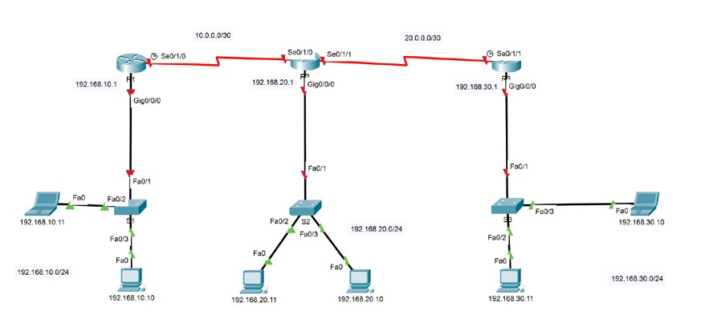
Refer to the above topology for addressing information.
Tasks:
- Set Up the Topology and Initialize Devices
- Configure Devices and Verify Connectivity
Assign static IPv4 information to the PC interfaces.

Configure basic router settings. (Refer to our previous labs. Basic Configurations includes hostname, passwords, line configurations, device security, domain lookups, banners)

Configuring your network with complete information is highly recommended.

Verify network connectivity.

- Configure Static, Default and Loopback addresses for all the routers Configure IPv4 Address for all the router interfaces.
R1
interface GigabitEthernet0/0
description S1 subnet
ip address 192.168.10.1 255.255.255.0
duplex auto
speed auto
!
interface GigabitEthernet0/1
no ip address
duplex auto
speed auto
shutdown
!
interface GigabitEthernet0/2
no ip address
duplex auto
speed auto
shutdown
!
interface Serial0/3/0
description int to R2
ip address 10.0.0.1 255.255.255.252
clock rate 2000000
!
interface Serial0/3/1
no ip address
clock rate 2000000
shutdown
!

R2
interface GigabitEthernet0/0
description S2 subnet
ip address 192.168.20.1 255.255.255.0
duplex auto
speed auto
!
interface GigabitEthernet0/1
no ip address
duplex auto
speed auto
shutdown
!
interface GigabitEthernet0/2
no ip address
duplex auto
speed auto
shutdown
!
interface Serial0/3/0
description to R1
ip address 10.0.0.2 255.255.255.252
!
interface Serial0/3/1
description to R3
ip address 20.0.0.1 255.255.255.252
!

R3
interface GigabitEthernet0/0
description S3 subnet
ip address 192.168.30.1 255.255.255.0
duplex auto
speed auto
!
interface GigabitEthernet0/1
no ip address
duplex auto
speed auto
shutdown
!
interface GigabitEthernet0/2
no ip address
duplex auto
speed auto
shutdown
!
interface Serial0/3/0
no ip address
clock rate 2000000
shutdown
!
interface Serial0/3/1
description to R2
ip address 20.0.0.2 255.255.255.252
clock rate 2000000
!

Configure loopback address (Lo1) as 50.50.50.50/32 at Router R2.
interface Loopback0
description Loopback
ip address 55.55.55.55 255.255.255.255
!

On R1, R2 and R3 configure IPv4 static route to connect other networks. Do not include Lo1 network.
R1 Routing Table
Gateway of last resort is 10.0.0.2 to network 0.0.0.0

10.0.0.0/8 is variably subnetted, 2 subnets, 2 masks
C 10.0.0.0/30 is directly connected, Serial0/3/0
L 10.0.0.1/32 is directly connected, Serial0/3/0
20.0.0.0/30 is subnetted, 1 subnets
S 20.0.0.0/30 [1/0] via 10.0.0.2
192.168.10.0/24 is variably subnetted, 2 subnets, 2 masks
C 192.168.10.0/24 is directly connected, GigabitEthernet0/0
L 192.168.10.1/32 is directly connected, GigabitEthernet0/0
S 192.168.20.0/24 [1/0] via 10.0.0.2
S 192.168.30.0/24 [1/0] via 10.0.0.2
S* 0.0.0.0/0 [1/0] via 10.0.0.2

R2 Routing Table
Gateway of last resort is not set

10.0.0.0/8 is variably subnetted, 2 subnets, 2 masks
C 10.0.0.0/30 is directly connected, Serial0/3/0
L 10.0.0.2/32 is directly connected, Serial0/3/0
20.0.0.0/8 is variably subnetted, 2 subnets, 2 masks
C 20.0.0.0/30 is directly connected, Serial0/3/1
L 20.0.0.1/32 is directly connected, Serial0/3/1
55.0.0.0/32 is subnetted, 1 subnets
C 55.55.55.55/32 is directly connected, Loopback0
S 192.168.10.0/24 [1/0] via 10.0.0.1
192.168.20.0/24 is variably subnetted, 2 subnets, 2 masks
C 192.168.20.0/24 is directly connected, GigabitEthernet0/0
L 192.168.20.1/32 is directly connected, GigabitEthernet0/0
S 192.168.30.0/24 [1/0] via 20.0.0.2

R3 Routing Table
Gateway of last resort is 20.0.0.1 to network 0.0.0.0

10.0.0.0/30 is subnetted, 1 subnets
S 10.0.0.0/30 [1/0] via 20.0.0.1
20.0.0.0/8 is variably subnetted, 2 subnets, 2 masks
C 20.0.0.0/30 is directly connected, Serial0/3/1
L 20.0.0.2/32 is directly connected, Serial0/3/1
S 192.168.10.0/24 [1/0] via 20.0.0.1
S 192.168.20.0/24 [1/0] via 20.0.0.1
192.168.30.0/24 is variably subnetted, 2 subnets, 2 masks
C 192.168.30.0/24 is directly connected, GigabitEthernet0/0
L 192.168.30.1/32 is directly connected, GigabitEthernet0/0
S* 0.0.0.0/0 [1/0] via 20.0.0.1

Configure default static route to reach Lo1 network using next-hop ip address at R1
R1 Routing Table
Gateway of last resort is 10.0.0.2 to network 0.0.0.0

S* 0.0.0.0/0 [1/0] via 10.0.0.2

Configure default static route to reach Lo1 network using exit interface at R3
R3 Routing Table
Gateway of last resort is 20.0.0.1 to network 0.0.0.0

S* 0.0.0.0/0 [1/0] via 20.0.0.1

Interpret the output from the routing table.
L - local
C - connected
S - static
* - candidate default

This means that C shows adjacent subnets, L generally shows the interface for that adjacent subnet, and S shows manually entered static routes, and S* shows the manually entered default static route.

Verify the status of the interfaces.
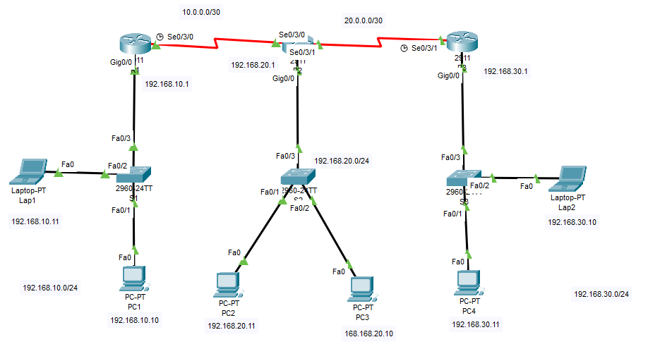
All non-used interfaces are set to down, and all in use are set to up as seen above

Verify the status of the network connectivity.
From Lap1:
C:\>ping 10.0.0.2

Pinging 10.0.0.2 with 32 bytes of data:

Reply from 10.0.0.2: bytes=32 time=1ms TTL=254
Reply from 10.0.0.2: bytes=32 time=1ms TTL=254
Reply from 10.0.0.2: bytes=32 time=2ms TTL=254
Reply from 10.0.0.2: bytes=32 time=2ms TTL=254

Ping statistics for 10.0.0.2:
Packets: Sent = 4, Received = 4, Lost = 0 (0% loss),
Approximate round trip times in milli-seconds:
Minimum = 1ms, Maximum = 2ms, Average = 1ms

C:\>ping 20.0.0.2

Pinging 20.0.0.2 with 32 bytes of data:

Reply from 20.0.0.2: bytes=32 time=15ms TTL=253
Reply from 20.0.0.2: bytes=32 time=4ms TTL=253
Reply from 20.0.0.2: bytes=32 time=3ms TTL=253
Reply from 20.0.0.2: bytes=32 time=2ms TTL=253

Ping statistics for 20.0.0.2:
Packets: Sent = 4, Received = 4, Lost = 0 (0% loss),
Approximate round trip times in milli-seconds:
Minimum = 2ms, Maximum = 15ms, Average = 6ms

C:\>ping 192.168.20.11

Pinging 192.168.20.11 with 32 bytes of data:

Request timed out.
Reply from 192.168.20.11: bytes=32 time=10ms TTL=126
Reply from 192.168.20.11: bytes=32 time=1ms TTL=126
Reply from 192.168.20.11: bytes=32 time=1ms TTL=126

Ping statistics for 192.168.20.11:
Packets: Sent = 4, Received = 3, Lost = 1 (25% loss),
Approximate round trip times in milli-seconds:
Minimum = 1ms, Maximum = 10ms, Average = 4ms

C:\>ping 192.168.30.11

Pinging 192.168.30.11 with 32 bytes of data:

Request timed out.
Reply from 192.168.30.11: bytes=32 time=2ms TTL=125
Reply from 192.168.30.11: bytes=32 time=12ms TTL=125
Reply from 192.168.30.11: bytes=32 time=2ms TTL=125

Ping statistics for 192.168.30.11:
Packets: Sent = 4, Received = 3, Lost = 1 (25% loss),
Approximate round trip times in milli-seconds:
Minimum = 2ms, Maximum = 12ms, Average = 5ms

This shows that all subnets can communicate with each other

Record your routers running configurations here!!! Do it separately for R1, R2 and R3

R1 running configuration:
Building configuration...

Current configuration : 1711 bytes
!
version 15.1
no service timestamps log datetime msec
no service timestamps debug datetime msec
service password-encryption
security passwords min-length 7
!
hostname R1
!
login block-for 120 attempts 3 within 60
!
!
enable secret 5 $1$mERr$EJnmB234UvJf9yoQMWYJK/
!
!
!
!
!
!
no ip cef
no ipv6 cef
!
!
!
username admin password 7 0822455D0A1613030B1B0D1739
!
!
license udi pid CISCO2911/K9 sn FTX15246LYN-
!
!
!
!
!
!
!
!
!
ip ssh version 2
no ip domain-lookup
ip domain-name networking.com
!
!
spanning-tree mode pvst
!
!
!
!
!
!
interface GigabitEthernet0/0
description S1 subnet
ip address 192.168.10.1 255.255.255.0
duplex auto
speed auto
!
interface GigabitEthernet0/1
no ip address
duplex auto
speed auto
shutdown
!
interface GigabitEthernet0/2
no ip address
duplex auto
speed auto
shutdown
!
interface Serial0/3/0
description int to R2
ip address 10.0.0.1 255.255.255.252
clock rate 2000000
!
interface Serial0/3/1
no ip address
clock rate 2000000
shutdown
!
interface Vlan1
no ip address
shutdown
!
ip classless
ip route 0.0.0.0 0.0.0.0 10.0.0.2
ip route 192.168.20.0 255.255.255.0 10.0.0.2
ip route 192.168.30.0 255.255.255.0 10.0.0.2
ip route 20.0.0.0 255.255.255.252 10.0.0.2
ip route 0.0.0.0 0.0.0.0 55.55.55.55
!
ip flow-export version 9
!
!
ip access-list extended sl_def_acl
deny tcp any any eq telnet
deny tcp any any eq www
deny tcp any any eq 22
permit tcp any any eq 22
!
no cdp run
!
banner motd ^CThis is a secure system. Authorized Access Only^C
!
!
!
!
!
line con 0
exec-timeout 5 0
password 7 0822455D0A1606181C1B0D1739
login
!
line aux 0
!
line vty 0 4
exec-timeout 5 0
password 7 0822455D0A1613030B1B0D1739
login local
transport input ssh
!
!
!
end

R2 running configuration:
Building configuration...

Current configuration : 1644 bytes
!
version 15.1
no service timestamps log datetime msec
no service timestamps debug datetime msec
service password-encryption
security passwords min-length 7
!
hostname R2
!
login block-for 120 attempts 3 within 60
!
!
enable secret 5 $1$mERr$EJnmB234UvJf9yoQMWYJK/
!
!
!
!
!
!
ip cef
no ipv6 cef
!
!
!
username admin password 7 0822455D0A1613030B1B0D1739
!
!
license udi pid CISCO2911/K9 sn FTX152487S3-
!
!
!
!
!
!
!
!
!
ip ssh version 2
no ip domain-lookup
ip domain-name networking.com
!
!
spanning-tree mode pvst
!
!
!
!
!
!
interface Loopback0
description Loopback
ip address 55.55.55.55 255.255.255.255
!
interface GigabitEthernet0/0
ip address 192.168.20.1 255.255.255.0
duplex auto
speed auto
!
interface GigabitEthernet0/1
no ip address
duplex auto
speed auto
shutdown
!
interface GigabitEthernet0/2
no ip address
duplex auto
speed auto
shutdown
!
interface Serial0/3/0
ip address 10.0.0.2 255.255.255.252
!
interface Serial0/3/1
ip address 20.0.0.1 255.255.255.252
!
interface Vlan1
no ip address
shutdown
!
ip classless
ip route 192.168.10.0 255.255.255.0 10.0.0.1
ip route 192.168.30.0 255.255.255.0 20.0.0.2
ip route 192.168.20.0 255.255.255.0 GigabitEthernet0/0
!
ip flow-export version 9
!
!
ip access-list extended sl_def_acl
deny tcp any any eq telnet
deny tcp any any eq www
deny tcp any any eq 22
permit tcp any any eq 22
!
banner motd ^CThis is a secure system. Authorised access only^C
!
!
!
!
!
line con 0
exec-timeout 5 0
password 7 0822455D0A1606181C1B0D1739
login
!
line aux 0
!
line vty 0 4
exec-timeout 5 0
password 7 0822455D0A1613030B1B0D1739
login local
transport input ssh
!
!
!
end

R3 running configuration:
Building configuration...

Current configuration : 1627 bytes
!
version 15.1
no service timestamps log datetime msec
no service timestamps debug datetime msec
service password-encryption
security passwords min-length 7
!
hostname R3
!
login block-for 120 attempts 3 within 60
!
!
enable secret 5 $1$mERr$EJnmB234UvJf9yoQMWYJK/
!
!
!
!
!
!
no ip cef
no ipv6 cef
!
!
!
username admin password 7 0822455D0A1613030B1B0D1739
!
!
license udi pid CISCO2911/K9 sn FTX1524CV8A-
!
!
!
!
!
!
!
!
!
ip ssh version 2
no ip domain-lookup
ip domain-name networking.com
!
!
spanning-tree mode pvst
!
!
!
!
!
!
interface GigabitEthernet0/0
ip address 192.168.30.1 255.255.255.0
duplex auto
speed auto
!
interface GigabitEthernet0/1
no ip address
duplex auto
speed auto
shutdown
!
interface GigabitEthernet0/2
no ip address
duplex auto
speed auto
shutdown
!
interface Serial0/3/0
no ip address
clock rate 2000000
shutdown
!
interface Serial0/3/1
ip address 20.0.0.2 255.255.255.252
clock rate 2000000
!
interface Vlan1
no ip address
shutdown
!
ip classless
ip route 0.0.0.0 0.0.0.0 20.0.0.1
ip route 192.168.10.0 255.255.255.0 20.0.0.1
ip route 192.168.20.0 255.255.255.0 20.0.0.1
ip route 10.0.0.0 255.255.255.252 20.0.0.1
!
ip flow-export version 9
!
!
ip access-list extended sl_def_acl
deny tcp any any eq telnet
deny tcp any any eq www
deny tcp any any eq 22
permit tcp any any eq 22
!
no cdp run
!
banner motd ^CThis is a secure system. Authorized Access Only^C
!
!
!
!
!
line con 0
exec-timeout 5 0
password 7 0822455D0A1606181C1B0D1739
login
!
line aux 0
!
line vty 0 4
exec-timeout 5 0
password 7 0822455D0A1613030B1B0D1739
login local
transport input ssh
!
!
!
end

