Individual Report – NHS

Student Name: Daniel Costache
Student ID: 1916533
Module Name: Human Capital Management
Module Code: LCMB7023_LON
Lecturer: Dr Gladius David Kulothungan

Introduction 2
Internal and external factors affecting nursing supply 3
Internal factors influencing nursing supply 5
Strategies for addressing nursing shortages 7
Workforce analytics and talent management in nursing 7
External Factors influencing Nursing Supply 8
Labour Market Trends 8
Immigration Policies and Integration of international nurses 9
Strategies for workforce development 10
Improving domestic nurse education and training 10
Compensation management in nursing 10
Position analysis for NHS doctors 11
Role and responsibilities 11
Working conditions 12
Challenges faced by NHS doctors 12
Compensation and benefits 13
Training and career development 13
Technological advancements 14
References 15

Introduction

This report aims to examine the challenges the United Kingdom’s National Health Service (NHS) faces by examining the internal and external issues affecting the supply of human capital, focusing on the nursing shortages that affect the organisation and offers a position analysis for doctors who work there.
The NHS is the UK’s the main healthcare provider as well as the largest employer in the country, with 1.7 million employees including 188,000 doctors and 423,000 nurses and midwifes (The NHS workforce in Numbers 2024), and they face challenges in maintaining a workforce large enough that can meet the needs of their patients. In the healthcare industry, human capital management is crucial since the readiness and quality of staff has a direct impact on the results of treatment. The current shortage of nurses is analysed and consideration is given to internal and external factors that affect the supply. By examining these factors, key issues that affect the workforce can be identified.
Secondly, doctors have a crucial role in the organisation, therefore the report conducts a thorough position analysis of their jobs using publicly available information and examines their roles, responsibilities, working conditions, challenges, and compensation.
By exploring these aspects of the NHS workforce, a clearer understanding is gained of the human capital management in the NHS.

Internal and external factors affecting nursing supply

Estimating the internal and external factors affecting the supply of nurses for the NHS is an important task, to understand why the organisation has been facing a shortage of nurses. According to the King`s Fund, 2024, the vacancy rate for nurses stands at 10.3% (figure 1), significantly higher than the UK’s overall vacancy rate of 3.4%.
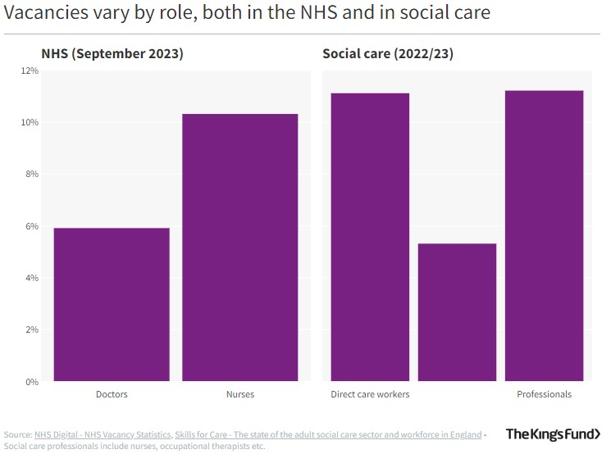
Besides recruitment, staff retention is also a critical issue, with 154000 workers having left their jobs in the NHS in 2023, or 10.7% of their total workforce.
The organisation employs several types of nurses, like bank nurses, permanent staff, and agency nurses and it relies on a significant percentage of international staff with around 27% of nurses being non-UK nationals (figure 2).

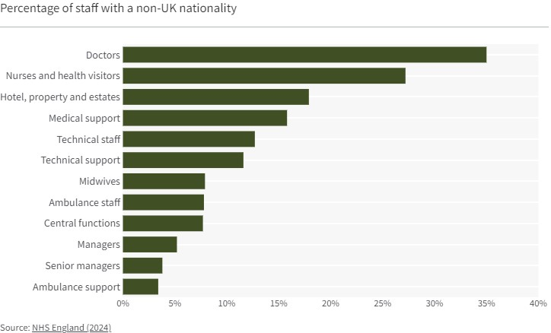
To accurately estimate the supply of nurses, key factors such as job satisfaction, working conditions, and the global competition must be analysed to gain a better understanding of the potential supply and be able to address the shortages.

Internal factors influencing nursing supply

The supply of nurses within the NHS is influenced by several internal factors that affect recruitment and retention. Understanding these factors is crucial to understand why the NHS is struggling with maintaining an adequate level of staffing.
The work environment plays a significant role in nurse retention. Factors like staff levels, work schedule, and work-life balance impact job satisfaction, which affects turnover rates. More than half of resignations in the NHS are voluntary and the top two reasons for doing so are to improve work-life balance and due to health issues. The number of staff leaving the NHS for these reasons has almost tripled since 2014 (figure 3).

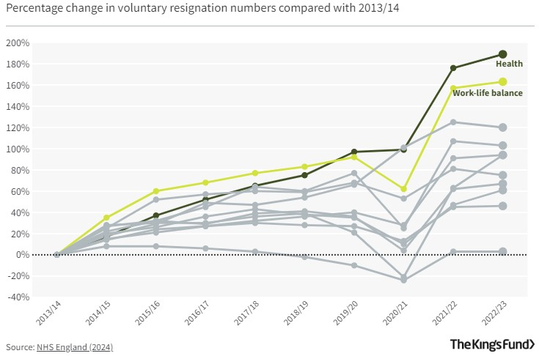
Some reasons why these two factors contribute to such an extent to staff turnover are that the levels of stress and feeling overworked are high, as revealed by the NHS staff survey, 2023 and the percentage of workers who consider that there is enough staff sits at just 32%, which is an improvement from previous 2 years, but a decrease from 38% in 2020 (figure 4).
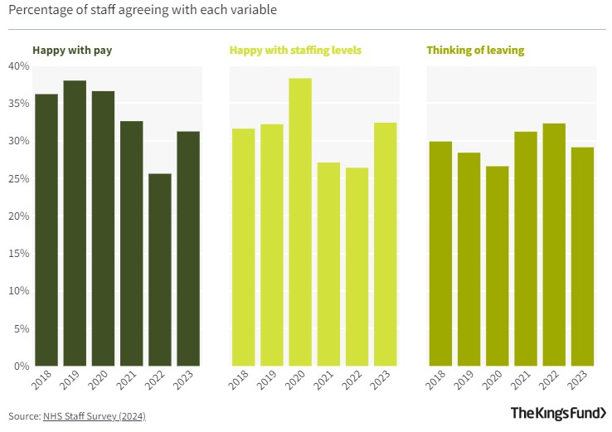
Another important internal factor is staff satisfaction, where the NHS survey of 2024 in figure 4 shows a considerable level of dissatisfaction among employees, with 29% thinking of leaving the organisation. The level of pay is another contributing factor to the dissatisfaction of employees, with only 31% being happy with the compensation they receive. For the 2024/25-year, new nurses receive a starting salary of £29,969 (band 5) per year, which is a 5.5% increase from the previous year, but it still being perceived as being too low, since only 19% see their compensation as being enough, compared to 49% in 2011 (RCN Submission to the Pay Review Body 2024-25).
The ability to grow professionally and acquire new skills is important to keep nurses in the workforce. Providing clear career paths and training initiatives can improve job satisfaction and retention, and preceptorship programs in the NHS are important to develop and support the nurses (Taylor et al., 2018). Another important internal factor is giving the nurses autonomy and involving them in the decision-making process, which can increase job satisfaction and improve the quality of care they provide (Zheng & Temkin-Greener, 2010).

Strategies for addressing nursing shortages

A comprehensive approach is required to tackle nursing shortages that considers many of the internal factors affecting nurse recruitment and retention. Research studies and expert opinions can help design strategies that address the shortage of staff.
Develop a supportive work environment that allows nurses to delegate more clinical duties, to help improve job satisfaction and staff retention. Introduce family-friendly initiatives aimed at helping staff return from sick leave back into the work force (Newman & Maylor, 2002).
Increase the pay of NHS nurses considerably to acquire and retain nursing staff, addressing the wage issue that impacts the nursing shortage problem (Frijters et al., 2006).

Workforce analytics and talent management in nursing

Workforce analytics can be a valuable tool for addressing the nurse shortage and optimise the workforce. Data driven approaches can influence decision making and workforce planning and decision making in human capital management.
For example, the Children’s Hospital of Philadelphia created a platform to integrate various datasets they get from their patients and staff which provided the nursing leaders with data analytics which helped with the decision making in improving the management of staff and patient outcomes. The platform automatically provides reliable analytics on metrics like nurse demographics, education, survey results, staffing actuals by job group, and patient experience. A usability survey showed that senior directors and managers were satisfied with the information they were getting, which indicated the platform is a valuable tool to support decision making (Cato et al., 2024).
By using similar approaches, the NHS can gain valuable data to make informed decisions about its nursing workforce. This can lead to better resource allocation, increased job satisfaction and improve the staff shortage issue.

External Factors influencing Nursing Supply

There are also several external factors that operate on a broader economic, societal and policy level that affect nurse supply. These factors are not under the control of the NHS and are important to understand to address the nurse shortage in the organisation. This section explores key external factors like labor market trends, immigration policies and integration of international nurses.

Labour Market Trends

The UK labor market is currently experiencing high vacancy rates and demand for talent, particularly in the public sector, which includes the NHS. Despite low unemployment overall, there are continued labor shortages, partly due to high economic inactivity rates. One significant trend impacting the nursing workforce is the decline in employees as many individuals aged over 50 are exiting the job market, which results in a shortage of nurses. Nonetheless there are indications that some people who were previously economically inactive might be rejoining the workforce.
The need for more flexible work arrangements is a factor for many people seeking employment, such as parents, individuals with disabilities and older workers. This could mean that providing flexible work options could play a role in attracting and retaining nurses.
International recruitment remains a strategy to complement the UK labor market particularly considering the high vacancy rates and lengthy training periods required for healthcare roles (Labour market trends 2022).

Immigration Policies and Integration of international nurses

The UK immigration policies regarding health care workers have recently been changed, and this will impact international recruitment. From April 2024, the minimum salary threshold for Health and Care Visas increased to £23.200 and it applies both to new applicants and for visa extensions. This type of visa will continue to be exempt from paying the Immigration Health Surcharge.
Unlike general care workers, nurses can still bring their dependents to the UK, but the minimum income for the family visa will rise to £29,000 in April 2024 and then again to £38,700 in 2025.
These policies try to balance the country’s needs for international healthcare workers with the efforts to decrease immigration and ensure fair compensation for domestic and international workers (Impacts of the changes to the UK immigration policy 2024).

Strategies for workforce development

Improving domestic nurse education and training

The NHS has implemented a development plan aimed at expanding its workforce and addressing the shortages in the coming years. Their strategy involves an investment of more than £2.4 billion that will fund a 27% expansion in training places by 2028. This will enable more than 500,000 trainees to begin clinical training in the next 6 years, an increase of nearly 60,000 compared to current levels. In the adult nurse section, training spots will increase by 92% with the aim to reach 38,000 more places by 2031. In the shorter term, around 8000 nurses will start training compared to current levels, with increases of 38% for mental health and 46% for learning disability nursing. The NHS also plans to develop nursing associates with an increase of 40% to 7000 by 2028 with a goal of having an extra 10,500 extra training spots by 2031. These initiatives show that the organisation is committed to addressing the nursing shortage with significant investment in training and education and providing a clearer path for progression (NHS Long Term Workforce Plan 2023).

Compensation management in nursing

Compensation management for NHS nurses is governed by the Agenda for Change pay system, which applies to all staff except doctors, dentists, and senior managers. It is based on experience-based progress through 8 pay bands, with each band having multiple pay points based on years of experience.
The pay rates for nurses start at band 2 with £23,615 per year and can reach up to £101,677 for the highest position in band 8. New nurses normally enter at band 5 with salaries between £29,970 and £36,483. Additional benefits are available, like high-cost supplements for those working in the London area which range from 5% to 20% extra on the basic salary. In recent years nurse salaries have increased by an average of 4% (The UK nursing salary and pay scale guide - 2024 n/a). While these increments have started to address historical pay issues, the current levels still fall well short of the Royal College of Nursing recommendation that they should start with around £35,000 per year. Currently, 42% of all nurses find themselves on the band 5 salaries, which is the lowest salary band. In consequence, only 19% of nurses see their compensation as being enough, compared to 49% in 2011 (RCN Submission to the Pay Review Body 2024-25).

Position analysis for NHS doctors

Role and responsibilities

General responsibilities of NHS doctors include diagnosing and treating patients, prescribing medications, maintaining patient records, and performing medical procedures. Some duties may vary depending on specialty and range from emergency medicine to surgery psychiatry and pediatrics.
Doctors work in various roles with increasing levels of responsibility:
- Junior doctors: include foundation year 1 and 2, specialty training and core level training
- Middle Grade doctors
- Specialty doctors which completed at least 4 years of postgraduate
- Specialist Doctors work in senior roles with high responsibility
- Consultants are the highest hospital doctor role and requires at least 8 years of postgraduate work
- General practitioners (GPs): they work in primary care
- Academic doctors do teaching, research and patient treatment (Platts, 2023)

Working conditions

The work takes place in various environments like hospital wards, consulting rooms, laboratories, and specialised units. Shifts usually involve a rota system but the working hours can be long and include weekends, nights and can include on-call periods. Demanding schedules are common in these roles and can negatively impact work-life balance.
The work can be mentally and physically demanding and involve a high level of responsibility for the patient's wellbeing and can also be rewarding when seeing the patient's recovery (Hospital doctor job profile n/a).

Challenges faced by NHS doctors

NHS doctors experience problems with their professional lives. Heavy reliance on an over-stretched workforce with a current shortage of around 4,200 GPs adds pressure to the system. This adds to high levels of burnout, with 45% saying they had become ill from work-related stress in the past year. An aging population, more complex health needs and history of under-resourcing has undermined the ability for doctors to operate efficiently. The COVID-19 pandemic has only added additional demands to an already stressed system, with adjustments in protocols and increased risk of infection. The stressful environment is contributing to the poor mental health and overall wellbeing of physicians. Together these challenges combine to provide highly demanding working conditions that impede job satisfaction, decrease retention rates, and affect patient care delivery. Addressing these issues is crucial to maintain a robust and effective healthcare system (Challenges facing the NHS 2024).

Compensation and benefits

NHS doctors are paid a salary based on experience and the role they undertake. Basic salary for foundation training junior doctors is between £32,398 to 37,303; Specialist doctors earn £43,923 to £63,152; Specialty Doctors: £52,530 – 82.400; Consultants — £93,666 to 126,287

Additional benefits: extra payment for overtime/night/weekend hours and on-call duty (37% increase). Private Practice Consultants may also apply for Clinical Excellence awards and supplement their income through private practice. These figures are based on NHS employment; private sector consultants can earn more. Doctors also get benefits such as an NHS Pension, annual leave allowances and other staff benefits that come with a full-time job (Hospital doctor job profile n/a).

Training and career development

The NHS provides extensive training programs and career development paths for its doctors, which have set the standard worldwide.
Initially doctors then enter the two-year Foundation Program after medical school.
After completion of Foundation Year 1 (FY1), they gain full General Medical Council (GMC) registration. In Foundation Year 2 the doctor is prepared for specialty training.
In Specialty Training doctors can progress in one of 60 specialties. Specialty Training programs can last between 3-8 years depending on the chosen field.
Specialty training is of 2 types:
- Run through training programs where doctors are recruited for the full duration of the training.
- Uncoupled specialty training split into 2-3 years of core training where doctors are known as CT1-3 or ST 1-3, and 3 to 5 years of higher specialty training ST4+.
- After finishing the specialty training doctors receive a Certificate of Completion of Training (CCT)
Continuous professional development is required throughout a doctor’s career, and includes regular assessments, exams for Royal College memberships, and ongoing learning (IMG Connect, 2022).

Technological advancements

The NHS implements technological advancements, which require doctors to continuously adapt and improve their skills, to keep up with the technologically demanding environment. Some of these advancements include:
- Digitization of patient records allows easier access and analysis for healthcare providers.
- Computer systems support improved patient safety in diagnosis enhanced diagnostic tools
- Telemedicine: Doctors now conduct remote consultations via video and chat programs.
- AI Integration: 29% of AI technologies in the NHS are within primary care, with GPs being the second-highest direct users.
- Remote Monitoring Technology enables doctors to monitor patients' conditions remotely.
- Digital Learning: The pandemic accelerated the adoption of online and remote supervision, teaching, and learning for doctors in training.
- Emerging Technologies: Doctors are expected to understand and utilize technologies like augmented and virtual reality in patient care and medical education.
These advancements require doctors to stay updated with the need for ongoing digital literacy training and familiarity with emerging technologies in healthcare (NHS choices n/a).

References

The NHS workforce in Numbers (2024) Nuffield Trust. Available at: https://www.nuffieldtrust.org.uk/resource/the-nhs-workforce-in-numbers .
Staff shortages (2024) The King’s Fund. Available at: https://www.kingsfund.org.uk/insight-and-analysis/data-and-charts/staff-shortages .
NHS staff survey (2023) National results across the NHS in England | NHS Staff Survey. Available at: https://www.nhsstaffsurveys.com/results/national-results/ .
‘RCN Submission to the Pay Review Body 2024-25’ (2024). Royal College of Nursing. Available at: https://www.rcn.org.uk/-/media/Royal-College-Of-Nursing/Documents/Publications/2024/February/011-448.pdf .
Taylor, L.M., Eost‐Telling, C.L. and Ellerton, A. (2018) ‘Exploring preceptorship programmes: Implications for future design’, Journal of Clinical Nursing, 28(7–8). doi:10.1111/jocn.14714.
Zheng, N.T. and Temkin-Greener, H. (2010) ‘End-of-life care in nursing homes: The importance of CNA staff communication’, Journal of the American Medical Directors Association, 11(7). doi:10.1016/j.jamda.2010.01.006.
Frijters, P., Shields, M.A. and Price, S.W. (2006) ‘Investigating the quitting decision of nurses: Panel data evidence from the British National Health Service’, Health Economics, 16(1). doi:10.1002/hec.1144.
Cato, K. et al. (2024) ‘A nursing clinical care services platform to support Leadership Decision making’, Studies in Health Technology and Informatics [Preprint]. doi:10.3233/shti240193.
Labour market trends 2022 (2022) NHS Employers. Available at: https://www.nhsemployers.org/publications/labour-market-trends-2022 .
Impacts of the changes to the UK immigration policy (2024) NHS Employers. Available at: https://www.nhsemployers.org/articles/impacts-changes-uk-immigration-policy .
NHS Long Term Workforce Plan’ (2023). NHS. Available at: https://www.england.nhs.uk/wp-content/uploads/2023/06/nhs-long-term-workforce-plan-v1.2.pdf .
The UK nursing salary and pay scale guide - 2024 (no date) Nurses.co.uk. Available at: https://www.nurses.co.uk/careers-hub/nursing-pay-guide/#nhs-pay-table-agenda-for-change-2021-22 .
Platts, D. (2023) Insights from our Medical Recruitment Agency: BDI Resourcing, Purple dot. Available at: https://www.bdiresourcing.com/img-media-hub/blog/nhs-doctor-job-titles-explained/ .
(No date) Hospital doctor job profile | prospects.ac.uk. Available at: https://www.prospects.ac.uk/job-profiles/hospital-doctor .
Challenges facing the NHS (2024) The Medic Portal. Available at: https://www.themedicportal.com/application-guide/the-nhs/challenges-facing-the-nhs/ .
IMG Connect (2022) Career pathway for a UK doctor in training: IMG Connect Ltd - International Medical Recruitment Specialists, IMG Connect. Available at: https://www.imgconnect.co.uk/news/2020/04/career-pathway-for-a-uk-doctor-in-training/69 .
(No date a) NHS choices. Available at: https://www.hee.nhs.uk/our-work/primary-care/technology-practice .

