

Food and Beverage Operation (BMIH4002)
Student Name:Vlad-Ionut Ghiurca
Student e-mail:2238719@student.uwtsd.ac.uk

Module lead: Antoinette Milne

The Garden Bistro Menu
Appetizers
Item | Description | Price (£)
Seasonal Soup | A rotating selection of soups made from the freshest seasonal vegetables. | 6.50
Garden Salad | Mixed greens with seasonal vegetables, topped with a light vinaigrette. | 7.00
Artisan Bread with Herb-infused Oils | Freshly baked bread served with a selection of house-made herb-infused oils. | 5.50
Main Courses
Item | Description | Price (£)
Grilled Vegetable Stack | Layers of grilled seasonal vegetables, served with a balsamic reduction. | 12.50
Herb-crusted Salmon | Fresh salmon with a crispy herb crust, served with a side of steamed vegetables. | 15.00
Farm-to-Table Chicken | Locally sourced chicken, roasted with garden herbs and spices. | 14.00
Side Dishes
Item | Description | Price (£)
Seasonal Roasted Vegetables | A medley of vegetables roasted with herbs and olive oil. | 4.00
Quinoa Pilaf | Fluffy quinoa cooked with seasonal vegetables and herbs. | 3.50
Garden-fresh Slaw | Crunchy slaw made with fresh garden vegetables. | 3.00
Desserts
Item | Description | Price (£)
Fruit Tartlets | Mini tartlets filled with seasonal fruits and a light custard. | 6.00
Vegan Chocolate Mousse | Rich and creamy chocolate mousse, made with high-quality vegan ingredients. | 5.50
Local Cheese Board | A selection of local cheeses, served with crackers and fruit. | 7.50
Beverages
Item | Description | Price (£)
Organic Wines | A selection of red, white, and rosé wines from organic vineyards. | 6.00/glass
Craft Beers | An assortment of local and imported craft beers. | 4.50/pint
Herbal Teas | A variety of herbal teas sourced from organic gardens. | 2.50
Fresh Juices | Freshly squeezed juices made from seasonal fruits. | 3.00

The Garden Bistro is a restaurant concept.

The Garden Bistro is a new restaurant in the Hotel Trinity chain that it is trying all the time the best offering now and in the future a unique dining experience. We have a restaurant with a nature theme and perspectives that has embraced sustainability concept. It feels like being outside and is peaceful and green. The decor has plants, sunlight, and calming colours that remind you of a garden.

Who is the intended audience?
When it comes to the inteded audience it is important to be stated that are people that are loving the nature but also teh food looking to get a
special dining experience. We also welcome business professionals who want a calm place for meetings and families who want a peaceful dining experience.

Reasoning for Menu Selection:

Our menu is designed to match our garden considerations and features fresh, locally sourced ingredients.

We focus on organic produce and offer a farm-to-table experience. We have different dishes for different diets, like vegetarian, vegan, gluten-free, and allergy-friendly options. The menu has a mix of healthy and indulgent options that cater to different tastes and preferences.

Menu Design: Creating a Memorable Dining Experience
Understanding or forming an idea:

Style: Our dining experience combines plated service and a tasting menu to create a one-of-a-kind experience and we re therefore focusing on offering unique components and elements making cooking to be one of the best .The restaurant has live cooking stations and a herb garden where guests can pick herbs for their dishes.

Menu options:

Starters: Soup of the season, salad with fresh vegetables, bread with flavoured oils.
Main dishes: Grilled vegetable stack, salmon with herbs, chicken from the farm.
Side dishes: Roasted vegetables, quinoa pilaf, slaw.
Desserts: Small fruit tarts, vegan chocolate mousse, and a selection of local cheeses.
Drinks: Organic wines, craft beers, herbal teas, fresh juices.
Pricing plan:

Based on the cost of ingredients, competition analysis, and what the target market wants.

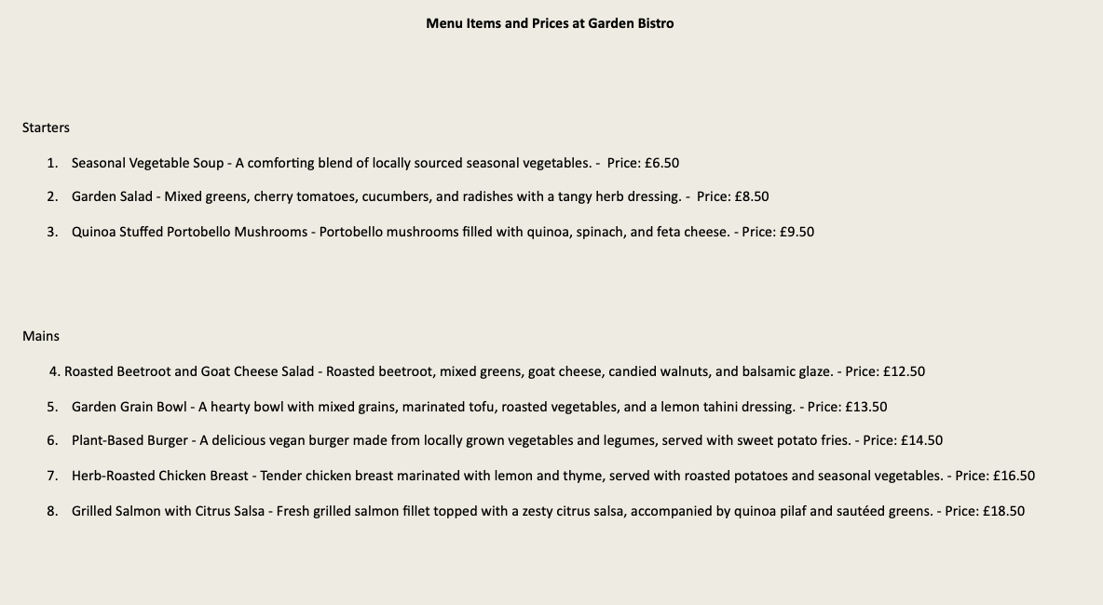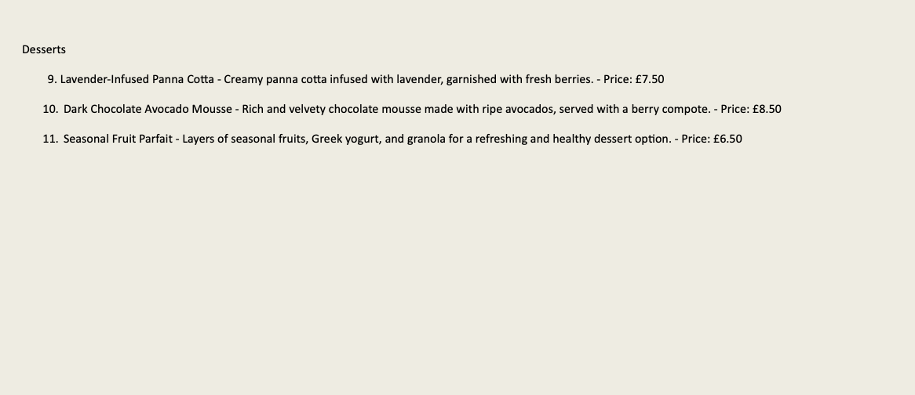

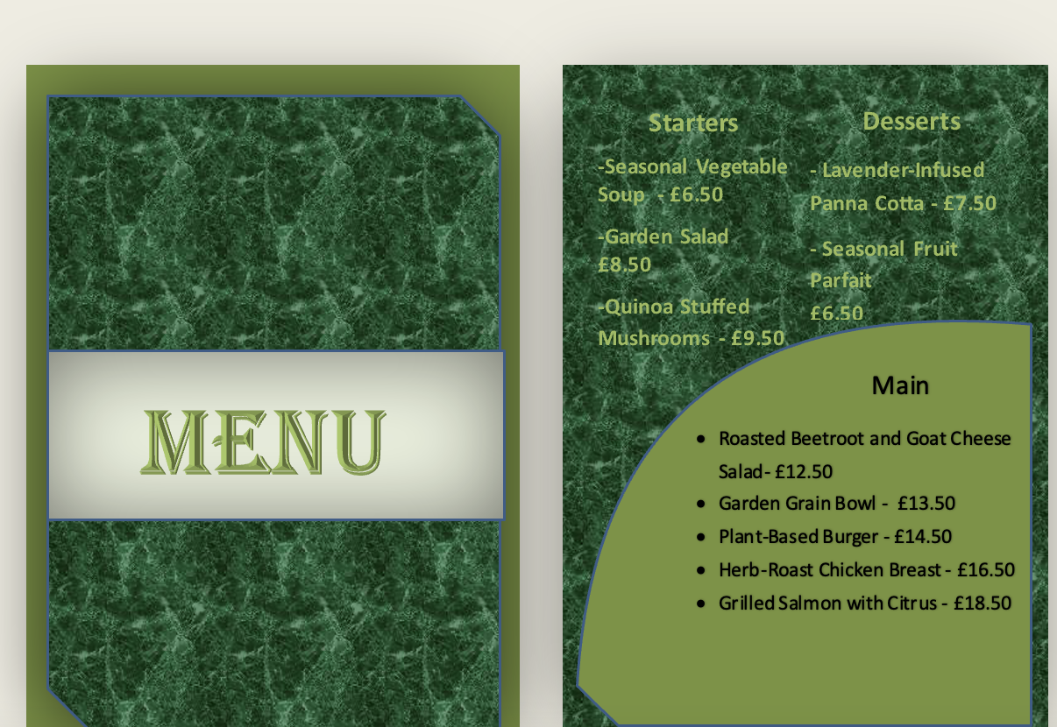
REFERENCES:
- Boussard, S. (2021) Food and Beverage Management in the Luxury Hotel Industry. New York: Business Expert Press.
- Brown, D. R., TotalBoox and TBX (2013) The Restaurant Manager’s Handbook: How to Set Up, Operate, and Manage w3/a Financially Successful Food Service Operation. 4th Edition. Atlantic Publishing Group.
- Cousins, J. (2020) Food and Beverage Service. 9th ed. London: Hodder Education Group.
- Cousins, J., et al. (2011) Food and Beverage Management: For the Hospitality, Tourism and Event Industries. 3rd edn. Oxford: Goodfellow.
- Davis, B., et al. (2018) Food and Beverage Management. 6th edn. London: Routledge.
- Foskett, D., et al. (2021) The Theory of Hospitality and Catering. 14th Edition. London: Hodder Education Group.
- Johnston, R. (2012) Service Operations Management: Improving Service Delivery. 4th ed. Harlow, England: Pearson.
- Motarjemi, Y. and Lelieveld, H. (2014) Food Safety Management: A Practical Guide for the Food Industry. Illustrated edition. Amsterdam: Academic Press.
- Walker, J. (2017) Introduction to Hospitality. Harlow: Pearson Education Limited.
- Wood, R. (2013) Key Concepts in Hospitality Management. London: Sage.
- Zutshi, A. (2019) ‘How to Develop Well-informed and Assured Teams to Embed Food Safety Compliance in the UK Catering and Hospitality Industry’, Perspectives in Public Health, 139(6), pp. 294–295.

