Certificate of Higher Education Skills for the Workplace
Digital Skills and Research Methods
BMSW4003

Natalie Youb 1920740

Login details:
natalielang9@hotmail.com
Password: Amiryoub1

Introduction

This report aims to explain why conducting market research and developing digital content is essential to my business so it can capitalize on research findings to help maximize sales and publicity for the organisation.

Market research informs you about your market and the business landscape. It can provide information about how your company is perceived by the customers and clients you want to reach. It can help you understand how to connect with them, show how you compare to the competition and guide your next steps.
Market research can also be useful in developing new products and services, bringing them to market, and marketing them to customers.

Primary research is used by businesses to collect data directly on a specific issue. Companies are keen and make a huge effort to collect data these days as it is very valuable to get first hand data that is authentic, to enable their product to succeed. Business uses a number of different methods including face to face interviews, online surveys, focus groups, and observations. Primary research can help you understand what may happen in the future and what challenges you may face as a business. It can help you achieve customer satisfaction as you will gain knowledge directly from clients. Primary research gives you accurate and up to date information and only primary research can give you real time insight into what customers need as the world is changing rapidly around us. Primary research can be a valuable asset to a company. It can start a conversation with your target audience, gather customer information, and then turn that information into actions and marketing collateral. Primary research can help you build a bank of unique data and knowledge that will put you ahead of the competition and give you an advantage. The benefits of using primary research are that because the information is coming first hand it will be more accurate, and will give your business a much deeper insight into how your clients or potential clients feel. Primary research is a method you have control over the collection of data and it is a method that has been used over and over so the results can be relied upon. Primary research is unique to you and the insight you gain can give you an advantage over competitors.

By conducting a questionnaire given to people who already have eyelash extensions, my market research has told me that my general demographic is females between the ages of 30-40 with this information I can find my target audience easier. Using the results has helped me to identify my customer base. We can see from the result below that the majority of clients are willing to pay between £30-£40, so with these results, I can set my prices accordingly ensuring I do price myself too high or too low.

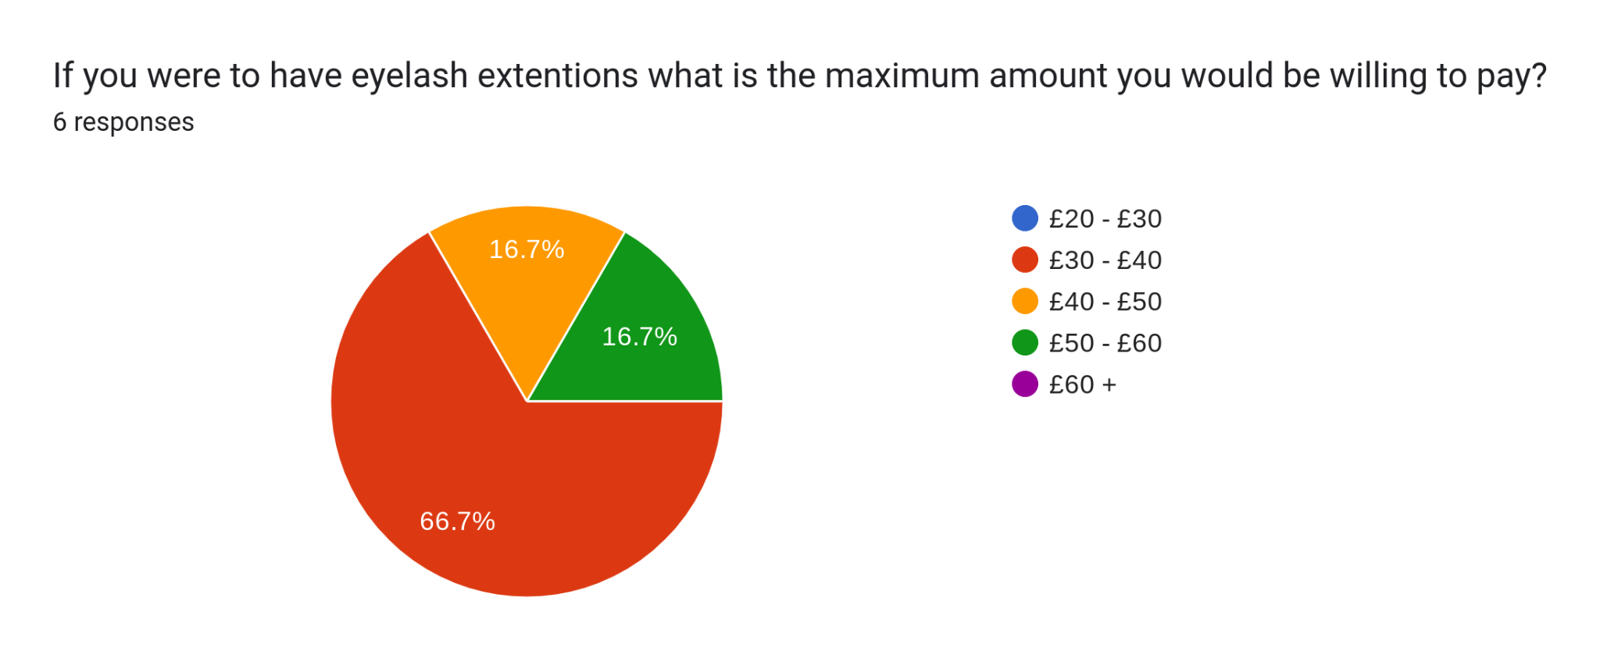

We can also see that there is a need for eyelash technicians to offer mobile services as the result showed a 50/50 result
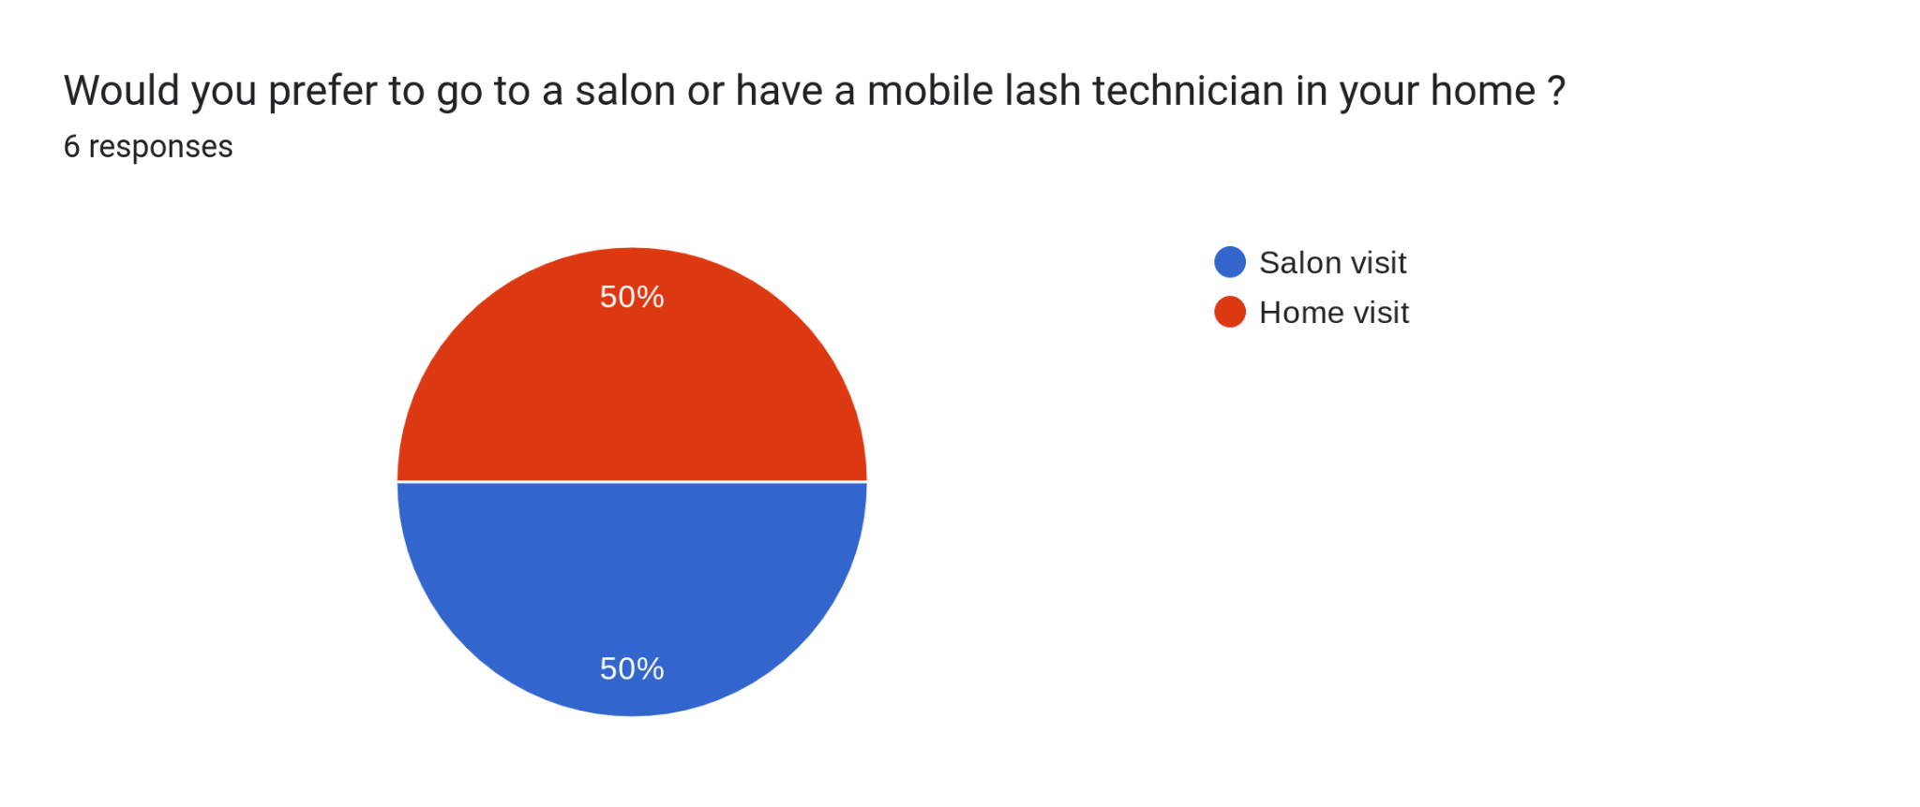
Customers are typically looking for classic, more natural looking lashes so this result enables me to purchase stock accordingly.
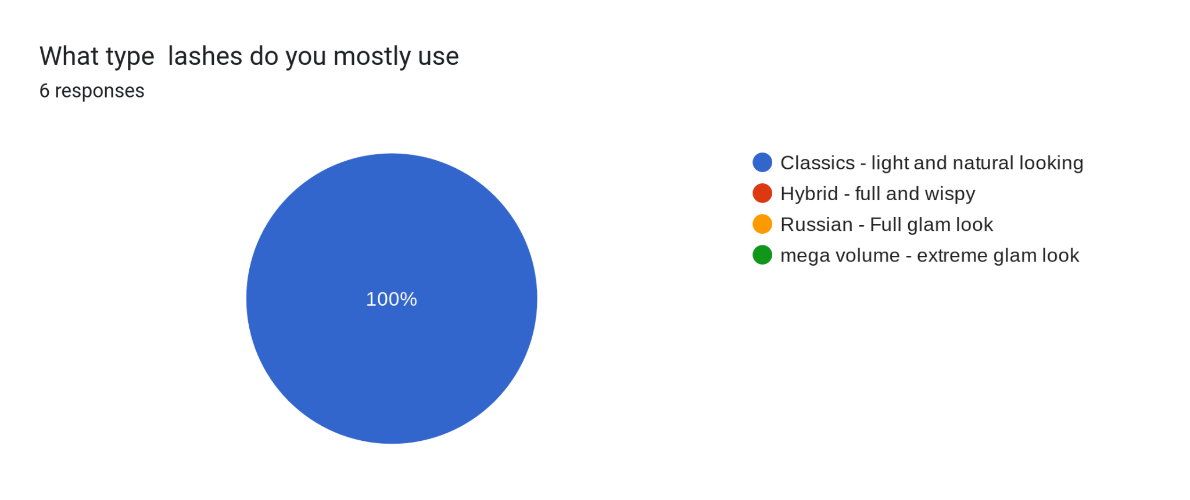Using my research results I will put more empahsis on classic lashes on my website and market classics lashes with a promotion initally. I will use pinks and light colours to give my website a soft and feminine feel as the majority of cutomers from the data are female.

SEO stands for ‘Search Engine Optimization’, which is the process of getting traffic from free, organic, editorial, or natural search results in search engines. It looks at making your website’s position in search results pages much more visible and attractive. The higher the website is listed, the more people will see it. SEO is considered an essential marketing activity.
- Good SEO involves many different activities, such as:
- Identifying relevant keywords with good search traffic potential
- Creating high-quality, useful content and optimizing it for search engines and for users
- Including relevant links from high-quality sites
- Measuring the results
The better the SEO the more people will find your business when doing their online searches. The reasons why SEO is so important for any business is the more customers that visit a page the more customers will be gained. According to fooxr digital marketing figures show that 1 percent of people go on the second page of google once they have done their search, so being on the first page people have more trust in the brand. SEO is measurable and quantifiable, being able to alalyse my customers habits, you will be able to get to know yours customers and can target your audience specifically. Using a good SEO will save money on uneccesary social media ads, and make it more affordable to grow a business. Having a great online presence will grown a business and give you the opportunity to see what your compitertors are doing in the market.

By using keywords on my website such as eyelash extention technician, classic lashes, hybrid lashes, mobile service will make me rank higher in google and become more visible.

Primary research aims to answer questions that are relevant only to your company, allowing you to can gain valuable insight into the key issues that affect your business; and. the data you collect belongs to you. Market research helps you to understand the exact needs of your customers so you're able to address them.

When designing a website using the Race framework it helps to bring structure, manage and improve results. There are five digital marketing techniques. Plan, reach, act, convert and engage. As mentioned above Plan is to help structure your digital marketing. Reach is making your brand known to consumers. Act is short for interact and this is to try and guide the customer to interact with your website. Convert is the conversion to sale and getting your customers to take the next step to purchase. Engage is the long term engagment and having loyal customers that keep coming back. Each area of the planning is essential to a good marketing technique.
To conclude market research is essential to any business and will enable you to market your business correctly to the right audience. Therefore will enable your business to make money.

https://www.questionpro.com/blog/primary-research/
https://blog.gclb2b.com/blog/info/5-reasons-why-primary-market-research-is-essential
https://www.qualtrics.com/uk/experience-management/research/primary-research/?rid=ip&prevsite=en&newsite=uk&geo=GB&geomatch=uk
https://digitalmarketinginstitute.com/blog/what-is-seo
https://foxxr.com/blog/why-is-seo-important/

