Assignment 1
Module Name: Computer Architecture and Operating Systems
Module Code: ACCA4022

Student Name: Jose Manuel Carneiro De Alva Noronha
Student ID: 2516682
Group: 2

Lecturer’s Name: Dr. Redhwan Al-Amri
UNIVERSITY OF WALES TRINITY SAINT DAVID
LONDON CAMPUS
Table of Contents
Introduction 3
Key functions of general Operating Systems 3
Process management 3
File & directory management 6
Network testing/monitoring 6
User management 7
Task scheduling 8
Use of Windows OS CLI commands 9
Dir 9
Md 10
Cd 11
Type 12
Copy 13
Del 14
Move-Item 14
Get-Process 15
Get-ComputerInfo 16
Select-String 17
Use of Linux OS CLI commands 18
Ls 18
Mkdir 19
Cd 20
Touch 21
Cp 21
Mv 22
Rm 23
Cat 23
Grep 24
Ps 25
Use of Windows OS scripts 25
Use of Linux OS scripts 27
Conclusion 29
References 29

Introduction
This work presents a study on operating system functionalities in general as well as the execution of several Batch, PowerShell, and Bash commands to demonstrate and explain their functionality, complete with screenshots of the results.
Additionally, two Batch scripts and two Bash scripts were created, demonstrating their execution, functionality, and purpose.

Key functions of general Operating Systems

Process management
This article[1] analyzes process management in Windows NT, detailing operations across the User, Kernel, and Hardware layers. A process is a dynamic structure of resources that transitions between states (New, Ready, Running, Waiting, and Terminated), under the control of a kernel scheduler.
It was concluded that every process has at least one thread, a private virtual address space, resource handles, a security context, and a PID. These threads contain CPU registers and their own ID. To manage this process execution, the kernel utilizes the Process Table, and management is based on switching the Process Context, which is composed of User, Register, and System levels (with static and dynamic parts).
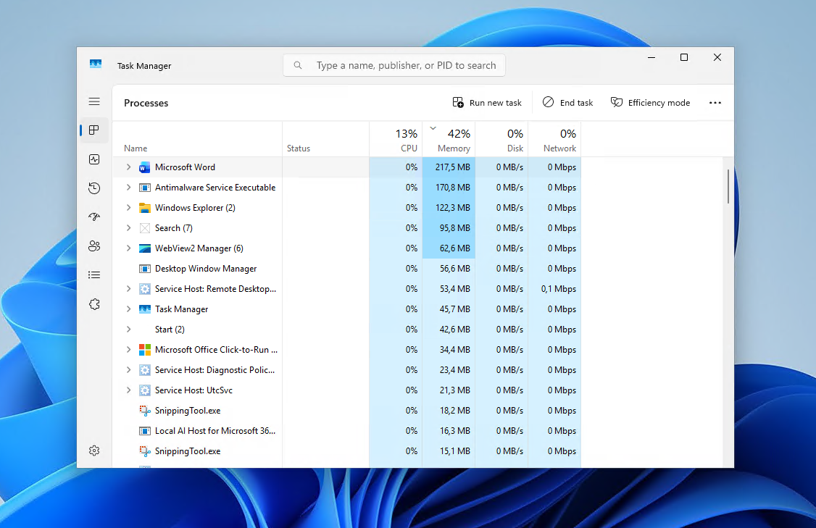
Figure 1 - Windows Task Manager: Process section
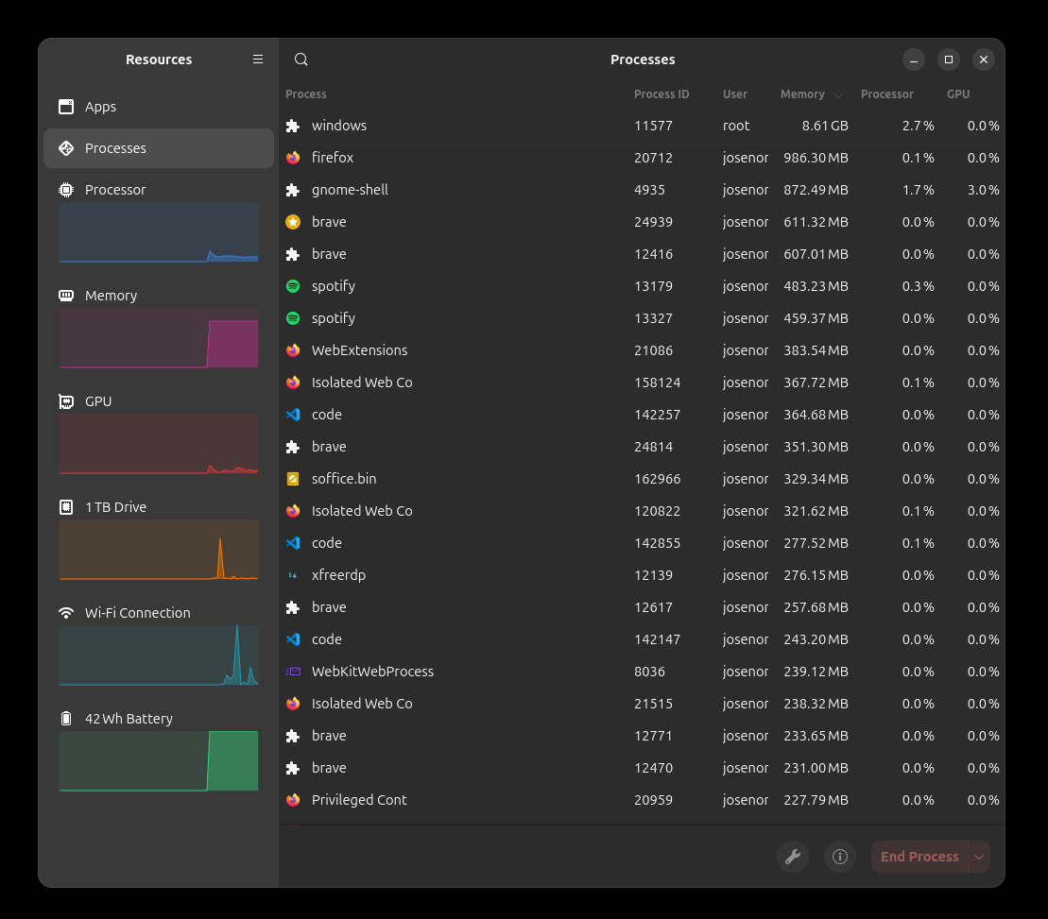
Figure 2 - Ubuntu Task Manager: Process section
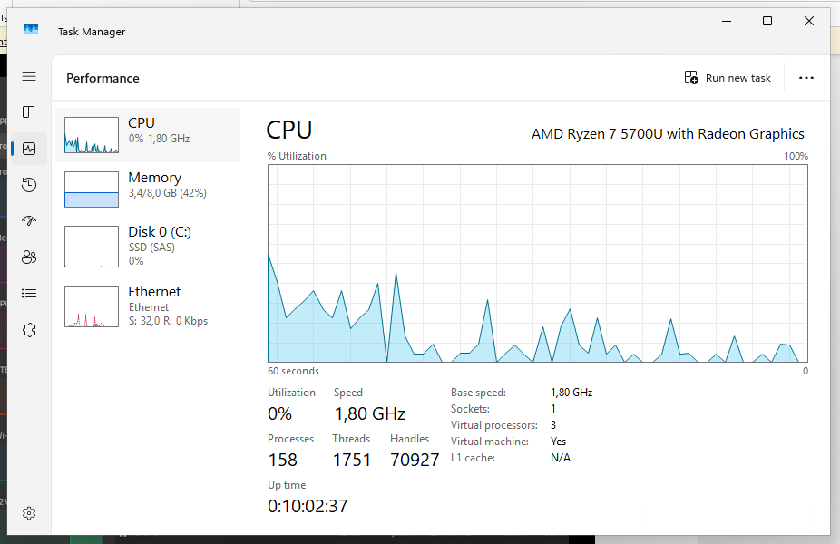
Figure 3 - Task Manager: CPU section
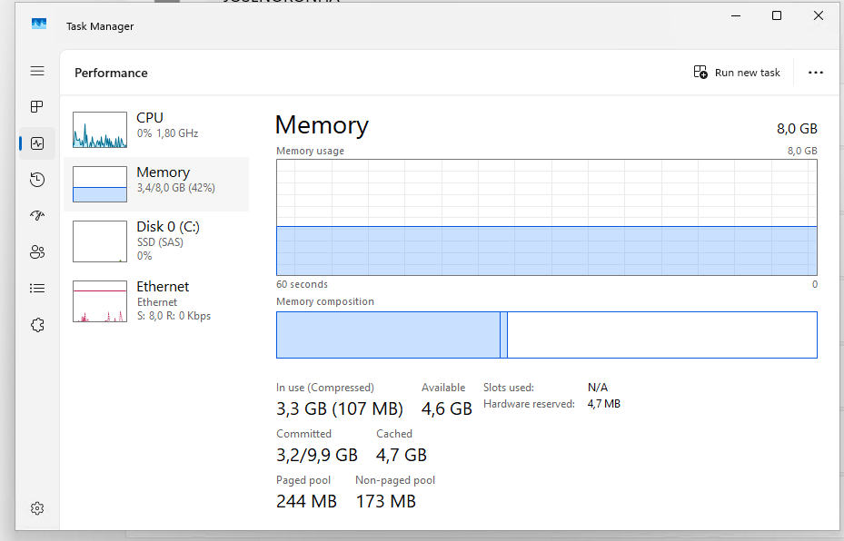
Figure 4 - Task Manager: Memory section

File & directory management
This book[2] presents file management as an essential skill for computer users, highlighting that organizational failures often lead to frustration and data loss. It also illustrates common everyday problems, such as being unable to locate downloads, losing unsaved documents, and overwriting files with generic names.
The primary cause of these difficulties is a lack of understanding of how to navigate in Windows folder structure. The proposed solution is based on the principle that everything has its place.
In conclusion, this book[2] seeks to teach, in simple language and without excessive technical details, how to navigate the system, where to store different file formats, how to use descriptive naming conventions for files and directories, and how to group data logically. Finally, it addresses techniques for transporting and protecting information, ensuring that data remains readily accessible at all times.

Network testing/monitoring
In this book[3], Network Testing and Monitoring is defined as the set of practices and tools used to monitor traffic, diagnose failures, and evaluate infrastructure performance. Its main purpose is to ensure connectivity between devices, identify and isolate communication bottlenecks, and maintain proactive system operation, preventing downtime.
Thus, it was possible to see that there are practical tools and applications within the Windows ecosystem, divided into the following groups:
- Command-Line Utilities: Essential tools for troubleshooting, such as “ping” (tests IP connectivity), “tracert” (maps routes and latency), “ipconfig” (checks and reconfigures network parameters), “netstat” (displays active connections and ports) and “nslookup” (tests name resolution via DNS).
- Native Monitoring Tools: System applications such as Performance Monitor to analyze traffic metrics, Resource Monitor to check real-time network consumption by processes, and Event Viewer to inspect system error logs.
- Analysis and Baselining: The importance of capturing regular network traffic to establish a normal usage pattern, facilitating the immediate identification of anomalies.
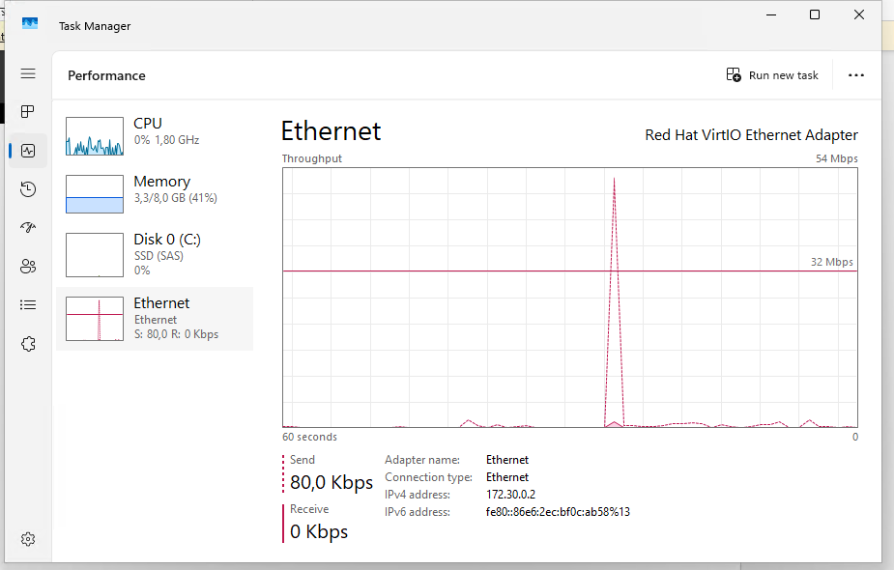
Figure 5 - Task Manager: Ethernet section

User management
This book[4] addresses user management in Windows, defining a user account as the record that identifies and authenticates who can access the computer, determining their access permissions to files and applications.
There are two main types of accounts:
- Administrator, with full control over the system and software installation.
- Standard User, focused on daily use without altering critical settings.
Data isolation is guaranteed by the user profile, which stores personal folders and individual preferences.
In addition, it explains “User Account Control (UAC)” as a security mechanism that requests authorization before deep system changes are made.
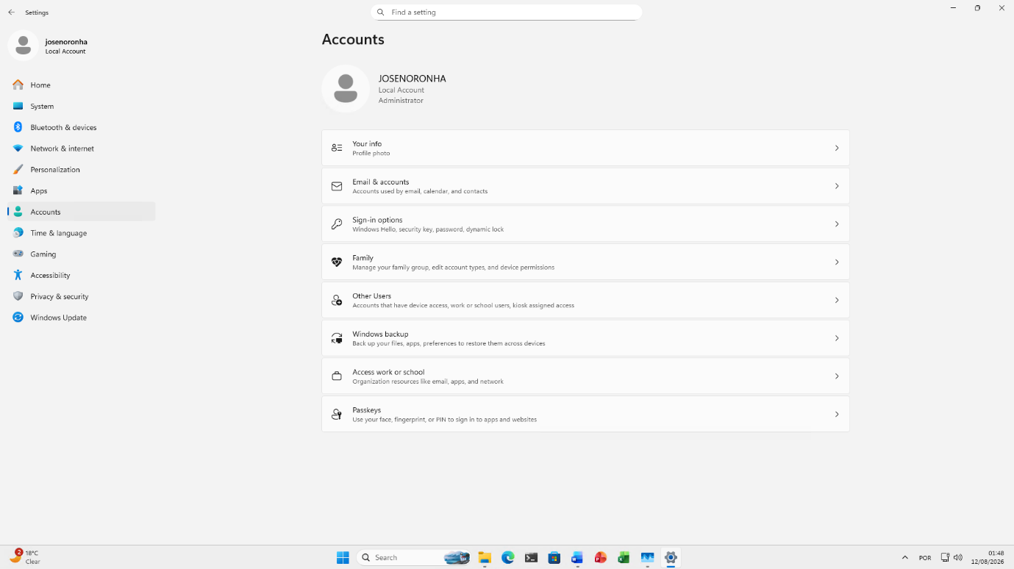
Figure 6 - Windows settings for users accounts

Task scheduling
This book[5] addresses task scheduling within the scope of system maintenance and automation, defining the Task Scheduler tool as an administrative console used to configure the automatic execution of programs, scripts, and processes at specific times or in response to system events.
It also explains how Windows automates essential routines, Windows Defender security scans, Windows Update updates, and disk optimization, teaching the user how to adjust these schedules to avoid performance drops during computer use.
Finally, it establishes a clear distinction between:
- Task Manager, focused on real-time monitoring and closing active applications.
- Task Scheduler, designed for automation and the planning of future and recurring tasks.
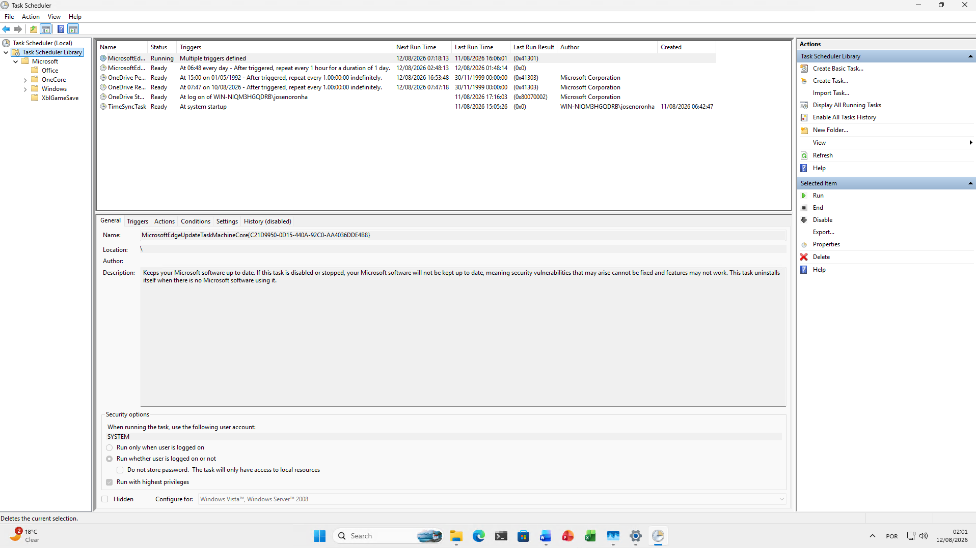
Figure 7 - Windows Task Scheduler

Use of Windows OS CLI commands

Dir
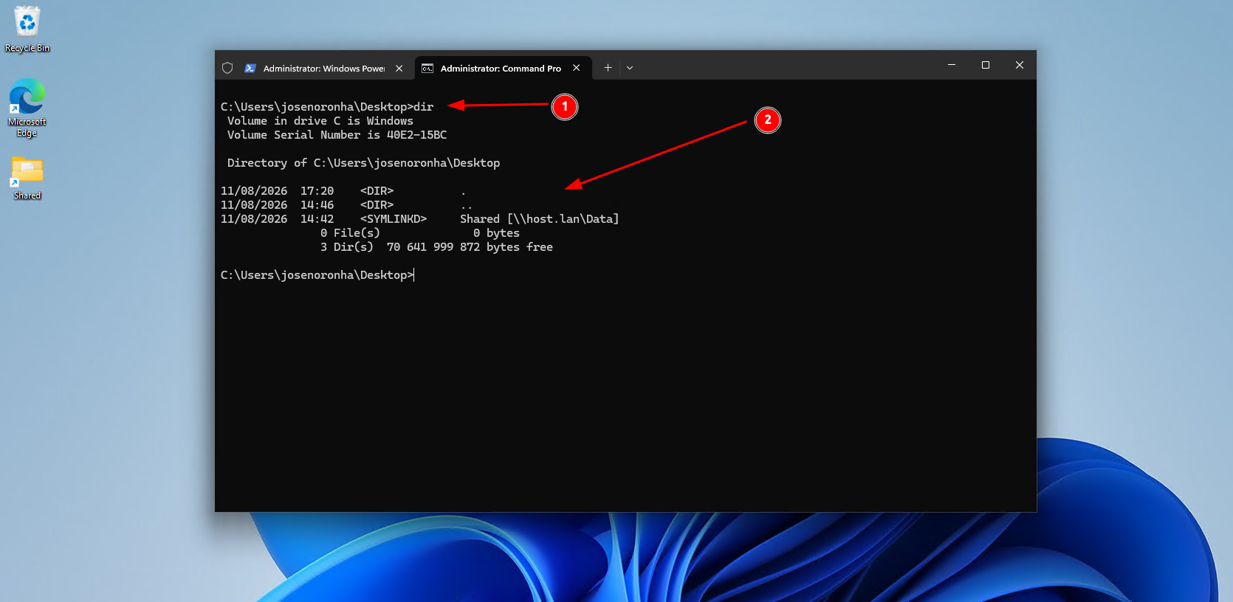
Figure 8 - Batch dir command
The “dir” command lists all files and folders in the current working directory. You can also pass a path as an argument to target a specific directory: “dir <directory>”.
In the image above, I am listing the files and folders located in the Desktop directory, as follows:
- The command “dir”
- Output after running the command “dir”.

Md
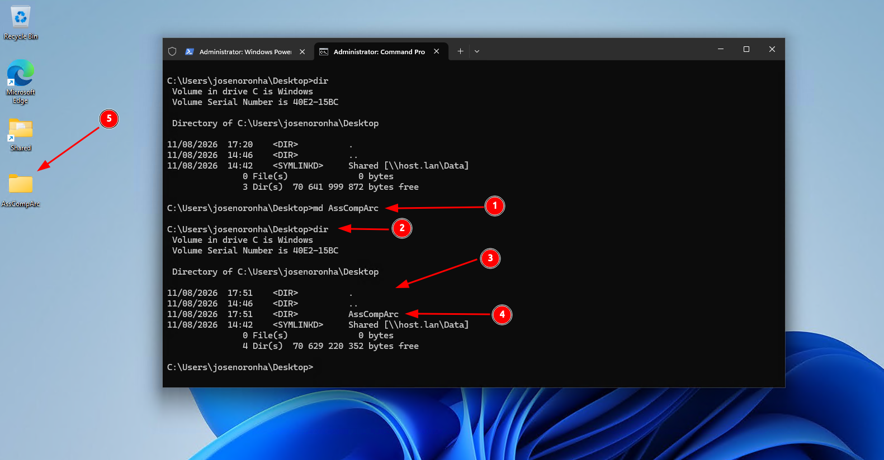
Figure 9 - Batch md command
Using the “md” command, folders can be created as shown above and described below following the numbered image:
- The “md” command accompanied by the name of the folder I want to create. In this case “AssCompArc”.
- Execution of the “dir” command to verify whether the folder was actually created.
- “dir” command output.
- Confirmation that the folder was successfully created.
- Verification of successful folder creation via Windows File Explorer.

Cd
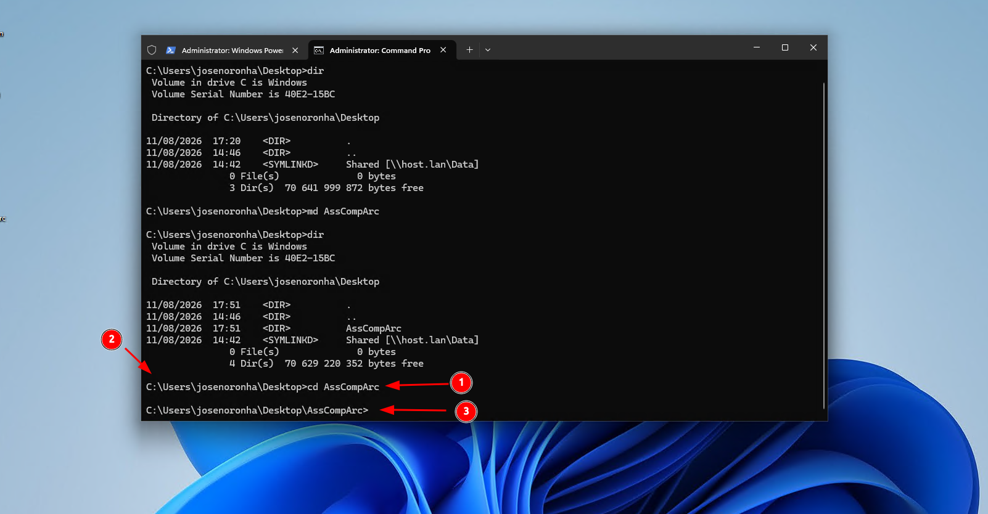
Figure 10 - Batch cd command
The “cd” command is used to change the directory, receiving the target path as an argument. As shown in the image above, I will change to the directory created with the “md” command, in this case “C:\Users\josenoronha\Desktop\AssCompArc” as described below:
- “cd” command with the path argument.
- Initial directory before executing “cd”: C:\Users\josenoronha\Desktop.
- Working directory after executing the cd command.

Type
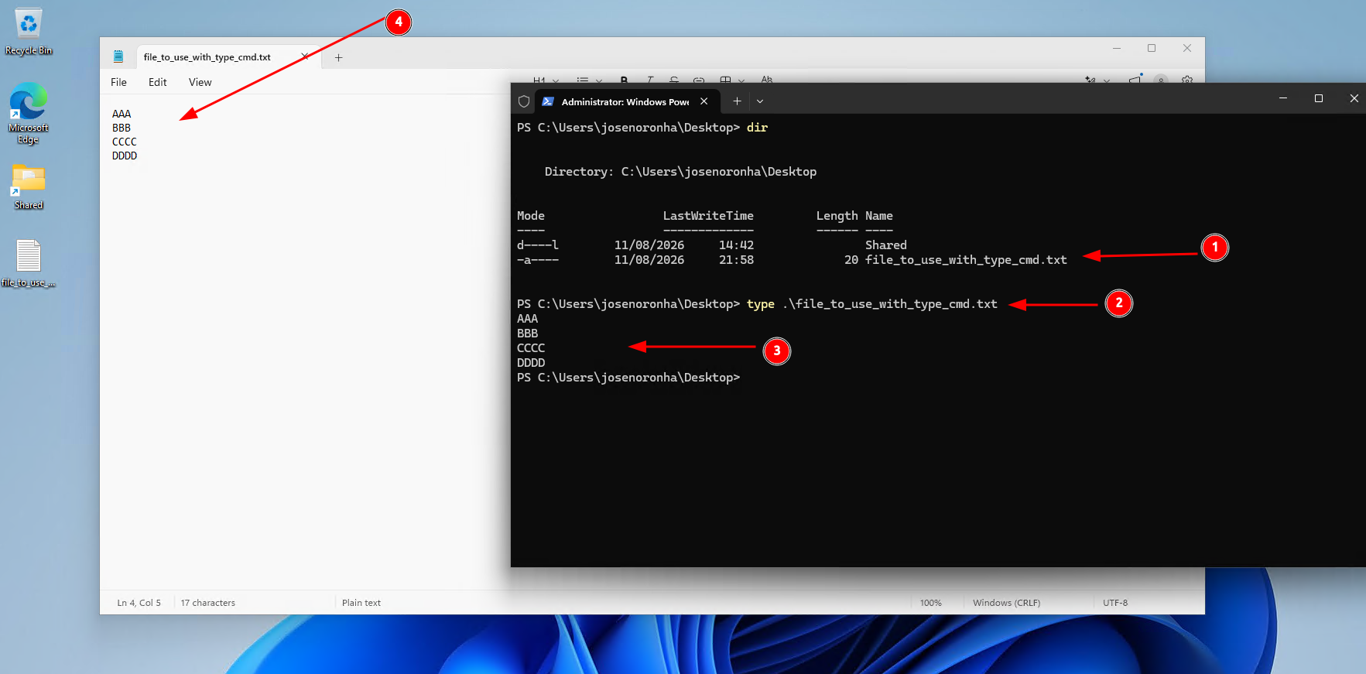
Figure 11 - Batch type command
The “type” command is used to display the contents of a text file directly in the terminal.
- List of files present in the Desktop directory.
- Command accepting a file as an argument to output its contents.
- Command output, which in this case is the content of the file.
- Contents of the file displayed in Notepad.
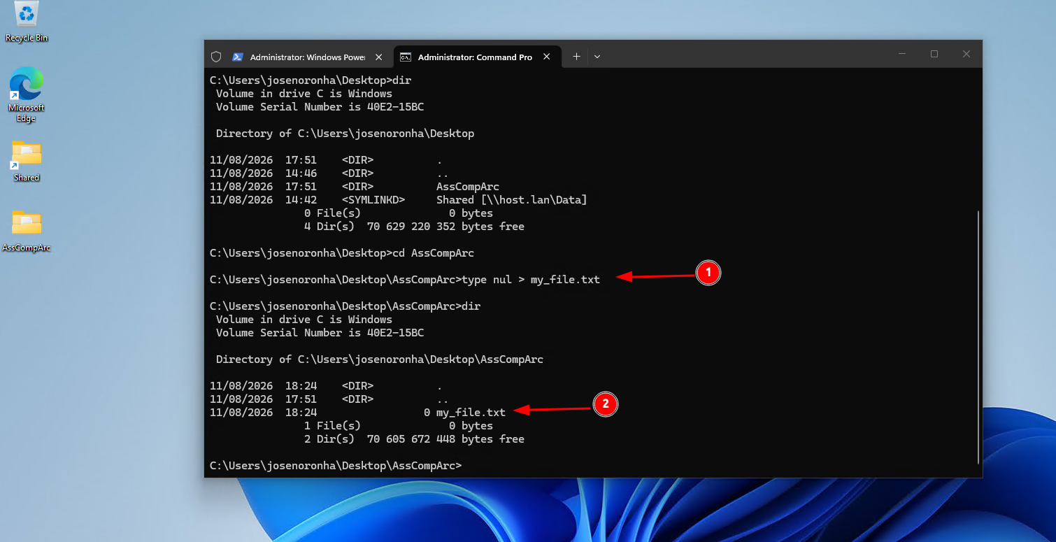
Figure 12 - Batch type command used to create empty file
However, in the image above, I am creating an empty text file (with no content). To do this, I pass the “nul” argument and redirect(“>”) the output of type to the file “my_file.txt”, which creates the file if it does not already exist.
With that in mind, here is the breakdown of the image above:
- Command to create the empty file.
- Confirmation that the file was successfully created.

Copy
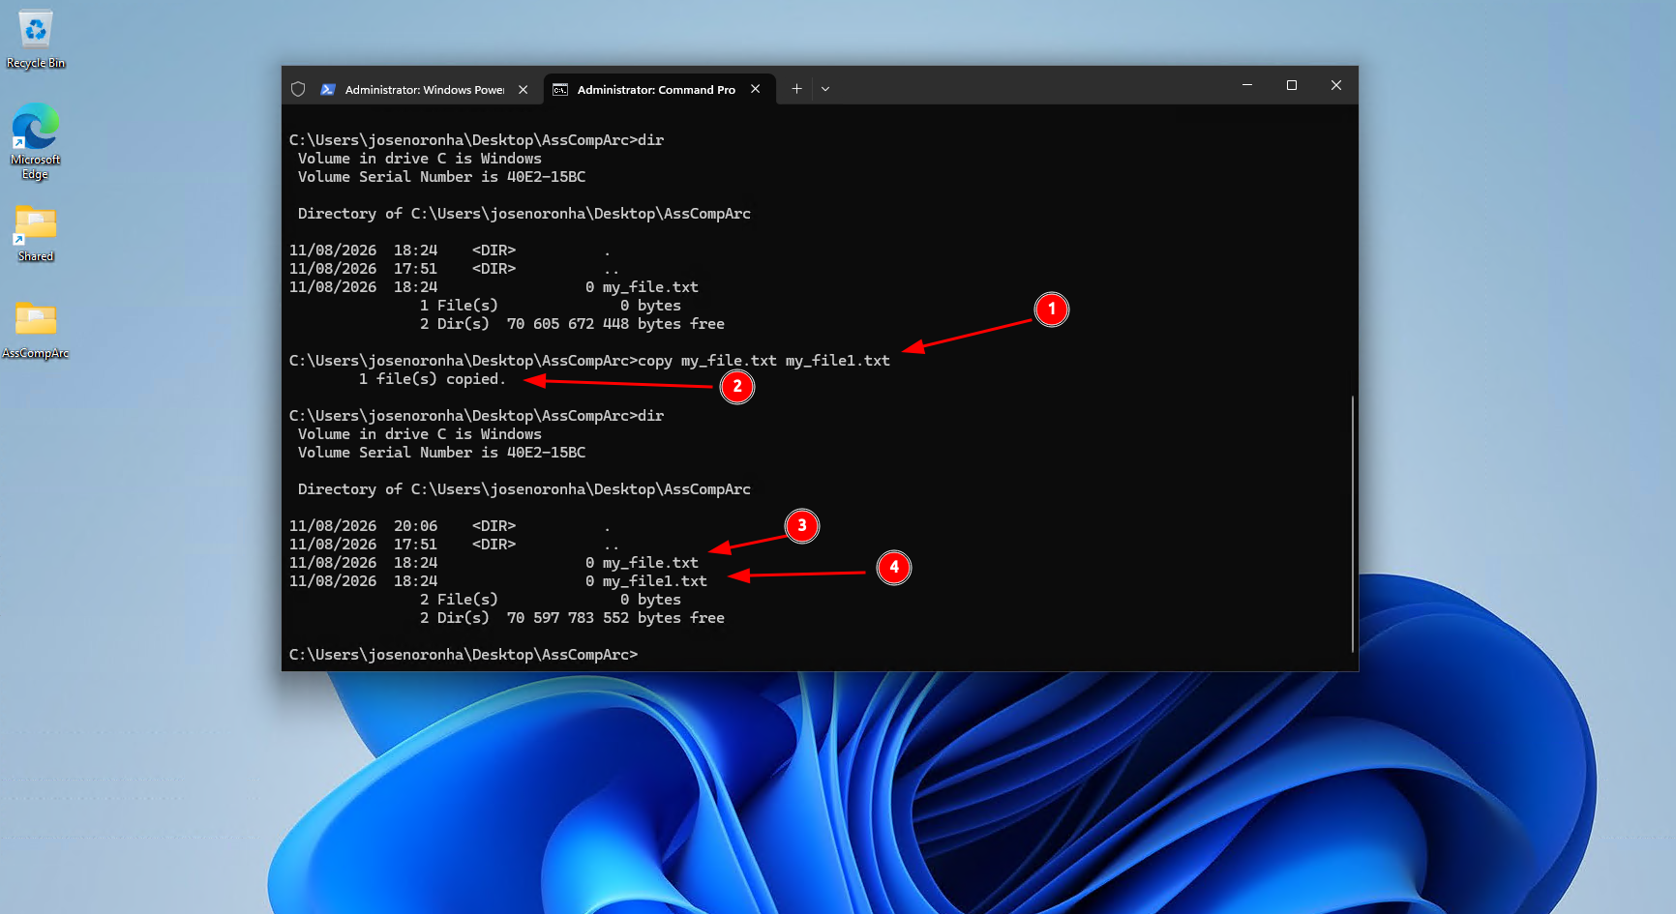
Figure 13 - Batch copy command
The “copy” command is used to copy a file, as described in the image above:
- The “copy” command with its arguments, where: “my_file.txt” is the source file, and “my_file1.txt” will be the name of the copied file.
- “copy” command output.
- Source file
- Confirmation that the file was successfully copied.

Del
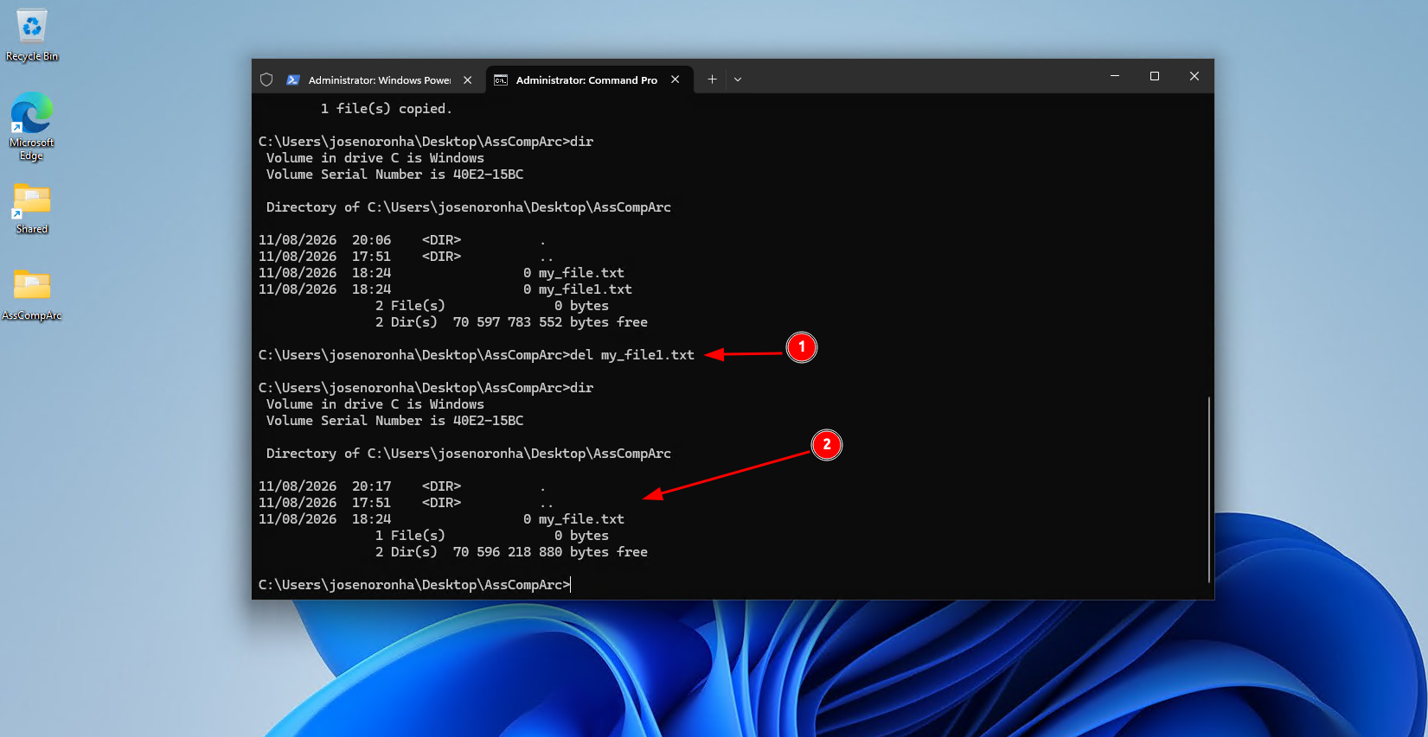
Figure 14 - Batch del command
The “del” command is used to delete files, as shown in the image above:
- Command “del” specifying the target file for deletion.
- Confirmation that the file was successfully deleted.

Move-Item
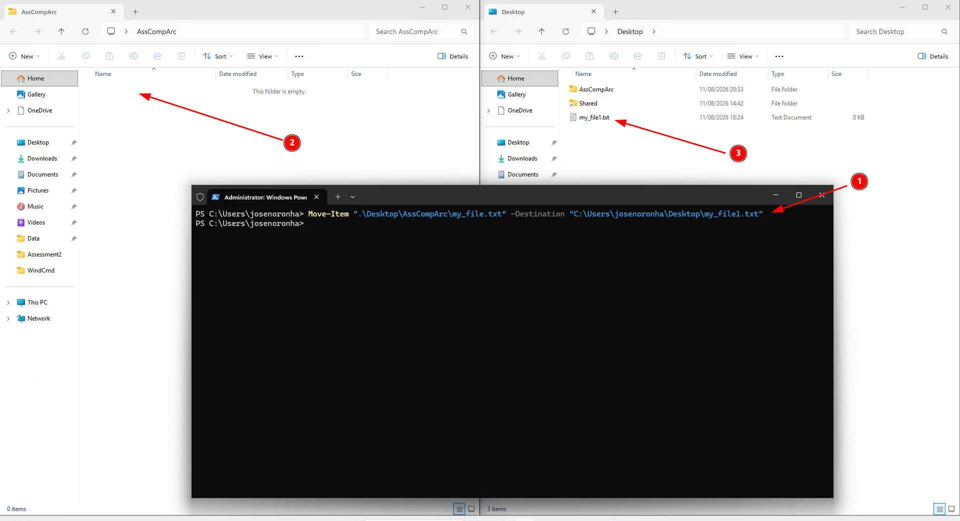
Figure 15 - PowerShell Move-Item command
The “Move-Item” command serves to relocate files or directories, as illustrated in the image above:
- Command specifying the target source file to move and the destination where the file should be moved.
- Verification that the file is no longer present in the source directory.
- Confirmation that the file was successfully moved.

Get-Process
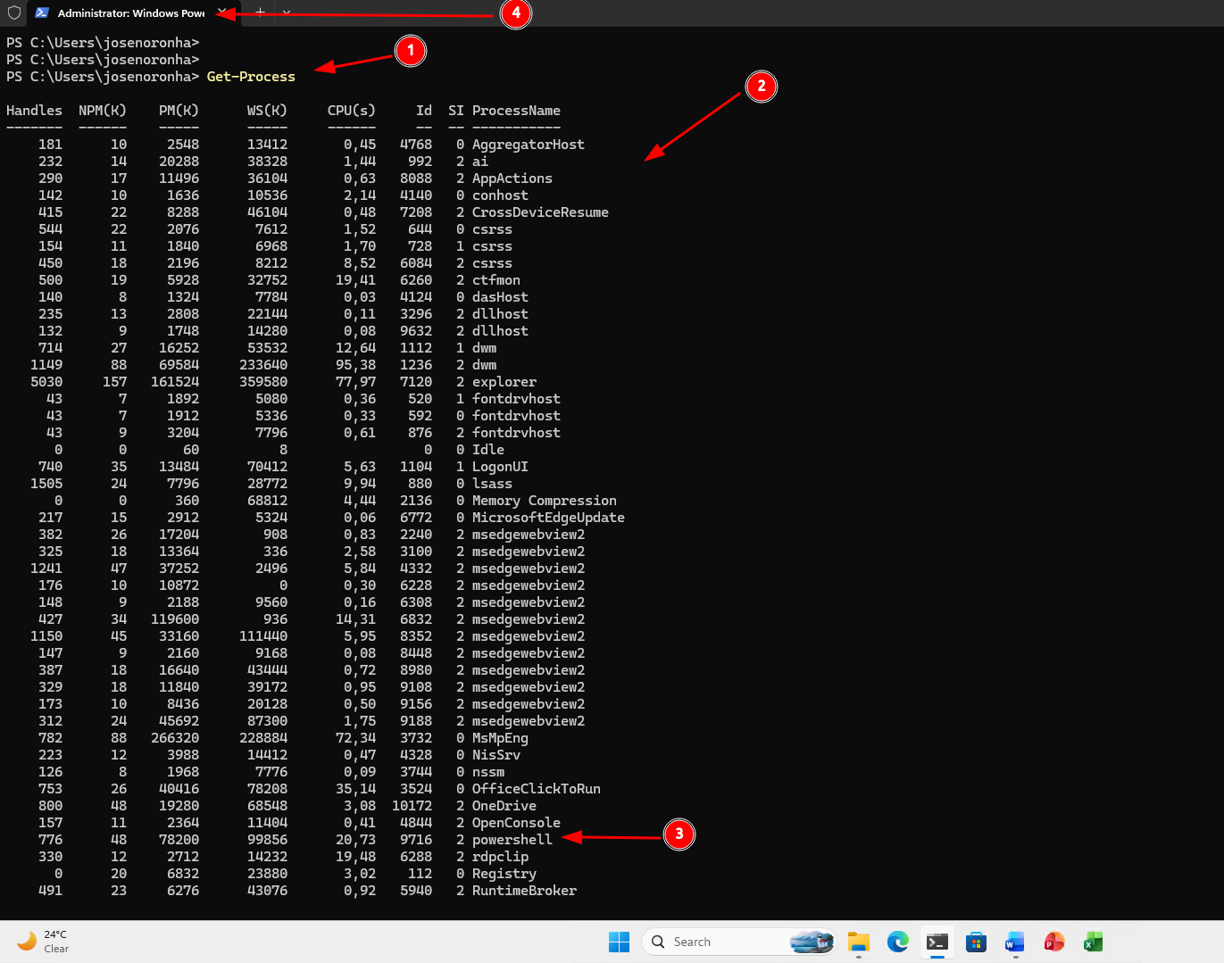
Figure 16 - PowerShell Get-Process command
The “Get-Process” command serves to list active processes in real time, alongside their respective process information, as illustrated in the image above and detailed below:
- The command “Get-Process”.
- “Get-Process” command output.
- This row tells me that PowerShell is currently running and shows all its process information.
- Confirmation that PowerShell is currently running.

Get-ComputerInfo
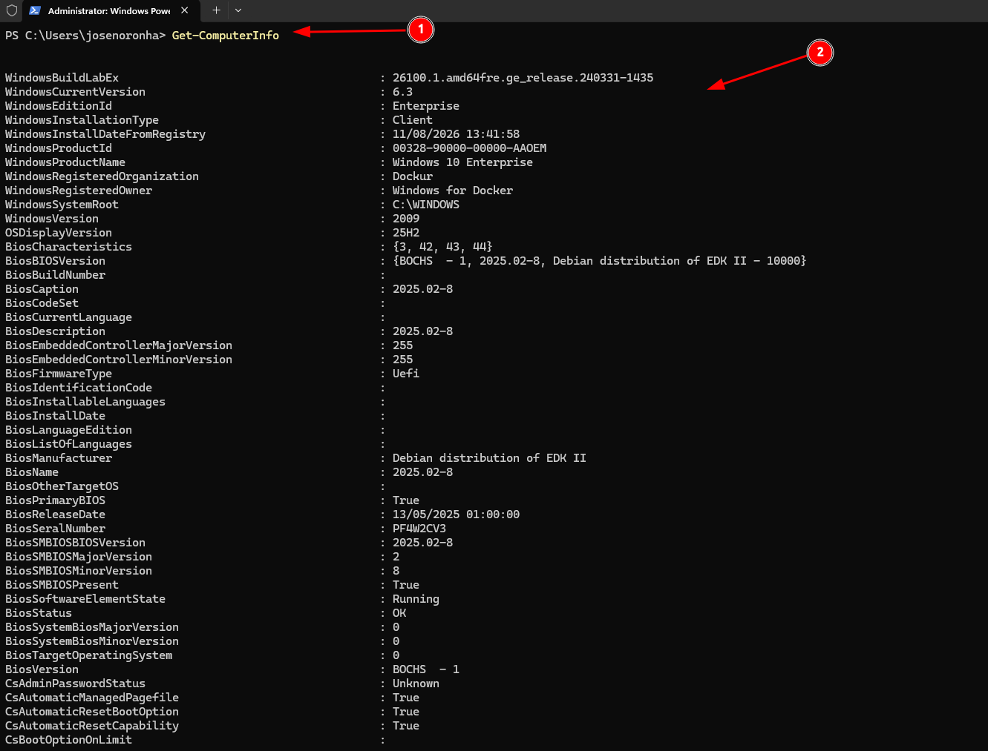
Figure 17 - PowerShell Get-ComputerInfo command
This command, “Get-ComputerInfo” displays a full summary of the operating system and computer hardware.
- The command “Get-ComputerInfo”.
- “Get-ComputerInfo” command output.

Select-String
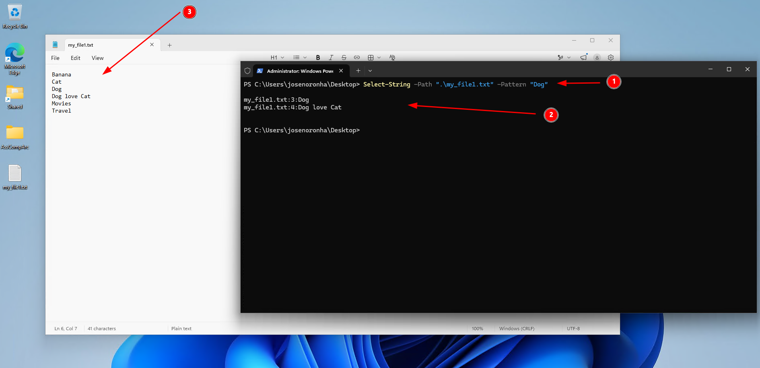
Figure 18 - PowerShell Select-String command
This command “Select-String” is used to search for words, phrases, or text patterns within a text file or through output redirection from another command. For example, the “Write-Host” command, which displays a text message in the terminal.
Description of the above figure:
- The “Select-String” command where “-Path” receives the text file and “-Pattern” receives the word to search for. In this case, the word is “Dog”
- “Select-String” command output. This line “my_file1.txt:3:Dog” contains the following information “file:line_containing_the_word:line_content”.
- The complete contents of the specified file.

Use of Linux OS CLI commands

Ls
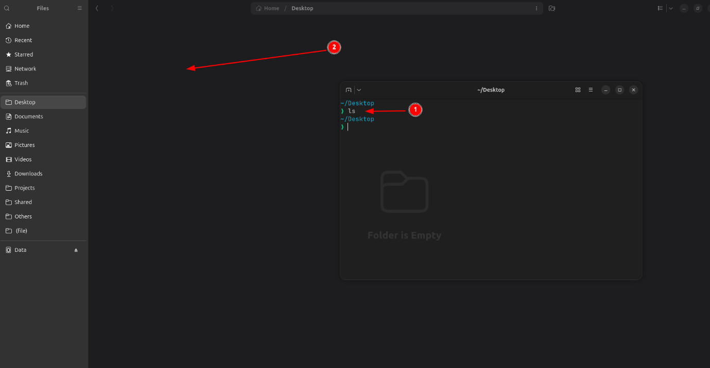
Figure 19 - Bash ls command
The “ls” command lists all files and folders in the current working directory. You can also pass a path as an argument to target a specific directory: “ls <directory>”.
In the image above, I am listing the files and folders located in the Desktop directory, as follows:
- The command “ls”.
- Confirmation that “Desktop” folder is currently empty.

Mkdir
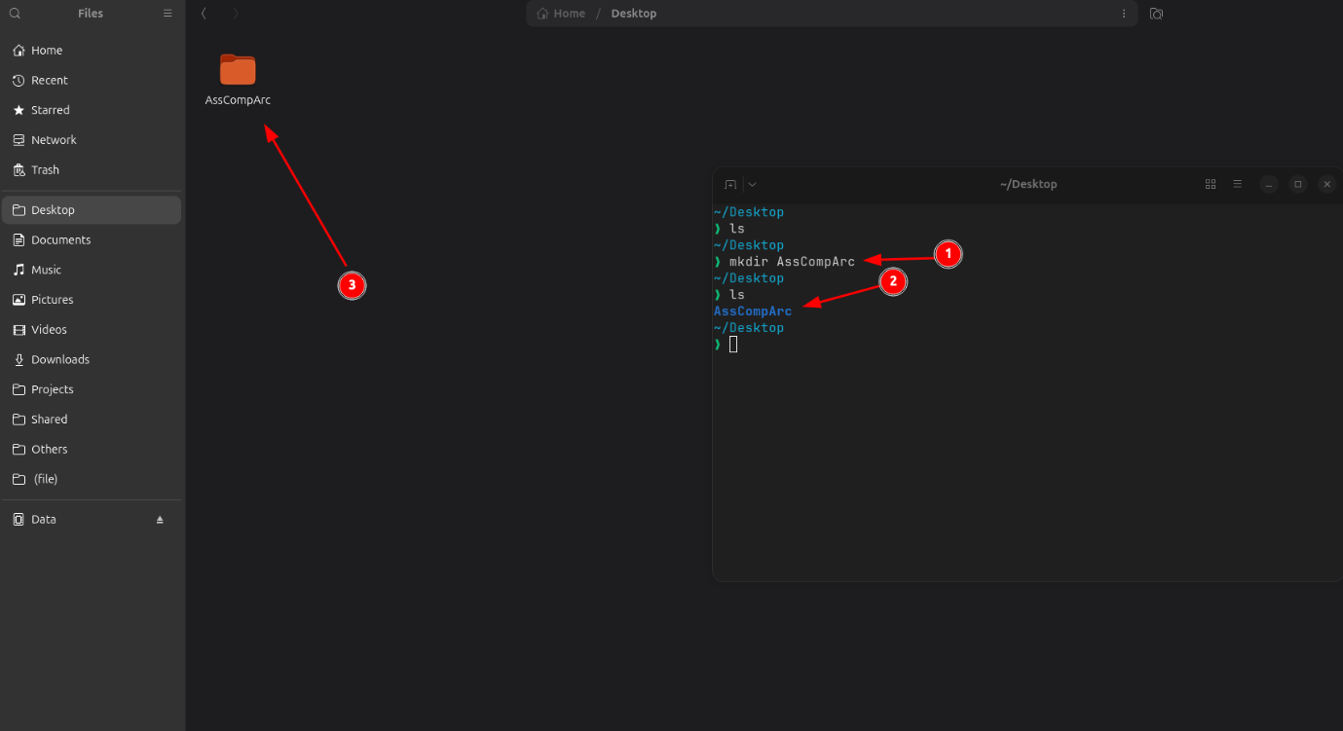
Figure 20 - Bash mkdir command
Using the “mkdir” command, folders can be created as shown above and described below following the numbered image:
- The “mkdir” command accompanied by the name of the folder I want to create. In this case “AssCompArc”.
- Execution of the “ls” command to verify whether the folder was actually created and confirmation that the folder was successfully created.
- Verification of successful folder creation via File Explorer.

Cd
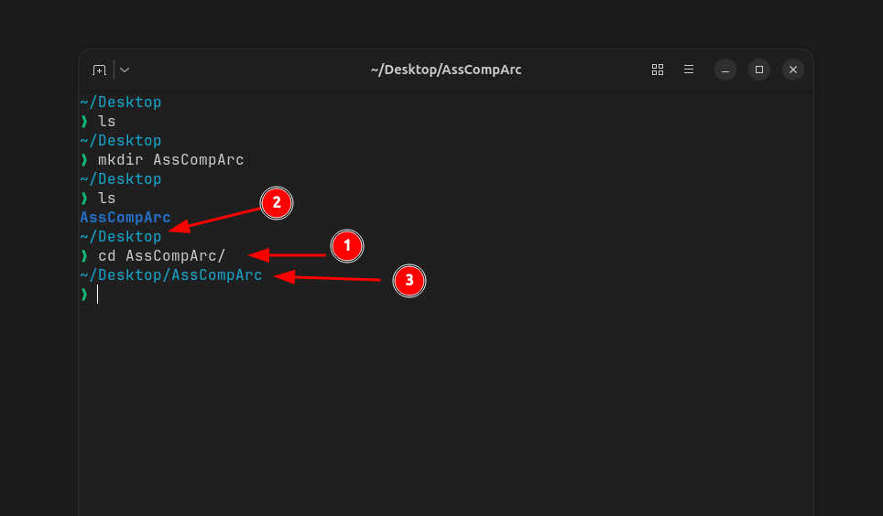
Figure 21 - Bash cd command
The “cd” command is used to change the directory, receiving the target path as an argument. As shown in the image above, I will change to the directory created with the “mkdir” command, in this case “~/Desktop/AssCompArc” as described below:
- “cd” command with the path argument.
- Initial directory before executing “cd”: ~/Desktop.
- Working directory after executing the cd command.

Touch
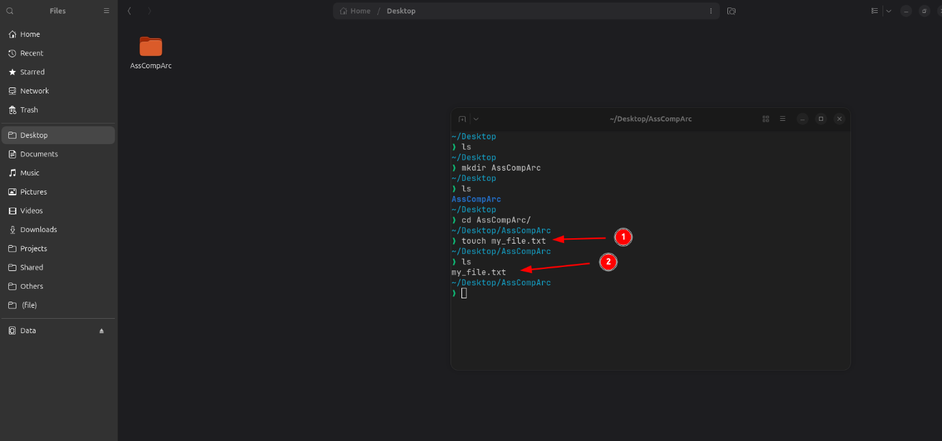
Figure 22 - Bash touch command
The “touch” command is used to create an empty text file (with no content).
With that in mind, here is the breakdown of the image above:
- Command to create the empty file.
- Confirmation that the file was successfully created.

Cp
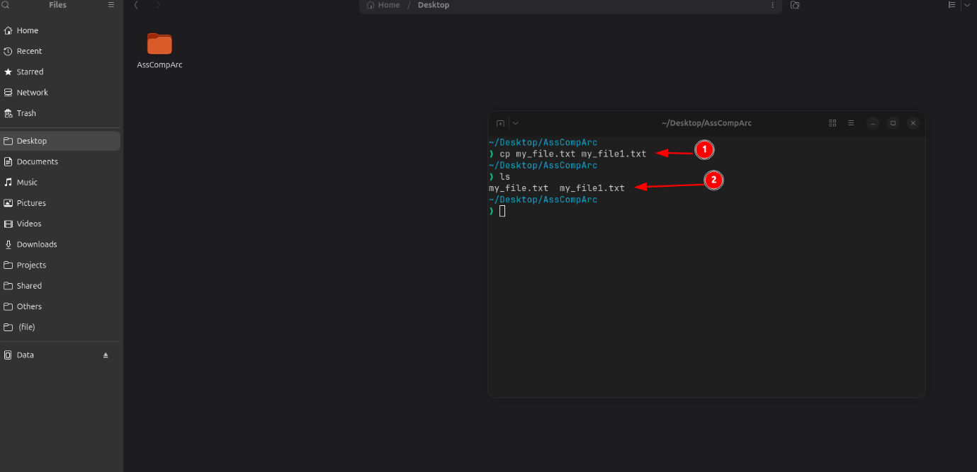
Figure 23 - Bash cp command
The “cp” command is used to copy a file, as described in the image above:
- The “cp” command with its arguments, where: “my_file.txt” is the source file, and “my_file1.txt” will be the name of the copied file.
- Confirmation that the file was successfully copied.

Mv
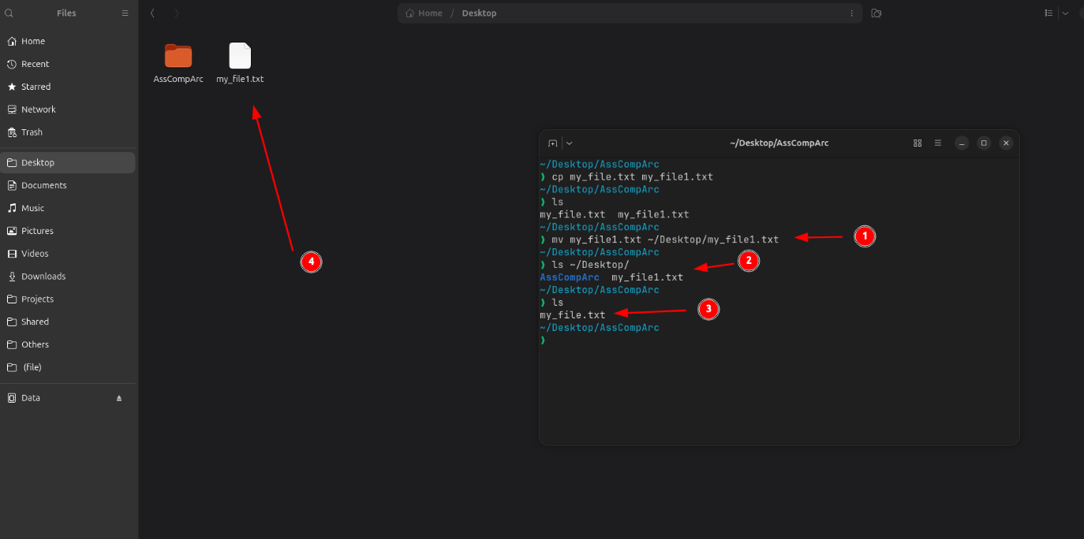
Figure 24 - Bash mv command
The “mv” command serves to relocate(or rename) files or directories, as illustrated in the image above:
- Command specifying the target source file to move and the destination where the file should be moved.
- Verification that the file is no longer present in the source directory.
- Confirmation that the file was successfully moved.
- Confirmation that the file was successfully moved via file explorer.

Rm
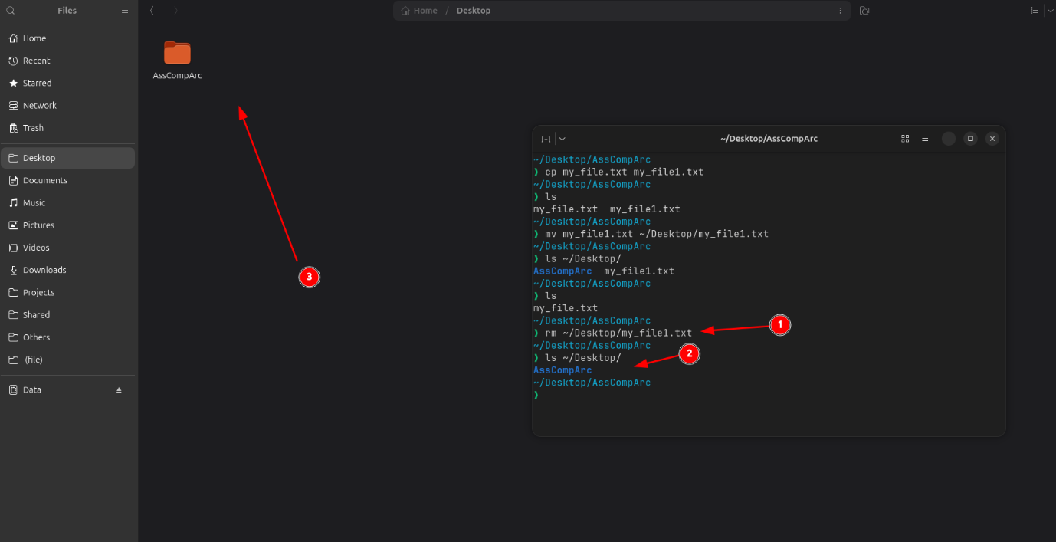
Figure 25 - Bash rm command
The “rm” command is used to delete files and directories, as shown in the image above:
- Command “rm” specifying the target file for deletion.
- Confirmation that the file was successfully deleted via terminal.
- Confirmation that the file was successfully deleted via file explorer.

Cat
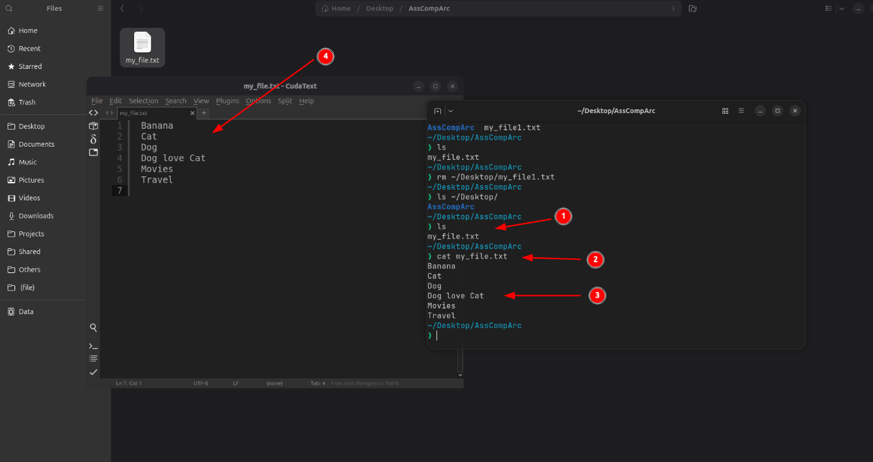
Figure 26 - Bash cat command
The “cat” command is used to display the contents of a text file directly in the terminal.
- List of files present in the “AssCompArc” directory.
- Command accepting a file as an argument to output its contents.
- Command output, which in this case is the content of the file.
- Contents of the file displayed in text editor app.

Grep
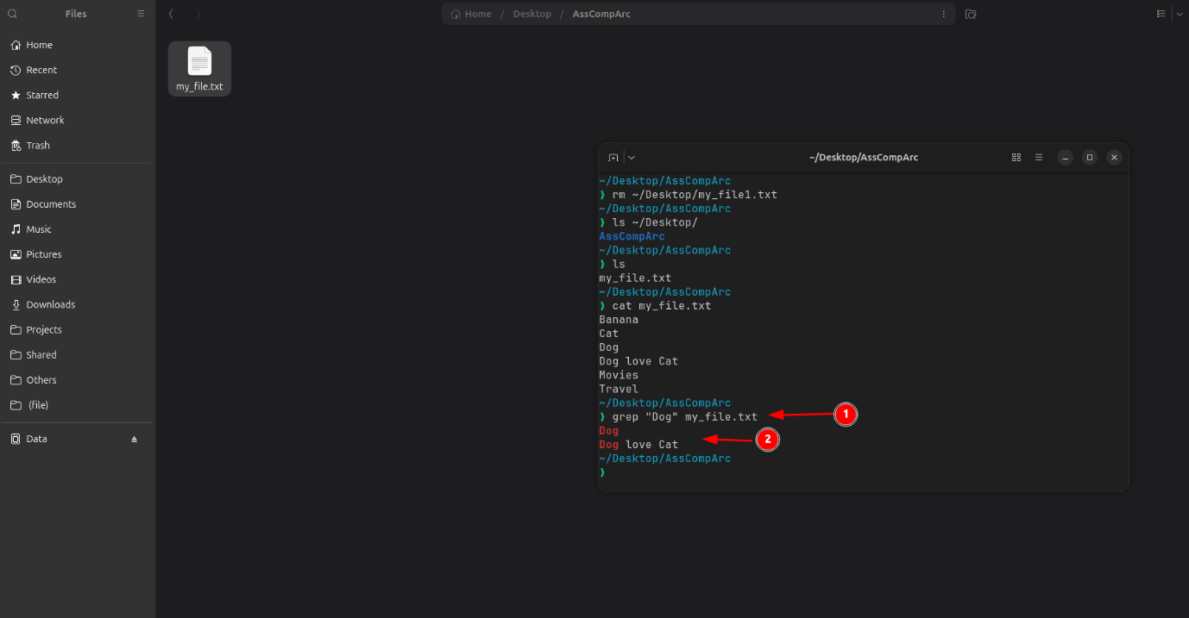
Figure 27 - Bash grep command
This command “grep” is used to search for words, phrases, or text patterns within a text file or through output redirection from another command. For example, the “echo” command, which displays a text message in the terminal.
Description of the above figure:
- The “grep” command where the first argument receives the word to search for and the second receives the text file. In this case, the word is “Dog”
- “grep” command output.

Ps
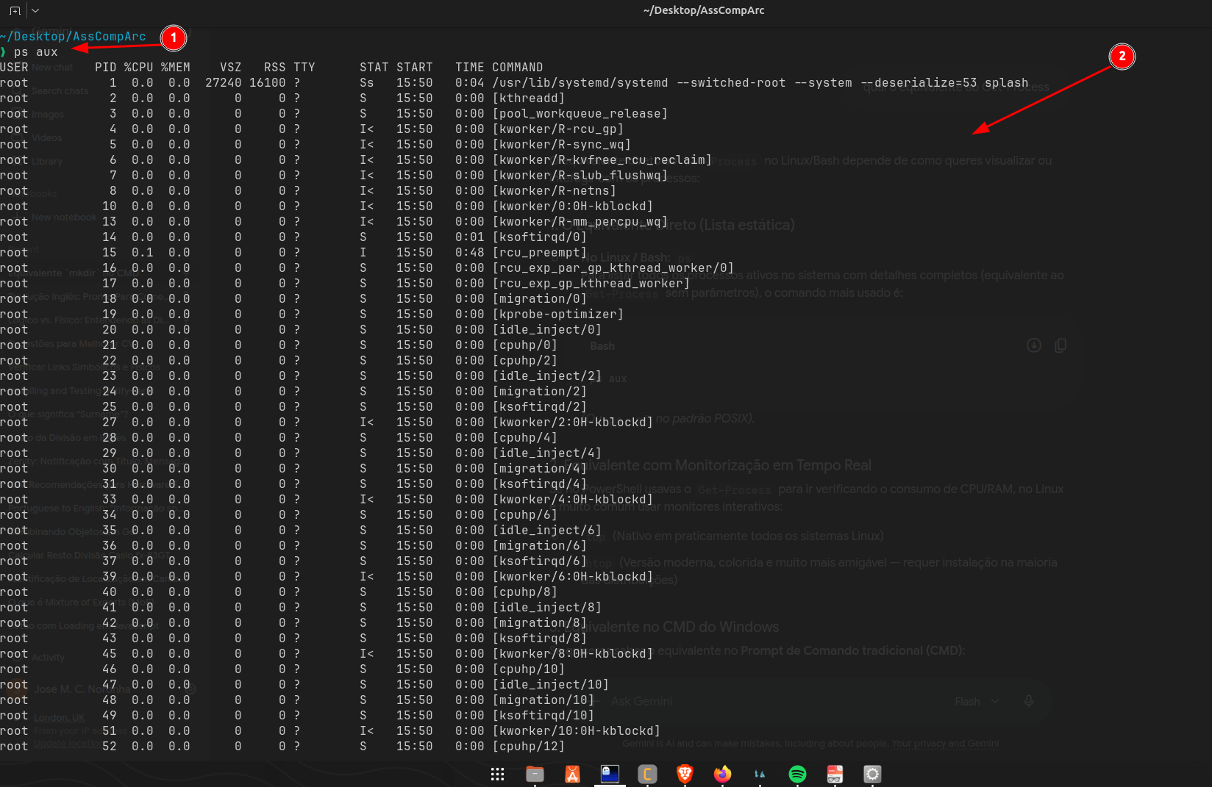
Figure 28 - Bash ps command
The “ps” command serves to list active processes in real time, alongside their respective process information, as illustrated in the image above and detailed below:
- The command “ps”. In short, the “aux” arguments tell the command to list all processes for all users, with or without a terminal, in detailed format (including CPU, RAM, etc.).
- “ps” command output.

Use of Windows OS scripts
I decided to develop two batch scripts: the first acts as a calculator, while the second receives only the calculation output to display it on the console. Following this, the first script completes its execution, displaying a termination message.
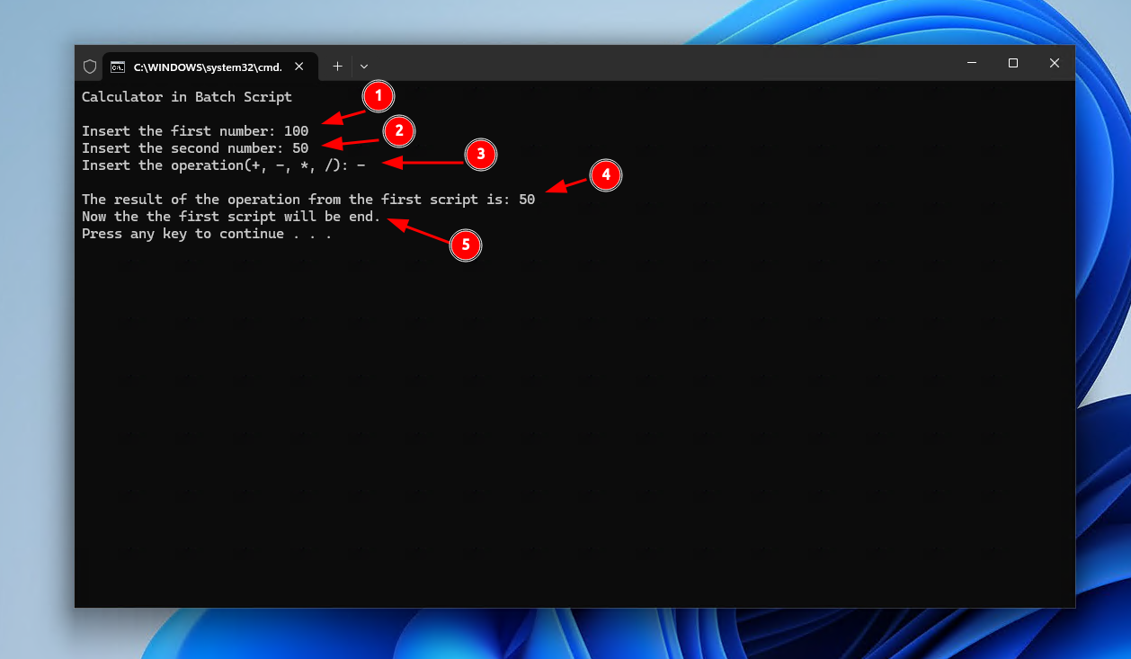
Figure 29 - Batch script calculator running
- First number inserted by user
- Second number inserted by user
- The operation inserted by user
- Display the result from the second script
- Display the end message from the first script
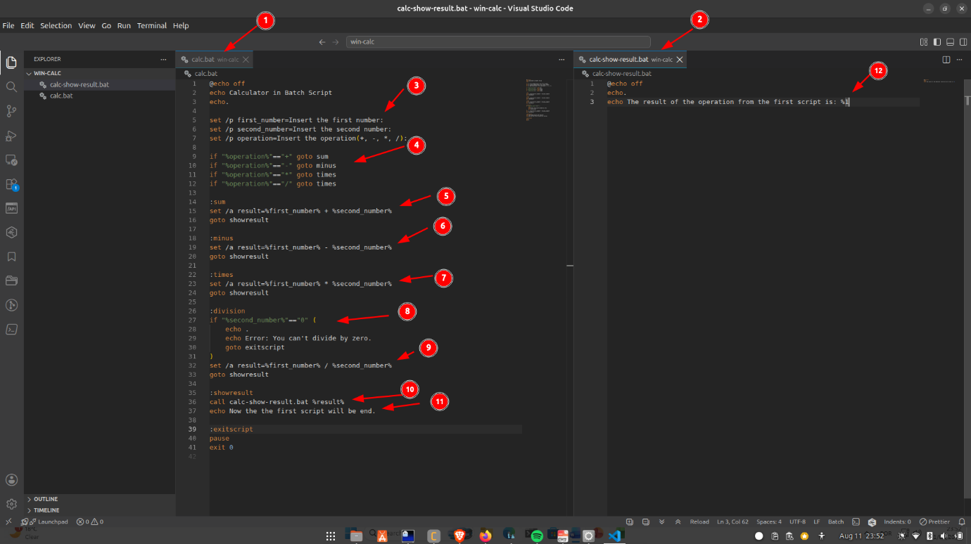
Figure 30 - Batch scripts implementation
Description of the script implementation shown in the figure above:
- First script with name: calc.bat.
- Second script with name: calc-show-result.bat.
- Requests user input for the required values and the arithmetic operation.
- Depending on the user-selected operation, the matching function is invoked to execute the operation.
- If addition is selected, the corresponding function performs the sum and subsequently invokes the result display function.
- If minus is selected, the corresponding function performs the sum and subsequently invokes the result display function.
- If times is selected, the corresponding function performs the sum and subsequently invokes the result display function.
- For division: validates that the second number is non-zero before proceeding.
- If division is selected, the corresponding function performs the sum and subsequently invokes the result display function.
- The second script is invoked via the “call” command to display the output, receiving the result as a positional argument.
- Once the output is rendered by the second script, control returns to the primary process to display the final exit message.
- The second script renders the output passed to it via command-line argument.

Use of Linux OS scripts
Since I developed the scripts to mirror the behavior of the Windows OS scripts, I will only provide descriptions for the images below.
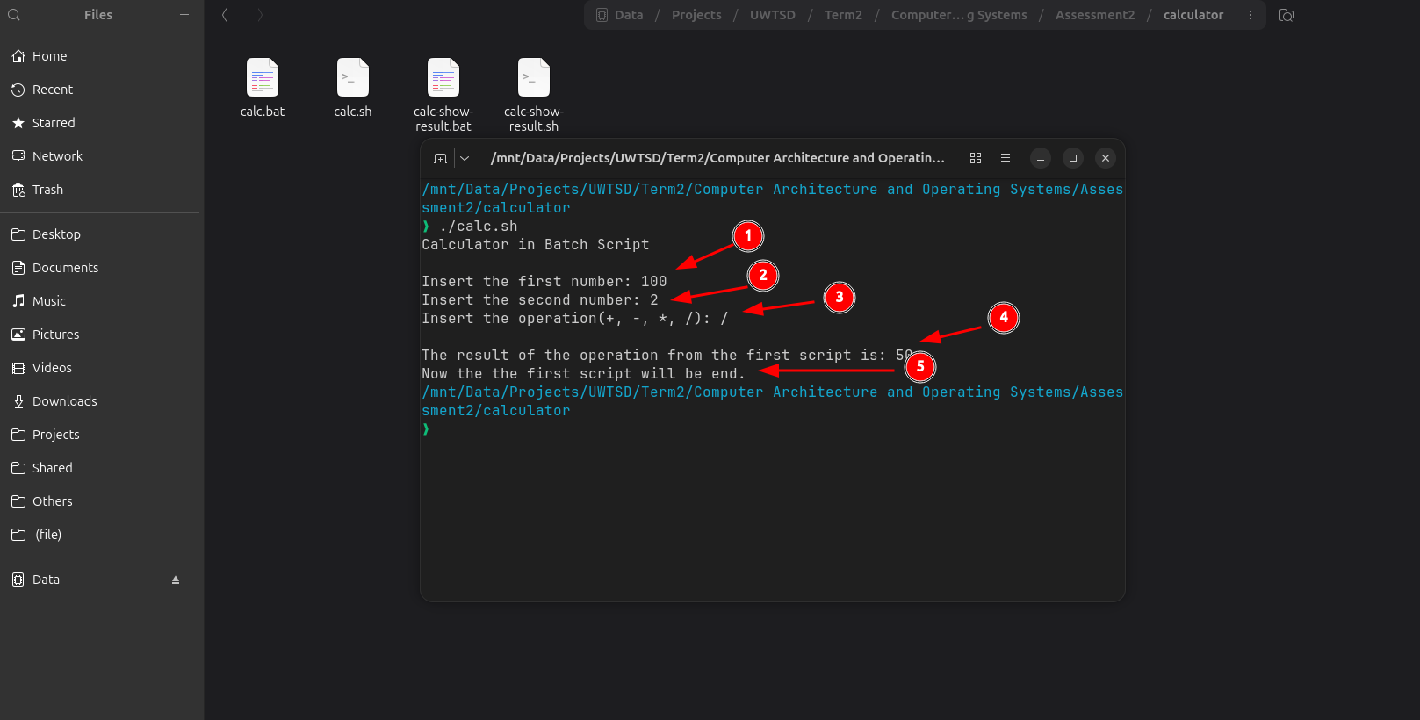
Figure 31 - Bash script calculator running

- First number inserted by user
- Second number inserted by user
- The operation inserted by user
- Display the result from the second script
- Display the end message from the first script

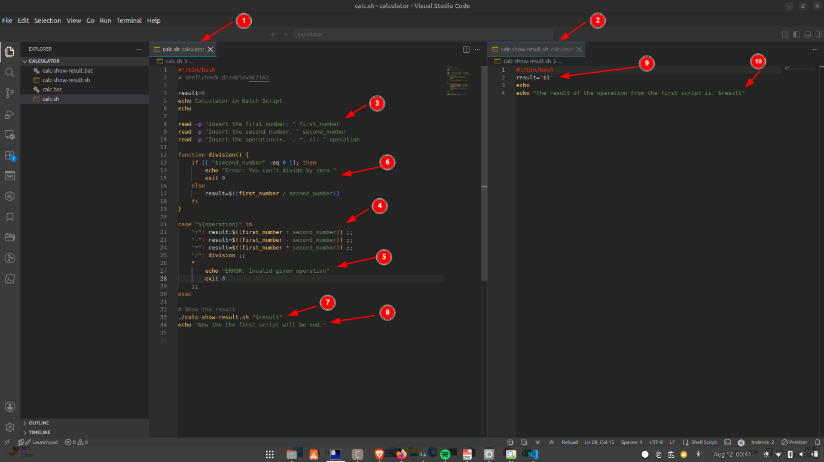
Figure 32 - Bash scripts implementation
Description of the script implementation shown in the figure above:
- First script with name: calc.sh.
- Second script with name: calc-show-result.sh.
- Requests user input for the required values and the arithmetic operation.
- Depending on the user-selected operation, the matching function is invoked to execute the operation.
- If user inserted an invalid operation, will display an error message and exit.
- For division: validates that the second number is non-zero before proceeding. If zero, will display an error message and exit.
- The second script is invoked to display the output, receiving the result as a positional argument.
- Once the output is rendered by the second script, control returns to the primary process to display the final exit message.
- The incoming argument is assigned to the “result” variable within the second script.
- The second script renders the output passed to it via command-line argument.

Conclusion
In this project, it was possible to analyze the main functions of operating systems in general, which was not easy to find. However, I managed to draw some valuable lessons regarding these features.
Regarding the commands, it was relatively straightforward since I was already used to using them on both Windows and Ubuntu. Therefore, it was only necessary to look up a few explanations, such as in the case of the “ps aux” command.

References
[1] M. Kulkarni, "Analysis of Process Structure in Windows Operating System," vol. 7, no. 6, pp.1–5, 2020,
[2] J. Moran, File management made simple, windows edition, Springer, 2015.
[3] D. Gibson, Microsoft Windows Networking Essentials, John Wiley & Sons, 2011.
[4] C. Panek, Windows Operating System Fundamentals, John Wiley & Sons, 2019.
[5] J. Lambert and S. Lambert,Windows 10 Step by Step, Microsoft Press, 2015.

