Name: Shuhaib Akkalath
Student ID: 2131583
MBA General Management
Dissertation LCMB7020_LON
2023
Supervisor: Rexon Nting

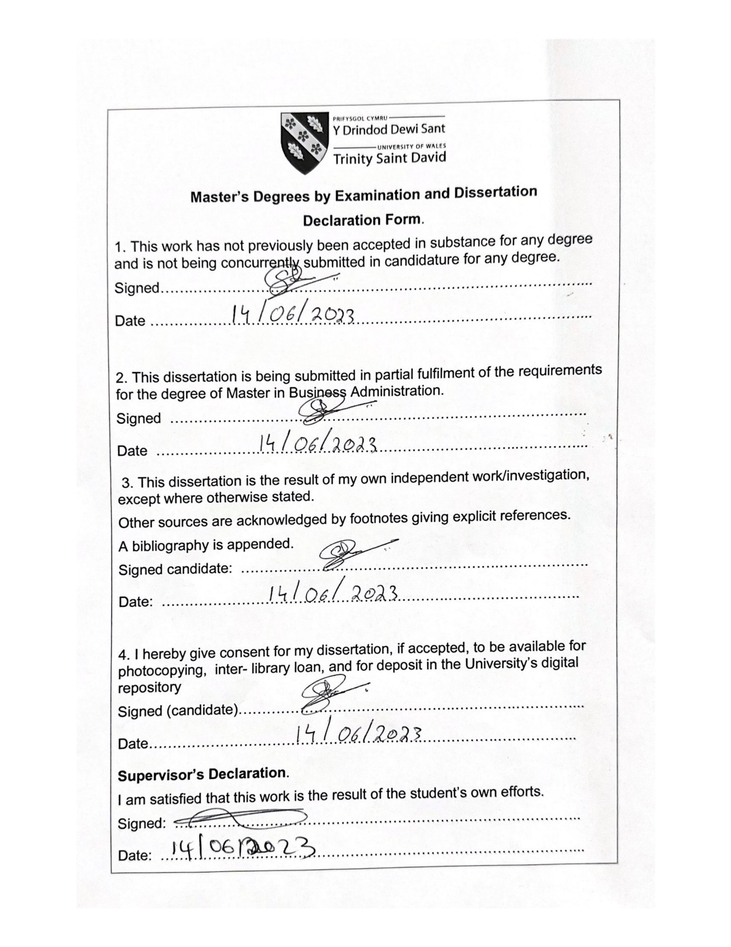

EVALUATION OF THE INCREASING SIGNIFICANCE OF CSR APPLICATIONS IN SUPPLY CHAIN OPERATIONS AND PROCUREMENT PROCESS IN THE UK RETAIL SECTOR

Abstract
The introduction chapter of the dissertation has focused on evolving the significance and rationale of the research. The initiatives for CSR policies that are important within the UK retail sectors have been initiated in the study effectively. The Issues and challenges to the approach have also been identified in this chapter. Furthermore, it provides an overall structure of the dissertation for further completion of the study.
The literature review chapter of the research has shed light on the proper implication of sustainable supply chain management in relation to the allocation of relevant theories and models. The implication of Artificial Intelligence, Carroll’s Pyramid of CSR, Triple Bottom Line theories have also been discussed in the study. The agile methodology has been evaluated in the study for the application and digital transformation in the retail industry. Various recommendations are forwarded against the improvement in the CSR approach has been determined in this chapter.
This methodology has included a research philosophy and the entire data collection process. The exclusion and inclusion criteria also discussed in this research. This methodology also discussed the ethical consideration in this research. A complete chapter summary has included in this research. Training the workers is essential for influencing workers to recognise the significance of CSR policies. The conclusion part of the study summarises the outcome of the research and also mentions the limitations linked with this research.
Training the workers is essential for influencing workers to recognize the significance of CSR policies. The conclusion part of the study summarizes the outcome of the research and also mentions the limitations linked with this research. It had been also analysed from the survey respondents; the CSR application in SCM promotes productivity and efficiency levels within the companies of the retail industry. It provides the findings and analysis that includes the challenges that are faced by the different retail companies for the CSR activities. In addition, it has also included the recommendations that can help to mitigate with this challenges. The supply chain in Sainsbury’s can be updated by applying end-to-end visibility in the supply chain, especially in the UK market. This study has recommended that the optimisation of transportation, circular economy, green supply chain and eco-friendly sourcing can be labelled as some of the effective strategies to apply CSR in business supply chain and procurement successfully.

Table of Contents
1.0 Introduction 4
1.1 Research Background 4
1.2 Rationale 5
1.3 Aims 7
1.4 Research Objectives 7
1.5 Research Question 7
1.6 Research Significance 7
1.7 Structure of Dissertation 9
1.8 Chapter Summary 9
2.0 Literature Review 10
2.1 Introduction 10
2.2 Conceptual Framework 10
2.3 Significance of CSR Application to Control the Procurement Process of Supply Chain along e-procurement by applying the triple bottom line theory 11
2.4 Application of Carroll’s Pyramid Theory to Increase the CSR Approaches of the retail industry 12
2.5 Practical Challenges in the implementation of CSR in Procurement and Supply Chain of the Retail industry 14
2.6 Application of Stakeholders value theory in the CSR Practices of the retail industry 15
2.7 Implication of Situational Leadership Theory to Increase Supply Chain Operation within the retail industry 17
2.8 Implementation of artificial intelligence to Increase the supply chain operation of the retail industry 18
2.9 Application of behavioural management theory to Increase the supply chain operation of the retail industry 20
2.10 Implications of the Agile project management methodology for developing projects related to the supply chain in the retail industry 21
2.11 Recommending potential solutions to use circular economy and avoid conflicts by treating suppliers equally with the application of legal laws and regulations 23
2.12 Literature gap 23
2.13 Chapter Summary 24
3.0 Research Methodology 25
3.1 Introduction 25
3.2 Research philosophy 25
3.3 Research approach 25
3.4 Research design 26
3.5 Research Strategy 26
3.6 Data type 27
3.7 Data collection methods 27
3.8 Tools and Techniques 27
3.9 Data analysis 28
3.10 Inclusion exclusion criteria 28
3.11 Sampling Method and sample size 28
3.12 Ethical Consideration 28
3.13 Research Timeline 29
3.14 Chapter Summary 29
Chapter 4: Findings, Analysis, Discussion 30
4.1 Introduction 30
4.2 Findings 30
4.3 Analysis 38
4.4 Discussion 43
4.5 Chapter Summary 46
Chapter 5: Conclusion and Recommendation 48
5.1 Conclusion 48
5.2 Objective Linking 49
5.3 Limitations of the Study 49
5.4 Recommendation 50
Reference List 52
Appendices 64
Appendix 1: 64

List of Figures
Figure 1: Retail sales values in the UK for the year 2005-2022 6
Figure 2: Sustainability credentials among the retailers within the UK based on consumer ranking 7
Figure 3: Socially Responsible Investments in the UK within the UK retail sector 9
Figure 4: Dissertation structure 10
Figure 5: Conceptual framework 12
Figure 6: Triple bottom line theory 13
Figure 7: Carroll’s CSR pyramid model 14
Figure 9: Shareholder value theory 18
Figure 10: Situational leadership theory 19
Figure 11: Implication of AI in the global retail industry and supply chain 20
Figure 12: Aspects of Behavioural Theory in inducing performance within the retail sectors 22
Figure 13: Steps of Agile Methodology in Project Management 23

1.0 Introduction
The potential benefits of CSR with better brand recognition, positive reputation on business with increased sales and customer loyalty within the UK retail sectors have been analysed in the study. The meaningful differences and creating opportunities within the UK retail sectors to align with customer values have been analysed in the study. Providing the organisations with concerted efforts to enhance the operational activities to impact the environment and society are identified in the study. The increasing number of company initiatives to implement the practices towards CSR initiatives has been analysed in this chapter. The challenges and issues faced by the retail sectors while implementing CSR activities have been analysed in the study.

1.1 Research Background
The CSR activities in the retail sectors give insight into the program's support to meet the strategic goals within the organisations. Highlighting the significance of conducting business operations with larger societal benefits is observed. The retail industry in the UK consists of 3000,000 separate businesses representing over 8% of jobs within such sectors (Ons.gov.uk, 2021). The retail industry is an essential part of the economy comprising a GDP of over 5.2 % in the UK. Companies such as Tesco, Asda, Sainsbury’s and others the primary reason for such growth. The study focuses on analysing the relationship between CSR activities and growth in sales revenue within the retail sectors’ organisation such as Sainsbury’s. The benefits of CSR are associated with creating meaningful differences with more opportunities for the customers and aligning with business and values within the organisation.
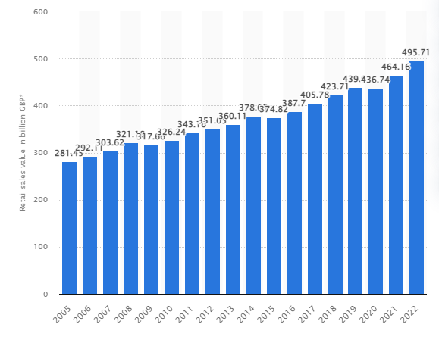

Figure 1: Retail sales values in the UK for the year 2005-2022
(Source: Statista.com, (2022)
The retail sector in the UK is focused on creating value for its members and communicating the way they operate for running a successful business. The initiative of “Better Retail and Better World” was initiated in 2018 to mobilise the retail industry to make a leading contribution to the SDG goals within the organisation (Brc.org.uk, 2023). The importance of the study lies in the fact of strategic prioritisation of SDG as an issue of measurement of metrics, communicating with the stakeholders and financial commitment for sustainability and economic growth within such sectors. Sainsbury’s has developed a five year plan for this business operation while preserving sustainability considerations such as 50% plastic packaging reduction by 2025 (about.sainsburys.co.uk, 2022). Therefore, significance of SDG goals is understandable for retail companies. Managers of the UK retail firms need to comply with the UN SDGs for maintaining sustainable business operations along with providing better quality retail service to the customers.

1.2 Rationale
The CSR activities require a great amount of investment and the companies within the retail sector need to implement the CSR process for higher customer satisfaction. The UK government has provided an ultimate purpose of CSR to maximise shared value among the organisations, employees, customers and community. The importance of the “sustainable procurement policy” with the integration of society and economy to minimise the damage to the environment are the major CSR activities (Boruchowitch and Fritz, 2022). The sustainable procurement policy helps to build a “circular economy” to reduce the adverse socio-economic and economic impacts of the goods and services. Moreover, incorporation of circular economy can be beneficial for decreasing waste material production along with supports customers in reducing their carbon footprint.
The UK Government has the forefront of the global fight against climate change which has promised to reduce emissions by40% to pass laws and end the contribution to global warming by 2050. As per the view of Xu and Jackson (2019), consumers in the UK are more focused on decreasing their impact on the environment. The consumer is more focused on sustainable focused consumption and more than 35 % of their retail spending is based on sustainable retailers. The net Zero target refers to the government initiatives in the UK to reduce the emission by a statutory target of 80 %. This is noticeable in Sainsbury’s as well. Leveraging the ideas of the circular economy helps the retail business to deliver long-term value to the customers.
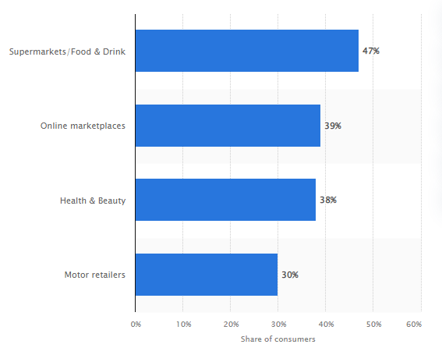

Figure 2: Sustainability credentials among the retailers within the UK based on consumer ranking
(Source: Statista.com, 2023)
The initiative needs to focus on creating a system with high-quality products and improve minimalism over consumerism within the retail sectors in the UK. Reinforcing the view and vision of “Cooperating for a fairer world” where the retail sector needs to focus on the sustainability of the planet and making efforts towards greener with greater customer focus committed to the environment (Brc.org.uk, 2023). Strategic initiatives for sustainability undertaken by Sainsbury’s rationalises this factor. The sustainable development goals with a driver to customer action and drive purchase decisions are also major concepts in effective CSR strategies within the organisation. The sustainability credentials of the valued consumers within the UK retail sectors have shown that the UK food and retail industry has the best suitability standards and practices (Statista.com, 2023). The pillars of sustainability in business operations within the retail sector focus on making sustainable choices and achieving the goal within the organisation. This can help UK-based retail firms in improving consumer services along with enhancing employee satisfaction rate for increasing corporate reputation.

1.3 Aims
The aim of the research is to analyse the increasing importance of CSR activities in the supply chain and procurement process within the UK retail industry.

1.4 Research Objectives
- To assess the increasing importance of CSR activities in the procurement process and supply chain management within the UK retail sector and Sainsbury’s
- To evaluate the significance of CSR efforts to produce a more productive and positive work environment for sustainable production and environmental practices in Sainsbury’s
- To analyse the challenges associated with the implementation of CSR practices within the UK retail sector
- To recommend effective CSR strategies to manage the effective supply chain and procurement strategies within the UK retail sector

1.5 Research Question
- What are the major reasons for improving the initiatives of the CSR activities within the UK retail sectors for effective procurement and supply chain management strategies?
- How are the effective CSR initiatives within the UK Retails Sectors to ensure sustainable production and environmental practices?
- What are the significant challenges faced by the UK retail sectors in designing an ideal CSR strategy for maintaining the supply chain and procurement processes?
- What are the various recommended strategies involved in enhancing the positive relations among the stakeholders and CSR initiatives within the UK retail sectors?

1.6 Research Significance
Sustainability within the supply chain helps to improve productivity by reducing costs within organisations. The study focuses on improving the suitable techniques and resources to build supply networks and digital foundation capabilities to transform the business towards environmental success has been analysed in the study. As opined by Centobelli et al. (2022), the supply chain is associated with the flow of processes involved in the production and distribution of products. The organisation needs to focus on areas of social responsibility including human rights, occupational health and safety and sustainable production practices. As per the view of Vătămănescu et al. (2021), sustainable procurement within the retail sector is to incorporate the corporate social responsibility principle for effective decision-making and meeting the needs of the stakeholders. The holistic approach towards CSR in Sainsbury’s is needed to be implemented to fully accept the responsibility of the services and to produce the products to sell within the retail sectors.
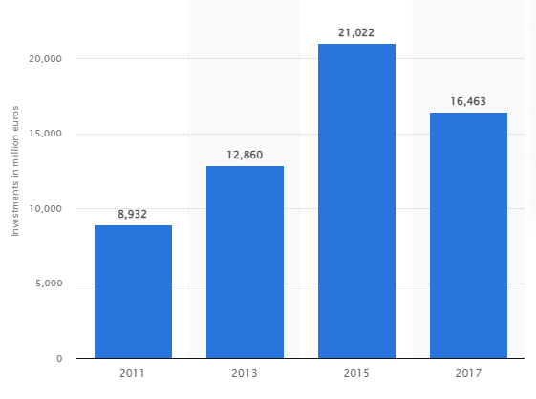

Figure 3: Socially Responsible Investments in the UK within the UK retail sector
(Source: Statista.com, 2018)

The above figure illustrates the total amount of “socially responsible investment” within the UK retail sector from 2011 to 2018. The CSR guidelines within the retail sectors in the UK have promoted the success of the organisation with strict legal duty with commitments and better operational processes within the organisations. CSR has a positive effect on competitiveness, loyalty to the consumers and better retail performance within such sectors. The study focuses on analysing the potential impact to examine the supply chain relationships within the retail industry. The impact on supplier performance has been mediated through improved cooperation and trust within retail organisations. Sainsbury’s CSR activities influence the relationship between the internal logistic systems and the upstream supply chain within the organisations (Omar et al., 2019). The challenges and issues faced by the retail industry in managing their supply chain and procurement princesses are a lack of consistent sourcing and carrier capacity, managing customer and loyalty demand and higher transportation costs across the production lines. Adopting the circular economy and green supply chain has helped in reducing the issues to some extent. The current research is significant as this provide essential information regarding the importance of CSR approaches for the retail sector to enhance organisational growth.

1.7 Structure of Dissertation
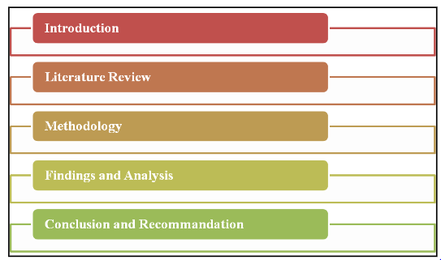

Figure 4: Dissertation structure
(Source: Created by Author)

1.8 Chapter Summary
The chapter of the dissertation focuses on effective CSR management of the retail sectors to follow the circular economy practices to use green supply chain management by lowering carbon emissions and improving the brand value within the retail sectors. The study focuses on the incorporation of CSR initiatives within Sainsbury’s for creating new opportunities and socially responsible activities to enhance the buyer's and suppliers' relationships. The distinct dimensions of relations between environment, diversity, human rights and safety are important factors for manifesting the indicators towards maintaining a sustainable supply chain. The challenges faced by retail organisations in painting effective supply chain and procurement policies are the lack of forecasting of the customer and industry demand, inconsistent sourcing, and inadequacy of finance and transportation facilities which are affecting the details sectors on an enormous scale.

2.0 Literature Review

2.1 Introduction
The retail industry is one of the most profit gaining industries across the globe. Specific difficulties such as disruption in the supply chain can create severe issues in the industry. This can create specific issues such as employee turnover and low-profit margins. The chapter focuses on the implication of relevant theories and models to evaluate the potential challenge of the retail industry and possible recommendations to mitigate the issues. The study has also focused on the significance of applying CSR approaches to increase the issues related to the difficulties of global SCM in the retail industry.

2.2 Conceptual Framework
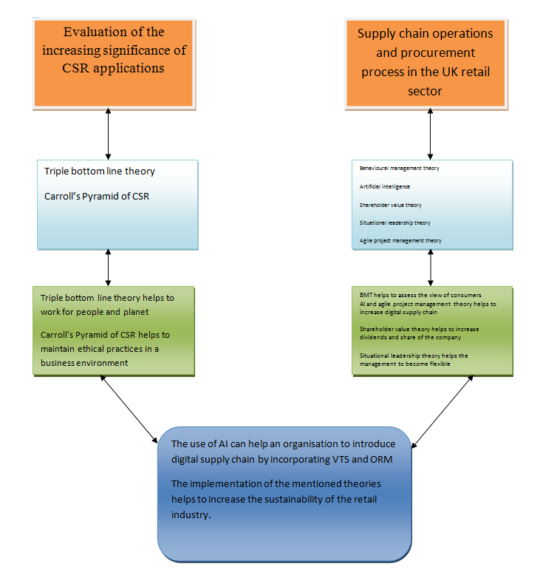

Figure 5: Conceptual framework
(Source: Created by author)

2.3 Significance of CSR Application to Control the Procurement Process of Supply Chain along e-procurement by applying the triple bottom line theory
CSR application is essential for an organisation to improve the supply chain operation of the retail organisations. As per the views of Onkila and Saama (2022), the effective application of Corporate Social Responsibility can increase the retention rate of employees to put the organisation toward practising responsible behaviour. The application of proper CSR approaches can be helpful for the retail industry as employees are often addressed as one of the key stakeholders of an organisation. On the contrary, Chen et al. (2021), have stated that the implication of ethical CSR can significantly impact the corporate image of the retail industry. This can also improve the sustainable supply chain strategy of an organisation in the mentioned industry.
Severe conflict in the interests of stakeholders and delayed schedules of suppliers can affect the retail industry. As per the view of Javeed et al. (2022), environmental safety has become one of the most progressive issues in industrial management. The use of sustainability can help the industry to practise sustainability. On the contrary, Changar and Atan (2021), sustainable development can balance and improve the environmental impact without damaging the economic performance of an organisation. The application of sustainability can also impact the supply chain of the retail industry massively. The use of this theory might help a retail organisation to increase its profit margin also by meeting the requirements of the consumers which is the sustainability of products.
It can be assumed that the practical implication of the triple bottom line theory might help the retail industry to improve its supply chain operations in order to meet the latest requirement of new-generation consumers. As per the views of Muñoz-Pascual et al. (2019), the implementation of the triple bottom line theory can help an organisation adopt environmental practices to a great extent. For example, organisation in the retail industry in the UK such as Sainsbury’s can apply the approach of people and the planet by implying sustainable supply chain management by focusing on social, environmental, and financial responsibilities. On the contrary, Masud et al. (2019), a triple bottom line (TBL) theory of social, economic and environmental dimensions of an organisation effectively. The use of CSR approaches can also be effective through the implementation of the TBL theory. For example, the UK retail industry can use the practice of human rights, ethical practices, and environmental practices to improve the implementation of CSR and a sustainable supply chain in the retail industry.
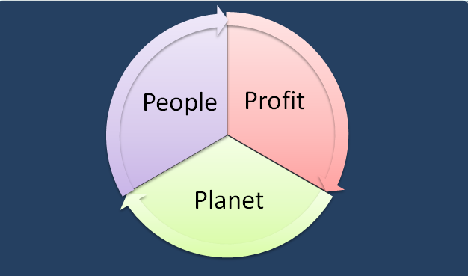

Figure 6: Triple bottom line theory
(Source: Created by author)
The implementation of CSR approaches can help an organisation ensure its market competitiveness in relation to quality, pricing, and delivery deadlines. The application of CSR approaches can also help to make effective communication with the suppliers as the approaches follow certain codes of ethics for businesses. Wang et al. (2022), have commented that the application of CSR approaches helps an organisation to make the relationship better between supply chain management and sales. It can be assumed that the retail industry can increase its global supply chain management (GSM) by practising proper CSR approaches.

2.4 Application of Carroll’s Pyramid Theory to Increase the CSR Approaches of the retail industry
CSR approaches of an organisation include practising environmental responsibility, ethical or human rights responsibility, and economic responsibility. As per the view of Keating (2022), corporate social responsibility has emerged as a key essentiality for both the government and organisations across the globe. The potential benefits of practising CSR approaches might be helpful for a retail organisation to receive sustainability. The supply chain of the retail shops can be increased by the proper application of CSR approaches by making the supply chain sustainable through applying the ethical approach. On the other hand, Daúet al. (2019), have suggested that CSR approaches can help to accelerate the implementation of sustainable approaches and transform the existing profit margin of an organisation. This can also help to achieve a sustainable supply chain management in the retail organisations.
The implementation of certain approaches of Carroll’s Pyramid theory can help the retail industry to practise economic, legal, ethical, and philanthropic approaches to the retail industry. According to Cheng (2022), Carroll’s CSR approaches primarily highlight three major pillars of practising CSR which include social, environmental, and economic factors. This can also help in contributing to the sustainable development of the supply chain of the retail industry. On the contrary, Costa et al. (2022), suggested that the application of Carroll’s CSR pyramid helps to conceptualise the role of business in society. This can also help the companies such as Sainsbury’s in retail industry to achieve a sustainable supply chain in the global market.
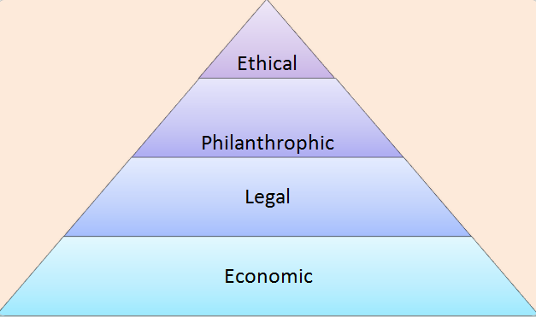

Figure 7: Carroll’s CSR pyramid model
(Source: Created by author)
The use of the CSR approaches of Carroll’s CSR pyramid helps companies adapt and improve business practices that are both profitable and ethical. Moreover, this also helps the company to become socially responsible and legally compliant. As per the view of Mazur and Walczyna (2020), the implementation of CSR approaches works as a vehicle for harmonisation, competitiveness and social integration. For example, the UK retail industry can practise economic responsibility by creating and sustaining jobs in the social community. Furthermore, the use of Carroll’s CSR theory helps an organisation to obey the law of government by maintaining safe and sustainable products to improve supply chain operations. The ethical responsibility of a retail shop can be achieved by practising suitability and this can also help the companies to become good corporate citizens. On the contrary, Kang et al. (2021), have mentioned that the use of Carroll’s Pyramid works as a mediator between CSR approaches and organisational behaviour. This can help the retail industry to stay ethical on business grounds by maintaining sustainability in the supply chain.

2.5 Practical Challenges in the implementation of CSR in Procurement and Supply Chain of the Retail industry
The effective implementation of corporate social responsibility might help the retail industry to practise social and environmental responsibility, ethical social responsibility, philanthropic social responsibility, and economic social responsibility. The implementation of the approaches might face certain issues which can be considered severe challenges to the industry. As per the view of Pasaribuet al. (2020), the implementation of CSR approaches may help an organisation to act and focus on the development of certain communities and improving the existing value of the companies. Certain difficulties such as the lack of a clear framework, transparency and accountability can make an organisation face difficulties in implementing CSR approaches. On the other hand, Zhang et al. (2023), have mentioned that the Department of CSR might face challenges to reduce transportation costs, assessing the evolving demand of the company, and poor sourcing capability due to incapable carrier capacity. This can create disruption in managing the cost of incorporating new supply chains and procurement reforms in the retail industry.
The retail industry can face severe challenges in the procurement of the supply chain such as souring, obtaining, and paying for goods and services along with poor shipping and warehouse management. According to Ivanov (2021), the implementation of digital supply chain management can be helpful for enhancing resilience and end-to-end delivery of product delivery. It can be assumed that the CSR departments of retail organisations can face difficulties to implement the latest digital technologies. On the other hand, Pyun and Rha (2021), have opined that the role of digital supply chain management has been increasing across the globe to meet the quickly evolving technology. This can also result in poor digital infrastructure and employee training facilities which may affect the management of the CSR department by affecting the digital infrastructure.
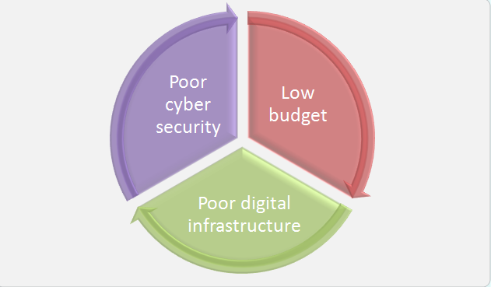
Figure 8: Challenges in implementing CSR approaches in procurement and supply chain
(Source: Created by author)
The report has shown that Works PLC faced the problem of cyber-attacks in 2022 which resulted in the disrupted delivery of products. As per the report, a total of 526 shops of the retail company had to stop operation due to the cyber-attack (Bbc.com, 2022). As a consequence, the CSR management had to deal with the difficulty of protecting valuable and resourceful data of its business. As per the suggestion of Yerpude et al. (2022), the use of blockchain technology might help an organisation to improve digital supply chain management. This can help to improve the CSR approaches of retail industry firms by decreasing supply chain disruptions across the globe. The efficiency of the supply chain has the ability to cater to ever-changing customer demands and increase the growth of the retail industry. On the other hand, Raja and Muthuswamy (2022), have opined that the retail industry can face severe challenges to spend the required budget for improving the procurement of supply chain management. It can be assumed that retail firms can try to make a one-time investment in integrating data protection tools to decrease the issue of disrupted supply chains.

2.6 Application of Stakeholders value theory in the CSR Practices of the retail industry
Proper communication with the stakeholders might help the retail industry to improve the supply chain management. The application of the stakeholder value theory (SVT) of Friedman implies that the role of the CSR manager refers to providing the shareholders with satisfaction. This can be possible by meeting the requirements of suppliers, society, consumers and employees. As per the view of O’Connell and Ward (2020), the approaches of stakeholder value theory imply that the shareholders are the ultimate owners of the asset of a corporate house. The theory argues that the priority of managers and other board members is to protect and grow the assets which are the shareholders of the company. On the other hand, Alsayegh et al. (2020), have mentioned that the implication of shareholder value theory helps to improve the sustainable growth of an organisation. The future landscape of the retail industry can be improved by the enhanced efficiency of the stakeholders. The supply chain of an industry can also be improved by the implementation of maintaining a good relationship with supplier stakeholders.
The effective implementation of shareholder value theory also helps to maximise the profit margin of an organisation by improving the relationship with suppliers of consumers. O’Connell and Ward (2020), mentioned that the dividend and share value can be increased by the application of the theory. For example, the UK retail industry can work on communicating with consumers to assess their changed perceptions of them regarding the supply chain. On the other hand, Wang et al. (2021), have suggested that the use of sustainable logistics and supply chain can develop the economic environment of a firm to a great extent. This can help in increasing the sustainable future of a business.
The retail industry can face the issue of a poor supply chain due to the changing perception of consumers across the globe. According to Sun and Sun (2021), the corporate competitive advantage of the retail industry is based on “green innovation” and a GSCM. Green supply chain integration can be helpful for the retail industry to practise the CSR approaches to keep the environment safe. Contradictorily, Fonseca and Carvalho (2019), have opined that modern organisations need to work on maintaining the “sustainable development goals” (SDGs) proposed by the United Nations. Almost 22.1% of organisations these days have been working on maintaining the climate and almost 23.8% of companies are working on maintaining the goal of responsible consumption and production.

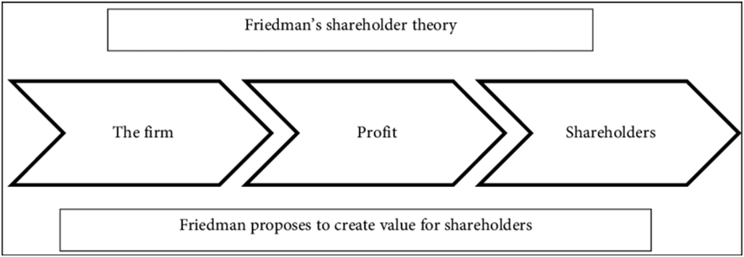

Figure 9: Shareholder value theory
(Source: Inspired by Narbel and Muff, 2017)
It can be assumed that the retail industry needs to maintain the goal of SDG 15 in its CSR strategies to decrease waste generation and environmental pollution from procurement and supply chain disruption. As per the report, SDG goal 15 is based on saving the life on land (Un.org, 2023). The use of this goal can help the retail industry to focus on using sustainable supply chains in their CSR approaches to save the environment and save lives on the earth.

2.7 Implication of Situational Leadership Theory to Increase Supply Chain Operation within the retail industry
The implication of proper leadership theory is helpful for the retail industry to mitigate the issues that can emerge from applying the CSR approaches. As mentioned by Williams and Murphy (2023), the resin for the increasing demand for sustainability in the UK retail sector includes maintaining the SDGs that have been proposed by the UN. The implementation of CSR approaches can help the retail industry to mitigate the issues with responsibility and ethics. The proper implementation of CSR approaches is associated with the effective application of leadership approaches. On the contrary, Katić et al. (2019), have mentioned that the approaches of the situational leadership model are dynamic and flexible and can influence the management style of the retail forms. The application of the theory might help the global retail industry to accept and make CSR responsibilities.
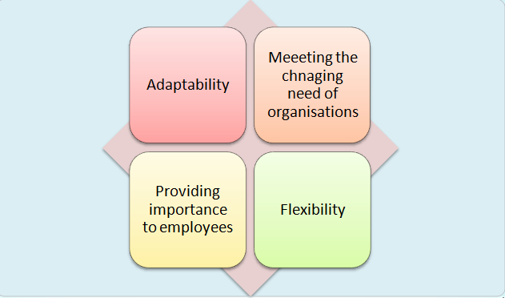

Figure 10: Situational leadership theory
(Source: Created by author)
The approaches of situational leadership include adopting a leadership style which can meet the unique needs of consumers and the team of an organisation. According to Wiyono and Wo (2022), situational leadership theory helps to assess the behaviour of consumers which is effective for knowing the perception of consumers regarding the supply chain. The proper implementation of the approaches of situational leadership style can help the CSR managers of a retail firm to adapt to the evolved situation. For example, the UK retail industry can work on realising the increasing demand for sustainability in the retail industry by making the supply chain sustainable. On the contrary, Jankelová and Joniaková (2021), have mentioned that the communication skills of leaders with the stakeholders can be enhanced by the proper implementation of a situational leadership style. This can help the retail industry firms to make a good relationship with stakeholders which might help to improve the growth of the CSR approaches and the profit margin of the retail industry across the globe. The global initiatives of applying CSR refer to practising environmental responsibility, economic responsibility, and increasing the loyalty of consumers massively.

2.8 Implementation of artificial intelligence to Increase the supply chain operation of the retail industry
Artificial intelligence can increase the effective integration of digital supply chain management in retail firms by conducting certain strategies. As per the opinion of Nozari et al. (2022), the application of artificial intelligence can improve the use of smart supply chains for increasing the growth of industrial management to a great extent. Supply chain management is one of the most fundamental issues that is getting faced by businesses and affecting the overall growth of an organisation. On the other hand, Dumitrascu et al. (2020), have mentioned that the implication of a sustainable supply chain management system can be increased by using artificial intelligence. The implementation of AI can help to plan the procurement policies in the retail industry. According to Johnstone and Lindh (2022), the implementation of AI can assist firms to enhance the competitive advantages and competencies of employees and enhance the retention rate of consumers and employees.
The approaches of artificial intelligence referred to include productivity within an organisation by focusing on the aspects that motivate the workforce. According to Khatua et al. (2021), Supply chain management (SCM), is one of the most complicated networks of a business that can be enhanced by the proper usage of AI-based applications. It can be assumed that the retail industry can introduce the usage of AI by designing optimised route maps and vehicle tracking systems.
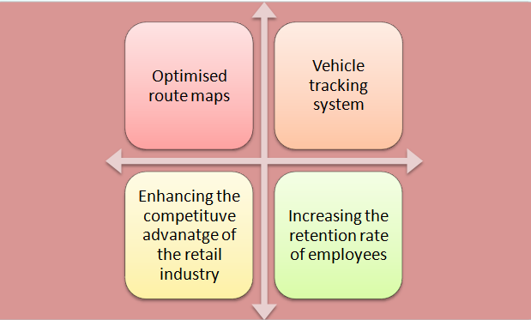

Figure 11: Implication of AI in the global retail industry and supply chain
(Source: Created by author)
The implementation of optimised route maps can help to improve supply chain management by optimising the delivery route of the products with the help of Google Maps. For example, the UK retail industry shops such as Asda and Sainsbury’s can introduce optimised route maps by sequencing multi-stop delivery routes. The use of this process might help retail firms to fine-tune the delivery order by enhancing the digital supply chain which is helpful for industrial growth also. According to Accorsi et al. (2019), it is essential to optimise the delivery and collection route of products to enhance the global supply chain. This can help the retail industry to make a tailored “GIS-driven decision support tool” for enhancing the logistical and environmental of the industry in a sustainable manner.
The retail industry can also use the vehicle tracking system (VTS) to track and control the vehicles in order to improve the supply chain on the global market. The implantation of CSR approaches can also be improved by the implementation of VTS by increasing the transparency which is one of the most fundamental principles of CSR approaches in the international market. According to Eldem et al. (2022), industry 4.0 needs to improve the supply chain for meeting the changed demand fluctuation of the industry. This can enhance the supply chain management of the industry. On the other hand, Ebinger and Omondi (2020), have suggested leveraging digital approaches to provide transparency in sustainable supply chains. This can help in increasing the effective usage of AI in GSM.

2.9 Application of behavioural management theory to Increase the supply chain operation of the retail industry
The implication of the behavioural management theory is an essential trend and domain in the field of operation management. As per the comment of Hänninen et al. (2021), the behavioural management theory focuses on the way the productivity of the organisations is managed by motivating the workforce. The behavioural aspects within the supply chain are associated with the lack of trust among the supply chain partners, misalignment of the incentives and natural risk aversion within the organisations. As opined by Xiao et al. (2021), management theory focuses on the employees who are motivated to work under relational factors such as monetary reward, attention and environmental factors ensuring the team is successful. The factors focus on the ideas of behaviour learned through interaction with the environment. As stated by Bednar and Welch (2020), viewing the workplace as a social environment and increasing the human potential for skill training and promoting collaboration are essential factors in the retail industry. The UK retail industry is moving towards using sustainable business practices by using effective CSR practices within organisations. For example, Sainsbury’s has witnessed 161% improvement from baseline regarding food waste (about.sainsburys.co.uk, 2022). It indicates a positive and sustainable business practices that UK retail industry is practicing increasingly.
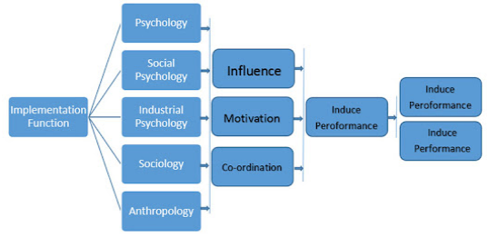

Figure 12: Aspects of Behavioural Theory in inducing performance within the retail sectors
(Source: Created by Author)
The implication of the theory has emphasised upon the managers within the retail industry to influence the creation of management systems with the division of labour and job specifications in the corporate strategy. As per the view of Adivar et al. (2019), the behavioural management theory has focused on new ways of thinking and the role of managers to motivate and encourage a high level of proficiency while working within organisations. Behavioural operations management understands the decision-making of the managers within the retail industry.
Ensuring flexibility, efficiency and better productivity with the implication of such theory within the retail sectors are essential factors. As per the view of Garay-Rondero et al. (2020), behavioural operations need to focus on judging the relationship between employees mental health and well-being and balanced behaviour at work. The retail sector needs to focus on comprehensive systems to analyse and provide insight into the operational processes to better manage the supply chain and procurement process within the organisations.

2.10 Implications of the Agile project management methodology for developing projects related to the supply chain in the retail industry
The agile supply chain puts a constant emphasis on the efficient process and empowered employees to work decisively within the organisation to achieve goals. As per the view of Gomes Silva et al. (2021), the agile methodology applies Big Data within the retail sectors to estimate the demands and needs of the customers with the quickly changing circumstances and data in the process. The retail organisation uses this technique to effectively adjust the inventory levels with respect to real-time and response to the competitors. As opined by Albuquerque et al. (2020), the agile methodology is useful for sectors with “high levels of uncertainty and changing requirements”. However, the major benefits of agile technology in the supply chain of retail organisations are that it allows the firms to constantly meet the ends of the customers with affordable shipping to meet the ever-changing market demands.
The aspects of flexibility and resilience are important concepts with the ethos of a lean supply chain and manufacturing within the retail industry. As opined by Zasa et al. (2020), the application of this methodology has helped retailers to analyse and figure out the competition within the sectors. Moreover, the approach facilitates collaboration and commitment between leadership and team members to ensure a successful outcome within the retail sector. Quality improvement techniques in the retail sector are achieved through the improvement of agile technology. As per the view of Albuquerque et al. (2020), agile technology adopted by traditional retailers has helped them to compete with the digital natives. The issues have pushed the digital transformation in retail to move in more flexible, efficient and cost-effective ways.
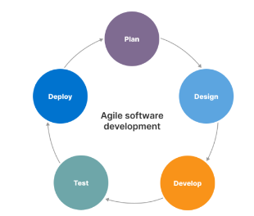

Figure 13: Steps of Agile Methodology in Project Management
(Source: Created by Author)
Retail agility has the ability to change and pivot whenever necessary based on the customer's demand. As stated by Buganová and Šimíčková (2019), retail sectors need to focus on an agile strategy to research, plan, and develop products and processes by creating minimal viable products and getting rapid feedback and itinerary for improvement within such sectors. Furthermore, the retail sector needs to focus on an agile marketing strategy to quickly analyse customer data and shift priorities of customer behaviour and guide further development.

2.11 Recommending potential solutions to use circular economy and avoid conflicts by treating suppliers equally with the application of legal laws and regulations
Retail organisations need to emphasise circular economy favour activities to preserve the values, labour and material within such sectors. As opined by Lim et al. (2022), focusing on the “principles of circular economy to eliminate waste and pollution and circulate the products and materials at the highest level” by regenerating nature is also a crucial factor. The retail sector needs to ensure long-standing compliance with the laws, regulations and policies as ethical principles in the decision-making process within the organisations. Keeping the investors informed about the finance and other decisions of the organisations is helpful, in avoiding injustice and partiality to the employees with effective CSR cavities. As stated by Khajuria et al. (2022), the common ethical issues within the retail sector need to be addressed effectively by adhering to alternative means to resolve the conflicts within the organisations. Analysing a positive correlation between CSR and green supply chain management will help to improve the firm's performance in meeting the objectives of the organisation.
Managing the suppliers' relationship in an environmentally responsible way to avoid the risk of reputational damage is a crucial factor within the retail organisation. The retail organisation needs to invest in financial resources and training among the employed to introduce the changes within the adoption of the circular economy model in various retail organisations. As per the view of Viles et al. (2022), the organisation needs to focus on the implementation of CSR programs and activities based on philanthropic initiatives within the organisation. Lowering the waste generation within the retail sectors and designing products from recycle to reuse which the retail organisation needs to focus on. For example, Sainsbury’s plastic packaging reduction initiative rationalises those perspectives. As opined by Lombardi et al. (2021), the entire model revolves around the concept of sustainable management of materials and encourages the use of renewable resources within the UK retail sectors. Adopting the policy of sustainable development “COREPLA (National Consortium for the Collection, Recycling and Recovery of Plastic Packaging)” in achieving a circular economy is an important concept in extending the product life cycle within the retail sectors.

2.12 Literature gap
The initiatives of CSR activities in the UK retail sectors are being a vast topic. The missing piece of information has been observed in dealing with the specifications adopted by the organisations in the retail sectors to improve the supply chain management and procurement process. The research articles selected within the study lack information relating to the information about the employees to improve the process within the organisations and work efficiently to meet certain goals and objectives as well. Moreover, the gap in the study has been noticed concerning the recent implications of digital technology in the field of operations within retail firms.
The recent changes made in their initiatives towards achieving sustainable goals within the organisations are not also effectively supported with empirical data. The application of project management methodology to analyse and predict the future direction of its competitors is not fully analysed in many of the articles in the study. The change from the traditional to the modern approach of CSR initiatives concerning industry-specific information is also a gap found in the research.

2.13 Chapter Summary
The chapter of the dissertation focuses on the significance of effective CSR initiatives within the retail sectors to meet the needs of the present generation. The study focused on the implementation of ethical CSR to improve the sustainable supply chain strategy within the retail sector. The application of digital transformation by the use of agile methodology has been defined in this chapter to get an overview of the process by creating minimal viable products within the retail sectors that have been analysed in the study. Moreover, the study focuses on the application of CSR in the supply chain and procurement process within the retail firms in the UK.
The challenges and issues faced while the successful implementation of the princesses has also been determined in the study. The increasing significance of the initiatives with theory alignment has been focused on in this chapter of the dissertation. The proper application of the approach concerning the social, economic and environmental to maintain the sustainability within the retail firms has been analysed in the study. The recommendations are forwarded against the implementation of the circular economy concept within the retail firms for creating products from recycle to reuse.

3.0 Research Methodology

3.1 Introduction
Research Methodology is an entire process to explain the method of this research. The research on the significance of CSR application in Supply Chain Management has been discussed. Regarding this, the entire process of data collection and strategy has been elaborately explained in this methodology. This methodology also critically evaluated the chosen factors and justified the process. Research philosophy, approach, and design have also been included in this part of the dissertation. Complete tools and techniques of the research have been evaluated and the taken data of this subject is also been analysed. This research also maintains all the ethical considerations of the methodology process to provide an effective result in this dissertation.

3.2 Research philosophy
The activities of CSR application in supply chain management of the retail firms in the UK have been selected the Positivism Philosophy in this research. Positivism Philosophy deals with the detectable reality of the social norms that lead to the generalisation of the situation (Alharahsheh and Pius, 2020). Considering this, the research has included the positivism philosophy in this methodology for generalising the findings of the subject. The use of the positivism philosophy has been helping the researcher to get the required idea about the social context of CSR application in the supply chain process.
The research has not used the interpretivism philosophy in this process to get the required findings to get the observable reality. The idea of the Interpretivism philosophy relies on the behaviour of humans and other components, such as language, consciousness, and shared meanings to get the reality (Ikram and Kenayathulla, 2022). The purpose of this research is to get general knowledge instead of social assumption. Hence, this has followed the positivism philosophy and avoided the interpretivism philosophy.

3.3 Research approach
The research has included the Inductive Research Approach in this to get a specific idea about the impact of CSR application in the supply chain management of the UK retail sector. The inductive research approach observes particular things and explicates them to analyse different cases (Khotimah and Faizah, 2021). The current impression of CSR in the supply chain management of the UK retail sector has required to observe the specific elements for analysing its factors. Hence, the use of an inductive research approach helps to evaluate its existing cases.
The research has avoided the deductive approach in this process to develop the theories. The purpose of the deductive approach in the research methodology is to confirm the existing theories to test the hypotheses or develop new theories (Pradeep. and Wijesekera, 2022). Adaption of the deductive approach in the research fluctuate the theories of the aforementioned subject and does not provide the required outcomes to analyse the cases. Hence, this research has used an inductive research approach instead of the deductive approach.

3.4 Research design
This research on the subject of CSR practice in supply chain management of the UK retail sector has selected the Descriptive Research Design to identify the issue. Descriptive research design follows a systematic pattern to reach its goal and obtain the required information about the context (Pandiangan et al., 2021). Regarding this, the research has chosen the descriptive research design in this process to maintain a systematic pattern in the process of information collection in CSR practices. This helps the research to get the required knowledge of supply chain management in a different context and improve the quality.
This research has not used the experimental research design in this process to discuss it in a scientific approach. The process of experimental research design has followed a scientific method with the use of two elements for measuring the difference (Stratton, 2019). The purpose of this research is to understand the relation of CSR in the supply chain process. Hence, this aforementioned subject has not used the experimental research design in this research to understand the impact of CSR on the supply chain management process.

3.5 Research Strategy
This research has included the Quantitative research strategy on the subject of CSR practices in supply chain management. The quantitative research strategy focuses on numeric and stable data in a detailed process to get convergent outcomes (Ali et al., 2020). Using this research strategy in the UK retail sector required data has been found for accomplishing this research process. A quantitative research strategy provides a certain amount of stable knowledge to evaluate the impact of CSR in supply chain management.
The use of qualitative research has been avoided in this methodology for understanding the market position of the UK retail sector. Qualitative research strategy has lacks transparency in the process of data collection; rather it focuses on the collective way (Aguinis and Solarino, 2019). Hence, this research has avoided using qualitative and selected the quantitative research strategy for getting the numerical data on CSR application in the supply chain of the UK retail sector.

3.6 Data type
The situation of CSR impact on the supply chain management of the UK retail sector is a regional issue. Regarding this, the research has selected the Primary data type to get the required information in the retail sector of the UK. The primary data type method collects its data from first-hand sources focusing on the selected subject (Romero and Ventura, 2020). The use of the primary data type in this research has helped to get genuine data from the field of the UK retail sector on the CSR application of supply chain management. Regarding this, the research has used a survey method to collect data on the CSR application of the supply chain management process. Hence, this approach has been used to guide the research to get essential information about the UK retail sector.

3.7 Data collection methods
The research of the CSR application in supply chain management of the retail market of the UK has used the Survey method for data collection following the primary data type. The survey process in the primary data collection method deals with the existing information on the selected subject to get the required information (Nayak and Narayan, 2019). Considering this, the research has selected 21 employees in the survey procedure of the UK retail sector. Hence, this guided the research to get specific information on the subject.
This research has avoided using secondary data types for getting specific information about the CSR application in supply chain management. The secondary data type collects its data from the existing research and is accomplished by other authors or other websites (Riad et al., 2019). Hence, the use of secondary data in this research on the CSR application has created issues to collect certain information.

3.8 Tools and Techniques
This methodology has included a survey process as a tool of the data collection method in the research of the impact of CSR application in supply chain management of the UK retail sector. A questionnaire has been prepared for this survey to get the required information on CSR applications in supply chain management. The survey process has focused on collecting numerical data on the aforementioned subject for analysing the current situation of the UK retail market. On the other hand, accomplishing the thematic analysis in the research also included other journal articles from the University library and other authentic sources. Following this technique, the research has gotten an effective result to analyse the impact of CSR application in supply chain management.

3.9 Data analysis
This research has included a Thematic Data Analysis process in the research of the CSR application in supply chain management of the UK retail sector. The thematic data analysis process analyses the existing data involved in this research to find the pattern for the themes of the data (Peel, 2020). Regarding this, the research has used thematic analysis in this subject for analysing the existing themes related to CSR application of supply chain management in the UK retail sector. This research on the CSR application in supply chain management has chosen 7-8 themes in this thematic analysis process. The process of the data analysis has evaluated each theme on the basis of the objectives and research questions to get the required answer on the topic. Hence, the use of the aforementioned theme establishes a proper sense of collecting data on the given subject of this research.

3.10 Inclusion exclusion criteria
The research of the CSR application in the supply chain management process has followed the all required process in this methodology to accomplish it in a successive manner. This research has included specific survey-based numerical data on the basis of the primary data collection method. On the other hand, it excluded irrelevant information regarding the UK retail sector taken from other sources for avoiding misconceptions in this research. This research also focused on including information relevant to CSR and supply chain management from the UK retail sector. The research also selected the primary data type and excluded the secondary information for providing specific information in this subject.

3.11 Sampling Method and sample size
This research used the Random Sampling method in sampling technique in the research of CSR applications in supply chain management of the UK retail sector. The use of the random sampling method in the research has equal prospects for each sample being chosen (Zejda et al., 2021). Regarding this, the research has used the random sampling method in this aforementioned subject to justify the sample size of the survey process in the research of the CSR application in supply chain management. The survey process is based on 21 employees of the UK retail sector related to the CSR process and supply chain management. The sampling size of this methodology is 21 which took part in the survey process of this research to deliver the required knowledge on this subject.

3.12 Ethical Consideration
The increasing significance of the CSR application in supply chain management has been discussed in elaborate research on the evaluation process. Following this, the research has tried to maintain all the ethical considerations and provide the required information on the topic. As opined by (Fiesler, 2019), the practice of ethical consideration in the research helps to avoid misconceptions and complexities in the given subject. Considering this, the research has maintained ethics in the process of data collection and provided informative data. This research has followed a primary data-based survey process that collects data from the employees with their general concerns. The research on this aforementioned subject also gathered other information for justifying the data from authentic journal articles and govt. Websites.
The collected data of this research has followed the “Data Protection Act of 2018” for conserving the ethical consideration in this aforementioned subject. The research has been focused on maintaining data confidentiality. The process of this research also avoided copying other works without their consent in the data collection process. On the other hand, the collected data for this research also took the general idea instead of copying it to refrain from plagiarism. Authentic citation of the author was made in the study to gather accurate information. Hence, it has been stated that following this process, the research provides a complete ethical process in the CSR application in supply chain management.

3.13 Research Timeline
[Refer to Appendix 1]

3.14 Chapter Summary
This methodology in the research of the CSR application in supply chain management of the UK retail sector has discussed the entire process. According to the strategy and design of this the research has evaluated its data and collection process in this aforementioned subject. This research has used the positivist research philosophy for detecting the reality of the social context of the UK retail sector. On the other hand, the research has followed an inductive research approach for presenting in a flexible and adaptable way. The research also used a Quantitative data collection method following the primary data type. A descriptive research design is also incorporated in this research for analysing this in a systematic process to get the required information. Hence, this can be stated that this research has provided all the required processes through this methodology in the CSR application of supply chain management in the UK retail sector.

Chapter 4: Findings, Analysis, Discussion

4.1 Introduction
Emerging CSR activities become essential for all business sectors including the retail industry for managing its procurement activities along with increasing overall efficiency of its Supply chain (SC). In this context, UK-based retail firms including Sainsbury’s’ need to apply within its supply chain management (SCM) procedure along with procurement operations for maintaining business sustainable. In this chapter, the result of the research survey which has been conducted on 21 employees of the UK-based retail sector has been analysed to understand their opinion regarding the significance of CSR.

4.2 Findings
Question 1: Do you think there are benefits of following emerging CSR activities for the UK retail sectors in procurement management?

Total participants | Responses | Total respondents | Percentage
21 | Yes | 12 | 57.14
21 | No | 4 | 19.04
21 | No idea | 5 | 23.80

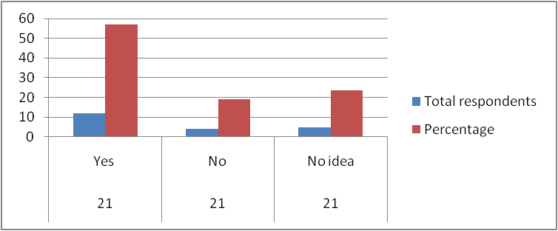
In this survey of UK-retail employees, a total of 12 employees agreed with the fact that emerging CSR activities can provide strategic benefits to the UK-based retail sectors. According to them, CSR approaches can support retail firms in brand reputation improvement along with ensuring better organisational growth. However, 4 research participants stated that they do not believe CSR activities can be beneficial for retail firms as this can reduce overall profitability of an organisation. Apart from this, 5 participants selected the “no idea” options as they have insufficient awareness regarding the significance of CSR activities for an organisation.
Question 2: Do you believe Sainsbury can be benefited through incorporating CSR in its supply chain management?
Total participants | Responses | Total respondents | Percentage
21 | Yes | 15 | 71.42
21 | No | 6 | 28.57

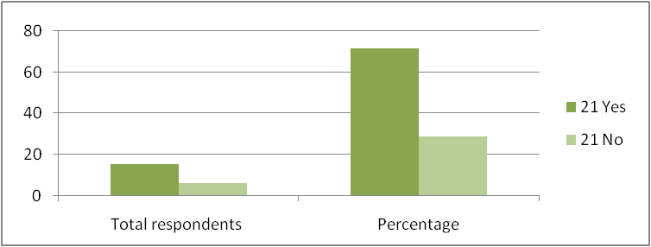
In the present time, retail firms of the UK including Sainsbury's need to follow CSR activities regarding its supply chain management (SCM). Among total 21 employees, 15 employees have selected the Yes option and agreed with the fact that Sainsbury’s can benefit from incorporating strategic CSR approaches for managing its supply chain (SC). They also share that CSR activities can also support Sainsbury’s in maintaining positive supplier relationships along with acquiring a higher consumer base. However, 6 participants have selected the No option as they believe that incorporating CSR policies in SCM requires huge investment which can be challenging for Sainsbury’s.
Question 3: Do you accept that CSR efforts can support Sainsbury’s in developing a positive working environment within the workplace?

Total participants | Responses | Total respondents | Percentage
21 | Yes | 13 | 61.90
21 | No | 8 | 38.09
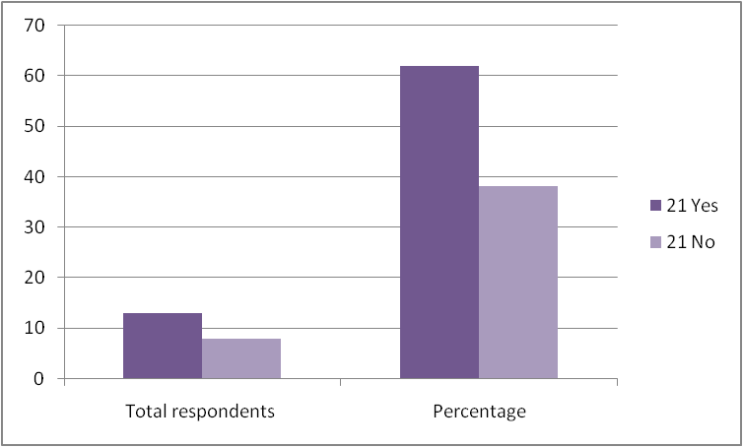

CSR activities can also support in creating a positive working environment within the workplace of an organisation for ensuring better employee engagement. Total 13 research participants have selected the Yes option as they agreed that following CSR activities can strategically support an organisation in maintaining a positive work culture within the workplace. However, 8 employees have selected the NO option as they believe that employees have different requirements which cannot be fulfilled through single CSR policies.
Question 4: Do you believe incorporating CSR efforts can support Sainsbury’s in maintaining sustainable production and following environmental practices?
Total participants | Responses | Total respondents | Percentage
21 | Yes | 18 | 85.71
21 | No | 3 | 14.28

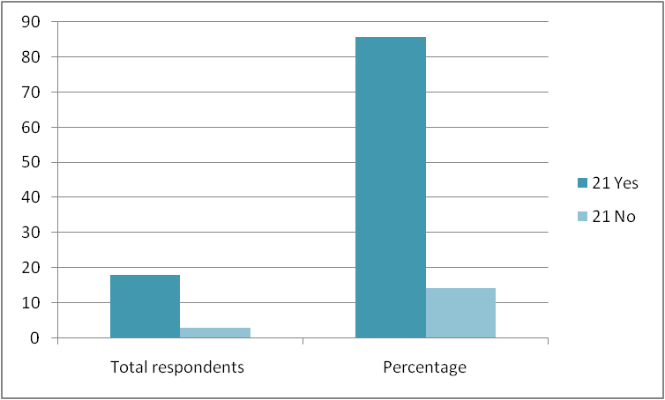
Different CSR efforts such as sustainable sourcing can support retail firms in maintaining sustainable production throughout its entire operational activities. Among the 21 participants, 18 participants strongly agreed with the fact that strategic CSR approaches can support Sainsbury’s in developing sustainable production strategy along with improving environmental practices. However, total 3 employees stated that they do not believe CSR policies can lead to sustainable production strategy as this can increase operational expenses.
Objective 3
Question 5- Which kind of challenges from below options is faced by your organisation regarding the CSR activities in the supply chain?
Total participants | Responses | Total respondents | Percentage
21 | Employees’ support | 12 | 57.14%
21 | Financial resources | 5 | 23.80%
21 | Lack of awareness on CSR activities | 4 | 19.04%
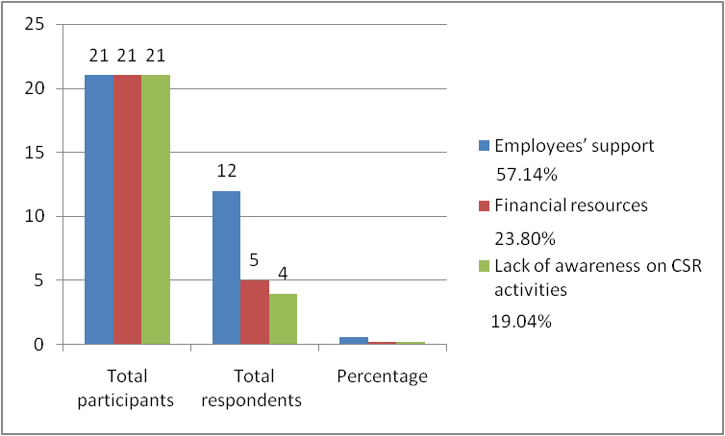
Organisations can face different types of challenges while implementing CSR strategies. Whether it is for philanthropic purposes or reputational purposes, different types of CSR activities can have their challenges depending on the organisation’s structures or employee management. The above figure and table includes the findings from the first question of the survey. As it can be seen, different employees responded with different answers from within the close ended answers during the survey. The first survey question related to objective 3 which indicate the challenges faced by the employees’ organisation regarding the use of CSR activities in the SC. As noted in the above figure, almost 57% of the participants had replied that employee support had been the most significant challenge faced by organisations in terms of initiating CSR activities in the supply networks. Hereby, this can indicate that the majority of the employees are unsure on whether CSR activities can help the retail organisation to gain better profit in the future. Almost 23.80% of participants have further highlighted the issue of financial resources as a major problem in terms of initiating better CSR approaches in the procurement channels. Therefore, this means Sainsbury can face financial barriers for its CSR in the future. Therefore, without the financial support and resources to back the CSR activities, retail organizations can indeed face a major issue before initiating better CSR initiatives such as green packaging, green mode of production and consumption.
On the other hand, 19.04% participants have highlighted a minor yet significant issue in terms of CSR initiatives. Lack of awareness about the implications or the benefits of CSR can potentially have become a challenge for organisational leaders. As the employees are not fully aware about the concept of CSR in the modern context of globalisation, gaining the retail employees' support can also be difficult for organizational leaders. Therefore, this minor concern highlights a root cause of why the majority of retail employees are not supportive towards the implementation of CSR strategies for the retail supply.
Question 6 of the survey required the participants to highlight potential issues regarding objective 3 for understanding how CSR can become a problem for their retail organisation. As seen in the above table and figure, almost 47.61% participants had been concerned about the issue of transparency and accountability when they were asked about future problems regarding CSR. More than 28% participants have replied that disagreement among stakeholders can become a concern for their retail organisations in the future. Furthermore, 23.80% participants are concerned about the allegations of greenwashing when asked about CSR activities in their organisation.
As CSR activities are closely interconnected with financial assets and resources of a firm, employees are most likely concerned whether doing CSR can reduce their reputation due to lack of transparency and accountability on the firm’s end. Hereby, this showcases that employees’ trust in their organisation’s ability to conduct CSR activities is not strong considering recent instances of greenwashing allegations on major retail brands. In this situation, it is reasonable that Sainsbury’s employees can also be concerned about the reputation of their organisations in terms of CSR activities.
Question 6: Which of the below mentioned CSR issues can become a reputational problem for your retail organisation’s supply chain?
Responses | Total participants | Total respondents | Percentage
Transparency and accountability | 21 | 10 | 47.61%
Allegations of greenwashing | 21 | 6 | 28.57%
Disagreement among stakeholders | 21 | 5 | 23.80%
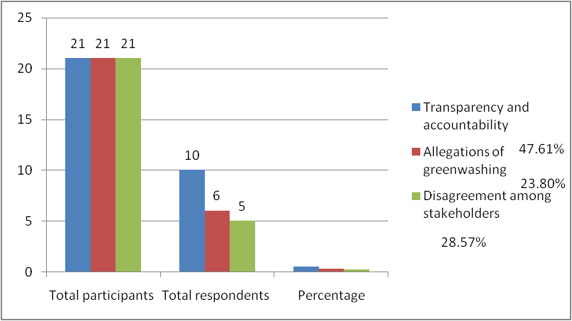
Objective 4
Question 7: Do you believe that effective training to employees can reduce the lack of knowledge regarding CSR activities?
Responses | Total participants | Total respondents | Percentage
Yes | 21 | 12 | 57.14%
No | 21 | 2 | 9.52%
Maybe | 21 | 7 | 33.33%
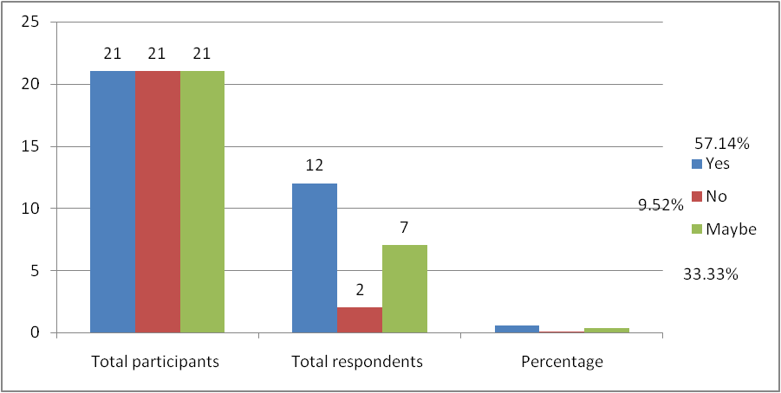
As seen in the above figure, more than 57% participants believe that providing employees training regarding the matter of CSR can develop active knowledge about the subject. These responses are interconnected with objective 4 where it is necessary to find strategies for implementing better CSR approaches. Hereby, lack of knowledge about the betterment of CSR can potentially help retail employees to have a positive approach towards embracing more CSR activities in their organisation. Thus, employees in the retail firms are in need of effective knowledge management strategies for improving their knowledge and capacity about CSR related activities. 33% participants are not certain about the aspect of employee training and knowledge management regarding CSR activities. This only reinforces the factor that employees in the Sainsbury firm need to have more awareness about CSR activities and their benefits for the retail organisation.
Question 8: In your opinion, which of the below options can be used by organizational leaders to gather reliable financial resources for implementing CSR activities?
Responses | Total participants | Total respondents | Percentage
Crowd funding campaigns | 21 | 13 | 61.90%
Partnership with social activist groups | 21 | 6 | 28.57%
Peer-to-peer fundraising | 21 | 2 | 9.52%
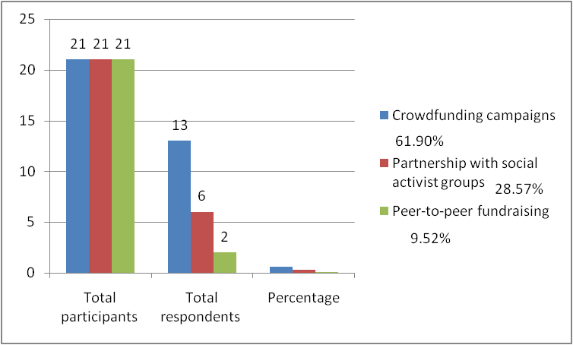
As financial assets are important in terms of conducting CSR activities, there is a need to understand if employees of different retail organisations meet objective 4. The above figure shows that 61.9% participants believe that crowd funding campaigns can help retail organisations to gather better financial assets for conducting CSR activities. Furthermore, 28.57% participants believe that partnerships with social activist groups can also help retail firms to gain better financial resources. On the contrary, only 9.5% participants have opted that peer-to-peer fundraising can be an effective source of finance for retail organisations. Hence, Sainsbury can create fundraising campaigns to gather resources for CSR activities.

4.3 Analysis
Theme 1: Maintaining environmental responsibilities in procurement and SCM to enhance brand reputation and reduce carbon footprint from product life-cycle of the UK retail sector
Practising strategic CSR approaches can support an organisation in developing a positive brand reputation among its consumer base along with enhancing employee engagement within the workplace for ensuring better competitive advantage. Based on the views of Vo and Arato (2020), strategic incorporation of CSR approaches in procurement can support an organisation in maintaining SC transparency along with ensuring “fair operating practices”. In this context, it can be beneficial for the UK retail firms in maintaining environmental responsibilities for decreasing carbon footprint from its entire product life-cycle for maintaining sustainable business within the retail industry. In Scope 3, Sainsbury’s decided to decrease its “absolute greenhouse gas emission” by nearly 50% by the year 2030 (Sainsburys.co.uk, 2023). This firm also concentrates on utilising renewable energy resources within its manufacturing procedure for enhancing its energy efficiency.
Apart from this, following environmental responsibilities can also support UK-retail firms in improving brand performance along with reducing carbon footprint of its products. Information regarding the reduction in carbon footprint from the product life-cycle along with decreasing greenhouse gas emission through following environmental responsibility approaches helps in meeting objective 1 of this research. Apart from this, Survey question 1 and 2 has been based on objective 1 which helps in understanding research participants' opinion regarding the CSR approaches. Hence, it can be stated that strategic incorporation of CSR policies through maintaining environmental sustainability can support Sainsbury’s in improving its organisational performance with better corporate reputation.
Theme 2: Sustainable sourcing and Inclusive workplace can support UK-based retail industry in developing positive working environment within the workplace for maintaining sustainable production in Sainsbury’s
Implementing sustainable SCM practices and maintaining CSR responsibilities can support retail firms in improving corporate reputation, improving financial performance along with increasing consumer loyalty. As mentioned by Fernando et al. (2022), incorporating CSR approaches within operational activities can support a business firm in sourcing sustainable raw materials, accessing essential organisational capital, improving consumer loyalty along with ensuring sustainable production. In this context, UK-based retail firms including Sainsbury's need to concentrate on its CSR efforts for developing effective SCM management strategies along with maintaining sustainable distribution of its products. Sainsbury’s significantly concentrates on developing an “inclusive workplace environment” through raising awareness about diverse cultures along with communities (Sainsburys.co.uk, 2023). Construction of an engaging as well as inclusive workplace can support UK retail firms enhancing employee efficiency. Survey question 3 has been on objective 2 which helps in gaining employees’ opinion regarding the significance of CSR for developing a positive working environment. Moreover, inclusive workplace strategy significantly helps Sainsbury’s in meeting the requirements of its consumers along with local communities.
Incorporation of sustainable sourcing strategies along with safeguarding the environment become significantly important for the UK-based retails firms as environmental awareness increases rapidly among customers. Based on the views of Thompson (2019), “Payments for ecosystem services” (PES) refers to an effective “environmental management tools” (EMT) that enables an organisation in enhancing its environmental performance in a strategic manner. Regarding this, incorporation of effective EMTs can support the UK-based retail industry in maintaining “sustainable production strategy”, conserving necessary natural resources, and reducing carbon footprint. Moreover, it can be beneficial for Sainsbury’s to incorporate green SCM for maintaining sustainable production in an effective manner. This firm concentrates on removing forced workers from its entire SC through “scaling detection” and also provides essential support to its suppliers (Sainsburys.co.uk, 2023). Essential information associated with the PES system, sustainable sourcing along with developing an inclusive working environment helps to achieve Objective 2. Hence, sustainable production strategy can support the UK-based retail firms including Sainsbury’s in meeting consumers’ need for ensuring better financial growth.
Theme 3: Net Zero carbon emission strategy and food waste reduction policy are the key environmental practices of Sainsbury’s regarding CSR
Environmental CSR practices support the UK-based retail sectors in eliminating adverse environmental impact through reducing water consumption along with enhancing energy efficiency for ensuring better SC efficiency. As mentioned by Gigauri and Vasilev (2022), following environmental CSR approaches can support an organisation in eliminating greenhouse gas emission along with ensuring sustainable utilisation of vital natural resources. Regarding the environmental practices, Sainsbury’s decided to decrease carbon emission from its operational activities along with reducing its energy consumption for lowering environmental pollution. Sainsbury’s aims to deal with the climate change issue through achieving “Net Zero” emission strategy for eliminating carbon emission from its business operations by the year 2035 (Sainsburys.co.uk, 2023). This can support Sainsbury's in improving organisational reputation in the global retail market along with attracting a major number of customers for increasing overall sales.
Apart from this, Sainsbury’s also developed strategic policies for reducing the amount of food waste production within its stores. As mentioned by Roy et al. (2023), incorporating an effective “food waste management system” can support an organisation in reducing the “waste disposal cost”, decreasing methane emission through improving procurement approaches. This firm incorporated strategic approaches for reducing wastage of food products. Sainsbury’s incorporated strategic “food waste reduction policies” to decrease the food waste production by nearly 50% by the year 2030 (Sainsburys.co.uk, 2023). Survey question 4 also has been based on objective 2 which help in collecting employees’ beliefs about the importance of environmental practices and sustainable production. Regarding the maintenance of CSR activities, Sainsbury’s donated the surplus food items to its “charity food donation partners”. This strategy supports this firm in reducing environmental pollution along with maintaining its CSR activities strategically. Information associated with net zero emission along with food waste reduction ensures to meet objective 2. In this context, sufficient CSR efforts strategically support Sainsbury’s in maintaining environmental sustainability for ensuring better brand reputation.
Theme 4: Employees of retail organisations are often concerned about recent instances of greenwashing and become uncertain about firm accountability
It is necessary to understand that all the survey responses are internally correlated and their implications can be dependent on each other. For example, the lack of accountability and transparency on CSR activities can potentially create problems within the company’s CSR structure as employees can be uncertain about their firm’s ability or accountability to perform effective CSR activities. Recent reports have showcased that retail firms generally have a greenwashing problem, as they often do not conform to the sustainability or CSR claims with their actions (Mytotalretail.com, 2022). Hence, employees’ concern about the lack of transparency and accountability in the retail SC is legit. For instance, retail companies such as Nestle, Boohoo have come under fire for supposedly greenwashing claims in recent years (Euronews.com, 2023). Hence, Sainsbury can be projected to greenwashing and lack of transparency in the retail supply-chain bottom line creates a problem for organisations to initiate successful CSR initiatives in the future and such claims can lead to official investigations and reputation issues for a retail firm.
Theme 5: Lack of knowledge and financial challenges about CSR benefits have become a major issue about employees in terms of supporting CSR activities
Lack of knowledge regarding the utilisation of CSR approaches is another reason which is affecting retail organisations. According to the views of Zou et al. (2021), most of the time, SMEs fail in their CSR strategies due to sufficient knowledge on CSR and regulatory advice. This indicates that lack of knowledge about CSR activities can become a potential problem for retail organisations. It was also necessary to understand how to gather funds from external sources and activities for initiating effective CSR strategies. It can be implied that employees need to become familiar with the concept of CSR and the benefits it can have for the organisational future. In this case, it is necessary to provide better knowledge management for Sainsbury employees in retail supply and procurement and create positive attitudes towards CSR in supply and procurement channels.
Theme 6: Effective training helps in reducing the issue of lack of knowledge of workers regarding the CSR strategy
The development of proper infrastructure of training is important for the company to enhance the awareness of the workers regarding the importance of CSR activities. In this case, the training of workers is beneficial for workers to understand that the CSR activities are important for improving the reputation or the image of the brand in the market. This improvement in reputation is essential for enhancing the trust of customers in the company. This trust is linked with the enhancement of the customer base of the company which is important for the economic benefit of the organisation. The economic benefit of a company can also benefit the workers economically (Mukhuty et al. 2022). Therefore, this training can help in motivating the workers to support the management of the company in implementing the strategy of CSR.
The findings section of the research reflects that the workers also believed that the knowledge of the workers in CSR activities can be improved through proper training. Workers can understand the significance of using the technologies in SC for implementing the CSR strategy. Workers can recognise that these technologies are useful for the workers to reduce the pressure of work and they can help in reducing the chances of error in work. It can help in motivating the workers to adopt new technologies linked with SC that are necessary for implementing the policies of CSR (Hegyes and Fekete-Farkas, 2019). The experts in this case of training can help in resolving the queries of individual workers of the company which is important for encouraging the workers to support the management in implementing CSR. Collaboration between the colleagues can help the workers of the company to adapt to the changes caused by the new CSR policies which are important for the success of the company.
Theme 7: Adaptation of end-to-end supply chain visibility involves careful monitoring of the supply chain and procurement process
End-to-end visibility of the supply chain is the ability of businesses to track individual components from the souring operation to the manufacturing and procurement process in an organisation. This strategy supports sustainable maintenance of supply chain and procurement operations and eventually allows businesses to conduct regular monitoring throughout the entire procurement process. In this aspect, Ivanov (2021) has outlined that end-to-end visibility in the supply chain promotes a seamless flow of procurement and supply chain activities in a business. Similarly, in the case of Sainsbury’s, the adaptation of this strategy can be successfully implemented for managing the supply chain operations with utmost effectiveness. Apart from that, it can reduce delays in the procurement of Sainsbury’s’ procurement activities. It eventually is going to help the brand create a strong relationship with its customers and suppliers in the UK market, eventually making its supply chain CSR-friendly in the process.
The implementation of end-to-end visibility in the supply chain requires a proactive approach. It also requires activities like data management, information organisation and above all, a significant investment in digitalisation support to pull off the entire process of supply chain and procurement more effectively. According to the view of Hamadneh et al., (2021), end-to-end visibility in supply chain and procurement allows businesses to control almost every piece of the supply chain for optimising the results for an organisation and its customers. Sainsbury’s can adopt this approach and can strengthen its relationship with customers to make its CSR activities more vibrant and visible amidst fierce competition in the UK retail market. Apart from that, visibility in the supply chain and procurement allows businesses to control costs through management. It eventually will allow companies like Sainsbury to keep their CSR activities in motion by maintaining proactive status in the UK market.

4.4 Discussion
Objective 1
Following CSR activities become a crucial factor for the retail firms for ensuring better public image which can lead to increase their consumer base. Based on the views of Cole and Aitken (2019), developing effective procurement strategies through incorporating CSR approaches can support an organisation in selecting appropriate partners for maintaining sustainable sourcing. In Theme 1, it has been evident that incorporation of CSR approaches in SCM can support enhancing SC transparency along with maintaining “fair operating practices” (Vo and Arato, 2020). CSR within the procurement strategy indicates that an organisation needs to take overall responsibilities for the products as well as services it provides to the customers. Sainsbury’s makes sufficient investment within the local communities for promoting “sustainable agricultural practices” and follows social, economic as well as environmental responsibilities (Sainsburys.co.uk, 2023). Apart from this, Sainsbury's simultaneously worked with the farmers along with growers for reducing the production of food wastage from its SC. However, Sainsbury's needs to understand customers’ opinion along with market trends for developing strategic procurement policies for enhancing SC efficiency.
As per the views of Mio et al. (2022), strategic SCM which include CSR responsibilities can support an organisation in recognising along with addressing problems associated with society and environment. As identified in 2.3 section of LR, strategic implication of CSR in SCM can support the retail industry in improving its corporate image along with maintaining organisational sustainability (Chen et al. 2021). Hence, Sainsbury’s and other retail firms in the UK need to improve its procurement strategy through ensuring better accomplishment of CSR approaches. Based on a report, the age group of 18-24 years customers of the UK significantly prefer to purchase from an organisation which possesses strong sustainable credentials and maintains ethical activities (Statista.com, 2022). Regarding this, as a major number of the young people realise the significance of CSR within business context, it can be essential for Sainsbury’s and other retail firms to maintain CSR activities in an ethical manner. Sainsbury’s committed to maintain sustainable sourcing in which this firm ensures all the raw materials along with ingredients used in manufacturing procedure must have a “sustainable sourcing roadmap” within 2025 (Sainsburys.co.uk, 2023). However, maintaining CSR within the SCM along with procurement operation can be challenging for an organisation as the required huge investment and increase operational expenses. In this context, Sainsbury’s and other business firms need to identify challenges associated with CSR and allocate a sufficient budget for CSR purposes. This can strategically help the retail industry of the UK in improving efficiency of its SC.
Objective 2
The business productivity and performance level are also improved by implementing the CSR applications within the soupy chain management. Based on the views of Omar et al., (2019), the SCM is the main factor for a manufacturing business organisation. Therefore, the business growth and development of a large business organisation such as Sainsbury’s and others are directly related to SCM improvement. As per the respondents of the survey, the CSR application promotes the data recording process of the business organisation. Therefore, every action and movement of the business factors as well as the employees are recorded. Based on this information, this higher authority of the business organisation draws the procurement activities. The demand and supply forecasting process within the business organisation is conducted easily within the SCM by using the CSR application. The technological errors and supply chain mistakes within the b business organisation are lowered after integration of the CSR. Furthermore, the efficiency and productivity level of the employees is improved and the quality of the retaining activities is promoted. It has been seen from the response to survey question two; more than half of business individuals provide positive answers regarding the benefits of CSR. On the other hand, both the brand value and visibility of the business organisation Sainsbury's are promoted by increasing the integration of CSR applications.
As per the views of Chen et al. (2021), the ethical part of a company is ensured by investing in corporate social responsibilities. In the retail sector, business ethics are important for processing business activities with distributors. At present, business organisations are started to invest in sustainable practices and share their positive initiatives with the stakeholders. The CSR applications assist companies to modify SCM practises into sustainable practices. Thus, investing in CSR determined the investment of all three factors of sustainability such as profit, planet and people. Through this technological integration, the carbon emission of the retail industry is lowered and the business organisation draws the concept of sustainability in an effective manner. As per Zhang et al. (2023), the ethical practices of the business organisation are directly related to CSR. The companies from the retail industry improve positive work practices and the workplace environment is also improved significantly. After the CSR application within SCM, the business individuals handle the digital supply chain management easily (Ivanov, 2021). The technological knowledge and motivation level of the employees is promoted within the increased resilience of CSR. From the LR chapter, it has been found that different retail companies including Sainsbury can face numerous challenges for the implication of CSR system in the “supply chain management”.
Objective 3
Based on the view of Zhang et al. (2023), the implementation of CSR technology can increase the cost of transportation for delivery purposes. Therefore, this can be a major problem for retail companies and it can also create barriers to meet the targeted demand. On the other hand, from the survey, it has been found that 57.14% of the 21 respondents identify that Employee support has been a major issue to implement CSR activities in the overall business operation. In addition, 23.80% of the respondents have identified that financial resources are another major challenge to engaging in CSR activities in the “supply chain” of different retail business organisations. On the other hand, the LR chapter includes that digital technologies can be included in the modern “supply chain” system and this can help to improve resilience. However, the members of the CSR department of different retail companies in the UK can face significant issues to implement digital technologies for the end-to-end delivery of different products. As per the view of Pyun and Rha (2021), there is a high demand for digital “supply chain” management across the globe. Therefore, this can affect the poor infrastructure and this can negatively impact the CSR department to adopt the new modern technology. In addition, the lack of technical knowledge can also be a major reason for the difficulties in implementing digital “supply chain management”. From the survey section, it has been found that 19.04% of the total respondents have agreed that the “lack of awareness” of CSR activities has been a major challenge for UK-based retail organisations.
In addition, 47.61% of the Total participants have identified that “Transparency” and “accountability” are one of the most significant challenges that have affected the UK-based retail organisation. However, the LR chapter reflects that the retail industry has to spend more money in order to use modern technologies for “supply chain management”. The members of the CSR management can also face the risks of poor cyber security in “digital supply chain management”. It can negatively impact the overall business performance of different retail business organisations in the UK. The companies also need to focus on data protection tools in order to mitigate the disruption of the “supply chain” along with “CSR activities”.
Objective 4
From the LR chapter, it can be analysed that retail organisations can focus on the circular economy for a better circulation of products. In addition, the senior authorities of the different retail organisations need to focus on decision-making. This is essential to maintain business ethics through effective decisions. Based on the view of Khajuria et al. (2022), the major ethical issues of business activities need to be identified. This can help to avoid the risks of arguments and conflicts within the organisational performance. In addition, this can help to manage a better relationship with the suppliers and the objectives of the business can be maintained through this process (Lim et al. 2022). Moreover in this context, the different retail organisations also need to arrange effective training sessions for the employees and this can help them to overcome their competencies. This can also help to contribute significantly to maintaining a better “supply chain management”. On the other hand, the survey section reflects that 57.14% of the total respondents identify that “effective training” for employees can help to improve their knowledge regarding “CSR activities”.
The LR chapter also reflects that different retail organisations can focus to make better investments in the “financial resources”. This can help to make better infrastructure regarding the technical innovation in the supply “chain management”. In addition, this can also help to reduce the complexities of CSR activities. Based on the view of Viles et al. (2022), retail companies can also take steps to implement “philanthropic initiatives”. This can help to reduce “waste generation” and the business objectives of the retail organisations can be maintained. On the other hand, companies can also focus to use of renewable resources. This can also help to maintain “sustainable development”. However, from the survey section, it is reflected that 61.90% of the total respondents have agreed that retail companies can focus to use “crowd funding campaigns”. This can help to gather better financial resources regarding the implementation of CSR activities. In addition, 28.57% of the total respondents have opined that retail companies can develop partnerships with “social activist groups”. This can also help to get the necessary financial resource for the engagement of “CSR activities”. However, the LR chapter reflects that the members of different retail organisations also need to focus on their packaging system. In this scenario, they can use recycling of the packages and this can help to contribute to the sustainable development of the “supply chain management”.

4.5 Chapter Summary
Lack of knowledge management of employees can become the reason for ineffective CSR strategies for retail firms. Recent instances have also revealed that claims of greenwashing can become a major concern for retail organisations in terms of better CSR management. Hereby, findings and discussion chapter has argued that better knowledge management is required for developing the workers’ consciousness of CSR strategies. Hereby, it has been noted that Sainsbury can create better sustainable and CSR practices by providing their employees with active knowledge and benefit about adhering to their social responsibility. However, while initiating CSR approaches into the organisation, the leaders also have to be ethical about conforming to their sustainability claims and develop a better relationship with the stakeholders. Initiation of such practices could help retail firms such as Sainsbury to become more concerned towards maintaining a better CSR approach through ethical means. Furthermore, crowdfunding campaigns can also be an active way to reduce financial problems and initiate more CSR activities in the firm. However, knowledge management of employees is a vital factor that needs to be addressed for a successful CSR approach throughout the retail SC and procurement channels.

Chapter 5: Conclusion and Recommendation

5.1 Conclusion
In recent days the organisations develop policies regarding the CSR to focus on sustainable procurement of the raw materials, and for making the supply chain sustainable. This research illustrates the strategy of Sainsbury regarding the CSR policy linked with the procurement as well as supply chain. CSR acts as the influencing factor that influences the management of the company to procure the materials that make less impact on the natural environment. In the modern day, the enhancement of consciousness of people also influences the company to procure the natural products or the organic products. These organic products make less impact on the environment and also cause no harm to the health of customers. CSR in sustainability influences the company to use more efficient technologies in the supply chain (SC) which is important for reducing the waste of energy in SC. A green SC is also associated with the CSR activities of the company that help the company to reduce the emission of carbon during the management of SC which can make a positive impact on the business performance of this brand.
Implementation of the CSR policies is also linked with an enhancement of the consciousness of the workers of this brand regarding the significance of CSR policies. Understanding the significance of the sustainable policies in SC and procurement can also influence the workers positively to use their full effort in achieving targets. A positive environment can be developed in the organisation where all the employees are focussed on the sustainable policies of the company that can help in achieving the target of sustainable business. Assessment of the outcome of this research reflects that all the workers of the company believe that these CSR policies are important for the benefit of the company in the long run. The workers also believed that sustainable practices can help the organisation to provide benefits to the environment and also help in reducing the wastage of resources of the company. It is important for reducing the cost of managing the business operation of the organisation. However, the company faced several challenges regarding the implementation of this CSR policy. In this case, the company needs to make changes in the business processes of the organisation and also needs to incorporate technologies.
The employees of the company faced the issues in adapting to the changes in business operations which induced the problem for the management to implement this policy of CSR. On the other hand, a lack of technical skills can create problems for the workers to use the technologies properly for managing the business operation or the operations of SC. Procurement of new products also induces the chances of risks for the company regarding the acceptance of the products by the customers. Therefore, prowler training of the workers and the effective promotion is important for resolving this type of issue in the company. This research conducts the primary research for accumulating data that helps in illustrating the importance of CSR on the SC and procurement of the company. The participants of this research are the employees of the retail sector which helps in gathering the core data of the issue. It helps the researcher to understand the several aspects of the factors linked with the issue as well as to develop the methodology of research. Assessment of the outcome helps in understanding the significance of the CSR policy and also understanding the issues for making the plan successful. Recommendations are provided in this study that can help in improving the research effectiveness and resolving the issues linked with research.

5.2 Objective Linking
1st objective
The first objective of this research emphasises the evaluation of the significance of CSR policies of the company associated with procurement along with the supply chain. The theme 1 of the findings section of the study as well as the literature review section mentioned regarding the benefit of these CSR policies that meet the requirement of the objective.
2nd objective
The second objective is to illustrate the impact of the CSR policy on the improvement of the environment of the company which is important for sustainability. Theme 2 as well as 3 in the findings section in this case elaborate on the effect of the policy on the work environment along with the sustainability that meets the need of this objective.
3rd objective
This objective is related to the challenges that can affect the CSR policy implementation by organisations. Theme 4 and theme 5, in this case, illustrate the challenges such as conflicts among all the stakeholders of the organisation as the problems of CSR implementation that help in meeting the requirements of this objective.
4th objective
This objective mentions the recommendations that can help this company to resolve the challenges and to achieve its goal properly. These 6 and 7 in this case of the findings illustrate the recommendations effectively that help in fulfilling the requirements of the objective.

5.3 Limitations of the Study
This study does not mention the importance of visionary leadership in developing a strategy regarding CSR that can improve the processes of procurement and the supply chain. On the other hand, this research does not elaborate the significance of modern technologies that can help the company to develop effective CSR policies linked with procurement as well as a supply chain that can benefit the organisation. The study also does not discuss the significance of these CSR activities by the company on the socio-economic benefit of customers that can help in improving the reputation of the company in the market.

5.4 Recommendation
The incorporation of CSR in supply chain and procurement comes with a series of positive effects on businesses. However, the process of serving CSR needs support from different eco-friendly and green approaches towards business, especially for better integration of CSR in business. In the current context of Sainsbury’s, a series of strategies are recommended for the brand to apply CSR in supply chain operations and procurement with utmost effectiveness.
- Implementing strategic supplier collaboration: In a vast supply chain, organisations are incapable of control over resources. In this circumstance, proper implementation of strategic supplier collaboration can appear as a feasible option for businesses to conduct CSR activities in a more sustainable way. According to Govindan et al., (2021), successful collaboration with suppliers involves cross-functional engagement, strategic alignment, organisational governance and most importantly clear communication. Considering these factors, retail brands like Sainsbury’s can approach a more strategic way of collaborating with suppliers. It eventually can boost profit for both parties, eventually making the supply chain profitable enough for both parties.
- Adapting circular strategy for supply chain and procurement: Circular economy has been in the discussions for a long time in the current age of sustainability in business. Now, organisations can start reducing their waste production and footprint on the environment to comply with their CSR guidelines successfully. As per the view of Corvellec et al., (2022), materials are generally channelled back to production through a disassembled system in a circular economy. In this process, businesses can reuse raw materials to create sellable and new products. This approach can be adopted by Sainsbury’s to reduce its waste production and manage its footprint on the environment. It eventually will allow the brand to achieve its CSR objectives by managing a green supply chain and procurement process.
- Facilitating eco-friendly sourcing for better supply chain activities: Material outsourcing is an integral part of an eco-friendly approach for businesses in the long run. With more ethical practices on board, business organisations in any industry can be capable of achieving sustainability in supply chain and procurement. Sourcing eco-friendly products through the supply chain can enable businesses to gain a competitive advantage by reducing sustainability in the long term (Reza et al., 2019). Similarly, in the case of Sainsbury’s, the brand can successfully adopt eco-friendly sourcing of materials for maintaining sustainability in the supply chain as well as procurement in the long run.
- Switching to a green supply chain for CSR activities: Green supply chain is currently one of the most effective trends in the business world, especially due to its incorporation in achieving business sustainability. According to the ideas of Tseng et al., (2019), improving energy efficiency, recycling materials and switching to green transportation supports the development and enforcement of green supply chains in business. Considering these factors, businesses like Sainsbury’s can approach applying a green supply chain in their business. This eventually can make the business prone to sustainable guidelines of the UK retail industry. Eventually, this can allow businesses to cope with the CSR objectives in the UK market with utmost effectiveness.
- Strategizing transportation optimization for emission control: Carbon emission and carbon footprint control are two of the most effective aspects of businesses in the current age of sustainability in business. Considering this approach Sainsbury’s can start adapting the transportation optimisation process, especially for reducing its carbon footprint on the environment. Optimisation of supply chain transport can be a complex process, but it is capable of eliminating costs and reducing fuel consumption greatly (Wang et al., 2019). Considering this aspect, businesses like Sainsbury’s can approach transportation optimisation. It eventually can allow the brand to support the CSR guidelines regarding emissions for business supply chains in the UK. Apart from that, the optimisation of transportation can also allow businesses to maintain a seamless procurement process in the industry.
With the help of these strategies, retail businesses like Sainsbury’s can thrive in the UK market, especially in terms of aligning businesses with CSR. Apart from that, implementing digital strategies for efficient business operations can also be helpful to apply CSR in business for better supply chain and procurement management.

Reference List
About.sainsburys.co.uk, (2022). ‘Sainsbury’s Plan for Better’. Available at: https://about.sainsburys.co.uk/~/media/Files/S/Sainsburys/CRS%20Policies%20and%20Reports/Sainsburys%20Plan%20for%20Better%202021-22%20Sustainability%20Update/Sainsburys%20Plan%20for%20Better%202021-22%20Sustainability%20Update.pdf [Accessed on: 14th May 2023]
Accorsi, R., Baruffaldi, G., Manzini, R. and Pini, C., (2019). ‘Environmental impacts of reusable transport items: A case study of pallet pooling in a retailer supply chain’. Sustainability, 11(11), p.3147
Adivar, B., Hüseyinoğlu, I.Ö.Y. and Christopher, M., (2019). ‘A quantitative performance management framework for assessing omnichannel retail supply chains’. Journal of Retailing and Consumer Services, 48, pp.257-269.
Aguinis, H. and Solarino, A.M., (2019). ‘Transparency and replicability in qualitative research: The case of interviews with elite informants’. Strategic Management Journal, 40(8), pp.1291-1315.
Albuquerque, F., Torres, A.S. and Berssaneti, F.T., (2020). ‘Lean product development and agile project management in the construction industry’. Revista de Gestão, 27(2), pp.135-151.
Alharahsheh, H.H. and Pius, A., (2020). ‘A review of key paradigms: Positivism VS interpretivism’. Global Academic Journal of Humanities and Social Sciences, 2(3), pp.39-43.
Ali, Z., Busch, M., Qaisrani, M.N. and Rehman, H.U., (2020). ‘The influence of teachers’ professional competencies on students achievement: a quantitative research study’. American Research Journal of Humanities & Social Science, 3(6), pp.45-54.
Alsayegh, M.F., Abdul Rahman, R. and Homayoun, S., (2020). ‘Corporate economic, environmental, and social sustainability performance transformation through ESG disclosure’. Sustainability, 12(9), p.3910.
Bbc.com, (2022). ‘The Works forced to shut some shops after cyber-attack’. Available at: https://www.bbc.com/news/business-60993635 [Accessed on: 4th May, 2023]
Bednar, P.M. and Welch, C., (2020). ‘Socio-technical perspectives on smart working: Creating meaningful and sustainable systems’. Information Systems Frontiers, 22(2), pp.281-298.
Boruchowitch, F. and Fritz, M.M., (2022). ‘Who in the firm can create sustainable value and for whom? A single case-study on sustainable procurement and supply chain stakeholders’. Journal of Cleaner Production, 363, p.132619.
Brc.org.uk, (2023). ‘THE RETAIL INDUSTRY IS TAKING ACTION TO BUILD A BETTER, MORE PROSPEROUS AND SUSTAINABLE WORLD’. Available at: https://brc.org.uk/campaigns/better-retail-better-world/, [Accessed on 25th April, 2023]
Buganová, K. and Šimíčková, J., (2019). ‘Risk management in traditional and agile project management’. Transportation Research Procedia, 40, pp.986-993.
Centobelli, P., Cerchione, R., Del Vecchio, P., Oropallo, E. and Secundo, G., (2022). ‘Blockchain technology for bridging trust, traceability and transparency in circular supply chain’. Information & Management, 59(7), p.103508.
Changar, M. and Atan, T., (2021). ‘The role of transformational and transactional leadership approaches on environmental and ethical aspects of CSR’. Sustainability, 13(3), p.1411.
Chen, C.C., Khan, A., Hongsuchon, T., Ruangkanjanases, A., Chen, Y.T., Sivarak, O. and Chen, S.C., (2021). ‘The role of corporate social responsibility and corporate image in times of crisis: The mediating role of customer trust’. International journal of environmental research and public health, 18(16), p.8275.
Cheng, E.W., (2022). ‘Revisiting the Concept of Values Taught in Education through Carroll’s Corporate Social Responsibility’. Sustainability, 14(18), p.11280.
Cole, R. and Aitken, J., (2019). ‘Selecting suppliers for socially sustainable supply chain management: post-exchange supplier development activities as pre-selection requirements’. Production Planning & Control, 30(14), pp.1184-1202.
Corvellec, H., Stowell, A.F. and Johansson, N., (2022). ‘Critiques of the circular economy’. Journal of Industrial Ecology, 26(2), pp.421-432.
Costa, A.J., Curi, D., Bandeira, A.M., Ferreira, A., Tomé, B., Joaquim, C., Santos, C., Góis, C., Meira, D., Azevedo, G. and Inácio, H., (2022). ‘Literature review and theoretical framework of the evolution and interconnectedness of corporate sustainability constructs’. Sustainability, 14(8), p.4413.
Daú, G., Scavarda, A., Scavarda, L.F. and Portugal, V.J.T., (2019). ‘The healthcare sustainable supply chain 4.0: The circular economy transition conceptual framework with the corporate social responsibility mirror’. Sustainability, 11(12), p.3259.
Dumitrascu, O., Dumitrascu, M. and Dobrotǎ, D., (2020). ‘Performance evaluation for a sustainable supply chain management system in the automotive industry using artificial intelligence’. Processes, 8(11), p.1384.
Ebinger, F. and Omondi, B., (2020). ‘Leveraging digital approaches for transparency in sustainable supply chains: A conceptual paper’. Sustainability, 12(15), p.6129.
Eldem, B., Kluczek, A. and Bagiński, J., (2022). ‘The COVID-19 impact on supply chain operations of automotive industry: A case study of sustainability 4.0 based on Sense–Adapt–Transform framework’. Sustainability, 14(10), p.5855.
Euronews.com, (2023), ‘Nestle, Coca-Cola, Boohoo: The companies under the radar in UK greenwashing probe’, Available at: https://www.euronews.com/green/2023/01/27/nestle-coca-cola-boohoo-the-companies-under-the-radar-in-uk-greenwashing-probe [Accessed on: 24.05.2023]
Fernando, Y., Halili, M., Tseng, M.L., Tseng, J.W. and Lim, M.K., (2022). ‘Sustainable social supply chain practices and firm social performance: Framework and empirical evidence’. Sustainable Production and Consumption, 32, pp.160-172.
Fiesler, C., (2019). Ethical considerations for research involving (speculative) public data. Proceedings of the ACM on Human-Computer Interaction, 3(GROUP), pp.1-13.
Fonseca, L. and Carvalho, F., (2019). ‘The reporting of SDGs by quality, environmental, and occupational health and safety-certified organizations’. Sustainability, 11(20), p.5797.
Garay-Rondero, C.L., Martinez-Flores, J.L., Smith, N.R., Morales, S.O.C. and Aldrette-Malacara, A., (2020). ‘Digital supply chain model in Industry 4.0’. Journal of Manufacturing Technology Management, 31(5), pp.887-933.
Gigauri, I. and Vasilev, V., (2022). ‘Corporate Social Responsibility in the Energy Sector: Towards Sustainability’. In Energy Transition: Economic, Social and Environmental Dimensions (pp. 267-288). Singapore: Springer Nature Singapore.
Gomes Silva, F.J., Kirytopoulos, K., Pinto Ferreira, L., Sá, J.C., Santos, G. and Cancela Nogueira, M.C., (2022). ‘The three pillars of sustainability and agile project management: How do they influence each other’. Corporate Social Responsibility and Environmental Management, 29(5), pp.1495-1512.
Govindan, K., Aditi, Dhingra Darbari, J., Kaul, A. and Jha, P.C., (2021). ‘Structural model for analysis of key performance indicators for sustainable manufacturer–supplier collaboration: A grey‐decision‐making trial and evaluation laboratory‐based approach’. Business Strategy and the Environment, 30(4), pp.1702-1722.
Hamadneh, S., Pedersen, O., Alshurideh, M., Al Kurdi, B. and Alzoubi, H.M., (2021). ‘An investigation of the role of supply chain visibility into the scottish blood supply chain’. J. Legal Ethical &Regul. Isses, 24, p.1.
Hänninen, M., Kwan, S.K. and Mitronen, L., (2021). ‘From the store to omnichannel retail: looking back over three decades of research’. The International Review of Retail, Distribution and Consumer Research, 31(1), pp.1-35.
Hegyes, E.G. and Fekete-Farkas, M., (2019). ‘Internal CSR as a strategic management tool in reduction of labour shortages’. Polish Journal of Management Studies, 19(2), pp.167-181.
Ikram, M. and Kenayathulla, H.B., (2022). ‘Out of Touch: Comparing and Contrasting Positivism and Interpretivism in Social Science’. Asian Journal of Research in Education and Social Sciences, 4(2), pp.39-49.
Ivanov, D., (2021). ‘Digital supply chain management and technology to enhance resilience by building and using end-to-end visibility during the COVID-19 pandemic’. IEEE Transactions on Engineering Management.
Jankelová, N. and Joniaková, Z., (2021), ‘March. Communication skills and transformational leadership style of first-line nurse managers in relation to job satisfaction of nurses and moderators of this relationship’. In Healthcare (Vol. 9, No. 3, p. 346). MDPI.
Javeed, S.A., Teh, B.H., Ong, T.S., Chong, L.L., Abd Rahim, M.F.B. and Latief, R., (2022). ‘How does green innovation strategy influence corporate financing? corporate social responsibility and gender diversity play a moderating role’. International Journal of Environmental Research and Public Health, 19(14), p.8724.
Johnstone, L. and Lindh, C., (2022). ‘Sustainably sustaining (online) fashion consumption: Using influencers to promote sustainable (un) planned behaviour in Europe's millennials’. Journal of Retailing and Consumer Services, 64, p.102775.
Kang, S.E., Lee, C.K., Moon, Y.J., Park, Y.N. and Suess, C., (2021). ‘Impact of CSR on organizational behavior during a pandemic: Highlighting public health and safety in the airline industry’. Sustainability, 13(17), p.9704.
Katić, I., Knežević, T., Berber, N., Ivanišević, A. and Leber, M., (2019). ‘The impact of stress on life, working, and management styles: how to make an organization healthier?’. Sustainability, 11(15), p.4026.
Keating, B.W., (2022). ‘CSR Commitment, Alignment and Firm Performance: The Case of the Australia-China Tourism Supply Chain’. Sustainability, 14(19), p.12718.
Khajuria, A., Atienza, V.A., Chavanich, S., Henning, W., Islam, I., Kral, U., Liu, M., Liu, X., Murthy, I.K., Oyedotun, T.D.T. and Verma, P., (2022). ‘Accelerating circular economy solutions to achieve the 2030 agenda for sustainable development goals’. Circular Economy, 1(1), p.100001.
Khatua, A., Khatua, A., Chi, X. and Cambria, E., (2021). ‘Artificial intelligence, social media and supply chain management: the way forward’. Electronics, 10(19), p.2348.
Khotimah, K. and Faizah, N., (2021). ‘Application of Virtual SevimaEdlink Class with Inductive Approach to Solving Math Problems Class X MA Mamba'ulMa'arif’. APPLICATION: Applied science in Learning Research, 1(2), pp.62-67.
Lim, M.K., Lai, M., Wang, C. and Lee, Y., (2022). ‘Circular economy to ensure production operational sustainability: A green-lean approach’. Sustainable Production and Consumption, 30, pp.130-144.
Lombardi, M., Rana, R. and Fellner, J., (2021). ‘Material flow analysis and sustainability of the Italian plastic packaging management’. Journal of Cleaner Production, 287, p.125573.
Masud, M.A.K., Rashid, M.H.U., Khan, T., Bae, S.M. and Kim, J.D., (2019). ‘Organizational strategy and corporate social responsibility: The mediating effect of triple bottom line’. International journal of environmental research and public health, 16(22), p.4559.
Mazur, B. and Walczyna, A., (2020). ‘Corporate Social Responsibility in the Opinion of Polish and Foreign Students in Management Program of Lublin University of Technology’. Sustainability, 13(1), p.333.
Mio, C., Costantini, A. and Panfilo, S., (2022). ‘Performance measurement tools for sustainable business: A systematic literature review on the sustainability balanced scorecard use’. Corporate social responsibility and environmental management, 29(2), pp.367-384.
Mukhuty, S., Upadhyay, A. and Rothwell, H., (2022). ‘Strategic sustainable development of Industry 4.0 through the lens of social responsibility: The role of human resource practices’. Business Strategy and the Environment, 31(5), pp.2068-2081.
Muñoz-Pascual, L., Curado, C. and Galende, J., (2019). ‘The triple bottom line on sustainable product innovation performance in SMEs: A mixed methods approach’. Sustainability, 11(6), p.1689.
Mytotalretail.com, (2022), ‘Retail Has a Greenwashing Problem; the Supply Chain Could Fix it’, Available at:https://www.mytotalretail.com/article/retail-has-a-greenwashing-problem-the-supply-chain-could-fix-it/ [Accessed on: 24.05.2023]
Narbel, F. and Muff, K., (2017). ‘Should the Evolution of Stakeholder Theory Be Discontinued Given Its Limitations?’.Theoretical Economics Letters, 7(05), p.1357.
Nayak, M.S.D.P. and Narayan, K.A., (2019). ‘Strengths and weaknesses of online surveys’. Technology, 6(7), pp.0837-2405053138.
Nozari, H., Szmelter-Jarosz, A. and Ghahremani-Nahr, J., (2022). ‘Analysis of the Challenges of Artificial Intelligence of Things (AIoT) for the Smart Supply Chain (Case Study: FMCG Industries)’. Sensors, 22(8), p.2931.
O’Connell, M. and Ward, A.M., (2020). ‘Shareholder theory/shareholder value’. Encyclopedia of sustainable management, pp.1-7.
Omar, H.A.M.B.B., Ali, M. and Jaharadak, A., (2019). ‘Green supply chain integrations and corporate sustainability’. Uncertain Supply Chain Management, 7(4), pp.713-726.
Onkila, T. and Sarna, B., (2022). ‘A systematic literature review on employee relations with CSR: State of art and future research agenda’. Corporate Social Responsibility and Environmental Management, 29(2), pp.435-447.
Ons.gov.uk, (2021). ‘Economic trends in the retail sector, Great Britain: 1989 to 202’. Available at: https://www.ons.gov.uk/economy/nationalaccounts/balanceofpayments/articles/economictrendsintheretailsectorgreatbritain/1989to2021, [Accessed on 25th April, 2023]
Pandiangan, S.M.T., Resmawa, I., Simanjuntak, O.D.P., Sitompul, P.N. and Jefri, R., (2021). ‘Effect of e-satisfaction on repurchase intention in Shopee user students’. Budapest International Research and Critics Institute-Journal (BIRCI-Journal), 4(4), pp.7785-7791.
Pasaribu, S.I., Vanclay, F. and Zhao, Y., (2020). ‘Challenges to implementing socially-sustainable community development in oil palm and forestry operations in Indonesia’. Land, 9(3), p.61.
Peel, K.L., (2020). ‘A beginner's guide to applied educational research using thematic analysis’. Practical Assessment, Research, and Evaluation, 25(1), p.2.
Pradeep, R.M.M. and Wijesekera, N.T.S., (2022), September. ‘Development of HydroGIS Model Development Framework: Research Methodological Perspectives’. In Proceedings of the 15th International Research Conference, Ratmalana, Sri Lanka (pp. 29-30).
Pyun, J. and Rha, J.S., (2021). ‘Review of research on digital supply chain management using network text analysis’. Sustainability, 13(17), p.9929.
Raja Santhi, A. and Muthuswamy, P., (2022). ‘Influence of blockchain technology in manufacturing supply chain and logistics’. Logistics, 6(1), p.15.]
Reza, A., Shim, S., Kim, S., Ahmed, N., Won, S. and Ra, C., (2019). ‘Nutrient leaching loss of pre-treated struvite and its application in Sudan grass cultivation as an eco-friendly and sustainable fertilizer source’. Sustainability, 11(15), p.4204.
Riad, A., Pokorná, A., Attia, S., Klugarová, J., Koščík, M. and Klugar, M., (2021). ‘Prevalence of COVID-19 vaccine side effects among healthcare workers in the Czech Republic’. Journal of clinical medicine, 10(7), p.1428.
Romero, C. and Ventura, S., (2020). ‘Educational data mining and learning analytics: An updated survey’. Wiley Interdisciplinary Reviews: Data Mining and Knowledge Discovery, 10(3), p.e1355.
Roy, P., Mohanty, A.K., Dick, P. and Misra, M., (2023). ‘A review on the challenges and choices for food waste valorization: Environmental and economic impacts’. ACS Environmental Au, 3(2), pp.58-75.
Sainsburys.co.uk, (2023), ‘An inclusive place to work and shop’, Available at:https://www.about.sainsburys.co.uk/sustainability/better-for-everyone/diversity-and-inclusion [Accessed on: 24-05-2023]
Sainsburys.co.uk, (2023), ‘Better for the plane’t, Available at:https://www.about.sainsburys.co.uk/sustainability/better-for-the-planet [Accessed on: 24-05-2023]
Sainsburys.co.uk, (2023), ‘Reduce food waste’, Available at:https://www.about.sainsburys.co.uk/sustainability/better-for-the-planet/food-waste#:~:text=As%20part%20of%20our%20commitment,as%20possible%20to%20good%20use. [Accessed on: 24-05-2023]
Sainsburys.co.uk, (2023), ‘Sustainability’, Available at:https://www.about.sainsburys.co.uk/sustainability [Accessed on: 24-05-2023]
Sainsburys.co.uk, (2023), ‘Sustainable sourcing’, Available at:https://www.about.sainsburys.co.uk/sustainability/plan-for-better/sustainable-sourcing#:~:text=Our%20key%20sustainable%20sourcing%20commitments,in%20Scope%203%20by%202050 [Accessed on: 24-05-2023]
Statista.com, (2018). ‘Total value of sustainability themed socially responsible investments (SRIs) in the United Kingdom (UK) biannually from 2011 to 2017’. Available at: https://www.statista.com/statistics/425758/socially-responsible-investments-united-kingdom-sustainability-themed/, [Accessed on 25th April, 2023]
Statista.com, (2022), ‘Share of UK consumers more likely to buy from an ethical retailer in 2022, by age’, Available at:https://www.statista.com/statistics/1296905/uk-ethical-retailer-preference/ [Accessed on: 24-05-2023]
Statista.com, (2022). ‘Annual sales value of all retailing in Great Britain from 2005 to 2022’. Available at: https://www.statista.com/statistics/287912/retail-total-annual-sales-value-great-britain/, [Accessed on 25th April, 2023]
Statista.com, (2023). ‘Consumers' ranking of sustainability credentials of various retailers in the United Kingdom (UK) in 2021’. Available at:https://www.statista.com/statistics/1292606/consumers-ranking-of-retailer-sustainability-credentials-uk/, [Accessed on 25th April, 2023]
Stratton, S.J., (2019). ‘Quasi-experimental design (pre-test and post-test studies) in prehospital and disaster research’. Prehospital and disaster medicine, 34(6), pp.573-574.
Sun, Y. and Sun, H., (2021). ‘Green innovation strategy and ambidextrous green innovation: The mediating effects of green supply chain integration’. Sustainability, 13(9), p.4876.
Thompson, B.S., (2019). ‘Payments for ecosystem services and corporate social responsibility: Perspectives on sustainable production, stakeholder relations, and philanthropy in Thailand’. Business Strategy and the Environment, 28(4), pp.497-511.
Tseng, M.L., Islam, M.S., Karia, N., Fauzi, F.A. and Afrin, S., (2019). ‘A literature review on green supply chain management: Trends and future challenges’. Resources, Conservation and Recycling, 141, pp.145-162.
Un.org, (2023). ‘Envision2030 Goal 15: Life On Land’. Available at: https://www.un.org/development/desa/disabilities/envision2030-goal15.html, [Accessed on: 4th May, 2023]
Vătămănescu, E.M., Dabija, D.C., Gazzola, P., Cegarro-Navarro, J.G. and Buzzi, T., (2021). ‘Before and after the outbreak of covid-19: Linking fashion companies' corporate social responsibility approach to consumers’ demand for sustainable products’. Journal of Cleaner Production, 321, p.128945.
Viles, E., Kalemkerian, F., Garza-Reyes, J.A., Antony, J. and Santos, J., (2022). ‘Theorizing the Principles of Sustainable Production in the context of Circular Economy and Industry 4.0’. Sustainable Production and Consumption, 33, pp.1043-1058.
Vo, H.T.M. and Arato, M., (2020). ‘Corporate social responsibility in a developing country context: A multi-dimensional analysis of modern food retail sector in Vietnam’. Agroecology and Sustainable Food Systems, 44(3), pp.284-309.
Wang, B., Liang, Y., Zheng, T., Yuan, M. and Zhang, H., (2019). ‘Optimisation of a downstream oil supply chain with new pipeline route planning’. Chemical Engineering Research and Design, 145, pp.300-313.
Wang, C.N., Nguyen, N.A.T., Dang, T.T. and Lu, C.M., (2021). ‘A compromised decision-making approach to third-party logistics selection in sustainable supply chain using fuzzy AHP and fuzzy VIKOR methods’. Mathematics, 9(8), p.886.
Wang, G., Guo, Q., Jiang, Q. and Li, B., (2022). ‘A Study on the Relationship between Corporate Social Responsibility and Supply Chain Profit Distribution in the Context of Common Prosperity’. Sustainability, 14(19), p.12410.
Williams, S. and Murphy, D.F., (2023). ‘Learning from each other: UK global businesses, SMEs, CSR and the Sustainable Development Goals (SDGs)’. Sustainability, 15(5), p.4151.
Wiyono, B.B. and Wu, H.H., (2022). ‘Investigating the Structural Effect of Achievement Motivation and Achievement on Leadership and Entrepreneurial Spirit of Students in Higher Education’. Administrative Sciences, 12(3), p.99.
Xiao, Q., Chen, L., Xie, M. and Wang, C., (2021). ‘Optimal contract design in sustainable supply chain: Interactive impacts of fairness concern and overconfidence’. Journal of the Operational Research Society, 72(7), pp.1505-1524.
Xu, X. and Jackson, J.E., (2019). ‘Examining customer channel selection intention in the omni-channel retail environment’. International Journal of Production Economics, 208, pp.434-445.
Yerpude, S., Sood, K. and Grima, S., (2022). ‘Blockchain-Augmented Digital Supply Chain Management: A Way to Sustainable Business’. Journal of Risk and Financial Management, 16(1), p.7.
Zasa, F.P., Patrucco, A. and Pellizzoni, E., (2020). ‘Managing the hybrid organization: How can agile and traditional project management coexist?’. Research-Technology Management, 64(1), pp.54-63.
Zejda, J.E., Brożek, G.M., Kowalska, M., Barański, K., Kaleta-Pilarska, A., Nowakowski, A., Xia, Y. and Buszman, P., (2021). ‘Seroprevalence of Anti-SARS-CoV-2 antibodies in a random sample of inhabitants of the katowice region, Poland’. International Journal of Environmental Research and Public Health, 18(6), p.3188.
Zhang, G., Yang, Y. and Yang, G., (2023). ‘Smart supply chain management in Industry 4.0: the review, research agenda and strategies in North America’. Annals of Operations Research, 322(2), pp.1075-1117.
Zou, Z., Liu, Y., Ahmad, N., Sial, M.S., Badulescu, A., Zia-Ud-Din, M. and Badulescu, D., (2021). ‘What prompts small and medium enterprises to implement CSR?’ A qualitative insight from an emerging economy. Sustainability, 13(2), p.952.

Appendices

Appendix 1:
Research Timeline
Task | Week 1 | Week 2 | Week 3 | Week 4 | Week 5 | Week 6 | Week 7 | Week 8
Selection of the Topic
Preparing the aims and objectives
Literature search
Building the literature review
Evaluation of the methods
Collection of data through primary data collection method
Analysing the themes using thematic data analysis
Managing the theme with random sampling
Preparing the data analysis
Evaluating the inclusion and exclusion criteria
Structuring the Chapter Summary
Meeting with supervisor
Final submission of the research

