Examining Differences in Attitudes Towards Feminism Between Males and Females

BSc Psychology and Counselling - UWTSD
Social Psychology: Global Perspectives
ECPS5005
Dr Judith Marshal
April 30, 2024
Abstract
Introduction
The term ‘feminism’, taken from the French word "féminisme" was coined by socialist and philosopher Charles Fournier in 1837 in reference to greater numbers of organised activism in support of women's suffrage (Goldstein, 1982). The first wave of feminism took place during the 19th and early 20th centuries in the Western world. It centred around the idealistic “New Woman” which encouraged social campaigns to challenge the male-centric world and express dissatisfaction regarding limits put upon women and their rights to work (Malinowska, 2020). Between the early days of women's suffrage and now, feminism support has continued to grow with women receiving more rights and equality in matters such as marriage, career opportunities, education and legal rights (Gamble, 2001; Whelehan, 1995). This report will not be focusing on the political landscape or the complex history of feminism. Rather, it will investigate and discuss how the feminist movement is perceived by the two groups of people it has impacted the most, these being men and women.
Despite primarily being a political movement, feminism also has its place in academic literature, particularly within sociology and psychology textbooks. Seminal works such as Carrol Gilligan’s In A Different Voice criticised male psychological theorist's points of view on women's development and in turn paved the way for women to become more involved with academic research (Gilligan, 1982). Early works examining feminism such as The Science Question in Feminism by feminist author Sandra Harding introduced the concept of “Standpoint Theory” (Harding, 1986). This theory proposes that it is an individual's personal social and political experiences that influence their perspectives and understanding of the world, when these experiences are collected it becomes a point of view/standpoint through which we perceive the world. When many people share the same standpoint, it will become dominant, and those who hold this standpoint will hold authority (Gurung, 2020). Standpoint theory does give power to “outsider” people like Carrol Gilligan who argued that females have the best standpoint to study, write about and deal with female-centric issues like women's development as they have the most first-hand experience that can offer valuable perspectives that challenge male dominant standpoints (Gilligan, 2012). While this may be the case, not only for feminism but also for issues of poverty and race, a wide variety of standpoints can also be established about the feminist movement itself and will likely differ between males and females (Rodriguez et al., 2022).
From very early on in the educational and developmental phases, we are taught expectations on how to think and act depending on our gender at birth, boys and girls are typically taught how to be ‘real’ men or women. Before infants are even aware of what's happening, they are dressed in either blue or pink and given either an Action Man or Barbie Doll. They are immediately taught the inherent differences between males and females and what this will mean going forward as each individual develops a standpoint view about the opposite sex (Adams & Laurikietis, 1980). These early set expectations are known as sex roles (Bem, 1981). The duality between masculinities and femininities are complete opposites and these ‘desirable’ traits for each gender are often imitated from our elders, i.e boys will copy their father's behaviours at football games or imitate sitting at a steering wheel. At the same time, girls will learn from their mothers how to style hair or do makeup among many other facets (Paechter, 2007).
Because of this, some feminist theorists believe that gender is less something that we are and more something that we do to ourselves and that it is coded that males may be hesitant to consider themselves feminists due to the clashing ideals of masculinity being tough and assertive contrasted with femininity being nurturing, passive and physically attractive (Williams & Wittig, 1997). A 2004 study investigated if men with high and low levels of masculinity show differing levels of support for feminism and predictably found that; when feminism is presented as inconsistent with masculine identity then highly masculine men will not show significant support for feminism while males with lower masculinity are more open to showing support (Toiler et al, 2004). This study will investigate differences between male and female perspectives and support for feminism in the modern age. The findings stated above with support from the standpoint theory and gender roles would suggest the following hypothesis: Females will score significantly higher in support of feminism than males.
Method
Participants
Participants were recruited via the online EMS system. This study offered an option to either complete the Qualtrics survey from a personal device online or through a controlled lab setting. A total of 23 participants (17 female and 6 male) took part in the study. This sample had an age range of 18 – 43 (M = 26.8, SD = 7.75) With one participant not specifying their age.
Design
This study features a between-subjects design to compare the mean scores of two groups, group one (Males) and group two (Females), these results will then be analysed using an independent between-subjects T-test.
The independent variables for this study are the two groups of males and females who will be compared in their scores of the dependent variable. The dependent variable for this study will be the mean score for support of feminism as determined by the total score for each participant from the questionnaire scale.
Materials
A scale used to measure individual participant support for or against the feminist movement was used for this study. The Feminism Attitudes Scale (FAS), as taken from ‘Attitudes Towards Feminism Predict Susceptibility To Feminism-Related Fake News’ (Murphy et al., 2021), was used to measure participant perceptions and level of support towards feminism. The five-statement questionnaire (Appendix A) asks participants to rate their agreeableness towards the statements on a Likert scale of 1 = Strongly Agree to 5 = Strongly disagree. These statements purposely do not define feminism and so participants will respond based on their own previous understanding of the movement.
Procedure
Once invited into the controlled lab setting, a researcher would direct the participant to a laptop with the Qualtrics survey already loaded. Participants received a quick explanation from the researcher before beginning the survey (Online participants received this information from the information sheet). The participant would first read the information sheet and consent form (Appendix B & C) and tick all appropriate boxes. Once Consent had been obtained the participant answered two demographic questions specifying gender and age. The participant then filled out the five-item Feminism Attitudes Scale questions and once completed were shown the debrief form (Appendix D) and asked to submit their results before being thanked for their participation and completing the study.
Results
An independent samples t-test was performed on SSPS to compare the mean scores of the two gender groups (males and females) on support for feminism. Male participants showed a mean total feminism score of 9.50 (SD = 1.97) and the female group showed a higher mean total of 10.88 (SD = 5.00) (Appendix E). A graph displaying mean responses for each question mean between males and females is displayed in Appendix F.
Levene’s test for Equality of Variance was assessed to check for no difference in variance between the two groups. The Levene’s test was significant indicating that there was a significant difference in the variance in scores between the two groups, therefore the adjusted DF values were interpreted (Appendix G).
The results of the t-test showed that there was no significant difference between the level of support for feminism as determined by the FAS; t (20.47) = - 0.95, p = .18 (one-tailed). As there is no significant difference between the mean scores of our two groups and females did not score significantly higher and so the hypothesis must be rejected.

Discussion
By using a very limited selection of questions as part of the questionnaire scale, there can be a more careful analysis/interpretation of differences in responses between males and females regarding each specific question. Looking at the results as a whole, we can interpret that females show slightly more support for feminism. However, this was found to be a non-significant difference between two very unequal group sizes, so these overall findings must be taken lightly.
One of the key statements on the scale was statement 3; I support the feminist movement. For the male participants, all but two stated that they strongly agreed, with the other two agreeing slightly less, however since the pool of male participants is so small, this dragged the mean down to 1.50 when compared to the female average (2.12). The issue here is that it is difficult to simply generalise male and female perspectives into only two distinct categories. Many males (like most participants) are supportive or at the least indifferent towards the feminist movement, yet it is often the vocal minority of ‘incels’ or extreme misogynists that distort the true feelings men have towards feminism, nor can any findings represent masculine standpoints from every corner of the globe (Bates, 2021; Whitehead & Barrett, 2008).
Another Key statement in the scale is statement 5; I support the #MeToo movement. In short, the #MeToo movement provides avenues for survivors of sexual abuse/assault to disclose their experiences online in a safe manner (Alaggia & Wang, 2020). An analysis of the results of this statement shows far more even mean support towards this movement between males (1.67) and females (1.82) when compared to other statements. A recent study has shown that willingness to actively engage in support for #MeToo depends on the perceptions of how effective this movement is at enacting change. It was found that women with positive beliefs about men were associated with lower beliefs about the beneficial effects of #MeToo and so were less likely to actively support, with the polar opposite effect being associated with women who displayed hostile perceptions of men. For men, it was found that having hostile sexism towards women meant less support and even expressed notions that #MeToo was detrimental to men and society at large. Men with positive perceptions of women were more open to collective action in support but also perceived the movement as potentially damaging to the traditional relationship between the sexes (Menegatti et al., 2022). These varied results indicate that it is best to analyse support for #MeToo on an individual basis.
When discussing limitations and improvements for this study it is important to note that, Lavine's equality of variance was violated during this study due to there not being enough males in the study to make the variance equal, the significance value of Lavine's test was .024 meaning we cannot assume the homogeneity of variance and so adjusted Df values were used. It is critical for future studies of this nature to aim for a non-significant result of the Lavines test by ensuring a more equal sample of males and females. Furthermore, additional research could benefit from investigating additional variables such as those found in Toiler et al’s study which investigated feminism support of males with high or low masculinity (Toiler et al, 2004) and included additional and abstract statements about feminism.
This interpretation of the collected results alongside previous literature concludes that a politically charged topic such as feminism is difficult to analyse due to the varied and controversial opinions that can be found between person to person, let alone between males and females. Much of the literature that provides ‘conclusive’ evidence that males look less favourably upon feminism than women is 20+ years old and so is likely outdated given the more equality-biased society we live in today. It is true that feminist issues are still prevalent, and that the vocal minority of misogynists still make men appear to have the same mindset they did years previously (Bates, 2021). However, it would appear today that men are more preoccupied with maintaining a front of masculinity than they are with tearing down the walls of feminity (Whitehead & Barrett, 2008; Whitehead et al., 2013), and that support for the feminist or #MeToo movement for males is dependent on if this support challenges their masculinity (Menegatti et al., 2022; Toiler et al, 2004). This likely stems from how we are assigned our gender roles early in life. However, newer generations are beginning to re-define the terms masculine and feminine, even introducing new and more accepted categories such as androgyny and transgender, so perceptions of femininity are on course for a dramatic shift from both genders (Bleie, 2021; Paechter, 2007).

Reference List
Adams, C., & Laurikietis, R. (1980). ‘I'm gonna be an engineer’. The gender trap: A closer look at sex roles (pp.15 -20). Virago in association with Quartet Books.
Alaggia, R., & Wang, S. (2020). “I never told anyone until the# metoo movement”: What can we learn from sexual abuse and sexual assault disclosures made through social media? Child abuse & neglect, 103, 104312.
Bates, L. (2021). Men who hate women: From incels to pickup artists: The truth about extreme misogyny and how it affects us all. Sourcebooks, Inc..
Bem, S. L. (1981). Bem sex role inventory. Journal of personality and social psychology.
Bleie, T. (2021). Aspects of androgyny. In Carved Flesh/Cast Selves (pp. 257-277). Routledge.
Gamble, S. (Ed.). (2001). The Routledge Companion to Feminism and Postfeminism (2nd ed.). Routledge. https://doi.org/10.4324/9780203011010
Gilligan, C. (1982). In a different voice: Psychological theory and women's development. Harvard University Press.
Gilligan, C. (2012). Looking back to look forward: Revisiting in a different voice. Classics Journal. https://classics-at.chs.harvard.edu/classics9-carol-gilligan-looking-back-to-look-forward-revisiting-in-a-different-voice/
Goldstein, L. F. (1982). Early feminist themes in French utopian socialism: The St.-Simonians and Fourier. Journal of the History of Ideas, 43(1), 91-108.
Gurung, L. (2020). Feminist standpoint theory: Conceptualization and utility. Dhaulagiri Journal of Sociology and Anthropology, 14, 106–115. https://doi.org/10.3126/dsaj.v14i0.27357
Harding, S. G. (1986). The science question in feminism. Cornell University Press.
Malinowska, A. (2020). Waves of feminism. The international encyclopedia of gender, media, and communication, 1, 1-7.
Menegatti, M., Mazzuca, S., Ciaffoni, S., & Moscatelli, S. (2022). Behind the lines of #Metoo: Exploring women’s and men’s intentions to join the Movement. Sustainability, 14(19), 12294. https://doi.org/10.3390/su141912294
Murphy, G., Murray, E., & Gough, D. (2021). Attitudes towards feminism predict susceptibility to feminism‐related fake news. Applied Cognitive Psychology, 35(5), 1182–1192. https://doi.org/10.1002/acp.3851
Paechter, C. (2007). Masculinities and femininities as communes of practice. in Being Boys; Being Girls: Learning Masculinities and Femininities. (pp. 22–41) McGraw-Hill Education (UK).
Rodriguez, M., Barthelemy, R., & McCormick, M. (2022). Critical race and feminist standpoint theories in physics education research: A historical review and potential applications. Physical Review Physics Education Research, 18(1), 013101-1-013101–22. https://doi.org/10.1103/physrevphyseducres.18.013101
Toiler, P. W., Suter, E. A., & Trautman, T. C. (2004). Gender role identity and attitudes toward feminism. Sex roles, 51(1–2), 85–90. Https://doi.org/10.1023/b:sers.0000032316.71165.45
Whelehan, I. (1995). Modern feminist thought: From the second wave to\post-feminism\. NYu Press, 25 – 43
Whitehead, S. M., & Barrett, F. J. (2008). The Sociology of Masculinity. In The Masculinities Reader (pp. 1–26). essay, Polity Pr.
Whitehead, S.M., Talahite, A. and Moodley, R. (2013) ‘The Politics of Gender Identity’, in Gender and Identity: Key Themes and New Directions. Don Mills, Ontario: Oxford, (pp. 95–142).
Williams, R., & Wittig, M. A. (1997). “I’m not a feminist, but…”: Factors contributing to the discrepancy between pro-feminist orientation and feminist social identity. Sex roles, 37, 885-904.

Appendices

Appendix A - Feminism Attitudes Scale (FAS) questions
1) I identify as a feminist.
2) I believe the feminist movement has gone too far (reverse scored).
3) I support the feminist movement.
4) I believe the feminist movement is necessary.
5) I support the #MeToo movement.

Appendix B – Information Sheet
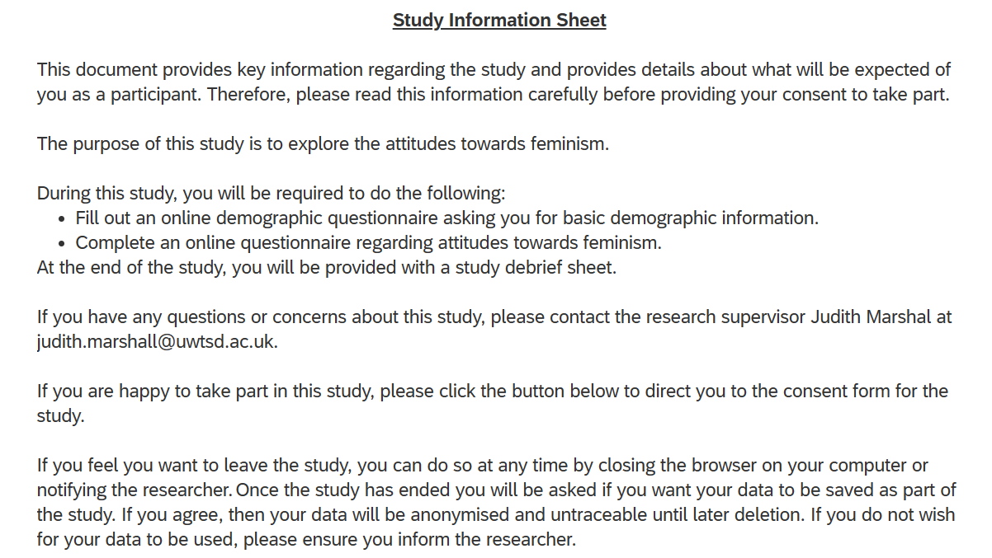

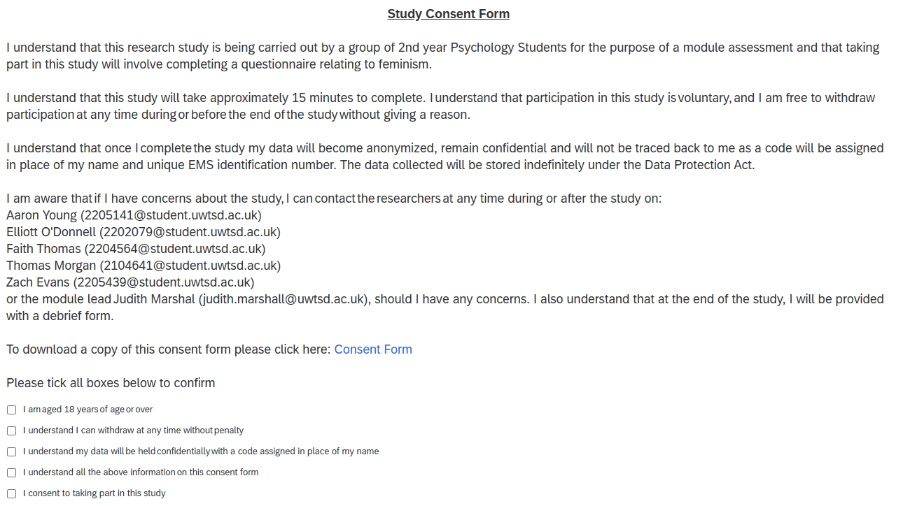
Appendix C – Consent Form

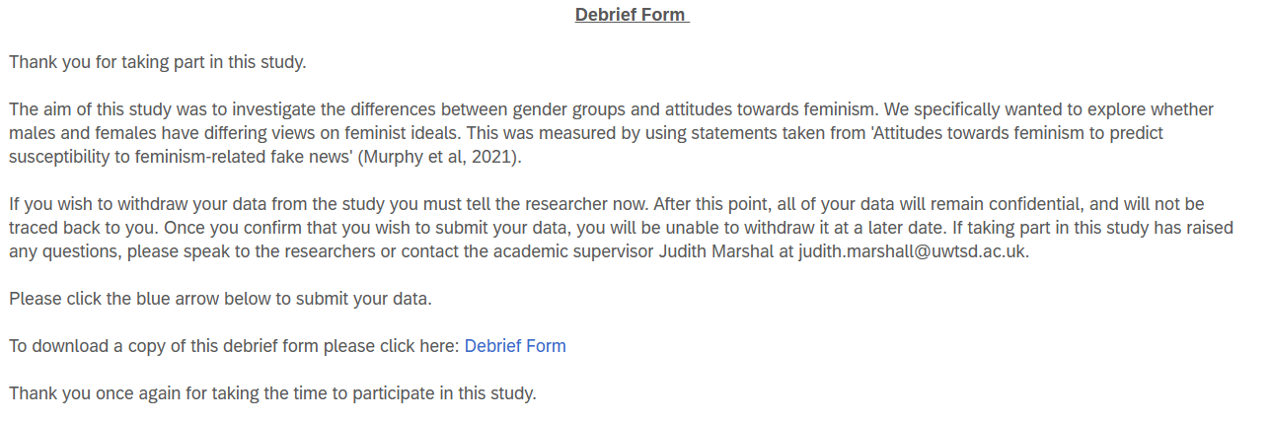
Appendix D – Debrief Form

Appendix E – Participant Group Statistics (SSPS)
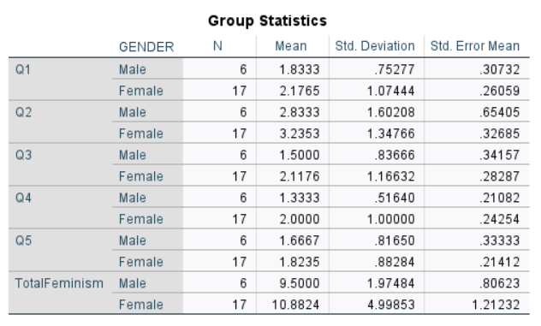
Appendix F - graph displaying mean responses for each question

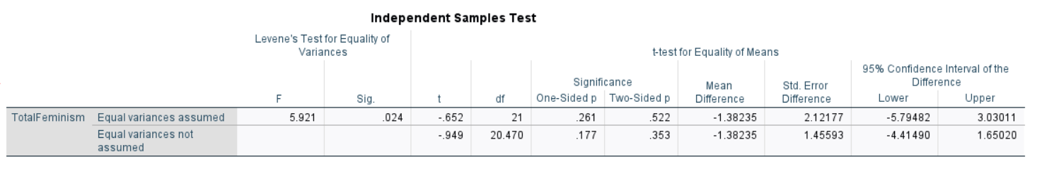

Appendix G - Independent samples t-test/Lavine's equality of variance (SSPS)

