Question Title: How do we remember? Using at least three examples, discuss the social, political and historical aspects of commemoration
Student Number: P150541
Course Title: Illustration Ba(Hons)
Word Count: 1586 (excluding bibliography)
Tutors: Sarah Tombs and Louise Burston

How Do We Remember?

Introduction
In this analysis I want to look at how, why and what we remember and what we think it means to remember, whether it’s a natural disaster or the birth of your first born. I want to find out exactly why we have memorials and what they represent. By the end of this paper I want to have a firm grip on these things I’ve outlined.
First, I want to look at the word “remember” itself, where it originates and other synonyms as well. I will be looking three memorable events in time, what they are and how they are remembered. I also want to look at what the poppy represents and how it came to be a symbol of remembrance.

What does it mean?
Google’s first dictation states that to remember as a verb is to “have in or be able to bring to one's mind an awareness of (someone or something from the past).” Google (n.d.). It also states that it’s originates from the Latin “memor” which translates to mindful or “rememorari” which means call to mind. Of course, in different contexts it has other similar meanings such as to remember someone in a will is to make provisions for them or to remember someone in a prayer is to wish wellbeing.
One way people remember is by way of a memorial, this can be in a form of a plaque, statue, holiday or a personal token. (R. Figley, 2012) says that “In the literature on memorials, the term memorial is closely linked to the word monument. The root of monument is also a Latin word, monere, meaning, "to remind or warn."” This is interesting as it means that a monument is not only there to sympathise and give closure or give remembrance to the viewer but also to warn them of sacrifice or that this should not be seen in vain.
When you ask someone, what was their most memorable moment, you usually get answers like the birth of their first born, when they met their spouse for the first time, family holidays and the classic egg and spoon race on sports day. So really you could say that people remember to get a fond feeling from that memory. Pleasant memories and always a pleasure to recall but according to research, a negative experience is easier to remember than a positive experience.
“I also will argue that although positive arousing and negative arousing experiences are more likely to be remembered than neutral ones, when it comes to remembering the details of those emotional experiences, valence is a critical factor. Negative affect, in particular, is more likely to lead to focal memory enhancements, whereas positive affect often conveys little benefit to memory accuracy.” (Kensinger, E. 2009)
Poppies
Poppies are large sign of remembrance originating from the first world war when a Canadian doctor noticed that after the death of a friend, the first signs of life on the battlefield were poppies. He then wrote a poem called ‘In Flanders Field’ about what he’d seen and felt. At first, he hated the poem but after showing it to some fellow soldiers he sent it to several publishing houses and after a rejection by the spectator magazine he then got an offer of publication from a magazine called ‘Punch’ in 1915. The poem inspired the use of silk poppies to be worn as remembrance to those lost in battle. Nowadays, one hundred years on, poppies are still worn as remembrance and the proceeds of selling the poppies go to the welfare of war veterans and their families in need of support. ‘In Flanders Field’ is now one of the most popular poems in the English language.

What do we remember?

“That’s one small step for man”- (Armstrong, N. 1969).
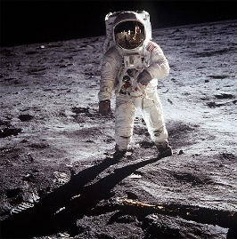
The moon landing of course is one of the most memorable moments in history, this moment changed everything, the first man on the moon opened up doors to new ideas and gave inspiration to many who made it their mission to take it one “step” further to see what can be accomplished. It has brought advancements in technology such as life supports, computer systems and space age materials. It also brought a sense of unity to the people around the world, as Armstrong took that first step, 600 million people watched at home. Putting aside their differences and spectated in awe of the first man on the moon. This unfortunately was short lived, but it made a difference, it showed that people are capable of unity and it only took one of the most memorable moments in time.
Figure 1
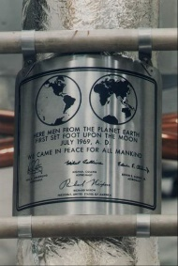
During the astronaut’s time on the moon they took samples, photographs and left behind an American flag with a plaque stating “Here men from the planet Earth first set foot upon the moon. July 1969 A.D. We came in peace for all mankind.” NASA. (n.d.). A plaque of remembrance, of achievement and the hard work it took to get men on the moon, a memory that will not be forgotten.
Figure 2

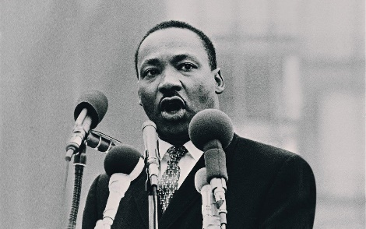
“I have a Dream” – (Luther King, Jr, M. 1963)
This of course refers to the march on Washington DC lead by Martin Luther King, Jr on August 28th, 1963 and his speech that so many know today.
In his speech, King talks about the rights that they had been promised and in his words, he states that “The check has come back marked ‘Insufficient funds’” (Luther King, Jr, M. 1963) and yet he refuses to believe that the “Bank of justice is bankrupt” (Luther King, Jr, M. 1963). This shows that even after his efforts and hard work, when he gets a negative response, he comes back even stronger with hope and belief there is a better way.
Figure 3
The name Luther King carries a memory itself, and not only were his words revolutionary but they carried hope and reassurance that there can be justice. He instils belief in the people who listen that America is capable of equality.
Although not all his marches were successful, he was one of the most memorable people in the movement and still had an effect even after his assassination.
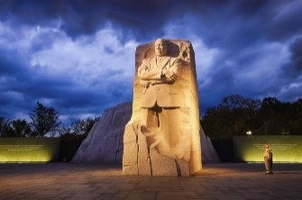
Despite not being a president, there is a memorial in Washington in his honour, an honour that only three other non-presidents have received. This is just one of the ways Martin Luthor King, Jr is remembered today. Although there unfortunately isn’t much of a tribute made in the UK. There is a holiday set aside in honour of his efforts set on the 15th of January (His birthday) and is celebrated every third Monday of January in the States.
Figure 4

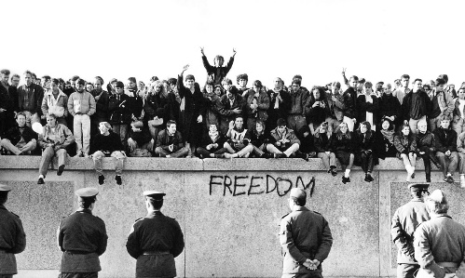
“Mister Gorbachev, tear down this wall!” – (Reagan, 1987)
Another of one of the most memorable moments in time is the collapse of the Berlin wall, this wall divided Berlin for 30 odd years. It was built in 1961 by the German Democratic Republic to prevent citizens in the communist east Germany from fleeing to the democracy in West Berlin. It included guarded towers and something that was known as the “Death Strip” that contained defences. Demolition of the wall finally began in 1989 but wasn’t completely destroyed until two years later.
Figure 5
Figure 4
"Yes, across Europe, this wall will fall. For it cannot withstand faith; it cannot withstand truth. The wall cannot withstand freedom." (Reagan, 1987)
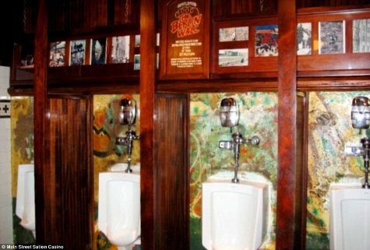
After the demolition of the wall started, the majority or the wall was reused to make other building materials for reconstructions projects, but some pieces were sold in auction and sent around the world, one piece is even displayed in the men’s room in a Las Vegas Casino. Supposing that it’s there as a memento to remind people of the suffering and tragedy of the wall but admittedly it is a strange place for it to turn up.
Figure 6
Other places it’s been displayed include Los Angeles, California and even Usain Bolt owns a piece as the city of Berlin gifted it to him when he broke the world records in 100 and 200 metre sprints.

Conclusion - So Why Remember?
In many way, remembrance is a way of learning, to learn what has happened in history whether it’s to warn or to remind people of the hard work or pain that others have experienced so that we can live happy and equal lives. Remembrance is also a good way to give someone closure for example if someone had lost a loved one in a war then remembrance would show them that they are not alone, and their sacrifice has not gone un-noticed. Or keeping in mind about the red poppy, the proceeds made from selling the remembrance piece goes to helping war vets and their families, therefor remembering our fallen soldiers also helps in another way.
Another reason it is good to remember is to know what others have accomplished before you and, so you can then know how to proceed for the better, for example, Apollo 11 was the first successful moon landing meaning that there had been other missions that had failed. To remember the loss, they can improve to save lives and accomplish the imaginable and un-imaginable.
As I have found in this investigation, there are many reasons to remember and many ways how to as well. Whether it’s to support those lives lost, lives survived, accomplishments, a personal memory or to show that someone cares, we all remember somehow. And I think it’s important to not stop. Ever.

Bibliography
Direct Quote-
- Armstrong, N. (1969). "That's one small step for man...". [Recording] United States: NASA. Available at: https://www.nasa.gov/wav/62284main_onesmall2.wav [Accessed: 12 Dec. 2017].
- Google (published date unknown) Google, Available at www.google.co.uk, (Accessed: 07/12/2017).
- Kensinger, E. (2009). Remembering the Details : Effects of Emotion. United States of America: NIHMS and PMC, p.Introduction. Available at: https://www.ncbi.nlm.nih.gov/pmc/articles/PMC2676782/ (Accessed: 13/12/2017)
- Martin Luther King, Jr. (1963). [video] Directed by M. Luther King, Jr. United States of America: Fight for the Future. Available at https://www.youtube.com/watch?v=smEqnnklfYs, (Accessed: 13/12/2017)
- NASA. (n.d.). July 20, 1969: One Giant Leap For Mankind. [online] Available at: https://www.nasa.gov/mission_pages/apollo/apollo11.html [Accessed: 12 Dec. 2017].
- Reagan, R. (1987). Tear Down This Wall. Available at: https://www.thelocal.de/20161109/ten-famous-quotes-about-the-berlin-wall-9-november-anniversary, (Accessed: 13/12/2017)
- R. Figley, C. (2012). Encyclopedia of Trauma: An Interdisciplinary Guide. [ebook] United States of America: SAGE Publications. Available at: https://books.google.co.uk/books?id=DCd1CQAAQBAJ&printsec=frontcover&source=gbs_atb#v=onepage&q&f=false [Accessed: 12 Dec. 2017].

Websites Used for research-
- http://www.telegraph.co.uk/news/health/news/4902836/Memories-of-historic-events-stonger-than-personal-moments.html
[accessed 07 December 2017]
- https://www.google.co.uk/search?q=remember&rlz=1C1GGRV_enGB762GB762&oq=reme&aqs=chrome.1.69i57j0l5.2585j0j7&sourceid=chrome&ie=UTF-8
[accessed 07 December 2017]
- https://owlcation.com/humanities/The-10-Most-Important-Moments-in-History-An-Illustrated-Guide
- http://www.viralnova.com/unexpected-views/
- https://www.collegenanniesandtutors.com/blog/title/Martin-Luther-King-Jr-and-His-Impact-on-Today
- https://sciencing.com/effect-first-moon-landing-world-8789492.html

Images-
- Figure 1 - http://www.herebeanswers.com/2010/10/neil-armstrong-moon-landing-nasa-fake.html
- Figure 2 -https://www.nasa.gov/centers/marshall/moonmars/apollo40/apollo11_plaque.html
- Figure 3 - http://wunc.org/post/listen-first-recording-mlks-i-have-dream-rocky-mount-1962-audio#stream/0
- Figure 4 - https://washington.org/visit-dc/martin-luther-king-jr-memorial
- Figure 5 - https://www.theguardian.com/world/2014/nov/06/-sp-fall-berlin-wall-what-it-meant-to-be-there
- Figure 6 - http://www.dailymail.co.uk/travel/travel_news/article-2820196/Where-parts-Berlin-Wall-scattered-past-25-years.html

