Planning and Delivering an International Event.

International Meetings Management BMIH6007
Teodor Catalin Belu (2116226)
Module Lead and Tutor: Kathryn Flynn

Table of Content

Introduction……………………………………………………………………..………………..3
- The event cycle……………………………………………………………..……………….4
  - Event concept ……………………………………..……………………..……………..4
  - Aims and objectives of EcoVista Expo 2025……………………………..………….5
- EcoVista Expo 2025 operational strategy…………………………………..………….6
- Tourism EcoVista Expo Budget ……………………………………………..…………..7
- Industry trends/impacts………………………………………………………..………….8
  - Technology and hybrid inclusion………………………………………………..……..8
  - Sustainability………………………………………………………………………..…...8
- Cultural and situational considerations……………………………….………………. 9
  - External factors affecting the event (PESTEL analysis)………………………….. 9
  - Risk management plan – SWAT analyses………………………………...………..10

References………………………………………………………………..…………..………….12
Appendices ……………………………………………………………..………………..……… 14
Appendix A………...………………………………………………………………….………….. 14
Appendix B……………………………………...…………………………………….………….. 15
Appendix C………………………………………...…………………………………….……….. 16
Appendix D…………………………………………...………………………………….……….. 17

Introduction

The tourist industry and research community just started to recognise "event tourism" as a phenomenon a few decades ago, thus the sector's subsequent expansion can only be described as remarkable. Lempel (2005, cited in Ruiz and Gandia, 2023) says the event is a spatiotemporal structure where people or actors from many industries or organisations get together, regularly, to generate and exchange value. Jackson (2008, cited in Kulshreshtha, 2023, p. 2) is defining events as organisations with a variety of themes which are influenced by the traditions of surrounding civilizations, attract tourists, and support the region's branding goal by arousing powerful emotions in guests. According to Herold (2022, p. 1) even if from the standpoint of the customer, they are frequently disregarded, the domains of logistics and coordination management are crucial and intricate in the context of an international event.
Tourism EcoVista Expo 2025 is a newly designed international super event developed in a public-private partnership which aims to bring change to the tourism sector by teaching the audience how to adapt the sector business to the new environmental requirements offering solutions to the main problems affecting the sector. The event will be shared in two areas, the conference area and the trade and exposition area.
Italy, one of the most visited countries in the world and also one that is most impacted by pollution and overtourism, was the deliberate choice for the location of this international event. Villa Borghese, Rome's most well-liked park, known as its "green lung," is going to be the venue of EcoVista Expo 2025. Situated near the Spanish Steps and Piazza del Popolo, the Villa Borghese Gardens are situated on the Pincian Hill. Cardone Scipione Borghese created the 80-hectare Gardens in 1606 to transform his old vineyard into the largest gardens ever constructed in Rome while at the same time architect Flaminio Ponzio was commissioned by the Cardinal to build the Villa Borghese Pinciana where the Galleria Borghese is currently housed (Villa Borghese, 2024). Today this magnificent place, an oasis of relaxation in the middle of nature, surrounded by history in the middle of one of the most visited cities of Europe (appendix A) was chosen to be the venue of EcoVista Expo 2025 (Statista.com, 2024). The conference area will be placed inside the Galleria Borghese while the trade and exposition area will be placed outside in the garden area.

- The event cycle:

The planning stage of the event cycle is crucial since it will almost always decide how the delivery stage is going to be and if the event is going to be a success (Quick, 2020, p.9). According to Holmes and Ali-Knight (2017, p. 989) researchers are starting to pay attention to the event life cycle, which is a key temporal subject that involves both shifting market attractiveness and event sustainability. For pertinent theories and models, the field of event and festival studies has looked to adjacent disciplines including management, tourism, and leisure studies. Few theories have come from the field itself, in comparison (Gets and Page, 2015, p. 594).

  - Event Concept

The focus of Tourism EcoVista Expo 2025 is sustainability in all its manifestations, with the intention of raising awareness and serving as a catalyst for significant change. The purpose of the event is to provide a thorough exhibition of sustainable living, bringing together innovators, consumers, and businesses under one roof. This social event seeks to transform the tourism and hospitality industries' approach to sustainable practices by demonstrating sustainable solutions and motivating individuals and organisations to embrace eco-friendly behaviours. Tourism's EcoVista Expo 2025 is a movement, not just an event. The idea is to provide a forum that breaks down barriers and encourages communication and cooperation to bring sustainable practices into the public eye. Through the combination of forward-thinking ideas and practical tactics, the event hopes to light a flame that converts individual viewpoints into a group commitment to sustainable tourism.
To successfully secure and deliver large events, all stakeholders must work together in a multi-agency partnership (United Kingdom Government, 2015). Wood (2022, p.6) also discovered that working together on a project from beginning to end yields greater benefits. At this event because of things like the yearly engagement of different speakers, the transitory involvement of workers, volunteers, and partners, and the rotation of venues and suppliers, the ties between event stakeholders are short-lived and based on this specific event (Tiew, Holmes and de Busy, 2022, p. 1298). The event will be evaluated based on how well it manages the conflicting demands, expectations, and interests of a wide variety of stakeholders (Bowdin et al, 2024, p. 254).
CWT meetings and events were selected by the Hardland (2017) association, the home of sustainable tourism in Italy in collaboration with the World Travel and Tourism Council (2024) the global representative of the travel and tourism sector to run EcoVista Expo 2025 which will take place in Rome in 25 - 26 May 2025. The audience will be entertained by more than 300 speakers on three stages. Greta Thunberg and Paul Watson, two of the top 10 activists of our times are just two of the big names and key stakeholders of the event (EcoCation, 2023). Chris Charles the general manager of the Pig at-combe Devon, one of the best eco-friendly hotels in the UK is also an important participant (Modi, 2023). Diversey (2024) the Solenis company with more than 100 years of experience and one of the main chemicals providers in the hospitality industry worldwide is the main sponsor and also partner of the event.

  - Aim and Objectives of EcoVista Expo 2025

The Tourism EcoVista Expo 2025 'A Sustainable Journey' mission statement can act according to Schulze and Merrill (2019, p. 180) as an event's compass, indicating the event's intended course and setting the direction and the event destination. According to the Welsh Government (2023) the event objectives are used as a strategic plan and as a guide for the event departments, divisions, and individual employees. EcoVista Expo's main aims are to make the best use of resources and technology, to present solutions for increasing sustainability in the tourism industry, to offer solutions for minimizing waste through recycling, to encourage the reduction of single-use plastic and energy-efficient lighting for the tourism sector businesses and to increase awareness and educate the consumers about the problem faced by the environment and the necessity of responsible tourism. The event's primary goals are to support travel agencies in marketing and selling eco-friendly travel destinations to tourists and to foster a positive environment that fosters trust and fosters cooperation in the travel industry for a better tomorrow. EcoVista Expo's main objectives are to recycle 80% of the event waste and generate income by selling 1000 tickets, 15 dedicated trade shows and 10 exhibition places.

- EcoVista Expo 2025 operational strategy:

Tourism EcoVista Expo event will be open to the public on 25 May between 10 am and 8 pm and 26 May between 10am and 5pm. The venue set up and organisation will start on 23 May at 9 am time from which the access to the venue is guaranteed according to the renting contract. The venue set-up will be managed by the event's management personnel hired on a contract basis, while the remainder of the crew hired out to help with venue setup, cleaning, and other tasks is going to be outsourced. The organising committee has decided to hire external personnel to cut expenses associated with hiring and onboarding new hires, as well as lodging and travel expenses. Targe Motivation (2024) company is in charge of the event logistics, reception service, press area, catering and social dinner service for speakers, interpretation and translation in multiple languages during the conference, ticketing process, equipment transport and so on. The venue management and employees will supervise the entire event, offering support and guidance where needed. The conference venue organisation is available in Appendix B. Trade and presentation area map is available in Appendix C.
The event security is ensured by Instituto di Vigilanza Privata CSM Global Security Service (2024) a contracted supplier specialised in security and protection. The contracted supplier will offer services during the event, the same as 2 days before the event during the preparation and venue set-up.
Food and beverage are available for the visitors contra-cost anytime during the event in the trade and presentation area (Appendix C), situated in the venue gardens and are provided by authorized distributors partners. A variety of street food such as pizza, tachos, vegetarian, and vegan food are accessible to the participants. Spikers and staff have free soft and hot drinks available all the time in a specific area inside the Gallery next to the conference room same as they have available buffet during lunch time between 1:00 pm and 3:00 pm. During lunch, conference attendees will also have access to the bar and buffet located inside the Gallery, this service is part of the conference registration fee.

- Tourism EcoVista Expo 2025 Budget (Appendix C)

The event expenses will include fixed unavoidable costs that remain constant for the entire event period, such as venue rent, authorisations costs, staff wages, speakers’ accommodation, security, and also variable costs as the ones used for marketing the event, equipment rental, transportation, and so on. Some of the variable costs are avoidable and may be saved or reduced if needed. The labour costs are fixed costs and stay fixed within the specified activity level of the event but can turn into semi -fixed costs According to Drury (2018, p. 29) and increase or decrease depending on the number of participants attending the event. The event's main income source is resulted from ticket sales, rental places for businesses, sponsorship, and advertising. The expected profit of the event is £101.372,00.

- Industry trends and impacts
Sustainability and technology integration are two significant trends in the event industry that continue to evolve. Combining these aspects can lead to more efficient, eco-friendly, and engaging events.
  - Technology and Hybrid events

Technology makes possible the creation of hybrid and virtual events, which lessens the need for actual travel because they incorporate both virtual and in-person components having also less impact on the environment. These events can reach a larger audience, including people who would not be able to physically attend because of travel, budgetary limitations, or other reasons (Tao, 2023). Attendees' freedom in choosing to attend in person or digitally, which gives them options to fit their schedules or preferences is also a plus of technology integration in event (Simons, 2019). Smart lighting, HVAC systems, and automated controls are just a few examples of the smart technologies that venues are integrating to manage energy more effectively. The experience of attendees is also improved through access to mobile apps and RFID (Radio-Frequency Identification) technology, which also simplifies event operations like contactless check-ins, access control, and customised content distribution.

  - Sustainability

To reduce its environmental impact, the event industry is gradually adopting eco-friendly practices. This entails putting sustainable transportation options into practice, reducing waste, and using recycled materials. Energy-efficient technology is being implemented in event spaces, and LED lighting is just one method that events are investigating to cut down on energy usage. Certain events are making investments in renewable energy projects or providing support for environmental initiatives to offset their carbon footprint.

- Cultural and situational considerations

  - External factors affecting the event (PESTEL analysis):

Political Factors:
Italy, one of the founding members of the European Union whose policies are centred on maintaining peace and promoting economic development, will host the tourism EcoVista Expo event. Italy is dedicated to reducing carbon consumption and promoting sustainability globally as a signatory to the Paris Agreement and a member of the United Nations.
Economic factors:
According to the International Trade Administration (2024) Italian economy is the eighth largest in the world and the third largest in the Eurozone, with a GDP of approximately $2.1 trillion in 2021 will reduce the risks of financial loss and will attract the participants and sponsors. European Union budgetary guidance lows are offering stability to the business sector. The high unemployment rate of the country, higher than the EU average, with an estimated by European Employment Service (2023) at 7.8% in March, is another economic factor that will benefit the Tourism EcoVisa Expo offering labour force and helping the event to increase the social joy and produce a positive effect.
Social Factors
80% of Italians identify as Catholics, religion plays a significant societal role in the country, and this may have an impact on the public's perception of social justice and human rights (Dell’Orto,2023). The good educational system of the country will provide the event with a highly skilled labour force.

Technological Factors
According to Dixon (2024) the country has a highly developed internet penetration rate with 51 million users in 2023 and a developed telecommunications network, which will support the creation and upkeep of aggressive marketing campaigns utilising a range of platforms and techniques.
Environmental factors
According to The Guardian (2023) climate change is one of the most urgent environmental problems Italy is now experiencing. The effects of global warming are already being felt in the nation same as worldwide and the Italian government has already put in place several laws and programmes to cut greenhouse gas emissions and move towards a low-carbon economy to fight climate change so Tourism EcoVista Expo will be an extra help in finding solution and making consumers understand the necessity of green hospitality and tourism.
Legal Factors
As a member of United Europe Italy is aligned with the European legal system and has strict regulations regarding event management, public and private place usage, using and closing public roads, labour force and so on.

  - Risk management plan – SWAT analyses:
In today's events sector, risk management is according to Nadda, Arnott, and Sealy, 2020) a critical necessity. When deciding whether to hold the event, all aspects of event delivery must be considered. This information must then be distributed to all relevant parties so that they can add it to the document.

Straights
The event is concentrating on the tourism industry, which is according to The United Nation World Tourism Organisation (2019) one of the largest commercial sectors in the modern world and is responsible for 5% of the global GDP by 2023 and is in contour with customer preferences given the rising demand for eco-friendly goods and services Paris Agreement requirements. Italy's deep cultural appreciation of art, history, and nature makes the setting ideal for an event where participants may connect with environmental and cultural values. The accessibility and aesthetic appeal of the venue can improve guests' overall experience. Italian food is well-known around the world, and the event can benefit from the long history of using organic and locally sourced food, encouraging sustainable agriculture and mindful eating. The speakers have a strong reputation, and several foreign organisations are looking for volunteers for the event without getting paid.

Weaknesses

Rome, like many major cities, faces challenges related to air quality and pollution. This could be a concern for a sustainable event as it might contradict the theme. The town is known for heavy traffic congestion, which may impact transportation to and from the conference venue. This can contribute to increased carbon emissions and present challenges for attendees. Like many cities Rome faces waste management challenges so ensuring effective waste reduction and recycling practices during the conference might be more complex. Even though English is widely spoken in the business and tourism sectors, language hurdles may nevertheless make it difficult for participants who do not understand the language to communicate effectively.
Opportunities

The event can leverage various opportunities to enhance its impact and reach. Rome's rich history and cultural heritage provide a unique backdrop for a sustainability event. The integration of sustainable practices within historical venues can create a powerful narrative. The country has organizations, businesses, and academic institutions that are leaders in sustainable practices. Partnering with these entities can offer volunteers and bring expert speakers, sponsors, and valuable insights to the event. Building relationships with local communities and involving them in the conference can foster support and create a positive impact on the event's success.

Threats

Rome's climate, with unpredictable weather patterns, poses a threat to outdoor activities planned as part of the event. Rain or extreme temperatures could disrupt planned events. The historical venues lack the necessary sustainable infrastructure, making it challenging to implement eco-friendly practices, such as waste reduction or energy efficiency and also restrictions on modifications or installations. Ongoing or emerging public health issues, such as pandemics or health crises, could disrupt travel plans and attendance, affecting the overall success of the conference.

References:
Dell’Orto,J. (2023) 'Nearly 80% of Italians say they are Catholic. But few regularly go to church'. APNews 5th Oct. Available at: https:// apnews.com/article/italy-religion-catholic-church-secular-032f2e49ba1a7149407ad25a62b481ab (accessed: 02.02.2024)

Dixon, S. J. (2024) 'Social media usage in Italy - Statistics & Facts'. Statistica 10 Jan. Available at: https:// /www.statista.com/topics/6449/social-media-usage-initaly/#:~:text=As%20of%20January%202023%2C%20Italy,by%20the%20end%20of%202028. (accessed: 02.02.2024)

Diversey (2024) About us. Available at: https:// diversey.com/en/about-us (accessed: 15.02.2024)

Drury, C. (2018) Managing and Cost Accounting. 10th Ed. China: RR Donnelley

EcoCation.org (2023) 'Famous environmental Activists – Top 10'. Available at: https:// ecocation.org/famous-environmental-activists/ (accessed: 01.02.2024)

European Employment Service [EURES] (2023) Labour Market Information: Italy. 15th Sept. Available at: https:// eures.europa.eu/living-and-working/labour-market-information/labour-market-information-italy_en#national-level (accessed: 16.02.2024)

The Guardian (2023) 'The extreme events scare me the most’: climatologist warns of Italy’s vulnerability to climate crisis'. Available at: https:// www.theguardian.com/world/2023/aug/04/the-extreme-events-scare-me-the-most-climatologist-warns-of-italys-vulnerability-to-climate-crisis (accessed: 17.02.2024)

Getz, D. and Page, S. (2016) 'Progress and prospects for event tourism research'. Tourism Management Volume 52 (Feb, Pages 593-631). Available at: https://doi.org/10.1016/j.tourman.2015.03.007 (accessed: 15.02.2024)

Hartland (2017) Hardland association. Available at: https://spiritsheartlandofintent.com (accessed: 01.02.2023)

Herold, D.M. (2022) Managing global sport events: logistics and coordination. London, England: Emerald Publishing Limited.

Holmes, K. and Ali-Knight, J. (2017) “The event and festival life cycle – developing a new model for a new context,” International journal of contemporary hospitality management, 29(3), pp. 986–1004. Available at: https://doi.org/10.1108/IJCHM-10-2015-0581. (accessed: 15.02.2024)

International Trade Administration (2024) Italy – Country Commercial guid. Available at: https:// www.trade.gov/country-commercial-guides/italy-market-overview#:~:text=The%20Italian%20economy%20is%20the,36%2C810%20per%20capita)%20in%202022.( accessed:02.02.2024)

Modi, R. (2023) 'The best eco-friendly hotels in the United Kingdom offer sustainable sanctuaries from every occasion'. The hotel Journal, 15th Aprile. Available at: https:// thehoteljournal.com/best-eco-friendly-hotels-united-kingdom-sustainable/ (accessed: 02.02.2024)

Nadda, V., Arnott, I. and Sealy, W. (eds) (2020) Legal, safety, and environmental challenges for event management: emerging research and opportunities. Hershey, Pennsylvania: IGI Global. Available at: https://doi.org/10.4018/978-1-7998-3230-0 (accessed:24.02.2024)

Ruiz, É. and Gandia, R. (2023) “The key role of the event in combining business and community-based logics for managing an ecosystem: Empirical evidence from Lyon e-Sport,” European management journal, 41(4), pp. 560–574. Available at: https://doi.org/10.1016/j.emj.2022.07.005 (accessed: 15.02.2024)

Schulze, H. and Merrill, D. (2019) Excellence wins: a no-nonsense guide to becoming the best in a world of compromise. Grand Rapids, MI: Zondervan (accessed: 15.02.2024).

Simons, I. (2019) “Events and online interaction: the construction of hybrid event communities,” Leisure studies, 38(2), pp. 145–159. Available at: https://doi.org/10.1080/02614367.2018.1553994 (accessed: 18.02.2024)

Statista (2024) 'Number of international tourist arrivals in selected cities and destinations in Europe from 2019 to 2022'. Available at: https://www.statista.com/statistics/487572/leading-european-city-destinations/ (accessed: 15.02.2023)

Tao, M. (2023) Marketing Virtual and Hybrid Events. Carpenteria, CA: linkedin.com. Available at: https://librarysearch.uwtsd.ac.uk/permalink/44WHELF_UWTSD/11c0l68/alma99100559444202421 (accessed: 18.02.2024)

The United Nation World Tourism Organisation [UNWTO] (2019) Tourism’s Carbon Emissions Measured in Landmark Report Launched At COP25. Available at:https:// www.unwto.org/news/tourisms-carbon-emissions-measured-in-landmark-report-launched-at-cop25 (accessed: 25.02.2024)

Tiew, F., Holmes, K. and de Bussy, N. (2022) “Investigating Stakeholder Salience Across the Event Management Life Cycle,” Event management, 26(6), pp. 1297–1313. Available at: https://doi.org/10.3727/152599522X16419948390925. (accessed: 15.02.2014)

United Kingdom Government [UKGov] (2015) Gold Framework Guidance on UK-level support available when bidding for and staging major sporting events. Available at: https://assets.publishing.service.gov.uk/media/5a7f866c40f0b6230269003e/K4094_Major_Events_Strategy_Doc_v7.pdf (accessed: 15.02.2024).

Welsh Government (2023) Establishing aims and objectives. Available at: https:// /www.carmarthenshire.gov.wales/home/business/organising-events/community-toolkit/establishing-aims-and-objectives/#:~:text=Objectives%20are%20essentially%20aims%20broken,spectators%2C%20sponsors%20and%20the%20media (accessed: 15.02.2024).

Villa Bourghese (2024) 'Vila Borghese Gardens'. Available at: https://www.villaborghesetours.com/info/villa-borghese-gardens/ (accessed: 15.02.2024)

Wood, L.C. (2022) Applied guide for event study research in supply chain management. Hershey, Pennsylvania: Business Science Reference.

World Travel and Tourism Council [WTTC] (2024) World Travel & Tourism Council (WTTC) represents the Travel & Tourism sector globally. Available at: https:// moodle.uwtsd.ac.uk/pluginfile.php/853950/mod_resource/content/1/harvard_Referencing%202023.pdf (accessed: 15.02.2024)

Appendices:

Appendix A
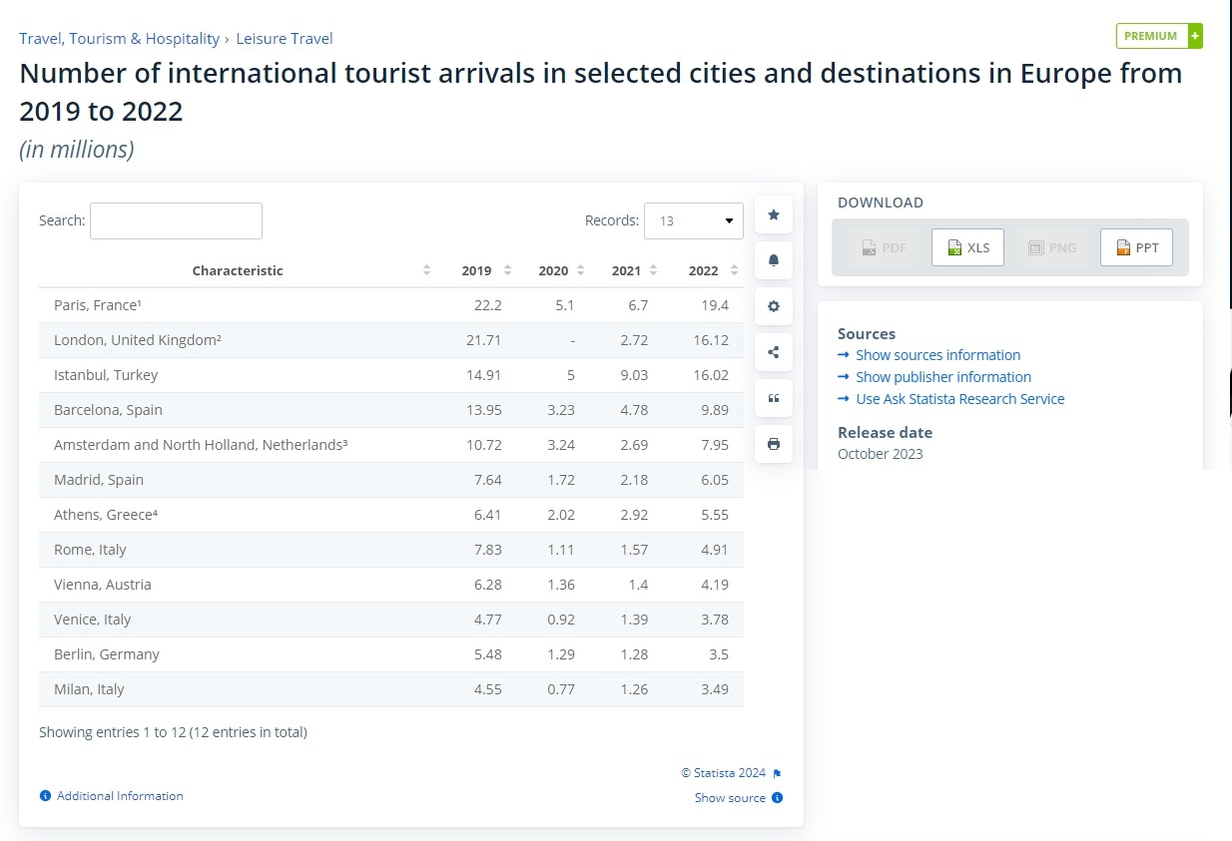
(Statista.com, 2024)

Appendix B
Conference Room inside the gallery set up plan.

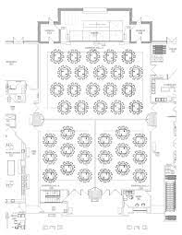
12 people on each table
Maxim total participants numbers for one session - 440

Appendix C
Trade and Presentation set up map.
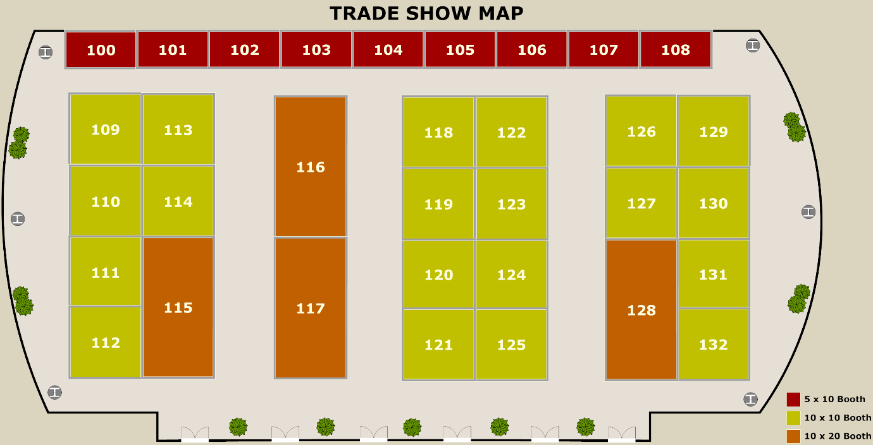
Green – Trade areas
Red – Presentation Areas
Orange – Food and Beverage Areas

Appendix D – Event Bouget



