
Programme: Master of Business Administration
Module: International Marketing Principles and Practices
Module Code: LCMB7026

Student Name: Jainil Kanubhai Patel
Student ID: 2519957
Group: 3

Lecturer: Tushara Balendran

AI acknowledgement
RESEARCH | For this assessment, you can use Generative AI to support you in research and data analysis. | Yes ☒  No ☐
STRUCTURE | For this assessment, you can use Generative AI to support you in structuring your submission, including creating a draft argument structure, identifying parts  and headings, etc. | Yes ☐  No ☒
PROOFREADING | For this assessment, you can use Generative AI to check your own text/creation for grammatical and syntactical mistakes, including getting suggestions to  rephrase your work. | Yes ☒  No ☐
WRITING | For this assessment, you can use Generative AI to create text for submission. | Yes ☐  No ☒
CREATIVE | For this assessment, you can use Generative AI to create creative materials, such as images. | Yes ☒  No ☐
PROGRAMING | For this assessment, you can use Generative AI to create and check code. | Yes ☐  No ☒
NONE | For this assessment, you are not allowed to use any type of Generative AI support. This includes research support, structure support, writing/proofreading  support and creative support. | ☐

I confirm that I used AI for just make image from Gemini (https://gemini.google.com/ ) and ChatGPT (https://chatgpt.com/ )

Table of content
1.1 Introduction of report 5
1.2 Background information of Cadbury 5
2. PESTEL Analyses for Cadbury 7
2.1 Political Factors 7
2.2 Economic Factors 8
2.3 Social Factors 9
CULTURAL FACTORS 10
Hofstede cultural dimension framework for UK and India 10
Advantages and disadvantages of Hofstede cultural dimension framework 13
2.4 Technological Factors 14
2.5 Environmental Factors 15
2.6 Legal Factors 15
3.0 Segmentation, Targeting, and Positioning (STP) 17
3.1 Segmentation 17
VALS Framework Alignment: UK vs. India 19
3.2 Targeting 19
3.3 Positioning 20
4.0 International Marketing Mix (7Ps) 23
4.1 Product 23
4.2 Price 26
4.3 Place 28
4.4 Promotion 30
4.5 People 31
4.6 Process 32
4.7 Physical Evidence 33
5. Cadbury Market Entry Method for India 35
6. Ethical and Unethical Marketing 37
7. Strategic Recommendations 38
Part:2 Gibbs Reflective Cycle 40
References 44

1. Introduction

1.1 Introduction of report
This report analyses the international marketing strategies of Cadbury in two different countries: the United Kingdom and India. The focus of this report is to examine how Cadbury adapts its marketing strategies across these markets by considering differences in their economic, political, social, technological, legal, and cultural environments. The report applies key international marketing frameworks, including PESTEL analysis, Hofstede's Cultural Dimensions, Segmentation, Targeting and Positioning (STP), and the Marketing Mix (7Ps), Market Entry Methods, Reaccommodation, Ethical and unethical marketing to evaluate the company's performance and strategic approach in both countries.

1.2 Background information of Cadbury
Cadbury is one of the world's most recognized confectionery brands and was founded by John Cadbury in Birmingham, England, in 1824. Initially established as a small business selling tea, coffee and drinking chocolate, the company expanded significantly and became a leading global chocolate manufacturer (Cadbury, 2025). Today, Cadbury operates as part of Mondelez International, a multinational snack food company with products sold in more than 150 countries worldwide (Mondelez International, 2025).

Source: Self-created from Gemini
The mission of Cadbury is to create moments of joy for consumers through high-quality confectionery products, while supporting sustainable and responsible business practices. The company's vision is aligned with Mondelez International's objective of leading the future of snacking by providing consumers with products that are enjoyable, innovative, and responsible produced (Mondelez International, 2025).
The United Kingdom has been selected as Cadbury's home country because it represents the origin of the brand and remains one of its most established markets. India has been chosen as the host country due to its importance as one of Cadbury's largest international markets. Cadbury entered India in 1948 and has since become the market leader in the country's chocolate confectionery industry. The company successfully adapted its products and promotional strategies to local consumer preferences by associating chocolate consumption with celebrations, gifting traditions, and family occasions. This localization strategy has contributed significantly to Cadbury's strong brand recognition and market success in India (Mondelez International, 2025).

2. PESTEL Analyses for Cadbury
The PESTEL framework is an important strategic scanning, identifying, and evaluating tool for the overall external environment (macro environment) that affects an organisation (Johnson, Whittington and Scholes, 2011). The framework identifies political, economic, social, technological, environmental, and legal factors as environmental forces, enabling researchers to identify risks and market opportunities beyond the control of a given company (Johnson, Whittington and Scholes, 2011). Therefore, it is important to perform a PESTEL analysis that gives the basic environmental information to assess market conditions and to build a flexible cross-border corporate strategy.
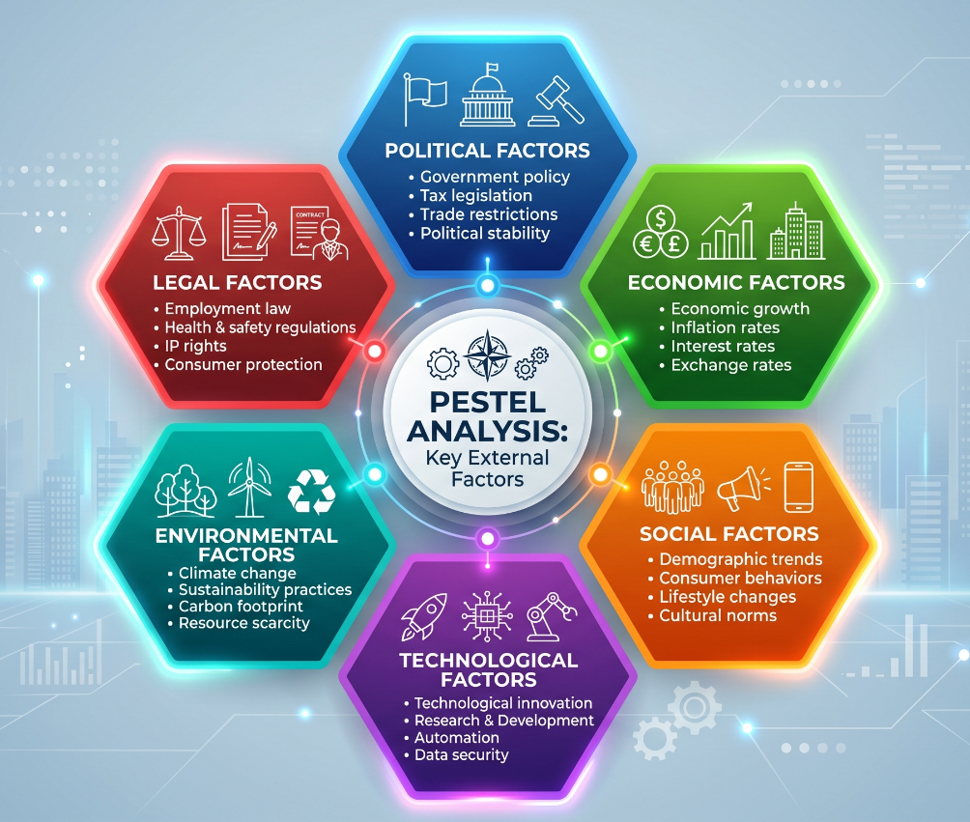
PESTEL Analyses Image (self-created)

2.1 Political Factors
United Kingdom – Favourable
The United Kingdom provides a favourable political environment due to its stable democratic government, transparent regulatory system and strong protection of intellectual property rights. These factors reduce business uncertainty and enable Cadbury to make long-term investment decisions confidently. Despite challenges created by Brexit, including customs procedures and higher import costs, the UK continues to offer a reliable business environment supported by efficient infrastructure and predictable government policies (Kotler and Keller, 2022; Mondelez International, 2024).
India – Favourable
India also presents a favourable political environment for Cadbury because government policies actively encourage foreign direct investment and manufacturing through initiatives such as Make in India. These policies have supported Cadbury's expansion of local production facilities and strengthened its nationwide distribution network. Although administrative procedures and state-level regulations can increase operational complexity, continuous government investment in industrial development and infrastructure creates attractive opportunities for multinational companies (Government of India, 2024; World Bank, 2024).

2.2 Economic Factors
United Kingdom – Favourable
The developed economy and high disposable income in the UK provide a positive environment for Cadbury's premium and seasonal confectionery products, with an annual GDP of $3.3 trillion, inflation rate of 2.5% and a revenue of approximately £1.8 billion (Euromonitor International, 2024; Kotler and Keller, 2022; Mondelez International, 2026; World Bank, 2024). The product availability and customer access is further bolstered by well-established retail networks and the extensive adoption of e-commerce. But with recent inflation and higher energy prices, manufacturing costs have risen and led to a more price-sensitive consumer response. However, Cadbury's reputation of brand loyalty allows it to hold a competitive advantage in the mature UK confectionery market (Kotler and Keller, 2022; Euromonitor International, 2024).

India – Favourable
India's rapidly expanding economy, growing middle class and increasing disposable incomes continue to create strong demand for branded chocolate products, driven by a robust GDP growth rate of 6.8%, an inflation rate of 4.5%, and Mondelēz India generating over ₹10,000 crore ($1.2 billion) in annual revenue (Business Standard, 2023; Mondelez India, 2024; World Bank, 2024). Customers' transition from traditional sweets to packaged confectionery has aided Cadbury's market growth, as a result of urbanization and the changing lifestyle of consumers. Moreover, the relatively low manufacturing costs allow the company to manufacture products competitively and meet the demands of consumers with different income levels with both affordable and premium product lines (World Bank, 2024; Mondelez International, 2024).

2.3 Social Factors
United Kingdom – Favourable
Chocolate consumption forms part of British culture, particularly during occasions such as Christmas, Easter and birthdays, making the social environment favourable for Cadbury. The brand's long history in the UK has created high levels of customer trust and emotional attachment. At the same time, increasing health awareness has encouraged consumers to seek reduced-sugar and healthier alternatives, prompting Cadbury to introduce smaller portion sizes and reformulated products to maintain consumer satisfaction (Mintel, 2024; Kotler and Keller, 2022).
India – Favourable
India's social environment strongly supports Cadbury because gifting chocolates during festivals such as Diwali and Raksha Bandhan has become increasingly popular. Cadbury has successfully positioned chocolate as a modern alternative to traditional sweets through culturally focused marketing campaigns. In addition, India's young population, expanding urbanisation and increasing acceptance of international brands continue to strengthen demand for Cadbury products across both metropolitan and emerging markets (Mondelez International, 2024; Euromonitor International, 2024).

CULTURAL FACTORS

Hofstede cultural dimension framework for UK and India
Hofstede's cultural dimensions (CD) model is an underlying model for analysing cross-cultural differences and the resulting effects on international business environments (Hofstede, 2011). The framework allows researchers to measure the different societal values and to compare them in a measurable way, as it quantifies them into specific dimensions, which makes it possible to compare national behaviors, organizational structures and strategic communication styles in different geographic areas (Hofstede, Hofstede and Minkov, 2010). It therefore offers important macro-environmental information for the implementation of contrasting global markets' strategic analyses.
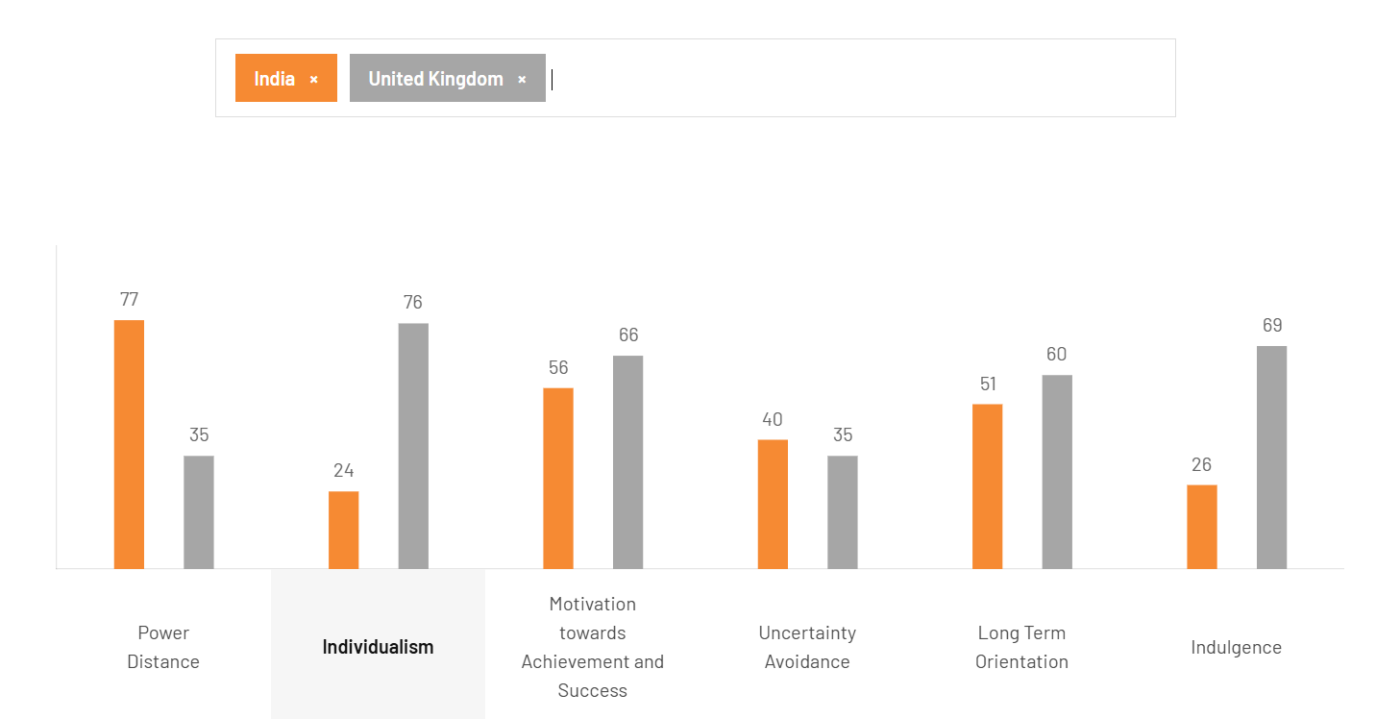
Source: Google
https://www.theculturefactor.com/country-comparison-tool
- Power Distance
United Kingdom: The UK scores low, meaning British culture values equality, fairness, and minimizing societal gaps (The Culture Factor, 2026). Management styles are democratic, and there is a strong belief that background should not limit personal growth (The Culture Factor, 2026).
India: India scores high, indicating a strongly hierarchical society (The Culture Factor, 2026). There is a high dependence on top-down direction, power is centralized, and employees expect formal, directive leadership in exchange for loyalty (The Culture Factor, 2026).

- Individualism
United Kingdom (76): Britain is highly individualistic (The Culture Factor, 2026). From a youthful age, individuals are taught to think for themselves, value privacy, and pursue personal happiness and self-fulfillment (The Culture Factor, 2026).
India: India has a low score, blending strong collectivist traits with individual accountability (The Culture Factor, 2026). Social frameworks—like extended family and work groups deeply dictate behavior, and relationships are vital for hiring (The Culture Factor, 2026). However, a philosophical belief in personal karma creates a unique individualistic streak (The Culture Factor, 2026).

- Motivation towards Achievement
United Kingdom: The UK is a success-oriented culture where people "live in order to work" (The Culture Factor, 2026). While the British often speak with modesty and understatement, they remain deeply driven by performance and ambition (The Culture Factor, 2026).
India: India is an achievement-oriented culture where visible success, status symbols, and designer brands matter (The Culture Factor, 2026). However, this drive is often balanced by spiritual traditions rooted in humility (The Culture Factor, 2026).
- Uncertainty Avoidance
United Kingdom: Scoring low, the British are comfortable with ambiguity and shifting plans (The Culture Factor, 2026). Business planning is often light on detail, which encourages a flexible, creative, and highly innovative work environment (The Culture Factor, 2026).
India: India has a medium-low score, showing a high tolerance for the unexpected (The Culture Factor, 2026). Rather than strictly following rigid rules, people frequently look for innovative ways to "adjust" and find inventive solutions to obstacles (The Culture Factor, 2026).

- Long Term Orientation
United Kingdom: The UK is a pragmatic society (The Culture Factor, 2026). People easily adapt long-standing traditions to suit new circumstances, and they place value on thrift and perseverance to achieve future results (The Culture Factor, 2026).
India: India holds an intermediate score (The Culture Factor, 2026). Time is viewed as cyclical rather than linear, which shapes a relaxed attitude toward punctuality and an openness to changing plans on the fly (The Culture Factor, 2026).
- Indulgence
United Kingdom: Britain is an indulgent culture (The Culture Factor, 2026). Leisure time United Kingdom is highly valued, and an optimistic outlook is reflected in a vibrant social, sports, and holiday culture (The Culture Factor, 2026).
India: India is a culture of restraint (The Culture Factor, 2026). Desires and gratification are tightly controlled by social norms, reinforced by traditional spiritual values that emphasize simplicity and self-discipline (The Culture Factor, 2026).
Comparative Analysis of cultural
UK - Favourable
The UK is characterized by high individualism and low power distance, which fosters a relatively flat hierarchy, high degree of autonomy in decision making and high consumer receptivity to purpose-driven marketing, but also creates strategic vulnerabilities (Hofstede, Hofstede and Minkov, 2010; The Culture Factor, 2026). If uncertainty avoidance is low, then the business planning may be more fluid and less structured, and can be affected by sudden disruptions in the supply chain (The Culture Factor, 2026). Furthermore, the high indulgence and individualist consumer behavior also make brand loyalty difficult to achieve in a highly competitive and mature market where there are many private label alternatives (Euromonitor International, 2023; The Culture Factor, 2026).

India - Favorable
India's high power distance and collectivist nature allows for the smooth operational execution from top to bottom and is a perfect backdrop for family and festival campaigns (Hofstede, 2011; International Journal of Advertising, 2021). Yet, when management is centralized and hierarchical, it can inhibit the initiative of local teams and hinder responsiveness to the market in real time in very fragmented distribution channels (NielsenIQ, 2023; The Culture Factor, 2026). Moreover, maintaining a culture of restraint and applying complex rules and procedures at the state level require a lot of managerial effort to reconcile traditional values with modern retail strategies (Government of India, 2024; The Culture Factor, 2026).

Advantages and disadvantages of Hofstede cultural dimension framework
- Advantages of Hofstede Model
The key strength of Hofstede's model is that it reduces complex and messy social behaviours into data points that are measurable (Hofstede, 2011). This provides an easy-to-use, organized resource for international managers to compare markets one by one. It provides a clear benchmark for human behavior, which makes it very useful for business strategy, as it becomes easier to anticipate what is expected in a workplace and to bridge the gap between different cultures, and easier to motivate employees in different countries (Hofstede, 2011).

- Disadvantages of Hofstede Model
However, using this framework completely has operational and analytical disadvantages. One of the critiques of Hofstede's model is that it assumes that all individuals within a nation have the same culture. This causes an overgeneralization as it fails to take into account rich regional differences, various ethnic subcultures, and the dynamism and fluidity of the contemporary globalized world (Hofstede, 2011). In addition, the data was collected from only one multinational company, which is a significant drawback if it is used to represent the diversity of a country's population (Hofstede, 2011).

2.4 Technological Factors
United Kingdom – Favourable
The United Kingdom provides a favourable technological environment for Cadbury because of its advanced digital infrastructure, widespread internet access and high adoption of e-commerce. These developments enable the company to strengthen its online presence through supermarkets and digital retail platforms while using data analytics and artificial intelligence to improve marketing campaigns and customer engagement. In addition, modern manufacturing technologies increase production efficiency and product quality, allowing Cadbury to remain competitive in the UK confectionery market (Kotler, Keller and Chernev, 2022; Mondelez International, 2024).
India – Favourable
India's technological environment is also favourable due to rapid digital transformation, increasing smartphone penetration and widespread use of affordable internet services. The growth of digital payment systems and online shopping platforms has enabled Cadbury to expand its reach to a larger consumer base, particularly among younger customers. Furthermore, investment in automated manufacturing and supply chain technologies has improved production efficiency and product availability across both urban and rural markets, supporting the company's continued market expansion (World Bank, 2024; Mondelez International, 2024).

2.5 Environmental Factors
United Kingdom – Unfavourable
Environmental factors are becoming increasingly unfavourable for Cadbury in the United Kingdom because of stricter sustainability regulations and growing public concern regarding climate change, packaging waste, and carbon emissions. Consumers increasingly expect businesses to reduce plastic packaging and source raw materials responsibly, placing additional pressure on confectionery manufacturers. Cadbury has responded by investing in recyclable packaging and sustainable cocoa sourcing; however, these initiatives increase operational and production costs (Johnson, Scholes and Whittington, 2020; Mondelez International, 2024).
India – Unfavorable
Environmental challenges are also unfavorable in India due to climate change, increasing temperatures and irregular weather patterns, which can affect cocoa production and agricultural supply chains. Waste management and plastic pollution remain significant concerns, encouraging businesses to adopt more environmentally responsible packaging solutions. Cadbury continues to invest in sustainable sourcing programmes and community farming initiatives; however, maintaining environmental sustainability while meeting increasing consumer demand remains a major business challenge (World Bank, 2024; Mondelez International, 2024).

2.6 Legal Factors
United Kingdom – Favourable
The legal environment in the United Kingdom is favourable because strong consumer protection laws, food safety regulations and intellectual property legislation provide a transparent framework for business operations. Compliance with food labelling requirements and advertising standards helps maintain consumer confidence while protecting Cadbury's brand reputation. Although compliance with these regulations increases administrative costs, the legal framework provides certainty and supports fair competition within the confectionery industry (Kotler, Keller and Chernev, 2022).
India – Favourable
India's legal environment is favourable as food safety standards have improved significantly under the Food Safety and Standards Authority of India. Enhanced regulations relating to food quality, labelling and consumer protection have strengthened consumer confidence in branded confectionery products. However, Cadbury must ensure compliance with different state-level regulations and taxation requirements, which can increase operational complexity. Despite these challenges, India's evolving legal framework supports long-term investment and market growth for multinational companies (Government of India, 2024; World Bank, 2024).

Similarities
Both the UK and India offer Cadbury favorable macro-environmental conditions, characterized by stable governance and well-developed retail growth. Demand remains strong in both markets due to the deep cultural association of chocolate with gifting and celebrations, backed by modern digital marketing and efficient supply chain technologies. However, Cadbury faces shared environmental challenges, including rising climate pressures and sustainability expectations, alongside strict local food safety and product quality regulations (Kotler, Keller and Chernev, 2022; Mondelez International, 2024; World Bank, 2024).
Differences
While the UK represents a mature, individualistic market where Cadbury navigates health-conscious dietary trends, strict packaging regulations, and e-commerce growth within flat organizational structures, India offers a rapidly expanding, collectivist market driven by FDI initiatives, low manufacturing costs, and deep-rooted festive traditions. Consequently, Cadbury must balance the UK’s focus on sustainable packaging and premium digital retail against India’s need for multi-tiered pricing, mobile-first payment platforms, and supply chain resilience against local climate risks.

3.0 Segmentation, Targeting, and Positioning (STP)
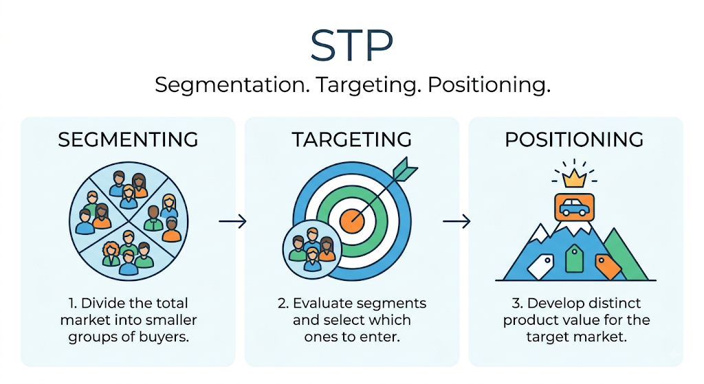
Source: Self-created from Gemini

3.1 Segmentation
Market segmentation involves dividing a consumer market into distinct sub-groups based on shared characteristics, enabling a firm to optimize resource allocation across heterogeneous operating environments (Kotler, Keller and Chernev, 2022). Cadbury relies on two foundational segmentation variables across the UK and India: Demographic and Psychographic segmentation.
Demographic Segmentation:
  - United Kingdom: Cadbury segments consumers along age cohorts, household structure, and purchasing power (Baines, Fill and Rosengren, 2021). The brand offers dark chocolate formats like Bournville for health-conscious older demographics, alongside child-focused items such as Freddo and Buttons (Mintel, 2024a).
  - India: Demographic segmentation in India prioritizes income stratification and age, separating low-to-middle-income mass buyers from higher-income urban youth (Euromonitor International, 2023). Cadbury captures lower-income brackets through low-unit price entry variants (e.g., ₹5 and ₹10 bars) while targeting urban consumers with premium offerings like Cadbury Dairy Milk Silk (Mondelez International, 2024).
  - Consequently, demographic segmentation strategies differ because UK consumers purchase based on individualized household preferences, whereas Indian consumers select formats dictated primarily by income disparities and fractional purchasing power.
Psychographic Segmentation:
Psychographic segmentation categorizes markets by psychological motivations, lifestyle values, and cultural orientations (Solomon, 2023).
  - United Kingdom: Cadbury targets consumers seeking individual sensory indulgence, alongside post-materialist consumers who prioritize ethical sourcing, reduced sugar formulations, and plant-based options like the Cadbury Plant Bar (Mintel, 2024a).
  - India: Indian psychographic segmentation focuses on consumers whose purchasing behavior is anchored in collectivist cultural values, family bonding, and traditional festive rituals (International Journal of Advertising, 2021). Consumers are segmented by their emotional orientation toward festive gift-giving (Shubh Aarambh) rather than individual lifestyle trends.
  - Therefore, psychographic segmentation reflects contrasting cultural drivers, as British consumers respond to individual wellness and ethical choices, whereas Indian consumers purchase driven by communal traditions and societal gifting obligations.

VALS Framework Alignment: UK vs. India

Market | Primary VALS Segments | Core Consumer Orientation | Strategic Product Focus
United Kingdom | Achievers & Thinkers (Solomon, 2023) | Driven by personal wellness, post-materialist ethical values, and lifestyle convenience (Solomon, 2023). | Reduced-sugar options, plant-based variants (Plant Bar), and ethically certified products (Cocoa Life) (DEFRA, 2023; Mintel, 2024a).
India | Believers & Strivers (Solomon, 2023) | Driven by social status, family bonding, collective traditions, and festive gifting (International Journal of Advertising, 2021). | Emotional gifting packs (Celebrations), luxury sub-brands (Silk), and auspicious ritual campaigns (Shubh Aarambh) (Mintel, 2024b; Mondelez India, 2024).

3.2 Targeting
Targeting involves evaluating market segments and selecting specific target groups that align with the firm's core competencies (Hollensen, 2020). Cadbury utilizes Differentiated Targeting across both operating environments.
- United Kingdom: Within a mature FMCG environment, Cadbury matches specialized product lines to distinct sub-segments to maximize shelf penetration (Jobber and Ellis-Chadwick, 2019). The brand targets mature palates with Cadbury Darkmilk, seasonal buyers with Creme Eggs during Easter, and household organizers through multi-pack formats (Baines, Fill and Rosengren, 2021).
- India: In India, differentiated targeting addresses the nation's dual economic structure by segmenting marketing streams between price-sensitive mass buyers and urban consumers (Euromonitor International, 2023). Cadbury targets rural and entry-level consumers with single-serve impulse bars while targeting urban gifters with pre-packaged Cadbury Celebrations assortments during major cultural festivals like Diwali (Mondelez International, 2024).
- Accordingly, Cadbury adapts its targeting strategy to reflect national economic realities, deploying category-filling portfolio differentiation to defend market share in the UK while leveraging dual-tier targeting to capture both volume and value in India.

3.3 Positioning
Positioning refers to establishing a distinctive brand identity and value proposition within the consumer's mind relative to competitor offerings (Kotler, Keller and Chernev, 2022).
- United Kingdom: Cadbury positions itself as a nostalgic, comforting national icon anchored in heritage, family warmth, and everyday kindness (Journal of Business Research, 2022). British consumers value tradition and long-standing emotional connections with heritage brands; therefore, Cadbury's "There's a glass and a half in everyone" campaign positions the product as an affordable, everyday compassionate comfort.
- India: In India, Cadbury positions chocolate as a modern, hygienic substitute for traditional Indian sweets (mithai), aligning its portfolio with rising urban disposable incomes and evolving lifestyles (International Marketing Review, 2020). Through taglines like "Kuch Meetha Ho Jaye" (Let's have something sweet), Cadbury positions its products as essential components of auspicious celebrations and cultural milestones.
Perceptual Map of Cadbury
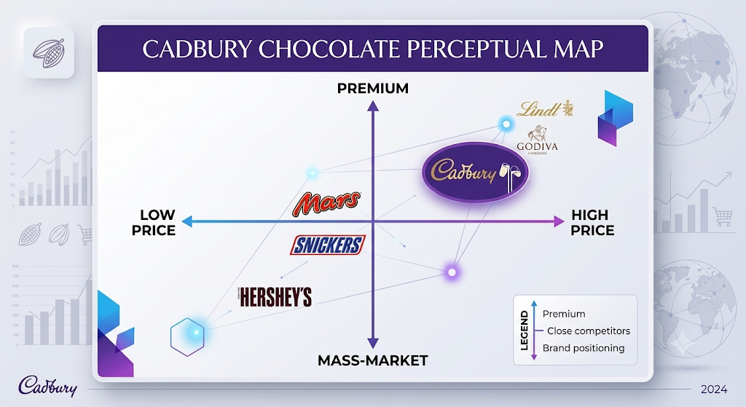
Self-created
This perceptual map is based on two factors: price (Low to High) and brand perception (Mass-Market to Premium) of major chocolate brands.
Cadbury is positioned as a high price, premium brand, near the luxury brands such as Lindt and Godiva, while the other brands such as Mars, Snickers, and Hershey's are in the lower price and mass market.

Similarities
Both the UK and India's central positioning architectures are firmly rooted in storytelling that is emotional and value-based, rather than functional and ingredients-based, with the very basic human idea of generosity at their heart. In both economic areas, Cadbury is able to maintain a balance between its market presence and its image as a comfort for everyday use and a trusted confectionery standard.

Differences
Cadbury's STP approach in the UK is an adaptive strategy in a mature market, where they have segmented the market on health trends and lifestyle, targeted health-conscious and ‘on-the-go' adults and positioned themselves as an iconic comfort food of everyday kindness and heritage. On the other hand, Cadbury in India's emerging market with high growth focuses on income segments and regional demographics, and offers multi-tiered price points, appealing to mass-market youth and families; and positioning its products as emotional and celebratory alternatives to traditional mithai.

4.0 International Marketing Mix (7Ps)
The international marketing mix represents the tactical synthesis of controllable marketing decision variables required to translate strategic market positioning into localized operational performance (Jobber and Ellis-Chadwick, 2019).

Source: Self-created

4.1 Product
In international marketing, product strategy involves a balance between maintaining a consistent core product and adapting it to local regulatory, climatic and consumer requirements (Kotler, Keller and Chernev, 2022).
UK: Product adaptation can help companies meet changing health needs in the mature market (Kotler, Keller and Chernev, 2022). Cadbury carries out product depth expansion and portfolio adaptation through the development of its variants, such as HFSS Cadbury Dairy Milk, Cadbury Dairy Milk 30% Less Sugar (for health-conscious consumers) and Cadbury Go Vegan (plant-based products) in the UK (DEFRA, 2023; Mintel, 2024a).
India: In emerging markets, an adjustment in the structure of the product is essential to address environmental and logistics challenges (Hollensen, 2020). Cadbury's reformulates the chocolate in India to maintain product integrity in tropical climate zones where there's no 24/7 cold-chain. (FSSAI, 2022) In addition, the depth of products ranges from low unit Cadbury Shots to festive Cadbury Celebrations gift packs designed to replace conventional sweets (Mintel, 2024b).
Cadbury Product Picture in India 
Source from Google
https://www.google.com/search?sca_esv=5fc228418363e72d&rlz=1C1CHBF_enIN974IN974&sxsrf=APpeQnsMLOMp248BrC93T0e_ctyIhpCEIQ:1785314739620&udm=2&fbs=ABfTbFVyMZGZf1hfvX9uKjN_-G8c4u0nXx4bEIpwm1lnNH832SMIiTl3t-JZ4hGJOxPbHYSIu8Q64jU5EwQ-803VaKbdipNP9IdSJPNW0dZW-vtpfTgsxPubDUGnnlexyWPgXsYQ501vMFanP6YYzZT8alsPK9K_UpvZv90tWB2_PHZ3qaLnMhS_YZwJh28ayySOW7TQxOj2Df-YULSzgdLJvDe51FJPcw&q=CADBURY+PRODUCT+PICTURE+IN+INDIA&sa=X&ved=2ahUKEwid0vfWv_eVAxVHV0EAHavCKhsQtKgLegQIFhAB&biw=767&bih=695&dpr=1.25

Cadbury product in UK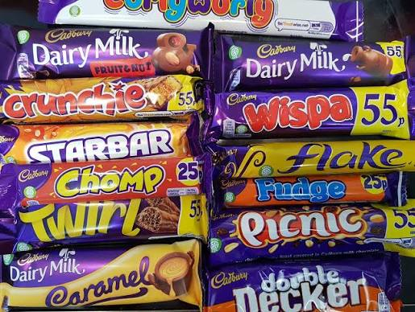
Source from Google
https://www.google.com/search?sca_esv=c3e0aac3b7d97f10&rlz=1C1CHBF_enIN974IN974&sxsrf=APpeQnsL1PHnLWmJ54crH9NGNnl6ecYuwA:1785315599820&udm=2&fbs=ABfTbFVyMZGZf1hfvX9uKjN_-G8c4u0nXx4bEIpwm1lnNH832SMIiTl3t-JZ4hGJOxPbHYSWZcx4hf2r6yHgBkrBbjJlxuoZPUbus4f50ICSfzuhmz7JbFqZNfNb3IWbvq7Yct8u2D1O2JrG2lF7ozvt_vOhVl2SGarC1XuY7ZJv1MP5eeCW2cPMNNKxW8R6ofiL-Hx7kEWBMR2zqLkb1BjKi27FGHae3g&q=CADBURY+PRODUCT+PICTURE+IN+UK&sa=X&ved=2ahUKEwjAkI7xwveVAxWqWkEAHbylPBUQtKgLegQIFBAB&biw=1536&bih=695&dpr=1.25sv=CAMSURoyKhBlLW9TRGZ6cE1odHFWYWFNMg5vU0RmenBNaHRxVmFhTToOYUl3ck5SalRoa3JjSU0gBCoXCgFzEhBlLW9TRGZ6cE1odHFWYWFNGAEwARgHIIrTtqEPSggQARgBIAEoAQ

Product depth in UK and India
India Product Depth:
Product depth strategy is geared towards unique texture-based innovations (Cadbury Dairy Milk Silk, Crispello, Fuse, Perk) and specialty festive gift packaging (Cadbury Celebrations) in the Indian market. This depth strategy directly addresses changing consumer preferences in the city for higher quality indulgence and replaces traditional Indian sweets (mithai) during cultural festivals (Mintel, 2024b; Mondelez International, 2024).

UK Product Depth:
In the UK, product depth is based on a wide range of heritage countlines and brand extensions (e.g., Crunchie, Wispa, Starbar, Twirl, Double Decker, Chomp). In this established segment, strategic growth is driven by optimizing impulse purchases, capitalizing on consumer nostalgia and satisfying today's dietary needs with HFSS compliant and plant-based products (Baines, Fill and Rosengren, 2021; Mintel, 2024a).
Width of Cadbury
UK Brand Extension: To build on Cadbury's trusted brand, the UK portfolio will grow to include functional hot chocolate variants such as Cadbury Hot Chocolate Low Sugar and Cadbury Hot Chocolate Plant Based to meet the needs of health-conscious adults who are looking for ethical, low-calorie evening relaxation (DEFRA, 2023; Mintel, 2024a).
Brand Extension in India: Cadbury has expanded its brand equity into the hot beverage segment with Cadbury Hot Chocolate and milk add-in products, positioning them as a healthy, soothing and contemporary option to replace traditional spiced drinks (kadha or haldi doodh) consumed by urban families (Mintel, 2024b; Mondelez India, 2024).
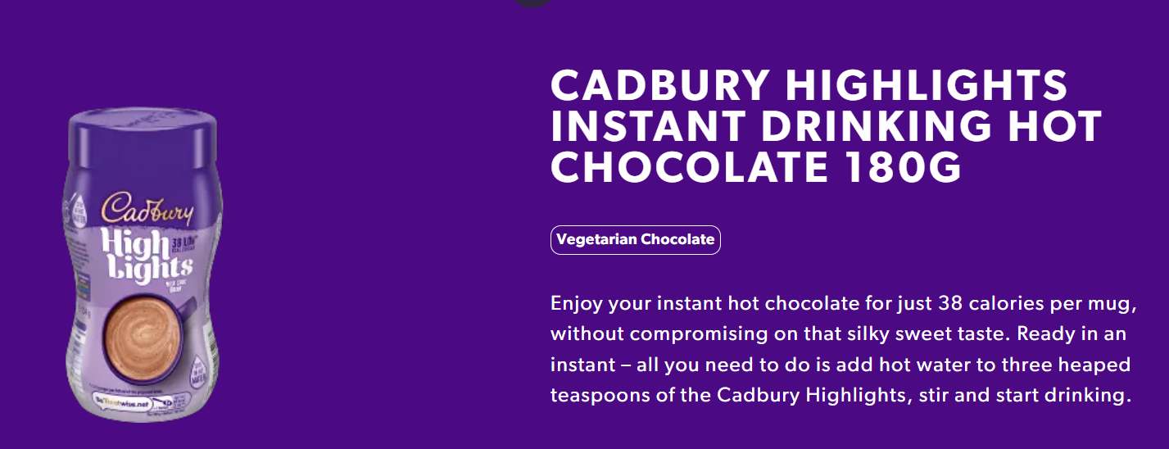
Source: Google https://www.cadbury.co.uk/products/

4.2 Price
Price is the monetary value or consideration given by the consumer to obtain the benefits of a product or service and is the most direct contributor to the revenue of an organization rather than cost, and is one of the elements in the marketing mix (Kotler, Keller and Chernev, 2022).
Affecting factors of price
UK
Raw Material Inflation:Global price rises in cocoa beans, sugar and dairy products necessitate price adjustments to protect gross margins (Baines, Fill and Rosengren, 2021).
Retail Power: Major supermarket chains such as Tesco and Sainsbury's have downward pressure on the wholesale prices and require high levels of promotion (Jobber and Ellis-Chadwick, 2019).
Customer Purchasing Power: The more disposable income that consumers have, the more they can afford to pay for value, but the more they feel the pinch of costs, the more price sensitive they will be (Kotler, Keller and Chernev, 2022).
HFSS Regulations: UK health regulations limit the use of traditional high-fat/sugar promotional displays, and traditional promotional pricing is changing (Mintel, 2024a).
Private-Label Competition: Supermarket own-brand products are a tight upper bound on the price of branded confectionery (Euromonitor International, 2023).
India
High Price Elasticity: Consumer demand is very price-sensitive across mass markets, due to low disposable income (NielsenIQ, 2023).
Strict Price Points: Traditional kirana stores implement strict “magic price points” (₹5, ₹10, ₹20) to facilitate fast cash micro-transactions (Hollensen, 2020).
Distribution Costs: Operating a cold chain in tropical climate zones contributes to the cost of the product (Jobber and Ellis-Chadwick, 2019).
Income Disparity: As wealth increases in urban middle class, high margin price skimming is possible on premium sub-brands such as Silk (Mintel, 2024b).
Festive Competition: The pricing of seasonal gift packs should be competitive with the traditional Indian sweets (mithai) (Mondelez International, 2024).

United Kingdom:
Cadbury adopts mainly Value Based Pricing for its key product lines, which are built on a strong brand equity, with the help of Competitive Pricing to compete with other fast-moving consumer goods (FMCG) brands (Baines, Fill and Rosengren, 2021). Cadbury applies a Shrinkflation Pricing approach to keep global raw cocoa commodity inflation under control, but not push consumers into resistance at the price level (Kotler, Keller and Chernev, 2022), which involves reducing the net product weight, but keeping the nominal price points unchanged (e.g. reducing the standard Dairy Milk bar size).
India:
Cadbury has applied a Penetration Pricing and Fractional Pricing strategy to overcome the low disposable income barriers and to promote mass consumer adoption in the price-sensitive Indian market (Euromonitor International, 2023). The strategy is heavily reliant on “magic price points” – ₹5, ₹10 and ₹20 single-serve packs that are tailored to cash-based micro-transactions at traditional ‘kirana’ retail outlets (NielsenIQ, 2023). On the other hand, Cadbury uses Price Skimming for its premium variants, like Cadbury Dairy Milk Silk and Bournville, as it is able to charge higher margins from affluent consumers and to broaden the penetration of the entire category (Jobber and Ellis-Chadwick, 2019).
International pricing strategy must align corporate margin requirements with local consumer purchasing power and economic stability (Jobber and Ellis-Chadwick, 2019).

4.3 Place
Place strategy is about how well an enterprise manages its national physical distribution networks to ensure product availability at the point of purchase (Hollensen, 2020).
United Kingdom: Place strategy is based on logistics networks that are centralised (Chaffey and Ellis-Chadwick, 2019). Cadbury has a centralized indirect distribution chain with major supermarket chains (Tesco, Sainsbury's, Asda) controlling the majority of the distribution chain with quick-commerce channels and direct to consumer (D2C) online gifting sites (Hollensen, 2020).
India: Multi-tiered intermediary structures are needed to overcome retail decentralization (NielsenIQ, 2023). Cadbury has an indirect distribution network with the help of the clearing agents, national stockists and wholesalers to reach more than a million of independent traditional kirana stores and also invested in branded Visi-coolers which are temperature controlled to ensure the quality of their stock (FSSAI, 2022).
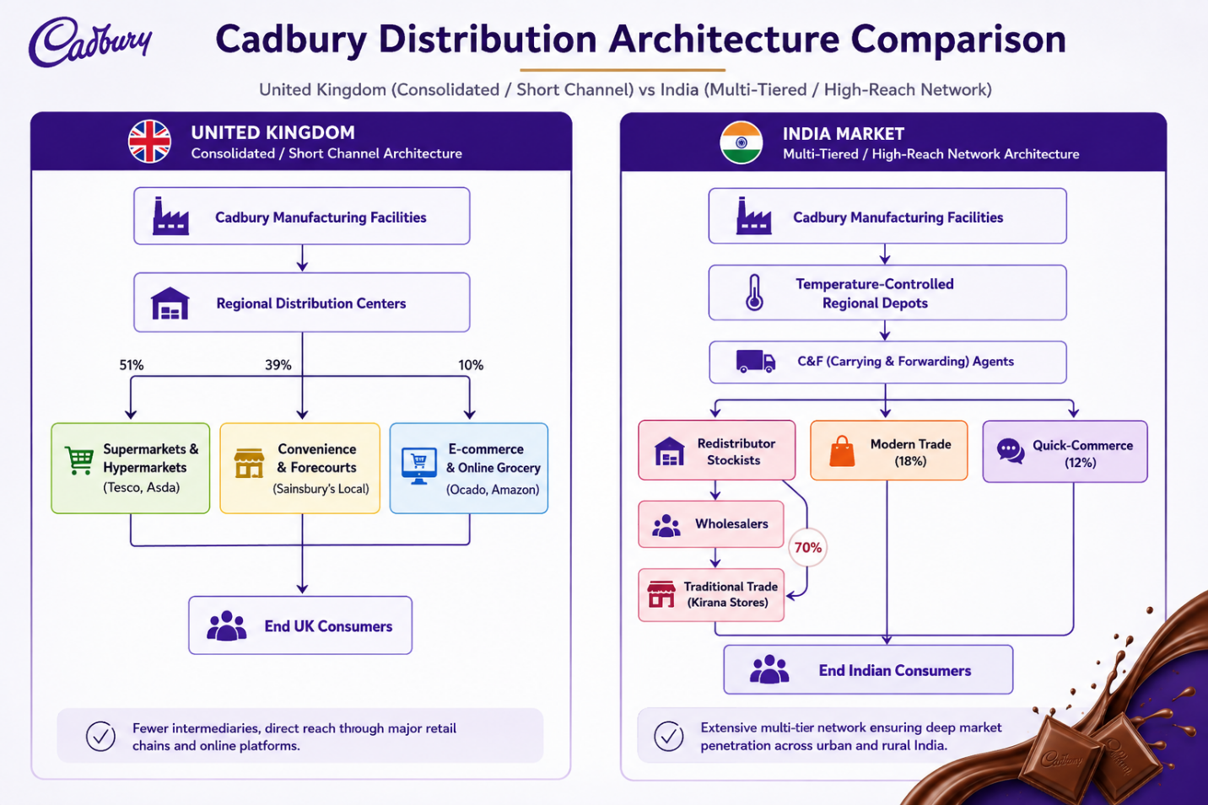
Self-created by ChatGPT

United Kingdom Distribution
Cadbury's distribution model is quite concentrated and short in the United Kingdom with more than 50% of confectionery sales accounted by large supermarket chains like Tesco and Sainsbury's (Jobber and Ellis-Chadwick, 2019; Mordor Intelligence, 2025). Automated Regional Distribution Centers (RDCs) are integrated into the supply chain system that directly connects to centralized retailer hubs to reduce the number of intermediaries in the process and improve logistics efficiency. But this high channel concentration puts Cadbury at risk of significant retailer power, and the terms of the supermarkets must be adhered to, as well as UK HFSS regulations (Baines, Fill and Rosengren, 2021).

India Distribution
Cadbury's approach in India, on the other hand, is built on a multi-layered distribution system designed to tackle the country's significant geographical fragmentation, with traditional ‘kirana’ stores making up around 70% of the sales volume (Hollensen, 2020; Mondelez India, 2024). The inventory flows through the Carrying & Forwarding (C&F) agents, redistributor stockists and local wholesalers, and for deep market penetration, both urban and rural. Furthermore, Cadbury has made significant investments in cold-chain facilities, and they offer the small retailers the branded visicoolers to maintain product integrity at the point of sale (Kotler, Keller and Chernev, 2022).

Consequently, distribution models are designed to align with the maturity of the trade in each region, with a centralized logistics system with automation to cater to concentrated grocery retailers in the UK, and a multi-layered partner network to address the traditional retail sector in India.

4.4 Promotion
Integrated Marketing Communications (IMC) combines the use of promotional tools, the creation of messages, and the purpose of the brand in order to establish long-term brand equity in a variety of cultural environments (Chaffey and Ellis-Chadwick, 2019; Kotler, Keller and Chernev, 2022).
UK: The emotional brand purpose and social authenticity are strong drivers of mature market consumers (Journal of Business Research, 2022). Purpose-driven branding is well received by UK consumers, and Cadbury's “Donate Your Words” campaign (in partnership with Age UK) is building the emotional connection and driving long-term brand loyalty, not primarily through price promotions (Age UK, 2020; Kotler, Keller and Chernev, 2022).
India: Collectivist values and well-known public personalities are used to create consumer trust in emerging markets (International Journal of Advertising, 2021). Cadbury is using aggressive marketing strategies such as "Kuch Meetha Ho Jaye" with celebrity endorsements to make chocolate part of the culture in India, as consumers equate confectionery with festive gifting and family celebrations (International Marketing Review, 2020).
Hence, the promotional strategies are different in nature as the UK consumers act on the basis of their individual emotional purpose and corporate social responsibility while the Indian consumers act on the basis of communal festival traditions, family values and celebrity endorsements. In a nutshell, Cadbury's localized promotional strategy has worked well to ensure that the creative messaging is in line with national cultural priorities, thus maximizing customer engagement.

4.5 People
The "People" element focuses on the importance of human resources, internal service culture and organizational capabilities in achieving the same brand promises throughout operations (Baines, Fill and Rosengren, 2021; Kotler, Keller and Chernev, 2022).

Human Resource Strategy in the United Kingdom focuses on specialized management skills, technical skills and corporate governance in high-cost operating environments (Baines, Fill and Rosengren, 2021). About 3,800 people work for Mondelēz International in the UK, including in manufacturing, corporate and research and development (R&D) activities (Mondelēz International, 2026). Cadbury's investment in workforce training, specialised key account management teams, and automated manufacturing oversight allows them to maintain high levels of operational efficiency, manage complex corporate retail accounts (such as Tesco and Sainsbury's) and ensure strict compliance with environmental and UK HFSS nutritional regulations (Jobber and Ellis-Chadwick, 2019; Mondelez International, 2024).

In emerging markets such as India, human capital in labor-intensive markets is more likely to be oriented towards direct channel management, broad trade coverage, and close relationship building (NielsenIQ, 2023). The company employs about 3,500 to 4,000 employees directly, with a large extended commercial network of third party employees, logistics staff, and stockist employees from the retail section across the country numbering over 50,000 (Mondelez India, 2024). Cadbury's structured field-force training programs enable salespeople with mobile terminals to keep their face-to-face connection with hundreds of thousands of independent kirana store owners, thereby ensuring uniform visual merchandising, micro-cooler stock replenishment, and localized trade support across the traditional distribution channels (NielsenIQ, 2023; Kotler, Keller and Chernev, 2022).

4.6 Process
Process design involves the systems, quality assurance processes and customer service workflows that guarantee that the product is of the same quality and meets regulatory standards and customer needs (Jobber and Ellis-Chadwick, 2019; Kotler, Keller and Chernev, 2022).

United Kingdom: Digital processes are used to integrate operations, to provide direct feedback loops with consumers, and to have structured resolution systems in place in digitally mature markets (Chaffey and Ellis-Chadwick, 2019). Cadbury implements automated Electronic Data Interchange (EDI) to keep inventory replenishment in sync with the big supermarket chains (Hollensen, 2020). Cadbury has a digital Careline system for customer complaints that assigns automated tracking numbers to inquiries made through direct hotlines, web forms, or social media; any product quality concerns are escalated for batch tracing and laboratory testing, resulting in a quick turnaround for compensation to customers (vouchers) and providing real-time data for process controls in manufacture.

India: Emerging market operational processes need to be flexible to deal with infrastructure and environmental volatility (Journal of International Marketing, 2019). Cadbury uses mobile ordering apps for field sales reps to collect real-time store demand, and batch-tracing and temperature-monitoring systems throughout its distribution channels to reduce supply chain risks due to climate-related issues (FSSAI, 2022; NielsenIQ, 2023). In conventional trade, complaints are addressed on two fronts: the first is through the consumer carelines, where the major quality related issues are addressed, and the second is through field sales representatives, who replace damaged products on the spot and are responsible for tracking localized heat-spoilage patterns, which will then be used to dynamically adjust batch distribution (Kotler, Keller and Chernev, 2022).

4.7 Physical Evidence
Physical evidence comprises the tangible touchpoints, visual assets, and packaging elements that communicate product quality and validate consumer expectations at the point of sale (Baines, Fill and Rosengren, 2021; Solomon, 2023).
- United Kingdom: Physical evidence is heavily shaped by consumer environmental values and visual brand consistency (DEFRA, 2023). The UK places greater emphasis on sustainable, recyclable packaging materials and clear nutritional labeling because environmental awareness and regulatory scrutiny are significantly higher among consumers (DEFRA, 2023; Solomon, 2023). This is complemented by standardized, clean supermarket shelf displays featuring Cadbury's iconic Pantone 2685C purple visual identity (Mintel, 2024a).
- India: Physical evidence in developing markets prioritizes functional product protection and high visual prominence in crowded retail spaces (NielsenIQ, 2023). India's packaging prioritizes durability and product protection through heavy-duty, double-sealed metallic foil inner packaging due to higher ambient temperatures and complex distribution conditions (FSSAI, 2022). Furthermore, physical evidence extends to glowing, branded Visi-cooler refrigeration units placed inside traditional kirana stores, which act as tangible indicators of product freshness and premium quality (NielsenIQ, 2023).
Cadbury wedsite in India Cadbury website in UK
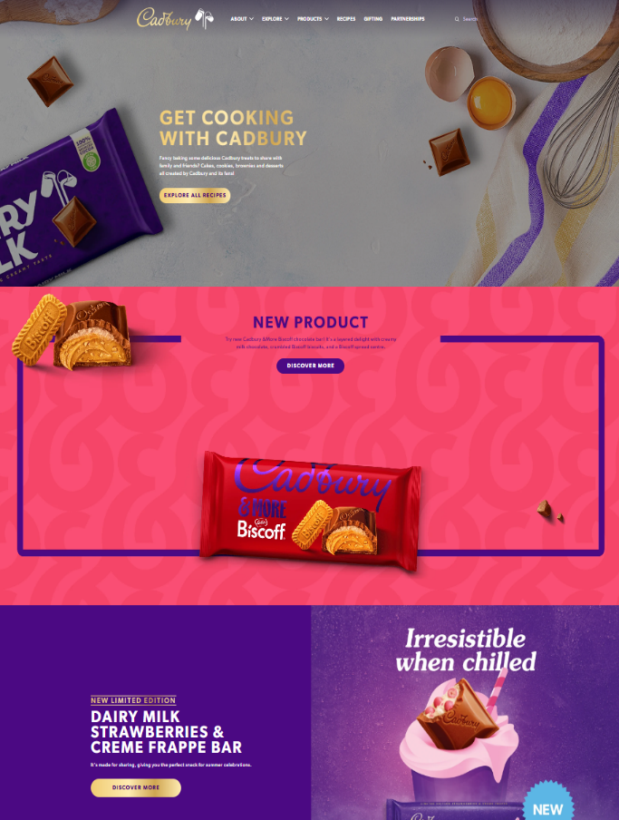
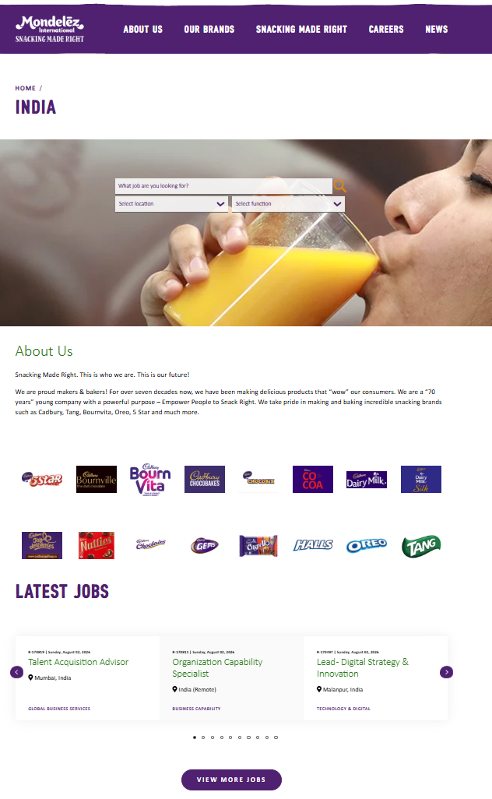

Product Packaging in India and UK
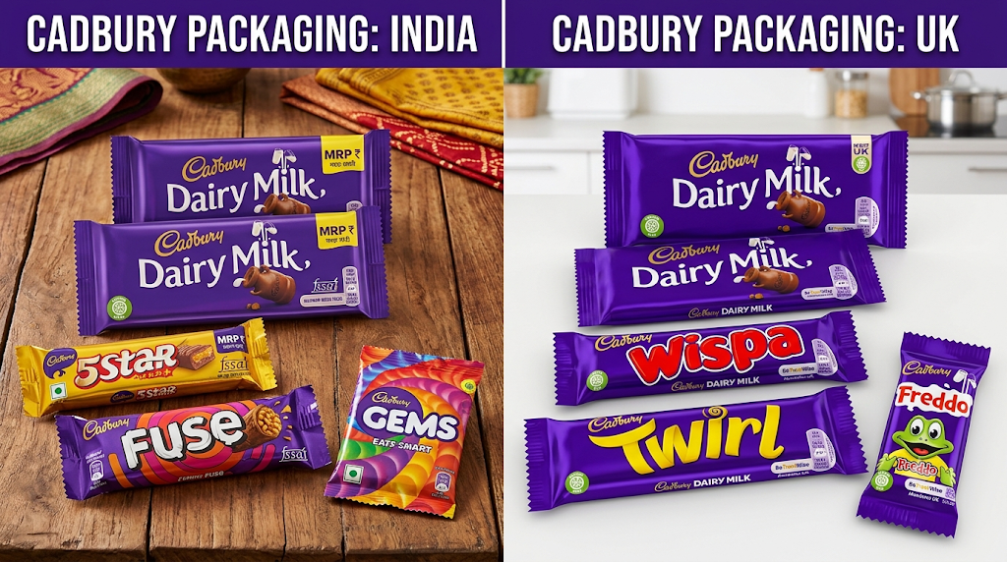

similarities

Cadbury is consistent with its core global brand, has a strong quality control process and employs a unified approach of emotional brand engagement across both the UK and India. Cadbury uses indirect distribution channels in both markets, has a strong brand presence in the form of their iconic purple colour and has set up structured digital customer carelines for tracking complaints and quality assurance (Jobber and Ellis-Chadwick, 2019; Kotler, Keller and Chernev, 2022). In addition, both areas are heavily dependent on ongoing staff training and inventory management based on data for long-term market leadership.

Difference
The 7Ps are executed differently, depending on the market maturity, retail infrastructure and economic constraints in the regions. Variants of the products that cater for health concerns (HFSS compliance), value-based and shrinkflation pricing, direct distribution to the centralised supermarket hubs, and purpose-driven marketing are all priorities for the UK market (Mintel, 2024a). In contrast, India's approach involves product reformulations to withstand heat, fractional “magic price points” (₹5/₹10), multi-tiered distribution to millions of traditional kirana stores, large-scale field-force use, and protective metallic foil packaging with branded visicoolers (NielsenIQ, 2023).

5. Cadbury Market Entry Method for India
Introduction
Choosing an international market entry strategy is one of the most important decisions that a company can make as it affects the level of control, the level of resources that a company commits to a host country and the risk that a company faces in that country (Hollensen, 2020). Cadbury's first foray into India was in 1948, soon after the country gained independence, as a private limited company. The company aggressively expanded its operational footprint, recognising the great long-term growth potential of the region. This early investment developed over the decades with significant local manufacturing facilities, ongoing capital investments in infrastructure and eventually corporate integration with Mondelēz International (Mondelez International, 2024).
Market Entry Method
Cadbury's entry and expansion into India was through a Wholly Owned Subsidiary (WOS) and later to a company known as Mondelēz India Confectionery Limited (Journal of International Marketing, 2019). The WOS structure was selected to manage India's historically complex and high tariff post-colonial trading environment as the direct import of finished consumer goods was economically unviable because of protectionist policies of the state (International Marketing Review, 2020).
Cadbury was able to create a separate domestic subsidiary to develop manufacturing facilities in important states such as Maharashtra and Himachal, allowing them to produce products suited for India's tropical climate and infrastructure issues (NielsenIQ, 2023). Moreover, the high commitment level of entry was an ideal fit for the Indian market, which is highly fragmented and allows the company to avoid the inefficiency of third-party distributors and establish a proprietary distribution network that can reach millions of independent kirana outlets. By having full ownership, Cadbury could invest in the brand, in localized marketing campaigns over many decades, as opposed to a local partner whose commercial priorities might differ (Kotler, Keller and Chernev, 2022). This financial and operational autonomy enabled Cadbury to move from a foreign luxury brand to a household name and dominate the domestic chocolate confectionery market like never before.
Advantages
Cadbury is a wholly owned subsidiary which gives it a distinct advantage to dominate the Indian confectionery market. In direct ownership, there is no governance issue with joint ventures, as the company has absolute control over the supply chain, brand positioning and corporate direction (Hollensen, 2020). This provides complete control of the production and ensures adherence to the global production standards, which is critical for maintaining the integrity of the product in the difficult non-refrigerated distribution system in India. Moreover, when Cadbury has full ownership it can make high impact marketing investments based on local cultural values, creating a trusted, premium brand and keeping 100% of the profits generated from the local market to continue investing in it (Kotler, Keller and Chernev, 2022; Journal of Business Research, 2022).

Disadvantages
Although it has proved successful, the wholly-owned subsidiary entry method has many drawbacks from an operational and financial perspective for Cadbury. It takes a long period of time to see a significant return on investment (ROI) due to the high initial capital investment needed for local manufacturing facilities, extensive distribution networks and specialized cold-chain infrastructure (Mondelez International, 2024). The absence of a local partner leaves Cadbury vulnerable to early macroeconomic slowdowns, currency fluctuations and the administrative challenges of dealing with India's complicated state tax systems and rigid labour laws (NielsenIQ, 2023). Furthermore, the company has to face high cultural adaptation issues when entering the market, as it takes time and resources to adjust the company's product portfolio to the preferences of each region and its festive gifting culture (International Journal of Advertising, 2021).

Ethical and Unethical Marketing
India
Ethical Marketing
The use of temperature controlled Visi-coolers by small traditional Kirana shop owners ensures the safety and quality of products against heat spoilage without burdening the retail shop owners with high investment in infrastructure (FSSAI, 2022; NielsenIQ, 2023).
The ability to buy quality controlled treats at lower price points (₹5 and ₹10 single serve packs) makes it easier for lower income consumers to access them without having to make a large purchase (Hollensen, 2020; Euromonitor International, 2023).

Unethical Marketing
High sugar festive gift boxes (e.g. Cadbury Celebrations) are marketed as an alternative to homemade sweets during cultural events without explicit recommendations on daily sugar intakes, targeting health vulnerable groups (International Marketing Review, 2020; Mintel, 2024b).
If there is no adequate cold-chain support, products may reach the rural consumers with heat damage or blooming due to continuation of traditional distribution channels without adequate support (FSSAI, 2022; Jobber and Ellis-Chadwick, 2019).

Strategic Recommendations

United Kingdom
- Boost Healthy & Reformulated Portfolio Depth: Add more lines and reformulated versions that are compliant with the upcoming tightening of public health regulations in the UK and the growing demand for functional, low-sugar confectionery (DEFRA, 2023; Mintel, 2024a).
- Innovate Sustainable & Circular Packaging: Invest in 100% recyclable, plastic-free packaging solutions for all primary & secondary countline products to meet UK environmental objectives and be attractive to eco-conscious consumers (DEFRA, 2023; Solomon, 2023).
- Improve Direct-to-Consumer (D2C) & Quick-Commerce Integration: Develop direct digital channels and increase partnerships with speedy delivery services to reduce dependence on big supermarket brands and the opportunity to sell high-margin impulse buys (Chaffey and Ellis-Chadwick, 2019; Jobber and Ellis-Chadwick, 2019).

India
- Increase the penetration of low energy, solar-powered Visi-coolers in Tier-2, Tier-3 and rural kiosks to reduce the risk of product spoilage due to tropical heat and improve deep retail reach (FSSAI, 2022; NielsenIQ, 2023).
- Ensure that the fundamental price points of ₹5 and ₹10 remain unchanged as cost efficiencies in the supply chain are achieved rather than reducing the weight of products to maintain the price points, thus preserving brand trust with price-sensitive consumers (Hollensen, 2020; NielsenIQ, 2023).
- Localize Premium Product Variants: Customize premium sub-brands such as Cadbury Silk and Bournville for a regionally flavoured offering and premium gift packaging to tap into the growth opportunity in the expanding urban middle class (Mintel, 2024b; Mondelez India, 2024).

Part:2 Gibbs Reflective Cycle
The Gibbs' Reflective Cycle is a structured model for learning from contextual experiences developed by Graham Gibbs, an American sociologist and psychologist in 1988. The framework is designed to help people reflect on their routine practice in a systematic way through six steps: Description, Feelings, Evaluation, Analysis, Conclusion, Action Plan, and to help them move from routine practice to personal and professional development. Gibbs' cycle goes beyond just summarizing events to critically analyze emotional reactions, contributing factors, and strategic enhancements, ensuring that past challenges are directly addressed in future actions.

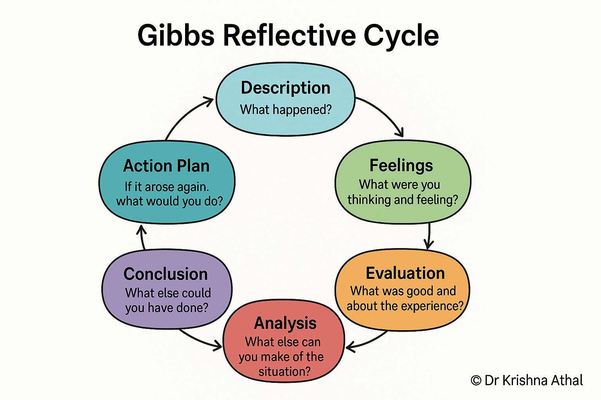
Source from Google

1. Description
In this strategic marketing audit, I analysed Cadbury's marketing mix in two different geographical markets, namely the United Kingdom (Mature economy) and India (Emerging economy). The task involved combining international marketing theories, real-world marketing operational strategies (SC architecture, packaging limitations, etc.), ethical and unethical marketing practices and recommendations based on empirical data. I incorporated the most recent market reports, regulations and academic research, citing in the UWTSD Harvard referencing system, to meet the academic level required for further study at Level 7.

2. Feelings
Initially, I was a little overwhelmed by the amount of work required to compare the two huge and structurally different markets in a structured academic report. I was worried about staying on the surface of the comparison, especially when planning the operational differences in a complex manner such as comparing the automated retail central distribution centers (CDCs) in the UK with the multi-tiered kirana store network in India. But as I was able to systematically deconstruct the analysis by applying the 7Ps framework, my confidence increased. The ability to organize and present complex data in a visual structure, like a market architecture model, gave clarity and direction to the data.

3. Evaluation
What Went Well: The 7Ps framework was well-structured and offered a clear lens to assess Mondelēz International's global strategy. The strategic management models (such as Dynamic Capabilities) and the practical operational aspects (such as HFSS compliance in the UK and cold chain Visi-Cooler usage in India) created a balanced and academically sound critique. There was a clear distinction between ethical initiatives and unethical dilemmas, such as Age UK partnership and shrinkflation, respectively, where critical thinking was successfully demonstrated.

One challenge was dealing with the balance of depth and conciseness. The regulatory information was complex, including DEFRA standards (UK) and FSSAI guidelines (India), and needed editing to ensure it did not go over the word count while still being academically sound and properly cited.

4. Analysis
In retrospect, the main lesson learned from the research process is that there is no clear-cut dichotomy between standardisation and adaptation when it comes to international marketing strategy; rather, there is a continuous balancing act (Hollensen, 2020). Teece, Pisano, and Shuen (1997) point out in their dynamic capabilities framework, however, that a firm's long-term competitive advantage is based on its capacity to reconfigure resources in response to changing environments.

Consumer protection laws (DEFRA, 2023) and a high level of retail consolidation in the UK mean that Cadbury must pay a lot of attention to non-price factors, digital integration, and health related product lines. On the other hand, in India, low per-capita disposable income and the retail fragmentation makes cost leadership at fractional price points (₹5/₹10) and physical availability most critical (NielsenIQ, 2023). Understanding the direct influence of macro-environmental factors on marketing execution made it possible to convert raw market data into insightful Marketing evaluation.

5. Conclusion
This comparative analysis was a learning experience for me that made me realize how good I am at doing research systematically, and where I need improvement in academic project management. I was able to incorporate cross-disciplinary ideas – operational logistics into ethical marketing – but found that I had spent too much time collecting a lot of general information from the industry before developing the core comparative arguments.
In retrospect, if I had to do this again, I would create a strict comparative matrix from the beginning of the research process to make the data collection easier and to make sure that the focus is on the same analytical frameworks from the beginning.

6. Action Plan
To continue to reflect on this evaluation in future academic studies and professional practice, I will perform the following:
- Outline specific criteria (e.g., regulatory compliance, infrastructure constraints) for comparison in the selected analytical models (7Ps/PESTLE) prior to market research to ease the process of extracting data.
- Create a comparative metrics template: Establish a consistent framework to measure cross-border markets, taking into account all financial, ethical and operational metrics equally in both regions.
- Improve Time and Word-Count Budgeting: Apply word limits for each section when drafting to make sure that the critical analysis and strategic recommendations are sufficiently supported without requiring excessive cuts at the end.

References
Age UK (2020) Donate Your Words: Partnering with Cadbury to Fight Loneliness. London: Age UK.
Baines, P., Fill, C. and Rosengren, S. (2021) Marketing. 6th edn. Oxford: Oxford University Press.
Business Standard (2023) Premiumisation drives growth in Indian confectionery sector: report. Available at: https://www.business-standard.com (Accessed: 20 July 2026).
Cadbury (2025) Our Story. Available at: https://www.cadbury.co.uk/our-story (Accessed: 20 June 2026).
Chaffey, D. and Ellis-Chadwick, F. (2019) Digital Marketing: Strategy, Implementation and Practice. 7th edn. Harlow: Pearson Education.
DEFRA (2023) Packaging and Packaging Waste Regulatory Guidelines. London: Department for Environment, Food & Rural Affairs.
Euromonitor International (2023) Confectionery in the United Kingdom and India. London: Euromonitor International.
Euromonitor International (2024) Packaged Food Market Analysis: UK and South Asia. London: Euromonitor International.
FSSAI (2022) Food Safety and Standards Regulations for Confectionery Products. New Delhi: Food Safety and Standards Authority of India.
Gibbs, G. (1988) Learning by Doing: A Guide to Teaching and Learning Methods. Further Education Unit. Oxford: Oxford Polytechnic.
Government of India (2024) Foreign Direct Investment and Manufacturing Growth Initiatives. New Delhi: Ministry of Commerce and Industry.
Hofstede, G. (2011) 'Dimensionalizing Cultures: The Hofstede Model in Context', Online Readings in Psychology and Culture, 2(1), pp. 1-26.
Hofstede, G., Hofstede, G.J. and Minkov, M. (2010) Cultures and Organizations: Software of the Mind. 3rd edn. New York: McGraw-Hill.
Hollensen, S. (2020) Global Marketing. 8th edn. Harlow: Pearson Education.

International Journal of Advertising (2021) 'Cultural value orientations and advertising appeals: a comparative study of collectivistic and individualistic consumer markets', International Journal of Advertising, 40(3), pp. 412-435.

International Marketing Review (2020) 'Locally premium: how multinational brands substitute traditional cultural products in emerging economies', International Marketing Review, 37(5), pp. 889-912.

Jobber, D. and Ellis-Chadwick, F. (2019) Principles and Practice of Marketing. 9th edn. London: McGraw-Hill Education.
Johnson, G., Scholes, K. and Whittington, R. (2011) Exploring Corporate Strategy. 9th edn. Harlow: Financial Times Prentice Hall.
Johnson, G., Scholes, K. and Whittington, R. (2020) Exploring Strategy: Text and Cases. 12th edn. Harlow: Pearson Education.
Journal of Business Research (2022) 'The power of nostalgia: how heritage brands leverage emotional positioning to maintain market dominance', Journal of Business Research, 142, pp. 654-668.

Journal of International Marketing (2019) 'Reconfiguring market boundaries: Mondelez and the transformation of the Indian chocolate category', Journal of International Marketing, 27(2), pp. 45-63.

Kotler, P. and Keller, K.L. (2022) Marketing Management. 15th edn. Harlow: Pearson Education.

Kotler, P., Keller, K.L. and Chernev, A. (2022) Marketing Management. 16th edn. Harlow: Pearson Education.

Mintel (2024a) UK Chocolate Confectionery Market Report. London: Mintel Group Ltd.
Mintel (2024b) India Chocolate Confectionery Market Report. London: Mintel Group Ltd.
Mondelez India (2024) People & Commercial Growth Strategy Report. Mumbai: Mondelez India Foods Private Limited.
Mondelez International (2024) 2023 Annual Report. Chicago: Mondelez International.

Mondelez International (2024) Annual Report 2024. Available at: https://www.mondelezinternational.com/investors/ (Accessed: 20 June 2026).

Mondelez International (2024) Snacking Made Right: Environmental, Social, and Governance Report. Chicago: Mondelez International.

Mondelez International (2025) About Us. Available at: https://www.mondelezinternational.com/about-us/ (Accessed: 20 June 2026).

Mondelez International (2026) UK Operations & Economic Impact Fact Sheet. Uxbridge: Mondelez International UK.

Mordor Intelligence (2025) United Kingdom Confectionery Market - Growth, Trends, and Forecasts. Hyderabad: Mordor Intelligence.

NielsenIQ (2023) Decoding the Indian FMCG landscape: modern trade vs traditional retail. Mumbai: NielsenIQ India.

NielsenIQ (2023) Navigating Traditional Trade & FMCG Distribution in South Asia. Chicago: NielsenIQ.

Solomon, M.R. (2023) Consumer Behaviour: Buying, Having, and Being. 14th edn. Harlow: Pearson Education.

Teece, D.J., Pisano, G. and Shuen, A. (1997) 'Dynamic capabilities and strategic management', Strategic Management Journal, 18(7), pp. 509-533.

The Culture Factor (2026) Country Comparison Tool: United Kingdom and India. Available at: https://www.hofstede-insights.com/country-comparison/ (Accessed: 20 June 2026).

World Bank (2024) Global Economic Prospects and Country Business Environment Indicators. Washington, D.C.: World Bank Group.

