

Develop a Node.js Web Application with RESTful Based API and MongoDB
by
Callum Cross

Supervisor: Michael Dacey
Second Marker: Gaynor Thomas

Project submitted as part of the requirements for the award of ….
BSc (Hons) Software Engineering

April 2020

I, Callum Mccorley Cross declare that I am the sole author of this Project; that all references cited have been consulted; that I have conducted all work of which this is a record, and that the finished work lies within the prescribed word limits.

This work has not previously been accepted as part of any other degree submission.

I Callum Mccorley Cross hereby consent that my Project, submitted in candidature for the B.Sc. (Hons) Software Engineering degree, if successful, may be made available for inter-library loan or photocopying (subject to the law of copyright), and that the title and abstract may be made available to outside organisations.

Table of Contents
Abstract 1
Introduction 2
Research Methodology 3
Development Methodology 4
Rapid Application Development 4.1
Rapid Application Development Steps 4.2
Project Requirements 5
Node.js 5.1
JavaScript 5.2
No Frameworks 5.3
BCrypt Hashing 5.4
MongoDB 5.5
Restful Based API 5.6
Node Package Manager 5.7
Handlebars Dynamic Templating 5.8
Apache JMeter 5.9
Virtual Machine 5.10
Visual Studio Code 5.11
Project Design 6
Important Factors 6.1
Server Software Distribution 6.2
Asynchronous vs Synchronous Workloads 6.3
Hashing Algorithms 6.4
API Communication 6.5
Project Flowcharts 6.6
Single Server Flowchart 6.7
Parallel Server Flowchart 6.8
Microservice Flowchart 6.9
Project Implementation 7
Project Set up and File Structure 7.1
Creating a Simple Node.js Server 7.2
Serving Multiple Endpoints 7.3
Serving Routes 7.4
MongoDB 7.5
Handlebars 7.6
Home Page 7.7
Results Page 7.8
Restful Based API 7.9
Project Analysis 8
Original Aims & Objectives 8.1
Test Environment 8.2
Node.js Web Application without Microservice 9
One Concurrent User 9.1
Ten Concurrent Users 9.2
Twenty-Five Concurrent Users 9.3
Fifty Concurrent Users 9.4
One Hundred Concurrent Users 9.5
Results & Findings 9.6
Node.js Web Application with Microservice 10
One Concurrent User 10.1
Ten Concurrent Users 10.2
Twenty-Five Concurrent Users 10.3
Fifty Concurrent Users 10.4
One Hundred Concurrent Users 10.5
Results & Findings 10.6
Comparison of Results 10.7
Evaluation 11
Improvements 11.1
Future Research 11.2
Reflection 12
Conclusion 13
Images & Figures 14
References 15

Abstract (1)

Web applications are the core of the World Wide Web it allows users to complete both complex and simple tasks or allows people to connect from around the world. Performance of web applications is a huge factor in the modern age of web servers because the less performant a web application is the more hardware you will require to support an endless number of users.

As the internet continues to grow, being able to extract the maximum performance out of your application is crucial in creating a financially dependent business or community without having to break the bank. To find out the exact performance your servers must take a large amount of research and testing, this can be done, however this will take an extensive amount of time.

Knowing the performance differences of when to use microservices within your software infrastructure allows a qualified technician to wisely choose when you should invest in new machines to support the additional load. For this reason, it could save money and will be more efficient in the future. Microservices have been around for a long time but are mostly used by the large corporations that have millions of users connecting to their servers every single day. Microservices can be used for a wide range of reasons for example from completing a search request to dealing with customer orders and can be used globally.

Introduction (2)

Within this report it will explain about the development process of a Node.js web application which is part of a student’s final project that is to be run on three web servers for performance purposes. The purpose of this project is that one Node.js web server will be completing all tasks on one machine which will be completing heavy computational hashing to the response of web pages back to the end-user. The second web server will be run with the exact same specifications as the first web server, but this will only respond to web page responses. The third server will then be working in parallel with the second webserver to complete heavy computational tasks at the user’s requests.

To continue, we will be looking at the performance benefits of having a microservice intercorrelated with a server and what the full differences are in practical use in the real world. We will look at the development requirements for this kind of project, and the type of hardware which will be needed for this project to succeed. Secondly, we will look at the design of the project and the decisions the student had chosen and why it would be beneficial and what decisions were made for the research of this project.

We will look at the methodologies used in the development process of the software being created and why the chosen methods were used for this project. The practical capabilities of the method selected will be looked at in detail and what the advantages and disadvantages of the methodology could either help in their project research or why it would allow the project to fail.

The penultimate part of this report will be looking at the overall results and findings of this project. The research will delve into the results which have been collected and what results the student expected. It will also look at why the overall conclusion of this project and why it has been a success in their eyes.

Finally, the last part of this report is the analysis of the project and the discussion between how this project has helped the student with their future endeavours and if they could start all over again with the project what would they have exactly changed to make it better.

Research Methodology (3)

In this chapter, we will look at the previous research that has been completed within this sector and will look into the performance evaluation of Node.js web applications

Research in the computer science field is excellent knowledge that allows others to use what researchers have found or created and be able to build upon those discoveries. Without any research being completed beforehand, would never allow us to use the services that we rely on around the globe daily, some examples of these are the World Wide Web, Wi-Fi and Ethernet. All of these areas use the same techniques and methods and must use a multitude of servers to send information across the World. This has allowed large corporations to build massive infrastructures for the services they provide while enabling end-users to get the least amount of latency time.

A paper created by Frank Werner and Svetland A. Kravchenko [1] is a small paper. Still, they looked at complex mathematical equations for specific problems being completed on singular machines versus parallel servers. They looked at the numerical performance of a singular server completing a wide range of tasks while comparing it to a multitude of servers working together to get the same jobs completed.

The difference between the experiment being created in this project compared to the above paper, depending on the algorithm they used which was a simple N number of jobs divided by how many machines they have to handle those jobs. The student will look at the comparison of one server completing an entirely different algorithmic task whilst two servers will be working cohesively together to get the same tasks complete.

Charles Uwadia and Olasupo Ajyayi wrote the second paper that is going to be discussed. Their paper looked at how load balancing works as explained by Olasupo Ajyayi “Load balancing has been defined as the transfer of any portion of the processing for a system to another independent system that will handle it concurrently [3]. It is a technique of spreading tasks between multiple computer servers, CPUs, storage devices, or other resources, in order to utilize these resources optimally, increasing throughput.” [2]. They also looked at the impacts of cloud computing and the effects of using cloud computers to complete tasks instead of real hardware. For this research, they used a load-balancer to distribute the workload and looked at the impact it has compared to having to deal with thousands of requests a second. They used Linux as the primary distribution operating system for their experiments, as it’s both freely distributed and many distributions of the operating system do not use any sort of GUI (Graphical User Interface).

They also looked at the server load differences compared with a load balancer and servers sending information between each other using a central server. They found that with a load balancer distributing the work across the cloud computers it allows the machines to complete the tasks needed in less time, mainly because if the required servers had to connect, it would create latency problems and could cause disruption to performance. With a load balancer that agitation is removed by just sending a task directly to a working machine.

This paper’s research is similar in some ways to the project being created because it shows that cloud computing can be beneficial, as you don’t have to deal with any physical hardware, which ultimately removes technical problems with equipment and allows you to focus more on the development of software.

The main differences between their project and the one that is going to be created, operating systems can make a significant difference on performance as Linux can have GUI’s, most distributions remove them for the sake of a simplistic server. On the other hand, Windows servers have a graphical user interface on all distributions released. However this will be a disadvantage as its graphical user interfaces can take up both a lot of RAM (Random Access Memory) and CPU Power, Interne this can decrease the number of output the CPU can calculate every second.

Many performance research reviews of software are generally completed on Linux systems because of this problem. In this project, we have focused on using the Windows Operating System because the student is more in tune with the software and has good knowledge of how the operating system functions. Although if needed, the software being built can easily be transferred over to Linux as Node.js is multiplatform and can run on all types of operating systems.

Hafiz Umar Nawaz and Denisa Rucaj created a paper to measure the impact of different application architectures and design on the scalability of a simple Node.js application. They tested mainly the performance of many web architectures they looked at web architectures of all angles from scaling upwards to scaling outwards. They used a simple Node.js server built-in Docker and hosted with Nginx as the main webserver with a load balancer in front. They discovered a few aspects that would have to be covered before they could test the performance one being the latency. They found that lag could be a significant factor as their servers were based in Germany and would contribute towards the results and processing time for their requests when testing the architectures of Node.js.

To remove this factor, they decided that for every architecture being tested, they would include the latency times in their results as explained by Hafiz Umar Nawaz “Generally, the performance metrics we considered for our experiments are latency and throughput” [3]. This was because removing the latency times could make the results inaccurate as every request is different from one another when being processed and you could be eliminating the time that would in-fact make an impact. Secondly removing latency times from each response could take an extensive amount of time even if done correctly.

They also found that while they were scaling out their server to allow for better performance, it would make less of an impact the more servers that were added, they found that the first few servers that were distributed gave a boost of performance of nearly 12/18%, but after scaling out after four servers, that this number could drop to 5/10% depending on the software and tasks being completed would continue to lose the more servers, they added. This paper showed that having more than one server is less beneficial overall the more you add each time.

This will help us in determining what kind of performance gains we might expect to see from the final project but could differ massively due to the strains and algorithms that will be implemented and loading onto the server. The other idea this paper has allowed us to look at is keeping the latency times in the results that we would be collecting. This is because it would save us time and effort instead of having to remove the latency time from each response, and with the timeframe that they have to complete the project may not be ideal for long extensive tasks.

An analysis paper created by Nimesh Chhetri from St. Cloud State University investigated the comparative research of Node.js. This paper considered the server-side performance comparison with Node.js using different web server frameworks. In this paper, he looked at the impact of poor handling of heavy server-side computation as he says “In general, any CPU intensive operation nullifies any of the throughput benefits Node offers with its event-driven, non-blocking I/O model because any incoming requests will be blocked, while the thread is occupied serving requests . Node struggles in handling of very high computationally intensive tasks, because whenever it executes long-running task, Node will queue all remaining incoming requests, because it implements single-threaded architecture with an event loop.” [4]. He discovered that any statements that block the event-driven loop built into Node.js could make a huge impact no matter the size. To determine this, he ran the Fibonacci algorithm that calculated the first 20 numbers, while doing this, their server hit 100% CPU Utilization while running. He found that the computational stress on the server caused it to struggle hard while performing the calculations and discussed that it would be better for Node.js utilize its single-threaded capacity across multiple servers/workers.

This paper showed that our project should show better performance when a cluster of servers is performing cumbersome computational processes. This allows us to make an assumption that the single server performing both tasks should struggle to keep and produce higher response times than the servers working together to complete both web requests and hash requests at the same time due to them working in parallel.

Development Methodology (4)

The development method that is chosen at the beginning of a large project is crucial in the design phase as it can make all the difference between a project being completed or become a complete disaster. Each update or release of a product will make an impact on the development methodology but will only make a slight change, larger changes can and will occur if the project is failing, quality assurance issues or inability to respond to quick requirements changes and a lot more.

Rapid Application Development (4.1)

Rapid Application Development or can also be known as RAD, is a software development methodology that arranges tasks in quick iterations as explained by . Rapid Application Development was created in 1991 by James Martin, even though it has been around for quite some time it is still used to this day, especially with projects that are looking for agile methods of application development.

Software and user feedback are as said by Michael Hammer “Active user involvement throughout the RAD lifecycle ensures that business requirements and user expectations are clearly understood. RAD takes advantage of powerful application development tools to develop high quality applications rapidly. Prototyping is used to help users visualize and request changes to the system as it is being built, allowing applications to evolve iteratively.” [5] Rapid application development relies on these two aspects to be successful over strict planning and requirements recording. Some of the key benefits of using RAD can be enhanced flexibility, and adaptability for developers, as it can allow for quick adjustments during the development phase, this, of course, can lead to faster iterations and speed up the delivery time for the project making both the project management and clients of the software happy.

Better risk management can be considered with rapid application development because it seeks to get both stakeholders and high-level management involved to discuss future improvements or current problems and vulnerabilities during the design process if needed. Increased customer satisfaction can be attracted as you could ask for feedback from existing customers which in turn leads to better community interaction and will show the customers that you are listening and care during the design phase.

Rapid Application Development Steps (4.2)

The first step to rapid application development is to define the requirements that are needed for the project. Clearly, this will usually include determining the project goals and the outcome of the project, and if required would have to identify what kind of budget you will be relying on during the development of the project. Once you have clearly defined the attributes of the plan, you must scope out each aspect of the project requirements. At the end of this step, you can finally seek management approval.

The second step to RAD is creating prototypes of the project being built, and these are usually the significant slices of the project that would need the most work. Quickly creating these prototypes can identify problems and errors in the project’s timeframe. Designers and developers will work closely together to make sure the prototypes are heading in the right direction and will continue to develop and improve the prototypes until the final product is complete.

The next step to a successful part of rapid application development is to gather as much as user feedback as possible as it allows you to tweak your product and improve current prototypes to create the best outcome possible. Customer feedback will enable you to measure the immediate customer satisfaction, as you will never know if your customers are currently happy or unhappy with your decisions, this step will allow you to get an idea of that satisfaction. It will enable the team to adjust if the satisfaction rating would need to be improved.

The penultimate part of this development method is to thoroughly test your product before release as this is the final part before presenting your product or software. This testing has to be intense because if you leave vulnerabilities in your software, this could later lead to hackers or unauthorised users getting access to information, they may not have authority to and could lead to many court cases and large fines if the vulnerability is severe enough.

Finally, the last step for rapid application development is to release the software, this, of course, leads to the end of RAD and the steps to a successful project release, overall this would be great for the current project because with the current time restrictions in place will lead to a faster development cycle and will have the best chance of getting a complete project.

The disadvantages of this development method would be the lack of user feedback and could ultimately be the fall of the project. This is because the project is a performance insight into Node.js and the single and multiple server performance capabilities unless the prototypes being developed during the early stages cannot be delivered quickly enough within the time constraints would lead to a downfall in productivity.

This problem can obviously be differed by creating prototypes early on and allow extra time for both improvements and bug fixes, as inevitably a practical project in software during the development phase will create bugs, and of course, will hopefully be found during the vigorous testing phasing which is an excellent attribute for this development methodology.

Project Requirements (5)

In this section of the report, we will be discussing the tools that will be necessary for this research project and how each tool will help us to get the final stage of the research project and what are the benefits using the tools. Secondly, we will look at the hardware that will be necessary for this project and what could be financial costs for this project. Finally, we will look at the software that will be needed to be able to get the results that we will be looking into. This is especially important because if the software is either old or not up to date, it could have some performance issues and could skew the results.

Node.js (5.1)

Node.js is an asynchronous event-driven JavaScript runtime as stated by Alex Young and Marc Harter “With Node, this has all changed.
The combination of non-blocking I/O and JavaScript is immensely powerful: we
can handle reading and writing files, network sockets, and more, all asynchronously
in the same process, with the natural and expressive features of JavaScript callbacks.”[6].
Node.js was designed and built to create highly scalable and efficient fast network web applications. Node.js is similarly intended to Ruby’s Event-driven machine or Python’s Twisted which are both also event-driven.

It presents its event-driven mechanism with a continuous event loop in a runtime application instead of a library. In most other systems there is blocking call that will start the event loop. Most behaviour is typically defined through callbacks at the beginning of a function or script. In Node.js there is no such start for an event-loop, node.js simply just enters the event loop after executing an input script. If there are no callbacks to perform Node.js exits the event loop, this behaviour acts like a browser and the event loop is hidden from the user.

Node.js is built upon the Chrome V8 Engine that was by the global behemoths Google, V8 is Google’s open-source and high-performance WebAssembly and JavaScript engine. It’s written in the programming language C++. It is used in both the Google Chrome web browser and Node.js and among others.

Node.js will be the acting backbone of this project. It will be the framework that the student will be building on to make this project a success. One of the main reasons this framework was picked was because of its fast internal architecture and memory efficiency, but it also has an inbuilt package manager which is called Node Package Manager, It’s a domain that has open-source and free modules built by the vast community to make the complexed and technical parts of web servers easier, an example of this would be download and installing an HTTP and HTTPS Request wrapper that can make both these protocols easier and simpler to use for developers without showing the complexed parts of communication.

The reason the student picked this as their initial framework was because of its lightweight and super-fast internal structure, but also because of its loosely coupled module system that allows for it to be super flexible and provide a lot highly scalable web architectures.

JavaScript (5.2)

JavaScript is a scripting language that is used widely across the internet as said by Justin Schere “JavaScript has become the mainstay language of the web. There is no extra runtime needed, and there is no compilation process required to run an application in JavaScript. Any user can open up a web browser and start typing in the console to learn the language.” [7]. It can be used for many applications, anything from building web applications, interactive graphical user interfaces and custom animations. JavaScript is also known as the third layer of the cake within web development, which is coherent with HTML and CSS and allows developers to create widely used web applications very quickly.

JavaScript enables developers to have full control over their applications and allows them to do many aspects of web development in one language, which is why it is so widely used. Not only that but JavaScript is also swift and efficient because it can run as a client-side language within the browser and can use the client's machine to perform tasks when needed.

The reason the student had chosen to pick this language for their web server is that Node.js relies on JavaScript be run within its environment even though other programming languages can be written with Node.js, in the end, those languages are trans compiled into pure JavaScript.

No Framework (5.3)

Web Frameworks that are built upon Node.js are exceptionally well designed and excellent for sizeable performant web applications. They provide many libraries and tools to be able to deal with known common problems with webservers and allow developers to use these libraries to build their web application quickly and efficiently. The only downfall to web frameworks is that with the many libraries and tools that come with them, they might not be necessary for the web application being built and could possibly make it less performant, you could lose precious milliseconds that could be the difference between allowing one extra user to connect to your webserver concurrently.

Considering this, the student decided not to use any frameworks built upon Node.js and decided to write code on a completely bare-boned Node.js architecture. This allows the student to get the maximum performance out of Node.js, and get the results that they will need, without them being skewed by many unnecessary libraries and tools that will not be required and will only allow the tools and libraries that will be necessary to be both manually installed and integrated into the infrastructure.

By not using a framework the student will have to create everything from scratch and deal with all possible outcomes that could happen an excellent example of this would be a simple HTTP Request that will allow users to request both data and web pages from the webserver. The student will have to create code for these scenarios and use standard techniques to make sure that the data being transferred is consistent and correct to be ready for the performance testing that will occur.

Bcrypt Hashing (5.4)

Bcrypt is a text hashing function that was developed by Niels Provos and David Mazières. It’s a hashing algorithm based on the blowfish cypher as explained by Katja Malvoni “Bcrypt is a password hashing scheme based on the Blowfish block cipher. It was designed to be resistant to brute force attacks and to remain secure despite of hardware improvements. Expensive key setup with userdefined cost setting makes this hash slow while rapid random 32-bit lookups using Blowfish’s variable S-boxes require 4 KB of local memory per instance.” [8]. Bcrypt was first presented at USENIX in 1999. Bcrypt is an encryption utility that is cross-platform and allows plain text and files to be encrypted. Passphrases must be between 8 and 56 characters and are hashed internally to a 448-bit key.

Blowfish is a symmetric encryption algorithm that takes a secret key which is known as salt and takes plain text and combines both these pieces of text and creates cypher text as a result. The idea behind this is that the ciphertext can only be transformed back into the original text if the same secret key is to be used, which of course leads to decrypting the desired cypher text.

Bcrypt took the logistics of blowfish and created a hashing algorithm. A standard cryptographic hashing algorithm doesn’t take a secret key and is not practically reversible without knowing the hashes original text and comparing hashes together to find an exact match. This, of course, creates problems because if two people have used the same text as a password then both their hashes will in fact match, causing a severe security flaw if you have millions of users with the same passwords.

BCrypt takes into consideration both salt and round mechanism. The round value tells the algorithm how many times the application should run the result that is produced into the same algorithm, causing a repetitive nature for the plain text, on every round the algorithm creates a new hash. Because of this if two users now use the same password, they will be completely different hashes allowing for a more secure way of denying access to unauthorised users.

MongoDB (5.5)

MongoDB is a NoSQL document-oriented database used for fast and high-volume data storage. Instead of using the standard structured rows and tables to store data, MongoDB makes use of collections and documents as explained by Kristina Chodorow “MongoDB is a document-oriented database, not a relational one. The primary reason for moving away from the relational model is to make scaling out easier, but there are some other advantages as well. A document-oriented database replaces the concept of a “row” with a more flexible model, the “document.” [9]. Kristina also explains that MongoDB removes the standard table and row format that is the typical standard of a relational database and replaces it with a key and value document-based database.

Data modelling in MongoDB is flexible, unlike SQL, which must follow a certain structure to make sure that the data is concise. MongoDB does not force that upon developers and comes with a much more relaxed set of documented structures allowing this type of database engine so powerful and easy to use.

Performance is a significant goal for MongoDB. It has shaped much of its design to correlate for this goal, MongoDB adds dynamic padding to documents and preallocated data files to provide extra space usage for consistent performance. It uses much random access memory as it possibly can as it caches results and automatically chooses the correct indexing for queries when needed. Overall, almost every aspect of MongoDB is designed for high-performance data storage.

Although MongoDB may be powerful, it attempts to keep as many features as possible from relational database systems, by design it is not intended to do everything that a typical relational database would do. Whenever possible, the database will offload processing and logic to the client-side (handled by either the drivers or by users application code). This streamlining design is one of the major reasons why MongoDB can achieve such high performance.

MongoDB will be used as the database engine for storing data. This will give us as much flexibility with how the tables are set up and will allow us for high-performance data transitions which will help get the results we need with either minimum or no effect at all.

RESTful Based API (5.6)

An Application Programming Interface or API for short is an interface that allows two or more applications to interact with each other. A Restful API is based on representational state transfer and will enable applications to communicate via communications with a specific type of request. REST Technology is preferred in the software industry because it uses less bandwidth overall and is more suitable for fast and efficient internet usage.

A Restful API is used for existing HTTP methodologies and is defined by the RFC 2616 Protocol. They use a request type which is stated by Leonard Richardson “Although a resource can be anything at all, a client can’t do whatever it wants to a resource. There are rules. In a RESTful system, clients and servers interact only by sending each other messages that follow a predefined protocol.” [10]. GET is used to retrieve information or data, PUT to change the status or to update data, POST to create a new piece of data, and finally, they use DELETE to delete a piece of data.

With all these transfer types, it makes web intercommunication endless and allows developers to interact with a web server without having direct access. If this is not done correctly though it can cause some unembellished security problems as you could allow unauthorised users interacting with data that may not be allowed to be publicly accessible.

The reason to use a Restful Based API is to allow the server to be able to communicate between two servers, one being that users can access the web application and the other doing more complexed equations, the first server can easily send API requests to the working server to start putting tasks in a queue and complete those tasks one by one and post the results of those tasks back to the user.

Node Package Manager (5.7)

Node Package Manager (NPM) is two things. Firstly it is an online repository of libraries and open-source Node.js projects. This allows many developers to contribute and share projects that they have been working on that others might find useful and use. Secondly, it is a command-line utility for interacting that aids in package management, version management and dependency management. Using NPM, you can install packages/modules in just one command line, and it will be ready to be used.

The use of Node Package Manager will be massive during the development as it will allow the student to create prototypes very quickly as some of the more complexed parts of a webserver would be created for them allowing them to speed up the development process, and allowing for better productivity across the whole project.

Handlebars Dynamic Templating (5.8)

Dynamic templating for web pages allows developers to create one web page that can be used for multiple purposes. This will eliminate having to create an individual web page for each scenario the user may encounter; this allows for better scalability and manageability of a project without having multiple files that could do the same task.

Handlebars were ideal for the dynamic templating engine as the student had previous experience with the dynamic template engine and was familiar with the syntax and implementation of the engine.

Apache JMeter (5.9)

Apache JMeter is an open-source tool built in Java. JMeter is an application designed and built to be capable of load testing on multiple software products. JMeter can be used to test performance for both static and dynamic resources. It can be used to simulate a heavy load on a web server by creating concurrent connections and requests.

JMeter can do all types of load testing. Still, the more exciting part that we have focused on is that it is compatible with HTTP requests, which will allow loading tell us how many concurrent users a technician can have on a web server at one time. The tool will also give us the results of those tests, including response times, latency times, average response times and the deviation of those response times. These tests can be repeated in quick succession as well, which allows us to get our results but will also allow us to make sure our results are consistent across the board.

The application is fully multi-threaded which allows the technician to create multiple threads for our web server to be tested upon. This will enable the web specialist to put the web server under heavy load whilst having to deal with heavy computational calculations which will allow the student to get a very good understanding about how well Node.js performs under both concurrent connections to stress and computational load.

Virtual Machine (5.10)

A virtual machine (VM) is a virtual environment that functions as a physical computer system with its full specification of hardware such as CPU, Random Access Memory, Network Interface and storage. A virtual machine is separated by a software called a hypervisor that distributes the hardware and provisions of a physical machine, this allows for flexibility behind the scenes of the machine by allowing the tasks to be completed by a single machine or multiple machines.

When a virtual machine is running and the application issues an instruction to be completed that will require additional resources from the physical hardware, the hypervisor will schedule a task on the physical machine to be completed, once the task that was scheduled is complete, the virtual machine will get a response and will continue.

Virtual machines are fantastic for this project as it will allow the student to distribute servers on their own devices evenly. Each virtual machine will have its separate hardware. Still, each virtual machine will have the same specifications of equipment as this will allow us to get more fair and consistent results without giving one virtual machine or test an advantage.

The following hardware specifications are listed below and will be used for each individual machine:

- CPU Cores: 2
- Random Access Memory (RAM): 2GB
- Storage Space: 50GB
- Bandwidth: Unlimited
- Operating System: Windows Server 2016

Visual Studio Code (5.11)

Integrated Development Environments (IDE) are the workhorses behind the development scene. They allow every aspect of development that you will need all in one piece of software. There are lots of IDE’s to choose from, but each one typically has a specific language or platform that it was built towards. Choosing the right IDE is beneficial, as this will determine how fast the developer can work if they are working with a familiar environment.

This reason alone and for the many extra features that Visual Studio Code integrates with is the reason why we chose to go with this development environment. It’s both fast and easy to use. It allows developers to create projects with a plethora of plugins created by the community that are added on top that allows a developer to customise the way the environment works or looks and will enable them to be more efficient and productive while in the development environment.

Project Design (6)

In this section we will look at the development and implementation of the project required to be built, we will look at the student's decision during the design and what problems they had to overcome for those designs to be implemented into the webserver. The implementation part of this report will look at how the student implemented their project and why they thought it was best to implement it in the way they had chosen. Finally, we will look at their thoughts on the overall outcome of the project.

Important Factors (6.1)

The most critical factors of the project were thought about during the design phase, as this could ultimately affect the results that would have been produced, some of these factors were how the project file structure would be set up, or how we would create the communications between two servers. How would they send tasks to the back-end server to complete computational tasks, would the server wait for a response from the back-end server before starting to send another task to the backend server?

Ultimately the student came up with a list of the most important factors that should be thought about during the design phase that would have to be solved:

- Synchronous or Asynchronous functions.
- Complete heavy computational tasks
- Restful API Communication
- Webserver Architecture
- Impact on Results

Server Software Distribution (6.2)

The first design decision was how are they going to distribute the software for the web application to 3 different servers, were they going to put all the required aspects of the project into one web application and distribute it in a way that a server will only do what it’s supposed to do. On the other hand, they could create three separate distributions of the software built for one suitable web server that will contain all the functions that are needed.

The student thought about the benefits and disadvantages of both ideas and found that if they were to build one distribution for all servers, this could cause future problems with performance as you would be using and loading more functionality than needed which could cause a decrease in production which would defeat the ultimate purpose of the project to get an insight into Node.js maximum performance when comparing a singular server with and without microservices.

This, of course, will allow a much more quick and agile environment enabling the student to follow the development methodology that they had chosen which could lead to better productivity and time management without having to keep track of the projects. Another benefit to splitting the distributions would be that the servers would have fewer files and source to code to manage, leading to quick adjustments without having to change large parts of the codebase.

Asynchronous vs Synchronous Workloads (6.3)

During the design process, the differences between asynchronous and synchronous functions for the application were thought about and what they could be best used towards. Asynchronous functions will complete all tasks with the thread that the function was called from meaning that it will follow a synchronous path so that when the function that the thread requested is complete, it will continue the execution and will always wait for return results from other tasks that are required.

The other solution to this problem would be making asynchronous functions that will allow the task to be run on a separate thread without stopping the execution of the thread that requested the service was called upon. This, of course, comes with a few problems, firstly it makes the complexity of the application a lot harder to manage as the application will be using more threads to complete the application tasks that have been requested, but there’s an advantage to this, as this will allow the application to run at a much greater speed and efficiency, this will allow multiple clients to do multiple tasks at the same time without blocking any event-driven functions. Due to the reasons above the student decided to use as many asynchronous tasks as possible during implementation and would only use synchronous features when only needed.

Hashing Algorithms (6.4)

Hashing in the real world is a necessity as it allows plain text to be hashed into a random set of characters that is unknown to the human eye, hashes cannot possibly be reverted to its standard set of characters unless it is either brute forced which in this modern-day of technology could perhaps take hundreds or thousands of years which is not ideal for hackers, but it is ideal for security implementations.

Hashing algorithms, especially in this technology age, are very computational and could take a long time to create just one hash. This is because a computer must follow a precise set of calculations and tasks to produce the result of a hash. These kinds of algorithms become ideal for putting a heavy load on servers, as they require an immense amount of computational cycles to create a single hash. If you create multiple hashes in one sitting, this could lead to a server being overloaded and pushed to its max.

This allows us to create an environment that could put a heavy load on a web server while performing realistic functions that would be used in the software industry and give us justifiable results at the end of this project.

API Communication (6.5)

The API Communication will allow for a positive response from the microservice most of the time, if the microservice does not respond to the client, then a timeout will occur, and the request will be cancelled.

The API had to be capable of requesting more than one method and had to be fast and efficient so that we the minimum amount of response time while completing the request if for any reason the API would be slowed down then it could drastically change the final results when collecting data.

Project Flowcharts (6.6)

In the design phase, we created flowcharts for all the tasks that would need to be run by both the single server and parallel servers when they are completed. These flow charts will give us an idea of how the project will be implemented and how we could create the distributions so the single server can complete multiple tasks whilst the servers in working together can communicate with one another.

Single Server Flowchart (6.7)
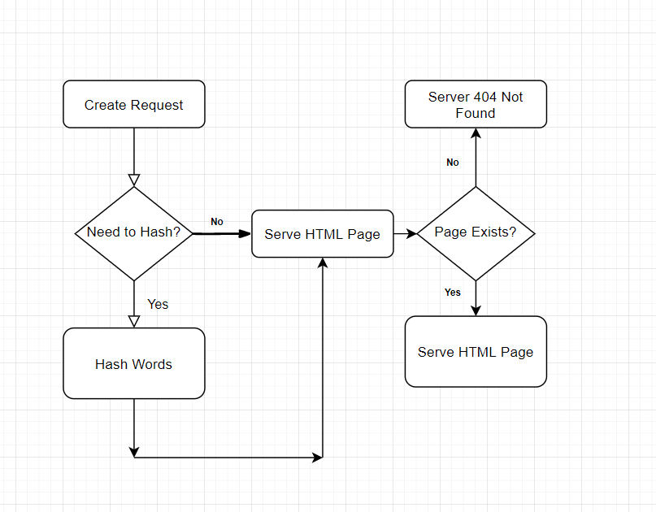

Parallel Server Flowchart (6.8)
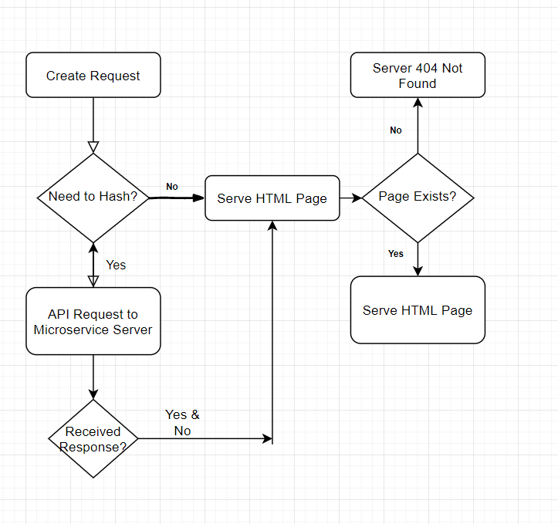
Microservice Flowchart (6.9)

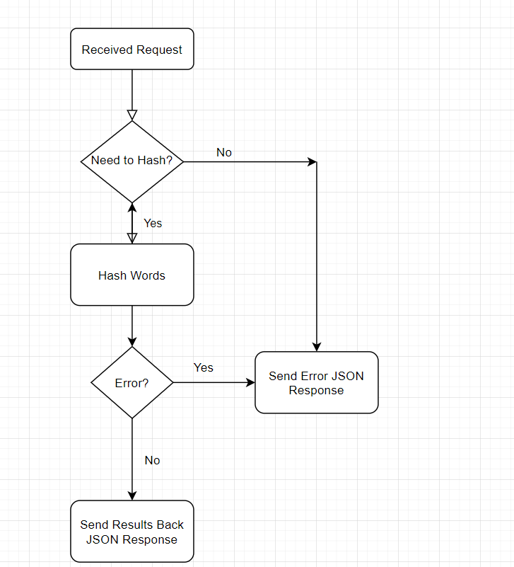

Project Implementation (7)
In this chapter, we will look at the implementation of the project and what decisions were made prior to and during the implementation of the project. We will discuss what the student thought about during each part of the project's implementation and what problems occurred during the implementation process and how they overcame those problems. We will look at what the student thought was the hardest parts of the implementations and what surprises did they uncover while implementing their project.

Project Setup and File Structure (7.1)

The first steps to the project implementation were installing all the necessary tools that would be needed for the project requirements. This was so that they could start working on the project and set up the file structure. They decided to use an architecture that was based on the Model View Controller structure as it would allow them to keep track and separate all files easily while having many records within the project that would be needed.

Creating a Simple Node.js Server (7.2)

The second part to the implementation was creating a simple Node.js Web server that could start accepting requests but not do anything other than that. This allowed them to create a simple prototype of creating a web server as Node.js provides developers with a simple function called “createServer”. When this function is called, they must pass a callback with the function provided, so the server knows what to do when an incoming request is created.

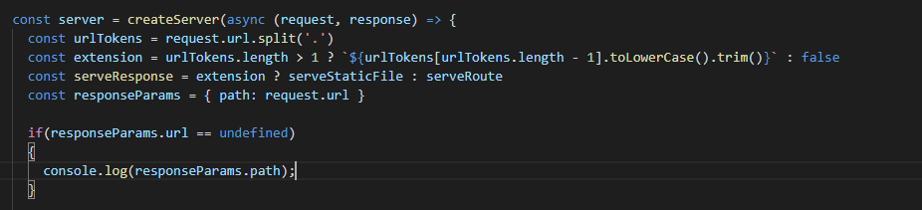

Serving Multiple Endpoints (7.3)

The next implementation problem they had to face was being able to deal and serve multiple endpoints for the user, an example of this is being ready to dynamically serve static files such as HTML, CSS and JavaScript files, but also dealing with API endpoints that might return JSON or XML data. The overall decision was to create method endpoints depending on the URL that was sent to the webserver. This allowed us to send dynamic and static pages when the user had requested a URL that suited that criteria but also allowed us to send data back in JSON format when the client requested an endpoint that matched an API Function.

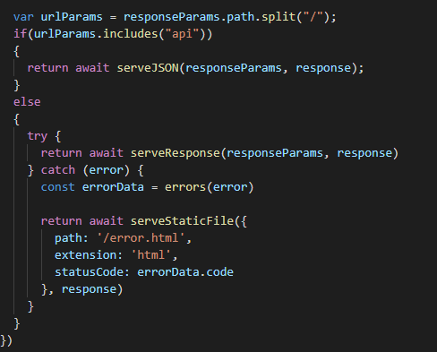

Serving Routes (7.4)

Allowing users to request routes was the next implementation step as this would allow us to create functions that will be called when a route is requested, this, for example, would allow us to send web pages back to the user if they were to request the homepage or would allow us to send hashes back to the user if they had requested that type of routing on the web application.

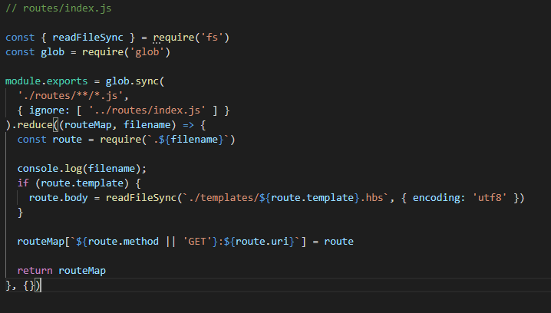

Each routing file must have three exports that allow us to identify the routing files URL, what method type the routing file is being used for and the View Template that would be sent back when the route is requested as shown below.

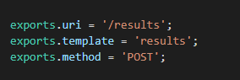

This implementation would be pretty simple as for each route the student could create a simple syntax that would allow the users to look for a certain URL that the user must request for the webserver to then grab the JavaScript routing file that matches the user's input. In the below example is the implementation that would allow us to search for a certain file depending on what URL the has requested if the routing does not exist we would then return an endpoint that was invalid and return a web page stating an error has occurred.

MongoDB (7.5)

MongoDB’s implementation was straightforward due to a large amount of documentation both provided on their website and a large number of discussions on multiple forums and platforms. A community driver must be installed on the machine to run MongoDB as this driver is used to communicate commands that will interact with the Database from applications.

MongoDB installs a tool called Mongo Compass that allows developers to create, manage, delete collections and databases. These tools will become useful for collecting data in the future but also for the setup and management of the database while in use.

A document was created inside the database that would allow us to store crucial data that the webserver has completed. This information could be put towards the results and findings, the data stored would enable us to know what were the resulting hashes that were completed, who requested the hashes to be computed and how long those computations of hashes took. This information will be ideal for our results and finding once we have collected all the data needed.

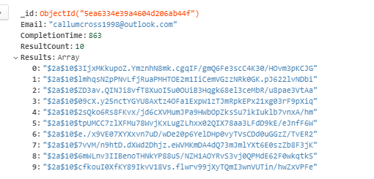

Handlebars (7.6)

Handlebars was installed with Node Package Manager. Handlebars allowed the student to create a template web page that will be used globally across the web application this allowed them to remove duplication of scripts, styling sheets and standard web page features that was implemented into the web application when the user requested content from the webserver the template page would be wrapped around the content.

The home and results page were both created with Handlebars and could allow for the dynamic information to be shown when the results had finally been collected, without this dynamic templating engine it would have been impossible to dynamically show data for a specific user.

In the image below shows a function that will be called if a route requested from the user is linked with a web page, if so then the template page that was created is compiled with a view that the user requested and they are both merged into one web page and then sent back to the user's browser to be shown.

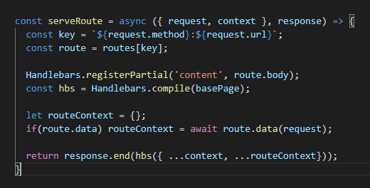

Home Page (7.7)
The next implementation was the home page, due to the extensive setup before this part of the application. The designs created before the installation made this effortless as it was more getting the layout correct than actually designing the web page.
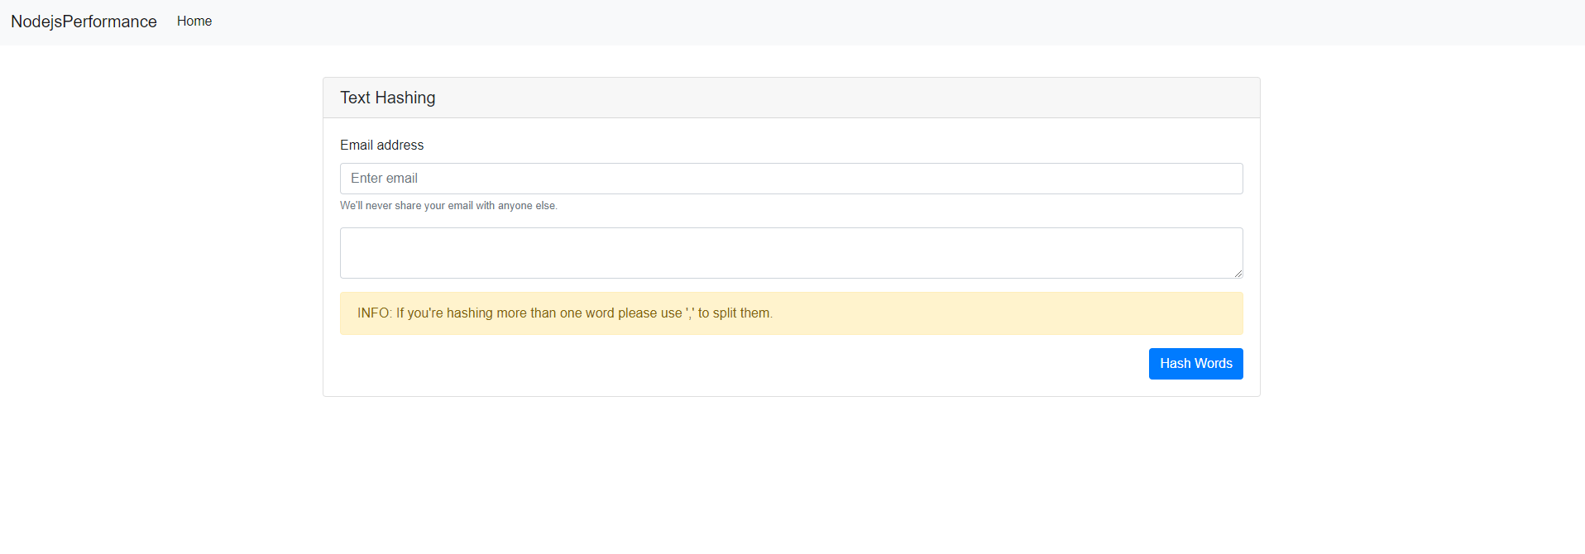

Results Page (7.8)
The results page was going to show the results of the hashes that the webserver had computed for the user. The design plan was for the user to be able to clearly identify the computed hashes that were computed but also be able to determine how long it took for those hashes to be calculated on either the webserver or microservice.
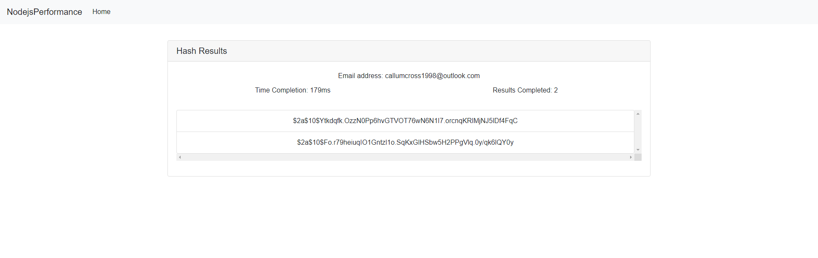

Restful Based API (Microservice Servers Only) (7.9)

The Restful API was implemented with scalability in mind so by doing this the URL was checked before make sure that the user was requesting a specific API Method with the correct parameters if so then the application would go through a series of checks to find if the required method matched any of the implemented processes if so would call the required function, but if there was no matching function then the API would respond with an error.

If at any point an error occurred during, before or after the API had requested a method then the user would get a returned object with the specified error and an empty data object that would indicate that an error did in-fact occur whilst trying to complete the request they had asked for.

In the image below is a snippet of code that shows how the API identifies which methods are available and correlates with them to receive a result, but if no method exists then an error will be returned.

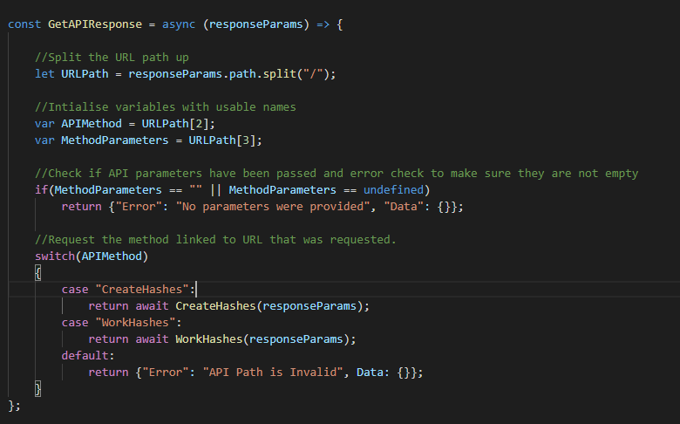

Project Analysis (8)
In this section of the report, we will look into the objectives and aims that have been initially set and the results composed from the upcoming experiments, firstly looking at each investigation conducted. We will then look at the results produced by the research. We will discuss what each test provided and then finally compare them with each other to find what we have discovered from the project and the advantages and disadvantages of this type of experiment.

Original Aims and Objectives (8.1)

The original aims and objectives of this project were to create a Node.js web application with a Restful Based API and using MongoDB, to identify the performance advantages of using microservices with a webserver to complete heavy computational tasks. We created the Node.js webserver to be as bare-boned as possible so that we do not have un-necessary modules that could affect the results.

Test Environment (8.2)

Each test would be run for a continuous ten minutes, with a set of concurrent users creating requests with the same purpose of pushing the server to the limit. This time limit was used as it was a reasonable amount of time that will allow the student to average the results out while having a good number of results.

Each test was conducted with a fixed number of hashes to be completed; this fixed number was set to 10 hashes. The text that was going to be used was also set to a fixed set of characters which were set at the text of “Callum11”, this would allow for a realistic set of characters that would be used for a password. This would give us a realistic setup for the experiment, which was one of the aims set.

The test environment setup for concurrent connections and hashes per request:
- One concurrent connection – 10 hashes per request
- Ten concurrent connections – 10 hashes per request
- 25 concurrent connections – 10 hashes per request
- 50 concurrent connections – 10 hashes per request
- 100 concurrent connections – 10 hashes per request

Node.js Web Application Without Microservice (9)

The first experiment conducted was a Node.js server that would be running with no microservices to help it during both requests and responses to the server but when a user would request a hash to be computed the webserver would complete the task in parallel.

One Concurrent User (9.1)

The first test without a microservice and with one concurrent connection went smoothly, and there was no disruption through the elapsed time. This was expected as one connection isn’t much to stress the server on bandwidth, but the load of the server was quite high due to having only one request that could be spammed over and over once completed.

Ten Concurrent Users (9.2)

The second test was going to start pushing the server a little bit more. The load showed that the increase of concurrent connections and tasks having to be completed did, in fact, increase the pressure on the server and started to create more significant response times than expected.

Twenty-Five Concurrent Users (9.3)

The next test that was performed increased the load by 150% this is what will test the server’s capacity. We will start to get an understanding of how the application will perform. The server began to struggle due to the amount of work that had to be completed and would take a long time to complete all computational hashes. Still, for the whole ten minutes, it did succeed in completing every task with no failures.

Fifty Concurrent Users (9.4)

The penultimate test was really to test how much performance can be given with 50 concurrent connections that were sending requests in parallel for hashes to be created. Ultimately even though the processing times would exceed extraordinary numbers, the webserver was handling the requests very well, so well the server completed all requests without any processing errors.

One Hundred Concurrent Users (9.5)

This would be the final test without microservices that would push a small server to its limit in both server capacity and server load. This test had been found to exceed response times of over one-minute when requesting ten hashes per request, but the server seemed to handle the load even though this was way above what was expected from such a small server with the hardware that it had.

Results & Findings (9.6)

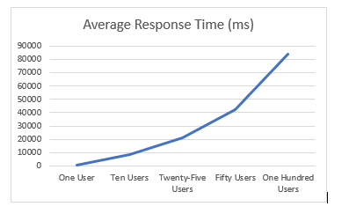

In the above chart shows the average response times that the users will receive when the server is at full load, these times start to increase rapidly as the concurrent connections increase. The first thing that was rather unexpected was that the response times were absurdly high, reaching over eighty seconds to complete one request when one hundred concurrent users were sending requests.

This chart, of course, will give us a good benchmark on where we expect the upcoming results to align when looking at the average response times. Even though the server does not have the best hardware specifications, the server dealt with all tasks with little to no issues on most tests. This gives us a good indication that Node.js even though it can be slow when dealing with heavy computational loads, it can still deal with them without crashing or causing disruption to the service.

It seems the server would be able to handle around eight to ten users concurrently before getting out of hand and would possibly be not quick enough for actual use. This was one of the expectations that were looked at and was expected from a server that had to multiple tasks which were heavy on computational performance.

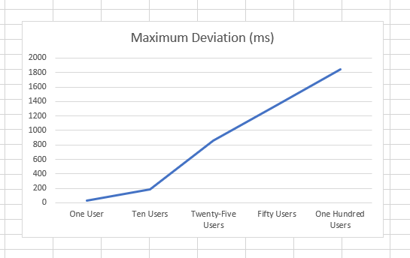

The maximum deviation between requests was minuscule to the response time. This was fantastic as it showed that the web application was working as efficiently as it possibly could while at full capacity because the times displayed in the above graph are within an average range of three per cent which is a small impact to the response time. This, of course, shows that all threads were working at a quick rate and were completing all requests.

Even though an average deviation is not as crucial as average response time, collecting this info could be essential for improving the product when needed, as this would allow developers to get an understand of the maximum difference between the shortest and largest response time.

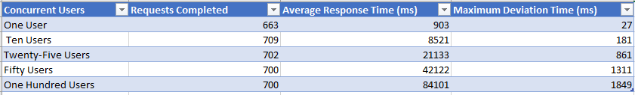

In the table above show the overall results of the tests completed, this gives us an indication of how well the server completed the requests that were being sent to the webserver whilst keep concurrent connections open to clients.

Node.js Web Application with Microservice (10)

The second experiment to be set up had the same environment as the web application without a Microservice. In these tests, we would be making full use of a microservice that would allow us to collect performance data when creating heavy computational hashes. We would expect better results from this experiment than compared to one web server having to keep continuous connections while responding to requests.

One Concurrent User Test (10.1)

Once the use of the microservice was tested for the first time, it run very smoothly and could perform at the max load, which allowed us to start the test. As expected, both servers completed all requests with no errors.

Ten Concurrent Users Test (10.2)

Ten concurrent users took a lot of stress off the webserver dealing with client page requests as it didn’t need to complete heavy computational tasks and could rely on the microservice to do those tasks for it, on the other hand, the microservice was at full load at all times during the elapsed testing time and was capable of completing all requests with no errors.

Twenty-Five Concurrent Users Test (10.3)

The third test of this experiment was pushing the server with twenty-five clients concurrently connected, this did increase the load on the webserver itself, but the processing times did increase quite rapidly during this test and showed that both the webserver and microservice was starting to struggle. After a full ten minutes of running the microservice and web server did complete all requests with no errors.

Fifty Concurrent Users Test (10.4)

With fifty clients using the webserver and microservice to fulfil their requests, some requests that were being processed would sometimes take longer than usual compared to other requests around them. This could be due to an overload of API calls that the microservice could not sustain or could be a small interference on the thread being used whilst fulfilling request. The overall results of failures were zero even with the minor long processing times that would rarely occur.

One Hundred Concurrent Users Test (10.5)

On this test, we saw the better side of microservices as it was more capable of completing and dealing with all requests at a reasonable rate even with the consistent load of requests being sent to the microservice. After eight minutes of running the server did drop one request which was the only drop across the whole tests conducted, but this could have been due to several problems, more than likely there was a request timeout or the thread simply could not handle the number of requests being sent with the enormous processing tasks it had to complete.

Results & Findings (10.6)

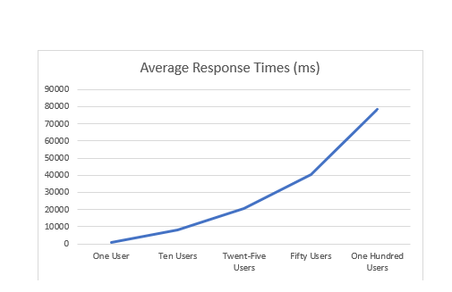

The average response times from all five tests showed a more considerable performance gap with some of the tests cutting response times by seconds and the smaller concurrent connections completed their times in milliseconds. This, of course, shows that the microservice did indeed help the primary web server by offloading heavy computational tasks onwards.

This data shows that even though the hardware wasn’t the most powerful, the server never crashed with gives us a good understanding that Node.js is a powerful framework to work with.

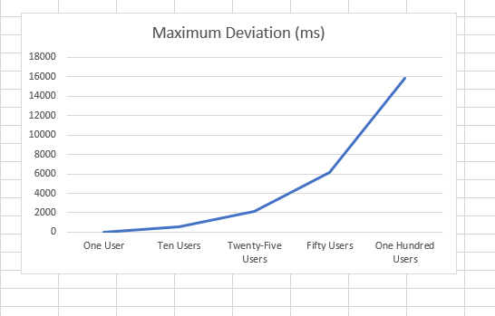

The maximum deviation did increase significantly. This is a significant figure because it shows that a microservice, when stressed, could become unstable and produce more inconsistent response results that are largely out of order and have a large deviation between them.

These kinds of deviation values could cause problems in the future if this microservice was to be used in the real world and could cause major disruptions if you are not careful with these types of heavy loading on microservices.

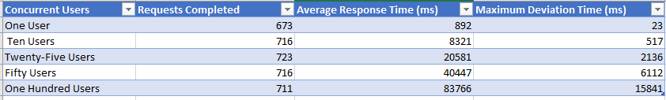

Comparison of Results (10.7)

Comparing the results from both experiments show that you do gain quite a hefty amount of performance when running heavy computational tasks, comparing the results from the past shown graphs and tables. We can see that the microservice cuts the processing times at larger scales when the concurrent users connected is increased, but we don’t see such a large gain in performance as the user count is lower.

We could possibly disregard both the first tests of the experiments because this does not ideally show the use of multiple threads being run due to the little number of concurrent connections which can be seen being used whilst the concurrent user count is increased.

A large increase was seen in the maximum deviation between both experiments, this is a bit odd as there wouldn’t have been more load on the microservice compared to the singular webserver that had to complete multiple tasks simultaneously. This could possibly just come down due to the number of requests that was being sent over the API and it started to become unstable due to this.

From the data collected we can assume that a maximum concurrent connections was achieved in both experiments because at the beginning of the experiment there was a natural rise of both completed requests, it became apparent that once the webserver computing tasks parallel hit the ten concurrent connections mark the performance started to drop slightly as it changed to fifty concurrent connections. On the other hand however, it seems the microservice helped the webserver that was only dealing with sending requests to the microservice by allowing double the amount of concurrent connections of twenty-five before we see a drop in performance of requests completed.

Evaluation (11)

In this section of the project report, we will evaluate and compare the results we have collected. We can look at the facts that we have received and make a good decision on whether having microservices are a performance benefit to Node.js webservers. We will evaluate our results and justify if the information we gained and the project we created allowed us to make a final justification on our aims and objectives.

Overall, the student felt the project was a great success for the time constraints that were placed upon the project. They felt that with the time constraints that were placed they managed both their time of research and development to a good standard and felt as if the project had been well built to provide the evidence for the aims and objectives of the project to be met

The overall conclusions of the data they have presented have shown that microservices do help greatly in performance when dealing with large computations algorithms whilst having to deal with concurrent connections of users using your services. The side effect to this though would be the fact that if the budget was not very high that’s it is still possible to run both processes on the same server but will lead to increased latency time.

The data provided did back up the literature review that was discussed in the beginning mainly, one of the main areas that the research was backed by was the paper created by Hafiz Umar Nawaz and Denisa Rucaj as they discussed their finding on Node.js web applications performance impacts, they found that with the heavy computational process with a microservice could great a performance percentage gain of between five to twelve per cent. This comes into aligning with our results that see an average performance boost of around four to six per cent.

The aims and objectives set for this project were to create a Node.js web application that used a Restful Based API and MongoDB. From the results, it seems that they have achieved the objectives that have been set within the constrained time frame provided. The second objective and aim were to look at the performance gains that Node.js provided with a microservice being interconnected that would be compared to a web server with the same architecture but did not have a microservice connected. Overall, they felt that most if not all, the objectives set were complete with the evidence provided.

The results that were found were surprisingly not the performance gains they expected, largely they thought that there would be a much larger performance gain than was actually collected, which made them think whilst collecting the results that they were doing something wrong so they run the tests much more than they should have, but every time they would get similar results leading them to believe that they were, in fact, the correct results. This kind of knowledge will allow them to have a better insight into how much microservices help performance when using them and when they should be used.

Being able to keep a concurrent connection of users and being able to perform tasks at a fast rate shows that both factors are very important when it comes to designing a system or software as these two factors will be the main contributors to what could possibly slow down your system when dealing with these factors you should take extra caution and be sure that the correct decisions have been made.

An example of this would be that if you don’t have more than 25 users using your web application, then you should be perfectly fine running a web server without any microservices but once you exceed the limit of 40-50 concurrently connected, you may want to look into creating microservices or getting better hardware for their server to sustain the constant load.

Improvements (11.1)

If the project was to be restarted there would be a few features they would change with the project that was created, firstly they could have allowed the users to pick an optional algorithm that they could run instead of having to force them to just run one heavy computational algorithm BCrypt. Another improvement would have been adding more overall interaction to the web pages we currently have, an example of this could have been that when a request is completed, it would show a list of the recently completed requests, how long they took to complete the request and the result timing of the request. This would have been a great idea as it would have allowed a more interactive experience across all the web pages.

Another improvement that would be more for the core functionality of the project would be changing the programming language from pure JavaScript to typescript as at the time of starting the project we had completed most of the project in JavaScript. The reason why we would have chosen typescript is that it allows for better management of the codebase by using the superset tools that are provided by typescript which would allow for a cleaner and more simple code whilst having to create basic and complexed statements.

Future Research (11.2)

This project has led to a wide variety of research aspects that could possibly be looked at. Future researchers could possibly look at how Node.js reacts when comparing current widely used web frameworks such as express and make a comparison on a bare-bone Node.js web server without any frameworks, and this could lead to a better understanding on whether creating your own framework would be better for your fundamental purposes or would it be better to use one that is created online and open source.

A second proposal to future research could be the maximum performance Node.js has to offer when combined with more than one microservice. You can definitely expand upon this project with more than one microservice with a suitable load balancer that could distribute the workload evenly, which could possibly show the maximum performance Node.js could possibly be pushed to.

One final proposal of future research could possibly be a comparison of web frameworks between performance capabilities as this would give developers a lot more information on which web frameworks would be best suited for the task or application they are trying to create.

Reflection (12)

During this process, the student in question learned a great deal of information behind the development and implementation of software. The student learned that designing a system is key when creating applications as this will be a fundamental part of the application. In the design phase mistakes can happen and will happen during the software development process, but it’s better to identify them during the design phase instead of the implementation phase as this could create a long delay in the development process.

The Design phase is a lot more than just writing the tools and languages that are going to be used it’s a way of being able to break down tasks in such a way that a large group of people can work cohesively together. They learned this whilst creating the flowcharts for the prototypes that were going to be developed. The flowcharts helped them understand how everything would eventually connect whilst breaking the larger problems into small problems so that they could be worked on individually and not all at once.

Another important factor that they had learned was that most tasks that are being completed do rely on research; this could either learning how to implement a function with a specific purpose. There’s a lot more information on the internet than there is on the software providers documentation.

The student had to learn a completely new language at the start of this project, which was JavaScript which, in fact, was the main language that had to be used for Node.js to run. They had to learn a large set of fundamentals before this project had started, they were glad that the project had taught them how powerful JavaScript is when it is used at its full capacity, they learned that the language is not only powerful, but they learned it’s a fundamental language when you go into web development and that you will come into contact with JavaScript as it’s so widely used.

Finally, the student learned the core functionality of web applications having to build their own with no frameworks was a complexed task with having to deal with every minor part of the application from delivering web pages and images to dealing with HTTP requests that must be completed and sending the response back to the user.

Overall the student felt that they had learned quite a lot from this project due to having to follow the whole software development cycle for their final project to be developed, they learned useful tips that they will be taking with them in their future endeavours and have understood a good wealth of knowledge whilst moving through the stages of development of design methodology, design and implementation.

Conclusion (13)

To conclude this report, we looked at the research and literature that was completed prior to this project being started and how the research would help us in the upcoming project to be created. We discussed what each reported finding was and what information we will be taking into consideration during development.

Secondly, this report looked at the tools and languages that would be used to create the project during the design phase, and we looked at the decisions that were made to confirm that those tools that were going to be used were the correct tools for the project.

Thirdly, we looked at the implementation of the project, and how we split the project into small pieces and implementing them together to do a large project, we discussed each individual feature of the implementation and why the feature was implemented in a certain way and why we used it, Finally we explained if there were any problems we discussed some of the issues that arise during the implementation and how we solved them.

We discussed the project analysis and explained what the experiments environment setup was going to be in the upcoming tests, and we explained each individual test performed and explained if there were errors during the test why they could possibly be happening.

Next, we evaluated the results and findings and matched any findings that correlated with our research prior to the project and explained our opinion on the experiments. We also looked at the expectations we had in mind prior to the project and explained our opinion whilst comparing the results from the experiments and our final opinion of the impact of the performance of microservices.

Finally, we discussed our opinion on the improvements that could have been made if the project was to be restarted and why the improvement should be made and what the benefits of the improvements would be.

Images & Figures (14)

Node.js Webserver without Microservice Results

1.0 One Concurrent User

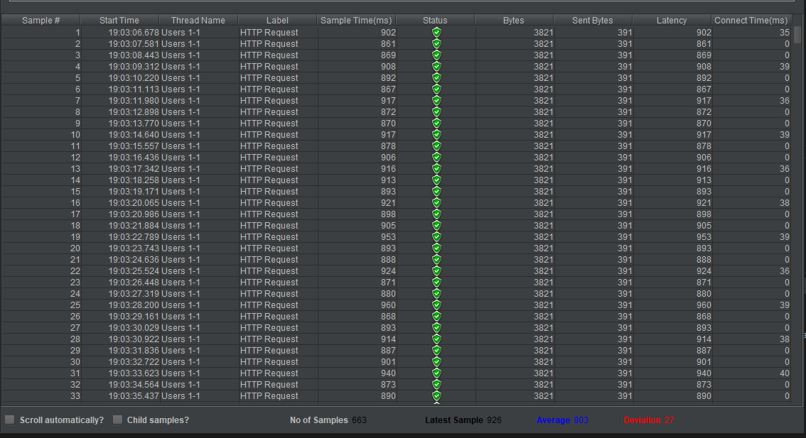

  - Ten Concurrent Users
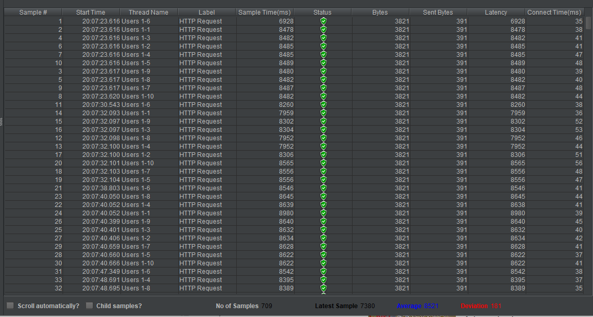

  - Twenty-Five Concurrent Users
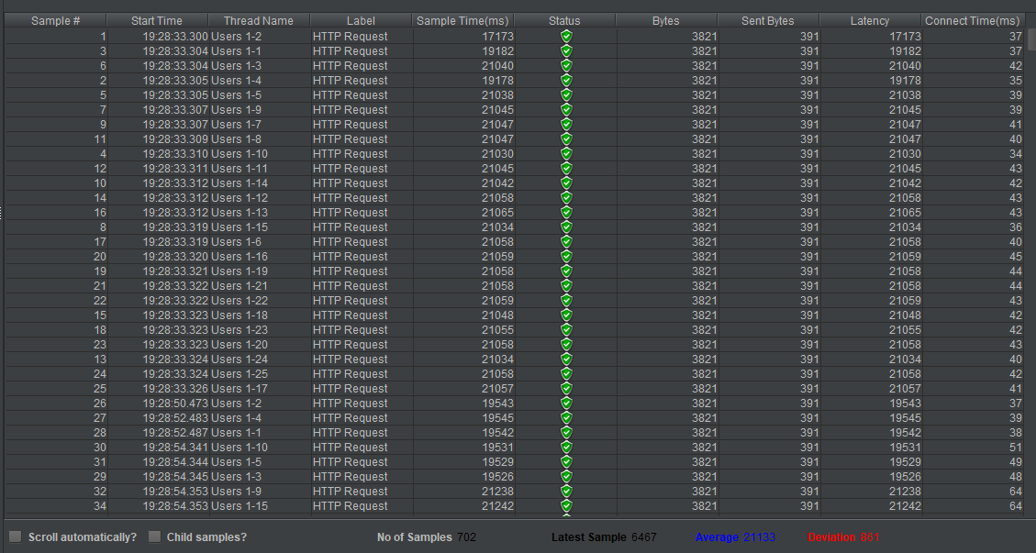

  - Fifty Concurrent Users
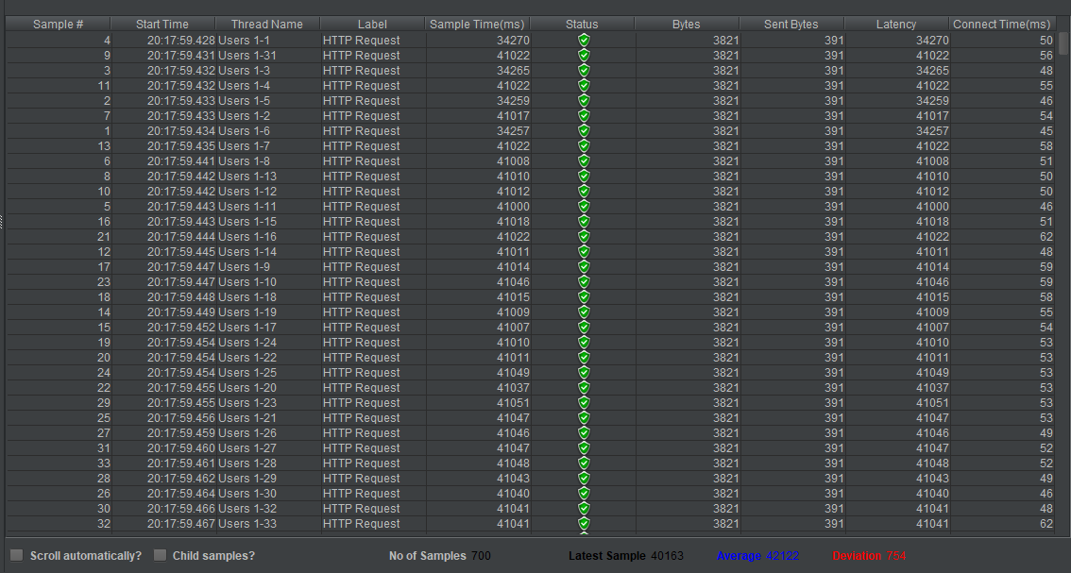

  - One Hundred Concurrent Users
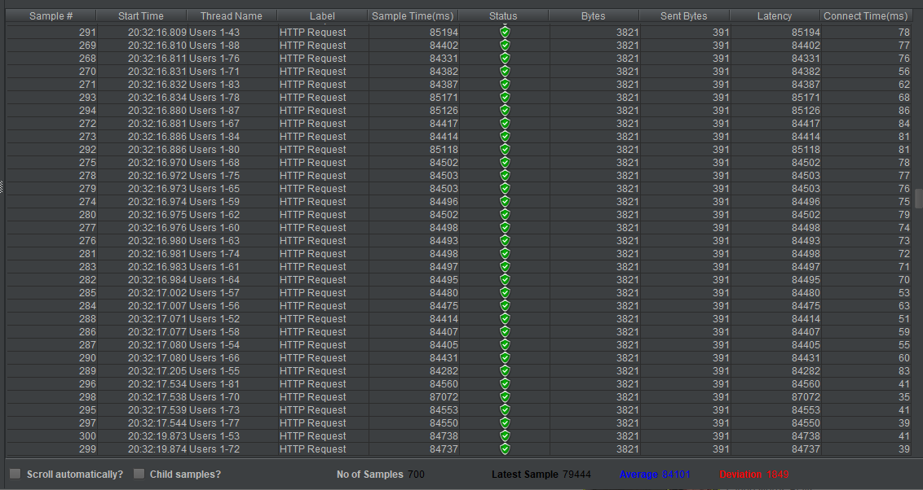

Node.js Webserver with Microservices Results

2.0 One Concurrent User
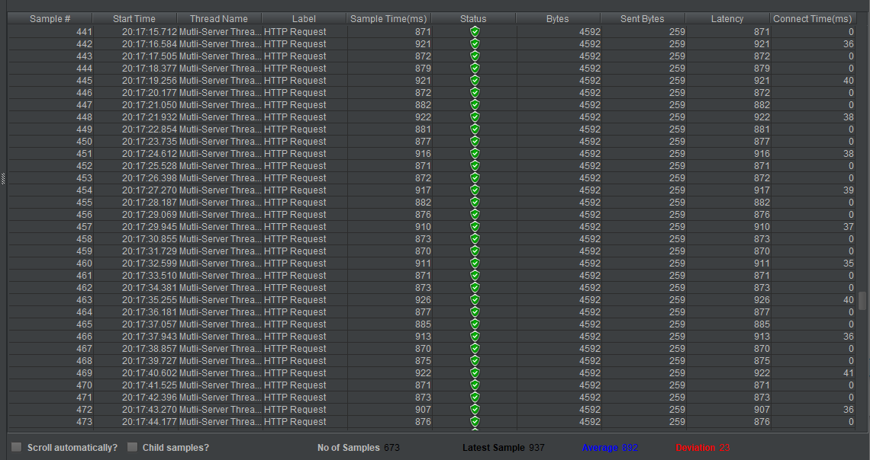

2.1 Ten Concurrent Users
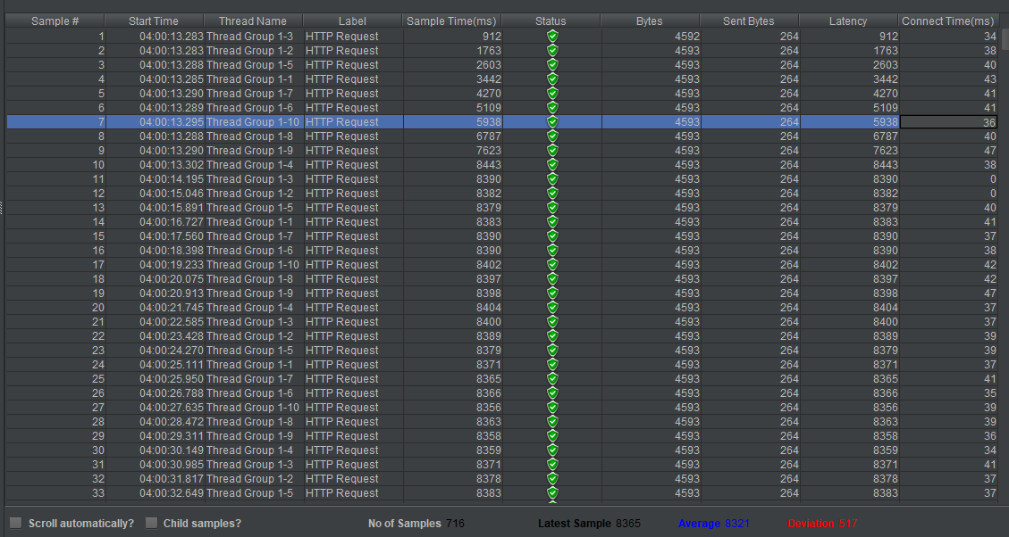

2.2 Twenty-Five Concurrent Users

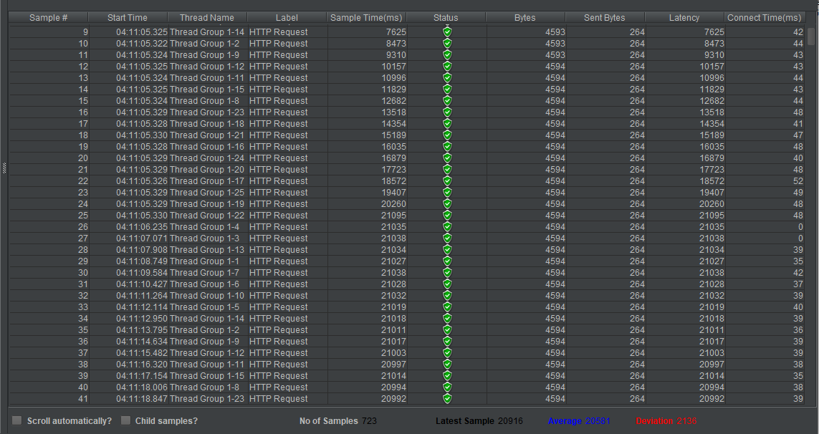

2.3 Fifty Concurrent Users
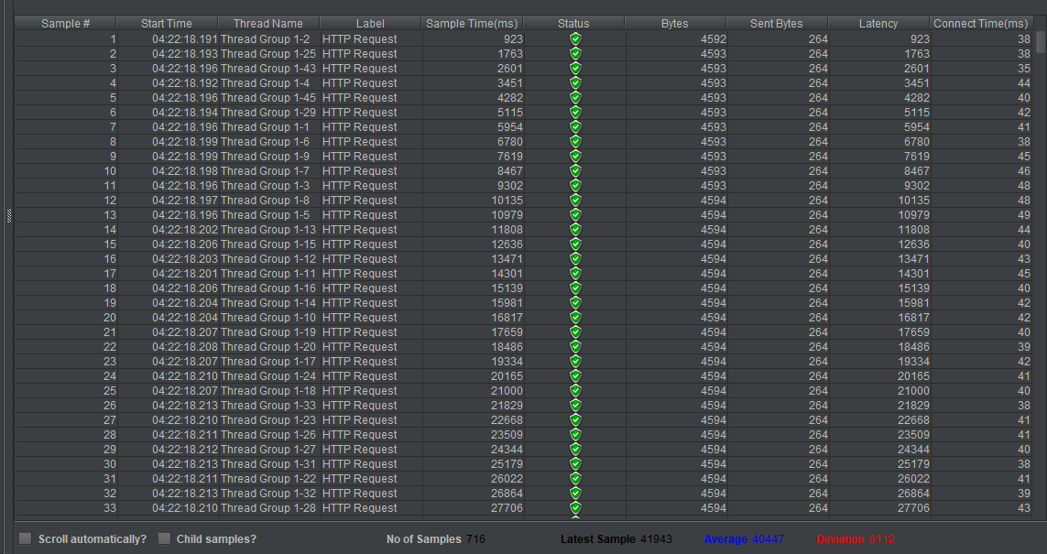

2.4 One Hundred Concurrent Users
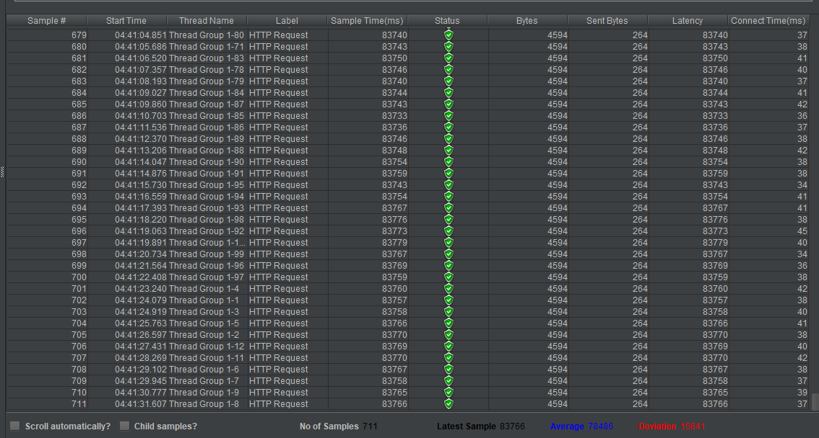

References (15)

[1] Kravchenko, S.A. and Werner, F. (1999). Scheduling on Parallel Machines with Single and Multiple Servers. United Institute of Informatics Problem, pp.14, 15.
[2] Ajayi, O. and Uwadia, C. (2015). Analysis of Two-Phased Approaches to Load Balancing in Cloud Computing. University of Lagos, p.2,3.
[3] Umar Nawaz, H., Rucaj, D. and Kamran, N. (2018). Evaluate scalable and high-performance Node.js Application Designs. Martin Lasak, p.1,7.
[4] Chhetri, N. (2016). A Comparative Analysis of Node.js (Server-Side JavaScript). Saint Cloud State University, pp.55, 56.
[5] Hammer, M. (1997). What is Rapid Application Development? CASEMaker Inc, pp.1, 6.
[6] Young, A. and Harter, M. (2015). Node.js in Practice. Manning Publications, p.1,5.
[7] Malvoni, K. and Knezovic, J. (2014). Are Your Passwords Safe: Energy-Efficient Bcrypt Cracking with Low-Cost Parallel Hardware. p.1,2,3.
[8] Scherer, J. (2020). Hands-On JavaScript High Performance. Packet Publishing, pp.1, 2.
[9] Chodorow, K. and Dirolf, M. (2015). MongoDB : the definitive guide. Sebastopol, Calif.: O’reilly, pp.5, 12.
[10] Richardson, L. and Amundsen, M. (2015). RESTful Web APIs. Beijing ; Cambridge ; Farnham ; Köln ; Sebastopol ; Tokyo: O’reilly, -05-22, pp.33, 34.

