MODULE TITLE AND CODE: BMIH 5007 – FINANCIAL MANAGEMENT FOR THE HOTEL INDUSTRY

Report Case Study: Urban
Heights Hotel

STUDENT NAME: SHABANA BEGUM
STUDENT ID: 2223853
Word Count: 3260

Acknowledgments of AI usage:
I acknowledge the use of consensus, ChatGPT to search for structuring the submission, including creating a draft structure, identifying parts and headings of the assignment and PROOFREAD it. I confirm that I have not presented any AI generated text as my own work. I confirm I have copies of my drafts, notes, and other resources I used before, and after the use of AI tools which I may be asked to provide in evidence.

Table of Contents
Executive Summary 3
Introduction 4
Financial Analysis 4
Key Issues and Risk Management 9
Strategies for Mitigation 10
Turnaround Strategy 11
Marketing and Revenue Management 14
Implementation Plan 15
Conclusion and Recommendations 16
Implementation and Monitoring 17
References list: 17

Executive Summary
This report examines the pressing financial challenges confronting Urban Heights Hotel, which include a significant decline in revenue, reduced occupancy rates, and deteriorating customer satisfaction levels. In order to assess the hotel's financial health and identify important areas of concern, the study thoroughly examines important financial measures, paying special attention to profitability, liquidity, and solvency ratios. These financial stresses have been made worse by economic pressures such rising inflation and consumer spending shifting towards more affordable options, which has made managing operating costs and generating income more difficult (Atrill & McLaney, 2021).
According to the findings, quick strategic actions are necessary to stop the hotel's financial downturn and put it in a competitive position. Implementing cost-cutting measures to increase profitability, improving service quality to increase customer happiness, and repositioning the market to attract and retain clients in a changing market are some of the main recommendations (Drury, 2021). By stabilising cash flow, cutting costs, and fostering client loyalty, these suggested measures seek to set up Urban Heights for long-term success. The suggestions offer the hotel a workable road map for overcoming present financial difficulties and ensuring a robust, sustainable future (Walker, 2021).

Introduction
Urban Heights Hotel is experiencing rising financial pressures due to a combination of internal inefficiencies and adverse external economic conditions. While occupancy rates are still declining, internal operating costs have increased, underscoring the urgent need for a successful financial recovery plan. The hospitality industry is extremely vulnerable to external economic swings, and more recent developments including growing inflation, heightened competition, and changes in consumer behaviour have put more pressure on the sector (Jones & Lockwood, 2004). Customers are changing their discretionary spending to reflect economic uncertainty and are looking for more affordable lodging options. Urban Heights has been adversely harmed by this trend, which has made its revenue problems worse and jeopardised its long-term survival.
Through the analysis of three important ratios—profitability, liquidity, and solvency—this research seeks to present a comprehensive financial evaluation of Urban Heights in order to analyse the hotel's present financial status and pinpoint areas that require urgent attention (Schmidgall, 2016). The paper aims to identify the fundamental problems that underlie the financial deterioration and offer practical remedies through this examination. Through an analysis of current market developments, including rising operating expenses, varying demand, and changing visitor expectations, this report will present recovery plans customised to meet Urban Heights' requirements. In order for Urban Heights to restore its financial stability and fortify its competitive position in a difficult market, the recommendations centre on cost reduction, customer service enhancements, and targeted market repositioning (Rutherford & O'Fallon, 2011).

Financial Analysis
By analysing profitability, liquidity, and solvency ratios from 2021 to 2023, this financial research assesses the significant obstacles Urban Heights faces. These indicators show the hotel's financial burden and serve as a foundation for comprehending the constraints and prerequisites for a workable recovery plan. This part also considers external economic issues that have further limited the hotel's capacity to generate income and control costs, such as inflation and changing client preferences.
Profitability
Over the past three years, Urban Heights' profitability has significantly decreased. After being positive 28% in 2021, net profit margins dropped precipitously to -27.8% in 2023, indicating a serious decline in financial health (Atrill & McLaney, 2021). Due to declining occupancy rates and rising operating costs, revenue decreased from £2,500,000 in 2021 to £1,800,000 in 2023. Gross profit margins have been further reduced by rising prices, especially in labour and suppliers, which emphasises how urgently expense control is needed to stop further financial decline (Drury, 2021).

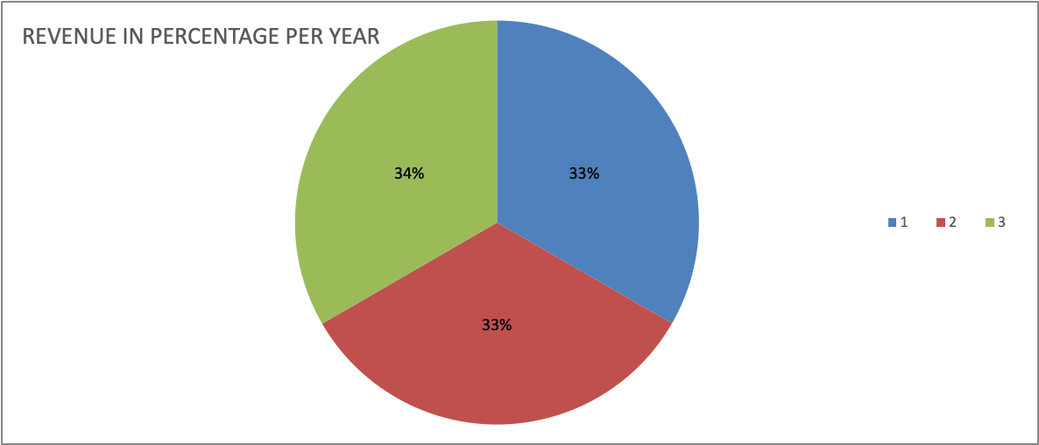
Year | 2021 | 2022 | 2023
Revenue | £2,500,000 | £2,200,000 | £1,800,000

This downward trend can be visually represented by a bar chart that shows the revenue decline from 2021 to 2023. This will serve to highlight the severity of the issue and the necessity of cost-control measures to stabilise profitability. If nothing is done, the hotel's financial situation would probably get worse due to its inability to pay for growing expenses.
Liquidity
According to liquidity ratios, Urban Heights has significant cash flow issues. The hotel's current ratio, which gauges its capacity to fulfil short-term commitments, dropped from 1.4 in 2021 to 0.6 in 2023, suggesting that current liabilities greatly outweigh current assets (Wild, Shaw & Chiappetta, 2018). The hotel's limited operating flexibility and possible difficulties fulfilling short-term financial obligations are indicated by this falling ratio.
Furthermore, the hotel's cash reserves have drastically decreased from £300,000 in 2021 to £100,000 in 2023, making it more difficult to handle unforeseen costs and keep things running smoothly (Morrison, 2018). Another worrying indicator is the decline in accounts receivable from £150,000 in 2021 to £80,000 in 2023, which is a result of fewer reservations and late payments that further strain cash flow (Slack, Brandon-Jones & Johnston, 2019). The liquidity issues can be clearly shown in a line graph that shows the declining trend in the cash reserves and current ratio throughout this time.
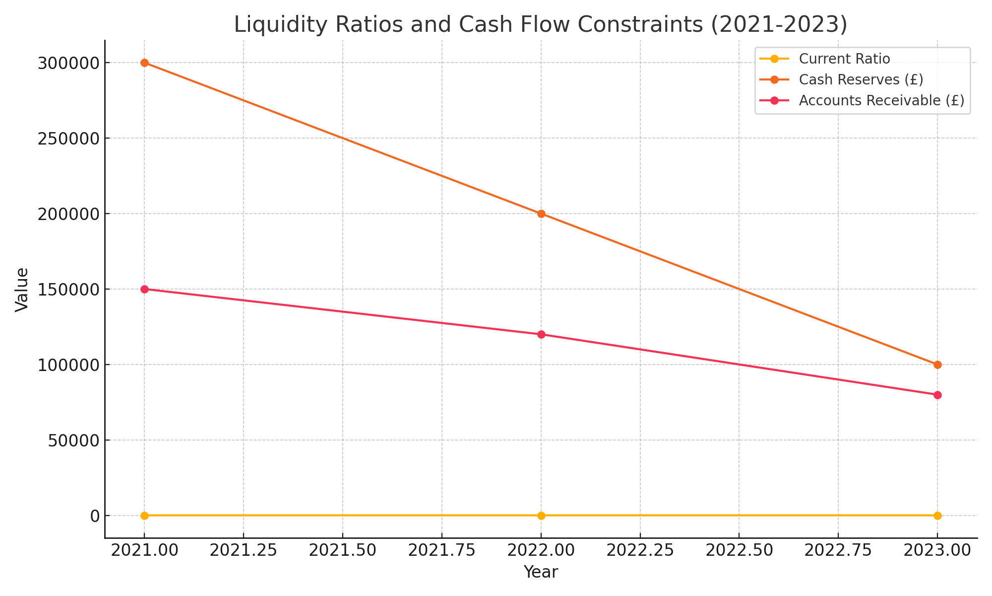
Urban Heights' operational flexibility is directly impacted by declining liquidity, which makes it difficult to adopt new tactics in the absence of funding. This limits the amount of money that may be spent on client retention initiatives or service enhancements, both of which are crucial for long-term recovery.
Solvency
An increased reliance on debt is revealed by solvency metrics, indicating the hotel's rising financial danger. The hotel's reliance on debt financing as its equity basis deteriorates is reflected in the debt-to-equity ratio, which increased from 1.5 in 2021 to 2.2 in 2023 (Jones & Lockwood, 2004). Due to its high level of leverage, the hotel has less financial flexibility and is less able to obtain extra money for possible turnaround measures (Kotas, 1999).
The hotel's balance sheet was impacted by operational losses throughout this time, as total liabilities rose from £3,250,000 to £3,300,000 and shareholder equity decreased from £2,200,000 to £1,380,000. The rise in financial risk and the requirement for restructuring would be graphically represented by a chart that compares solvency metrics, such as the debt-to-equity ratio and changes in equity and liabilities.
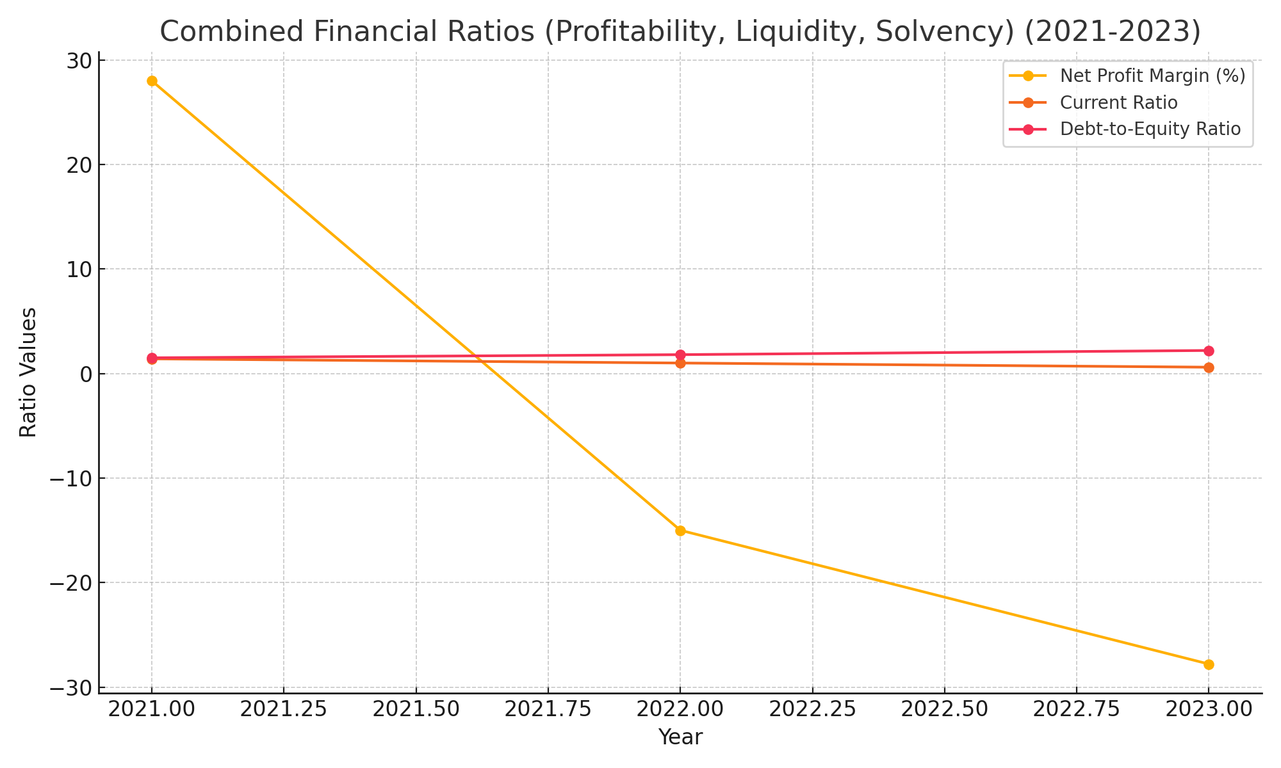
Urban Heights' capacity to fund necessary upgrades is hampered by its growing debt load, which also puts the hotel in risk of becoming unduly reliant on its lenders. Improving solvency and ensuring long-term stability would require lowering debt and looking at equity financing possibilities (Rutherford & O'Fallon, 2011).
External Economic Factors
Broader economic forces, namely inflation and shifting consumer behaviour, exacerbate Urban Heights' problems. Operating costs have gone up due to rising inflation, particularly for labour, utilities, and supplies. Additionally, it has become more difficult for the hotel to draw in and keep customers due to changes in consumer spending, which favour less expensive travel options (Pizam, 2010). By connecting these outside variables to the internal financial analysis, Urban Heights can get a comprehensive picture of the issues it needs to deal with in order to stay competitive.

Key Issues and Risk Management
A number of significant issues, such as declining customer satisfaction, growing operating expenses, and decreasing occupancy, pose a danger to the financial health of the Urban Heights Hotel. These risks are exacerbated by wider economic pressures including inflation and decreased disposable income, which have caused hotel occupancy rates to decline as travellers choose less expensive vacation options (Pizam, 2010). Furthermore, growing labour, utility, and supply costs have reduced profit margins, highlighting the necessity of thorough risk management to lessen financial effects (Rutherford & O'Fallon, 2011).
Risk Identification and Assessment

Risk | Likelihood | Impact | Priority | Mitigation Strategy
Occupancy & Satisfaction | High | High | High | Implement loyalty programs and improve service quality to retain guests and boost satisfaction.
Cost Escalation | High | High | High | Utilise energy-efficient upgrades and renegotiate supply contracts to control and reduce operational costs.
Liquidity Constraints | Medium | High | High | Improve cash flow management and explore short-term financing options to enhance liquidity.

A risk management framework should be used to identify and rank each risk according to its likelihood and possible impact in order to methodically handle these issues. A risk matrix, which classifies threats as high, medium, or low priority, can be used to organise this assessment. For Urban Heights, the following high-priority hazards have been identified:
1. Occupancy and Customer Satisfaction: Revenue and market position are directly threatened by declining occupancy rates and low customer satisfaction. While fewer visitors translate into less money, unhappy customers can harm a brand's reputation and make repeat business less likely.
2. Cost Escalation: Growing labour, supply, and utility costs have a big influence on profitability, particularly in a setting where costs are high. Inflationary forces that raise the price of necessary operational expenses increase this danger.
3. Liquidity Limitations: The hotel's resilience and flexibility are further impacted by its inability to invest in upgrades or meet unforeseen financial demands due to inadequate cash flow and insufficient liquidity.

Strategies for Mitigation
1. Occupancy and Satisfaction: Urban Heights should put focused client retention tactics into place to alleviate occupancy difficulties and raise customer satisfaction. In a competitive market, implementing a loyalty program that provides discounts or other advantages to returning customers could increase retention by roughly 20–30% and promote loyalty (Woods & King, 2010). Enhancing customer happiness and promoting favourable ratings can also be achieved by addressing frequent customer pain points, such as expedited check-in and customised experiences.

2. Cost Control: Sustaining profitability requires efficient cost management. Smart thermostats and LED lighting are two examples of energy-efficient enhancements that could lower utility expenditures by 10% to 15%, easing some of the inflationary pressures on operational costs (Yu, 1999). Rising expenses can also be reduced by renegotiating supply contracts to obtain bulk savings.
3. Financial flexibility and planning: Urban Heights should use scenario planning, which entails evaluating possible economic outcomes and formulating plans appropriately, to be ready for changes in the economy. This proactive strategy keeps the hotel's operations stable by enabling it to swiftly adapt to shifting circumstances, including increasing inflation or changes in demand (Walker, 2021).

Urban Heights can reduce the most urgent threats and enhance its operational and financial resilience by giving priority to these solutions. For the hotel's long-term viability, this risk management framework offers an organised method for recognising, evaluating, and reacting to financial risks.

Turnaround Strategy
The three main pillars of the suggested turnaround plan for the Urban Heights Hotel are strategic repositioning, cost optimisation, and client retention. Every tactic is intended to alleviate the hotel's current financial difficulties, reduce hazards that have been identified, and enhance long-term sustainability.

Cost Optimisation
To enhance cash flow and improve profitability, cost optimisation initiatives focus on reducing operational expenses. Energy-efficient upgrades, such as installing LED lighting and smart thermostats, have the potential to lower utility costs by 10–15%, especially given the recent rise in energy prices (Seal, Garrison & Noreen, 2008). For instance, replacing traditional lighting with LED options can reduce electricity usage, while smart thermostats can automate heating and cooling based on occupancy, minimising waste. A pie chart illustrating operational costs before and after these proposed reductions can highlight the expected savings and illustrate the impact on the hotel’s budget.
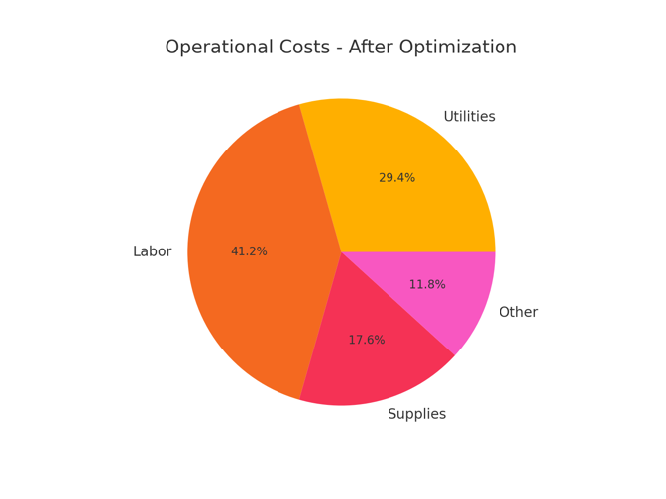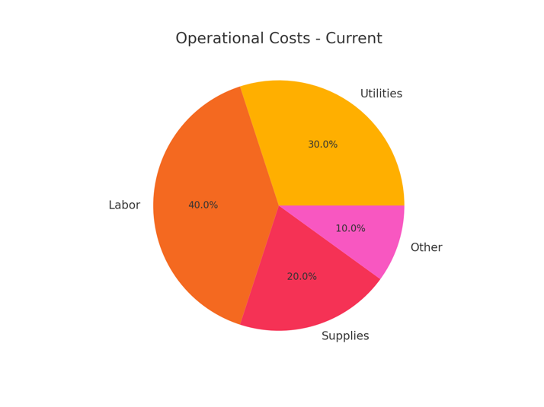
Renegotiating supply contracts is another way to cut costs. The hotel can lower the unit cost of high-consumption commodities like linens and cleaning supplies which are crucial in the hospitality industry by negotiating bulk purchase agreements (Guilding, 2014). More precise demand forecasting combined with efficient inventory management can also cut waste and avoid overstocking (Evans et al., 2003). When taken as a whole, these cost-cutting initiatives seek to ease financial strain and provide the hotel more leeway in how it handles spending.

Retaining customers and improving services
Stabilising occupancy rates and guaranteeing steady revenue depend on increasing client retention. Customer retention can rise by roughly 20–30% by implementing a loyalty program that provides rewards for repeat business, such as points for reservations, exclusive facilities, or discounts (Jones & Lockwood, 2004). By cultivating a devoted clientele that is less susceptible to price changes, this program addresses the identified risk of decreased occupancy. In addition to providing a steady flow of income, loyal consumers serve as brand ambassadors, attracting new customers through word-of-mouth recommendations.

Metric | Current Level | Projected Level After Loyalty Program
Occupancy Rate (%) | 65 | 80
Customer Retention (%) | 50 | 70
Average Customer Lifetime Value (£) | 1500 | 2000

Customer feedback-driven service improvements can further increase customer satisfaction and lower attrition. For instance, enhancing front desk productivity or implementing digital check-in choices can streamline check-in procedures, greatly improving the guest experience, resolving frequent grievances, and setting Urban Heights apart in a crowded market (Kotas, 1999). By putting in place a feedback loop where visitors may offer ideas and opinions, the hotel can proactively address customer service concerns and increase repeat business.
Justification: Initiatives to retain customers reduce the danger of decreasing occupancy and disgruntled customers. Urban Heights can stabilise occupancy and guarantee repeat business from happy customers by enhancing service quality and encouraging loyalty.

Marketing and Revenue Management
Urban Heights can maximise earnings from current visitors while attracting new market segments with a strategic repositioning approach. To cater to consumers that are cost-conscious but value-seeking, the hotel can use a hybrid pricing strategy that strikes a compromise between quality and affordability by utilising Bowman's Strategy Clock (Slack et al., 2019). This strategy puts Urban Heights in a competitive position in a market where consumers are valuing cost-effective solutions more and more because of economic uncertainties.

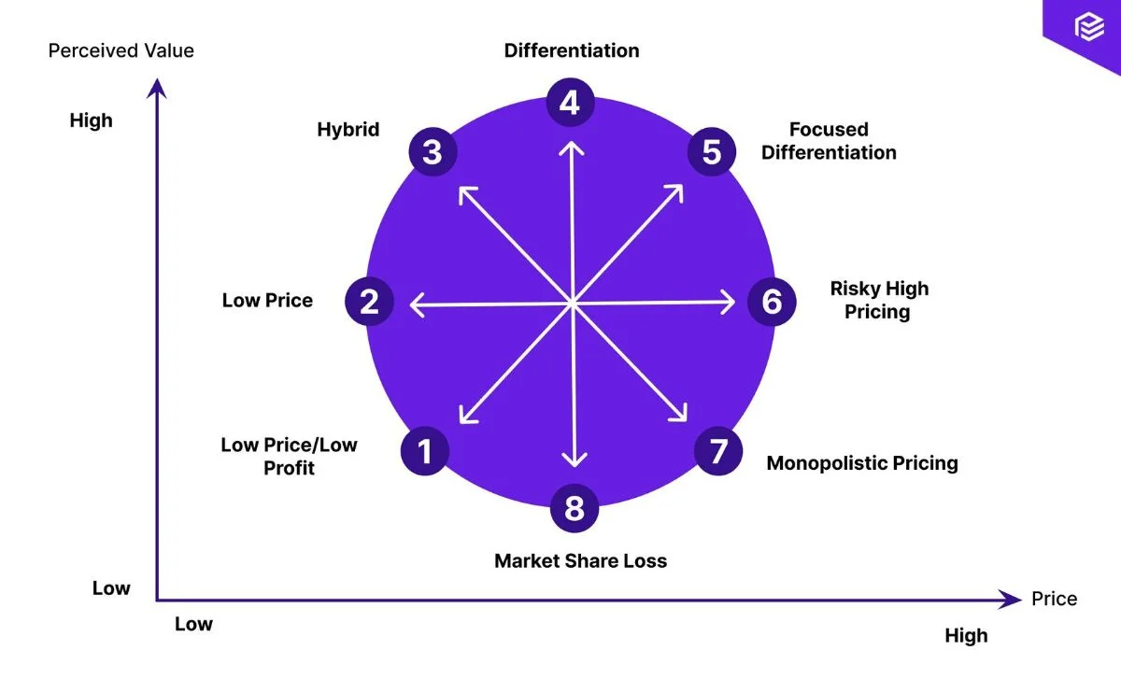
Another essential element of the revenue management plan is dynamic pricing. The hotel may maximise profits by instantly changing room rates in response to demand, especially during busy times of the year. According to studies, when demand is high, dynamic pricing models can maximise occupancy at higher rates, increasing income by up to 10% (Tranter, Stuart-Hill & Parker, 2014). The financial advantages of this strategy could be further illustrated with a line graph showing the anticipated revenue rise from applying dynamic pricing.
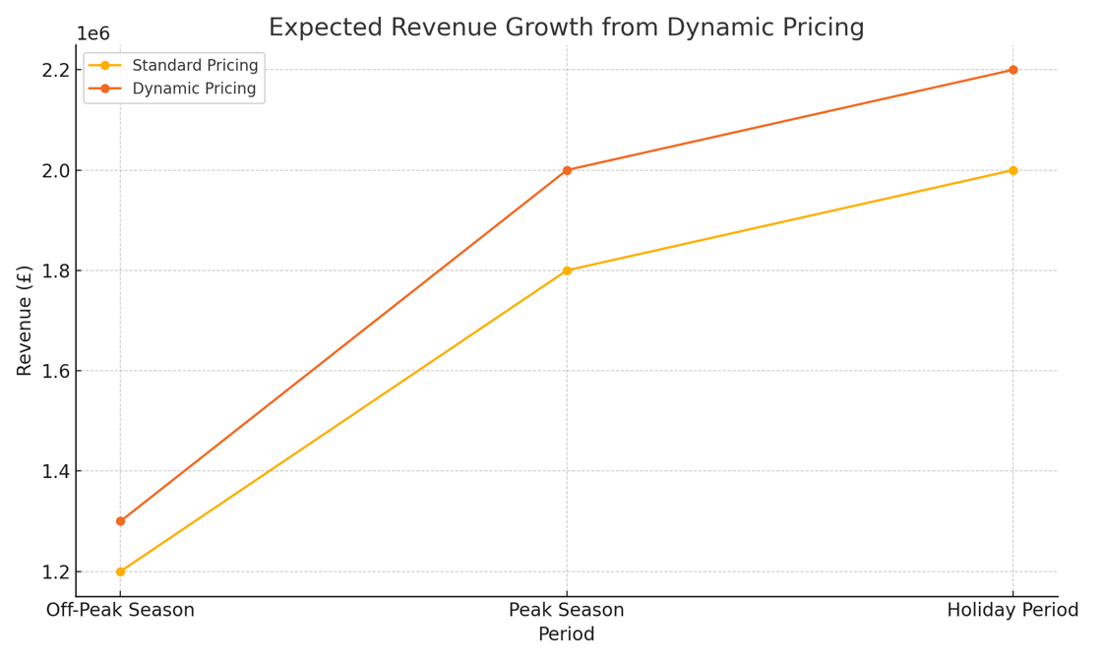
Furthermore, the hotel can increase direct bookings and lessen its dependency on third-party platforms that impose exorbitant commission costs by utilising digital marketing initiatives including search engine optimisation (SEO), social media advertising, and targeted email campaigns (Yu, 1999). Customised promotions based on previous visitor behaviour or preferences can increase interaction and drive clients to the hotel's website, which has low booking costs.
Justification: Through boosting direct reservations, cutting third-party commission expenses, and expanding the audience through value-focused marketing, these revenue management and marketing techniques alleviate budgetary limitations. This improves the hotel's market standing in addition to increasing revenue.

Implementation Plan
A gradual strategy is recommended for the implementation of these strategies. Energy-efficient renovations and other cost-optimisation strategies should be started early because of their comparatively rapid effect on cutting costs. In order to address customer retention, a customer loyalty program and service improvements might be implemented concurrently. Once cost improvements are established, digital marketing strategies and dynamic pricing should be implemented to maximise revenue without overstretching resources. Frequent performance evaluations will guarantee that the tactics are meeting goals and enable any necessary modifications.
Urban Heights can reduce its biggest financial risks and ensure a more resilient future by concentrating on cost control, improving client retention, and repositioning itself in the market. Restoring competitiveness and financial health requires putting these principles into practice, which also offers a strong foundation for long-term sustainability.

Conclusion and Recommendations
The Urban Heights Hotel has had sharp drops in profitability, liquidity, and solvency during the last three years, indicating serious financial issues. The hotel is in an unstable situation as a result of rising operating expenses, falling occupancy rates, and outside economic pressures. To stabilise finances, regain competitiveness, and ensure long-term survival, a thorough turnaround plan is necessary. The hotel's financial situation has been examined in this study, and practical solutions that are suited to Urban Heights' particular requirements and the state of the market have been found.
Key Recommendations
- Cost Reduction: Urban Heights should prioritise installing energy-efficient equipment, including LED lighting and smart thermostats, to reduce utility expenses by an estimated 10–15% yearly, given the significant impact that rising operating costs have on profitability (Kotas, 1999). Renegotiating supplier contracts and taking advantage of bulk purchase agreements are two other ways to save expenses related to high-consumption goods. When combined, these actions will assist increase cash flow, which will enable the hotel to put savings back into crucial departments like marketing and customer service.
- Customer Retention Initiatives: Stabilising revenue requires increasing customer happiness and loyalty. Establishing a loyalty program that offers discounts or special advantages for recurring reservations may boost retention by 20% to 30% (Woods & King, 2010). Improved customer retention will lower the expenses of continuously bringing in new clients, increase the stability of the income base, and lessen the risks associated with varying occupancy rates.
- Revenue management and market repositioning: Urban Heights could implement a hybrid price plan that targets budget-conscious tourists while upholding quality standards in order to draw in a wider market segment and maximise income. The hotel can maximise revenue, particularly during peak hours, by using Bowman's Strategy Clock for pricing and putting in place dynamic pricing models that modify room prices based on demand (Slack et al., 2019). In addition to resolving existing occupancy issues, this strategy puts Urban Heights in a better position to compete in a market where consumers are price conscious.

Implementation and Monitoring
To guarantee that these strategies successfully solve Urban Heights' financial difficulties, regular monitoring and assessment are necessary. Setting performance measures for every suggestion is crucial for adjusting tactics as market conditions change. Examples of these metrics include measuring retention rates through loyalty program participation or tracking cost savings from energy-efficient upgrades.
Urban Heights can reduce short-term financial risks, improve its competitiveness, and provide a solid basis for long-term growth in a difficult economic climate by implementing these suggestions (Evans et al., 2003).

References list:
Atrill, P. and McLaney, E. (2021) Management accounting for decision makers. 10th edn. Harlow: Pearson Education.
Drury, C. (2021) Management and cost accounting. 11th edn. Andover: Cengage Learning.
Evans, N., Campbell, D. and Stonehouse, G. (2003) Strategic management for travel and tourism. Oxford: Butterworth-Heinemann.
Guilding, C. (2014) Accounting essentials for hospitality managers. 3rd edn. Abingdon: Routledge.
Jones, P. and Lockwood, A. (2004) The management of hotel operations. London: Thomson Learning.
Kotas, R. (1999) Management accounting for hospitality and tourism. 3rd edn. Andover: Cengage Learning EMEA.
Morrison, A. M. (2018) Marketing and managing tourism destinations. 2nd edn. Abingdon: Routledge.
Pizam, A. (ed.) (2010) International encyclopedia of hospitality management. 2nd edn. Oxford: Butterworth-Heinemann.
Rutherford, D. G. and O'Fallon, M. J. (2011) Hotel management and operations. 5th edn. Hoboken: Wiley.
Schmidgall, R. S. (2016) Hospitality industry managerial accounting. 8th edn. Educational Institute of the American Hotel and Lodging Association.
Seal, W., Garrison, R. H. and Noreen, E. (2008) Management accounting. 3rd edn. Maidenhead: McGraw-Hill Education.
Slack, N., Brandon-Jones, A. and Johnston, R. (2019) Operations management. 9th edn. Harlow: Pearson Education.
Tranter, K. A., Stuart-Hill, T. and Parker, J. (2014) An introduction to revenue management for the hospitality industry: principles and practices for the real world. Harlow: Pearson Education.
Walker, J. R. (2021) Introduction to hospitality. 8th edn. Harlow: Pearson Education.
Wild, J. J., Shaw, K. W. and Chiappetta, B. (2018) Fundamental accounting principles. 24th edn. Maidenhead: McGraw-Hill Education.
Woods, R. H. and King, J. Z. (2010) Leadership and management in the hospitality industry. 3rd edn. Educational Institute of the American Hotel and Lodging Association.
Yu, L. (1999) The international hospitality business: management and operations. Abingdon: Routledge.

