Name: | Derek Carvell
Student Number: | 2012800
Module Title: | Network Operating Systems and Services (ACCA5023)
Assignment Title: | Apply a systematic understanding of network operating system environments to deploy, manage and maintain critical network services and resources.
Lecturer Name: | Dr. N Kaliyamurthy

Part 1 - Practical Work

Setup and Installation of VirtualBox
For the assignment task Type 2 Hypervisor Management Software will be required.
Oracle VirtualBox is a free, popular and capable product with good technical documentation/support available for creating Type 2 Virtual Machines (VMs) on suitably performant computers.
VirtualBox is installed.
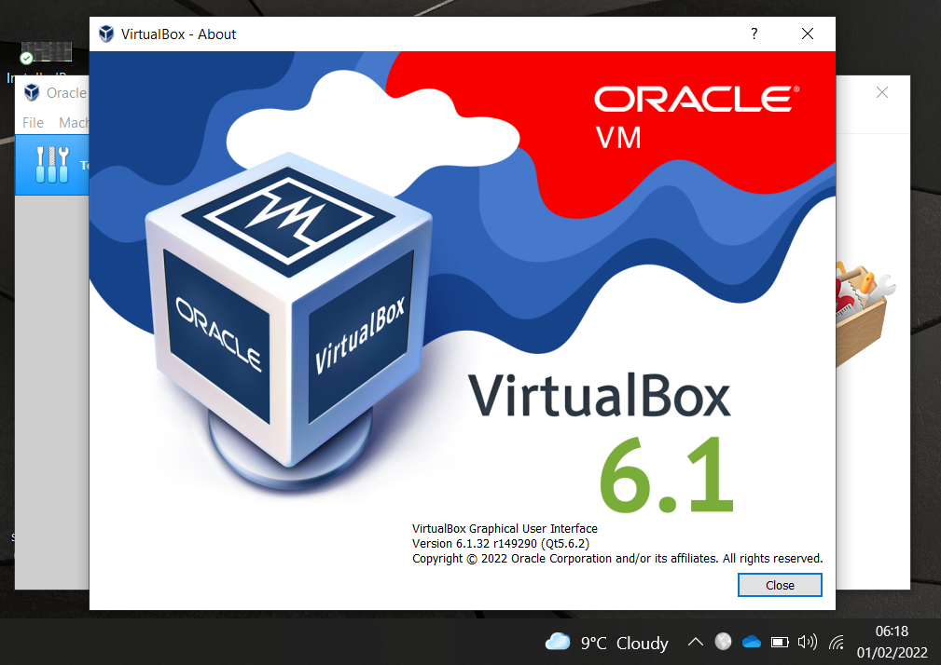
Figure 1: VirtualBox Splash Screen

Server and Client VMs need to be created. ISO images for Windows 10 and Server 2019 are obtained from University Azure Portal subscription.
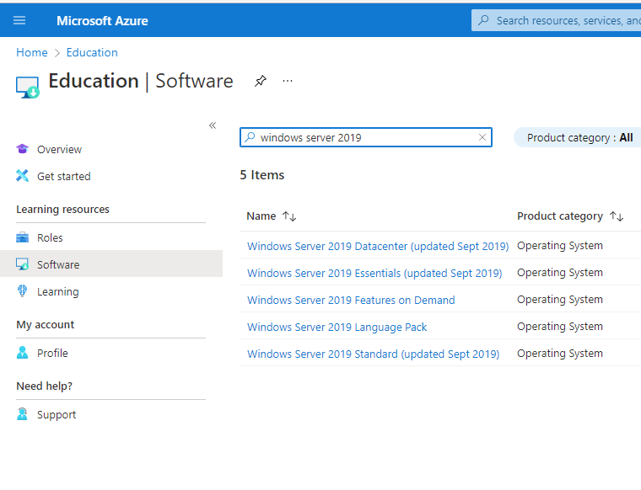
Figure 2: Obtaining Operating Systems

Virtual Server Creations
Creation of virtual servers inside VirtualBox is required. To ensure the VM will perform adequately, within the virtual environment, minimum hardware specification is obtained informing VM configuration.
Windows Server 2019 minimum specification [1]:
- Processor - 1.4GHz 64-bit processor.
- RAM - 512MB.
- Disk Space - 32GB.
- Network - Gigabit (10/100/1000baseT) Ethernet adapter.
- Video - SuperVGA (1024x768).
Server1 VM is created.
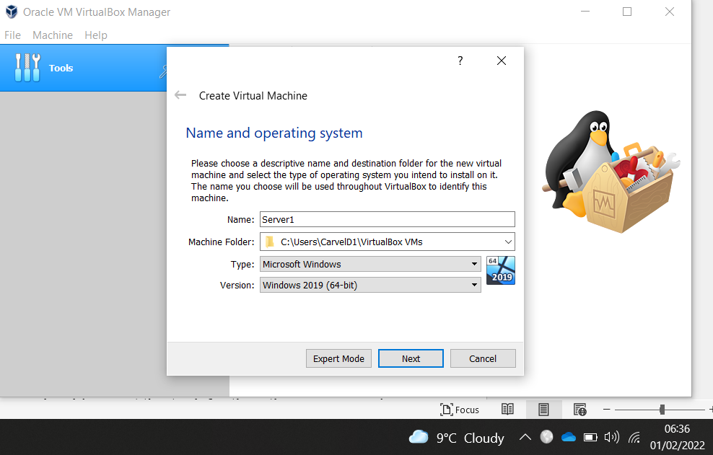
Figure 3: Server1 VM set up.
Virtual hard disk created; default storage allocation reduced to 25 GB to save space.
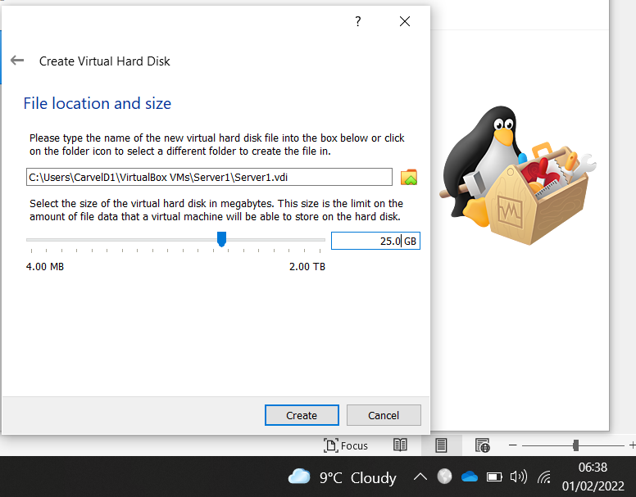
Figure 4: Virtual Hard Disk creation
The same settings are applied for Server2 VM.

Virtual Client Creations
As above, minimum specification is obtained from official documentation.
Windows 10 Professional [2]:
- Processor - 1GHz or faster.
- RAM - 2GB for 64-bit.
- Disk Space - 20GB for 64-bit OS.
- Network - Gigabit (10/100/1000baseT) Ethernet adapter.
- Video - VGA (800x600).
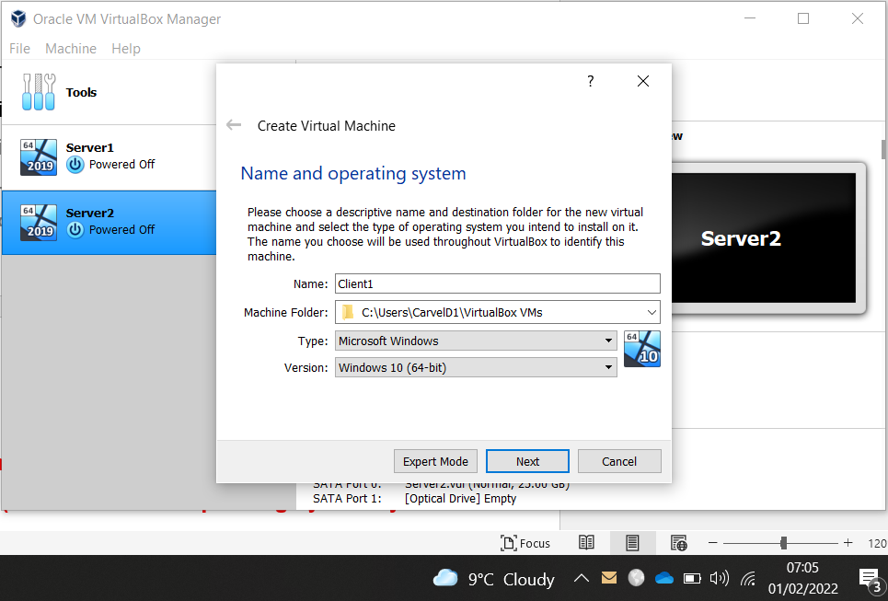
Figure 5: Client1 VM setup
The same settings are applied for Client2 VM.

Initial configuration for the 4 VMs is completed and ready for OS installations.
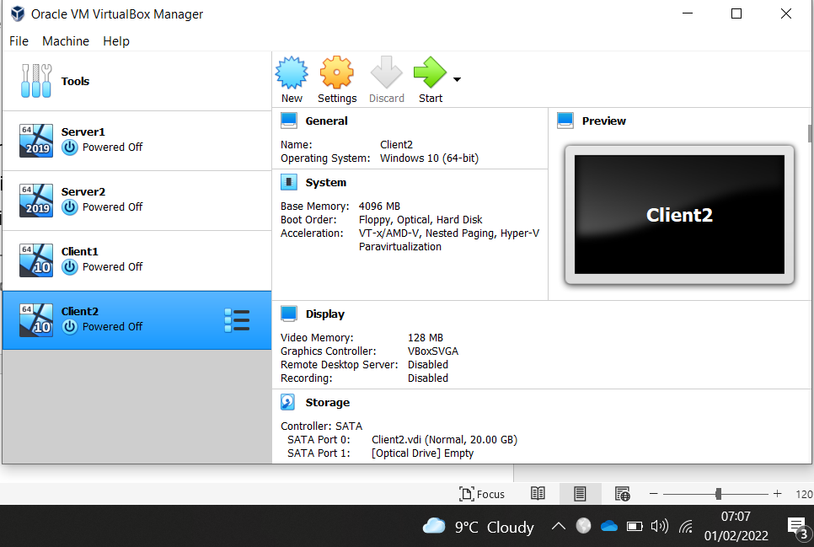
Figure 6: Base VMs configured
ISO images are selected for installation.
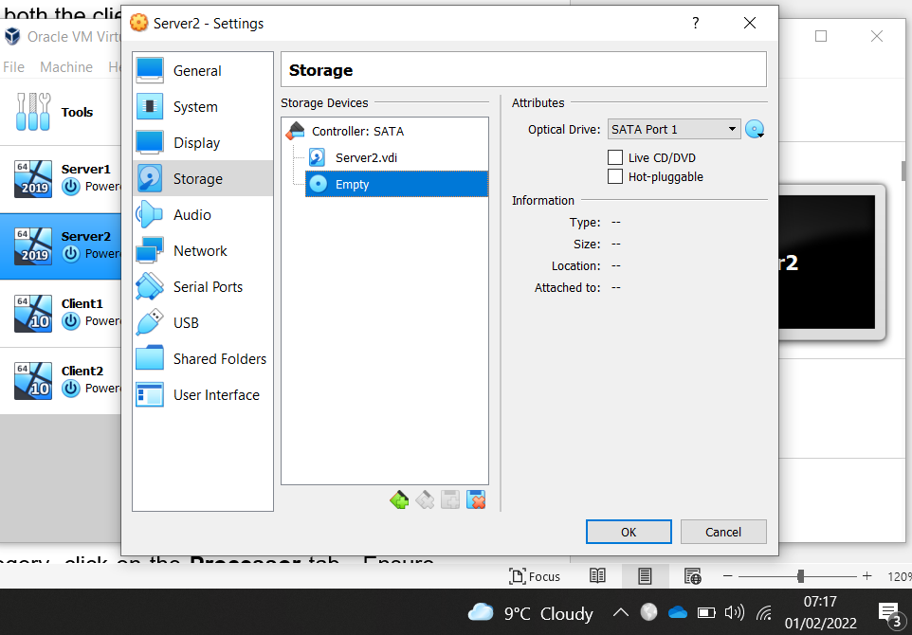
Figure 7: Selecting the ISO for install

The number of processors to be used is set to 1.
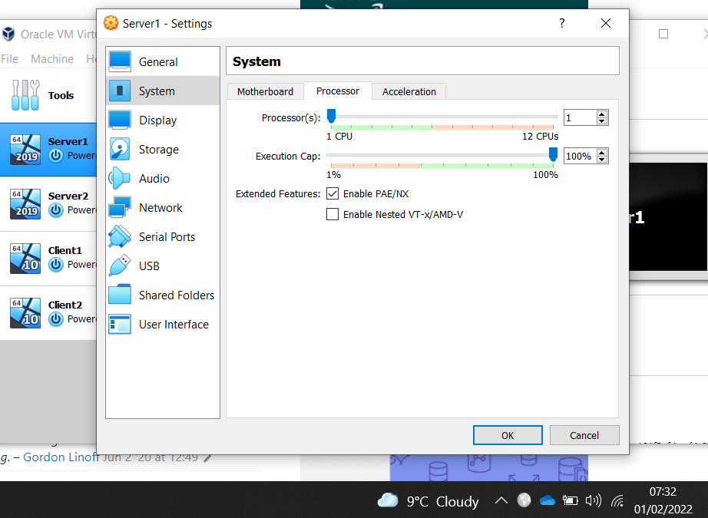
Figure 8: Setting CPU and PAE/NX enabling physical address register of host system CPU to be more accessible to each VM.
The University worksheet refers to tips for improving performance of the VMs [3]. Many suggestions had already been actioned, use SSD, increase VM memory, etc. however, performance issues were being experienced. For example, slow machine start-up/shutdown and instability of VMs. Research indicated that installation of Guest Additions software would assist, “VirtualBox Guest Additions consist of device drivers and system applications that optimize the operating system for better performance and usability.” [4].
Installation of this Guest Additions software, to each VM, improved start-up/shutdown and stability.
Poor performance was also evident during VM operation. To alleviate this the CPU setting was increased to 2, resolving the issue. That increase was applied to all VMs.

Windows 2019 Server OS Install
VirtualBox VM started, launches the OS installation programme as if it were running on a physical device.
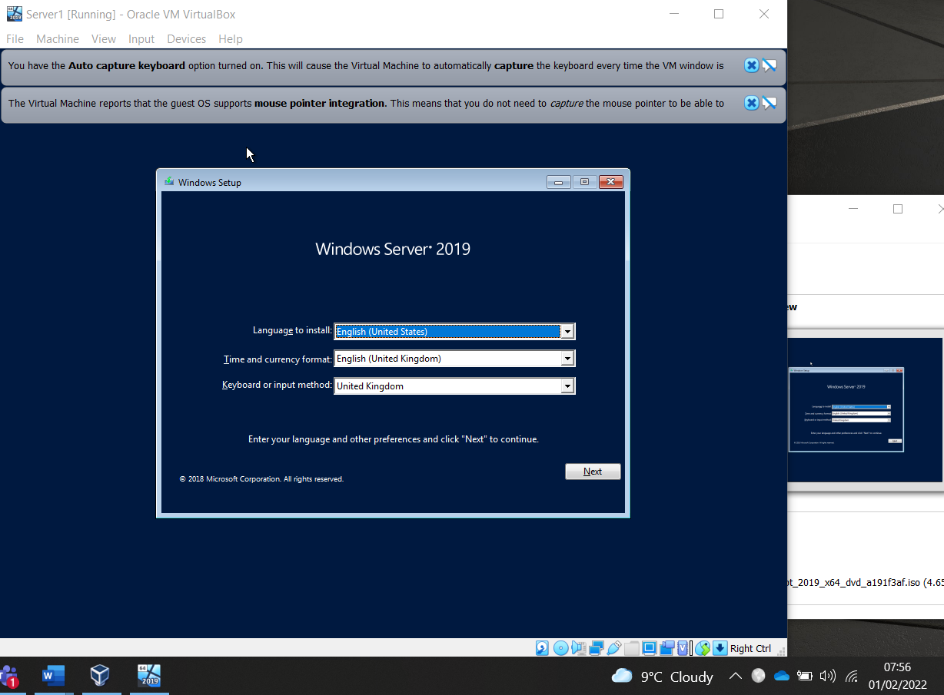
Figure 9: Installation commences

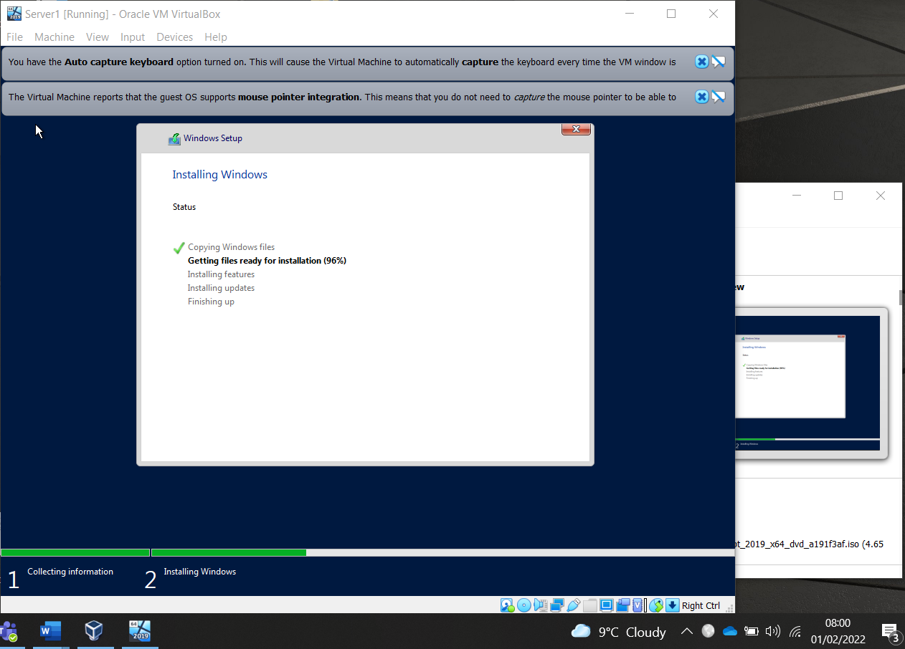
Figure 10: Installation progresses
Monitoring of the physical host machine’s resources was undertaken throughout installation and operation of VMs, to analyse impacts on host device. If this had proved problematic, the use of University VMs would need to be considered.
Monitoring results provided assurance that host was of sufficient specification to handle VMs, and its own, workloads.
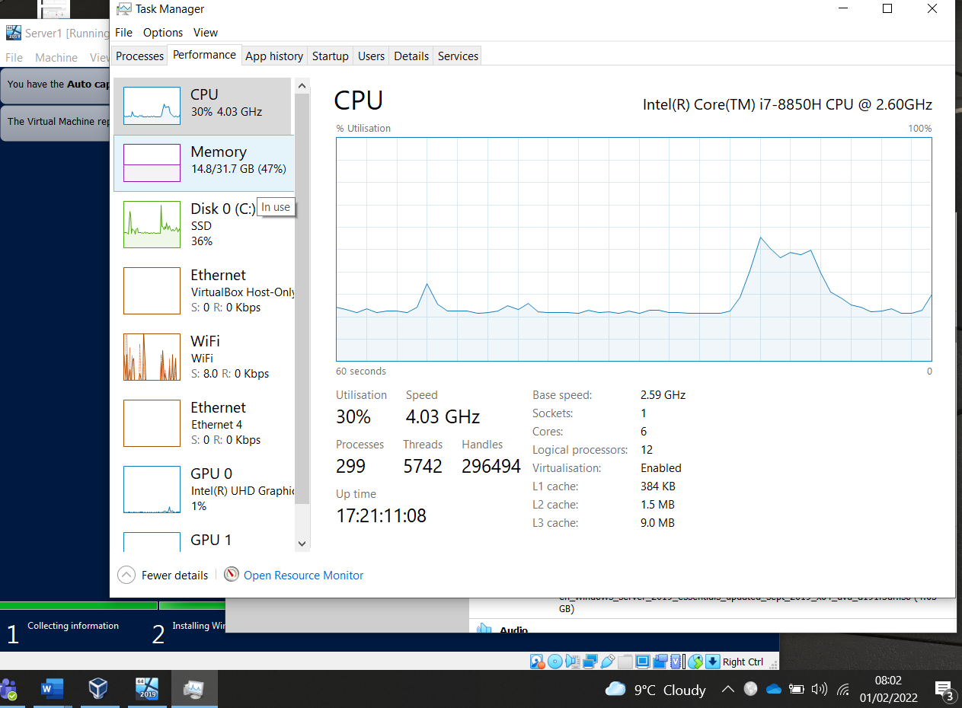
Figure 11: Monitoring/analysing host resources

The task requires client attachment to a domain, an OS to facilitate that is chosen. Windows 10 Home cannot be used, as it doesn’t have the option for domain joining.
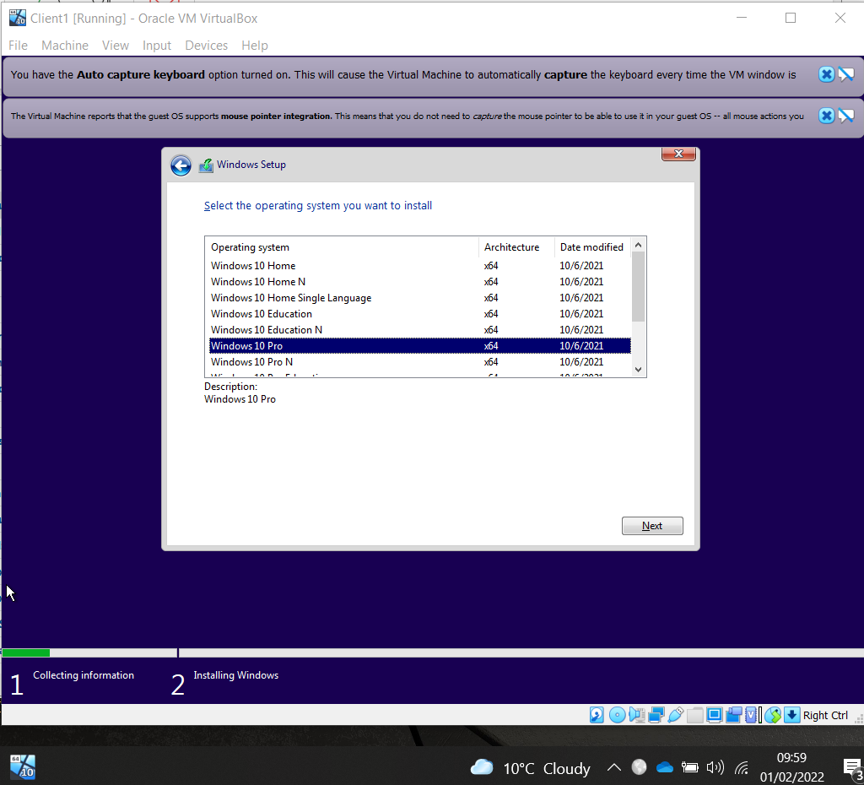
Figure 12: Windows 10 Pro chosen

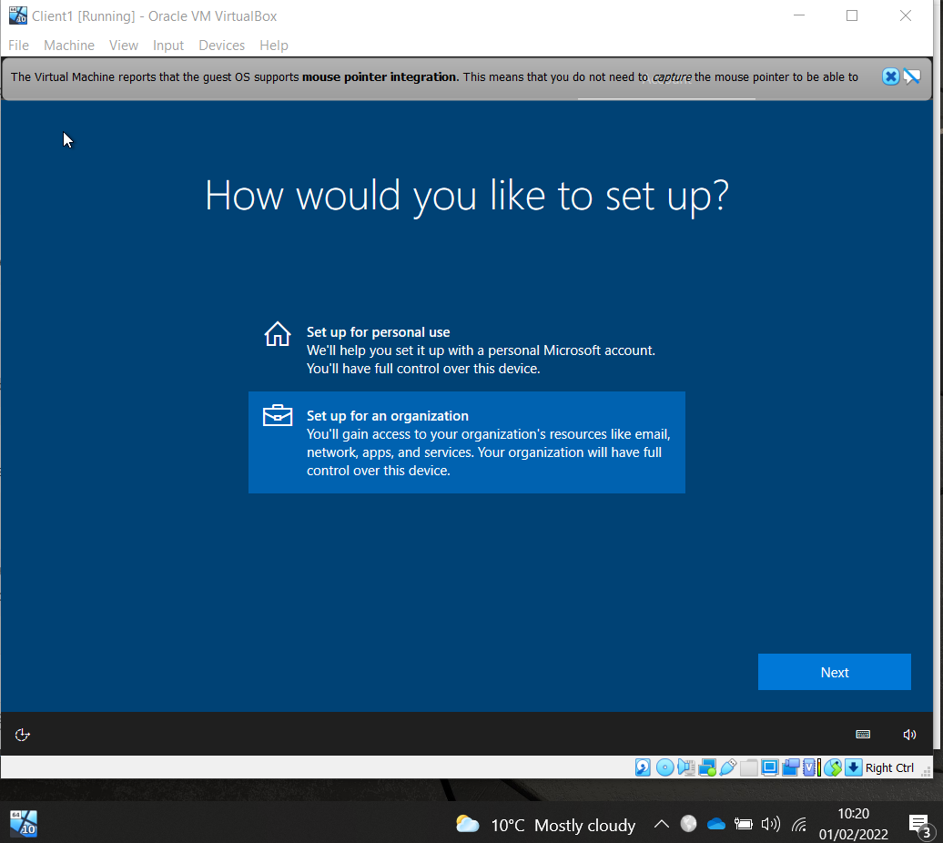
Figure 13: Organisation selected

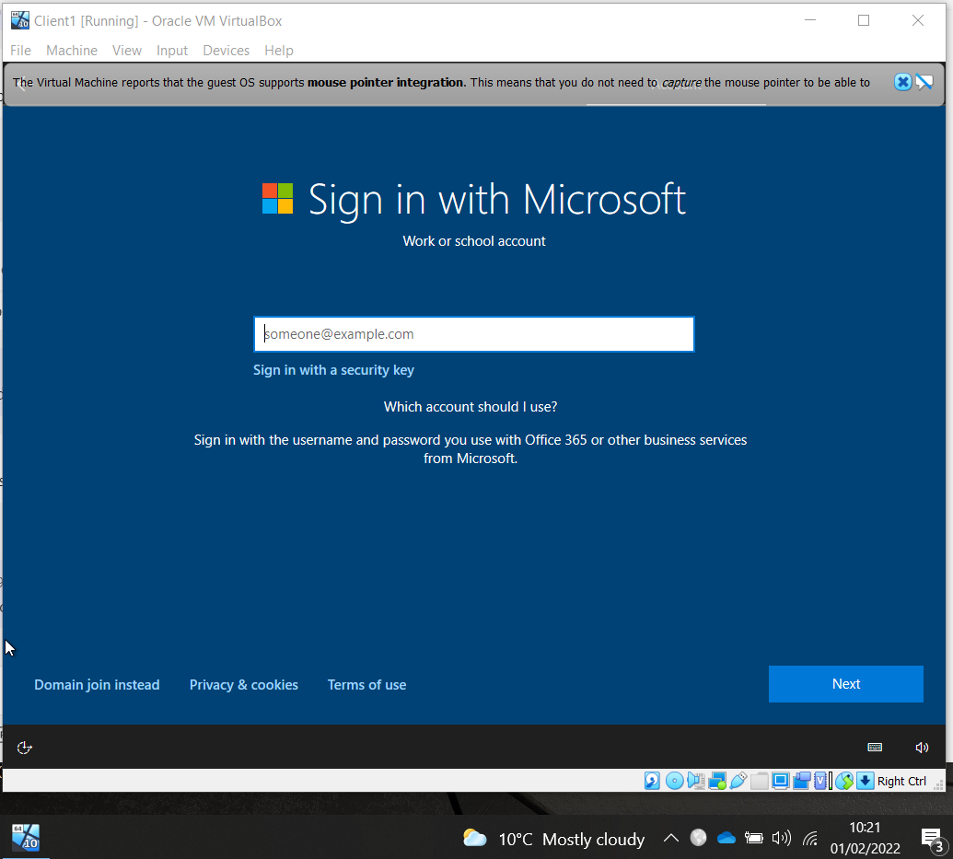
Figure 14: Domain join selected.

Server OS installation is completed on all VMs.
NOTE: at this point the VM could have been cloned, see “Additional Information” below.

Virtual Network Configurations
The task requires network configuration to be completed, Figure 15.
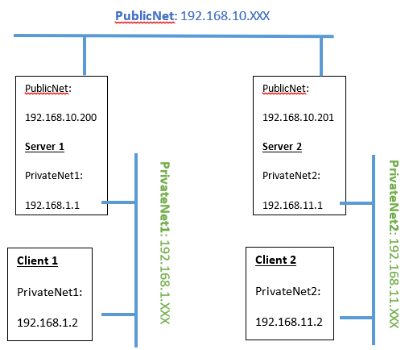
Figure 15: Network configuration (Source [5])

For the task, settings for Adaptor 1 (Internal Network) for Server1 on PublicNet are completed in VirtualBox, creating a virtual switch. Similar setting for Adaptor 2, shown blow.
The server is configured for attachment to the network.
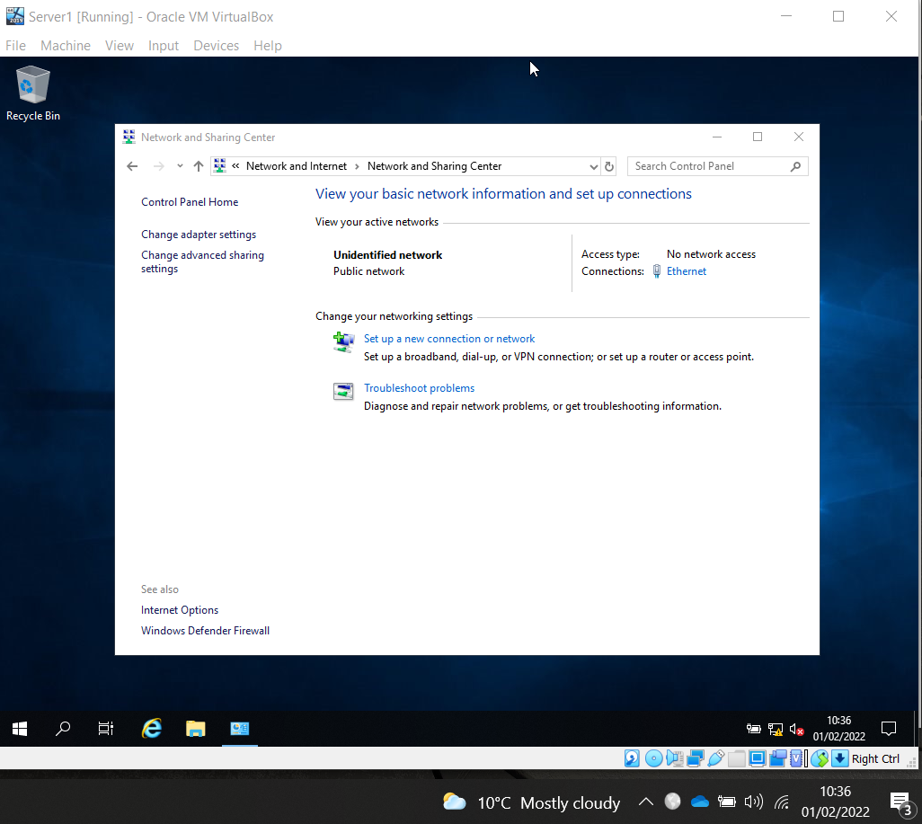
Figure 16: Public Network attachment created.

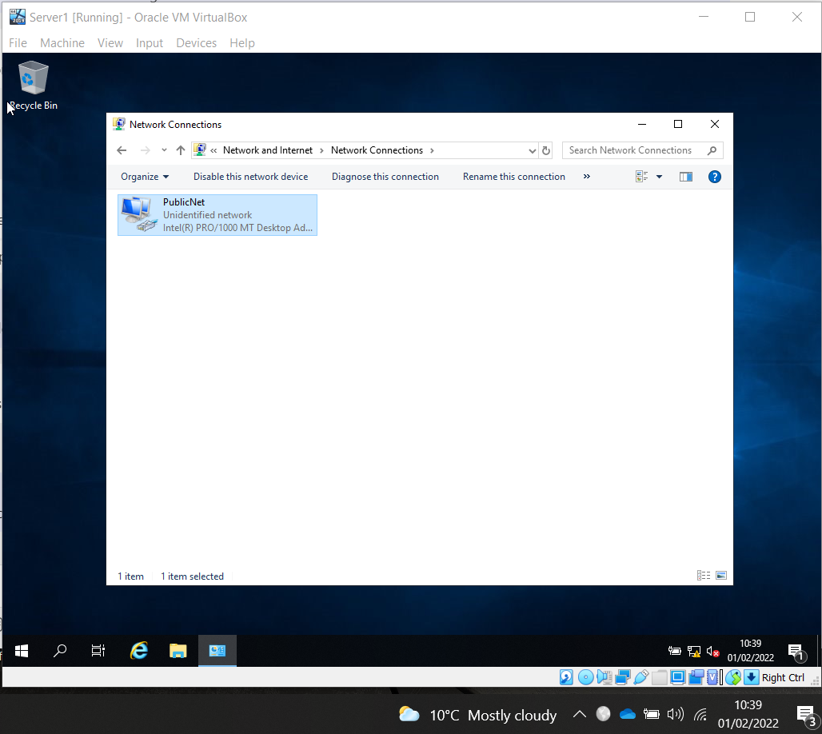
Figure 17: Adaptor renamed PublicNet.

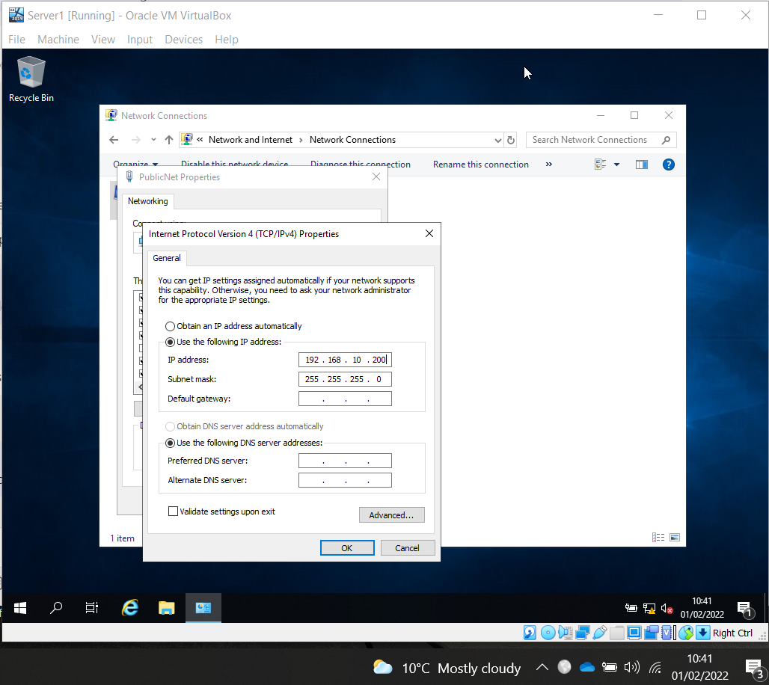
Figure 18: Static IP address is configured.

Adaptor 2 for Internal Network PrivateNet1 is created in VirtualBox.
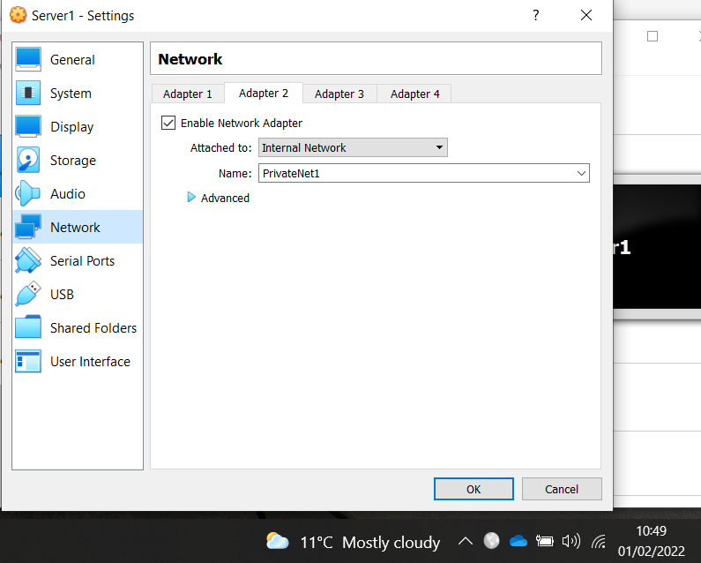
Figure 19: PrivateNet1 network.

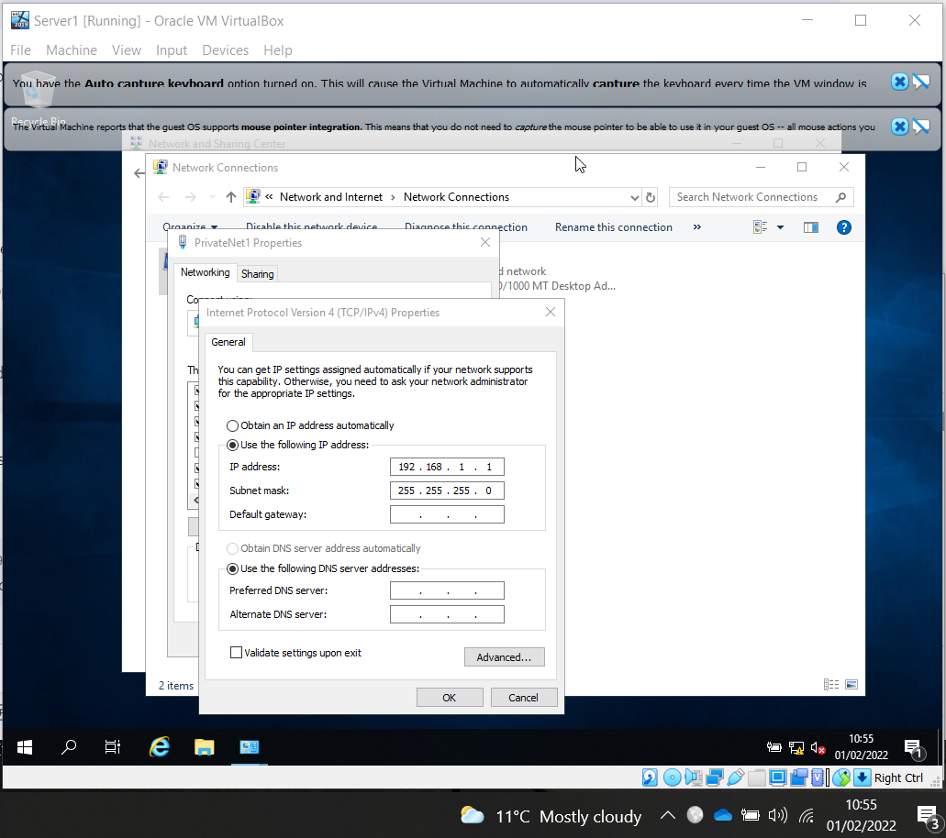
Figure 20: Configuring static IP address Server1 on PrivateNet1

Windows 10 Client OS Install
Adaptor 1, Client1 PrivateNet1 settings completed.
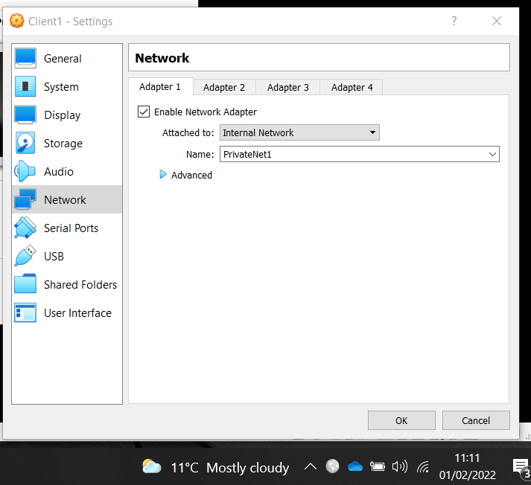
Figure 21: Setting up network enabling Server1 and Client1 to communicate via PrivateNet1.

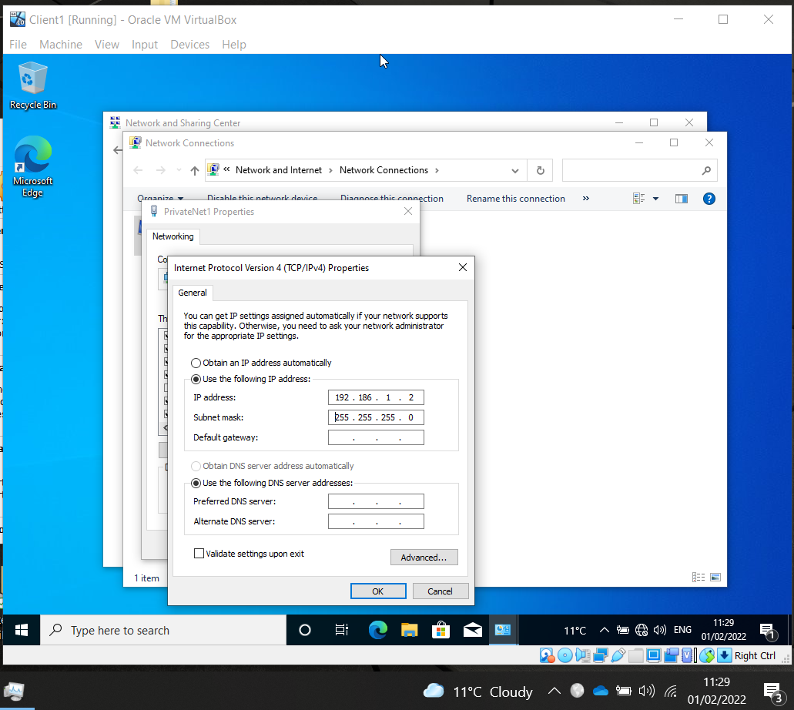
Figure 22: Setting static IP address on Client1.
Server2 and Client2 are also setup as above, using IP addresses provided in network diagram (Figure 15).
Firewalls on all Servers and Clients are disabled. Connectivity is confirmed on all devices, using ICMP (Ping).
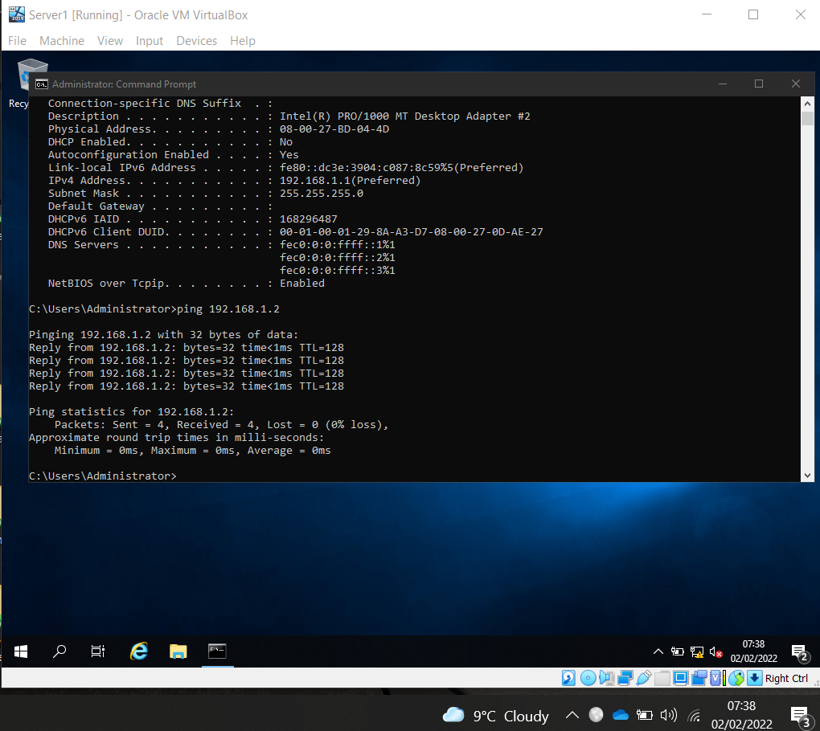
Figure 23: Successful Ping from Server1 to Client1

Task 2 - Deploying a Network Directory Service, Creating and Understanding Active Directory Network Objects
Evidence static IP assigned, and no DNS set for Server1, PrivateNet1.
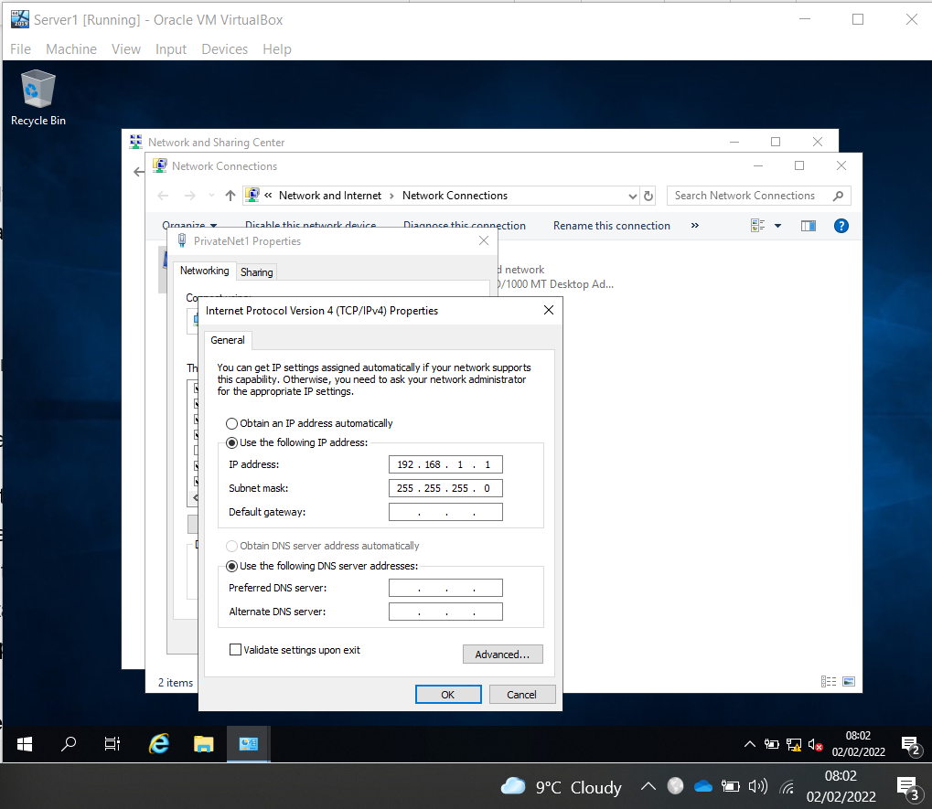
Figure 24: Worksheet evidence

Evidence static IP assigned, and no DNS set for Server1 on PublicNet.
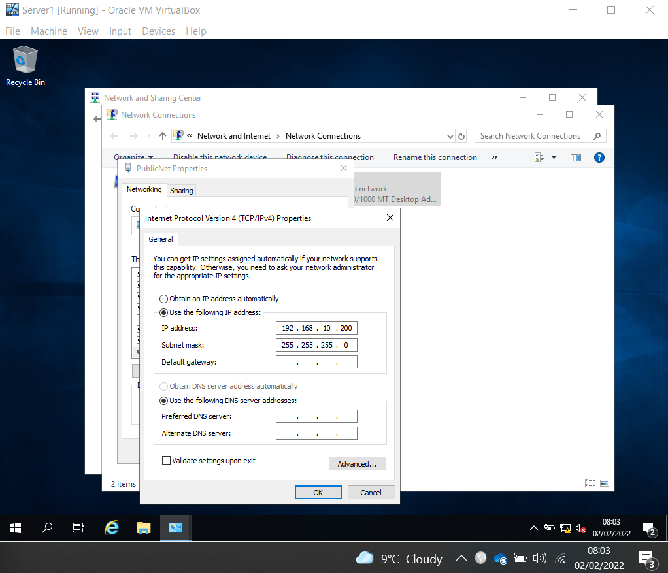
Figure 25: Worksheet evidence
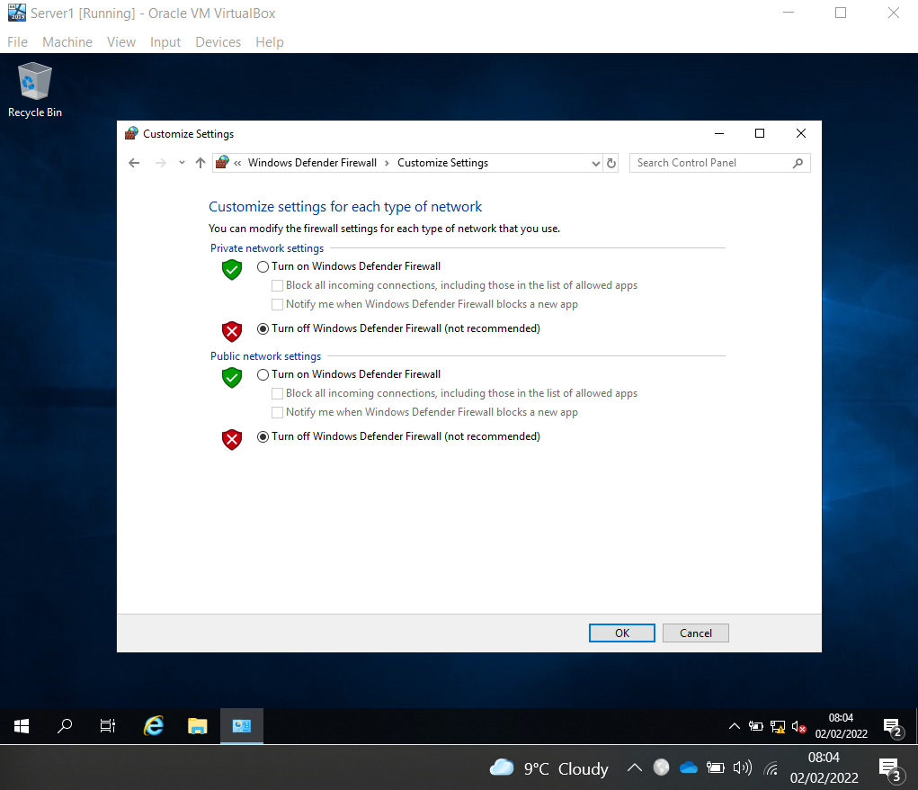
Figure 26: Evidence firewall off on Server1

Renaming the server as Domain Controller.
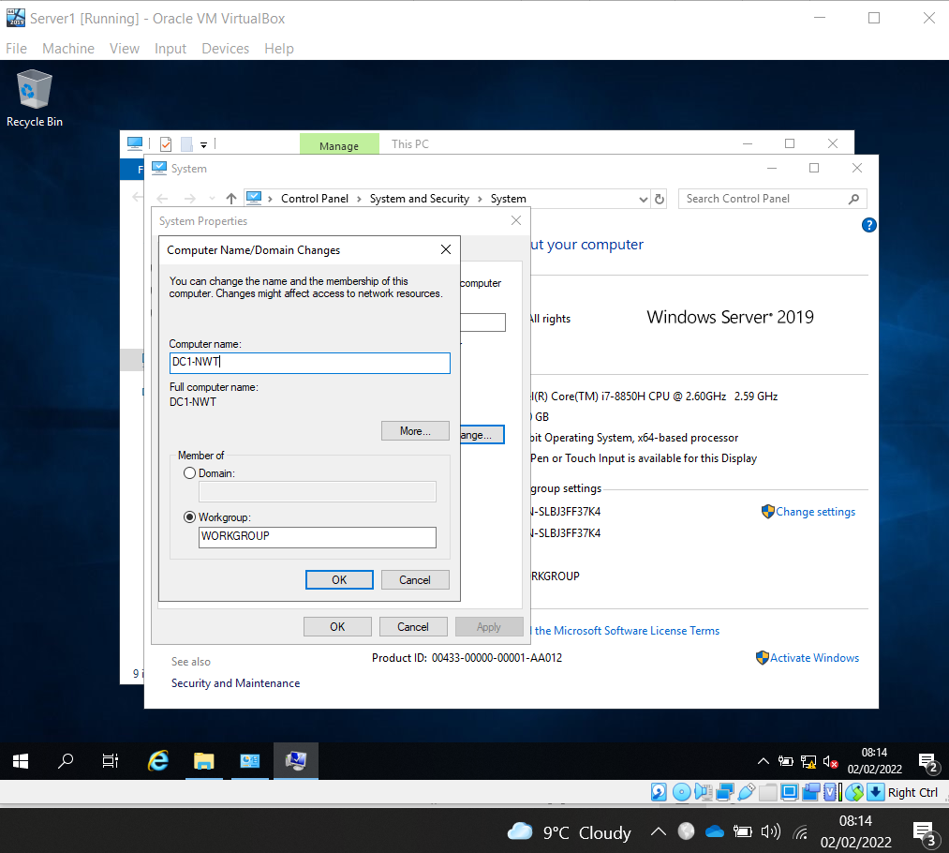
Figure 27: Server renamed
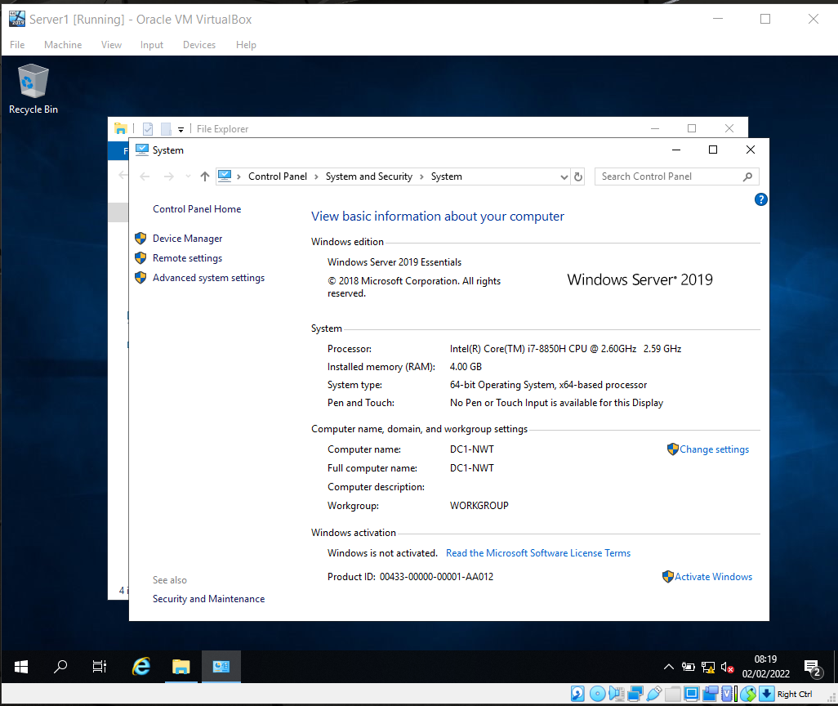
Figure 28: Evidence of server name change

Installing Active Directory Domain Services
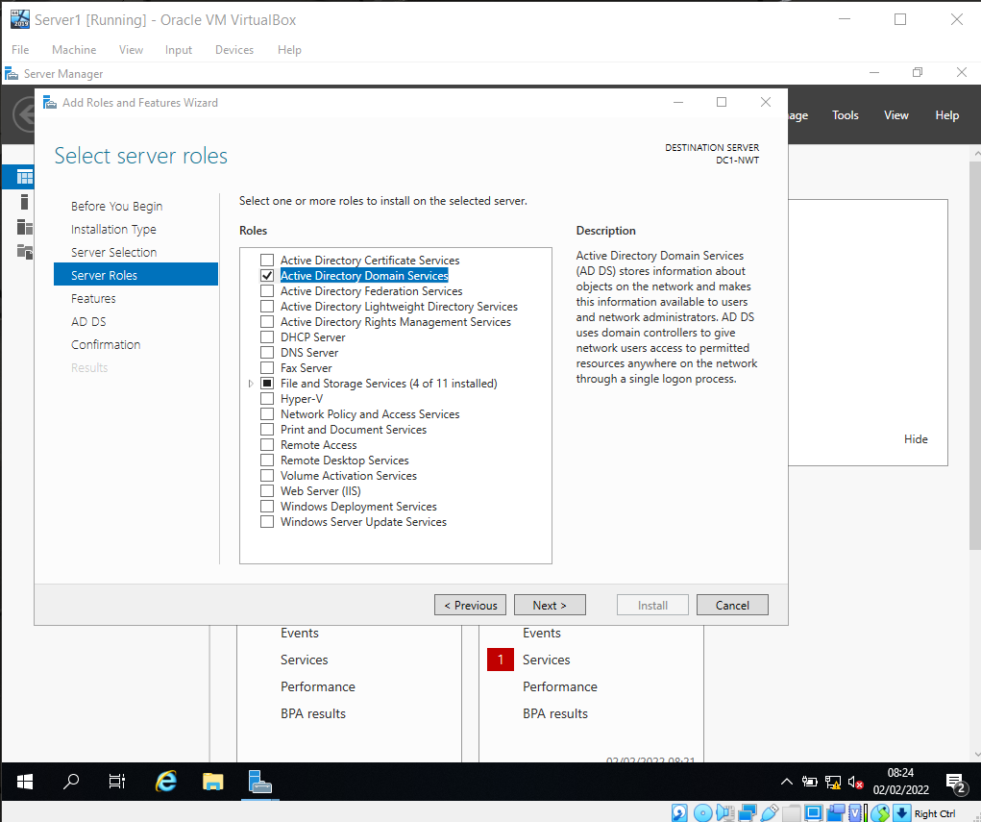
Figure 29: Selecting ADDS Server Role

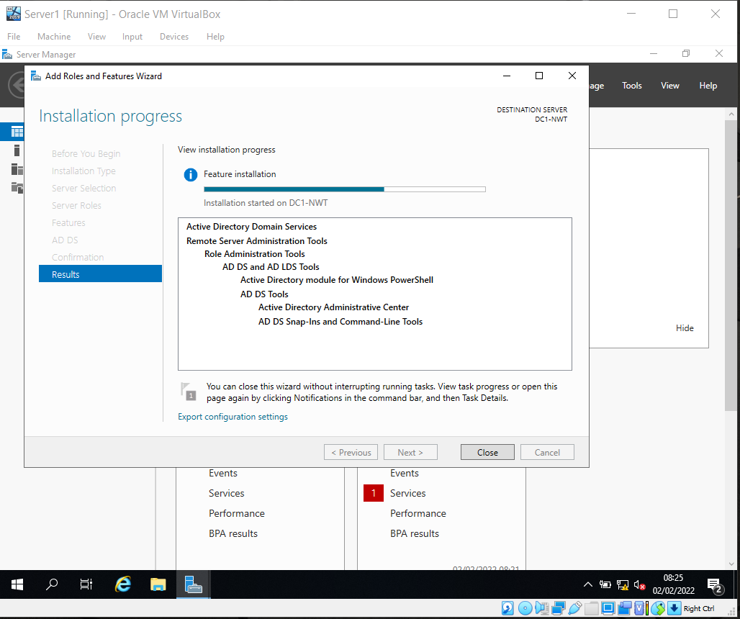
Figure 30: ADDS installation progress

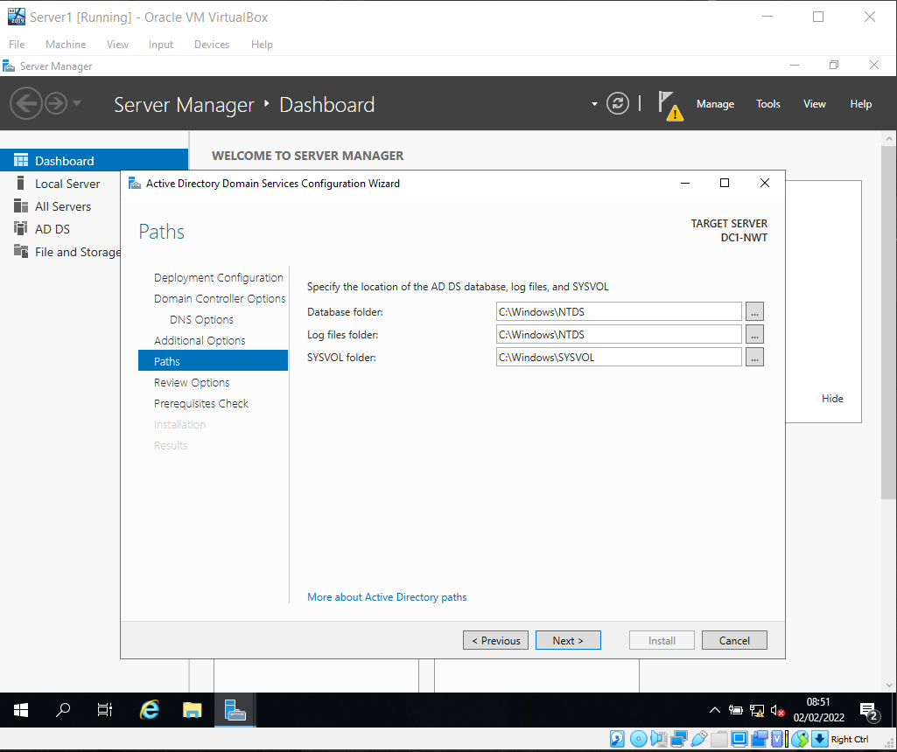
Figure 31: Noting ADDS paths

Screenshot of Active Directory Users and Computers confirms server DC1-NWT as nosstask.msft domain controller
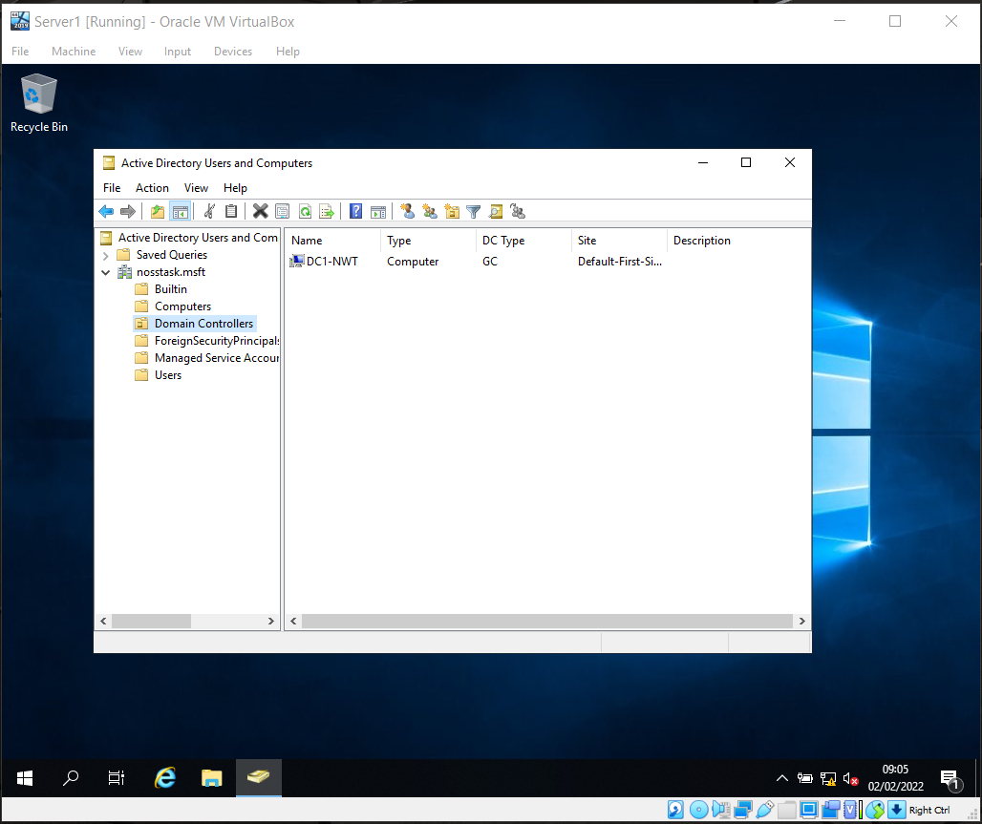
Figure 32: Domain controller snapshot

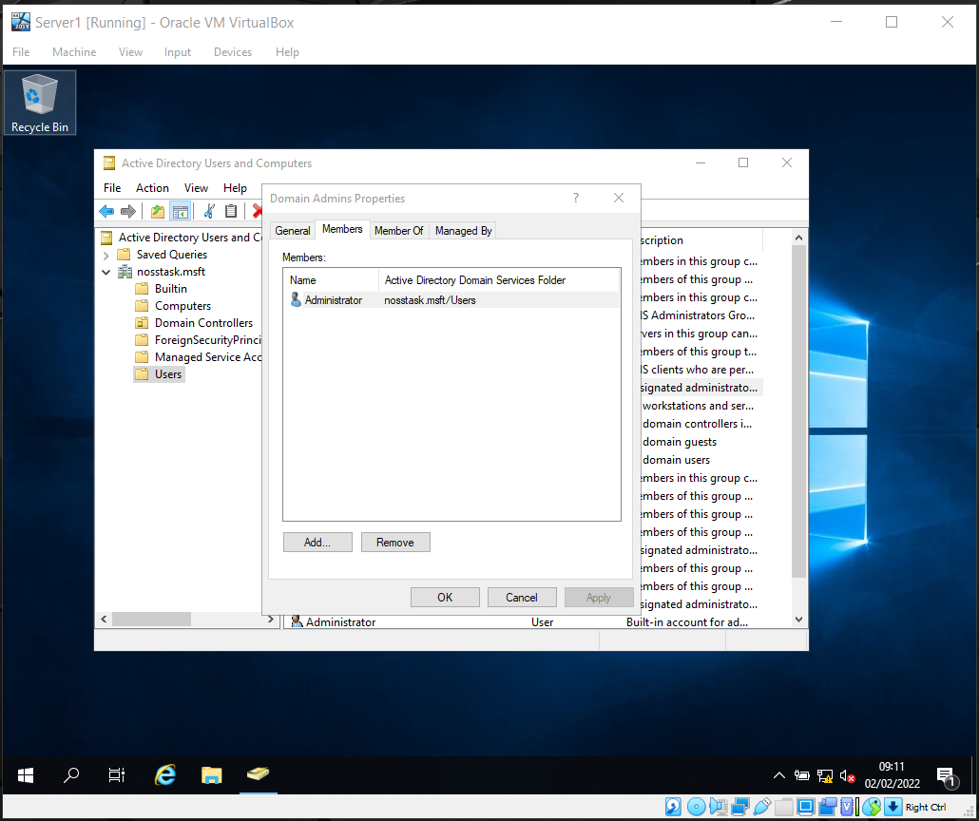
Figure 33: Domain Admin properties screenshot

Creating Domain Admins User
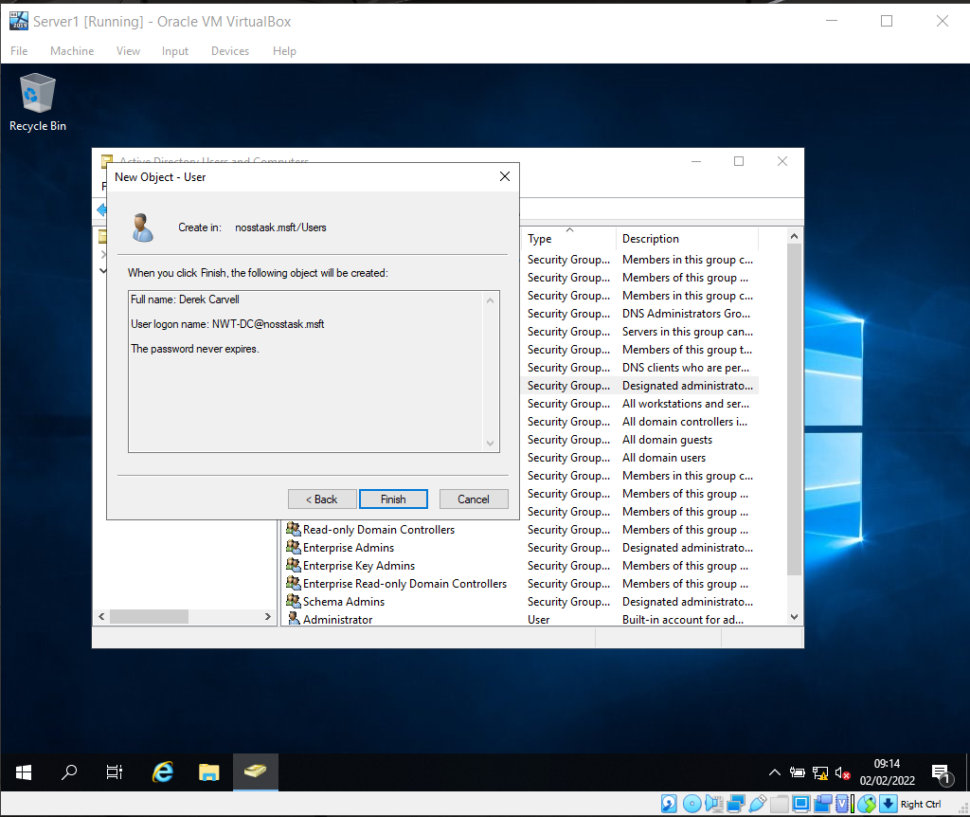
Figure 34: User created

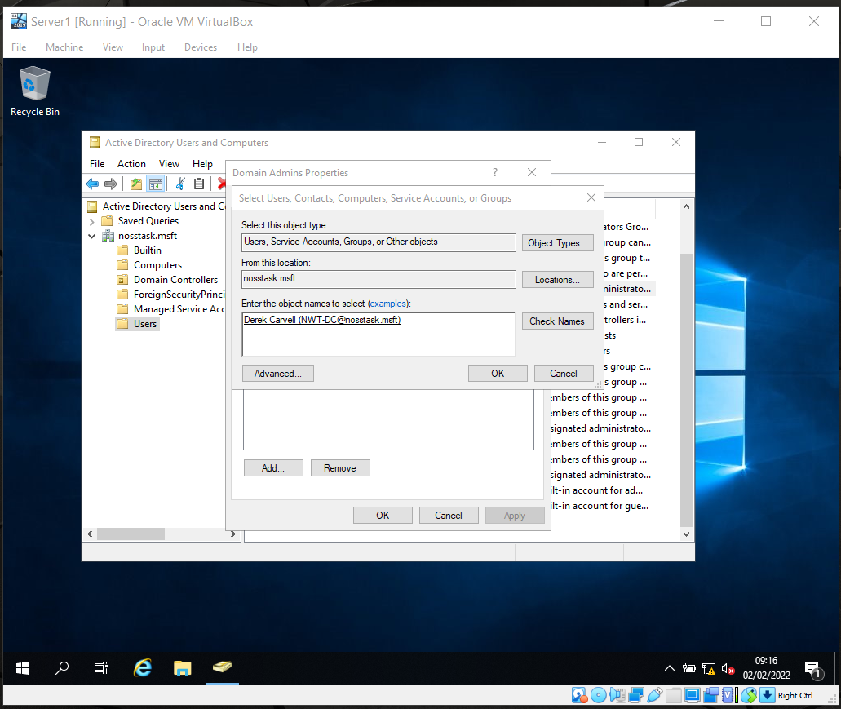
Figure 35: Adding user to Domain Admins

Creating non-admin user
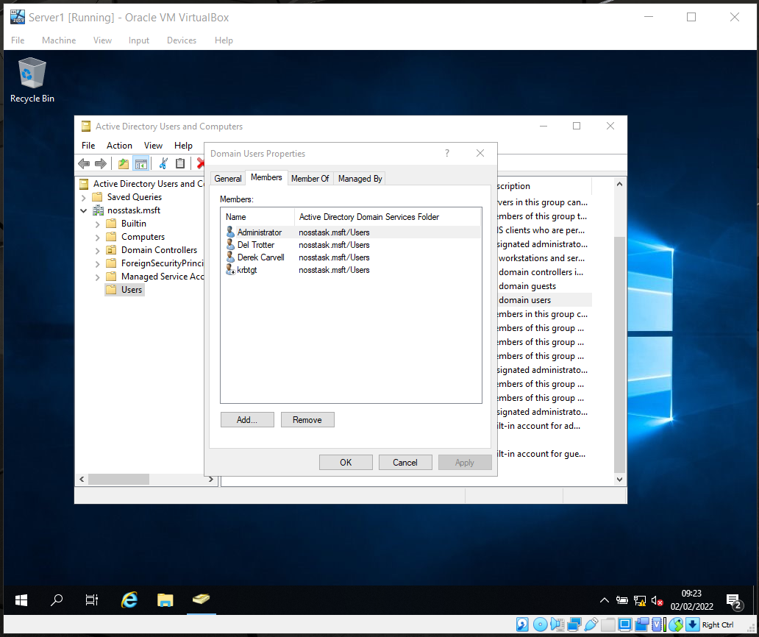
Figure 36: Non-admin user Del Trotter created as member of Users group

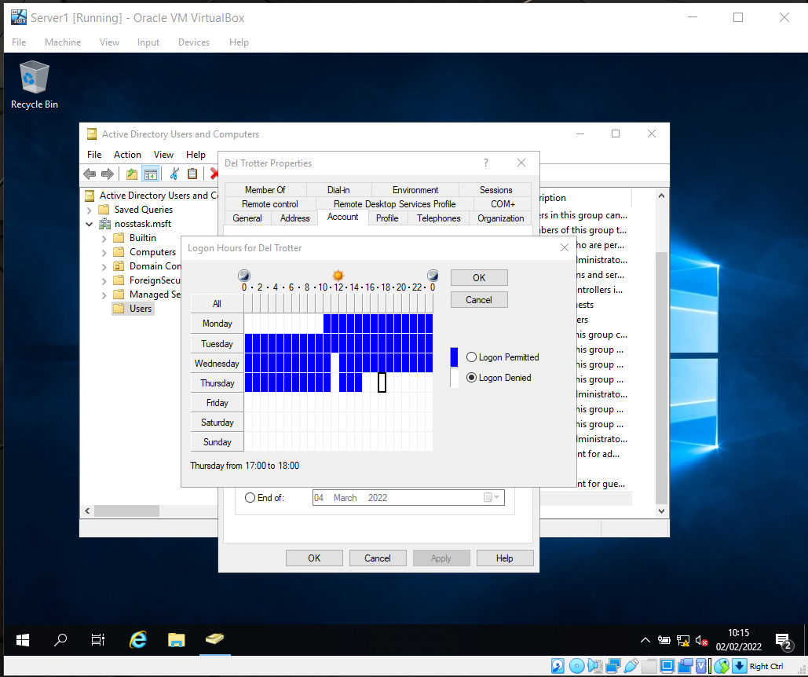
Figure 37: Permitted logon hours (Monday 10am - Thursday 3pm and 11-12 Wednesday - Friday) set for Del

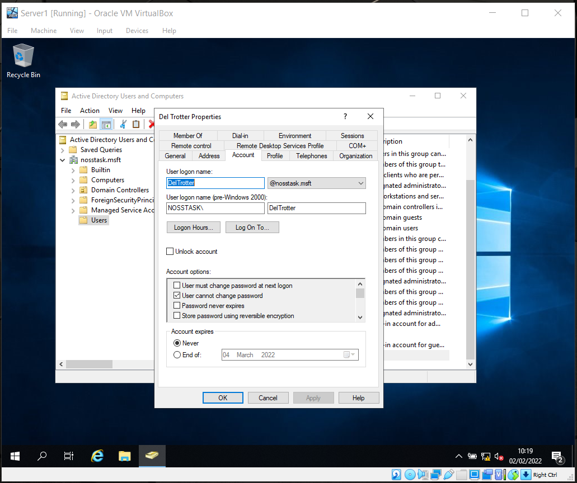
Figure 38: New added user account screenshot

Join Domain and Test
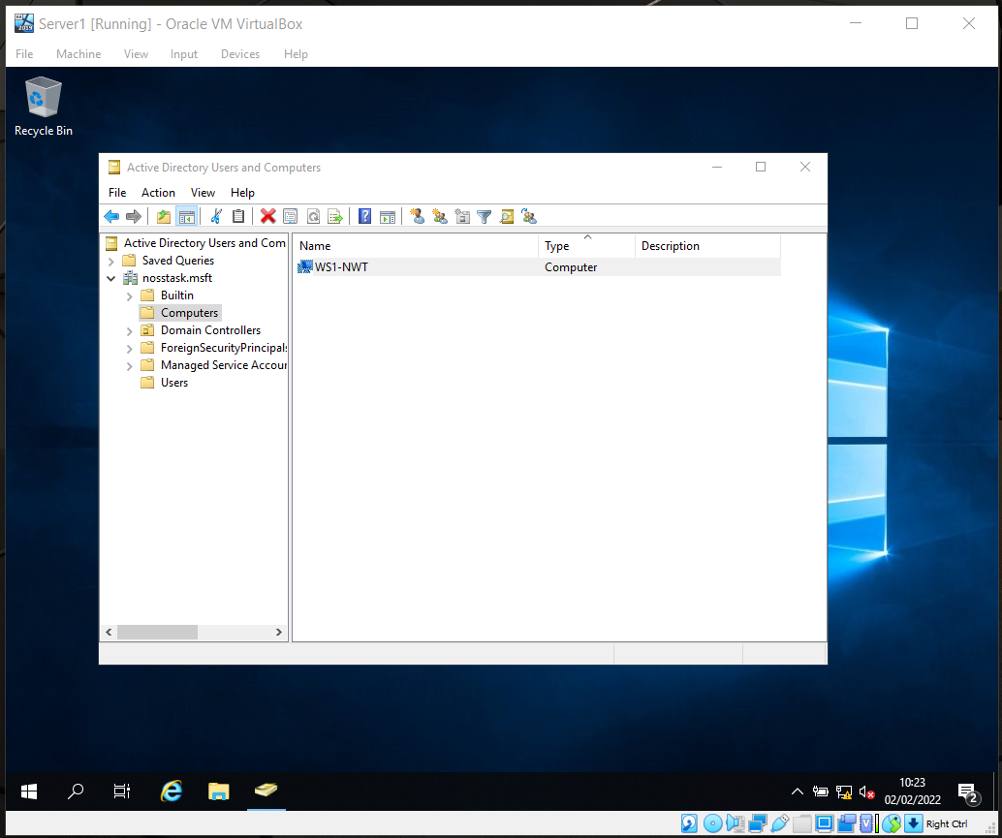
Figure 39: Screenshot Active Directory prepared to have new computer join the domain

Client Domain Joining
DNS Server address assigned.
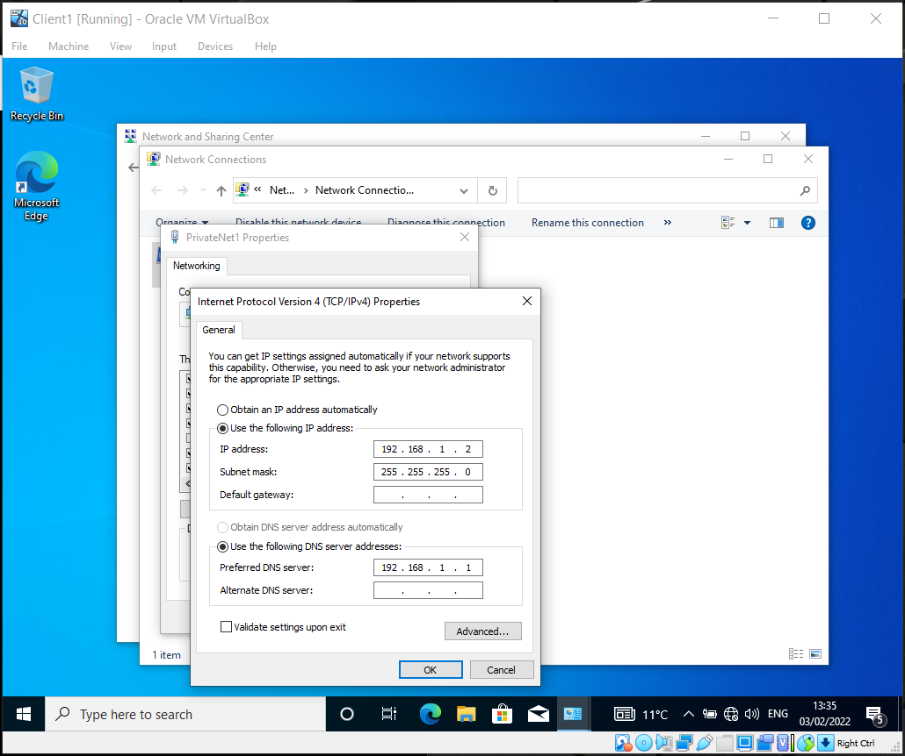
Figure 40: Corrected IP address assigned
Domain credentials provided to join domain.
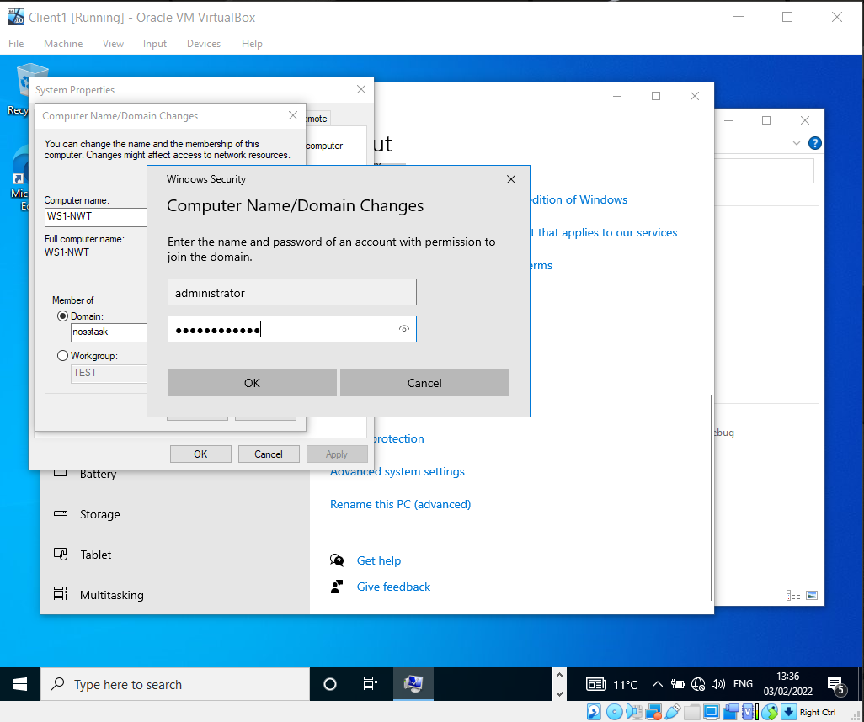
Figure 41: Joining domain successfully
A Welcome to the nosstask domain message is displayed, and the VM restarted.
Del Trotter logs in to Client1
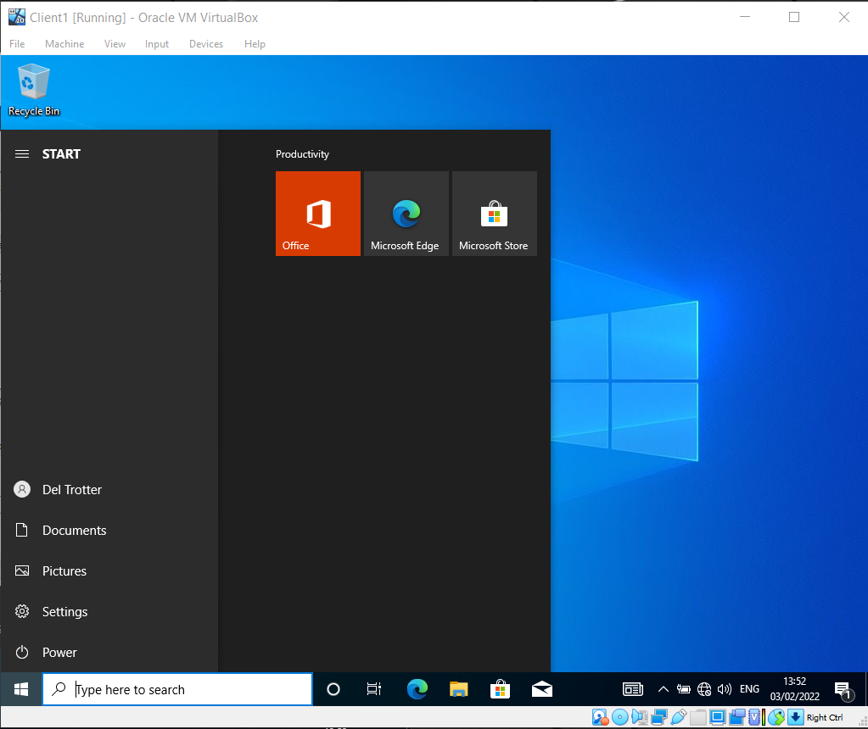
Figure 42: Del Trotter successfully logged into domain

Additional Information
Later information received (from Lee Cobley) indicated that a VM cloning feature is available in VirtualBox. If cloning is undertaken the option to “generate new MAC addresses for all network adaptors” MUST be chosen, see Figure 43. Failure to do this will cause conflict issues when trying to use a cloned VM on the same network as the source VM device.
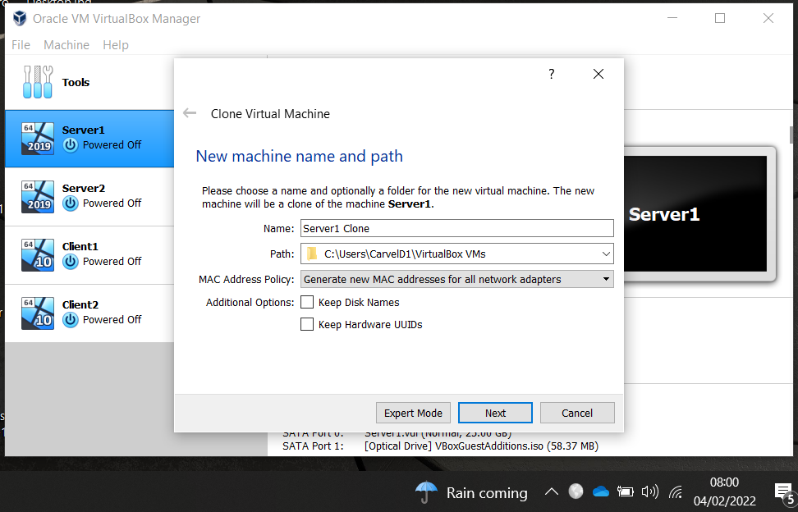
Figure 43: Generate new MAC address option.
(1040 words)

Task 3 - Observational Tasks

Type 1 and Type 2 Hypervisor Differences
The diagram below shows Type 1 and Type 2 Hypervisors.
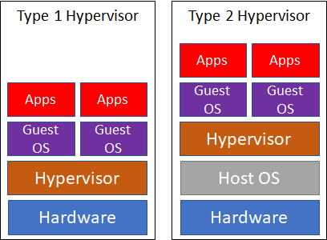
Figure 44: Diagram of Hypervisors
The key differences are:
- Specialist hardware and know-how may be required to operate Type 1, whereas Type 2 may be operated by any user with a suitably performant standard computer
- Type 1 is installed directly on the hardware, whereas Type 2 is an application on the host OS
- Type 1 are more likely to be used on an enterprise architecture, Type 2 more suitable for smaller scale projects or proofs of concept.
Benefits – Both hypervisor types facilitate virtualised computing, enabling multiple device OSs to run on a single piece of hardware. Type 2 hypervisors require less cost, VM specific knowledge, and computing resources to operate. Type 2 will be easier and quicker to implement, not requiring much more than a performant computer.
Drawbacks – Type 1 may be more expensive to implement and operate. Type 1 may require specialist resources to set-up and support.
Vendors:
- Type 1: VMWare, Microsoft Hyper-V, Citrix and Red Hat Enterprise Virtualisation (RHEV)
- Type 2: Oracle VirtualBox, Parallels Desktop, VMWare Workstation or, for Mac, Fusion

Cloud Computing
Cloud computing is the provision of computing services – storage, servers, databases, networks, software, security, etc. over the internet. Providing resource flexibility, with quicker innovation, whilst lowering running costs.
Cloud computing removes the need to set-up and operate an on-premises datacentre. That lies with the cloud provider.
There are several types of cloud model available.
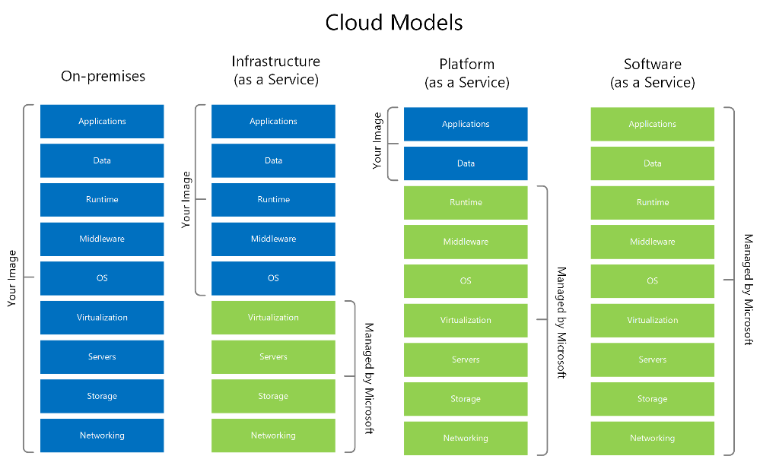
Figure 45: Cloud Models. Source [6]
Models described:
- On Premises – Solely managed by the user
- Infrastructure as a Service (IaaS)– user installs and manages OS, applications, and data. Hardware managed by cloud provider
- Platform as a Service (PaaS)– user installs and manages application and data. Hardware and OS managed by cloud provider
- Software as a Service (SaaS) – Solely managed by cloud provider. Example, email service such as GMail
Benefits:
- Lower operating costs - customers may share resources
- Elastic scaling enabling resources to be increased during high-demand periods and scaled back as demand lessens. For an on-premises infrastructure to prepare for such high-demand scenarios, powerful/costly hardware would be required that would likely be underutilised for long periods, proving wasteful and expensive.
- Quick, straightforward resource deployment
- Promotes inexpensive and quick innovation avoiding costs for physical devices
Drawbacks:
- Vendor tie-in, e.g. provider proprietary offerings that are not available with other providers
- Significant service impacts hitting multiple cloud customers. AWS has experienced several high impact failures that have widely compromised business availability
- Would be more expensive if business mandates single tenancy on resources
The main cloud providers are - Amazon Web Services (AWS) 40.8%, Microsoft Azure 19.7%, Alibaba 9.5%, Google Cloud 6.1% (source: Gartner Worldwide IaaS Public Cloud Market Share [7])

Domain Name Service (DNS)
AWS describes DNS as the service that “translates human readable domain names (e.g. www.amazon.com) to machine readable IP addresses (e.g. 192.0.2.44)” [8].
Simply, DNS behaves like a telephone book for a network enabling use of easily remembered names, e.g., website name, to access resources, e.g., web server, so that users needn’t remember numerous IP addresses for network services.
The diagram below describes DNS functions:
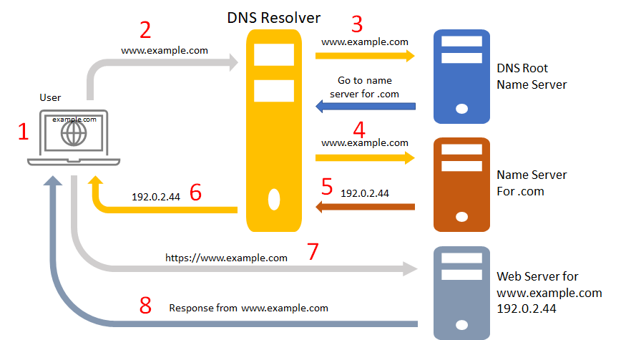
Figure 46: DNS Explained, adapted from [9]
- User requests web page www.example.com
- Request is routed to DNS resolver, probably provided by the Internet Service Provider
- Request is routed to DNS root name server that has information on Top Level Domains, in example “.com”
- The request may be routed to other name servers until
- The record of the IP address for www.example.com is returned
- The DNS resolver returns the IP address to the user’s browser
- The user’s browser sends a request for www.example.com to the IP address received
- The web server, or other resource, returns the web page www.example.com, and this is displayed by the browser.
DNS provides a level of abstraction, or uncoupling, that facilitates the changing of devices and their IP addresses, so that the user would never be aware of the change.
DNS’s significance to ADDS is described by Microsoft as using “DNS as its domain controller location mechanism.” [10] to perform AD operations - authentication, updating, or searching.

Other Critical Roles
Several server roles are available on Windows 2019, Figure 47.
DHCP and WSUS are chosen as the critical roles for brief overview.
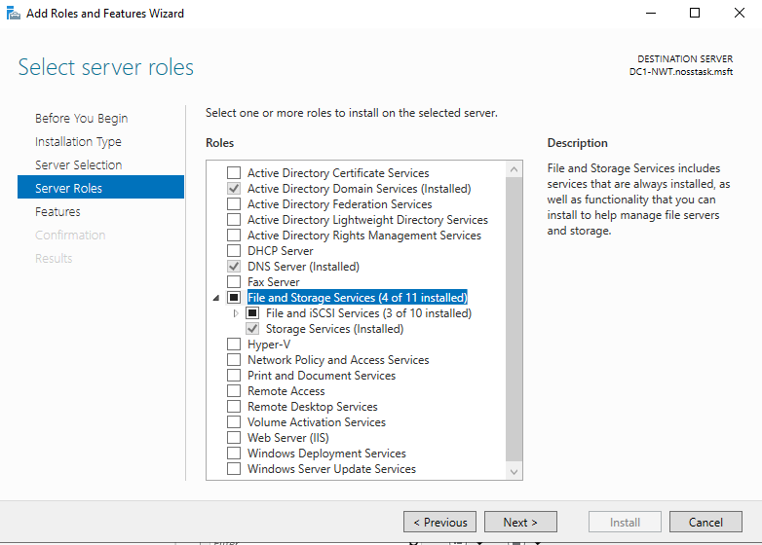
Figure 47:

Dynamic Host Configuration Protocol (DHCP)
Microsoft state, DHCP is “designed to reduce the administrative burden and complexity of configuring hosts on a TCP/IP-based network, such as a private intranet” [11].
Without DHCP every single client computer connected to a network, would need to be manually assigned a static Internet Protocol (IP) address to enable network communications. Host IP addresses must be unique to facilitate error-free communication.
Manually assigning IP addresses would be cumbersome, time-consuming and error prone. DHCP automates this process by leasing IP addresses for a set time-period. Dynamic IP allocation prevents IP duplication and can facilitate “more” devices on a network, as DHCP reclaims IP addresses for further use.
Note: devices such as printers, servers, switches, etc. must have static IP addresses as they cannot move on a network.

Windows Server Update service (WSUS)
“WSUS allows system administrators to manage the distribution of Microsoft's product updates to their organization's computers.” [12].
WSUS infrastructure enables system administrators to control deployment of updates and patches to computers attached to their network.
Administrators may schedule, postpone, not apply, or force (urgent) updates to devices. This level of control enables thorough device build testing of deployments prior to distribution. Thus, introducing environment stability.
Application versions, and patch levels, installed can be reported for each computer.

Worksheet Terminologies and Purposes
ICMP (Ping)
“The Internet Control Message Protocol (ICMP) is a network layer protocol used by network devices to diagnose network communication issues.” [13]
The Ping command, together with IP address or host name, is usable within Windows and Linux environments. Its primary purpose is to diagnose network issues, it informs whether data has reached a specified destination.
Figure 48 displays a successful ping of network packets being sent and received. Additionally, information on time taken for ping to make a round trip host to destination and back.
Historically, pings have been used to initiate attacks on network connected devices. To protect against this many OSs block ping by default, providing a level of security by hiding a device’s existence.
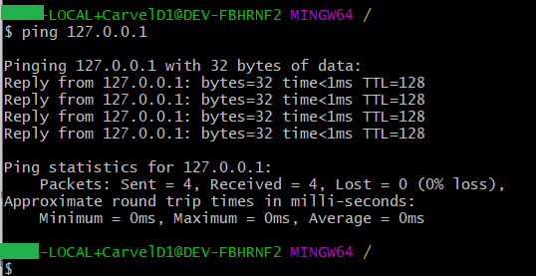
Figure 48: Successful ping
Firewall
“a firewall either permits or blocks a requested network connection” [14], Britannica definition.
Firewalls can be software or dedicated hardware devices and used to protect networks by filtering traffic. E.g., they may be configured to only allow connections from specified IP addresses and deny all other connection attempts. New connections will require specific changes to the firewall ruleset to grant access to network resources.
More modern firewalls may dynamically learn rules for denying and allowing connections.
Within the context of the task - Windows OS provides a host-based firewall service that is on by default. Linux based OSs use ufw (Uncomplicated Firewall) [15] that, in contrast, is disabled by default.
PAE/NX
Oracle VirtualBox documentation states “Determines whether the PAE and NX capabilities of the host CPU will be exposed to the virtual machine.” [16]. PAE is required for 32bit VMs to use more than 4GB of RAM, but this explanation does not cover the NX part.
Further research on Stack Exchange [17] referenced a Wikipedia article [18] that provided information on why PAE/NX is necessary - enabling the checkbox provides a security feature preventing VM code execution through to the physical host.
Out of Box Experience (OOBE)
The initial installation, or configuration, of software and/or hardware on a computer.
Another word often used to describe OOBE is vanilla [19] (plain/pure/standard ice-cream flavour).

User Principal Name (UPN)
Microsoft term used for Active Directory configuration, described as “an attribute that is an internet communication standard for user accounts” [20]. For example, person@network.com.
(1308 words)

Reflection
The task required a small client/server network to be built that comprised 4 virtual machines. This was achieved using Type 2 hypervisor software, VirtualBox.
Undertaking the task readily demonstrated how relatively quick, cheap, and straightforward a small virtual network could be established. Without the need to procure expensive hardware, software, and any skilled resources. Furthermore, this was all achieved on a single device.
The task also required the installation of AD, a service typically used to administer and manage users, computers, etc. on medium to large scale networks.
Using AD on a small network may be overkill, with set-up and administration outweighing manual configuration effort. However, as a network scales up and out AD will prove beneficial, providing tools and resources needed to make overall system administration easier and enabling remote management of devices and users.
On undertaking the task, the following queries became apparent –
- How can the network be secured with client firewalls enabled?
- How could this setup be automated?
- Can a client join a domain without required domain authentication e.g. remotely?
- How does additional DNS instances or network routing enable/maintain connectivity?
The report author will undertake further research on these questions, and more.
(196 words)

(Total: 1040 + 1308 + 196 = 2544 words)

References
[1] Microsoft Documentation. (2021, 23 December). Hardware requirements for Windows Server. [Online]. Available at: https://docs.microsoft.com/en-us/windows-server/get-started/hardware-requirements
[2] Microsoft Support. (No Date). Windows 10 System Requirements. [Online]. Available at: https://support.microsoft.com/en-us/windows/windows-10-system-requirements-6d4e9a79-66bf-7950-467c-795cf0386715
[3] Waddilove, R. (No Date). Speed up VirtualBox in Windows and run virtual machines faster. [Online]. Available at: http://www.rawinfopages.com/tips/2017/07/speed-up-virtualbox-in-windows/
[4] Oracle. (No Date). 6.4 Installing the VirtualBox Guest Additions. [Online]. Available at: https://docs.oracle.com/cd/E26217_01/E26796/html/qs-guest-additions.html
[5] Cobley, L and Kaliyamurthy, N. (No Date). Network Operating Systems and Services (NOSS) (ACCA5023) Worksheet 1, Objectives (Page 2). [Online]. Available at: https://moodle.uwtsd.ac.uk/course/view.php?id=8759
[6] Microsoft Documentation. (2021, 12 November). Cloud monitoring guide: Formulate a monitoring strategy. [Online]. Available at: https://docs.microsoft.com/en-us/azure/cloud-adoption-framework/strategy/monitoring-strategy
[7] Rimol, M. (2021, 28 June). Gartner Says Worldwide IaaS Public Cloud Services Market Grew 40.7% in 2020. [Online]. Available at: https://www.gartner.com/en/newsroom/press-releases/2021-06-28-gartner-says-worldwide-iaas-public-cloud-services-market-grew-40-7-percent-in-2020
[8] Amazon Web Services (AWS). (No Date). What is DNS? [Online]. Available at: https://aws.amazon.com/route53/what-is-dns/
[9] AWS. (No Date). What is DNS, How does DNS route traffic to your web application? [Online]. Available at: https://aws.amazon.com/route53/what-is-dns/
[10] Microsoft Documentation. (2022, 10 January). Domain Name System (DNS). [Online]. Available at: https://docs.microsoft.com/en-us/windows-server/networking/dns/dns-top
[11] Microsoft. (2021, 29 July). What’s New in DHCP. [Online] Available at: https://docs.microsoft.com/en-us/windows-server/networking/technologies/dhcp/what-s-new-in-dhcp
[12] Dauti, B. (October 2019). Windows Server 2019 Administration Fundamentals (Second Edition), Understanding WSUS (page 326). Packt Publishing Ltd. Birmingham. ISBN 978-1-83855-091-2
[13] CloudFlare. (No Date). What is the Internet Control Message Protocol (ICMP)? [Online]. Available at: https://www.cloudflare.com/en-gb/learning/ddos/glossary/internet-control-message-protocol-icmp/
[14] Encyclopaedia Brittanica. (No Date). Firewall. [Online]. Available at: https://www.britannica.com/technology/firewall
[15] Ubuntu Documentation. (2020). Firewall, ufw - Uncomplicated Firewall. [Online]. Available at: https://ubuntu.com/server/docs/security-firewall
[16] Oracle VirtualBox. (No Date). Configuring Virtual Machines, 3.5.2 Processor Tab, Enable PAE/NX. [Online]. Available at: https://www.virtualbox.org/manual/ch03.html
[17] Stack Exchange. (2020, 1 May). When do I have to use PAE/NX?, The NX Part. [Online]. Available at: https://superuser.com/questions/1118712/when-do-i-have-to-use-pae-nx
[18] Wikipedia. (2021, 2 May). NX Bit. [Online]. Available at: https://en.wikipedia.org/wiki/NX_bit
[19] Stack Overflow. (2013, 30 December). What does vanilla mean? [Online]. Available at: https://stackoverflow.com/questions/20836115/what-does-vanilla-mean
[20] Microsoft Documentation (2021, 29 December). Plan and troubleshoot User Principal Name changes in Azure Active Directory. [Online]. Available at: https://docs.microsoft.com/en-us/azure/active-directory/hybrid/howto-troubleshoot-upn-changes
All Figures, unless otherwise stated in the Figure caption, have been created by Derek Carvell. (2022, February).

