++

Population Health and Digital Health Promotion
LCHS7007
STUDENT NAME: TIRTH PRAVINBHAI MEWADA
STUDENT ID: 2406573
LECTURER NAME: DR PING WU

Task 1: Blog
Table of Contents
Blog 1: The Impact of an Existing Digital Health Promotion Technology 3
Addressing a Public Health Problem 3
Use of MyFitnessPal in Health Promotion 3
Evidence of MyFitnessPal’s Effectiveness 4
Critical Analysis of MyFitnessPal’s Impact 5
Addressing the Shortfalls 5
Blog 2: The Impact of a Newly Designed Digital Health Promotion Technology 7
Addressing a Public Health Problem 7
Description of NutriCoach AI 7
Use of NutriCoach AI in Health Promotion 7
Critical Analysis of NutriCoach AI’s Impact 8
Addressing the Shortfalls 8
Conclusion 9
References 10

Table of Figures
Figure 1: prevalence of overweight and obesity in adults (aged 18 years and over) 3
Figure 2: My Fitness Pal 4
Figure 3: Nutri Coach AI 7

Blog 1: The Impact of an Existing Digital Health Promotion Technology

Addressing a Public Health Problem
About 28% of adults in the UK suffer from obesity, which is still a major public health concern. Obesity also contributes to major health problems such diabetes, cardiovascular disease, and some types of cancer (GOV.UK, 2024). By promote the healthy behavior, digital health promotion had become vital instrument in the fight against the epidemic. One famous technology which is known as MyFitnessPal a well-known smart phone software, which is made to help diet tracking and weight management (Putri, 2024).

Use of MyFitnessPal in Health Promotion
A digital health tour which is known as my fitness was created to help people control their weight by increase self-avoidance and accountability. It helped the user to keep track of their food consumption and exercise routine by pride, food diary, calorie counter, and activity tracker. Real time synchronization of health data for a more modified experience is made possible by the app to smooth integration with wearable technology such as fit bit and Apple health (Petkevičius, 2024).
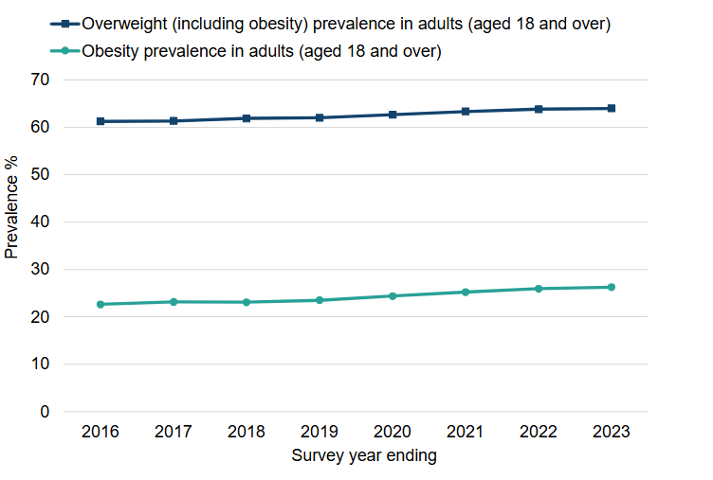
Figure 1: prevalence of overweight and obesity in adults (aged 18 years and over)
(Sources: GOV.UK, 2024)
This app helped the people to make educated dietary decision and increased healthy eating habit with it knowledge, food database and meal recommendations. It helped a different user to achieve the sustainable weight management and promote the long-term behavior change by offer the goal taking and data driven knowledge.

Evidence of MyFitnessPal’s Effectiveness
The research shows the mobile health application for self-monitor greatly increase the weight loss result. After six months of use this app users 5-7 percentage decrease in body weight as comparison to no users. This app dietary suggestion which assists users in making knowledgeable food choice make it so advantage. This app also increases the accountability and healthier behavior by monitor calorie in tech and combine the wearable technology.
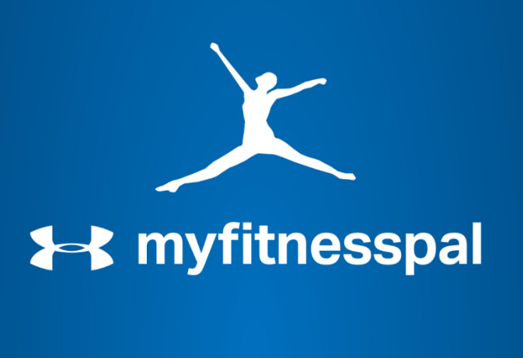
Figure 2: My Fitness Pal
(Sources: FinSmes, 2020)
It is a famous tool for manage weight because of its knowledge, food database and easy to use interface. But there is still problem like accurate, self-reporting and persistent environment (RAHIM et al., 2025). There are some limitations on this important app, of digital health promotion, we saw the how technology may help the people lose weight in a sustainable way. The future development can be increasing influence on public health initiative such as AI power meal tracking and improved behavior coaching.

Critical Analysis of MyFitnessPal’s Impact
Advantages:
- Accessibility: It is widely accessible due to its free availability on cellphones.
- User Engagement: Elements like community support and gamification boost adherence.
- Integration with Wearables: Personalized recommendations are improved through syncing with fitness trackers.
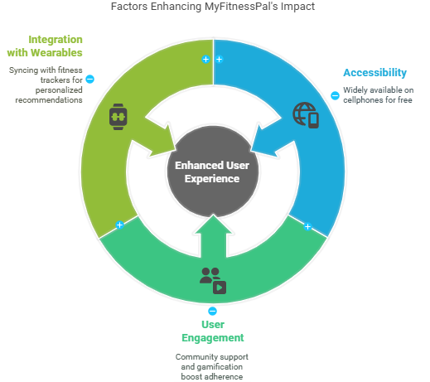
Figure 3: Factors Enhancing MyFitnessPal Effect
(Sources: Self Developed)
Disadvantages & Limitations:
- Accuracy Issues: Self-reported food intake might result in either an overestimation or an underestimation of the number of calories consumed.
- Digital Divide: People who don't have cellphones or internet connection are left out, which exacerbates health disparities.
- Sustainability of Behavior Change: Maintaining commitment over the long run is still difficult.

Addressing the Shortfalls
Machine learning algorithm can be incorporate to enhance the accuracy of calorie calculation in digital health treatment such as this app. They are different users have faced a challenge, accurate recording, how much food they eat, which caused them to either over report or under report their calorie in tech. Real-time meal composition in portion size analysis is possible with AI powered image recognition, nutrition evaluation.
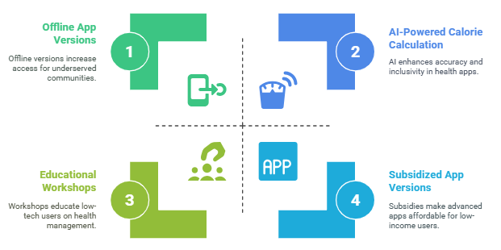
Figure 4: Enhancing Digital Health Solutions
(Sources: Self Developed)
Partnership with public health can also expand the base to include underserved digital communities. Their capacity of different lower income population to take advantage of this type of technology Limited. Since they do not have access to smart phone or internet connectivity (Czerska, 2024). This app can be more famous available through subsidy app version off-line feature and educational workshop by working with a government initiative, community health program and non-government organization. These improvements will guarantee that digital health solutions are inclusive as well as successful, assisting a larger population in attaining long-lasting health gains.

Blog 2: The Impact of a Newly Designed Digital Health Promotion Technology

Addressing a Public Health Problem
Building on the obesity problem, NutriCoach AI is a recently developed digital health promotion technology that seeks to overcome the shortcomings of MyFitnessPal and other applications. Although calorie counting apps are useful for taking diet, they are frequently fall certain in offer, individualized real time coaching to maintain behavior changes (Chidambaram et al., 2024). Augmented reality and artificial intelligence are combined in Nutri Coach AI to enhance nutrition instruction and increase better eating practices.

Description of NutriCoach AI
An inventive smartphone software, which is known as Nutricoach which is used by AR graphics and AI powered food identification technology to increased better eating practices. User can also obtain immediate nutrition breakdown, including calorie content, meant, compositions and portion size analyses by using the different camera on their phone to scan meals. The app improves the individualized nutrition course by provide the real time meal recommendation based on each user dietary requirement and a goal.

Figure 5: Nutri Coach AI
(Sources: Nutri Coach AI)
This app virtual nutrition driven by that offered continuous advice, habit, monitor and behavior reinforcement. By incorporate AR graphics, the software empowers users to make a informed decision by improve their knowledge of nutrition and portion contour (Kim et al., 2025). This have become a close the gap between conventional diet tracking apps and real time, actionable diet coaching by feeding state of the art, AI, AR and health research. This creative technique increased long lasting behavior change which eventually helped the lower obesity and increased public health outcomes.

Use of NutriCoach AI in Health Promotion
- Real-Time Meal Analysis: Using augmented reality overlays, users can see portion sizes and the distribution of macronutrients.
- AI-Powered Meal Suggestions: NutriCoach AI suggests better options based on dietary choices and health objectives.
- Gamification Features: Rewards and challenges promote consistent participation and adherence.
- Personalized Coaching: AI chatbots can offer dietary guidance at a lower cost than human dietitians.
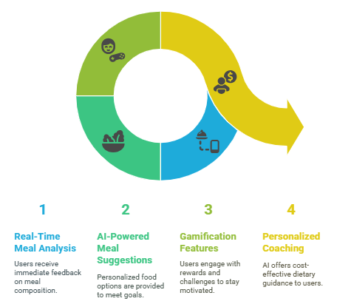
Figure 6: NutriCoach AI Engagement Cycle
(Sources: Self Developed)

Critical Analysis of NutriCoach AI’s Impact
Advantages:
- Enhanced Accuracy: AI food identification removes human entry errors.
- Behavioral Reinforcement: Long-term habit building is improved by real-time guidance.
- Accessibility: To encourage diversity, it is available in several languages.
Disadvantages & Limitations:
- Technological Barriers: Requires AI-capable smartphone cameras, which restricts low-income populations' access.
- User Dependence on AI: Relying too much on AI to make nutritional choices may cause people to lose their ability to think critically about nutrition.
- Privacy Concerns: Data security and individual privacy are issues brought up by real-time meal scanning (Ijiga et al., 2024).
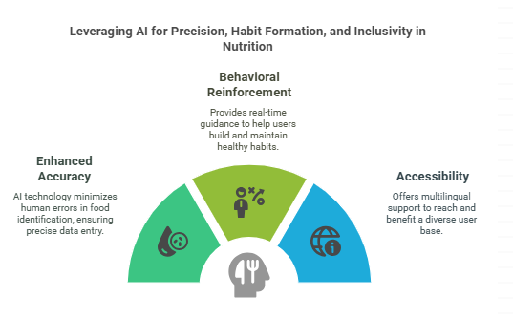
Figure 7: Leveraging AI for Precision, Habit Formation and Inclusivity in Nutrition
(Sources: Self Developed)

Addressing the Shortfalls
This app might include the off-line capability to solve accessibility. Challenges allow the users to access key functionalities without internet connection. This would guarantee that real time, nutrition, track and meal analysis are still accessible to people in places with poor connectivity. Using human nutritionist for recover evaluation would improve the accuracy of recommendation produced by AI (Berardi et al., 2024). Human oversight, guarantee, accuracy, personalization, and trust in nutritional suggestion, even as AI driven knowledge provide efficiency.
Long-term user engagement could increase and potential bias in AI algorithm which radio is using hybrid strategy that combined expert validation with AI automation. This AI can offer more sustainable efficient and inclusion, digital health solution by strike balance between expert assistance and technological innovation (Pape et al., 2025). By fulfilled a gap between technology and human this technique not only improve the impact on public health, but also increase the bro expectation of digital health intervention among different of demographics.

Conclusion
The suggested NutriCoach AI and MyFitnessPal both assist behavior changes and increase food knowledge, which advances digital health promotion. However, to maximize their impact on public health initiatives, it will be essential to solve issues of data security, user involvement, and accessibility.

References
Berardi, C., Antonini, M., Jordan, Z., Wechtler, H., Paolucci, F. and Hinwood, M., 2024. Barriers and facilitators to the implementation of digital technologies in mental health systems: a qualitative systematic review to inform a policy framework. BMC health services research, 24(1), p.243. https://link.springer.com/content/pdf/10.1186/s12913-023-10536-1.pdf
Chidambaram, S., Jain, B., Jain, U., Mwavu, R., Baru, R., Thomas, B., Greaves, F., Jayakumar, S., Jain, P., Rojo, M. and Battaglino, M.R., 2024. An introduction to digital determinants of health. PLOS digital health, 3(1), p.e0000346. https://journals.plos.org/digitalhealth/article/file?id=10.1371/journal.pdig.0000346&type=printable
Czerska, I., 2024. Gamification in Ηealth Promotion in the Context of Creating the Concept of Health 2.0-A Comparative Analysis of Selected Health Mobile Applications. European Research Studies Journal, 27(44). https://wir.ue.wroc.pl/docstore/download/UEWR69fd67e1c7ec4857b9f81d12bf1c0b82/Czerska_Gamification_in_%CE%97ealth_Promotion.pdf
FinSmes, 2020. Francisco Partners To Acquire MyFitnessPal from Under Armour. [Online] Available at https://www.finsmes.com/2020/11/francisco-partners-to-acquire-myfitnesspal-from-under-armour.html#google_vignette
GOV.UK, 2024. Obesity Profile: short statistical commentary May 2024. [Online] Available at https://www.gov.uk/government/statistics/update-to-the-obesity-profile-on-fingertips/obesity-profile-short-statistical-commentary-may-2024
Ijiga, A.C., Abutu, E.P., Idoko, P.I., Ezebuka, C.I., Harry, K.D., Ukatu, I.E. and Agbo, D.O., 2024. Technological innovations in mitigating winter health challenges in New York City, USA. International Journal of Science and Research Archive, 11(01), pp.535-551. https://pdfs.semanticscholar.org/1fcb/ea927e0c54271a592ae284677cd13f27165d.pdf
Kim, G., Hwang, M., Lee, S. and Park, Y.H., 2025. Need for and Acceptance of Digital Health Interventions for Self-Management Among Older Adults Living Alone: A Mixed-Methods Approach. Asian Nursing Research, 19(1), pp.86-95. https://www.sciencedirect.com/science/article/pii/S1976131724001634/pdf?md5=f16b4d7bf7e1f5e113d9c8f9e08a79eb&pid=1-s2.0-S1976131724001634-main.pdf
NutriCoach AI, 2025. A Nutrition Coach always available for you to Eat Better and Lose Weight. [Online] Available at https://nutricoachai.com/
Pape, C., Gugathasan, A., Chopra, A., Kundurthi, S., Kassam, I., Shin, H.D. and Strudwick, G., 2025. Mobilizing Innovation: An Environmental Scan of Global Digital Health Centres. In From Insights to Action: Empowering Health (pp. 76-77). IOS Press. https://ebooks.iospress.nl/pdf/doi/10.3233/SHTI250024
Petkevičius, M., 2024. The impact of gamification elements on the intention to use health related applications (Doctoral dissertation, Vilniaus universitetas.). https://epublications.vu.lt/object/elaba:191573575/191573575.pdf
Putri, U.M.P., 2024. The Effect of Nutrition Counseling Using Whatsapp and MyfitnessPal Application on Vegetable and Fruit Consumption in Overweight and Obese Students. International Nutrition and Health Administrations Journal, 3(1). https://www.inhaj.iiknutuban.ac.id/index.php/inhaj/article/download/23/13
RAHIM, S.S., WAI, C.H., PARUMO, S., ABDUL, R. and SAMAD, S.K.J., 2025. UTILIZING INTERACTIVE MOBILE TECHNOLOGY FOR HEALTH EDUCATION: CREATION AND EVALUATION OF A CALORIE AND NUTRITION TRACKING APPLICATION FOR THE MALAYSIAN POPULATION. Journal of Theoretical and Applied Information Technology, 103(4). http://www.jatit.org/volumes/Vol103No4/27Vol103No4.pdf



