Assignment feedback

Student Name: Kenny Owen
Student University Email: 1300552@student.uwtsd.ac.uk
Module code: AHAC5013  Module title: Bio-Archaeology and Forensics | Student ID number:  1300552 |  | Educational support needs:  Dyslexic
Assignment title: “Skeletal remains: Frozen environments/preservation of soft tissue”
Assignment due date: 27th March 2018.
Assignment Number: 1
(i.e. 1,2,3)
Marker’s signature: |  | Date:
Provisional.
NB. All marks are provisional until confirmed by the final examination board.

Contents

Introduction
Environment and Climate
Dating, Excavation and Analysis
Preservation and Decay of Soft Tissue
Further analysis – Blood and Bacterial DNA
Other Cold Cases
Conclusion
Appendix

Introduction
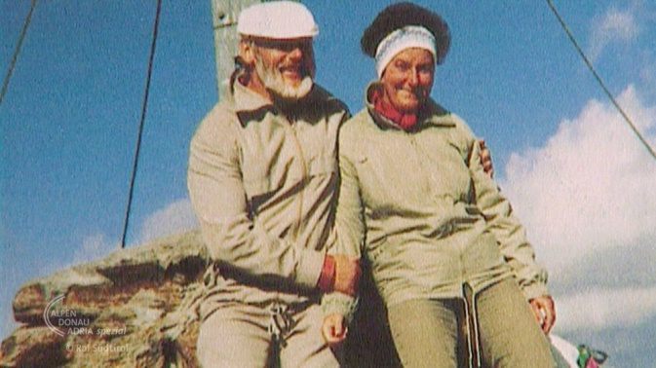
German hikers, Erika and Helmut Simon, made an extraordinary discovery on 19th September 1991 while walking in the South Eastern Alps which would change archaeological contemporary understanding of the Neolithic. They discovered a human body, head and shoulders above the melt-water of an ancient glacier. A nearby ski clip convinced them that the brown figure with a medallion sized hole in its cranium was a recent mountain fatality. They photographed the body, descended to their lodge in Similaunhutte where the owner alerted the police (Spindler, 1994, p9-11).
Fig.1. The Simons’ who discovered Ötzi
This essay looks at how the body came to be buried at high altitude in the East Alpine environment, the forensic taphonomy of the find, how soft tissue is preserved in frozen environments while providing a contrasting view with fresh body tissue, and fluids, from bodily remains, the excavation and the haphazard methods used to release the corpse, the analysis, chronology and the history that led to the deposition of the Iceman, known as Ötzi.

Environment and Climate

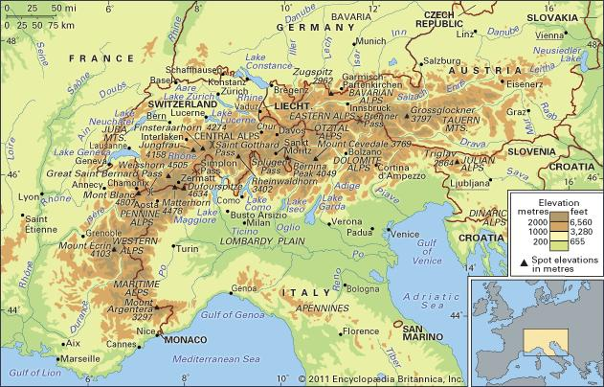
Fig. 2. Map showing Austrian/Italian border and the Ötztal Alps

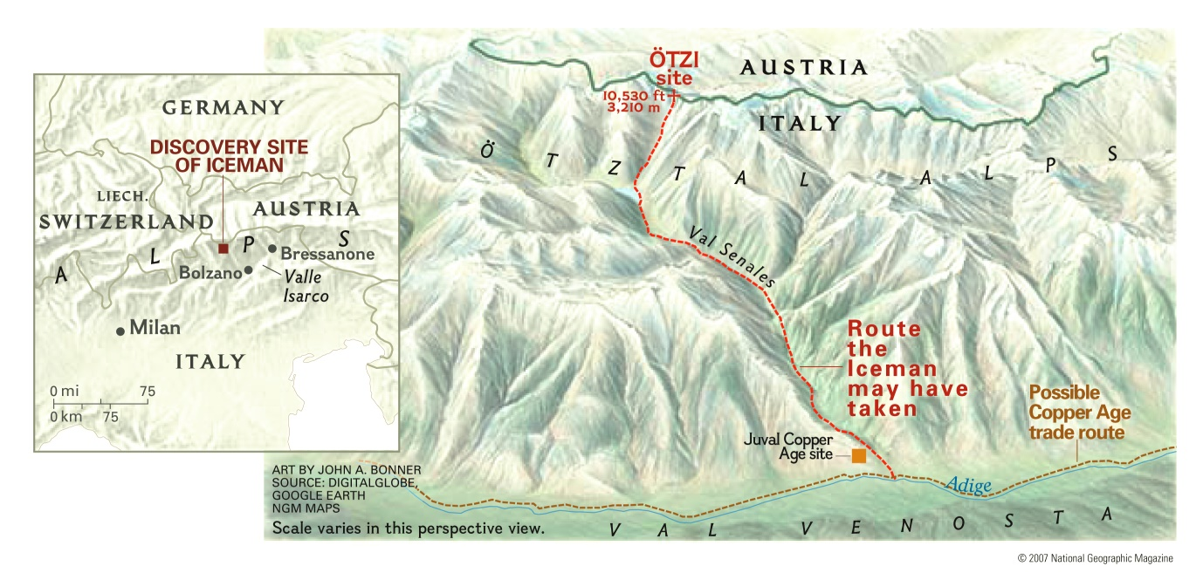
Fig.3. Map showing where Ötzi was discovered

Ötzi was found, 3210 metres above sea level, on the Tisenjoch, a region in the Ötztal Alps, along the Austrian-Italian border. The remains were found in a shallow glacial depression, flanked either side by rocky ridges (Kutschera, 1994; Spindler, 1994; Vanzetti et al, 2010). Spindler (1994, p53) states that, Ötzi was interred in a horizontal, hull shaped gully, aligned west-southwest to east-northeast, 5 metres wide and 50 metres in length. When discovered, the floor of this shallow ravine was filled with glacial ice and 30 centimetres of melt water which, drained along a conduit in a northeast direction towards the Niederjochferner, a glacier to the west of Mount Similaun (3606 m) (Mitterer, 2018). A pool of water remained in the lower section of the gully and, due to the flat wind exposure, Spindler (1994, p53) suggests, that glacial deposits in cold climatic conditions never reaches over 20 – 25 metres deep. The movement of the glacial deposit is affected by the terrain which is along a gradual slope. The ice-flow moves slowly across the ridge with no movement at the base. These dynamics explain why Ötzi’s body remained intact unaffected by the usual grinding and sheering effects of glacial movement which usually results in disarticulation.

Spindler (1994, p54), considers the climate at this time 5000BCE, to be similar to today. He proposes that the remains had been exposed to warm spells during Roman times, the Middle Ages and recently as 1991 when unusual climatic conditions combined with allochthonous Saharan dust caused a melting of the ice revealing Ötzi. This indicates that the gully was free from snow and ice at Ötzi’s death. Kutschera (1994, p4) undertook ¹⁴C analysis of the body and other artefacts (found with the body) using the Vienna Environmental Research Accelerator (VERA) at the University of Vienna and evidence was found that early Holocene was warmer than our present climate. Kutschera goes on to say,

“Such changes in temperature can be most sensitively traced at high altitudes, where the vegetation reaches its limit of existence…tree logs set free by the rapidly receeding Pasterze Glacier of the Grossglocker, the highest mountain in the Austrian Alps, have been ¹⁴C-dated to the period between 8000 and 6900BC. These finds indicate that the trees must have grown during that time at locations still covered by glaciers today.”

Further climatic indicators found at the site include grass, moss, other plants (including salix herbacea), animal dung (coprolite), wood and soil. Contemporary grass species were analysed, which don’t grow at 3210 metres today but, seeds could have been transported in Ötzi’s clothing from lower altitudes. If grass did grow at the site, this shows a warmer climate 5000 years ago. According to Acs et al (2005, p2; Hall, 2007), ‘At 3210m a.s.l., it is the highest located subfossil plant assemblage ever found in the Alps in connection with archaeological findings.’ Other plants including salix herbacea grow in sheltered, snow covered depressions like that of the burial site also suggesting a warmer period. Grass detritus lying evenly over the artefacts in the icy grave also suggests a freeze-thaw-freeze episode.

A change in climatic conditions led to the excellent state of preservation of the body, probably protected in snow and ice immediately after death. If the snow had remained cold and dry for long periods it would have caused a dry-freezing effect from the exposure to the wind. The body did not dehydrate completely at deposition, the moisture was kept constant by the freeze-thaw effect (Spindler, 1994). ‘A rapid climate change has been suggested by Baroni & Orombelli at about 5300-5050ka for the millennial persistent snow burial of the Iceman over ice-free ground’ (Orombelli, 2011). Who was Ötzi and why was he so high in the Alps?
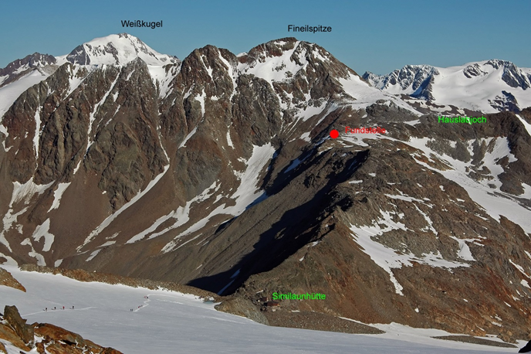
Fig.4. The Ötztal Alps showing the Similaunhutte refuge and Ötzi’s resting place in red

Spindler (1994) proposes, ‘The Disaster’ theory, depicting Ötzi as a shepherd on the high altitude, summer pastures of the Ötztal, descending to Val Venosta before the winter snow. Spindler suggests Ötzi sustained a rib trauma during a violent struggle, although Wilson (2001) contradicts the broken rib theorising that eight ribs were broken, possibly during the removal of the body in 1991. Spindler believes that Ötzi fled and was killed by an arrow in his left shoulder. He lay undiscovered at the Hauslabjoch until 1991, frozen, with his bow, arrows and other artefacts, in a glacial deposit. Vanzetti et al (2005), challenges this theory arguing that Ötzi was killed lower down the mountain and later interred in the location of the 1991 find. A modified stone platform, 0.8m higher and 5m further from the location is thought to be the original burial place. The plotting of burial artefacts, indicates that gravity and melt-water flow repositioned the body, which had turned, repositioning its left arm at an angle across the body during climate changes. ‘This reconstruction is consistent with previous discoveries and the analytical results of the body’s state of conservation’ (Vanzetti et al, 2005, p681). Botanical analysis of the intestines show that Ötzi died during early/mid spring and, at a lower altitude; pollen in the gut suggesting his last meal was during April, while botanical and environmental evidence at the deposition site suggests a late summer/early autumn burial. Beau lines on Otzi’s fingernails showed he’d been ill six months prior to death (Vanzetti et al, 2005, p681; Hall, 2007; Dickson et al, 2003).

Dating, Excavation and Analysis
Two days after the original discovery by the Simons’, Hans Kammerlander and Reinhold Messner photographed the body guessing the age at 500 years (Kutschera, 1994, p1). Spindler estimated it to be around 4000 years old based on a copper axe find (Spindler, 1994, p77; Wilson, 2001, p.57). The excavation was compromised before it was made secure; visitors collected souvenirs, and, inexperienced individuals attempting recovery.
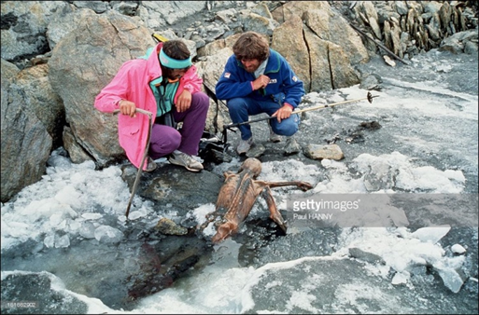
Fig.5. Reinhold Messner (right) and Hans Kammerlander discovering Ötzi

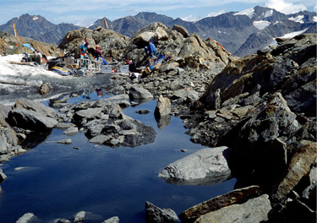
Markus Wiegele attempted to retrieve the body with ski-poles and ice-picks even using Ötzi’s bow, eventually freeing the corpse. Earlier, a policeman, Anton Koler, believing the body to be a modern fatality, used a pneumatic hammer damaging the body’s left hip during the attempt. The Iceman’s backpack was damaged and the site well-trodden before the forensic team arrived; the forensic archaeological integrity of the find was badly compromised. Two days later Rainer Henn from the University of Innsbruck recovered Ötzi and flew the remains, to the institute for forensic examination (Kutschera, 1994, p1; Hays, 2009; Spindler, 1994, p.9-80). With the corpse gone the first excavation commenced using steam blowers and hair dryers to reveal grass matting on which the body had lain, remnants of a birch-bark container, containing Norway maple leaves, grass and charcoal particles. To the south-west a rock shelf, where Kutschera (1994) contests is the original point of deposition, fur, leather, cords of twisted grass and wood splinters were found. On the rocky-shelf, a long-haired pelt and two shards of Ibex bone were discovered. During the excavation, theodolite measurements, confirmed that Ötzi was found 92m inside the Italian border (Spindler, 1994, p.71).
Fig.6. The second excavation

Now that the border issue was clarified, the South Tyrol Ancient Monuments Office took charge of further excavations. A second archaeological examination of the site took place on 20th July 1992 after heavy snowfalls in the Tyrol region. During the warm summer period 500 centimetres of snow had melted but, a further 100 centimetres had to be cleared by hand at the deposition site. Unlike the first excavation, integrity of the forensic evidence was adhered to. Excavation was executed by hand instead of using diesel-driven machines reducing old carbon pollution of samples collected; steam blowers and hair dryers were again used. Remains found included, grasses, moss, leaves, charcoal, hair and insect parts. Sediment analysis in the gully contained human remains, skin, muscle fibres, hair, blood vessels and a finger nail probably torn away by the pneumatic drill. The lower part of the broken bow was a significant find. To date the finds, AMS laboratories in Oxford and Zurich were hired for ¹⁴C dating, returning a date of 5300 to 5200BCE (Spindler, 1994; Dickson et al, 2005, p3; Kutschera, 1994; South Tyrol Museum of Archaeology, 2018).

Preservation and Decay of Soft Tissue
Preserved with this "Iceman" were fragments from three layers of clothing, which had survived the ice and give a retrospective view of the Neolithic 5000 years ago. He wore a woven grass cape, fur leggings, goatskin undergarments, leather shoes insulated with grass and a brown bear fur hat. Also found were stone implements, a backpack constructed from hazel and larch, a quiver, bow and arrows, and, a copper axe with handle, all perfectly preserved by the ice. On the body were black charcoal marks, tattoos, believed to be a remedy for arthritis (Spindler, 1994, p.132-147; Wilson, 2001, p58).

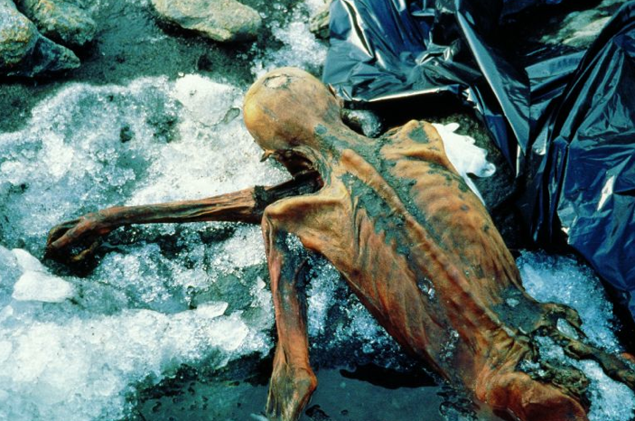
Fig.7. Ötzi preserved freeze-dried body with the epidermis changed to adipocere

Ötzi’s body was mummified by freeze-drying (sublimation) immediately after death and then covered in snow and ice, preservation was complete. Additionally, tannic acid from wood artefacts found with Otzi may have assisted in preservation (Aufderheider, 2003, p.174). Normally, a fresh body would be subject to scavengers, micro-organisms and the enzyme breakdown of its own cells through autolysis. In the case of Ötzi, freeze-dry dynamics prevented decay (Micozzi, 1997; Gill-King, 1997, p.95-96). Micozzi (1997, p.171) states,

‘Immediate post-mortem change is essentially a competition between decay and desiccation, and external factors such as temperature and humidity largely define the outcome…preservation of soft tissue occurs with freezing through a process of sublimation, or freeze-drying, in regions within the Arctic and Antarctic circles, and at high altitude.’

As Ötzi had been in melt-water during warm periods, his skin had turned to adipocere, or grave-wax. All of his hair, toe and finger nails (apart from one), had fallen off along with the epidermis, the skin outer-layer. Virtually resistant to decay, adipocere along with desiccation through drying and freezing effect preserved Ötzi (Larson, 2017; Spindler, 1994, p.152; Clark et al, 1997, p.158-159; Gill-King, 1997, 101-103).

Putrefaction occurs, if a body has not been preserved naturally or artificially, due to anaerobic degradation of the exterior and internal viscera caused by humid conditions and moderate temperatures of between 15°C and 37°C. The effect of bacteria on a body, causing putrefaction, is inhibited at temperatures below 4°C as multiplication of bacteria ceases completely. Decay is caused by aerobic degradation. In the case of Ötzi, sublimation occurred, desiccating the body, thus, preserving it. Freezing prevents growth of bacterial damage by influencing the division of the cells during death. In warm periods, when Ötzi was temporarily released from the ice, bacteria would have flourished. However, it is unlikely the temperatures at high altitudes would reach above 12°C where bacterial activity is retarded. The rate of desiccation for preservation is reduced at temperatures between 5°C and 15°C, however, desiccation must be rapid or putrefaction occurs; at lower than 5°C the desiccation rate is minimal and, at 0°C, no desiccation is necessary. The lack of bacterial dynamics in freezing conditions, hinders observation of decay patterns. Decomposition of a body that has been frozen and then thawed shows signs of decay from the ‘outside in’ due to external biodynamics, while putrefaction of unfrozen bodies decompose from the ‘inside out’ due to bacteria dissemination of the abdomen. Cryoturbation also affects depositional post-mortem remains from freeze-thaw dynamics, resulting in involution and disarticulation of remains (Micozzi, 1997, 172-175; Scott and Connor, 1997, p.31: Chamberlain and Pearson, 2001, p.12-18; Rodriguez, 1997, p459-467).

Further analysis – Blood and Bacterial DNA
Degradation evidence of red blood cells (RBCs), were found in tissues from the 5300 year old Iceman. ‘Changes in elasticity and structures of RBCs are important indicators of disease, and this makes them interesting for medical studies’ (Janko et al, 2012). Raman spectroscopy analysis showed dried RCBs, similar to haemoglobin (a bloody protein). Analysis with sensitive apparatus can show diet and disease, living conditions and how preserved bodies like Ötzi were mummified. It was thought, from earlier microscopic analysis of mummified tissue that RCBs could only last for 2000 years; analysis of the Iceman has proved to be 5300 years. Tissue samples were taken from the wounds on Ötzi’s hand and from the arrow wound under the left spina scapulae which ruptured the subclavian-artery (Fig.8) and resulted in the detection of RBCs. Indication of blood clots were identified
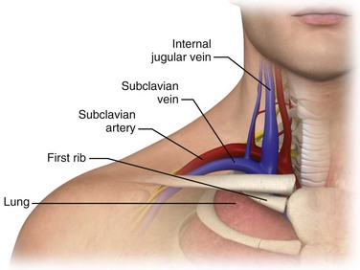
Fig:8 Subclavian vein trauma

formed when fibrin (Thrombocyte, 2018) is present. A single RBC was located in the hand tissue and two RBCs in the shoulder. The analysis demonstrated that the morphology of the RBCs did not degrade, or show damage or disorder. The result of the analysis showed that the Iceman suffered numerous injuries prior to death and RCBs revealed no blood disorders but, proved RBCs can survive in a 5300 year old corpse (Janko et al, 2012). Samples of skin and muscle tissue were analysed to investigate the process of mummification. Unfortunately, shortly after the recovery of Ötzi, due to several people handling the body, at the deposition location, blue-green spots began to show on the cadaver. At first this was believed to be biological contamination, however, after analysis this proved to be natural forming vivianite, a mineral in the soils where Ötzi had lain; the body was washed in phenol removing any trace of ancient surface bacteria. Untreated skin did show evidence of Sphingomonas, Afipia, Curtobacterium and others while muscles provided rich samples of bacteria DNA. The bacterial DNA evidence showed that the mummy had not desiccated in a warm air stream before being frozen, but, that Otzi was most definitely freeze-dried through sublimation. Much of the ancient DNA (Parsons and Weedn, 1997, p.120) evidence came from the Iceman’s clothing and shoe grasses, and the tissue analysed came from damage inflicted by Kolers pneumatic drill. Traces of cadaveric flora DNA could not be tested due to centuries of contamination in the ice and by twentieth century mishandling of the corpse during recovery from the ice. Polymerase chain reaction (PCR) (Parsons and Weedn, 1997, p.114-115) was used to amplify the DNA samples and surprisingly no traces were found on the Phenol treated skin, however, 2000 copies of bacterial DNA were recorded in the muscle tissue. The PCR analysis isolated natural soil forming bacteria DNA and showed an abundance of a single species, Clostridium algidicarnis in the muscle tissue; the bacteria ceases growth at 4°C and its composition is not readily known but is believed to originate in the intestinal region (Rollo et al, 2000, p.211-219). Rollo et al (2000) suggest, ‘It seems logical to assume that the mummification process responsible for the preservation of the human DNA, irrespective of the way the process took place, allowed preservation of the DNA of the bacteria (cadaveric microflora) that grew within the corpse for a certain time span following death.’

Other Cold Cases – See Appendix

Conclusion
The integrity of any investigation, crime scene or otherwise, is paramount, for evidence not to be corrupted; The Forensic Crime Service draws attention to this in their handbook (FFS, 2017). Analysis of RBCs shows their longevity and ancient bacteria in tissue can reveal so much about mummification and past lives which was not possible before Alex Jeffries discovery of DNA profiling in 1984. Ötzi threw a new light on the Neolithic, how they lived, ate and were clothed, especially for colder climes. The Iceman is now preserved in a refrigerated environment where academics of the future, with new interpretations can undertake to throw new light on the Neolithic. Forensic archaeology, anthropology and taphonomy have, since the haphazard recovery of Ötzi, has become a far more exact scientific discipline, as mentioned by Dirkmaat et al (2008), saying, ‘It requires data analysis and comparison through scientiﬁcally validated studies of all presented conclusions (from biological identity to trauma interpretations).’
References
Acs, P. et al, 2005. Remains of Grasses Found with the Neolithic Iceman “Ötzi”. Vegetation History and Archaeobotany, [e-journal] 14 (3) p.198-206. Available through: https://link-springer-com.ezproxy.uwtsd.ac.uk/article/10.1007/s00334-005-0014-x [Accessed: 12 February 2018].
Auferheide, A. C., 2003. The Scientific Study of Mummies. Cambridge: Cambridge University Press.
BR.de, 2015. Ötzi – The Man from the Ice. [Photograph] Available at: https://www.br.de/br-fernsehen/sendungen/alpen-donau-adria/ada-rai-suedtirol-oetzi-100.html [Accessed: 14 February 2018] Fig.1.
Chamberlain, A. T. and Pearson, M. P., 2001. Earthly Remains. London: The Bath Press.
Clark, A. M. et al, 1997. Postmortem Changes in Soft Tissues. In: W. D. Haglund and M. H. Sorg, ed. 1997. Forensic Taphonomy – The Postmortem Fate of Human Remains. Boca Raton: CRC Press LLC. P.158-159.
Dickson, J. et al, 2003. The Iceman Reconsidered. Scientific American Special Edition [online] Available through: http://web.b.ebscohost.com.ezproxy.uwtsd.ac.uk/ehost/detail/detail?vid=1&sid=a9a6ab0d-39d9-471a-91cb-6b161d65884b%40sessionmgr120&bdata=JnNpdGU9ZWhvc3QtbGl2ZQ%3d%3d#AN=15610225&db=bth [Accessed: 18 February 2018].
Dirkmaat, C. D., et al, 2008. New Perspectives in Forensic Anthropology. Yearbook of Physical Anthropology, [online] Available through: https://www.scribd.com/document/237729017/Dirkmaat-et-al-2008 [Accessed: 18 February 2018].
Encyclopedia Britanica, 2011. Ötztal Alps Map. [online] Available at: http://international-programs.forestry.oregonstate.edu/sites/ip/files/alps%20map.jpg [Accessed: 14 February 2018] Fig.2.
Forensic Science Service, 2017. The Scenes of Crime Handbook. [online] Available at: https://www.westmercia.police.uk/media/1745/Scenes-of-Crime/pdf/fssscenesofcrim.pdf [Accessed: 18 February 2018].
Gill-King, H., 1997. Chemical and Ultrastructural Aspects of Decomposition. In: W. D. Haglund and M. H. Sorg, ed. 1997. Forensic Taphonomy – The Postmortem Fate of Human Remains. Boca Raton: CRC Press LLC. P.95-96.
Gill-King, H., 1997. Chemical and Ultrastructural Aspects of Decomposition. In: W. D. Haglund and M. H. Sorg, ed. 1997. Forensic Taphonomy – The Postmortem Fate of Human Remains. Boca Raton: CRC Press LLC. P.101-103.
Geoface, 2018. The Subclavian Vein Trauma. [Photograph] Available at: http://geoface.info/ef8714/subclavian-vein-anatomy [Accessed: 17th February 2018] Fig.8.
Hall, S.S., 2007. Last Hours of the Iceman. [online] National Geographic, July 2007, Vol.21, (1), Available through: http://web.a.ebscohost.com.ezproxy.uwtsd.ac.uk/ehost/detail/detail?vid=7&sid=7d34e436-34ad-4ec7-91b4-b982198bf97b%40sessionmgr4006&bdata=JnNpdGU9ZWhvc3QtbGl2ZQ%3d%3d#AN=25438033&db=aph [Accessed: 14 February 2018].
Hanny, P., 1991. Ötzi, The Mummy from the Ötztal Alps. [Photograph] Available at: https://www.gettyimages.co.uk/license/161662902 [Accessed: 14 February 2018] Fig.5.
Hays, J., 2009. Ötzi the Iceman. [online] Available at: http://factsanddetails.com/world/cat56/sub362/item1496.html [Accessed: 13 February 2018].
Hays, J., 2009. The Second Excavation. [Photograph] Available at: http://factsanddetails.com/world/cat56/sub362/item1496.html [Accessed: 14 February 2018] Fig.6.
Janko, M. et al, 2012. Preservation of 5300 Year Old Red Blood Cells in the Iceman. Journal of the Royal Society Interface, [online] Vol.9 (75) p.2581-2590. Available through: http://rsif.royalsocietypublishing.org/content/9/75/2581.short [Accessed: 17 February 2018].
Kutschera, W., 1994. Radiocarbon Dating of the Iceman Ötzi with Accelerator Mass Spectrometry. Google Scholar [online] Available through: http://www.nupecc.org/iai2001/report/B44.pdf [Accessed: 11 February 2018].
Larson, M., 2017. National Geographic [online] Available at: http://ngm.nationalgeographic.com/2007/07/iceman/did-you-know-learn (Accessed: 14 February 2018].
Micozzi, S. M., 1997. Frozen Environments and Soft Tissue Preservation. In: W. D. Haglund and M. H. Sorg, ed. 1997. Forensic Taphonomy – The Postmortem Fate of Human Remains. Boca Raton: CRC Press LLC. P.171-179.
Mitterer, S. A., 2018. 2013 - Similaun (3606 m.) + Marzellkamm (3147 m.) [online] Available at: http://www.stefanmitterer.de/similaun-2013.html [Accessed: 12 February 2018].
National Geographic Magazine, 2007. Discovery Site of Iceman. [online] Available at: http://ngm.nationalgeographic.com/ngm/0707/feature2/map.html [Accessed 14 February 2018].
Orombelli, G., 2011. Holocene Mountain Glacier Fluctuations: A Global Overview. Researchgate, [online] Available through: https://www.researchgate.net/publication/286222887_Holocene_mountain_glacier_fluctuations_A_global_overview [Accessed: 7 February 2018].
Parsons,T. J. and Weedn, V. W., 1997. Preservation and Recovery of DNA in Postmortem Specimens and Trace Samples. In: W. D. Haglund and M. H. Sorg, ed. 1997. Forensic Taphonomy – The Postmortem Fate of Human Remains. Boca Raton: CRC Press LLC. P.114-115.
Parsons,T. J. and Weedn, V. W., 1997. Preservation and Recovery of DNA in Postmortem Specimens and Trace Samples. In: W. D. Haglund and M. H. Sorg, ed. 1997. Forensic Taphonomy – The Postmortem Fate of Human Remains. Boca Raton: CRC Press LLC. P.120.
Qilsakitsoq Mummies, 2018. Qilakitsoq Mummies burial site. [Picture] Available at: https://g00bypls.weebly.com/discovery-site.html [Accessed: 14 February 2018] Fig.9.
Qilsakitsoq Mummies, 2018. The Six Month Old Baby. [Picture] Available at: https://g00bypls.weebly.com/discovery-site.html [Accessed: 14 February 2018] Fig.10.
Rodriguez, W. C., 1997. Decomposition of Buried and Submerged Bodies. In: W. D. Haglund and M. H. Sorg, ed. 1997. Forensic Taphonomy – The Postmortem Fate of Human Remains. Boca Raton: CRC Press LLC. P.459-467.
Rollo, F. et al, 2000. Analysis of bacterial DNA in Skin and Muscle of the Tyrolean Iceman Offers New Insight Into the Mummification Process. American Journal of Physical Anthropology, Available through: http://onlinelibrary.wiley.com/doi/10.1002/(SICI)1096-8644(200002)111:2%3C211::AID-AJPA7%3E3.0.CO;2-M/full Vol 111 (2) p.111-119. [Accessed: 17 February 2018].
Samadelli, M., No date. Ötztal Alps: Similaunhutte and Ötzi’s Resting Place. [Photograph] Available at: http://www.age-of-the-sage.org/archaeology/otzi_the_iceman_map.html [Accessed: 18 February 2018].
Scott, D. D., Connor, M., 1997. Context Delicti: Archaeological Context in Forensic Work. In: W. D. Haglund and M. H. Sorg, ed. 1997. Forensic Taphonomy – The Postmortem Fate of Human Remains. Boca Raton: CRC Press LLC. P.31.
South Tyrol Museum of Archaeology, 2018. Who Was Ötzi? [online] Available at: http://www.iceman.it/en/who-was-oetzi/ [Accessed: 14 February 2018].
Spindler, K., 1994. The Man in the Ice. London: Weidenfeld and Nicholson.
Vanzetti, A. et al, 2010. The Iceman as a Burial. Antiquity, [e-journal] 84,(325). Available through: ProQuest https://search-proquest-com.ezproxy.uwtsd.ac.uk/docview/755013317/fulltext/192A145BB7174DCBPQ/1?accountid=130472 [Accessed: 11 February 2018].
Sudtirol Archeological Museum, 2018. Ötzi’s remains frozen in glacial ice. [Photograph] Available at: https://ericksongypsycaravan.wordpress.com/2014/08/05/otzi-the-iceman/ [Accessed: 14 February 2018] Fig.7.
The Earth Chronicals of Life, 2016. The Pazyryk Barrows. [Photograph] Available at: https://earth-chronicles.com/histori/the-pazyryk-barrows-in-the-altai-mountains-back-the-original-appearance.html [Accessed: 14 February 2018] Fig.11.
The Earth Chronicals of Life, 2016. The Pazyryk Barrows deep burial - excavation. [Photograph] Available at: https://earth-chronicles.com/histori/the-pazyryk-barrows-in-the-altai-mountains-back-the-original-appearance.html [Accessed: 14 February 2018] Fig.12.
The Earth Chronicals of Life, 2016. The Pazyryk Barrows - a preserved ice body. [Photograph] Available at: https://earth-chronicles.com/histori/the-pazyryk-barrows-in-the-altai-mountains-back-the-original-appearance.html [Accessed: 14 February 2018] Fig.13.
Thrombocyte, 2018. Thrombocyte. [online] Available at: http://www.thrombocyte.com/ [Accessed: 17 February 2018].
Wilson, I., 2001. Past Lives – Unlocking the Secrets of our Ancestors. London: Cassell & Company.

Appendix
a.s.l. Above Sea Level.
BCE Before Common Era
BP Before Present – (1950)

Other Cold Cases
The 500 year old graves of Inuit Indians, in Greenland, were discovered in 1972. The deposition in a rock-shelter overhang, contained the mummified bodies of six women and two children and were perfectly preserved through the process of sublimation, freeze-drying. They were dressed for freezing conditions, with fur and skins which, were warm and water tight while allowing moisture dissipation. Although the bodies were not encased in ice, they became desiccated by the circulating flow of freezing air through stones placed over the burial location. The most intact body was a six month old baby. Tattoos found on the women’s skin, like those on Ötzi, indicated their marital status, and not for medicinal purposes. Worn teeth, not just as a result of chewing but, from preparing skins, and plant remains in the gut suggested a midsummer death and smoke in the lungs from inhalation of burning seal fat (Chamberlain and Pearson, 2001, p.124-126).
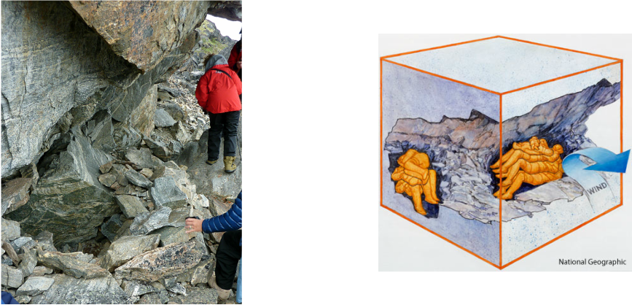
Fig.9. The Qilakitsoq Mummies burial site (left) and depiction of the sublimation effect

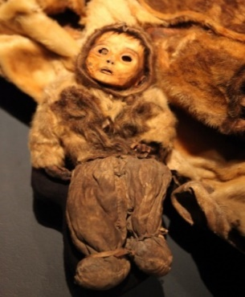
Fig.10. The six month old baby
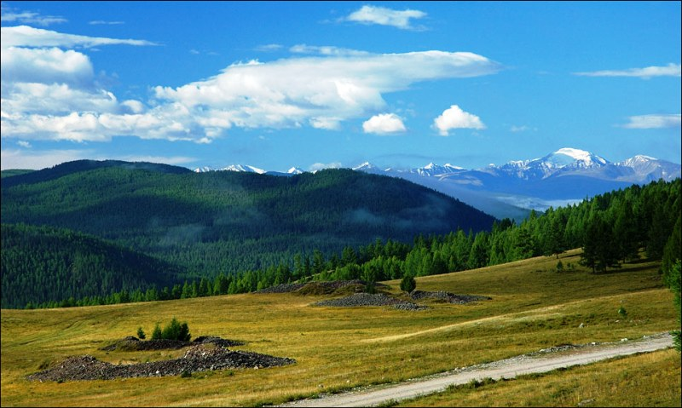
Fig.11. The Pazyryk Barrows along the Russian, Chinese and Mongolia borders

In 1924 Russia, in Russia’s Altai mountain’s, archaeologists discovered the Pazyryk barrows where bodies had been preserved in ice for over 2500 years. The permafrost of the region had kept the embalmed corpses preserved and frozen, throughout the summer months. ‘The Pazyryk barrows are a rare example of the deep-frozen preservation of a society’s normal burial practice’ (Chamberlain and Pearson, 2001, P. 133-142).

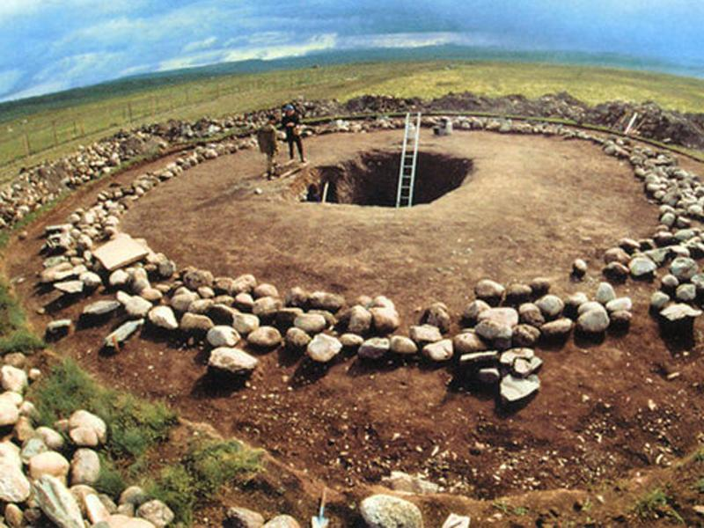
Fig.12. The Pazyryk Barrows deep burial - excavation

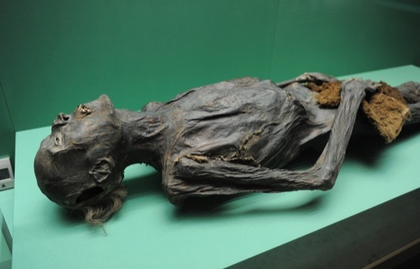
Fig.13. The Pazyryk Barrows - a preserved ice body

SELF-REFLECTION SHEET.

PLEASE COMPLETE BEFORE SUBMISSION AND ATTACH TO YOUR WORK

Date:27th March 2018 Module: Bio-Archaeology and Forensics AHAC5013 Name: Kenny Owen

Guidance: You might consider the following elements:

- Argument: does it have one/ is it backed by sufficient evidence/ how lucid is it?
- Structure: how clear is it /is my essay easy to follow/ does it help my argument?
- Analysis: is more/less analytical than narrative/ does it address the question?
- Reading: was this sufficiently broad/ have I referenced properly?
- How might I improve my performance in future?

Strengths

Enthusiasm

Weaknesses:

Wine
General Comments:
I struggle to understand the question fully, but, hey ho.
Please give a mark for your work: 69-60

(for eg: 1st = 70+: 2/1 = 69-60: 2/2 = 59-50: 3rd = 45-49: pass = 40-44: fail = 39- )

