

Strategic Management and Sustainability
Module code : LCBB6004
Lecturer : Hossein Shokri
Student name : Nikolay Petkov
Student id : 2011288

Table of Contents
Introduction 3
Business strategies of Volkswagen 4
Overview of Volkswagen's Key Business Strategies from 2017 to 2022 4
Analysis of Strategies using Porter's Generic Strategies 5
Discussion of Reasons for Pursuing or Changing Strategies: 7
Resources and capabilities of Volkswagen over the past five years 8
Identification of Volkswagen's Key Resources and Capabilities: 8
VRIO to evaluate Volkswagen's resources and capabilities: 9
Sustainability and Competitiveness at Volkswagen 11
Discussion of Volkswagen's initiatives and practices related to sustainability 11
Analysis of the impact of these initiatives on the company's competitiveness: 12
Recommendations 14
Use of frameworks to support the recommendations: 16
Conclusion 17
Reference 18

Introduction
When "defeat devices" were discovered in millions of Volkswagen diesel cars in 2015, the firm was shaken by a tremendous uproar. These devices are intended to assist vehicles pass emissions testing, but they actually allow for higher pollutant output. The scandal, dubbed "Dieselgate," had far-reaching effects, forcing the business to make significant changes to its economic goals and incur billions of dollars in fines and legal settlements. This report analyzes Volkswagen's company strategies, assets, and sustainability initiatives throughout the preceding five years (2017-2022). This study will enlighten readers on VW's most vital business strategies, and how well they fit with the company's existing strengths and shortcomings. Volkswagen's initiatives to increase competitiveness without compromising environmental or ethical standards will also be analyzed in the report. The study will also recommend other eco-friendly changes that will offer Volkswagen an advantage in the industry. The potential areas in which Volkswagen might improve its sustainability policy will be used to evaluate the benefits and risks of these ideas. Porter's Generic Strategies, Virtual Reality Implementation Organization, Triple Bottom Line, Sustainable Value Framework, and the circular economy will all be used as analytic and recommendation frameworks in the final report.

Business strategies of Volkswagen
Overview of Volkswagen's Key Business Strategies from 2017 to 2022
Volkswagen's performance from 2017-2022 may be attributed to the company's many strengths. These abilities and resources include, for instance:
- Strong brand reputation: Volkswagen is a well-known brand that many people have confidence in. It took years of hard work to earn this great reputation, but it has paid dividends in the form of new business and repeat customs.
- Skilled workforce: Volkswagen has a highly skilled workforce that can design and build innovative vehicles from the ground up (David Allen Aaker, 2020). The company invests much in its employees' education and growth so that they may perform their duties effectively.
- Advanced technology: Because it has access to cutting-edge technology, Volkswagen is able to produce state-of-the-art automobiles. The company is known for manufacturing high-performance, environmentally friendly vehicles including hybrids and electrics.
- Strong supply chain: Volkswagen is able to get reliable raw materials and components thanks to its efficient supply chain (Eldring, 2019). The company's ability to manufacture durable automobiles of the highest quality is guaranteed.
- Efficient manufacturing processes: Volkswagen's efficient assembly processes allow the corporation to produce cars at low cost. This allows the company to sell its wares at competitive prices without sacrificing quality.
For example, Volkswagen's great reputation is strongly linked to the success of the brand. In 2021, the corporation saw global sales of its vehicles rise by 12.4%, reaching a total of 9.9 million units (Lodge, 2022). This shows that customers have maintained their confidence in Volkswagen. The exceptional quality of the company's vehicles is mirrored in the company's commitment to employee growth. For example, Volkswagen's 2021 World Car of the Year award for the Golf exemplifies the company's inventive workforce and state-of-the-art technology.

Analysis of Strategies using Porter's Generic Strategies
Using Porter's Generic Strategies framework, one can analyze Volkswagen's fundamental business strategies through the lenses of cost leadership, differentiation, and focus, differentiate focus (Gavinelli, 2017). It seems that Volkswagen's primary differentiation strategy is the development of distinctly diverse products.
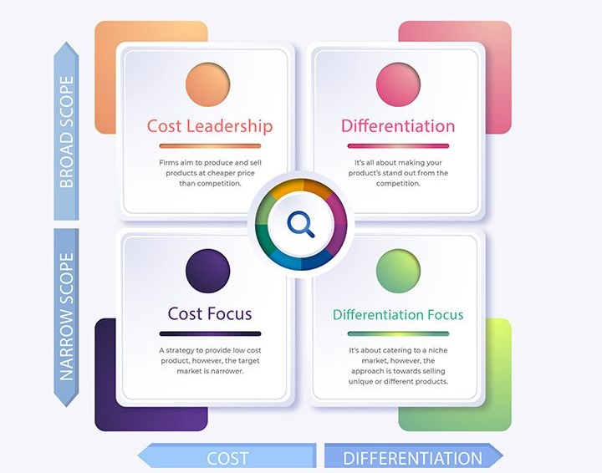
Figure 1 Porter’s generic strategies
Source: (Zhao, 2018).
Analysis of Strategies using Porter's Generic Strategies:
Cost leadership, differentiation, and focus are the three primary strategic alternatives that may be used to examine Volkswagen's core business strategies under Porter's Generic Strategies framework.
- Cost Leadership: Volkswagen has not pursued a "cost leadership" strategy in an effort to become the industry's cheapest supplier. Instead, they've dedicated themselves to delivering an excellent product or service.
- Product Differentiation: Volkswagen has been trying to distinguish itself from competitors by developing innovative new products (Ifedapo Adeleye and Esposito, 2020). There is an increasing number of electric vehicles on the market, and two that stand out in terms of functionality and style are the ID.4 and ID.3. Volkswagen's new digital offerings, such as the WeCharge app, offer users a number of benefits.
- Differentiation Focus: Volkswagen has been investing heavily in its brand, particularly in green initiatives and cutting-edge technology. The "New Volkswagen" branding campaign features not just the cutting-edge products of the corporation, but also its commitment to electrification and sustainability (Kess, Westlin and Commerce Clearing House, 2019). With the introduction of high-end models like the Touareg and Arteon, Volkswagen has positioned itself as a premium manufacturer.
- Focus: Volkswagen has not pursued a strategy of narrowing its client base in favour of catering to a larger pool of potential buyers.

Discussion of Reasons for Pursuing or Changing Strategies:
The transition that Volkswagen is making toward digitization and electrification is being driven by a number of different compelling reasons. To begin, worries about global warming and pollution may be seen as the root cause of the growing interest in environmentally friendly forms of transportation such as electric automobiles and other eco-friendly options (Porter Raymond Lee and American Association Of Social Workers, 2019). Second, emerging technologies are causing widespread disruption in the automotive sector, which presents both possibilities and challenges for well-established businesses like Volkswagen. Competition in the automobile sector is heating up as a result of Tesla and Chinese firms joining the market (Lodge, 2022). This is driving industry veterans like Volkswagen to upgrade their products or risk going out of business. During the course of the previous five years, Volkswagen has prioritized achieving its business objectives in the areas of electrification, digitization, operational simplicity, and international expansion. These programs are focused on making the firm more environmentally friendly and forward-thinking, with the eventual goal of differentiating it from its competitors. Both widespread trends and intensifying competition are driving the automobile sector toward greater use of digital technology and electrification of its processes.

Resources and capabilities of Volkswagen over the past five years

Identification of Volkswagen's Key Resources and Capabilities:
Volkswagen has been successful during the last five years thanks to the strength of its brand awareness, the breadth of its product range, the depth of its distribution system, and its innovative research and development. The commitment of the organization to both quality and innovation has resulted in a significant increase in brand recognition. The firm offers customers a diverse selection of automobiles, ranging from economy to high-end models and including both hybrid and electric variants (Rubalcaba-Bermejo and European Commission (Brussels, Dgiii, Industry, 2019). Volkswagen has manufacturing facilities in almost every country on the planet and maintains an extensive dealer network across the board. The areas of electric and driverless cars, as well as digital services, have received the majority of attention in terms of research and development.
The present commercial strategy of Volkswagen is in line with the company's significant investments in the technology behind driverless vehicles, electric cars, and digital services. In order for the corporation to make the shift from conventional internal combustion engines to electric and hybrid cars, it has had to make significant expenditures in research and development as well as production facilities (Zhao, 2018). Volkswagen's mission is to astonish its clientele with ground-breaking products and services; thus, the company has been investing extensively in cutting-edge digital services, such as the WeCharge mobile application.

VRIO to evaluate Volkswagen's resources and capabilities:
The VRIO framework is a useful tool for evaluating a company's assets and capabilities in terms of its value, uniqueness, stability, and adaptability. One set of criteria that may be used by Volkswagen to determine where it stands would be:

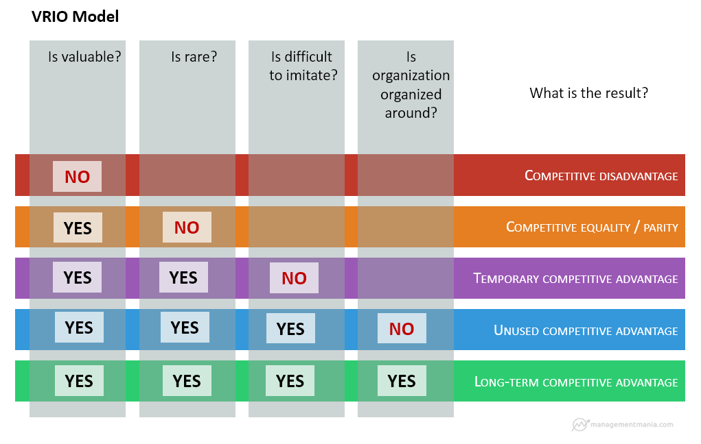
Figure 2 VRIO Model
Source: (Zhao, 2018).
Valuable: Volkswagen's strengths in the highly competitive car industry include a strong brand name, a large and diverse product range, a large distribution and manufacturing base, and strong research and development capabilities (Powalla and Bresser, 2017). Because of these advantages, Volkswagen is able to compete effectively and offer customers unique products and services.
Rare: Volkswagen has access to unique resources and expertise, especially in the areas of research and development for electric and autonomous vehicle technologies, making it a frontrunner in the industry. By investing so much, Volkswagen has an advantage over its competitors who have not.
Inimitable: Due to the high cost, it may be difficult to imitate Volkswagen's resources and capabilities, such as the company's manufacturing and distribution network (Powalla and Bresser, 2019). Competitors may easily replicate its success by copying its popular brand as well as its other assets and skills.
Organized: Volkswagen's focus on autonomous and electric vehicle technology, as well as digital services, is indicative of the company's ability to coordinate and integrate its many assets.
Volkswagen has competitive advantages due to the scarcity and high market value of its in-house resources. Even if some of its resources and abilities are hard to copy, the company will need to keep inventing and investing in new technology to maintain its competitive advantage.

Sustainability and Competitiveness at Volkswagen
In recent years, Volkswagen has made significant steps to boost its competitiveness while also making sustainability and environmental responsibility central tenets of the company's mission. The corporation has made the creation and distribution of EVs (electric cars) a priority as part of its efforts to reduce its environmental impact.

Discussion of Volkswagen's initiatives and practices related to sustainability
The automobile manufacturer Volkswagen has committed to the lofty goal of reaching carbon neutrality by the year 2050. The objective of the corporation is to manufacture 26 million electric vehicles by the year 2029 and to have a manufacturing method that is free of carbon emissions by the year 2050 (Zhao, 2018). In order to lessen the environmental impact of its current lineup of automobiles, Volkswagen is devoting its attention to the development of combustion engines that are more energy-efficient and is funding research into emerging technologies such as fuel cells. Because of the importance that Volkswagen places on being sustainable, the firm has made being environmentally friendly one of its primary objectives. The firm has installed solar panels at its manufacturing facilities and is acquiring renewable electricity from wind and hydroelectric power plants in order to lessen its impact on the environment and encourage the development of alternative energy sources. Additionally, Volkswagen has taken steps to lessen the toll its supply chain takes on the environment and its consumption of water.

Analysis of the impact of these initiatives on the company's competitiveness:
Volkswagen's sustainability initiatives may be evaluated using the TBL framework, which takes into account the company's financial performance, social effect, and ecological footprint. The TBL measures how an organization's activities affect the world around it.
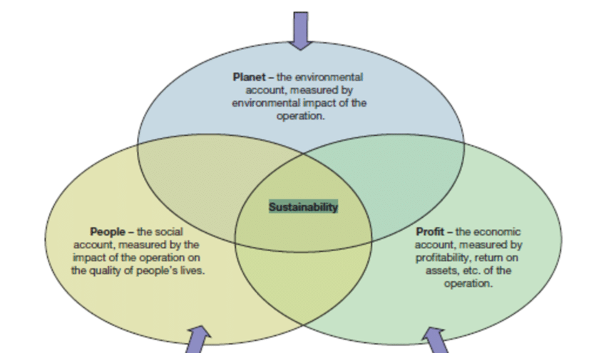
Figure 3 TBL framework
Source: (Bailey and Al, 2018)
Economic Impact: Volkswagen's commitment to sustainable mobility options has helped the corporation remain flexible in the face of a changing market. Volkswagen's investment in EVs has allowed the business to retain market share and even gain an advantage over traditional automakers who have been slower to adopt EV technology as the demand for green vehicles has grown (Cool and Woo, 2014). Volkswagen's brand image has been bolstered by the business's commitment to carbon neutrality and sustainability, which might help the company keep existing customers and attract new ones.
Social Impact: Volkswagen's commitment to environmental responsibility has paid dividends for the surrounding community in the shape of improved infrastructure and more employment opportunities. The company's commitment to mass-producing electric vehicles has spawned new job opportunities in related fields, such as battery and electric motor manufacturing. As part of its community development activities, Volkswagen has provided funding for local schools and invested in community infrastructure projects (Cornelis and Pearce, 2019).
Environmental Impact: Volkswagen's commitment to sustainability has had a significant positive impact on the environment. The company's increased manufacturing of electric vehicles and decreased emissions from its present fleet significantly contributed to the reduction of greenhouse gas emissions and the development of a more sustainable transportation system. Volkswagen's commitment to carbon neutrality and ecologically sound production techniques has helped lessen the automaker's impact on the planet and inspired the corporation to behave more responsibly.
Volkswagen's commitment to sustainability has had a positive impact on the company's bottom line, the economy, and the environment. By prioritizing sustainability and environmental responsibility, Volkswagen has pushed a more sustainable and responsible business strategy, enabling the firm to stay competitive in a dynamic market (David Allen Aaker, 2020). The corporation, however, will need to keep investing heavily in green practices and new technologies if it wants to remain competitive in the years to come.

Recommendations
Suggestions for enhancing Volkswagen's current environmental initiatives:
- Increase focus on renewable energy: Solar and wind power are two renewable energy sources that Volkswagen may employ more of to power its plants and charging stations. This would have the added benefit of decreasing the business' need for fossil fuels.
- Promote circular economy: Volkswagen is able to reduce waste and make better use of its resources by adopting the concepts of the circular economy. Goods would be designed with the aims of reusing and recycling components, reducing waste, and prolonging the lifespan of the product in mind.
- Enhance supply chain sustainability: Volkswagen may push its suppliers to reduce emissions and waste as part of an effort to promote sustainable business practices (Cool and Woo, 2014). The company might also look at using wood components used in car interiors that were harvested from legally protected forests.
- Expand electric vehicle offerings: Volkswagen can continue to meet customer demand for more sustainable transportation choices and reduce its carbon footprint by expanding investment in the study and production of electric vehicles. The company may consider investing in a better charging infrastructure to increase interest in EVs among customers.
- Implement sustainable packaging: Volkswagen can help the environment by using greener packaging materials. Reduced packaging and the use of recyclable or biodegradable materials are two such examples.

Benefits and risks of these recommendations:
By taking these recommendations into account, Volkswagen may be able to save money in the long run while also improving the brand's reputation among environmentally conscious customers. The implementation of sustainable practices may come with greater initial expenses, and suppliers may push back if they don't see sustainability as a priority.

Use of frameworks to support the recommendations:
The Sustainable Value Framework is a useful tool for evaluating the economic, societal, and environmental impacts of Volkswagen's sustainability initiatives. To maximize the positive effects of its environmental initiatives, Volkswagen may use this practice. Volkswagen may gain a competitive advantage while also positively impacting society and the environment if it focuses on long-term value creation.
This section of the Sustainable Value Framework focuses on the monetary benefits of being environmentally responsible. Volkswagen may create economic value by decreasing costs via resource efficiency, increasing revenues through the development of environmentally friendly products and services, and fortifying the company's brand and the loyalty of its client base (A, Williamson Steven A and Babson, 2018). The company may, for instance, invest in renewable energy to reduce energy costs and increase energy independence, or it could come up with financially viable, environmentally responsible solutions to transportation.
Social effect analysis of Volkswagen's sustainability activities is included in the Sustainable Value Framework. Volkswagen may create social value by promoting social justice and fairness, investing in local communities, and improving the well-being of its stakeholders. Collaboration with local organizations may help sustain development and enhance communities, while investing in renewable energy and electric vehicles may reduce the company's influence on the environment and the public's health (Bailey and Al, 2018).
The Sustainable Value Framework's environmental indicator looks at how Volkswagen's sustainability activities affect the environment (Best, Waller and Columbia, 2017). Volkswagen may have a positive impact on the environment by reducing carbon emissions, increasing recycling, and minimizing pollutants. To reduce its carbon footprint and resource consumption, the company may, for example, use circular economy principles to reduce waste and increase resource efficiency, or it could invest in renewable energy, electric vehicles, and sustainable materials.

Conclusion
Volkswagen's "dieselgate" scandal resulted in monetary penalties, damage to the company's reputation, and heightened attention from regulators, among other negative results. In an effort to address the issue, the company has made management changes, reimbursed affected customers, and shifted its focus to sustainability and electric vehicles. This report summarizes Volkswagen's key business strategy, resources, competencies, and sustainability policies and makes suggestions for the company's future success. We used many models, including Porter’s Generic Strategies, VRIO, the Triple Bottom Line, and the Sustainable Value Framework, to perform a SWOT analysis of the organization. Volkswagen has shown a dedication to sustainability and competitiveness; if it continues to strive to improve its practices, it may not only recover from the "dieselgate" crisis but also return to its position as a market leader.

Reference
A, C., Williamson Steven A and Babson, H.C. (2018). Business policy and strategy : the art of competition. Boca Raton, Fl: Auerbach Publications.
Bailey, J.M. and Al, E. (2018). Modern competitiveness in the twenty-first century: global experiences. Lanham, Md.: Lexington Books.
Best, T., Waller, F. and Columbia, B. (2017). Business strategies. Vancouver: British Columbia Association Of Magazine Publishers.
Cool, K.O. and Woo, C.Y. (2014). Porter’s (1980) generic competitive strategies : a test of performance and functional strategy attributes. West Lafayette, Ind.: Institute For Research In The Behavioral, Economic, And Management Sciences, Krannert Graduate School Of Management, Purdue University.
Cornelis and Pearce, J.A. (2019). Strategy : a view from the top (an executive perspective). Upper Saddle River, N.J.: Pearson/Prentice Hall.
David Allen Aaker (2020). Developing business strategies. New York: John Wiley And Sons Ltd.
Eldring, J. (2019). Porter’s (1980) generic strategies, performance and risk : an empirical investigation with German data. Hamburg: Diplomica-Verl.
Gavinelli, L. (2017). Business strategies and competitiveness in times of crisis : a survey on Italian SMEs. London: Palgrave Macmillan.
Ifedapo Adeleye and Esposito, M. (2020). Africa’s competitiveness in the global economy. Basingstoke, Hampshire: Palgrave Macmillan.
Kess, S., Westlin, B. and Commerce Clearing House (2019). Business strategies. Chicago, Ill.: Commerce Clearing House.
Lodge, G.C. (2022). Perestroika for America : restructuring U.S. business-government relations for competitiveness in the world economy. Boston, Mass.: Harvard Business School Press.
Porter Raymond Lee and American Association Of Social Workers (2019). Social case work, generic and specific; an outline. New York, American Association Of Social Workers.
Powalla, C. and Bresser, R.K.F. (2017). Can ignorance beat the resource based view? comparing the vrio framework to the recognition heuristic. Berlin Freie Univ.
Powalla, C. and Bresser, R.K.F. (2019). Performance forecasts in uncertain environments examining the predictive power of the VRIO-framework. Berlin Freie Univ.
Rubalcaba-Bermejo, L. and European Commission (Brussels, Dgiii, Industry (2019). Business services in European industry : growth, employment and competitiveness. Luxembourg: Office For Official Publications Of The European Communities.
Zhao, F. (2018). Information technology entrepreneurship and innovation. Hershey Pa: Information Science Reference.

