
APPENDIX GA36c

LEVEL 6 ASSESSMENT SPECIFICATION

 | Student name: | Steph Challenger | Student ID number: | 133155
 | Programme:
 | Module: | Data Warehousing and Data Mining
 | Module code: | ACCA6026 | Contribution to Overall Module Assessment (%): | 50%
 | Lecturer: | John Williams | Internal Verifier: | Bev Holland
 | Assignment Title: | Data Warehousing | Word count (or equivalent): | 3000
 | Submission deadline: | 28th January 2022 | Return date of provisional marks & written feedback: | 25th February 2022
 | Submission method: | All written assessments, where practical and possible, must be submitted via Turnitin unless otherwise instructed by the Lecturer. (Please DO NOT put this assessment specification into Turnitin or it will match many similarities with other students’ submissions.)  Alternative submission method (if applicable):  Late submission of the assessment will result in a late penalty mark. Penalties for late submission: Up to one week late, maximum mark of 40%. Over one week late, 0%. Only the Extenuating Circumstances Panel may approve a change to submission dates.
 | Academic honesty / referencing: | Academic honesty is required. In the main body of your submission you must give credit to authors on whose research and ideas your work is based. Append to your submission a reference list that indicates the books, articles, etc. that you have used, cited or quoted in order to complete this assessment.
Module Learning Outcomes (from module syllabus)
Upon the successful completion of this module, the student should be able to:
- Analyse critically the structure, capabilities and role of a data warehouse within a modern business environment.
- Select and perform appropriate data analysis and reporting on data within a data warehouse environment and critically evaluate the results
- Provide business intelligence through the creative application of appropriate data mining processes and the critical evaluation of their results.

TASK DESCRIPTION

Task 1 (100%)
Analyse the Blood Transfusion Service Centre Data Set (available from the UCI Machine Learning Repository at https://archive.ics.uci.edu/ml/datasets/Blood+Transfusion+Service+Center) to classify the different groups of blood donors into groups based upon when they first and last gave blood, how often they have given blood and how much blood they have donated overall and to predict which of these groups are more likely to give blood in future.

Once you have completed this, write a report to describe the dataset and its context, and explore in detail the analyses you have performed and the results you have discovered. You should finish by making appropriate business recommendations on how these results might be used.

Your report should include:
- A brief explanation of the purpose and practice of data mining and how it can be used in business | (10 marks)
- A data set description in terms of the attributes present in the data, the number of instances, missing values, and other relevant characteristics. You should also include a summary of the results of your data familiarisation, exploration and visualisation process | (15 marks)
- A description of the pre-processing and post-processing of your data. You should include both primary and secondary pre-processing needed to perform the analyses, together with any postprocessing required to prepare the results for reporting. | (25 marks)
- Appropriate sample runs and results, together with an explanation of why you have chosen the analysis methods used. | (30 marks)
- A set of business recommendations based upon your findings. | (10 marks)
- A reflective commentary discussing the following:  - Does it work well (e.g., accuracy, efficiency)?  - What do you think are the advantages/disadvantages?  - If you were to do it again, what would you do differently? | (10 marks)

The report should be no more than 3000 words long and should include such graphics as are appropriate to illustrate your answers.

GUIDANCE FOR STUDENTS IN THE COMPLETION OF TASKS

NOTE: The guidance offered below is linked to the five generic assessment criteria overleaf.

1. Engagement with Literature Skills
Your work must be informed and supported by scholarly material that is relevant to and focused on the task(s) set; you should make use of scholarly reviews and primary sources, where appropriate (for example, refereed research articles and/or original materials appropriate to the discipline). You should provide evidence that you have accessed a wide range of sources, which may be academic, governmental and industrial; these sources may include academic journal articles, textbooks, current news articles, organisational documents, and websites. You should consider the credibility of your sources; academic journals are normally highly credible sources while websites require careful consideration/selection and should be used sparingly. Any sources you use should be current and up-to-date, mostly published within the last five years or so, though seminal/important works in the field may be older. You must provide evidence of your research/own reading throughout your work, using a suitable referencing system, including in-text citations in the main body of your work and a reference list at the end of your work.

Guidance specific to this assessment: This will be most evident in the description of how data mining is used, although it may also be useful when you are justifying your choice of analysis approaches.

2. Knowledge and Understanding Skills
At level 6, you should be able to demonstrate coherent and detailed knowledge and a systematic understanding of the subject area, at least some of which is informed by the latest research and/or advanced scholarship within the discipline. You should be aware of the uncertainty, ambiguity and limits of knowledge. Your work must demonstrate the growing extent of your knowledge and systematic understanding of concepts and underlying principles associated with the subject area. Knowledge relates to the facts, information and skills you have acquired through your learning. You demonstrate your understanding by interpreting the meaning of the facts and information (knowledge). This means that you need to select and include in your work the concepts, techniques, models, theories, etc. appropriate to the task(s) set. You should be able to explain the theories, concepts, etc. meaningfully to show your understanding. Your mark/grade will also depend upon the extent to which you demonstrate your knowledge and understanding; ideally each should be complete and detailed, with comprehensive coverage.

Guidance specific to this assessment: This relates to your understanding of the appropriate tools and techniques to use for this task. What are the industrial standard methods for this type of problem?

3. Cognitive and Intellectual Skills
You should be able to: critically evaluate evidence, arguments, assumptions, abstract concepts and data some of which are at the forefront of a discipline (and that may be incomplete) to devise and sustain arguments, to make judgements and/or solve problems; describe and comment upon particular aspects of current research, or equivalent advanced scholarship, in the discipline Your work must contain evidence of logical, analytical thinking, evaluation and synthesis. For example, to examine and break information down into parts, make inferences, compile, compare and contrast information. This means not just describing what! But also justifying: Why? How? When? Who? Where? At what cost? At all times, you must provide justification for your arguments and judgements. Evidence that you have reflected upon the ideas of others within the subject area is crucial to you providing a reasoned and informed debate within your work. Furthermore, you should provide evidence that you are able to make sound judgements and convincing arguments using data and concepts. Sound, valid conclusions are necessary and must be derived from the content of your work. Where relevant, alternative solutions and recommendations may be proposed.

Guidance specific to this assessment: Once you have some results you will have to evaluate them to see if they are relevant, interesting and useful. How could your findings be used by an organisation in the appropriate sector?

4. Practical Skills
At level 6, you should be able to apply the methods and techniques that you have learned to review, consolidate, extend and apply your knowledge and understanding, and to initiate and carry out projects. You will deploy accurately established techniques of analysis and enquiry relevant to the discipline, and apply them in complex and unpredictable contexts, to devise and sustain arguments and/or to solve problems. You should be able to frame appropriate questions to achieve a solution - or identify a range of solutions. You should be able to demonstrate how the subject-related concepts and ideas relate to real world situations and/or a particular context. How do they work in practice? You will deploy models, methods, techniques, and/or theories, in that context or circumstances, to assess current situations, perhaps to formulate plans or solutions to solve problems, or to create artefacts, some of which may be innovative and creative. This is likely to involve, for instance, the use of real world artefacts, examples and cases, the application of a model within an organisation and/or benchmarking one theory or organisation against others based on stated criteria. You should show awareness of the limitations of concepts and theories when applied in particular contexts.

Guidance specific to this assessment: What tools and techniques will you use for this? Make sure that you describe what you have done; although there is no need for step-by-step screenshots of your processing and analysis sections you should be able to describe and justify your choices with appropriate illustrations.

5. Transferable Skills for Life and Professional Practice
Your work must provide evidence of the qualities and transferable skills necessary for graduate-level employment requiring the exercise of initiative and personal responsibility and decision-making in complex and unpredictable circumstances. This includes demonstrating: the learning ability for professional development to advance existing skills and acquire new competences of a professional nature that will enable you to assume significant responsibility within organisations; that you can initiate and complete tasks and procedures, whether individually and/or collaboratively; that you can use appropriate media to effectively communicate information, arguments and analysis in a variety of forms to specialist and non-specialist audiences; fluency of expression; clarity and effectiveness in presentation and organisation. Work should be coherent and well-structured in presentation and organisation.

Guidance specific to this assessment: Structure your work on a standard industrial process for data mining. Ensure that your final recommendations are presented in a manner that is suitable for a management team, not for a data mining team.

STUDENT FEEDBACK FORM

This section details the extent to which the assessment criteria are demonstrated by you, which in turn determines your mark. The marks available for each category of skill are shown. Lecturers will use the space provided to comment on the achievement of the task(s), including those areas in which you have performed well and areas that would benefit from development/improvement.

Generic Assessment Criteria | Marks  available | Marks  awarded
1. Engagement with Literature Skills
.
Sections 1, 4  Engagement with an extensive range of relevant and credible literature, informed by the latest research. Consistently accurate application of referencing. | 10 | 7
2. Knowledge and Understanding Skills

Sections 2, 3  Knowledge is reasonably extensive coherent and detailed. Exhibits very good understanding of the breadth and depth of established views, and the work informed by current research and scholarship. | 15 | 10.5
3. Cognitive and Intellectual Skills

Sections 3.5  Sound critical thinking, analysis, synthesis and evaluation. Ability to investigate contradictory or incomplete information and make strong, persuasive, arguments and good judgements. Evidence of independent thought and ability to ‘see beyond the question’, suggesting a grasp of the broader field and wider concepts | 25 | 17.5
4. Practical Application Skills

Section 3, 4  An advanced application of a range of methods, tools and techniques. The context of the application is well considered, and insightful. Can identify complex problems and propose good solutions. Innovation and creativity evident. | 35 | 25
5. Transferable Skills for Life and Professional Practice

Sections 5, 6  Can communicate professionally confidently and consistently in a suitable format. Work is coherent, very fluent and is presented Professionally. Can work autonomously with initiative. Demonstrates excellent graduate employment skills and an appetite for further development | 15 | 11

Assessment Mark (Assessment marks are subject to ratification at the Exam Board. These comments and marks are to give feedback on module work and are for guidance only until they are confirmed. ) | Late Submission Penalties (tick if appropriate) |  | 71%
 | Up to 1 week late (40% Max) |  | 71%
 | Over 1 week late (0%) |  | 71%

GENERIC ASSESSMENT CRITERIA
Level 6
In accordance with the Framework for Higher Education Qualifications, at the end of Level 6 students should have coherent and detailed knowledge and a systematic understanding of their subject area, at least some of which is informed by the latest research and/or advanced scholarship within the discipline. They will be able to accurately deploy established techniques of analysis and enquiry within a discipline, using their conceptual understanding to devise and sustain arguments and/or to solve problems. They should be aware of the uncertainty, ambiguity and limits of knowledge. They should be able to critically evaluate evidence, arguments, assumptions, abstract concepts and data (that may be incomplete), to make judgements, and to frame appropriate questions to achieve a solution - or identify a range of solutions. They will apply the methods and techniques that they have learned to review, consolidate, extend and apply their knowledge and understanding, and to initiate and carry out projects. They will have the ability to manage their own learning, and to make use of scholarly reviews and primary sources (for example, refereed research articles and/or original materials appropriate to the discipline). They will demonstrate the qualities and transferable skills necessary for employment requiring: the exercise of initiative and personal responsibility; decision-making in complex and unpredictable contexts; the learning ability needed to undertake appropriate further training of a professional or equivalent nature.

Level 6 | FAIL | MARGINAL FAIL | SATISFACTORY  (3rd / Pass) | GOOD  (2.2 / Pass) | VERY GOOD  (2.1 / Merit) | EXCELLENT  (1st / Distinction) | EXCEPTIONAL  (1st / Distinction)
Category | 0-29% | 30-39% | 40-49% | 50-59% | 60-69% | 70-84% | 85-100%
Engagement  with literature  (including reading,  referencing, academic conventions and academic honesty) | Little or no evidence of reading and/or reliance on inappropriate sources. Views and findings mostly unsupported and nonauthoritative. Referencing conventions used incoherently or largely absent. | Poor engagement  with essential reading. No evidence of wider reading. Reliance on inappropriate sources, and/or indiscriminate use of sources. Heavily reliant on information gained through class contact. Inconsistent and weak use of referencing. | Engagement with a limited range of mostly relevant and credible sources. Some omissions and minor errors.  Referencing conventions evident though not always applied accurately or consistently. | Engagement with an appropriate range of researchinformed  literature, including sources retrieved independently. Some over-  reliance on texts. Referencing may show minor inaccuracies or inconsistencies. | Engagement with a wide range of researchinformed  literature, including sources retrieved independently. Selection of relevant and credible sources. Very good use of referencing, with no/very few inaccuracies or inconsistencies. | Engagement with an extensive range of relevant and credible  literature, informed by the latest research. Consistently accurate application of referencing. | Exceptional engagement with an extensive range of relevant and credible  literature, informed by the latest research. High-level referencing skills consistently and professionally applied.
Knowledge and understanding  (Coherent and detailed | Major gaps in knowledge and systematic understanding of the subject | Gaps in knowledge, with only superficial systematic understanding. | Limited knowledge and systematic understanding of the relevant | Knowledge is reasonably detailed, accurate with a good systematic | Knowledge is reasonably extensive coherent and detailed. | Excellent coherent and detailed knowledge and systematic | Exceptionally coherent and detailed knowledge and systematic

Level 6 | FAIL | MARGINAL FAIL | SATISFACTORY  (3rd / Pass) | GOOD  (2.2 / Pass) | VERY GOOD  (2.1 / Merit) | EXCELLENT  (1st / Distinction) | EXCEPTIONAL  (1st / Distinction)
Category | 0-29% | 30-39% | 40-49% | 50-59% | 60-69% | 70-84% | 85-100%
knowledge and systematic understanding of the subject area, at least some of which is informed by the latest research and/or advanced scholarship within the discipline.) | matter. Substantial inaccuracies. No awareness of knowledge of the latest research and/or advanced scholarship within the discipline. | Some significant inaccuracies and/or irrelevant material. No awareness of knowledge of the latest research and/or advanced scholarship within the discipline. | concepts and principles within the subject area which to some  limited extent, is informed by current research and scholarship. | understanding of  the field of study and to some extent, current research and scholarship. | Exhibits very good understanding of the breadth and depth of established views, and the work is, at least in part, wellinformed by current research and scholarship. | understanding of the principles and theories of current research and scholarship. Clear awareness of challenges to established views and the limitations of the knowledge base. | understanding of the principles and theories of the subject, wellinformed by current research and scholarship. A critical, sophisticated and nuanced awareness of the ambiguities and limitations of knowledge.
Cognitive and intellectual skills  (Conceptual and  critical thinking, analysis, synthesis and evaluation of research, assumptions, abstract concepts  and data (that  may be  incomplete); logic, argument and judgement.) | Wholly or almost wholly descriptive work. Little or no analysis, synthesis or evaluation. Failure to develop arguments, leading to illogical or invalid judgements. Unsubstantiated generalisations, made without use of any credible evidence. | Largely descriptive work, with superficial use of critical evaluation.  Weak development of arguments and judgements. Information accepted uncritically, uses generalised statements made with scant evidence and unsubstantiated opinions. Ideas  sometimes  illogical and contradictory. | Limited attempt  at critical thinking, analysis, synthesis and evaluation, tending towards description.  Some evidence to support emerging arguments and judgements but these may be  underdeveloped  or with a little inconsistency / misinterpretation. Asserts rather than argues a case. | Some critical thinking, analysis, synthesis and evaluation. Can analyse new and/or abstract concepts and data without guidance. An emerging awareness of different stances and ability to use evidence (that may be incomplete) to support the argument. Mostly valid arguments and  logical judgements. Some tendency to assert/state opinion rather than argue on | Sound critical thinking, analysis, synthesis and evaluation demonstrating critical thinking. Ability to devise and sustain persuasive arguments, and  to review the  reliability, validity and significance  of evidence (that may be incomplete) to make mostly appropriate and valid judgements. | Excellent critical thinking, analysis, synthesis and evaluation. Ability to investigate contradictory or incomplete information and make strong, persuasive, arguments and sophisticated judgements. Some evidence of independent thought and  ability to ‘see beyond the question’, suggesting a grasp of the broader field and wider concepts. | Exceptional  critical thinking, analysis, synthesis and evaluation based on judiciously selected evidence. Ability to investigate contradictory or incomplete information and make strong, persuasive, arguments and sophisticated, nuanced, judgements. Evidence of independent thought and  ability to ‘see beyond the question’, suggesting an outstanding

Level 6 | FAIL | MARGINAL FAIL | SATISFACTORY  (3rd / Pass) | GOOD  (2.2 / Pass) | VERY GOOD  (2.1 / Merit) | EXCELLENT  (1st / Distinction) | EXCEPTIONAL  (1st / Distinction)
Category | 0-29% | 30-39% | 40-49% | 50-59% | 60-69% | 70-84% | 85-100%
 |  |  |  | the basis of reason and evidence. |  |  | grasp of the broader field and wider concepts.
Practical skills  (Apply/deploy accurately established tools and techniques; initiate and carry out projects; formulate solutions to solve problems in complex and unpredictable contexts.) | Limited or no use of methods, materials, tools and/or techniques. Little or no appreciation of the context of the application. Limited understanding of the application of theory to practice or making appropriate links between the two. Very weak problem-solving skills in complex and unpredictable contexts. | Rudimentary application of methods, materials, tools  and/or techniques but without consideration and competence. Flawed appreciation of the context of the application.  Weak  understanding of the application of theory to practice, with only occasional evidence of making appropriate links between the two. Weak problemsolving skills in complex and unpredictable contexts. | An adequate awareness and mostly appropriate application of well-established methods, materials, tools and/or techniques. Basic appreciation of the context of the application. Theoretical knowledge and understanding applied in practice, but not always making  logical links between the two. Can identify problems and propose basic solutions in complex and unpredictable contexts without fully appreciating the complexity. | A good and appropriate application of standard methods, materials, tools and/or techniques. Clear appreciation of the context of the application. Mainly consistent, accurate and logical application of theory to practice, making appropriate links between the two Can identify problems and propose mostly appropriate solutions in complex and unpredictable contexts. | A very good application of a range of methods, materials, tools and/or techniques. Very good consideration of the context of the application, with perceptive insights. Can identify problems and propose appropriate solutions in complex and unpredictable contexts. Evidence of some innovation and creativity. | An advanced  application of a range of methods, materials, tools and/or techniques. The context of the application is well considered, and insightful. Application and deployment extend beyond established conventions. Can identify complex problems and propose excellent solutions. Innovation and creativity evident. | Exceptional levels of application and  deployment  skills in unpredictable, practical contexts, drawing skilfully on the latest research within the discipline. Can identify complex problems and propose sophisticated solutions. Assimilation and development of cutting edge processes and techniques.
Transferable  skills for life and professional practice (Exercise of initiative and | Communication medium is inappropriate or misapplied. Work is poorly structured, disorganised | Communication medium is poorly designed and/or not suitable for the audience. Work is poorly presented in a | Can communicate in a suitable medium but with some room for improvement. | Can communicate  effectively in a suitable format, but may have minor errors. | Can communicate  well, confidently and consistently in a suitable format. | Can communicate  professionally confidently and consistently in a suitable format. | Can communicate with an exceptionally high level of professionalism.

Level 6 | FAIL | MARGINAL FAIL | SATISFACTORY  (3rd / Pass) | GOOD  (2.2 / Pass) | VERY GOOD  (2.1 / Merit) | EXCELLENT  (1st / Distinction) | EXCEPTIONAL  (1st / Distinction)
Category | 0-29% | 30-39% | 40-49% | 50-59% | 60-69% | 70-84% | 85-100%
personal responsibility; professional development; initiate and complete tasks and procedures: individually and/or collaboratively; use appropriate media to communicate  effectively; fluency of expression; clarity and effectiveness in presentation and organisation.) | and/or confusingly expressed. Very weak use of language and/or very inappropriate  style. Little or no evidence of autonomy (or collaboration, where relevant) in the completion of tasks. Little or  no evidence of the skills required in graduate employment. | disjointed manner. It is loosely, and at times incoherently, structured, with information and ideas often poorly expressed. Weak use of language and/or inappropriate style. Weak independent  initiative (or collaboration, if relevant). Limited evidence of the skills required in graduate employment. | Mostly ordered presentation and structure in which relevant ideas / concepts are reasonably expressed. Work may lack coherence in places. Can work as part of a team, but with  limited involvement in group activities. Demonstrates  the basic skills required in graduate employment, with some areas  of minor weakness. | Mostly coherent, organised work, in a suitable structure and is for the most part clearly expressed. Can work effectively independently and/or as part of a team, with clear contribution to group activities. Demonstrates  the skills required in graduate employment, with some areas of strength and some of minor weakness. | Work is coherent, fluent, well-structured and organised. Can work very well autonomously and/or as part of a team, with very good  contribution to group activities. Demonstrates very good graduate employment  skills, with just occasional minor weakness. | Work is coherent, very  fluent and is presented professionally. Can work autonomously with initiative. Where relevant can work professionally within a team,  showing  leadership skills  as appropriate, managing  conflict and meeting obligations.  Demonstrates excellent graduate employment skills and an appetite for further development. | Work is exceptionally coherent, very fluent and is presented professionally. Can work exceptionally well and professionally within a team, showing advanced leadership skills. Demonstrates exceptional graduate  employment skills and an appetite for further development.

THIS DOCUMENT IS ALSO AVAILABLE IN WELSH



Data Mining





Student Name: Steph Challenger (133155)
Supervised by: John Williams
Date: 28/1/22

Contents
Data Mining 3
Dataset description 4
Pre-processing and Post-processing 5
Classification and J48 tree 7
Sample Runs and Results 10
Classifiers 10
Clusters 15
Business Recommendations 17
Reflection 18
References 19

Data Mining

Companies utilise data mining to transform raw data into meaningful information. Businesses will learn more about their users by employing software to search for trends in large amounts of data. This allows them to build better marketing strategies, improve sales, and cut expenses. To be successful, data mining requires effective data collecting, warehousing, and computer processing, as well as machine learning and other kinds of artificial intelligence (AI) to be able to uncover patterns that lead to insights or predictions from even the most unstructured or massive data sets. ^{[1]}
There are five steps in the data mining process. Organizations begin by gathering data and loading it into data warehouses. The data is then stored and managed, either on-premises or in the cloud. Data is accessed by business analysts, management teams, and information technology specialists, who then decide how to arrange it. The data is then sorted by application software depending on the user's responses, and the data is eventually presented in an easy-to-share format, such as a table or graph, by the end-user. ^{[1]}
With platforms like Twitter and Facebook, social media has proven to be among the most profitable uses of data mining. They collect vast amounts of data about individual users in order to draw assumptions about their interests and provide tailored marketing advertisements. Most industries, such as the financial industry, can benefit from data mining, using it to explore market patterns, while governments use it to uncover possible security risks. ^{[1]}
Simply put, in businesses, data mining is utilised to answer queries that were previously too time consuming to answer. They explore databases for hidden patterns, uncovering predicting data that specialists may overlook because it falls outside of their usual scope. It enables them to make informed and proactive decisions. The information can be used to cut costs, increase revenue, reduce risks and improve customer relationships. ^{[1]}

Dataset description

The data is collected from the blood transfusion service center in Hsin-Chu City located in Taiwan. ^{[2]}
There are 748 number of instances with 500 selected at random as the training set and 248 as the testing set. The data has 5 attributes with no missing data. The data is described in the table below. ^{[2]}

Attribute Name | Data Type | Range of values  (Min – Max) | Missing | Mean | StdDev | Description
Recency | Numeric | 0 – 74 | 0 | 9.74 | 8.07 | Months since last donation ^{[2]}
Frequency | Numeric | 1 - 50 | 0 | 5.51 | 5.84 | Total number of donation ^{[2]}
Monetary | Numeric | 250 – 12500 | 0 | 1378.68 | 1459.83 | Total blood donated in c.c. ^{[2]}
Time | Numeric | 2 - 98 | 0 | 34.42 | 24.32 | Months since first donation ^{[2]}
Donated | Numeric | 0 – 1 | 0 | 0.238 | 0.426 | A binary variable representing whether he/she donated blood in March 2007 (1 stands for donating blood and 0 stands for not donating blood) ^{[2]}

StdDev = Standard Deviation

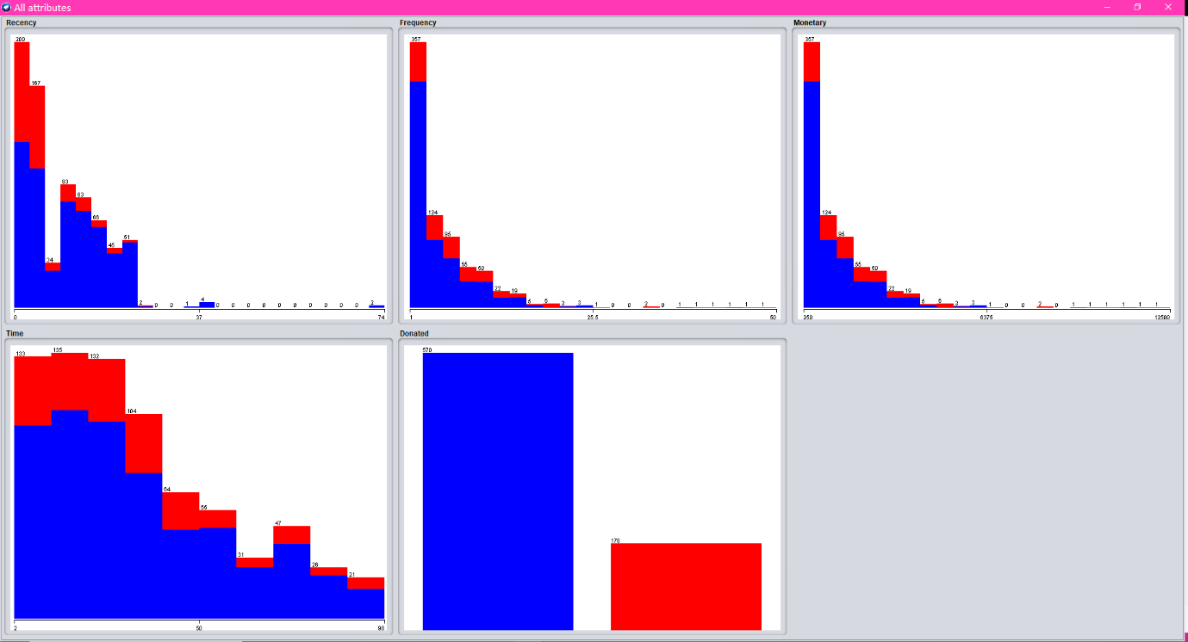
This data is put into weka where all the attribute graphs can be visualised in one window:

The graphs are to visualise the number of instances, for example, with the donated attribute bar chart, there are 570 instances for not donating blood indicated with the colour blue and 178 instances for donating blood indicated with the colour red. These also show the first few months were the more popular for people donating blood, the recency chart shows the first 2 months were the highest where people last donated and the time chart shows the first 4 months were the highest when people first donated.

Pre-processing and Post-processing

The transfusion.data file has been converted into an arff file.
Below is the original file type:
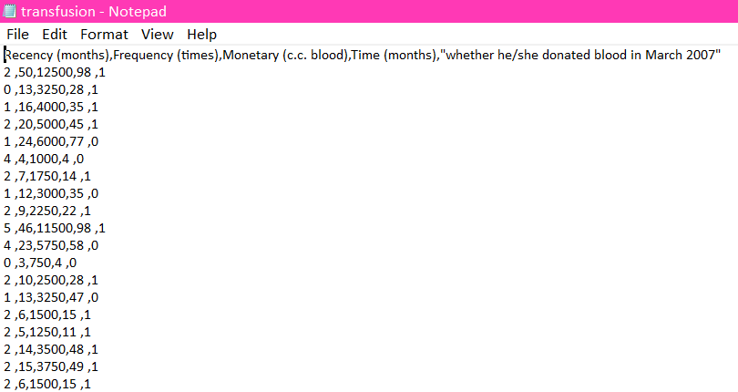

That file gets converted into an excel spreadsheet by saving the original file as ‘transfusion.csv’. The excel spreadsheet, .csv version is displayed below:
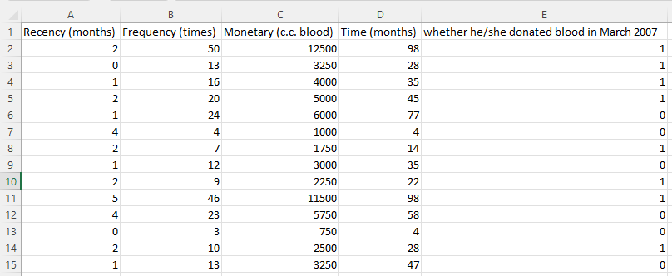

The attribute names have been shortened:
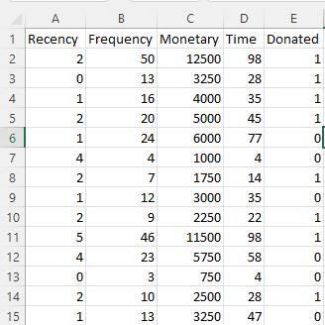

The .csv file type can then be converted into an arff file through Weka.
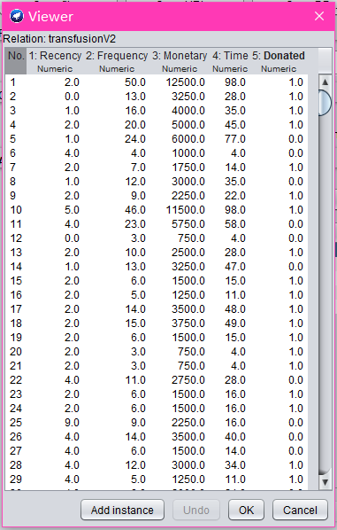

To be able to run the J48 tree, the donated attribute data type needed to be changed from numeric to nominal. In the viewer above, under each attribute name states their data type where they are all numeric. Below shows the donated attribute has been changed to nominal:
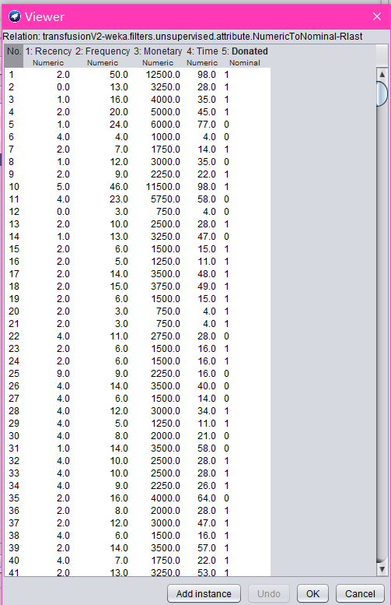

Classification and J48 tree

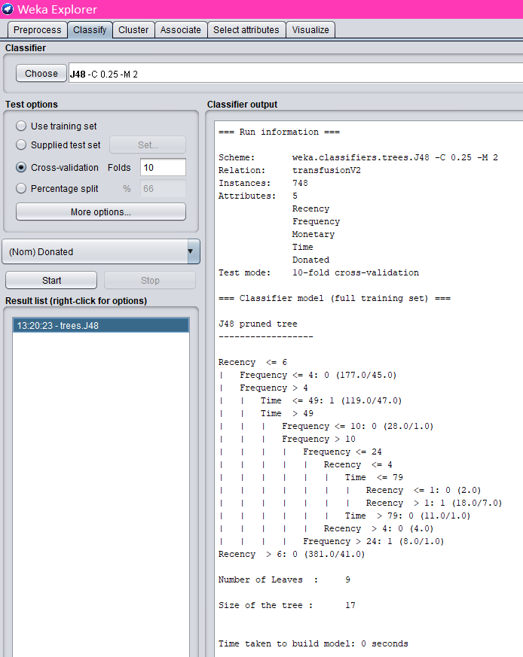

The classifier output box is where the predictions have been made by evaluating the provided input attributes. The scheme is what has been used: Weka, the classifier and the J48 decision tree. It provides the relation, which is the file name, the number of instances, which in this case is 748, the number of attributes and the names of the attributes, as well as the test mode, which is 10-fold cross-validation. The cross-validation divides the data set into 10 parts using 9 parts for training and reserving one part for testing, this gets repeated 10 times reserving a different one for testing.
It then shows it has used the pruned tree option, along with the IF statement (this is explained further down under the decision tree visualisation), the number of leaves, the size of the tree and the time it took to build the model. Pruning provides fewer and easier to understand outcomes. The number of leaves corresponds to the number of terminal nodes (those without branches). In the Weka tree diagram, they are represented by rectangles. The total number of nodes in the tree which includes both terminal and nonterminal nodes, determines the tree’s size. ^{[3]}

Further down the classifier output, below the ‘time taken to build the model’ is the summary:

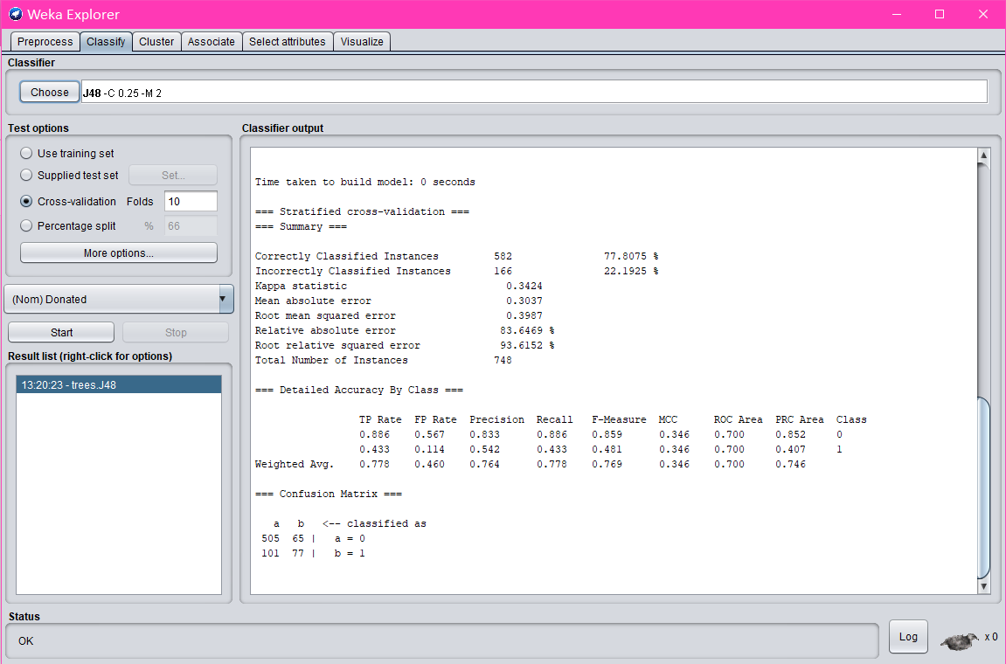

The first part is the correctly classified instances, which totalled 582 out of 748, giving a 77 percent accuracy rate. This leaves 166 instances incorrectly classified with a 22 percent inaccurate rate.
At the bottom is the confusion matrix that reports the correct and incorrect instances. The row indicates the true class, the column indicates the classifier output. It shows 505 a’s were correctly classified as a’s and 77 b’s were correctly classified as b’s but 101 b’s were incorrectly classified as a’s and 65 a’s were incorrectly classified as b’s. As a result, all correct classifications are on the top-left to bottom-right diagonal. Everything off that diagonal is an incorrect classification of some sort. ^{[3]}
The next step is to look at the tree visualizer:
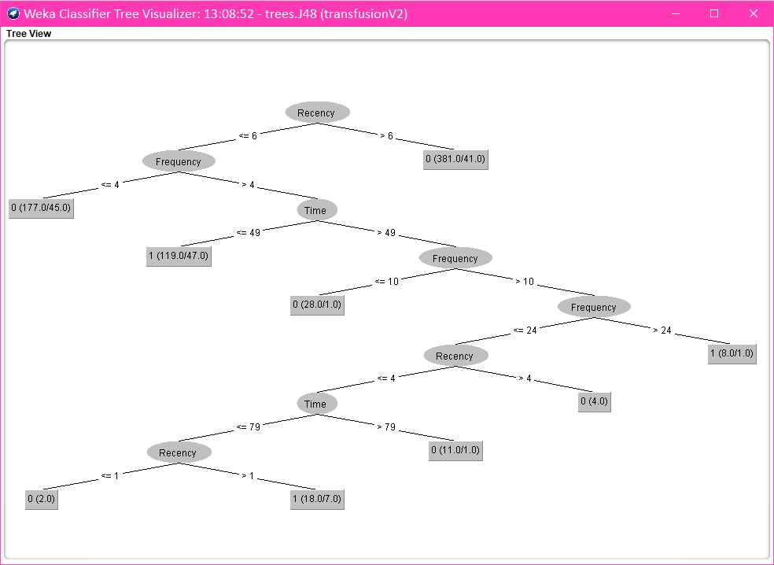

This tree visualisation shows that ‘Recency’ is the root node. Branches are created for each possible attribute value and the instances are split into subsets, one for each branch extending from the node. The tree will keep splitting until it has pure nodes meaning all instances have the same class. There are two splits from the recency root node, one split looking at less than or equal to 6 months and the other split is looking at greater than 6 months. If the recency is less than or equal to 6, the tree further analyses the frequency. If the recency is greater than 6, it shows 0 which stands for not donating blood. The first number in the brackets indicates the number of correct things that reach that node, in this instance, there are 381. The second number in the brackets indicates all the incorrect things that reach that node which is 41. Looking at the second node of frequency, if less than or equal to 4, it shows not donating blood (0), if greater than 4, the tree further analyses the time where if it is less than or equal to 49 it shows a ‘1’ which stands for donating blood, if greater than 49, it further analyses the frequency. This continues down to the last node being recency where if less than or equal to 1, it shows ‘0’ for not donating blood but if greater than 1, it shows ‘1’ for donating blood. This decision tree represents who is more likely to donate blood under different categories (attributes). The above decision tree shows the people who are most likely to donate blood again are the ones who first donated blood less than 49 months ago, the ones who have donated blood more than 24 times and the ones who donated blood more than 1 month ago since their last donation. ^{[4 & 5]}

Sample Runs and Results

Various other ways of putting the data through different options has been tested to try and get a more accurate reading to make the data more reliable to be able to predict who is more likely to donate blood.

Classifiers

J48 tree classifier:
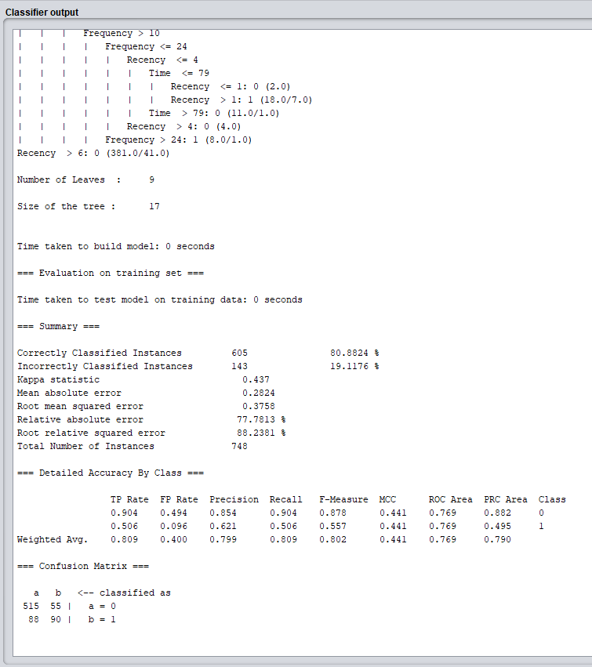

Above shows the test options changed from the 10-fold cross-validation to the training set test option (still using the J48 tree). This gives a slightly higher percentage for the correctly classified instances, it has changed from 77.8% to 80.9%. Due to the higher percentage of accuracy, the confusion matrix has also changed slightly showing 515 a’s correctly classified as a’s and 90 b’s correctly classified as b’s, whereas with the 10-fold cross-validation test option there were 505 a’s and 77 b’s that were correctly classified. The training set differentiates from the 10-fold cross-validation as this option is very optimistic, it indicates an upper bound to the model’s performance on new data. ^{[3]}
In the below picture, the test options have been changed back to the 10-fold cross-validation test option. The unpruned option is changed from false to true switching it to not pruning. As seen below, this has not made much of a difference where the correctly classified instances percentage was 77.8% when pruned and 77.9% when unpruned, a 0.1% difference.
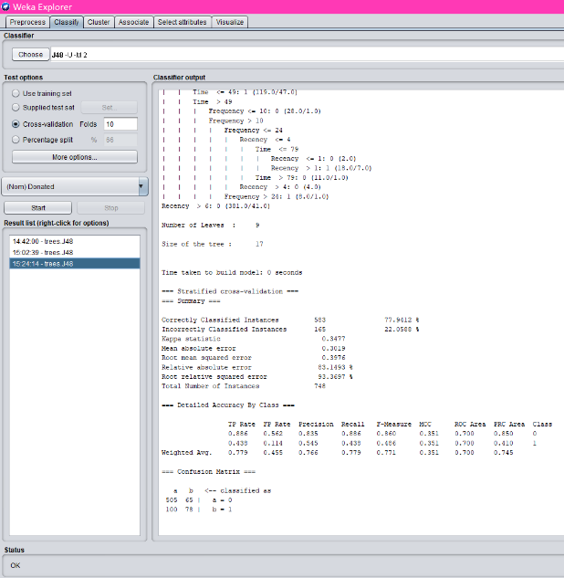

Naïve Bayes classifier:
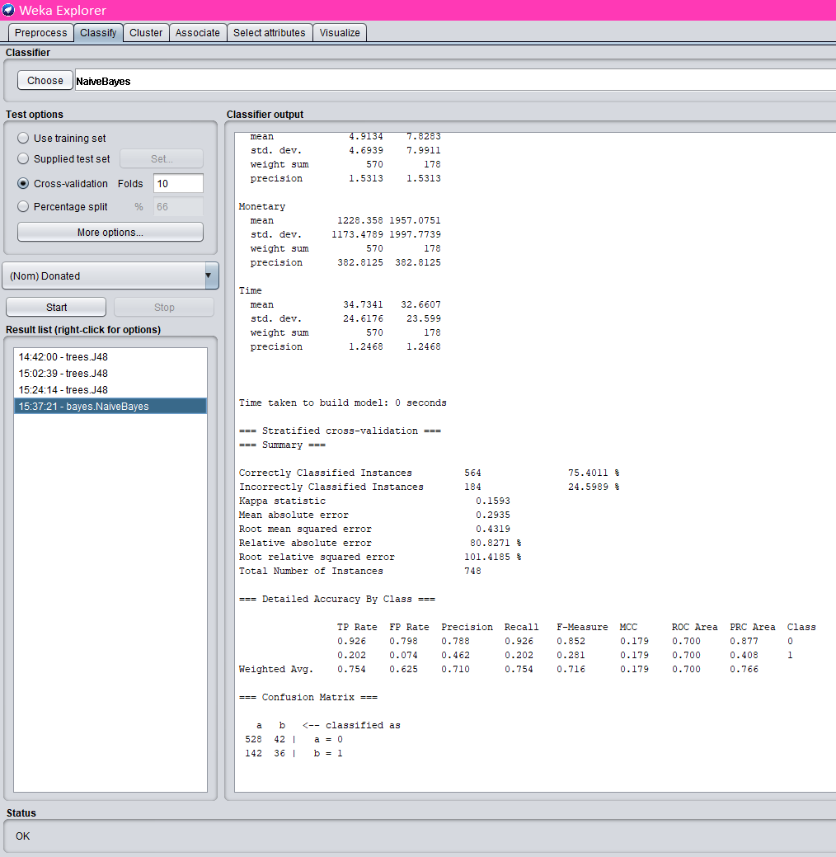

The Naïve Bayes classifier was tried and tested which gave a 75.4% correctly classified instances, lower than the original J48 tree option of 77.8%. The assumption made by naive Bayesian classifiers is that there are no relationships between attributes. Class conditional independence is the term for this assumption. It's designed to make the computations easier. ^{[6]}

K-Nearest neighbour classifier (IBk):
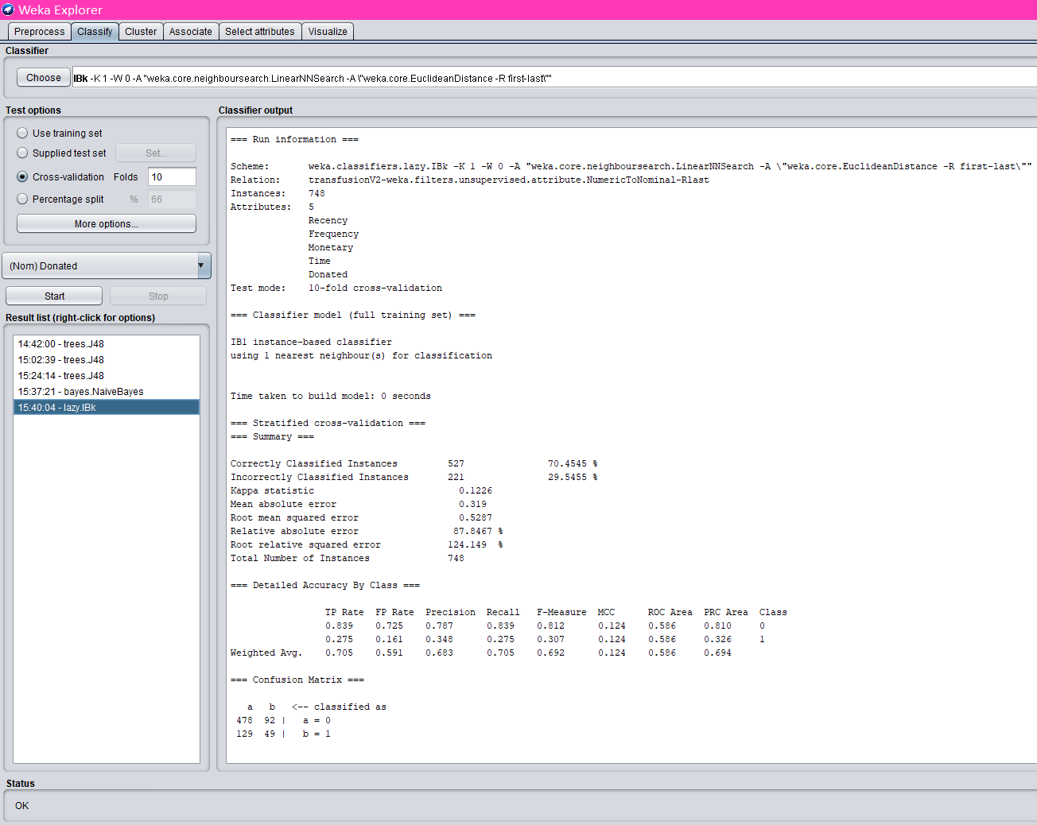

The K-Nearest neighbour classifier (IBk) was also tried and tested resulting in a 70.5% correctly classified instances, again lower than the J48 tree option percentage. The KNN value was set to 1 in the above picture, this then was changed to a higher value of 6 which took the correctly classified instances percentage up to 77.4% as shown in the picture below. Numerous other values were tried but the value of 6 produced the highest percentage. This algorithm classifies objects based on the majority class among their k-nearest neighbours. The KNN is a lazy learning technique where only a local approximation of the function is made and all calculation is postponed until classification. ^{[6]}

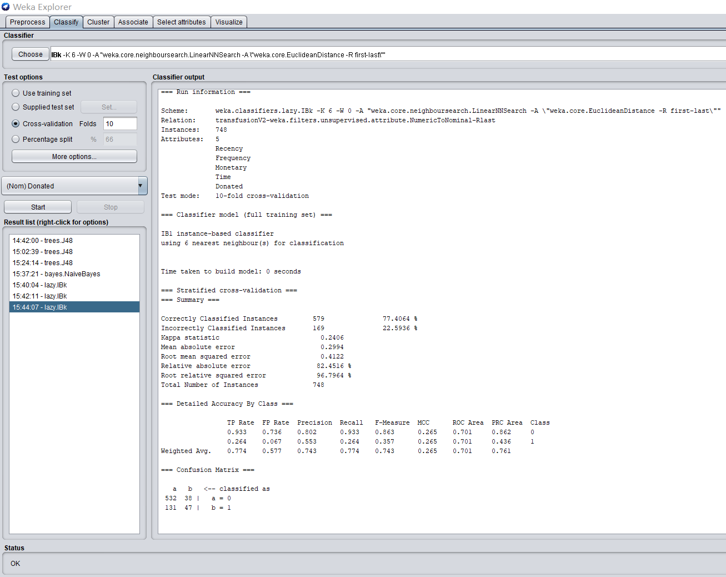

Below shows the test options changed from the 10-fold cross-validation to the training set test option (still using the K-Nearest neighbour classifier). The KNN value was set to 1 which produced a 93.2 percent accuracy. Numerous other values were tried with this test option but the value of 1 produced the highest percentage.

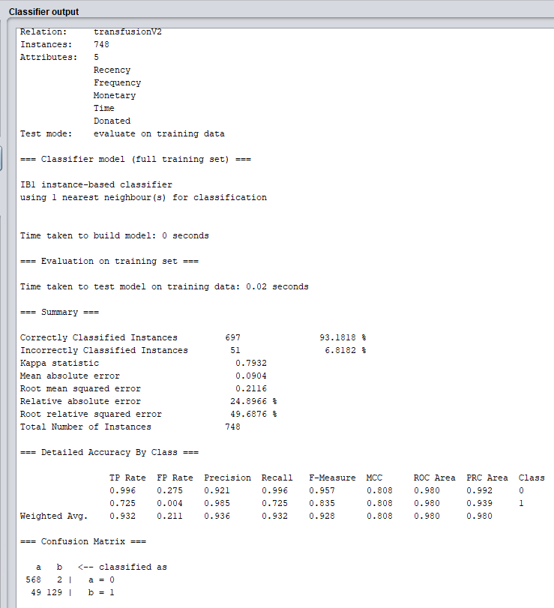

Linear regression classifier:
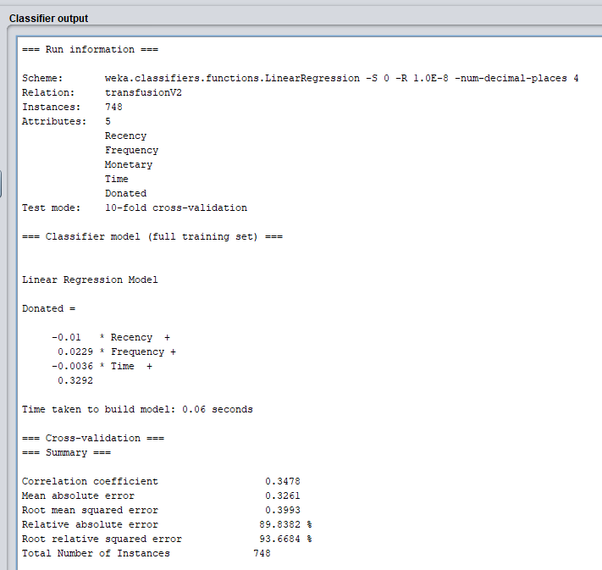

Regression is the simplest strategy to employ, yet it is also the least effective. A number of independent variables combine to generate an outcome known as a dependent variable. “The regression model is then used to predict the result of an unknown dependent variable, given the values of the independent variables.” ^{[7]}
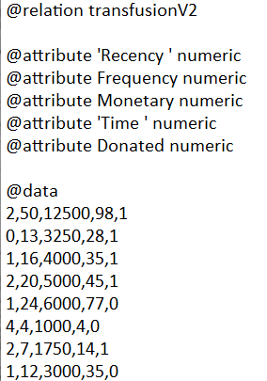
To use the linear regression classifier, the donated attribute
data type had to be converted from nominal to numeric. The
above picture shows weka has put the regression model in the
output. The below picture shows the regression model with
data inputted into an excel spreadsheet using sums to calculate
the result. From the ‘C’ to ‘E’ column it has calculated a 1,
meaning they will donate blood and from the ‘G’ to ‘I’ column, it
has calculated a 0, meaning they will not donate blood.
The data was used from lines 1 and 5 under @data (source on the
right).
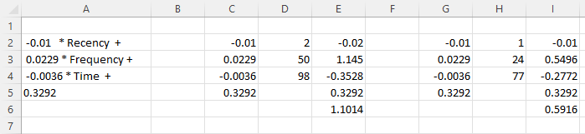

Clusters

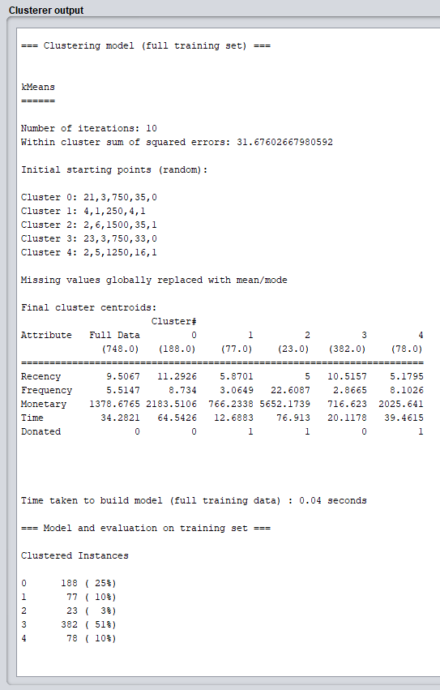
Simple K Means:

The simple K means method above was run to create clusters. The ‘numClusters’ field was set to the value of 5, which created 5 clusters. Each cluster is showing a type of behaviour of people donating or not donating blood. As displayed above, we can see that cluster 0 and 3 will not donate blood whereas clusters 1, 2 and 4 will donate blood. The readings interpreted:
Cluster 0: It has been 11 months since the last donation with 8 donations made in total and 2183 c.c. blood donated altogether. It shows 64 months since the first donation.
Cluster 1: It has been 5 months since the last donation with 3 donations made in total and 766 c.c. blood donated altogether. It shows 12 months since the first donation.
Cluster 2: It has been 5 months since the last donation with 22 donations made in total and 5652 c.c. blood donated altogether. It shows 76 months since the first donation.
Cluster 3: It has been 10 months since the last donation with 2 donations made in total and 716 c.c. blood donated altogether. It shows 20 months since the first donation.
Cluster 4: It has been 5 months since the last donation with 8 donations made in total and 2025 c.c. blood donated altogether. It shows 39 months since the first donation.
This explains cluster 2 has the highest donations and have been donating blood longer than any other cluster. It has been a while since cluster 0 and 3 have donated blood which explains the 0 for not donating blood under the donated attribute. Cluster 3 has very little donations made of only been twice, although cluster 1 only has 3 donations made, however, their time since first donation and recency since last donation is a lot less than clusters 3 time and recency.
The below image shows a visualisation chart with the clustered numbers put into different colours (colour indication at the bottom), recency (months since last donated) on the X axis and whether they donated or not on the Y axis. The majority of donations were last made less than 37 months ago, although there are a few that have gone past 34 months since they last donated, going all the way up to 74 months.

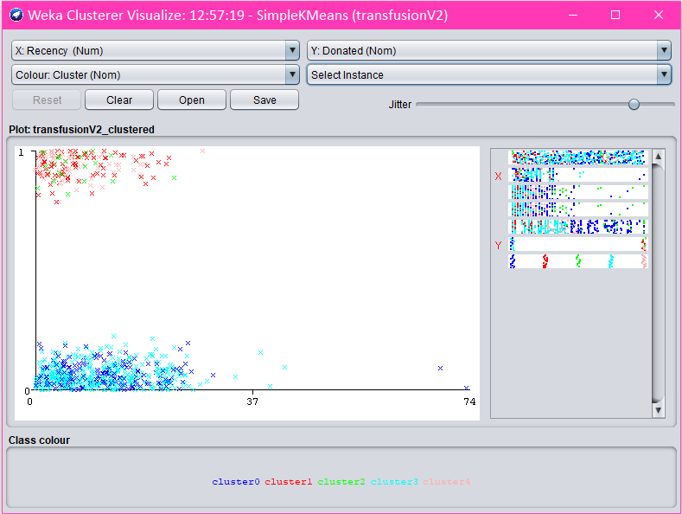

Business Recommendations

Pre-processing the data before carrying out any tests is recommended to check for missing values and outliers that could affect the findings, as well as to identify and eliminate any noisy data. It is also needed to be able to convert the file type to an arff file and run some of the methods, for instance, the J48 tree would not run with the donated attribute data type as numeric, this needed to be changed to nominal data type.
The K-nearest neighbour (IBk) classifier using the training set test option produced the highest percentage for the correctly classified instances of 93.2% among the many methods tested. This appears to be the most effective way for achieving a higher accuracy rating. The higher the accuracy rating, the more reliable the data will be to help with future business decisions. As a result, this method would be recommended for the business.
The J48 tree method, together with the training set test option, produced the second highest percentage of correctly classified instances (80.9%), but is still far lower than the 93.2% above, giving a 12.3% difference.
With the data pruned or unpruned, the J48 tree method and the 10-fold cross-validation test option both returned a 77 percent. A 77 percent result was also produced using the k-nearest neighbour approach with a KNN value of 6 and the 10-fold cross-validation test option. The accuracy rating for these findings is 16 percent lower than the 93.2 percent produced from the k-nearest neighbour method with the training set test option. Therefore, these methods would not be recommended.
The Naïve Bayes classifier is not recommended since it only identified 75.4 percent accuracy, compared to the 93.2 percent produced from the k-nearest neighbour method utilising the training set test option. And the linear regression method wasn’t particularly useful for the blood transfusion data set as it doesn’t include all the attributes or give information about the accuracy ratings.
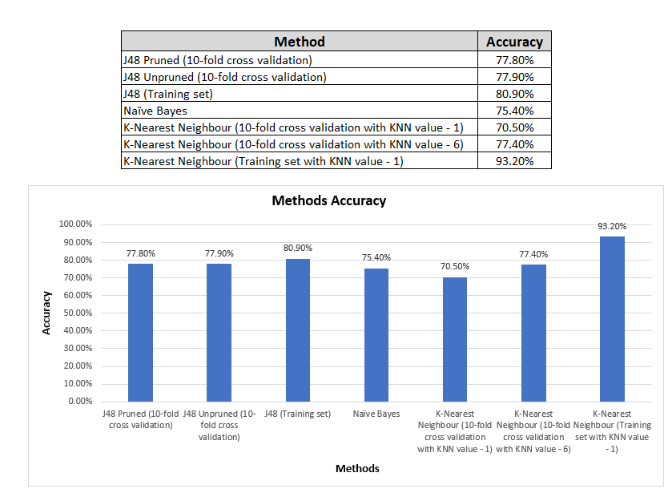
The following is the comparison showing the classification results of the different methods in terms of accuracy.

The clustering, simple K means method on the other hand, was insightful as it helped to determine which groups are more likely to donate blood in the future. It is also very simple to read and provides lots of information giving the numbers for each attribute under different cluster groupings. Clustering can help the business manage their data more effectively. Although, this does not predict a single value or an accuracy rating, it just puts the data into clusters/groups.

Reflection

The data mining algorithms are effective in predicting which groups will donate blood in the future. All of the methods that were tested had a decent accuracy rate of 70% or more, however the k-nearest neighbour method with the training set test option performed exceptionally well, with a 93.2 percent accuracy rating and just 6.8% incorrect.
The algorithms evaluated the data extremely fast, taking just 0 or up to 0.04 seconds to do so, the time it took to build the model is displayed in the images above under the classifier or clusterer output.
Predicting blood donations is important for blood supply chain decisions, therefore these data mining algorithms, particularly the k-nearest neighbour method with the training set test option, can be extremely helpful.
The data visualisations, which provide data through graphics such as coloured bar charts, decision trees, and cluster graphs, are beneficial because they make it easier and clearer for organisations to examine the findings. When provided with data that is simple to grasp and evaluate, businesses can make faster, more informed decisions.
Another benefit of data mining algorithms is that they can assist businesses in making educated decisions to make necessary operational modifications. In comparison to other data applications, it is also a cost-effective and efficient option.
There are some small drawbacks in terms of accuracy as some data can be inaccurate, which can cause problems with decision-making. In addition, there are various mining tools available with each of them having a unique algorithm and design. Without having enough technical knowledge, the tool selection can be quite challenging.
If this were to be done all over again, I would set aside more time to study a lot more different methods/algorithms and test them to see if I could come up with additional ways to produce high accuracy ratings like the 93.2 percent rating discovered, or even a higher percentage if possible. Although, the accuracy rating of 93.2 percent was a really good finding.

References

- Prasdika P. View of A Review Paper on Big Data and Data Mining Concepts and Techniques | IJID (International Journal on Informatics for Development). Ejournal.uin-suka.ac.id. 2018.[accessed 4 Dec 2021] Available from: http://ejournal.uin-suka.ac.id/saintek/ijid/article/view/07107/1613
- Yeh l. Knowledge discovery on RFM model using Bernoulli sequence | Expert Systems with Applications. Dl.acm.org. 2008. [accessed 1 Jan 2022] Available from: https://dl.acm.org/doi/10.1016/j.eswa.2008.07.018
- Witten I. & Frank E. The Weka Workbench. Cs.waikato.ac.nz. 2016. [accessed 14 Jan 2022] Available from: https://www.cs.waikato.ac.nz/ml/weka/Witten_et_al_2016_appendix.pdf
- Girones J. J48 decision tree - Mining at UOC. Data-mining.business-intelligence.uoc.edu. [accessed 1 Jan 2022] Available from: http://data-mining.business-intelligence.uoc.edu/home/j48-decision-tree
- Witten I. Data Mining with Weka. 2013. [accessed 1 Jan 2022] Available from: https://www.youtube.com/watch?v=l7R9NHqvI0Y&list=PLm4W7_iX_v4NqPUjceOGd-OKNVO4c_cPD&index=17
- Ashari A. Performance Comparison between Naïve Bayes, Decision Tree and k-Nearest Neighbor in Searching Alternative Design in an Energy Simulation Tool. Thesai.org. 2013. [accessed 14 Jan 2022] Available from: https://thesai.org/Downloads/Volume4No11/Paper_5-Performance_Comparison_between_Na%C3%AFve_Bayes.pdf
- Abernethy M. Introduction and regression. IBM Developer. 2010. [accessed 14 Jan 2022] Available from: https://developer.ibm.com/articles/os-weka1/
- Bhardwaj A. Citeseerx.ist.psu.edu. 2012. [accessed 21 Jan 2022] Available from: http://citeseerx.ist.psu.edu/viewdoc/download?doi=10.1.1.441.7419&rep=rep1&type=pdf
- Bahel D. PREDICTING BLOOD DONATIONS USING MACHINE LEARNING TECHNIQUES. Matthewalanham.com. 2017. [accessed 21 Jan 2022] Available from: http://www.matthewalanham.com/Students/2017_MWDSI_Final_Bahel.pdf
- Birhane T. Predicting the Behavior of Blood Donors in National Blood Bank of Ethiopia Using Data Mining Techniques. Mecs-press.org. 2020. [accessed 21 Jan 2022] Available from: https://www.mecs-press.org/ijieeb/ijieeb-v13-n3/IJIEEB-V13-N3-5.pdf
- Tech G. 10 Key Data Mining Techniques and How Businesses Use Them - Georgia Tech Boot Camps. Georgia Tech Boot Camps. 2021. [accessed 21 Jan 2022] Available from: https://bootcamp.pe.gatech.edu/blog/10-key-data-mining-techniques-and-how-businesses-use-them/
- Salazar-Concha C. Predicting the Intention to Donate Blood among Blood Donors Using a Decision Tree Algorithm. Symmetry. 2021. [accessed 21 Jan 2022] Available from: https://www.mdpi.com/2073-8994/13/8/1460

