Worksheet Two
James Andrew David Beard
Student University of Wales Trinity St David
Swansea, Wales
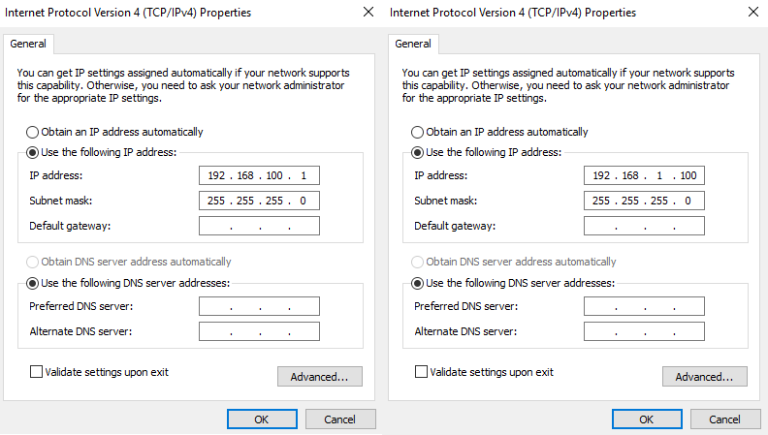
1901671@student.uwtsd.ac.uk

- Practical Tasks
- Checking set up.
The first task the author had to do was to double-check that he had correctly configured the IP address on Server one, that no DNS had been set up on the server and that the firewall was switched off. This was important as it ensured that the server was correctly set up to complete the tasks in this worksheet and not get to a point where he was trying to communicate with client one and found that it was not working and waste time troubleshooting to find out if the firewall was blocking communication or the IP address wasn't right and client one couldn't reach it. Proof that these checks were completed, and everything was as expected can be found in Fig. 1 for proof of IP addresses and DNS server setting correctly configured and Fig. 2 for proof of firewalls being switched off.

Fig. 1 Server One “PrivateNet1” (Left) & “PublicNet” (Right) IP Addresses and DNS Server Details.
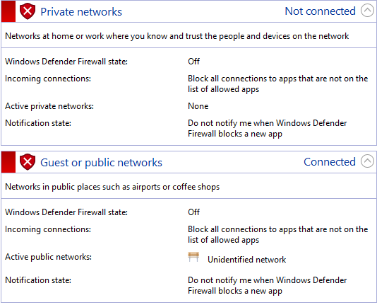

Fig. 2 Firewall status switched off.

- Renaming device
The next task the author completed was to rename the computer that would become the Domain Controller from its default name and give it a meaningful name. This is an important aspect as an organization’s network such as the university will have hundreds of devices, so it important that the administrator can identify what devices provide each task and select it. This will ensure that the network can run smoother than if they were trying to find a device amongst a group of almost identical names. The author achieved this by going to the properties of “This PC”, choosing the advanced settings and changing the name and then restarting the device to implement the change. Finally, the author when back to the advanced setting to check that the name had changes successfully as seen in Fig. 3 the change was successful.
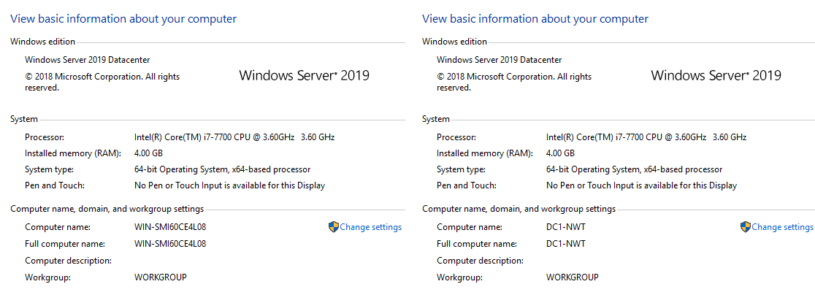
Fig. 3 Device Name Change Before (Left) & After (Right)

- Deploying Active Directory
The next task the author had to complete was to deploy Active Directory on Server One and set the administrator account on the active directory. Active Directory is an important feature to utilises as it allows the administrators to easily manage the network and the network users’ roles and access. By creating groups in the active directory, the author can limit what each group can do on the network. Adding the domain administrator account is important as it sets the user who has access to it all rights and privileges on this network, meaning that they can add or remove users, reset their passwords, and give them rights on the network. In summary, without this account, the author would be able to make changes in the active directory.

This was achieved by first navigating to the “Roles or feature based installation” tab on server manager and selecting the Server one device, which as expected was the name given in the previous task. Next, he clicked to add Active Directory Domain Services and clicked to add the features with the default settings. After a few more steps the Active Directory Domain services was successfully installed.

Next, the author had the option to promote this server to the domain controller which he accepted. He then created a new forest and gave it the desired root domain name. Then he began to set up the domain controller’s forest function level and the domain function level, he then specified the capabilities to the controller. He then checked on the DNS server and global catalogue options, after this he set directory services to restore the password. He then completed several more steps and completed a pre-requisites step, the author found no errors, so he began the installation that proved successful as the system promoted to show that the device was now the domain controller before rebooting itself. As seen i
n Fig. 4 the login display shows that it is trying to log into the domain the author had created.
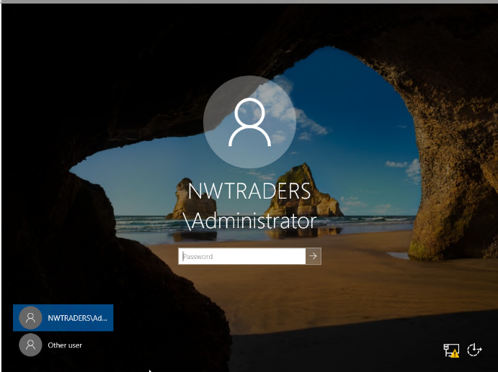
Fig. 4 Login Menu Displaying Added Domain

Creating the Domain controller was important as it will authenticate the request to access the network by checking that the credentials (Username and password) match a user on this network and that their account privilege meets the requirement to access this device. This means that a standard user account cannot access the domain controller, but the administrator account can.

- Creating Users accounts
The next task on the author’s agenda was to add existing users accounts to the desired user groups in the recently created domain and to create new user accounts on the domain and add them to the desired user group. There were two separate accounts for the author to create an account to be added to the domain admin group, it is a good idea to have multiple accounts in this group just in case the administrator is unable to access the other account, they can access this account and reset the administrator account’s password to regain access instead of being locked out of the domain controller as this would be disastrous in a real-life network.

This process was completed by first navigating to “Active Directory Users and Computers” then from there navigating to the domain controller window to check if server one (DC1-NWT) was listed as the domain controller as can be seen in Fig. it is. After this, the author began to create the account that would be added to the domain admin group. This was chevied by navigating to the user container and selecting the options to create a new user.
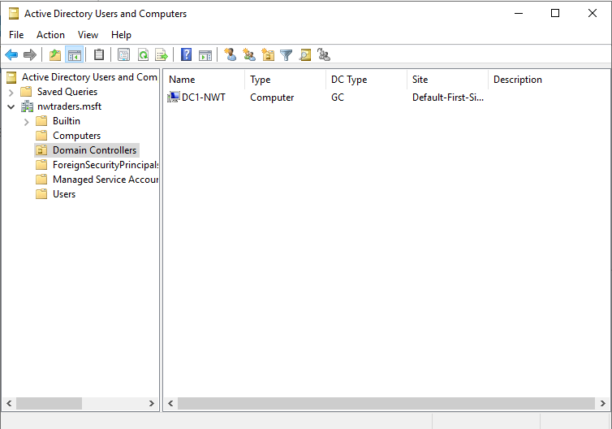
Fig. 5 List of Domain Controllers.
After the author input, the accounts credentials (Username, Account name and password) in the password set up the author changed the preferences so that the password would not need to be changed on the next login as the author will be the main user of this account, so he need not change it.

The second change was that the author set it up so that the password would not expire as it would be pointless to have a backup account that could not be accessed in an emergency. After this, the author navigated to the domain admin group, clicked the member tab and added the new account to the group as can be seen in Fig. 6.
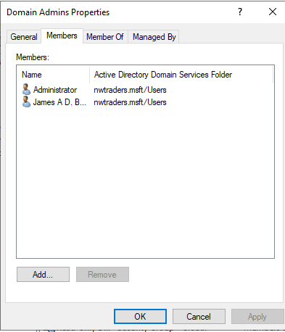

Fig. 6 New List of Domain Admin Members.
The second account that the author created was to be the standard user domain group, this account would have basic rights on the domain but would not be able to access the domain controller and active directory. The reason for this is to ensure that the author could create and add accounts on the domain and network when he needed, as in a real-life scenario a domain will not have one account on it.
The other reason it was important to create a new basic user account was to test that it could not access the domain controller device, as well as testing other object attributes on this account that would help the author learn more ways to use Windows server and manage the network and domain. This will be discussed further in sub section’s E and F. This account was created following the same steps as previously discussed with the domain admin account but without adding it to the domain admin group. Proof of its creation and addition to the “Domain User” group can be seen in Fig. 7.

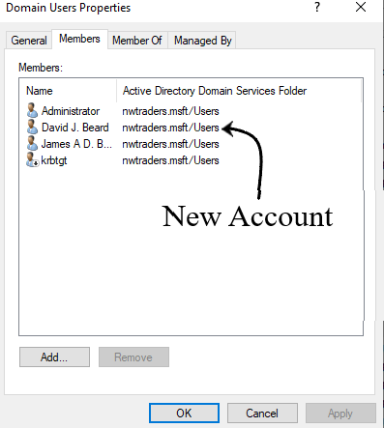
Fig. 7 List of Domain Users Members.

- Object attributes of interest.
The next task the author completed was to set up object attributes to the recently created account (David J. Beard) in this worksheet these attributes restricted the account user’s ability to access the domain and login at certain times of the day. This could be useful in preventing the account from being accessed outside of work times, preventing them from snooping around the domain when it is not required as well as preventing others from using their credentials to access the domain in their leisure time.

The timer restraints were set up by first right-clicking on the desired user and choosing properties, then the author went to the accounts tab, chose logon hours, and set it to the desired timings as can be seen in Fig. 8.

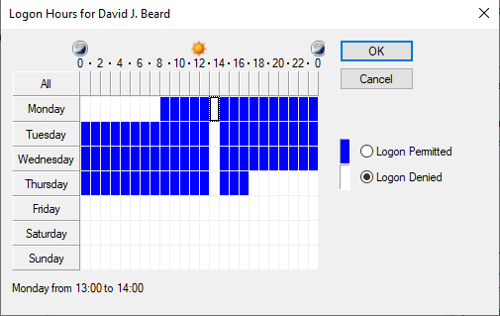
Fig. 8 Logon Hours Settings.
The second attribute added restricted the account users right to change the password to their account. This could be handy in a real-world environment where these accounts could be shared between multiple people, preventing the chances that users may not be able to access the account. Without this restraint the administrator may become overwhelmed with requests to rest passwords, taking away time from completing their other tasks and roles. This task was completed by simply checking the option “User cannot change password” underneath the account options on the previously mentioned account tab, this can be seen in Fig. 9.

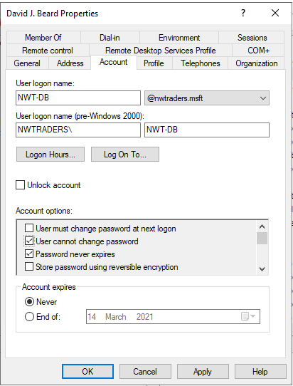
Fig. 9 Account Tab Settings and Options.

- Adjoining the Domain and Testing Logins.
The Final practical tasks that the author had to complete was to first add this computer to the active directory and check that the accounts created were operating correctly, this meant that the accounts that were part of the domain admin group could log into both the domain controller (server machine) and client machine, whereas the accounts belonging only to the domain user group could only log into client machine.

First while on the domain controller the author navigated to computer container on active directory users and computers. He then proceeded to choose the option to add a new computer and gave the computer a meaningful name (WS1-NWT). After this the computer was created and ready to join the domain once the steps on the client device were completed.

The first task the author had complete was to log into the client machine with the administrator’s credentials, navigate to “This PC” properties, chose advanced system settings, then navigated to the computer name tab and gave the computer the same name as was inputted on the domain controller before (WS1-NWT). After this, the client device rebooted and again the author log into the administrator account, this time to set up the DNS server address on this machine.

This was completed by navigating to the “view network status” and tasks option, going to the “change adapter settings” and selecting “PrivateNet1”, the shared network between “Client1” and “Server1” aka the domain controller. Once here the author went to its properties and selected “Internet Protocol Version 4(TCP/IPv4)”. The Preferred DNS Server field was set to the IP address of “Server1” on the “PrivateNet1” network and selected ok to save the changes and proceed to close the windows.

The final part of the task the author had to do was to return to the computer name tab, check the domain button under the “Member of” subheading, following this the author enterer “nwtraders. msft” and clicked ok, this led to pop up requesting administrator credentials to authorise the addition, which once completed displayed a pop up welcoming the computer to the domain. This was proven by shutting down the machine and restarting it, which now showed the login screen displaying the "nwtraders. msft" domain as can be seen in Fig. 10.

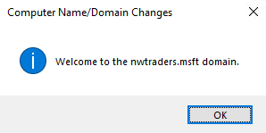
Fig. 10 Computer Successfully Joined Domain.
It was an important task to complete successfully as it finally meant that the author had a running domain with both domain admin accounts and domain users accounts. The author could now test how successful his previous tasks were. He could now test to see if the domain admin account could access the domain controller if the logon hours restraint was working and test if the newly created admin account could change their password.

Finally, the author did test his work as he mentioned he would in the previous paragraph to ensure it worked as expected. This was import in the author's option as it is always wise to check and troubleshoot work after completion to ensure it is working as expected instead of just expecting it to do so.

The author tested to see if the newly created domain user account could log into the domain controller. The test showed that this was not possible something the author hoped to see. However, after a check to see if this domain user account could access the client machine came back unsuccessful, the author considered the possibility that the test may not have worked due to a mistake by him, so he began to troubleshoot what was causing the problem.

After a short time, the author realized he was currently trying to use the new account outside of its designated hours, which once temporally altered allowed access to the client machine. This may have added a few minutes onto the author time, but it proved that the logon hours restriction was working correctly and after repeating the test on the domain controller this account did not have access again, proving that this time the system was working correctly. A screenshot showing a failed login attempt on the domain controller can be seen in Fig. 11.

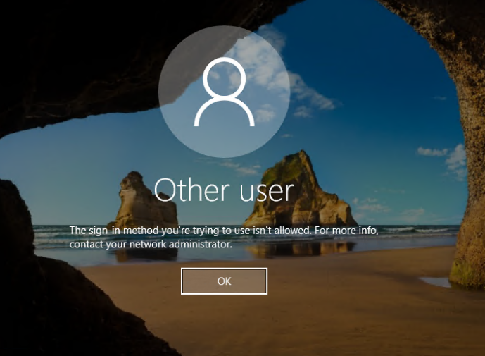
Fig. 11 Failed Login Attempt on Domain Controller.
- Observations Tasks.
- DNS
- What it is?
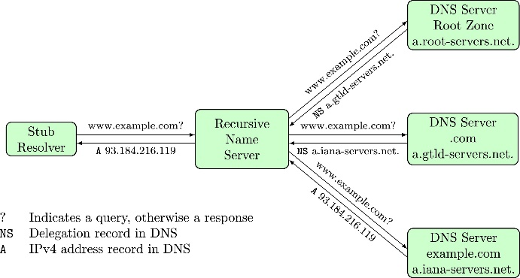
DNS is a distributed database that maps IP addresses to hostnames through the DNS protocol on a DNS server [1], each hostname has a unique IP address associated with it using a hierarchical scheme [1]. This is through a client-server scheme this allows local control of the segments [1]. The rightmost label in a domain name is referred to as the top-level domain and the root of the hierarchy is the null label [2].
- How DNS Works?
A DNS database is split into zones, zones are portions of namespaces where one authority has all the administrative responsibilities [2]. There is no restriction on how these zones manage one or more domains. Authorities can and will often delegate the responsibility of sub-domains to new authorities to manage to lighten the burden on them, this is achieved by creating "NS" records whose value is the name of a server belonging to the authority figure of the subdomain [2]. The “NS” records are stored inside of the root zone, the zone corresponding to the empty label [2]. These “NS” records specify the names for all TLDs for the authoritative DNS servers [2].

DNS resolves names to IP address in the following ways. Firstly, the Client sends a query, this is done by using a resolver and asking the servers [3]. Secondly, the client uses the Operating system's Resolver to find the IP address [3]. Where possible the server being asked/ queried will try to find the answer for the client [3]. The servers in question function from the root, or the top of the tree to the bottom, asking and referring to all servers along the way until the client’s query is answered [3]. A diagram of this can be seen in Fig. 12.
Fig. 12 Diagram Showing How DNS Resolves Client Queries.

Often resolves and DNS will cash equerries and records to speed up the process of resolving the domain name for a short time [2]. The client can afford a small degree of privacy in this process with the use of forwarding resolvers [2], this is because the IP address of the client is hidden from the name servers and prevents operators on the name servers from monitoring the source of the DNS requests [2]. However, operators can still monitor and censor the user's request to some degree still [2].

- Significance within Active Directory Domain Services?
DNS is used as the primary domain controller location mechanism by the active directory domain services [4]. When any of the primary AD operations are performed by computers such as searching for, updating or authenticating, the DNS server is used by the computer to locate the AD domain controllers, as well as AD domain controllers using DNS to locate each other [4]. When administrators add a new AD forest and domain, DNS is automatically installed as the global catalogue server for the domain and forest [4]. When a TCP/IP network connection is configured with a DNS server's IP address [4], the DNS Client will query the DNS server to find the domain controllers as well as to resolve IP Addresses [4].

An example of this is a user on the network with an AD user account logs in to the active directory domain [4], the DNS client service will query the DNS server to find one of the domain controllers for the active directory domain [4]. When a response is sent from the DNS server regarding the IP address query and gives the client the domain controller’s IP address [4]. Finally, the client can message the domain controller and begin the authentication process of logging into their account [4].

- Overview of 2 other critical roles in an enterprise Network
- DHCP
Dynamic host configuration protocol or known more commonly by its abbreviation DHCP, DHCP is protocol baes around that of the bootstrap protocol (BOOTP), which allows for configurations information to be passed to hosts on a TCP/IP network with the uses of frameworks it provides [5]. The purpose of DHCP is to provide the capabilities to automatically allocate IP addresses and configuration options to devices on the Local Area Network (LAN) [5].

There are two main compounds to DHCP, the first is a protocol for delivering host-specific configuration parameters to a device or host from a DHCP server and the second protocol consists of a mechanism used for allocating IP addresses to hosts [5]. DHCP is designed on a client/server model, where chosen DHCP server hosts give out the IP addresses and deliver configuration parameters to dynamically configured devices and hosts [5].

- Remote Desktop Service
A remote desktop is used by a user to connect and control their computer while in a remote location away from the device, this done on Windows devices by using Microsoft Remote Desktop Client this software is also compatible with iOS, Android and macOS [6].

This is achieved by using a different device to remotely connect to the desired computer if both devices have an internet connection [6]. The desired PC is switched on and running, remote desktop is enabled [6]. The firewall of the devices that will be used in this connection has been set up to allow the connection and the user must be part of the domain group that has permission and the sensitivity level/label to access the device [6]. when working the user can access all the files, apps, programs, and resources as if they were sitting at the device [6].

- The importance to have different levels of access/roles within the Network User Account groups
The different levels of access/ roles are an important feature to have as it makes it easier to manage the controls and restrictions attached to a practical task or role, especially when this role may be subject to regular changes in the organization [1]. Instead of constantly changing a user’s rights, the administrator can simply assign the needed rights and privileges to the role and when a user comes or go, they can be quickly added and removed [1].

The second reason it is important to have different levels of access and roles on a domain and network, including the ability to restrict what each account can do on the domain. These restrictions should be set to a level where each account has access to the data and information that the user requires to complete their role. For example, the IT department of a hospital does not need access to a patient's health record, the only people who should have access to this is the medical professionals taking care of them. Whereas the roles and access privileges that the IT department have is related to the maintenance of computer systems, something a doctor will not have access to as their job role does not require them to make changes to the computer system.

The ability to have a strong grip on access control within the domain and network helps to ensure to an extent the CIA security triad of Confidentiality, only those who have been granted access can view the data. Integrity, data can only be altered by those with access to the data, lowering the chances of wrongful or malicious changes. and availability, information is readily available to the correct persons is implemented within the system and account groups. Other advantages to this implementation include the ease of making changes to access/roles in certain groups, for example, if someone switched departments at an organization instead of having to manually change their privileges, they can be moved to a new group and instantly gain those privileges.

- Ideas on Microsoft’s recommendations on AGDLP and AGUDLP for assigning permissions.
AGDLP is a simple acronym used by Microsoft to help system administrators and users to remember everything they need to know for using groups in a single domain forest [5]. When abbreviated the acronym gives a flow process in the essence that the A stands for the accounts on the domain such as users and objects, the accounts are stored in global groups this is what the G in the acronym stands for [5]. The DL in the acronym stands for domain local groups, global groups are placed in domain local groups [5]. These domain local groups are added into access control lists and given certain permissions to the Data and resources; this where the P comes from in the acronym as it stands for permissions [5].

AGUDLP is also an acronym used to help users remember the flow process in the active directory but AGUPLP is used to guide the user when working with a universal group [6], the letters in the abbreviation are the same and the process/ hierarchical flow is almost the same but beside one step. In AGUDLP instead of global groups being placed inside a domain local group [6], the universal group houses multiple global groups/ user domains in them [6]. This what the U stands for in abbreviation, universal group [6]. Then the universal group is added to the domain local groups and the process is the same as in AGLP from there [6].

The author discusses some of his ideas on how using AGDLP and AGUDLP for assigning permissions to afford the administrators several advantages as well as a possible drawback to using these models as a systems administrator in appendix One.

- Appendix One – Advantages and Disadvantages of AGDLP/ AGUDLP

- Advantages
The author can see why Microsoft recommends the use of AGDLP or AGUDLP for assigning permission on domains and local networks, the author believes he has identified a couple of major advantages to this approach. The first advantage the author feels that implementing this strategy for granting access and permissions is the simplicity and quickness of adding and removing accounts access and privileges to resources and data. Instead of having to mainly go in and edit all of their permissions on their account the system administrators of the network can simply add them to a new group with those permissions. This would be especially convenient in large organizations and the education sector where there are hundreds of accounts that must have appropriate permissions for their role and task. Large organization to an extent but the education sector especially has a large turnover of accounts every year if the administrator had to manually set permissions for each account this would not only become extremely tedious for the administrators but also a great waste of their time, that could be spent on other things.

The previous advantage discussed also lead to the author's second advantage less chance of the administrator going into autopilot. As previously mentioned, if the system administrators were adding the permissions and access to resources and data individually, they are likely to go into autopilot if they are repeating the same process repeatedly increasing the likelihood of accidentally granting wrong permissions and access to data. For example, if the administrator was setting up permissions for a dozen new workers in the financial department and one worker in the logistics department then there is a chance that the administrator will accidentally grant the later to confidential resources, they have no rights to and not to the resources they require.

- Disadvantages
The only major disadvantage the author can think of that would be more common in these strategies is the risk of accidental granting the wrong permissions to a group instead of just a single account. Using the previous example again instead of just one individual account having access to confidential resources such as payslip, bank details and personal details it the whole department meaning there is a far higher chance that someone in that department is going to do something malicious with their wrongfully given permission. The workers whose details have been wrongfully accessed could make a legal challenge against what has happened, and the administrator is at the heart of it.

- Summary
In summary, most of the advantages that the author identified in these strategies are based on making the systems administrators job role more convenient, simple, and quicker. The ability to quickly make changes to a group's permission is far better for the administrator than doing it individually, where it takes up a large chunk of time from completing their other roles and tasks. Though as also discussed the system administrator still must have their focus on the task as accidentally adding an account to the wrong group can cause a major problem, even worse if the administrator accidentally grants the wrong group access and permission to a resource that they should not.

- References

[1] | Cisco, “Configuring DNS,” IP Addressing: DNS Configuration Guide, no. 15SY, pp. 1,2,3, 2017.
[2] | C. Grothoff, M. Wachs, M. Ermert and J. Appelbaum, “Toward secure name resolution on the internet,” Computers & security, vol. 77, no. 10, pp. 695,696, 2018.
[3] | NSRC, “DNS refresher,” NSRC, Oregon, 2018.
[4] | E. Ross and J. Mclllece, “Domain Name System (DNS),” Microsoft, 2020.
[5] | Cisco, “DHCP Overview,” in IP Addressing: DHCP Configuration Guide, San Jose, Cisco Systems, Inc, 2011, pp. 1,2.
[6] | L. Poggemeyer et al., “Remote Desktop - Allow access to your PC,” 06 05 2018. [Online]. Available: https://docs.microsoft.com/en-us/windows-server/remote/remote-desktop-services/clients/remote-desktop-allow-access. [Accessed 01 02 2021].
[7] | M. Whitman and H. Mattord, “Security Technology: Firewalls and VPNs,” in Principles of Information Security, Boston, Cengage Learning, 2011, p. 247.

