DIGITAL SKILLS AND RESEARCH METHODS
Module Code: BMSW4002
Tutor: Suneth Fernando
Student Name: Daniel Costache
Student ID: 1916533

Impact of Virtual Learning Environment (VLE) – Moodle on students’ Learning Experience

Table of Contents
Introduction 3
Published Literature Review 3
Primary research method 5
Questionnaire Analysis 6
Conclusion 11
References 12
Appendix 13
Appendix (continued) 14
Appendix (continued) 15
Appendix (continued) 16

Introduction

In our day and age, technology plays an increasingly important role in education and in support of the learning process. Because of technology, education is becoming more flexible and accessible. We have seen a growing popularity of online degrees and mobile learning, physical boundaries have been removed, and many executives have embraced technology to supplement the further education of their employees (The Growing Importance of Technology in Education | uopeople.edu, 2020). A majority of universities and educational institutions are already using technology with their teaching methods. From entirely online classes, availability of learning materials online, hybrid courses to aid to special needs students, technology is being used in various forms, and has the potential to revolutionise the traditional learning process. This role has been put in overdrive in the recent months, due to the global pandemic of COVID-19 and the regulations imposed because of it. Universities have been forced to change to online classes, and the main reason is to reduce the spread of the virus. In this research report, we will analyze how students at our university experience learning with the use of the Virtual Learning Environment by using primary research in the form of a in class survey, as well as secondary research by using published literature relevant to our topic.

Published Literature Review

We will proceed by analysing relevant published literature in order to get a view of what is a Virtual Learning Environment, how it impacts higher education, how successful they are and what to expect from such systems in the future. By definition, a Virtual Learning Environment(VLE) is an online system that allows teachers and trainers to share educational materials and communicate with their learners via the web. Usually with built in tools to create engaging learning content (Gallacher, 2015). This definition is generally accepted among scholarly publications, with Goodall and Press, (2016) further describing different types of VLE’s to work slightly differently but ultimately perform the same function and can deliver the same learning materials. Higher Education institutions are likely to have licences for a VLE from one of the following three categories:
- Off-the-shelf, such as Blackboard
- Open source (often free to use and adapt but support is charged for), such as Moodle
- Bespoke (developed by institutions for their own individual needs).
While it is unclear for how long Virtual Learning Environments have been in use, since different universities have been using computers for learning since the 1970s the most popular platforms Blackboard and Moodle have been around since 2000 and respectively, 2001. They have enjoyed success , by 2010 Blackboard software was used by over 3700 educational institutions in more than 60 countries (Blackboard, 2011), and by 2011, Moodle had a user base in 212 countries with 49,365 active sites in more than 75 languages (Moodle, 2011).
A number of studies and surveys analysed the impact of Virtual Learning Environments on students, and certain beneficial aspects have been observed across these studies. Some technical advantages provided by these systems are the ability to deliver courses to a large number of students and potential to present a consistent experience for students and staff, according to (Virtual learning environments (VLE), 2016).
For students, some of the major benefits that have observed across different publications are the ability to learn at a pace that suits them and the flexibility of distance learning, observed by Future Ready Education, (2019) and Virtual College, (2012), which enables classes with high number of participants to be organised, and students improve their attendance. A research based on a survey conducted on 40 students by Ryan E and Poole C, 2016, revealed that Virtual learning seemed to significantly improve students' satisfaction/engagement and recall (Ryan E, Poole C, 2016). This was done by asking the participants to complete a questionnaire regarding one of two teaching session they attended. Both sessions were identical except a VLE was used in the second talk with the first being solely didactic. Use of VLEs was associated with greater satisfaction/engagement than didactic information (Ryan E, Poole C, 2016).
In 2008 the Office for Standards in Education, Children's Services and Skills (Ofsted) evaluated the use of VLEs in a number of educational establishments and published “Virtual learning environments: an evaluation of their development in a sample of educational settings”(Ofsted, 2009). They visited 41 establishments, including 18 colleges and 6 primary schools and in all off them they found that the idea of VLE is relatively new, with colleges taking the most use from them and primary schools the least. When best used, VLEs have improved the learning experience, mainly because it enabled students to reinforce parts of their work and catch up on missed materials (Ofsted, 2009). Interactive tools like discussion facilities and forums have not been used much, and success with the use of VLEs appeared to be linked to the enthusiasm of individual teachers to use technology(Ofsted, 2009). Ofsted found that access to internet for students and staff training to be key factors in the effectiveness of Virtual Learning Environments.
Right now because of the COVID-19 pandemic, the entire world is experimenting with online teaching using Virtual Learning Environments. It looks like the pandemic will bring changes in different aspects of life and education might be one of them if remote teaching develops to be successful. We should try to improve our virtual learning experience and contribute to the success of our VLE by providing feedback, incorporating it in our learning style, and by collecting our own data to analyse and find the shortcomings and opportunities to improve our learning system.

Primary research method

A questionnaire was developed to collect the primary data we will be analysing next. A questionnaire is a research instrument that gathers information from the responders through a series of questions (Questionnaire, 2019). It uses close ended questions with multiple choice answers that will provide quantitative data for our analysis. As shown in Appendix A, colleagues have been asked to provide information regarding their student status and online attendance through Moodle in a first series of multiple-choice questions, then their likeness and motivation towards the platform is assessed through linear scale questions, the perceived benefits and skills they improve are assessed through multiple choice questions that give them the option to choose the skills important to them, and the questionnaire finishes with a straight forward question whether they prefer online or in class learning followed by a short opinion on the topic. It was distributed among students at University Of Wales Trinity Saint David and twelve students have completed the survey (Appendix B). This provided enough data to assess the experience of my fellow students regarding their experience with the Virtual Learning Environment Moodle.
‌

Questionnaire Analysis

The collected data is analysed using descriptive statistics, and the reason for that being that it will provide a high amount of information, given the small number of answers. In order to visualise the data and prepare it for analysis, the questions and answers were grouped in tables that contain similar questions and their answers, and this has been further transformed in graphic charts that will help visualise the data and make a clear analysis on the different topics the questions cover.
The first two questions have the purpose of assessing the participants (Appendix C), and establishing if they are indeed students and attend their classes online as shown in the picture below

Questions | Answer Yes | Answer No
Are you a student? | 12 | 0
Do you attend classes online? | 12 | 0

Image 1: Are the participants students ?
As seen in the chart, all of the participants that completed the questionnaire are students, and they currently attend their classes online. This is relevant and important as we don`t want any non-students to fill out the questionnaire and decrease the effectiveness of the data collected and it`s potential to give an understanding of our Virtual Learning Environment. Having established that our answers come from the right category of people and are valid for our research, we will move on to establish the frequency of attendance through the Virtual Learning Platform used by our university, which is Moodle.

Question | Very Often | Often | Sometimes | Rarely | Never
How Often do you attend online classes trough Moodle? | 8 | 4 | 0 | 0 | 0

Image 2: The frequency of attendance

The second image addresses the question of participation (Appendix D). By analysing the data, we will gain an insight on the frequency of attendance using the university VLE platform Moodle. Out of those surveyed, all the answers indicate a high frequency of attendance through Moodle, with students attending their classes on a very often basis. We can conclude from this information that Moodle has a positive impact on students, and classes are rarely skipped thanks to this.

Moving on, we will further analyse the satisfaction of the students while using Moodle. For this reason, we will group the next three questions together, as they will indicate the likeness, motivation and difficulty in using the platform.

Questions | Low 1 | 2 | 3 | 4 | High 5
How much do you like attending classes online? | 4 | 3 | 1 | 3 | 1
On a scale from 1 to 5, how strong is your motivation to learn online rather than in class? | 0 | 0 | 9 | 2 | 1
On a scale of 1 to 5, how would you rate the difficulty to find the information you are looking for through Moodle? | 3 | 3 | 6 | 0 | 0
Image 3: the overall satisfaction in using the platform
For these questions, a linear scale has been used with answers ranging from Low(1) to High (5). By grouping the 3 questions together (Appendix E), we can get a better view on the overall satisfaction with the
using the platform. The analysis reveals that most of the students tend to be in the middle range in terms of motivation, with most of the answers being at the median range of the scale, with a few being more motivated to study online. Students find the information they look for, as indicated by the answers being in the low range of difficulty. The fact that neither of the questions have received responses in the high range on likeness and motivation, indicate that students are not quite fond of the change in their learning system, which is also collaborated by a high number of answers to the question about how much they like learning online being in the medium and low range.

Questions | Develop Online Competency | Improved Attendance | Improved interaction between peers and tutors | Availability of learning materials
Which of the following benefits of online learning apply to you? | 8 | 7 | 6 | 4
How does the university course platform Microsoft Teams benefit you in advancing you studies? Please select all that apply. | 7 | 10 | 3 | 5
Image 4: perceived benefits of using VLE
The questions presented in image 4 (Appendix F)have the purpose of defining the perceived benefits of online learning in relation to some relevant skills that can be improved through attending online classes like developing online competency, a skill which has received a high number of answers due to the online nature of it. As previously noted in the secondary research, improved attendance is an obvious benefit and it has received a total of 17 votes by our participants. In the previous questions, the availability and ease of access of learning materials has been noted, but due to the relatively low number of answers we will conclude that it is not a major benefit as perceived by my colleagues.

Question | Answer yes | Either one | Answer no
Would you prefer to attend classes online for the rest of the academic year? | 2 | 3 | 7

Image 5: Preference between online and school classes
The last question (Appendix G) reveals a clear preference between physical and online courses, with seven answers being a definitive no – which indicates a preference towards physical class. With three of the participants voting either way and just 2 preferring to continue studying online, we can confidently conclude that students are more used to and prefer physical classes.

Conclusion

The goal of this study was to assess how the students in our university experience their courses using the universities available Virtual Learning Environments Moodle and Microsoft Teams. The results point towards a preference of physical class rather than online, even though the experience with VLE seems to be overall positive. The accuracy of the primary research based on a low number of participants, but it can be said with confidence that it reflects the students view on Virtual Learning Environments, so within a larger sample of students the same tendencies can be expected.

References

Blackboard (2011) About Bb. Available online at: http://www.blackboard.com/About-Bb/Company.aspx
En.wikipedia.org. 2020. Questionnaire. [online] Available at: <https://en.wikipedia.org/wiki/Questionnaire> [Accessed 1 September 2020].
Future Ready Education. 2019. Virtual Learning Environments (Vles) - Future Ready Education. [online] Available at: https://www.futurereadyedu.com/virtual-learning-environments-vles/#:~:text=Also%20known%20as%20the%20future,and%20students%20feel%20at%20ease.&text=The%20process%20of%20Virtual%20learning,a%20pace%20that%20suits%20them..
Gallacher, C., 2015. What Is A VLE (Virtual Learning Environment?) - EPALE - European Commission. [online] EPALE - European Commission. Available at: <https://epale.ec.europa.eu/en/blog/what-vle-virtual-learning-environment>.
Goodall, F. and Press, O., 2016. Oxford University Press | Online Resource Centre | Learn About Virtual Learning Environment/Course Management System Content. [online] Global.oup.com. Available at: <https://global.oup.com/uk/orc/learnvle/>.
Jisc. 2016. Virtual Learning Environments (VLE). [online] Available at: <https://www.jisc.ac.uk/guides/technology-and-tools-for-online-learning/virtual-learning-environments>
Moodle (2011) Moodle. Available online at http://moodle.org/ (accessed 6 February 2011).
Ofsted, 2009. Virtual Learning Environments: An Evaluation Of Their Development In A Sample Of Educational Settings. Ofsted. Available at: <https://dera.ioe.ac.uk/325/1/VLE%20an%20evaluation%20of%20their%20development.pdf>.
Ryan E, Poole C. Impact of Virtual Learning Environment on Students' Satisfaction, Engagement, Recall, and Retention. J Med Imaging Radiat Sci. 2019;50(3):408-415. doi:10.1016/j.jmir.2019.04.005
University of the People. 2020. The Growing Importance Of Technology In Education | University Of The People. [online] Available at: <https://www.uopeople.edu/blog/the-growing-importance-of-technology-in-education/>.

Virtual-college.co.uk. 2012. Virtual Learning Environments 'Benefit Students And Teachers' | Virtual College. [online] Available at: https://www.virtual-college.co.uk/resources/2012/05/virtual-learning-environments-benefit-students-and-teachers.
Ofsted, 2009. Virtual Learning Environments: An Evaluation Of Their Development In A Sample Of Educational Settings. Ofsted. Available at: <https://dera.ioe.ac.uk/325/1/VLE%20an%20evaluation%20of%20their%20development.pdf>.

Appendix

Appendix A
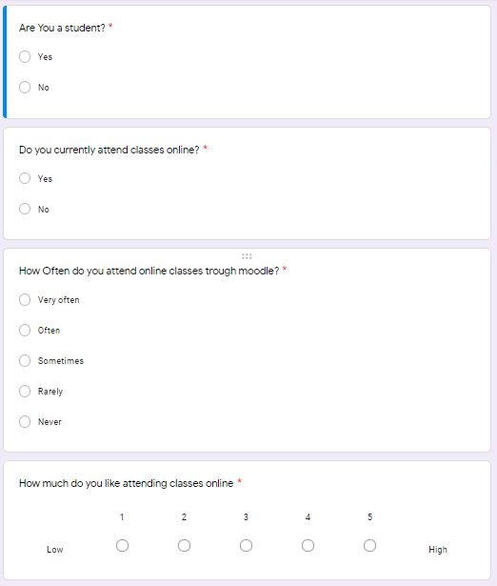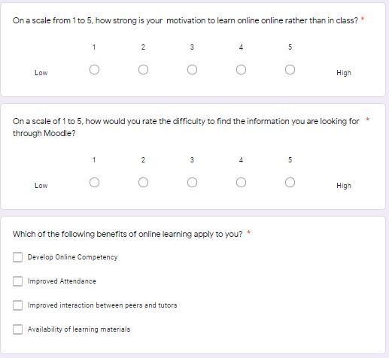
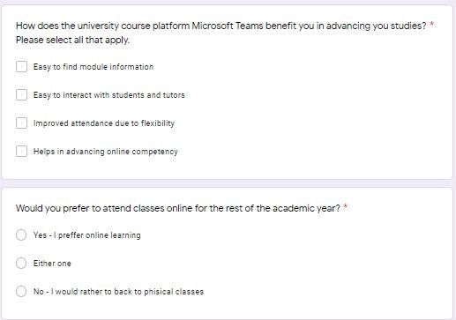

Appendix (continued)

Appendix B
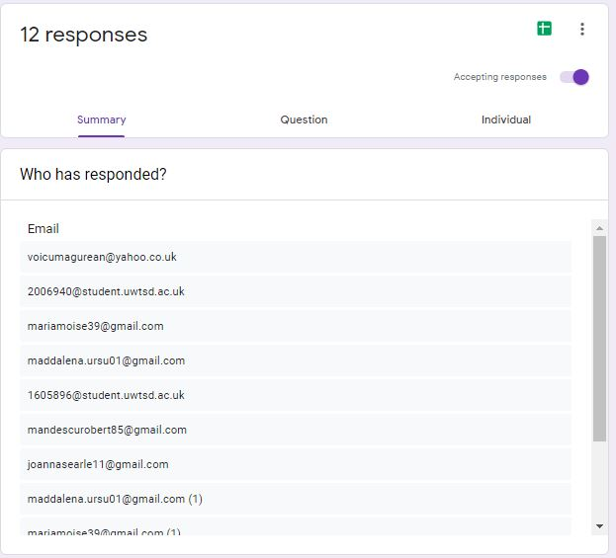Appendix C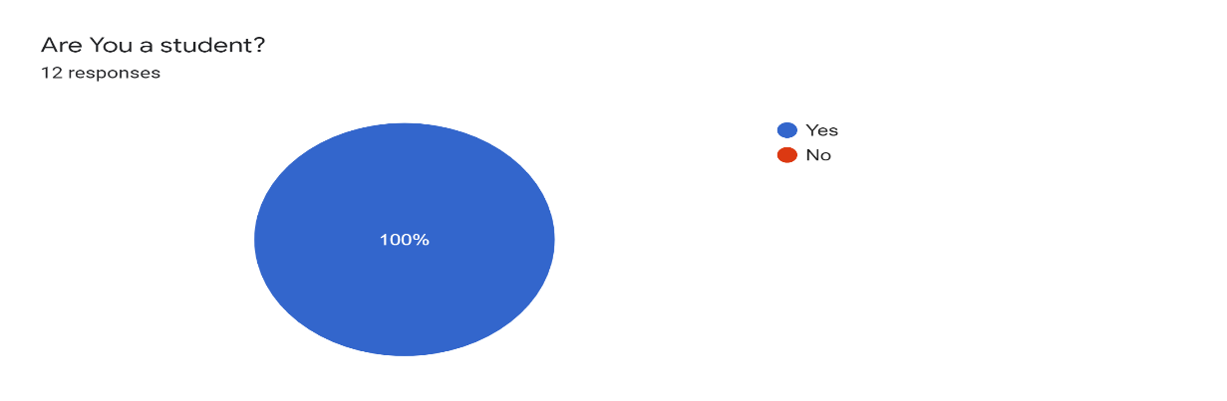 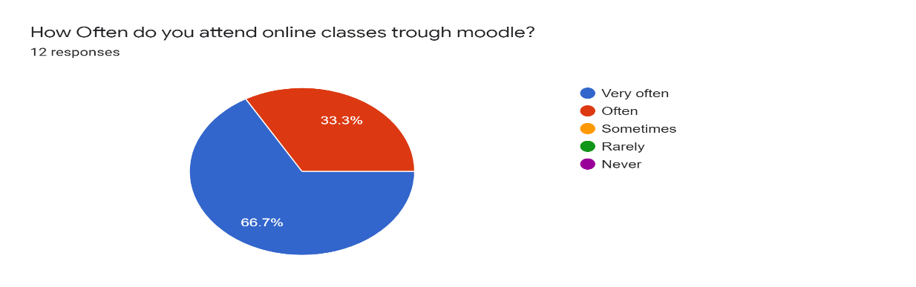

Appendix (continued)

Appendix D

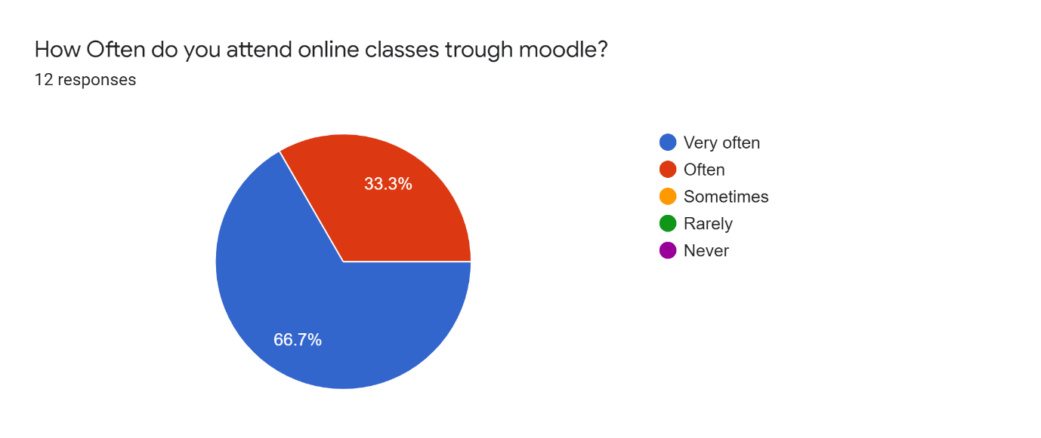
Appendix E
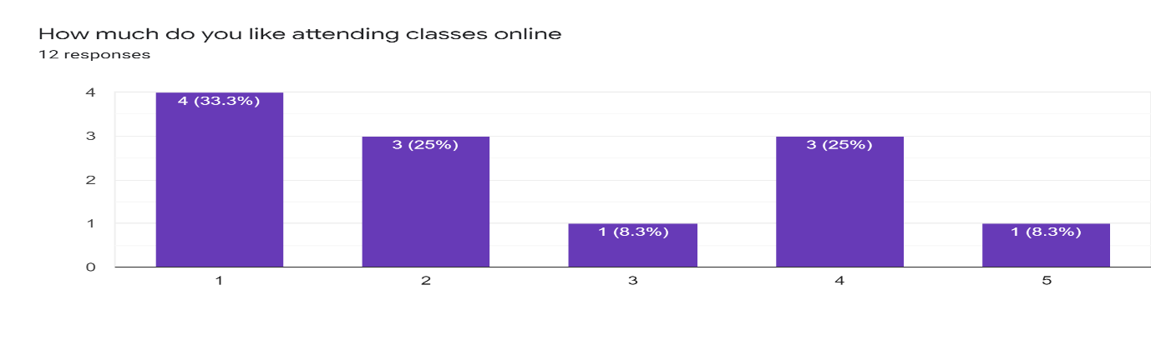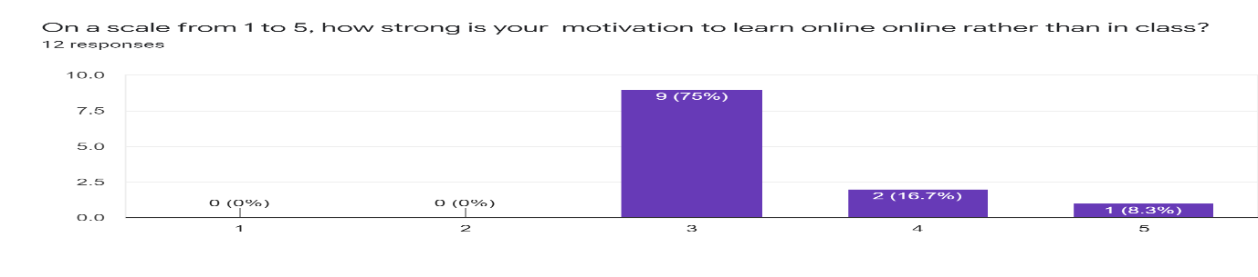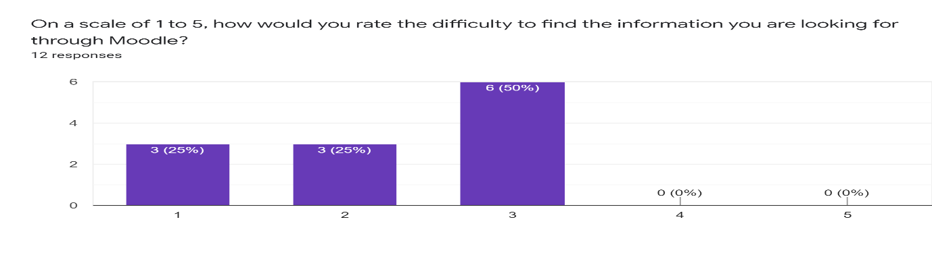

Appendix (continued)

Appendix F
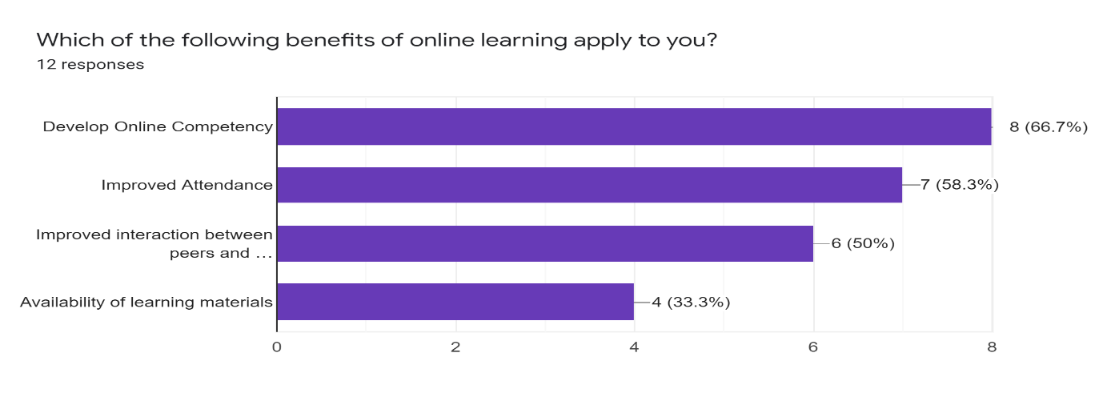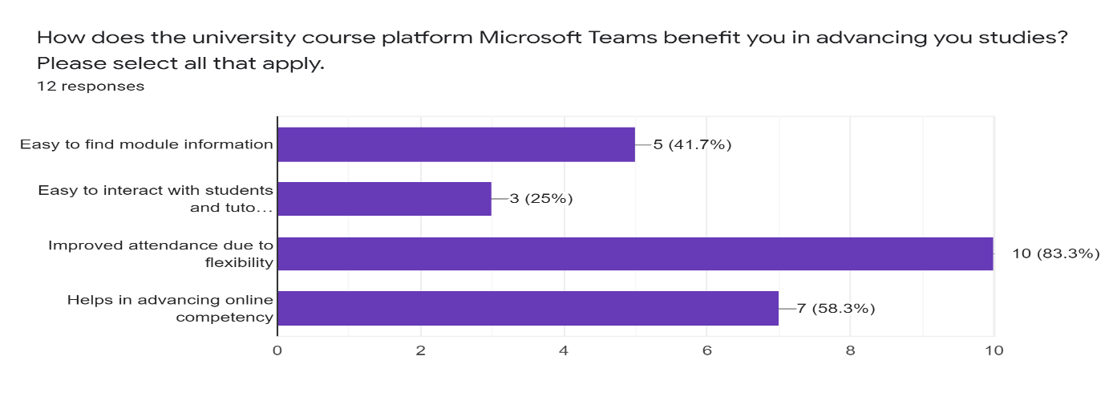

Appendix G


