The Ara Pacis, also known as the Ara Pacis Augustae is the altar of Augustan peace located in Rome. Its 4 walls are adorned with a number of intricate designs and depictions of mythical and cultural themes and was erected in Rome’s Campus Martius. The Ara Pacis can be analysed in a number of ways, considering its significance in terms of different aspects of society and Roman life whether it be the political impact or the impact on everyday Roman life.

The Ara Pacis holds significance in terms of the political aspect of Rome. It was constructed
adjacent to the Via Flaminia, a route that Augustus took on the return of his victory. The Via
Flaminia was also one of the major pathways into Rome, ‘by placing the Ara Pacis right by it,
Augustus, in a way, forced everyone entering Rome through the Via Flaminia to
acknowledge the tribute to his greatness.’ This demonstrates that the Ara Pacis’ was of
importance to Augustus in terms of reminding those living in Rome and those who entered
that he was a great man- one who was heroic and a well-respected leader. The entrance through the Via Flaminia is not considered to be the main entrance to the Ara Pacis, the western entrance is considered to be the main entrance facing Campus Martius. This position meant that anyone who was making a sacrifice had to turn their back to the Campus Martius, therefore turning their back to Mars, God of war. This could illustrate people turning their back on the concept of war, instead advocating the idea of peace.

Moreover, the Ara Pacis was commissioned in 13 BCE to commemorate the return of Emperor Augustus from the provinces of Gaul and, as decided by Augustus, was constructed near his own mausoleum. ‘The altar came to represent Pax (Peace), a concept particularly forwarded during the reign of Augustus’, this could be represented by the previously mentioned suggestion of citizens turning their backs to the idea of war due to how important peace was in 1st century Rome, ‘No other monument of the Augustan Age known to us can rival the Altar of Augustan Peace in its harmonious translation of the ideological program of Augustus into aesthetically convincing form.’ It can therefore be suggested that the nature of the Ara Pacis was not only to glorify Augustus himself but to promote the ideal of peace in Rome.

The four walls of the Ara Pacis contain different imagery; the eastern wall consists of a relief that is suggested to most likely be a depiction of Mother Earth holding two children who may symbolise the people of Rome and illustrates fertility and prosperity as the benefits of peace. The Roma panel on the eastern wall was redrawn from Roman coins, it depicts the female warrior Roma sitting on a pile of weapons so that they cannot be used, placing further emphasis on the want for peace within Rome. The first panel on the western wall consists of the Aeneas panel, this illustrates the heroic founder Aeneas making sacrifice to the Penates with two attendants beside him which shows the importance of the Penates, household gods that were worshipped both privately and publically for their protection, they were of great significance amongst the Romans. However, there is another interpretation that this image is actually the second king of Rome, Numa Pompilius. The Lupercal Panel is also located on the west wall of the Ara Pacis but is fairly poorly preserved after excavations in 1536. It is, however, said to show Romulus and Remus suckling a she-wolf as they are observed by the god Mars, demonstrating the origins of Rome. The eastern and western walls of the Ara Pacis are of significance to Rome at the time not only in terms of political significance but social too. The construction depicts peace but also illustrates the founding of Rome itself. The imagery on the walls consists of works that hold a social significance in terms of gender; the Ara Pacis focuses mainly on Augustus, Agrippa and a number of adult men, according to an online paper, ‘Women and children in fact make up only about 20% of the two processions.’ This shows the social focus on men as the most important social figures and reflects the gender stereotypes and roles of 1st century Rome. The North and South walls further reflect social importance; the north presenting Senators and their families in religious procession and the south presenting Augustus himself in religious ceremonies and Agrippa. The presentation of the family unit portrays the importance of the subject and of social class as the only families who are presented upon the Ara Pacis are of high class and standing and also presents Augustus as the Pater Familias, demonstrating that he views all Roman citizens as members of his own family. The interior walls also depict nature such as vines and fruits which further emphasises fertility and prosperity.

The Ara Pacis seems to be predominantly of political significance rather than anything else, ‘the Ara Pacis and Augustan classicism in general exerted little influence on the art of any class of Roman society other than the aristocracy.’ This suggests that the Ara Pacis was constructed on the grounds of Augustus wanting to create Rome based on his own personal ideals and preferences whilst still presenting the foundations of Rome. This political importance is presented through all aspects of the Ara Pacis such as the imagery on the walls and the way in which Augustus has himself portrayed that could not possibly make him seem to be anything other than a hero.

In conclusion, the Ara Pacis Augustae held significance to 1st century Rome in terms of the political, and social aspects of society. The imagery portrays the Roman ideal but also manages to present Augustus himself as the respected and victorious leader he intended to portray himself as as well as demonstrating the origins and foundation of Rome itself. Upon analysing the Ara Pacis and its reasoning for being erected, it seems obvious that it was constructed according to Augustus’ beliefs and the way in which he wanted Rome to be presented.

WORD COUNT: 1054

BIBLIOGRAPHY

- 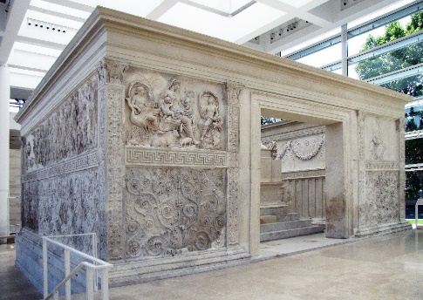

- Lefty, M. ‘Augustus’ Ara Pacis: An Exercise of Politics and Propaganda’ 2006 Shuruisun.blogspot.co.uk. http://shuruisun.blogspot.co.uk/2010/07/augustus-ara-pacis-exercise-of-politics.html. [Accessed on 26/11/2017]

- Cartwright, M. ‘Ara Pacis Augustae’. Ancient History Encyclopedia. https://www.ancient.eu/article/618/ara-pacis-augustae/ [Accessed on 28/11/17]

- Hanfmann, G.M.A, 1964. Roman Art. London: Cory, Adams & Mackay LTD.
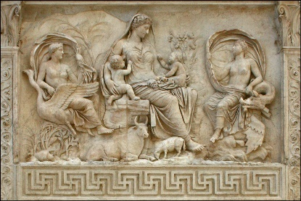

- 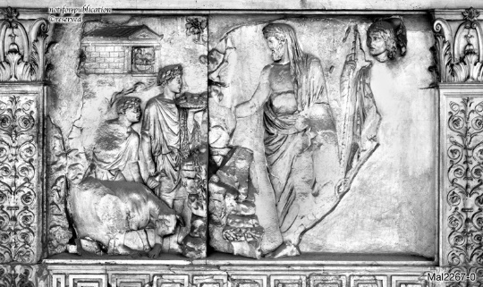

- Rehak, P. 2005. ‘Women and Children on the Ara Pacis Augustae’ ‘Kuscholarworks.ku.edu’.
https://kuscholarworks.ku.edu/bitstream/handle/1808/5682/Rehak_WomChild_AP.pdf?sequence=1&isAllowed=y [Accessed 24/11/2017]

- 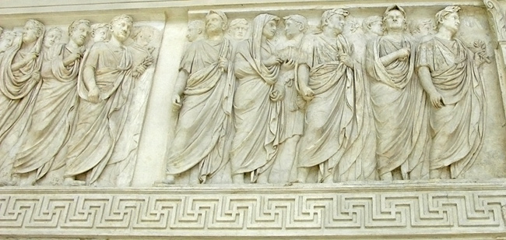

- 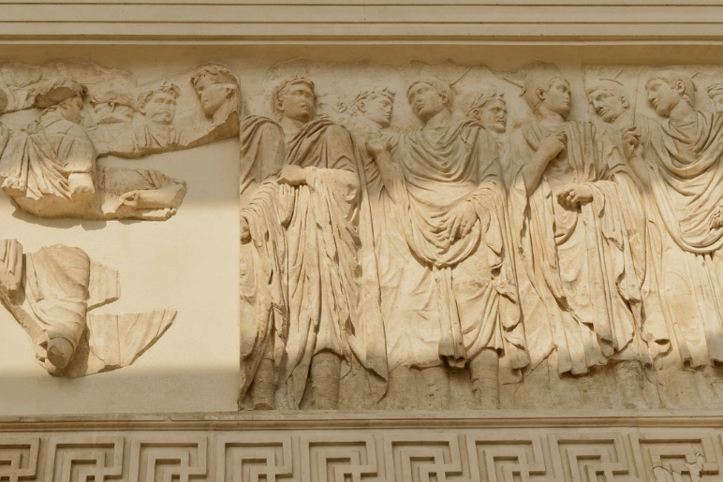

- D’ambra, E. 1993. Roman Art in Context. USA: Prentice-Hall, Inc.

Fig. 1
Lefty 2006
Cartwright
Roman Art 1964: 105
Fig 2
Fig 3
Rehak 2005
Fig 4
Fig 5
Roman Art in Context 1993: 40

