Critical response to an article that provides evidence of sound knowledge and understanding of themes related to the teaching of Welsh in the English-medium sector.
Introduction
The importance of a bilingualism is an ever-growing focus in Wales and has become increasingly apparent in recent years. Due to this growing interest in the improvement of bilingualism in Wales, Welsh Government have put set a target of reaching the goal of one million Welsh speakers by 2050, “The year 2050: The welsh language is thriving, the number of speakers has reached a million, and it is used in every aspect of life.” (Welsh Assembly Government, 2017) However, whilst this target of doubling the current number of welsh speakers (according to the 2011 census, see appendix 1) will enrich and support the culture of Wales, it will provide with it a multitude of its own challenges. Due to these challenges, Welsh Government have made the decision to review many ways in which Welsh second language is taught and how it may be taught more efficiently and successfully. Several of these changes are being make to the curriculum in order to improve the standards of welsh this includes the impending language continuum being implemented into schools. Welsh Government (2013) highlight how this may appear in English medium education,
“This led us to suggest that the literacy framework for welsh be developed as a basis for one continuum of learning Welsh in all schools- this would result in the term ‘second language’ itself being removed.”
Whilst this reform will be a substantial change to Welsh language education in English medium education, there are still other ways of improving the pedagogical skills of teaching Welsh. An effective way of improving our own bilingual education in Wales is to look towards good practice both in schools within Wales and beyond. By looking at the way other countries/ cultures are teaching second languages it may benefit our own bilingual teaching here in Wales.
This essay shall be a critically evaluation of an article reviewing how English is taught as a second language. The focus will be to identify both the strengths and weaknesses of said approach and to distinguish if the methodologies discussed could be applied and used in Wales as a way of teaching the Welsh language in the English medium sector.
Review Background
Firstly, it is important to identify the type of publication that is on review, whom the audience is for this publication and how the author of the publication has authority over the information they are sharing. By evaluating all of these contributors it will allow for a better understanding of the context of the review allowing for a critical evaluation to take place.
- The purpose for the piece of text is to be a review of the way in which English is being taught as a second language in the Philippines; it identifies how bilingual pupils use both their mother tongue and their second language and also how they make use of their bilingualism to learn specific subjects (such as mathematics).
- The text is written with the objective to exemplify the practice that is taking place, to be used as an informative study for academics and allows for comparison of these experiences to that of our own in Wales.
- The authors behind the publication are Dr Allan B.I. Bernardo and Dr Marianne J.M. Gaerlan. Dr Bernardo, a professor at De La Salle University, is a psychologist. He has a strong focus on the concept of Polyculturalism. Polycultural is defined, within the Oxford dictionary as being, “Involving or consisting of a number of (especially well-integrated) cultural or ethnic groups; reflecting or embodying several cultural or ethnic influences.” (Oxford University Press, No date). It is this initial focus on the concept of polyculturalism that will have influenced Dr Bernardo to explore the concept of bilingualism and the benefits and limitations of bilingualism. Dr Gaerlan is also a Dr at the De La Salle University. Her area of expertise centres around ‘applied Linguistics, an area that is closely connected to the study of bilingualism.
It is extremely important to consider these elements when analysing this review as naturally the authors will have their own opinion of bilingualism due to their interests and intellectual background.
Main Body
The first important distinction to make in this text is that the pupils taking part in the review are able to speak both their mother tongue (minority language) and are developing the use of a second language (a majority language). This aspect is incredibly important as pupils learning a majority language provides the pupils with intrinsic motivation to learn. In this case the review highlights how individuals often associate the development of their English language skills (their second language) as being of great importance if they are wishing to advance in a number of areas of their lives,
“Learning English is a means towards other personal and social goals…For others, the goals may relate to qualifying for certain jobs or for professional advancement.” (Bernardo & Gaerlan, 2011).
The importance of having the ability to speak English is made evident here, however it is important to reference that English is one of the top three languages spoken in the world behind Chinese and Spanish. Aspects such as this share key features with the development of the Welsh language, particularly with regards to intrinsic motivation. Currently the importance of being able to speak welsh in Wales is regarded as secondary to speaking English. It is often considered to not be as important as English also, this is something that is made evident from the attitudes of not only pupils learning welsh but the teachers teaching the subject. In order for individual’s attitudes to change, the language must first be made relevant and practical in todays society for young people. Welsh assembly Government (2012, pp.45) intend to achieve this through the development of the languages use in everyday life,
“Focusing welsh language marketing and promotional approaches on younger age groups, maximising the potential of technology such as the internet and new social media.”
They go on to discuss the encouragement of using welsh in the free market, this is yet another way in which the welsh language will be incorporated into everyday life, there becoming an important aspect of everyday life and welsh culture in the future. Strubell (2011) supports this idea, highlighted that for a language to be recognized as being important and influential in a culture there must be demand for it in everyday life such as in public services. Limitations of this aspect would be the challenge in getting pupils motivated to learn the language, however this shall be discussed later in this response.
The use of English in this review is centred around the teaching of mathematics. Whilst using this methodology all of the subject sessions are taught through the medium of English. This approach is referred to as ‘CLIL’ (content and Language Integrated Learning), it provides the opportunity to develop pupils’ subject skills, in this case mathematics, alongside the development of linguistic skills. This methodology of learning a language can be employed into an English medium school in Wales, however it is rarely implemented. Bernardo & Gaerlan (2011) state, “We do not see learning as a process that merely involves memory based processes such as storage.” It is this belief that could be learnt from in Wales, as currently the structure of welsh second language within school revolves around the concept of memorising vocabulary. By incorporating language acquisition, by the means of a CLIL approach, it is thought to have a significant impact on the knowledge retained, “increasing exposure, increasing practice, increasing language competence.” (Dalton-Puffer, 2008) However it is also important to consider the practicality of teaching through a CLIL methodology. Dallinger et al. (2016) highlights, “When interpreting CLIL-effects, the amount of teaching time needs to be considered since CLIL-classrooms usually receive more lessons in the content subject.” With the constant pressure on teachers, it is quite apparent that the reality of implementing a CLIL methodology may be too much considering teachers workload is already large and expectations of them are so high.
The use of a mixture of languages throughout learning opportunities is utilised in the present review. It is believed that by using a combination of languages aided the pupils in their cognitive thinking skills, “Bilingual students who were told to switch languages half-way through a brainstorming task generated more insights compared to those students who were instructed to use only one language.” (Bernardo & Gaerlan,2011). The benefits of changing languages during an activity may arise for several reasons. Firstly, switching to the pupils’ secondary language keeps them engaged longer, they will need to think more carefully about their answers thus keeping them engaged longer. Secondly, whilst pupils are considering what information they should include in their non-native tongue they are developing memorising skills alongside linguistic ones. This model of using a combination of languages is also supported by Pearl and Lambert (1962) “Intellectually his experience with two language systems seems to have left him with a mental flexibility, a superiority in concept formation, a more diversified set of mental abilities.” By encouraging staff in English medium schools in Wales to adopt this approach it will encourage pupils to use more welsh in their classes; it will provide them opportunities to develop their cognitive thinking skills further and will also aid in the advancement of staffs use of second language welsh granting them the chance to develop their incidental welsh further. However, this approach comes with its limitations, these being that staff need to have a sound knowledge of the Welsh language in order to support and drive pupils further in their learning. Shulman (1986) highlights the importance of substantial subject knowledge and how it may be applied to the curriculum.
The final important finding within the review was the amount of language exposure in the home. The importance of consistency is paramount if pupils are to be expected to become fluent in both languages. Gaerlan (2011) stresses the importance of this,
“language exposure at home which included: availability of resources at home that expose the students to language, actual languages used at home, and influence of/on family members on the use of English”
This aspect has already been identified as highly important by both Estyn and Welsh Government and actions are currently being put into place. Estyn have made the following recommendations in order to target this, “More opportunities for pupils in English-medium settings to use and hear Welsh outside of school. Welsh Government, by funding organisations such as the Mentrau Iaith and the Urdd, should facilitate this.” (Welsh Government, 2014). There are a great number of ways schools in Wales would be able to take this approach forward and use it in their schools and wider communities. Employing parental engagement techniques such as after school clubs and community projects will support welsh language development through to the new curriculum. Professor Donaldson (2015) has supported the Welsh language development that is currently taking place in Wales, considering carefully how it should be implemented within the new curriculum,
“There is a firm commitment to the Welsh language and bilingualism, to the principle of comprehensive, inclusive education, and to the inclusion of a welsh dimension in the education of all children and young people.”
Conclusion
Overall there are a multitude of different themes and pedagogical methodologies that are being used in the Filipino school system to help develop bilingual skills could be adopted in English medium education in order to teach second language welsh. To improve the standards of second language welsh teaching, drawing upon the information given here, aspects that could be taken away include, developing opportunities for staff to motivate learners to want to speak welsh. The use of the second language in different lessons not only language development sessions. Encouraging the use of the language outside of school; provide opportunities for families to practice together thus making the language more relevant and useful in their daily life. The success of the Philippians and other countries ability to teach English as a second language provide many lessons for countries like Wales. If teachers in Wales decided to attempt any of the methods present here, they would be presented with challenges to overcome, however by adopting these approaches they may be able to develop and improve on the welsh second language education we currently have in place.

Reference list
Bernardo, A.B.I. & Gaerlan, M.J.M. (2011) ‘Non-Native English Students Learning in English: Reviewing and Reflecting on the Research’. In Jaidey, R., Sandorra, M.L.C., Wong, J.O., Lee, M.C.& Lorente, M.C. (eds.) Global perspectives, local initiatives: Reflections and practices in ELT. National University of Singapore, CELC, pp. 1-9
Dallinger, S. et al. (2016) ‘The effect of content and language integrated learning on students’ English and History competencies- Killing two birds with one stone?’. Learning and Instruction, Volume 41, pp.23-31. Available at: https://www-sciencedirect-com.ezproxy.uwtsd.ac.uk/science/article/pii/S095947521530027X (Accessed 5 February 2019).
Dalton-Puffer, C. (2008) ‘Outcomes and processes in content and language integrated learning (CLIL): Current research from Europe’. University of Vienna. Available at: https://www.univie.ac.at/Anglistik/Dalton/SEW07/CLIL%20research%20overview%20article.pdf (Accessed 5 February 2019).
Donaldson, G. (2015) ‘Successful futures’. Available at: https://gov.wales/docs/dcells/publications/150225-successful-futures-en.pdf (Accessed 8 February 2019).
Oxford University Press. (N.D.) ‘English Oxford Living Dictionaries’. Available at: https://en.oxforddictionaries.com/definition/polycultural (Accessed 5 February 2019).
Pearl, E. & Lambert, W.E. (1962) ‘The relation of Bilingualism to Intelligence Psychological Monographs’. 76, no. 27: 1-23. Available at: https://www.researchgate.net/publication/232605722_The_Relation_Of_Bilingualism_To_Intelligence (Accessed 6 February 2019).
Shulman, L. S. (1986) ‘Those who understand: Knowledge growth in teaching’. Education Researcher. 15(2) 4-14. Available at: https://journals.sagepub.com/doi/abs/10.3102/0013189X015002004?journalCode=edra (Accessed 8 February 2019).
Strubell, M & Boix-Fuster, E. (2011) ‘Democratic Policies for Language Revitalisation: The case of Catalan’. United Kingdom: Pelgrave Macmillan.
Welsh Assembly Government. (2012) ‘A Living Language: a language for living Welsh language strategy 2012-17’.
Welsh Assembly Government. (2013) ‘One language for all: Review of Welsh second language at key stage 3 and 4’. Available at: https://beta.gov.wales/sites/default/files/publications/2018-05/review-of-welsh-second-language-at-key-stages-3-and-4.pdf (Accessed 5 February 2019).
Welsh Assembly Government. (2014) ‘Response to Welsh second language review group recommendations. Available at: file:///C:/Users/caitlin/Downloads/Response%20to%20the%20Welsh%20second%20language%20review%20group%20recommendations.pdf (Accessed 7 February 2019).
Welsh Assembly Government. (2017) ‘Cymraeg 2050: A Million Welsh Speakers’. Available at: http://www.assembly.wales/Laid%20Documents/GEN-LD11108/GEN-LD11108-e.pdf (Accessed 5 February 2019).
Appendices

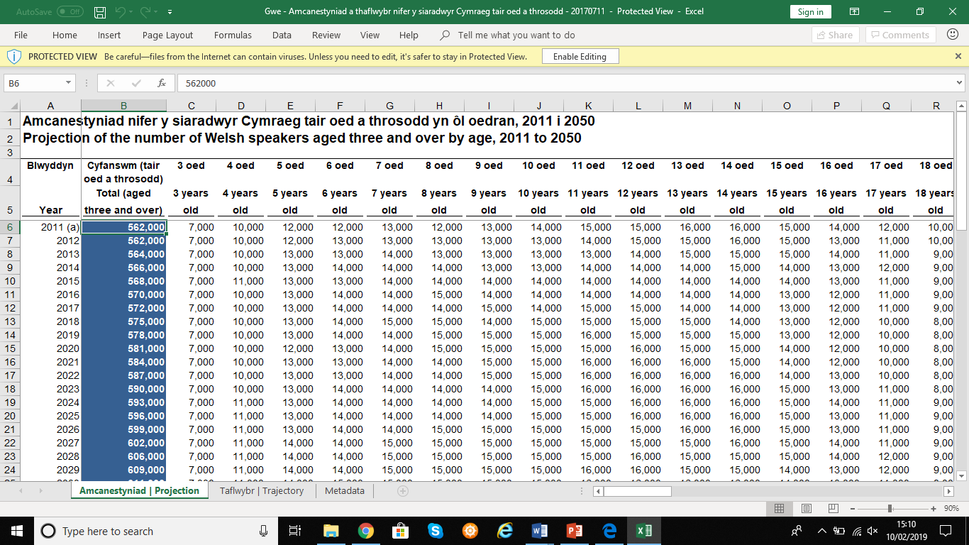
Appendix 1: https://statswales.gov.wales/Catalogue/Welsh-Language

