Cover Page

Table of Contents
Introduction 1
Task 1. e-Commerce Website builders or software solutions 1
1.1 WooCommerce 1
1.2 Wix 1
Task 2. Mind-map of contemporary software applications 1
a. Mind mapping and explain the benefits of using mind mapping in business operations 1
b. Create a mind map of contemporary software applications 1
Task 3. Office Applications 1
a. Four office software solutions for business operations 1
MS Word 1
MS PowerPoint 1
MS Excel 1
MS Access 2
b. Practical demonstration of Two Office Features 5
Mail Merge 5
If Statement 6
Task 4. Communication and Collaboration applications 6
a. One contemporary Communication and one Online Collaboration applications/tools 6
MS Outlook 6
MS Teams 6
b. One feature of a freely available Communication (1) and one feature of a Collaboration (1) application 6
MS Outlook 6
Ms Teams 6
Conclusion 6
References 6

Introduction
<Insert Information Here>

Task 1. e-Commerce Website builders or software solutions

1.1 WooCommerce
<Insert Information here – 250 words>
WooCommerce is an open-source e commerce plugin for WordPress. You install it on a WordPress site, then you sell products online. You keep full control of your store. You manage products, orders, payments, and shipping from one dashboard.
WooCommerce gives you strong features with no licence fee. You pay for hosting and any paid extensions. This keeps your costs low. You set up physical products, digital products, or services. You track stock levels. You add product images. You write descriptions that help buyers understand what they buy.
WooCommerce supports secure payments. You connect Stripe, PayPal, or bank transfer. You accept card payments and issue refunds from your dashboard. You use built in reports to track sales. You see bestselling items. You see customer behaviour and plan improvements.
The plugin has a large library of extensions. You add bookings, subscriptions, gift cards, and multi-currency features. You improve SEO with specialist plugins. You improve page speed with caching tools. The system lets you customise your shop to match your business needs.
You choose a theme that fits your brand. Many themes support WooCommerce out of the box. You change colours and layout. You create a simple shopping experience that helps customers move from product to checkout with fewer steps.
WooCommerce integrates with marketing tools. You link Mailchimp or Meta Pixel. You run email campaigns and track conversions. Many small and medium businesses use WooCommerce because it gives strong control, flexible design, and low cost. It suits users who want full ownership of their e commerce site.

1.2 Wix
<Insert Information here – 250 words>
Wix is a hosted e commerce website builder that gives you an all-in-one setup for selling online. You build your store through a visual editor. You drag and drop elements. You add pages, products, and payment options without coding. Wix handles hosting, security, and updates, so you focus on your business.
Wix offers clear product management tools. You add product images, quantities, variants, and pricing. You set up digital goods or services. You display items in organised collections. You track orders from a single dashboard. This helps you maintain a steady workflow.
Wix supports secure online payments. You connect Wix Payments, Stripe, or PayPal. Customers pay with cards or digital wallets. You issue refunds with a few steps. You view sales data in built analytics. You monitor traffic, abandoned baskets, and revenue trends.
Wix has many templates designed for e commerce. You pick a layout that matches your brand. You adjust fonts, colours, and product grids. You aim for a fast checkout flow that reduces drop off. The platform also offers mobile optimisation. Customers browse and shop with ease on phones or tablets.
The App Market adds more features. You add product reviews, loyalty programs, live chat, or booking tools. You connect marketing platforms like Google Analytics, Meta Pixel, and Mailchimp. You run email campaigns and track customer behaviour.
Wix suits beginners and small businesses seeking a quick launch. It offers simple setup, stable hosting, and strong visual design tools. It gives you a structured system that supports growth without technical effort.

Task 2. Mind-map of contemporary software applications

Mind mapping and explain the benefits of using mind mapping in business operations
<Insert information appr 500 words> A mind map is a visual layout that organises information around a central idea. You place the main topic in the middle. You create branches for key themes. You add subbranches for details. You use short labels, colours, and simple icons. You see the whole structure on one page. You understand how each part links to the next. Contemporary software applications, like Microsoft 365, Google Workspace, Asana, Trello, Slack, Zoom, and CRM platforms, fit well into a mind map because each tool supports a different area of business operations.
A mind map helps you plan how your software tools support tasks. You place “Business Software” at the centre. You create branches for communication, project management, data storage, marketing, finance, and customer support. Under communication, you add tools like Teams, Slack, and Zoom. Under project management, you add Trello or Asana. Under data storage, you add Google Drive or OneDrive. The map shows how your systems link together. You make faster decisions about which tools to use for each task.
Mind mapping gives clear benefits in business operations.
Benefits:
• Faster planning. You organise large amounts of information on one page. You see tasks, risks, and resources without reading long paragraphs.
• Better understanding. You see relationships between ideas. You see how each department connects to another. You reduce confusion.
• Improved teamwork. Teams use mind maps during meetings. Everyone sees the same structure. Each person adds ideas in real time. This supports equal participation.
• Strong problem solving. You break a problem into smaller parts. You analyse causes, effects, and solutions. You follow each path visually. You avoid missing important details.
• Clear decision making. You compare options side by side. You map advantages, costs, and impacts. You choose the option that supports your goals.
• Better project planning. You outline tasks, deadlines, and responsibilities. You place each task on its branch. You keep a clear picture of the workflow.
• Higher creativity. A mind map removes linear thinking. You follow new branches. You add fresh ideas without strict order. You develop more practical solutions.
• Improved memory. The visual layout helps you remember information. Your brain stores ideas faster when they appear in a structured and visual form.
• Strong communication. You explain complex topics with a simple map. You use it in presentations, training, and project reviews.
In business, mind mapping software like Mind Meister, XMind, and Microsoft Whiteboard supports digital collaboration. You share maps online. Team members edit them at the same time. You attach documents, links, and notes. You update plans quickly. You save versions for future reviews.
Mind mapping supports growth because it helps you understand your tools, your tasks, and your goals. You build clearer strategies. You reduce mistakes. You support teamwork. You improve how your business responds to challenges. A mind map gives you a structured and visual method to manage information and make practical decisions.

Create a mind map of contemporary software applications
<Insert diagram using mind Meister app>

Task 3. Office Applications

Four office software solutions for business operations

MS Word
<Insert information appr 500 words>
MS Word is a word processing application used in business for writing, editing, and formatting documents. You create reports, letters, proposals, manuals, and forms with precision. The layout tools help you produce clean documents that follow professional standards. The interface is simple to navigate. You work with ribbons, tabs, and panels that group tools by purpose. This supports fast and accurate document creation.
MS Word improves writing quality with strong editing features. You use spell check, grammar check, and readability tools. You highlight errors and correct them without slowing your workflow. You use Track Changes during reviews. This tool marks edits clearly. Teams see each revision. Managers approve or reject edits with a click. This improves the quality of collaborative writing.
MS Word offers structured formatting. You create headings, subheadings, lists, tables, and numbered sections. You use styles to keep your formatting consistent. This matters in reports and academic documents where structure guides the reader. You insert tables, figures, and diagrams. You label them with captions. You cross reference sections. This supports clear and organised documents.
MS Word integrates with cloud storage. You save files to OneDrive or SharePoint. You access your documents on any device. You work offline and sync when connected. This supports teams that work across locations. Version history allows you to restore earlier drafts. You avoid losing work.
Templates improve efficiency. Word includes templates for letters, invoices, CVs, agendas, and reports. Businesses use templates to maintain brand identity. You customise colours, logos, and fonts. Staff follow the same format. This keeps communication consistent across the organisation.
MS Word supports collaboration. Multiple users edit a document at the same time when saved in the cloud. You see live updates from team members. You leave comments. You resolve issues quickly. This reduces meeting time and improves workflow.
Mail Merge automates repetitive tasks. You create bulk letters, labels, and emails. You link Word to Excel or Outlook. You insert fields like names, addresses, and dates. You generate hundreds of personalised documents in minutes. This supports marketing and administration.
Security features protect your documents. You add passwords. You restrict editing rights. You choose read only access. This keeps sensitive information safe. You lock sections of a document. Staff see content, but they do not change it.
MS Word integrates with other Microsoft applications. You insert Excel tables and update them without copying data again. You link PowerPoint slides. You attach Outlook contacts into Mail Merge. This creates a smooth workflow across departments.
Businesses rely on MS Word because it supports clear writing, structured formatting, secure file sharing, and real time collaboration. You create professional documents with accuracy. You manage information in a controlled and organised environment. The tool fits academic work, administration, HR, finance, marketing, and customer communication. It remains one of the most used office applications in modern business

MS PowerPoint
<Insert information appr 500 words>
MS PowerPoint is a presentation software used in business to share information in a visual and structured way. You use it for meetings, training, pitches, reports, and project updates. The interface is simple. You work with slides arranged in a sequence. You add text, images, charts, icons, and diagrams. You present information in small sections that your audience follows with ease.
PowerPoint supports clear communication. You break complex information into short points. You avoid long paragraphs. You highlight key facts, statistics, and actions. This keeps your audience engaged. You add speaker notes that guide your delivery without appearing on the slide.
PowerPoint offers templates that save time. They include built in layouts for titles, bullet points, charts, timelines, and comparisons. You choose a theme that matches your brand. You adjust colours, fonts, and backgrounds. This gives your presentation a professional and consistent style.
PowerPoint includes strong visual tools. You insert SmartArt diagrams to display processes, cycles, and hierarchies. You add shapes and icons to support key ideas. You create charts from Excel data. The chart updates automatically when the linked Excel file changes. This supports accurate reporting.
The software helps you structure your message. You use slide sorter view to arrange, remove, or reorder slides. You group ideas clearly. You avoid clutter. You guide the audience from introduction to conclusion with a clean and logical flow.
PowerPoint supports multimedia. You add audio, video, and screen recordings. You show a product demo or training clip directly in the slide. This improves understanding. The animations and transitions let you control how content appears. You use simple effects to highlight important points.
PowerPoint supports collaboration. You save your presentation to OneDrive or SharePoint. Team members open the same file. They comment, edit, and update slides in real time. Version history protects your work. You restore earlier drafts when needed.
PowerPoint improves training delivery. You create step by step guides. You insert screenshots, instructions, and arrows. You use Presenter View during delivery. You see your notes, the current slide, and the next slide on your screen. The audience sees only the main content. This supports confident and structured delivery.
PowerPoint connects well with other Microsoft tools. You insert Excel spreadsheets, Word sections, and Outlook calendars. You export your slides as PDF files for distribution. You convert your presentation into a video for online learning.
PowerPoint helps businesses share ideas in a simple, visual, and organised format. Staff present results, plans, and processes with accuracy. Managers brief teams. Sales staff pitch products. Trainers guide learners. The software supports clear communication, consistency, and stronger decision making.

MS Excel
<Insert information appr 500 words>
MS Excel is a spreadsheet application used in business for organising data, analysing information, and supporting decision making. You work with rows, columns, and cells. You enter numbers, text, dates, and formulas. You structure data in a way that supports clear calculations and fast reporting. The layout is simple, which helps you manage large data sets with precision.
Excel supports strong data analysis. You use formulas like SUM, AVERAGE, IF, and VLOOKUP. These formulas help you calculate totals, compare values, and search for information in tables. You reduce manual work and avoid mistakes. Conditional formatting highlights trends and risks. Values change colour when they meet set rules. This helps you spot patterns fast.
Excel offers charts that turn data into visual information. You create bar charts, line charts, pie charts, and column charts. These visuals make reports easier to understand. Managers see progress, performance, and financial trends. You update the data in the sheet, and the chart changes instantly.
PivotTables support advanced analysis. You summarise large data sets in minutes. You group, filter, and compare information without writing formulas. You use Pivot Charts to add visuals. This supports clear reporting in finance, sales, HR, and operations.
Excel improves accuracy in planning and forecasting. You build budgets, cash flow sheets, and sales forecasts. You adjust numbers to test different outcomes. You see the impact of changes with speed. This helps you make informed decisions.
Excel supports data cleaning. You remove duplicates, split text, and sort information. You organise messy data into a clean format for analysis or reporting. This is important in industries that rely on accurate information.
Excel integrates with other Microsoft applications. You export tables to Word. You insert charts into PowerPoint. You link sheets to databases and web platforms. This creates a smooth workflow across departments.
Collaboration features support teamwork. You save your file on OneDrive or SharePoint. Team members edit it at the same time. You see their changes live. Comments allow discussion inside the sheet. Version history protects your work and lets you restore earlier drafts.
Excel includes templates for budgets, invoices, schedules, and reports. Businesses use these templates to save time and maintain consistency. You customise them with your own data, logos, and colours.
Security tools protect sensitive data. You lock sheets, hide formulas, or protect entire workbooks with passwords. This stops unauthorised changes. You restrict access based on roles. This supports safe handling of financial and customer information.
MS Excel remains essential in business because it supports clear organisation, accurate analysis, and strong decision making. You handle numbers with control. You present information with precision. You use data to understand performance and plan future actions. Excel supports work in finance, sales, marketing, HR, supply chain, and administration.

MS Access
<Insert information appr 500 words
Microsoft Access is a database management system (DBMS) that allows individuals and organizations to store, manage, and analyse data efficiently. It is part of the Microsoft 365 suite and provides tools for creating relational databases, which link different data tables together to reduce duplication and improve data integrity. Access is suitable for small to medium-sized businesses, departments within larger organisations, and educational purposes where a full-scale database system may be unnecessary.
Access combines a graphical user interface with powerful database functionality. Users can create tables to store data, define relationships between tables, and enforce rules to maintain data consistency. Queries allow users to filter, sort, and retrieve specific data sets quickly. These queries use Structured Query Language (SQL), but Access provides a user-friendly query design view that does not require advanced coding skills.
Forms in Access allow users to enter, edit, and view data in a structured way. Forms can include dropdowns, checkboxes, and validation rules to ensure data accuracy. Reports help present data in a professional format for analysis, decision-making, or record-keeping. Users can design reports with charts, graphs, and calculations, making it easier to summarise large volumes of information.
Access supports automation through macros and Visual Basic for Applications (VBA). Macros allow users to automate repetitive tasks, such as opening forms, running queries, or generating reports. VBA provides advanced programming capabilities, enabling custom functions, error handling, and integration with other Microsoft applications like Excel, Word, and Outlook. This flexibility makes Access a versatile tool for creating tailored database solutions.
Integration with other Microsoft 365 applications enhances workflow efficiency. For example, data from Access can be exported to Excel for detailed analysis, or emails can be generated through Outlook based on database records. Access also supports importing and linking data from external sources such as SQL Server, SharePoint, and online databases. This ensures that users can centralize and manage data from multiple systems within a single interface.
Security and data integrity are key features of Access. Users can set permissions for different roles, restricting who can view or modify data. Password protection and encryption help safeguard sensitive information. Access also supports backup and recovery options to prevent data loss.
Access is suitable for both beginner and advanced users. Its design tools make database creation straightforward for novices, while its powerful query, reporting, and automation features serve advanced users and developers. It is commonly used for inventory management, customer databases, project tracking, and small-scale business applications.
Overall, Microsoft Access provides a comprehensive platform for creating, managing, and analysing data. Its combination of relational database functionality, user-friendly interface, automation options, and integration with Microsoft 365 makes it a practical solution for organisations seeking to improve data organisation, reporting, and decision-making. Access reduces manual data handling, improves accuracy, and enables efficient access to critical information.

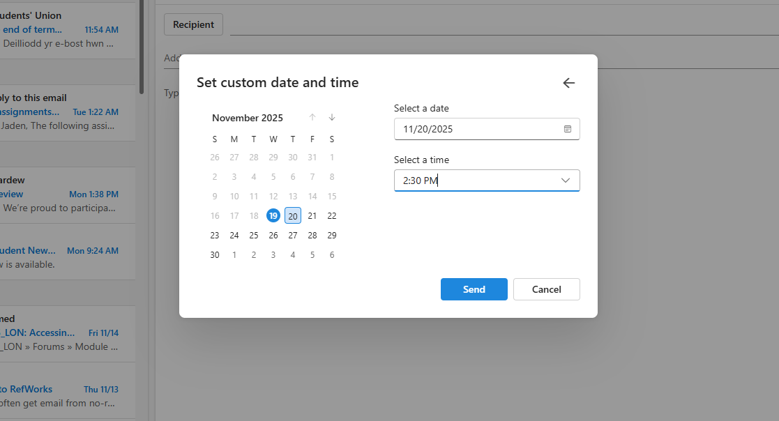t￼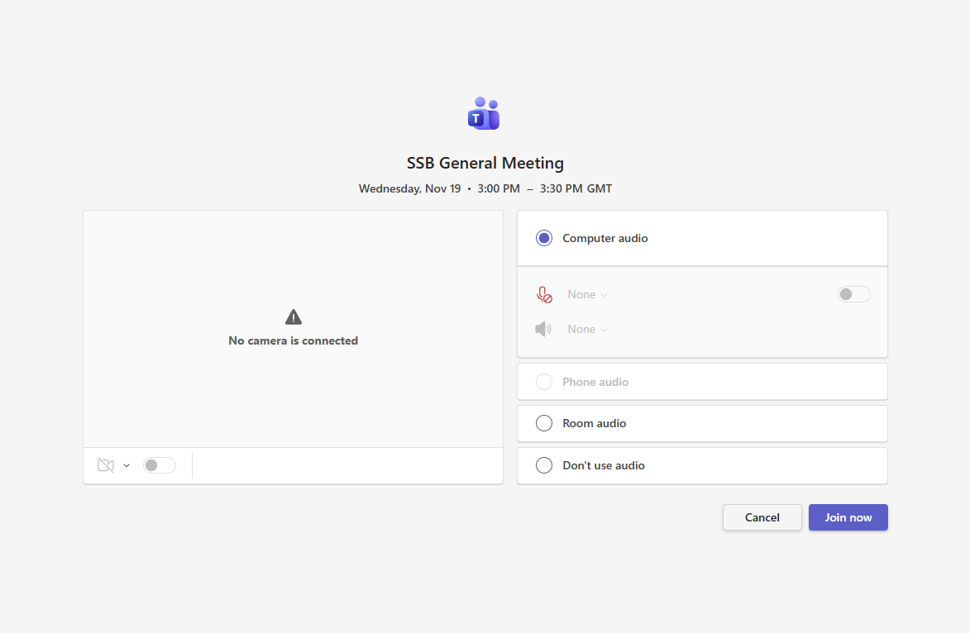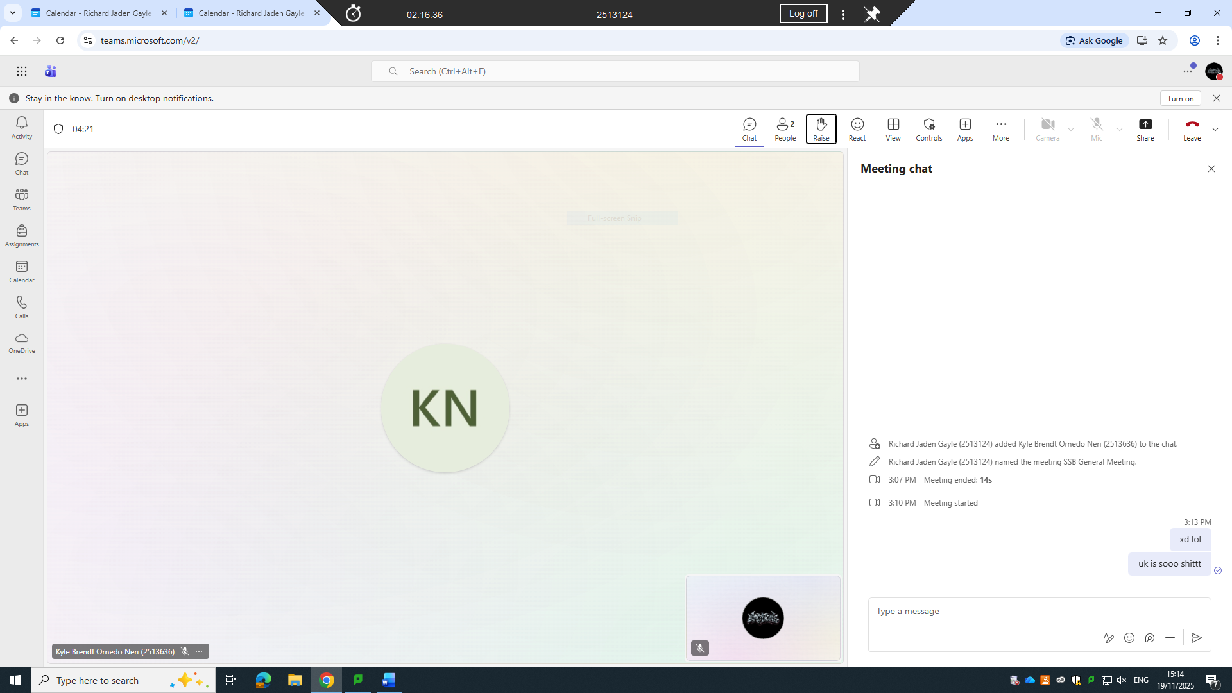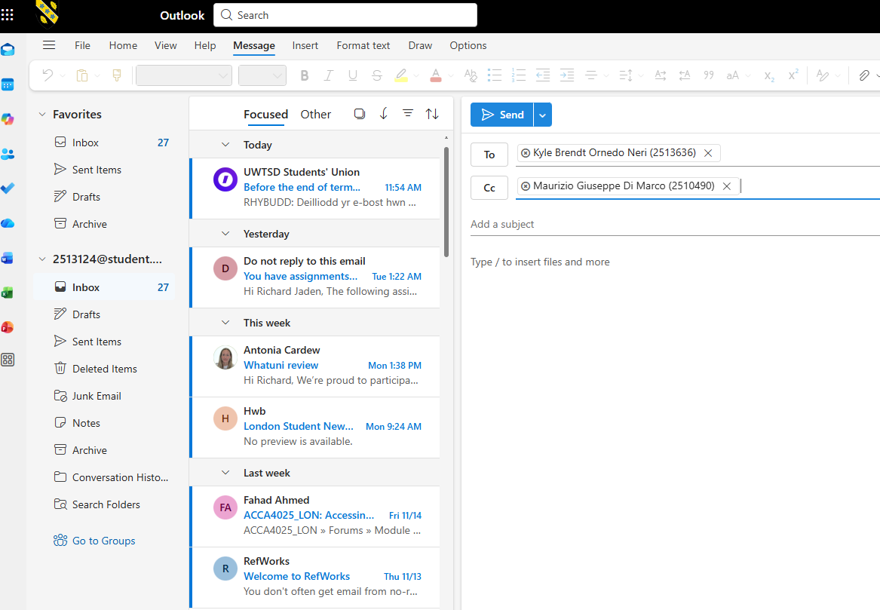

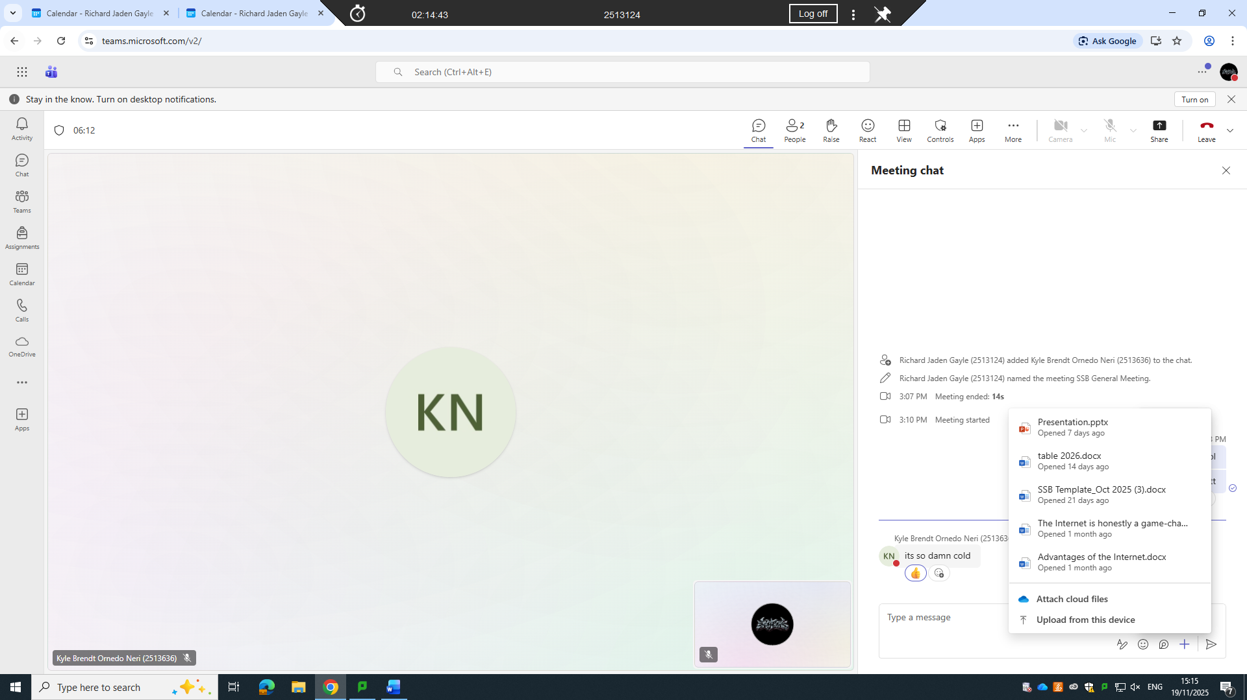Practical demonstration of Two Office Features

Mail Merge
<Insert screenshots with captions>

If Statement
<Insert screenshots with captions>

Task 4. Communication and Collaboration applications

One contemporary Communication and one Online Collaboration applications/tools

MS Outlook
<Insert information appr 500 words>
MS Outlook is a widely used communication and personal information management application. It is part of the Microsoft Office suite and provides multiple tools for managing emails, calendars, contacts, and tasks. Outlook is designed to help businesses and individuals streamline communication and organise their work efficiently.
The primary function of Outlook is emailing management. Users can send, receive, and organise emails in a structured way. Outlook allows the creation of folders and subfolders to sort emails by project, client, or priority. It also has powerful search features to quickly locate specific messages. The application supports rules and filters, which automatically manage incoming emails, such as moving them to designated folders or flagging them for follow-up. This reduces time spent on manual email management and increases productivity.
Outlook integrates a calendar system that enables users to schedule meetings, set reminders, and plan tasks. The calendar can be shared with colleagues to coordinate meetings and avoid conflicts. Users can create recurring events, schedule resources like conference rooms, and send automatic notifications to participants. This integration improves collaboration within teams and ensures deadlines are met efficiently.
Another key feature of Outlook is its contact management system. Users can store contact information for clients, colleagues, and suppliers. The system allows grouping of contacts for bulk communication, which is particularly useful for marketing or team announcements. Contact details are linked to emails and calendars, allowing for easy access during communication or scheduling.
Outlook supports task management, which helps users track personal and team responsibilities. Tasks can be created with deadlines, priority levels, and status updates. Users can assign tasks to team members, monitor progress, and mark them as complete. This functionality ensures accountability and smooth project management.
Integration is a major strength of Outlook. It works seamlessly with other Microsoft tools such as Teams, OneDrive, and SharePoint. Emails can include attachments from OneDrive, and Teams meetings can be scheduled directly through Outlook. This connectivity reduces the need to switch between multiple applications and simplifies communication workflows.
Outlook also prioritises security and privacy. It provides built-in encryption options, junk mail filters, and phishing detection. Businesses can implement policies to safeguard sensitive information, ensuring that email communication remains secure. Mobile apps extend Outlook’s functionality to smartphones and tablets, enabling users to manage emails, calendars, and tasks on the go.
In summary, MS Outlook is a comprehensive communication tool that combines email, scheduling, contacts, and task management in one platform. Its integration with Microsoft Office applications, strong security features, and organisational tools make it essential for modern business communication. By centralising communication and collaboration, Outlook improves efficiency, reduces time wasted on administrative tasks, and supports team coordination across different locations and devices.

MS Teams
<Insert information appr 500 words>
Microsoft Teams is a communication and collaboration platform designed for businesses, educational institutions, and organizations. It integrates chat, video meetings, file storage, and application integration into a single interface. Teams is part of the Microsoft 365 suite, which allows seamless access to other Microsoft applications such as Word, Excel, PowerPoint, and OneDrive. This integration simplifies workflow, enabling users to manage documents, schedule meetings, and collaborate in real time without leaving the platform.
The platform supports instant messaging, allowing users to communicate through private messages or group chats. Users can share files, images, and links directly within chats. Teams also supports threaded conversations, which keeps discussions organized and easy to follow. Notifications alert users to messages, mentions, or updates, ensuring important communications are not missed.
Teams includes a robust video conferencing feature. Users can host meetings with participants both inside and outside the organization. Meetings support audio and video calls, screen sharing, and recording for later review. The platform also allows scheduling directly through Outlook, syncing calendars for efficiency. During meetings, participants can collaborate on shared documents in real time, enhancing productivity and reducing delays caused by back-and-forth emails.
Collaboration in Teams extends beyond chat and meetings. Users can create channels within teams, each dedicated to a specific project, department, or topic. Channels organize conversations, files, and apps in one place, making it easier for teams to track progress. Integration with third-party apps like Trello, Asana, and Zoom allows users to bring tools they already use into Teams. This reduces the need to switch between multiple platforms and centralizes work.
Teams also emphasizes security and compliance. Microsoft provides enterprise-grade security, including data encryption, multi-factor authentication, and compliance with industry standards. Administrators can control access, set permissions, and monitor activity to protect sensitive information. This makes Teams suitable for industries with strict data privacy requirements.
The platform is accessible on multiple devices, including desktops, laptops, tablets, and smartphones. Its mobile app ensures that users can stay connected and participate in discussions even when away from their desks. Offline access allows users to view messages and documents without an active internet connection, increasing flexibility.
Overall, Microsoft Teams improves communication, streamlines collaboration, and enhances productivity within organizations. Its integration with Microsoft 365 applications, combined with robust security features and mobile accessibility, makes it a comprehensive tool for modern work environments. Teams reduces reliance on email, centralizes workflows, and supports real-time collaboration, enabling teams to work efficiently and effectively regardless of location

One feature of a freely available Communication (1) and one feature of a Collaboration (1) application

MS Outlook
<Insert screenshots with captions>

Ms Teams
<Insert screenshots with captions>

Conclusion
<Insert information>

References

