What helps me learn language and mathematics? An analysis of a child’s learning in mathematics and language with recommendations for ensuring progress.
This essay will discuss and analyse a child’s learning and understanding of language and mathematics. Strategies and resources will be discussed and evaluated to identify what the learner found helped them to learn language and mathematics. Examples of the child’s work will be discussed and analysed and their attitude towards mathematics and language as a subject will be explored. Observational notes and examples of work will be discussed and links to the national curriculum and learning outcomes will be analysed linking to the child’s work.
Donaldson states that “Literacy and numeracy are universally acknowledged to be the essential foundations of education” this emphasises the need for young children to have a deep knowledge and understanding of mathematics and language if they are going to do well within education (Donaldson, 2015). The evidence that will be critically analysed and discussed has been gathered from a 6-year-old girl in a year 1/2 class who was identified by the class teacher as an ‘Average’ attainer. This class was mixed with pupils from both year 1 and year 2 where introductions for lessons were done as a whole class and then the class would be split into the year groups for the focus tasks. The child will be referred to as ‘Child A’. Child A was classed as an ‘Average’ attainer in the class. However, it was clear that she was very competent in her skills, knowledge and understanding during every introduction with the year 2 class. She attended an average size primary schools situated in South Wales. Evidence for this was gathered over a 5-week period and the Mosaic Approach was used to collect data. This approach places high emphasis on the “Child’s voice” being heard and allowing them to be involved in evaluation of their own learning, while encouraging them to be creative by using their voice and drawings in order to express their opinion (Clark and Moss, 2011). Teachers and parents are therefore able to have a greater knowledge and understanding of children’s lives and thus help them to become “Ambitious capable learners” which is one of Donaldson’s four purposes of the new curriculum (Donaldson, 2015). In order to gain an understanding of how the child felt about their learning and progress the Attitudes, Skills and Knowledge (ASK) model will be used (Nottingham, 2013). The ASK model is crucial for teachers to use in order to understand the role that a child’s attitude, skills and knowledge can have on their learning, and to allow a child to develop these three areas in their learning (Nottingham, 2013). Evidence was gathered in accordance with the school’s safeguarding policy. As a result, some evidence will be given as resources as the activity carried out involved taking photographs of the child’s face during the activity and therefore cannot be used as evidence in this essay.
“During the Foundation Phase, children develop their skills, knowledge and understanding of mathematics through oral, practical and play activities. They enjoy using and applying mathematics in practical tasks, in real-life problems, and within mathematics itself.” (Welsh Government, 2015, p.27). This statement from the foundation phase framework tells us that mathematics should not just be learning about numbers but should give children the opportunity to develop skills that they will be able to use later in life and within real life contexts. The successful futures document supports this and says that mathematics helps children understand the world around them and handle themselves appropriately later in life. In the successful futures document, Donaldson also states that “Priority has already been given to literacy and numeracy within the Welsh curriculum through the LNF” and thus the LNF had been incorporated into the lessons (Donaldson, 2015, p.39).
Some maths sessions I carried out with the year 1 class related to identifying and adding and subtracting money. Dickson et al (1984) said that Gibson (1981) had identified three key concepts that children should learn about money. They are: Coin recognition, Equivalence and Practical situations (Hansen, 2005). During the sessions each of these concepts were covered and Child A showed different levels of understanding for each. To introduce the topic of money I cut out and laminated coins up to 20p equivalent to the size they are (see appendix 1). Before showing the children the coins, I asked them open ended questions about what they knew about money. Using open ended questions allowed for discussion between myself and the children, engaging them in the learning and so making their learning experience more meaningful. Askew at al, supports this and states that “One factor involved in effective teaching was the emphasis placed on child/teacher discussion” (Hansen, p. 14, 2005). Child A was excited about the topic of money as she was given money by her nan once a week and said, “I know what they look like and that they are different colours but I don’t know all the shapes” (See Appendix 2) In relation to the ASK model this shows that Child A’s attitude towards money was positive as she related it to real life, and was curious about the different shapes of the coins. She was eager to learn and always put her hand up to answer questions.
Although Child A was confident in the use of coins, she struggled at first in understanding the value of the coins. I placed a cut out 5p and 2p on the floor and asked her which one was worth more. She at first pointed to the 2p coin and said that it was worth more as it was bigger. This is common in children and can be classed as a misconception. Barmby et al say that misconceptions are when a child’s “conception is considered to be in conflict with the accepted meanings and understandings in mathematics” (Barmby et al, p.4, 2009). Margaret Donaldson believes that children make errors and misconceptions as they are trying to make ‘human sense’ of the situation and that can be seen here, where Child A believed that the bigger the object the more it’s worth. In relation to the ASK model Child A’s knowledge of money was poor and her concepts were blurred. Ryan and Williams (2007) state that mathematical misconception and errors can be corrected by the teacher as they are within the surface levels of knowledge (Hansen, 2005). After realising Child A’s confusion, I showed her a 2p with 2 1ps underneath, and did the same with a 5p and explained that there were only 2 1ps but 5 1ps in a 5p coin so it was worth more. After learning about the coins and their value I brought a till into the classroom and made a pop-up shop where the children could go and buy items. They were able to use this during their ‘free time’ in class. Child A would be the first one to go to the area. By observing child A in the shop area, I noted that she would always try and be the one behind the till so that she could give out change and check whether she was being given the correct money (See appendix 3).Placing the till in the continuous provision area it allowed Child A the chance to learn for herself rather than being told how to learn. Froebel agrees with this and says that children should be encouraged to find an activity to carry out for themselves rather than being told what to do (Pound, 2006).
At the end of the money topic I carried out an interview with Child A and asked what helped her learn about money. She said, “I enjoyed playing on the till it helped me use different coins and I was able to add and take away like the people in shops” (See appendix 4). By relating the learning to a real-life context Child A found it easier to understand money and its value. Dewey supports this and states that education should be based on real life situations and that “Education comes through the stimulations of the child’s powers by the demands of the social situations in which he finds himself” (Pound, 2006, p.21) In relation to the ASK model, Child A developed her skills in social, communicative and intellectual ways. By using the till in the shop area she developed her social skills as she built a ‘rapport with classmates and respected others viewpoint’, her intellectual skills were developed as she identified the ‘relationship’ between money and real life situations in which it can be used and developed her communicative skills by ‘listening and responding appropriately to others’ (Nottingham, p.39, 2013).
Another topic covered that was taken from the foundation phase framework was to ‘find halves in practical situations’ (Welsh Government, p. 31, 2015). In order to relate this to real life I merged it with their theme of Welsh wildlife. Explaining that halving meant sharing between two, I took them into the wooded area of the playground and asked them to look for an animal that may be able to help us learn; I had also set up different plastic animals that may be found in the wooded area. Child A identified a ladybird almost immediately, and when asked why this would help, she explained that the ladybirds had spots on their back which had to be the same on each side of their wing. I chose to start the learning outdoors as children are more engaged and will retain information better. Frobel supports this as he believes that space and light outside are essential to positive learning. As an activity the children were given a worksheet with lady birds and missing dots with multilink in front of them (see appendix 5). Child A understood that the multilink represented the dots on the ladybird and could be seen splitting the multilink into two halves to go onto the ladybird’s back (See appendix 6). Using the multilink gave Child A a visual representation of the numbers and how to half them. By using visual representation, the child is able to explore for themselves the connection between the number and the real-life situation. Post and Cramer (1989) support this and state that using visual representation enables a child to make connections between mathematical concepts and own personal experiences and highlight that visual representation is important for both the pupils and the teachers in learning and teaching mathematics (Barmby et al, 2012). In relation to the ASK model Child A’s attitude, skills and knowledge were all being challenged and developed.
Graham Donaldson has created new areas of learning and experience in the new curriculum, one of these being “Languages, literacy and communication”. He states that “Language is the essence of thinking and is integral, not just to effective communication, but to learning, reflection and creativity” (Donaldson, p.48, 2015). Language and literacy are an important factor in a child’s learning journey, and it is therefore essential that language is of the highest standard within education to ensure a child’s success. An Estyn report supports this and states that “Early gains in literacy have the effect of raising standards overall and preventing underachievement” (Estyn, p.7, 2011).
In the year 1/2 classroom there was a reading corner which has a little hut with cushions and toys where the children could go to during their free time. This allows children to develop their language, literacy and communication skills as it states in the foundation phase framework that “They should have opportunities to choose and use reading materials” (WAG, p.12, 2015). Whilst observing Child A, I noted that she spent a lot of time there either on her own or with friends. When I asked her why she enjoyed being in there she said that it made her ‘smile’ when she was in there. Maslow (1943) stated that people are motivated to achieve and that once they have achieved one level, they will move onto the next. He created a hierarchy of needs which include 5 motivational needs and states that a child must be content within themselves to move onto the next (McLeod, S. A. 2007). Child A was content within the reading corner and felt confident within herself to read independently. In a conversation with Child A she explained how she had books at home that sometimes her mum reads to her or she reads on her own, thus explaining why reading made her smile as it was something she enjoyed doing outside of school. A report by the National Literacy Trust found that children who have books in their home enjoy reading more than those who do not have access to books at home, and that these children are more likely to read above the expected level (Chaimberlain, 2018).Every morning each child would carry out read write ink. They each had their own booklets where they would first learn the sound through phonics and would then write out the letter. Goswami (2010) states that phonology is “The way the brain represents the sound structure of spoken language” (Waugh et al, p.4, 2015). The children would first sound out the letter then repeat the rhyme of how to write it, while signing it with their finger in the air. Doing it this way allowed the children to associate an action for the sounds/letters. Child A enjoyed using phonics and when writing out the letter would say the rhyme out loud to remind herself of where the formation of the letter should be at each point. This developed her oracy, reading and writing skills, all which are stands of the foundation phase document for language, literacy and communication. In an interview after a read write ink session, I asked Child A whether she enjoyed learning phonics and what helped her learn. She replied that she enjoyed phonics because she was able to sing a little rhyme to go along with the writing of the letter, and that signing a rhyme helped her remember the sound and what it should look like. Robert Owen supports this and states that children learn best when being exposed to music and should be encouraged to spend more time learning through strategies that make children happy (Pound, 2006). In a recent Estyn (2018) inspection it was found that the best results in developing pupils’ oracy skills were those that dedicated time to incorporating singing into the lessons.
During my time on professional teaching practice, I taught the topic of imperative verbs over a week. To introduce this to the children, I created a powerpoint showing what imperative (bossy verbs) are. As an activity on the carpet I held up A4 sheets which had imperative verbs on them in both English and Welsh (See appendix 7). I then asked the children to stand up and with a partner carry out the action for the imperative verb. I then asked one child in the pair to close their eyes while I gave them an imperative verb to act out for their partner to guess. Vygotsky supports this type of learning as it links to his theory of the ‘zone of proximal development’. This is described as a gap in the child’s learning of what they can do alone and what they are able to do with the help of someone else (Pound, 2006). Child A thrived when working with a partner for this activity. However, she became frustrated when she was unable to remember the Welsh word for the action unlike some other children. In relation to the ASK model Child A’s attitude towards this activity was less motivated than the others. However, instead of giving up she carried on and after being given a little more time to answer, was able to correctly identify the Welsh word for the action as well. Child A realised that the only way she was going to remember the Welsh words was to do it herself. This demonstrated that Child A had a growth mindset. This is where children take responsibility for their learning and success and understand that it is their own effort, behaviour and resilience that will impact on their learning (Willis, 2019). The class was split into groups of 4 and were given a focus task, one of these to be carried out in the role play area. I asked the children to act out a scenario using as many imperative verbs as possible. Whilst observing Child A in the role play area, I noted that her oracy skills were very clear, and that she was pronouncing the imperative verbs well, highlighting that they were imperative verbs. By using role play as a teaching and learning strategy Child A was able to communicate freely, and in relation to the ASK model developed all the skills associated with it, including her social interaction and physical skills. Estyn support this type of learning and state that “Role-play in particular can make a valuable contribution to children’s language and literacy skills, particularly oracy skills” (Estyn, p.15, 2011).

After observation and evaluation Child A is working at an outcome 4 level in the foundation phase framework in mathematics (see appendix 8). In my time on professional teaching experience she only covered a few of the strands however was making steady progress in furthering her knowledge.
Child A had many strengths within maths sessions and showed confidence in the subject throughout my time on professional teaching experience. However, a lot of the activities that child A carried out in mathematics were worksheet based. This is not beneficial for Child A, as in order to progress her learning further she needs to be presented with practical situations. Schoenfeld supports this and states that “Mathematics is a living subject which seeks to understand patterns that permeate both the world around us and the mind within us” if a child is unable to relate their learning to real life situations then it is no use to them in their understanding of the subject. He also states that it is the teacher’s responsibility to give children “opportunities to study mathematics as an exploratory, dynamic, evolving discipline rather than as a rigid, closed body of laws” (Mooney et al, 2014, p.71). I could have implemented this by giving Child A an activity whereby she would share a packet of sweets between two people.
Child A showed a high level of understanding in mathematics for her age and was confident in her ability. However, upon reflection of each of the sessions I carried out, the questioning was very much teacher led. This can be detrimental to the child’s future attitude and development towards maths. Watson and Mason support this and state that the learning of mathematics should take place in a “social situation of talk, compromising of discussion, questions, prompt and answers”. They also say that relying on questions alone will not alert teachers to any misconceptions that a child may have (Watson and Mason, 1998, p.37).Briggs and Davis (2008) further support the need for strategic questioning, as they state that it can provide children with opportunities to be creative in their thinking and answers in mathematics. By providing Child A with skilful questioning this would move her learning towards the next outcome in the foundation phase framework, as she could then explain her thought process and method of completing the question. Child A would develop her higher order thinking skills which involve taking a concept and splitting it into different parts and discussing different ways to understand it (Bookhart, 2010).
Child A was confident within the mathematics sessions I taught and understood the process and method needed to carry out the tasks. However, on reflection, I can see that I did not include and promote mathematical language within the session or the learning objective, and as a result did not use it within her work. In future sessions key vocabulary could be typed on laminated flash cards and placed around the classroom. The key vocabulary should have a big part in the introduction and the strategy “me then you” should be adopted, where the teacher says it first and then the children. This is then repeated 3 times. Mayow supports the importance of mathematical vocabulary and says that “mathematical meaning is crucial in bridging the gap in mathematical understanding and therefore language and number are intrinsically linked” (Mooney et al, 2014, p. 74).
After observation and evaluation Child A is working at an outcome 4 level in literacy, language and communication. However, she also is working at outcome level 3 in the writing strand of the curriculum (see appendix 9).
Child A’s reading skills were average for her age and within the class. However, when it came to writing she struggled with some of the spelling and capital letters. As she is not as competent in these areas, she is unable to move onto the next outcome. Therefore, to help her move her learning along, sessions where the teacher scaffolds some writing would be beneficial. This would allow her to identify what a sentence should look like and what should be in it, for example, capital letters and full stops. Vygotsky and Piaget both support this as they believe giving a child a small amount of scaffolding in their learning allows them to then independently move their learning forward (Pound, 2006). To develop her spelling, Child A could be exposed to more consonant, vowel and consonant sound (CVC) and consonant, consonant, vowel, consonant (CCVC) activities which could show pictures representing the meaning of the word. This would allow Child A to identify the relationship between phonemes and spellings of multiple words including their meaning. Crystal and Adams suggest that “80-90% of spellings conform to a general pattern and that many more words could be spelled correctly if other information was taken into account” (Waugh et al, 2019, p.70). To ensure improvement Child A could be sent home with homework of ‘tricky words’ to go through with their guardians. Sending homework involves the child’s guardians in their education and can boost self-confidence within the child. Hornby (2011) supports this and says that extensive research has found that parental involvement has improved social and academic achievements for children.
The area that Child A struggled with in reading was understanding what the punctuation meant in the text. She did not associate a full stop with taking a breath in a sentence, or that and exclamation mark needed a change in her voice. In future sessions, small group work could be undertaken using whiteboards. The teacher could write a short sentence down and ask each child to read the sentence asking what the punctuation may mean. Once confident, the children could split into pairs and create their own sentences for each other. Child A would feel comfortable doing this as she felt safe surrounded by her friends. This would challenge her learning at the same time as she would not look for rewards from the teacher but instead from her peers. Child A would then be experiencing flow which means that she is happy in the challenge she has been set. Csikszentmihalyi (2014) supports this and states that when experiencing flow, you are doing things that are so enjoyable that a child would want to pursue it for their own satisfaction.

Reference list

- Barmby, P. et al. (2009) Primary Mathematics: Teaching For Understanding: Teaching for Understanding. New York: Open University Press.
- Barmby, P. et al. (2012) Developing the use of visual representations in the primary classroom. Available at: https://www.nuffieldfoundation.org/sites/default/files/files/Developing%20the%20use%20of%20visual%20representations%20in%20the%20primary%20classroom%2013Jun13.pdf (Accessed: 26th March 2019)
- Briggs, M.J. and Davis, S. (2008) Creative Teaching: Mathematics in the Early Years and Primary Classroom. Oxon: Routledge.
- Brookhart, S.M. (2010) How to Assess Higher-Order Thinking Skills in Your Classroom. Alexandria: ASCD.
- Chamberlain, L. (2018) Inspiring Writing in Primary Schools 2nd Ed. United Kingdom: Sage.
- Clark, A and Moss, P. (2011) Listening to Young Children the Mosaic approach 2nd Ed. London: NCB.
- Csikszentmihalyi, M. (2014) Applications of Flow in Human Development and Education. USA: Springer.
- Donaldson, G. (2015) Successful Futures. Available at: https://gweddill.gov.wales/docs/dcells/publications/150225-successful-futures-en.pdf (Accessed: 22nd March 2019)
- Estyn. (2011) Literacy and the Foundation Phase An evaluation of the implementation of the Foundation Phase for five to six-year-olds in primary schools, with special reference to literacy. Available at: https://www.estyn.gov.wales/sites/default/files/documents/Literacy%20and%20the%20Foundation%20Phase%20%20-%20September%202011.pdf (Accessed: 31st March 2019)
- Estyn. (2018) Rapid development of pupils’ oracy skills. Available at: https://www.estyn.gov.wales/effective-practice/rapid-development-pupils’-oracy-skills (Accessed 28th March 2019)
- Gilderdale, C. et al. (2017) Approaches to Learning and Teaching Mathematics. Cambridge: Cambridge University Press.
- Hansen, A. (2011) Children’s Errors in Mathematics 2nd Ed. Exeter: Learning Matters Ltd.
- Hornby, G. (2011) Parental Involvement in Childhood Education. London: Springer.
- Mason, J. and Watson, A. (1998) Questions and Prompts for Mathematical Thinking. London: Association of Teachers of Mathematics.
- McLeod, S. A. (2007) Maslow's Hierarchy of Needs. Available at: http://highgatecounselling.org.uk/members/certificate/CT2%20Paper%201.pdf (Accessed: 30th March 2019)
- Mooney, C. et al. (2014) Primary Mathematics Teaching Theory & Practice 7th Ed. London: Sage Publications Inc.
- Nottingham, J. (2013) Encouraging learning. Oxon: Routledge.
- Nottingham, J. (2016) Challenging Learning 2nd Ed. Oxon: Routledge.
- Pound, L. (2006) How children learn. London: Practical Pre-School Books.
- Waugh, D and Desmond, C and Carter, J. (2015) Lessons in Teaching Phonics in Primary Schools. London: Sage Publications.
- Waugh, D. and Warner, C. and Waugh, R. (2019) Teaching Grammar, Punctuation and Spelling in Primary Schools 3rd Ed. London: Sage.
- Welsh Government (2015) Foundation Phase Framework. Available at: https://gov.wales/sites/default/files/publications/2018-02/foundation-phase-framework-revised-2015.pdf (Accessed: 19th March 2019)
- Willis, N. (2019) Growth Mindset: A practical Guide. London: Bloomsbury Publishing Plc.

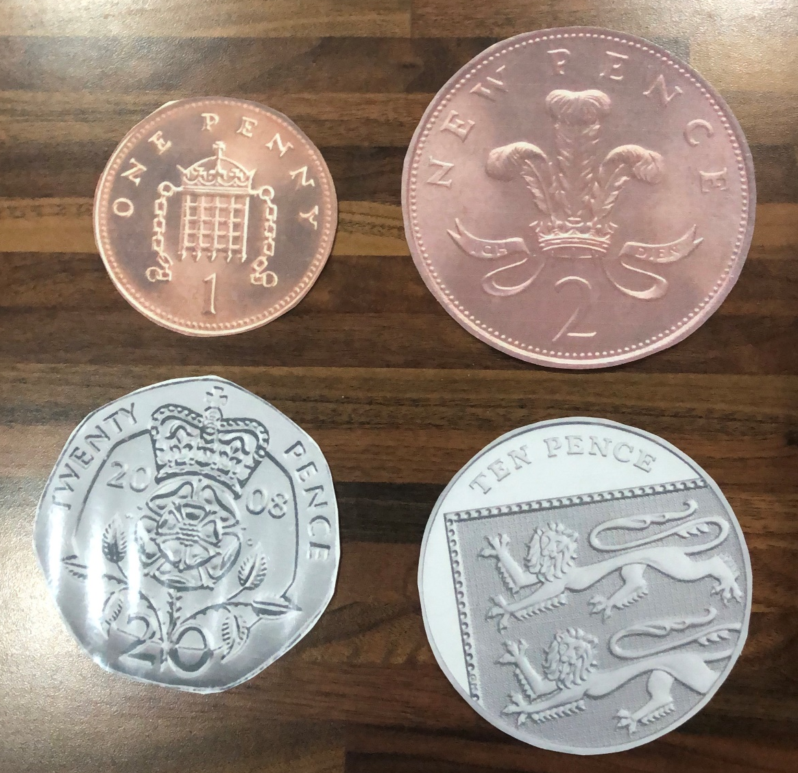
Appendix 1

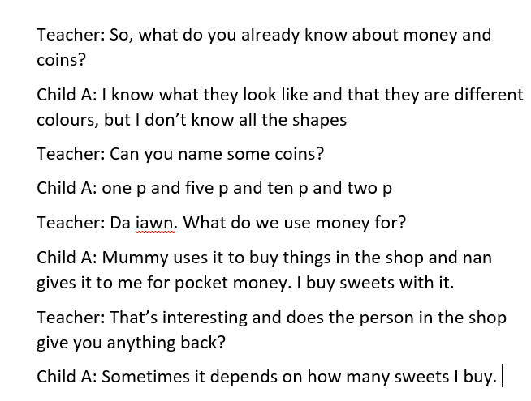
Appendix 2

Appendix 3
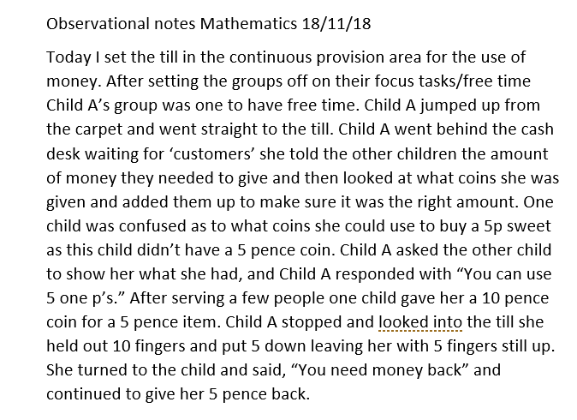

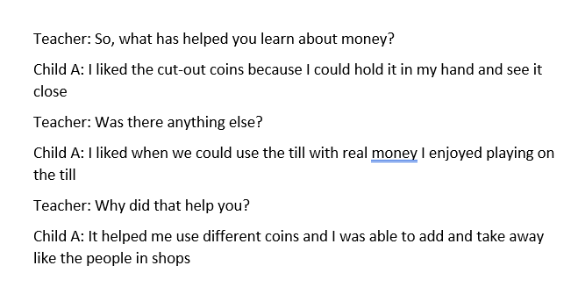
Appendix 4

Appendix 5

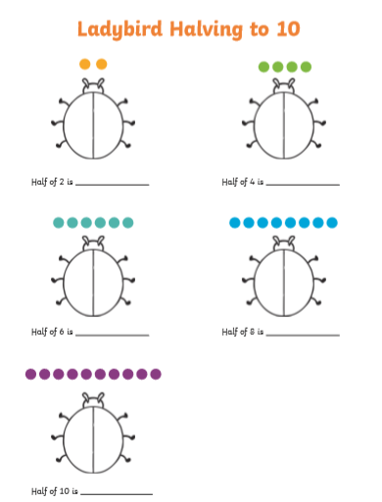
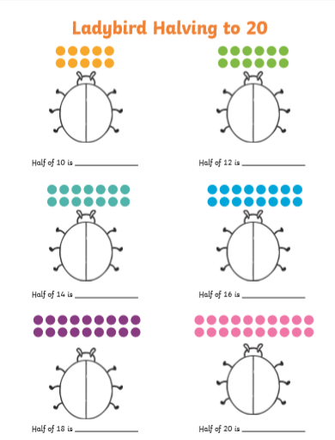

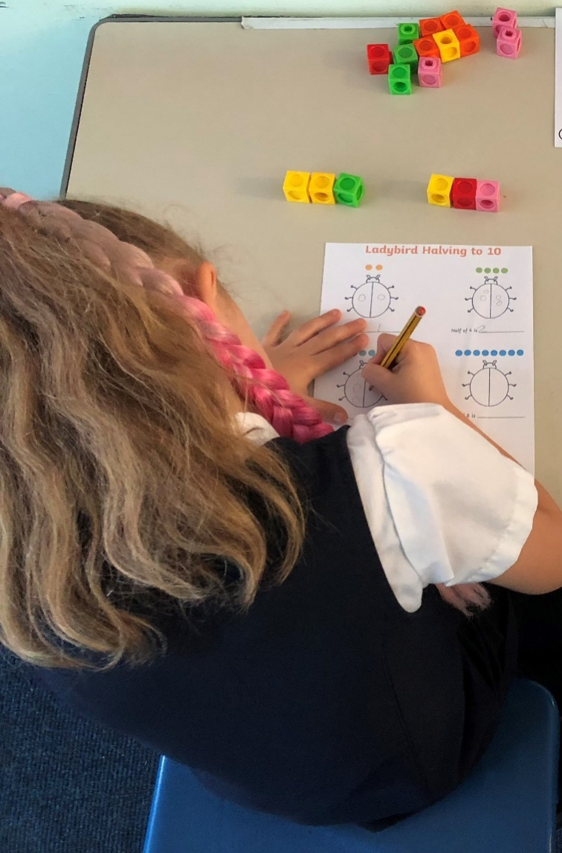
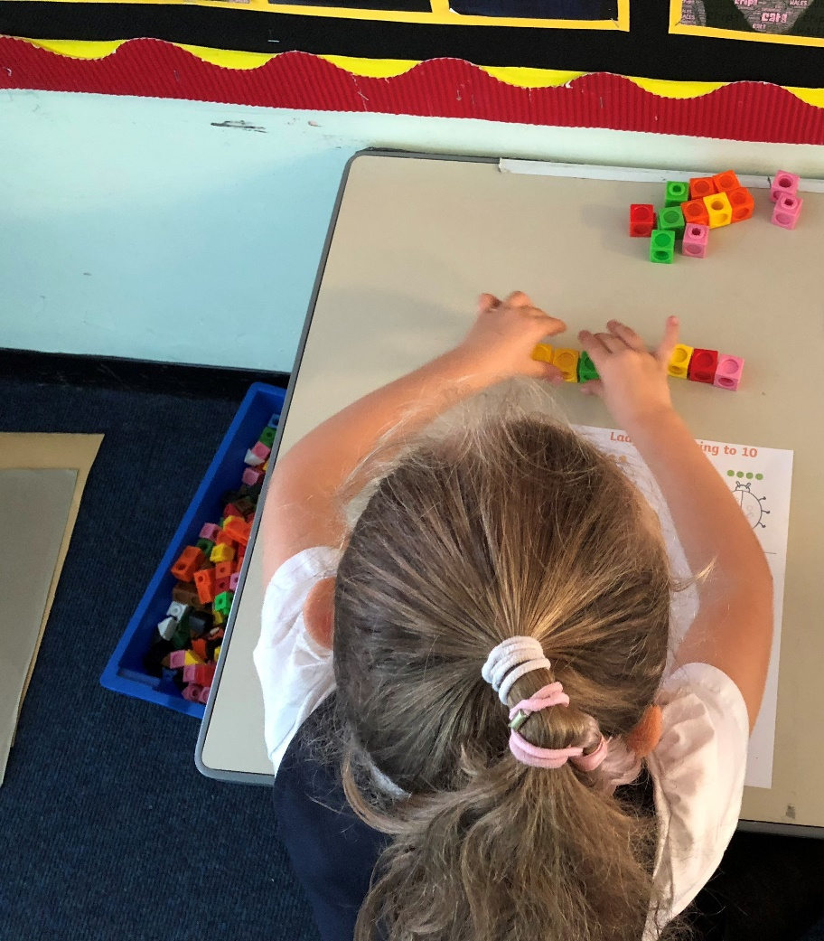
Appendix 6

Appendix 7

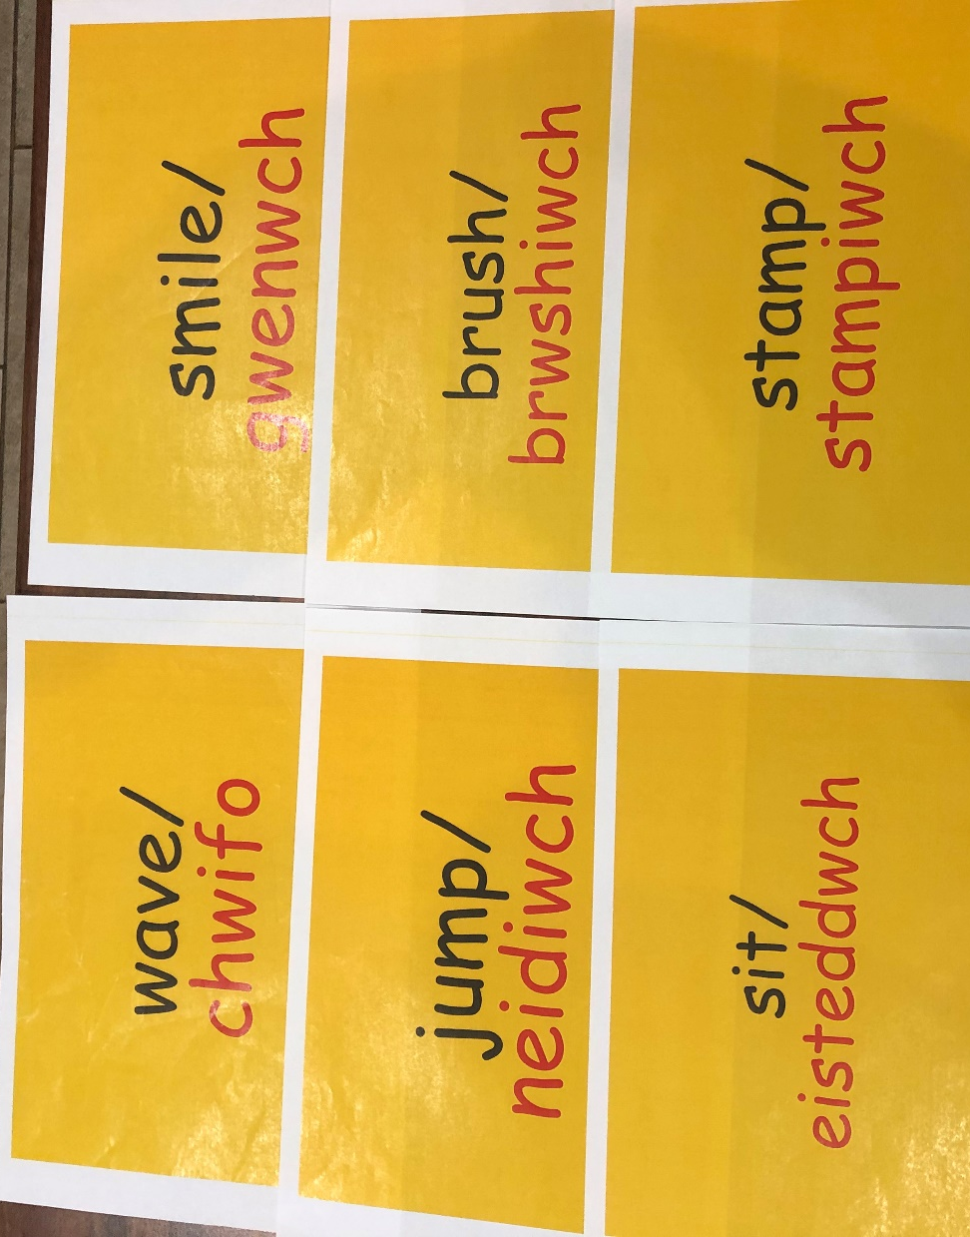

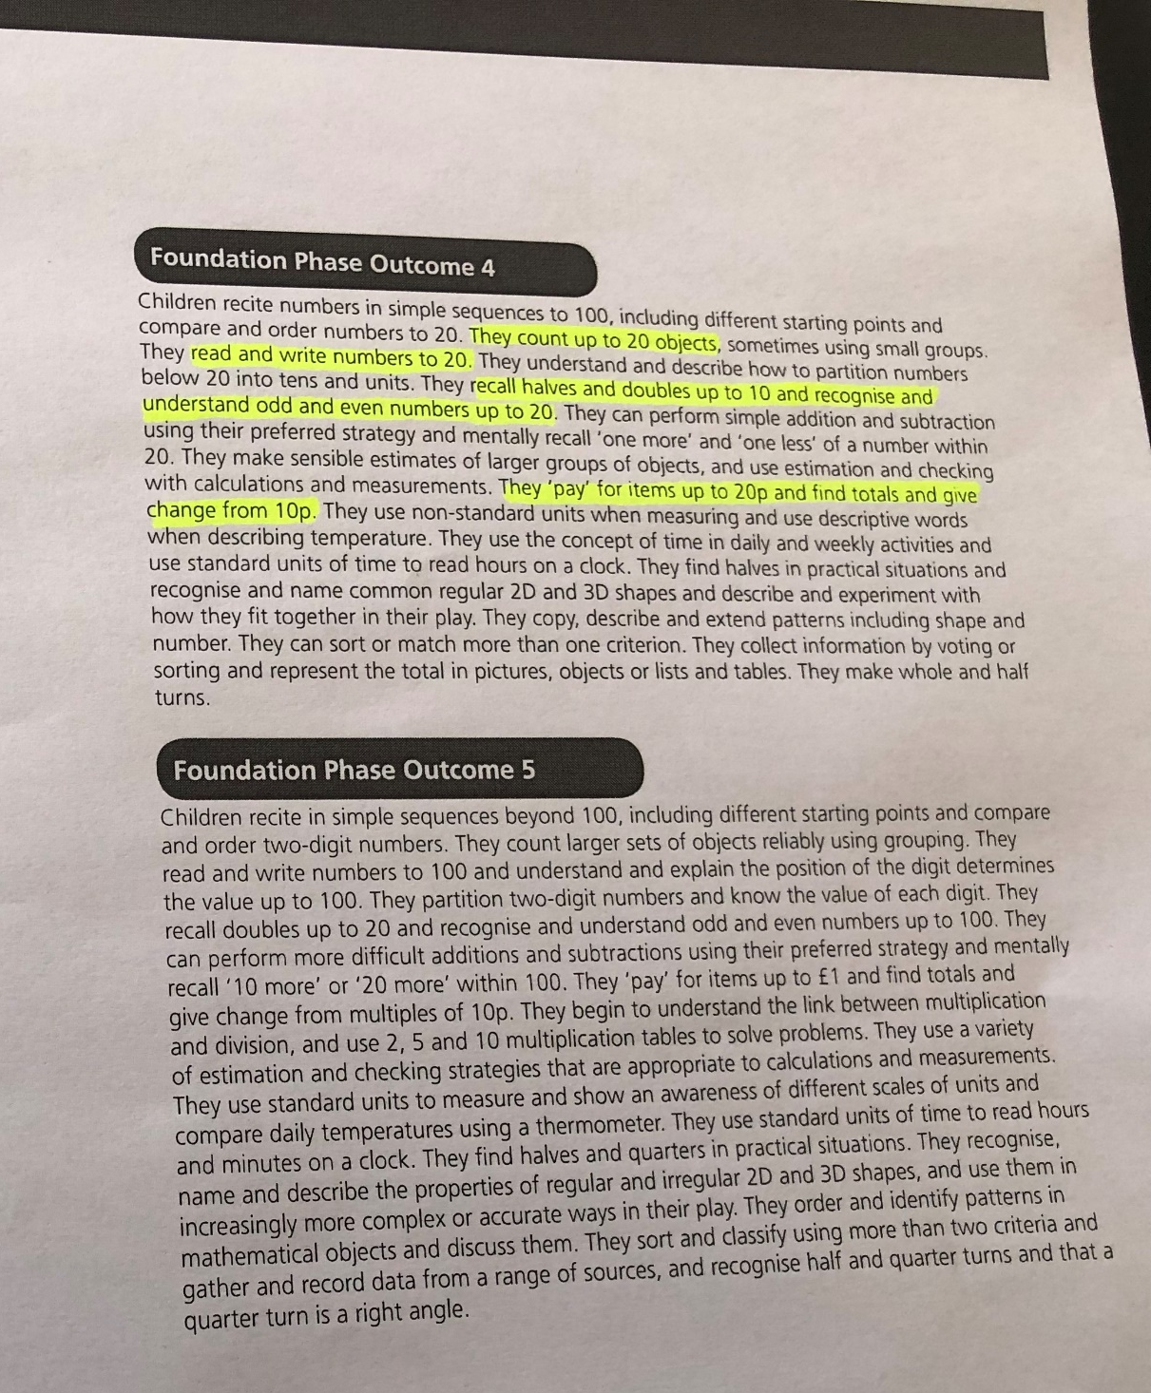
Appendix 8

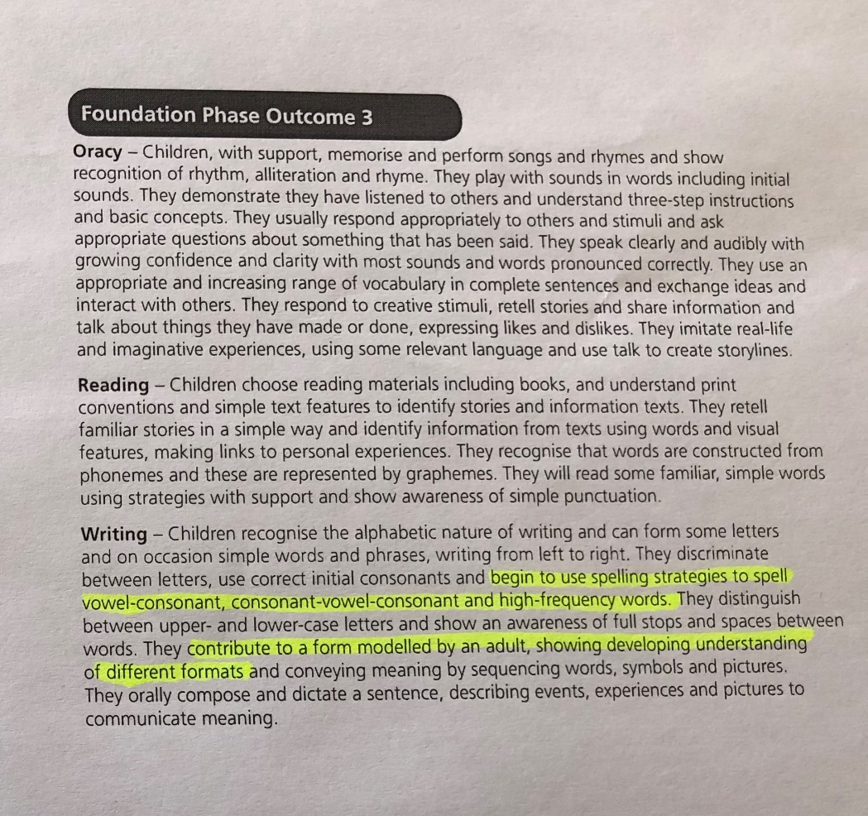
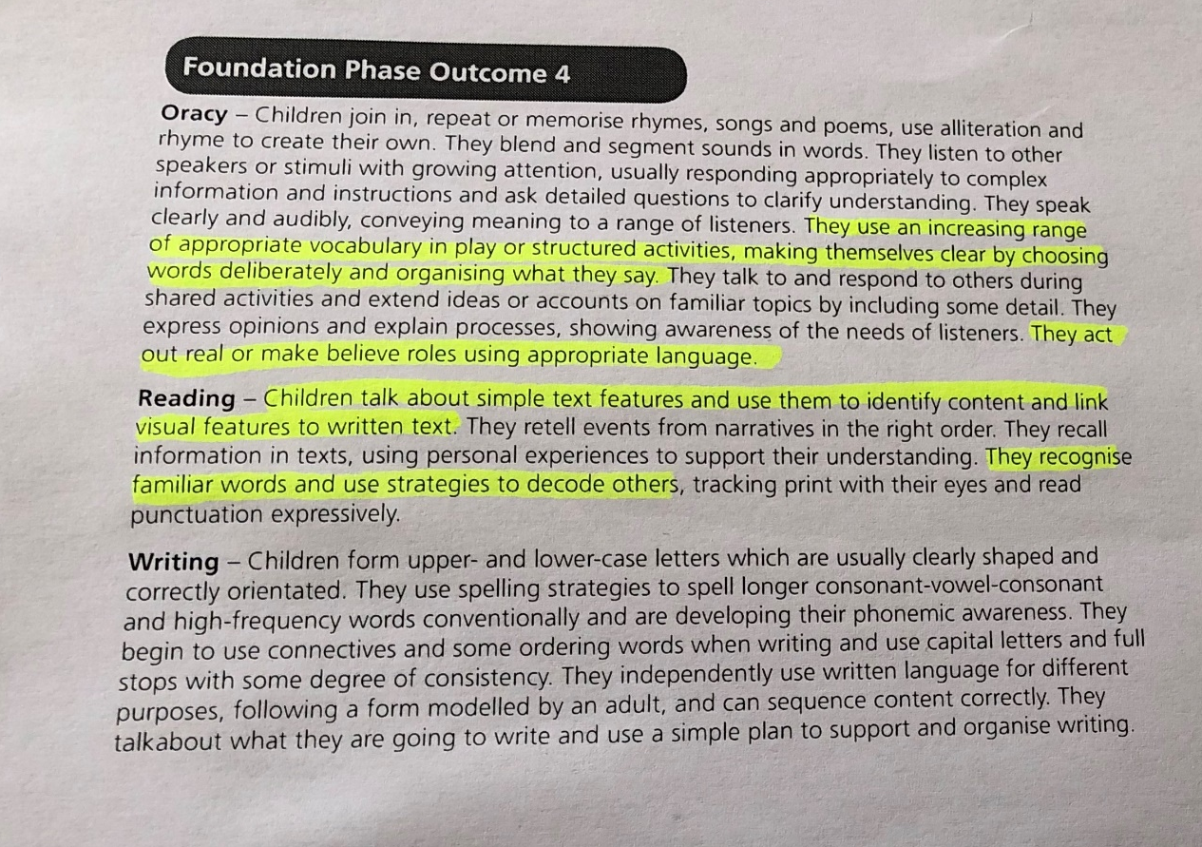
Appendix 9

