Mohammad Asif Yaqoob
2419891

Research, build, and deploy a Virtualised Enterprise network
Network Operating Systems and Services

Contents
Task 1: Report: Research 2
1. Hypervisor Research 2
2. IP Addressing Research 3
3. Research on Routing 4
4. Research on Network Services 5
Task 2: Report: Technical Documentation 6
2.1 Choice of Hypervisor 6
2.1.1 Justification for Selecting Oracle VM VirtualBox 6
2.2 Download and Setup 7
2.2.1 Software Acquisition from Authoritative Sources 7
2.2.2 Virtual Machine Deployment 8
2.3 IP Addressing Configuration 12
2.3.1 Addressing Scheme Implementation 12
2.4 Testing and Troubleshooting 22
2.4.1 Successful Intra-Network Connectivity 22
2.4.2 Unsuccessful Inter-Network Connectivity 29
Troubleshooting Process 31
Conclusion 31
Task 3: Reflection 32
3.1 Technical Reflection 32
3.2 Personal Reflection 32
References 33

Task 1: Report: Research
This assignment combines research and practical implementation, aiming to design, deploy, and document a virtualised network for NOSS2026, a multinational corporation with sites in Swansea and London. The task emphasizes not only the technical deployment but also critical evaluation of concepts and decisions, referencing recent academic and industry literature.

1. Hypervisor Research
Virtualisation abstracts physical hardware, allowing multiple operating systems to run concurrently on a single host. Hypervisors enable this abstraction and are categorized into Type 1 bare-metal and Type 2 hosted. Type 1 hypervisors run directly on hardware, providing efficient resource scheduling, reduced latency, and strong isolation [1]. Type 2 hypervisors operate atop an existing host OS, which introduces an additional software layer but allows easier deployment and cross-platform flexibility [2].
For the NOSS2026 topology, Windows Server 2022 provides Domain Controller, DNS, DHCP, IIS, and RDS services, while Debian functions as a DHCP Relay. Stability, security, and cross-platform compatibility are essential. Considering typical lab hardware constraints and the need to support future enhanced topologies for both Swansea and London branches, a Type 2 hypervisor, Oracle VirtualBox, is suitable. It allows rapid VM deployment, snapshot management, and flexible virtual networking, enabling VLAN isolation, NAT, and host-only networking for multiple OS environments [3].
The SWANSEA.ACCA domain requires secure authentication, seamless communication between Windows and Debian clients, and reliable DHCP distribution. VirtualBox supports these requirements, balancing usability, security, and scalability. Its resource-efficient nature allows the network to function effectively on standard lab machines, avoiding additional hardware procurement that could delay submission. Furthermore, VirtualBox’s portability supports replication and experimentation for future coursework enhancements. Therefore, Oracle VirtualBox is justified as the virtualization solution for this virtualised lab environment.

2. IP Addressing Research
IP addressing enables devices to communicate by providing unique identifiers for data delivery. During group activities, it became clear that routers and switches play distinct roles: routers use destination IP addresses to forward packets between networks, while switches forward frames within a subnet based on MAC addresses [4].
Efficient IP addressing is critical for network functionality. IPv4 employs a 32-bit structure in dotted-decimal notation (e.g., 192.168.10.1), while IPv6 uses 128-bit hexadecimal addresses, allowing vast expansion to accommodate global networks [5]. Subnetting segments networks into smaller subnets, reducing broadcast domains and enhancing address utilization. For example, a /24 subnet supports 254 usable host addresses, suitable for lab-based multi-server setups.
In the NOSS2026 virtualised topology, Windows Server 2022 and Debian DHCP Relay are assigned addresses within the same subnet (e.g., 192.168.10.1 and 192.168.10.2). Subnetting ensures segregation of server roles and client traffic, improves security, and allows for scalable expansion to London or additional test VLANs.
Summary Table (VLSM)
Device / Segment | Network Address | Subnet Mask | Host Range | Default Gateway
WAN (S-DC / L-CD) | 20.0.0.0 | 255.255.255.252 | 20.0.0.1 – 20.0.0.2 | 20.0.0.1 / 20.0.0.2
S-DC LAN | 192.168.1.0 | 255.255.255.0 | 192.168.1.1 – 192.168.1.254 | 192.168.1.1
L-CD LAN | 192.168.2.0 | 255.255.255.0 | 192.168.2.1 – 192.168.2.254 | 192.168.2.1
Diagram 1 illustrates IPv4 subnet allocation for this topology.

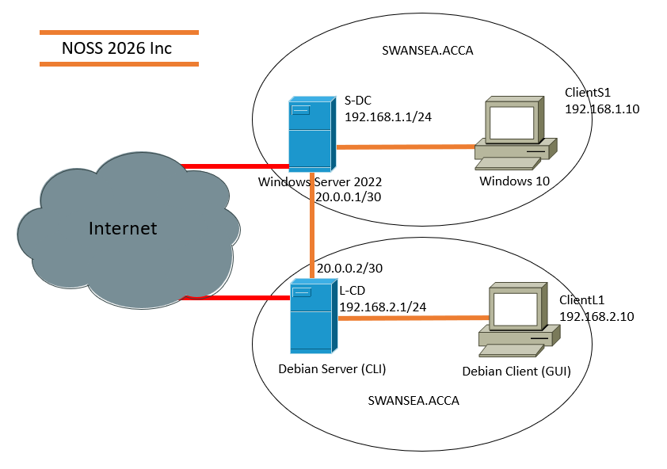
Diagram 2 Topology for coursework 1

IP addressing ensures proper routing, identification, and fault isolation. In practice, DHCP automates IP distribution, reducing configuration errors. Understanding both IPv4 and IPv6 addressing and applying subnetting principles directly contributes to the lab’s operational efficiency, network reliability, and readiness for future expansions.

3. Research on Routing
Routing protocols determine paths for data across interconnected networks. Static routing relies on manually configured paths, offering predictability and minimal overhead, whereas dynamic routing protocols such as OSPF or RIP automatically update routes in response to network topology changes [6].
For NOSS2026, the Debian server acts as a DHCP Relay, forwarding requests from remote clients to Windows Server 2022. Reliable routing ensures timely delivery of DHCP and authentication traffic. A hybrid approach, employing static routes for critical servers and dynamic routing for experimental subnets, provides both reliability and adaptability. Static routing guarantees predictable communication between Windows and Debian servers, minimizing potential downtime. Dynamic routing facilitates future expansion, such as linking Swansea and London virtual subnets.
The routing approach must also accommodate cross-OS communication, ensuring that virtualised clients in separate VLANs or subnets can reach core services. This balance supports enhanced topology planning, providing a testbed for exploring routing behaviours, subnet isolation, and multi-site connectivity. Integrating static and dynamic routes within VirtualBox enables practical experimentation, critical for understanding network resilience and scalability in a real-world corporate scenario.

4. Research on Network Services
Key network services ensure security, automation, and operational efficiency in the virtualised topology. Active Directory Domain Services (AD DS) centralizes authentication, user management, and policy enforcement, which is essential for the SWANSEA.ACCA domain [7]. DHCP, combined with the Debian relay, automates IP allocation, reducing manual configuration errors and supporting efficient IP management across multiple subnets.
VPNs provide secure remote access for distributed teams, encrypting traffic to protect sensitive corporate data. Certificate Authorities (CAs) issue digital certificates to verify server authenticity, securing services such as HTTPS, RDS, and internal web portals [8]. Best practices include isolating critical servers, enabling VLAN segmentation, implementing secure boot, and maintaining up-to-date certificates.
In the NOSS2026 lab environment, AD DS authenticates users, DHCP and the relay manage IP distribution, and CAs secure service communications. VirtualBox enables flexible experimentation with these services, including VLAN configurations, snapshot rollback for testing, and cross-OS interactions. This approach provides a realistic simulation of enterprise environments while supporting educational objectives. Proper integration of these services ensures stability, security, and scalability in preparation for future coursework expansions, reflecting both practical implementation and research-informed design decisions.

Task 2: Report: Technical Documentation

2.1 Choice of Hypervisor

2.1.1 Justification for Selecting Oracle VM VirtualBox
The virtualised infrastructure for NOSS2026 was implemented using Oracle VM VirtualBox. The selection was based on a structured evaluation of performance capability, network flexibility, scalability for future coursework expansion, and compatibility with available hardware resources.
VirtualBox operates as a hosted (Type-2) hypervisor. Although bare-metal hypervisors such as VMware ESXi provide enhanced enterprise-level performance, Type-2 hypervisors remain highly effective in controlled laboratory environments where hardware resources are limited [9]. Given that this implementation is conducted on an academic workstation rather than a dedicated enterprise server, VirtualBox offers a practical and efficient solution.
A critical factor influencing the decision was network configuration flexibility. The topology requires two isolated LAN environments (Swansea and London), interconnected via a simulated WAN link. VirtualBox supports multiple virtual networking modes, including Internal Network, NAT, Bridged, and Host-Only adapters [10]. This capability allows accurate modelling of segmented enterprise networks without physical switching or routing equipment.
Additionally, the project will extend in Coursework 2 to include services such as Active Directory, DHCP, DNS, routing and Remote Desktop Services. VirtualBox supports snapshots and cloning, enabling controlled testing and rollback during service deployment. This significantly reduces configuration risk when implementing domain services.
Cost and licensing considerations also influenced the decision. VirtualBox is distributed under an open-source license, making it appropriate for academic deployment without financial implications [9]. While enterprise organisations frequently utilise Microsoft Hyper-V or VMware platforms, the foundational principles of virtualization remain consistent across environments [11]. Therefore, practical skills developed through VirtualBox remain transferable to commercial infrastructures.
Based on these technical and operational considerations, Oracle VM VirtualBox was determined to be the most suitable hypervisor for deploying and extending the NOSS2026 network.

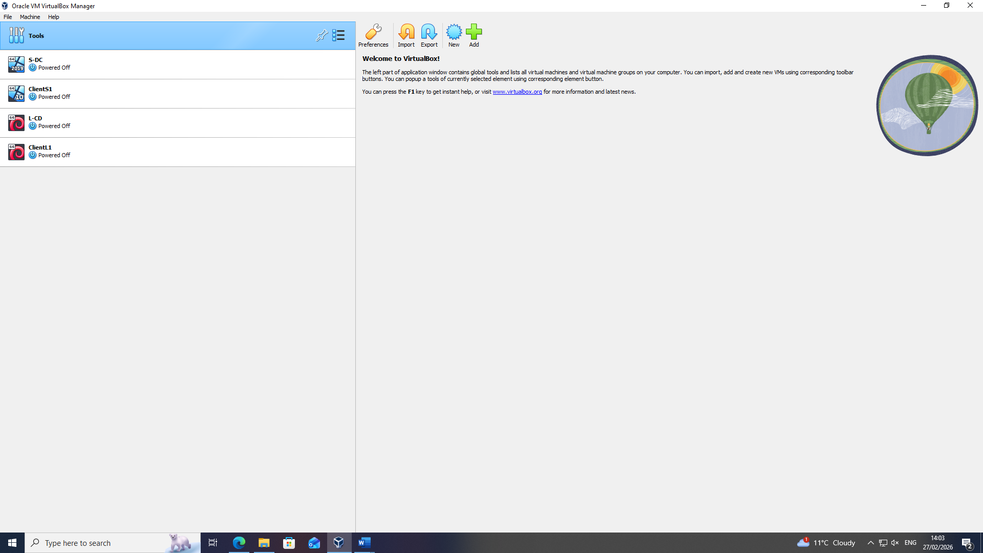Screenshot 1 : VirtualBox successfully installed on host system with visible system date and time.

2.2 Download and Setup

2.2.1 Software Acquisition from Authoritative Sources
All software components were obtained directly from official vendor websites to ensure authenticity, integrity, and compliance with security best practices.
The following resources were used:
- Oracle VM VirtualBox (latest stable release) [9]
- Windows Server 2022 Evaluation Edition [12]
- Windows 10 ISO image [13]
- Debian 12 (Bookworm) ISO image [14]
Obtaining software from verified sources reduces exposure to malicious modifications and ensures version compatibility. Microsoft evaluation versions were selected as they provide full enterprise functionality suitable for testing and infrastructure simulation.

2.2.2 Virtual Machine Deployment
Four virtual machines were deployed according to the topology design:
Virtual Machine | Operating System | Role
S-DC | Windows Server 2022 | Primary server (future Domain Controller)
ClientS1 | Windows 10 | Swansea client
L-CD | Debian Server (CLI) | London server
ClientL1 | Debian GUI | London client

Each virtual machine was provisioned with appropriate RAM and CPU resources to ensure stable performance while maintaining host efficiency.
To simulate geographical separation, two Internal Networks were created within VirtualBox:
- Swansea-LAN
- London-LAN
A separate internal adapter was configured to represent the WAN segment between the two servers. Multi-homed configuration was applied to S-DC and L-CD to allow dual interface assignment (LAN + WAN). This architectural decision prepares the environment for routing configuration in subsequent coursework.
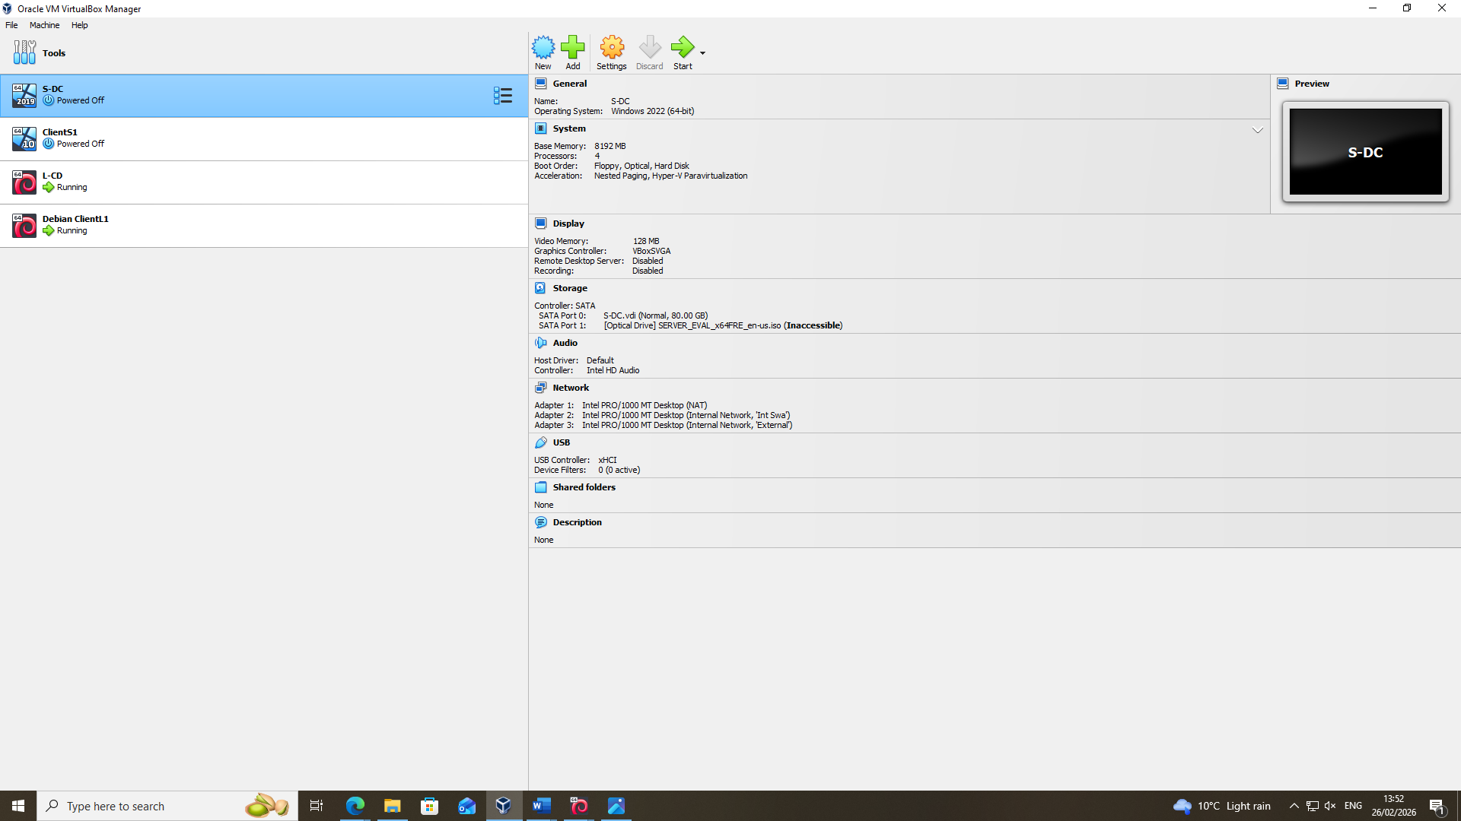Screenshot 2: Creation of Windows Server virtual machine.

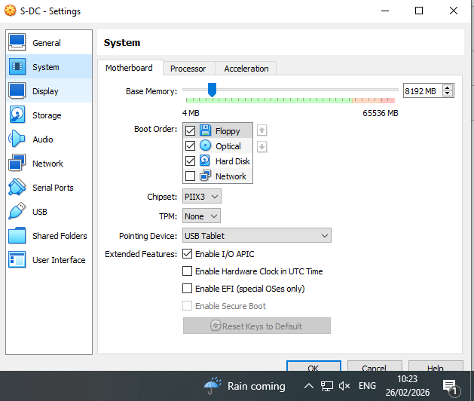Screenshot 3.1: Creation of Windows Server virtual machine.
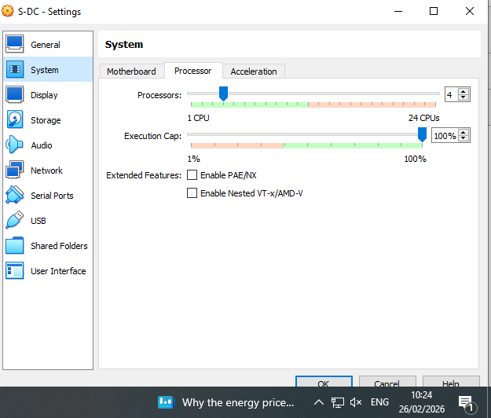Screenshot 3.2: System Memory and processors.

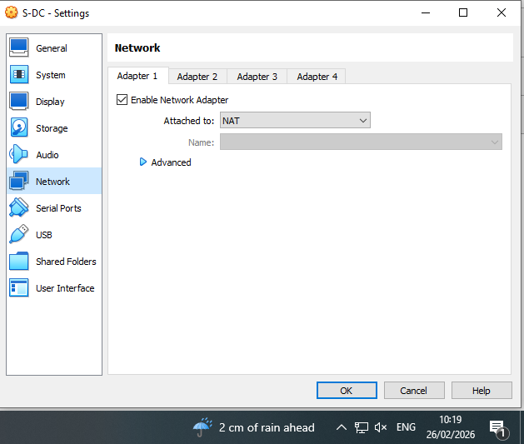
Screenshot 4.1: Windows Server Network adapters configuration showing Internal/External Network assignment.
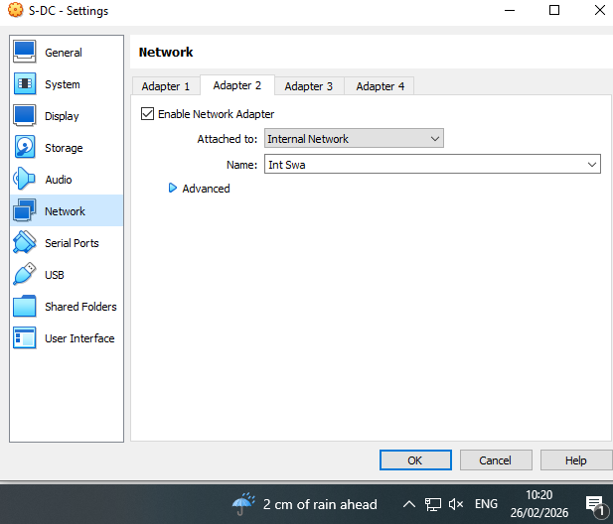
Screenshot 4.2: Windows Server Network adapters configuration showing Internal/External Network assignment.

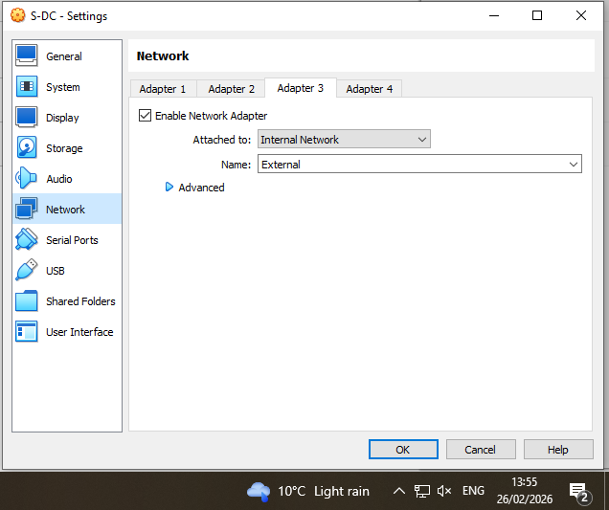
Screenshot 4.3: Windows Server Network adapters configuration showing Internal/External Network assignment.

2.3 IP Addressing Configuration

2.3.1 Addressing Scheme Implementation
The addressing structure followed the topology specification while incorporating efficient subnet allocation principles. Private IPv4 addressing was used for internal LAN communication, in alignment with RFC 1918 guidelines.
Swansea LAN
Network: 192.168.1.0/24
Subnet Mask: 255.255.255.0
- S-DC: 192.168.1.1
- ClientS1: 192.168.1.10
- Default Gateway (ClientS1): 192.168.1.1
London LAN
Network: 192.168.2.0/24
Subnet Mask: 255.255.255.0
- L-CD: 192.168.2.1
- ClientL1: 192.168.2.10
- Default Gateway (ClientL1): 192.168.2.1
WAN Point-to-Point Link
Network: 20.0.0.0/30
Subnet Mask: 255.255.255.252
- S-DC WAN Interface: 20.0.0.1
- L-CD WAN Interface: 20.0.0.2
The /30 subnet provides precisely two usable addresses, making it technically appropriate for point-to-point communication. This demonstrates application of Variable Length Subnet Masking (VLSM) principles, where subnet sizes are allocated based on actual host requirements rather than uniform allocation [15]. The design minimises IP address wastage while preserving logical segmentation.
Static addressing was configured manually within each operating system. Windows systems were configured via IPv4 adapter properties, while Debian systems were configured using network interface configuration files and verified using the ip a command.
This structured addressing approach ensures correct intra-site communication while intentionally preventing inter-site communication prior to routing implementation.

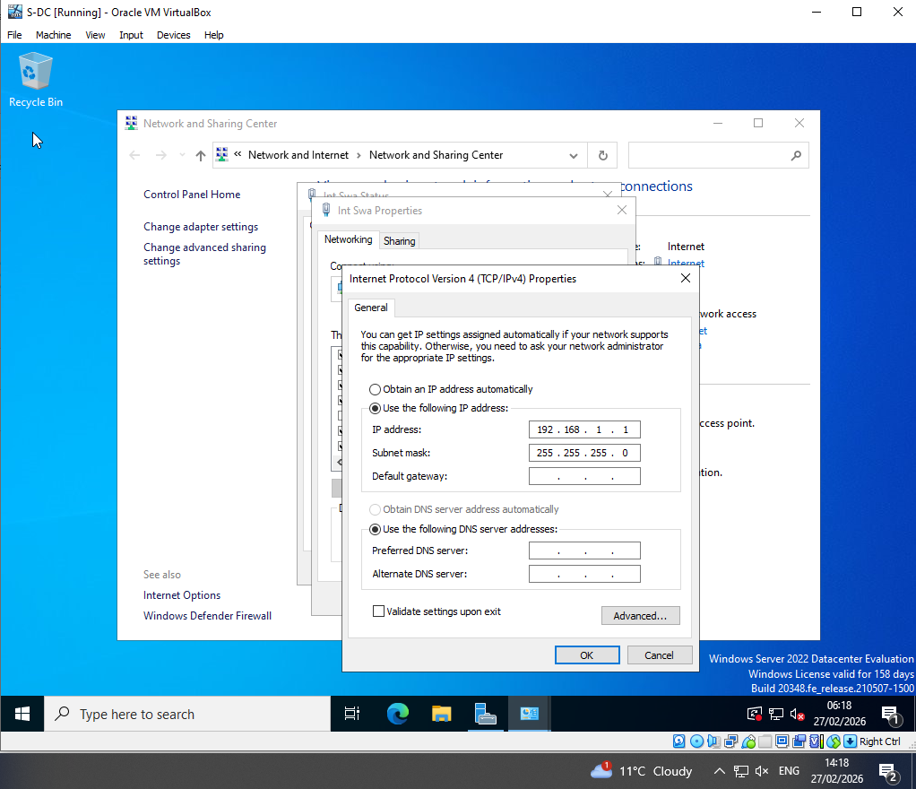
Screenshot 5.1: Windows Server IPv4 configuration.

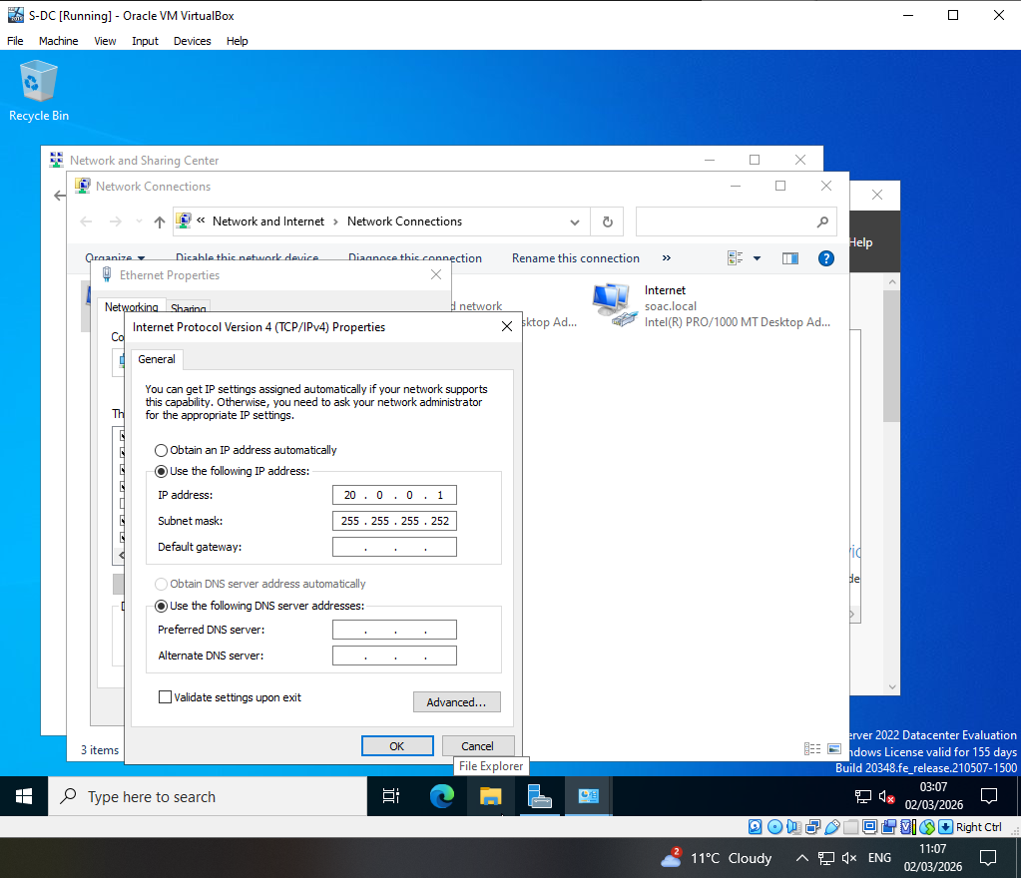
Screenshot 5.2: Windows Server IPv4 configuration.
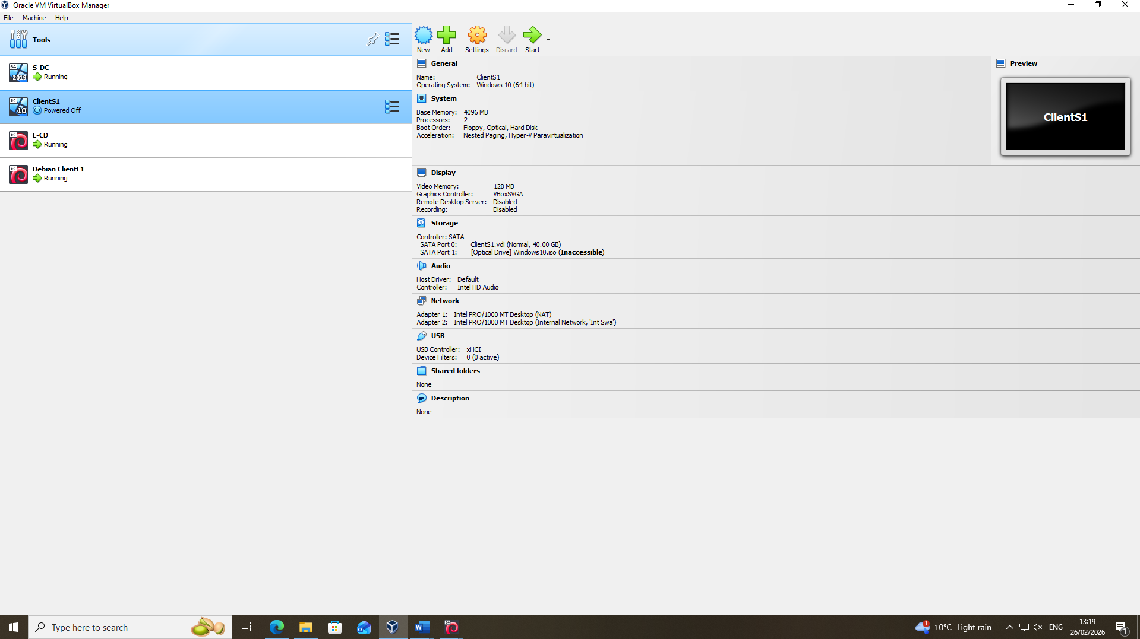
Screenshot 6: Creation of Windows 10 virtual machine.

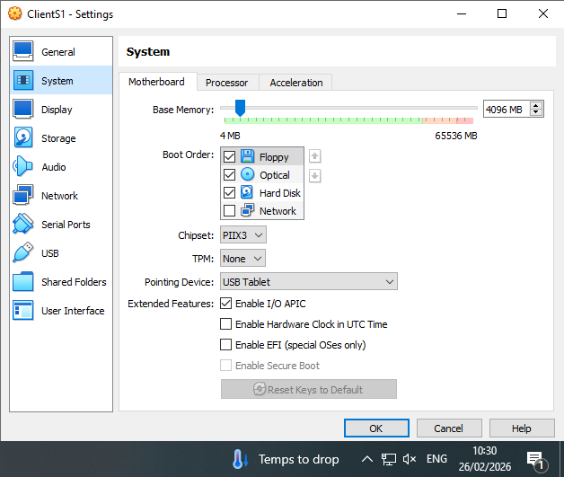
Screenshot 7.1: System Memory and processors.

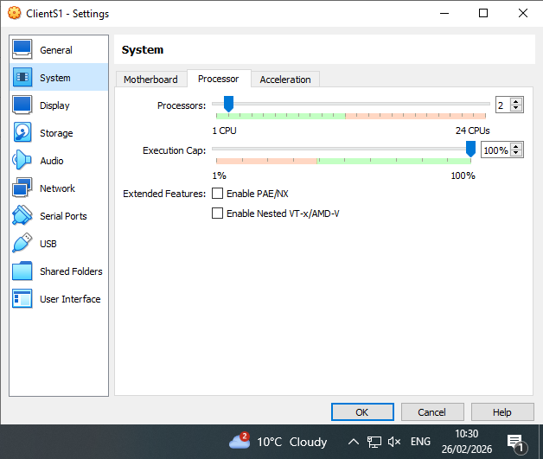
Screenshot 7.2: System Memory and processors.
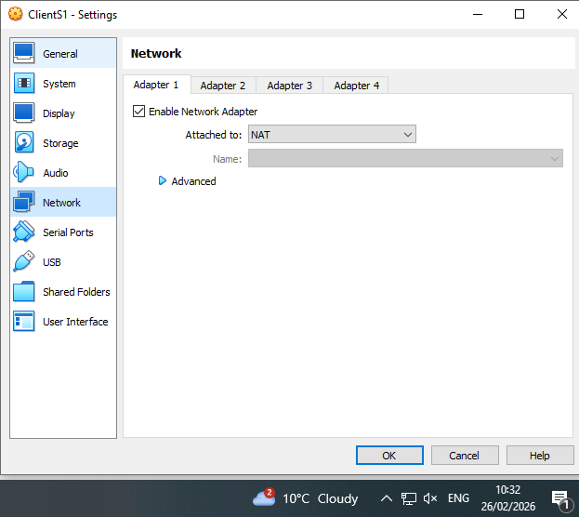
Screenshot 8.1: Windows 10 Network adapters configuration showing Internal Network assignment.

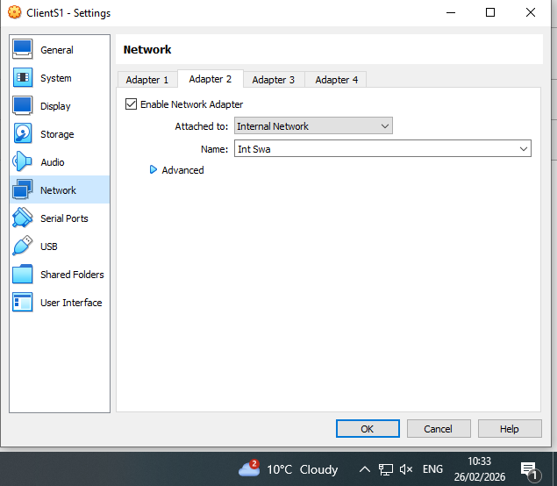
Screenshot 8.2: Windows 10 Network adapters configuration showing Internal Network assignment.
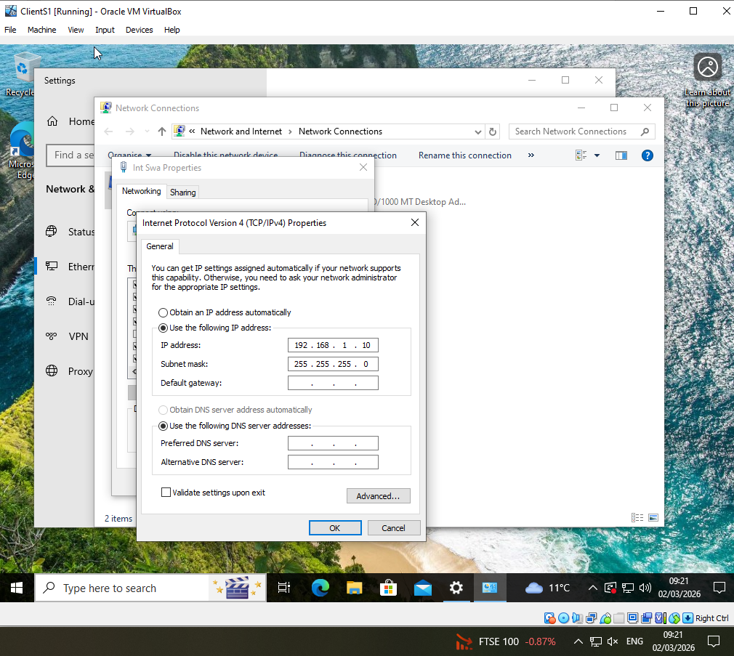
Screenshot 9.1: Windows 10 ipconfig /all output.

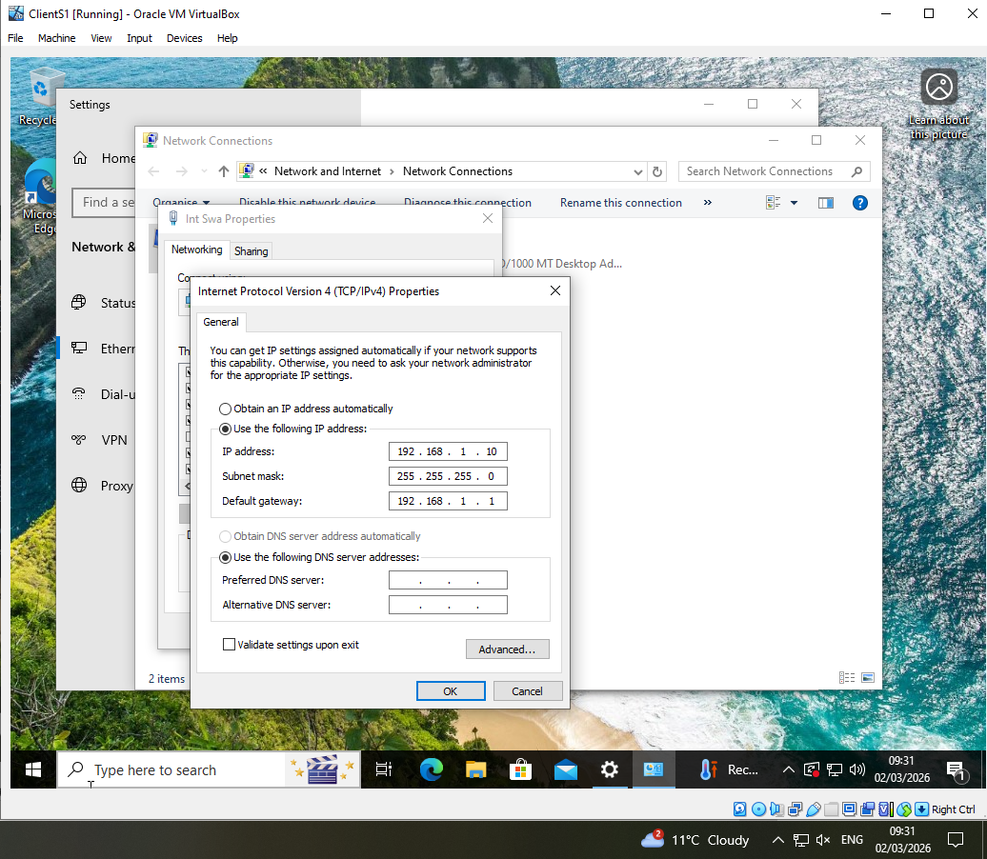
Screenshot 9.2: Windows 10 ipconfig /all output.
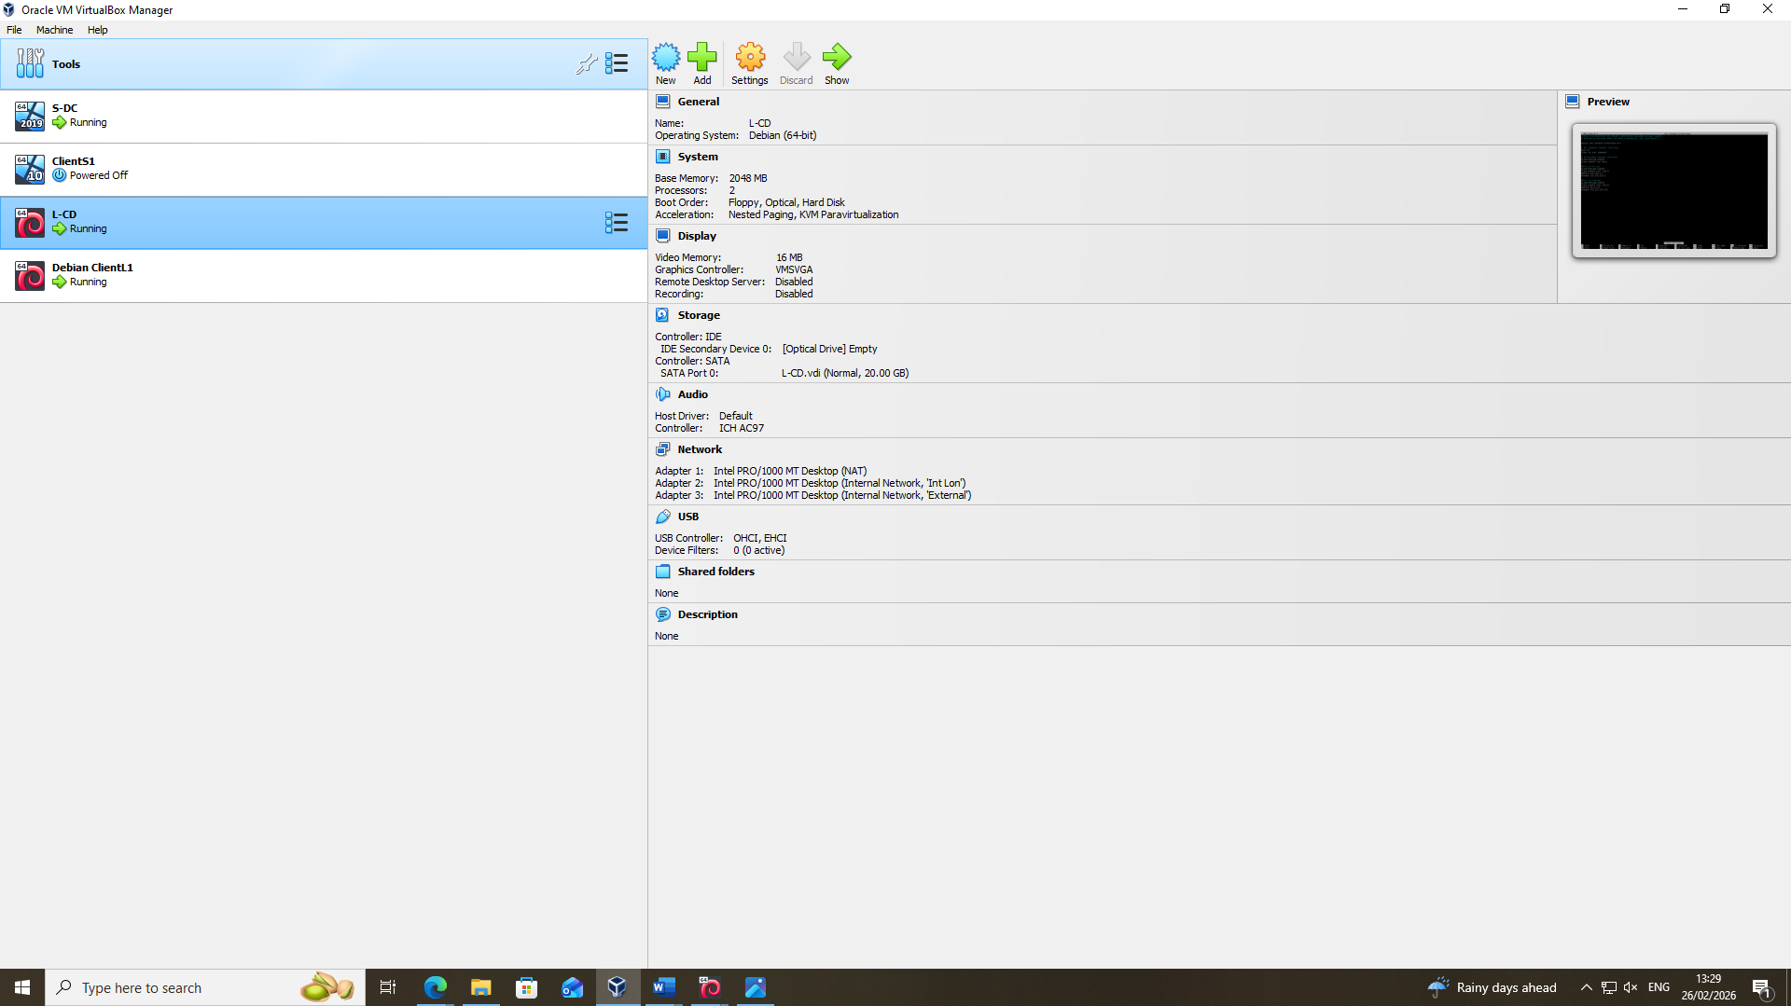
Screenshot 10: Creation of Debian Server virtual machine.

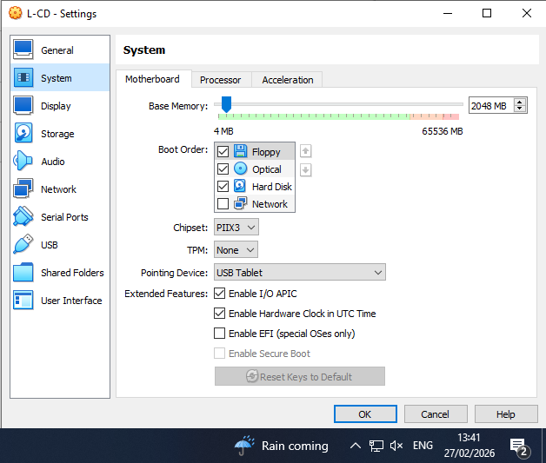
Screenshot 11.1: System Memory and processors.

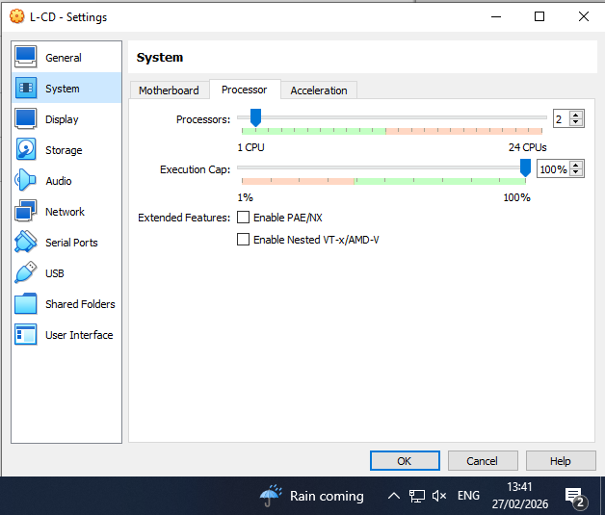
Screenshot 11.2: System Memory and processors.
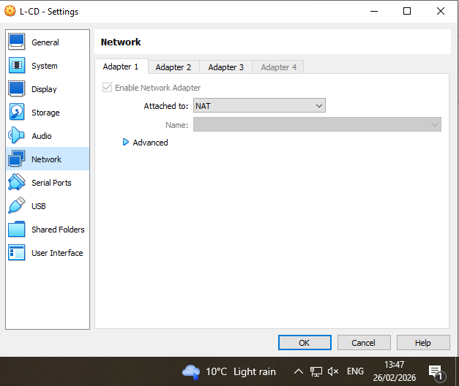
Screenshot 12.1: Network adapters configuration showing Internal/External Network assignment.

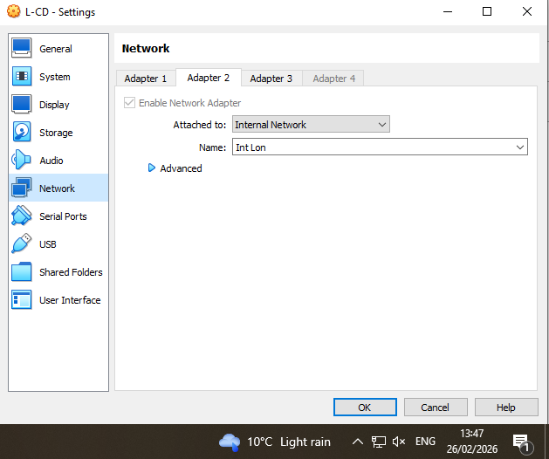
Screenshot 12.2: Network adapters configuration showing Internal/External Network assignment.

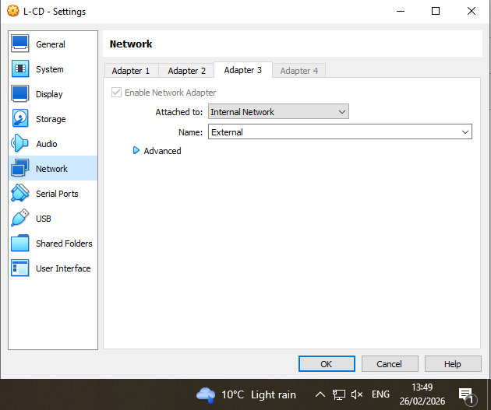
Screenshot 12.3: Network adapters configuration showing Internal/External Network assignment.
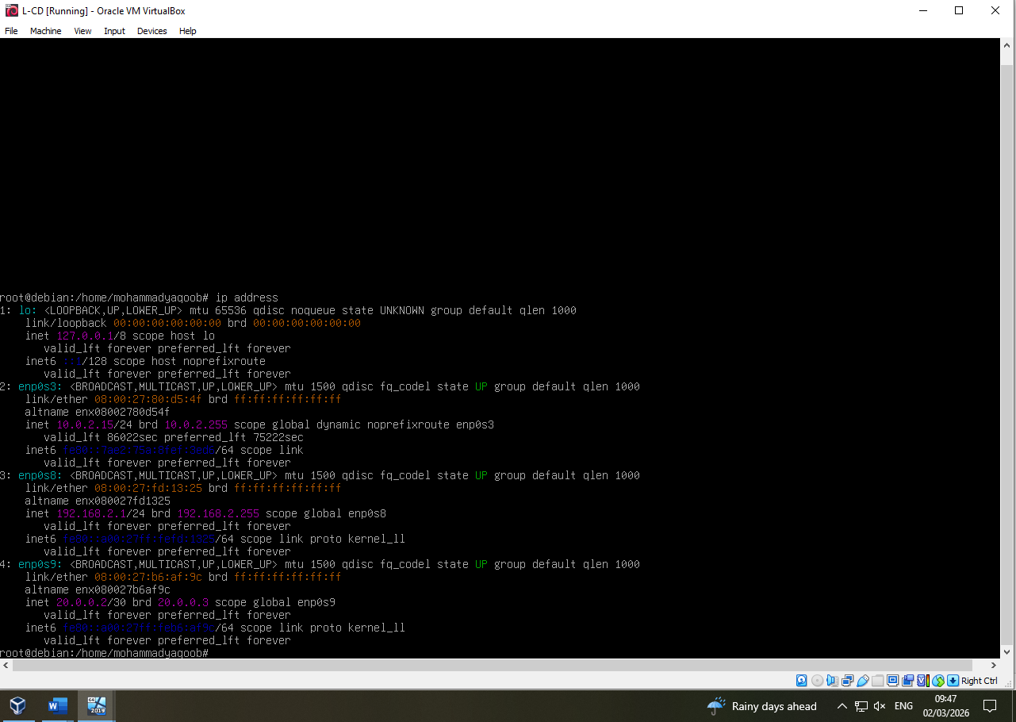
Screenshot 13.1: Debian Server ip address output displaying dual interfaces.

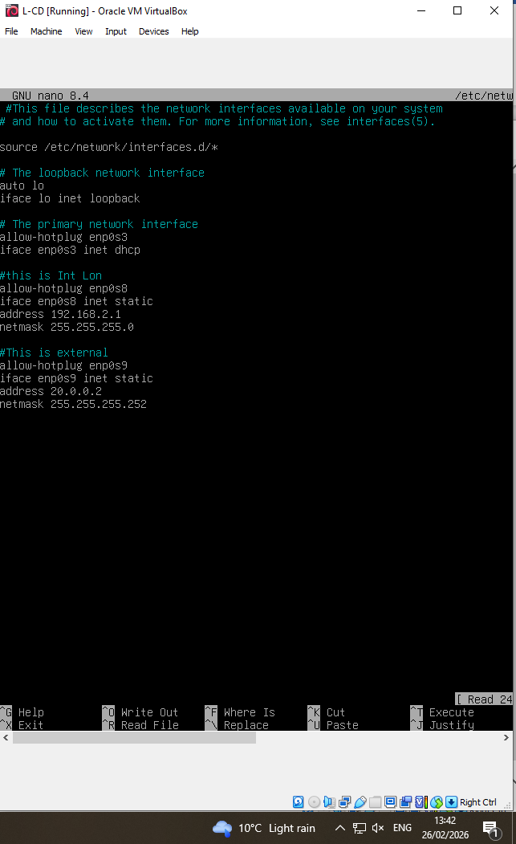
Screenshot 13.2: Debian Server ip address output displaying dual interfaces.
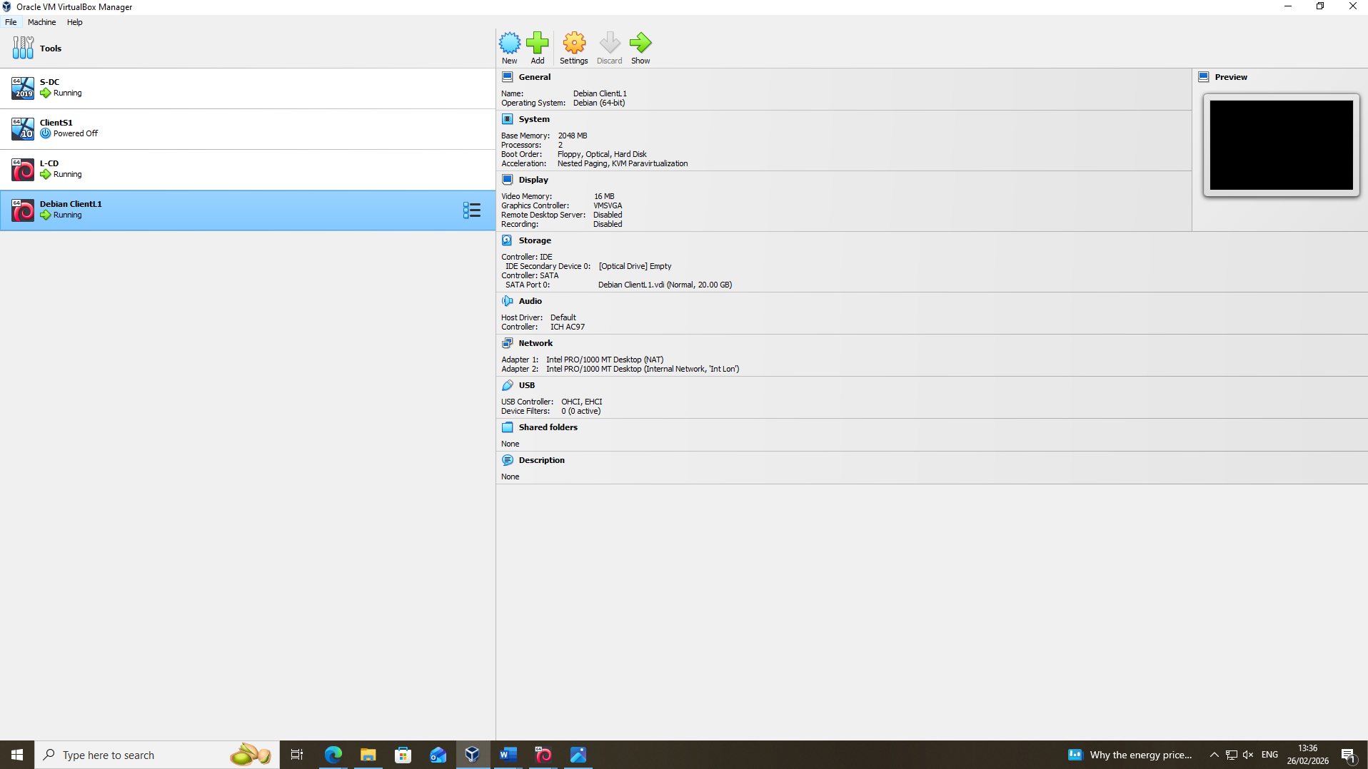
Screenshot 14: Creation of Debian Client virtual machine.

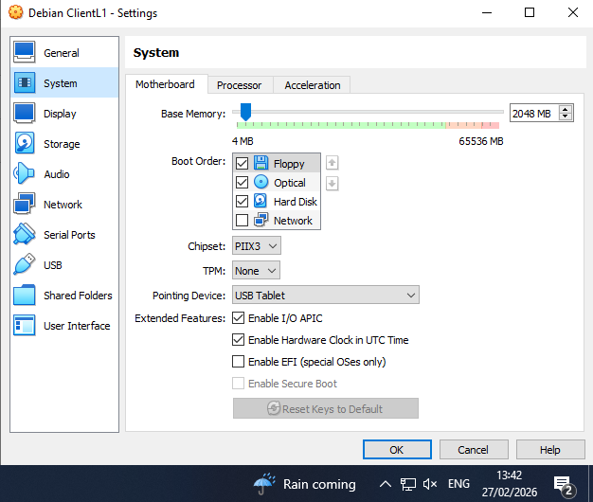
Screenshot 15.1: System Memory and processors.

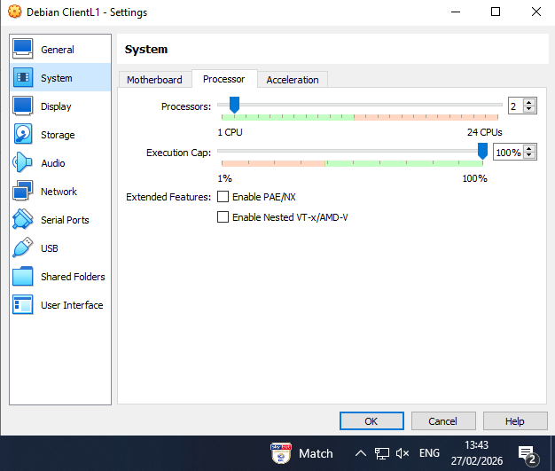
Screenshot 15.2: System Memory and processors.
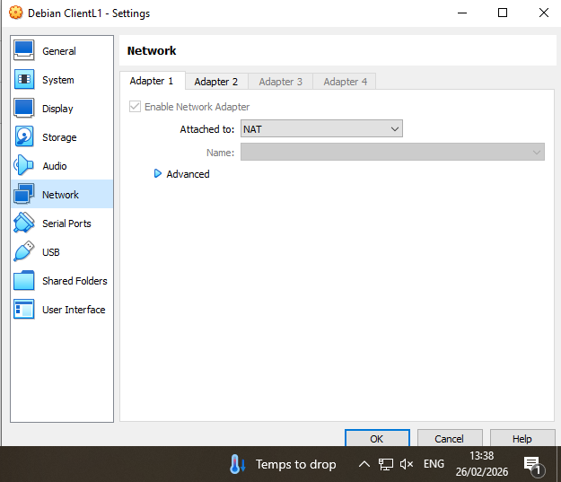
Screenshot 16.1: Network adapters configuration showing Internal Network assignment.

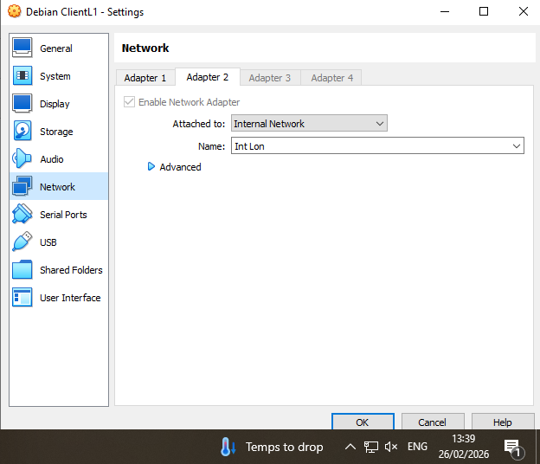
Screenshot 16.2: Network adapters configuration showing Internal Network assignment.

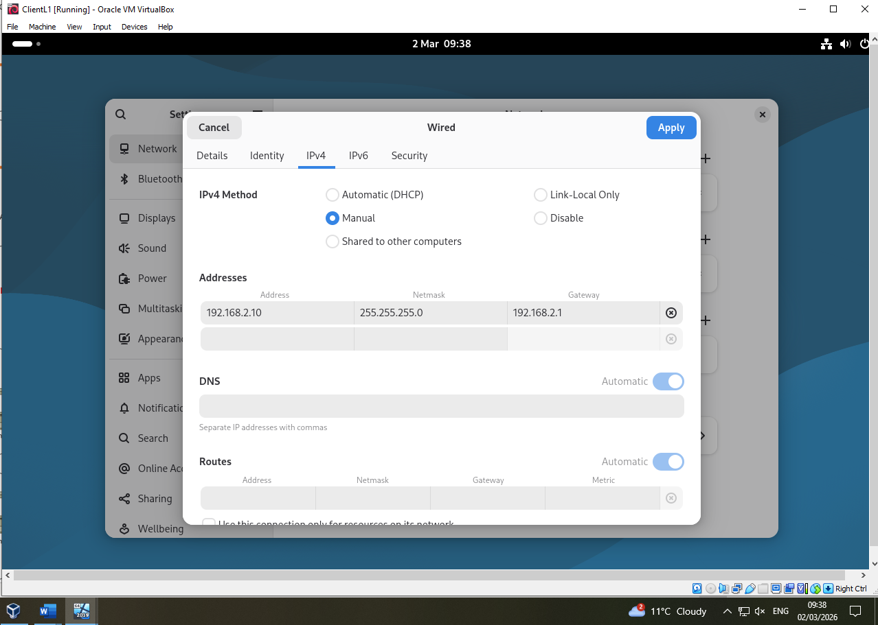Screenshot 17: Debian Client IP configuration.

2.4 Testing and Troubleshooting
Connectivity validation was performed using ICMP echo requests to assess network segmentation and address configuration accuracy.

2.4.1 Successful Intra-Network Connectivity
Within the Swansea LAN, ClientS1 successfully communicated with S-DC (192.168.1.1). Similarly, within the London LAN, ClientL1 successfully communicated with L-CD (192.168.2.1).
These successful responses confirm:
- Correct subnet mask configuration
- Proper default gateway assignment
- Functional Internal Network adapters
- Absence of local firewall misconfiguration

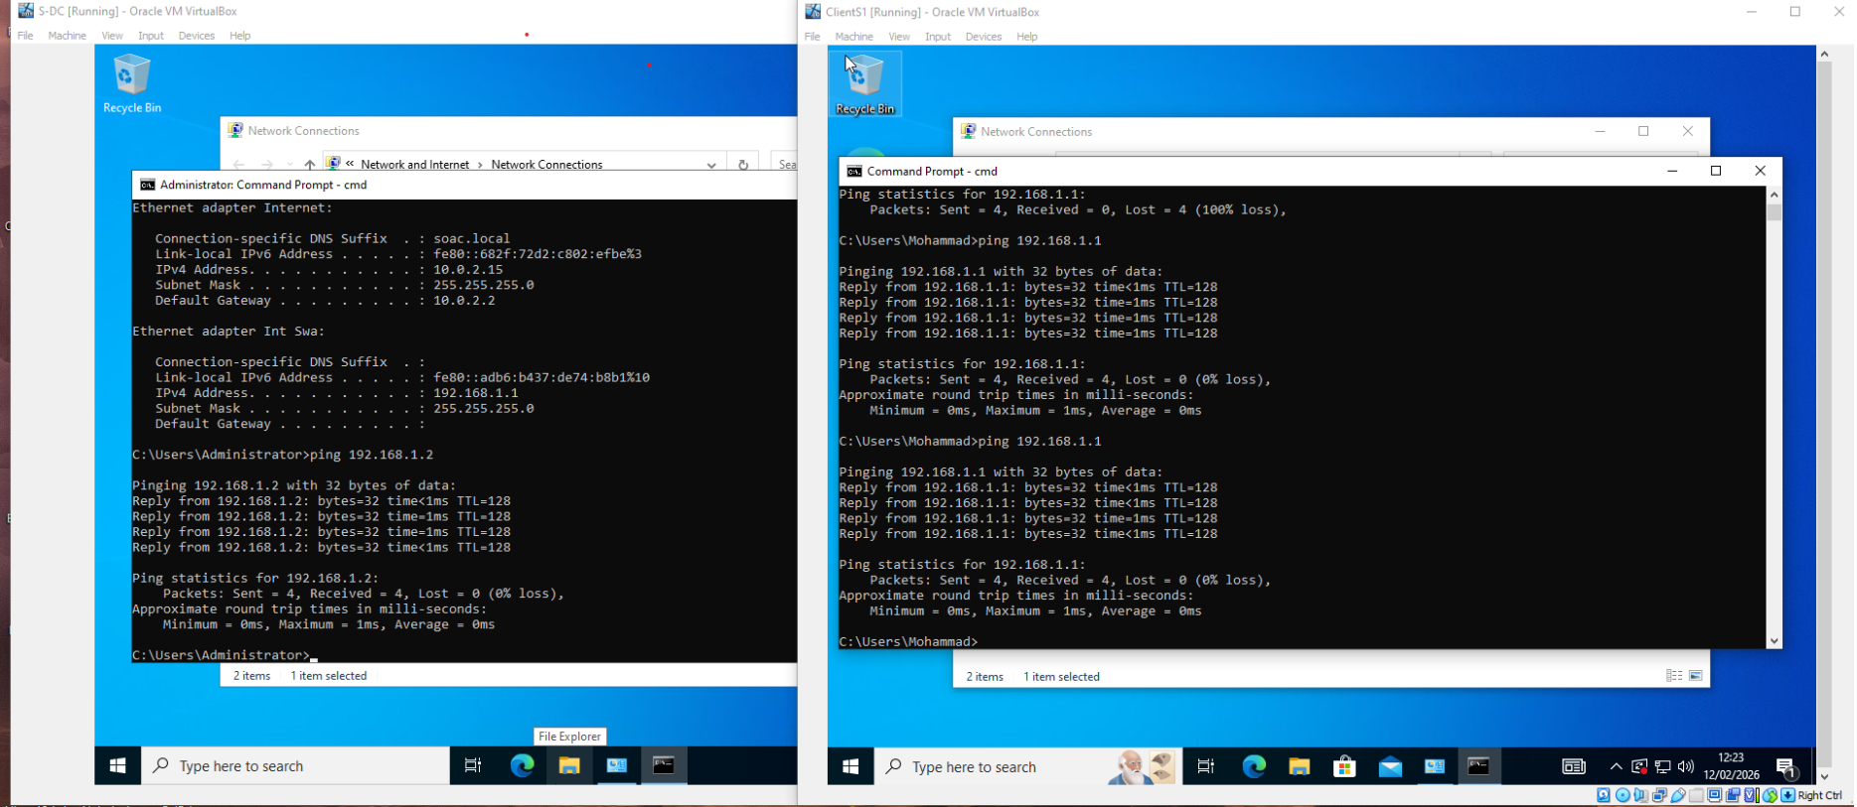Screenshot 18.1: Successful ping within Swansea LAN.

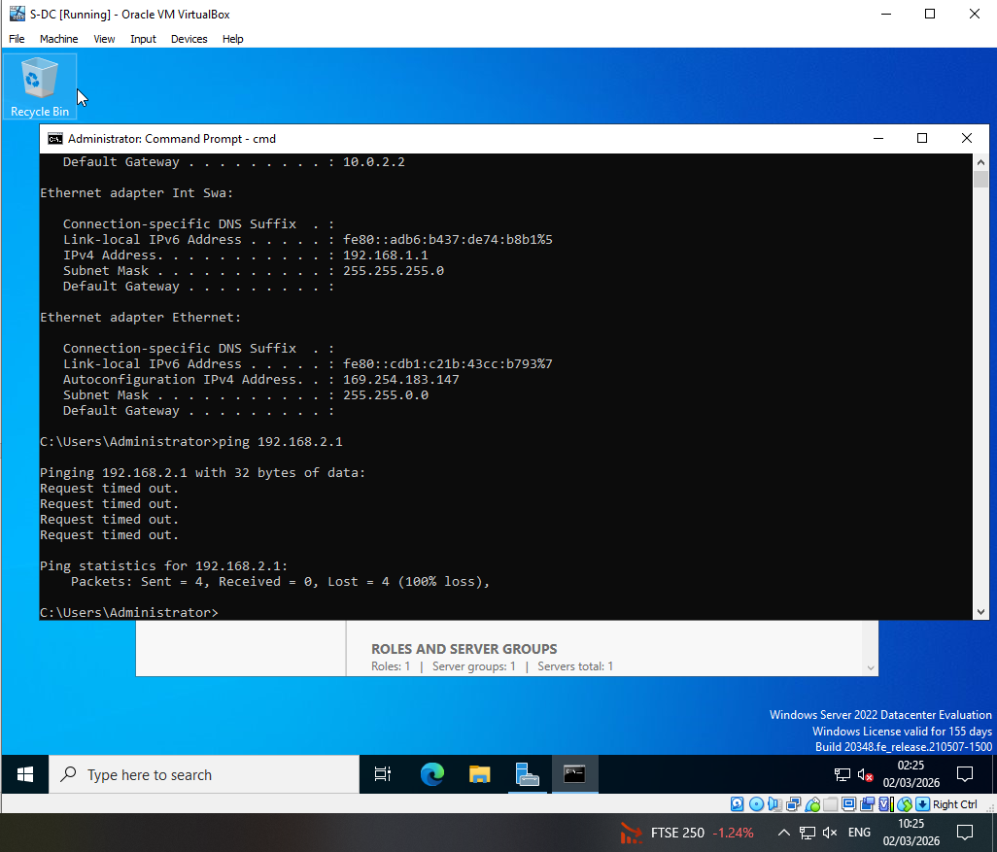Screenshot 18.2: Successful ping within Swansea LAN.
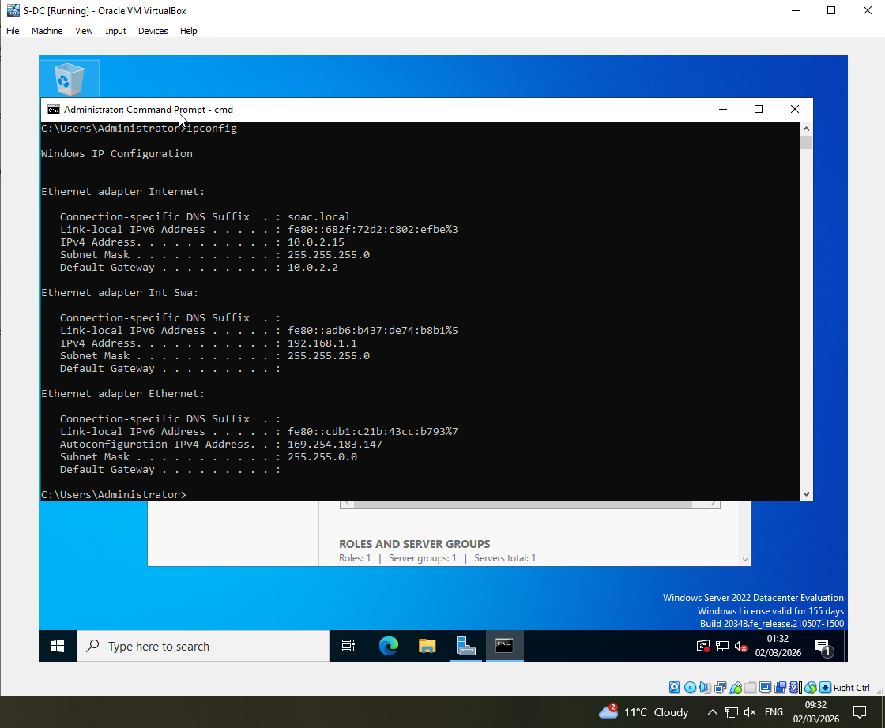
Screenshot 18.3: Successful ping within Swansea LAN.

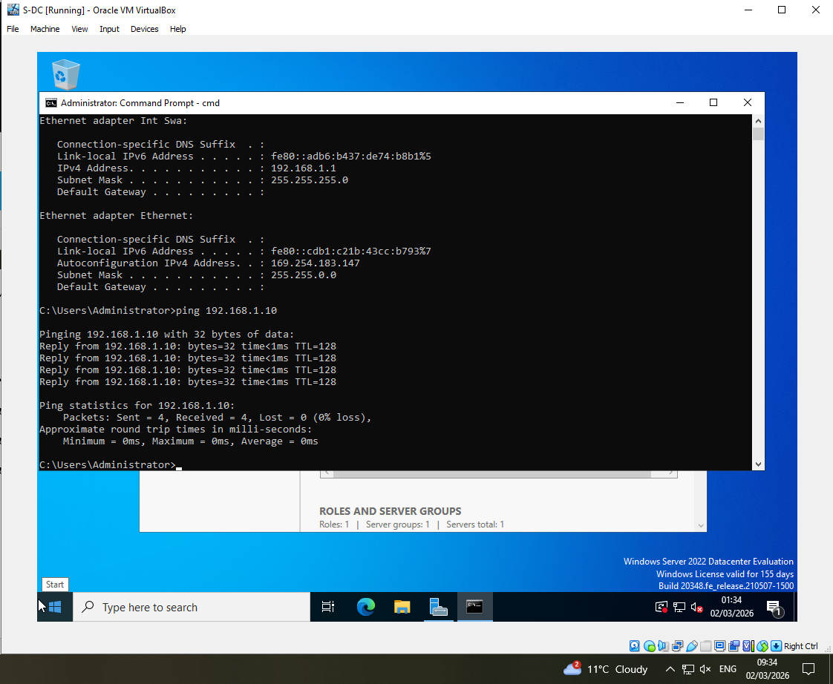
Screenshot 18.4: Successful ping within Swansea LAN.
Screenshot 18.5: Successful ping within Swansea LAN.

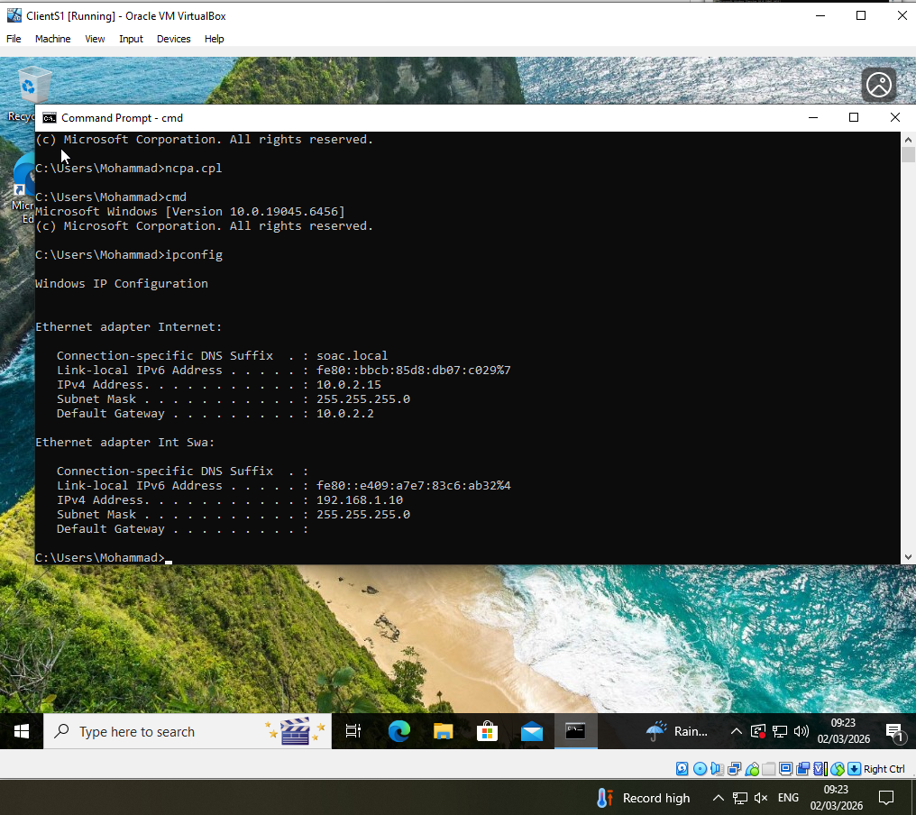
Screenshot 18.6: Successful ping within Swansea LAN.
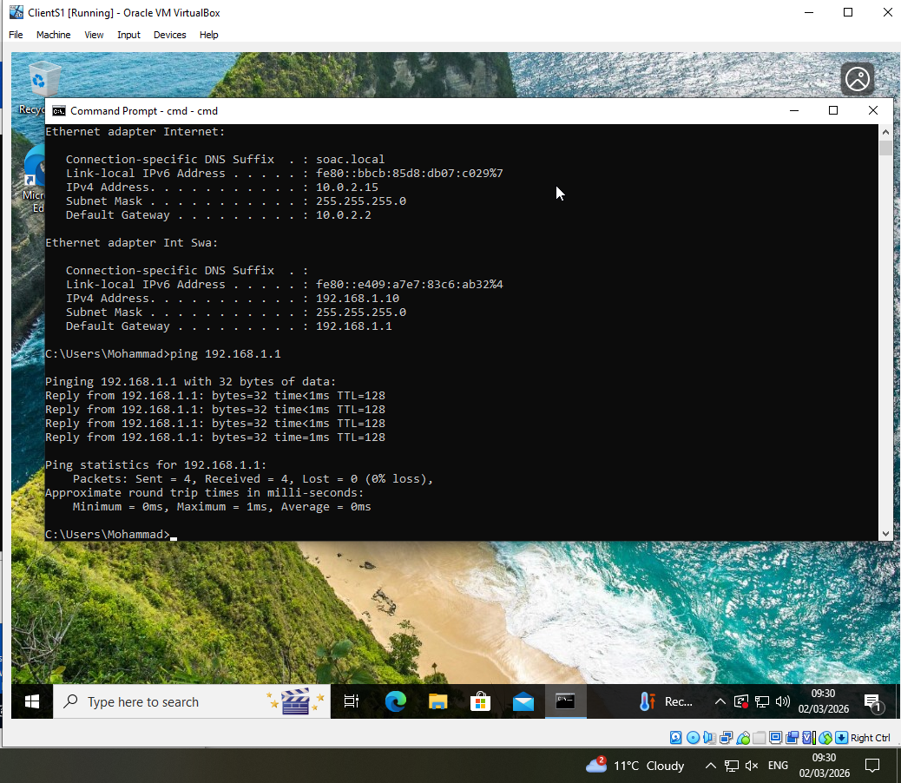
Screenshot 18.7: Successful ping within Swansea LAN.

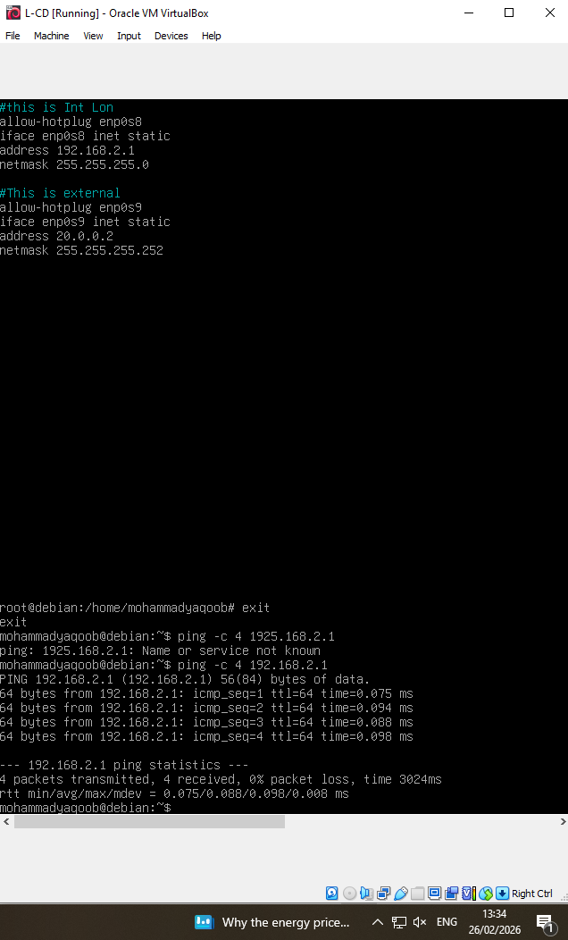
Screenshot 19.1: Successful ping within London LAN.
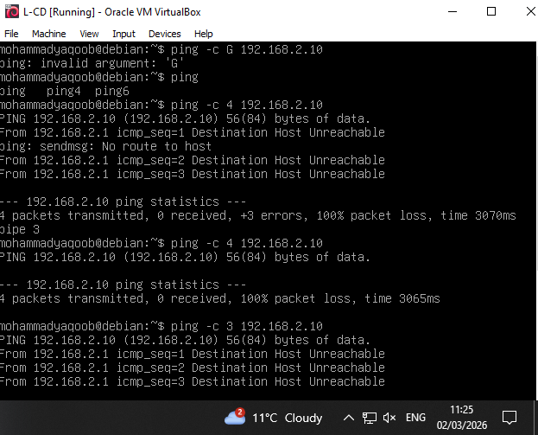
Screenshot 19.2: Successful ping within London LAN.

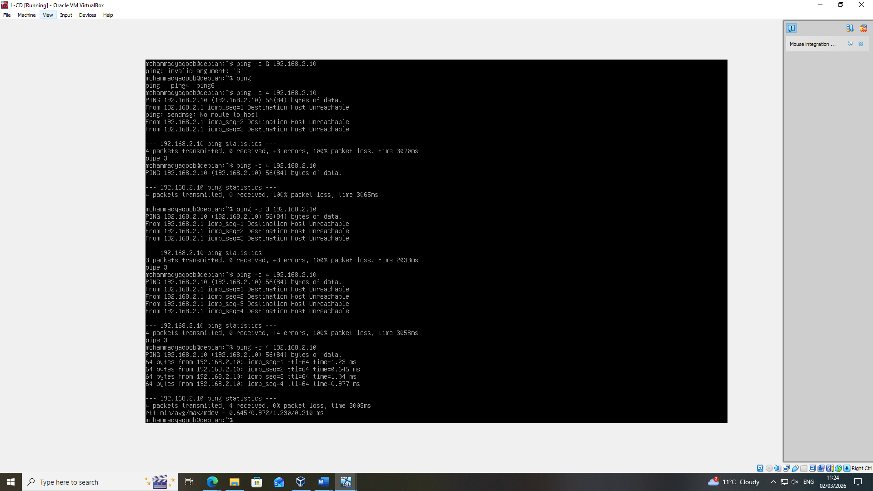
Screenshot 19.3: Successful ping within London LAN.
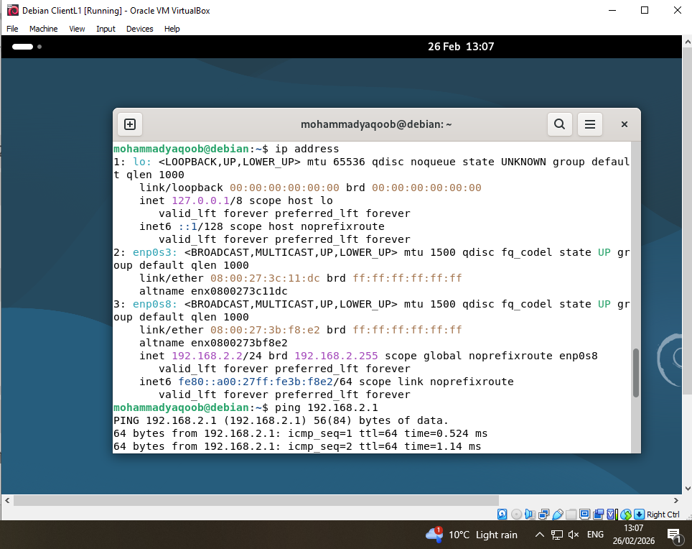
Screenshot 19.4: Successful ping within London LAN.

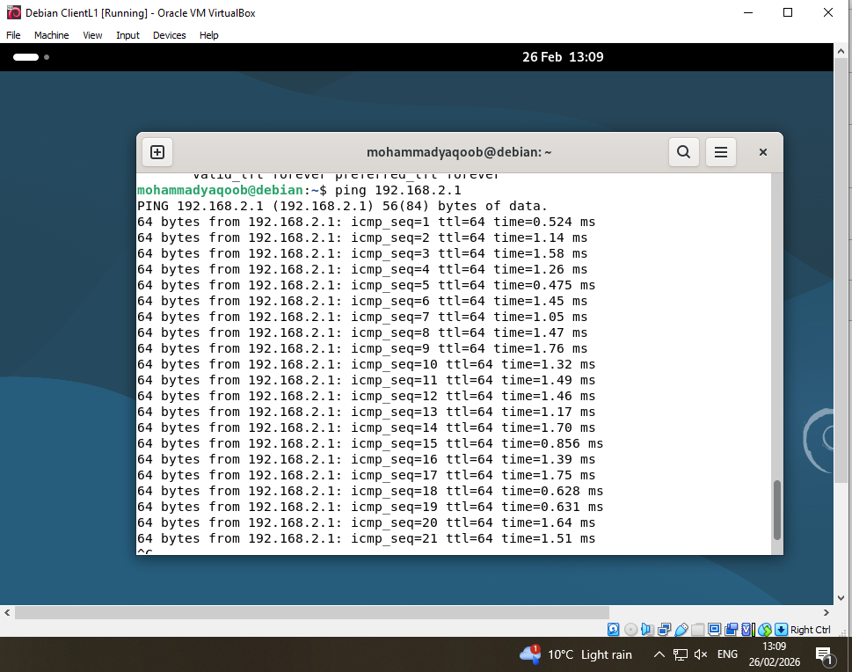
Screenshot 19.5: Successful ping within London LAN.
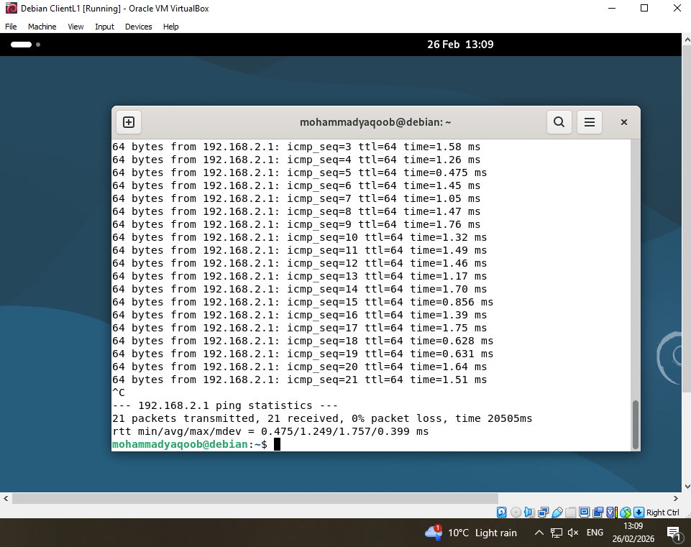
Screenshot 19.6: Successful ping within London LAN.

2.4.2 Unsuccessful Inter-Network Connectivity
Cross-site communication attempts resulted in “Request Timed Out” responses. For example:
192.168.1.10 → 192.168.2.10
This outcome is technically expected because routing services have not yet been enabled. No static routes, dynamic routing protocols, or IP forwarding mechanisms are currently configured between the two LAN segments.
The unsuccessful connectivity confirms effective network isolation and validates the segmentation architecture. This controlled failure is an essential verification step, demonstrating that broadcast domains remain independent until routing policies are implemented.
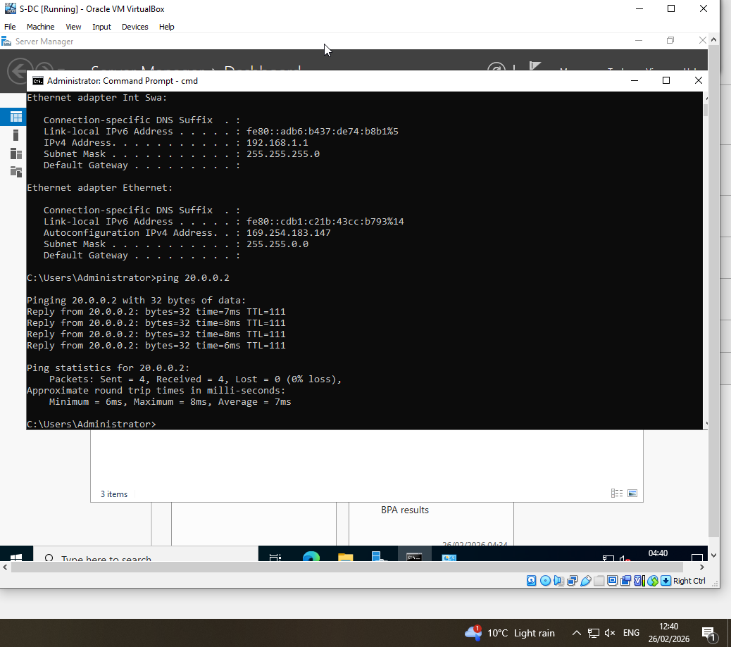
Screenshot 20.1: Successful ping attempt between Swansea and London networks.

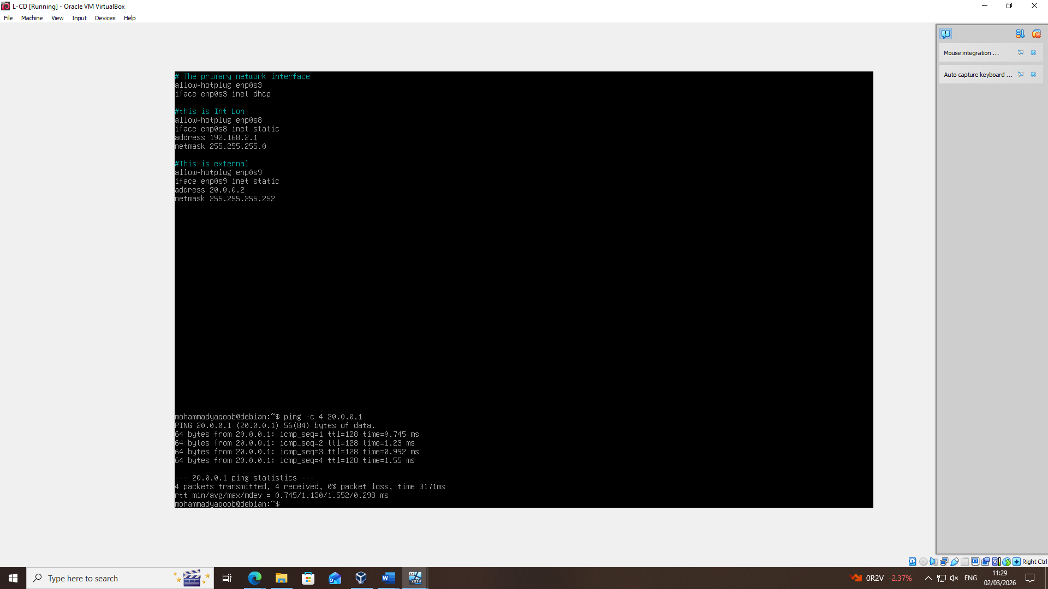Screenshot 20.2: Successful ping attempt between Swansea and London networks.

Troubleshooting Process
During configuration, minor issues were identified and resolved:
- Incorrect adapter mode initially configured as NAT instead of Internal
- Windows Firewall blocking ICMP traffic
- Subnet mask misconfiguration on Debian client
Each issue was resolved through systematic verification using command-line diagnostics and adapter configuration review. This demonstrates structured troubleshooting methodology and effective technical decision-making.

Conclusion
The virtualised dual-site infrastructure for NOSS2026 has been successfully deployed using Oracle VM VirtualBox. Two logically separated LAN environments were configured with static addressing, interconnected through a /30 WAN segment designed according to efficient IP allocation principles.
Connectivity testing verified correct intra-network communication while confirming intentional inter-network isolation due to the absence of routing services.
The infrastructure is now fully prepared for Coursework 2 enhancements, including Active Directory deployment, DHCP configuration, DNS integration, and routing service implementation.
This implementation demonstrates practical understanding of virtualization, IP addressing strategy, network segmentation, and structured troubleshooting within an enterprise simulation environment.

Task 3: Reflection

3.1 Technical Reflection
Implementation within the VirtualBox environment required accurate logical planning and disciplined validation procedures. Early connectivity failures emphasised the importance of verifying default gateway assignments and subnet alignment. Systematic testing ensured faults were isolated logically rather than addressed through trial-and-error configuration.
DNS misconfiguration during hostname resolution further reinforced the dependency of domain-based infrastructures on accurate service integration [16]. The experience demonstrated that structured diagnostic processes beginning with IP verification and progressing toward routing and service validation are essential for stable network deployment [17].

3.2 Personal Reflection
This coursework enhanced both my analytical capability and technical independence. Designing and deploying a segmented network using VLSM strengthened my understanding of address planning efficiency. Additionally, managing virtual adapters and troubleshooting within a hosted hypervisor improved my practical confidence.
Documenting timestamped evidence encouraged steady progress and professional discipline. Overall, the exercise has prepared me for more advanced service configuration in future coursework.

References

[1] | R. Buyya, R. Ranjan and R. N. Calheiros, “Modeling and Simulation of Scalable Cloud Computing Environments and the CloudSim Toolkit: Challenges and Opportunities,” Future Generation Computer Systems, vol. 29, no. 2, pp. 599-611, Feb 2013.
[2] | Oracle, “Oracle VM VirtualBox User Manual,” 2023. [Online]. Available: https://www.virtualbox.org/manual/. [Accessed 01 Mar 2026].
[3] | A. S. Tanenbaum and H. Bos, “Modern Operating Systems,” in Modern Operating Systems, 4th ed., Pearson, 2015.
[4] | J. Kurose and K. Ross, Computer Networking: A Top-Down Approach, 8th ed., Pearson, 2020.
[5] | W. Stallings, Data and Computer Communications, 11th ed., Pearson, 2020.
[6] | E. Rosen, A. Viswanathan and R. Callon, “Multiprotocol Label Switching Architecture,” 2001.
[7] | Microsoft, “Active Directory Domain Services Overview,” 2022. [Online]. Available: https://docs.microsoft.com/en-us/windows-server/identity/ad-ds/get-started/virtual-dc/. [Accessed 01 Mar 2026].
[8] | S. S. Gill, Implementation, Management, and Security, CRC Press, 2018.
[9] | O. Corporation, Oracle VM VirtualBox User Manual, Oracle Documentation Library, 2023.
[10] | O. Corporation, “VirtualBox Networking Modes,” 2023. [Online]. [Accessed 01 Mar 2026].
[11] | R. Morabito, J. Kjällman and M. Komu, “Hypervisors vs. Lightweight Virtualization: A Performance Comparison,” in IEEE International Conference on Cloud Engineering, 2015.
[12] | M. Corporation, “Windows Server 2022 Evaluation Center,” Microsoft Learn, 2023. [Online]. [Accessed 01 Mar 2026].
[13] | M. Corporation, “Download Windows 10 Disk Image (ISO File),” Microsoft Software Download Portal, 2023. [Online]. [Accessed 01 Mar 2026].
[14] | D. Project, “Debian 12 (Bookworm) Release Notes,” Debian Documentation, 2023. [Online]. [Accessed 01 Mar 2026].
[15] | W. Stallings, Data and Computer Communications, 10th ed., Pearson Education, 2014.
[16] | Microsoft, “Active Directory Domain Services Overview,” Microsoft Learn, 2022. [Online]. [Accessed 01 Mar 2026].
[17] | A. S. Tanenbaum and D. Wetherall, Computer Networks, 6th ed., Pearson, 2021.

