Student name- Leoni Shaw
ID Number- 2502432
Module-Niche Marketing and Social Media
Module Code- BMTH4014
Lecture- Chris Watkins
Assignment Title-
Word Count- 1500 (+/- 10%)
Submission Deadline- 12th December 2025 11:59pm

Ai Declaration
I confirm that I have not used any AI tools in the research and creation of this assignment. I confirm that I have not presented any AI generated materials as my own work. I confirm I have copies of my drafts, notes and other resources I used, which I may be asked to provide in evidence.

Introduction
This report is based on the Swansea Arena House Party, its a marketing plan to understand a strategy that will boost audiences coming in and increase revenue for the venue management. This particular event is primarily targeted at university students more towards GenZ and Millennials, who come out to be socially active and like to be engaged into the music genre. Its going to have the SOSTAC for the strategic plannings, the 4’Ps marketing mix to refine offerings “Marketing mix is a major contributor to boost customer loyalty with regard to company products” (Madanat, 2015) and then utilise Ansoff’s Matrix to be able to find the growth opportunities. This plan is key in the marketing concept like, strategic marketing market segmentation, niche target market planning and value proposition development. The main goal is to make the house party as a cultural event that balances the entertainment with the community value and audience growth
Situational analysis
Strengths | Weaknesses
- Well known location since its in the centre of Swansea  - There are accessible links with 5 min walk to bus or 20 to the train station | - Not much advertisement being sent out compared to more bigger events  - To much dependence on social media on ticketing, when it comes to on the day and there is an IT failure
Opportunities | Threats
- Further social media influences, displaying the event from 2024 downwards  - Collaboration with other brands to boost awareness of the event | - Costs of ticket prices let alone prices inside the venue  - Weather conditions may stop people from wanting to travel far
Company- Swansea arena gains many strengths from what I stated, things like where its placed and how it has so many links to help provide for the people before hand and afterwards. Weaknesses like less advertisement or IT failure can cause a huge concern when leading up to the event and when the event starts Opportunities show when there’s awareness or displays of the event to gain more customers and show what the event is about. Lastly, threats can include the costing of items inside the arena and weather conditions not the day.
Customers- customer segmentation for Swansea Arena House party reveals to us three different profiles from using demographics, psychographic, behavioural and geographic. From using Similarweb. I generated 3 different profiles (Appendix 2): music lover, socially independent person and a social media person. These insight support different target markets that go with different preferences of people attending the House Party. “Mosaic is a powerful consumer segmentation framework that leaps you to understand your customers and prospects at a deeper level” (Experian, 2025)
Competitors- Swansea arena would no doubt have competition with other venues such as the Utilita arena Cardiff, ICC Wales, the depot and many more, each showcasing different placements. The perceptual map (appendix A) is showing where swansea arena is placed. I placed that there due to the fact of how interactive/busy it gets and how most tickets are reasonable pricing. “A perceptual map is a chart used to illustrate where a product or brand and its competitors are positioned according to consumer perception” (Asana, 2025).
Collaborators- having collaboration within the event can boost the audience attendance by a lot. “By forming creative partnerships with other businesses, you can leverage strengths to attract new customers, nuance offerings and drive sales” (No Author, 2024). Partnerships like, ticket master or influencers using TikTok and instagram can reach the type of audiences to grab their attention quicker. One other alliance could also be with the transport, advertising transport or blogging it would hopefully boost people by travelling from other areas of Swansea.
Climate- Swansea Arena House Party is shown form macro-environmental factors which are shown in a PESTEL framework (Appendix 3). External factors, politically show that Swansea council funding and improvement of late transportation will enhance the accessibility side. Economically, rising the venue costs may reduce spending within the arena itself. Socially, having the event joined into popular genre’s could boost target audiences. Technological, using social media can gain more followers and have more audience engagement. Environmentally, noise and waste could cause problems later down the line. “Organisations can assess any risks specific to their industry and organisation, and make informed decisions aligned to current and future plans.” (CIPD, 2025)
Objectives
My SMART objective for this would be to potentially increase the social engagement across channels like Instagram and TikTok as the highest channels for the most engagement by 15%-25% within half of the year ending up to the event happening, with potential of 10-15% with engagement on posts and 5-10% on the growth of followers showcasing their interested in the event.
Strategy
The Ansoff Matrix is a format that helps marketers understand what areas are needed to improve on while showcasing off new products. “It’s used to evaluate opportunities for companies to increase their sales through showing alternative combinations for new markets.” (Hanlon, 2021). This goes onto to explain how the Ansoff Matrix is the right tool to use in the business sector to guide business perplexing of the risk and opportunities their gaining.
The marketing mix of the arena House party can propose different strategies. The product side can show how the Arena are trying to be more outstanding from other venues showcasing more of a bold title to grab viewers attention. “Consumers say they want experiences over goods. As always, they are looking to get he most value for their dollar” (McKinsey, 2024)
When it comes to pricing in the Swansea arena, they can gain these two ways, one from the tickets they sell and the other if they do revenue management to be able to gain that extra revenue. Having a set up for ticketing like early bird, student rates or VIP packages will not only help the arena gain more money it also helps them have more of an understanding on where the tickets are selling out most. “Revenue management helps businesses get the most out of what they sell, offer specific deals to customers who value them the most”. (Beaver, 2025)
“CRM stands for customer relationship management, which is a system for managing all of your company's interactions with current and potential customers” (salesforce, no date). CRM is known at the Swansea arena, as it works with a lot of new and current customers while also managing the yield management. By using CRM in Swansea Arena, it can gain benefits for them examples like revenue growth if they promote sales in different ways ‘early bird, student sales’, gaining more trust and loyalty from the customers, this helps by having on-going same customers or sending out pre emails about things leading up to the event to make more customers excited to attend and potentially forward it to other friends to make them want to go.
Tactics
Being able to develop tactical strategies for the Swansea Arena by using the RACE framework in conjunction with the communications mix to show us what areas show to different needs and behaviours. “The RACE framework is a powerful way to plan and execute marketing activities. It provides a clear structure for moving prospects from initial awareness to repeat business.” (Brameld, 2025)
Act- many students use social media in their everyday lives through the top ones ` Instagram and TikTok. Swansea Arena uses short but engaging videos to grab everyone’s attention on what the event is going to be about, even with help with university societies, to collab and bring the audience together. “Every six out of 10 businesses utilise video in their digital marketing strategy and those using it are seeing an average 84% increase in purchases”. Going into using societies, using university sport groups or and sort of student creator will boost the House party more frantically. “Hosting or Attenborough events allows you to increase your brand awareness and get your products and service in front of as many potential customers as possible” (Donaldson, 2024)
The act strategies will relate to the needs, behaviours lifestyle of customer profile number 2 because this student very rarely likes to leave Swansea and spends most of their time with their university flatmates. This student is very easily persuaded so showing off ads on social media like Tik Tok or Instagram, posters on university walls will boost their likeliness of attending the event. Giving out promotions to the event will no doubt also get the student to go since they are on a low disposable income so things like “2 for 1 ticket for one hour” could boost their ego to get that chance. Altogether, the act tactics are designed to fit this customer profile to their needs and expectations.
Action
My action plan provides my marketing channels and schedule. Using social media as my source of decisions, would be a good option as it will always be a continuous platform that will be used for generations on end. Using Chanel’s like Instagram and TikTok would be the best option for me because it's where you would gain the most interactive responses from certain age groups, age groups who go out a lot an engage with other audiences. The schedule set up would look like this:
(You must support this section with use of a Gannt chart to be included in the appendicies)

Control
Having success of the Swansea House party marketing plan was measured though KPI “KPI provide targets for teams to shoot for, milestone to gauge progress and insights that help people across the organisation make better decisions”. (Qlik, 2021). We would identify the new targets by who signs up through the website via ticketing data given. Social media interactions, likes, shares and using hashtags, will show us what engagements are having the most interactions is and to show brand visibility. These can be tracked using SimilarWeb highlighting what is being reached out by the most. Ticket sales and profits will give ROI (Return on Investment) an understanding of the measures. “Aligning your customer support, marketing and sales teams with a customer-service-focussed approach can help increase your profits.” (Thompson, 2024)
Conclusion
The marketing plan challenges were aimed at my profile 2, who was the budget student, while choosing this profile I outlined different strategies therefor focusing on affordability, social appeal, accessibility and making sure the event is aimed for students who are struggling financially with their money. Recommendations have been mentioned in the objective, offering student discount, doing a prize draw for 5 people to get free entry or giving out different sort of promotions to gain more audience and more engagement on social media.
References
“\R\N \N Creative Partnership Ideas to Boost Customer Engagement and Sales\N \R\N.” Llchamber.com, 2024, www.llchamber.com/15--creative-partnership-ideas-to-boost-customer-engagement-and-sales. Accessed 11 Dec 2025
“\R\N \N the Power of Video\N \R\N.” Venus.ai, 2019, www.venus.ai/news/the-power-of-video. Accessed 10 Dec 2025
Asana. “Level up Your Marketing with a Perceptual Map.” Asana, 2024, asana.com/resources/perceptual-map-template. Accessed 11 Dec 2025
Beaver, Scott. “Revenue Management Defined: Ultimate Guide for 2022.” Oracle NetSuite, 2022, www.netsuite.com/portal/resource/articles/financial-management/revenue-management.shtml. Accessed 4 Nov 2025
Brameld, Stuart. “RACE Framework: A Comprehensive Guide for Growth Marketers - Growth Method.” Growth Method, 14 Oct. 2024, growthmethod.com/race-framework/. Accessed 10 Nov 2025
CIPD. “PESTLE Analysis.” CIPD, 21 Mar 2025 www.cipd.org/uk/knowledge/factsheets/pestle-analysis-factsheet/. Accessed 7 Nov 2025
Donaldson, Caylee. “9 Benefits of Event Marketing.” Blog.hettshow.co.uk, 16 June 2022, blog.hettshow.co.uk/benefits-of-event-marketing. Accessed 11 Dec 2025
Experian. “Mosaic | Consumer Classification Platform | Experian Business.” Www.experian.co.uk, 2023, www.experian.co.uk/business/platforms/mosaic. Accessed 10 Nov 2025
Hanlon, Annmarie. “The Ansoff Model.” Smart Insights, Smart Insights, 12 Aug. 2021, www.smartinsights.com/marketing-planning/create-a-marketing-plan/ansoff-model/. Accessed 4 Dec 2025
Kohli, Sajal, and Joydeep Sengupta. “Think You Know What Consumers Want? Think Again.” McKinsey & Company, McKinsey & Company, 25 July 2024, www.mckinsey.com/industries/consumer-packaged-goods/our-insights/think-you-know-what-consumers-want-think-again. Accessed 4 Nov 2025
Nuseir, Mohammed T., and Hilda Madanat. “4Ps: A Strategy to Secure Customers’ Loyalty via Customer Satisfaction.” International Journal of Marketing Studies, vol. 7, no. 4, 30 July 2015, pp. 78–87. Researchgate, https://doi.org/10.5539/ijms.v7n4p78.
Qlik. “What Is a Key Performance Indicator (KPI)? Guide & Examples.” Qlik, 2021, www.qlik.com/us/kpi. Accessed 11 Dec 2025
Salesforce. “Salesforce.” Salesforce, 2025, www.salesforce.com/uk/crm/what-is-crm/. Accessed 4 Nov 2025
Shuey, Greg. “Like PB&J: Customer Service as a Marketing Strategy.” Business.com, business.com, 26 Mar 2015 www.business.com/articles/customer-service-as-a-marketing-strategy/. Accessed 10 Nov 2025
Appendice
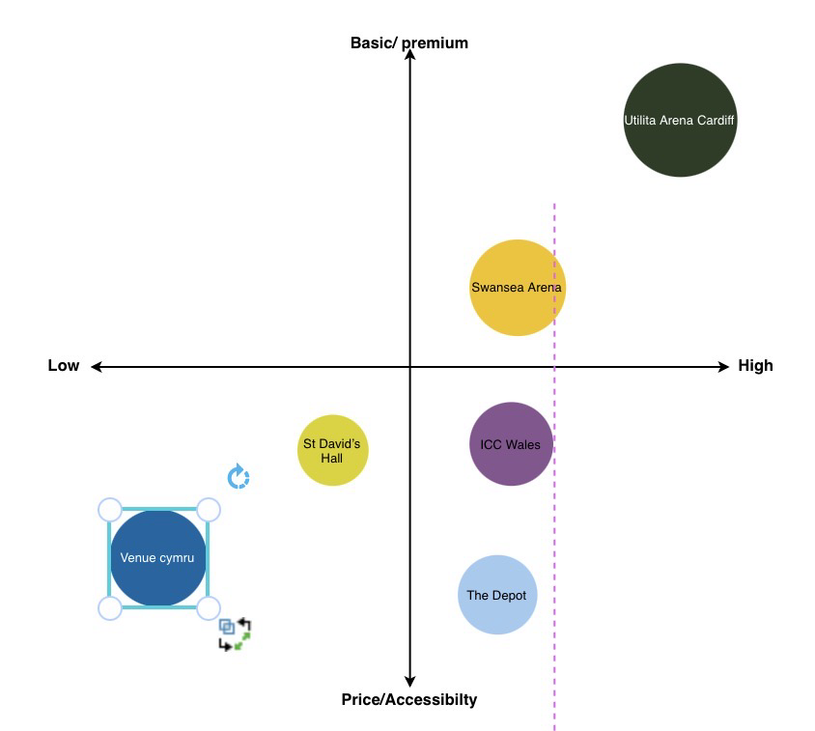
Profile 1- Music Lover | Profile 2- Budget Student | Profile 3- Independent person
Geographic  - Lives on the outside area of Swansea (Llanelli)  - Has near by transportation (bus or train)  Demographic  - Age: 20-25  - Student but has a part time job in fast food, on national minimum wage  Psychographics  - Passionate about rock bands  - Loves being surrounded by crowds  - To them, music is a way to connect to new people  Behavioural  - Attends local rock gigs when they're in Swansea or sometimes Cardiff  - Loves to be round big crowds to get the vibe going  - Doesn’t worry about money that much so would buy tickets at any price | Geographic  - From the city centre of Swansea  - Walks most of the time but lives next to a bus top and the train-station  - Very rarely leaves Swansea due to expenses  Demographic  - Age: 18-22  - Full time undergraduate doing art  - Does not have much money to go off when wanting to go to events  Psychographic  - Has a lot of fun on Wednesday social nights  - Likes to visit it free events when possible  Behavioural  - Doesn’t think when buying tickets before hand (peer-pressured by their mates)  - Likes to show off their nights on their social media  - Always attends with flatmates to make the night bigger and more fun | Geographic  - Lives in a small village outside of Swansea  - Has to use public transport all the time but can drive when needed  - Very rarely goes on nights out or goes and socialise  Demographic  - Age: 22-26  - Post graduate student in creative writing  - Has a decent income so doesn’t worry much about pricing  Psychographic  - Likes to have alone time and independence  - Likes to attend events where they ain’t pressured into going to  - Likes to go to more live performances  Behavioural  - Purchases tickets before hand to not hav the worry on the day of the event if they should go or not  - Doesn’t like to post many things on social media  - Doesn’t like to travel far due to timings and how late it gets

Political  - Having the local council help for funding (Swansea Council)  - Later transportation to and from the Arena | Economic  - Venue hire cost for the bands playing and overall event budget wanted  - Cost of living crises with prices on the rise
Social  - Using current trends and preferences to fit the right target audience  - Plenty of cultural and social activities happening in and around Swansea | Technological  - Using social media platforms for showcasing the event and selling tickets  - Going live on the night to lighten up the event and push more customers to come
Environmental  - After-hour noise management  - Waste management and recycling at the arena | Legal  - Health and safety regulations being brought forward  - Privacy policy, data protecction and usage

