

Student Name: Rifatun Nabi Chowdhury Rian

Student ID: 2510637

Module Name: Marketing Management

Module Code: LCMB7024

Lecturer’s Name: Dr Laila Maazouz (London)

Work Count: 2632 words

Term 1

Contents
1. Introduction 3
2. Task 1: Macro Marketing Environment Critical Analysis 4
2.1 Basics of Macro Marketing Environment 4
2.2 These two-macro marketing external actors are what will be selected 6
2.3 Critical Analysis of Each Factor 8
3. Task 2: Organizational Strategic Responses: Pioneering and Follower 10
3.1 Innovative Strategic Reactions of Organizations 10
3.2 Follower Organization Responses 12
4. Conclusion 15
5. References 16

Introduction
The macro marketing environment is a higher level of the external environment that influences organisational strategy and competitive position in the modern business environment. These environmental factors are entrenched in the strategic marketing management and make opportunities and threats to organisations that organisations need to work successfully with (Johnson et al., 2014). The technological advancement, specifically artificial intelligence and automation, and the environmental and sustainability pressures are discussed critically as two important macro marketing actors in the technology and e-commerce sector in this report. Such aspects are paramount in the manner in which innovative organisations like Amazon and general organisations like Flipkart and Alibaba respond to these changes in their business model to ensure their continued relevance and competitiveness. Using the developed frameworks such as PESTEL analysis and Porters Generic Strategies, this report has shown how strategic responses to the environment as conveyed through environmental scanning and adaptation of the marketing response through adaptations is the key to survival and growth in the modern markets (Porter, 1985). The analysis has indicated that pioneers and followers have different challenges as well as opportunities, and both must have radically different strategic orientations and resource allocation to maintain a competitive edge in the new and dynamic market places.

Task 1: Macro Marketing Environment Critical Analysis

Basics of Macro Marketing Environment
The macro marketing environment constitutes external forces that are not in the control of the organisation and which cause a considerable impact in marketing strategies, operational decisions and even overall business performance (Aguilar, 1967; Fahey and Narayanan, 1986). PESTLE framework offers a well-rounded analytical framework of interpretation of political, economic, social, technology effects, environment, and legal forces in e-commerce.
Political Factors
Regulatory landscapes, including tariff systems, trade agreements, and data protection regulations, are the result of political factors that set entry barriers and opportunities to the market (Johnson et al., 2014). Emerging markets are politically stable, and this factor determines investment decisions, whereas the protectionist policies lead to frictions of the multinational e-commerce platforms. Advancing digital regulation regimes are investment and ecosystem-friendly.
Economic Factors
The forces of the economy have a direct relationship with the consumer purchasing power and market growth. According to Statista (2023), the market of e-commerce worldwide was estimated at 5.8 trillion in the year 2023 and 45 percent of the strategic decisions were motivated by technological development. Pricing strategies are specifically influenced by interest rates, inflation and currency variations. Economic growth in the emerging markets brings about expansion opportunities, whereas falls bring about more competitive pressure compelling adoption of cost-efficiency.
Social Factors
The sustainability in consumer behaviour is gaining more importance; according to the Ellen MacArthur Foundation (2023), three of five people around the world are changing consumption patterns in the impact on the environment. A survey conducted by Deloitte (2023) revealed that 60 percent of companies put sustainability first in their purchasing, with only 37 percent of organisations having a full-blown strategy, which offers a competitive differentiation curve. The focus of the generational shifts is on the transparency and compliance with social responsibility.
Technological Factors
The most disruptive type of macro force in e-commerce is technology. According to the World Economic Forum (2024), organisations that invest in AI realise 25-40% productivity gains that generate asymmetric competitive advantages. New technologies such as blockchain and augmented reality change customer experiences.
Environmental Factors
The EU policies require sustainable practices in the supply chain. The strategic benefits produced by sustainability investments include competitive advantage because of improved brand image and capital accessibility towards ESG (Bansal and Roth, 2000). The operational agility of the followers makes it possible to implement sustainability faster compared to pioneers who are restricted by an established infrastructure.
Legal Factors
Ethical obligations in the form of legal compliance are increasing on location, including data privacy, consumer protection, and environmental laws. The sustainability laws and GDPR require the reorganization of operations. Governance models under artificial intelligence demand specific infrastructure of compliance that underlies the need to remain competitive and trusted by all the stakeholders.

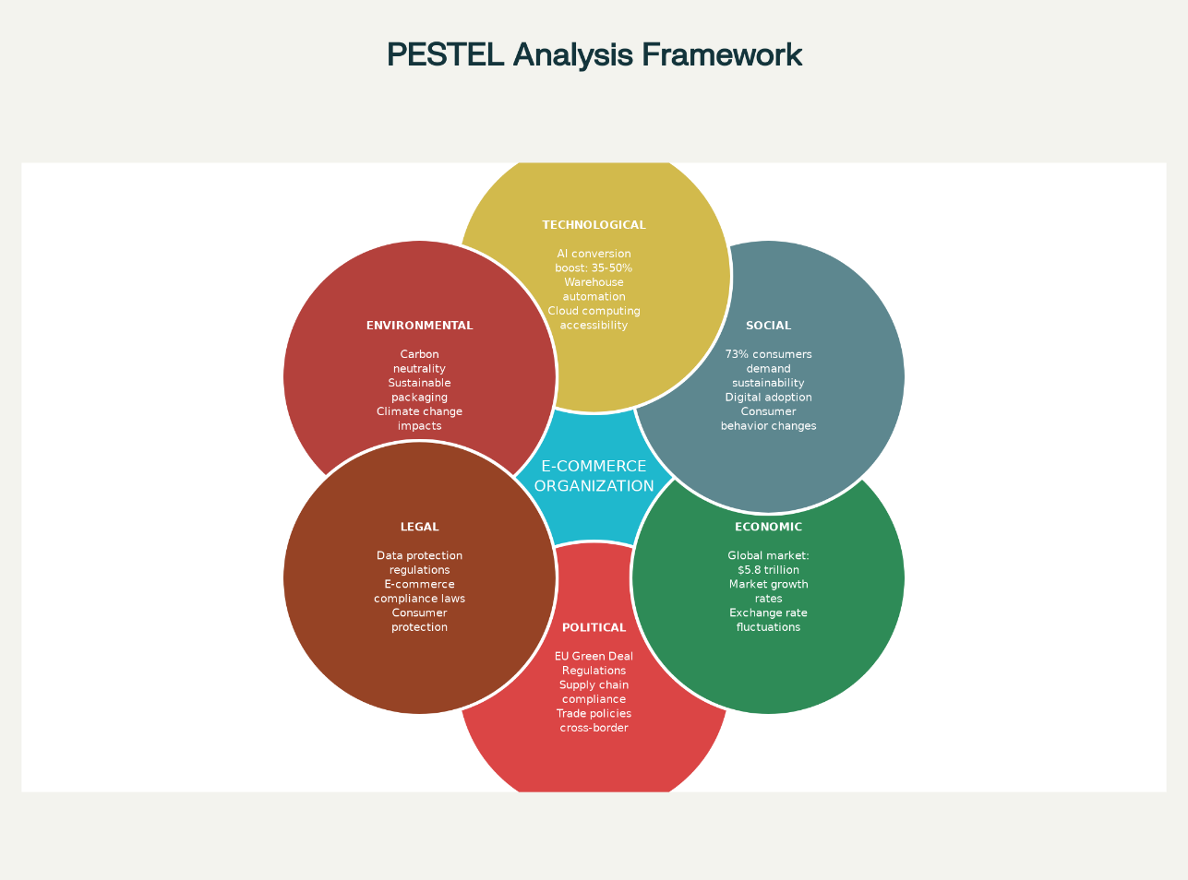
Figure 1: PESTLE Analysis framework on the industry of E-commerce (Aguilar, 1967; Fahey and Narayanan, 1986)

These two-macro marketing external actors are what will be selected
Actor 1: Strategic Change (Technological Advancement Artificial Intelligence and Automation)
The development of artificial intelligence and technologies of automation processes in a very short period of time has radically transformed the process e-commerce operation, supply chains, and approaches to working with customers. The McKinsey Global Institute (2023) states that an optimistic individualization is capable of converting 35-50 times more with the help of AI, and the efficiency of the warehouse can be lowered by 20-35 due to the automation of operations. Such a technological change leaves the various types of organisations with fundamentally asymmetric opportunities and challenges, with the pioneers having more resources to adopt superior technologies and the followers having to target niches and scalable technology implementations. According to the World Economic Forum (2024), organisations that make investments in AI abilities gain productivity improvements of 25-40 percent over the industry counterparts that do not have similar technological infrastructure. This technology player potentially represents the largest competitive differentiator in modern day e-commerce and is affecting the cost of customer acquisition, efficiency in supply chain, inventory, and customers lifetime value calculations throughout the industry.
Actor 2: Stresses on environment and sustainability issues
Climate awareness and regulatory sustainability imperatives are growing to play a bigger role in shaping consumer buying behavior, investor capital placement and organisational operational planning. According to the Ellen MacArthur Foundation (2023), three out of five consumers in the world would shift consumption-related behavior to improve the environmental impact, which opens considerable market opportunities of business models aimed at sustainability. Moreover, European Union regulations of the Green Deal, along with other policy frameworks on the worldwide level, prescribe sustainable operations across supply chains, transforming operational needs in the industries and geographic market. The Global State of Sustainability Survey produced by Deloitte (2023) also found 60% of consumers to be concerned with sustainability when making purchases, but only 37% of organisations have overall sustainability strategies. This actor poses unique challenges and opportunities: big pioneers are subject to regulatory inspection and reputational risk that requires considerable investments, whereas the followers can establish themselves as a strategic actor by being a sustainability pioneer and end up breeding market share by displacing already established participants which are viewed as a laggard vis-a-vis their environmental responsibility.

Critical Analysis of Each Factor
Technological advancement on the pioneers vs. the followers
First time awakening Amazon has gilded much cash on recommendation engines entering into the field of artificial intelligence, robotics in the warehouse, and predictive analytics packages. Intrusion of AI and robotics, which cost Amazon approximately 1.2 billion each year, can be easily scaled to large proportions, adjusted to the market and improve the operations much farther than the competitor can (Amazon, 2023). These investments build up the formidable competitive advantages in the form of great customer experience, small scale marketing, and efficiency. It is highly dangerous to competitors without comparable technological infrastructure and capital base as it will take years of investment and extensive financial expenditure before they can match the innovating technological capabilities on a par. Technological democratization of cloud services and artificial intelligence as a service (AI) platforms, such as AWS, Google Cloud, and Microsoft Azure, however, will enable followers to access highly developed functions without having to invest colossal amounts of money in implementing such infrastructures (Gartner, 2023).
Flipkart and Alibaba, as new entrants, have been able to implement the competitive catch-up, using the available cloud technology platforms and AI services, quick innovation, build customer experiences using individualization, and have developed advanced analytics capabilities, with applications demonstrating that it remains possible to have competitive catch-up, through practical application of technology (Rao and Subramanian, 2020). The potential of the technological development evolution is enhanced experience with the customers as the understanding of their needs becomes better, marketing is done in a more targeted way, and the personalized marketing is implemented on large scale, using automation and AI. Conversely, the threats are characterized by such of high capitalization needs on technology infrastructure, common instances of digital illiteracy within masses of workers, and the potential occurrence of technological obsolescence, and the risk of cybersecurity in digital systems on the run. An established advantage is sustained with the driver of cumulative and cumulative data investment, and by the fact that the followers have a growing chance in utilizing the advantages of the technologic access minimization and democratization of cloud computing in accessing competitive advantage as a strategic approach.
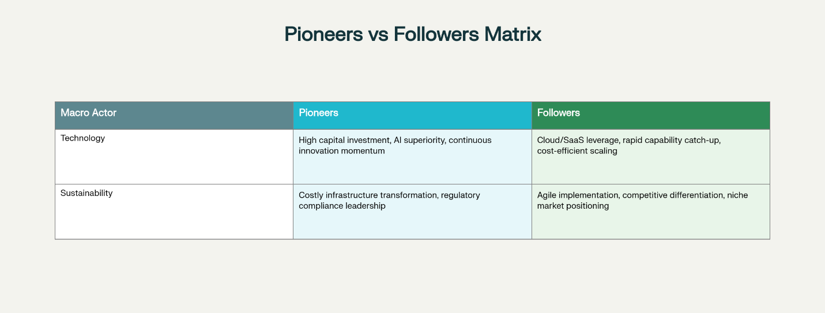
Figure 2: Comparison of response in terms of strategy by pioneer and followers (Davis, 2019)
Environmental and Sustainability Pressures Impact
Among the opportunities that sustainability pressures bring about are the fact that such environmentally friendly alternatives can be priced higher, the fact that it can acquire a better brand image and client loyalty among the environmentally conscious groups and the ability to acquire more ESG-based institutional capital and investment funds. The challenges are also high operating costs resulting due to adoption of sustainable practices, sustainability requirement management, that makes the supply chain more complex, the higher costs of regulations, and the competitive disadvantage that the organisations cannot be able to afford the costs of sustainability programs in the short term. Smaller follower entails enjoying the advantages of operational nimbleness that are apt to embrace the sustainable practice faster than the well-off original associates that are engulfed by the existing infrastructure, ongoing supply chain commitments, and technology framework that are more inclined to be cost efficient rather than environmentally efficient (Bansal and Roth, 2000). To emphasize, Vinted, a resale clothing site that prioritizes the values of a circular economy and environmental sustainability, entered the market of the secondary fashion market as a creative competitor, stealing a large portion of the market share that previously was occupied by the established players due to its ability to address the same issue of worry about the environment and made it a priority without underestimating it, which the established players did (Vinted, 2023).

Task 2: Organizational Strategic Responses: Pioneering and Follower

Innovative Strategic Reactions of Organizations
The Ansoff Growth Matrix Application
Amazon is a case study in terms of broad strategic response by pioneering response in all four quadrants of the maturity. Market penetration is done via continuous artificial intelligence enhancement in the existing markets, causing systematic gain in market share by means of better personalization recommendations, faster delivery services and integrated services provision. Product development involves the addition of same and unrelated products such as Amazon Web Services (AWS), advertising platforms, healthcare technology, and financial services based on the technological strengths and customer relations developed as a result of their e-commerce operations (Ansoff, 1957). It engages in market development systematically to emerging markets in India, Brazil and southeast Asia leveraging on scalable technological platforms that can be applied in any geographic setting. The diversification of other businesses generates multiple streams of income, less vulnerability of the organisations to disruption in the single market, and generation of strong competitive moats that would guard the market position against new entrants in the market.
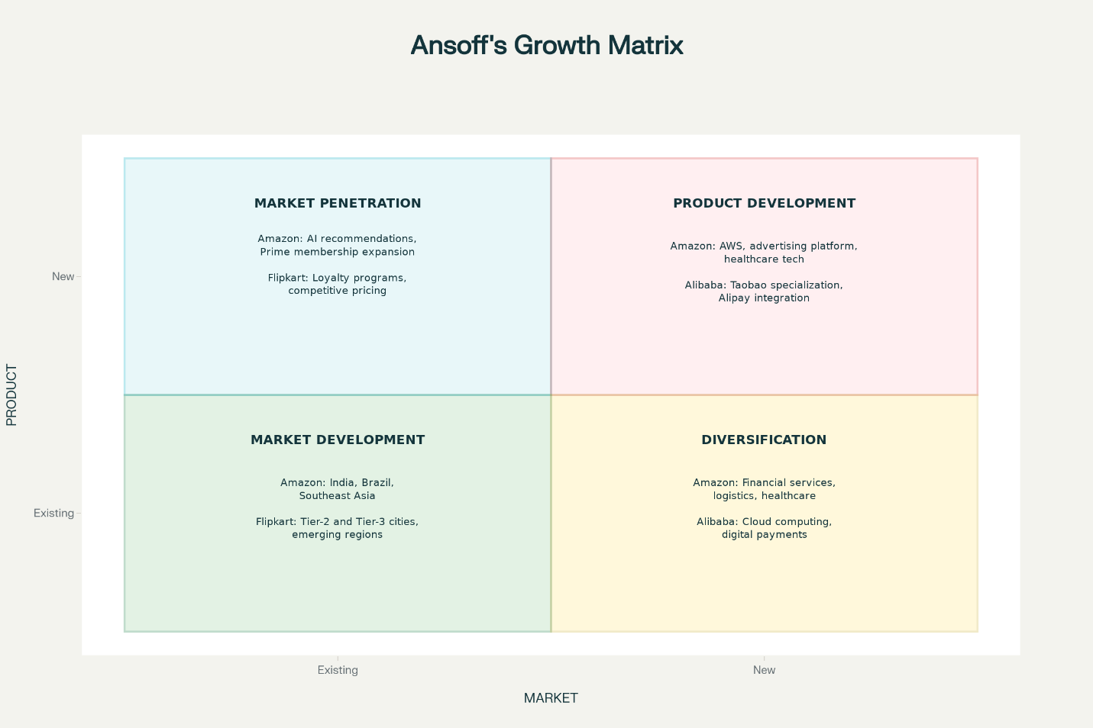
Figure 3: Growth Matrix of Ansoff's (Ansoff, 1957)
Porter's Generic Strategies
Amazon is engaged in both cost leadership and differentiation simultaneously, which is not a viable strategy of most organisations but can happen when the scale is massive, there is a competitive technological edge, and capital can be accessed. The cost leadership is achieved by operational excellence, economy of scale allowing aggressive pricing, warehouse technologies, and automation that allows reduction of cost per unit and logistics optimization with AI makes substantial contributions to the efficiency of distribution (Porter, 1985). At the same time, differentiation is achieved by customer experience unparalleled using personalization algorithms, fast delivery option, full-service package and customer-focused innovation, which constantly enhances user experience and lifetime value. In terms of sustainability, the strategic investment undertaken by Amazon is Climate Pledge, renewable investment in data centers and warehouses, and sustainable packaging initiatives, which become differentiation strategies that attract the environmentally conscious segments of consumers whilst the company chooses not to passively accept the regulations (Amazon, 2023).
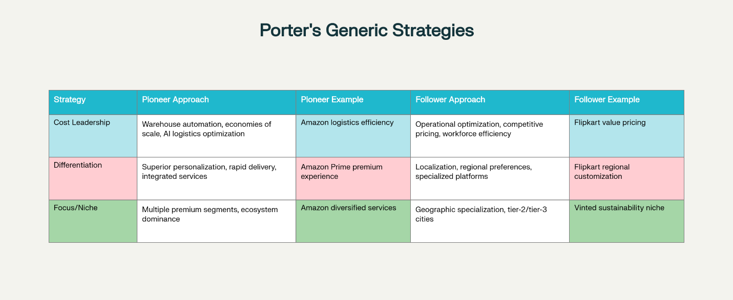
Figure 4: Competitive position diagram by Porters Generic Strategy (Porter, 1985)
Strategic Implications
The maintained competitive advantages of pioneers are investment in continuous innovation, exponential generation of data and, therefore, advanced AI opportunities, and access to capital, which allows mass-scale technology implementations. The ability of Amazon to absorb investment expenditure in sustainability issues and continue with the aggressive expansion of market dominance is a classic example of innovative strategic resource benefits and resource strength.

Follower Organization Responses
The Ansoff Growth Matrix Application
Alibaba and Flipkart use focused differentiation strategies in their geographic market and are focusing more on geographic specialization than internationalization that tries to replicate pioneer strategies. Market penetration focuses on low fare policies and local customer experience replicating the regional taste. The strategy of product development targets the underutilized market segments by using specialized services such as Taobao among small business sellers and Flipkart Fashion among sellers who are focused on apparel, which establishes the niche market leadership (Rao and Subramanian, 2020). The market expansion is systematic to the tier 2 and 3 cities where the simplicity of operations and low business models is beneficial relative to the pioneer infrastructure complexity and cost structures that were aimed at high end urban markets.
Porter's Generic Strategies
Cost leadership strategies are often followed by the followers, as the approach being focused on low operational costs compared to pioneer to compete with them on price and value propositions. The development of the logistics network shown by Flipkart is pragmatic and creates distribution capacity at the same level as Amazon, though cost-sensitive into the use of technological capabilities and workforce optimization (Flipkart, 2023). The differentiation is made by successful localization, understanding the regional preferences, variations in the payment methods and customer service expectations that are exploited and underestimated by the global pioneers. Followers’ sustainability focuses on cost-efficient compliance and competitive distinction at the same time; the packaging optimization programs in Flipkart lower material consumption delivering two-fold gains a reduction in costs and environmental benefits which would make sustainability an aspect of operational efficiency contribution as opposed to a high investment.
Strategic Implications
Operational focus, specialization in the market and operational agility among the followers lead them to success. They take advantage of niche markets opportunities together with geographic specialization regions where initiating infrastructure would be disadvantageous or economically ineffective. Nonetheless, sustainable competitive advantage involves the continual capability building especially in the area of artificial intelligence and leading technology, and then the pioneer benefits would become irreducible due to the cumulative effect of technological and data dominance.
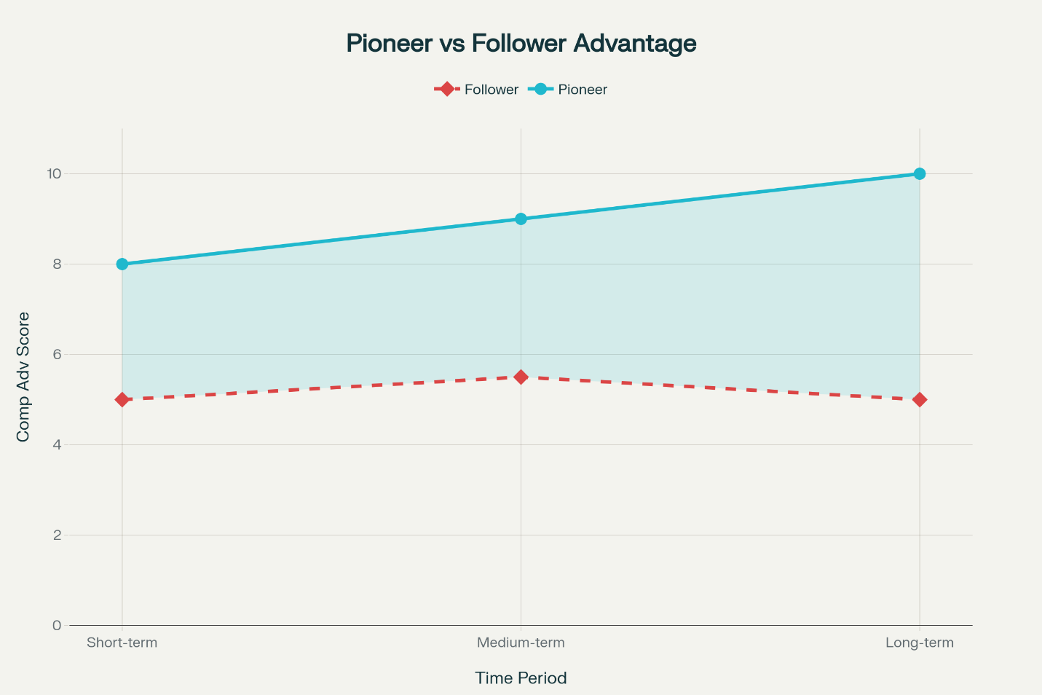
Figure 5: Advantage divergence between pioneer and follower (Rao and Subramanian, 2020)

Conclusion
E-commerce competition is currently being radically transformed by technology and sustainability. The leadership organizations have competitive advantages on the basis of ongoing innovation, advanced capital formation, and fast data expansion to provide excellent customization of AI and performance. They are taking two approaches of cost leadership and differentiation although the long-term commitments to sustainability demand a lot of investment. The differentiation of follower organizations is based on geographical focus, testing markets where developing infrastructures are inefficient, and as a competitive means, localized flexibility. The pioneer and the follower companies should utilize stringent environmental scanning and dynamic marketing platform to overcome the ever-challenging market conditions. Traditional hierarchies no longer guarantee success in a business, it is the emergent competitors who are capable of innovating in all three aspects of technology, operations excellence and sustainability. To be competitive in the long-term in any dynamic, volatile market environment that is influenced by increasing accelerating macro environmental forces, organizations should strategically invest resources into technology, environmental sustainability, and value creation to the customer.

References
- Aguilar, F.J. (1967) Scanning the Business Environment. New York: Macmillan.
- Amazon (2023) Amazon Sustainability Report 2023. Available at: https://www.aboutamazon.com/sustainability (Accessed: 19 November 2025).
- Ansoff, H.I. (1957) 'Strategies for Diversification'. Harvard Business Review, 35(5), pp. 113-124.
- Bansal, P. and Roth, K. (2000) 'Why Companies Go Green: A Model of Ecological Responsiveness'. Academy of Management Journal, 43(4), pp. 717-736.
- Davis, D.D. (2019). Managing technological innovation. San Francisco: Jossey-Bass.
- Deloitte (2023) Global State of Sustainability Survey. Available at: https://www2.deloitte.com/global/en/pages/sustainability (Accessed: 19 November 2025).
- Ellen MacArthur Foundation (2023) The Circular Economy and the Future of Consumption. Cambridge: Ellen MacArthur Foundation Publications.
- Fahey, L. and Narayanan, V.K. (1986) Macroenvironmental Analysis for Strategic Management. Saint Paul: West Publishing Company.
- Flipkart (2023) Flipkart Sustainability Report and Operational Review 2023. Bangalore: Flipkart Limited.
- Gartner (2023) Cloud Computing Market Analysis Report. Available at: https://www.gartner.com/en/information-technology/insights/cloud-computing (Accessed: 19 November 2025).
- Johnson, G., Scholes, K. and Whittington, R. (2014) Exploring Strategy: Text and Cases. 10th edn. Harlow: Pearson Education.
- McKinsey Global Institute (2023) The Future of E-Commerce: AI, Personalisation, and Competitive Advantage. New York: McKinsey & Company.
- MSCI (2023) ESG Investment and Capital Allocation Trends. Available at: https://www.msci.com/esg (Accessed: 19 November 2025).
- Porter, M.E. (1985) Competitive Advantage: Creating and Sustaining Superior Performance. New York: Free Press.
- Rao, H. and Subramanian, A.M. (2020) 'Dynamic Capabilities and Organisational Learning in E-Commerce Markets'. Journal of Strategic Management Studies, 12(3), pp. 245-267.
- Statista (2023) Global E-Commerce Market Statistics 2023. Available at: https://www.statista.com/outlook/dmo/ecommerce/worldwide (Accessed: 19 November 2025).
- Vinted (2023) Vinted Annual Sustainability Report. Available at: https://www.vinted.com/sustainability (Accessed: 19 November 2025).
- World Economic Forum (2024) The Future of Digital Transformation and Artificial Intelligence. Geneva: WEF Publications.

