Entrepreneurship (LCBB5001_BIRM)
Business plan- Anoya coffee
Lecturer name: Essa Bah
Student name: Alexandra M Cristea
Student number: 2190713

Table of Contents
1. Overview of the business idea and it’s product/service 3
2. Ownership and Legal format of the startup 4
3. Management of the company 5
4. Explanation of the target market and the marketing strategies the company will adopt to reach their customers 6
5. Evaluation of the business idea by using the SWOT analysis model. 7
6. Assessment of the current external environment by using the PESTEL analysis model 8
7. Identification of the key marketing factors by using the 4Ps of marketing mix model 9
8. A cash flow forecast for the first 12 months- startup costs cannot exceed £25,000 10

Overview of the business idea and it’s product/service

Entrepreneurship is the activity of setting up a business or businesses, taking on financial risks in the hope of profit.
The business displayed is a small medium enterprise business having as subject a coffee shop, called Anoya.
Anoya was created to offer a wide range of flavoured coffees, warm and cold, as well as tapas and pantry products. The business offers stayed in servings within a warm environment as well as take away, and is situated in the heart of the town, location able to provide an outspread customers inflow.
Considering the theme of the business, supplied services and accessibility, the prosperity of Anoya is easily predictable. According to Appinio website, on a typical day, Brits drink between 2 and 3 cups of coffee per day, coffee lovers having 3 cups of coffee a day.
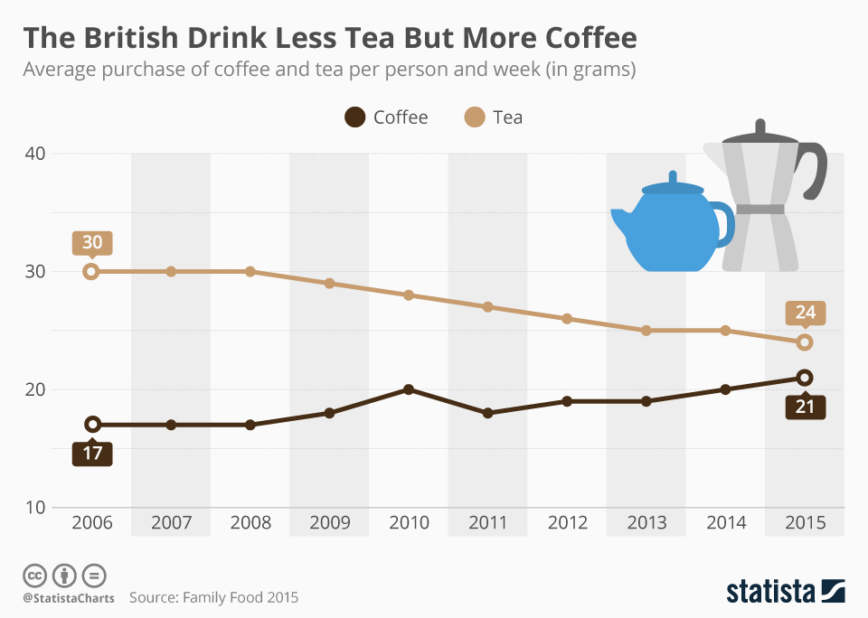

Ownership and Legal format of the startup

The chosen legal format of the business is sole trader or proprietorship defined as “a simple business structure in which one individual runs and owns the entire business. A sole trader is entitled to keep all profits after taxes have been deducted but is also liable for all losses the business incurs.” ( https://www.sumup.com/en-gb/invoices/dictionary/sole-trader/ )
There are disadvantages, as well as a plethora of advantages when choosing this type of ownership. Few advantages are represented as it follows: easy and affordable to create, complete authority over all business activities, easy to change the legal status of the business later, if anything changes or the business expands enough to have its status replaced, financially rewarding, flexible payments.
Alongside advantages, there are disadvantages too. The negative aspects of owning this kind of legal format are outlined below: full personal liability for any debts, difficulties to scale a business on your own, retaining high calibre employees can be challenging. ( https://www.smallbusinesspro.co.uk/small-business-finance/sole-trader.html )
Considering the matters previously mentioned, one of the main reasons for choosing a sole trader ownership is the full control over it and its affordability to start a business.

Management of the company

The director of the coffee shop is Maria with over 5 years’ experience within the industry, previously worked and expanded her knowledge at Starbucks as branch manager. Additionally, Maria holds a degree in Business Management, graduated with honours.
Working for such a famous company for a long period of time, preparing, selling, analysing everything coffee related, monitoring the marker, competitors and customers’ requirements, Maria developed a series of strengths and critical market skills which help her to start her own business. Gained experience is a must when starting a new coffee shop, hence there will be plenty of competition in the field, as well as challenges.
Well highlighted implication within the field helps facing threads easily comparing to the newbies, also owning in depth understanding and putting passion and meticulosity towards the business supports rapid development of the business.
At the beginning, Anoya would need 2 baristas, 1 accountant, 1 web designer which will be the same as the director.


Picture 2. https://www.canva.com/design/DAFb-sHWZug/Qk1XV1vAA19QfcAFzRcMTg/edit

Explanation of the target market and the marketing strategies the company will adopt to reach their customers

Marketing strategies are techniques or approaches used by businesses to promote their products or services and attract customers. Here are some common marketing strategies:
Content marketing: This involves creating and sharing valuable content to attract and engage potential customers. Examples include blog posts, videos, social media posts, and email newsletters.
Social media marketing: This involves using social media platforms such as Facebook, Twitter, Instagram, and LinkedIn to promote products or services, build brand awareness, and engage with customers.
Search engine optimization (SEO): This involves optimizing website content to rank higher in search engine results pages (SERPs). It involves techniques such as keyword research, on-page optimization, and link building.
Paid advertising: This involves paying to place ads on social media platforms, search engines, or other websites. Examples include pay-per-click (PPC) ads, display ads, and sponsored content.
Email marketing: This involves sending emails to customers or potential customers to promote products or services, build relationships, and increase brand awareness.
Event marketing: This involves organizing or sponsoring events to promote products or services, build brand awareness, and engage with potential customers.
Referral marketing: This involves encouraging existing customers to refer friends and family to the business in exchange for rewards or discounts.
The founding strategies for the coffee shop are content marketing, social media marketing and referral marketing.
Analysing thoroughly the strategies, throughout the first two, the business will be recognised by a broader range of customers considering the linking between blogs, videos, newsletter emails as well as social media. Social media is one of the most powerful weapon in advertising a new business taking in account the fact that over 90 percent of the people nowadays, own a social media account, being it Facebook, Instagram, Twitter, LinkedIn, Pinterest or TikTok.
On the other hand, referral marketing represents a genuine tangent which can benefit both existing customers and new ones. The existing customers will gain rewards through a fidelity card given after the first 10 purchases, allowing them to add up their servings and be rewarded with a free cup on their choice, once they buy 5 days a week. The referenced ones will benefit of a free cup, on their choice, after the first 5 purchases.
When mentioning target market, the aim is to have a various age mixture, based on what the business offers.

Evaluation of the business idea by using the SWOT analysis model.

SWOT analysis is a strategic planning tool used to evaluate the Strengths, Weaknesses, Opportunities, and Threats of a project, business, or organization.
SWOT analysis evaluation for Anoya coffee shop:
Strengths:
- High demand for coffee and specialty drinks.
- Ability to offer a unique atmosphere and experience for customers.
- Potential for repeat customers and loyal fans.
- Opportunity to create partnerships with local suppliers.
Weaknesses:
- High competition in the coffee industry.
- Dependence on seasonal demand and weather.
- Need for high-quality ingredients and equipment, which can be costly.
- Difficulty in maintaining consistent quality and service.
Opportunities:
- Growing demand for specialty coffee and other drinks.
- Opportunity to expand the menu and offer food options to attract more customers.
- Ability to leverage social media and online marketing to reach a wider audience.
- Potential to partner with local businesses and organizations to attract more customers.
Threats:
- Economic downturns could reduce disposable income and decrease demand.
- New competitors entering the market.
- Changes in consumer preferences or trends.
- Increasing regulations and costs associated with running a business.
Based on this SWOT analysis, the coffee shop has several strengths and opportunities, but also faces some challenges and potential threats. To build on their strengths and take advantage of opportunities, the coffee shop could focus on offering unique and high-quality drinks and food options, while also leveraging social media and partnerships to attract more customers. They may also want to plan for potential economic downturns or changing consumer preferences and focus on maintaining consistent quality and service to retain loyal customers. Overall, a SWOT analysis can help the coffee shop's owners develop a more comprehensive understanding of the opportunities and challenges associated with their business and make informed decisions as they move forward.

Assessment of the current external environment by using the PESTEL analysis model

PESTEL analysis is a tool that helps organizations to understand the broader macro-environmental factors that can impact their operations. The PESTEL acronym stands for Political, Economic, Sociocultural, Technological, Environmental, and Legal factors. Here's an overview of each of these factors and how they may be relevant to a business:
Political: This factor refers to the political environment in which a business operates. This could include government stability, regulation, taxation policies, and trade agreements. For example, changes in trade policies between countries could impact a business's supply chain and profitability.
Economic: This factor refers to the economic conditions of the market in which a business operates. This could include inflation rates, interest rates, economic growth, and unemployment rates. For example, an economic recession could lead to decreased consumer spending and lower sales for a business.
Sociocultural: This factor refers to the social and cultural norms, beliefs, and values of the market in which a business operates. This could include demographics, lifestyle trends, and consumer preferences. For example, changing consumer preferences towards healthier food options could impact a restaurant's menu offerings.
Technological: This factor refers to technological advancements and innovations that can impact a business's operations. This could include changes in automation, artificial intelligence, and digitalization. For example, the rise of online shopping could impact the sales of brick-and-mortar stores.
Environmental: This factor refers to environmental concerns and issues that can impact a business's operations. This could include climate change, sustainability, and natural disasters. For example, a natural disaster could disrupt a business's supply chain and operations.
Legal: This factor refers to the legal and regulatory framework in which a business operates. This could include labour laws, intellectual property rights, and consumer protection laws. For example, changes in data privacy laws could impact a business's data management practices.
By analyzing each of these factors, organizations can develop a more comprehensive understanding of the external environment in which they operate and how these factors may impact their operations. This understanding can then inform strategic decision-making and help businesses navigate potential risks and opportunities in the market.

Identification of the key marketing factors by using the 4Ps of marketing mix model

The 4Ps of marketing mix model is a framework that helps businesses identify and evaluate the key marketing factors that can influence their success in the market. The 4Ps refer to Product, Price, Place, and Promotion. Here's an overview of each of these factors and how they can impact a business:
Product: This factor refers to the product or service that a business offers to customers. It includes the design, features, quality, and packaging of the product or service. A business needs to ensure that its product or service meets the needs and preferences of its target customers.
Price: This factor refers to the price that a business charges for its product or service. It includes factors such as pricing strategy, discounts, and payment options. A business needs to ensure that its pricing is competitive and reflects the value that its product or service provides to customers.
Place: This factor refers to the distribution channels that a business uses to make its product or service available to customers. It includes factors such as retail locations, online channels, and distribution partners. A business needs to ensure that its product or service is available in the right place at the right time to reach its target customers.
Promotion: This factor refers to the marketing and promotional activities that a business uses to raise awareness and interest in its product or service. It includes factors such as advertising, public relations, sales promotions, and social media marketing. A business needs to ensure that its promotion strategy effectively communicates the value and benefits of its product or service to its target customers.
By evaluating each of these factors, businesses can develop a more comprehensive marketing strategy that takes into account the needs and preferences of their target customers, the competitive landscape, and the resources available to the business. By understanding the 4Ps of marketing mix model, businesses can develop a more effective marketing plan that positions them for success in the market.

A cash flow forecast for the first 12 months- startup costs cannot exceed £25,000

Start up cost  £25000 | Month 1 | Month 2 | Month 3 | Month 4 | Month 5 | Month 6 | Month 7 | Month 8 | Month 9 | Month 10 | Month 11 | Month 12
Cash inflows: sales revenue | £0 | £3000 | £5000 | £6000 | £7000 | £8000 | £9000 | £10000 | £11000 | £12000 | £13000 | £14000
Cash outflow: operating expenses | £25000 | £2000 | £3500 | £4000 | £4500 | £5000 | £5500 | £6000 | £6500 | £7000 | £7500 | £8000
Closing balance | -£25000 | -£24000 | -£22500 | -£20500 | -£18000 | -£15000 | -11500 | -£7500 | -£3000 | -£2000 | £7500 | £13500

This cash flow forecast assumes that the business generates sales revenue starting in month 2, with an average increase in monthly sales revenue of £1,000 per month. Operating expenses are assumed to be 70% of sales revenue. The forecast also assumes that there are no other significant cash inflows or outflows during the 12-month period.

- Reference List
- https://www.smallbusinesspro.co.uk/small-business-finance/sole-trader.html
- https://www.sumup.com/en-gb/invoices/dictionary/sole-trader/
- https://www.smallbusinesspro.co.uk/small-business-finance/sole-trader.html
- https://www.canva.com/design/DAFb-sHWZug/Qk1XV1vAA19QfcAFzRcMTg/edit
- https://scholar.google.com/
- Used power point support from class for a better understanding

