Student name: | Nadeie Seaied | Student ID number: | 2212621
programmer: | MSc Public Health and Social Care in Practice
Module: | Quality Assurance and Service Improvement
Module code: | LCHS7006 | Assignment tilt | CASE STUDY LUCY LETBY CASE CONUNTESS OF CHESTER HOSPITAL UK
Lecturer: | Dr Fahad Khan

Table of Contents
1. Introduction 3
2. Main body 4
2.1 Root Cause Analysis 4
2.1.1 Fish Bone Analysis 4
2.1.2 5 Whys 6
2.1.3 Donabedian Model 7
2.2 Strategic Planning 9
2.2.21 SWOT Analysis ………………………………………………………………………9
2.2.1 PESTLE Analysis 9
3. Recommendations using a PDSA cycle 11
3.1 Plan 11
3.2 Do 12
3.3 Study 13
3.4 Act 13
4. Conclusion 14
5. References 16

CUSES TUDY: LUCY LETBY CASE (COUNTESS OF CHESTER HOSPITAL UK)

1. Introduction
The UK health and social care system has quality management and patient safety as its core priorities, especially in the high-risk clinical settings like neonatal care. The work of neonatal services is associated with managing vulnerable patients having a low physiological reserve, that is, small failures in the work of the staff, growth, or loss of control are immediately followed by a significant damage. Clinical governance is thus critical in making sure that the risks are detected early, escalated as and when necessary and solved by means of constant learning and improvement. Patient safety may be endangered in the context of known risks that are not translated into action by governance systems despite the existence of policies, standards and reporting mechanisms.
The present report concentrates on the neonatal service at County of Chester hospital in the years 2015- 2016, during which time the unexpected neonatal deaths and clinical deteriorations that have been increasing have been experienced. The investigations, regulatory reviews, and subsequent public reporting revealed several concerns, such as staffing and skill-mix deficit, a lack of senior clinical oversight, environmental and infection-control risks, and the flaws of the escalation and organisational learning processes (CQC, 2016; RCPCH, 2016; Lawrence and Conn, 2024). All these problems led to a criminal investigation and the creation of the Thirlwall Inquiry, aimed at not only investigating personal behavior but also systemic and governance failure that might have enabled risks to continue (DHSC, 2023).
Later criminal investigations, in this instance, determined neonatal nurse Lucy Letby to be guilty of intentional harm against several infants during the period of 2015 to 2016. Nevertheless, in combination with personal criminal responsibility, the organizational governance failures were also pointed out through investigations into frequent ineffectiveness of clinical concerns signaled by consultants, unwillingness to engage external regulators, and the ongoing high-risk service delivery despite the emergence of safety red flags. This case of Lucy Letby is important not only to a single organisation. It mirrors broader issues impacting NHS, such as staffing shortages, financial and capacity crises, ageing infrastructure and the inability to sustain strong safety cultures in the face of sustained operational pressure (NHS England, 2023). Notably, the case brings out the element of formal safety tool availability, including risk registers, incident reporting, and professional standards, not being a safety enabler when they are not underpinned by the prompt decision-making, effective escalation, and responsible leadership.
This report aims at analysing the underlying causes of the quality and safety lapses in this case as well as making evidence-based suggestions on how the service can be improved. The primary body is used to apply various analytical models, such as the Fishbone analysis, the 5 Whys, and the Donabedian Model, to create a system-level perspective of failure, as well as the strategic planning tools (PESTLE). Based on these results, this report offers specific recommendations with a Plan-Do-Study-Act (PDSA) improvement model to enhance the sustainability of quality improvement in neonatal care and increase the resilience of governance.

2. Main body

2.1 Root Cause Analysis

2.1.1 Fish Bone Analysis
The results of the fishbone suggest the presence of interacting system weaknesses and not individual defects. People factors indicate a loss of capability: workforce shortages and skill-mix imbalances slow down the surveillance and recognition of deterioration, and leave a significantly narrowing safe escalation threshold in a high-acuity neonatal unit (CQC, 2016). The main point of criticism is that such risks have been reported repeatedly, so the incident indicates the organizational tolerance of the known risks instead of the lack of warning (CQC, 2016). Also the fact that an individual staff member in Lucy Letby who was convicted of intentional harm was ever present further brought into view how workforce surveillance, supervision, and performance monitoring systems were not good enough to reveal and address extreme risk behaviors. The mismatch in abilities and acuity is mentioned in the case of leadership/oversight: the fact that senior cover and standards were reviewed externally suggests that the expert decision support was not consistently available when the unit was said to be working out of its depth (RCPCH, 2016; Lawrence and Conn, 2024). Process/learning means that incident reporting was not gaining momentum; ongoing threats mean that feedback loops are weak, ownership is undefined, or the organization is unable to execute the changes (CQC, 2016). The issues of the environment/infrastructure are risk multipliers in neonatal care due to a lack of infection-control capabilities and the estate reducing the resilience of the system (Lawrence & Conn, 2024). Lastly, the failure in governance to convert clinician concern into external scrutiny in a timely manner is identified in communication/escalation, which the inquiry mandate directly questions (DHSC, 2023; Lawrence and Conn, 2024). Consultants reportedly raised concerns about Lucy Letby’s involvement in several clinical incidents, yet these concerns were not escalated promptly to external safeguarding or regulatory bodies, indicating breakdowns in governance accountability pathways. Interaction is the primary risk across branches: the lack of staffing increases the burden of cognition and complicates the process of escalation, and a small amount of senior supervision slows down the independent review and makes risk normalization more entrenched. The trend suggests that it has been drifting well outside of risky ranges and not faced with any scrutiny (CQC, 2016; DHSC, 2023).
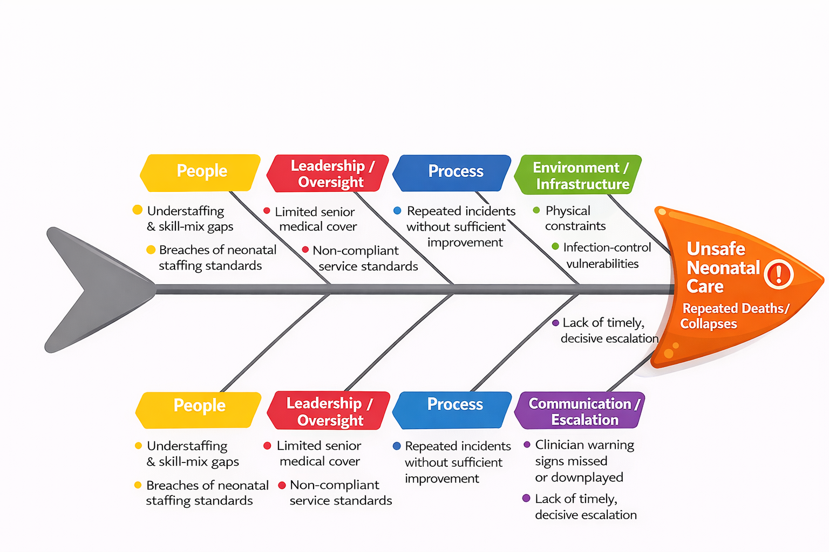
Figure 1: Root Cause Analysis using Fish Bone Diagram

2.1.2 5 Whys
The 5 Whys can be helpful here given that it puts the analysis past the surface incident (increasing number of deaths/collapses and slow organizational reaction) and challenging why safety indicators failed to generate decisive and prompt action. The former of these causes identifies the failure of escalation: the concerns of clinicians and indicators of governance were not consistently the triggers to initiate external scrutiny and rapid mitigation, implying the failure of organizational sense-making and not the deficiency of information (CQC, 2016; Lawrence and Conn, 2024). The second why draws attention to prioritization and decision thresholds: in case staffing risks were noticed multiple times but persisted, the question arises how leaders were perceiving the risk, what evidence they needed, and why the line of intervention was high when the number of signals has been accumulating (CQC, 2016). The third reason is the connection of this to constraints in capability: working with lean staffing and a lack of specialist supervision can become normalized deviance, with working at the limit becoming a standard practice and risks redefined as normal noise in operations (Lawrence & Conn, 2024; NHS England, 2023). System-wide workforce pressures and cultural obstacles to speaking up are found in the fourth and fifth reasons, which undermine the concept of psychological safety and slow the pace of learning and corrective action (Francis, 2015; NHS England, 2022; NHS England, 2023). Nonetheless, one of the most significant critiques is the fact that 5 Whys would fail to differentiate between the root causes which can be all the same: staffing shortages. Here, the more plausible conclusion is that there is a governance failure in converting identified risks into action and escalation, which the investigation directly tries to investigate (DHSC, 2023). For example, repeated association of adverse incidents with a specific staff member in Lucy Letby did not trigger immediate removal from clinical duties or formal safeguarding investigation, suggesting that organizational thresholds for action were set too high despite accumulating risk indicators.

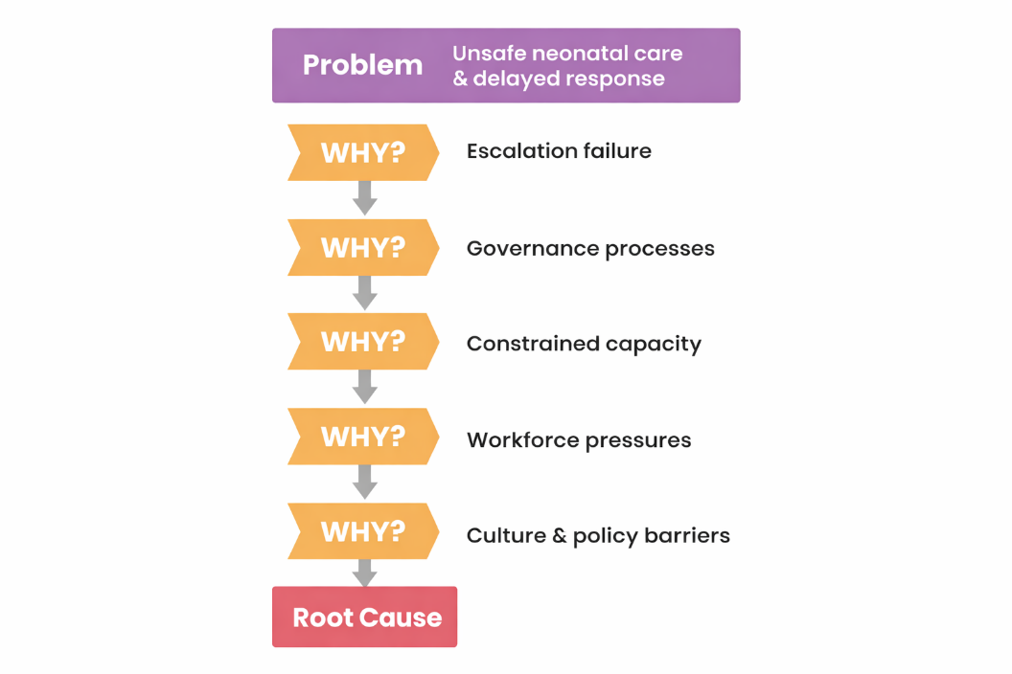
Figure 2: Application of 5 Whys applied to the Case Study

2.1.3 Donabedian Model
The Structure-Process-Outcome logic developed by Donabedian allows to test the plausibility of the fact that the harms in cases of care provided to the neonatal can be attributed to the conditions in which care was provided, instead of blaming outcomes and perceiving them as random or merely personal failures (Donabedian, 1988). In this instance structural weaknesses were not insidious. Inspection evidence revealed staffing deficits and ability pressure, and the material of external reviewing tools expressed worries regarding standards and the extent of senior medical cover, which is fundamentally important in high-intensity neonatal decision making (CQC, 2016; RCPCH, 2016). The criticism is that such structural gaps are foreseeable risk-making: as the capacity of a unit is exceeded, such processes as surveillance, escalation, and timely interventions are put at risk of delay and variability. The process fragility can be observed in the fact that the clinician concerns and safety signals did not always translate to decisive governance action, or external escalation, implying the weak control mechanisms and ineffective closure of the loop between identifying the risk and taking action (DHSC, 2023; Lawrence and Conn, 2024). The initial process failures that can be especially observed were connected with the slow reaction to the issues about clinical practice of Lucy Letby as a consultant, which is a sign of poor incident review processes, governance protection, and the existence of multidisciplinary risk assessment systems. Increasing numbers of deaths/collapses, staff suffering and loss of confidence, then become less unexpected and predictable with a system that runs outside the safety parameters (Lawrence and Conn, 2024; Thirlwall Inquiry, n.d.). Causality can however be oversimplified by Donabedian when it means a tidy chain. The network capacity and the case mix affect the neonatal outcomes and thus, structural fixes should be accompanied by a strong escalation governance and an adequate system-level support to prevent the recurrence of the same pattern of failures (Donabedian, 1988; NHS England, 2023). The resulting increase in neonatal deaths in Lucy Letby and collapses later linked to intentional harm demonstrates how unsafe processes and governance delays can allow both systemic risk and individual misconduct to produce severe patient safety consequences.

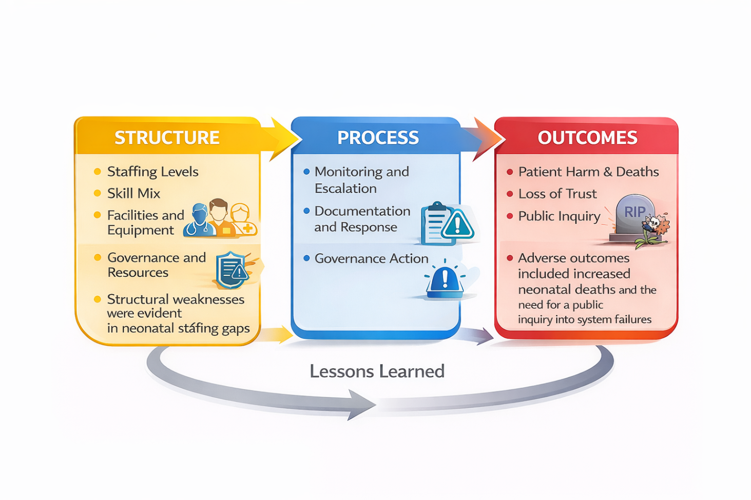

2.2 Strategic Planning
2.2.1 SWOT Analysis
SWOT is used to summarise internal conditions and external pressures so that improvement options align with real constraints.
Table 1: SWOT analysis
Strengths | Weaknesses
Risk tools and governance structures existed (e.g., registers/reviews), creating a basis for surveillance and learning. (CQC, 2016) | Staffing and skill-mix gaps reduced resilience and increased variation in care and escalation reliability. (CQC, 2016)
UK-wide neonatal standards and network models provide clear expectations for capability matching and escalation routes. (BAPM, 2022) | Physical environment and infection-control vulnerabilities reduced safety margins in high-acuity care. (CQC, 2016; Lawrence & Conn, 2024)
National patient-safety policy increasingly supports systems-based learning (PSIRF), enabling better-quality investigations. (NHS England, 2022) | Governance responses to clinician concerns were not consistently timely or decisive, undermining trust and assurance. (DHSC, 2023; Lawrence & Conn, 2024)
Opportunities | Threats
National maternity/neonatal safety improvement programmes provide structured support to reduce variation and harm. (NHS England, n.d.) | Workforce shortages remain a system-level risk, limiting the speed and sustainability of local improvements. (NHS England, 2023)
Digitisation programmes (records and safer information flows) can strengthen surveillance and escalation if implemented well. (NHS England, 2024) | Financial pressure and reliance on temporary staffing can destabilise continuity and safety culture. (NAO, 2025; NHS England, 2024)
Stronger speak-up culture and duty of candour compliance can improve early risk detection and transparency. (CQC, 2025; Francis, 2015) | Legal and reputational risk rises when harm occurs, increasing costs and reducing public confidence. (NHS Resolution, 2024)

Overall, the findings imply that structural resilience (staffing, senior oversight, safe environment) and reliable escalation/learning loops must be prioritised first, otherwise opportunities like PSIRF and digitisation will not translate into sustained neonatal safety improvement.

2.2.1 PESTLE Analysis
PESTLE is used to scan the external environment shaping neonatal safety and governance decisions.
Table 1: PESTLE Analysis
Factor | Issue | Implication for the case context
Political | In 2024/25, NHS England had an overall budget of around 204.7 billion, which was yet another sign of high political priorities to healthcare and higher scrutinies and accountability demands (NHS England, 2024). | High political attention leads to high expectations of transparency, high escalation and learning when safety signals continue to be high and this puts pressure on governance systems to act decisively.
Economic | NHS in England described about 113,000 vacancies among the staff, and the system has continued to depend on agency workforce and associated financial stretched Ness (NHS England, 2023). | Staffing and capability strain directly contribute to the workforce shortages, which cause more operational disruption with admissions closed and safety improvements that are less sustainable.
Social | The 2023 NHS Staff Survey found 41.6% of staff felt unwell due to work-related stress, and only 62.3% felt safe to speak up about concerns (NHS England, 2023). | The stress levels and the inability to speak up undermine early warning systems, diminish psychological safety, and impose restrictive barriers to effective organizational learning based on the risk signals. Loss of public trust following such cases in Lucy Letby can affect staff morale, recruitment, and perceived safety of neonatal services.
Technological | The NHS England has invested 1.9 billion in frontline digitization and have an ambition of 95 percent of trusts to have or upgrade electronic patient records by March 2026 (NHS England, 2024). | Better digital surveillance has the potential to reinforce escalation and risk monitoring, and the benefits of digital surveillance are enhanced by governance action and staff training, not technology.
Legal | In 2023/24 NHS Resolution spent on clinical negligence compensation around 2.82 billion of which about 41% of the total payment was on maternity (NHS Resolution, 2024). | Increasing legal liability strengthens the proactive confirmation, escalation transparency, and prevention-oriented safety enhancement in neonatal pathways. High-profile criminal cases such as the Lucy Letby convictions increase scrutiny of safeguarding governance and may lead to stronger legal expectations around early intervention and organisational accountability.
Environmental | In 2023/24, it was estimated that the NHS estate backlog maintenance cost was £13.8 billion, which points to ageing infrastructure and safety risks (National Audit Office, 2025). | Poor physical conditions and IPC exposure decrease safety margins of neonatal care which exacerbates risk when services are provided under pressure.

On the whole, the PESTLE results criticize any form of improvement plan, which aims at being in-unit based. Structural headwinds include the external environment of vacancies, agency dependence, stress and speak-up constraints, infrastructure backlog, and the increasing cost of negligence, and are likely to kill local fixes unless it is reinforced at board, network, and system levels. Meanwhile, national levers (PSIRF, digitization funding, and neonatal improvement programmers) are legitimate opportunities, but they can only be converted into reduced risks when they are applied in an environment of direct responsibility, escalation pathways that work, and long-term professional capacity.

3. Recommendations using a PDSA cycle

3.1 Plan
A single, time-limited improvement goal may be set in order to correct the convergent weaknesses identified in the root cause and strategic analyses. Specific learning from the Lucy Letby case highlights the need for early staff-related risk escalation protocols, including structured review triggers when unusual clinical incident patterns are observed. The service may aim to over a 12-week period to replace unexpected deterioration events and enhance responsiveness of governance in response to unexpected events, as well as to safeguard safe transfers and staff wellbeing. This objective represents the interacting pressures that have been identified in the evidence, such as strain of staffing and capability, delayed escalation, environmental susceptibility, and poor learning processes (CQC, 2016; DHSC, 2023; Lawrence and Conn, 2024). When the improvement activity is shared across the professional roles, it is more likely to be effective, which is why a multidisciplinary team consisting of clinical, managerial, governance, and network representation would help incorporate a systems-focused approach (NHS England, 2022). Before introducing change, it would be prudent to create clear measures in order to determine progress based on the results and not just presence. These may be deterioration and unplanned transfers rates, as well as process indicators like staffing compliance, and escalation timeliness, and balancing indicators to represent workload and staff experience (BAPM, 2022; CQC, 2016; NHS England, 2023). Priority change concepts may be based on the analysis’s failings, which might include capability/capacity controls, more stable escalation routes, environmental and infection-control risks mitigation, and enhanced speak-up and candor mechanisms. It would be correct to test these changes with the help of PDSA since it allows using small measurable improvements in complex systems where numerous factors are interconnected instead of being related by a simple straight cause (NHS Wales Improvement Cymru, 2023).

3.2 Do
During the Do phase, two mini tests may be executed during 2-3 weeks and optimized. The initial test may be based on one bay or on one shift pattern and test the red-flag escalation bundle. The test could also include a safeguarding review trigger requiring multidisciplinary assessment if repeated incidents involve the same staff member, reflecting lessons from the Countess of Chester events in Lucy Letby. This may involve an SBAR template, a specified period of time during which the seniors should review it, and a brief documented decision pathway explaining if the care will proceed locally or the need to transfer or request outside neonatology consultation. A short handover conference might ensure person personnel and acuity and allocate responsibility to various staff members in the event of pressure (NHS Wales Improvement Cymru, 2023).
A second test may be conducted one week at service level and emphasized on the capability-capacity control. In the event that staffing or skill mix becomes below threshold, or acuity is higher than is safely possible, early network escalation and transfer pathways might be triggered instead of letting it deteriorate repeatedly. This is a reaction to the trend that stressed ability can postpone decisiveness and cause preventable damage (CQC, 2016; Lawrence and Conn, 2024).

3.3 Study
Quantitative and qualitative evidence should be learnt after every cycle. It is possible to use run charts to demonstrate the improvement of time-to-review, the earlier escalation, and the reduction of deterioration events. Monitoring should include analysis of incident clustering by staff exposure to detect abnormal patterns early in cases like Lucy Letby. It should be checked by staff feedbacks to determine the usability, workload, and the process functionality under real conditions. The main questions will be whether the delays minimized, whether the delays avoided the unavoidable worsening of the situation, and whether the unwanted effects were experienced, i.e., more closures or workload peaks.
It should also be at this stage that the changes are put to the test on the feasibility of changes within the structural workforce limits. Due to chronic and systemic shortages, compliance failure in predictable points of pressure would speak to such a change not being resilient and requiring redesign (e.g., backup rotes, cross-cover agreements, or networked senior support) instead of increased staff effort (NHS England, 2023). To enhance the quality of organizational learning, learning needs to be recorded in a PSIRF-aligned methodology to have systems focus (NHS England, 2022).

3.4 Act
In case the experiments prove to be helpful, then the phase of the Act would be aimed at standardization and scaling of what proved to be helpful. The escalation bundle may be a part of the local policy, induction, and audited to improve its reliability. The capabilities capacity limits may be established as regular operational rules with explicit authority to temporarily restrict and activate transfer activation of rapid transfer in line with the neonatal standards and network expectations (BAPM, 2022). Formal safeguarding escalation policies should clarify authority to remove staff from clinical duties pending investigation where credible safety concerns arise like in Lucy Letby case.
In cases of mixed results, additional PDSA cycles would make the design change. Indicatively, the continual delays in responding overnight could encourage rota swap or formal distance specialist help with the assistance of the neonatal network. Assuming that speaking up is still held back, the later cycles may reinforce the visual FTSU Guardian participation, response cycles (you said, we did), and the leadership vows in accordance with national speak-up anticipations (Francis, 2015; NHS England, n.d.). Lastly, governance practices must be also consistent with the duty of candour and transparency requirements, such as the timely disclosure of safety signals to oversight bodies when the thresholds are reached, to restore assurance and minimise recurrence of the known hazards without decisive action (CQC, 2025; DHSC, 2023).

4. Conclusion
As has been shown in this report, the quality and safety breakdowns witnessed in the Countess of Chester neonatal service were not caused by a single error or a single action, but the interaction of the system weak points. The Lucy Letby case further demonstrates that patient safety failures may arise not only from structural pressures but also from delayed organisational responses to individual risk signals. The root cause analysis revealed the combination of staffing and skill-mix strain, limited senior control, weak learning, environmental risks and ineffective escalation caused the reduction of safety margins over time. The 5 Whys analysis further validated that the absence of information was not the root cause of the problem, but the failure of the governance to transform the perceived risks and clinician concerns into action.
Strategic planning tools have also noted that the failures in question happened against the backdrop of a hard external environment, which was conditioned by the lack of workforce in the country, financial constraints, infrastructure delay, and increased legal risk. Although national policy frameworks and safety programmes are open to improvement, the analysis indicates that only in connection with good local governance, defined escalation thresholds, and workforce sustainability, these levers result in safer care.
The PDSA results highlight that systemic thinking, proactive governance, and ongoing education are the tools of sustainable improvement in neonatal safety instead of the retrospective accusation approach, where early warning signals are always followed by protective action.

5. References
BAPM. (2022). Service and quality standards for provision of neonatal care in the UK. British Association of Perinatal Medicine. https://hubble-live-assets.s3.eu-west-1.amazonaws.com/bapm/file_asset/file/3581/BAPM_Service_Quality_Standards_FINAL.pdf
British Association of Perinatal Medicine. (2022). Service and quality standards for provision of neonatal care in the UK. https://hubble-live-assets.s3.eu-west-1.amazonaws.com/bapm/file_asset/file/3581/BAPM_Service_Quality_Standards_FINAL.pdf
Care Quality Commission. (2016). Countess of Chester Hospital NHS Foundation Trust: Inspection report (including maternity/neonatal findings). https://www.cqc.org.uk/provider/RJR/reports
Care Quality Commission. (2016). The Countess of Chester Hospital NHS Foundation Trust: Quality report (June 2016). https://api.cqc.org.uk/public/v1/reports/7d84e4fd-bdbe-4e99-839d-df83baa36adc
Care Quality Commission. (2025). Regulation 20: Duty of candour (Guidance). https://www.cqc.org.uk/guidance-providers/regulations-enforcement/regulation-20-duty-candour
Care Quality Commission. (2025). Regulation 20: Duty of candour. https://www.cqc.org.uk/guidance-regulation/providers/regulations-service-providers-and-managers/health-social-care-act/regulation-20
Department of Health and Social Care. (2023). Thirlwall Inquiry: Terms of reference and documents. https://thirlwall.public-inquiry.uk/
Department of Health and Social Care. (2023). Thirlwall Inquiry: Terms of reference. https://www.gov.uk/government/publications/thirlwall-inquiry-terms-of-reference
Donabedian, A. (1988). The quality of care: How can it be assessed? JAMA, 260(12), 1743–1748. https://doi.org/10.1001/jama.260.12.1743
Francis, R. (2015). Freedom to Speak Up: An independent review into creating an open and honest reporting culture in the NHS. https://www.gov.uk/government/publications/freedom-to-speak-up-independent-review-into-creating-an-open-and-honest-reporting-culture-in-the-nhs
Francis, R. (2015). Freedom to Speak Up: An independent review into creating an open and honest reporting culture in the NHS. https://www.gov.uk/government/publications/freedom-to-speak-up-independent-review-into-creating-an-open-and-honest-reporting-culture-in-the-nhs
King’s Fund. (2024). The NHS budget and spending (including 2024/25 figures). https://www.kingsfund.org.uk/insight-and-analysis/data-and-charts/nhs-budget-nutshell
Lawrence, F., & Conn, D. (2024, September 8). A superbug, doctor shortages and a neonatal unit ‘out of its depth’: Failures at Lucy Letby hospital revealed. The Guardian. https://www.theguardian.com/uk-news/article/2024/sep/08/a-superbug-doctor-shortages-and-a-neonatal-unit-out-of-its-depth-failures-at-lucy-letby-hospital-revealed
Lawrence, F., & Conn, D. (2024, September 8). A superbug, doctor shortages and a neonatal unit ‘out of its depth’: Failures at Lucy Letby hospital revealed. The Guardian. https://www.theguardian.com/uk-news/article/2024/sep/08/a-superbug-doctor-shortages-and-a-neonatal-unit-out-of-its-depth-failures-at-lucy-letby-hospital-revealed
National Audit Office. (2025). NHS workforce in England: Briefing (vacancies/agency context). https://www.nao.org.uk/
NHS Employers. (2024). NHS Staff Survey results (work-related stress statistic and trends). https://www.nhsemployers.org/articles/nhs-staff-survey-results-2023
NHS England. (2022). Patient Safety Incident Response Framework (PSIRF). https://www.england.nhs.uk/patient-safety/incident-response-framework/
NHS England. (2023). NHS Long Term Workforce Plan. https://www.england.nhs.uk/long-read/nhs-long-term-workforce-plan/
NHS England. (2023). NHS Long Term Workforce Plan. https://www.england.nhs.uk/publication/nhs-long-term-workforce-plan/
NHS England. (2024). Digitising the frontline (EPR investment and targets). https://www.england.nhs.uk/digitaltechnology/digitising-the-frontline/
NHS England. (n.d.). Freedom to Speak Up. https://www.england.nhs.uk/ourwork/freedom-to-speak-up/
NHS England. (n.d.). Maternity and Neonatal Safety Improvement Programme. https://www.england.nhs.uk/mat-transformation/maternal-and-neonatal-safety-collaborative/
NHS Resolution. (2024). Annual report and accounts 2023/24 (payments and maternity share). https://resolution.nhs.uk/
NHS Wales Improvement Cymru. (2023). Model for Improvement: Toolkit guide (PDSA support). https://performanceandimprovement.nhs.wales/functions/quality-safety-and-improvement/improvement/improvement-cymru-academy/resource-library/academy-toolkit-guides/model-for-improvement-toolkit-guide/
Royal College of Paediatrics and Child Health. (2016). Review of neonatal services / external review evidence (Countess of Chester context). https://www.rcpch.ac.uk/
Thirlwall Inquiry. (n.d.). Official inquiry website and updates. https://thirlwall.public-inquiry.uk/

