Mental Health Awareness Campaign
Blogs

Module Name: Managing Projects in the Organisation (BMSW5009_SWAN)
Student name: Ionela Catalina Simion
Student Number :2227035

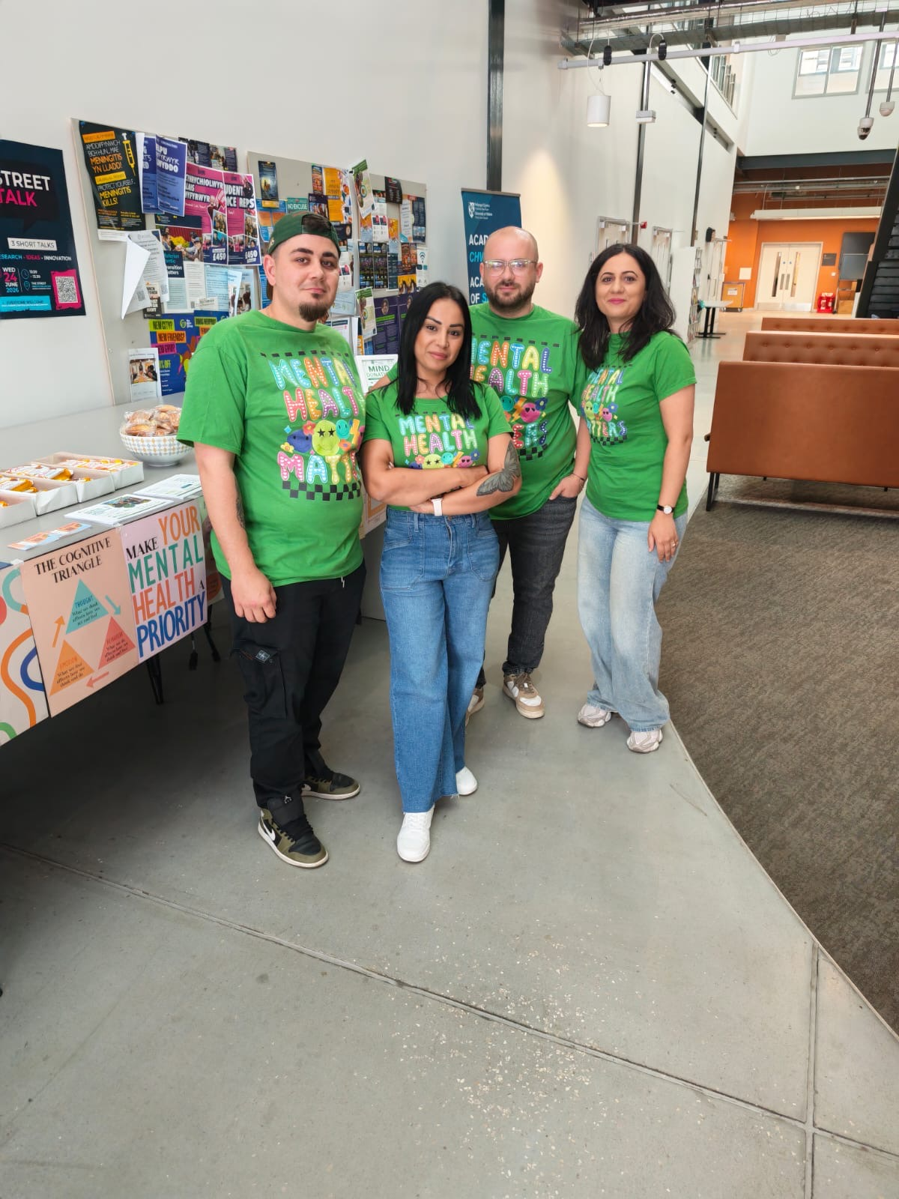

Blog 1: Project Introduction and Team Role Reflection

As a Business Management student, I am working with Sanda, Marian and Daniel on a Mental Health Awareness Campaign as part of the Project Management module. Our project is supervised by our module lecturer, Giulia Chifari, who has supported us throughout the planning and development process. The aim of the project is to raise awareness of mental health issues among university students while generating donations for Mind, a leading UK mental health charity. After discussing several project ideas, the team agreed that mental health awareness was both relevant and meaningful for students.
Following discussions about our strengths and responsibilities, Sanda was selected as project leader due to her confidence and organisational skills. My Skills Matrix identified teamwork, organisation and problem-solving as key strengths. I contributed to organising the campaign and assisted with decisions regarding promotional materials, including the design and purchase of our awareness T-shirts. My Belbin Team Role result identified me as a Coordinator, reflecting my ability to encourage collaboration and help the team work towards shared goals (Belbin, 2010).
Although Belbin’s theory is widely used, it has been criticised for oversimplifying individual behaviour. Fisher, Hunter and Macrosson (2001) argue that individuals often display characteristics from multiple team roles. Overall, this experience highlighted the importance of teamwork, communication and effective role allocation in project management.

Blog 2: Project Initiation and Scope
As our Mental Health Awareness Campaign progressed, the group focused on developing a realistic project plan. Our aim was to raise awareness of mental health among students while generating donations for Mind charity. To achieve this, we agreed on key objectives, including promoting wellbeing, engaging students and organising fundraising activities.
We also identified our main deliverables as a promotional campaign with flyers and a social media event page, a live awareness event offering refreshments and information, and a group presentation reflecting on the project.
Figure 1: Mental Health Awareness Campaign Flyer

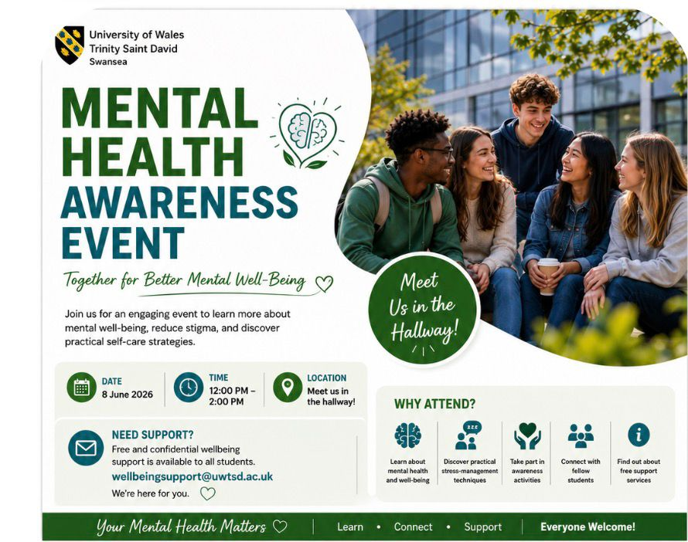

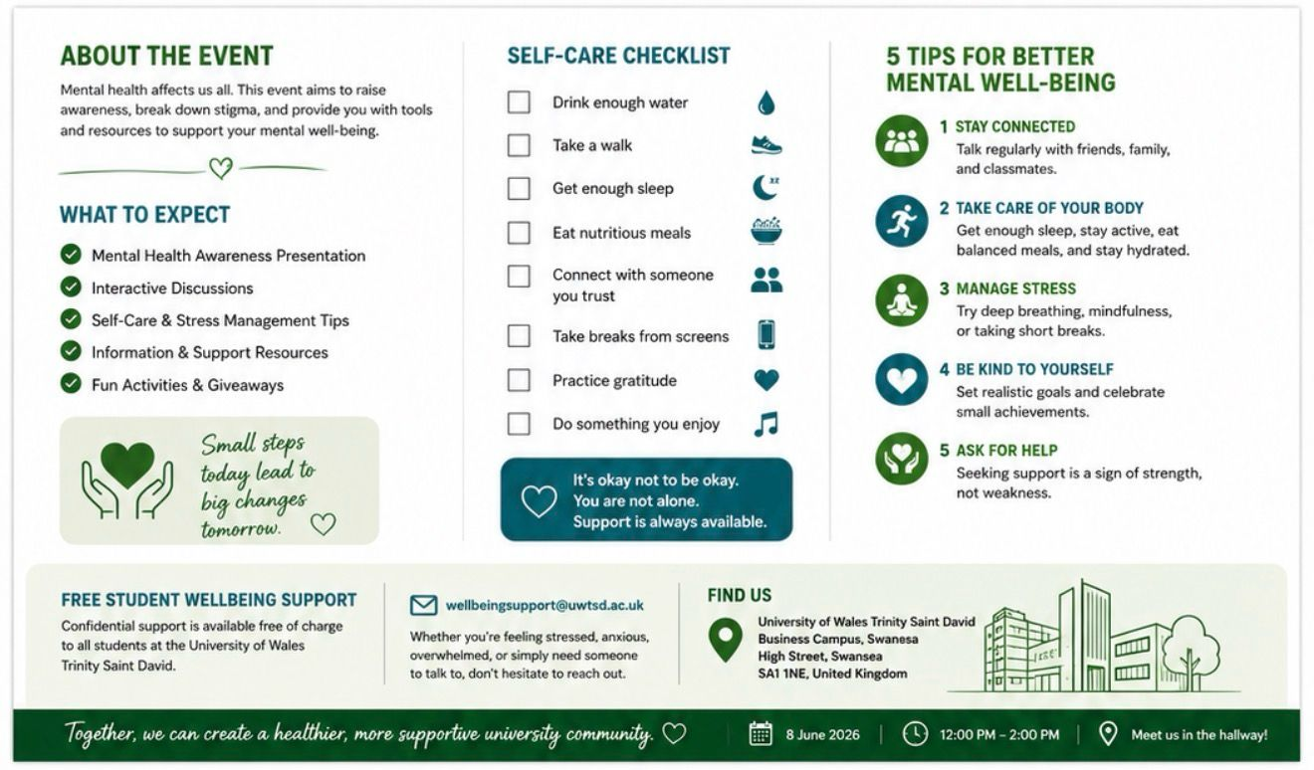
During the planning stage, we encountered two challenges. Firstly, we were unsure about the correct procedure for handling and donating the money raised so we emailed Ffion Cumberpatch, for guidance. This highlighted the importance of stakeholder communication when uncertainties arise (PMI, 2021).
Secondly, Marian and I realised we would be out of the country when the presentations were scheduled. Therefore, the group completed the campaign and presentation earlier. This reduced the time available for promotion and organisation, demonstrating the importance of the Iron Triangle. Despite the shorter timeframe, the team adapted effectively and maintained the quality of the campaign (Kerzner, 2022).

Blog 3: Stakeholder Analysis and Communication

As a group, we identified our key stakeholders as students, the Student Wellbeing Team, Mind charity, university staff and our own project team. Freeman (1984) defines stakeholders as any group or individual who can affect or be affected by what an organisation is trying to achieve, and working through this helped us think more carefully about who we needed to involve.
To prioritise our stakeholders we used the Power-Interest Grid. Students were identified as low power but high interest, meaning our main responsibility was to keep them informed and engaged through flyers and social media. The Student Wellbeing Team was identified as high power and high interest and was therefore our most important external stakeholder. Sanda contacted them by email to request support and guidance. Project Management Institute (2021) emphasises that matching the communication method to the stakeholder is just as important as the content of the message itself.
One challenge we faced was that we did not identify the university operations team as a stakeholder earlier in the planning process. Their delayed approval meant we had to reschedule the event, which created pressure for the whole group.

Blog 4: WBS and Gantt Chart
One of the most important parts of planning our Mental Health Awareness Campaign was organising the work into manageable tasks. To do this, our group used a Work Breakdown Structure (WBS), which helped us break the project into smaller activities such as assigning roles, contacting stakeholders, designing flyers, creating the social media event, ordering T-shirts, purchasing refreshments and preparing the final presentation. A WBS is a useful project management tool because it allows teams to move from a broad project idea to smaller work packages that are easier to manage and monitor (PMI, 2021).
After identifying the tasks, we created a Gantt Chart to organise them into a logical sequence and timeline. Gantt Charts are valuable because they help project teams visualise deadlines, task dependencies and project milestones, while also supporting effective time management (Lock, 2020). One challenge we encountered was discovering late in the planning process that approval from the University Operations Team was required before the event could take place. This affected our original plans and highlighted the importance of including external approvals within project schedules. As a result, several activities had to be rescheduled, demonstrating the importance of maintaining a flexible project schedule.
Although both tools were useful, I found the Gantt Chart more valuable because it provided a clear overview of deadlines and progress. However, planning tools are only effective when they remain realistic and adaptable to unexpected changes (Kerzner, 2022). Overall, the WBS and Gantt Chart improved organisation, communication and time management, helping the team stay focused and adaptable throughout the project.

Figure 2: Gantt Chart
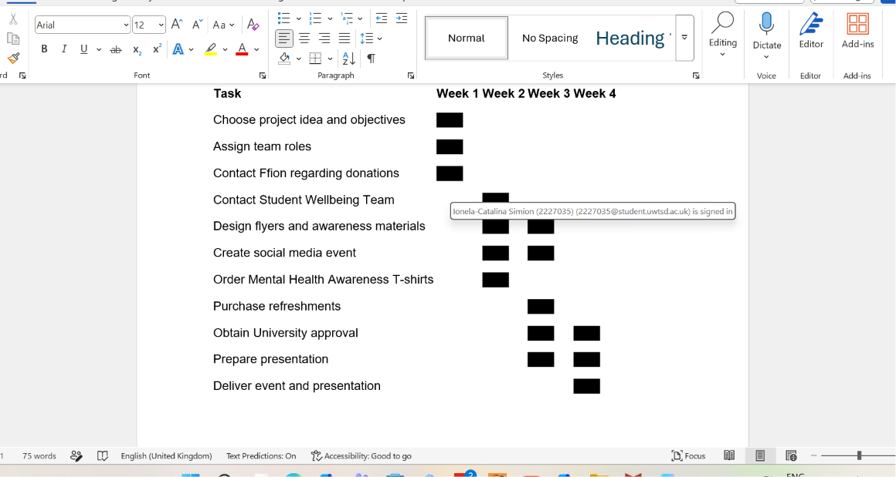

Blog 5: Self-Evaluation and Development Plan

Looking back on the Mental Health Awareness Campaign, I feel that one of my biggest strengths was working effectively as part of a team. Throughout the project, I used my organisational, teamwork and problem-solving skills to support the group and contribute to key decisions. I also helped organise promotional activities, including the design and choose our Mental Health Awareness T-shirts.
The project was a positive experience, but it also highlighted areas where I need to improve. One challenge occurred when Marian and I realised we would be out of the country during the original presentation period, meaning the team had to adjust our plans and work to a tighter schedule. We also discovered late that approval from the University Operations Team was required before the event could take place. This experience showed me the importance of identifying risks and external requirements early in a project (Hillson, 2017).
Reflecting on these challenges helped me recognise both my strengths and weaknesses. Gibbs (1988) suggests that reflection is important for learning and personal development, while Heagney (2016) argues that successful project management requires continuous improvement and the ability to learn from previous projects. In future projects, I plan to improve my planning and risk management skills by identifying potential issues earlier and monitoring project progress more closely.

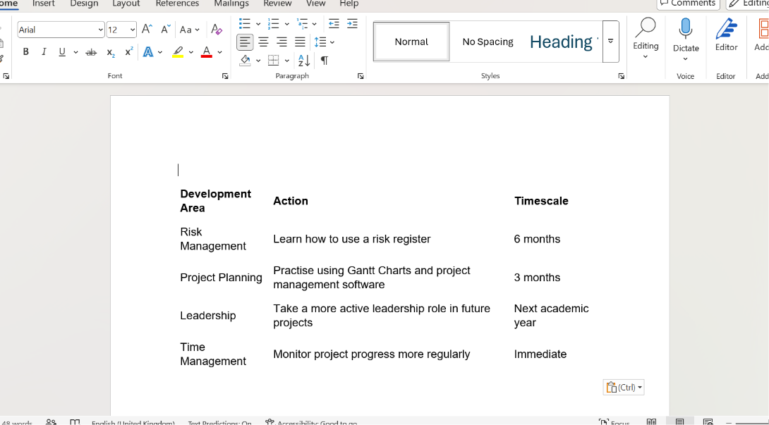

Reference list:
Belbin, R.M. (2010) Management Teams: Why They Succeed or Fail. 3rd edn. Oxford: Butterworth-Heinemann.
Bourne, L. (2015) Stakeholder Relationship Management. Farnham: Gower.
Fisher, S.G., Hunter, T.A. and Macrosson, W.D.K. (2001) ‘A validation study of Belbin team roles’, European Journal of Work and Organizational Psychology, 10(2), pp. 121–144.
Freeman, R.E. (1984) Strategic Management: A Stakeholder Approach. Boston: Pitman.
Gibbs, G. (1988) Learning by Doing: A Guide to Teaching and Learning Methods. Oxford: Oxford Polytechnic.
Heagney, J. (2016) Fundamentals of Project Management. 5th edn. New York: AMACOM.
Hillson, D. (2017) The Risk Management Handbook. London: Kogan Page.
Kerzner, H. (2022) Project Management: A Systems Approach to Planning, Scheduling, and Controlling. 13th edn. Hoboken, NJ: Wiley.
Lock, D. (2020) Project Management. 11th edn. London: Routledge.
Mind (2025) Mental health support and information. Available at: https://www.mind.org.uk (Accessed: 5 June 2026).
Project Management Institute (2021) A Guide to the Project Management Body of Knowledge (PMBOK Guide). 7th edn. Newtown Square, PA: Project Management Institute.

