PROGRAM: MSc Public Health and Social Care in Practice
MODULE: Social Epidemiology and PublicHealthDevelopment
Module code: LCHS7000
Lecturer: Muhammad Aliyu
TOPIC: ETHINIC AND HEALTH INEQUALITIES IN THE UK

Name: Zakiyabanu Zakirhusen Malek
Student Number: 2531983

Executive Summary
Task 1
The following report tries to examine the concept of health inequality that has been defined as an avoidable difference in the health outcomes across populations in the United Kingdom. In this report the topic of ethnic and health inequalities have been selected to explore certain key determinants which include factors such as the social economic status, ethnicity, education as well as the geographical location, to assist in understanding how the healthcare and overall well-being of the people of the nation has been affected. There are numerous evidences which highlights that the individuals which reside in the weaker community experience lesser and comparatively poorer health outcomes and reduce life expectancy. The role of public health policies and interventions as well as those that have been implemented by the NHS England and WHO are also been evaluated in this report, to assist in a better understanding of the prevalent health disparities within the minorities presiding in the UK and provide a better perspective.
Task 2
The following report has been prepared to effectively analyze Type 2 Diabetes and understand its implications on the public. Type 2 diabetes is a major health concern throughout the world. The report looks to examine the numerous risk factors that are associated with the culmination of Type 2 diabetes. Statistics and reports from the International Diabetes Federation and Diabetes UK have displayed a continuously growing scale of this disease. A proper analysis of the strategies and programs and the evaluation of the strengths and weakness of the programs implemented by the government have been discussed and a short idea of a preventive program has also been mentioned towards the end of the report.

Table of Contents
Executive Summary 2
Task 1 4
Introduction 4
Background and Underlying Factors 4
Diseases 4
Social Issues 5
National Response to Extend Help to the Affected 6
Organizations established for Support 7
Conclusion 7
Reference 8
Task 2 9
Introduction 9
Public Health Measures 9
Preparation 10
Prevention 11
Protection 11
Risk Factors and Determinants 11
Epidemiological Studies and Health Needs Assessment 12
Monitoring and Surveillance 12
Impact on Public Health 12
Short Term Impact 12
Long Term Impact 13
Design of Prevention Program 13
Evaluation of Intervention 13
Strengths and Weaknesses of Epidemiological Approach 14
Conclusion 14
References 15

Task 1

Introduction
The following report looks into the discussion of ethnic and health inequalities. In the United Kingdom it can be seen that the ethnic minority is faced with a comparatively poorer health conditions as compared to their locals. This disparity in the healthcare is a result of numerous other socio economic determinants.

Background and Underlying Factors

Diseases
Higher Prevalence of Type 2 Diabetes
According to reports ethnic minorities residing in the UK particularly the South Asians display a 2-6 times higher chance for the development of type 2 diabetes (Farmaki et al, 2022). Late diagnosis of the earlier symptoms, due to limited healthcare access as well as lack of awareness is a major cause for this. Addressing this issue entails the usage of numerous education programs tailored to suit the targeted minorities; this could assist in educating the communities of the earlier symptoms and prevent further drastic cases.
Cardiovascular Diseases
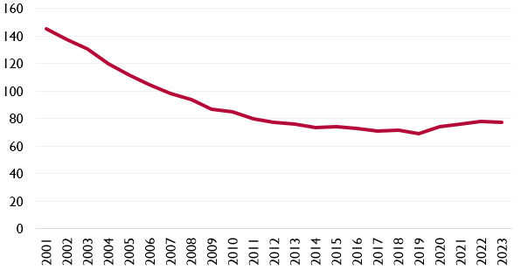
Figure 1.1: Mortality rate of Cardiovascular Disease in UK
(Source: UK Parliament, 2025)
Cardiovascular diseases have remained as one of the major causes for increased mortality rates among the minorities. The South Asian population as well as the Black communities follows a dietary structure that entails the consumption of numerous calorie rich and heavily spiced dishes on a regular basis. Studies have displayed that the consumption of such food products daily can increase the rate of cardiovascular diseases by 40%. Another cause for this is the constant strain and stress that the people of these communities are in due to lack of proper facilities provided for them.
Mental Health Issues
Mental health is a significantly important topic in the modern times. People in general face numerous mental health problems due to several reasons such as stress, hypertension, overwork etc. In case of the South Asians and the people of the Black communities it is a much of serious concern as they don't receive proper healthcare to tackle these problems. Many people just ignore these issues due to lack of awareness as well as proper facilities that could assist in guiding them through it.

Social Issues
Poverty and Socio-economic Inequality
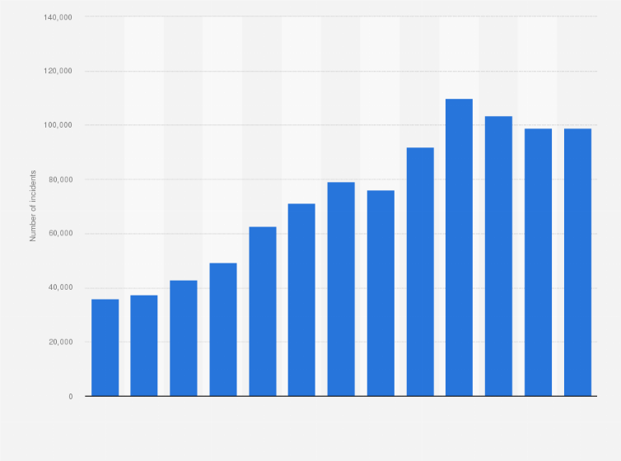
Figure 1.2: England and Wales Racial Discrimination
(Source: Statista, 2025)
The ethnically minor population of the UK is statistically represented to possess a significantly lower income rate as compared to others. The lack of funds and poverty is one the major causes that restricts the minor communities to gain access to proper medical care that they deserve. This also restricts them from other crucial necessities for a healthy lifestyle such as dietary choices and healthy living environment. As per statistics people with restricted access to healthcare have an approximately 10 year lower average life span than the other masses (Galvani-Townsend, et al, 2022)
Housing Problems
Social issues with housing have become more pronounced, especially since the COVID-19 pandemic, and ethnic minority groups are disproportionately impacted. Most people in these groups are unable to afford decent housing with proper sanitation, ventilation and other necessary facilities. These poor living conditions subjects them to the risk of contracting communicable diseases since overcrowding and lack of hygiene renders control of infection a challenge. Moreover, such environments also cause psychological stress, anxiety, and diminished overall wellbeing. An integrated influence of physical health hazards and mental strain indicates the significance of a house as a crucial social determinant of health and inequality.
Social Exclusion
The ethnic minorities often face the issue of social discrimination and racism based on culture, language, and traditions, which have a substantial impact on their wellbeing. Such experiences might lead to psychological discomfort, such as anxiety, depression and trauma, since one might experience rejection or being sidelined in society. Abubakar et al. (2022) note that such discrimination exists in healthcare environments as well since one might receive an unequal level of treatment, or other factors might interfere with their ability to obtain the necessary services. Consequently, such communities tend to experience not only delays in diagnosis, as well as insufficient care, but also increase health outcomes and lead to existing imbalances in the healthcare system.

National Response to Extend Help to the Affected
The UK government has tried to establish initiatives to assist the communities. The NHS Long Term Plan has established norms to assist minor communities to get proper access to healthcare services and proper diagnosis of preliminary symptoms (NHS England,2026). Similarly, the Public Health England’s Diabetes Prevention Program has been established by the government to assist in reducing the Type 2 diabetes, especially within the ethnically minor communities.

Organizations established for Support


Figure 1.3: Diabetes UK Logo
(Source: Diabetes UK, 2026)

Many charitable organizations have been put in place to provide ethnic minority communities with proper health education and guidance to enhance improved self-management practices like the Diabetes UK. Such organizations are crucial in the reduction of health disparities as they provide culturally relevant information and resources that are diverse to other populations. Brown et al. (2023) argue that these programs are able to make people more aware of disease prevention and management. Moreover, Diabetes UK also carries out research and creates awareness among communities and thus health interventions made are done in a manner that does not interfere with cultural, religious and social values. Consequently, they have gone a long way in improving health outcomes and quality of life of many patients as a result of these efforts.

Conclusion
In conclusion, it can be witnessed that the health inequalities prevalent in the UK has significantly affected the ethnic minorities due to numerous factors that are deeply rooted within its social and economic sectors. However, there are organization that have been established to fight these inequalities and assist the communities to gain a better healthcare benefits.

Reference
Abubakar, I., Gram, L., Lasoye, S., Achiume, E.T., Becares, L., Bola, G.K., Dhairyawan, R., Lasco, G., McKee, M., Paradies, Y. and Sabharwal, N.S., 2022. Confronting the consequences of racism, xenophobia, and discrimination on health and health-care systems. The Lancet, 400(10368), pp.2137-2146.
Brown, O.I., Drozd, M., McGowan, H., Giannoudi, M., Conning-Rowland, M., Gierula, J., Straw, S., Wheatcroft, S.B., Bridge, K., Roberts, L.D. and Levelt, E., 2023. Relationship among diabetes, obesity, and cardiovascular disease phenotypes: a UK biobank cohort study. Diabetes Care, 46(8), pp.1531-1540.
Diabetes UK (2026). Diabetes UK | Home Page. [online] Available at: https://www.diabetes.org.uk/ [Accessed on 10 April, 2026]
Farmaki, A.E., Garfield, V., Eastwood, S.V., Farmer, R.E., Mathur, R., Giannakopoulou, O., Patalay, P., Kuchenbaecker, K., Sattar, N., Hughes, A. and Bhaskaran, K., 2022. Type 2 diabetes risks and determinants in second-generation migrants and mixed ethnicity people of South Asian and African Caribbean descent in the UK. Diabetologia, 65(1), pp.113-127.
Galvani-Townsend, S., Martinez, I. and Pandey, A., 2022. Is life expectancy higher in countries and territories with publicly funded health care? Global analysis of health care access and the social determinants of health. Journal of global health, 12, p.04091.
NHS England (2026). Nhs England | Fit for the Future: 10 Year Health Plan for England. [online] Available at: https://www.england.nhs.uk/long-term-plan/ [Accessed on 10 April, 2026]
Statista (2025). Number of racial hate crimes in England and Wales 2012-2025. [online] Available at: https://www.statista.com/statistics/624093/racist-incidents-in-england-and-wales/?srsltid=AfmBOoriH-9TRgCs4yQX5RuCr0StuP4UsROr3oogOaWfZ8_Gca11minF [Accessed on 10 April, 2026]
UK Parliament (2026). Cardiovascular disease: What is the government doing about England’s leading cause of premature death? [online] Available at: https://lordslibrary.parliament.uk/cardiovascular-disease-what-is-the-government-doing-about-englands-leading-cause-of-premature-death/ [Accessed on 10 April, 2026]

Task 2

Introduction
Type 2 diabetes is a severe condition which entails the resistance of insulin within a person as well as impaired glucose metabolism. Type 2 diabetes is not a communicable disease however it is a major health threat for the world. According to reports approximately 500 million people worldwide have been affected with diabetes and almost 90% of these said cases are of individuals that have been affected with type 2 diabetes. In the UK almost 4.3 million people suffer from diabetes.
This report focuses on the proper examination of the Type 2 diabetes and also discusses the proper measures that have been put into practice to assist in curbing the surge of this disease.

Public Health Measures
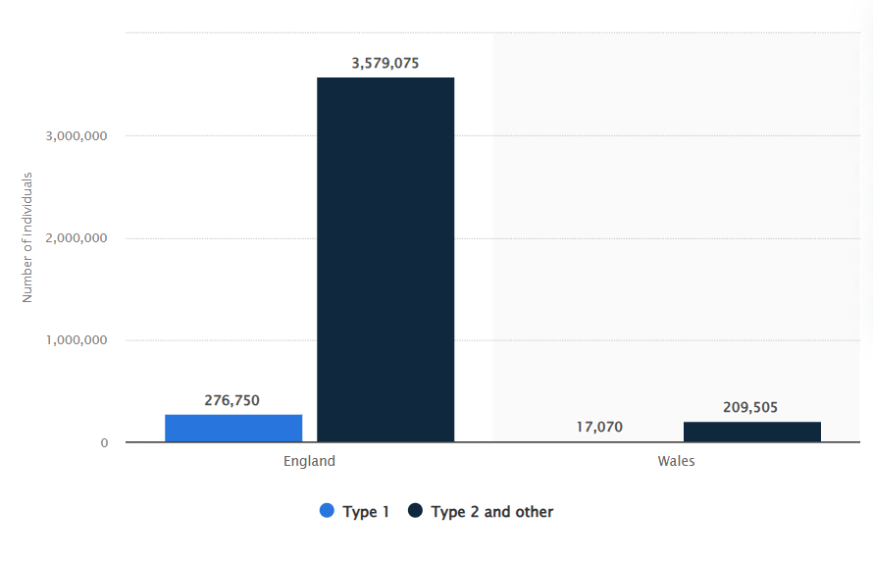
Figure 2.1: Number of individuals registered with diabetes in England and Wales in 2023/24, by type
(Source: Statista, 2025)
The government and healthcare organizations have adopted several public health actions to help in the prevention and treatment of Type 2 diabetes that can be explained using the 3P framework of the WHO prevention, promotion and protection. As shown by the graph, the percentage of patients undergoing the care process, and treatment in England (2023/24) has been increasing over time with better monitoring and service delivery of various types of diabetes. This is indicative of good preventive screening, health promotion programs, and defensive clinical programs (Statista, 2025). Higher coverage of patients in care processes suggest closer detection and management strategies in the initial stages, showing how integrated public health efforts are contributing to disease burden reduction and enhanced health outcomes overall.

Preparation
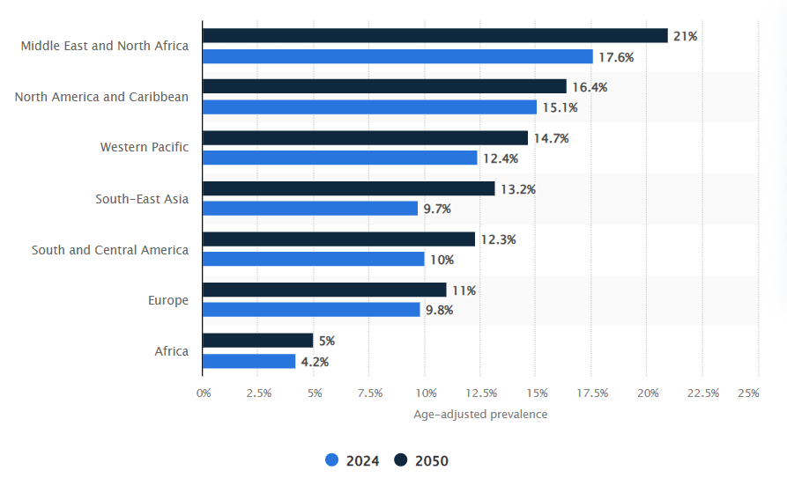
Figure 2.2: Estimation of diabetes from 2024-50
(Source: Statista, 2026)
There are many preventative health strategies designed to help reduce the consequences of Type 2 diabetes that are actively practiced by healthcare authorities or organizations to stimulate societal awareness on the importance of living a healthier lifestyle (Chimeize, 2023). Such programs aim to inform individuals about risk factors including poor diet, lack of exercise and obesity and to encourage early screening and frequent health check-ups. Moreover, cooperation with local populations and organizations is essential to guarantee information is distributed to different population segments. These types of partnerships can be used to customize interventions based on cultural and social needs to make them inclusive and more engaging (Misra et al., 2023). On the whole, such initiatives help to raise awareness and prevent diabetes early on and better manage it among people.

Prevention
There are also many preventive strategies put in place to minimize the threat of Type 2 diabetes with the main focus being the change in lifestyle and better nutrition (Butt, 2022). Such prescriptions are aimed at encouraging healthy diets with necessary nutrients, decreasing consumption of processed and high-carbohydrate food, and physical activity to fight obesity. The need to stay underweight and have active daily routine is also underlined by public health initiatives. The overall awareness of the population towards healthier lifestyles and prevention of disease has been positively influenced by campaigns like Change4Life (Mahdi et al., 2025). These strategies, collectively, are designed to reduce risk factors, facilitate enduring changes in behavior, as well as, improve the overall population health outcomes.

Protection
Several preventive practices have been enacted to help in the early diagnosis and successful management of conditions like Type 2 diabetes. A healthy lifestyle, such as balanced diets and exercise, is encouraged in public health, to help mitigate the risks of sedentary behavior (Dhondge et al., 2024). Also, the people who have a family history of diabetes known are given specific learning and directions to be aware of the initial symptoms and implemented preventive measures. Such strategies can be used to enhance awareness, promote early intervention, and eventually minimize the health-related problems of diabetes over the long run in the high-risk groups.

Risk Factors and Determinants
As per health care experts the cause of Type 2 diabetes within an individual is caused due to a combination of numerous factors such as biological behavioral as well as social. Some of these factors are mentioned below:-
- Obesity
- Sedentary lifestyle
- Improper diet
- Genetic predisposition
- Inadequate physical activity
The lifestyle changes and intervention of the public health can help monitor and manage behavioral and social risk factors of Type 2 diabetes; nevertheless, biological factors cannot be completely avoided. Genetic predisposition is an important factor in predisposing an individual to diabetes. To illustrate, an individual whose parent has diabetes has an approximate probability of 40 to contract the disease, whereas when parents are both infected, it is approximately 70% though not definite (Tauschmann et al., 2022). This underscores the significance of screening and prevention in people with history of diabetes in the family.

Epidemiological Studies and Health Needs Assessment
Epidemiological studies done over Type 2 diabetes reveal numerous valuable insights regarding its occurrence and determinants. Cross sectional studies conducted over this topic has provided valuable data regarding the significant increase in the occurrence of the disease in deprived areas and among people that choose to lead a sedentary lifestyle (Alrashed et al, 2024). Studies have also shown that in the UK the ethnic minorities are in a high risk category of possessing Type 2 diabetes due to the lack of proper medical and health care facilities and proper knowledge to prevent the earlier symptoms (Motala et al, 2022).

Monitoring and Surveillance
Proper tracking of Type 2 diabetes is required to comprehend its prevalence and direct prevention measures. The Global Health Observatory of World Health Organization offers stable information about disease trends and risk factors worldwide, aiding evidence-driven decision-making (Ali et al., 2022). Organizations’ like the NHS in the UK are capable of collecting and analyzing health data, in order to assist policymakers and other healthcare professionals come up with tailored intervention, based on the populations at high risk. This perpetual surveillance helps to detect anomalies early, better brainstorming of resources and formulation of sound policies on public health to reduce the incidence of diabetes and general health outcome of a population

Impact on Public Health

Short Term Impact
The immediate consequences of Type 2 diabetes are increased requests to medical institutions, diagnostic procedures, and regular checks (Shubrook et al., 2022). This additional demand put the direct burden on healthcare services, overloading the professionals and lengthening the waiting time of individuals. Simultaneously, people might be financially strained and feel stressed out because of recurrent visits to hospitals and the need to attend to them all the time. Comprehensively, a high healthcare system burden is induced by the condition immediately affecting individuals.

Long Term Impact
Long term impact comprises of:-
- Cardiovascular diseases
- Neuropathy
- Kidney failure
- Vision Impairment
These impact the lifestyle of an individual and reduce the quality of their life while severely increasing the mortality rates. These also put a strain on the healthcare centers and officials.

Design of Prevention Program
The prevention or intervention program to utilize for reducing the cases of Type 2 diabetes would require the utilization of a multi faceted approach which includes components such as:-
- Nutritional education
- Behavioral and mental support
- Frequent monitoring
- Physical activities
A well constructed program that comprises all four of these components would be beneficial to address the needs of the patients.

Evaluation of Intervention
The evaluation of the prevention or intervention program mentioned above can easily be monitored through the usage of indicators like:-
- Reduction in incidence rates
- Increased awareness among masses
- Improved glycaemic control
These indicators would be the most effective in determining the effectiveness of the program on detail

Strengths and Weaknesses of Epidemiological Approach
Some of the strengths and weakness that could be identified of the epidemiological approach are mentioned below:-
Strengths
- Providing insights that have been based on hard evidence and global trends.
- Proper and effective identification of risk factors that are associated with the increase in the spread of Type 2 diabetes among individuals.
- Proper analysis of the derived data to reach effective conclusions as to how the disease is to be taken care of.
Weaknesses
- Limitations in the acquisition of data that could lead to an improper analysis of the disease and its impacts.
- A lack of cultural sensitivity during the process of data collection and interpretation of it.

Conclusion
In conclusion, it can be seen that the healthcare officials around the world have put much effort in making strategic progress to prevent Type 2 diabetes among individuals and to also curb the mortality rates arising from it. The report displayed that Type 2 diabetes is a significant public health concern for the global economy. While the public health measures and policies implemented by the healthcare organizations has made progress, further efforts and constant monitoring is required to effectively deal with the underlying social and cultural factors.

References
Ali, M.K., Pearson-Stuttard, J., Selvin, E. and Gregg, E.W., 2022. Interpreting global trends in type 2 diabetes complications and mortality. Diabetologia, 65(1), pp.3-13.
Alrashed, F.A., Iqbal, M., Alsubiheen, A.M. and Ahmad, T., 2024. Exploring determinants of sex and family history-based disparity in type 2 diabetes mellitus prevalence among clinical patients. BMC Public Health, 24(1), p.682.
Butt, S.M., 2022. Management and treatment of type 2 diabetes. International Journal of Computations, Information and Manufacturing (IJCIM), 2(1).
Chimezie, R.O., 2023. Health awareness: A significant factor in chronic diseases prevention and access to care. Journal of Biosciences and Medicines, 11(2), pp.64-79.
Dhondge, R.H., Agrawal, S., Patil, R., Kadu, A. and Kothari, M., 2024. A comprehensive review of metabolic syndrome and its role in cardiovascular disease and type 2 diabetes mellitus: Mechanisms, risk factors, and management. Cureus, 16(8).
Mahdi, S., Chilcott, J. and Buckland, N.J., 2025. The impact of the Change4Life Food Scanner app on children’s diets and parental psychological outcomes: a randomized pilot and feasibility study. BMC Public Health, 25(1), p.2215.
Misra, S., Ke, C., Srinivasan, S., Goyal, A., Nyriyenda, M.J., Florez, J.C., Khunti, K., Magliano, D.J. and Luk, A., 2023. Current insights and emerging trends in early-onset type 2 diabetes. The Lancet Diabetes & Endocrinology, 11(10), pp.768-782.
Motala, A.A., Mbanya, J.C., Ramaiya, K., Pirie, F.J. and Ekoru, K., 2022. Type 2 diabetes mellitus in sub-Saharan Africa: challenges and opportunities. Nature Reviews Endocrinology, 18(4), pp.219-229.
Shubrook, J.H., Neumiller, J.J. and Wright, E., 2022. Management of chronic kidney disease in type 2 diabetes: screening, diagnosis and treatment goals, and recommendations. Postgraduate medicine, 134(4), pp.376-387.
Statista (2025). England: share of patients receiving care processes for diabetes 2023/24, by type. [online] Available at: https://www.statista.com/statistics/386758/patients-receiving-the-care-processes-for-diabetes-by-type-in-england/?srsltid=AfmBOoqn2rrLc9wnPPZIhxGcv_LsrXbCR839xXBv9BUM5ItLAu2Sry9W (Accessed on 10 April 2026)
Statista (2025). Prevalence of diabetes worldwide by region 2024 and 2050. [online] Available at: https://www.statista.com/statistics/495292/diabetes-prevalance-forecast-globally-by-region/?srsltid=AfmBOopKqWo8sOzSvwjysKsWWzmQUMVAVK27eYP5JPwAggQVCQxGhnjr (Accessed on 10 April 2026)
Tauschmann, M., Forlenza, G., Hood, K., Cardona‐Hernandez, R., Giani, E., Hendrieckx, C., DeSalvo, D.J., Laffel, L.M., Saboo, B., Wheeler, B.J. and Laptev, D.N., 2022. ISPAD clinical practice consensus guidelines 2022: diabetes technologies: glucose monitoring. Pediatric diabetes, 23(8), pp.1390-1405.

