Smart and Connected Devices 1

Visualisation of IoT Data

ACDA5005

Harry Byrne P133366

Contents

Introduction 3
Conninfo 4
Import 5
Login, Check Login and Logout 7
All Sensor Data/Landing Page 9
Graphs 11
References 13

Introduction

This report is looking at the PHP and HTML code to insert rainfall data from a text file for 3 sensors into a database, then allow a user to interact with the data in an easily readable format.

The text files for each sensor contain rainfall readings per hour in millimeters and a date and time.

The Data must be read into a database using PHP script and must allow a user to access said data from a website with selected filters via a HTML form. The user should have assistance in reading the data e.g. tables and graphs and have basic security measures in place such as a login page.

Conninfo
The Starting point of creating a database in MySql is creating the database and the PHP page called conninfo. This creates a connection to the database as well as setting up a username and password to access it. The below raindata table has the fields set in correspondence to the data in the data files, id was set as a primary key on auto increment.

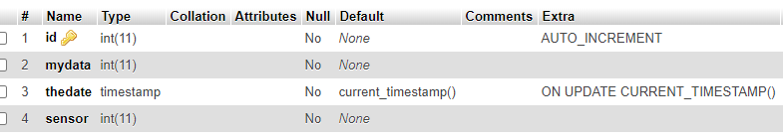

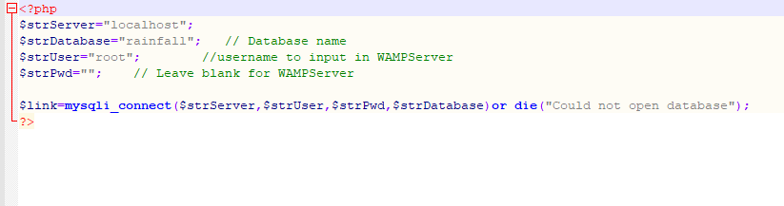

Import
The next aspect undertook was the PHP page to import the data from the text documents into the database. From expanding the start code suppled to include all three text files the code worked perfectly on first initiation, however, if run a second time a large amount of errors were detected as the text files had been read and cleared.
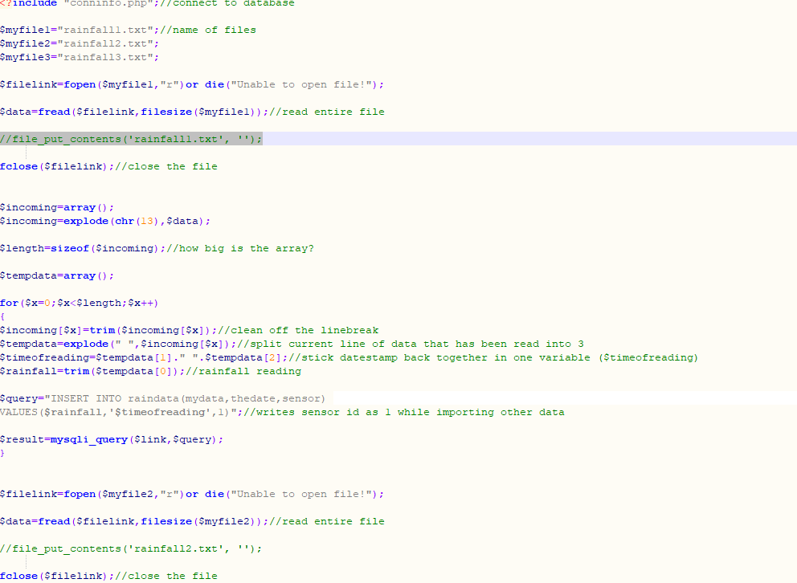
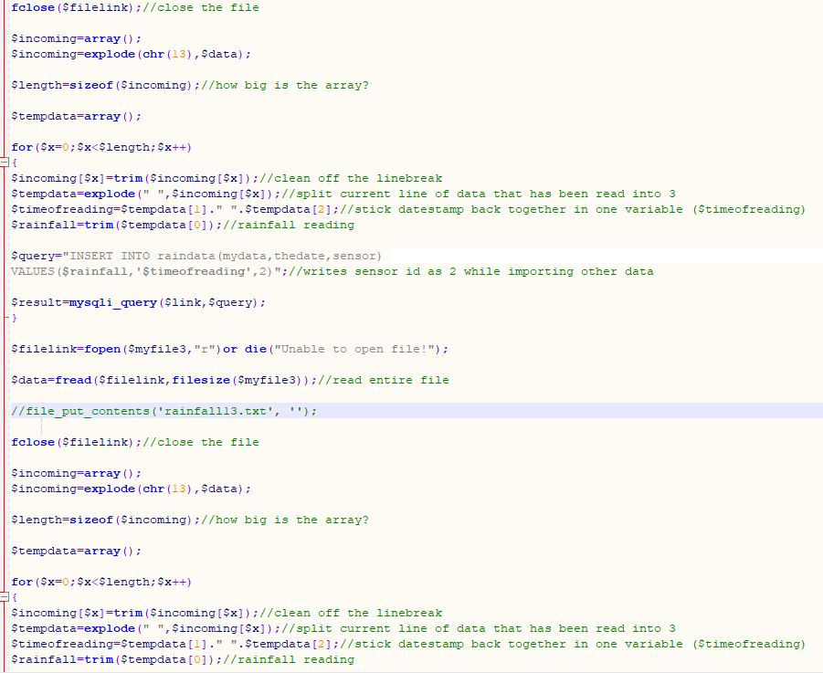
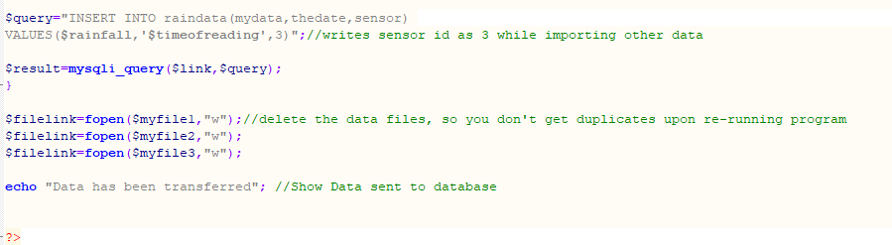
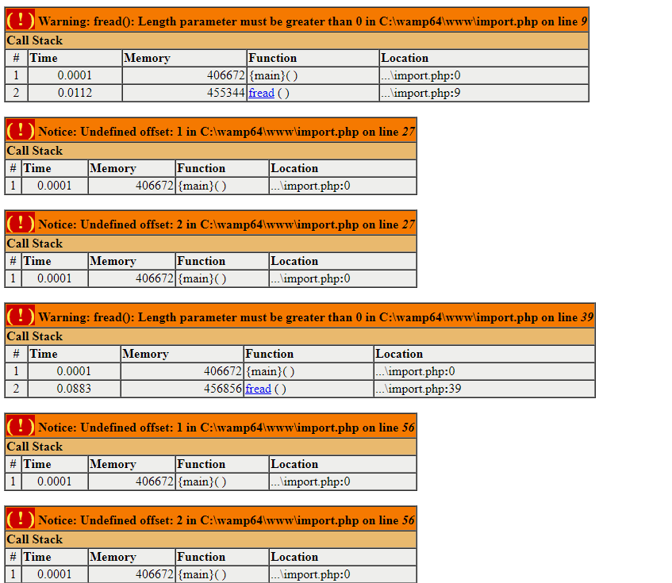

This was overcome by changing the code with if else statements. The if...else statement executes some code if a condition is true and another code if that condition is false.[1]
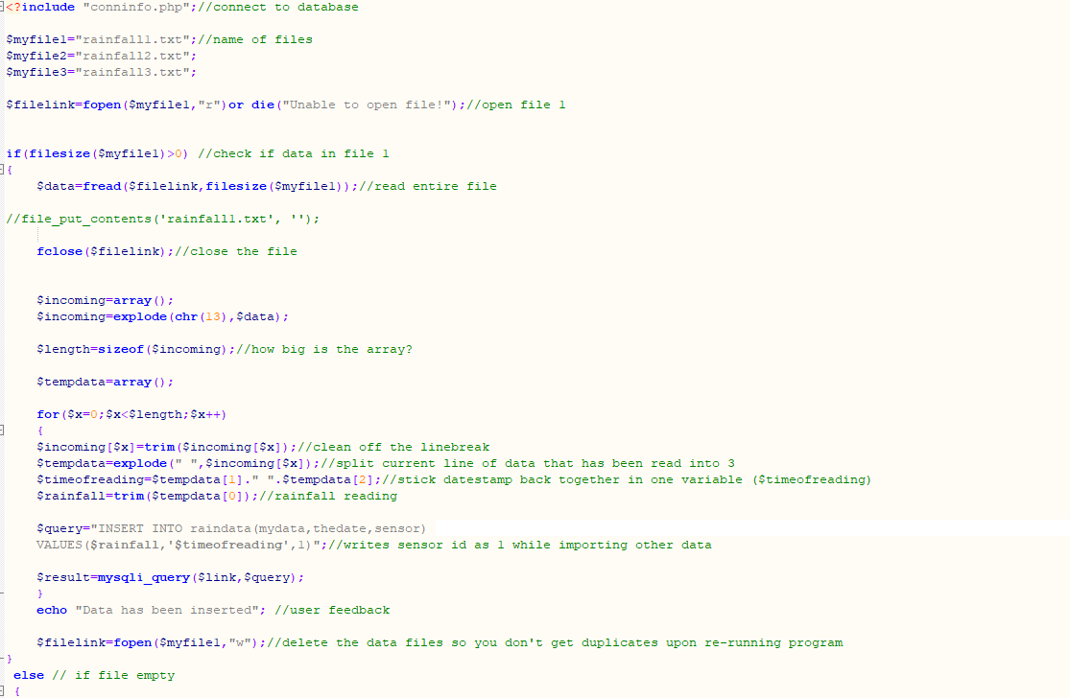
When initialised with empty text files, the following screen is shown.
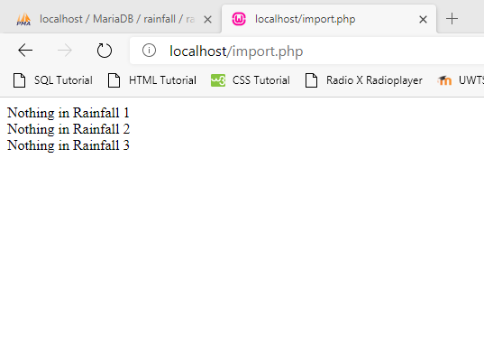

Login, Check Login and Logout
The first point of creating login data was to create a new table within the database named users.

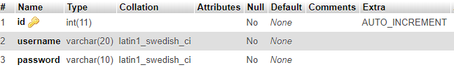
Within this table a few users were added to allow for testing.
The HTML and PHP was coded and called login.php. The page has a basic format where if the user inputs a correct username and password into the form they are directed into the check login page with a link to the landing page. If an incorrect username or password are entered, the user is directed to check login page where they are told that the details are incorrect with a link back to the login page.
Below is the login page code.

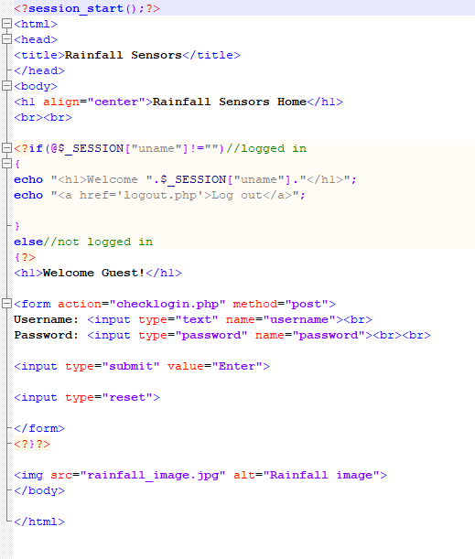

Below is how the login page looks.
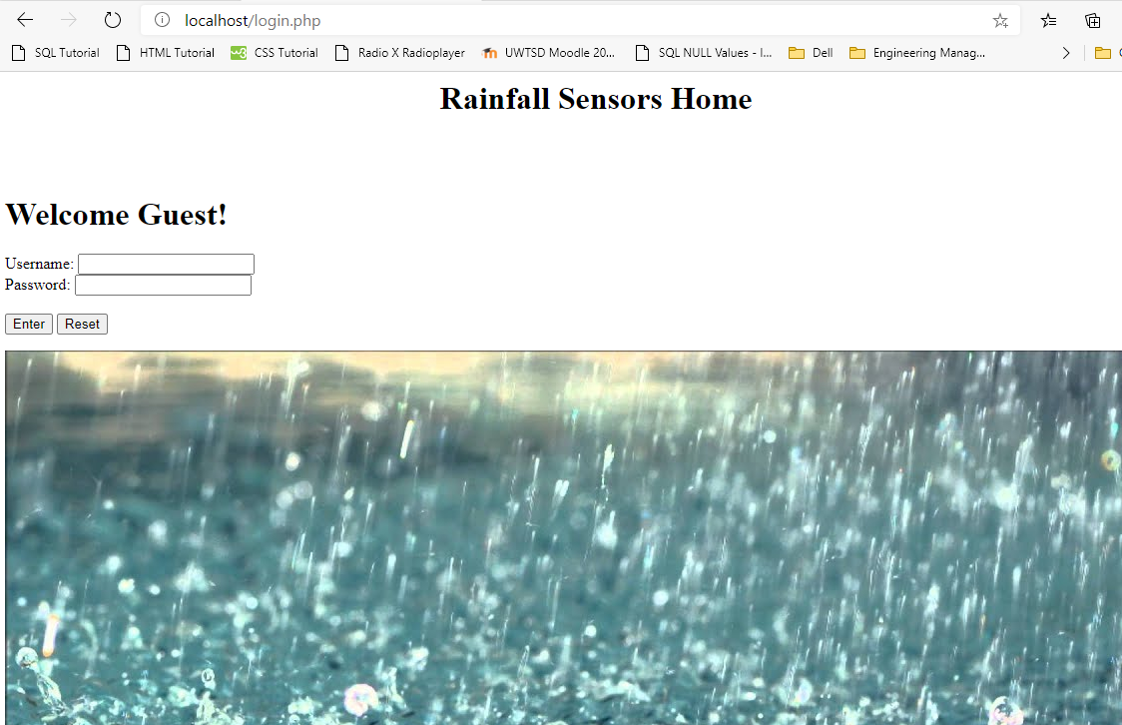

Below is the check login code.

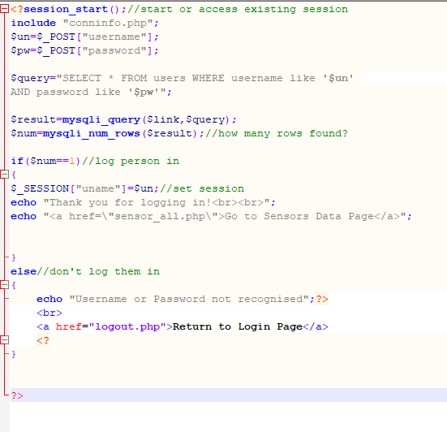

Below is the page shown if username and password are inputted correctly.

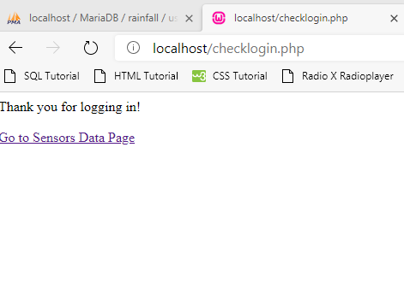

Below is the page shown if either the username or password are inputted incorrectly.
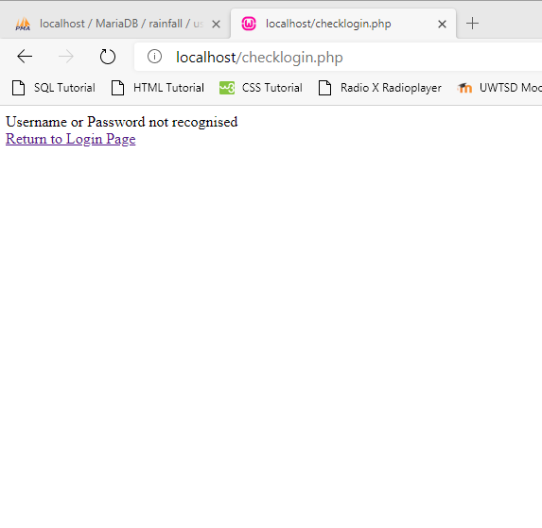
The logout code is used in most if the following pages of code to allow safe logout for the user.
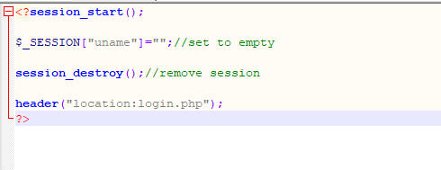

All Sensor Data/Landing Page
The Code for the all sensors page has been used as the landing page as it covers the data supplied by all 3 sensors. The radio button code remains the same on all sensor pages, as does the code for the hover dropdown menu with the three dates the sensors were active in. It was deemed easiest to read the graph on the landing page as a line graph simply due to the quantity of data shown. A table is also shown on each page with the data for further reference.
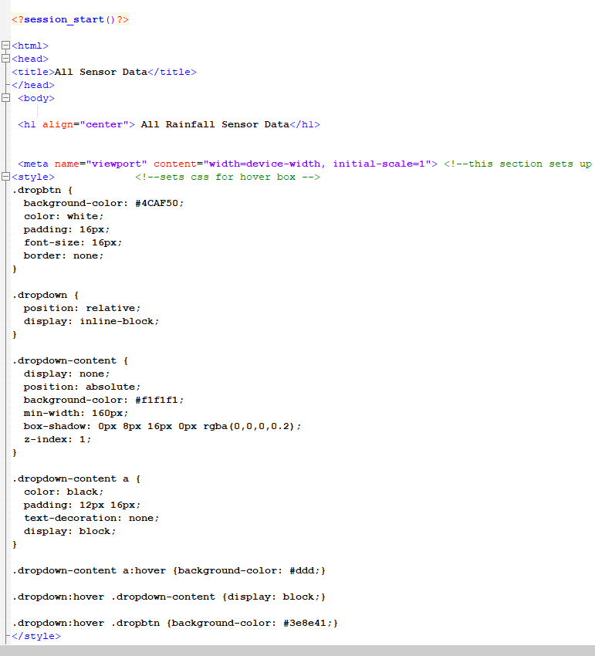
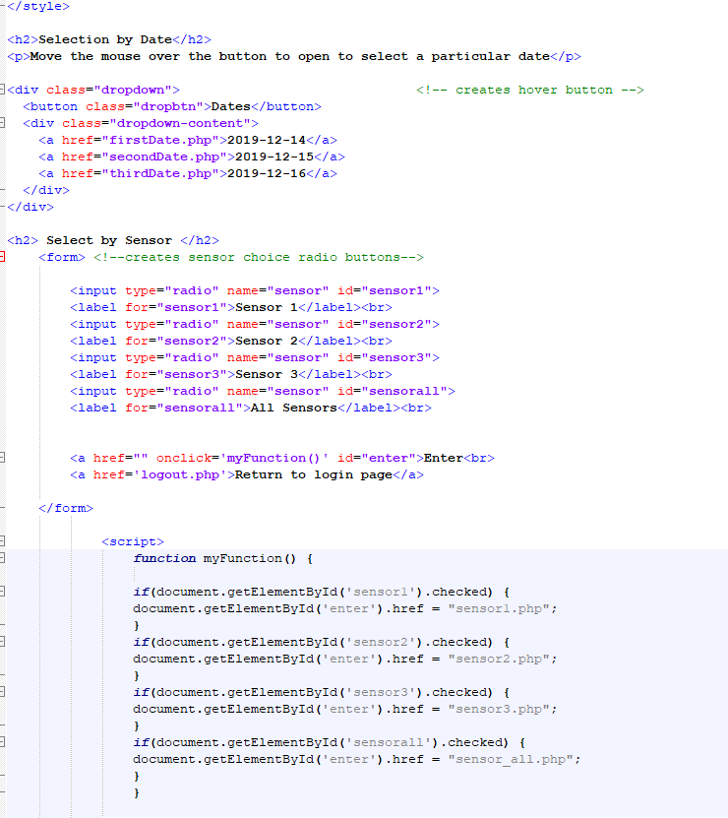

The dropdown menu is styled with a background colour, padding etc The .dropdown class uses position:relative, which is needed when we want the dropdown content to be placed right below the dropdown button (using position:absolute). The .dropdown-content class holds the actual dropdown menu. It is hidden by default, and will be displayed on hover. Note the min-width is set to 160px. Instead of using a border, we have used the box-shadow property to make the dropdown menu look like a "card". We also use z-index to place the dropdown in front of other elements.The :hover selector is used to show the dropdown menu when the user moves the mouse over the dropdown button.[2]

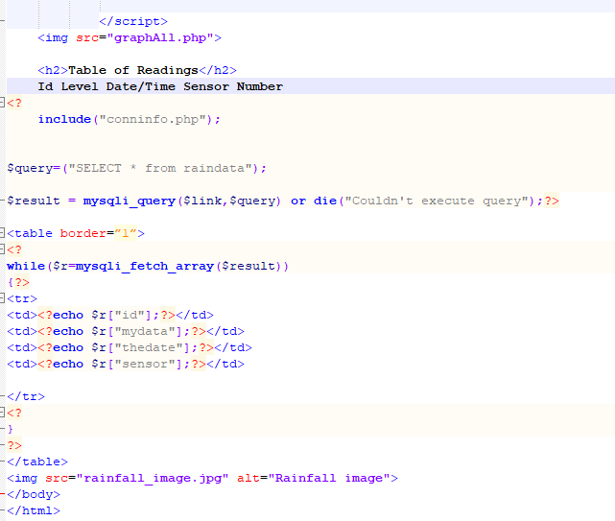

Below is how the first part of the page looks. Following this part is simply a table of the data and an image of rainfall.

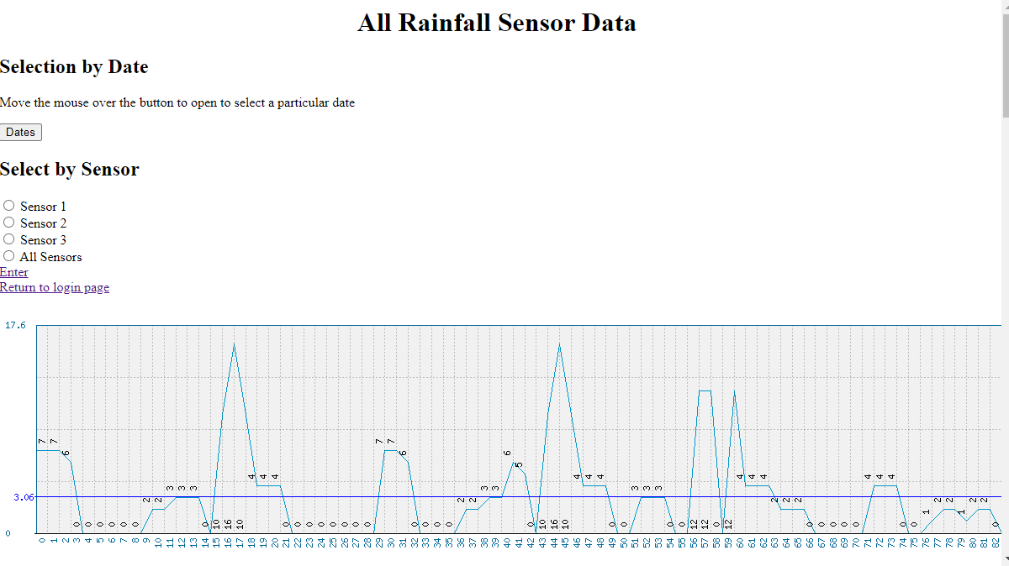

Graphs
The Graphs all use phpMyGraph5.0.php libraries, as mentioned previously the all sensors graph was deemed too difficult to read, however for simplistic reading it was thought that a simple bar graph would be useful.

Below is shown the code for the graph for sensor 1.
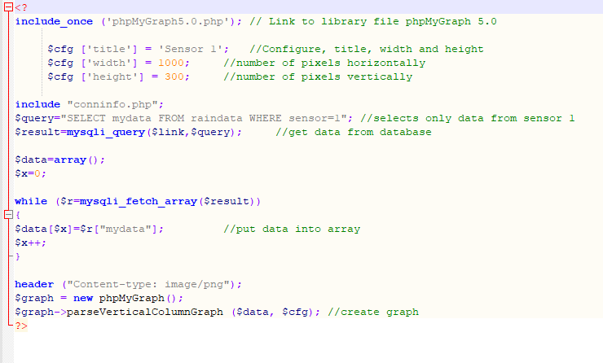
This code was used for the other sensors with minor alterations to the data selected from the database to refer to the correct sensor.

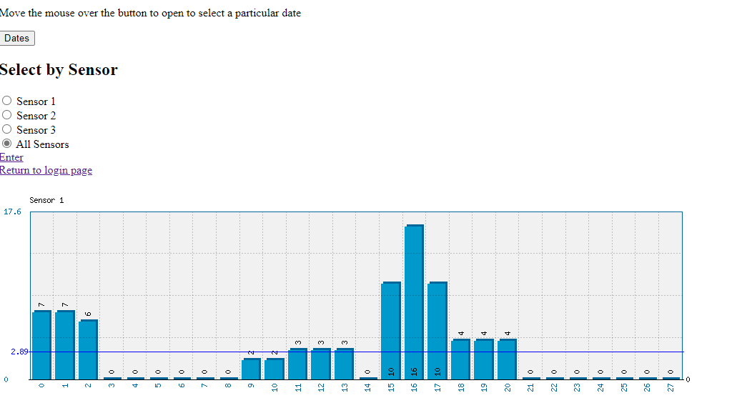
The graphs for the hover dropdown menu were using very similar code but as can been seen, instead of looking for the individual sensor data, it is looking at the date in the database. This part of the user experience is poor as there is no back or different selection options, with the only means of going back is by using the browsers back button.
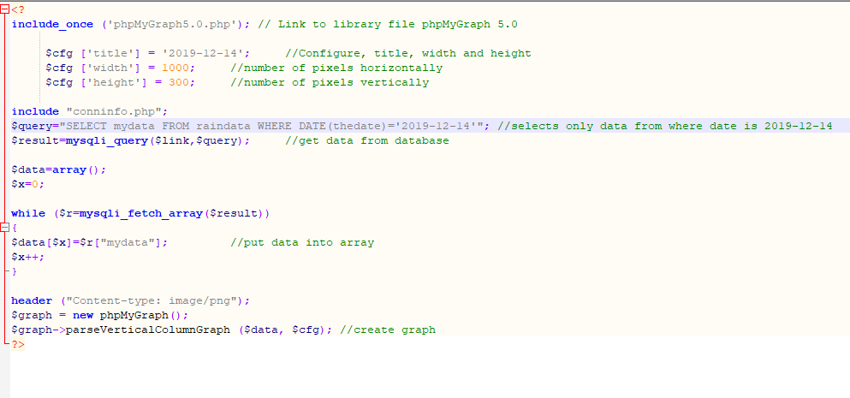

References
[1] “PHP if...else...elseif Statements.” [Online]. Available: https://www.w3schools.com/php/php_if_else.asp. [Accessed: 12-Jun-2020].
[2] “How To Create a Hoverable Dropdown Menu.” [Online]. Available: https://www.w3schools.com/howto/howto_css_dropdown.asp. [Accessed: 12-Jun-2020].

