

A Study of the Preferred Orientation of a User Interface in Hand Tracked Virtual Reality Games

by
Martin Dunn

Supervisor: Nik Whitehead/Mike Dacey

Project submitted as part of the requirements for the award of
BSc (Hons) Computing (Games Development)

May 2022

DECLARATION

I, Martin Christopher Dunn declare that I am the sole author of this Project; that all references cited have been consulted; that I have conducted all work of which this is a record, and that the finished work lies within the prescribed word limits.

This work has not previously been accepted as part of any other degree submission.

Date : 11/05/2022

FORM OF CONSENT

I Martin Christopher Dunn hereby consent that my Project, submitted in candidature for the B.Sc.(Hons) Computing (stream) degree, if successful, may be made available for inter-library loan or photocopying (subject to the law of copyright), and that the title and abstract may be made available to outside organisations.

Date : 11/05/2022

Abstract
A study of the usability of user interface orientations for and tracking games within virtual reality has been conducted to find a preferred, easy to use and comfortable orientation for users. There are four main objectives for this study; explore the current literature, design and build a suitable solution, testing and evaluate future possibilities for this area of study. There was no definitive preferred orientation defined within this study, though there was a least favourite identified from the tests conducted. Future research is needed with prolonged tests to examine the comfortability of the orientations and if an unacceptable level of discomfort or fatigue is caused as a result of the testing. Additionally, tests could be conducted among a larger focus group and using a random order of orientation per tester to ger more feedback regarding the interface.

List of Figures
Figure 1. VPL Data Glove [64] 7
Figure 2. Nintendo Power Glove [65] 8
Figure 3. Wii console and remote [66] 8
Figure 4. Microsoft Kinect [67] 9
Figure 5. Azure Kinect [68] 9
Figure 6 Leap Motion Controller [60] 10
Figure 7 Leap Motion Controller Exploded View [59] 10
Figure 8 HTC Vive [61] 12
Figure 9. Vive Pro 2 [28] 12
Figure 10. Vive Cosmos [29] 13
Figure 11. Valve Index [32] 14
Figure 12. Valve Index Controllers [62] 14
Figure 13. Quest 2 [63] 14
Figure 14. Questionnaire used after each test 23
Figure 15. First mind map broad range of ideas 24
Figure 16. Block Builder Mind Map 24
Figure 17. First sketch of the UI that can be used anchored to the hand 26
Figure 18.UI Sketch with a handle added to the bottom for the ability to mode the panel around the world to position it where comfortable 26
Figure 19. Cylinder using multiple box colliders for its collision 28
Figure 20. Hand Anchored User Interface 29
Figure 21. World user Interface 30
Figure 22. Dynamic User Interface Closed 31
Figure 23. Dynamic User Interface Open 31

List of Tables
Table 1. Block builder MOSCOW table 25
Table 2. Requirements list prioritised with top being the highest priority and bottom being the lowest 25

Contents
1 Introduction 6
2 Literature Review 6
2.1 Introduction 6
2.2 Gesture-Based Interfaces 6
2.2.1 What is a gesture-based interface? 6
2.2.2 Existing Gesture-Based Technology 7
2.2.3 LEAP Motion Controller 10
2.2.4 Existing Research 10
2.3 Virtual Reality 11
2.3.1 What is Virtual Reality? 11
2.3.2 Existing Virtual Reality Technology 11
2.3.3 Quest 2 14
2.3.4 How much has Virtual Reality improved? 15
2.4 Existing Systems 16
2.4.1 Education 16
2.4.2 Healthcare 16
2.4.3 Other Possibilities 17
2.5 Usability 17
2.5.1 What is Usability? 17
2.5.2 Usability Testing 18
2.6 Conclusion 19
3 Research Methodology 19
3.1 Research Methods 19
3.1.1 Qualitative research Methods 19
3.1.2 Quantitative Research Methods 20
3.2 Research Processes 20
3.2.1 Software and Hardware 21
3.2.2 Focus Group 22
3.2.3 Testing 22
4 Design and Implementation 23
4.1 Design 23
4.1.1 Block Builder 25
4.1.2 User Interface Design 27
4.2 Implementation 27
5 Results 29
5.1 Hand Anchored UI 29
5.2 World UI 29
5.3 Dynamic UI 30
5.4 Overview 31
5.5 Questionnaires 32
6 Evaluation 32
7 Conclusion 32
7.1 Future work ideas 33
8 Reflection 33
9 References 33
10 Appendix 39

Introduction
Virtual reality and hand tracking are both technologies that are continuously advancing at a rapid rate, especially within the games industry, so the usability of their different aspects is required to be examined to aid with the design and development of future technology and applications for the benefit of the user.
The aim of this study is to attempt to identify a preferred orientation of a user interface withing VR using hand tracking. The technology being used is a Meta Quest 2 combined with a Leap Motion Controller for accurate hand tracking. There are 4 main objectives, listed below, to aid with satisfying the aim of this study.
- Explore the literature of the field
- Design and build a solution
- Test with suitable users
- Evaluate future possibilities
Using these objectives, we can try to identify an answer for the main aim and provide results that can be useful to the field and any future researchers.
In the following report there are a number of sections. Firstly, a literature review has been conducted and documented to provide background knowledge of the technology and usability. Following this, the research methodology is documented, stating different research methods and the ones that are being used for this study and why. The research process is also documented noting how the research has been conducted to gain the results for this study, and define the steps taken for potential future replication of this study. Additionally, the design and implementation is detailed within section 4 showing how the application was designed and the reasons for these decisions and how they were created. Finally, the results are listed and evaluated followed by a conclusion and suggestions for related work, ending with a personal reflection.

Literature Review

Introduction
In this section the existing literature will be examined and reviewed to give groundwork for this study, to gain knowledge and assist with the design of the application based on previous studies experiences. The section is broken up into multiple parts where we explore gesture-based interfaces and some of their history, and the same with Virtual Reality. Some existing systems in a range of fields are noted and usability is given a brief overview and some usability examples.

Gesture-Based Interfaces

What is a gesture-based interface?
The main method used to interact with computers remains mostly unchanged for a significant number of years. Keyboard and Mouse have been the common input devices used for computers since the beginning of their development [1]. Gesture-based interfaces aim to enable a user to interact with a system using gestures, such as hand or body movements, eye tracking or motion detection. This creates a more natural interface that the user will experience when interacting with a system. There are several potential benefits to being able to interact with a computer system using gestures such as educational, medical and entertainment. It could also make computer interaction easier for users who are not familiar with the technology as they do not need to learn any specific controller layout or button mapping systems to be able to interact with the program.

Existing Gesture-Based Technology

Data Glove
The Data Glove was an early gesture-based technology first bought to market in 1987 created by VPL Research based on an original Optical Glove invented by Thomas Zimmerman [2]. This was a glove which the user would wear on the hand and using a range of different sensors and magnets, can determine the orientation of the hand and even individual fingers when bent or straightened. This could then be used with a 3D virtual hand model that can be manipulated in real time and interact with objects within the virtual environment [3].

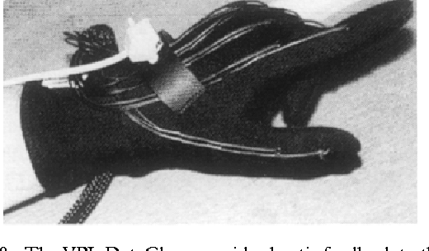
Figure 1. VPL Data Glove [64]

Using Zimmerman’s prior inventions, Abrams Gentile Entertainment (AGE) were able to develop a consumer aimed and affordable product titled ‘Power Glove’. The power glove released in 1989 and was used with the Nintendo Entertainment System (NES) to play games. This was also some of the earliest VR gameplay mechanics as one of the main games ‘Bad Street Brawler’ enabled the user to make a fist and use the space in front of them to throw punches and this movement would then be translated into the game [4].

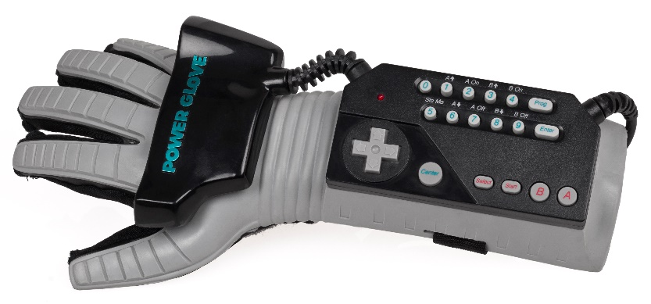
Figure 2. Nintendo Power Glove [65]

Nintendo Wii
The Nintendo Wii was a very popular commercial video game console released November 2006 [5]. The entire premise of this system was to be interacted via gestures using the Wii remote (Wiimote) and an IR camera pointed at the user. The Wiimote uses accelerometers to determine its position and motion, this data is then transferred via Bluetooth to the Wii console. As the connectivity of the Wiimote is Bluetooth, it is very easy to connect it to many other devices and take advantage of its gesture features. It can also be used as a pointer to select things on the screen of the Wii by pointing the Wiimote at the included IR camera [6]. The cheap nature and accuracy of the Wiimote made it desirable for researchers in many areas enabling many more studies and experiments to take place.

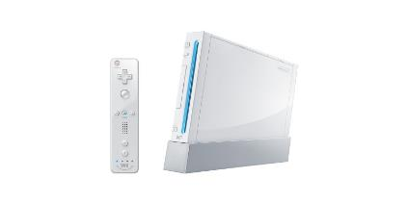
Figure 3. Wii console and remote [66]

Microsoft Kinect
Microsoft entered the world of gestures with their release of the Kinect accessory released in 2010 for the Xbox 360. The release was a huge success, scoring a Guinness World Record for fastest selling peripheral over 60 days, averaging 133,333 sales per day [7]. Unfortunately, the success of the Kinect was short lived, even after releasing a newer version with the Xbox One system in 2013. This seemed to be largely due to the lack of successful applications developed for the system as it became a very difficult task to develop for this platform causing many studios to avoid it altogether [8].
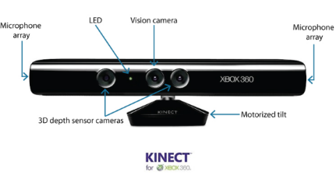
Figure 4. Microsoft Kinect [67]

The Kinect sensor uses an array of IR sensors, cameras, and microphones to provide full body motion tracking, facial recognition, and voice commands [9]. This enables the user to have many new features on their system such as security using facial/voice recognition or playing games using nothing but your own body as an input device.
In 2012 Microsoft released the Kinect for Windows alongside an SDK enabling developers to build applications to take advantage of the Kinect capabilities, although developers had been using the Xbox Kinect on Windows for some time, the Kinect for windows comes more optimised for the windows environment and a new ‘near mode’ detecting accurate movements as close a 50cm to the sensor. Microsoft also announced the newer versions of Xbox Kinect will not be compatible with windows and the same applies to Kinect for Windows with Xbox [10].
Kinect has taken a very different position in the market since its first release and initial intention to be a gaming device. In 2019 the newest version titles Azure Kinect was released that proved to be an improvement upon both previous versions of the Kinect devices [11]. Microsoft [12] states that “Azure Kinect is a cutting-edge spatial computing developer kit with sophisticated computer vision and speech models, advanced AI sensors and a range of powerful SDKs that can be connected to Azure cognitive services”. The possibilities for uses of the Kinect system in different industries are almost endless and are already being used in several incredible ways from home fitness [13], to medical usage [14].

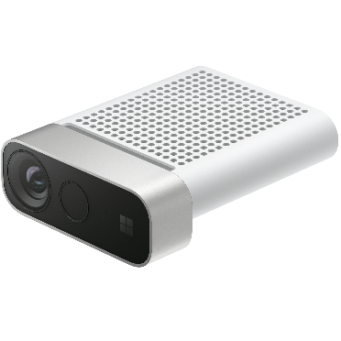
Figure 5. Azure Kinect [68]

LEAP Motion Controller

What is it?
The Leap Motion controller is a small consumer grade hand tracking device created by Ultraleap [15]. Frank Weichert [16] suggests the Leap Motion Controller performs with a sub-millimetre accuracy when tracking hands, making it more accurate than other hand tracking competition. The device uses infrared cameras combined with LEDs to track the position of hands within range, this data is then delivered to the computer via USB input [17]. Using the Ultraleap hand tracking software the input from the device can be read directly into the PC and even used to control the operating system itself.

Why are we using it?
The Leap Motion Controller has been chosen for its small form factor, affordability, and tracking accuracy as the experience for the user needs to be as natural as possible. Using a less accurate alternative could lead to more breaks in immersion which could make the purpose of the product less effective. Also, this technology is priced reasonably and accessible easily. Additionally, Ultraleap offer a healthy SDK package to enable even novice developers to create systems using this hardware almost effortlessly.
When trying to create a virtual environment a very difficult task to achieve is immersion. Many things can break immersion such as, being bound by long cables that you can feel on your body, not having enough open space to perform the required actions needed by the program, or limited area of use because of hardware limitations. Therefore, the Leap Motion Controller has an available accessory that enables the used to mount the tracker to the front of the head mounted display to enable to user to reach out in front of them regardless of orientation or position, just like in the real world [18].

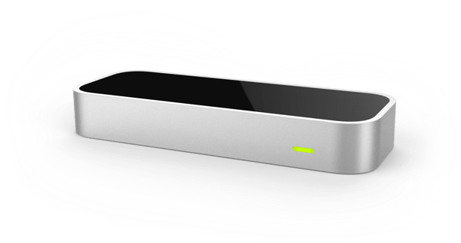
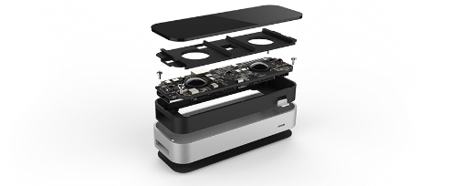
Figure 6 Leap Motion Controller [60]
Figure 7 Leap Motion Controller Exploded View [59]

Existing Research
There are a large range of applications available with support from the Leap Motion Controller in the current time, as the device nears 10 years since its release there has been a large amount of time for many people to experiment and study this device and create many different games or applications that fit into a wide array of fields. A focus has been attempted with respect to games and user interface or usability studies to gather input to aid with this project but there are many promising studies in different fields, such as using the Leap Motion Controller to recognise sign language input [19].
As suggested by Falcao et al [20] the Leap Motion controller still suffers from some usability issues preventing it from becoming a suitable replacement for standard computer interaction devices such as, mouse and keyboard, or drawing tablets for designers creating artwork using programs such as Photoshop. This test was conducted on 5 designers who use Photoshop daily to complete 3 separate basic tasks using the Leap Motion Controller and measuring the time taken per task, and feedback from heuristic surveys completed by participants. However, it is noted that this is a promising technology and with some improvements could become a replacement for current devices.
A study of the Leap Motion Controller within games or gamification applications has shown that there is potential for the device within training and rehabilitation whilst stating a lower-than-average rating on the SUS scale and over 20 points less then standard keyboard input. In addition, it was noted that participants with a gaming history or background had an easier time using the device compared to those with little or no experience. Also, users reported that after around 20 minutes of use they began to feel tired or fatigued due to the need to keep the arms elevated and performing movements during the interaction with the game. However, it was suggested the Leap Motion Controller is more ‘fun to use’ then standard keyboard input [21].

Virtual Reality

What is Virtual Reality?
Merriam-webster [22] defines virtual reality as “an artificial environment which is experienced through sensory stimuli (such as sights and sounds) provided by a computer and in which one's actions partially determine what happens in the environment.” In the present-day Virtual Reality (VR) is becoming increasingly popular and affordable to the public rather than being an expensive piece of specialist equipment. The gaming industry is largely responsible for the reduction in price as the increase in popularity for VR games has increased the demand for this technology to be more affordable.
Most of the VR systems available today consist of a Head Mounted Display (HMD), controllers, and some accessories such as cameras of sensors that are required to be wet up and positioned correctly with clear vision of the intended play space. Additionally, they require a PC with a higher-than-average level of hardware to drive the demanding applications for the VR system. The different pieces of hardware can then communicate with each other and the system its connected to, to determine position and orientation within 3D space.

Existing Virtual Reality Technology

HTC

HTC released their initial VR system in April 2016 titled “HTC Vive” [23]. The original Vive was created in collaboration with Valve and utilised SteamVR, a Valve developed software that essentially acts as the systems operating system and tracking system [24]. It was claimed to be the first ‘Room Scale’ VR experience enabling you to walk around your virtual environment seamlessly enabling the user to feel fully immersed within the virtual experience. This was made possible using the Lighthouse tracking system developed by Valve and, what are known as ‘Base Stations’ that use infrared LEDs and IR sensors to track the position of the HMD and controllers within the users pre-defined play space that can be up to a stated maximum 4x4 metre area [25]. The Lighthouse system functions by scanning the users play area vertically and horizontally repeatedly to define the position of the HMD and the controllers in real time and translate this to the virtual environment. This process is very fast and precise enough for its purpose, VR gaming [26].
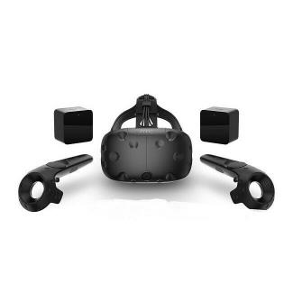
HTC since then have gone on to release several different VR systems at different price points with different goals in mind. The Vive Pro was crated for a more professional audience and come with a lot more features and hardware out of the box, from increased resolution and field of view to built-in headphones on the head strap and even the base station 2.0 for more accurate large-scale tracking [27]. This was recently followed up by the release of the Vive Pro 2 claiming ‘Next-gen Graphics’ using 5K resolution at 120 degrees field of view, high quality audio, and more comfort [28].
Figure 8 HTC Vive [61]
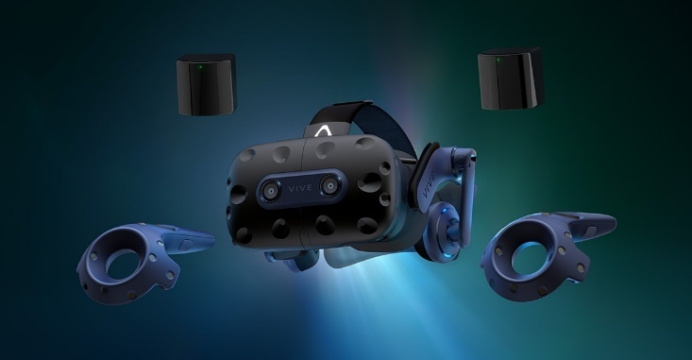

Figure 9. Vive Pro 2 [28]

One of the more noteworthy releases was the Vive Cosmos as this claimed to have ‘inside out’ tracking, meaning there was no need for base stations within the room and the use of the HMD and controllers were all that are required for the system to work [29]. However, this system suffered greatly with low accuracy when tracking controllers using its new ‘inside-out’ tracking system. It was confirmed to be the least accurate VR in a controller tracking test [30]. The Vive Cosmos has since received a new release to the market title Vive Cosmos Elite where it has moved to using the reliable and well tested SteamVR Lighthouse tracing system with Base stations [31].

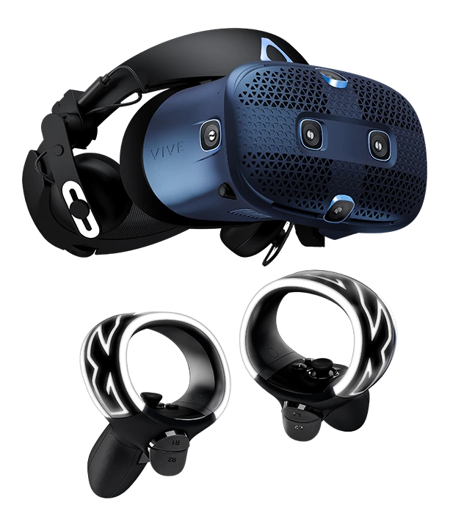

Figure 10. Vive Cosmos [29]

Valve Index

Valve also have their own VR system titled Valve Index. This system was released by valve after their initial collaboration with HTC on the Vive system. This system utilises the same Lighthouse system and base stations as the Vive and can work with the Vive controllers allowing users to buy only the HMD instead of the full kit. However, the index system ships with new base station 2.0, enabling a larger usable area, and valves new innovative Index controllers [32]. The Index controllers are also compatible with Vive and Vive pro systems enabling a lot of flexibility and preference to consumers when choosing what they want to invest their money in to when considering purchasing a VR system.
Valve Index Controllers are an innovative and unique addition to the VR experience at the time of their launch. This was because of the new individual finger tracking capabilities Valve has creates. This was made possible by each individual controller using an array of 87 sensors combined with software algorithms to accurately determine the position and orientation of each individual finger of the user in real time [33]. Now the user is free to individually manoeuvre each finger within the virtual world in which they are playing not only increasing immersion but also increasing the possibilities that are available within a virtual world.
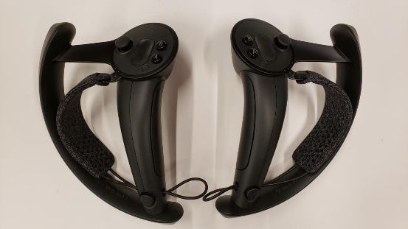
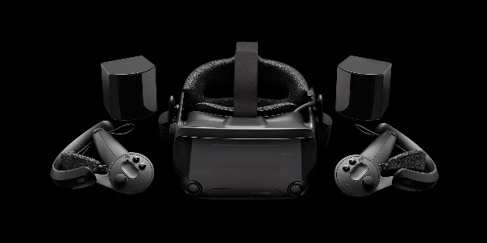
Figure 11. Valve Index [32]
Figure 12. Valve Index Controllers [62]

Quest 2

What is it?

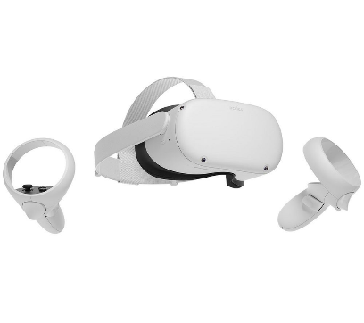
The Quest and Quest 2 was a VR system originally developed and released by Oculus, under the brand of Facebook, now known as Meta [34]. The Quest is a standalone, room scale, gaming VR system that runs totally wireless and without the need to mount base stations or lighthouse systems within the room that the user wishes to play, using inside-out tracking. This enables the system to become much more appealing to the average consumer as they are not permanently confined to 1 single room or area that they can use without having to either mount base stations to walls or provide some other means of mounting for them to be able to track the usable area accurately. Furthermore, the Quest has always been at a much cheaper price point in the market making it even more appealing to consumers.
Figure 13. Quest 2 [63]

Quest comes with its own hand tracking feature which enables the user to use their hands instead of the touch controllers. The array of cameras on the HMD uses images of the hands to determine significant points on the hands suck as fingertips or knuckles to track the position and orientation in real time and translate this information to a hand model within the HMD for the user to see [35]. This is a very impressive feature but has chosen to not be used for the tracking of hands for this project due to the lack of accuracy in comparison to the commercially available Leap Motion Controller.
Although the Quest 2 is a standalone headset with its own market full of games and apps, there are ways in which the user can use the Quest 2 to access SteamVR and other PC content too, either wired using the Oculus Link Cable, or even wirelessly. This was originally achieved through the usage of a thirst party application titled ‘Virtual Desktop’ that enables users to use their PC within a VR HMD. Virtual Desktop allowed users to play games from the PC using its hardware, through the Quest 2 system. However, there has since been and update to the quest system adding a feature called ‘Air Link’ removing the need for using Virtual Desktop to achieve this.

Why are we using it?

There several reasons the Quest 2 has been chosen for this project. Firstly, it offers an out of the box wireless set up and does not require the setup of external tracking devices in the usable area to enable it to function. Additionally, it is a great and reasonably priced piece of hardware that is much cheaper than most of its competition currently on the market offering similar features. Finally, the Quest 2 is one of the newest and innovative VR systems on the market with an aim to make VR more accessible for everyone, meaning more people will be familiar with this system and its functionality.

How much has Virtual Reality improved?
Virtual Reality can be dated back to the 1800s with the invention of the Stereoscope by Charles Wheatstone [36]. Wheatstone discovered that observing 2 dissimilar images (one per eye) can give the illusion of depth to a 2D image, thus creating 3D imagery. Using this discovered information Wheatstone created a Stereoscope, a device that enables the viewing of the 2 images, with each image being isolated to 1 eye, using viewing holes and mirrors and two sticks to adjust the distance and angle at which the image is viewed [37].
The first flight simulator was created in 1929 by Edwin Link and titles “Link Trainer” and was officially patented in 1931 [38]. Link states that his aim of this invention is to provide student aviators with an apparatus to practice that subjects the student to the natural sensations of flying within a safe environment. Additionally, Link states the invention can also be used as an entertainment device running via coin operation much like an arcade machine at an amusement park, and this was initially its main interest in its early days. In 1934 the U.S Air Corps ordered 6 of the flight trainers after taking over the airmail service and needing to train pilots safely after having some crashes due to instrument failure in bad weather or flying at night [39]. However, the flight simulator really took off during the second world war where over 500,000 pilots used a newer model they nicknamed “Blue Box” to learn to fly, using 10,000 Blue Box machines. The Link Flight Trainer has been designated as a “Historical Mechanical Engineering Landmark”.
In the 1950’s and American cinematographer name Morton Heilig envisioned the first instance of what is now known as VR [40]. The machine he went on to create was titled the “Sensorama” and used stereoscopic motion pictures, audio, haptic vibrations, smells and even wind to make the user feel like they were within the video, not just watching it [41].
In the process of creating the Sensorama, Heilig also created the first ever head mounted display titled “Telesphere Mask” with stereoscopic video, wide screen, stereo audio, and scents [42]. Unlike modern HMD’s this would just serve as a non-interactive media playback device. The creation of such systems has led to Heilig being named the father of virtual reality.
All the stated contributors, and potentially many more, helped build the foundation for the current model of VR that is know and used widely in the modern day. It’s taken little over 50 years to make huge leaps in technological advancement to place users within an immersive virtual world.

Existing Systems

Education
Virtual Reality and Gesture-Based Interfaces can be used to change the way education is delivered in almost any field. This provides a new, unique, and more interactive way for learners to become engaged with the content being taught, it can also provide users with experiences that are only possible to experience with this technology, other than the real thing. For example, virtual tours of architectural landmarks would be a much cheaper and more accessible way for more architect students to experience without having to pay large travel costs and site entry fees. Using this technology to experience architectural techniques and experiencing them in a new way could assist with the learning for students [43]. However, it should be noted that this should not be used instead of, only as well as real world examples.
In addition, Martin Ebner and Norbert Spot [44] state that the use of game with gesture-based interfaces such as the Leap Motion Controller could significantly improve learning for some school subjects. However, they also state that it is not beneficial for all students, as they witnessed students in need of special education, or children who struggle with hand eye coordination. It can be noted that there is no singular ‘correct’ method of delivering education, as there are many different learning styles and there is no ‘one-fits-all’ mould for the education system. In addition, the more available methods of learning will, in turn increase ease of gaining knowledge for more and more learners. There are studies that suggest using gestures and human movement reinforces learning and makes the content more memorable. A review of gesture-based computing found that the use of gestures within education is an increasing theme and will continue to increase as the technology become more accessible and affordable whilst maintaining low maintenance. The Nintendo Wii is most used alongside Microsoft Kinect and Smartphones. Additionally, it was stated that the use of gesture-controls within special education has a large positive impact, especially with autistic users [45].

Healthcare
Using VR and gestures in healthcare learning can be achieved by providing a virtual experience of certain high-risk situations before experiencing the real situation. This could help reduce errors and panic before a real-world example as there could be an underlying expectation of what will happen, this is also a process that can be repeated as many times as needed without risk [46]. Additionally, the data being delivered can be experienced in a unique way from unique angles that would not be possible within the real world, this in turn could help to reinforce the knowledge for students. For example, internals of human organs or body parts that have rare unique conditions or illnesses can now be properly visualised, rotated, zoomed into, or even blown up to identify the insides. This could save many resources as these rare conditions would be more accessible and viewable in detail as often as needed.
Another area that studies suggest gesture-based games could be beneficial, is for the rehabilitation of motor functions within patients that suffer from central nervous system diseases [47]. These systems can be used to help increase mobility and hand eye coordination in a fun, engaging and natural way alongside current existing therapies. This would be a valuable use for these systems as it would enable victims of such illnesses to gain more independence and better quality of life rather than relying entirely on others for the support they need.

Other Possibilities
The possibilities with VR and Gesture-Based Interfaces are near limitless and becomes even broader as technology continues to advance at a rapid rate. For example, VR could be used to train soldiers for the battlefield without putting any lives at risk or wasting any valuable resources needed to recreate such an environment for training purposes. One benefit of this is the experience that is provided can be continuously edited, updated, or changed entirely to fit the needs of any situation, helping soldiers to be equipped and ready for anything that might happen.
There are a vast number of commercial VR headsets, as previously discussed, designed for home use enabling users to have unique gaming experiences and environments. There is a wide range of ways that VR can be used for entertainment from gaming, media consumption, and even fitness. All these VR systems are controlled through gestures using either the controllers provided, hand tracking, or other third-party tracking methods, they all require gesture input to function.

Usability

What is Usability?
Usability is a key area of almost any product and discipline. It refers to the level of skill required for a user to interact with the product easily. The difference between good and bad usability can be the key to a successful product as a good user experience is essential for success, as the product needs to be usable for both new, novice users and/or experienced ones at the same time. Ben Schneiderman [48] suggests that, to increase universal usability within software there should be a “Multi-Layer Interface” meaning that new/novice users can start at layer 1 with a limited number of features and progress through the layers at their own pace and will. This method of learning is present throughout many practical activities, particularly those with high safety risks and proves to be a successful method to perfect an ability.
When a user interacts with a piece of software it should be clear on how it functions on a basic level with the minimum amount of thought or questioning possible. However, some software will need to be complicated by nature so the ‘minimum’ level of thought of questioning can differ for all products [49]. This can be achieved through a good usability testing phase as designers and developers are unable to predict every action any given user is going to attempt; they can only design/develop for expected and intended use case.

Usability is an extremely important for VR. This is because the user is inside a created environment using natural interaction and if it feels unnatural to use or is difficult to interact with this will cause the user issues and effect their experience within the environment. This also applies to gestures, because if a gesture is complicated and hard to replicate it could lead to a bad user experience causing the user to be frustrated, or even physical discomfort. When creating a product for VR and gestures there are many usability issues to be considered. For example, Wang et al [50] found in a study for testing different postures of mid-air text entry that the hands-up posture causes users arms to become tired and ache, in turn this could lead to inaccurate or rushed typing and mistakes can occur. It was also noted that users with previous experience within the technologies had an easier time using the systems.
Gesture based interfaces also require a high level of usability attention because of the very nature of the technology. Gestures create a natural user interface (NUI) meaning the user must interact in a natural way. Bad usability can lead to interfaces not feeling natural and causing issues for the user to interact with them in the intended way and execute tasks efficiently and without major difficulty or instruction. This could specifically cause issues to people who have little to no previous experience with the technology as it has been shown, that even though these are ‘natural’ interactions, there is still a learning curve involved. With more and more gesture-based technology becoming commercially available and affordable, more attention needs to be paid to the usability as number of users will increase all with varying levels of capabilities and understanding of functionality.

Usability Testing
When in a usability testing phase there are many aspects that need to be considered as there is no finite measurement for usability itself, there is no single variable accountable for the level of usability of any product. However, we can easily measure where people have issues with products, where they have difficulties or unexpectedly lengthy interaction times in specific areas or sections of a program. This data can then be used to see what areas the usability could be changed or adjusted to create a better, easier, and more enjoyable experience for users [51].
There are many approaches to be considered when testing usability as every product is unique and will have different requirements and expectations to be met and considered during the testing process. Each one should be defined before testing begins so the correct variables can be examined and recorded to formulate accurate results that can be passed back to a development team for improvements. An observational approach can be taken when looking for issues within the usability of a product, meaning users are given an instruction prior to the test beginning and then observed, without interference, to identify issues they appear to experience within the program. Data such as time taken for specific tasks can also be logged from within the software at run time for later use and sessions can also be recorded to analyse and compare between subjects [52].
Summative usability testing can be used when a product is ‘complete’ and ready for use to gather feedback on the final level of usability for the product. This testing would be conducted towards the end of the development cycle to ensure the product is complete with all features included. The results from this testing phase will help provide the developers with data to show the quality of the final product and any issues that users may experience when interacting with the product [53].
Out-of-the-box testing can be a good indicator of how a user will naturally interact with a product through their own initiative without any prompts or prior information on how to use or interact with it. This testing can help to provide data on how users are likely to interact with the product in a ‘real world’ scenario and how to plan or design for unexpected use case to prevent issues. Additionally, any issues the user could have at different stages when using the product can be identified along with the difficulties they faced to overcome them without assistance [53]. This data can help improve the user experience when trying this for the first time without any assistance or support to guide them through different sections during use.

Conclusion
Whilst conducting a review of the current literature many pieces of knowledge have been gained and the background to this field has been established. Gesture-based interfaces are everywhere, including in modern smartphones that are so commonly used in the modern day. However, hand tracked gesture-based interfaces are not so common and are usually a specialist piece of technology. The Meta Quest 2 is aiming to build hand tracking into their VR headset, this would make hand tracking much more widely used, and affordable.
VR has evolved a large amount within a relatively short period of time, and if this evolution is projected into the future, hand tracking gesture-based games will soon be upon us meaning the usability of this product is a necessity as there are some unique things to consider such as fatigue within the arms when held up for too long.
There is not a large amount of usability studies within gesture-based VR games UI and their orientations effecting user experiences making this study a valuable one for researchers or developers in this area.

Research Methodology
There are many research methods that can be used when undertaking a study and each have their own benefit or drawbacks to different types of studies, this section will detail some of these options and the methods that will be used within this study and why they are being used.

Research Methods

Qualitative research Methods
Qualitative research methods are used to gather open-ended data that can be used to identify themes, and usually suggests there is not much written within the current are of study being researched [54]. There are several qualitative research methods that are known, such as grounded theory, developed by Barney Glaser and Anslem Strauss in 1967 [55]. The aim of this approach is to analyse the data to develop a theory meaning its is ‘grounded’ in the data. The theories that are created because of the data can help enhance understanding and guide researchers on the next actions needed [56].
There are other qualitative methods available such as Ethnography, Case Studies, Phenomenological Research and Narrative Research [54]. Ethnography involves studying people and their behaviour in everyday contexts over a set time with data gathered via observation or informal conversation [57]. Case study research involves studying a defined case to find the answers to research questions where there is no prior theory for the result [58]. Phenomenological Research is used for studying the feelings and experiences of humans and commonly used in psychological research [59]. Stories that are told in a list of life events by the researcher is known as Narrative Research [60].
The different types of qualitative research discussed show that these research methods have a focus on concepts, opinions, or experiences, and can be used to gather detailed data about a known issue or identify new areas to be researched. Therefore, this approach would not be a suitable selection for this study as there is a question asked and an accurate result, with the ability to replicate, is the aim for the outcome of this study.

Quantitative Research Methods
Quantitative research methods are used to prove or disprove a hypothesis by counting or measuring data to acquire the result of the study [58]. As with qualitative methods there are many quantitative research methods that exist such as developmental design, experimental, and survey-based research [61].
Richey and Klein [62] describe developmental research as “Developmental research seeks to create knowledge grounded in data systematically derived from practice.” It is used to test hypothesized theories that validate practice. An experimental approach is where all aspects of the study are kept constant except the experimental variable that is being tested to gather results on the changes made by altering this variable [63]. When gathering results using questionnaires or interviews to gather feedback about a specific topic this would be known as survey-based research [64].
The quantitative approach for this study will be far more applicable as there is a given hypothesis to be tested to gain an answer. It will be an experimental approach as the changing variable will be the orientation of UI within a VR gesture application where the application and its functionality remain the same across all instances. Therefore, any difference in usability between the applications should link directly to the changed variable if there are no other external factors effecting the testing.
Additionally, the results will be gathered using observational methods by observing the users interact with each application and identifying where they have difficulty. The session will be screen recorded so and evidence of difficulty within the application can be reviewed and analysed. There is also a timer within the application that will be logged at the end of each level to state the time taken for each user to complete each orientation within the application.
There is a small aspect of survey-based research being adopted for this project as there will be questionnaires for the user to complete as an extra result that can be used alongside the observational results gathered.
The positivist research methodology is being used as the existing literature is being studied and knowledge is being gained from accepted theory and practice. By using the available literature, it can be used to assist with design and implementation decisions based on the results and/or experiences from previous study in this area.
A hypothesis has been created for the usability of different design orientations within VR using hand tracking, and an experiment is designed and executed to gather results and evidence to assist with proving or disproving this theory with a deductive approach.

Research Processes
The hypothesis for this experimental project is titled “What is the Preferred Orientation of User Interface Within Gesture Based Virtual Reality Games?” There are many ways that UIs can be implemented in software. However, within the VR environment there are more considerations that need to be made as the UI needs to be accessible and usable but not hinder the environment or cause the user issues or discomfort when interacting with it. That is the goal of this study, to test 3 different UI orientations and gather results on which is the most preferred implementation.
An experimental approach is being used for this study as it will provide results that can be evaluated to generate a result for the hypothesis given. This approach Is being taken because it can be an effective and efficient way to gather the data needed to generate an acceptable result. The experimental approach also has several benefits such as high level of control, specific conclusions, and easy to replicate results [54]. However, experimental design can have negatives such as ethical issues with participants of the study when gaining results. These issues were mitigated by filing an ethics form and ensuring no personally identifiable data is collected from any participants, and as an extra layer of security it will be stored within the UWTSD OneDrive secure cloud storage.
A review of the existing literature has been conducted to gain knowledge within the existing area of study, its hardware, and ways it can be used to perform an experiment to test the given hypothesis. This will be tested using software development to create an application to be used to gain feedback to formulate a result for the hypothesis.
VR and gestures are becoming increasingly popular as technology continues to advance, making it more accessible and affordable to the general population rather then being a specialist high value product. With the large increase in users and the increase likely to continue, with companies such as Meta aiming to create a ‘Metaverse’ which is a fully virtual world where users can work, play, relax or even hang out with friends all from the comfort of their own homes by using a virtual environment. Meta stated they are investing $150 million into VR to aid students’ creators and developers to unlock learning opportunities within the Metaverse [55]. With this projected increase in users, potentially increased by rival technologies too, there is a need to evaluate the usability of aspects of this technology for the benefits of the user. As previously mentioned, Meta is already creating their own hand tracking system that can be used currently on the Meta Quest 2 meaning this technology could be close to being widely adapted within VR. These are some of the reasons it is believed this project is valid research and can provide useful results for designers and developers of this platform in the future or create a foundation for further studies.

Software and Hardware

Hardware
The Meta Quest 2 is the target platform for this application as it is an affordable, consumer grade VR system that is easy to set up and use without requiring external accessories for device tracking within a play area. Furthermore, it is a modern and up to dare piece of VR hardware with regular updates and improvements via software.
Whilst the Quest 2 can track users hand movements with its Beta hand tracking mode, the Leap Motion Controller is the device responsible for the hand tracking in this application. The Leap Motion Controller is very small form factor, has an available VR mount accessory, and affordable. It is advertised with sub-millimetre accuracy making it more accurate than the Quest 2’s own tracking system at present.
A Windows 10 PC is also required for all development and execution of the application.
The Quest 2 will be connected to the Windows PC, using Oculus Link, as will the Leap Motion Controller, using a USB 2.0 connector. The application will then be executed from the pc displaying to the VR headset and using the Leap Motion Controller. It is understood that the Quest 2 can be connected wirelessly to the PC, but for the purposes of this test it will be connected using an Oculus Link Cable that is USB-C to USB-C.

Software
There are 3 key pieces of software needed for this project: Unity, Visual Studio 2019 (VS19), and Utraleap’s Tracking Service.
Unity is being used in collaboration with VS19 to build the application required for the experiment testing. Unity engine is being used to create the 3D world that will be used within VR and all user interface (UI). Unity also has easy to configure systems to handle physics and collision making the required amount of code needed for a basic scene to be interactable is very low. VS19 is used for writing all scripts to be used within the application and apply all the required functionality of the application. This is very helpful as VS19 can assist with syntax or general code errors.
Ultraleap’s Tracking Service is an application provided by Ultraleap so the PC can communicate with the Leap Motion Controller and read the hand tracking data provided by it. Ultraleap defines its as ‘The brains of the operation’ [56] as it has everything you need to use hand tracking.

Additional tools
There are additional tools being used that are required for implementation of this project, such as the Leap Motion Unity Plugin [57]. This plugin provided by Ultraleap gives the required assets needed for quick implementation within unity such as, hand models and an Interaction Engine to handle the logic of interaction between the hands and other objects within the environment. Also, the Unity API Documentation web page was occasionally consulted during development to learn how various parts of the plugin work [58].

Focus Group
There were 5 individuals used for the experiment of this project made up of 2 female and 3 male participants, with ages ranging from 25-42 with an average age of 32.4. Making 60% of the test subjects male and 40% female. There is also a varying range of previous experience with VR technology between the participants from little to no experience, to considerable experience. However, none of the users had prior experience with the Leap Motion Controller or fully hand tracked applications.
Because of this varying range of people, it is believed they are an appropriate test group to represent the average user and provide useful results to this study.

Testing
Users were given only limited information about the orientation of the UI they would be currently testing and the location of the Leap Motion Controller on the HMD, so they know where to hold their hands to gain tracking. The user was placed in a 2.5x2.5 metre play space with no obstacles within reach to affect their experience. What the user can see withing the HMD is recorded for further observation or review if needed, observations were also taken at the time of testing and noted down. After each orientation testing had been completed the user was asked to fill out a simple questionnaire to gain an addition layer of feedback and any independent opinions that they might wish to make known.


Figure 14. Questionnaire used after each test

Bugs
During testing a bug was identified to complete the level when the use is still holding the block, rather then it be a free-standing tower. It is believed that this bug has not impacted this study in any way as the towers were still made, and the main aim was to test usability of the UI orientations, and this has not affected that process. However, this bug could have cause serious issue to the game if the user was aware and exploited it by simply holding a single block in the required height for 3 seconds the game would be triggered as completed. Furthermore, this could be fixed by checking to see if the hands are in contact with any of the blocks before waiting 3 seconds to ensure the tower is free standing.

Design and Implementation

Design
At the very early stages of the design phase mind maps were utilised to note down ideas that could be used to create the application. At this stage of the design process the contents of the mind maps were very broad and contain a lot of content that is either not necessary or even out of scope for the required project. The aim of this approach was to release ideas, regardless of relevance to be visualised and help identify the importance of individual components of the application and guide the project in the right direction. This process was a very beneficial step as it can be very easy to move away from the target and into comfortable or interesting areas and implement a product that is interesting and enjoyable but not fit for testing purposes to get results for the hypothesis. By visualising the data in a mind map it was easier to deem sections of the mind map as unimportant or completely unnecessary. This helped ensure the scope of the project would be simplified and directed to only creating the required features.

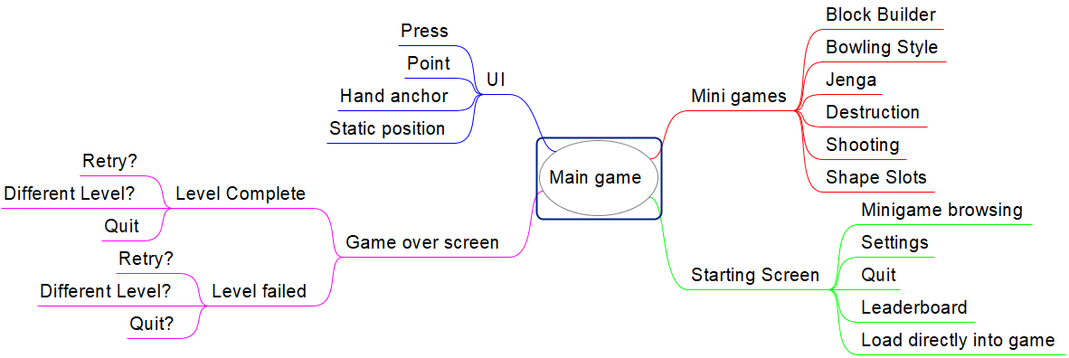
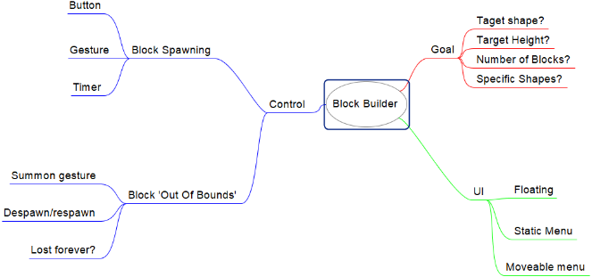
Figure 15. First mind map broad range of ideas

Figure 16. Block Builder Mind Map

It was at this early phase within the design that VR was chosen to be the platform on which this application would be created as the very nature of VR itself is almost entirely gesture driven and hand tracking is becoming closer to being a consumer level feature as technology is advancing at a rapid pace and even being incorporated within current VR technologies. There are many ways in which UIs are already implemented across all genres of VR applications therefore attempting to highlight a preferred/easier system can aid with future development within this field.
After this initial mind map phase had been completed, time was taken to refine a more specific mind map to create a more accurate scope of what is needed to meet the minimum requirements to create the application needed for the results to be gathered. A MOSCOW table was developed to help define the minimum essential requirements that are needed for a functional application that is fit for purpose, and to aid the development process and prioritise features that need to be developed.

Must Have | Should Have | Could Have | Won’t Have
Interactable Game Objects | Different Block Shapes | Sounds | Dynamically changing block sizes
Target Height | 3 different UI orientations | Difficulty Settings | Blocks that compress
UI | Timer | High score/scoreboard | Complex block shapes
Block Spawning | Block colour changing | Control to rotate around the tower | Detailed graphics
 |  |  | Controller support
Table 1. Block builder MOSCOW table
Using this MOSCOW breakdown, we can build a requirements list in the order of priority from top to bottom so that they can be implemented 1 feature at a time to help make the project feel more manageable and be able to measure progress accurately. Additionally, it ensures that all the essential features are within the program from the very beginning rather than wasting time implementing something that is not needed or will not produce the test results that are required for this project.
Requirements
Interactable Game Objects
Block Spawning
User interface
Target height for the blocks to be stacked to
3 Different orientations of the user interface
Timer
Different Block Shapes
Colour Changing Blocks
Table 2. Requirements list prioritised with top being the highest priority and bottom being the lowest
This stage of the development was very valuable as it defines the foundation on which the application is built, the specific individual requirements needed, and their priorities set out prior to implementation being commenced. Additionally, this aided with time management and the approach of the development itself by visualising the application as mini applications that needed to be created and then combined for the final, acceptable product.
With hand tracking being a focus of this study there were several game ideas initially proposed for implementation ranging from bowling style game to shooting games. Many of these concepts were eventually removed from consideration after the level of implementation was of a higher level then needed and the game’s core mechanics wouldn’t offer valuable feedback during testing to gain the results needed. This is when the ‘Block Builder’ game became a focus for this study as it’s a barebones, straight forward, and simple concept that many people are aware of as it is learnt at a very young age to stack simple primitive shapes to make a small tower. Using this basic concept, it is intended that the user would pay more attention to the functionality, UI, and any issues experienced, rather then having the focus taken away by a more engaging game. Another contributing factor to the use of basic concepts is to attempt to decrease any prior knowledge or experience with the technologies needed to be able to successfully complete the game.

Block Builder
When the Block Builder game became the focus of the development thoughts of the UI began. At this point there had been some light use of the Leap Motion Controller packages and examples seeing how the UI can be created. Using these examples as a foundation, and building on them, would be an efficient way to proceed as they accurately demonstrate the structure and functionality of the assets and scripts included within their Unity plugin package. UIs were selected and sketched to see how they could look within the application whilst keeping them basic without overwhelming the users with many buttons and setting to learn to begin to play.

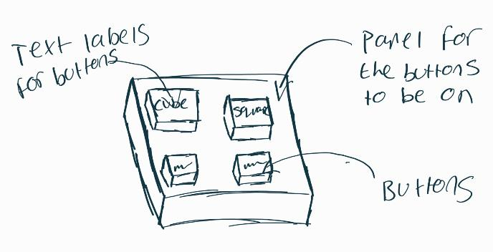

Figure 17. First sketch of the UI that can be used anchored to the hand

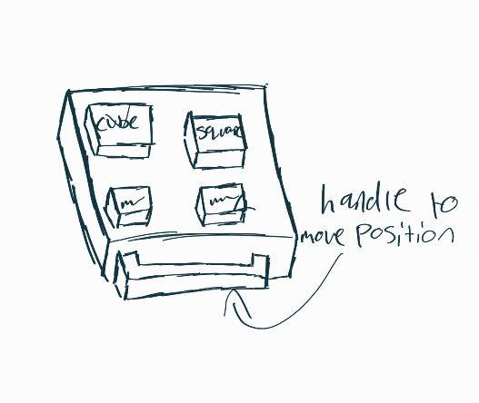

Figure 18.UI Sketch with a handle added to the bottom for the ability to mode the panel around the world to position it where comfortable

The goal of the game is to stack blocks on top of each other until the target height is reached, upon doing this the game would be completed. 3 different shapes of block were chosen to add a little more diversity to the game without over complicating the game. Additionally, this could help the user pay more attention to the UI as there are more options available then just a singular button to spawn in a block. A cube, rectangle, and cylinder were selected for use and the ability to change the colour of the next block spawned was also added. This would mean that there are 6 buttons on each of the UI, 3 for spawning blocks, 3 for changing colours.
A timer will be used to measure how long each user took to perform each level to help assist with the results and show any levels that are particularly more difficult than others. This can then be compared with the gathered feedback from the user to see if the results match.

User Interface Design
When designing the style of user interface to be used, there was a lot of focus on simplifying the number of options and selections needed for interaction with the game, as the main goal is the identify the preferred orientation of the UIs within VR. However, there needed to be enough options for the user to pay attention to the UI and interact with it more than just a singular button. A simple panel with a small number of buttons on was chosen to be used as there is not an overwhelming number of options and each one is clearly labelled for its functionality. This was then to be created in 3 separate orientations for the user Hand Anchored UI, where the UI is anchored to the left hand of the user but is only visible when the hand is oriented with the palm facing the camera, thus preventing it interfering with the application and preventing accidental presses.
Secondly, a partially static UI with a handle on the bottom enabling the user to position this panel anywhere within the virtual environment at any time. Each person is comfortable in many ways, so adding the freedom of positioning the UI could improve the usability of this design. Additionally, using the discoveries from the researched literature, gestures and VR can cause fatigue when not positioned comfortably for the user and being able to choose positioning could help to prevent this issue.
Finally, a dynamic UI that is a combination of both hand anchored and static. This would be achieved by having icons anchored to the users left hand, much like in the hand anchored UI, but when grasped and moved into the environment by the user it opens a panel up within the world that has interactable buttons available for the user to interact with. This can also be placed back into the small icon on the hand to remove the panel from the world.
This UI approach changes the way each user needs to interact with the game to complete the level without changing the game itself or any off its core features, they are all different systems with the same functionality and can be compared to find the preferred method of design to improve the user experience with the application.

Implementation
When beginning the implementation, the requirements list effectively served as a task list as it is ordered by priority. This is how the requirements list was utilised during the development as it made the visualisation of the completion of tasks and the progress made, along with the amount of work still needed to complete more visible to the developer and helped keep the development on track.
The first stages of the implementation were initially slow and steady due to the lack of experience with the hardware and software being used. This was aided using the Ultraleap documentation that is very thorough, also examples provided within their Unity plugins to show how different assets function and can be used together. When making interactable objects it was discovered that developing and then needing to test within the VR device was more difficult and time consuming then initially anticipated. This was mitigated by using a standard non-VR setup in Unity and laying the leap motion flat on a desk to enable the testing of functionality with objects and buttons to ensure they were functional before adding them into a VR environment. Using this approach, it decreased the time taken to learn and test different aspects that were created as you can simply test at any point without needing to get into the VR device and correct position with enough space to test a simple feature such as a button press, or weather a block can be picked up.
There was a difficulty in getting buttons to work within the application as there are many components and Ultraleap provided scripts that are needed to create the functionality required. This problem was solved by using the examples provided to replicate the structure of a button and which different game objects required each script. Then discovering the OnPress() function, that triggers when a button is pressed in the required amount, uses a Unity Event to execute any logic needed upon pressing. Being unfamiliar with Unity as a whole, Unity events were a new concept and required light online research to learn their functionality and how they could be used for this given problem. A GameManager empty game object was created with a Game Controller script attached. This contains all the core functions and code for the game to be running as intended, the OnPress() function can then access the functions within GameManager once it had been referenced to that script.
When creating the block prefabs for the level, there was an issue with the Cylinder as the Unity engine uses a Capsule Collider for this 3D object, meaning that the cylinder could not stand on one end as it had no flat surface on the top or bottom of the object. This could cause the cylinder to roll around, even on its end, making it impossible to stack upon each other to create a tower type structure required for this game. When this was discovered, the way it was corrected was by removing the Capsule Collider completely, and adding multiple box colliders, with each one being rotated slightly to create a round type edge around the circumference of the object. Whilst not being the most optimal fix, it was fit for purpose as it enabled the cylinder to have correct collision physics with very minimal trade off, this being the cylinder didn’t not roll as efficiently when laid horizontally. However, this was deemed not a valid point as it can still roll, just not as optimal, and there is no use for a rolling block within this application.

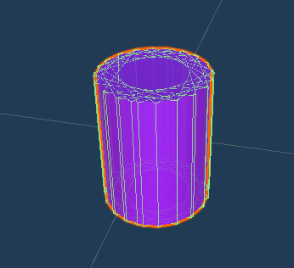
Figure 19. Cylinder using multiple box colliders for its collision

When trying to build the different user interfaces the Leap Motion plugin examples were very valuable source as they contained prefabs for buttons and how scripts should be applied to different game objects and how they are laid out in the hierarchy. Using these prefabs, it was much easier to develop each of the 3 UI orientations.

Results

Hand Anchored UI
When using the hand anchored UI users usually had the longest time with this orientation of all with an average time of 129.28 seconds. This is believed to be because it was the first test that each user undertook and the first time using the Leap Motion Controller. Therefore, the extended time used on this level should not be an indication to the orientation of the UI and its usability.
During the tests the main issue that persisted through multiple tests is the UI would sometimes spawn in when unintended, for example when a user reaches out with the left hand the UI would pop up then disappear after the hand orientation changed. However, this did not seem to cause issue to any user’s performance or experience within the game, but it has potential to cause issues when used for prolonged periods of time. This issue could be prevented by implementing some wait before the UI is called to appear to the user, for example have the palm facing the user for 3 seconds before the UI appears. This could help random pop ups of the menu for brief moments when the hand is in palm up orientation.

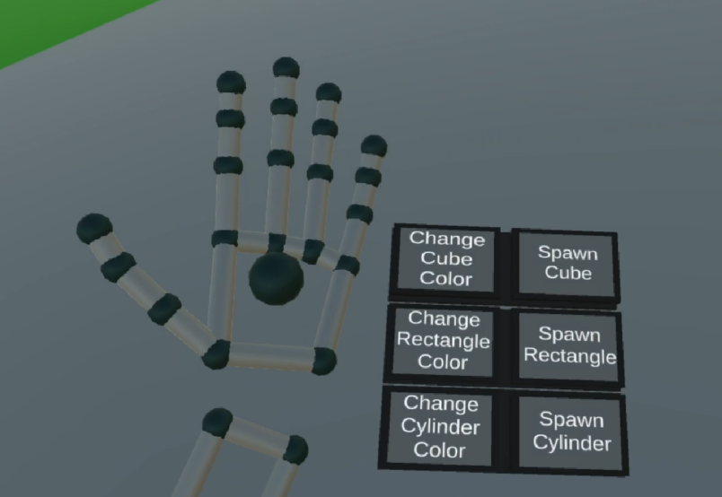

Figure 20. Hand Anchored User Interface

World UI
During the usage of the World UI users initially tended to work around the default location of the UI rather then repositioning it to a more comfortable location within the world, even if it seemed to be affecting their ability to build the tower. This made it seem like an inconvenience to the user compared to the other UI orientations as they can be placed out of view but always be in reach and accessible to the user. When moving the UI around the grasping does not always release the grab bar in a clean way, similarly to the grasping issues users experienced with the blocks and can lead the UI to be angled or rotated slightly through no fault of the user.
During the observations, it was believed that this UI would be a least favourite to many users as it is in a fixed position within the world, and this location must be returned to interact with it or remember to reposition it somewhere more convenient if this is preferred. The added time of moving to the UI to interact with it could have a small impact on the times of users during testing. However, it should be noted that majority of users tried to build more complex towers using different types of blocks during this test as they began to be more comfortable with the hardware, also impacting the time taken for completion.
The average time to complete the world UI orientation us 120.34 seconds, making it approximately 9 seconds faster than the Hand Anchored UI, even when taking into consideration the usage of more complex towers and multiple block shapes.

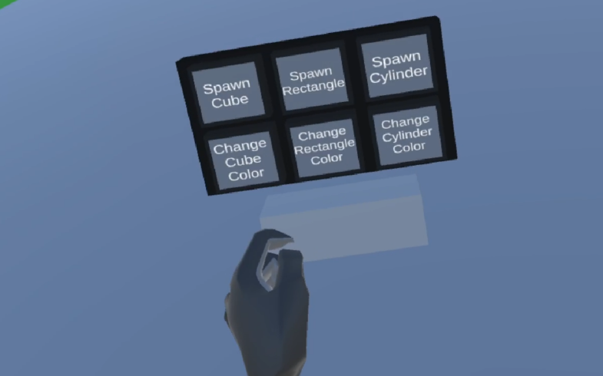
Figure 21. World user Interface

Dynamic UI
The Dynamic UI seemed to cause initial confusion for users most of the time with them not knowing how to open the menu. This can be seen when users are trying to press it like a button or push it. Additionally, there were no prompts on screen or information given to the users on how to open the menu, they were only told prior to the testing that it was a combination of the previous 2 UI orientations. However, even with these miner setbacks the dynamic UI orientation is by far the fastest average time with only 66.87 seconds to complete, making is approximately half the time of both the previous orientations.
There were no other visibly identifiable issues with the usage of the dynamic UI during the testing sessions other then previously stated. The icon for the UI could appear next to the hand at times when unintended similarly to the hand anchored UI, though this is not believed to be an issue as it is much smaller and requires the user to grasp with the other hand and remove it from its ‘slot’ to become interactable.

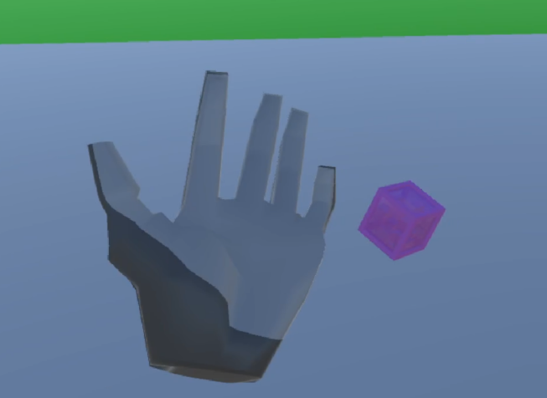

Figure 22. Dynamic User Interface Closed

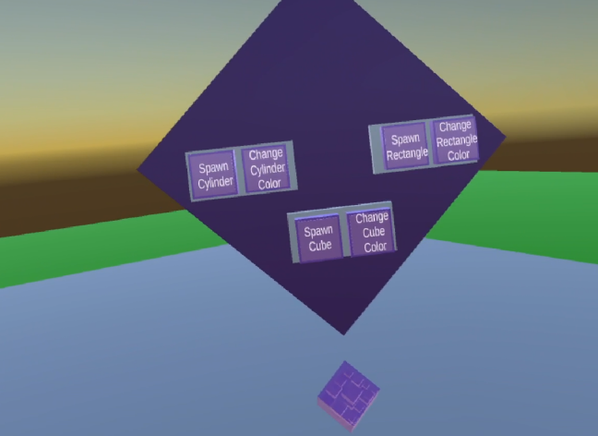
Figure 23. Dynamic User Interface Open

Overview
All the orientations of the user interface performed with little issues to the user during the tests that have been conducted. Each orientation was completed faster then the previous, in most cases, but it is believed that this is a result of the familiarity with the technology and how to interact with it to achieve the desired goal. This implies that the Leap Motion Controller, whilst being a natural user interface, still requires learning and is not just as simple as using the hands in the real world. With this information further questions could be posed such as is hand tracking easier to learn then controllers, as there could be arguments for the natural way in which the hand is used could be easier for new users to understand as its how they interact in the real world. There are many different routes that can be taken to build upon this research within future studies.
Additionally, there were several issues across all the tests and multiple users with the usage of the hand tracking and issues releasing grasped objects. When trying to release objects this could lead to several issues such as the object not being released, or the block being thrown in a random direction because of a collision that was not intended. This caused some of the users’ issues and frustration when trying to execute some actions or stack the blocks. Further investigation into the scripts and setup of the Leap Motion plug-ins for Unity to determine a fix for this issue and improve the user experience of this device for future users.
In conclusion, there is no single clear orientation of UI from this study that is preferred for the user. However, there was a least favourable orientation defined as the world UI for the reasons previously stated. The hand anchored UI and dynamic UI performed similarly during the tests, disregarding the time differences due to experience from previous tests, making them both a suitable choice for hand tracked VR games.

Questionnaires
The questionnaires result all show that the users were comfortable using and learning the UI orientations used within this project with all users scoring 4 or above for the satisfaction rate of this. Many of the users also reported issues with the blocks not releasing from the hand easily when trying to drop them causing issues and unwanted movements within the game.

Evaluation
When the observations of the testing were done, and re-evaluated using the taken recordings, it was deemed there is no clear preferred orientation from the 3 proposed by this study. However, there were indications of a least favourite, based only on observation, being the World UI. This is believed as it requires more thought to interact with it and increased the amount of time needed by moving back to the location of the UI to press buttons. Furthermore, the Leap Motion controller has shown issues when trying to release a grasped object not being registered as released, meaning the UI could be moved to unintended location or orientation within the world.
There were persistent issues with users being unable to smoothly release blocks from the hand after picking them up. After opening the hand, the block would either still appear to be grasped by the user, or it could even just collide with the hand and knock down the tower, or even be thrown in a random direction. This effected multiple users during testing. It is believed this is an issue with the implementation of the grasping gesture within the Leap Motion plug-ins and will improve with time as the technology and support for it increases.
Further research should be done within this area to aid with the identification of a preferred UI orientation such as longer tests to ensure no discomfort is present after prolonged use or testing the orientations in different orders between testers to see how the times to complete vary when done in a different order to a new user.

Conclusion
This study has been conducted with 4 main aims as stated within the introduction section. It is believed that these aims have all been met individually. A review of the relevant literature has been conducted and documented within section 2 giving background knowledge and information regarding the hardware and research already conduced relevant to this study. Following this, an appropriate solution was designed and implemented using appropriate hardware and software for the testing phase to be completed to gain results. Finally, tests were conducted with suitable users that represent and average or new user to replicate the results that users would experience when interacting with an application of this type.
After taking observations of each user interact with the 3 different proposed UI orientations there is not a clear indication to a preferred orientation in any of the tests. Each UI was used with little issues effecting the gameplay or interaction. The times suggest users were fastest when using the Dynamic UI with an average time of 66.87 seconds to complete the level. However, this is believed to be because the users became more comfortable with the technology and how to interact with it, this was also noted by users within the questionnaires.

Future work ideas
There are a number of future study possibilities that can be explored following this research. There are 3 main future work ideas the researcher believes needs exploring to gain more results regarding hand tracked VR UI. Firstly, users need to experience the UI over a more prolonged period of time to ensure there is not an unacceptable level of discomfort being created as a result of the design of the application. It should be noted that as VR is a physically active environment that fatigue will always be an issue that is experience with all prolonged users as this is the nature of this hardware.
Secondly, a similar study could be replicated but having the users test the UI in different orders to ensure the reason for the faster time with the dynamic orientation was a result of users becoming more experienced with the hardware and how to use it more efficiently. Additionally, a larger focus group can be used to gain more accurate representation of the average user.
Finally, exploration of the implementation to reduce the interaction issues that users’ experiences with blocks when trying to release them as this was a persistent issue throughout all the conducted test across all the users and UI orientations. This could require more technical knowledge of the hardware and its libraries to determine a solution for this problem.

Reflection
I feel that this project has been a successful one even though there was not a finite answer to the question that was posed. The research that has been done can be useful for future studies within this area and built upon. I think that the project did not go to plan in many ways mostly as a result of external personal problems and illness such ad Covid-19 during crucial testing stages of the study. If I was to reperform this project I would pay a larger amount of attention to the time management and pre planning areas, as it is very easy to underestimate seemingly simple tasks and taking up a large chunk of the time that was unexpected and unplanned.
I have learnt a lot of skills during this project, such as familiarity with unity, developing a VR environment for the Quest and C# unity scripting. Additionally, skills within researching and problem solving have been refined a large amount during this project which are both valuable skills that will be used throughout my whole development career.
I believe if I was to do this project a second time the main areas of improvement would be time management, and specific technical research, as there were a large number of issues encountered when using the Leap Motion Controller as the libraries were unfamiliar to me as was C#.

References

[1] | N. S. Martin Ebner, “Game-Based Learning With the Leap Motion Controller,” in Handbook of Research on Gaming Trends, 2015, pp. 555-565.
[2] | H. E. Lowood, “Britannica,” 13 May 2021. [Online]. Available: https://www.britannica.com/technology/virtual-reality/Entertainment. [Accessed 27 December 2021].
[3] | J. L. C. B. S. B. a. Y. H. Thomas G. Zimmerman, “A Hand Gesture Interface Device,” California, 1987.
[4] | D. L. Gardner, “The Power Glove,” Design News, vol. 45, no. 23, p. 63, 1989.
[5] | M. C. Kathleen Sanders, “IGN,” IGN, 16 June 2012. [Online]. Available: https://www.ign.com/articles/2006/09/14/us-wii-price-launch-date-revealed. [Accessed 27 December 2021].
[6] | D. R. S. R. W. H. W. E. J. K. E. S. a. M. S. W. Spencer L. Tomarken, “Motion Tracking in Undergraduate Physics Laboratories with the Wii Remote,” 2012.
[7] | Guinness, “guinnessworldrecords,” 3 january 2011. [Online]. Available: https://www.guinnessworldrecords.com/world-records/fastest-selling-gaming-peripheral. [Accessed 29 December 2021].
[8] | B. Hester, “Polygon,” 14 January 2020. [Online]. Available: https://www.polygon.com/2020/1/14/21064608/microsoft-kinect-history-rise-and-fall. [Accessed 29 December 2021].
[9] | W. Zeng, “Microsoft Kinect sensor and its effect,” Multimedia at work.
[10] | K. Stuart, “Guardian,” 10 January 2012. [Online]. Available: https://www.theguardian.com/technology/gamesblog/2012/jan/10/kinect-for-windows-launch?newsfeed=true. [Accessed 29 December 2021].
[11] | M. D. L. C. a. P. H. Michal Tölgyessy, “Evaluation of the Azure Kinect and Its Comparison to Kinect V1 and Kinect V2,” Snesors, vol. 21, no. 2, p. 413, 2021.
[12] | Microsoft, “Azure,” Microsoft, [Online]. Available: https://azure.microsoft.com/en-gb/services/kinect-dk/#overview. [Accessed 30 December 2021].
[13] | Microsoft, 18 May 2020. [Online]. Available: https://customers.microsoft.com/en-gb/story/810722-tempo-health-provider-azure-kinect. [Accessed 30 December 2021].
[14] | Microsoft, 18 May 2020. [Online]. Available: https://customers.microsoft.com/en-gb/story/810724-ocuvera-health-provider-azure-kinect. [Accessed 30 December 2021].
[15] | Ultraleap, “Ultraleap,” [Online]. Available: https://www.ultraleap.com/product/leap-motion-controller/. [Accessed 15 December 2021].
[16] | D. B. B. R. a. D. F. Frank Weichert *, “Analysis of the Accuracy and Robustness of the Leap,” Sensors, vol. 13, no. 5, pp. 6380-6393, 2013.
[17] | Ultraleap, “Ultraleap for Developers,” [Online]. Available: https://docs.ultraleap.com/hand-tracking/. [Accessed 15 December 2021].
[18] | Utraleap, “Ultraleap,” Ultraleap, [Online]. Available: https://www.ultraleap.com/product/vr-developer-mount/. [Accessed 28 JanuarY 2022].
[19] | E. R. C. G. Ching-Hua Chuan, “American Sign Language Recognition Using Leap Motion Sensor,” Florida.
[20] | A. C. L. M. S. Christianne Falcao, “Evaluation of Natural User Interface: A Usability Study Based on The Leap Motion Device,” Procedia Manufacturing, no. 3, p. 5490 – 5495, 2015.
[21] | A. H. a. C. G. Johanna Pirker. Mathias Pojer, “Gesture-based Interactions in Video Games with the Leap Motion Controller,” 2017.
[22] | Merriam-Webster, “Merriam-Webster,” [Online]. Available: https://www.merriam-webster.com/dictionary/virtual%20reality. [Accessed 15 December 2021].
[23] | HTC, “HTC,” 2016. [Online]. Available: https://www.htc.com/us/newsroom/2016-06-07/. [Accessed 21 December 2021].
[24] | A. Souppouris, “engadget,” 18 March 2016. [Online]. Available: https://www.engadget.com/2016-03-18-htc-vive-an-oral-history.html. [Accessed 21 12 2021].
[25] | Vive, “blog.vive,” HTC, 25 October 2017. [Online]. Available: https://blog.vive.com/us/2017/10/25/roomscale-101/. [Accessed 21 December 2021].
[26] | L. L. M. L. Diederick C. Niehorster, “The Accuracy and Precisionh,” i-Perception, pp. 1-23, 2017.
[27] | HTC, “VIVE,” HTC, [Online]. Available: https://www.vive.com/uk/product/vive-pro-full-kit/. [Accessed 23 December 2021].
[28] | HTC, “Vive,” HTC, [Online]. Available: https://www.vive.com/uk/product/vive-pro2-full-kit/overview/. [Accessed 23 December 2021].
[29] | HTC, “Vive,” HTC, [Online]. Available: https://www.vive.com/uk/product/vive-cosmos/overview/. [Accessed 23 December 2021].
[30] | S. Hayden, “roadtovr,” 6 August 2020. [Online]. Available: https://www.roadtovr.com/htc-vive-cosmos-accuracy-test-controller/. [Accessed 24 December 2021].
[31] | HTC, “Vive,” HTC, [Online]. Available: https://www.vive.com/uk/product/vive-cosmos-elite/overview/?wpsrc=Google%20AdWords&wpcid=13612771621&wpsnetn=g&wpkwn=vive%20cosmos%20elite&wpkmatch=e&wpcrid=529206009109&wpscid=125588197602&wpkwid=kwd-880195910543&gclid=Cj0KCQiA_JWOBhDRARIsANymNOY8FtJSUt8. [Accessed 24 December 2021].
[32] | Valve, “valvesoftware,” [Online]. Available: https://www.valvesoftware.com/en/index. [Accessed 23 December 2021].
[33] | Valve, “valvesoftware,” [Online]. Available: https://www.valvesoftware.com/en/index/controllers. [Accessed 23 December 2021].
[34] | Meta, “Oculus,” [Online]. Available: https://www.oculus.com/quest-2/?utm_source=gg&utm_medium=ps&utm_campaign=15215862691&utm_term=quest%202&utm_content=561155179674&utm_ad=133217893127&utm_location=1007418&utm_location2=1007440&utm_placement=kwd-299553308559&utm_device=c&utm_matchtype=e&utm. [Accessed 28 December 2021].
[35] | Meta, “Support.oculus,” [Online]. Available: https://support.oculus.com/articles/accounts/privacy-information-and-settings/hand-tracking-privacy-notice. [Accessed 28 December 2021].
[36] | C. Wheatstone, “Contributions to the Physiology of Vision - Part the First,” Philosophical Transactions of the Royal Society of London, vol. 128, pp. 371-394, 1838.
[37] | C. Wheatstone, “Contributions to the Physiology Of Vision - Part the Second,” Philosophical Transactions of the Royal Society of London, vol. 142, pp. 1-17, 1852.
[38] | E. A. Link, “Combination Training Device for Student Aviators and Entertainment Apparatus”. United States of America Patent 1,825,462, 21 September 1931.
[39] | ASME Interntional, The Link Flight Trainer: A Historical Mechanical Engineering Landmark, New York: ASME International, 2000.
[40] | M. Helig, “The Cinema of the Future,” pp. 239-251, 1955.
[41] | Whitney Publications, Industrial Design, Whitney Publications, 1964.
[42] | M. J. Heilig, “Stereoscopic-television Apparatus for Individual Use”. United States of America Patent 2,955,156, 24 May 1957.
[43] | C. M. H. T. Luhur Sapto Pamungkas, “Virtual Realitty As A Spatial Experience For Architecture Design: A Study of Effectiveness for Architecture Students,” SHS Web Of Conferences, vol. 41, 2018.
[44] | M. E. a. N. Spot, “Game-Based Learning With the Leap Motion Controller,” Handbook of Research on Gaming Trends, pp. 555-565, 2015.
[45] | F.-R. S. a. N.-S. Chen, “A Review of Gesture-Based Computing Research in Education,” Computers and Education, vol. 78, no. 268-277, 2014.
[46] | M.-C. H. a. J.-J. Lee, “Preliminary Study of VR and AR Applications in Medical and Healthcare Education,” Journal of Nursing and Health studies, vol. 3, no. 1, 2018.
[47] | N. Z.-A. D. M.-C. R. L.-V. E. O.-G. M. C. O.-P. Irene Cortés-Pérez, “Leap Motion Controller Video Game-Based Therapy for Upper Extremity Motor Recovery in Patients with Central Nervous System Diseases. A Systematic Review with Meta-Analysis,” Sensors, vol. 21, no. 2065, 2021.
[48] | B. Schneiderman, “Promoting Universal Usability with Multi-Layer Interface Design,” Assosiation for Computing Machinery, New York, 2002.
[49] | S. Krug, Don't Make Me Think, 2014.
[50] | Y. W. J. C. Y. W. J. Y. T. J. a. J. H. Yahui Wand, “Investigating the Performance of Gesture-Based Input for Mid-Air Text Entry in a Virtual Environment: A Comparrison of Hand-Up versus Hand-Down Postures,” Sensors, vol. 21, no. 1582, 2021.
[51] | J. R. Lewis, “Usbility Testing,” IBM Software Group, Florida, 2006.
[52] | C. H. M. M. K. Z. Marcio C. Cabral, “Usability of Gesture Interfaces in Virtual Reality Environments”.
[53] | K. J. &. S. A. Y. Wiklund, Usability testing of medical devices (Second edition.), London: CRC Press, Taylor & Francis Group., 2016.
[54] | S. Campbell, “What is Qualitative Research?,” Journal of the American Society for Medical Technology, vol. 27, no. 3, 2014.
[55] | A. L. S. Barney G. Glaser, The Discovery of Grounded Theory, Aldine Transaction, 1967.
[56] | S. Khan, “Qualitative Research Method: Grounded Theory,” International Journal of Bussiness and Managment, vol. 9, no. 11, 2014.
[57] | M. Hammersley, Reading Ethnographic Researc: A critical Guide 2nd editon, New York: Routledge, 1998.
[58] | B. Gillham, Case Study Research Methods, Bloomsbury Publishing, 2000.
[59] | C. Moustakas, Phenomenological Research Methods, Sage Publications, 1994.
[60] | C. S. a. M. T. Molly Andrews, Doing Narrative Research Second Edition, Sage Publications, 2013.
[61] | C. Williams, “Research Methods,” Journal of business & Economic Research, vol. 5, no. 3, 2007.
[62] | R. C. R. a. J. D. Klein, “Developmental Research Methods: Creating Knowledge From Instructional Design and Devlopment Practice,” Journal of Computing in Higher Education, vol. 26, no. 3, pp. 23-38, 2005.
[63] | S. M. R. a. G. R. Morrison, “Experimental Research Methods,” Handbook of Research on Educational Communiccations Technology, vol. 2, pp. 1021-1043, 2004.
[64] | R. B. J. a. L. A. T. Larry B. Christenden, Research methods, Design, and Analysis, Pearson, 2015.
[65] | L. Gaille, “Vittana,” Vittana, 13 April 2017. [Online]. Available: https://vittana.org/16-advantages-and-disadvantages-of-experimental-research. [Accessed 10 04 2022].
[66] | Meta, “Meta,” Meta, [Online]. Available: https://about.facebook.com/actions/. [Accessed 20 04 2022].
[67] | Ultraleap, “Ultraleap for developers,” Ultraleap, [Online]. Available: https://developer.leapmotion.com/tracking-software-download. [Accessed 29 03 2022].
[68] | Ultraleap, “Ultraleap,” Ultraleap, [Online]. Available: https://developer.leapmotion.com/unity. [Accessed 19 04 2022].
[69] | Ultraleap, “Ultraleap,” Ultraleap, [Online]. Available: https://docs.ultraleap.com/unity-api/. [Accessed 19 04 2022].
[70] | Ultraleap, “Ultraleap for developers,” Ultraleap, [Online]. Available: https://blog.leapmotion.com/leapuvc/. [Accessed 22 04 2022].
[71] | Ultraleap, “Ultraleap,” Ultraleap, [Online]. Available: https://www.ultraleap.com/leap-motion-controller-whats-included/. [Accessed 22 April 2022].
[72] | Used Plus, “Used Plus,” [Online]. Available: https://www.used.plus/products/htc-vive-full-kit?variant=28825850314829&currency=GBP&utm_medium=product_sync&utm_source=google&utm_content=sag_organic&utm_campaign=sag_organic&gclid=Cj0KCQjwpImTBhCmARIsAKr58cz62S1jLrC6Kl8DNVAUBU9PeXJk856bb_W4QWDeX6O-l3q-Y. [Accessed 22 april 2022].
[73] | M. Higam, “Gamespot,” 06 June 2019. [Online]. Available: https://www.gamespot.com/articles/valve-index-impressions-a-necessary-but-incrementa/1100-6467377/. [Accessed 22 April 2022].
[74] | Argos, “Argos,” [Online]. Available: https://www.argos.co.uk/product/9461987?istCompanyId=a74d8886-5df9-4baa-b776-166b3bf9111c&istFeedId=30f62ea9-9626-4cac-97c8-9ff3921f8558&istItemId=piwipirqx&istBid=t&&cmpid=GS001&_$ja=tsid:59130%7cacid:289-152-2757%7ccid:599609992%7cagid:24126986217%7ctid. [Accessed 22 April 2022].
[75] | D. E. Burt, “Virtual reality in anaesthesia,” British journal of anaesthesia , 1995.
[76] | Wikipedia, “Wikipedia,” [Online]. Available: https://en.wikipedia.org/wiki/Power_Glove. [Accessed 22 April 2022].
[77] | Nintendo, “Nintento Wii,” Nintendo, [Online]. Available: https://www.nintendo.co.uk/Wii/Wii-94559.html. [Accessed 05 April 2022].
[78] | S. Bouchard, “Robotiq,” 16 August 2011. [Online]. Available: https://blog.robotiq.com/bid/40428/Using-The-Kinect-For-Robotic-Manipulation. [Accessed 05 April 2022].
[79] | Microsoft, “Azure Kinekt DK,” [Online]. Available: https://www.microsoft.com/en-us/d/azure-kinect-dk/8pp5vxmd9nhq?activetab=pivot:overviewtab. [Accessed 05 April 2022].

Appendix

Unity Scripts
GameController.cs
using System.Collections;
using System.Collections.Generic;
using UnityEngine;
using UnityEngine.UI;

public class GameController : MonoBehaviour
{

//Location used to spawn a block
public Transform cubeLoc;
public Transform rectangleLoc;
public Transform cylinderLoc;

//Variable to hold amount of time elapesd
public float timeElapsed = 0;

//reference to bool stating if level has been completed
public GameObject flag;

//reference to level complete UI
public GameObject completedLevelUI;

//reference to prefab manager for material changes
public PrefabManager prefabs;

//variable to define color choice
private int choice = 0;

//-------------Spawn cylinder--------------------
public void spawnCylinder()
{
GameObject.Instantiate(prefabs.prefabs[2], cylinderLoc);
}
//Change the color of the cylinder
public void changeCylinderMaterial()
{
prefabs.setMaterial(2, choice);
}
//makes sure the value for color is always between 0-3 as there are only 4 availible colors
public void selectCylinderColor()
{
if (choice == 3)
{
choice = 0;
changeCylinderMaterial();
}
else
{
choice++;
changeCylinderMaterial();
}
}

//-------------Spawn rectangle, change rectangle color --------------------
public void spawnRectangle()
{
GameObject.Instantiate(prefabs.prefabs[1], rectangleLoc);
}

public void changeRectangleMaterial()
{
prefabs.setMaterial(1, choice);
}

public void selectRectangleColor()
{
if (choice == 3)
{
choice = 0;
changeRectangleMaterial();
Debug.Log(choice);
}
else
{
choice++;
changeRectangleMaterial();
Debug.Log(choice);
}
}

//------------------------------------------------------------------------------

//-----------------Spawn cube, change cube color----------------------------------
public void spawnCube()
{
GameObject.Instantiate(prefabs.prefabs[0], cubeLoc);
}

public void changeCubeMaterial()
{
prefabs.setMaterial(0, choice);
}

public void selectCubeColor()
{
if (choice == 3)
{
choice = 0;
changeCubeMaterial();
Debug.Log(choice);
}
else
{
choice++;
changeCubeMaterial();
Debug.Log(choice);
}
}

public void gameTimer()
{
//Begins a timer that continuously counts untill the game is complete
if(flag.GetComponent<TowerHeight>().gameComplete == false)
{
timeElapsed += Time.deltaTime;
Debug.Log(timeElapsed);
}

}
//if the level is complete enable the level complete screen
void gameOver()
{
if (flag.GetComponent<TowerHeight>().gameComplete == true)
{
//level over
completedLevelUI.SetActive(true);
}
}
//update function called every frame
private void Update()
{
gameTimer();
gameOver();
}

}

PrefabManager.cs

using System.Collections;
using System.Collections.Generic;
using UnityEngine;

public class PrefabManager : MonoBehaviour
{
//set public arrays to hold prefabs and materials that can be populated within the unity editor
public GameObject[] prefabs;
public Material[] materials;
//function to select what prefab and material to use
public void setMaterial(int prefabIndex, int materialIndex)
{
prefabs[prefabIndex].GetComponent<Renderer>().material = materials[materialIndex];
}
}

TowerHeight.cs

using System.Collections;
using System.Collections.Generic;
using UnityEditor;
using UnityEngine;

public class TowerHeight : MonoBehaviour
{
public bool gameComplete = false;

private float startTime;

//Check if a block has entered the height trigger
private void OnTriggerEnter(Collider other)
{
if (other.gameObject.CompareTag("Block"))
{
Debug.Log("Target height");
startTime = Time.time;
}
}
//whilst the block is inside the trigger check if it has been inside for moe then 3 seconds, if yes, level completed
private void OnTriggerStay(Collider other)
{
if (other.gameObject.CompareTag("Block") && gameComplete != true)
{
//check if stayed inside the trigger for 3 seconds
if (Time.time <= startTime + 3)
{
Debug.Log("You Win!");
gameComplete = true;
}
}
}

}

