DEVELOPING WORKPLACE CRITICAL THINKING
Student Name: Rabia Miah
Student Number: 1605763
Module Number: BMSK5001

Module Title: Developing workplace critical thinking
Lecturers Name: Molly Jack

Contents
Introduction: 5
Company overview: 5
Identification of management theory and the impact of beliefs, values, and attitudes: 6
Administrative theory of Henry Fayol: 6
Explanation of my role with the administrative management theory: 9
The reason for selecting the administrative management theory: 10
F. W. Taylor’s scientific management theories: 10
Classical management theory: 11
Distinguish among belief, attitudes, and values 11
The relationship between beliefs, values, and attitudes: 11
Differences among beliefs, values and attitude: 13
Impact on beliefs, values, and attitudes on workplace behavior: 15
Explanation of the impact of workplace attitude: 15
Belief: 15
Types of beliefs: 16
Values: 16
Attitude: 18
Components of attitude: 18
Impact of beliefs, values and attitudes: 18
A range of management theories to my role in the workplace: 20
Contingency theory: 21
Maslow’s hierarchy of needs: 22
Conclusion: 24
References 25

Introduction:
The efficiency of the workplace relies on how the managers, stakeholders, and employees are taking the organizational culture. Their own beliefs, attitudes, and values within the workplace have an influence on the organizational structure, culture, and internal communication. However, the aim of the following discussion is to develop a critical approach to workplace-based thinking that will be based on the theoretical model of management (Schmitz, 2015). The discussion will focus on distinguishing among beliefs, attitudes, and values in the workplace context of Primark, critically assessing their impact on the workplace behavior. Lastly, there will be an application of the critical assessment of appropriate management with a view to evaluating the differences in belief, attitudes, and values interpreting with the theories differently.

Company overview:
Primark is an Irish fashion retailer that was established in 1969 with headquarter in Dublin and operating in the UK with 4% sales growth heading to be the second giant in the clothing industry of the country overtaking Next. Highly ethical practices in maintaining a strong bond with both the internal and stakeholders are the main reason for their faster success. However, the company is operating with 368 stores offering clothes, cosmetics, and housewares operating in 13 countries (Primark.com, 2018).

Identification of management theory and the impact of beliefs, values, and attitudes:
Management refers to the planning, organization, coordination, measuring and controlling the organizational resources to attain a particular organizational goal. Human resource is considered as the blood of the organization that helps the company to implement the planning of the business activities. Therefore, the individual beliefs, values, and attitude of the employees possess a significant impact on the organizational culture and core values of the organization with the increasing concern of the customers over the ethical behavior of the company the concern of the employment right has got importance (Campling, 2008). However, Primark, the second largest fast fashion retailer of the UK can use the following management theories to shape the beliefs, values, and attitudes of the individual.

Administrative theory of Henry Fayol:
The administrative management theory has explained the management process with five elements, such as, planning the structural plan of action with the identification of the goals and objectives of management of Primark, organizing the economic and capital resources needed to implement the planning, commanding or leading the human resources of the organization motivating them with the incentives to ensure their full engagement to the achievement of the organizational goal where the individual beliefs, values, and attitude have a strong impact to shape the organizational culture and structure, coordinating the capital resources and human resources with the organizational goal, and lastly, controlling the outcome of the four stages with the organizational objectives that have been set in the planning stage (Schroeder and Kardoff, 2014).
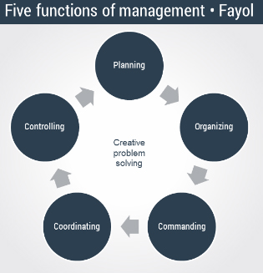
Figure 1: five functions of management
Source: (Buchanan and Huczynski, 2017)
However, the administrative management theory suggests 14 principles that can be used as the guideline to shape and combine the individual beliefs, values, and attitude to attain the organizational goals and objectives
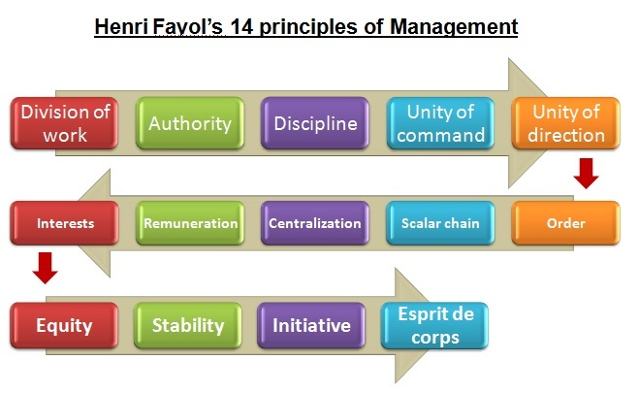
Figure 2: Principles of administrative management theory
Source: (Campling, 2008)
Fayol has suggested dividing the tasks and actions according to the skills, attitudes, and capabilities of the employees. Primark ensures the right person in the right place in the organization according to the abilities and performance of employees and managers. It helps the employees to perform their responsibilities with appropriate empowerment and authority. Discipline helps to manage the lean manufactory process of the company in spite of the thinner power distance where the impact of the organizational culture on shaping the employee attitude has played a significant role. With the proper management of the flow of the author to command others, Primark has managed the chain of command. The group behavior and the role culture has eased the company to maintain the chain of command. All the stores, top management, and the authorities direct the employees to the single purpose that helps the company to maintain the unity of direction too and create a consistent attitude among the employees of Primark. The encouragement of the manager to the group behavior and the role culture established in the organization persuades the employees to the subordination of their personal interest to the general interest. Positive attitude and behavior of the employees have helped to ensure the full participation of the company avoiding the short-term absenteeism (Management Insights, 2011).
Primark has successfully established a belief among the employees and the suppliers that they are going to pay a fair remuneration for their contribution to the company and the improvement of their performance will improve the standard of the remuneration contributes to the increase in the experience curve of the company indirectly. The company maintains the hierarchy of the organizational structure but the flat organizational structure has simplified the process. The right choice of the individual and the assessment of their performance according to their skills and competencies. The job security in the Primark is higher than other retailers that helps the company to minimize their cost of recruitment and training the employees. as stated previously that the company encourages the employees to take part in the decision making process and provides the the freedom to make their own decision that is good for the company to achieve its goal. This freedom of making decision provides an acknowledgment to the employee’s effort that inspires them to think out of the box to improve the performance of the company along with increasing the efficiency of production and operation (Kochan and Schmalensee, 2014).

Explanation of my role with the administrative management theory:
I have played the role of the store manager in one of the store of Primark in London. I have applied the administrative management theories that help me to understand the skills and competencies of the subordinates in the stores contributing to identifying the right place for them. I have divided the employees into different groups and left the decision of taking group mate on them. The team leader has the allowance to contact with the store managers while formal communication that helps to maintain the discipline and the unity of command. To ensure the unity of direction, all the subordinates were educated with the core values, vision, mission and the target of the organization to this purpose. I have ensured the right order of the employees of my store with the proper assessment of their competency and role in achieving the goal of the team and the organization to avoid glass ceiling ensuring equal opportunities. The decision making process in our store is partly decentralized in case of choosing the target for the company or making any significant changes, the decision making process depends on the central or regional manager. The remuneration process of Primark is highly fair and ethical and the role culture has helped to make sure the proper assessment of the performance of the employees. I have used the democratic leadership style to encourage the employees to subordinate their own interest and focus on the interest of the company. The equity of the authority and low power distance has helped the stuff in my store take initiative if it is needed (Chitale, 2013). However, to apply the administrative theory of management I have to face the problem of self-reference criterion and high ethnocentrism in managing the performance of the group along with the assurance of the cultural diversity.

The reason for selecting the administrative management theory:
To understand the significance of the administrative management theory regarding in managing the workplace at Primark, the other theories need to be assessed properly, therefore the classical theory of management and the F.W. Taylor’s scientific management theories needed to be assessed

F. W. Taylor’s scientific management theories:
This theory is the first theory of management that has focused on the outcome or the performance of the organization managing and directing the human resources appropriately maintaining strategies to attain the organizational goal with higher efficiency. It is the most ancient theory of management. Primark operates in 13 countries with excessive cultural diversity that makes the management strategy of the company further difficult as it has to consider the group behavior according to the culture of the employee from the same region along with their personal differences. Therefore, to ensure the minimum productivity of the company, the managers of Primark can use the scientific management theory considering the four principles it has emphasized that are to replace the working with a rule of thumb assigning the job according to competency of the employee, monitoring their performance with supervision and instruction and lastly allocating the responsibilities to the managers and employees helping them to plan, train and allow the employees to perform efficiently (Campling, 2008). All of these rules are included in the administrative theory of management. Because of commonality among them, I have chosen the administrative theory of management to perform my role of store management.

Classical management theory:
The simplest management theory is the classical management theory that believes that the employees are working for their physiological need to be fulfilled and this theory follows the centralized decision making process with the minimum involvement of the employees in the decision making process. It emphasizes the economies of scales experience curve with the specialization of labor with a motto of profit maximization. The role of human resource management is completely avoided in this management theory (Mondy and Martocchio, 2016). Therefore, it is now in vogue to use in managing the workplace as the concern over the right of the employees has been improved.

Distinguish among belief, attitudes, and values
As stated above in the previous initiation that an individual’s belief attitude and values have a significant influence on his behavior in the organization. In this discussion, the relationship and the differences among these terms will be assessed. Beliefs, values, and attitude are interrelated to form a particular behavioral pattern of an individual and it contributes to shaping the group behavior and ultimately in formulating the organizational culture.

The relationship between beliefs, values, and attitudes:
As discussed before the core values of an individual is formed by his set of beliefs to something. In the same way, the attitude of a person is made of the core values of the person. In the following figure, the interrelation among these three terms are going to be explained in a nutshell-
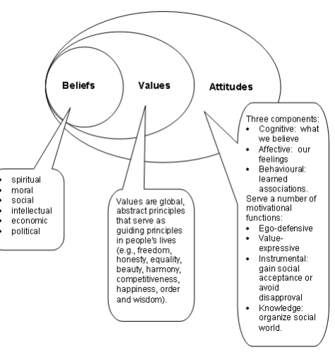
Figure 2: the interrelation among beliefs, values, and attitude
Source: (Chitale, 2013)
The set of spiritual, moral social intellectual, economic, political belief the individual forms the values towards something or about any matter. Different core values like freedom honesty equality harmony, happiness, competitiveness etc. contribute to form an attitude towards something previously before experiencing the situation or the products.
Primark helps their employees and molds their belief, contributing to the values, and that has resulted in the assurance of the full engagement of the employees to the organizational objectives. The less structured task pattern, role culture, and the thinner power distance have helped the manager to this purpose of creating a positive attitude person. The employee involvement, continuous development, and especially the lean manufactory process helps the company to this purpose that ultimately has resulted in strong expertise in maintaining the experience curve of the company (Buchanan and Huczynski, 2017).

Differences among beliefs, values and attitude:
Beliefs | Values | Attitude
the idea that an individual held to be true | the long lasting beliefs of the person on the particular matter, subject, or about what is important for the person | the mental set up of a person towards the events or a certain situation, and to other previously before the decision making circumstances arrives
Based on certainties, probabilities or the matter of faith | Based on the beliefs that are durable and contributes to the formulation of the attitude in the long run | Based on the core values that a person has built
Sources of beliefs are  - Past experience  - Social and cultural norms  - Peer group influences | Sources of values:  - Religion  - Family  - Friends  - Peers  - Media  - School | Sources of attitude:  - Emotions  - Behaviors  - Thoughts
Types of beliefs:  Spiritual  Moral  Social  Intellectual  Economic  Political | Types of values:  Core values of life  Corporate values | Types of attitudes:  Positive  Negative  Neutral
Table 3: the differences among beliefs, values, and attitude
Source: (Buchanan and Huczynski, 2017)

Impact on beliefs, values, and attitudes on workplace behavior:

Explanation of the impact of workplace attitude:

Belief:
It refers to the idea that an individual held to be true and it is based on certainties, probabilities or the matter of faith (Buchanan and Huczynski, 2017). An individual forms belief from his past experience on that particular event or matter, with the cultural and social norms and formulates by mentoring or education. The sources of the beliefs are,
Past experience
Social and cultural norms and acceptance
Peers influence
Education
Religion
Organizational culture
Table 1: the sources of belief
Source: (Burns, 2012)
Primark tries to formulate the belief of their employees to improve the workplace environment shaping the organizational behavior of the identical person. The fair trade practices and the flat organizational system have assisted the firm to form a belief among the employees that the company is maintaining fairness of treatment with them avoiding the glass ceiling, and allows whistleblowing to eradicate the misuse of empowerment and workplace security.

Types of beliefs:
There are different types of beliefs that ultimately contributes to the formulation of the core values of life and corporate values also. Primark considers the following beliefs while planning the organizational values behavior and culture.
Spiritual belief: the belief formed by the teaching of religion and philosophy of the core theory of life is called the spiritual belief.
Moral: the rules that distinguish and establishes the perception of right and wrong
Social: the faith created with the influence of society and social rule
Intellectual: the faith created with the conscience of the individual in a logical way
Economic: the belief created with the economic ups and downs of life is considered as the economic belief
Political: the beliefs about the politics in the organization group, and society is called the political belief
Table 2: types of belief
Source: (Chitale, 2013)

Values:
Value of an individual reflects the long-lasting beliefs of the person on the particular matter, subject, or about what is important for the person. It shows that belief plays the role of the source of value to this purpose and it grows with the person’s increasing commitment as long as he considers it important. it is an abstract and global principle serving as the guideline of an individual’s life (Giuliani and Kurson, 2015).
Primark helps their employees to form values and beliefs with the organizational value helping them to choose the core value maintaining an ideal set of criteria and alternative using the following format
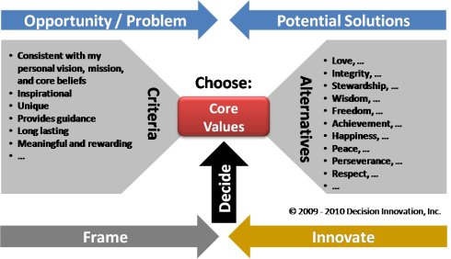
Figure 3: formulation of core value
Source: (Kochan and Schmalensee, 2014)
The above figure shows the way a person can formulate his core values in liaison with the organizational value and culture. To ensure the positive result of the career development process in the workplace maintaining the organizational value and culture, the individual should form the core values consciously in a structured way. While choosing core values according to the organizational value, the individual should combine it according to the personal vision, mission, core beliefs discussed in the previous discussion. The values must be inspirational for the person and his peer and reference group too. The unique core values can differentiate the person in the group with a significant impact on the role he is going to play in the group performance. The core values must provide the guidance of life directing the person to achieve the personal goal of life contributing to the long-term vision of the company and in case of Primark, the core general values of the employees represent the culture and values of the company. As per the definition of value, it is the long lasting belief of an individual that emphasizes that the durability of the core values. They must be meaningful and rewarding to build an attitude contributing to the efficiency of the employee or the personnel (Management Insights, 2011).
There are some alternatives that can help to ease the process of choosing the core values. Love including patience kindness, forgiveness, trust, selflessness, compassion and protection; integrity, stewardship, wisdom with intelligence understanding insight, and perception; freedom achievement, happiness, peace, perseverance, and respect are the alternative core values that must be present to be successful in group performance focused by Primark in their creative activities specially. Assessing the criteria and alternatives the individual takes the decision on the set of core values to be chosen.

Attitude:
Attitude refers to the mental set up of a person towards the events or a certain situation, and to other previously before the decision making circumstances arrives. The result of attitude is the behavior of a person that is influenced by the beliefs and values of the individual. The attitude towards something can be positive negative or neutral that arises from an inner framework of values and beliefs that are developed with the lapse of time. Attitude is actually the readiness of the psyche of acting and reacting in a distinct way (Burns, 2012).

Components of attitude:
There are three components of attitude, such as emotions, behaviors, and thoughts. The emotional response of the person can be considered as the effective behavior; whereas, when the individual evaluates all the factors influenced the facts based on the internal system and response accordingly, it is called the cognitive response. Lastly, the behavioral response is the result of the verbal and behavioral tendency of the individual.

Impact of beliefs, values and attitudes:
The beliefs are the basement of my values that creates my attitude towards the particular circumstances of the company that ultimately results in the behavior. the following figure is going to show the impact of beliefs, values, and attitudes of the individual employee on the workplace behavior.
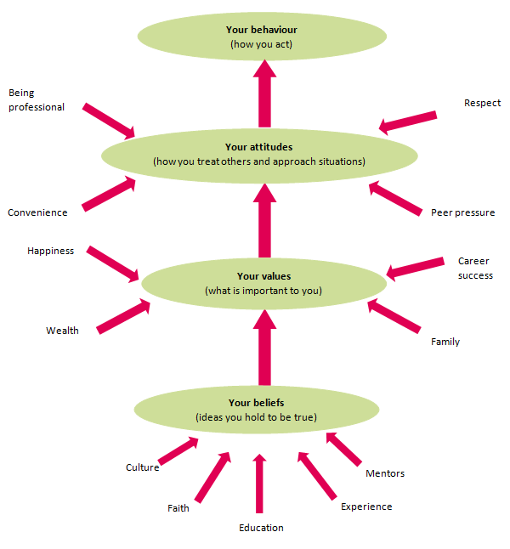
Figure 4: the interrelationship among beliefs values and attitudes in resulting expected behavior
Source: (Burns, 2012)
Primark has availed their employees with the facilities of personal development with full participation in the decision making process with proper empowerment the flat organizational culture has encouraged the informal communication process between the managers and employee that decreases the power n the at distance and emphasizes the role culture assessing the role of an individual in the attainment of the group goal or the organizational goal. We the employees are helped to get a positive understanding from the organization of working together and the significance of cooperation that improves our social belief. The set of positive belief creates our strong pluralistic value that enhances the group or team efficiency and directs the team to the single goal spontaneously. Our value of career success and happiness with the achievement of the organizational goal contributes to the positive attitude towards the decision of the organization. But because of the decline on the security and safety issues in the stores of the company with the fire broke in 28th August 2018, there is negative attitude spreads among the employees. These macro-environmental forces are hindering their success in getting full engagement of the company towards achieving the organizational goal. However, the positive attitude towards the company has resulted in our human transaction and full involvement and participation in the decision making process of the company. The company is maintaining the quality of the products along with the lower price and that has been possible because of their expertise in managing human resources ensuring their full participation with the lean manufactory process. The company has to incur a huge cost when the Rana Plaza tragedy has broken out. However, the company’s effort to make sure the employment right with the fair trade policy has strengthened the positive attitude and extracted the favorable behavior of the employees (Management Insights, 2011).

A range of management theories to my role in the workplace:
As described before that my role is the store manager of Primark in London and I have used the administrative theory of management by Henry Fayol that had allowed me to follow the proper breakdown of the tasks providing the responsibilities to the right person with adequate empowerment. The chain of command has been maintained with the flat organizational hierarchy and the informal communication process. The company’s human resource policy has also facilitated me to this purpose as the remuneration process is too fair to motivate the employees to improve the economies of scale and maintain the experience curve that is one of the most significant competitive edges of the retailer. However, to manage my role more appropriately, I have used more motivation theories and leadership theories of management (Schmitz, 2015).

Contingency theory:
To ensure the appropriate leadership style to maintain the optimal productivity of the workforce I have used the contingency theory using the Fiedler’s contingency model of leadership that emphasizes that there is no particular best way of organizing the activities. I have used this theory as the excessive cultural diversity demands the changes in the leadership for almost every employee. moreover, the differences of their individual traits have also emphasized to manage the difference in the leadership style. There was a chance to face the role ambiguity because of the changes in the leadership style for each of the stuff but I have handled them using the distinct organizational culture focusing on the role of employees in achieving the target of the store.
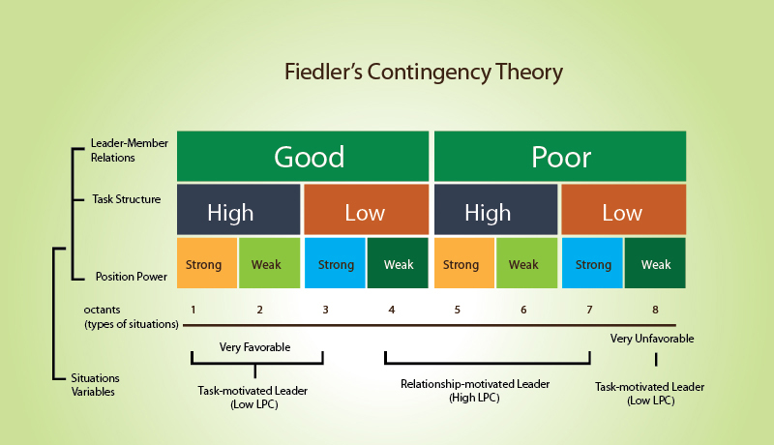
Figure 6: Fiedler’s contingency model of leadership
Source: (Burns, 2012)
This model has focused on the changes in leadership style based on the leader-member relationship, task structure, and position power. The model has shown that the relationship motivated leaders can enjoy the best productivity level. I have managed the task motivated leadership managing the very favorable situation in the organization especially for the lower management of the stores and in case of the middle management, I have focused on the relationship motivated leadership (Schroeder and Kardoff, 2014).

Maslow’s hierarchy of needs:
To ensure the appropriate motivational tools for the subordinates in my store, I have used the hierarchy of needs by Maslow to identify the level of needs of my stuff and choose appropriate motivational tools. However, this motivation theory of management suggests that the needs of the individual changes over time maintaining the hierarchy he has shown. After the completion of one hierarchy, they go for another.

Figure 7: Maslow’s hierarchy of needs
Source: (O'Neil, et al., 2012)
The above model suggests five stages of needs, such as the physiological need that includes the basic needs like food, shelter, treatment etc. The human resource policy of Primark strongly ensures this need of the employees from the very bottom level, even it concerns about the assurance of this need for the workers of their suppliers. Therefore, I don’t have to plan to meet this need in while managing the store. Primark wants to avoid the switching costs of the employees and want to assure the experience curve for the organization that allows me to create appropriate work environment providing the employees with the job security that is related to their role played in the achievement of the organizational goal. As a store manager, I have successfully maintained these two needs of the hierarchy and now I am focusing on the further stages as I need to achieve the satisfaction of the employees to avoid the current crisis in the retail industry of high employee retention rate. I have focused on the belongings and love need of the members of the group providing them with appropriate empowerment according to the responsibilities allocated to them (Long, 2012). As a store manager, I have focused on these three stages only, as the further needs are difficult to be managed as I maintain a different leadership role for different subordinates and the decision making process is partly decentralized. Moreover, the use of administrative theory has also hindered me to take a decision on eth further needs because of my boundary of a chain of command.

Conclusion:
The above discussion was about the use of management theories in managing the workforce considering the beliefs, values, and attitudes of the individual employees. the discussion has started with choosing the administrative theory of management as the appropriate management style to explain the management of the stores of Primark, the second largest fast fashion retailer of the UK with 4% sales growth in almost all stores (Rankin, 2018). Because of the inefficiency of the classical theory of management and the combination of scientific theory of management with the administrative theory, they have been rejected. To understand the role of beliefs, values, and attitude the clear understanding about them has been discussed. The impact on the store management of Primark has been shown and lastly, the use of leadership theory and a motivation theory has been discussed that has been applied to ensure the efficiency of this management theory in managing the workplace.

References
Buchanan, D. and Huczynski, A. (2017). Organizational behaviour. Harlow: Pearson.
Burns, J. (2012). Leadership. New York, NY: Open Road Integrated Media.
Campling, J. (2008). Management. Milton, Qld.: John Wiley & Sons Australia.
Chitale, A. (2013). Organizational behaviour. delhi: Prentice-Hall Of India.
Giuliani, R. and Kurson, K. (2015). Leadership. New York: Hyperion.
Kochan, T. and Schmalensee, R. (2014). Management. Cambridge, Mass: MIT Press.
Long, R. (2012). Motivation. David Fulton Publishers.
Management Insights. (2011). Production and Operations Management, 20(6), p.vii-ix.
Mondy, R. and Martocchio, J. (2016). Human resource management. Harlow, Essex, England: Pearson.
O'Neil, J., Drillings, M. and O'Neil, H. (2012). Motivation. Hoboken: Taylor and Francis.
Primark.com. (2018). [online] Available at: https://www.primark.com/ [Accessed 23 Dec. 2018].
Rankin, J. (2018). Primark says it is still gaining market share as shoppers shift to 'value' clothes. [online] the Guardian. Available at: https://www.theguardian.com/business/2014/feb/24/primark-market-share-shift-value-clothes [Accessed 23 Dec. 2018].
Rashid, S. and Archer, M. (2013). Organizational behaviour. Toronto: Methuen.
Schmitz, P. (2015). Workplace Surveillance, Privacy Protection, and Efficiency Wages. SSRN Electronic Journal.
Schroeder, B. and Kardoff, A. (2014). Management. Upper Saddle River, N.J.: International Association of Administrative Professionals and Prentice Hall.

